Supplementary Materials for
Unconventional syntropic spin alignment at the interface between ferromagnetic and superconducting nitrides

Qiao Jin, Qinghua Zhang, Bai He, Meng Yang, Yonglong Ga, Shengru Chen, Haitao Hong, Ting Cui, Dongke Rong, Ting Lin, Jia-Ou Wang, Can Wang, Yanwei Cao, Lin Gu, Guozhu Song, Shanmin Wang, Kun Jiang, Zhi-Gang Cheng, Tao Zhu, Hongxin Yang, Kui-juan Jin,* and Er-Jia Guo*
Correspondence to: E-mail: kjjin@iphy.ac.cn and ejguo@iphy.ac.cn
This PDF file includes:
Figure S1. Microscopic structural and chemical composition characterizations of Fe₃N/VN bilayer.
Figure S2. Electronic state of Fe₃N/VN bilayer probed by EELS.
Figure S3. Identify the crystal structure of iron oxide on Fe₃N surface layer.
Figure S4. XAS at N K- and Fe L-edges for Fe₃N/VN bilayer.
Figure S5. Magnetic-field response of Fe₃N/VN bilayer.
Figure S6. Magnetization measurements.
Figure S7. Comparison of PNR spin asymmetry (SA) fitting with three models.
Figure S8. PNR measurements on Fe₃N/VN bilayer at 6.5 K under different fields.
Figure S9. Enhanced electronic anisotropy in a 6-nm-thick VN single film.
Figure S10. Transport properties of a 6-nm-thick VN single film and a Fe₃N/VN(6nm) bilayer.
Figure S11. Theoretical calculation models and density of state across the Fe₃N/VN interface.
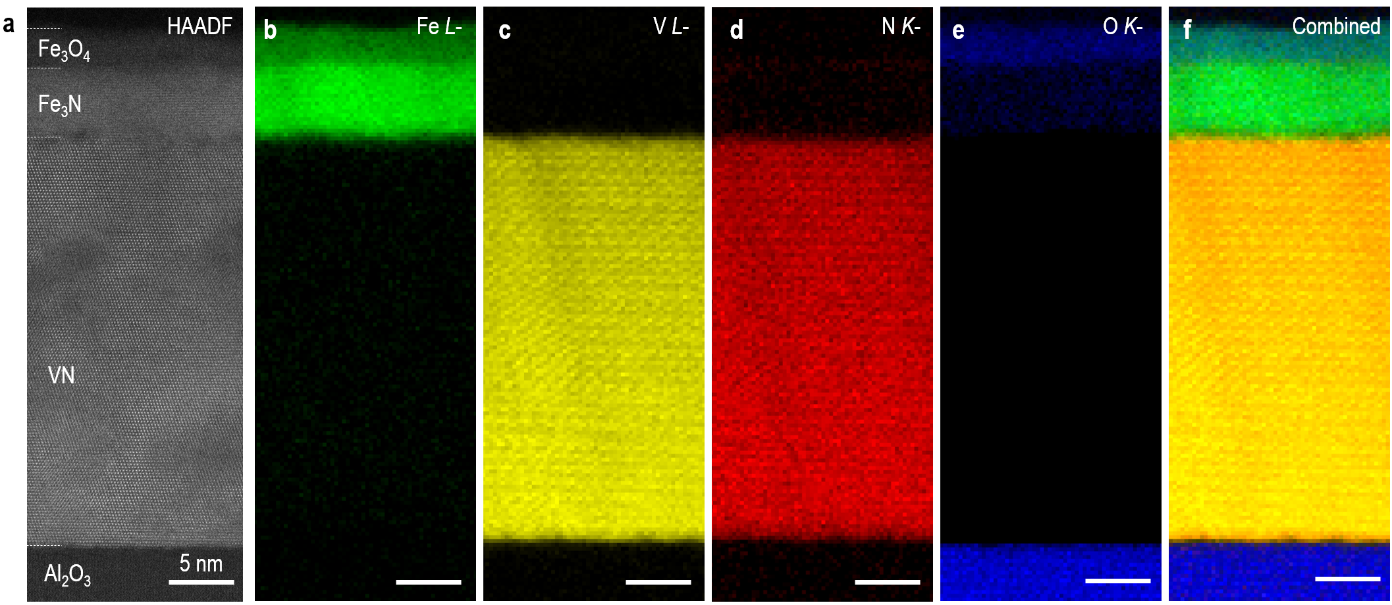
Figure S1. Microscopic structural and chemical composition characterizations of the Fe₃N/VN bilayer. (a) Low-magnification HAADF-STEM image of the Fe₃N/VN bilayer grown on Al₂O₃ substrates. The EELS spectrum images collected from the same region in (a). The color images show the integrated intensities from (b) Fe L-, (c) V L-. (d) N K-, and (e) O K-edges. (f) A combined EELS image from all elements. The EELS results indicate the distributions of V and N ions within VN layer are uniform and interfaces are atomically sharp with negligible chemical intermixing. We find that the surface layer of Fe₃N is heavily oxidized, as illustrated by an enhanced O signal and reduced Fe signal. This phenomenon is unavoidable when an as-grown Fe₃N layer exposes in air. The thickness of iron oxide is approximately 2 nm. We believe that the iron oxide is stable and stops further oxidizing into Fe₃N layer at ambient conditions. Therefore, the thickness of iron oxide will not further increase. Furthermore, we believe that the oxidization of Fe₃N surface layer will not influence the interfacial magnetic coupling between Fe₃N and VN.
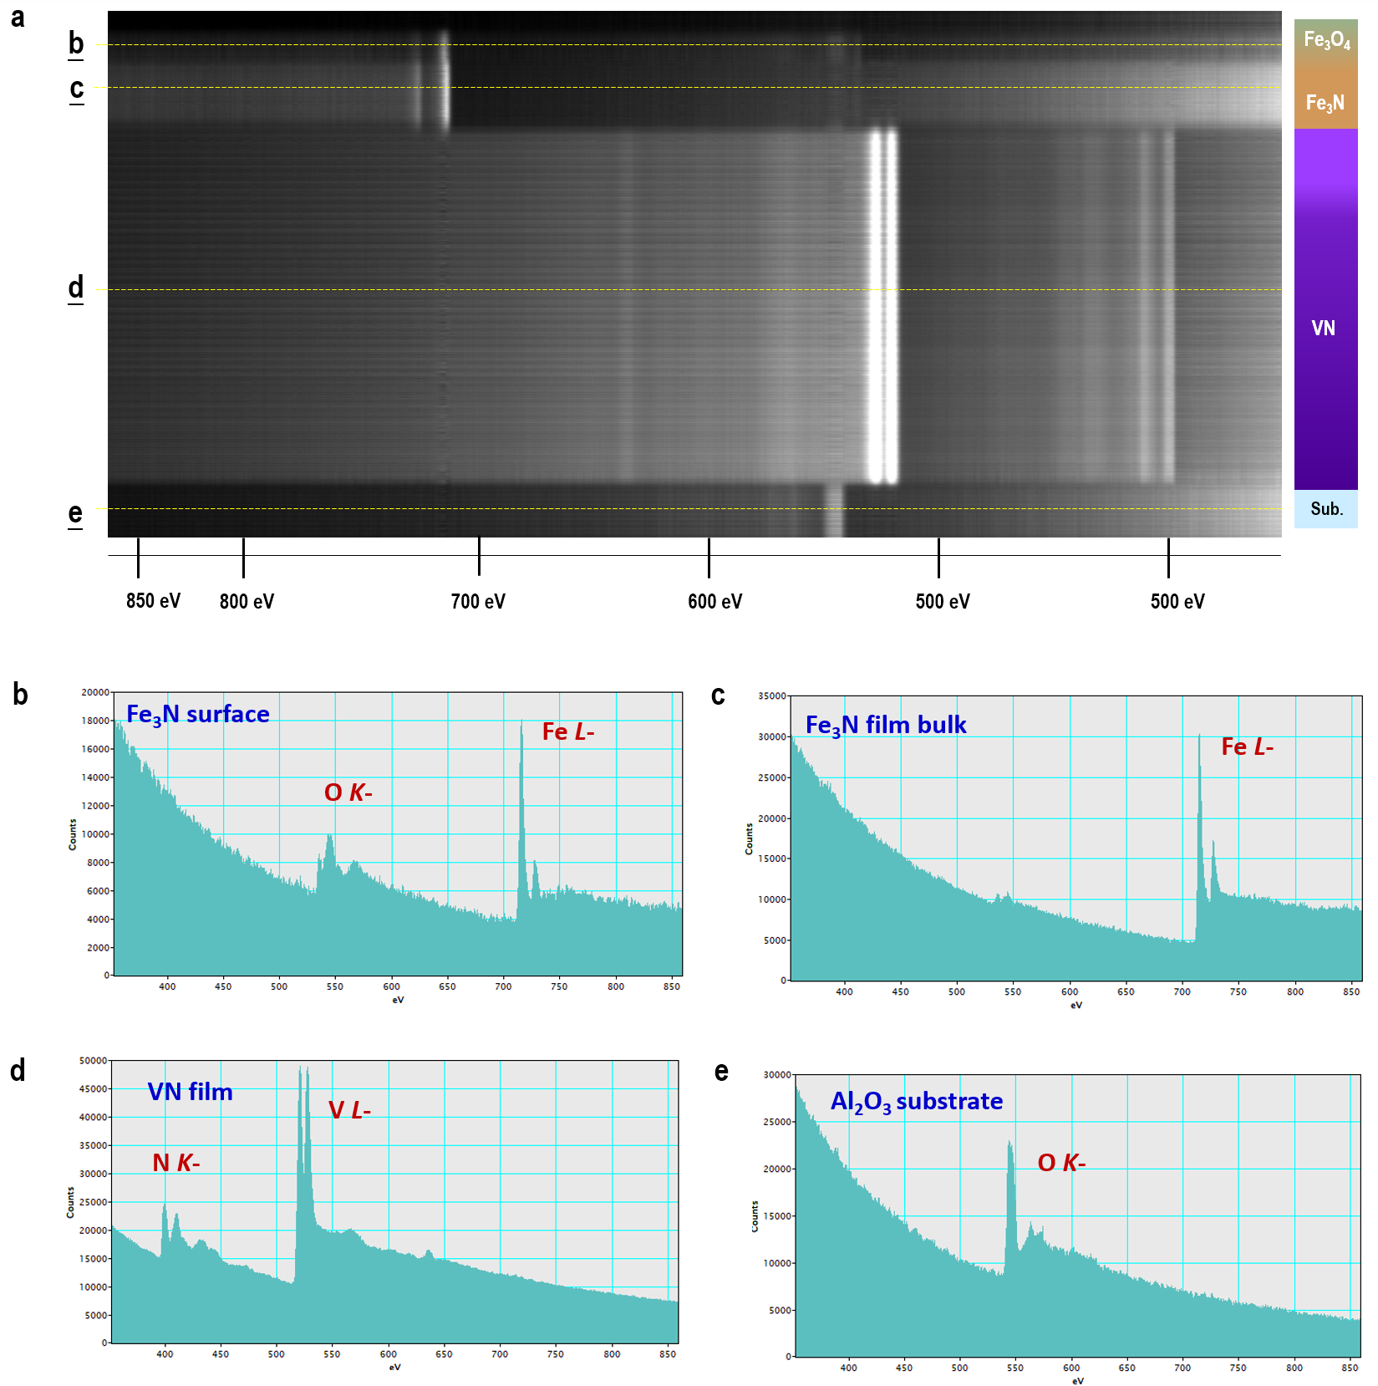
Figure S2. Electronic state of Fe₃N/VN bilayer probed by EELS. (a) Layer-thickness-resolved full EELS spectra of the Fe₃N/VN bilayer. Averaged spectra from (b) Fe₃N surface layer, (c) Fe₃N internal layer, (d) VN layer, and (e) Al₂O₃ substrates. The EELS spectra are raw data without subtracting the background.
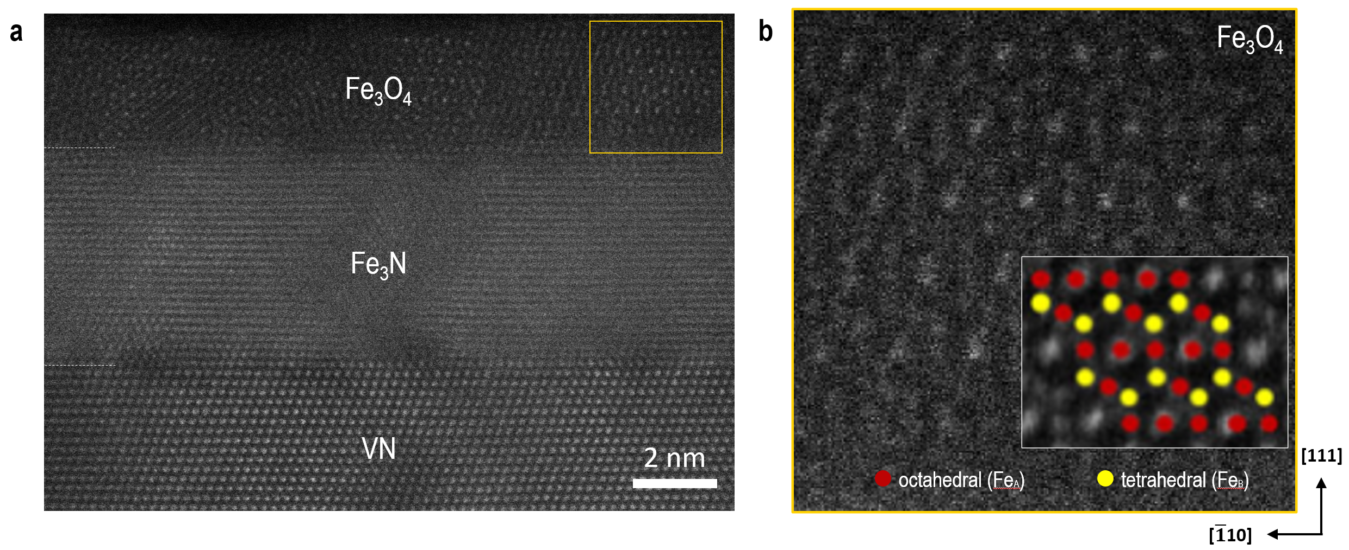
Figure S3. Identify the crystal structure of iron oxide on Fe₃N surface layer. (a) High-resolution HAADF-STEM image of a region close to the top surface of the Fe₃N/VN bilayer. The interfaces between Fe₃N and VN are atomically sharp with negligible chemical intermixing. On the surface of Fe₃N, the layer has been partially oxidized. The iron oxide layer has a thickness of ~ 2 nm. (b) The zoom-in STEM image, from a region marked with orange rectangle in (a). The overlaid atomic structural models identify the iron oxide is magnetite (Fe₃O₄). The octahedral (Fe_{A}) and tetrahedral (Fe_{B}) atomic columns are shown in red and yellow, respectively. The partially oxidization at the surface of Fe₃N is unavoidable when it exposes in air. This sample keeps at the ambient condition for over six months. The thickness of Fe₃O₄ layer does not increase, indicating the Fe₃O₄ layers are stable at room temperature. We believe the formation of nanometer thick Fe₃O₄ well-protects the rest of Fe₃N layers. What is more important, the Fe₃O₄ layer does not affect the interfacial proximity effect at Fe₃N/VN interfaces.
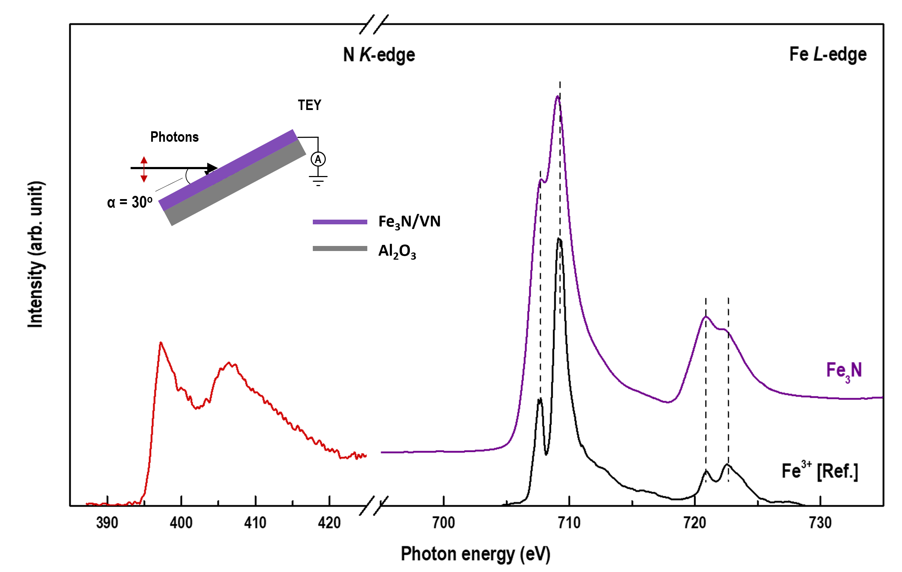
Figure S4. XAS at N K- and Fe L-edges for the Fe₃N/VN bilayer. We observe a clear N K-edge peak, indicating the sufficient nitrogen content in Fe₃N layers. XAS results show strong peaks at ~710 and ~721 eV for Fe L-edges. We plot the reference XAS spectra for Fe³⁺ ions (BiFeO₃, Adv. Mater. 2017, 29, 1700790). The lineshape between Fe₃N and Fe³⁺ ions are considerably different, suggesting the valence state of Fe ions is not +3. Possibly, there is charge transfer between V and Fe ions across the interfaces. Since the VN layer is capped by Fe₃N layer, the XAS V L-edge spectra cannot be detected. All spectra were collected at room temperature in total electron yield (TEY) mode. The linearly polarized light was incident on the sample with an angle of 30º with respect to the surface plane.
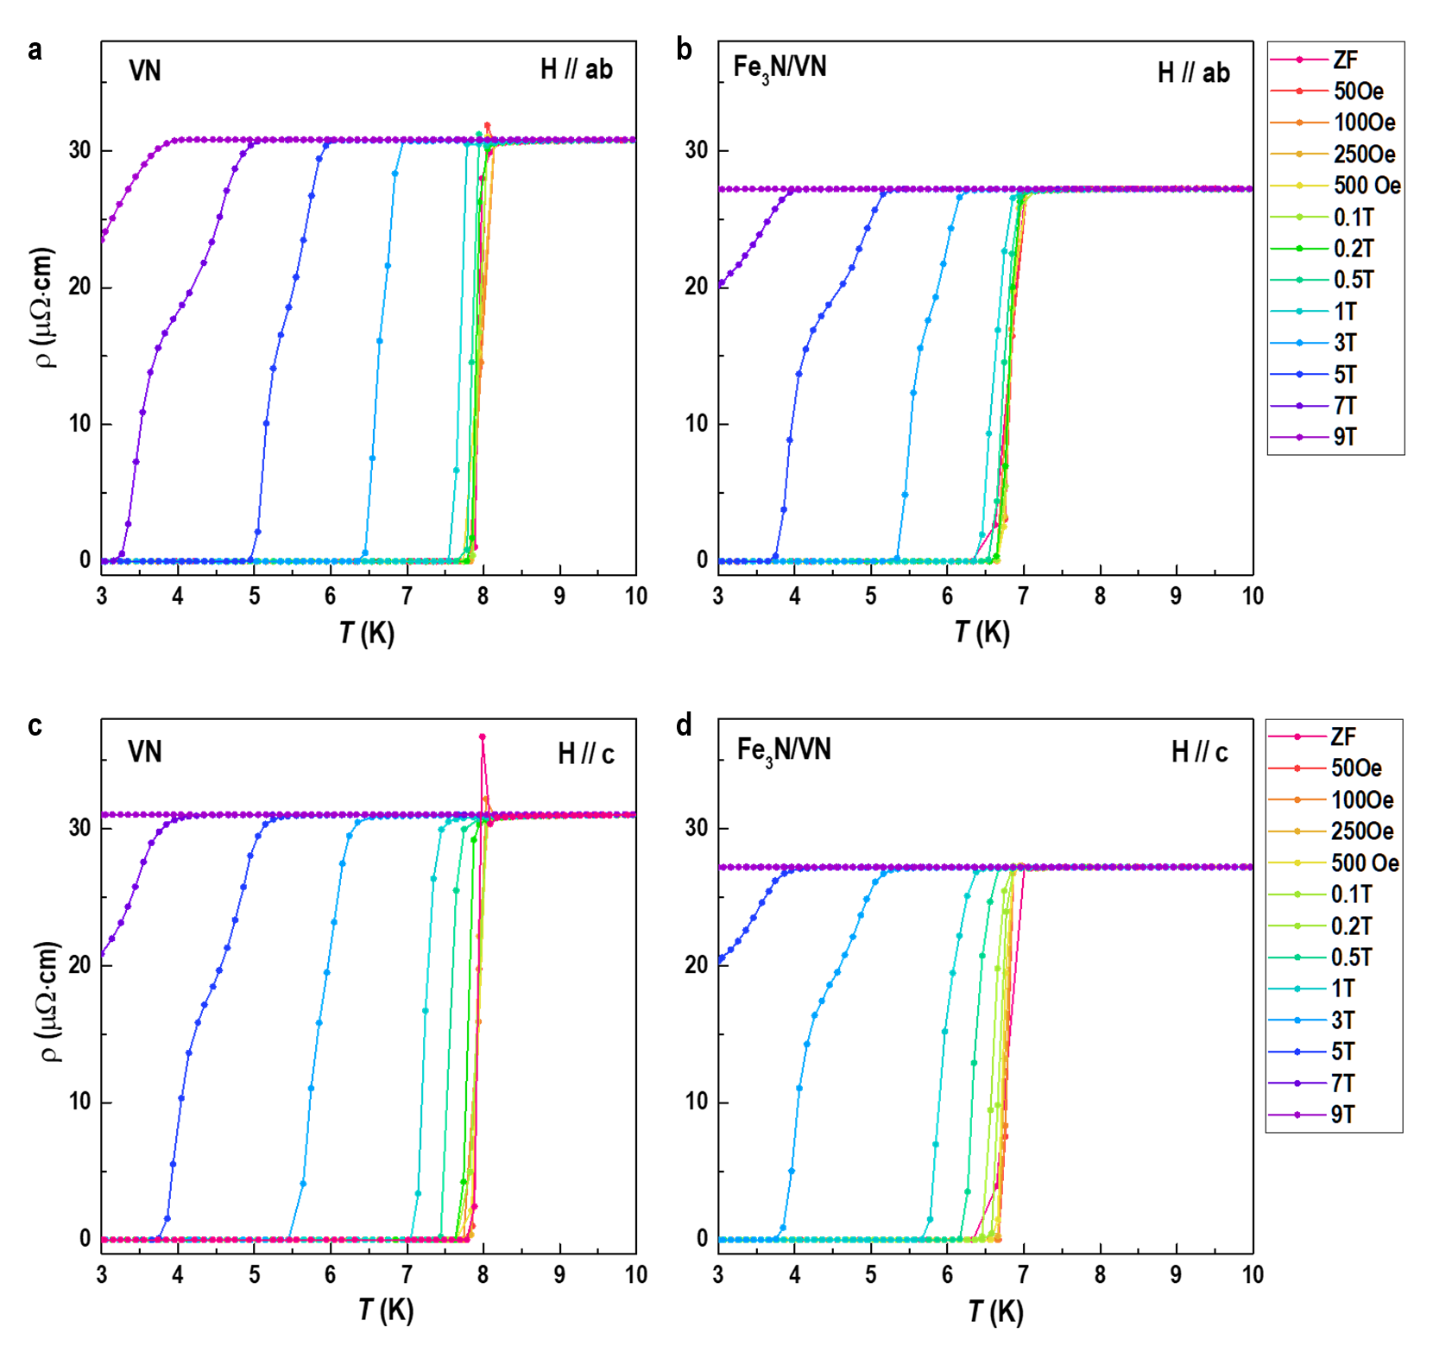
Figure S5. Magnetic-field response of Fe₃N/VN bilayer. (a) and (b) ρ-T curves of a VN single layer and a Fe₃N/VN bilayer, respectively, when magnetic fields are applied parallel to the film plane. ρ-T curves of two samples when magnetic fields are applied perpendicular to the film plane are shown in (c) and (d). In both cases, the magnetoresistance is fairly small in the normal state. The superconductivity of VN is strongly suppressed as increasing magnetic fields.
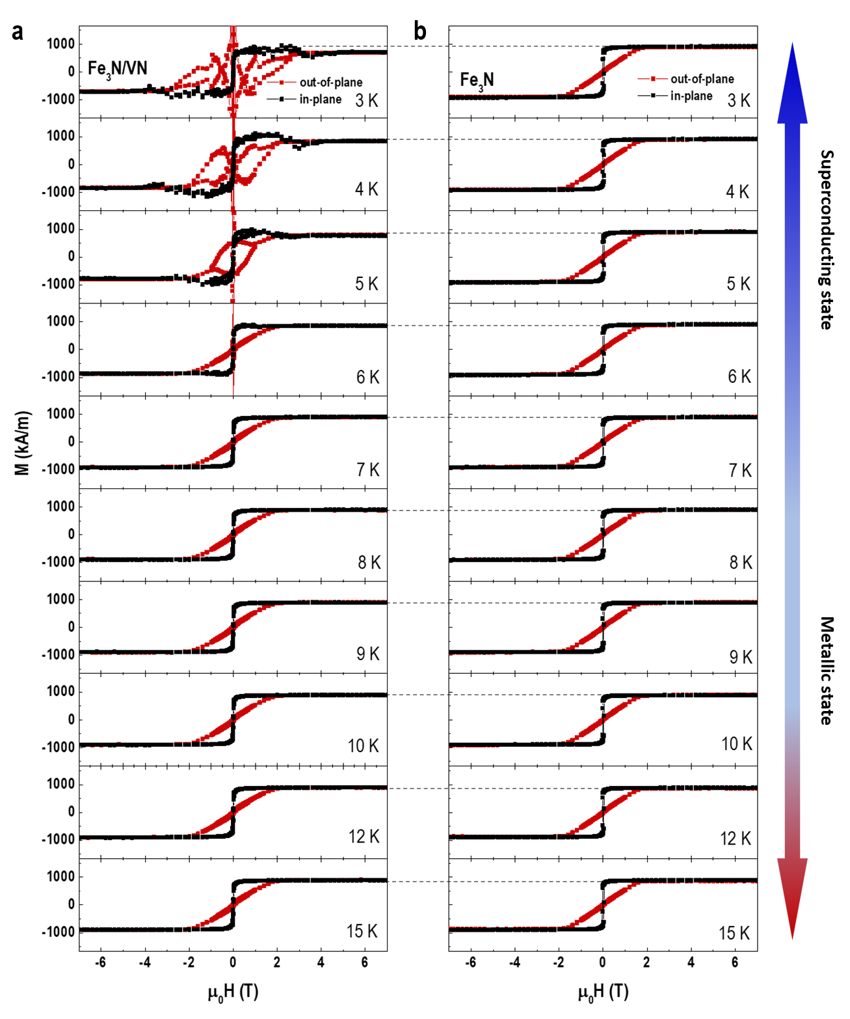
Figure S6. Magnetization measurements on a Fe₃N single layer and a Fe₃N/VN bilayer. (a) and (b) M-H hysteresis loops of a Fe₃N/VN bilayer and a Fe₃N single layer, respectively. Both in-plane (black) and out-of-plane (red) magnetizations were recorded up to ± 7 T at the temperatures ranging from 3 to 15 K. The broad range of measuring temperature covers the superconducting transition temperature (T_{C} ~ 6.5 K) of VN layers.
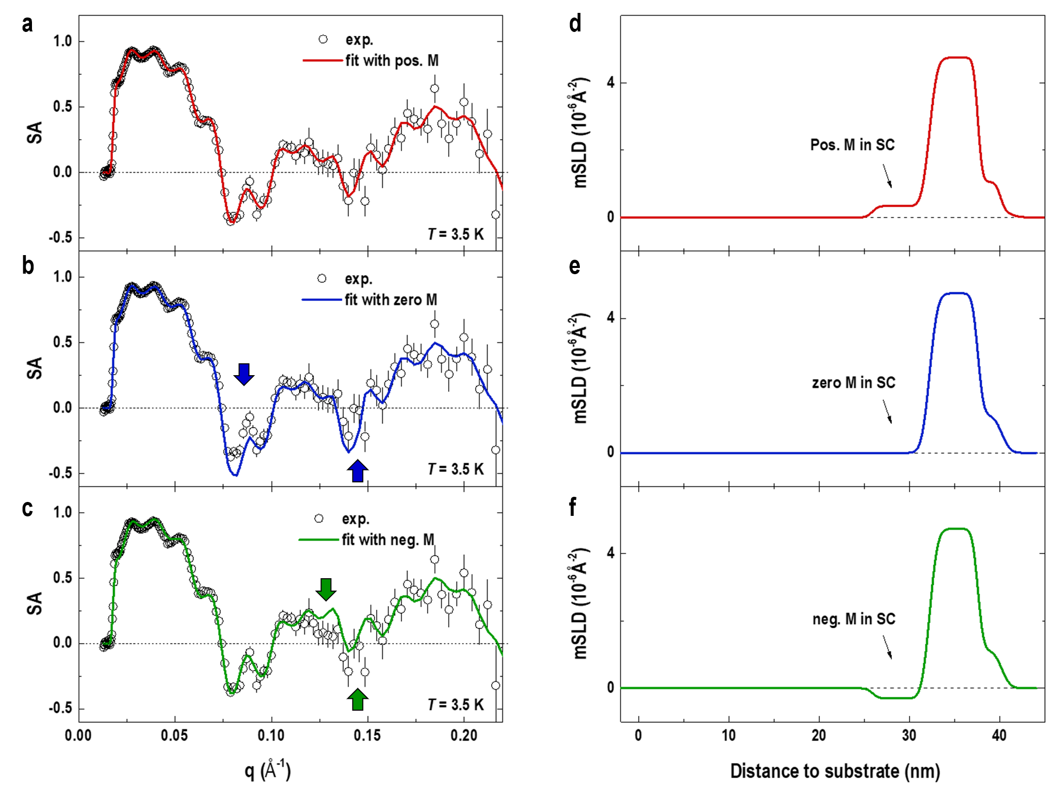
Figure S7. Comparison of PNR spin asymmetry (SA) fitting with three models. SA derived from the reflectivity measurements is calculated by (R⁺+ R–)/( R⁺–R–). We consider three different models for PNR fittings: (a) positive M (magnetization parallel to M of Fe₃N), (b) zero M, and (c) negative M (magnetization anti-parallel to M of Fe₃N) in VN interface layers. The open symbols and solid lines represent the experiment data and reasonable fits. The best fits to the PNR data with constrain of zero M and negative M in VN interface layers have large deviations from the experiment data. The color arrows indicate the positions of fitting curves with a large discrepancy between experiment data and fits where the statistics errors are small based on model (a). (d)-(f) Magnetization profiles of Fe₃N/VN bilayers with model (a)-(c), respectively. The SA fits for model (a), (b), and (c) yield χ² metrics of 1.1, 3.6, and 3.1, respectively. Compared with three models, the best fitting corresponds to the positive M in VN interface layer with respect to M of Fe₃N layer.
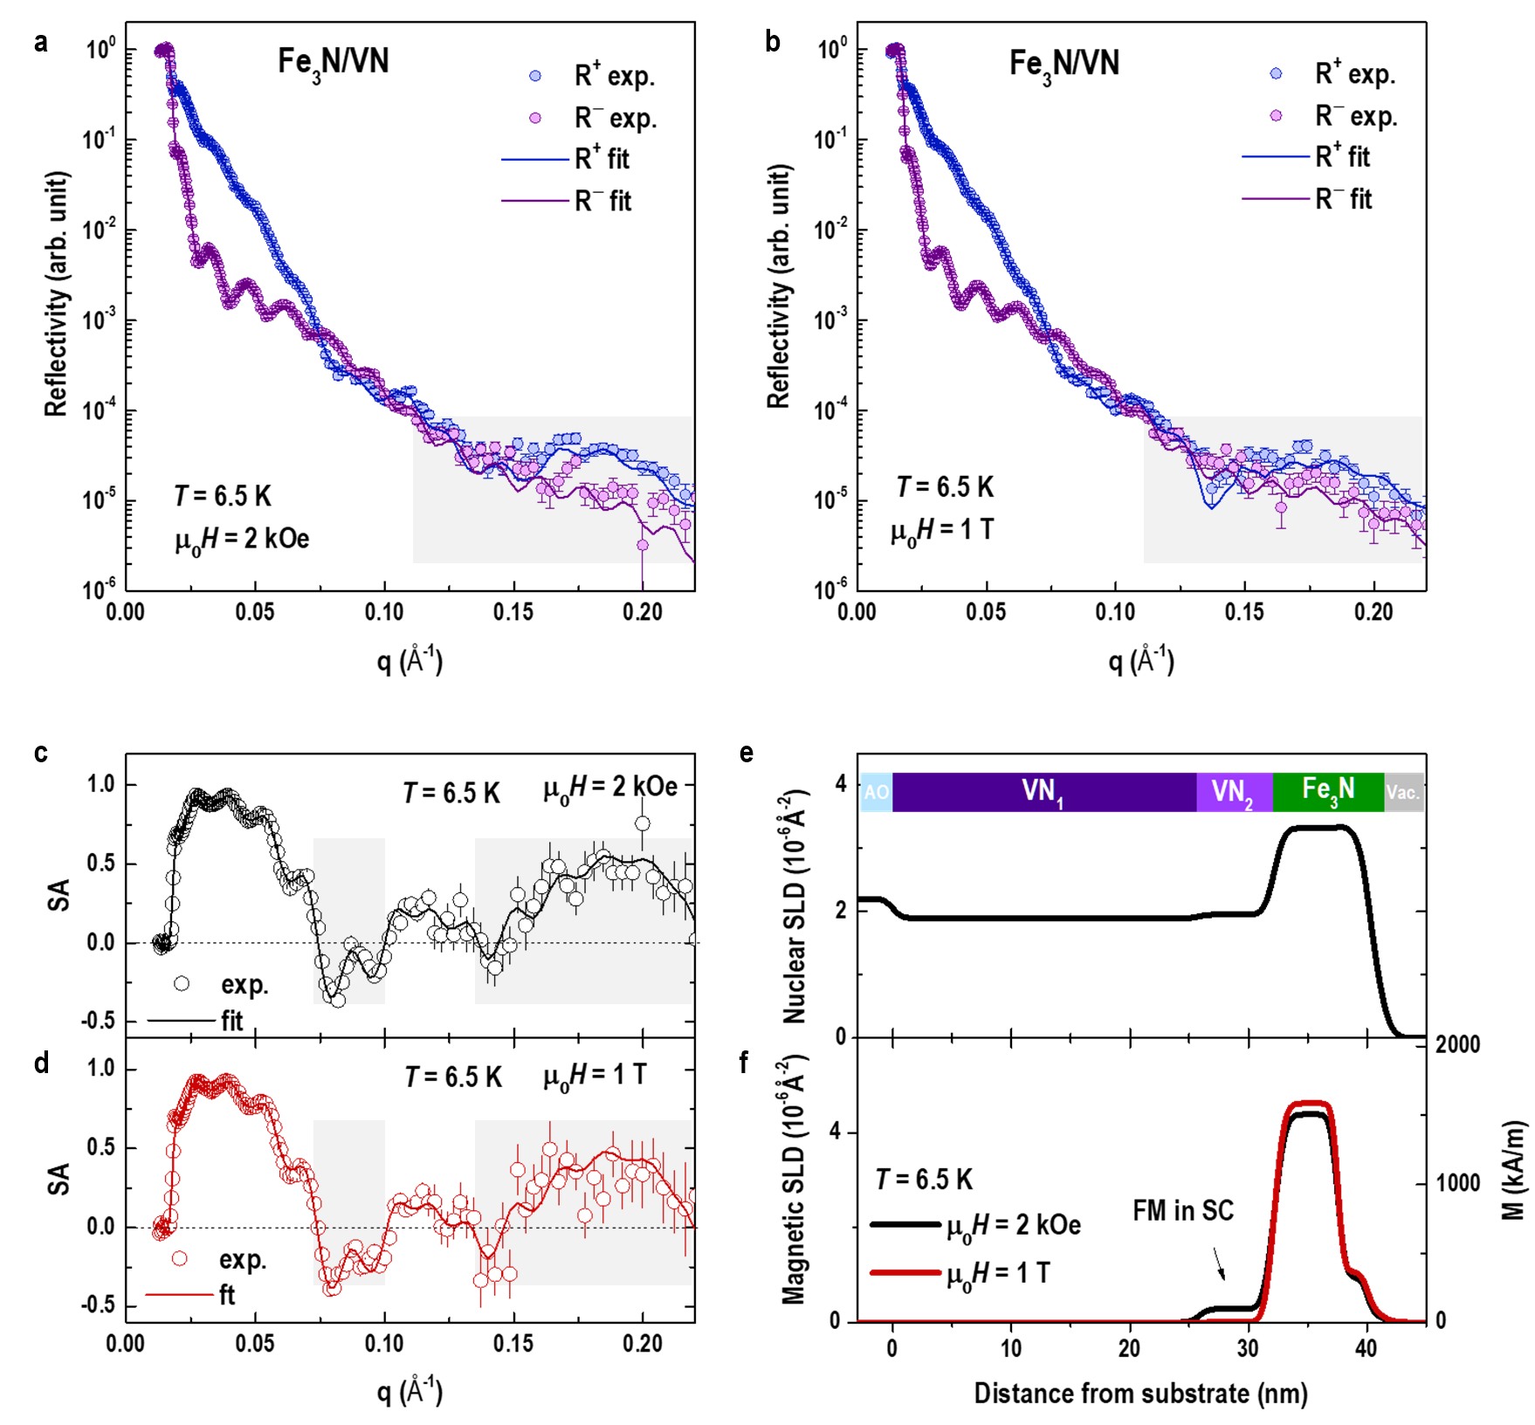
Figure S8. PNR results on Fe₃N/VN bilayer at 6.5 K under different magnetic fields. (a) and (b) Measured (open symbols) and fitted (solid lines) reflectivities for spin-up (R⁺) and spin-down (R–) polarized neutron beams are plotted as a function of the wave vector (q) at 6.5 K under magnetic fields of 2 kOe and 1 T, respectively. The shadow regions in (a) and (b) indicate the large discrepancy between two datasets. (c) and (d) SA derived from the experimental data and fittings. (e) Nuclear scattering length density (nSLD) depth profile and (f) magnetic scattering length density (mSLD) depth profiles under 2 kOe and 1 T. Since the coercive fields of Fe₃N is ~ 300 Oe, the M of Fe₃N layer at 2 kOe and 1 T is very close, ~1507 and ~1587 kA/m, respectively. The M of VN interfacial layer is ~96.5 kA/m. The nonzero M at the VN interface indicates the inverse proximity effect between Fe₃N and VN.
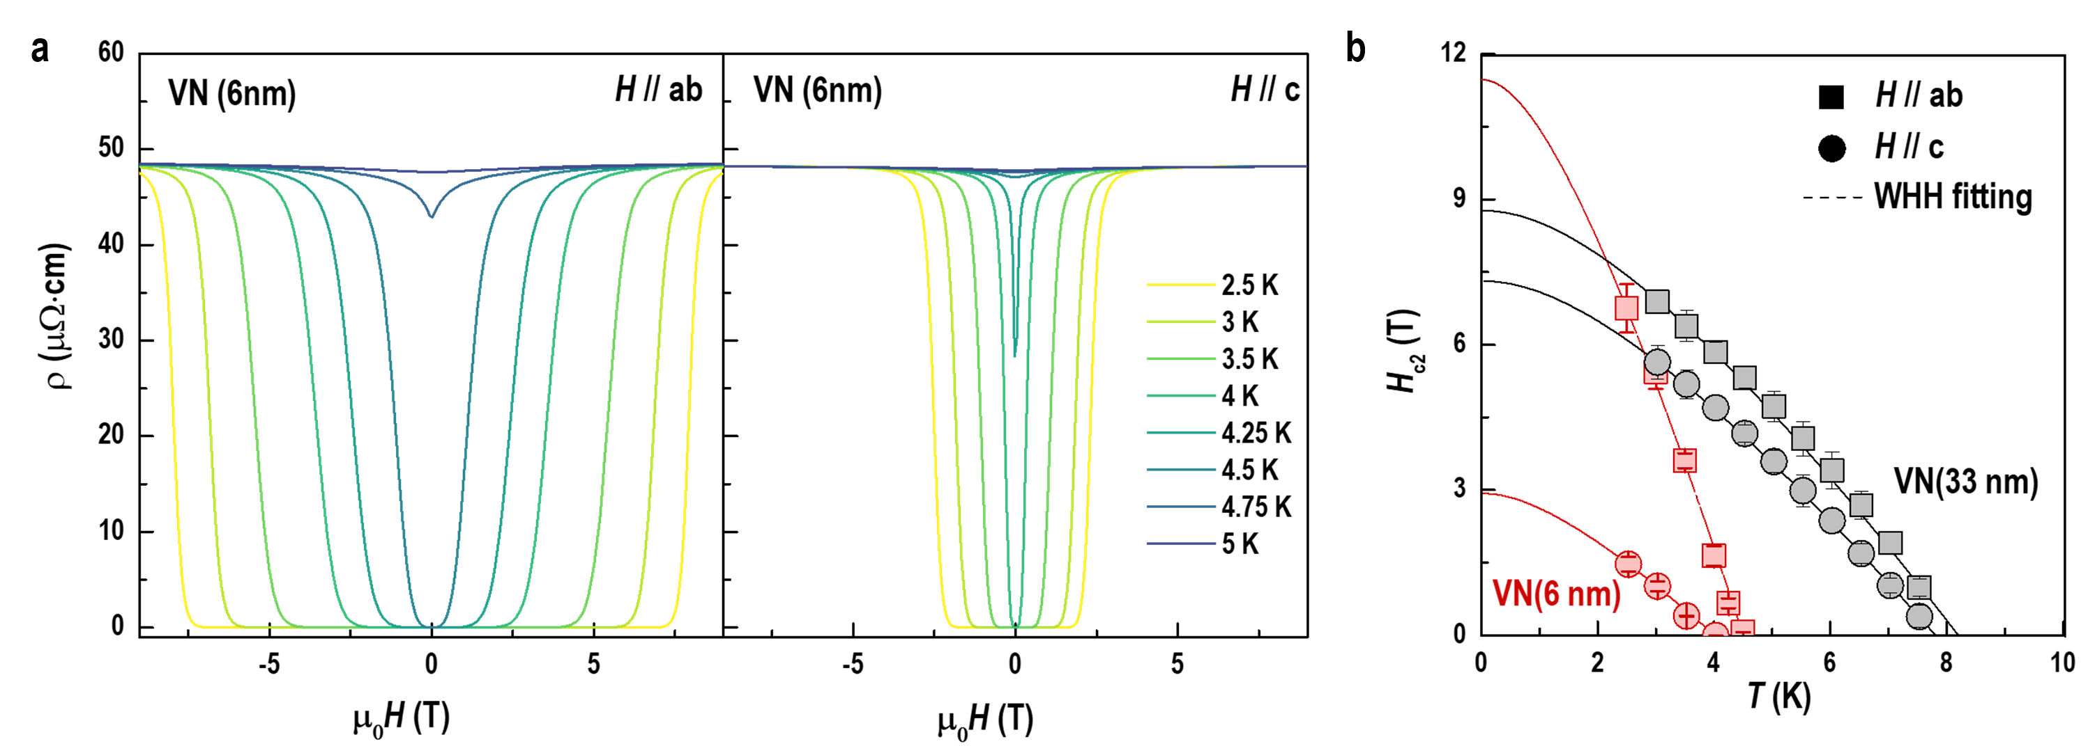
Figure S9. Enhanced electronic anisotropy in a 6-nm-thick VN single film. (a) Field dependent resistivity of a 6-nm-thick VN single layer when H // ab and H //c. The measuring temperature is swapped from 2.5 to 5 K. (b) Temperature dependent upper critical field (H_{c2}) for 6-nm-thick VN single film. The H_{c2} of a 33-nm-thick VN single film is plotted for comparison. Both in-plane and out-of-plane H_{c2} were fitted based on Werthamer-Helfand-Hohenberg (WHH) model. The fitting parameters are summarized in Table I in main text. Apparently, the anisotropy of superconducting order parameters is heavily increased as film thickness reduces. This result is in agreement with the typical characters of superconducting films approaching the two-dimensional limit.
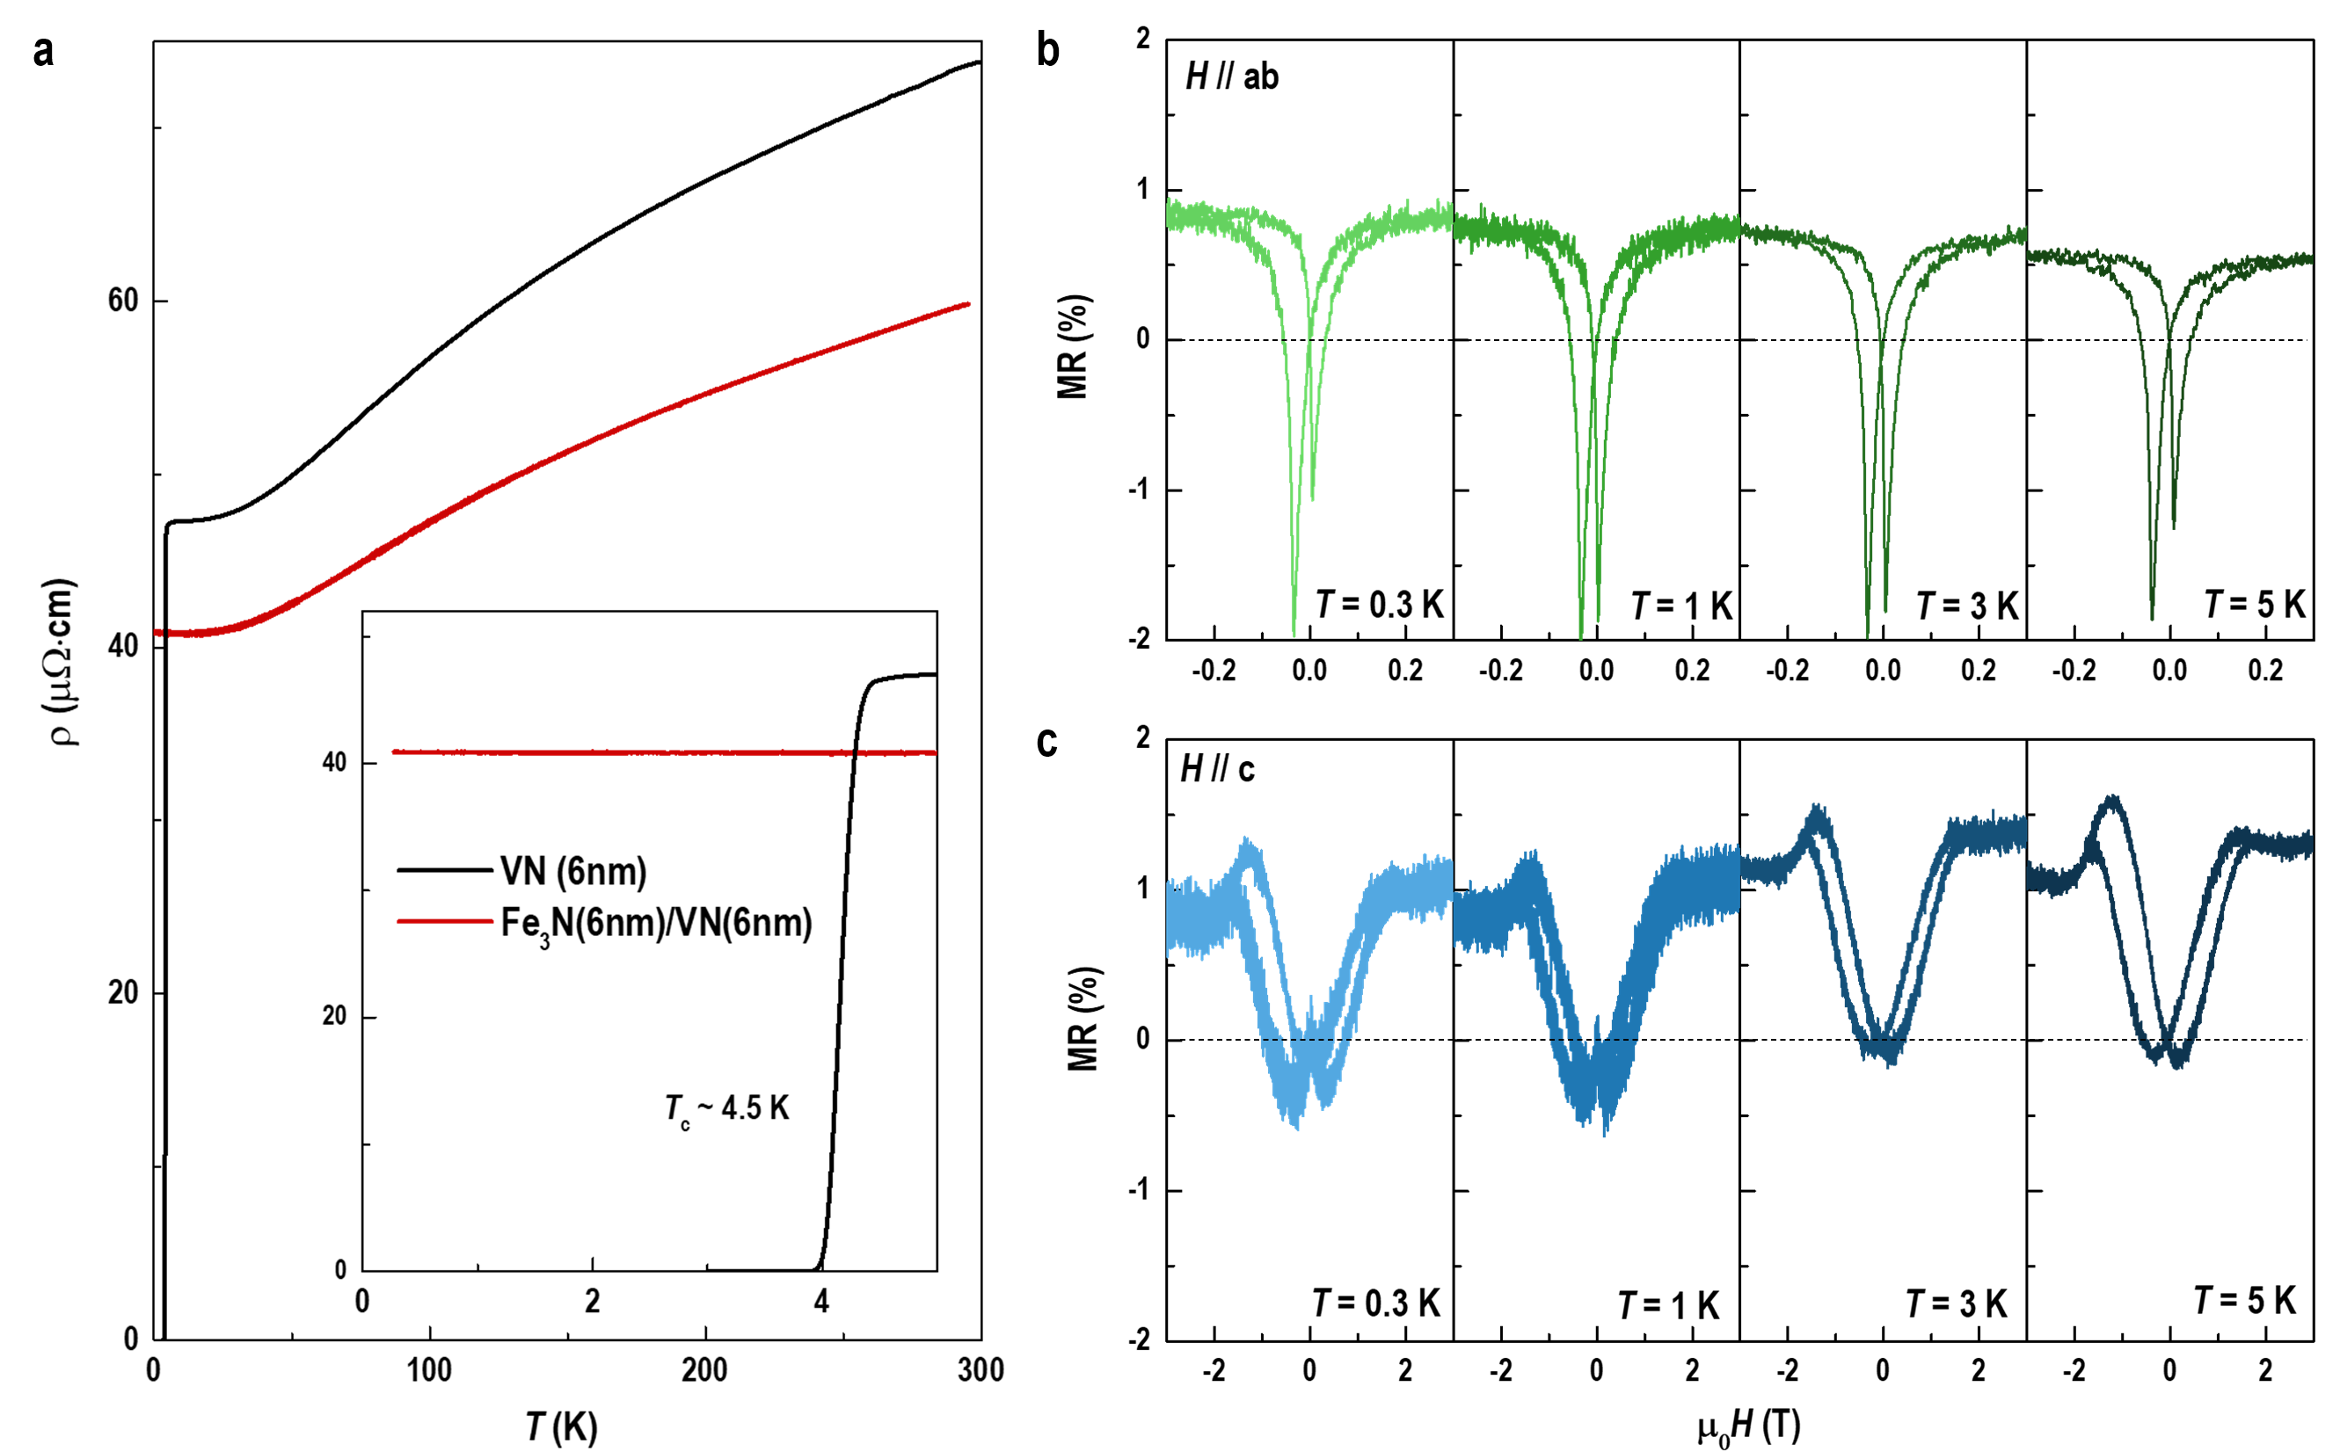
Figure S10. Transport properties of a 6-nm-thick VN single film and a Fe₃N/VN(6nm) bilayer. (a) Temperature dependent resistivity of both samples. The 6-nm-thick VN single layer exhibits a clear superconducting behavior with T_{C} ~ 4.5 K, whereas the Fe₃N/VN bilayer does not show superconducting transition when the temperature is lowered down to 300 mK. (b) and (c) Magnetoresistance (MR) of the Fe₃N/VN bilayer when H // ab and H //c, respectively. The temperature gradually raises from 300 mK to 5 K. The Fe₃N/VN bilayer exhibits clear MR induced by ferromagnetism. The MR strongly depends on the direction of applied magnetic field.
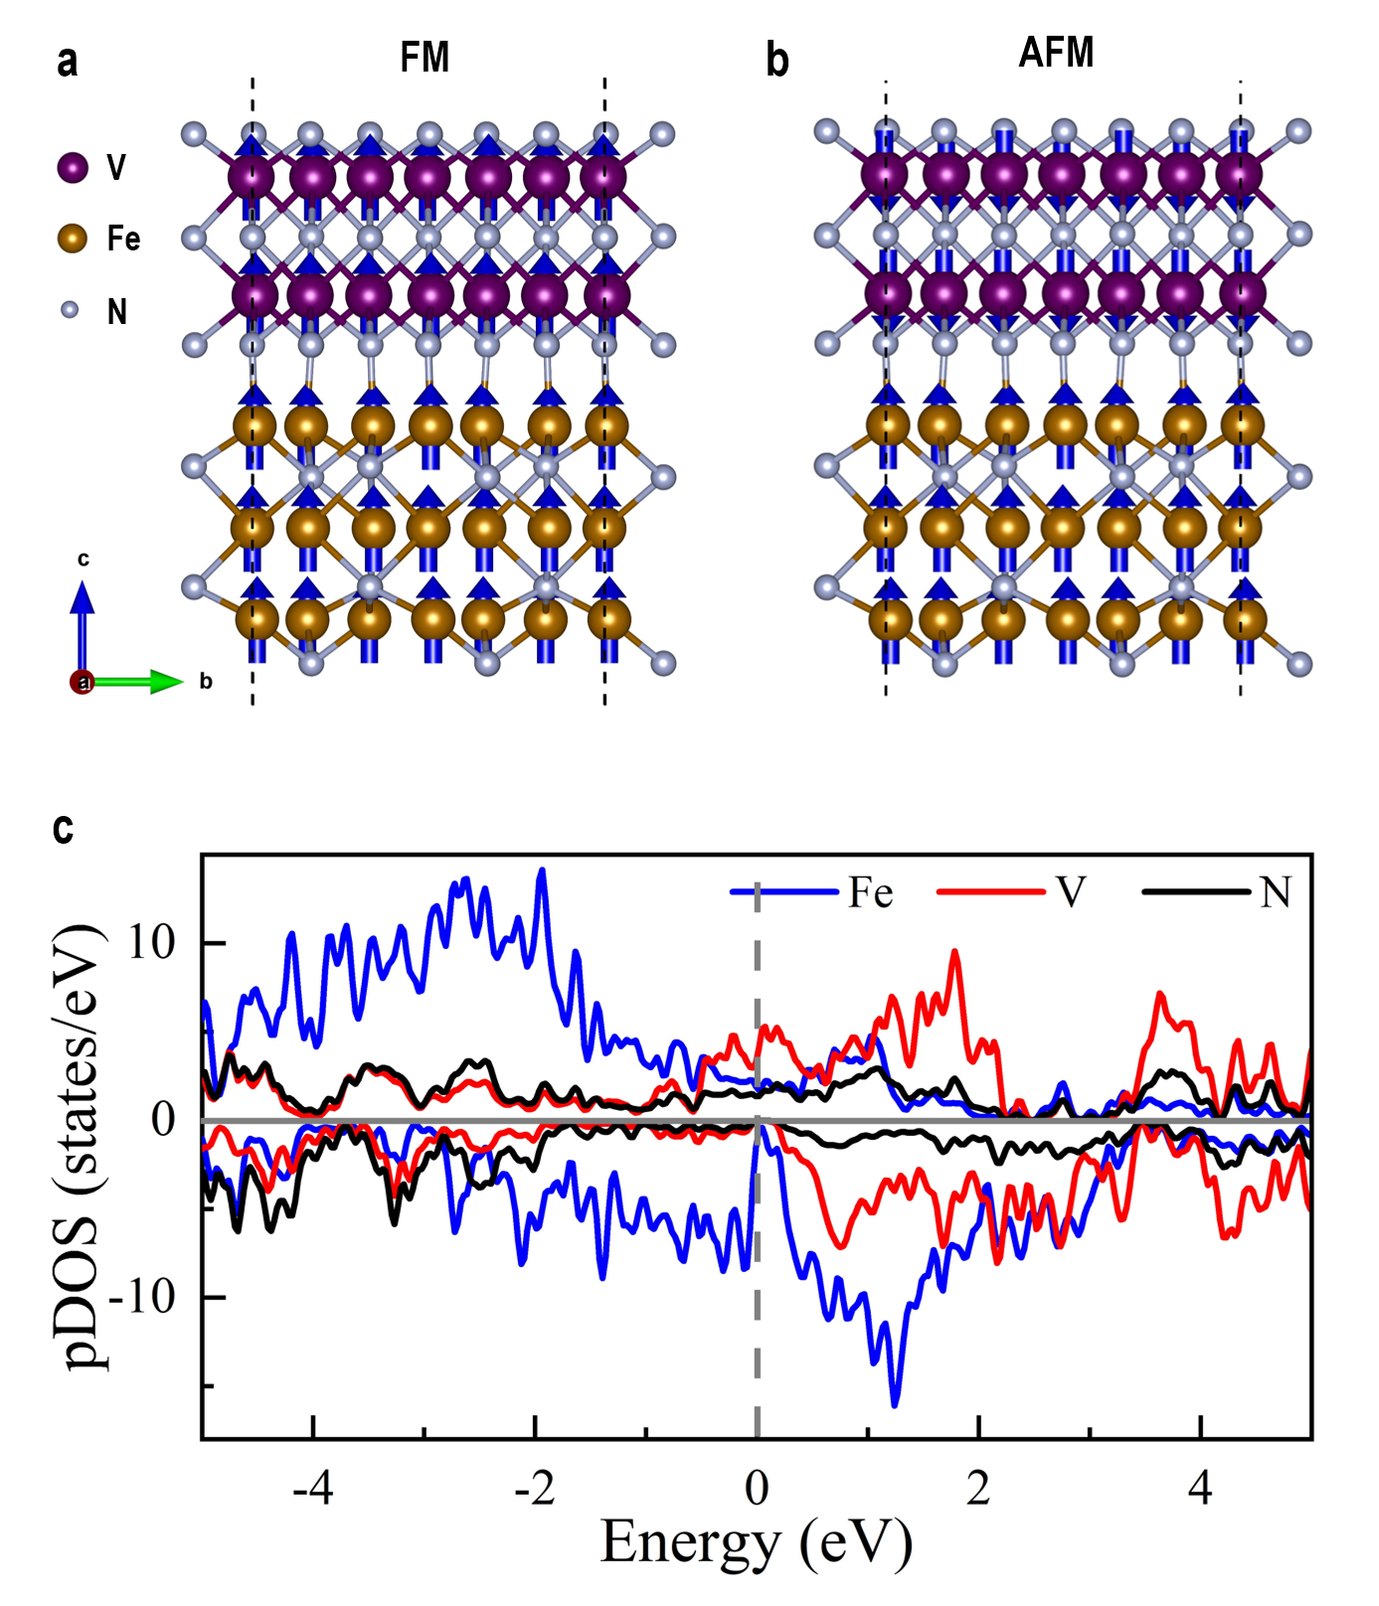
Figure S11. Theoretical calculation models and density of state across the Fe₃N/VN interface. (a) Ferromagnetic (FM) and (b) antiferromagnetic (AFM) magnetic configurations across Fe₃N/VN heterointerface. (c) The spin up (positive) and spin down (negative) projected density of states (DOS) and elements-projected DOS for Fe, V and N. The results suggest the ferromagnetically coupling between Mn and V ions.

