Supporting Information
Reversible Modulation of Interlayer Stacking in 2D Copper-Organic Frameworks for Tailoring Porosity and Photocatalytic Activity
Pei-Ye You, Yu-Mei Wang, Xiao-Chun Lin, Kai-Ming Mo, Jia-Tong Lin, Mo Xie, Rong-Jia, Wei, Guo-Hong Ning* and Dan Li *
College of Chemistry and Materials Science, and Guangdong Provincial Key Laboratory of Functional Supramolecular Coordination Materials and Applications, Jinan University, Guangzhou, 510632, People’s Republic of China
*Corresponding authors: Guo-Hong Ning: guohongning@jnu.edu.cn; Dan Li: danli@jnu.edu.cn

Contents
1. General procedure 3
2. Synthesis of covalent organic frameworks (JNMs) 4
2.1 Synthesis of Cu-CTU 4
2.2 Synthesis of JNM-7-AA, JNM-8-AA and JNM-9-ABC. 4
3. Characterization of JNM-7-AA, JNM-8-AA and JNM-9-ABC. 6
3.1 Structural simulation 6
3.2 Energy Dispersive X-ray Spectroscopy (EDS) 21
3.3 Gas adsorption isotherms and pore size distribution of JNM-9-ABC. 22
4. Structure reversible transformation 23
4.1 Experimental procedures 23
4.2 Structural simulation for JNM-7-ABC and JNM-8-ABC 24
4.3 Revisable structure transformation PXRD. 28
4.4 Fourier-transform infrared (FT-IR) spectra 29
4.5 Solid-state ¹³C CP/MAS NMR spectra. 29
4.6 Scanning electron microscopy (SEM). 30
4.7 X-ray photoelectron spectroscopy (XPS). 30
4.8 Thermogravimetric analysis (TGA) 30
4.9 Various-Temperature PXRD. 31
4.10 Stability in various solvents. 31
4.11 Gas adsorption isotherms and pore size distribution of JNM-8. 32
4.12 DFT calulations 32
4.13 Reversible encapsulation and release of lipase 33
5. Optical and electronic properties 35
6. Photocatalytic Application 37
6.1 Experiments of CDC reactions. 37
6.2 Characterization for the product of JNM-8-AA catalyzed CDC reaction. 37
6.3 Catalytic recyclability for JNM-8-AA. 38
6.4 Gram-scale CDC reactions. 39
6.5 Reaction mechanisms. 39
6.6 Comparison of yield and TOF for JNM-8-AA with existing catalysts. 41
6.7 Scope of JNM-8-AA Catalyst for oxidative cross-coupling reactions. 41
¹H NMR and ¹³C NMR spectra of all compounds 45
References 53

1. General procedure
Starting materials, reagents, and solvents were purchased from commercial sources and used without further purification. Powder X-ray diffraction (PXRD) data was collected at 40 kV, 30 mA using microcrystalline samples on a Rigaku Ultima IV diffractometer using Cu-Kα radiation (λ = 1.5418 Å). The measurement parameters include a scan speed of 0.5°/min, a step size of 0.02°, and a scan range of 2θ from 1.5° to 30°. For Temperature-dependent PXRD, the measurement parameters include a scan speed of 2 °C/min, a step size of 0.02°, and a scan range of 2θ from 1.5° to 30°. Thermogravimetric analysis was performed on a Mettler-Toledo (TGA/DSC1) thermal analyzer. Measurement was made on approximately 5 mg of dried samples under an N2 flow with a heating rate of 10 °C/min. The scanning electron microscopy (SEM) images and Energy Dispersive X-ray Spectroscopy (EDS) were obtained on a JEOLJSM7600F microscope, operating at an acceleration voltage of 5 kV and magnification is 2000. Transmission electron microscopy (TEM) analysis was performed on an FEI Titan 80-300 S/TEM (Scanning /Transmission Electron Microscope) operated at 200 kV. Fourier transform infrared (FT-IR) spectrum was measured using a Nicolet Avatar 360 FT-IR spectrophotometer. X-ray photoelectron (XPS) spectroscopy spectra were performed by a Thermo ESCALAB 250XI system. GC-MS analysis was carried out on an Agilent 7890B GC analyzer. Liquid ¹H and ¹³C NMR spectra were recorded on Bruker Biospin Avance (400 MHz) equipment using tetramethylsilane (TMS) as an internal standard. Solid-state NMR experiments were performed on a Bruker WB Avance II 400 MHz NMR spectrometer. The ¹³C CP/MAS NMR spectra were recorded with a 4-mm double-resonance MAS probe and with a sample spinning rate of 10.0 kHz; a contact time of 2 ms (ramp 100) and a pulse delay of 3 s was applied. Gas sorption analyses were conducted using an ASAP 2020 PLUS Analyzer (Micromeritics) with extra-high pure gases. The samples were outgassed at 100 ºC for 8 h before the measurements. Surface areas were calculated from the adsorption data using Brunauer-Emmett-Teller (BET) methods. The pore size distribution curves were obtained from the adsorption branches using the density functional theory (DFT) method.

2. Synthesis of covalent organic frameworks (JNMs)

2.1 Synthesis of Cu-CTU
Cu-CTU was synthesized according to the previously reported method.¹ A mixture of the ligand 1H-pyrazole-4-carbaldehyde (HL) (24.0 mg, 0.25 mmol), Cu₂O (14.3 mg, 0.1 mmol), 4 mL ethanol, and 0.1 mL pyridine was sealed in an 10 mL Pyrex tube, heated in an oven at 120 °C for 72 h. The light-yellow needle crystals of Cu-CTU formed were filtered and collected under a microscope manually. The yield of Cu-CTU: 23.7 mg (75.8%, based on Cu₂O). Chemical formula: C₁₂H₉Cu₃N₆O₃.

2.2 Synthesis of JNM-7-AA, JNM-8-AA and JNM-9-ABC.
JNM-7-AA: a 10 mL Schlenk tube was charged with Cu-CTU (23.7 mg, 0.05 mmol), p-4,4'-diaminobiphenyl (DABP) (13.8 mg, 0.075 mmol), 0.7 mL of 1,2-dichlorobenzene, 0.3 mL of 1-Butanol, and 0.1 mL of 6 M trifluoroacetic acid. Schlenk tube containing was flash-frozen at 77 K in a liquid nitrogen bath and degassed with three freeze-pump-thaw cycles. Upon warming to room temperature, tube was heated at 120 °C for 72 h. The brown solid from each tube was isolated by filtration, washed, and solvent exchanged with methanol. The resultant solids were dried under vacuum at 100 °C for 8 h to give JNM-7-AA as brown powders. Yield: 21.5 mg (70.6% based on Cu). Elemental analysis calcd (%): C 71.01, H 4.14, N 24.85; Found: C 45.06, H 1.220, N 7.94.
JNM-8-AA: a 10 mL Schlenk tube was charged with Cu-CTU (23.7 mg, 0.05 mmol), p-4,4'-diamino-p-terphenyl (DATP) (19.5 mg, 0.075 mmol), 0.5 mL of 1,2-dichlorobenzene, 0.5 mL of 1-Butanol, and 0.1 mL of 6 M trifluoroacetic acid. Schlenk tube containing was flash-frozen at 77 K in a liquid nitrogen bath and degassed with three freeze-pump-thaw cycles. Upon warming to room temperature, tube was heated at 120 °C for 72 h. The brown solid from each tube was isolated by filtration, washed, and solvent exchanged with methanol. The resultant solids were dried under vacuum at 100 °C for 8 h to give JNM-8-AA as brown powders. Yield: 35.0 mg (97% based on Cu). Elemental analysis calcd (%): C 52.91, H 1.633, N 8.84; Found: C 75.54, H 4.12, N 20.33.
JNM-9-ABC: a 10 mL Schlenk tube was charged with Cu₃L₃ (23.7 mg, 0.05 mmol), 4,4'-diamino-p-quaterphenyl (DAQP) (25.2 mg, 0.075 mmol), 0.3 mL of 1,2-dichlorobenzene, 0.7 mL of 1-Butanol, and 0.1 mL of 6 M trifluoroacetic acid. Schlenk tube containing was flash-frozen at 77 K in a liquid nitrogen bath and degassed with three freeze-pump-thaw cycles. Upon warming to room temperature, tube was heated at 120 °C for 72 h. The pale-yellow solid from each tube was isolated by filtration, washed, and solvent exchanged with methanol. The resultant solids were dried under vacuum at 100 °C for 8 h to give JNM-8-AA as pale-yellow powders. Yield: 38.5 mg (92% based on Cu). Elemental analysis calcd (%): C 46.52, H 1.289, N 8.31; Found: C 78.36, H 4.48, N 17.14.

3. Characterization of JNM-7-AA, JNM-8-AA and JNM-9-ABC.

3.1 Structural simulation
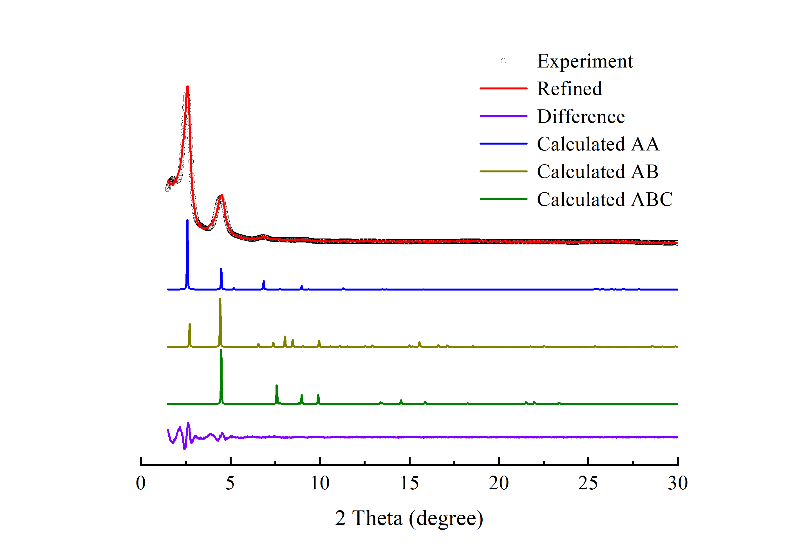
Supplementary Figure 1. PXRD patterns of JNM-7-AA with the experimental profiles in red, difference curve in purple, and calculated profiles of AA (blue), AB (yellow), and ABC (green).

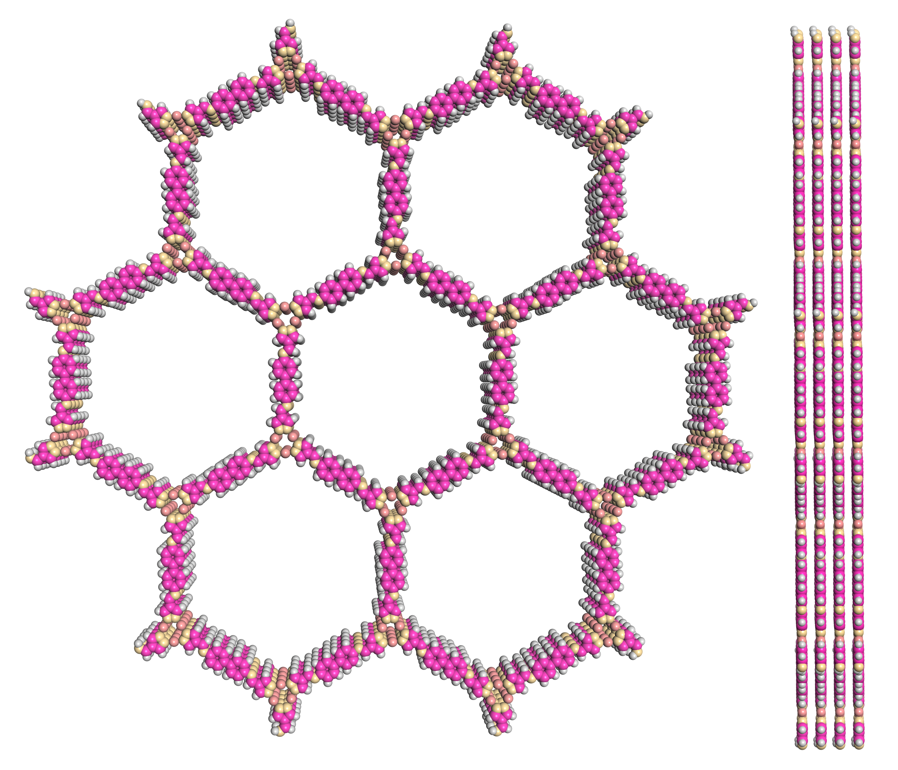
Supplementary Figure 2. Space-filling model of JNM-7-AA in AA stacking mode viewed from (left) c axis and (right) a axis.
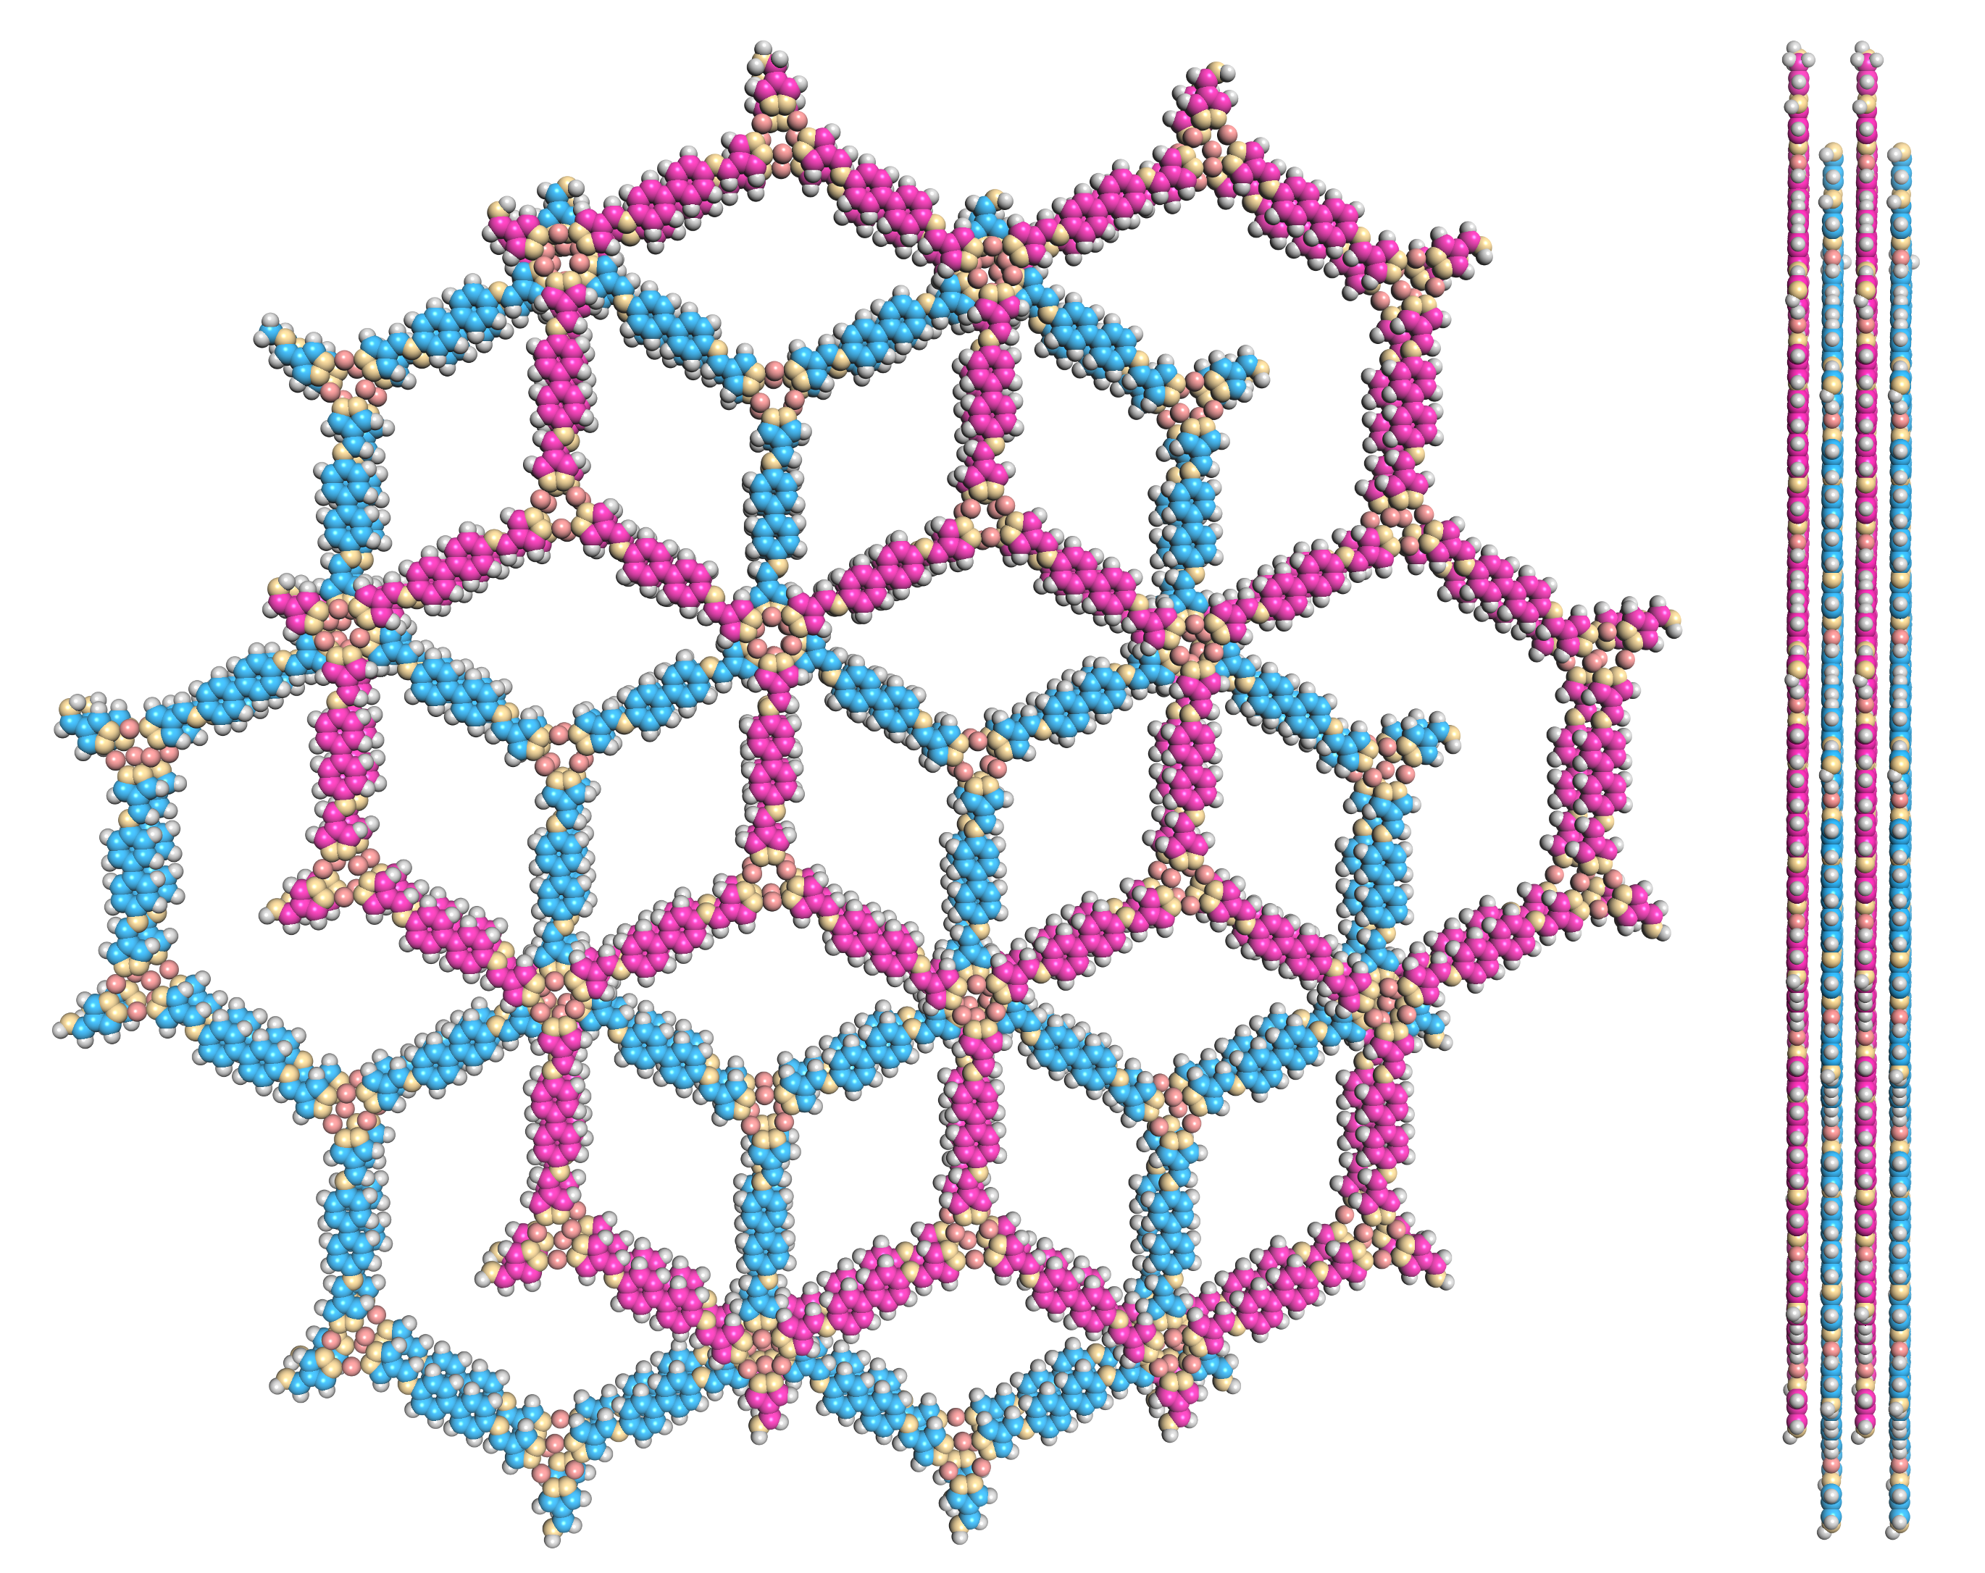
Supplementary Figure 3. Space-filling model of JNM-7-AB in AB stacking mode viewed from (left) c axis and (right) a axis.

Supplementary Table 1. Fractional atomic coordinates for JNM-7-AA.
JNM-7-AA
Space group symmetry: P6/M
a = b = 41.2260 Å; c = 3.5549 Å
α = β = 90.0000°; γ = 120.0000°
Atom name | Atom | x | y | z
N1 | N | 0.37985 | 0.74181 | 0.5
C2 | C | 0.41129 | 0.61368 | 0.5
C3 | C | 0.37241 | 0.59409 | 0.5
C4 | C | 0.43594 | 0.59767 | 0.5
C5 | C | 0.44512 | 0.54463 | 0.5
C6 | C | 0.48438 | 0.56609 | 0.5
C7 | C | 0.50589 | 0.54854 | 0.5
C8 | C | 0.4886 | 0.50931 | 0.5
C9 | C | 0.44932 | 0.48804 | 0.5
C10 | C | 0.42779 | 0.50557 | 0.5
N11 | N | 0.42226 | 0.56173 | 0.5
Cu12 | Cu | 0.31147 | 0.61267 | 0.5
N13 | N | 0.26222 | 0.60827 | 0.5
C14 | C | 0.22852 | 0.57694 | 0.5
H15 | H | 0.35657 | 0.56216 | 0.5
H16 | H | 0.4676 | 0.61708 | 0.5
H17 | H | 0.49884 | 0.59798 | 0.5
H18 | H | 0.53775 | 0.56623 | 0.5
H19 | H | 0.43469 | 0.45614 | 0.5
H20 | H | 0.39591 | 0.48801 | 0.5
H21 | H | 0.22268 | 0.54704 | 0.5

Supplementary Table 2. Fractional atomic coordinates for JNM-7-AB.
JNM-7-AB
Space group symmetry: P63/M
a = b = 41.2260 Å; c = 6.8000 Å
α = β = 90.0000°; γ = 120.0000°
Atom name | Atom | x | y | z
N1 | N | 0.71318 | 0.40847 | 0.25
C2 | C | 0.74462 | 0.28035 | 0.25
C3 | C | 0.70574 | 0.26076 | 0.25
C4 | C | 0.76927 | 0.26434 | 0.25
C5 | C | 0.77845 | 0.21129 | 0.25
C6 | C | 0.81772 | 0.23276 | 0.25
C7 | C | 0.83922 | 0.21521 | 0.25
C8 | C | 0.82193 | 0.17598 | 0.25
C9 | C | 0.78265 | 0.15471 | 0.25
C10 | C | 0.76112 | 0.17224 | 0.25
N11 | N | 0.75559 | 0.22839 | 0.25
Cu12 | Cu | 0.6448 | 0.27934 | 0.25
N13 | N | 0.59555 | 0.27493 | 0.25
C14 | C | 0.56186 | 0.2436 | 0.25
H15 | H | 0.6899 | 0.22883 | 0.25
H16 | H | 0.80094 | 0.28374 | 0.25
H17 | H | 0.83217 | 0.26464 | 0.25
H18 | H | 0.87109 | 0.23289 | 0.25
H19 | H | 0.76803 | 0.12281 | 0.25
H20 | H | 0.72925 | 0.15467 | 0.25
H21 | H | 0.55601 | 0.2137 | 0.25
N22 | N | 0.95349 | -0.07514 | 0.25
C23 | C | 0.92204 | 0.05298 | 0.25
C24 | C | 0.96092 | 0.07258 | 0.25
C25 | C | 0.89739 | 0.06899 | 0.25
C26 | C | 0.88822 | 0.12204 | 0.25
C27 | C | 0.84895 | 0.10058 | 0.25
C28 | C | 0.82745 | 0.11813 | 0.25
C29 | C | 0.84473 | 0.15736 | 0.25
C30 | C | 0.88402 | 0.17863 | 0.25
C31 | C | 0.90554 | 0.16109 | 0.25
N32 | N | 0.91108 | 0.10494 | 0.25
Cu33 | Cu | 1.02187 | 0.05399 | 0.25
N34 | N | 1.07112 | 0.0584 | 0.25
C35 | C | 1.10481 | 0.08973 | 0.25
H36 | H | 0.97676 | 0.10451 | 0.25
H37 | H | 0.86573 | 0.04959 | 0.25
H38 | H | 0.83449 | 0.06869 | 0.25
H39 | H | 0.79558 | 0.10044 | 0.25
H40 | H | 0.89864 | 0.21052 | 0.25
H41 | H | 0.93742 | 0.17866 | 0.25
H42 | H | 1.11066 | 0.11963 | 0.25

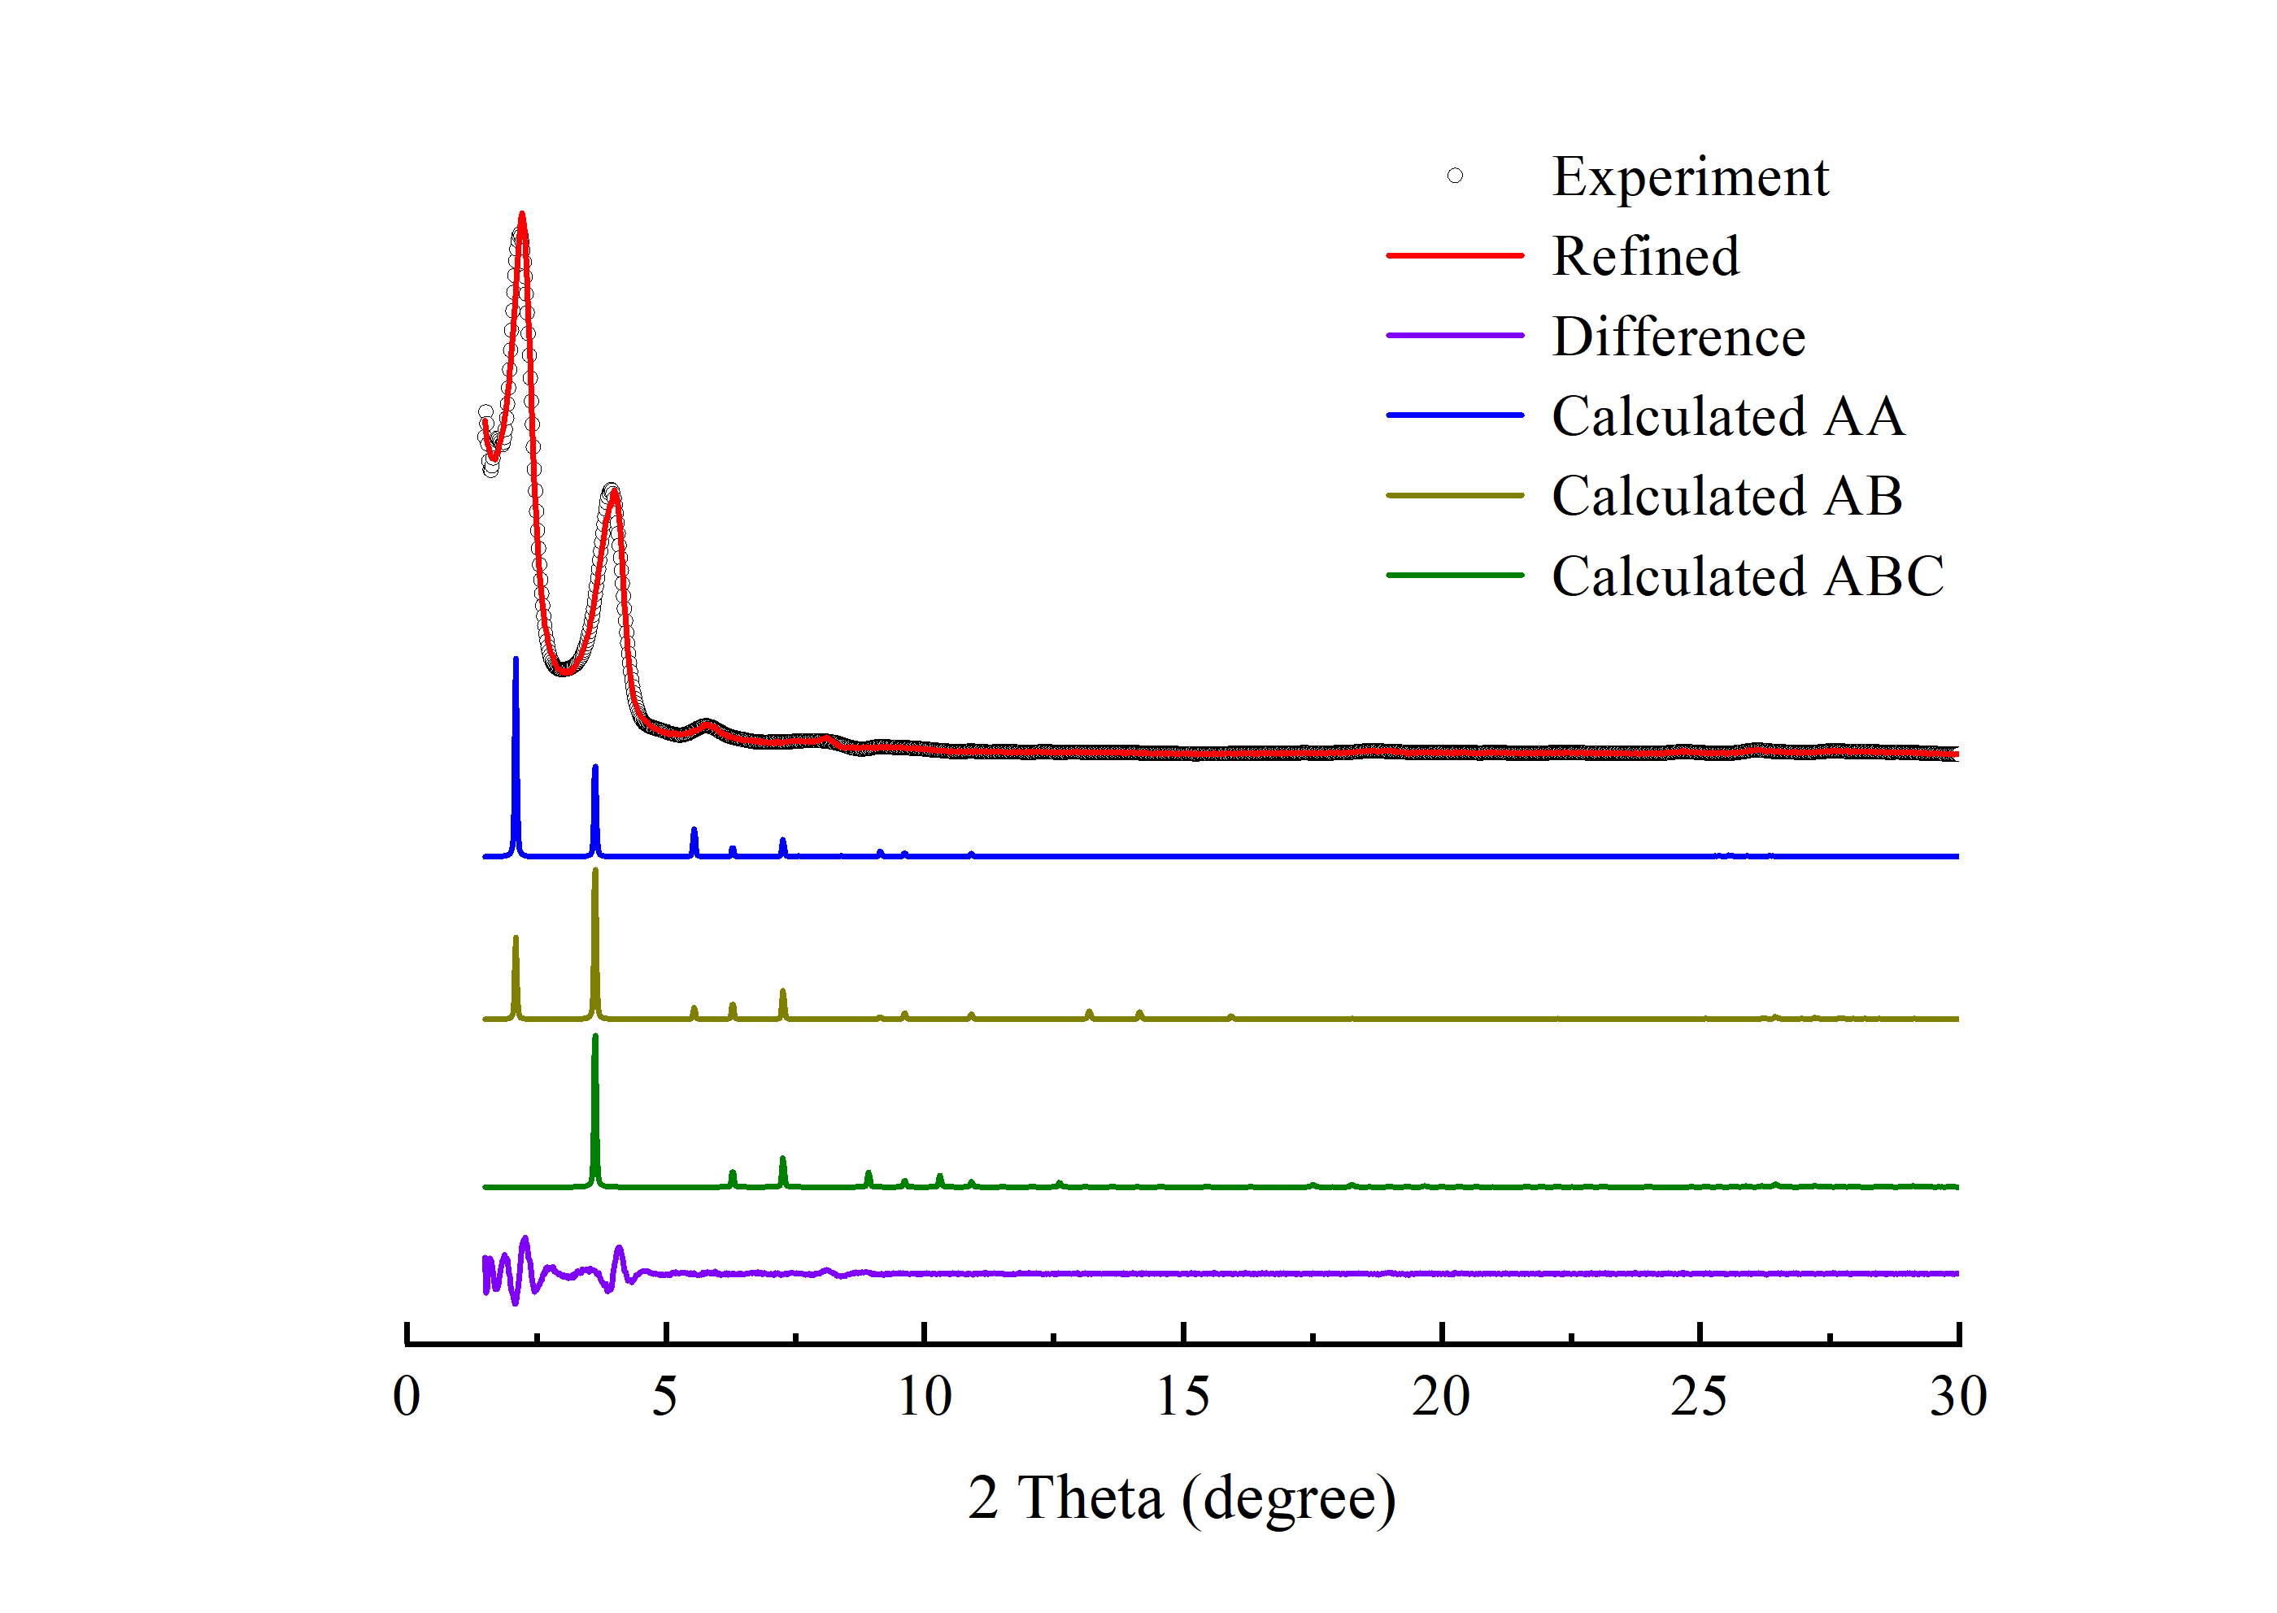
Supplementary Figure 4. PXRD patterns of JNM-8-AA with the experimental profiles in red, difference curve in purple, and calculated profiles of AA (blue), AB (yellow), and ABC (green).

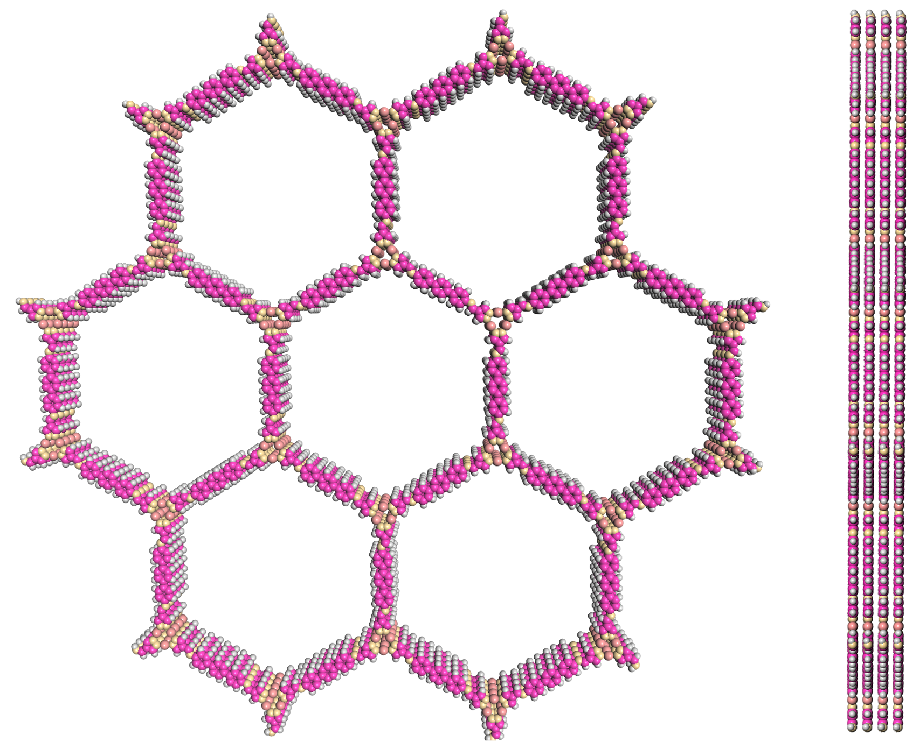
Supplementary Figure 5. Space-filling model of JNM-8-AA in AA stacking mode viewed from (left) c axis and (right) a axis.

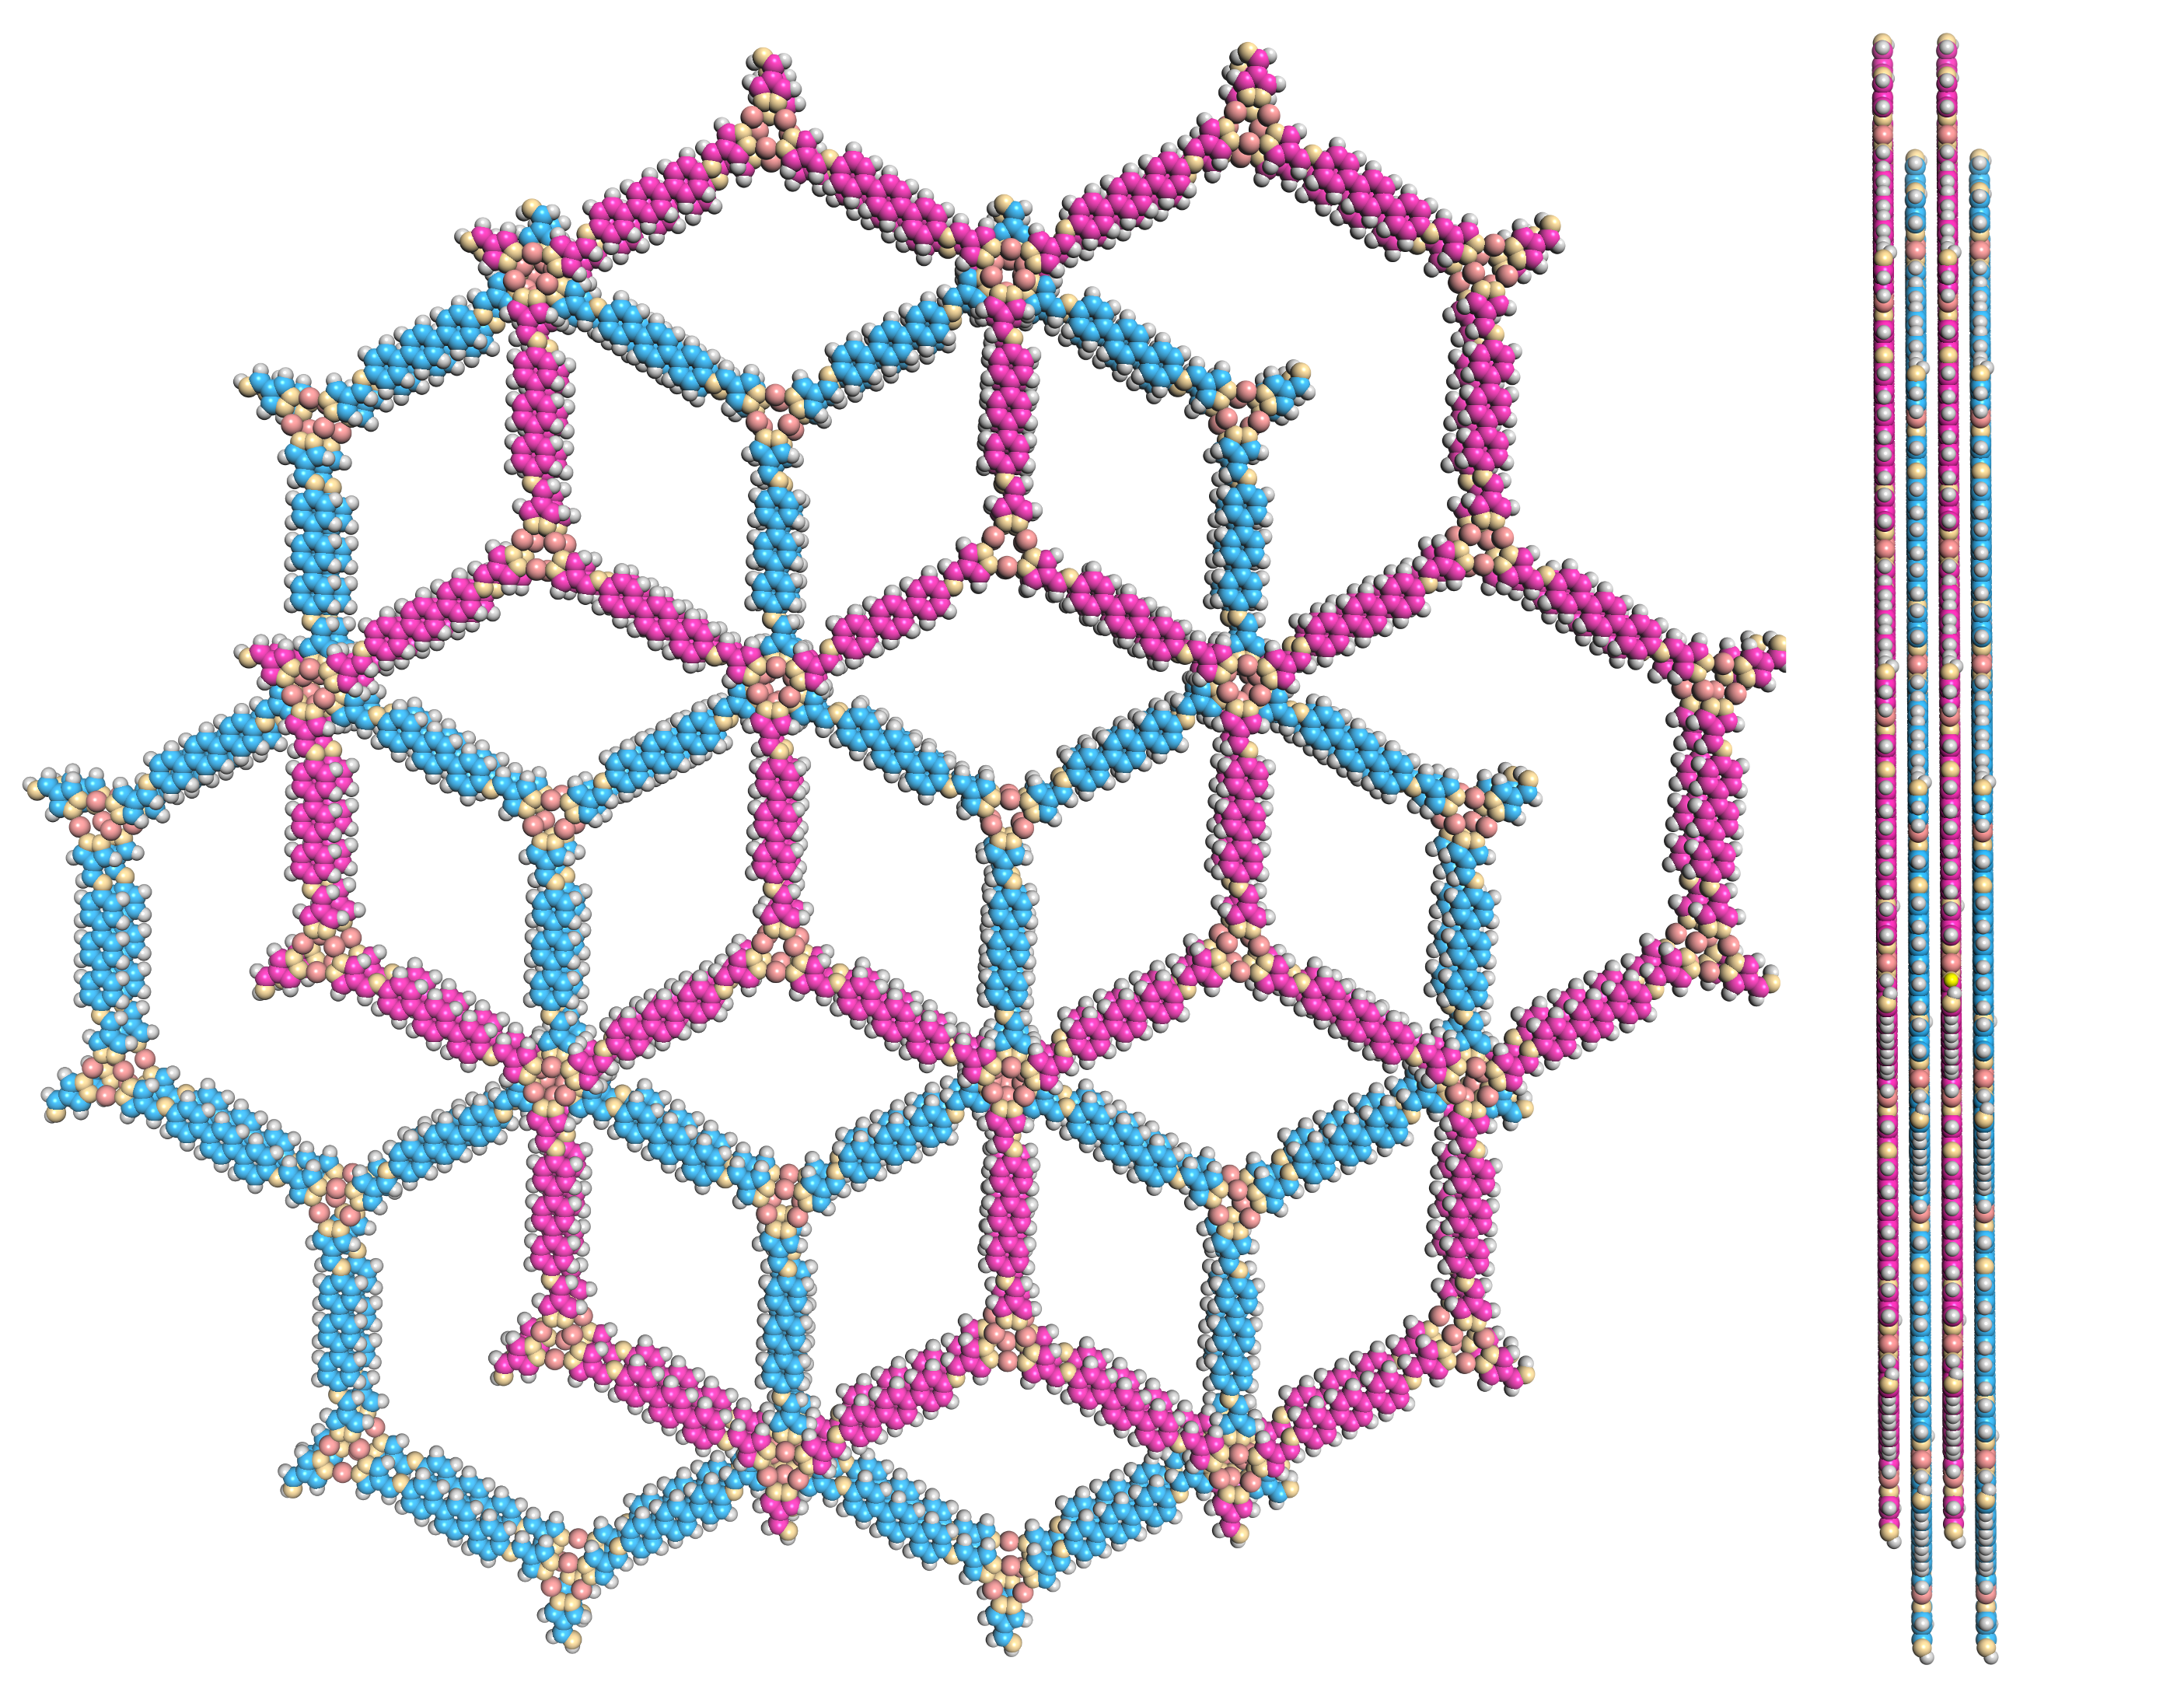
Supplementary Figure 6. Space-filling model of JNM-8-AB in AB stacking mode viewed from (left) c axis and (right) a axis.

Supplementary Table 3. Fractional atomic coordinates for JNM-8-AA.
JNM-8-AA
Space group symmetry: P6/M
a = b = 49.3206 Å; c = 3.5288 Å
α = β = 90.0000°; γ = 120.0000°
Atom name | Atom | x | y | z
C1 | C | 0.4038 | 0.62449 | 0.51482
C2 | C | 0.37141 | 0.60777 | 0.51476
N3 | N | 1.2717 | 0.61459 | 0.51453
N4 | N | 1.26727 | 0.6389 | 0.51459
C5 | C | 1.24374 | 0.58808 | 0.51461
C6 | C | 1.18679 | 0.57471 | 0.51481
N7 | N | 0.72829 | 0.38543 | 0.52537
N8 | N | 0.73273 | 0.36113 | 0.52529
C9 | C | 0.76364 | 0.37145 | 0.52489
C10 | C | 0.7793 | 0.40384 | 0.52469
C11 | C | 0.75624 | 0.41194 | 0.52507
C12 | C | 0.81321 | 0.42534 | 0.52418
C13 | C | 0.8659 | 0.43252 | 0.51973
C14 | C | 0.88265 | 0.41749 | 0.42471
C15 | C | 0.91535 | 0.43392 | 0.42253
C16 | C | 0.93206 | 0.46581 | 0.52068
C17 | C | 0.91521 | 0.4808 | 0.62169
C18 | C | 0.88249 | 0.46438 | 0.62176
C19 | C | 0.96687 | 0.48334 | 0.51927
C20 | C | 0.9838 | 0.46877 | 0.63404
C21 | C | 1.0165 | 0.48524 | 0.63261
C22 | C | 1.03313 | 0.51671 | 0.51656
C23 | C | 1.01621 | 0.53128 | 0.40176
C24 | C | 0.9835 | 0.51481 | 0.40312
C25 | C | 1.08481 | 0.51929 | 0.41439
C26 | C | 1.06794 | 0.53425 | 0.51557
C27 | C | 1.08463 | 0.56613 | 0.61446
C28 | C | 1.11734 | 0.58256 | 0.61296
C29 | C | 1.1341 | 0.56755 | 0.51788
C30 | C | 1.11753 | 0.5357 | 0.41496
N31 | N | 1.16771 | 0.58567 | 0.52056
N32 | N | 0.83229 | 0.41439 | 0.51785
Cu33 | Cu | 0.31543 | 0.61888 | 0.5145
Cu34 | Cu | 0.69656 | 0.31545 | 0.52546
H35 | H | 0.35647 | 0.58259 | 0.51481
H36 | H | 1.24046 | 0.56469 | 0.51458
H37 | H | 1.17833 | 0.54983 | 0.51799
H38 | H | 0.77389 | 0.35652 | 0.52471
H39 | H | 0.7595 | 0.43533 | 0.52497
H40 | H | 0.82165 | 0.45022 | 0.52101
H41 | H | 0.87024 | 0.39296 | 0.34684
H42 | H | 0.92751 | 0.42173 | 0.33737
H43 | H | 0.9273 | 0.50509 | 0.70906
H44 | H | 0.87053 | 0.47663 | 0.71039
H45 | H | 0.97179 | 0.44481 | 0.73389
H46 | H | 1.02876 | 0.4735 | 0.73122
H47 | H | 1.02822 | 0.55525 | 0.30209
H48 | H | 0.97125 | 0.52656 | 0.30451
H49 | H | 1.07272 | 0.49501 | 0.3264
H50 | H | 1.07246 | 0.57829 | 0.69973
H51 | H | 1.12973 | 0.60707 | 0.69145
H52 | H | 1.1295 | 0.52348 | 0.3261

Supplementary Table 4. Fractional atomic coordinates for JNM-8-AB.
JNM-8-AB
Space group symmetry: P63/M
a = 48.6500 Å; b = 48.6500 Å; c = 6.7975 Å
α = β = 90.0000°; γ = 120.0000°
Atom name | Atom | x | y | z
C1 | C | 0.73189 | 1.28755 | 0.25
C2 | C | 0.69896 | 1.27121 | 0.25
N3 | N | 0.60623 | 1.28424 | 0.25
N4 | N | 0.6031 | 1.30962 | 0.25
C5 | C | 0.57757 | 1.25786 | 0.25
C6 | C | 0.52118 | 1.24748 | 0.25
N7 | N | 1.06043 | 1.0491 | 0.25
N8 | N | 1.06356 | 1.02371 | 0.25
C9 | C | 1.09442 | 1.03229 | 0.25
C10 | C | 1.11101 | 1.06522 | 0.25
C11 | C | 1.08909 | 1.07547 | 0.25
C12 | C | 1.14548 | 1.08585 | 0.25
C13 | C | 1.19799 | 1.09312 | 0.25
C14 | C | 1.21615 | 1.07818 | 0.25
C15 | C | 1.24925 | 1.09617 | 0.25
C16 | C | 1.26476 | 1.12945 | 0.25
C17 | C | 1.24643 | 1.14436 | 0.25
C18 | C | 1.21333 | 1.1264 | 0.25
C19 | C | 1.29986 | 1.1485 | 0.25
C20 | C | 1.3182 | 1.13361 | 0.25
C21 | C | 0.35129 | 1.15157 | 0.25
C22 | C | 0.3668 | 1.18483 | 0.25
C23 | C | 0.34847 | 1.19972 | 0.25
C24 | C | 1.31538 | 1.18176 | 0.25
C25 | C | 0.42024 | 1.18897 | 0.25
C26 | C | 0.4019 | 1.20388 | 0.25
C27 | C | 0.41742 | 1.23716 | 0.25
C28 | C | 0.45052 | 1.25515 | 0.25
C29 | C | 0.46868 | 1.24021 | 0.25
C30 | C | 0.45333 | 1.20694 | 0.25
N31 | N | 0.50254 | 1.25932 | 0.25
N32 | N | 1.16412 | 1.07401 | 0.25
Cu33 | Cu | 0.64777 | 1.28756 | 0.25
Cu34 | Cu | 1.02688 | 0.9811 | 0.25
H35 | H | 0.68268 | 1.24457 | 0.25
H36 | H | 0.57238 | 1.23245 | 0.25
H37 | H | 0.51057 | 1.22062 | 0.25
H38 | H | 1.10477 | 1.01601 | 0.25
H39 | H | 1.09428 | 1.10089 | 0.25
H40 | H | 1.15609 | 1.11271 | 0.25
H41 | H | 1.20388 | 1.05116 | 0.25
H42 | H | 1.26381 | 1.0837 | 0.25
H43 | H | 1.25854 | 1.17137 | 0.25
H44 | H | 1.19866 | 1.13875 | 0.25
H45 | H | 1.30609 | 1.1066 | 0.25
H46 | H | 0.36596 | 1.13921 | 0.25
H47 | H | 0.36057 | 1.22673 | 0.25
H48 | H | 1.30071 | 1.19412 | 0.25
H49 | H | 0.40813 | 1.16196 | 0.25
H50 | H | 0.40286 | 1.24964 | 0.25
H51 | H | 0.46279 | 1.28217 | 0.25
H52 | H | 0.468 | 1.19458 | 0.25

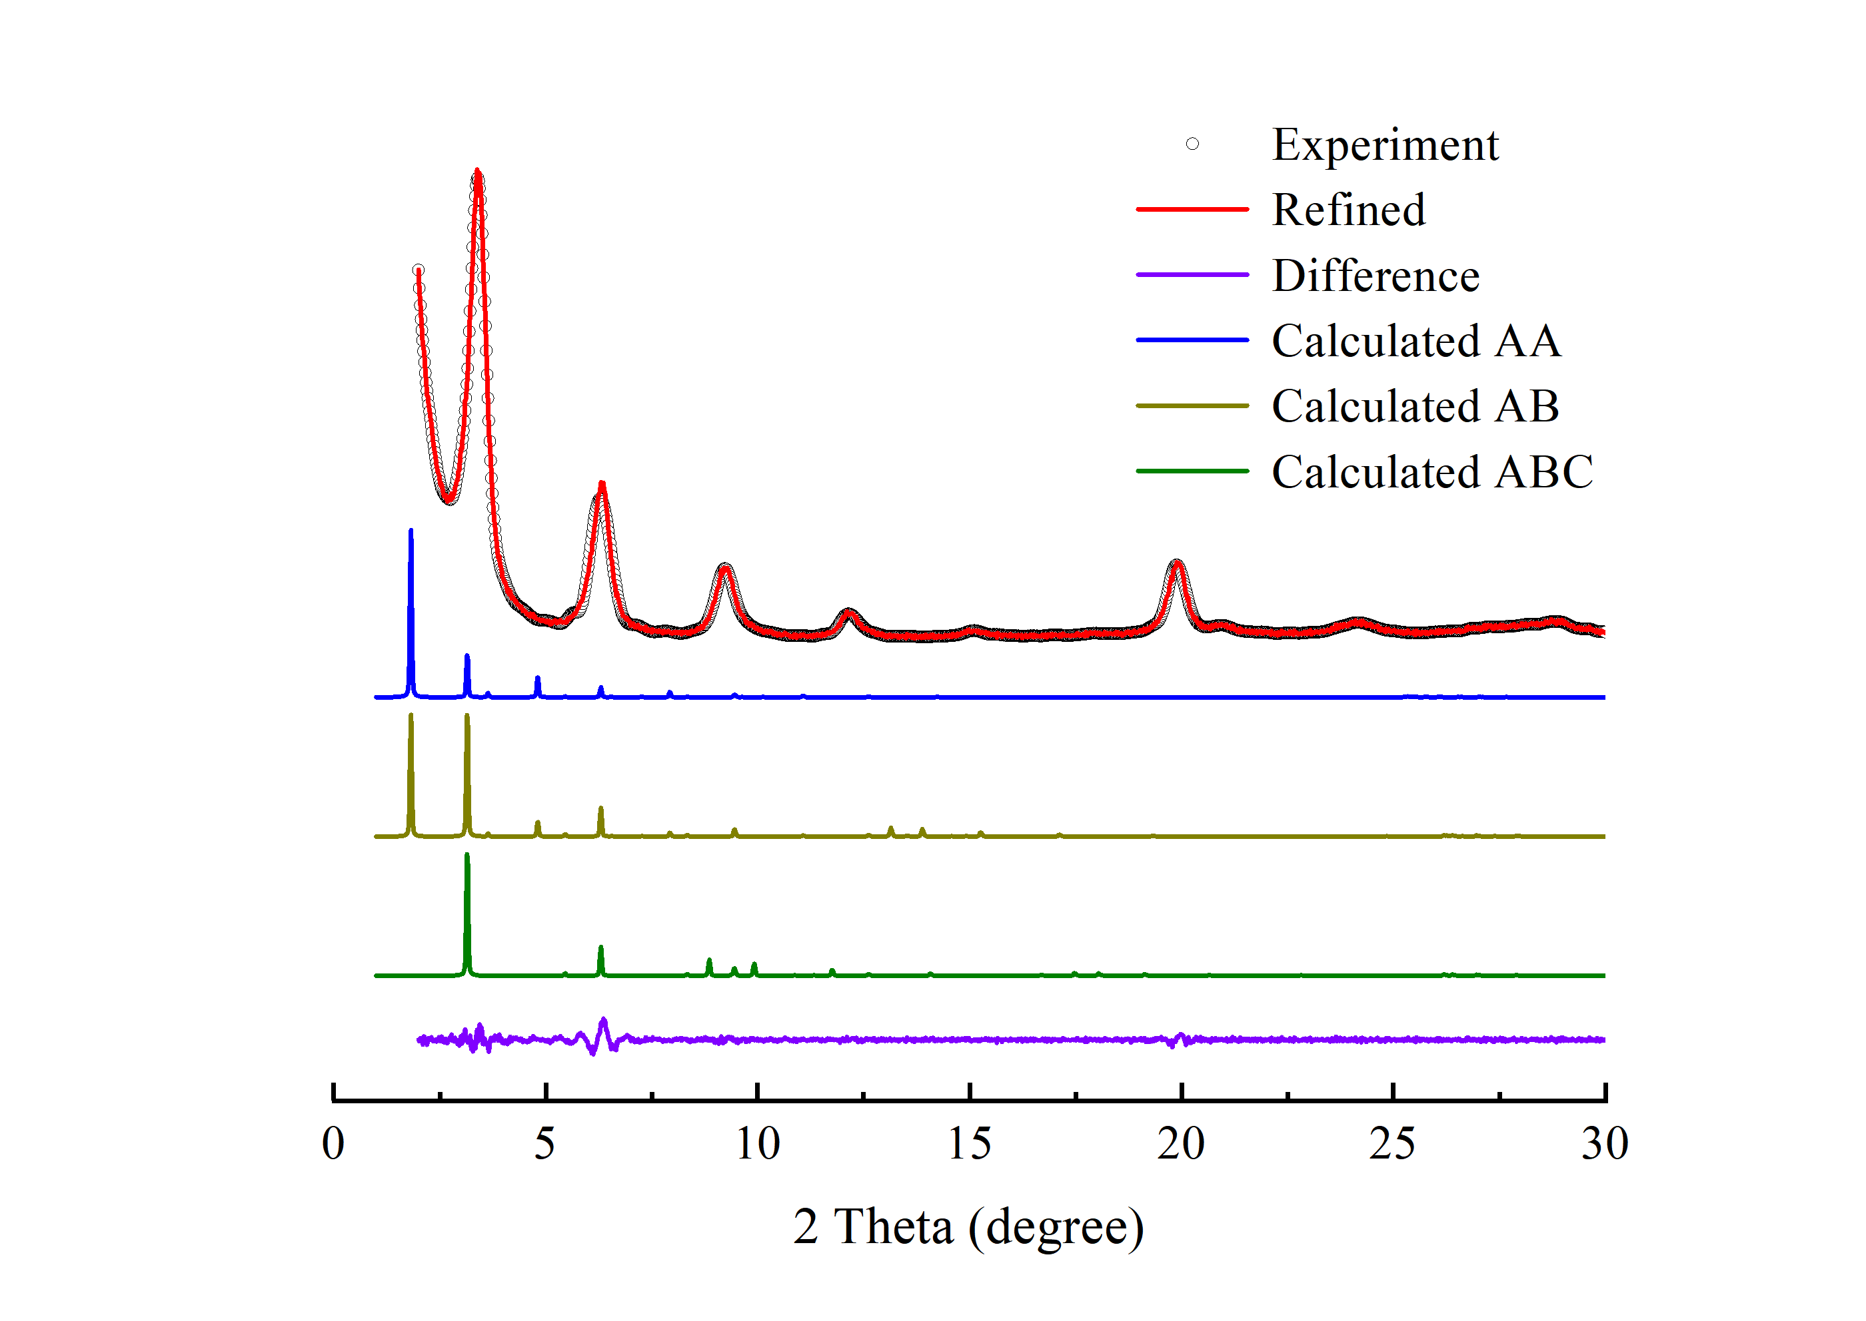
Supplementary Figure 7. PXRD patterns of JNM-9-ABC with the experimental profiles in red, difference curve in purple, and calculated profiles of AA (blue), AB (yellow), and ABC (green).

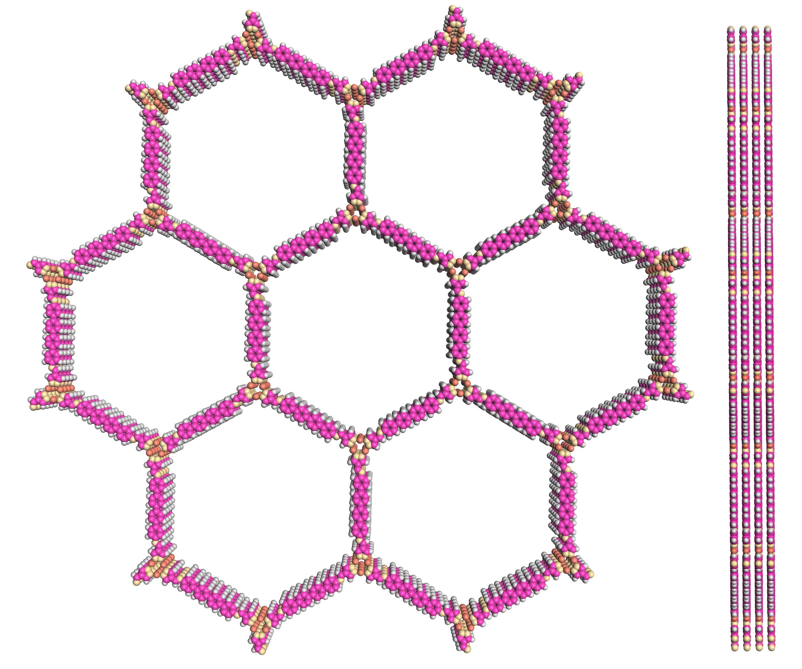
Supplementary Figure 8. Space-filling model of JNM-9-AA in AA stacking mode viewed from (left) c axis and (right) a axis.
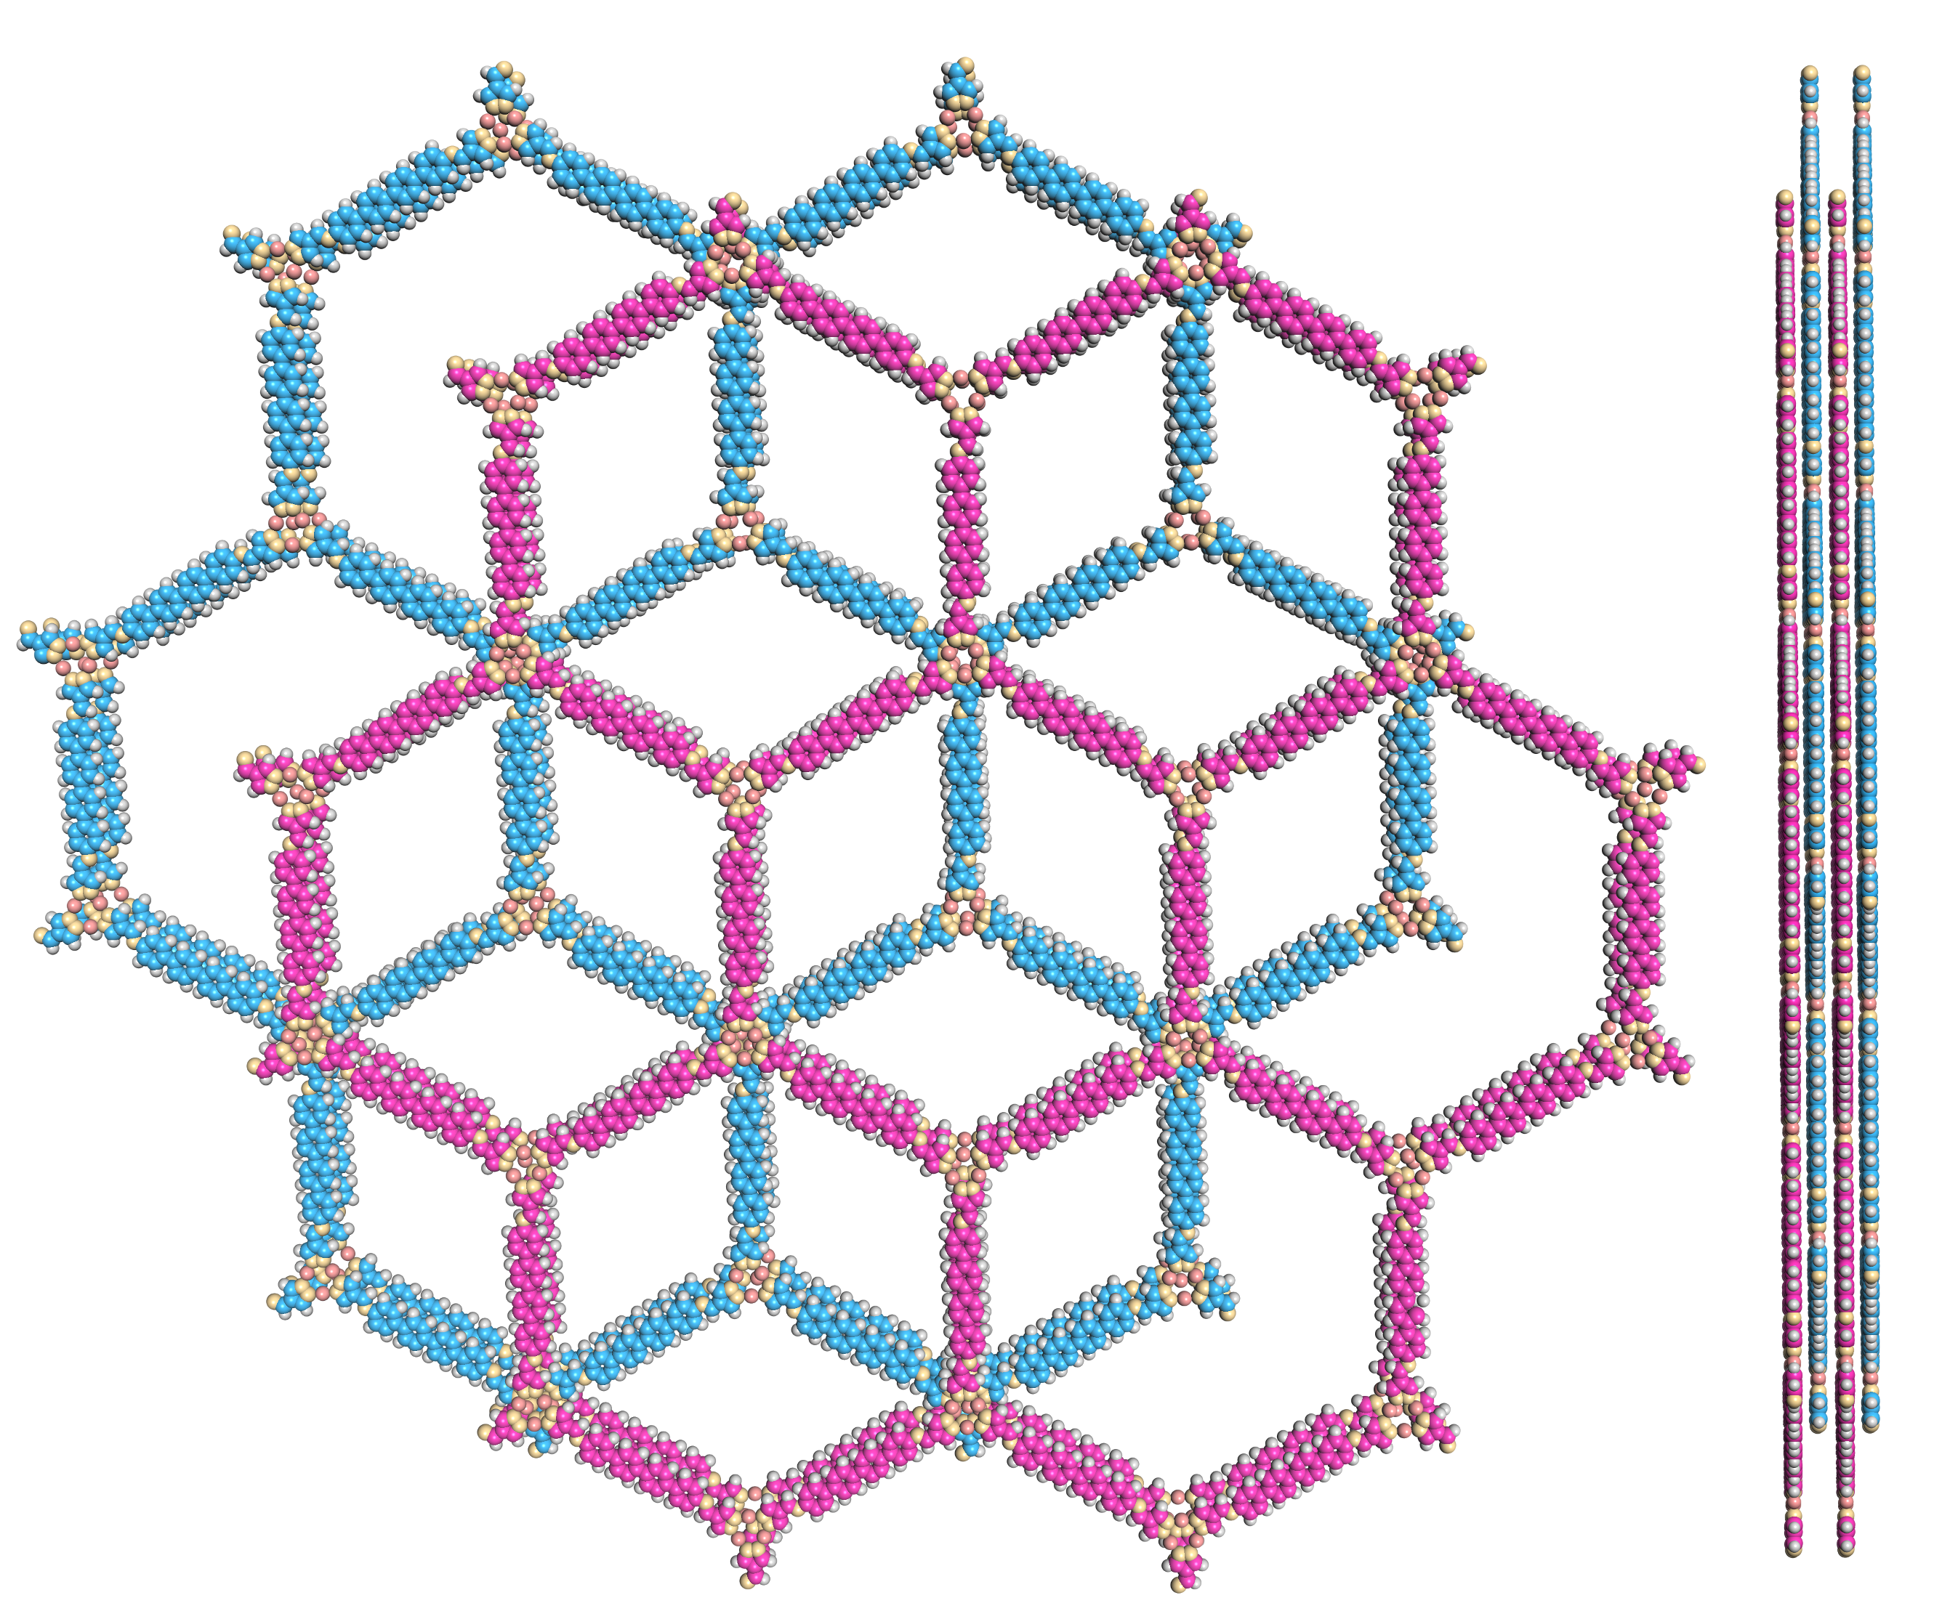
Supplementary Figure 9. Space-filling model of JNM-9-AB in AB stacking mode viewed from (left) c axis and (right) a axis.
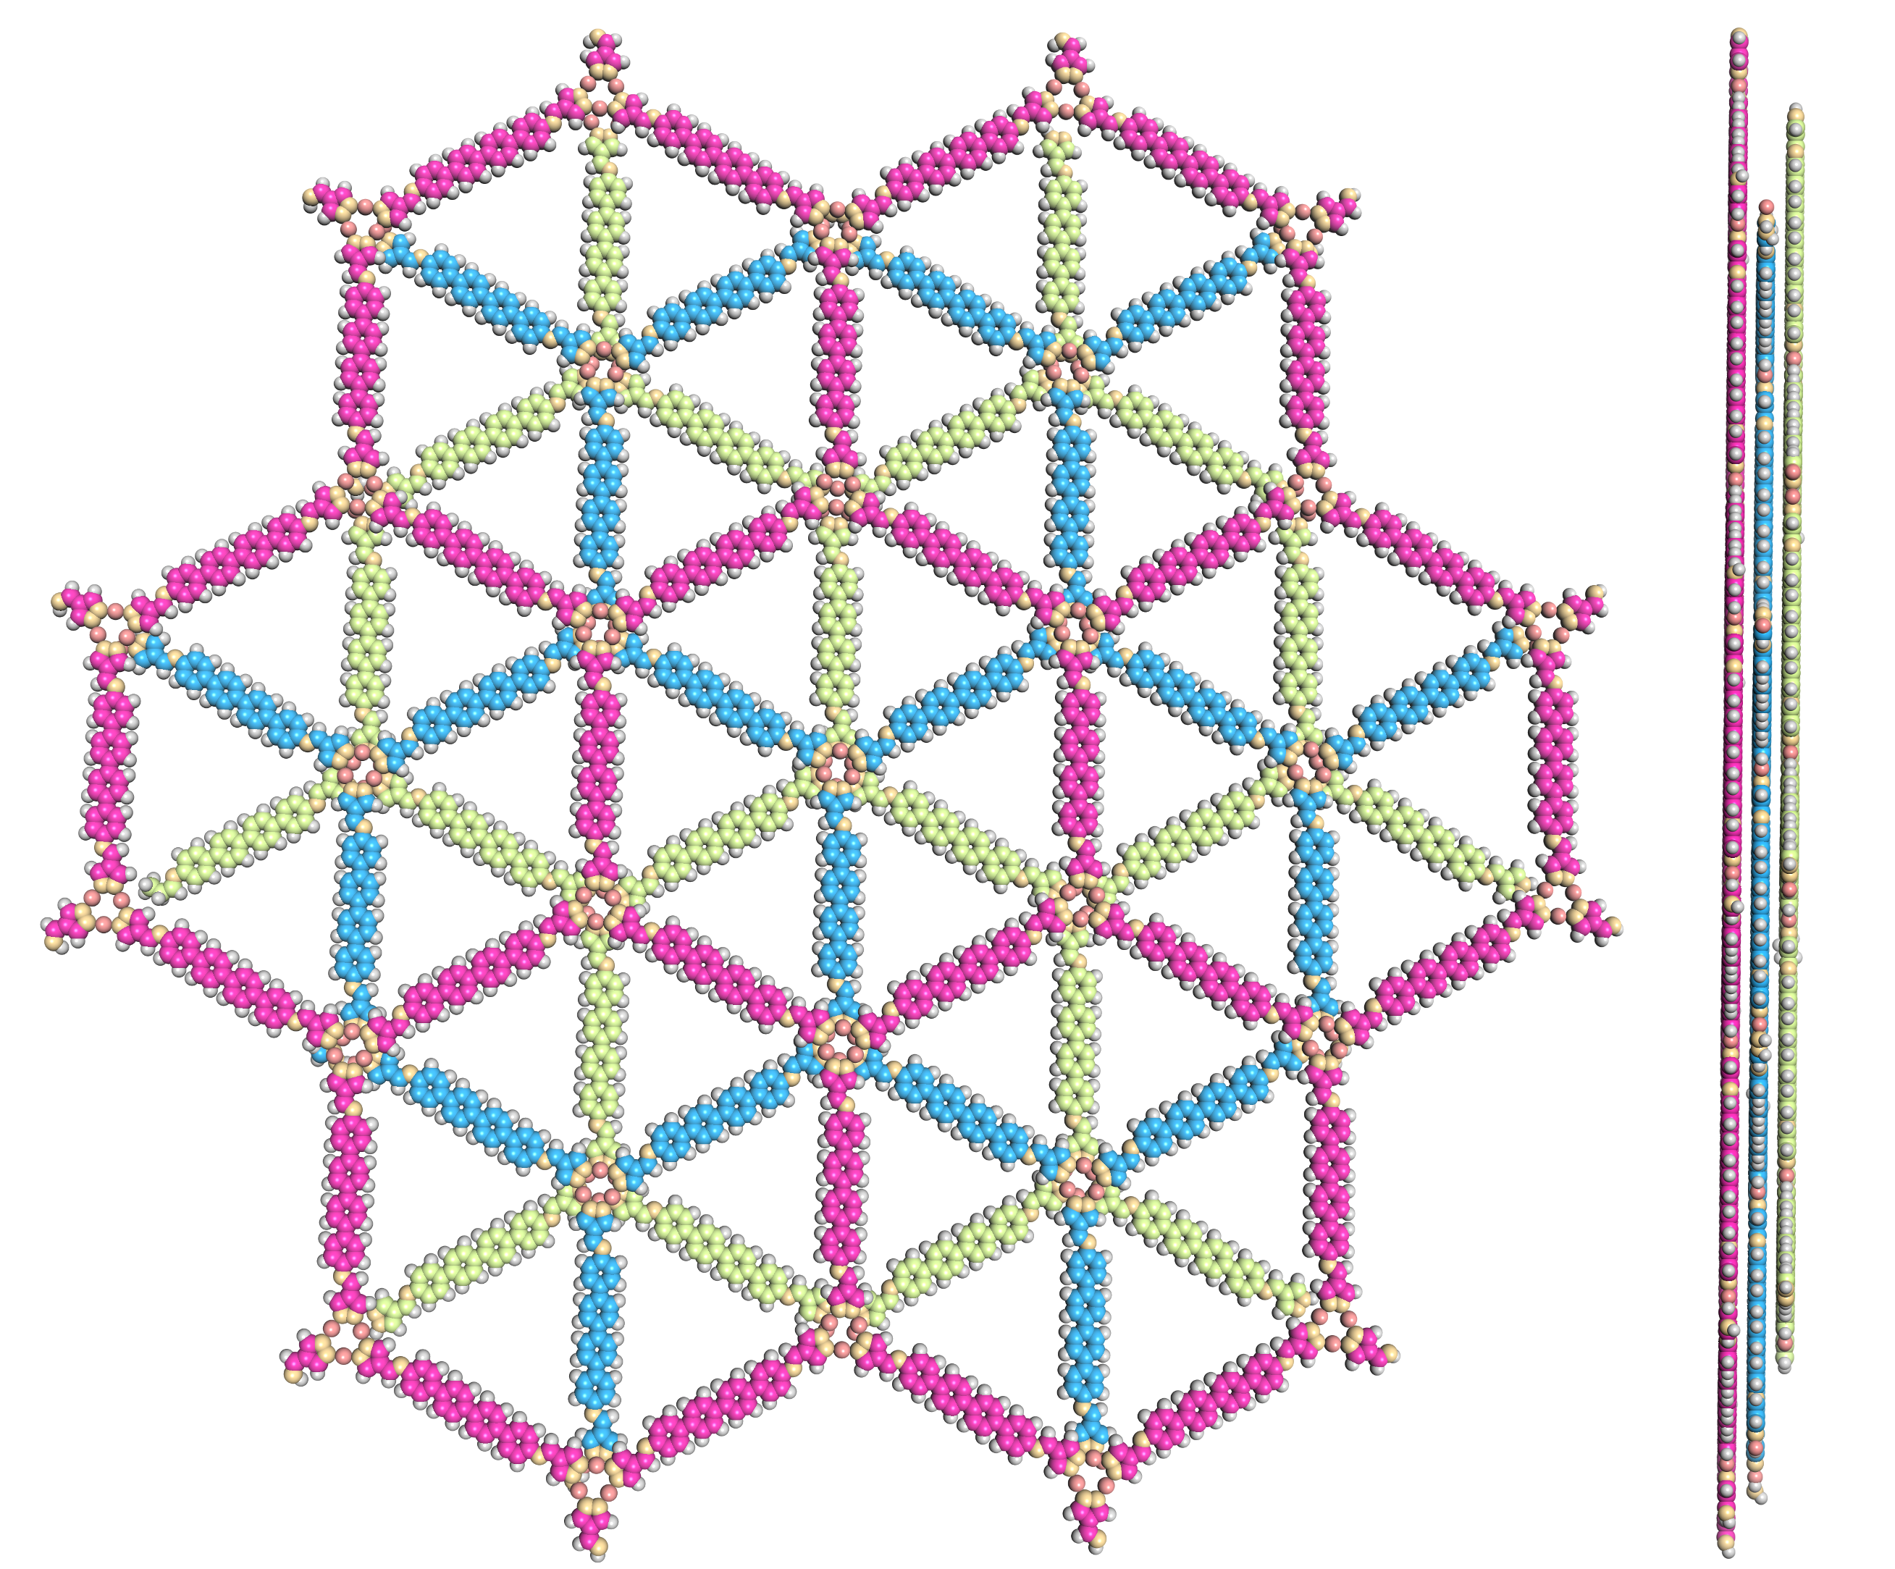
Supplementary Figure 10. Space-filling model of JNM-9-ABC in ABC stacking mode viewed from (left) c axis and (right) a axis.

Supplementary Table 5. Fractional atomic coordinates for JNM-9-AA.
JNM-9-AA
Space group symmetry: P6/M
a = b = 56.1215 Å; c = 3.5215 Å
α = β = 90.0000°; γ = 120.0000°
Atom name | Atom | x | y | z
Cu1 | Cu | 0.37306 | 0.68976 | -0.5
C2 | C | 0.38938 | 0.62638 | -0.5
C3 | C | 0.40711 | 0.61419 | -0.5
N4 | N | 0.62432 | 0.34352 | -0.5
C5 | C | 0.46064 | 0.53393 | -0.5
C6 | C | 0.44755 | 0.5051 | -0.5
C7 | C | 0.44429 | 0.54803 | -0.5
C8 | C | 0.39997 | 0.54606 | -0.5
N9 | N | 0.39668 | 0.58774 | -0.5
N10 | N | 0.27826 | 0.64644 | -0.5
C11 | C | -0.25587 | 0.39845 | -0.5
C12 | C | 0.38763 | 0.74845 | -0.5
C13 | C | 0.49181 | 1.02884 | -0.5
C14 | C | 0.50705 | 1.01522 | -0.5
C15 | C | 0.53588 | 1.03097 | -0.5
C16 | C | 0.54917 | 1.05967 | -0.5
C17 | C | 0.42313 | 0.88051 | -0.5
C18 | C | 0.40984 | 0.8518 | -0.5
C19 | C | 0.42523 | 0.83833 | -0.5
C20 | C | 0.46722 | 0.88263 | -0.5
H21 | H | 0.58931 | 0.24271 | 0.5
H22 | H | 0.49231 | 0.06818 | 0.5
H23 | H | 0.46838 | 0.01636 | 0.5
H24 | H | 0.54867 | 0.02034 | 0.5
H25 | H | 0.5726 | 0.07226 | 0.5
H26 | H | 0.50934 | 0.10499 | 0.5
H27 | H | 0.53346 | 0.15692 | 0.5
H28 | H | 0.61359 | 0.16074 | 0.5
H29 | H | 0.58956 | 0.10875 | 0.5
H30 | H | 0.43044 | 0.62802 | 0.5
H31 | H | 0.32825 | 0.74878 | 0.5

Supplementary Table 6. Fractional atomic coordinates for JNM-9-AB.
JNM-9-AB
Space group symmetry: P63/M
a = b = 56.1215 Å; c = 6.8003 Å
α = β = 90.0000°; γ = 120.0000°
Atom name | Atom | x | y | z
Cu1 | Cu | -0.29361 | 0.35643 | 0.25
C2 | C | -0.27729 | 0.29305 | 0.25
C3 | C | -0.25955 | 0.28086 | 0.25
N4 | N | -0.04234 | 0.01019 | 0.25
C5 | C | -0.20603 | 0.2006 | 0.25
C6 | C | -0.21911 | 0.17177 | 0.25
C7 | C | -0.22238 | 0.2147 | 0.25
C8 | C | -0.26669 | 0.21272 | 0.25
N9 | N | -0.26998 | 0.2544 | 0.25
N10 | N | -0.3884 | 0.31311 | 0.25
C11 | C | 0.09633 | 0.05605 | 0.25
C12 | C | 0.07747 | 0.06512 | 0.25
C13 | C | 0.12625 | 0.07378 | 0.25
C14 | C | -0.27904 | 0.41512 | 0.25
N15 | N | -0.32314 | 0.38587 | 0.25
C16 | C | -0.32098 | 0.4108 | 0.25
C17 | C | -0.05429 | -0.08178 | 0.25
N18 | N | -0.03484 | -0.05507 | 0.25
C19 | C | -0.13274 | -0.26004 | 0.25
C20 | C | -0.16156 | -0.27578 | 0.25
C21 | C | -0.17485 | -0.30449 | 0.25
C22 | C | -0.15962 | -0.31811 | 0.25
C23 | C | -0.13079 | -0.30237 | 0.25
C24 | C | -0.1175 | -0.27366 | 0.25
C25 | C | -0.17371 | 0.65144 | 0.25
C26 | C | -0.20254 | 0.6357 | 0.25
C27 | C | -0.15848 | 0.63782 | 0.25
C28 | C | -0.21583 | 0.60699 | 0.25
C29 | C | -0.24354 | 0.54718 | 0.25
C30 | C | -0.25682 | 0.51847 | 0.25
C31 | C | -0.24143 | 0.505 | 0.25
C32 | C | -0.19945 | 0.5493 | 0.25
C33 | C | -0.11864 | -0.22959 | 0.25
C34 | C | -0.13389 | -0.21597 | 0.25
C35 | C | -0.12061 | -0.18725 | 0.25
C36 | C | -0.0919 | -0.17166 | 0.25
C37 | C | -0.07651 | -0.18514 | 0.25
C38 | C | -0.0898 | -0.21385 | 0.25
N39 | N | -0.07893 | -0.14228 | 0.25
Cu40 | Cu | 0.01663 | 0.03972 | 0.25
H41 | H | -0.23623 | 0.29468 | 0.25
H42 | H | -0.24253 | 0.15898 | 0.25
H43 | H | -0.29013 | 0.20012 | 0.25
H44 | H | 0.08212 | 0.0872 | 0.25
H45 | H | 0.13575 | 0.0971 | 0.25
H46 | H | -0.25597 | 0.42395 | 0.25
H47 | H | -0.33841 | 0.41545 | 0.25
H48 | H | -0.07736 | -0.09062 | 0.25
H49 | H | -0.17435 | -0.26515 | 0.25
H50 | H | -0.19829 | -0.31697 | 0.25
H51 | H | -0.118 | -0.313 | 0.25
H52 | H | -0.09407 | -0.26108 | 0.25
H53 | H | -0.21533 | 0.64633 | 0.25
H54 | H | -0.13504 | 0.6503 | 0.25
H55 | H | -0.23927 | 0.59441 | 0.25
H56 | H | -0.25623 | 0.55792 | 0.25
H57 | H | -0.28026 | 0.50593 | 0.25
H58 | H | -0.176 | 0.56168 | 0.25
H59 | H | -0.15733 | -0.22835 | 0.25
H60 | H | -0.13321 | -0.17642 | 0.25
H61 | H | -0.05307 | -0.17259 | 0.25
H62 | H | -0.07711 | -0.22459 | 0.25

Supplementary Table 7. Fractional atomic coordinates for JNM-9-ABC.
JNM-9-ABC
Space group symmetry: R3
a = b = 56.1215 Å; c = 10.2004 Å
α = β = 90.0000°; γ = 120.0000°
Atom name | Atom | x | y | z
Cu1 | Cu | -0.37306 | -0.68976 | 0.00001
C2 | C | -0.38938 | -0.62638 | 0.00001
C3 | C | -0.40711 | -0.61419 | 0
N4 | N | -0.62432 | -0.34352 | -0.00001
C5 | C | -0.46064 | -0.53393 | 0
C6 | C | -0.44755 | -0.5051 | 0
C7 | C | -0.44429 | -0.54803 | 0
C8 | C | -0.39997 | -0.54606 | 0
N9 | N | -0.39668 | -0.58774 | 0
N10 | N | -0.27826 | -0.64644 | 0.00001
C11 | C | -0.74413 | -0.39845 | -0.00001
C12 | C | -0.38763 | -0.74845 | 0.00001
C13 | C | -0.49181 | -0.02884 | 0
C14 | C | -0.50705 | -0.01522 | 0
C15 | C | -0.53588 | -0.03097 | 0
C16 | C | -0.54917 | -0.05967 | 0
C17 | C | -0.42313 | -0.88051 | 0
C18 | C | -0.40984 | -0.8518 | 0
C19 | C | -0.42523 | -0.83833 | 0
C20 | C | -0.46722 | -0.88263 | 0
H21 | H | -0.43044 | -0.62802 | 0
H22 | H | -0.42413 | -0.49231 | 0
H23 | H | -0.37654 | -0.53346 | 0
H24 | H | -0.74878 | -0.42053 | -0.00001
H25 | H | -0.41069 | -0.75729 | 0.00001
H26 | H | -0.46838 | -0.01636 | 0
H27 | H | -0.54867 | -0.02034 | 0
H28 | H | -0.5726 | -0.07226 | 0
H29 | H | -0.41044 | -0.89125 | 0
H30 | H | -0.38641 | -0.83926 | 0
H31 | H | -0.49066 | -0.89501 | 0

3.2 Energy Dispersive X-ray Spectroscopy (EDS)
Supplementary Figure 11. EDS of JNM-7-AA. (a) SEM photo of JNM-7-AA; Element mapping of (b) C: Red; (c) C: Green; (d) N: Purple.

Supplementary Figure 12. EDS of JNM-8-AA. (a) SEM photo of JNM-8-AA; Element mapping of (b) C: Red; (c) C: Green; (d) N: Purple.

Supplementary Figure 13. EDS of JNM-9-ABC. (a) SEM photo of JNM-9-ABC; Element mapping of (b) C: Red; (c) C: Green; (d) N: Purple.

3.3 Gas adsorption isotherms and pore size distribution of JNM-9-ABC.
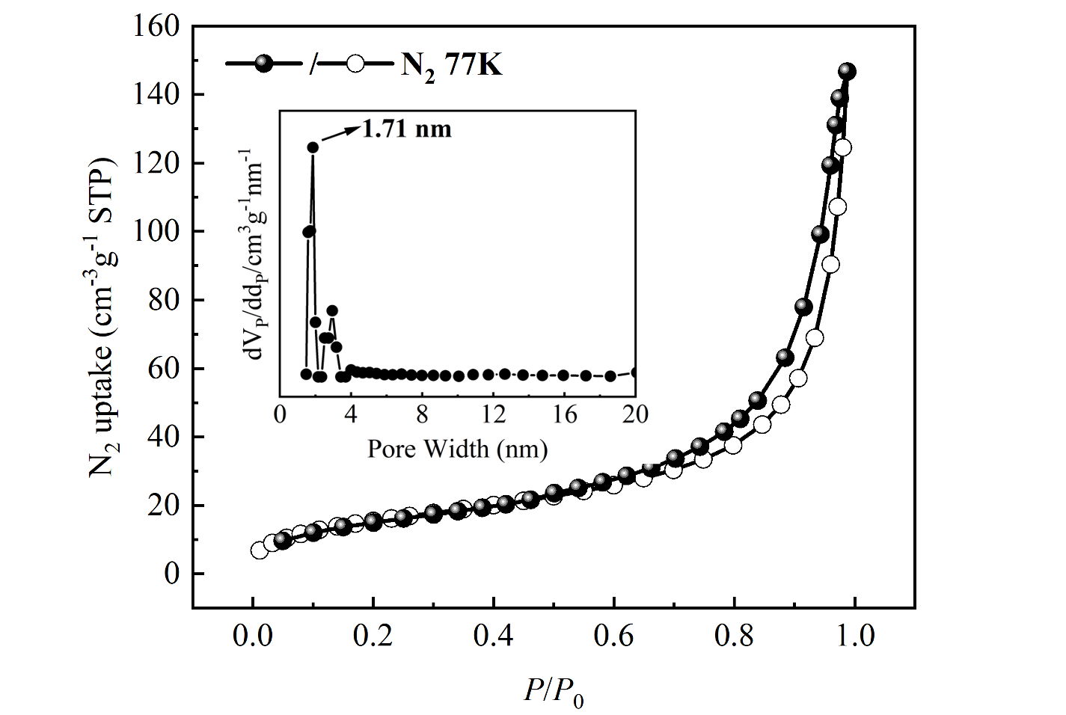
Supplementary Figure 14. N₂ adsorption-desorption isotherms and pore size distribution profiles of JNM-9-ABC.

4. Structure reversible transformation

4.1 Experimental procedures
Structure transformation from AA to ABC. To a 10 mL Schlenk tube, pristine sample of JNM-7-AA (50 mg) or JNM-8-AA (50 mg) and 5 mL DMF was added. The resulted mixture was stirred at 80 °C for 10 h, and then the solid was isolated by filtration, washed and solvent exchanged with EtOH and acetone several times. Resulted powder was dried under vacuum at room temperature for 3 h. Finally, the pale-yellow powders JNM-7-ABC or JNM-8-ABC were obtained. JNM-7-ABC IR (KBr): ν = 1669 (m), 1624 (s), 1594 (m), 1543 (m), 1489 (s), 1406 (w), 1376 (w), 1306 (w), 1241 (m), 1202 (s), 1241 (m), 1056cm⁻¹ (m). JNM-8-ABC IR (KBr): ν = 1669 (m), 1625 (s), 1589 (m), 1532 (m), 1484 (s), 1404 (w), 1376 (w), 1320 (w), 1201 (s), 1175 (w), 1056 cm⁻¹ (m).
Structure transformation from ABC to AA. JNM-7-ABC (20 mg) or JNM-8-ABC (20 mg), 0.5 mL of 1,2-dichlorobenzene, 0.5 mL of 1-butanol, and 0.1 mL of TFA (6 M) were added a 10 mL Schlenk tube. The resulted mixture was stirred at 80 °C for 10 h, and then the solid was isolated by filtration, washed and solvent exchanged with EtOH and acetone for several times. Resulted powder was dried under vacuum at room temperature for 3 h. Finally, the brown powder JNM-7-AA or JNM-8-AA with similar diffraction peaks to AA simulation were obtained.

4.2 Structural simulation for JNM-7-ABC and JNM-8-ABC
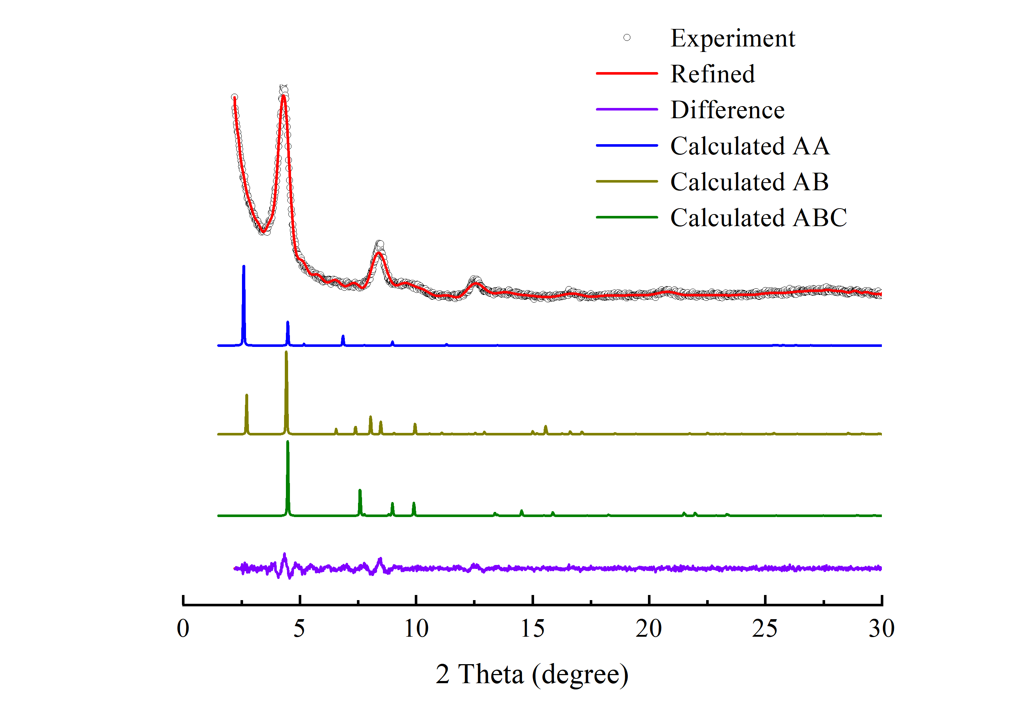
Supplementary Figure 15. PXRD patterns of JNM-7-ABC with the experimental profiles in red, difference curve in purple, and calculated profiles of AA (blue), AB (yellow), and ABC (green).
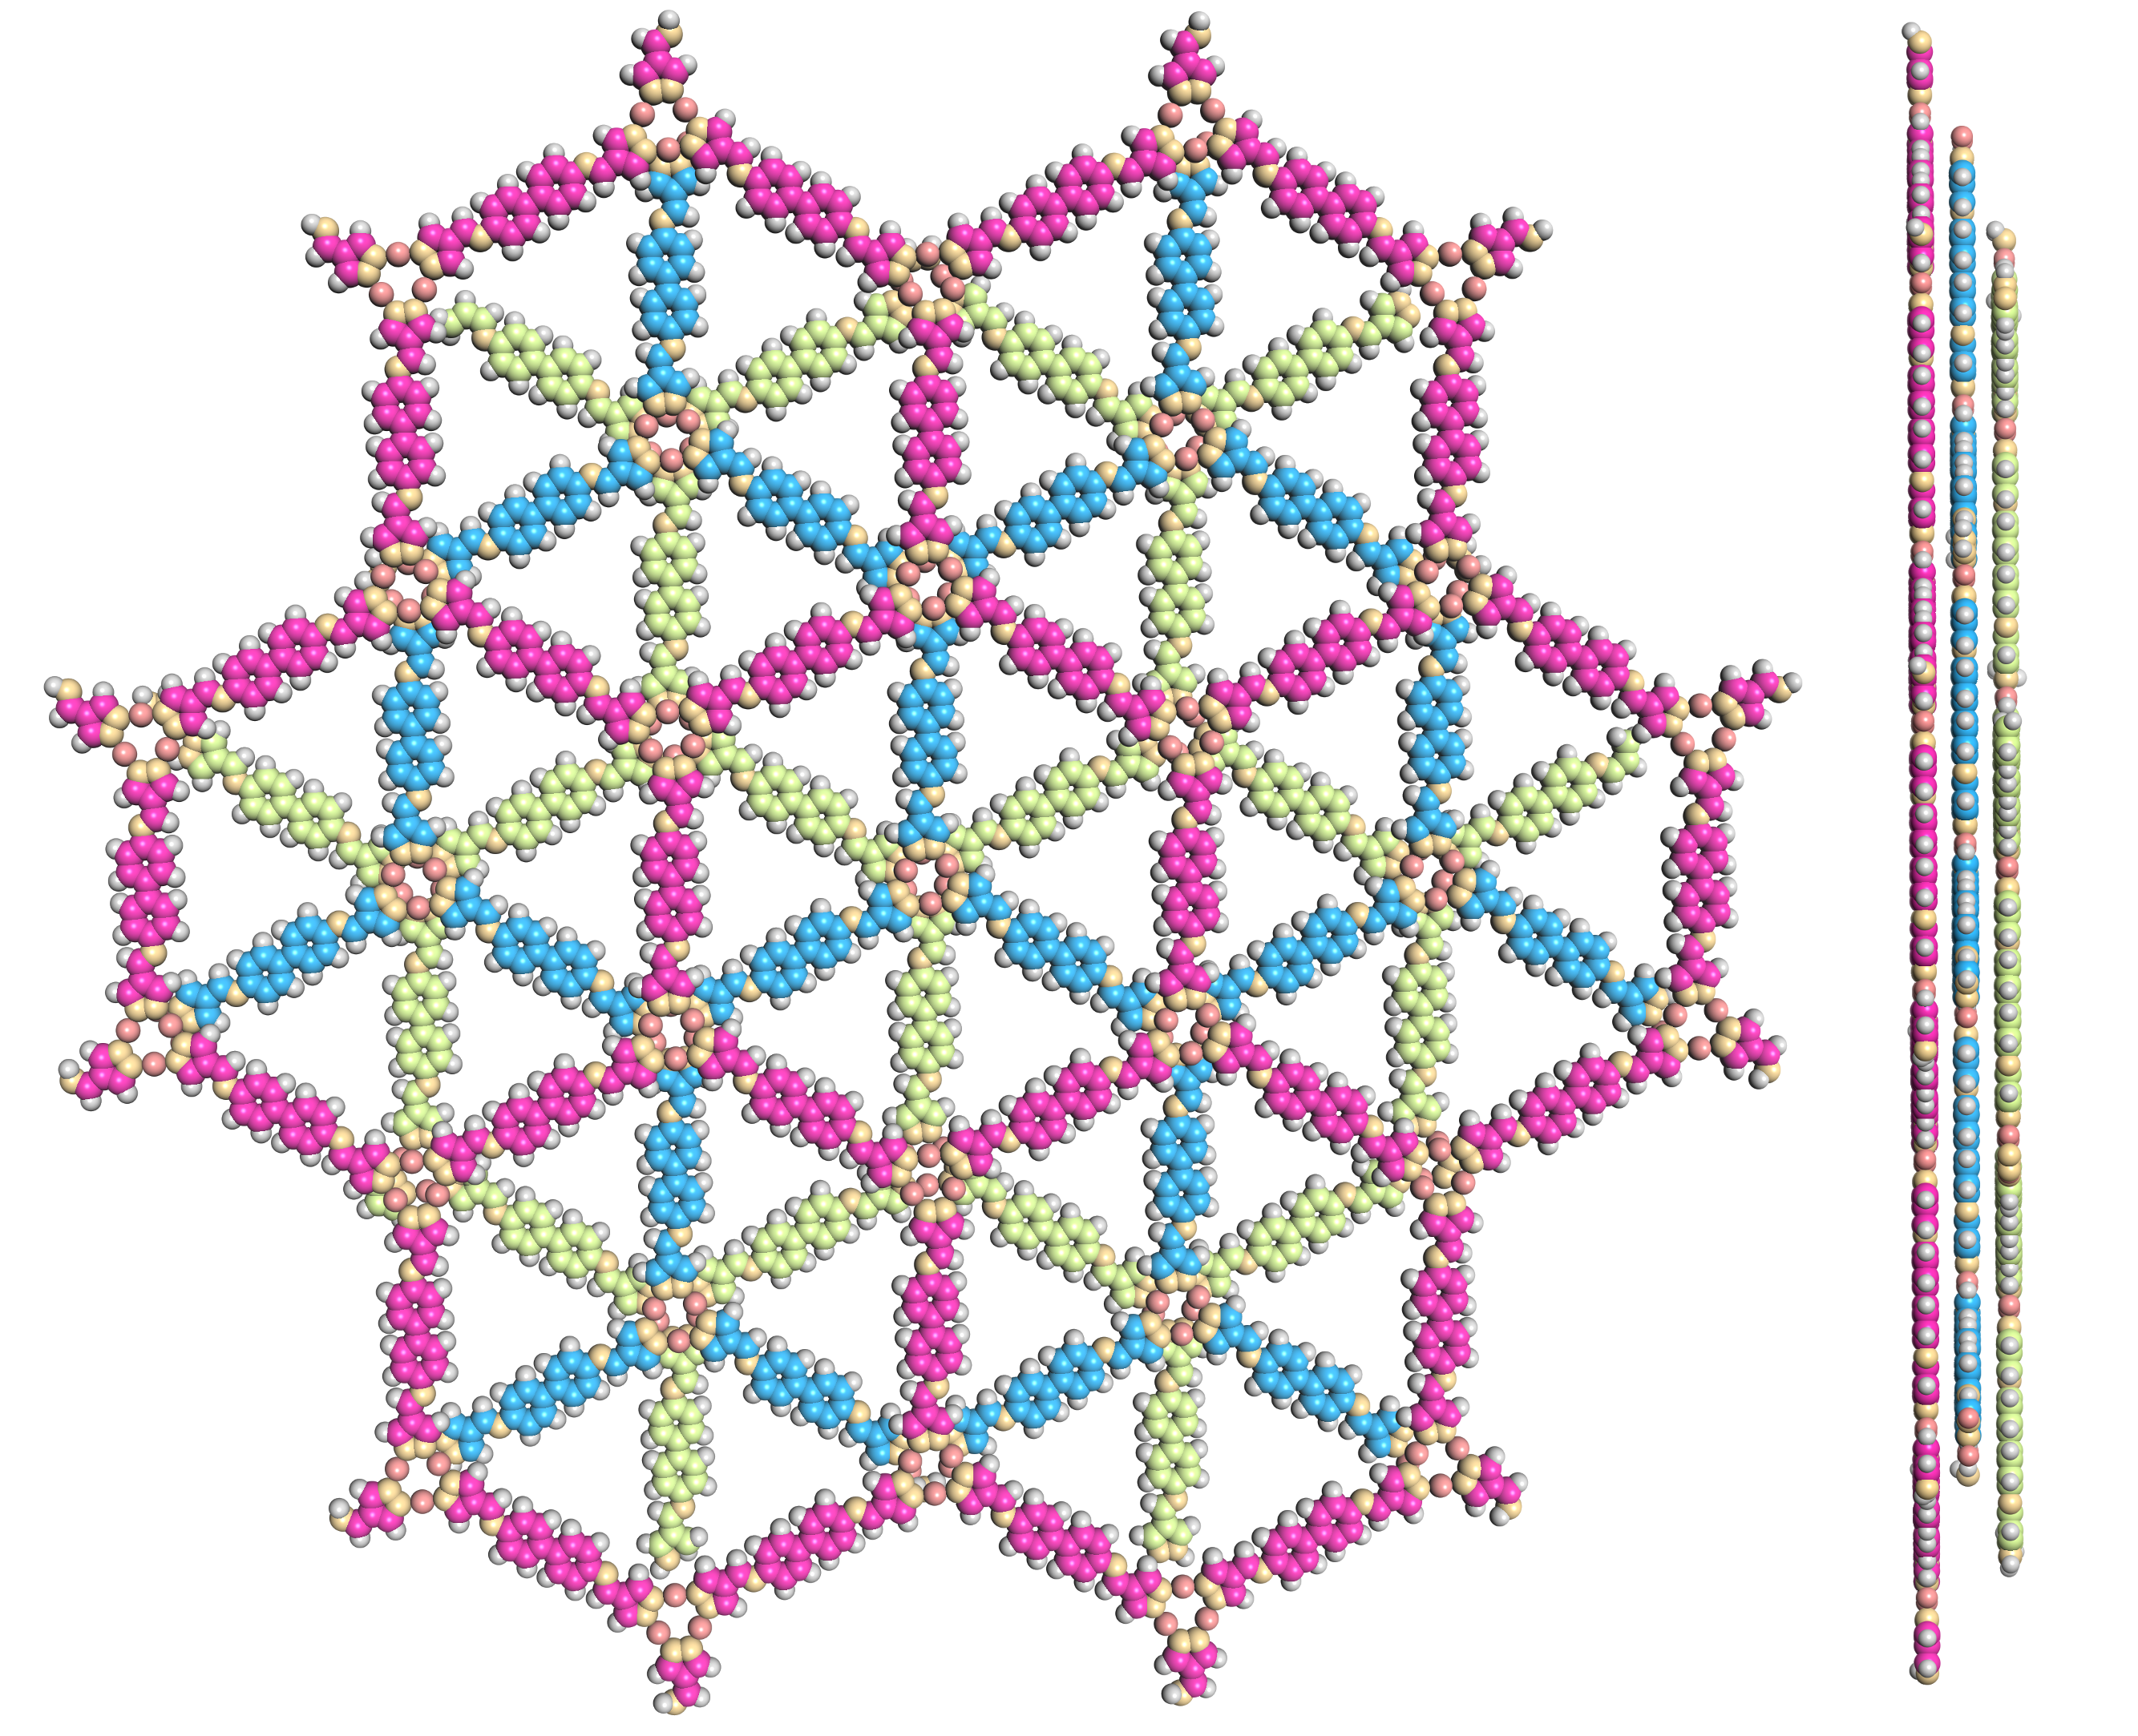
Supplementary Figure 16. Space-filling model of JNM-7-ABC in ABC stacking mode viewed from (left) c axis and (right) a axis.

Supplementary Table 8. Fractional atomic coordinates for JNM-7-ABC.
JNM-7-ABC
Space group symmetry: R3
a = b = 41.2260 Å; c = 10.2000 Å
α = β = 90.0000°; γ = 120.0000°
Atom name | Atom | x | y | z
N1 | N | -0.37985 | -0.74181 | 0
C2 | C | -0.41129 | -0.61368 | 0
C3 | C | -0.37241 | -0.59409 | 0
C4 | C | -0.43594 | -0.59767 | 0
C5 | C | -0.44512 | -0.54463 | 0
C6 | C | -0.48438 | -0.56609 | 0
C7 | C | -0.50589 | -0.54854 | 0
C8 | C | -0.4886 | -0.50931 | 0
C9 | C | -0.44932 | -0.48804 | 0
C10 | C | -0.42779 | -0.50557 | 0
N11 | N | -0.42226 | -0.56173 | 0
Cu12 | Cu | -0.31147 | -0.61267 | 0
N13 | N | -0.26222 | -0.60827 | 0
C14 | C | -0.22852 | -0.57694 | 0
H15 | H | -0.35657 | -0.56216 | 0
H16 | H | -0.4676 | -0.61708 | 0
H17 | H | -0.49884 | -0.59798 | 0
H18 | H | -0.53775 | -0.56623 | 0
H19 | H | -0.43469 | -0.45614 | 0
H20 | H | -0.39591 | -0.48801 | 0
H21 | H | -0.22268 | -0.54704 | 0

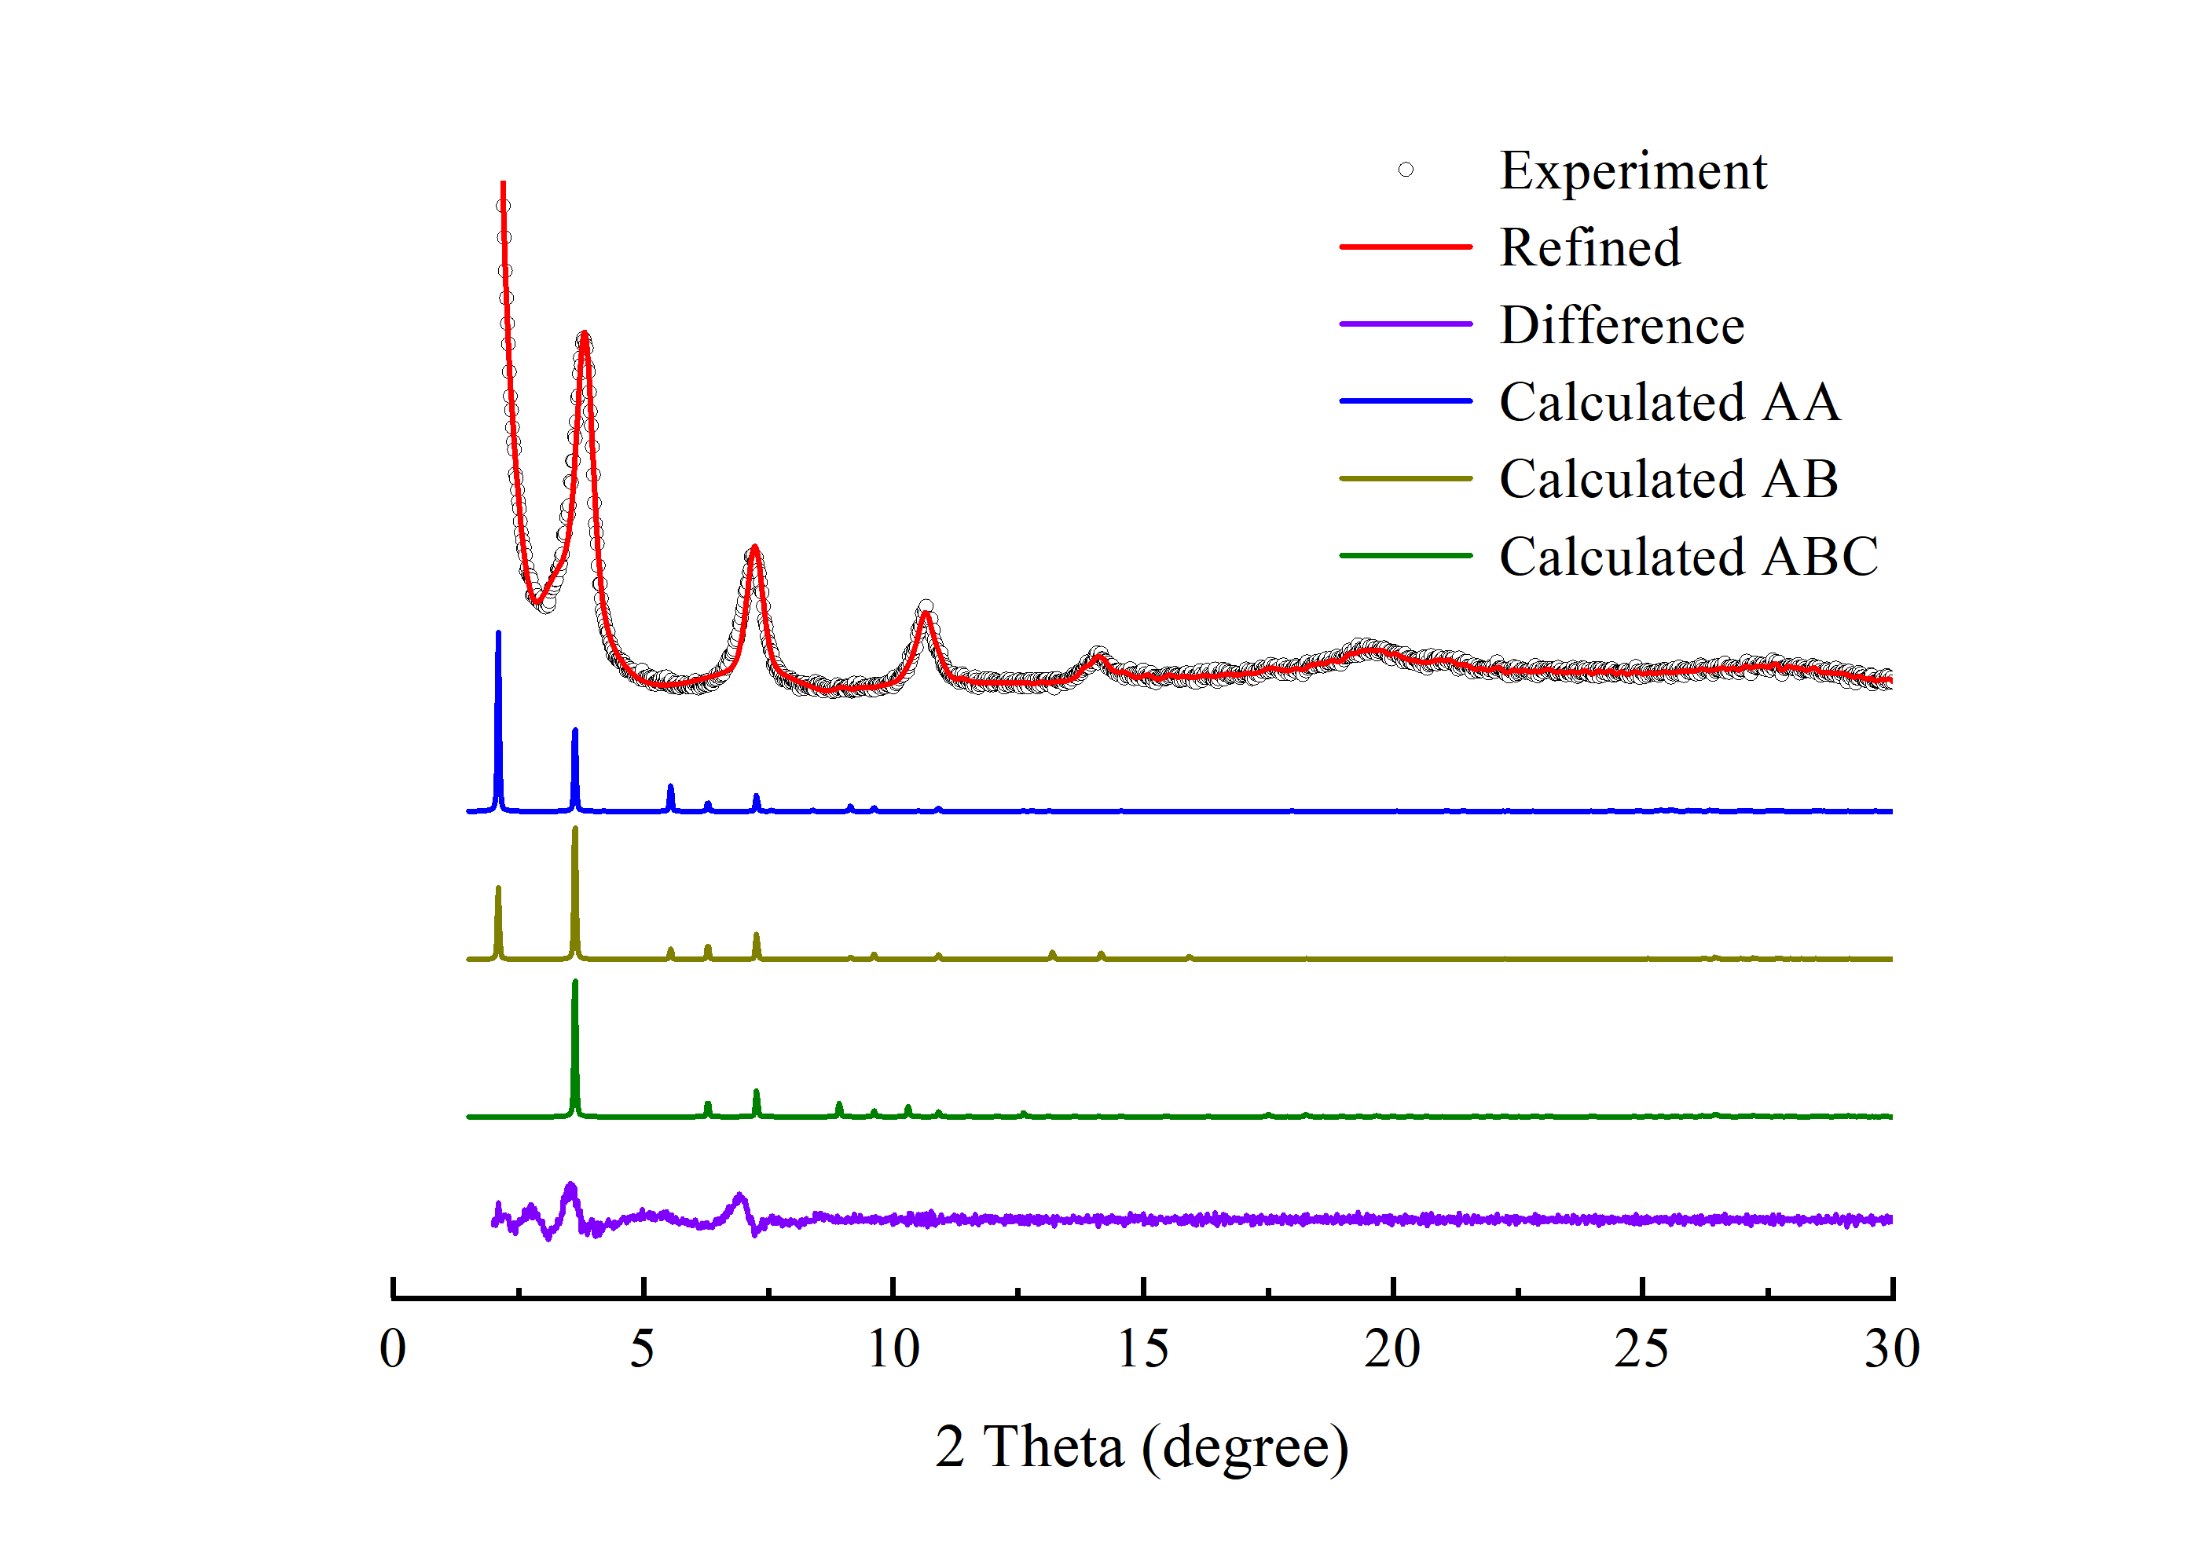
Supplementary Figure 17. PXRD patterns of JNM-8-ABC with the experimental profiles in red, difference curve in purple, and calculated profiles of AA (blue), AB (yellow), and ABC (green).

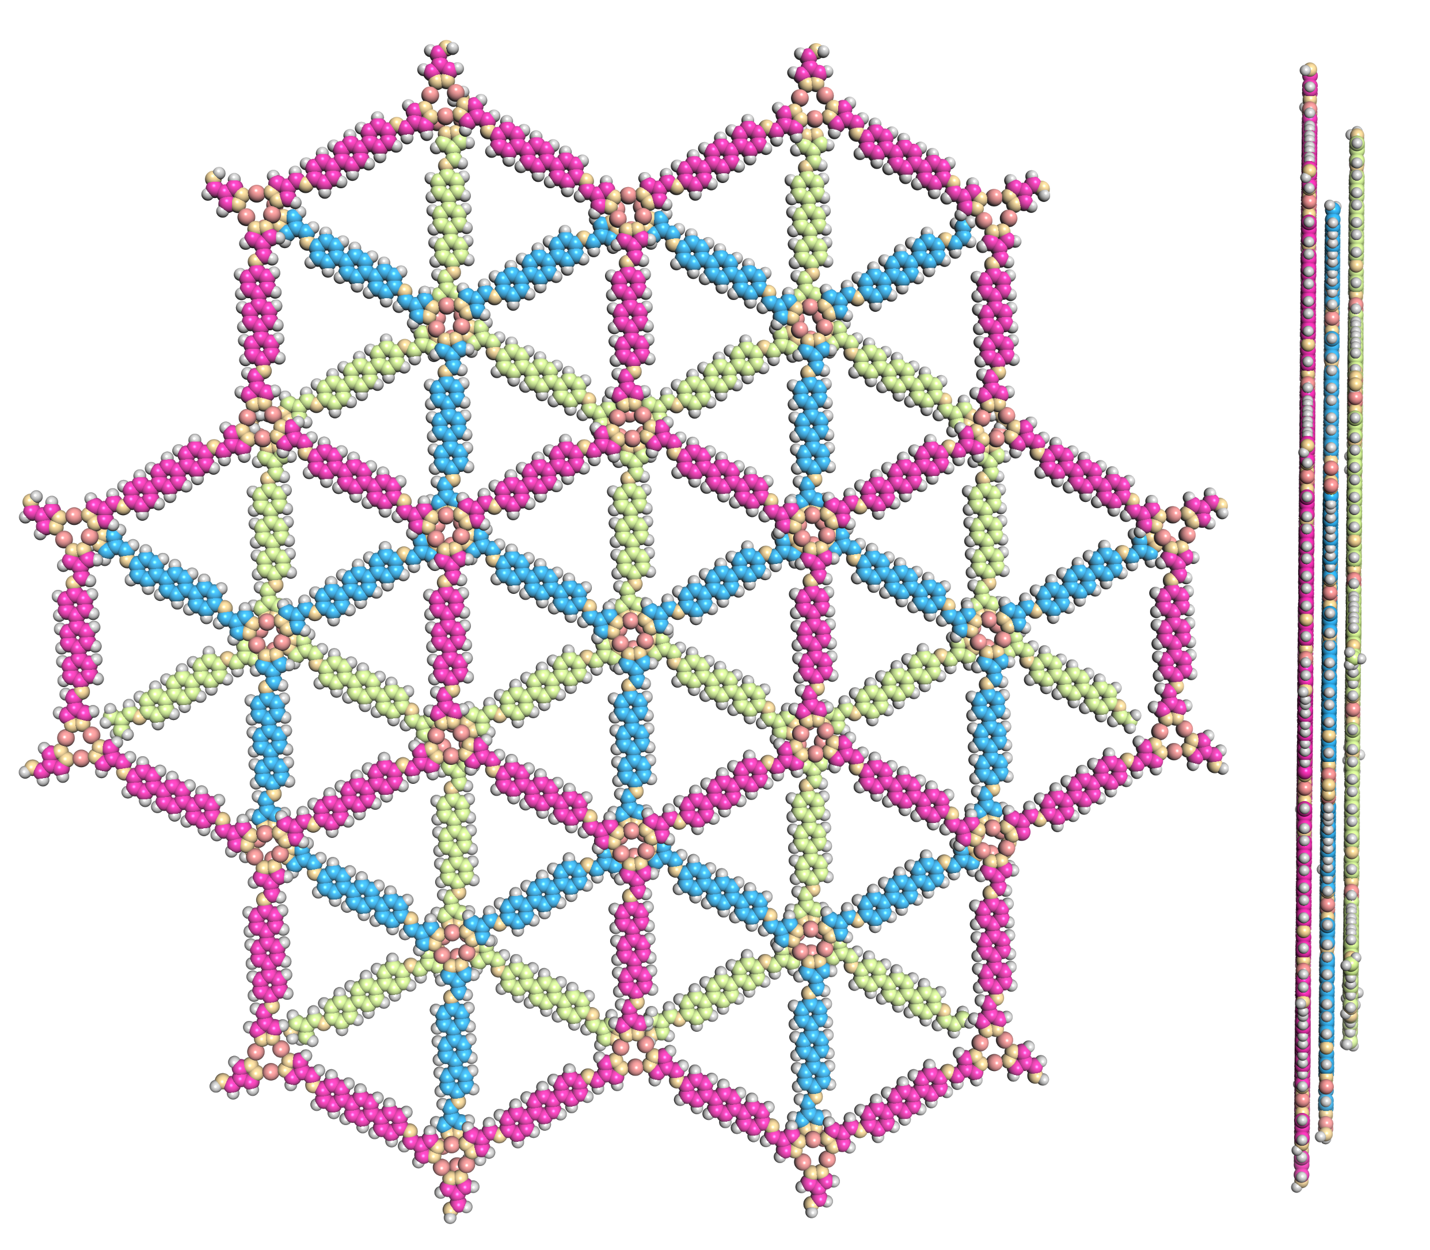
Supplementary Figure 18. Space-filling model of JNM-8-ABC in ABC stacking mode viewed from (left) c axis and (right) a axis.

Supplementary Table 9. Fractional atomic coordinates for JNM-8-ABC.
JNM-8-ABC
Space group symmetry: R3
a = b = 48.6710 Å; c = 10.2001 Å
α = β = 90.0000°; γ = 120.0000°
Atom name | Atom | x | y | z
C1 | C | -0.39856 | -0.62088 | 0
C2 | C | -0.36563 | -0.60454 | 0
N3 | N | -0.2729 | -0.61757 | 0
N4 | N | -0.26977 | -0.64295 | 0
C5 | C | -0.24424 | -0.59119 | 0
C6 | C | -0.18785 | -0.58081 | 0
C7 | C | -0.86466 | -0.42645 | 0
C8 | C | -0.88281 | -0.41152 | 0
C9 | C | -0.91591 | -0.4295 | 0
C10 | C | -0.93143 | -0.46279 | 0
C11 | C | -0.91309 | -0.47769 | 0
C12 | C | -0.88 | -0.45973 | 0
C13 | C | -0.96653 | -0.48184 | 0
C14 | C | -0.98487 | -0.46694 | 0
C15 | C | -0.01796 | -0.4849 | 0
N16 | N | -0.16921 | -0.59266 | 0
Cu17 | Cu | -0.31444 | -0.62089 | 0
H18 | H | -0.34936 | -0.57792 | 0
H19 | H | -0.23905 | -0.56579 | 0
H20 | H | -0.17724 | -0.55397 | 0
H21 | H | -0.87055 | -0.38451 | 0
H22 | H | -0.93047 | -0.41704 | 0
H23 | H | -0.9252 | -0.50469 | 0
H24 | H | -0.86534 | -0.47208 | 0
H25 | H | -0.97277 | -0.43995 | 0
H26 | H | -0.03262 | -0.47255 | 0

4.3 Revisable structure transformation PXRD.
Supplementary Figure 19. PXRD structural analysis of JNM-8-ABC showing space-filling model (C, light pink; H, white; Cu, red; N, pink).

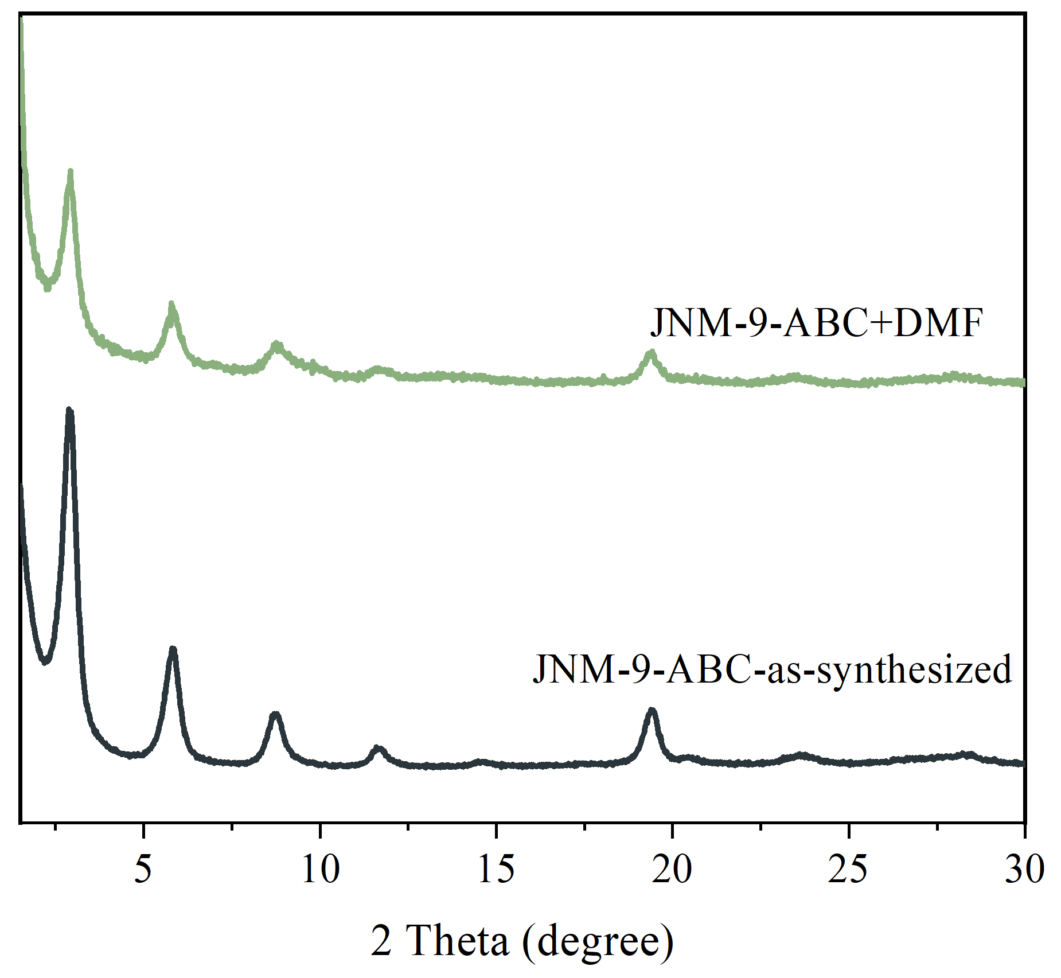
Supplementary Figure 20. PXRD patterns of JNM-9-ABC into DMF solution at 80 °C for 10 h.

Supplementary Figure 21. Revisable structure transformation PXRD analysis of JNM-8-AA (pristine), JNM-8-ABC and JNM-8-AA (regenerated).

4.4 Fourier-transform infrared (FT-IR) spectra
Supplementary Figure 22. FT-IR analyses of (a) JNM-7 and (b) JNM-8.

4.5 Solid-state ¹³C CP/MAS NMR spectra.
Supplementary Figure 23. Solid-state ¹³C CP/MAS NMR spectra and peak assignments for (a) JNM-7 and (b) JNM-8.

4.6 Scanning electron microscopy (SEM).
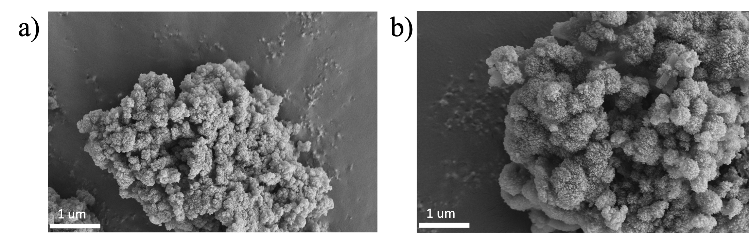
Supplementary Figure 24. SEM analyses of (a) JNM-7-ABC and (b) JNM-8-ABC.

4.7 X-ray photoelectron spectroscopy (XPS).
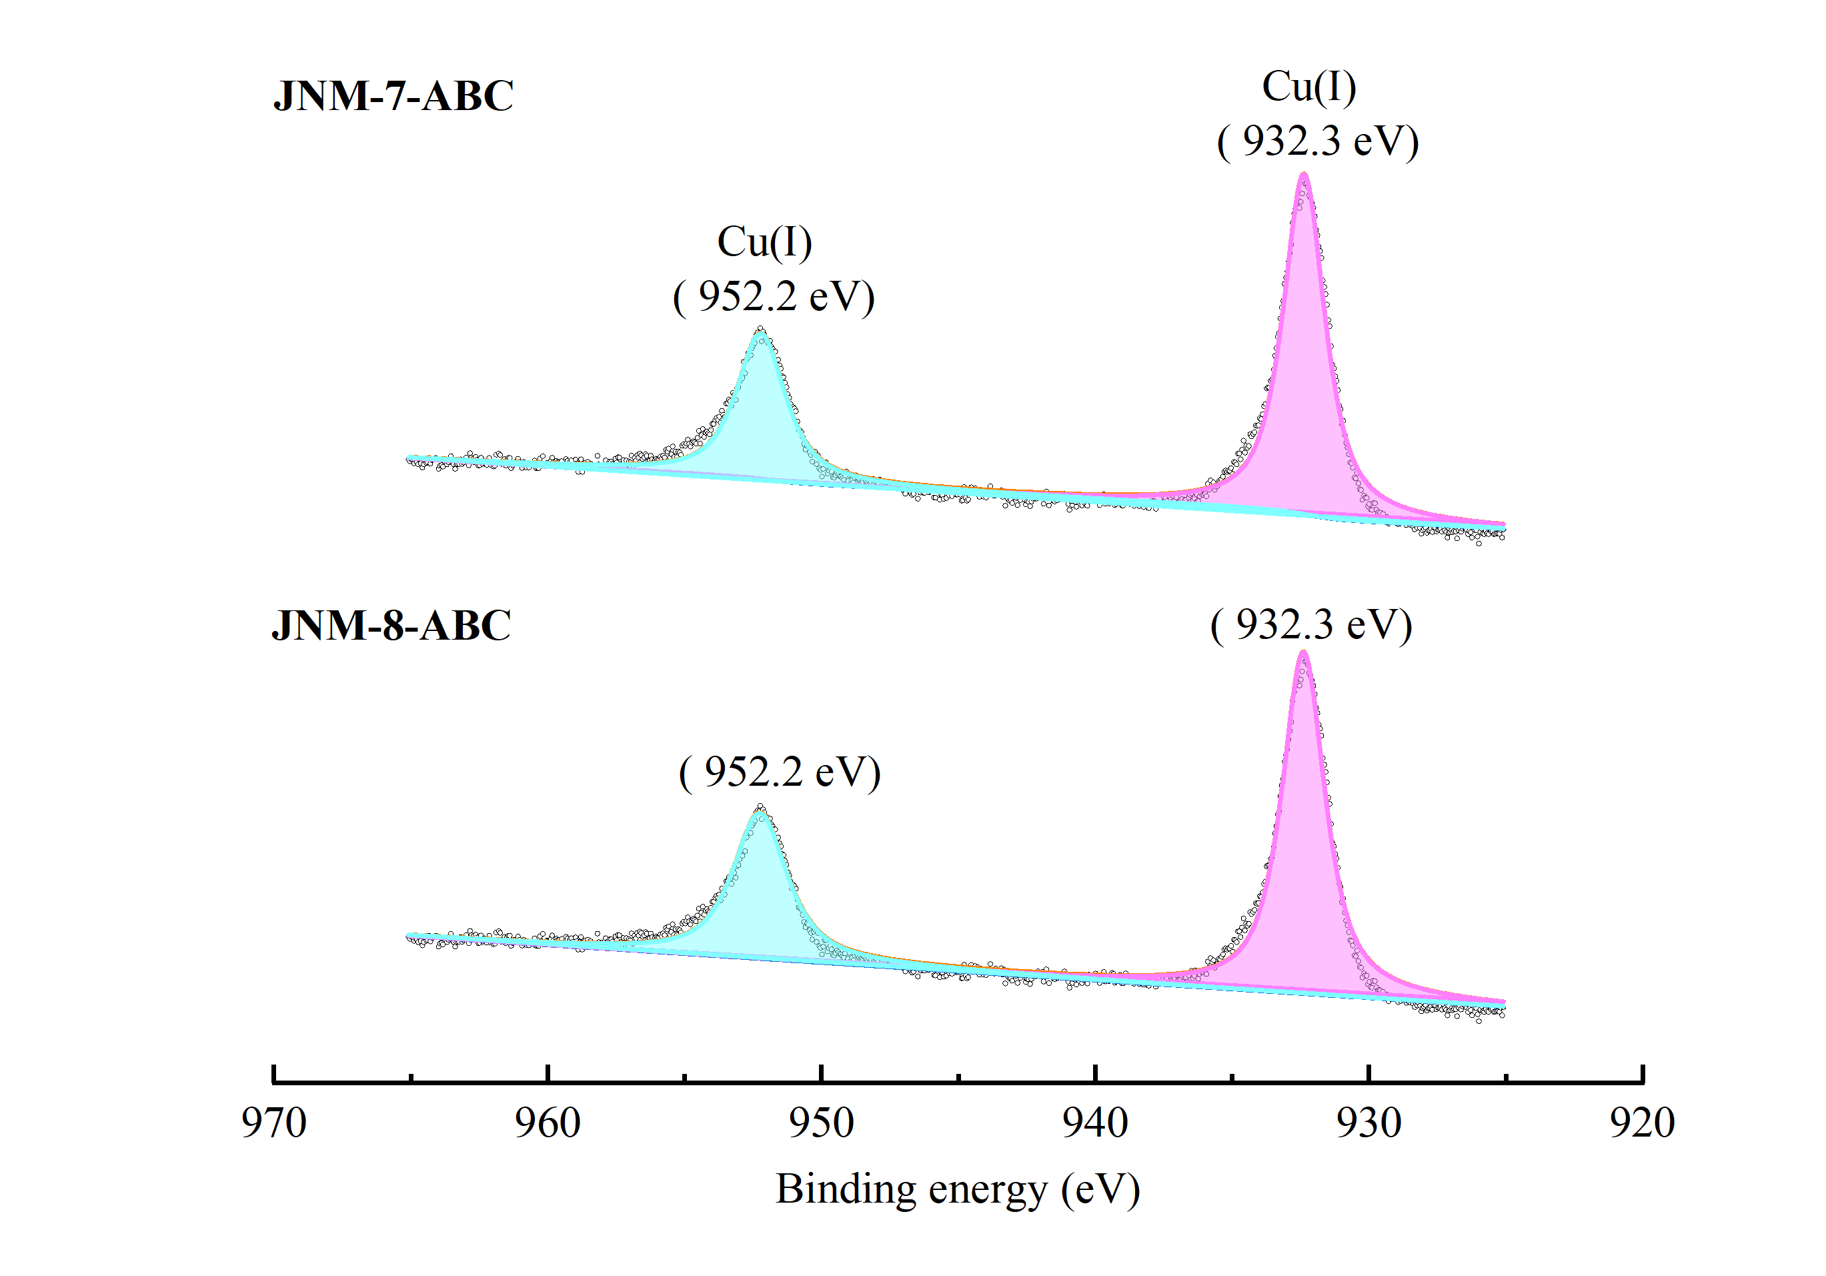
Supplementary Figure 25. XPS spectrum of JNM-7-ABC and JNM-8-ABC.

4.8 Thermogravimetric analysis (TGA)
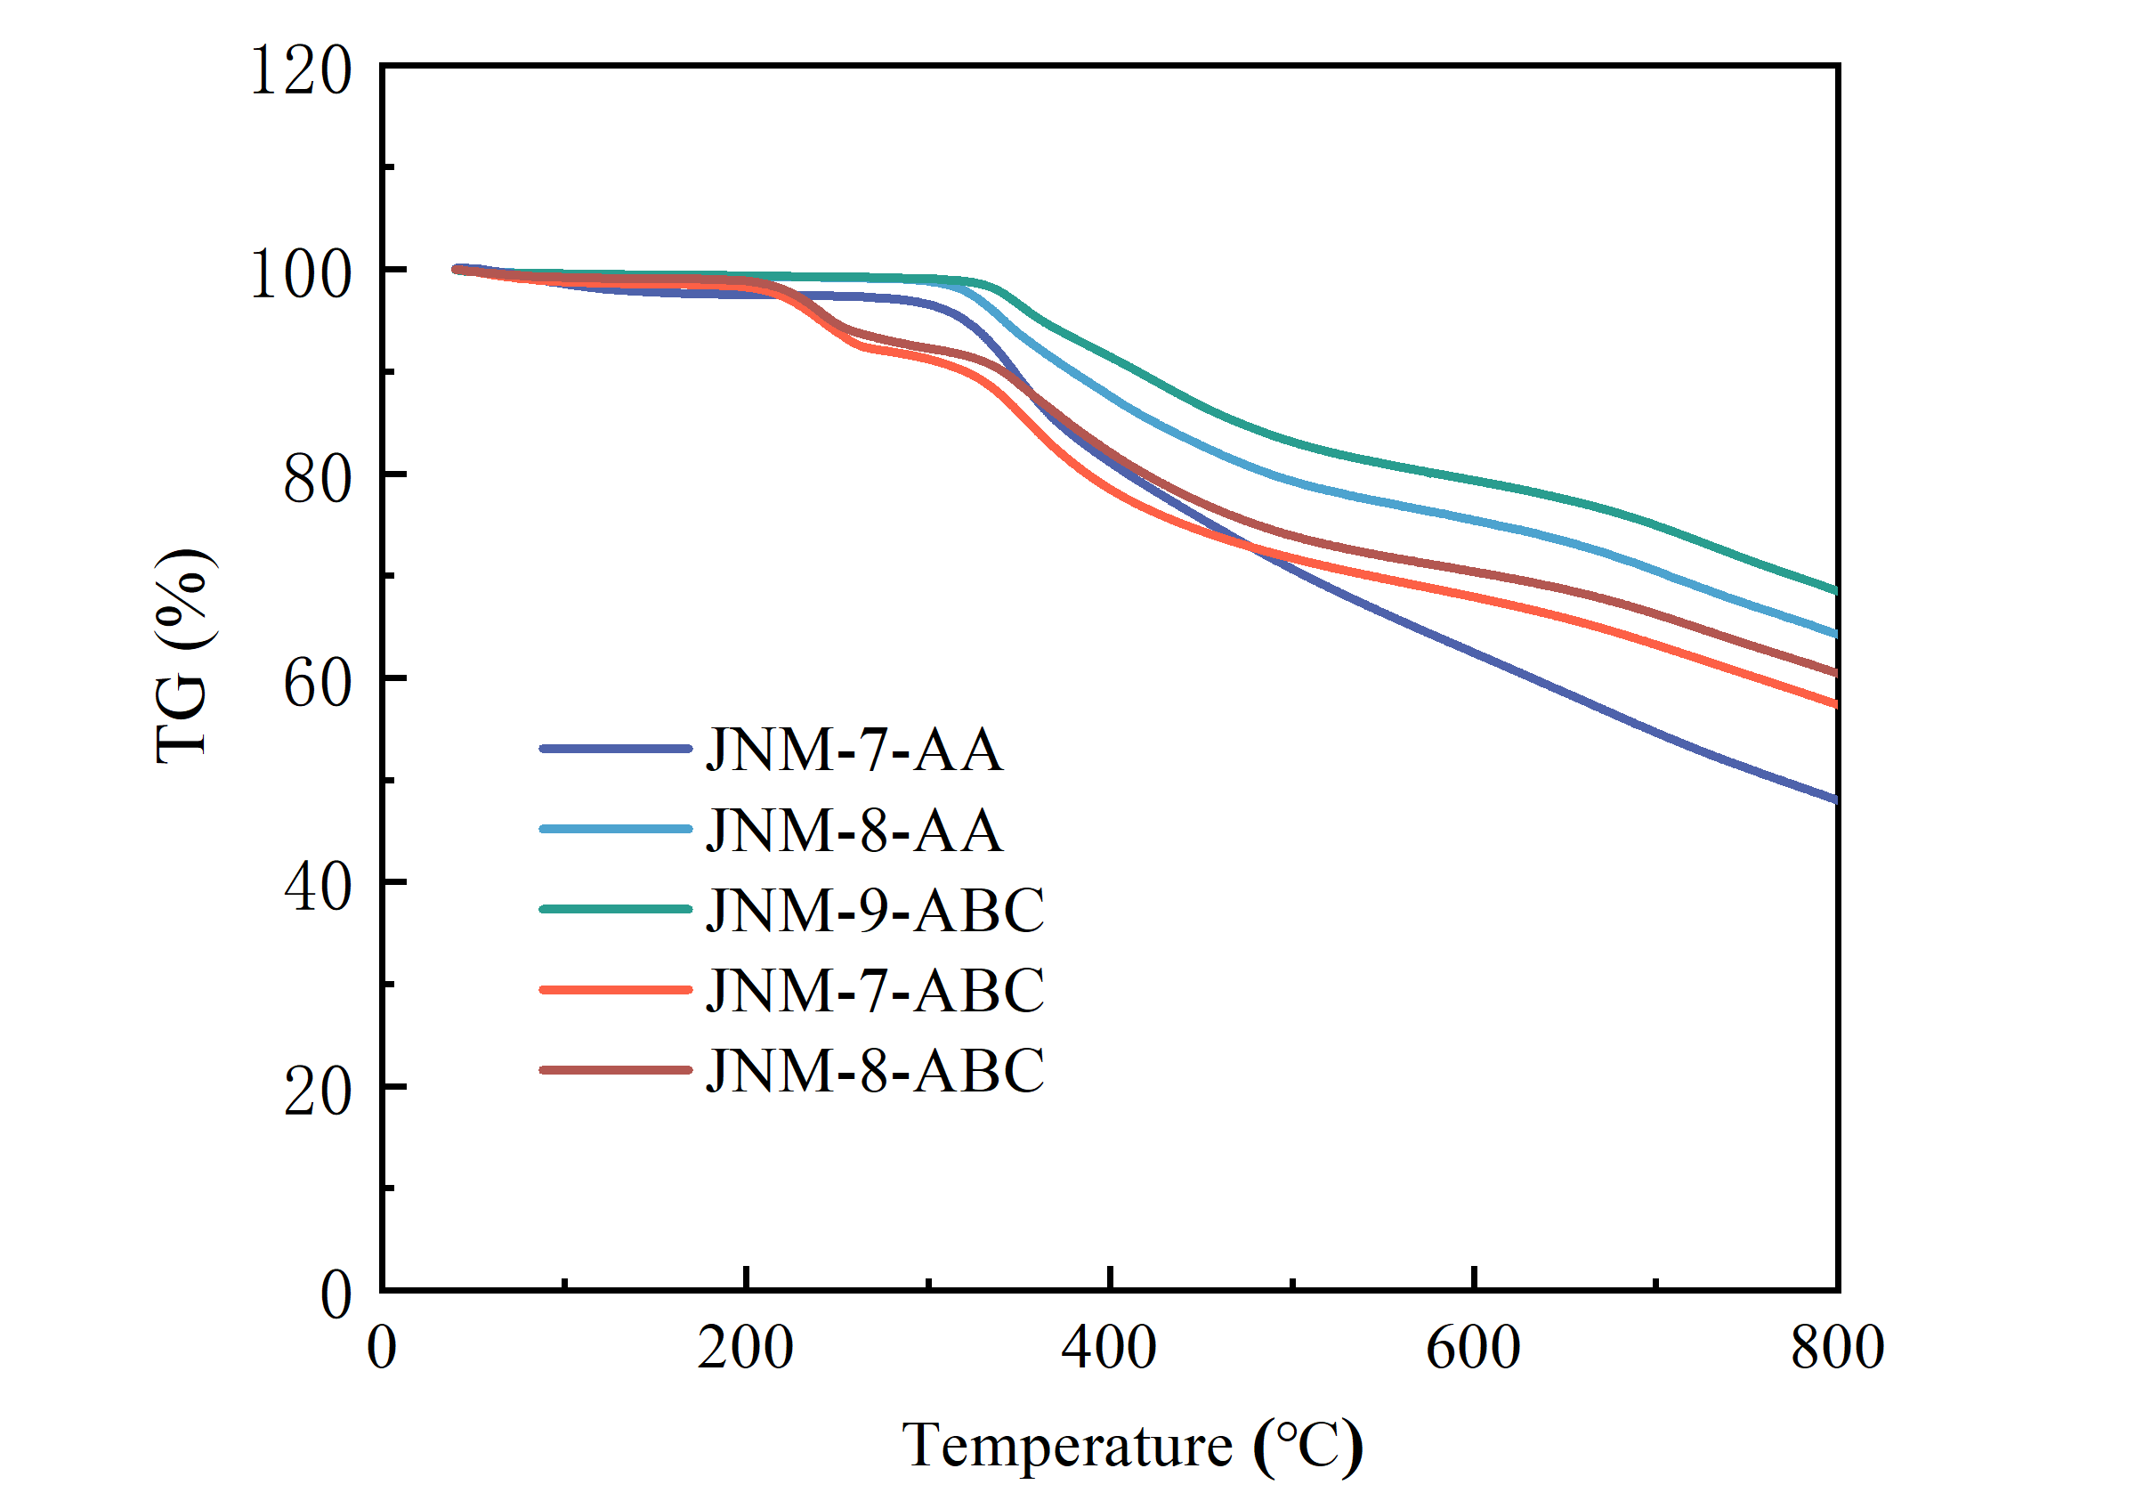
Supplementary Figure 26. TGA curve of JNM-7-AA, JNM-8-AA, JNM-9-ABC, JNM-7-ABC, and JNM-8-ABC under N2 atmosphere.

4.9 Various-Temperature PXRD.
Supplementary Figure 27. PXRD patterns for samples of (a) JNM-7-AA, (b) JNM-8-AA, (c) JNM-9-ABC, (d) JNM-7-ABC and (e) JNM-8-ABC form 25°C to 300°C.

4.10 Stability in various solvents.
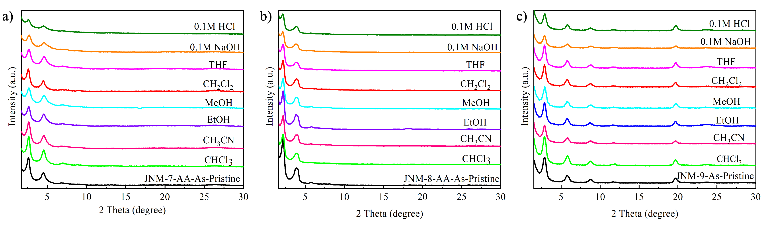
Supplementary Figure 28. PXRD patterns for samples of (a) JNM-7-AA, (b) JNM-8-AA, (c) JNM-9-ABC, (d) JNM-7-ABC and (e)JNM-8-ABC after treatment with different solvents for 24 h.

4.11 Gas adsorption isotherms and pore size distribution of JNM-8.
Supplementary Figure 29. Revisable structure transformation (a) BET surface analysis and (b) pore size distribution profiles of JNM-8-AA (pristine), JNM-8-ABC and JNM-8-AA (regenerated).

4.12 DFT calculations^{2, 3}
Density functional theory (DFT) calculations were performed in the DMol³ molecular dynamics module software. Generalized gradient approximation (GGA) and Perdew–Burke–Ernzerhof (PBE) were used. The total energy difference and maximum residual force converged within 10⁻⁴ Ha and 0.05 Ha/Å during optimization. In all calculations, we used periodic boundary conditions and a supercell large enough to present the full coordination environments of JNM-7. The structures of the simulated AA stacked and ABC stacked JNM-7 were firstly optimized, then solvent molecules were introduced to the channel pore.
Supplementary Table 10. The cell parameters, total energy of the possible structures of JNM-7 under different states.
Structure |  | Formula | c (Å) |  | Total energy (kcal/mol)
JNM-7-AA | C₁₈₀H₁₂₆N₅₄Cu₁₈ |  |  | 10.25 | -8713563.47
JNM-7-ABC | C₁₈₀H₁₂₆N₅₄Cu₁₈ |  |  | 10.25 | -8713373.43
JNM-7-AA-DMF | C₁₈₃H₁₃₃N₅₅OCu₁₈ |  |  | 10.25 | -8869306.91
JNM-7-ABC-DMF | C₁₈₃H₁₃₃N₅₅OCu₁₈ |  |  | 10.25 | -8869097.28
NM-7-AA-TFA | C₁₈₂H₁₂₇N₅₄Cu₁₈O₂F₃ |  |  | 10.25 | -9043675.61
JNM-7-ABC-TFA | C₁₈₂H₁₂₇N₅₄Cu₁₈O₂F₃ |  |  | 10.25 | -9043841.94
DMF | C₃H₇NO |  |  | 10.25 | -155779.57
TFA | C₂HO₂F₃ |  |  | 10.25 | -330372.34

4.13 Reversible encapsulation and release of lipase
Encapsulation of lipase. In a typical adsorption experiment, 15 mg of JNM-8-AA was added to 1 mL of an aqueous phosphate buffer solution of lipase (pH = 7.0, C₀ = 30 mg/mL), and the mixture was shaken at 175 rpm and 25 °C for 6 h. Afterwards, the resultants were centrifuged and the solid was collected to give LP@JNM-8-AA. The supernatant was further analyzed by UV-Vis spectroscopy using n-butyl cyanoacrylate (BCA) method to give the concentration of lipase (C_{at}).
The adsorption efficiency of lipase was calculated as following equation (1):
Adsorption efficiency (%) = (C₀ − C_{at}) / C₀ × 100% (1)
Where C₀ and C_{at} are the concentration of lipase at the initial condition and in the filtrate after adsorption, respectively.

Release of lipase. The LP@JNM-8-AA obtained in the above adsorption process was added to an aqueous phosphate buffer (0.5 mL) and DMF mixture solution (0.5 mL), and then the mixture was heated at 80 °C for 6h, followed by cooling down to room temperature. Afterwards, the resultants were centrifuged, filtrated and the solid was collected to give JNM-8-ABC. The filtrate was further analyzed by UV-Vis spectroscopy using n-butyl cyanoacrylate (BCA) method to give the concentration of lipase (C_{dt}).
The desorption efficiency of lipase was calculated as following equation (2):
Desorption efficiency (%) = C_{dt} / (C₀ − C_{at}) × 100 (2)
Where C₀, C_{at} and C_{dt} are the concentration of lipase at the initial condition, in the filtrate after adsorption process and in the filtrate after desorption process, respectively.

Preparation of the BCA Working Reagent^{4, 5}:
The BCA working reagent was first prepared by mixing 50 parts of BCA Reagent A with 1 part of BCA Reagent B (Cu²⁺ solution). As a typical run, combine 5 mL of Reagent A with 100 µL of Reagent B.
Test-tube Procedure:
I: Pipette 140 µL of each standard and unknown sample into an appropriately labeled 10mL test tube.
II: Add 2.8 mL of the working reagent to each tube and mix well.
III: Cover tubes at 55 ºC for 15 min.
IV: Cool all tubes to RT for 30 min.
V: Prepare a standard curve. Use the standard curve to determine the protein concentration of each unknown sample.

Supplementary Figure 30. (a) UV-Vis spectra of lipase with known concentrations for preparing (b) standard curve.
Supplementary Figure 31 PXRD patterns for (a) JNM-8-AA (b) JNM-8-ABC after lipase adsorption and desorption twice.

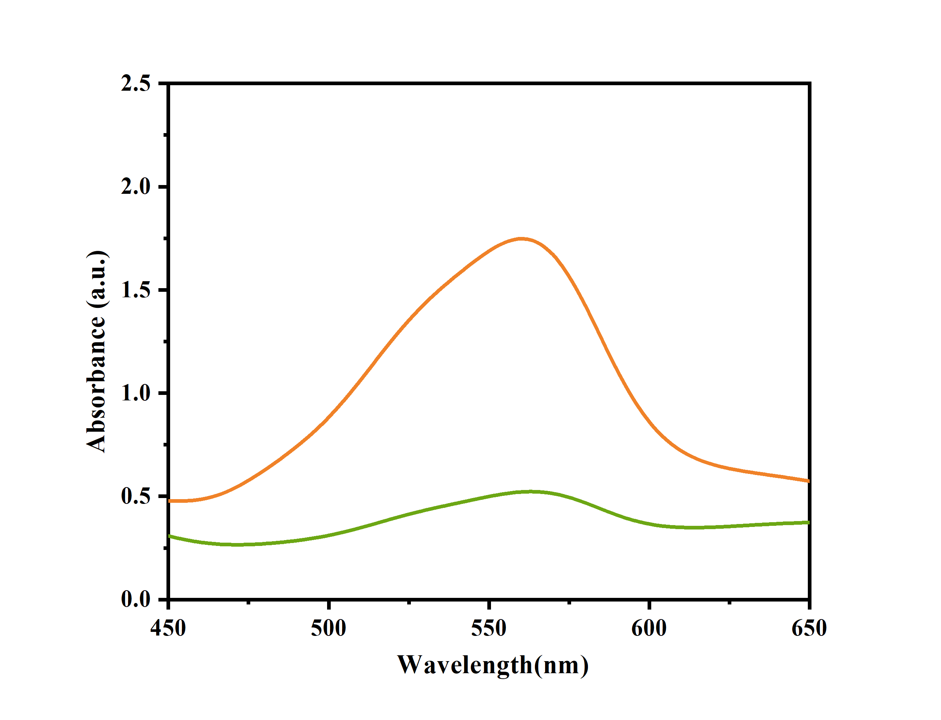
Supplementary Figure 32. UV-Vis spectrum of residual lipase concentrations after adsorption and desorption of JNM-8 in the second cycle.

5. Optical and electronic properties
Supplementary Figure 33. Mott-Schottky plots for (a) JNM-7-AA, (b) JNM-7-ABC, (c) JNM-8-AA and (d) JNM-8-ABC in 0.1 M Na2SO4 aqueous solution.

Supplementary Table 11. The EIS simulated resistance values of JNMs.
Sample | R_{s} (Ω) | R_{ct} (Ω)
JNM-7-AA | 17.57 | 39.74
JNM-7-ABC | 23.41 | 75.30
JNM-8-AA | 20.48 | 36.91
JNM-8-ABC | 12.22 | 57.66

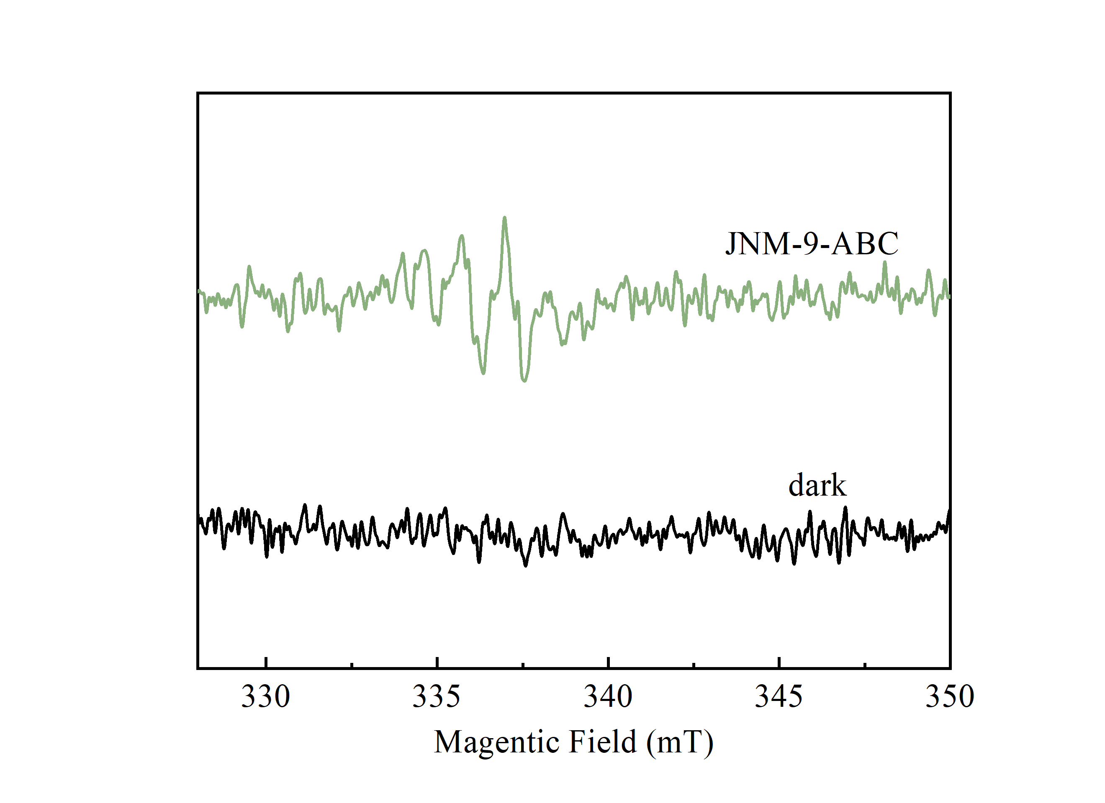
Supplementary Figure 34. Electron paramagnetic resonance (EPR) measures signals of ¹O₂ for JNM-9-ABC.

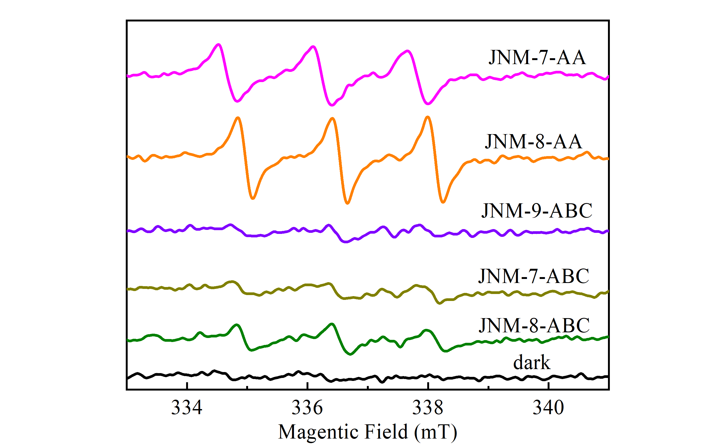
Supplementary Figure 35. Electron paramagnetic resonance (EPR) measures signals of O₂^{•−} for JNMs.

6. Photocatalytic Application

6.1 Experiments of CDC reactions.
Before the catalytic experiment, the catalysts were dried in a vacuum at 120°C for 8h. 2-phenyl-1,2,3,4-tetrahydrolisoquinoline (1a) (19.03 µL, 0.1 mmol), phenylacetylene (2a) (10.20 µL, 0.1 mmol), JNM-8-AA (1.82 mg, 0.0025 mmol) in CH₃CN (1mL) was stirred at room temperature under photo-irradiation for 12h using 12W white LED. Then the supernatant was analyzed by gas chromatography-mass spectrometry (GC–MS). The reaction conversion was calculated based on the alkyne substrate. After evaporation of the solvent, the crude residue was purified by flash column chromatography on silica gel (petroleum ether : ethyl acetate = 10: 1) to afford desired pure CDC products. Different catalysts, solvents, catalyst loading, and others were investigated in a similar procedure

6.2 Characterization for the product of JNM-8-AA catalyzed CDC reaction.
Supplementary Figure 36. Gas chromatography-mass spectrometry (GC–MS) for the reaction solution of JNM-8-AA catalyzed CDC reaction.

6.3 Catalytic recyclability for JNM-8-AA.
Supplementary Figure 37. (a) Recyclability of JNM-8-AA for CDC reaction. (b) Comparison of PXRD patterns of the As-synthesized JNM-8-AA catalysts and that after being used for 3 cycles.

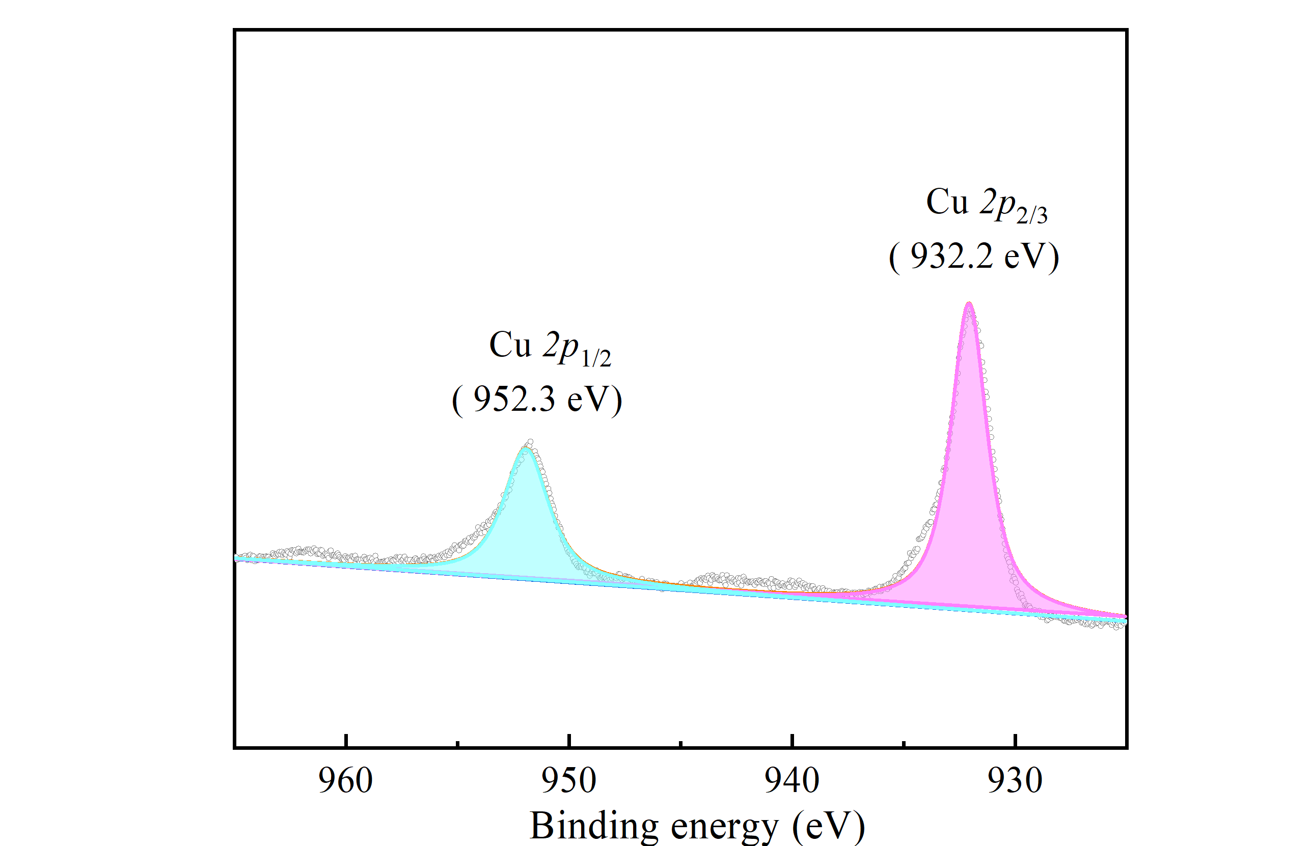
Supplementary Figure 38. XPS for JNM-8-AA after the catalytic reaction.

6.4 Gram-scale CDC reactions.
2-Phenyl-1,2,3,4-tetrahydrolisoquinoline (1a) (1g, 5 mmol), Phenylacetylene (2a) (510 mL, 5 mmol), JNM-8-AA (5 mg, 6.9×10⁻³ mmol) in CH₃CN (AR) (50 mL) were added into a vial. The mixture was stirred under 12W white LED for 12h at room temperature. The conversion of 3a was monitored by GC-MS. After the reaction was completed, the CDC product 3a was isolated following the general procedure.
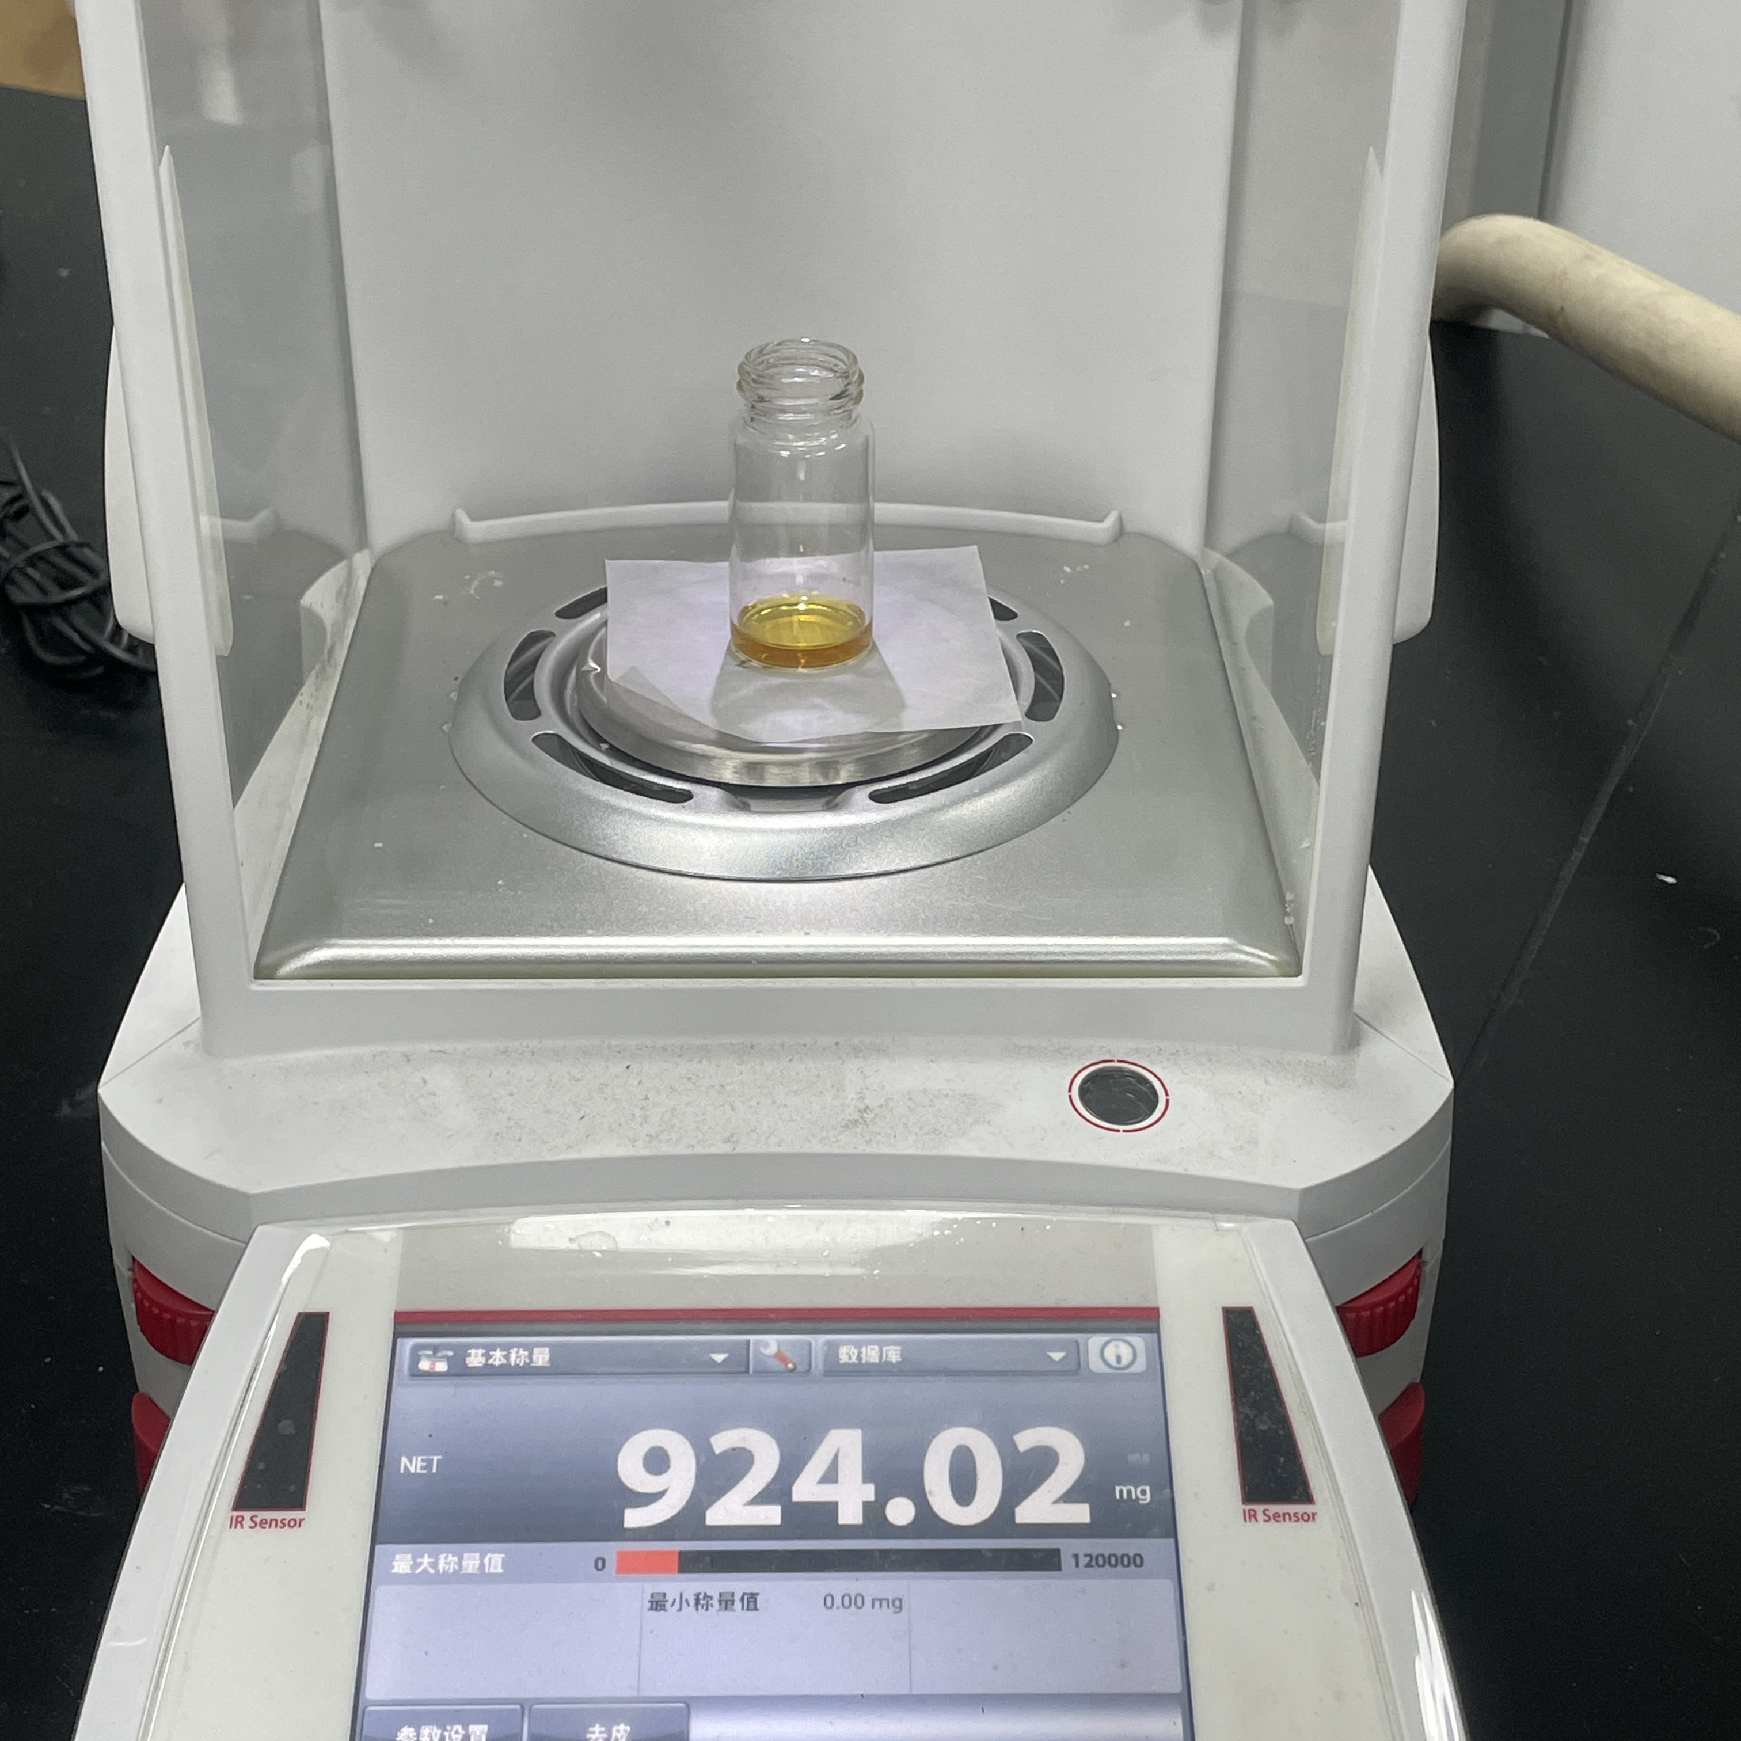
Supplementary Figure 39. The CDC product of 3a using low loading of JNM-8-AA.

6.5 Reaction mechanisms.
Supplementary Figure 40. Photocatalytic reaction mechanisms verification.

Based on experimental results and related literature a plausible mechanism is proposed.^{6, 7} Under visible light irradiation, JNM-8-AA produces the excited species JNM-8-AA*, which is reductively quenched by 2-Phenyl-1,2,3,4-tetrahydrolisoquinoline (1a) through a single electron transfer (SET) process to form a radical cation A and a radical anion JNM-8-AA^{•−}. The generated radical anion JNM-8-AA^{•−} is subsequently quenched by molecular O₂ to form the superoxide anion O₂^{•−}and simultaneously regenerate JNM-8-AA. The superoxide anion O₂^{•−} subsequently extracts a proton from A, yielding iminium intermediate B and releasing HO₂⁻. The imine intermediate B undergoes addition with copper alkynyl to obtain the final product 3a.
Supplementary Figure 41. Proposed mechanism for the photocatalytic reaction of JNM-8-AA.

6.6 Comparison of yield and TOF for JNM-8-AA with existing catalysts.
Supplementary Table 12. Comparison of yield and TOF for JNM-8-AA with previous reports for 2-Phenyl-1,2,3,4-tetrahydroisoquinoline and phenylacetylene CDC reactions.
Catalyst | Condition | Additive | Yield | TOF/h⁻¹ | Reference
CuOTf | 0 ºC, O₂, visible light, 48h | Rose Bengal,  ligand | 81% | 0.15 | ⁸
CuI | air, visible light, 36h | Rose Bengal | 73% | 0.20 | ⁷
CuO–Fe₃O₄ | Air, 50 °C, 3d | None | 63% | 0.24 | ⁹
CuOTf | Air, 50 °C, 2d | Ligand, ^{t}BuOOH | 63% | 0.28 | ¹⁰
CuCl | Ar, 50 °C, 24h | ^{t}BuOOH | 86% | 0.35 | ¹¹
CuCl₂·2H₂O | O_{2,} rt,17h | ^{t}BuOOH | 89% | 0.52 | ¹²
CuBr₂ | O_{2,} rt, 3 W blue LED, 12 h | Conjugated polymetric photocatalysts (CPPs) | 66% | 1.10 | ¹³
CuNPs/ZY | Air, 70°C,20 h | ^{t}BuOOH -H₂O | 62% | 2.07 | ¹⁴
(MeCN)₄P₆ | Air, rt, 5W visible light, 36h | [Ru(bpy)₂(dtbbp)] (PF₆)₂ | 88% | 5.5 | ¹⁵
DA-CMP3 | O₂ (1.0 bar), 30 W blue LED,25 °C, 1h | None | 70% | 10.78 | ⁶
JNM-8-AA | Air, 12W white LED, 12h | None | 60% | 36.23 | This work

6.7 Scope of JNM-8-AA Catalyst for CDC reactions.
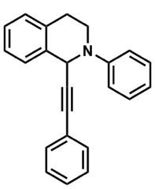
2-Phenyl-1-phenylethynyl-1,2,3,4- tetrahydroisoquinoline (3a). ¹H NMR (400 MHz, CDCl₃) δ[ppm] = 7.43 – 7.27 (m, 6H), 7.24 (s, 5H), 7.15 (d, J = 8.2 Hz, 2H), 6.91 (t, J = 7. 2 Hz, 1H), 5.66 (s, 1H), 3.77 (dd, J = 17.0, 4.7 Hz, 1H), 3.73 –3.63 (m, 1H), 3.18 (dd, J = 14.2, 8.1 Hz, 1H), 3.05 – 2.95 (m, 1H). ¹³C NMR (101 MHz, CDCl₃, 298 K) δ [ppm] = 149.40, 135.29, 134.33, 131.75, 129.16, 128.94, 128.09, 128.06, 127.44, 127.27, 126.31, 122.96, 116.84, 88.43, 84.92, 77.25, 52.45, 43.57, 28.87.
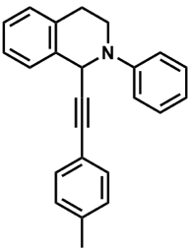
1-(p-Tolylethynyl)-2-phenyl-1,2,3,4-tetrahydroisoquinoline (3b). ¹H NMR (400 MHz, CDCl₃) δ[ppm] = 7.49 – 7.37 (m, 3H), 7.36 – 7.24 (m, 5H), 7.21 (d, J = 7.1 Hz, 2H), 7.10 (d, J = 6.6 Hz, 2H), 6.97 (t, J = 6.9 Hz, 1H), 5.73 (s, 1H), 3.79 (dtt, J = 19.7, 9.8, 5.0 Hz, 2H), 3.22 (dt, J = 14.9, 7.3 Hz, 1H), 3.05 (d, J = 16.0 Hz, 1H), 2.36 (s, 3H).¹³C NMR (101 MHz, CDCl₃, 298 K) δ [ppm] = 149.60, 138.13, 135.58, 134.43, 131.69, 129.19, 128.90, 127.51, 127.24, 126.32, 119.66, 116.76, 87.89, 84.96, 52.38, 43.52, 28.98.
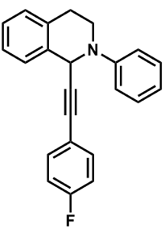
1-(4-Fluorophenylethynyl)-2-phenyl-1,2,3,4-tetrahydroisoquinoline (3c). ¹H NMR (400 MHz, CDCl₃) δ[ppm] = 7.43 – 7.29 (m, 5H), 7.28 – 7.23 (m, 3H), 7.21 (t, J = 6.4 Hz, 2H), 7.03 – 6.89 (m, 3H), 5.68 (s, 1H), 3.84 – 3.76 (m, 1H), 3.76 – 3.66 (m, 1H), 3.22 (ddd, J = 16.0, 10.0, 6.0 Hz, 1H), 3.04 (dt, J = 16.2, 3.7 Hz, 1H).¹³C NMR (101 MHz, CDCl₃, 298 K) δ [ppm] = 163.61, 134.19, 133.67, 133.59, 129.20, 128.96, 127.40, 126.39, 117.06, 115.47, 115.25, 52.66, 43.81, 28.72.
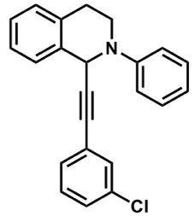
2-Phenyl-1-(-3-Chloro-phenylethynyl)-1,2,3,4-tetrahydroisoquinoline (3d). ¹H NMR (400 MHz, CDCl₃) δ[ppm] = 7.43 – 7.29 (m, 4H), 7.28 – 7.14 (m, 5H), 7.10 (d, J = 7.7 Hz, 1H), 6.99 (dt, J = 12.2, 7.9 Hz, 3H), 5.68 (s, 1H), 3.80 (dt, J = 9.3, 5.4 Hz, 1H), 3.70 (td, J = 12.4, 11.3, 4.2 Hz, 1H), 3.21 (ddd, J = 16.2, 10.1, 5.9 Hz, 1H), 3.03 (dt, J = 16.2, 3.7 Hz, 1H).¹³C NMR (101 MHz, CDCl₃, 298 K) δ [ppm] = 134.22, 129.70, 129.62, 129.22, 128.98, 127.64, 127.45, 127.39, 126.41, 118.66, 118.43, 117.08, 115.58, 115.37, 43.78, 29.73, 28.73.
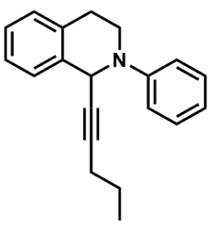
2-phenyl-1-(1-pentynyl)-1,2,3,4-tetrahydroisoquinoline (3e). ¹H NMR (400 MHz, CDCl₃) δ[ppm] = 7.35 – 7.31 (m, 2H), 7.27 – 7.16 (m, 4H), 7.10 (d, J = 7.9 Hz, 1H), 7.02 (d, J = 7.9 Hz, 1H), 6.92 – 6.84 (m, 1H), 4.45 (s, 1H), 3.78 – 3.70 (m, 1H), 3.66 – 3.58 (m, 2H), 3.14 (td, J = 10.3, 5.2 Hz, 1H), 3.04 – 2.94 (m, 2H), 2.11 (td, J = 7.0, 2.1 Hz, 1H), 1.61 (s, 1H), 1.53 – 1.31 (m, 2H), 0.88 (t, J = 7.4 Hz, 2H).¹³C NMR (101 MHz, CDCl₃, 298 K) δ [ppm] = 129.21, 129.04, 128.83, 128.53, 127.31, 126.96, 126.55, 126.34, 126.13, 126.03, 119.31, 118.68, 116.55, 115.16, 51.75, 50.76, 46.55, 43.19, 29.14, 28.90, 22.17, 20.77, 13.38.
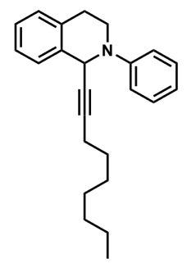
2-Phenyl-1-(1-Nonynyl)-1,2,3,4-tetrahydroisoquinoline (3f). ¹H NMR (400 MHz, CDCl₃) δ[ppm] = 7.34 (td, J = 7.5, 3.4 Hz, 3H), 7.23 (ddt, J = 13.0, 9.1, 3.9 Hz, 3H), 7.12 (d, J = 8.1 Hz, 2H), 6.91 (t, J = 7.3 Hz, 1H), 5.47 (s, 1H), 3.75 (ddd, J = 11.8, 5.4, 3.6 Hz, 1H), 3.63 (ddd, J = 12.3, 10.5, 4.2 Hz, 1H), 3.14 (ddd, J = 16.2, 10.3, 6.0 Hz, 1H), 2.98 (dt, J = 16.1, 3.7 Hz, 1HS), 2.14 (td, J = 7.0, 1.9 Hz, 2H), 1.42 (dd, J = 13.7, 6.5 Hz, 2H), 1.35 – 1.18 (m, 9H), 0.92 (t, J = 7.0 Hz, 3H).¹³C NMR (101 MHz, CDCl₃, 298 K) δ [ppm] =149.62, 136.23, 134.15, 129.05, 128.84, 127.33, 126.98, 126.15, 116.59, 85.38, 43.22, 31.76, 28.92, 28.67, 22.63, 18.78, 14.15.x
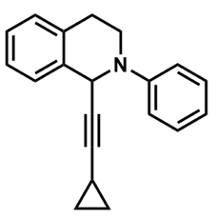
2‐Phenyl‐(1‐cyclopropyl‐ethynyl)‐1,2,3,4‐tetrahydroisoquinoline (3g). ¹H NMR (400 MHz, CDCl₃) δ[ppm] = 7.35 – 7.29 (m, 3H), 7.24 – 7.17 (m, 3H), 7.07 (d, J = 7.9 Hz, 2H), 6.89 (t, J = 7.3 Hz, 1H), 5.40 (s, 1H), 3.72 (ddd, J = 12.2, 5.9, 3.6 Hz, 1H), 3.60 (ddd, J = 12.3, 10.4, 4.3 Hz, 1H), 3.11 (ddd, J = 16.2, 10.3, 5.9 Hz, 1H), 2.98 – 2.91 (m, 1H), 1.17 (dddd, J = 13.2, 8.2, 5.0, 1.6 Hz, 1H), 0.72 – 0.64 (m, 2H), 0.58 – 0.50 (m, 2H). ¹³C NMR (101 MHz, CDCl₃, 298 K) δ [ppm] = 134.20, 129.03, 128.83, 127.31, 126.97, 126.14, 119.31, 116.50, 88.29, 76.72, 51.73, 43.21, 8.34, 1.05.

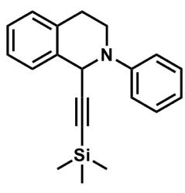
2-Phenyl-(1-trimethylsilanylethynyl)-1,2,3,4-tetrahydroisoquinoline (3h). ¹H NMR (400 MHz, CDCl₃) δ[ppm] = 7.35 (t, J = 7.0 Hz, 3H), 7.31 – 7.16 (m, 4H), 7.12 (d, J = 7.9 Hz, 2H), 6.93 (t, J = 7.2 Hz, 1H), 5.47 (s, 1H), 3.73 (d, J = 12.1 Hz, 1H), 3.64 (dt, J = 11.9, 6.7 Hz, 1H), 3.15 (ddd, J = 16.0, 10.1, 6.0 Hz, 1H), 2.98 (d, J = 16.0 Hz, 1H), 0.12 – 0.10 (m, 8H). ¹³C NMR (101 MHz, CDCl₃, 298 K) δ [ppm] =149.58, 135.23, 134.35, 129.03, 128.91, 127.46, 127.16, 126.22, 119.70, 104.74, 89.08, 52.73, 43.36, 28.82.

¹H NMR and ¹³C NMR spectra of all compounds
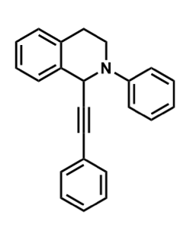
¹H NMR spectrum (400 MHz, CDCl₃, 298 K) of Compound 3a
¹³C NMR spectrum (101 MHz, CDCl₃, 298 K) of Compound 3a
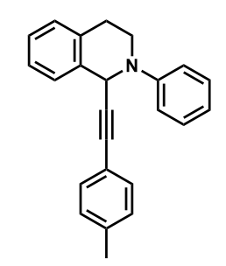
¹H NMR spectrum (400 MHz, CDCl₃, 298 K) of Compound 3b

¹³C NMR spectrum (101 MHz, CDCl₃, 298 K) of Compound 3b

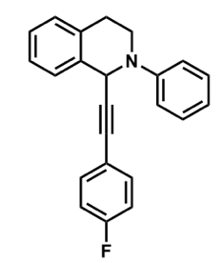
¹H NMR spectrum (400 MHz, CDCl₃, 298 K) of Compound 3c
¹³C NMR spectrum (101 MHz, CDCl₃, 298 K) of Compound 3c

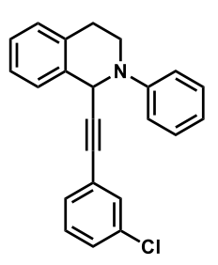
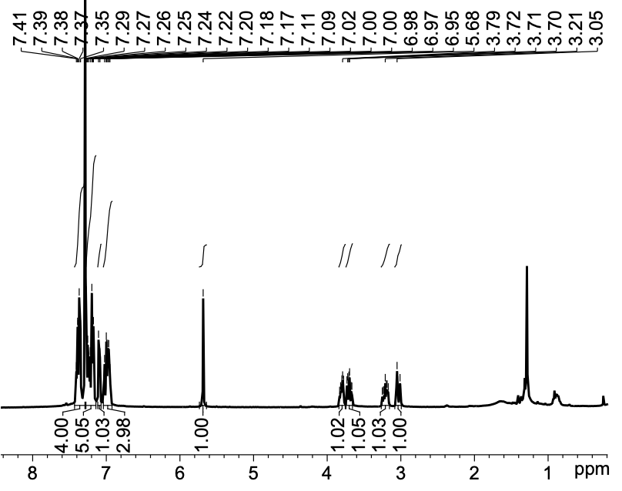
¹H NMR spectrum (400 MHz, CDCl₃, 298 K) of Compound 3d

¹³C NMR spectrum (101 MHz, CDCl₃, 298 K) of Compound 3d

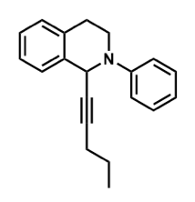
¹H NMR spectrum (400 MHz, CDCl₃, 298 K) of Compound 3e
¹³C NMR spectrum (101 MHz, CDCl₃, 298 K) of Compound 3e

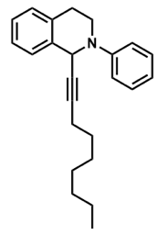
¹H NMR spectrum (400 MHz, CDCl₃, 298 K) of Compound 3f
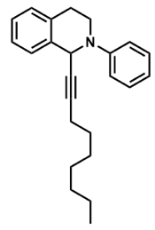
¹³C NMR spectrum (101 MHz, CDCl₃, 298 K) of Compound 3f
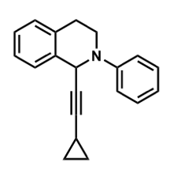
¹H NMR spectrum (400 MHz, CDCl₃, 298 K) of Compound 3g
¹³C NMR spectrum (101 MHz, CDCl₃, 298 K) of Compound 3g

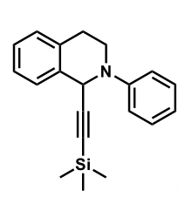
¹H NMR spectrum (400 MHz, CDCl₃, 298 K) of Compound 3h
¹³C NMR spectrum (101 MHz, CDCl₃, 298 K) of Compound 3h

References
(1) Wei, R.-J.; Zhou, H.-G.; Zhang, Z.-Y.; Ning, G.-H.; Li, D. Copper (I)–Organic Frameworks for Catalysis: Networking Metal Clusters with Dynamic Covalent Chemistry. CCS Chem. 2021, 3 (7), 2045-2053.
(2) Kang, C.; Zhang, Z.; Wee, V.; Usadi, A. K.; Calabro, D. C.; Baugh, L. S.; Wang, S.; Wang, Y.; Zhao, D. Interlayer Shifting in Two-Dimensional Covalent Organic Frameworks. J. Am. Chem. Soc. 2020, 142 (30), 12995-13002.
(3) Wu, X.; Han, X.; Liu, Y.; Liu, Y.; Cui, Y. Control Interlayer Stacking and Chemical Stability of Two-Dimensional Covalent Organic Frameworks via Steric Tuning. J. Am. Chem. Soc. 2018, 140 (47), 16124-16133.
(4) Huang, T.; Long, M.; Huo, B. Competitive Binding to Cuprous Ions of Protein and BCA in the Bicinchoninic Acid Protein Assay. Open Biomed. Eng. J. 2010, 4, 271-278.
(5) Au - Desjardins, P.; Au - Hansen, J. B.; Au - Allen, M. Microvolume Protein Concentration Determination using the NanoDrop 2000c Spectrophotometer. JoVE 2009, (33), e1610.
(6) Zhi, Y.; Ma, S.; Xia, H.; Zhang, Y.; Shi, Z.; Mu, Y.; Liu, X. Construction of donor-acceptor type conjugated microporous polymers: A fascinating strategy for the development of efficient heterogeneous photocatalysts in organic synthesis. Appl. Catal. B Environ. 2019, 244, 36-44.
(7) Fu, W.; Guo, W.; Zou, G.; Xu, C. Selective trifluoromethylation and alkynylation of tetrahydroisoquinolines using visible light irradiation by Rose Bengal. J. Flurorine Chem. 2012, 140, 88-94.
(8) Kumar, G.; Verma, S.; Ansari, A.; Noor-ul, H. K.; Kureshy, R. I. Enantioselective cross dehydrogenative coupling reaction catalyzed by Rose Bengal incorporated-Cu (I)-dimeric chiral complexes. Catal. Commun. 2017, 99, 94-99.
(9) Marset, X.; Pérez, J. M.; Ramón, D. J. Cross-dehydrogenative coupling reaction using copper oxide impregnated on magnetite in deep eutectic solvents. Green Chem. 2016, 18 (3), 826-833.
(10) Li, Z.; Li, C.-J. Catalytic enantioselective alkynylation of prochiral sp3 C− H bonds adjacent to a nitrogen atom. Org. Lett. 2004, 6 (26), 4997-4999.
(11) Gröll, B.; Schaaf, P.; Schnürch, M. Improved simplicity and practicability in copper-catalyzed alkynylation of tetrahydroisoquinoline. Monatsh. Chem. 2017, 148, 91-104.
(12) Boess, E.; Schmitz, C.; Klussmann, M. A comparative mechanistic study of Cu-catalyzed oxidative coupling reactions with N-phenyltetrahydroisoquinoline. J. Am. Chem. Soc. 2012, 134 (11), 5317-5325.
(13) Zhu, S.-S.; Liu, Y.; Chen, X.-L.; Qu, L.-B.; Yu, B. Polymerization-Enhanced Photocatalysis for the Functionalization of C (sp3)–H Bonds. ACS Cata. 2021, 12 (1), 126-134.
(14) Alonso, F.; Arroyo, A.; Martín-García, I.; Moglie, Y. Cross-Dehydrogenative Coupling of Tertiary Amines and Terminal Alkynes Catalyzed by Copper Nanoparticles on Zeolite. Adv. Synth. Catal. 2015, 357 (16-17), 3549-3561.
(15) Rueping, M.; Koenigs, R. M.; Poscharny, K.; Fabry, D. C.; Leonori, D.; Vila, C. Dual Catalysis: Combination of Photocatalytic Aerobic Oxidation and Metal Catalyzed Alkynylation Reactions—C-C Bond Formation Using Visible Light. Chem. Eur. J. 2012, 18 (17), 5170-5174.

