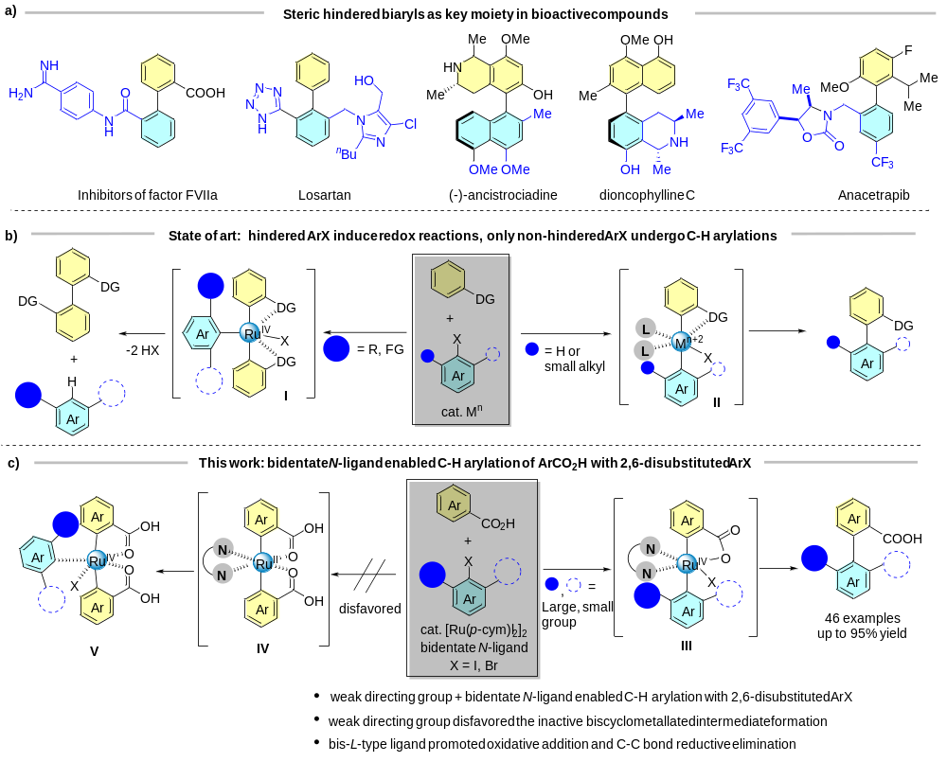
Scheme 1. (a) Steric hindered biaryls as key moiety in bioactive compounds; (b) State of art: steric hindered ArX induce redox reactions and non-steric hindered ArX undergo C–H arylation; (c) This work: bidentate N-ligand enabled C–H arylation of ArCO₂H with 2,6-disubstituted ArX.

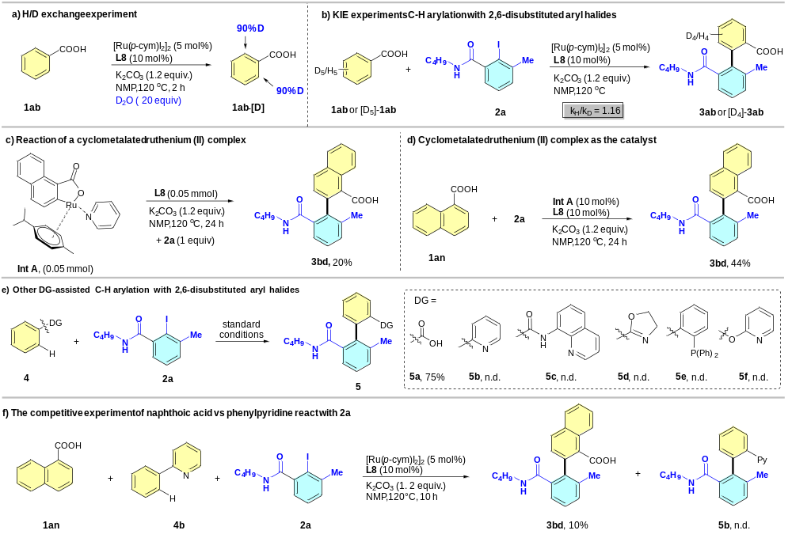
Scheme 2. Mechanistic studies and control experiments.

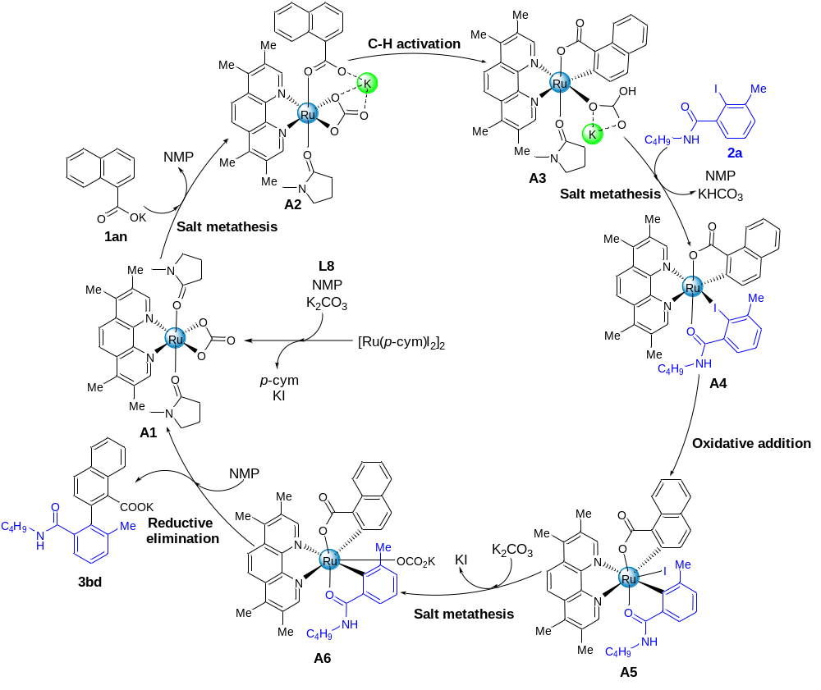
Scheme 3. Proposed reaction mechanism for [Ru(p-cym)I₂]₂ catalyzed carboxylate-assisted C−H arylation with 2,6-disubstituted aryl iodide.

