Table 1. Optimization of the reaction conditions for C–H arylation with 2,6-disubstituted aryl halide 2a.^{[a]}
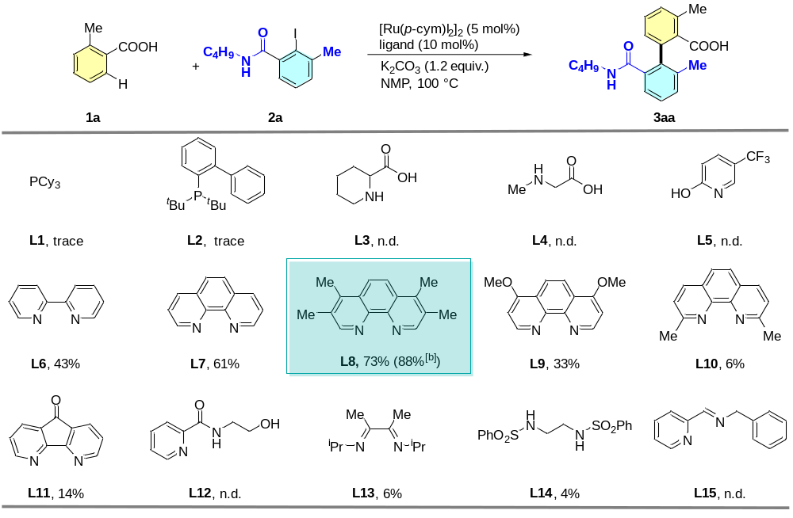
[a] Reaction conditions: 1a (0.1 mmol), 2a (0.15 mmol), [Ru(p-cym)I₂]₂ (5 mol%), ligand (10 mol%), K₂CO₃ (1.2 equiv), NMP (1.0 mL), 100 ºC, 24 h, N₂ atmosphere. Yields of the corresponding methyl esters determined by GC analysis after esterification with K₂CO₃ (2 equiv) and MeI (5 equiv.) in NMP using n-tetradecane as the internal standard. Yields of isolated products are given in parentheses. [b] At 120 ºC.

Table 2. Scope of 2,6-disubstituted aryl halides and (hetero)aromatic acids^{[a]}
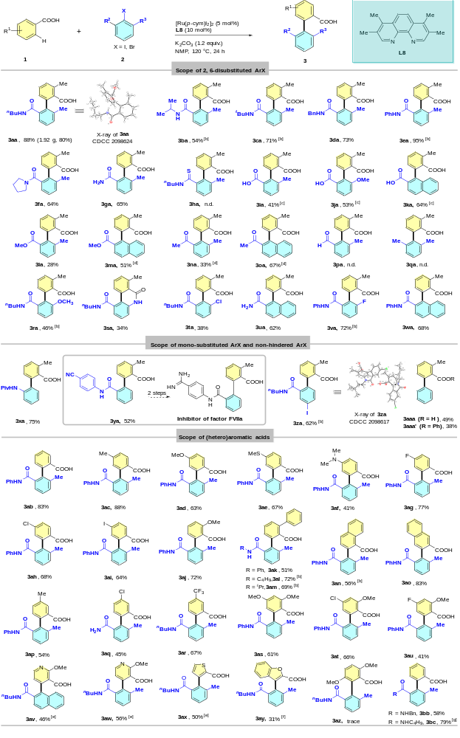
[a] Conditions: 2ka, 2ma, 2ra, 2ua, 2wa were coupled with aryl bromides, all other products were generated from aryl idodides. 1 (0.3 mmol), 2 (0.45 mmol), [Ru(p-cym)l₂]₂ (5 mol%), L8 (10 mol%), K₂CO₃ (1.2 equiv.) were stirred in NMP (2 mL at, 120 ºC for 24 h under an N₂ atmosphere. Yields correspond to the isolated amounts of methyl esters following in situ esterification with K₂CO₃ (2 equiv.) and MeI (5 equiv.). [b] Isolated as the free acid. [c] K₂CO₃ (3.0 equiv.). [d] Ru-cat (7.5 mol%), L8 (15 mol%), 130 ºC. [e] use Ru(p-cym)(dtbpy)Cl₂ (5 mol%) instead of [Ru(p-cym)l₂]₂ and dtbpy. [f] [Ru(p-cym)l₂]₂ (7.5 mol%), 4,4'-di-tert-butyl-2,2'-bipyridine (dtbpy) (15 mol%). [g] use Ru(p-cym)(L8)Cl₂ (10 mol%) instead of [Ru(p-cym)l₂]₂ (5 mol%) and L8 (10 mol%).

