Supplementary Information
Ligand Enabled ortho-Arylation of (hetero)Aromatic Acids with 2,6-Disubstituted Aryl Halides
Xianglin Luo^{†1}, Zhewei Li^{†2}, Yuzhen Zheng¹, Yueping Lin¹, Huanfeng Jiang¹, Lukas J. Gooßen,*³ Ming Lei,*² Liangbin Huang*¹
¹ School of Chemistry and Chemical Engineering, State Key Laboratory of Pulp & Paper Engineering, South China University of Technology, Guangzhou 510640, People’s Republic of China
² State Key Laboratory of Chemical Resource Engineering, Institute of Computational Chemistry, College of Chemistry, Beijing University of Chemical Technology, Beijing 100029 (China)
³ Ruhr-Universität Bochum Lehrstuhl für Organische Chemie, Universitätsstraße 150, 44801 (Bochum)
*Corresponding author. Email: huanglb@scut.edu.cn; leim@mail.buct.edu.cn; lukas.goossen@ruhr-uni-bochum.de
[†] These authors contributed equally to this work.

Table of Contents
1. General Information S2
2. Optimization of Reaction Conditions S3
3. Methods for the Synthesis of 2,6-Disubstituted Aryl Halides S6
4. General Procedures for Carboxylic Acid Directed Arylation with Sterically Hindered Aryl Halides S10
5. Analysis Data for the Products S11
6. Gram Scale Experiment S26
7. Control Experiments and and Mechanistic Studies S26
8. Single Crystal Structure and Data S33
9. Copies of NMR Spectrums S43
10. Details of DFT Calculations S109
11. References...................................................................................................................................................................................S200

1. General Information
Reagents
All compounds were used as received unless otherwise noted.
Metals: All metal catalysts were stored and handled in a nitrogen-filled glovebox. RuCl₃, [Ru(p-cym)I₂]₂ and [Ru(p-cym)Cl₂]₂ were purchased from Laajoo and used as received. Other metal catalysts were palladium acetate (Bidepharm), silver carbonate (Energy Chemical.) and silver acetate (Energy Chemical).
Ligands: L1-L23 were commercially available, L24-L30 were synthesized as according to the corresponding literatures. ^{[1-5]}
Additives: Tetrabutylammonium bromide was purchased from Bidepharm, other additives tested were tetrabutylammonium iodide (Bidepharm), tetrabutylammonium fluoride (Bidepharm), potassium fluoride (Energy Chemical), potassium bromide (Energy Chemical), potassium iodide (Energy Chemical), silver fluoride (Innochem), cesium fluoride (Energy Chemical), zinc fluoride (Innochem), lithium fluoride (Energy Chemical), cesium carbonate (Bidepharm), potassium carbonate (Tianjin beilian), potassium acetate (Energy Chemical).
Solvents: The solvent N-methylpyrrolidone (NMP) and hexafluoroisopropanol (HFIP), 1,4-dioxane, N,N-dimethylformamide (DMF) and toluene were purchased from Energy Chemical.
Aromatic carboxylic acids and others aromatic rings: All carboxylic acids were purchased from Energy Chemical and used as received without further purification. Other aromatic rings containing various directing groups tested were 1,1'-biphenyl]-2-yldiphenylphosphane, 2-phenylpyridine (Energy Chemical), 1-phenyl-1H-pyrazole (Bidepharm), 2-phenyl-4,5-dihydrooxazole (Bidepharm). N-(quinolin-8-yl)benzamide was synthesized as according to the corresponding literature.
Aryl halide: 2l-m were commercially available, other 2,6-disubstituted aryl halides were prepared according the reported procedures.^{[6]}
Other Reagents: Acetic acid was purchased from Energy Chemical.
NMR Spectroscopy
¹H Nuclear magnetic resonance (NMR) spectroscopy chemical shifts were reported in ppm and referenced to TMS (tetramethylsilane) in CDCl₃ (δ = 0 ppm) or the residual solvent peak for CDCl₃ (δ = 7.26 ppm) or (CD₃)₂SO (δ = 2.50 ppm). For ¹³C NMR chemical shifts, the residual solvent peak (CDCl₃, δ = 77.00 ppm) or (CD₃)₂SO (δ = 39.60 ppm) were used as references. NMR spectra was recorded on Avance Bruker NMR spectrometers operating at either 400 MHz or 500 MHz and data analysis was performed using the MestReNova software. Chemical shifts were reported in parts per million (ppm), multiplicities were indicated by s (singlet), d (doublet), t (triplet), q (quartet), m (multiplet) and br (broad). Coupling constants (J) were reported in Hertz.
Gas Chromatography
GC analysis was performed on an Agilent 7890B GC equipped with HP-5 columns (30 m × 320 μm × 0.25 μm), FID detectors, and hydrogen as the carrier gas. A sample volume of 1 μL was injected at a temperature of 250 °C and a 15:1 split ratio. The initial inlet pressure was 2.7 psi but varied as the column flow was heated constant at 1 mL/min for the duration of the run. The initial oven temperature of 60 °C was heated for 0 min followed by a temperature ramp of 50 °C/min up to 300 °C. The temperature was heated at 300 °C for 6 min. The total run time was 10.8 min and the FID temperature was 300 °C.
GC/MS Analysis
GC/MS analyses were performed on a Shimadzu GCMS-QP2010SE equipped with an RTX-5MS column (30 m × 0.25 mm × 0.25 μm) with a quadrupole mass analyzer using helium as the carrier gas. The analysis method used in all cases was 5 μL injection of sample, an injection temp of 250 ºC, and no split ratio. The initial inlet pressure was 7.8 psi, but varied as the column flow was heated constant at 1.7 mL/min for the duration of the run. The interface temperature was heated at 250 ºC, and the ion source (EI+, 30 eV) was heated at 250 ºC. The initial oven temperature was heated at 50 ºC for 1 min with the detector off, followed by a temperature ramp, with the detector on, to 250 ºC at 30 ºC/min. The temperature was heated at 250 ºC for 5 min, then to 280 ºC and heated for 11 min. Total run time was 25.17 min.
High Resolution Mass Spectrometry
HRMS spectra was acquired using an Agilent 6210 ESI/TOF mass spectrometer and a Thermo MAT 95XP double-focusing magnetic sector analyzer (EI, 70 eV).
Thin Layer / Column Chromatography
Thin layer chromatography was performed on TLC Silica Gel 60 F254 plates. Visualization was accomplished with potassium permanganate after inspection under UV light. Flash chromatography was performed using silica gel 60, particle size 0.040-0.063 mm using standard flash techniques.

2. Optimization of Reaction Conditions
Table S1. Classical reaction conditions were tested for this carboxylate directed C-H arylation with 2a.^{[a]}
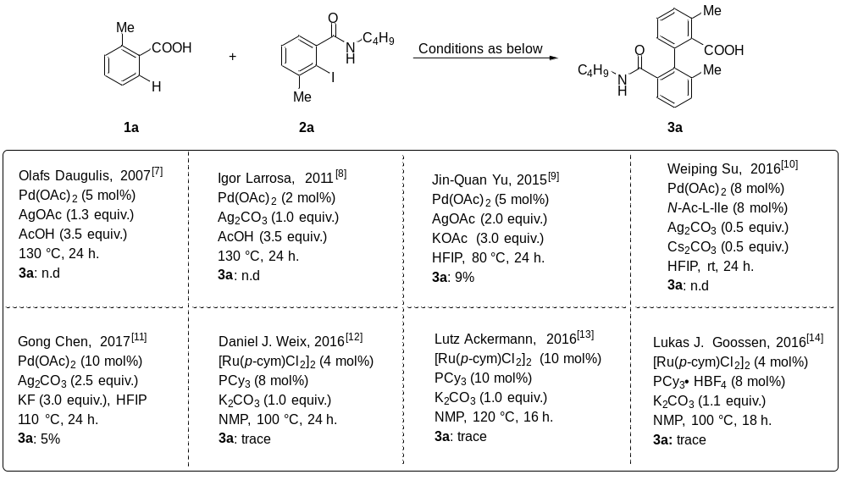
[a] Reaction conditions: 1a (0.1 mmol), 2a (0.15 mmol) under the above reaction conditions. Yields of the corresponding methyl esters were determined by GC analysis after esterification with K₂CO₃ (2.0 equiv.) and MeI (5.0 equiv.) in NMP using n-tetradecane as the internal standard.
Table S2. Screening of the Ligands for C-H arylation of ortho-methyl benzoic acid.^{[a]}
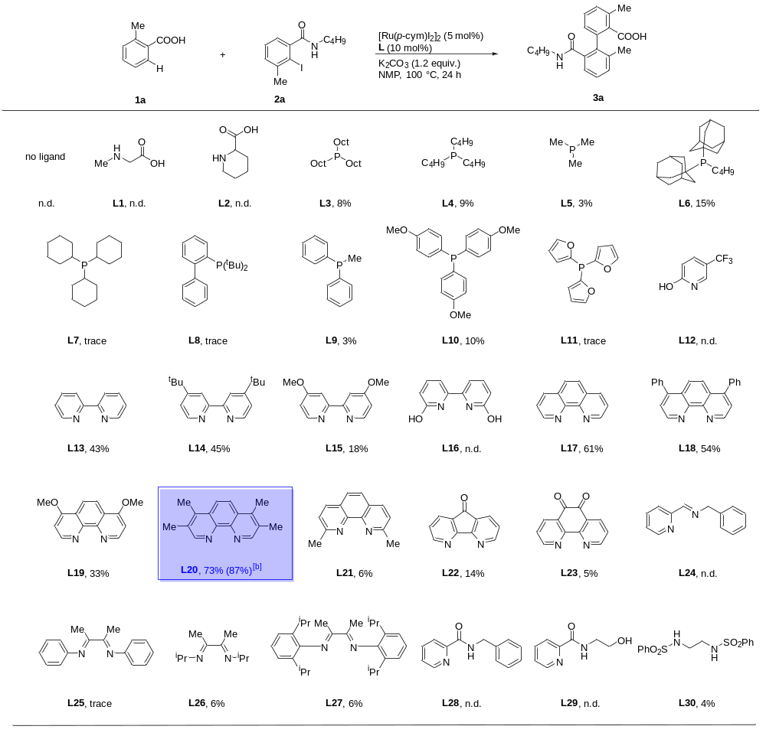
[a] Reaction conditions: 1a (0.1 mmol), 2a (0.15 mmol), [Ru(p-cym)I₂]₂ (5 mol%), L (10 mol%), K₂CO₃ (1.2 equiv.), NMP (1.0 mL), 100 ºC, 24 h, N₂ atmosphere. Yields of the corresponding methyl esters were determined by GC analysis after esterification with K₂CO₃ (2.0 equiv.) and MeI (5.0 equiv.) in NMP using n-tetradecane as the internal standard. [b] 120 ºC.
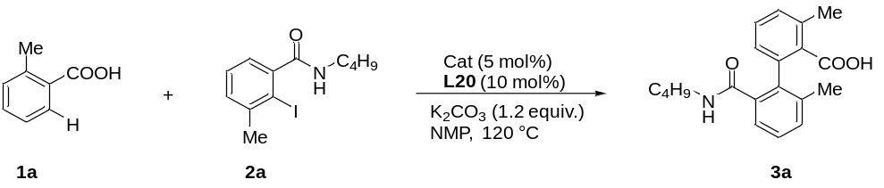Table S3. Screening of Ru-catalysts for C-H arylation of ortho-methyl benzoic acid.^{[a]}
Entry | Cat | Yield of 3a (%)
1 | [Ru(p-cym)I₂]₂ | 84
2 | [Ru(p-cym)Cl₂]₂ | 81
3 | RuCl₃ | n.d.
[a] Reaction conditions: 1a (0.1 mmol), 2a (0.15 mmol), cat (5 mol%), L20 (10 mol%), K₂CO₃ (1.2 equiv.), NMP (1.0 mL), 120 ºC, 24 h, N₂ atmosphere. Yields of the corresponding methyl esters were determined by GC analysis after esterification with K₂CO₃ (2.0 equiv.) and MeI (5.0 equiv.) in NMP using n-tetradecane as the internal standard.

Table S4. Screening of solvents for C-H arylation of ortho-methyl benzoic acid.^{[a]}

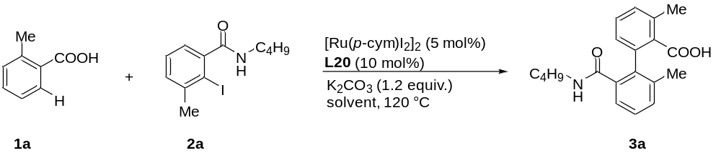
Entry | Solvent | Yield of 3a (%)
1 | NMP | 84
2 | 1,4-dioxane | trace
3 | DMF | trace
4 | toluene | 67
[a] Reaction conditions: 1a (0.1 mmol), 2a (0.15 mmol), [Ru(p-cym)I₂]₂ (5 mol%), L20 (10 mol%), K₂CO₃ (1.2 equiv.), solvent (1.0 mL), 120 ºC, 24 h, N₂ atmosphere. Yields of the corresponding methyl esters were determined by GC analysis after esterification with K₂CO₃ (2.0 equiv.) and MeI (5.0 equiv.) in NMP using n-tetradecane as the internal standard.

3. Methods for the Synthesis of 2,6-Disubstituted Aryl Halides

Typical Procedure I: Synthesis of 2-Amido-6-Substituted Aryl Halides

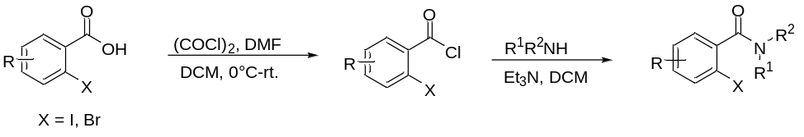
To a solution of benzoic acid (1.0 equiv.) in CH₂Cl₂ was added oxalyl chloride (1.5 equiv.) and DMF (9.5 mol%). Stirring was continued until the solid disappeared. The volatile was removed under reduced pressure. Then CH₂Cl₂ was added followed by addition of amine (1.0 equiv.) and triethylamine (1.0 equiv.). After being stirred at room temperature for another one hour, the mixture was quenched with water and saturated aqueous NaHCO₃, and the aqueous phase was extracted with ethyl acetate. The combined organic phase was dried over Mg₂SO₄. The reaction mixture was concentrated and purified by column chromatography to afford the desired product.

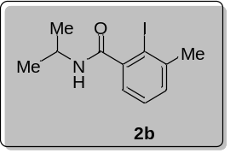
2-Iodo-N-isopropyl-3-methylbenzamide (2b)
Following the typical procedure I, 2-iodo-3-methylbenzoic acid (785.9 mg, 3.0 mmol), oxalyl chloride (387.0 µL, 4.5 mmol), DMF (22.0 μL, 0.285 mmol), triethylamine (417.0 µL, 3.0 mmol), propan-2-amine (177.0 mg, 3.0 mmol), CH₂Cl₂ (6.0 mL) were used. The product 2b (772.0 mg, 85% yield) was obtained. Physical state: white solid; MP = 135 – 137 ºC; ¹H NMR (500 MHz, CDCl₃) δ 7.25 – 7.21 (m, 2H), 7.10 – 7.06 (m, 1H), 5.63 (s, 1H), 4.31 – 4.23 (m, 1H), 2.47 (s, 3H), 1.27 (d, J = 6.6 Hz, 6H); ¹³C NMR (125 MHz, CDCl₃) δ 169.5, 144.1, 142.7, 130.2, 128.0, 124.9, 99.2, 42.0, 29.1, 22.5 (2C); ESI-HRMS (m/z): [M+H]⁺calcd for C₁₁H₁₄INO, 304.0193, found: 304.0195.

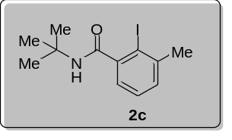
N-(Tert-butyl)-2-iodo-3-methylbenzamide（2c）
Following the typical procedure I, 2-iodo-3-methylbenzoic acid (523.9 mg, 2.0 mmol), oxalyl chloride (258.0 µL, 3.0 mmol), DMF (15.0 μL, 0.19 mmol), triethylamine (278.0 µL, 2.0 mmol), 2-methylpropan-2-amine (146.0 mg, 2.0 mmol), CH₂Cl₂ (6.0 mL) were used. The product 2c (486.0 mg, 77% yield) was obtained. Physical state: white solid; MP = 126 – 128 ºC; ¹H NMR (500 MHz, CDCl₃) δ 7.22 (d, J = 4.8 Hz, 2H), 7.09 (t, J = 4.5 Hz, 1H), 5.53 (s, 1H), 2.47 (s, 3H), 1.47 (s, 9H); ¹³C NMR (125 MHz, CDCl₃) δ 169.6, 144.7, 142.6, 130.0, 128.0, 124.8, 99.2, 52.1, 29.1 (3C), 28.7; ESI-HRMS (m/z): [M+H]⁺calcd for C₁₂H₁₆INO, 318.0349, found: 318.0352.

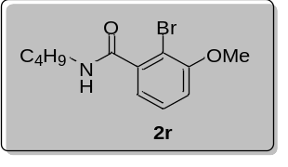
N-Butyl-2-iodo-3-methoxybenzamide (2r)
Following the typical procedure I, 2-bromo-3-methoxybenzoic acid (459.9 mg, 2.0 mmol), oxalyl chloride (258.0 µL, 3.0 mmol), DMF (15.0 μL, 0.19 mmol), triethylamine (278.0 µL, 2.0 mmol), N-butylamine (146.0 mg, 2.0 mmol), CH₂Cl₂ (6.0 mL) were used. The product 2r (359.0 mg, 63% yield) was obtained. Physical state: white solid; MP = 99 – 101 ºC; ¹H NMR (400 MHz, CDCl₃) δ 7.18 (t, J = 7.6 Hz, 1H), 6.90 (d, J = 7.4 Hz, 1H), 6.84 (d, J = 8.1 Hz, 1H), 6.27 (s, 1H), 3.82 (s, 3H), 3.36 – 3.29 (m, 2H), 1.55 – 1.46 (m, 2H), 1.39 – 1.31 (m, 2H), 0.89 (t, J = 7.0 Hz, 3H); ¹³C NMR (100 MHz, CDCl₃) δ 167.6, 155.8, 140.0, 128.2, 120.5, 112.5, 108.9, 56.3, 39.5, 31.2, 19.9, 13.5; ESI-HRMS (m/z): [M+H]⁺calcd for C₁₂H₁₆BrNO₂, 286.0437, found: 286.0439.

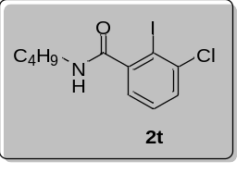
N-Butyl-3-chloro-2-iodobenzamide (2t)
Following the typical procedure I, 3-chloro-2-iodobenzoic acid (563.8 mg, 2.0 mmol), oxalyl chloride (258.0 µL, 3.0 mmol), DMF (15.0 μL, 0.19 mmol), triethylamine (278.0 µL, 2.0 mmol), N-butylamine (146.0 mg, 2.0 mmol), CH₂Cl₂ (6.0 mL) were used. The product 2t (438.0 mg, 65% yield) was obtained. Physical state: white solid; MP = 75 – 76 ºC; ¹H NMR (500 MHz, CDCl₃) δ 7.41 (d, J = 7.5 Hz, 1H), 7.23 (t, J = 7.4 Hz, 1H), 7.05 (d, J = 7.0 Hz, 1H), 6.37 (s, 1H), 3.34 (d, J = 6.2 Hz, 2H), 1.63 – 1.50 (m, 2H), 1.45 – 1.30 (m, 2H), 0.93 (t, J = 7.0 Hz, 3H); ¹³C NMR (125 MHz, CDCl₃) δ 169.2, 145.8, 139.6, 129.6, 129.2, 125.3, 97.1, 39.7, 31.1, 20.0, 13.6; ESI-HRMS (m/z): [M+H]⁺calcd for C₁₁H₁₃ClINO, 337.9803, found: 337.9808.

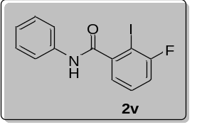
3-Fluoro-2-iodo-N-phenylbenzamide (2v)
Following the typical procedure I, 3-fluoro-2-iodobenzoic acid (531.8 mg, 2.0 mmol), oxalyl chloride (258.0 µL, 3.0 mmol), DMF (15.0 μL, 0.19 mmol), triethylamine (278.0 µL, 2.0 mmol), aniline (186.0 mg, 2.0 mmol), CH₂Cl₂ (6.0 mL) were used. The product 2v (612.0 mg, 90% yield) was obtained. Physical state: white solid; MP = 156 – 158 ºC; ¹H NMR (500 MHz, CDCl₃) δ 7.70 – 7.59 (m, 3H), 7.40 – 7.34 (m, 3H), 7.27 (d, J = 9.1 Hz, 1H), 7.18 (t, J = 7.4 Hz, 1H), 7.12 (t, J = 7.9 Hz, 1H); ¹³C NMR (125 MHz, CDCl₃) δ 166.2, 161.8 (d, J = 246 Hz), 144.2, 137.3, 130.4 (d, J = 8.0 Hz), 129.1 (2C), 125.1 (2C), 123.9, 120.2, 116.9 (d, J = 24.6 Hz), 81.1 (d, J = 27.4 Hz); ¹⁹F NMR (470 MHz, CDCl₃) δ -88.7 (t, J = 4.7 Hz, 1F); ESI-HRMS (m/z): [M+H]⁺calcd for C₁₃H₉FINO, 341.9786, found: 341.9788.

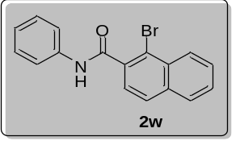
1-Bromo-N-phenyl-2-naphthamide (2w)
Following the typical procedure I, 1-bromo-2-naphthoic acid (1.5 g, 6.0 mmol), oxalyl chloride (774.0 µL, 9.0 mmol), DMF (44.0 μL, 0.57 mmol), triethylamine (417.0 µL, 3.0 mmol), aniline (558.0 mg, 6.0 mmol), CH₂Cl₂ (6.0 mL) were used. The product 2w (1.94 g, 99% yield) was obtained. Physical state: white solid; MP = 175 – 177 ºC; ¹H NMR (500 MHz, CDCl₃) δ 8.33 (d, J = 8.4 Hz, 1H), 7.81 (t, J = 8.2 Hz, 3H), 7.65 (t, J = 8.2 Hz, 3H), 7.58 (t, J = 7.4 Hz, 1H), 7.54 (d, J = 8.2 Hz, 1H), 7.36 (t, J = 7.8 Hz, 2H), 7.17 (t, J = 7.4 Hz, 1H); ¹³C NMR (125 MHz, CDCl₃) δ 166.6, 137.6, 136.2, 134.7, 131.8, 129.1, 128.4 (2C), 128.3, 128.2 (2C), 127.9, 127.8, 125.0, 124.9, 120.1, 119.9; ESI-HRMS (m/z): [M+H]⁺calcd for C₁₇H₁₂BrNO, 326.0175, found: 326.0177.

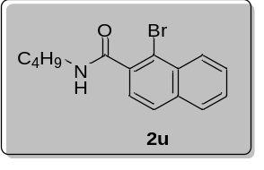
1-Bromo-N-butyl-2-naphthamide (2u)
Following the typical procedure I, 1-bromo-2-naphthoic acid (749.9 mg, 3.0 mmol), oxalyl chloride (387.0 µL, 4.5 mmol), DMF (22.0 μL, 0.285 mmol), triethylamine (417.0 µL, 3.0 mmol), N-butylamine (219.0 mg, 3.0 mmol), CH₂Cl₂ (6.0 mL) were used. The product 2u (862.0 mg, 94% yield) was obtained; Physical state: white solid; MP = 124 – 126 ºC; ¹H NMR (500 MHz, CDCl₃) δ 8.26 (d, J = 8.4 Hz, 1H), 7.75 (d, J = 7.9 Hz, 1H), 7.69 (d, J = 8.0 Hz, 1H), 7.58 (t, J = 7.6 Hz, 1H), 7.52 (t, J = 7.4 Hz, 1H), 7.38 – 7.31 (m, 1H), 6.28 (s, 1H), 3.45 – 3.35 (m, 2H), 1.61 – 1.53 (m, 2H), 1.44 – 1.36 (m, 2H), 0.93 (t, J = 7.3 Hz, 3H); ¹³C NMR (125 MHz, CDCl₃) δ 168.5, 136.5, 134.3, 131.7, 128.1, 128.0, 127.9, 127.7, 127.3, 125.0, 119.5, 39.7, 31.3, 20.1, 13.7; ESI-HRMS (m/z): [M+H]⁺calcd for C₁₅H₁₆BrNO, 306.0488, found: 306.0487.

Typical procedure II: synthesis of 2-methyl-6-acetylaryl halide derivative
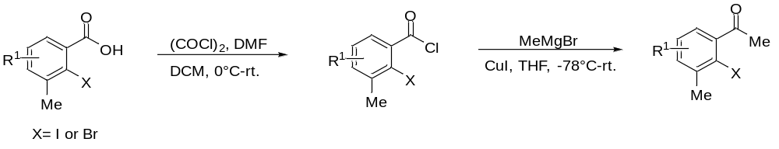
Oxalyl chloride (1.1 equiv.) was added dropwise to a solution of benzoic acid (1.0 equiv.) and DMF (one drop) in dry DCM at 0 ºC, then the reaction mixture was warmed to rt and stirred for 2 h. The mixture was concentrated in vacuum, and the residue was dissolved in dry THF, then CuI (1.0 equiv.) was added. The reaction mixture was cooled to -78 ºC, and Grignard reagent (1.2 equiv.) was added dropwise, then the mixture was warmed to rt and stirred for another 2 h. Saturated aqueous solution of NH₄Cl was added to the mixture and the organic layer was separated. The aqueous layer was extracted with EtOAc. The combined organic layer was washed with brine, dried over Na₂SO₄, filtered and concentrated in vacuo. The residue was purified by column chromatography on silica gel to give the ketones.
Typical procedure III: synthesis of 3-amino-N-butyl-2-iodobenzamide
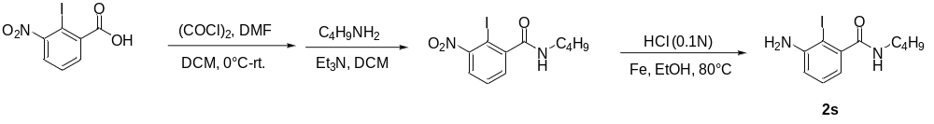
To a solution of 2-iodo-3-nitrobenzoic acid (585.8 mg, 2 mmol) in CH₂Cl₂ was added oxalyl chloride (1.5 equiv.) and DMF (9.5 mol%). Stirring was continued until the solid disappeared. The volatile was removed under reduced pressure. Then CH₂Cl₂ was added followed by addition of butan-1-amine (146.0 mg, 2 mmol) and triethylamine (1.0 equiv.). After being stirred at room temperature for overnight, the mixture was quenched with water and saturated aqueous NaHCO₃, and the aqueous phase was extracted with ethyl acetate. The combined organic phase was dried over Mg₂SO₄. The reaction mixture was concentrated and purified by column chromatography to afford the corresponding amide product (600.5 mg, 86% yield). Then add iron powder (3.0 equiv.), followed by HCl (0.1 N, 1.0 mL/mmol) to a solution of ethanol. Stir the resulting mixture vigorously at 80 ºC (oil bath) for 40 minutes. And TLC analysis reveals that the reduction reaction is complete. Followed wash the filtrate with saturated aqueous Na₂CO₃ and extract the aqueous phase with EtOAc, the reaction mixture was concentrated and purified by column chromatography to afford the desired product 2s. reduction step of 2s was prepared according the reported procedures.^{[15]} Physical state: yellow solid; ¹H NMR (500 MHz, d⁶-DMSO) δ 8.19 (t, J = 5.8 Hz, 1H), 7.06 (t, J = 7.7 Hz, 1H), 6.76 (d, J = 8.0 Hz, 1H), 6.43 (d, J = 7.2 Hz, 1H), 5.34 (s, 2H), 3.17 (q, J = 6.6 Hz, 2H), 1.50 (p, J = 7.2 Hz, 2H), 1.37 (p, J = 7.3 Hz, 2H), 0.91 (t, J = 7.3 Hz, 3H); ¹³C NMR (125 MHz, d⁶-DMSO) δ 170.2, 149.2, 145.4, 129.0, 115.8, 114.4, 82.6, 39.0, 31.5, 20.2, 14.2; ESI-HRMS (m/z): [M+H]⁺calcd for C₁₁H₁₆IN₂O₄, 319.0302, found: 319.0298.

Typical procedure IV: synthesis of methyl-2-methyl-6-carboxylate iodobenzene derivative
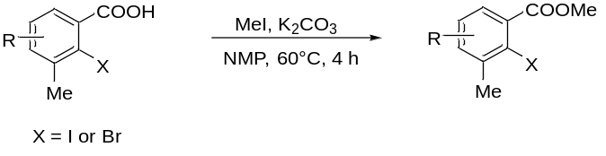
To a solution of the corresponding carboxylic acid (2 mmol) and iodomethane (5.0 equiv.) in NMP was added K₂CO₃ (2.0 equiv.). The resulting mixture was stirred at 60 ºC for 4 h. Water (10 mL) was added to the reaction mixture. And the resulting solution was extracted with ethyl acetate (3 × 10 mL). The organic layer was combined and washed with water to remove any remaining NMP and dried over anhydrous MgSO₄. The solvent was removed under vacuum and the residue was purified by flash column chromatography on silica gel using (petroleum ether: ethyl acetate = 20:1) to give the title compound as white solid.

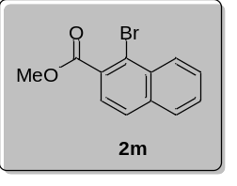
Methyl-1-iodo-2-naphthoate (2m)
Following the typical procedure III, 1-bromo-2-naphthoic acid (499.9 mg, 2.0 mmol), iodomethane (10.0 mmol), K₂CO₃ (4.0 mmol), NMP was used. The product 2m (476.0 mg, 90% yield) was obtained. Physical state: white solid; MP = 54 – 56 ºC; ¹H NMR (500 MHz, CDCl₃) δ 8.41 (d, J = 8.5 Hz, 1H), 7.80 – 7.76 (m, 2H), 7.64 (d, J = 8.5 Hz, 1H), 7.61 – 7.57 (m, 1H), 7.55 (dd, J = 11.0, 3.9 Hz, 1H), 3.98 (s, 3H); ¹³C NMR (125 MHz, CDCl₃) δ 167.7, 135.0, 132.2, 131.1, 128.4, 128.1 (2C), 128.0, 127.7, 125.6, 122.5, 52.6; ESI-HRMS (m/z): [M+H]⁺calcd for C₁₂H₉BrO₂, 264.9859, found: 264.9861.

4. General Procedures for Carboxylic Acid Directed Arylation with 2,6-Disubstituted Aryl Halides.
Procedure A: An oven-dried 4 mL vessel was charged with the carboxylic acid 1 (0.3 mmol, 1.0 equiv.), 2,6-disubstituted aryl halides 2 (1.5 equiv.), [Ru(p-cym)I₂]₂ (14.7 mg, 5 mol%), K₂CO₃ (49.7 mg, 1.2 equiv.), after flushing the vessel with 3 alternating vacuum and nitrogen purge cycles, 3,4,7,8-tetramethyl-1,10-phenanthroline (7.1 mg, 10 mol%), NMP (2.0 mL), the resulting mixture was stirred at 120 °C for 24 h. After the reaction was complete, the mixture was allowed to cool to rt. K₂CO₃ (0.6 mmol) and MeI (1.5 mmol) were added and the mixture was stirred at 60 °C for another 2 h. The mixture was allowed to cool to RT, brine (20.0 mL), saturated sodium chloride solution was added and the resulting mixture was extracted with ethyl acetate (3× 20 mL). The combined organic layers were dried over MgSO₄, filtered, and the volatiles were removed under reduced pressure. The residue was purified by column chromatography (petroleum ether/ethyl acetate) yielding the arylation production in the form of its methyl ester.
Procedure B: An oven-dried 4 mL vessel was charged with the carboxylic acid 1 (0.3 mmol, 1.0 equiv.), 2,6-disubstituted aryl halides 2 (1.5 equiv.), [Ru(p-cym)l₂]₂ (22 mg, 7.5 mol%), K₂CO₃ (49.7 mg, 1.2 equiv.), after flushing the vessel with 3 alternating vacuum and nitrogen purge cycles, 3,4,7,8-tetramethyl 1,10-phenanthroline (10.6 mg, 15 mol%), NMP (2.0 mL), the resulting mixture was stirred at 130 °C for 24 h. Others were the same as procedure A.
Procedure C: An oven-dried 4 mL vessel was charged with the carboxylic acid 1 (0.3 mmol, 1.0 equiv.), 2,6-disubstituted aryl halides 2 (1.5 equiv.), [Ru(p-cym)l₂]₂ (22 mg, 7.5 mol%), K₂CO₃ (49.7 mg, 1.2 equiv.), after flushing the vessel with 3 alternating vacuum and nitrogen purge cycles, 4,4'-di-tert-butyl-2,2'-bipyridine (dtbpy) (12 mg, 15 mol%), NMP (2.0 mL), the resulting mixture was stirred at 120 °C for 24 h. Others were the same as procedure A.
Procedure D: An oven-dried 4 mL vessel was charged with the carboxylic acid 1 (0.3 mmol, 1.0 equiv.), 2,6-disubstituted aryl halides 2 (1.5 equiv.), [Ru(p-cym)l₂]₂ (14.7 mg, 5 mol%), K₂CO₃ (124.2 mg, 3.0 equiv.), after flushing the vessel with 3 alternating vacuum and nitrogen purge cycles, 3,4,7,8-tetramethyl 1,10-phenanthroline (7.1 mg, 10 mol%), NMP (2.0 mL), the resulting mixture was stirred at 120 °C for 24 h. Others were the same as procedure A.

5. Analysis Data for the Products
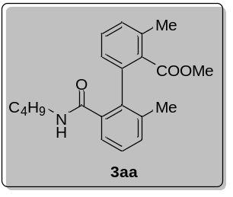
Methyl-2'-(butylcarbamoyl)-3,6'-dimethyl-[1,1'-biphenyl]-2-carboxylate (3aa)
Compound 3aa was prepared following procedure A, starting from 2-methylbenzoic acid (40.8 mg, 0.3 mmol) and N-butyl-2-iodo-3-methylbenzamide (142.7 mg, 0.45 mmol). After purification, 3aa was obtained as white solid (89.0 mg, 88% yield); MP = 65 – 67 ºC; ¹H NMR (400 MHz, CDCl₃) δ 7.44 (d, J = 7.4 Hz, 1H), 7.35 (t, J = 7.6 Hz, 1H), 7.29 (d, J = 7.6 Hz, 1H), 7.26 – 7.21 (m, 2H), 7.02 (d, J = 7.6 Hz, 1H), 6.95 (s, 1H), 3.67 (s, 3H), 3.25 – 3.16 (m, 1H), 2.93 – 2.85 (m, 1H), 2.40 (s, 3H), 1.99 (s, 3H), 1.00 – 0.93 (m, 4H), 0.74 (t, J = 6.6 Hz, 3H); ¹³C NMR (100 MHz, CDCl₃) δ 171.0, 169.5, 138.0, 137.9, 136.2, 136.0, 134.9, 133.0, 130.8, 130.3, 129.5, 127.9, 127.0, 125.4, 52.2, 39.0, 31.1, 19.9, 19.8, 19.7, 13.7; ESI-HRMS (m/z): [M+H]⁺calcd for C₂₁H₂₆NO₃, 340.1907, found: 340.1907.

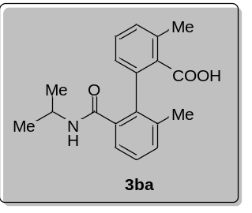
2'-(Isopropylcarbamoyl)-3,6'-dimethyl-[1,1'-biphenyl]-2-carboxylic acid (3ba)
Compound 3ba was prepared following procedure A, starting from 2-methylbenzoic acid (40.8 mg, 0.3 mmol) and 2-iodo-N-isopropyl-3-methylbenzamide (136.4 mg, 0.45 mmol). Methylation step did not run, and product was isolated as acid. After purification, 3ba was obtained as white solid (50.0 mg, 54% yield); MP = 180 – 182 ºC; ¹H NMR (500 MHz, CDCl₃) δ 7.31 (d, J = 7.4 Hz, 1H), 7.29 – 7.27 (m, 1H), 7.26 (s, 1H), 7.23 (d, J = 7.6 Hz, 2H), 6.74 (dd, J = 7.4, 1.4 Hz, 1H), 6.29 (d, J = 7.6 Hz, 1H), 4.02 – 3.91 (m, 1H), 2.44 (s, 3H), 2.00 (s, 3H), 1.13 (d, J = 6.6 Hz, 3H), 0.99 (d, J = 6.6 Hz, 3H); ¹³C NMR (125 MHz, CDCl₃) δ 171.5, 170.5, 138.3, 138.1, 135.5, 135.4, 135.0, 134.9, 132.4, 130.0, 129.1, 128.1, 125.2, 123.3, 42.4, 22.2, 22.1, 19.8, 19.7; ESI-HRMS (m/z): [M+H]⁺calcd for C₁₉H₂₂NO₃, 312.1594, found: 312.1597.

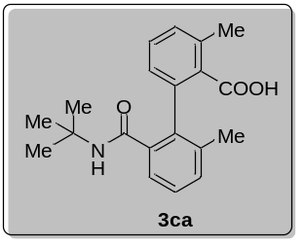
2'-(Tert-butylcarbamoyl)-3,6'-dimethyl-[1,1'-biphenyl]-2-carboxylic acid (3ca)
Compound 3ca was prepared following procedure A, starting from 2-methylbenzoic acid (40.8 mg, 0.3 mmol) and N-(tert-butyl)-2-iodo-3-methylbenzamide (142.7 mg, 0.45 mmol). Methylation step did not run, and product was isolated as acid. After purification, 3ca was obtained as white solid (69.0 mg, 71% yield); MP = 187 – 188 ºC; ¹H NMR (500 MHz, CDCl₃) δ 7.28 (m, 2H), 7.25 – 7.20 (m, 3H), 6.77 (d, J = 6.6 Hz, 1H), 6.25 (s, 1H), 2.43 (s, 3H), 2.00 (s, 3H), 1.21 (s, 9H); ¹³C NMR (125 MHz, CDCl₃) δ 172.0, 170.7, 138.0, 137.8, 135.9, 135.5, 135.4, 134.8, 132.0, 129.8, 129.0, 128.0, 125.3, 123.1, 52.5, 28.2 (3C), 19.8, 19.7; ESI-HRMS (m/z): [M+H]⁺calcd for C₂₀H₂₄NO₃, 326.1751, found: 326.1751.

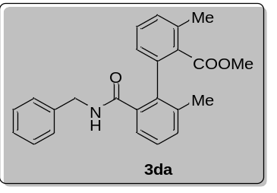
Methyl-2'-(benzylcarbamoyl)-3,6'-dimethyl-[1,1'-biphenyl]-2-carboxylate (3da)
Compound 3da was prepared following procedure A, starting from 2-methylbenzoic acid (40.8 mg, 0.3 mmol) and N-benzyl-2-iodo-3-methylbenzamide (158.0 mg, 0.45 mmol). After purification, 3da was obtained as white solid (82.0 mg, 73% yield); MP = 96 – 98 ºC; ¹H NMR (500 MHz, CDCl₃) δ 7.48 (d, J = 7.6 Hz, 1H), 7.36 (s, 1H), 7.34 – 7.27 (m, 2H), 7.23 (d, J = 7.6 Hz, 1H), 7.19 – 7.11 (m, 4H), 7.01 (d, J = 7.5 Hz, 1H), 6.74 (d, J = 7.0 Hz, 2H), 4.48 (dd, J = 14.6, 7.0 Hz, 1H), 4.04 (dd, J = 14.6, 3.9 Hz, 1H), 3.57 (s, 3H), 2.21 (s, 3H), 1.95 (s, 3H); ¹³C NMR (125 MHz, CDCl₃) δ 170.8, 169.4, 137.8, 137.6, 137.4, 136.3, 136.2, 135.2, 132.7, 131.0, 130.3, 129.6 (2C), 128.2, 127.9 (2C), 127.5, 126.8, 126.8, 125.6, 52.0, 43.6, 19.9, 19.7; ESI-HRMS (m/z): [M+H]⁺calcd for C₂₄H₂₄NO₃, 374.1751, found: 374.1754.

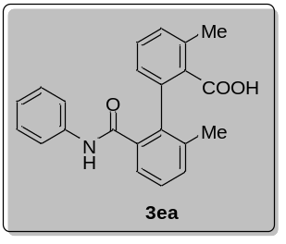
2',3-Dimethyl-6'-(phenylcarbamoyl)-[1,1'-biphenyl]-2-carboxylic acid (3ea)
Compound 3ea was prepared following procedure A, starting from 2-methylbenzoic acid (40.8 mg, 0.3 mmol) and 2-iodo-3-methyl-N-phenylbenzamide (152.0 mg, 0.45 mmol). Methylation step did not run, and product was isolated as acid. After purification, 3ea was obtained as white solid (98.0 mg, 95% yield); MP = 115 – 117 ºC; ¹H NMR (400 MHz, CDCl₃) δ 8.29 (d, J = 13.8 Hz, 1H), 7.46 (d, J = 7.4 Hz, 1H), 7.44 – 7.38 (m, 3H), 7.32 (m, 3H), 7.27 – 7.20 (m, 2H), 7.16 (t, J = 7.2 Hz, 1H), 6.82 (d, J = 6.8 Hz, 1H), 2.47 (s, 3H), 2.04 (s, 3H); ¹³C NMR (125 MHz, CDCl₃) δ 171.5, 170.3, 137.9, 137.9, 137.1 (2C), 136.0, 135.2, 134.9 (2C), 134.4, 132.5, 130.0, 129.7, 128.8, 128.0, 125.7, 125.0, 124.4, 120.6, 19.8, 19.7; ESI-HRMS (m/z): [M+H]⁺calcd for C₂₂H₂₀NO₃, 346.1438, found: 346.1440.

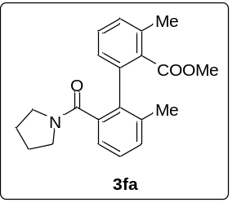
Methyl-2',3-dimethyl-6'-(pyrrolidine-1-carbonyl)-[1,1'-biphenyl]-2-carboxylate (3fa)
Compound 3fa was prepared following procedure A, starting from 2-methylbenzoic acid (40.8 mg, 0.3 mmol) and (2-iodo-3-methylphenyl)(pyrrolidin-1-yl)methanone (142.0 mg, 0.45 mmol). After purification, 3fa was obtained as colorless liquid (65.0 mg, 64% yield); ¹H NMR (400 MHz, CDCl₃) δ 7.32 (t, J = 7.6 Hz, 1H), 7.28 – 7.22 (m, 2H), 7.19 (d, J = 7.6 Hz, 1H), 7.12 (td, J = 6.6, 2.8 Hz, 2H), 3.56 (s, 3H), 3.37 – 3.16 (m, 3H), 2.40 (s, 3H), 2.07 (s, 3H), 1.81 – 1.68 (m, 4H); ¹³C NMR (100 MHz, CDCl₃) δ 169.1, 168.6, 137.7, 137.5, 137.4, 137.2, 135.9, 132.6, 129.9, 129.6, 129.1, 128.2, 127.1, 123.2, 51.3, 48.5, 45.1, 25.9, 24.3, 20.5, 20.3; ESI-HRMS (m/z): [M+H]⁺calcd for C₂₁H₂₄NO₃, 338.1751, found: 338.1745.

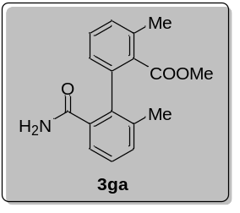
Methyl-2'-carbamoyl-3,6'-dimethyl-[1,1'-biphenyl]-2-carboxylate (3ga)
Compound 3ga was prepared following procedure A, starting from 2-methylbenzoic acid (40.8 mg, 0.3 mmol) and 2-iodo-3-methylbenzamide (118.0 mg, 0.45 mmol). After purification, 3ga was obtained as white solid (55.0 mg, 65% yield); MP = 128 – 130 ºC; ¹H NMR (500 MHz, CDCl₃) δ 7.50 (d, J = 7.2 Hz, 1H), 7.37 (t, J = 7.6 Hz, 1H), 7.31 (t, J = 7.6 Hz, 1H), 7.26 (m, 2H), 7.02 (d, J = 7.6 Hz, 1H), 6.84 (s, 1H), 5.43 (s, 1H), 3.64 (s, 3H), 2.40 (s, 3H), 1.99 (s, 3H); ¹³C NMR (125 MHz, CDCl₃) δ 171.8, 170.8, 137.9, 136.6, 136.5, 136.3, 135.2, 132.9, 131.4, 130.4, 129.7, 128.0, 127.0, 125.7, 52.1, 20.0, 19.8; ESI-HRMS (m/z): [M+H]⁺calcd for C₁₇H₁₈NO₃, 284.1281, found: 284.1285.

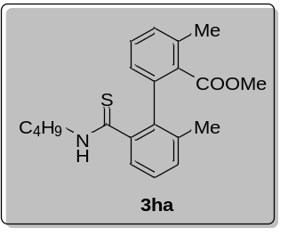
Methyl-2'-(butylcarbamothioyl)-3,6'-dimethyl-[1,1'-biphenyl]-2-carboxylate (3ha)
Compound 3ha was prepared following procedure A, starting from 2-methylbenzoic acid (40.8 mg, 0.3 mmol) and N-butyl-2-iodo-3-methylbenzothioamide (150.0 mg, 0.45 mmol). Unfortunately, this substrate had no product.

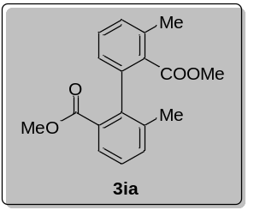
Dimethyl-3,6'-dimethyl-[1,1'-biphenyl]-2,2'-dicarboxylate (3ia)
Compound 3ia was prepared following procedure D, starting from 2-methylbenzoic acid (40.8 mg, 0.3 mmol) and 2-iodo-3-methylbenzamide (118.0 mg, 0.45 mmol). After purification, 3ia was obtained as colorless liquid (55.0 mg, 41% yield); ¹H NMR (500 MHz, CDCl₃) δ 7.70 (d, J = 7.8 Hz, 1H), 7.32 – 7.28 (m, 2H), 7.22 (t, J = 7.7 Hz, 1H), 7.14 (d, J = 7.6 Hz, 1H), 6.93 (d, J = 7.6 Hz, 1H), 3.54 (s, 3H), 3.36 (s, 3H), 2.32 (s, 3H), 1.96 (s, 3H); ¹³C NMR (125 MHz, CDCl₃) δ 169.3, 167.6, 140.6, 138.8, 137.9, 135.2, 133.3, 132.4, 130.4, 129.0, 128.9, 127.3, 126.6, 51.8, 51.4, 20.5, 20.0; ESI-HRMS (m/z): [M+H]⁺calcd for C₁₈H₁₉O₄, 299.1278, found: 299.1273.

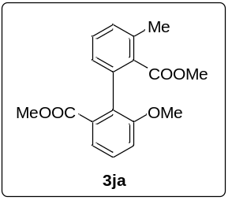
Dimethyl-6'-methoxy-3-methyl-[1,1'-biphenyl]-2,2'-dicarboxylate (3ja)
Compound 3ja was prepared following procedure D, starting from 2-methylbenzoic acid (40.8 mg, 0.3 mmol) and 2-iodo-3-methoxybenzoic acid (125.0 mg, 0.45 mmol). After purification, 3ja was obtained as colorless liquid (50.0 mg, 53% yield); ¹H NMR (400 MHz, CDCl₃) δ 7.52 – 7.50 (m, 1H), 7.40 – 7.36 (m, 1H), 7.35 – 7.31 (m, 1H), 7.22 – 7.20 (m, 1H), 7.08 (dd, J = 8.3, 1.1 Hz, 1H), 7.04 (d, J = 7.6 Hz, 1H), 3.72 (s, 3H), 3.60 (s, 3H), 3.48 (s, 3H), 2.43 (s, 3H); ¹³C NMR (100 MHz, CDCl₃) δ 169.2, 167.6, 157.0, 136.0, 135.5, 132.6, 131.8, 130.6, 129.3, 128.9, 128.4, 127.6, 121.8, 114.0, 56.1, 51.8, 51.3, 20.3; ESI-HRMS (m/z): [M+H]⁺calcd for C₁₈H₁₉O₅, 315.1227, found: 315.1219.

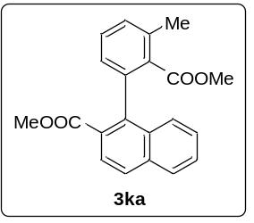
Methyl-1-(2-(methoxycarbonyl)-3-methylphenyl)-2-naphthoate (3ka)
Compound 3ka was prepared following procedure D, starting from 2-methylbenzoic acid (40.8 mg, 0.3 mmol) and methyl-1-iodo-2-naphthoate (140.0 mg, 0.45 mmol). After purification, 3ka was obtained as colorless liquid (64.0 mg, 64% yield); ¹H NMR (500 MHz, CDCl₃) δ 8.00 (d, J = 8.7 Hz, 1H), 7.90 - 7.88 (m, 2H), 7.55 - 7.52 (m, 1H), 7.48 – 7.38 (m, 3H), 7.33 (d, J = 7.7 Hz, 1H), 7.13 (d, J = 7.5 Hz, 1H), 3.69 (s, 3H), 3.26 (s, 3H), 2.47 (s, 3H); ¹³C NMR (125 MHz, CDCl₃) δ 169.0, 167.7, 140.4, 137.7, 135.6, 134.6, 133.2, 132.6, 129.5, 129.0, 127.9, 127.8, 127.8, 127.6, 127.5, 127.2, 126.5, 125.5, 52.0, 51.3, 20.2; ESI-HRMS (m/z): [M+H]⁺calcd for C₂₁H₁₉O₄, 335.1278, found: 335.1270.

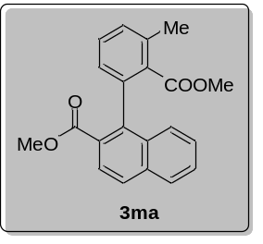
Methyl-1-(2-(methoxycarbonyl)-3-methylphenyl)-2-naphthoate (3ma)
Compound 3ma was prepared following procedure B, starting from 2-methylbenzoic acid (40.8 mg, 0.3 mmol) and methyl-1-bromo-2-naphthoate (119.0 mg, 0.45 mmol). After purification, 3ma was obtained as colorless liquid (51.0 mg, 51% yield); ¹H NMR (500 MHz, CDCl₃) δ 7.99 (d, J = 8.6 Hz, 1H), 7.91 – 7.84 (m, 2H), 7.53 (t, J = 7.0 Hz, 1H), 7.46 – 7.37 (m, 3H), 7.32 (d, J = 8.6 Hz, 1H), 7.10 (d, J = 8.0 Hz, 1H), 3.67 (s, 3H), 3.25 (s, 3H), 2.46 (s, 3H); ¹³C NMR (125 MHz, CDCl₃) δ 169.0, 167.7, 140.4, 137.8, 135.7, 134.6, 133.2, 132.7, 129.5, 129.0, 127.9, 127.8, 127.8, 127.6, 127.5, 127.2, 126.5, 125.5, 51.9, 51.3, 20.2; ESI-HRMS (m/z): [M+H]⁺calcd for C₂₁H₁₉O₄, 335.1278, found: 335.1277.

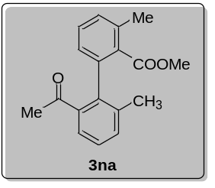
Methyl-2'-acetyl-3,6'-dimethyl-[1,1'-biphenyl]-2-carboxylate (3na)
Compound 3na was prepared following procedure B, starting from 2-methylbenzoic acid (40.8 mg, 0.3 mmol) and 1-(2-iodo-3-methylphenyl)ethan-1-one (117.0 mg, 0.45 mmol). After purification, 3na was obtained as colorless liquid (28.0 mg, 33% yield); ¹H NMR (500 MHz, CDCl₃) δ 7.50 (d, J = 7.6 Hz, 1H), 7.39 – 7.32 (m, 2H), 7.32 – 7.27 (m, 1H), 7.24 (d, J = 7.6 Hz, 1H), 7.03 (d, J = 7.6 Hz, 1H), 3.48 (s, 3H), 2.39 (s, 3H), 2.10 (s, 3H), 2.04 (s, 3H); ¹³C NMR (125 MHz, CDCl₃) δ 202.3, 169.2, 140.0, 138.1, 137.4, 135.7, 132.6, 129.5, 129.3, 128.8, 127.5, 127.5, 127.0, 125.6, 51.4, 29.7, 20.3, 19.9; ESI-HRMS (m/z): [M+H]⁺calcd for C₁₈H₁₉O₃, 283.1329, found: 283.1324.

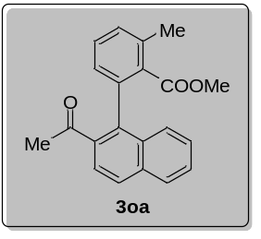
Methyl-2-(2-acetylnaphthalen-1-yl)-6-methylbenzoate (3oa)
Compound 3oa was prepared following procedure B, starting from 2-methylbenzoic acid (40.8 mg, 0.3 mmol) and 1-(1-bromonaphthalen-2-yl)-ethan-1-one (112.0 mg, 0.45 mmol). After purification, 3oa was obtained as yellow liquid (64.0 mg, 67% yield); ¹H NMR (500 MHz, CDCl₃) δ 7.89 - 7.82 (m, 2H), 7.75 (d, J = 8.6 Hz, 1H), 7.53 – 7.46 (m, 2H), 7.45 – 7.39 (m, 2H), 7.36 (d, J = 7.6 Hz, 1H), 7.15 (d, J = 7.5 Hz, 1H), 3.25 (s, 3H), 2.46 (s, 3H), 2.10 (s, 3H); ¹³C NMR (125 MHz, CDCl₃) δ 203.0, 168.8, 137.3, 137.0, 136.9, 136.1, 134.2, 134.0, 131.9, 130.3, 129.5, 128.0, 127.7, 127.5 (2C), 127.3, 126.6, 124.5, 51.4, 30.0, 20.0; ESI-HRMS (m/z): [M+H]⁺calcd for C₂₁H₁₉O₃, 319.1329, found: 319.1331.

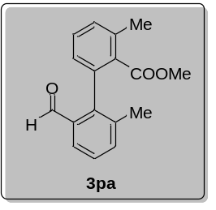
Methyl-2'-formyl-3,6'-dimethyl-[1,1'-biphenyl]-2-carboxylate (3pa)
Compound 3pa was prepared following procedure A, starting from 2-methylbenzoic acid (40.8 mg, 0.3 mmol) and 2-iodo-3-methylbenzaldehyde (111.0 mg, 0.45 mmol). Unfortunately, this substrate had no product.

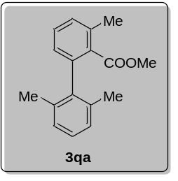
Methyl-2',3,6'-trimethyl-[1,1'-biphenyl]-2-carboxylate (3qa)
Compound 3qa was prepared following procedure A, starting from 2-methylbenzoic acid (40.8 mg, 0.3 mmol) and 2-iodo-1,3-dimethylbenzene (104.0 mg, 0.45 mmol). Unfortunately, this substrate had no product.

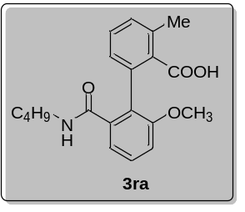
2'-(Butylcarbamoyl)-6'-methoxy-3-methyl-[1,1'-biphenyl]-2-carboxylic acid (3ra)
Compound 3ra was prepared following procedure A, starting from 2-methylbenzoic acid (40.8 mg, 0.3 mmol) and 2-bromo-N-butyl-3-methoxybenzamide (128.0 mg, 0.45 mmol). Methylation step did not run, and product was isolated as acid. After purification, 3ra was obtained as white solid (47.0 mg, 46% yield); MP = 115 – 117 ºC; ¹H NMR (500 MHz, CDCl₃) δ 7.36 (t, J = 8.0 Hz, 1H), 7.29 – 7.25 (m, 1H), 7.24 (d, J = 5.4 Hz, 1H), 7.05 – 6.99 (m, 2H), 6.81 (d, J = 7.0 Hz, 1H), 6.40 (s, 1H), 3.69 (s, 3H), 3.20 (td, J = 7.2, 1.6 Hz, 2H), 2.45 (s, 3H), 1.34 (m, 2H), 1.21 (m, 2H), 0.84 (t, J = 7.3 Hz, 3H); ¹³C NMR (125 MHz, CDCl₃) δ 171.4, 170.3, 157.6, 136.4, 135.7, 134.9, 133.0, 130.1, 129.7, 129.0, 127.9, 126.2, 118.0, 113.7, 56.2, 39.9, 31.1, 19.9, 19.8, 13.6; ESI-HRMS (m/z): [M+H]⁺calcd for C₂₀H₂₄NO₄, 342.1700, found: 342.1700.

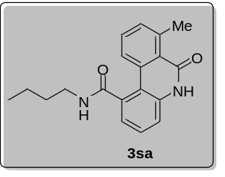
N-Butyl-7-methyl-6-oxo-5,6-dihydrophenanthridine-1-carboxamide (3sa)
Compound 3sa was prepared following procedure A, starting from 2-methylbenzoic acid (40.8 mg, 0.3 mmol) and 3-amino-N-butyl-2-iodobenzamide (143.0 mg, 0.45 mmol). After purification, 3sa was obtained as white solid (31.3 mg, 34% yield); MP = 195 – 197 ºC; ¹H NMR (500 MHz, d⁶-DMSO) δ 11.50 (s, 1H), 8.55 (t, J = 5.2 Hz, 1H), 8.07 (d, J = 8.2 Hz, 1H), 7.57 (t, J = 7.8 Hz, 1H), 7.46 (t, J = 7.8 Hz, 1H), 7.41 (d, J = 7.4 Hz, 1H), 7.36 (d, J = 7.8 Hz, 1H), 7.04 (d, J = 6.6 Hz, 1H), 3.28 (dd, J = 12.8, 6.6 Hz, 2H), 2.87 (s, 3H), 1.53 (dt, J = 14.6, 7.2 Hz, 2H), 1.37 – 1.30 (m, 2H), 0.92 (t, J = 7.4 Hz, 3H); ¹³C NMR (125 MHz, d⁶-DMSO) δ 171.0, 162.2, 141.4, 137.8, 136.9, 135.3, 131.8, 131.4, 129.1, 125.1, 124.5, 122.6, 116.6, 115.0, 39.3, 31.0, 24.4, 20.2, 14.1; ESI-HRMS (m/z): [M+H]⁺calcd for C₁₉H₂₁N₂O₂, 309.1598, found: 309.1592.

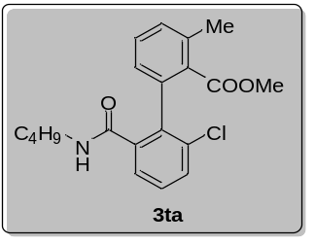
Methyl-2'-(butylcarbamoyl)-6'-chloro-3-methyl-[1,1'-biphenyl]-2-carboxylate (3ta)
Compound 3ta was prepared following procedure A, starting from 2-methylbenzoic acid (40.8 mg, 0.3 mmol) and n-butyl-3-chloro-2-iodobenzamide (152.0 mg, 0.45 mmol). After purification, 3ta was obtained as white solid (41.0 mg, 38% yield); MP = 80 – 82 ºC; ¹H NMR (500 MHz, CDCl₃) δ 7.53 (d, J = 7.6 Hz, 1H), 7.44 (d, J = 8.0 Hz, 1H), 7.38 (t, J = 7.6 Hz, 1H), 7.34 (t, J = 7.8 Hz, 1H), 7.27 (d, J = 6.2 Hz, 1H), 7.03 (d, J = 7.6 Hz, 2H), 3.76 (s, 3H), 3.29 - 3.15 (m, 1H), 2.92 - 2.77 (m, 1H), 2.44 (s, 3H), 0.94 (d, J = 3.1 Hz, 4H), 0.74 (d, J = 5.8 Hz, 3H); ¹³C NMR (125 MHz, CDCl₃) δ 170.9, 168.1, 139.7, 136.6, 136.1, 135.5, 133.1, 132.7, 130.5, 130.5, 130.2, 129.2, 127.4, 126.5, 52.3, 39.1, 31.1, 20.1, 19.8, 13.7; ESI-HRMS (m/z): [M+H]⁺calcd for C₂₀H₂₃ClNO₃, 360.1361, found: 360.1364.

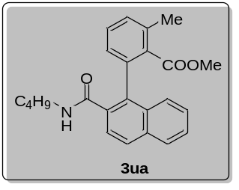
Methyl-2-(2-(butylcarbamoyl)naphthalen-1-yl)-6-methylbenzoate (3ua)
Compound 3ua was prepared following procedure A, starting from 2-methylbenzoic acid (40.8 mg, 0.3 mmol) and 1-bromo-N-butyl-2-naphthamide (137.0 mg, 0.45 mmol). After purification, 3ua was obtained as white solid (70.0 mg, 62% yield); MP = 107 – 109 ºC; ¹H NMR (500 MHz, CDCl₃) δ 7.88 (d, J = 8.5 Hz, 1H), 7.83 (d, J = 8.2 Hz, 1H), 7.70 (d, J = 8.6 Hz, 1H), 7.49 – 7.44 (m, 1H), 7.43 – 7.38 (m, 1H), 7.36 (t, J = 4.4 Hz, 2H), 7.33 (d, J = 7.7 Hz, 1H), 7.15 (t, J = 6.5 Hz, 1H), 7.07 (s, 1H), 3.35 (s, 3H), 3.25-3.32 (m, 1H), 2.98 – 2.89 (m, 1H), 2.45 (s, 3H), 1.02-0.95 (m, 4H), 0.75 (t, J = 6.9 Hz, 3H); ¹³C NMR (125 MHz, CDCl₃) δ 170.8, 169.5, 136.8, 134.8, 134.2, 133.6, 133.5, 131.3, 130.3, 129.9, 128.3, 128.1, 127.8, 126.5 (2C), 126.4, 126.3, 124.8, 51.9, 39.0, 31.1, 19.8, 19.7, 13.6; ESI-HRMS (m/z): [M+H]⁺calcd for C₂₄H₂₆NO₃, 376.1907, found: 376.1910.

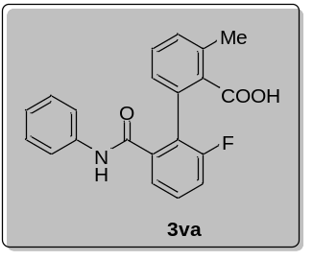
2'-Fluoro-3-methyl-6'-(phenylcarbamoyl)-[1,1'-biphenyl]-2-carboxylic acid (3va)
Compound 3va was prepared following procedure A, starting from 2-methylbenzoic acid (40.8 mg, 0.3 mmol) and 3-fluoro-2-iodo-N-phenylbenzamide (154.0 mg, 0.45 mmol). Methylation step did not run, and product was isolated as acid. After purification, 3va was obtained as white solid (75.0 mg, 72% yield); ¹H NMR (400 MHz, d⁶-DMSO) δ 9.94 (s, 1H), 7.57 (m, 1H), 7.51 (d, J = 7.6 Hz, 1H), 7.43 (t, J = 8.6 Hz, 1H), 7.40 – 7.33 (m, 3H), 7.31 – 7.23 (m, 3H), 7.11 – 7.02 (m, 2H), 2.41 (s, 3H); ¹³C NMR (125 MHz, d⁶-DMSO) δ 171.2, 166.0, 160.4, 158.4, 139.3, 138.9, 135.1, 134.9, 131.6, 130.9, 130.5 (d, J = 8.4 Hz, 2C), 129.8, 129.2, 127.9, 126.6 (d, J = 18.5 Hz), 124.3, 124.2 (d, J = 2.9 Hz), 119.7, 117.4 (d, J = 22.7 Hz), 20.2; ¹⁹F NMR (471 MHz, d⁶-DMSO) δ -113.5 (q, J = 4.7 Hz, 1F); ESI-HRMS (m/z): [M+H]⁺calcd for C₂₁H₁₇FNO₃, 350.1187, found: 350.1190.

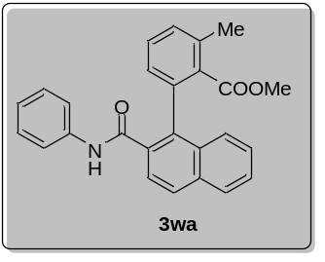
Methyl-2-methyl-6-(2-(phenylcarbamoyl)naphthalen-1-yl)benzoate (3wa)
Compound 3wa was prepared following procedure A, starting from 2-methylbenzoic acid (40.8 mg, 0.3 mmol) and 1-bromo-N-phenyl-2-naphthamide (146.0 mg, 0.45 mmol). After purification, 3wa was obtained as white solid (81.0 mg, 68% yield); MP = 175 – 177 ºC; ¹H NMR (500 MHz, CDCl₃) δ 9.08 (s, 1H), 7.95 (t, J = 8.9 Hz, 1H), 7.88 (d, J = 8.2 Hz, 1H), 7.82 – 7.79 (m, 1H), 7.53 – 7.48 (m, 1H), 7.40 (t, J = 4.6 Hz, 2H), 7.36 (t, J = 5.6 Hz, 1H), 7.30 (t, J = 7.2 Hz, 2H), 7.25 (s, 1H), 7.20 (t, J = 7.8 Hz, 2H), 7.17 (d, J = 7.6 Hz, 1H), 7.01 (t, J = 7.4 Hz, 1H), 3.45 (s, 3H), 2.46 (s, 3H); ¹³C NMR (125 MHz, CDCl₃) δ 171.5, 167.8, 138.3, 136.6, 134.9, 134.8, 134.6, 133.8, 133.2, 131.4, 130.7, 130.4 (2C), 128.7, 128.2, 128.0, 126.8, 126.7 (2C), 126.6, 125.0, 123.9 (2C), 119.4, 52.2, 19.8; ESI-HRMS (m/z): [M+H]⁺calcd for C₂₆H₂₂NO₃, 396.1594, found: 396.1596.

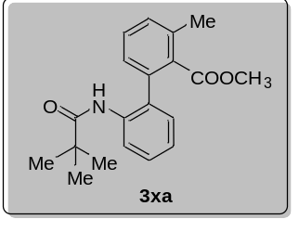
Methyl-3-methyl-2'-pivalamido-[1,1'-biphenyl]-2-carboxylate (3xa)
Compound 3xa was prepared following procedure A, starting from 2-methylbenzoic acid (40.8 mg, 0.3 mmol) and N-(2-iodophenyl)-pivalamide (136.0 mg, 0.45 mmol). After purification, 3xa was obtained as black liquid (73.0 mg, 75% yield); ¹H NMR (400 MHz, CDCl₃) δ 8.12 (d, J = 8.2, 1H), 7.41 – 7.31 (m, 3H), 7.29 (d, J = 7.5, 1H), 7.16 – 7.07 (m, 3H), 3.51 (s, 3H), 2.41 (s, 3H), 1.04 (s, 9H); ¹³C NMR (125 MHz, CDCl₃) δ 176.3, 169.4, 135.9, 135.5, 135.4, 134.2, 131.5, 129.9, 129.7, 129.2, 128.6, 127.4, 123.8, 122.0, 51.89, 39.4, 27.1, 19.6; ESI-HRMS (m/z): [M+H]⁺calcd for C₂₀H₂₄NO₃, 326.1751, found: 326.1750.

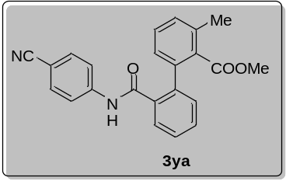
Methyl-2'-((3-cyanophenyl)carbamoyl)-3-methyl-[1,1'-biphenyl]-2-carboxylate (3ya)
Compound 3ya was prepared following procedure A, starting from 2-methylbenzoic acid (40.8 mg, 0.3 mmol) and N-(3-cyanophenyl)-2-iodobenzamide (157.0 mg, 0.45 mmol). After purification, 3ya was obtained as yellow solid (58.0 mg, 52% yield); ¹H NMR (500 MHz, CDCl₃) δ 8.95 (s, 1H), 7.78 – 7.75 (m, 1H), 7.47 (d, J = 8.1, 4H), 7.42 – 7.38 (m, 2H), 7.27 (d, J = 5.7, 1H), 7.18 (dd, J = 4.3, 3.0, 2H), 7.06 (d, J = 7.4, 1H), 3.77 (s, 3H), 2.43 (s, 3H); ¹³C NMR (125 MHz, CDCl₃) δ 171.7, 167.6, 142.3, 138.6, 137.8, 136.2, 135.1, 133.0, 132.1, 130.2, 130.0, 129.2, 128.7, 128.4, 127.2, 118.9, 106.6, 52.6, 19.6; ESI-HRMS (m/z): [M+H]⁺calcd for C₂₃H₁₉N₂O₃, 371.1390, found: 371.1385.

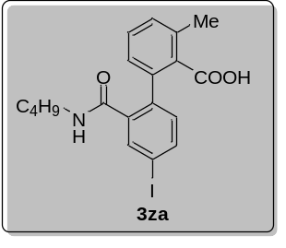
2'-(Butylcarbamoyl)-4'-iodo-3-methyl-[1,1'-biphenyl]-2-carboxylic acid (3za)
Compound 3za was prepared following procedure A, starting from 2-methylbenzoic acid (40.8 mg, 0.3 mmol) and N-butyl-2,5-diiodobenzamide (193.0 mg, 0.45 mmol). Methylation step did not run, and product was isolated as acid. After purification, 3za was obtained as white solid (81.0 mg, 62% yield); ¹H NMR (400 MHz, d⁶-DMSO) δ 7.87 (t, J = 5.2, 1H), 7.85 – 7.78 (m, 2H), 7.32 (m, 2H), 6.97 (d, J = 8.0, 1H), 6.93 (dd, J = 5.2, 3.2, 1H), 2.99 (s, 2H), 2.36 (s, 3H), 1.09 (m, 2H), 0.97 (m, 2H), 0.73 (t, J = 7.2, 3H); ¹³C NMR (100 MHz, d⁶-DMSO) δ 170.8, 167.5, 138.9, 138.3, 138.1, 137.1, 136.2, 134.7, 134.5, 132.0, 130.1, 129.2, 126.9, 94.3, 39.1, 31.1, 19.8, 19.7, 14.1; ESI-HRMS (m/z): [M+H]⁺calcd for C₁₉H₂₁INO₃, 438.0561, found: 438.0563.

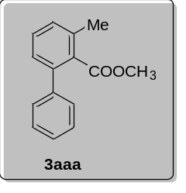
Methyl-3-methyl-[1,1'-biphenyl]-2-carboxylate (3aaa)
Compound 3aaa was prepared following procedure A, starting from 2-methylbenzoic acid (40.8 mg, 0.3 mmol) and iodobenzene (91.8 mg, 0.45 mmol). After purification, 3aaa was obtained as colorless liquid (33.0 mg, 49% yield); ¹H NMR (400 MHz, CDCl₃) δ 7.43 – 7.36 (m, 5H), 7.37 – 7.34 (m, 1H), 7.26 (s, 1H), 7.24 (s, 1H), 3.61 (s, 3H), 2.44 (s, 3H); ¹³C NMR (125 MHz, CDCl₃) δ 170.3, 140.9, 140.1, 135.4, 133.1, 129.4, 129.1, 128.3, 128.2, 127.3, 127.2, 51.8, 19.7.

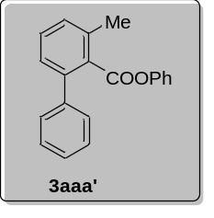
Phenyl-3-methyl-[1,1'-biphenyl]-2-carboxylate (3aaa')
Compound 3aaa' was prepared following procedure A, starting from 2-methylbenzoic acid (40.8 mg, 0.3 mmol) and iodobenzene (91.8 mg, 0.45 mmol). After purification, 3aaa' was obtained as colorless liquid (33.0 mg, 38% yield); ¹H NMR (400 MHz, CDCl₃) δ 7.56 – 7.41 (m, 5H), 7.43 – 7.37 (m, 1H), 7.36 – 7.26 (m, 4H), 7.27 – 7.16 (m, 1H), 6.72 (d, J = 1.4 Hz, 1H), 6.70 – 6.68 (m, 1H), 2.59 (s, 3H); ¹³C NMR (125 MHz, CDCl₃) δ 168.1, 150.4, 140.9, 140.4, 135.7, 132.5, 129.8, 129.3, 129.2, 128.7, 128.5, 127.6, 127.3, 125.9, 121.4, 19.8; ESI-HRMS (m/z): [M+H]⁺calcd for C₂₀H₁₇O₂, 289.1223, found: 289.1222.

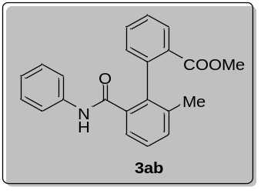
Methyl-2'-methyl-6'-(phenylcarbamoyl)-[1,1'-biphenyl]-2-carboxylate (3ab)
Compound 3ab was prepared following procedure A, starting from benzoic acid (36.6 mg, 0.3 mmol) and 2-iodo-3-methyl-N-phenylbenzamide (152.0 mg, 0.45 mmol). After purification, 3ab was obtained as yellow liquid (86.0 mg, 83% yield); ¹H NMR (500 MHz, CDCl₃) δ 8.73 (s, 1H), 7.81 (d, J = 7.6 Hz, 1H), 7.57 (d, J = 7.6 Hz, 1H), 7.49 (t, J = 7.6 Hz, 1H), 7.35 (dd, J = 14.8, 7.6 Hz, 2H), 7.29 (d, J = 7.6 Hz, 1H), 7.20 (d, J = 7.6 Hz, 3H), 7.16 (t, J = 7.8 Hz, 2H), 6.97 (t, J = 7.2 Hz, 1H), 3.83 (s, 3H), 1.91 (s, 3H); ¹³C NMR (125 MHz, CDCl₃) δ 169.8, 167.9, 139.8, 138.0, 137.4, 137.0, 135.6, 132.5, 131.3, 130.5, 130.4 (2C), 129.0, 128.6, 127.8, 127.8, 125.5, 123.8 (2C), 119.5, 52.8, 20.0; ESI-HRMS (m/z): [M+H]⁺calcd for C₂₂H₂₀NO₃, 346.1438, found: 346.1439.

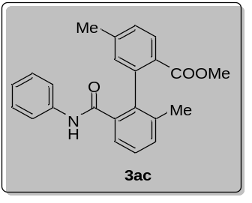
Methyl-2',5-dimethyl-6'-(phenylcarbamoyl)-[1,1'-biphenyl]-2-carboxylate (3ac)
Compound 3ac was prepared following procedure A, starting from 4-methylbenzoic acid (40.8 mg, 0.3 mmol) and 2-iodo-3-methyl-N-phenylbenzamide (152.0 mg, 0.45 mmol). After purification, 3ac was obtained as colorless liquid (95.0 mg, 88% yield); ¹H NMR (500 MHz, CDCl₃) δ 8.77 (s, 1H), 7.74 (d, J = 7.8 Hz, 1H), 7.58 (d, J = 7.6 Hz, 1H), 7.34 (t, J = 7.6 Hz, 1H), 7.28 (d, J = 7.6 Hz, 1H), 7.21 (d, J = 7.8 Hz, 2H), 7.17 (t, J = 7.8 Hz, 3H), 7.01 – 6.96 (m, 2H), 3.82 (s, 3H), 2.32 (s, 3H), 1.90 (s, 3H); ¹³C NMR (125 MHz, CDCl₃) δ 169.8, 168.0, 143.4, 140.1, 138.2, 137.6, 137.0, 135.6, 131.3, 131.2, 129.2, 128.6 (3C), 127.7, 127. 5, 125.6, 123.8, 119.5 (2C), 52.6, 21.4, 20.0; ESI-HRMS (m/z): [M+H]⁺calcd for C₂₃H₂₂NO₃, 360.1594, found: 360.1598.

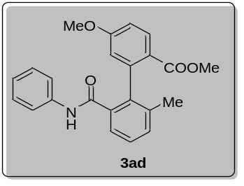
Methyl-5-methoxy-2'-methyl-6'-(phenylcarbamoyl)-[1,1'-biphenyl]-2-carboxylate (3ad)
Compound 3ad was prepared following procedure A, starting from 4-methoxybenzoic acid (45.6 mg, 0.3 mmol) and 2-iodo-3-methyl-N-phenylbenzamide (152.0 mg, 0.45 mmol). After purification, 3ad was obtained as colorless liquid (71.0 mg, 63% yield); ¹H NMR (500 MHz, CDCl₃) δ 8.73 (s, 1H), 7.84 (d, J = 8.8 Hz, 1H), 7.58 (d, J = 7.6 Hz, 1H), 7.35 (t, J = 7.6 Hz, 1H), 7.29 (d, J = 7.6 Hz, 1H), 7.23 (d, J = 7.8 Hz, 2H), 7.19 (t, J = 7.8 Hz, 2H), 6.99 (t, J = 7.2 Hz, 1H), 6.85 (dd, J = 8.8, 2.4 Hz, 1H), 6.68 (d, J = 2.6 Hz, 1H), 3.82 (s, 3H), 3.76 (s, 3H), 1.92 (s, 3H); ¹³C NMR (125 MHz, CDCl₃) δ 169.3, 168.0, 162.8, 142.7, 138.2, 137.7, 136.8, 135.4, 131.5, 131.4, 128.7 (2C), 127.8, 125.5, 123.9, 122.3 (2C), 119.5, 115.7, 113.7, 55.5, 52.5, 20.0; ESI-HRMS (m/z): [M+H]⁺calcd for C₂₃H₂₂NO₄, 376.1543, found: 376.1544.

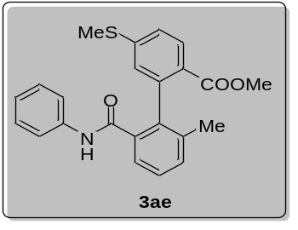
Methyl-2'-methyl-5-(methylthio)-6'-(phenylcarbamoyl)-[1,1'-biphenyl]-2-carboxylate (3ae)
Compound 3ae was prepared following procedure A, starting from 4-(methylthio)-benzoic acid (50.4 mg, 0.3 mmol) and 2-iodo-3-methyl-N-phenylbenzamide (152.0 mg, 0.45 mmol). After purification, 3ae was obtained as white solid (79.0 mg, 67% yield); MP = 96 – 98 ºC; ¹H NMR (500 MHz, CDCl₃) δ 8.71 (s, 1H), 7.75 (d, J = 8.2 Hz, 1H), 7.56 (d, J = 7.6 Hz, 1H), 7.35 (t, J = 7.6 Hz, 1H), 7.29 (d, J = 7.6 Hz, 1H), 7.23 (d, J = 7.8 Hz, 2H), 7.18 (t, J = 7.6 Hz, 3H), 7.03 – 6.95 (m, 2H), 3.82 (s, 3H), 2.39 (s, 3H), 1.92 (s, 3H); ¹³C NMR (125 MHz, CDCl₃) δ 169.3, 167.8, 145.6, 140.7, 138.0, 137.3, 136.9, 135.6, 131.3, 129.5 (2C), 128.7, 127.8, 126.6, 126.0, 125.5, 124.5, 123.9, 119.5 (2C), 52.6, 20.0, 14.7; ESI-HRMS (m/z): [M+H]⁺calcd for C₂₃H₂₂NSO₃, 392.1315, found: 392.1310.

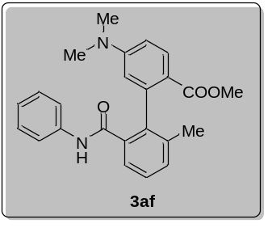
Methyl-5-(dimethylamino)-2'-methyl-6'-(phenylcarbamoyl)-[1,1'-biphenyl]-2-carboxylate (3af)
Compound 3af was prepared following procedure A, starting from 4-(dimethylamino)-benzoic acid (49.5 mg, 0.3 mmol) and 2-iodo-3-methyl-N-phenylbenzamide (152.0 mg, 0.45 mmol). After purification, 3af was obtained as yellow solid (48.0 mg, 41% yield); MP = 142 –144 ºC; ¹H NMR (500 MHz, CDCl₃) δ 8.80 (s, 1H), 7.81 (d, J = 8.8 Hz, 1H), 7.59 (d, J = 7.6 Hz, 1H), 7.33 (t, J = 7.6 Hz, 1H), 7.29 – 7.22 (m, 3H), 7.19 (t, J = 7.8 Hz, 2H), 6.98 (t, J = 7.2 Hz, 1H), 6.55 (dd, J = 8.8, 2.6 Hz, 1H), 6.33 (d, J = 2.6 Hz, 1H), 3.79 (s, 3H), 2.94 (s, 6H), 1.94 (s, 3H); ¹³C NMR (125 MHz, CDCl₃) δ 169.5, 168.3, 152.9, 142.5, 139.1, 138.4, 136.6, 135.6, 131.7, 131.2, 128.7 (2C), 127.3, 125.5, 123.7, 119.6 (2C), 115.9, 113.2, 109.9, 52.1, 39.9 (2C), 19.9; ESI-HRMS (m/z): [M+H]⁺calcd for C₂₄H₂₅N₂O₃, 389.1860, found: 389.1860.

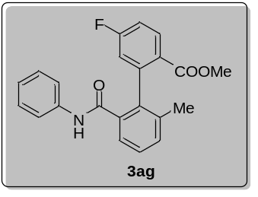
Methyl-5-fluoro-2'-methyl-6'-(phenylcarbamoyl)-[1,1'-biphenyl]-2-carboxylate (3ag)
Compound 3ag was prepared following procedure A, starting from 4-fluorobenzoic acid (42.0 mg, 0.3 mmol) and 2-iodo-3-methyl-N-phenylbenzamide (152.0 mg, 0.45 mmol). After purification, 3ag was obtained as white solid (84.0 mg, 77% yield); MP = 109 – 110 ºC; ¹H NMR (500 MHz, CDCl₃) δ 8.66 (s, 1H), 7.87 (dd, J = 8.6, 5.6 Hz, 1H), 7.55 (d, J = 7.6 Hz, 1H), 7.37 (t, J = 7.6 Hz, 1H), 7.31 (d, J = 7.8 Hz, 1H), 7.25 (d, J = 8.6 Hz, 2H), 7.19 (t, J = 7.8 Hz, 2H), 7.05 (td, J = 8.4, 2.6 Hz, 1H), 7.00 (t, J = 7.2 Hz, 1H), 6.94 (dd, J = 8.8, 2.4 Hz, 1H), 3.84 (s, 3H), 1.93 (s, 3H); ¹³C NMR (125 MHz, CDCl₃) δ 168.2 (d, J = 135.8 Hz), 165.6, 163.6, 143.2, 138.0, 136.9, 136.4, 135.4, 131.8 (d, J = 9.4 Hz), 131.5, 128.8 (2C), 128.2, 126.5, 125.5, 124.0, 119.5 (2C), 118.1 (d, J = 21.8 Hz), 115.1 (d, J = 21.4 Hz), 52.9, 20.0; ¹⁹F NMR (471 MHz, CDCl₃) δ -105.00 (dd, J = 14.1, 8.1, 1F); ESI-HRMS (m/z): [M+H]⁺calcd for C₂₂H₁₉FNO₃, 364.1346, found: 364.1343.

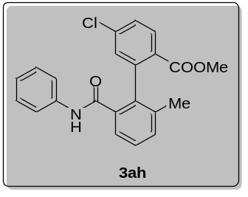
Methyl-5-chloro-2'-methyl-6'-(phenylcarbamoyl)-[1,1'-biphenyl]-2-carboxylate (3ah)
Compound 3ah was prepared following procedure A, starting from 4-chlorobenzoic acid (46.8 mg, 0.3 mmol) and 2-iodo-3-methyl-N-phenylbenzamide (152.0 mg, 0.45 mmol). After purification, 3ah was obtained as white solid (77.0 mg, 68% yield); MP = 103 – 105 ºC; ¹H NMR (500 MHz, CDCl₃) δ 8.66 (s, 1H), 7.78 (d, J = 8.4 Hz, 1H), 7.55 (d, J = 7.5 Hz, 1H), 7.36 – 7.33 (m, 2H), 7.30 (d, J = 7.5 Hz, 1H), 7.25 (d, J = 7.8 Hz, 2H), 7.22 (d, J = 1.8 Hz, 1H), 7.19 (t, J = 7.9 Hz, 2H), 7.00 (t, J = 7.3 Hz, 1H), 3.83 (s, 3H), 1.92 (s, 3H); ¹³C NMR (125 MHz, CDCl₃) δ 168.8, 167.5, 141.9, 138.7, 138.0, 136.9, 136.2, 135.5, 131.5, 130.6, 130.5 (2C), 128.8, 128.7, 128.2, 128.1, 125.5, 124.0, 119.5 (2C), 52.9, 20.0; ESI-HRMS (m/z): [M+H]⁺calcd for C₂₂H₁₉ClNO₃, 380.1048, found: 380.1051.

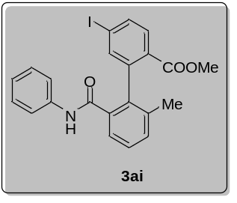
Methyl-5-iodo-2'-methyl-6'-(phenylcarbamoyl)-[1,1'-biphenyl]-2-carboxylate (3ai)
Compound 3ai was prepared following procedure A, starting from 4-iodobenzoic acid (74.1 mg, 0.3 mmol) and 2-iodo-3-methyl-N-phenylbenzamide (152.0 mg, 0.45 mmol). After purification, 3ai was obtained as white solid (90.0 mg, 64% yield); MP = 134 – 136 ºC; ¹H NMR (500 MHz, CDCl₃) δ 8.64 (s, 1H), 7.73 (dd, J = 8.2, 1.6 Hz, 1H), 7.60 (s, 1H), 7.54 (t, J = 9.2 Hz, 2H), 7.36 (t, J = 7.6 Hz, 1H), 7.30 (d, J = 7.6 Hz, 1H), 7.26 – 7.24 (m, 2H), 7.21 (d, J = 7.4 Hz, 2H), 7.01 (t, J = 7.2 Hz, 1H), 3.82 (s, 3H), 1.92 (s, 3H); ¹³C NMR (125 MHz, CDCl₃) δ 169.1, 167.5, 141.6, 139.2, 138.0, 137.1, 136.9, 136.1, 135.6, 131.5, 130.4, 130.3, 129.8, 128.8, 128.2, 125.5, 124.0, 119.6 (2C), 99.7, 52.9, 20.1; ESI-HRMS (m/z): [M+H]⁺calcd for C₂₂H₁₉INO₃, 472.0404, found: 472.0405.

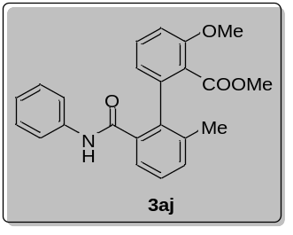
Methyl-3-methoxy-2'-methyl-6'-(phenylcarbamoyl)-[1,1'-biphenyl]-2-carboxylate (3aj)
Compound 3aj was prepared following procedure A, starting from 2-methoxybenzoic acid (45.6 mg, 0.3 mmol) and 2-iodo-3-methyl-N-phenylbenzamide (152.0 mg, 0.45 mmol). After purification, 3aj was obtained as white solid (81.0 mg, 72% yield); MP = 135 – 137 ºC; ¹H NMR (500 MHz, CDCl₃) δ 9.10 (s, 1H), 7.54 (d, J = 7.6 Hz, 1H), 7.34 (t, J = 7.0 Hz, 4H), 7.29 (d, J = 7.4 Hz, 1H), 7.18 (t, J = 7.8 Hz, 2H), 6.98 (t, J = 7.4 Hz, 1H), 6.86 (d, J = 8.4 Hz, 1H), 6.78 (d, J = 7.6 Hz, 1H), 3.83 (s, 3H), 3.75 (s, 3H), 2.05 (s, 3H); ¹³C NMR (125 MHz, CDCl₃) δ 170.0, 167.7, 156.2, 138.9, 138.4, 137.8, 136.2, 135.5, 131.9, 131.4, 128.5 (2C), 128.2, 125.8, 123.7 (2C), 122.2, 121.6, 119.4, 110.7, 56.0, 52.7, 19.8; ESI-HRMS (m/z): [M+H]⁺calcd for C₂₃H₂₂NO₄, 376.1543, found: 376.1544.

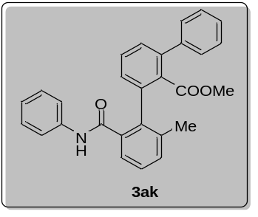
Methyl-2-methyl-6-(phenylcarbamoyl)-[1,1':3',1''-terphenyl]-2'-carboxylate (3ak)
Compound 3ak was prepared following procedure A, starting from [1,1'-biphenyl]-2-carboxylic acid (59.4 mg, 0.3 mmol) and 2-iodo-3-methyl-N-phenylbenzamide (152.0 mg, 0.45 mmol). After purification, 3ak was obtained as white solid (64.0 mg, 51% yield); MP = 98 – 99 ºC; ¹H NMR (500 MHz, CDCl₃) δ 9.35 (s, 1H), 7.56 (d, J = 7.6 Hz, 1H), 7.46 (t, J = 7.6 Hz, 1H), 7.43 – 7.38 (m, 5H), 7.36 – 7.30 (m, 5H), 7.22 – 7.18 (m, 3H), 6.99 (t, J = 7.2 Hz, 1H), 3.41 (s, 3H), 2.03 (s, 3H); ¹³C NMR (125 MHz, CDCl₃) δ 171.9, 167.8, 140.1, 140.1, 138.3, 138.1, 137.9, 136.4, 135.9, 131.8, 131.4, 130.6, 129.4, 128.7, 128.5 (2C), 128.4, 128.3 (2C), 128.0 (2C), 127.7, 125.7 (2C), 123.8, 119.4, 52.4, 19.9; ESI-HRMS (m/z): [M+H]⁺calcd for C₂₈H₂₄NO₃, 422.1751, found: 422.1752.

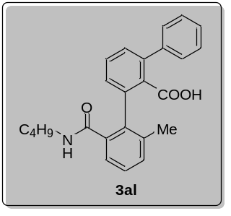
(2-(Butylcarbamoyl)-6-methyl-[1,1':3',1''-terphenyl]-2'-carboxylic acid (3al)
Compound 3al was prepared following procedure A, starting from [1,1'-biphenyl]-2-carboxylic acid (59.4 mg, 0.3 mmol) and N-butyl-2-iodo-3-methylbenzamide (143.0 mg, 0.45 mmol). Methylation step did not run, and product was isolated as acid. After purification, 3al was obtained as white solid (84.0 mg, 72% yield); MP = 163 – 165 ºC; ¹H NMR (500 MHz, CDCl₃) δ 7.41 (d, J = 7.2 Hz, 2H), 7.33 – 7.26 (m, 4H), 7.25 – 7.21 (m, 1H), 7.18 (t, J = 7.5 Hz, 1H), 7.15 – 7.05 (m, 2H), 6.84 (s, 1H), 6.78 – 6.74 (m, 1H), 3.17 –2.95 (m, 2H), 1.88 (s, 3H), 1.19 (d, J = 9.3 Hz, 2H), 1.10 – 1.02 (m, 2H), 0.71 (t, J = 7.3 Hz, 3H); ¹³C NMR (125 MHz, CDCl₃) δ 172.2, 170.3, 139.9, 139.4, 138.0, 137.6, 135.9, 135.0, 134.8, 132.2, 129.6, 129.0, 128.5, 128.3 (2C), 128.1 (2C), 127.4, 127.0, 123.7, 39.8, 30.9, 19.9, 19.6, 13.5; ESI-HRMS (m/z): [M+H]⁺calcd for C₂₅H₂₆NO₃, 388.1907, found: 388.1906.

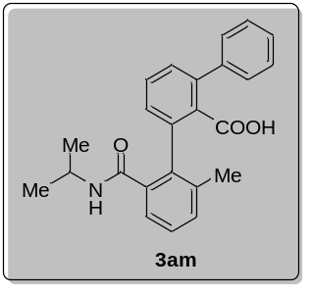
2-(Isopropylcarbamoyl)-6-methyl-[1,1':3',1''-terphenyl]-2'-carboxylic acid (3am)
Compound 3am was prepared following procedure A, starting from [1,1'-biphenyl]-2-carboxylic acid (59.4 mg, 0.3 mmol) and 2-iodo-N-isopropyl-3-methylbenzamide (136.0 mg, 0.45 mmol). Methylation step did not run, and product was isolated as acid. After purification, 3am was obtained as white solid (77 mg, 69% yield); MP = 228 – 230 ºC; ¹H NMR (500 MHz, CDCl₃) δ 7.49 (d, J = 7.2 Hz, 2H), 7.40 (d, J = 4.2 Hz, 3H), 7.38 (d, J = 7.7 Hz, 2H), 7.34 (d, J = 7.2 Hz, 1H), 7.30 (d, J = 7.2 Hz, 1H), 7.22 (d, J = 6.6 Hz, 1H), 6.89 (t, J = 4.4 Hz, 1H), 6.38 (d, J = 7.6 Hz, 1H), 4.01 – 3.93 (m, 1H), 2.00 (s, 3H), 1.07 (d, J = 6.6 Hz, 3H), 0.97 (d, J = 6.5 Hz, 3H); ¹³C NMR (125 MHz, CDCl₃) δ 171.3, 170.2, 139.9, 139.6, 138.3, 137.7, 136.0, 135.2, 134.9, 132.4, 129.7, 129.1, 128.5, 128.4 (2C), 128.2 (2C), 127.6, 127.0, 123.6, 42.4, 22.1, 22.1, 20.0; ESI-HRMS (m/z): [M+H]⁺calcd for C₂₄H₂₄NO₃, 374.1751, found: 374.1756.

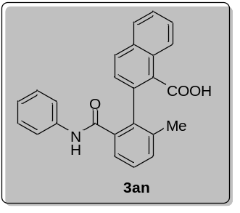
2-(2-Methyl-6-(phenylcarbamoyl)phenyl)-1-naphthoic acid (3an)
Compound 3an was prepared following procedure A, starting from 1-naphthoic acid (51.6 mg, 0.3 mmol) and 2-iodo-3-methyl-N-phenylbenzamide (152.0 mg, 0.45 mmol). Methylation step did not run, and product was isolated as acid. After purification, 3an was obtained as yellow solid (64.0 mg, 56% yield); MP = 227 – 229 ºC; ¹H NMR (400 MHz, d⁶-DMSO) δ 10.24 (s, 1H), 8.05 – 7.98 (m, 3H), 7.69 – 7.58 (m, 2H), 7.55 (d, J = 3.4 Hz, 1H), 7.49 (s, 2H), 7.32 (d, J = 8.1 Hz, 2H), 7.26 (d, J = 8.4 Hz, 1H), 7.15 (t, J = 7.6 Hz, 2H), 6.96 (t, J = 7.2 Hz, 1H), 2.01 (s, 3H); ¹³C NMR (125 MHz, d⁶-DMSO) δ 170.8, 168.3, 138.8, 137.9, 137.4, 137.0, 134.6, 132.6, 132.1, 131.8, 130.1, 129.1, 129.0 (2C), 128.8, 128.5, 128.1, 127.3, 127.1, 125.8, 125.3, 124.3, 119.9 (2C), 20.3; ESI-HRMS (m/z): [M+H]⁺calcd for C₂₅H₂₀NO₃, 382.1438, found: 382.1443.

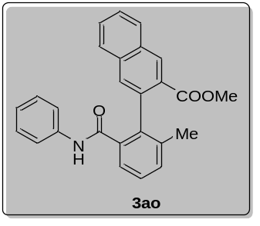
Methyl-3-(2-methyl-6-(phenylcarbamoyl)phenyl)-2-naphthoate (3ao)
Compound 3ao was prepared following procedure A, starting from 2-naphthoic acid (51.6 mg, 0.3 mmol) and 2-iodo-3-methyl-N-phenylbenzamide (152.0 mg, 0.45 mmol). After purification, 3ao was obtained as white solid (98.0 mg, 83% yield); MP = 138 – 140 ºC; ¹H NMR (500 MHz, CDCl₃) δ 8.97 (s, 1H), 8.40 (s, 1H), 7.86 (d, J = 7.8 Hz, 1H), 7.76 (d, J = 7.8 Hz, 1H), 7.67 (s, 1H), 7.61 (d, J = 7.8 Hz, 1H), 7.52 – 7.47 (m, 2H), 7.37 (t, J = 7.6 Hz, 1H), 7.30 (d, J = 7.6 Hz, 1H), 7.18 (d, J = 7.8 Hz, 2H), 7.07 (t, J = 7.8 Hz, 2H), 6.88 (t, J = 7.4 Hz, 1H), 3.90 (s, 3H), 1.90 (s, 3H); ¹³C NMR (125 MHz, CDCl₃) δ 169.9, 168.2, 138.1, 137.4 (2C), 136.1, 135.5, 134.7, 131.5, 131.2, 130.5, 129.7, 128.6 (2C), 128.5, 128.2 (2C), 128.0, 127.7, 127.1, 125.5, 123.6, 119.3 (2C), 52.9, 20.1; ESI-HRMS (m/z): [M+H]⁺calcd for C₂₆H₂₂NO₃, 396.1594, found: 396.1593.

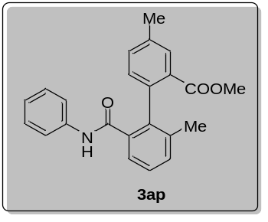
Methyl-2',4-dimethyl-6'-(phenylcarbamoyl)-[1,1'-biphenyl]-2-carboxylate (3ap)
Compound 3ap was prepared following procedure A, starting from 3-methylbenzoic acid (40.8 mg, 0.3 mmol) and 2-iodo-3-methyl-N-phenylbenzamide (152.0 mg, 0.45 mmol). After purification, 3ap was obtained as colorless liquid (58.0 mg, 54% yield); ¹H NMR (500 MHz, CDCl₃) δ 8.73 (s, 1H), 7.64 (s, 1H), 7.56 (d, J = 7.6 Hz, 1H), 7.37 – 7.30 (m, 2H), 7.28 (d, J = 7.6 Hz, 1H), 7.23 (d, J = 7.8 Hz, 2H), 7.18 (t, J = 7.8 Hz, 2H), 7.09 (d, J = 7.8 Hz, 1H), 6.99 (t, J = 7.2 Hz, 1H), 3.84 (s, 3H), 2.36 (s, 3H), 1.91 (s, 3H); ¹³C NMR (125 MHz, CDCl₃) δ 170.0, 168.1, 138.2, 137.8, 137.4, 137.2, 137.0, 135.9, 133.4, 131.3, 130.5, 130.2, 129.6 (2C), 128.7, 127.7, 125.6, 123.8 (2C), 119.5, 52.7, 21.0, 20.1; ESI-HRMS (m/z): [M+H]⁺calcd for C₂₃H₂₂NO₃, 360.1594, found:360.1593.

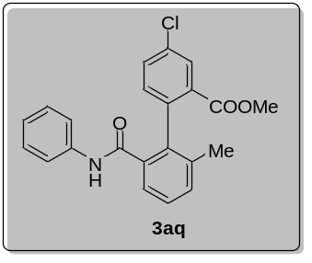
Methyl-4-chloro-2'-methyl-6'-(phenylcarbamoyl)-[1,1'-biphenyl]-2-carboxylate (3aq)
Compound 3aq was prepared following procedure A, starting from 3-chlorobenzoic acid (46.8 mg, 0.3 mmol) and 2-iodo-3-methyl-N-phenylbenzamide (152.0 mg, 0.45 mmol). After purification, 3aq was obtained as white solid (51.0 mg, 45% yield); MP = 98 – 99 ºC; ¹H NMR (500 MHz, CDCl₃) δ 8.63 (s, 1H), 7.82 (d, J = 1.8 Hz, 1H), 7.53 (d, J = 7.6 Hz, 1H), 7.47 (dd, J = 8.2, 1.8 Hz, 1H), 7.35 (t, J = 7.6 Hz, 1H), 7.30 (d, J = 7.6 Hz, 1H), 7.25 (d, J = 7.6 Hz, 2H), 7.20 (t, J = 7.8 Hz, 2H), 7.15 (d, J = 8.2 Hz, 1H), 7.01 (t, J = 7.2 Hz, 1H), 3.84 (s, 3H), 1.91 (s, 3H); ¹³C NMR (125 MHz, CDCl₃) δ 168.4, 167.7, 138.3, 137.9, 137.1, 136.3, 135.7, 133.8, 132.5, 132.0, 131.7, 131.4, 129.2 (2C), 128.8, 128.1, 125.3, 124.0, 119.5 (2C), 53.0, 20.0; ESI-HRMS (m/z): [M+H]⁺calcd for C₂₂H₁₉ClNO₃, 380.1048, found: 380.1047.

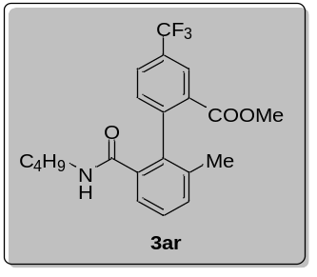
Methyl-2'-(butylcarbamoyl)-6'-methyl-4-(trifluoromethyl)-[1,1'-biphenyl]-2-carboxylate (3ar)
Compound 3ar was prepared following procedure A, starting from 3-(trifluoromethyl)-benzoic acid (57.0 mg, 0.3 mmol) and N-butyl-2-iodo-3-methylbenzamide (143.0 mg, 0.45 mmol). After purification, 3ar was obtained as colorless liquid (79.0 mg, 67% yield); ¹H NMR (500 MHz, CDCl₃) δ 8.14 (s, 1H), 7.80 (dd, J = 8.0, 1.2 Hz, 1H), 7.43 (d, J = 7.4 Hz, 1H), 7.39 – 7.30 (m, 2H), 7.28 (d, J = 6.6 Hz, 1H), 6.42 (s, 1H), 3.81 (s, 3H), 3.26 – 3.17 (m, 1H), 2.94 – 2.83 (m, 1H), 1.91 (s, 3H), 1.00 – 0.93 (m, 4H), 0.73 (t, J = 6.8 Hz, 3H); ¹³C NMR (125 MHz, CDCl₃) δ 169.3, 167.6, 144.2, 136.9, 136.3, 135.1, 131.5, 131.4, 131.0, 130.1 (q, J = 33.3 Hz), 128.7 (q, J = 3.4 Hz), 128.1, 126.1 (q, J = 3.6 Hz), 125.0, 123.5 (q, J = 272.8 Hz), 52.8, 39.0, 31.2, 20.0, 19.7, 13.4; ¹⁹F NMR (471 MHz, CDCl₃) δ -62.8 (s, 3F); ESI-HRMS (m/z): [M+H]⁺calcd for C₂₁H₂₃F₃NO₃, 394.1624, found:394.1628.

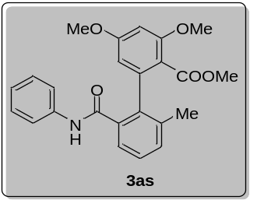
Methyl-3,5-dimethoxy-2'-methyl-6'-(phenylcarbamoyl)-[1,1'-biphenyl]-2-carboxylate (3as)
Compound 3as was prepared following procedure A, starting from 2,4-dimethoxybenzoic acid (54.6 mg, 0.3 mmol) and 2-iodo-3-methyl-N-phenylbenzamide (152.0 mg, 0.45 mmol). After purification, 3as was obtained as white solid (74.0 mg, 61% yield); MP = 58 – 60 ºC; ¹H NMR (500 MHz, CDCl₃) δ 9.28 (s, 1H), 7.55 (d, J = 7.6 Hz, 1H), 7.38 – 7.32 (m, 3H), 7.30 – 7.25 (m, 1H), 7.20 (t, J = 7.8 Hz, 2H), 6.99 (t, J = 7.4 Hz, 1H), 6.39 (d, J = 1.6 Hz, 1H), 6.27 (d, J = 1.4 Hz, 1H), 3.81 (s, 3H), 3.74 (s, 3H), 3.70 (s, 3H), 2.06 (s, 3H); ¹³C NMR (125 MHz, CDCl₃) δ 170.0, 167.7, 162.3, 158.1, 140.7, 138.5, 137.5, 136.0, 135.9, 131.4, 128.6 (2C), 128.1, 125.8, 123.6, 119.4 (2C), 115.0, 105.7, 98.3, 55.9, 55.5, 52.6, 19.6; ESI-HRMS (m/z): [M+H]⁺calcd for C₂₄H₂₄NO₅, 406.1649, found: 406.1650.

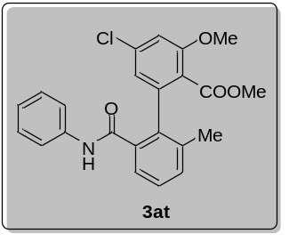
Methyl-5-chloro-3-methoxy-2'-methyl-6'-(phenylcarbamoyl)-[1,1'-biphenyl]-2-carboxylate (3at)
Compound 3at was prepared following procedure A, starting from 4-chloro-2-methoxybenzoic acid (55.8 mg, 0.3 mmol) and 2-iodo-3-methyl-N-phenylbenzamide (152.0 mg, 0.45 mmol). After purification, 3at was obtained as white solid (81.0 mg, 66% yield); MP = 141 – 143 ºC; ¹H NMR (500 MHz, CDCl₃) δ 9.12 (s, 1H), 7.53 (d, J = 7.6 Hz, 1H), 7.37 (d, J = 7.8 Hz, 2H), 7.34 (d, J = 7.6 Hz, 1H), 7.29 (d, J = 7.6 Hz, 1H), 7.21 (t, J = 7.8 Hz, 2H), 7.01 (t, J = 7.4 Hz, 1H), 6.87 (t, J = 2.0 Hz, 1H), 6.82 (d, J = 1.6 Hz, 1H), 3.82 (s, 3H), 3.75 (s, 3H), 2.05 (s, 3H); ¹³C NMR (125 MHz, CDCl₃) δ 169.3, 167.3, 157.0, 140.2, 138.3, 137.7, 137.4, 136.1, 134.3, 131.5, 128.7 (2C), 128.6, 125.9, 123.8, 121.6 (2C), 120.9, 119.4, 111.5, 56.3, 52.9, 19.8; ESI-HRMS (m/z): [M+H]⁺calcd for C₂₃H₂₁ClNO₄, 410.1154, found: 410.1152.

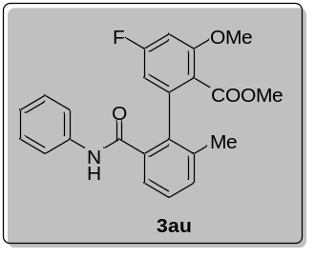
Methyl-5-fluoro-3-methoxy-2'-methyl-6'-(phenylcarbamoyl)-[1,1'-biphenyl]-2-carboxylate (3au)
Compound 3au was prepared following procedure A, starting from 4-fluoro-2-methoxybenzoic acid (51.0 mg, 0.3 mmol) and 2-iodo-3-methyl-N-phenylbenzamide (152.0 mg, 0.45 mmol). After purification, 3au was obtained as white solid (48.0 mg, 41% yield); Physical state: white solid; MP = 80 – 82 ºC; ¹H NMR (500 MHz, CDCl₃) δ 9.13 (s, 1H), 7.53 (d, J = 7.6 Hz, 1H), 7.37 (d, J = 8.2 Hz, 3H), 7.29 (d, J = 7.6 Hz, 1H), 7.21 (t, J = 7.4 Hz, 2H), 7.01 (t, J = 7.4 Hz, 1H), 6.60 (d, J = 10.4 Hz, 1H), 6.53 (d, J = 8.4 Hz, 1H), 3.84 (s, 3H), 3.76 (d, J = 0.6 Hz, 3H), 2.06 (s, 3H); ¹³C NMR (125 MHz, CDCl₃) δ 169.4, 167.4, 165.2, 163.2, 158.2 (d, J = 10.8 Hz), 141.0 (d, J = 10.4 Hz), 138.4, 137.7, 136.0, 134.7, 131.5, 128.7, 128.6, 125.9, 123.8, 119.4 (2C), 118.6, 108.8 (d, J = 22.2 Hz), 99.2 (d, J = 25.6 Hz), 56.3, 52.9, 19.7; ¹⁹F NMR (471 MHz, CDCl₃) δ -105.3 (t, J = 9.2 Hz, 1F); ESI-HRMS (m/z): [M+H]⁺calcd for C₂₃H₂₁FNO₄, 394.1449, found: 394.1453.

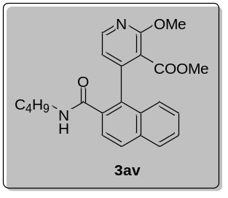
Methyl-4-(2-(butylcarbamoyl)naphthalen-1-yl)-2-methoxynicotinate (3av)
Compound 3av was prepared following procedure C, starting from 2-methoxynicotinic acid (45.9 mg, 0.3 mmol) and 1-bromo-N-butyl-2-naphthamide (137.0 mg, 0.45 mmol). The difference is that use Ru(p-cym)(dtbpy)Cl₂ (5 mol%) instead of [Ru(p-cym)l₂]₂ (7.5 mol%) and dtbpy (15 mol%). After purification, 3av was obtained as white solid (54.1 mg, 46% yield); ¹H NMR (500 MHz, CDCl₃) δ 8.31 (d, J = 5.2 Hz, 1H), 7.92 (d, J = 8.6 Hz, 1H), 7.87 (d, J = 8.2 Hz, 1H), 7.69 (d, J = 8.6 Hz, 1H), 7.50 (t, J = 7.4 Hz, 1H), 7.42 (t, J = 7.6 Hz, 1H), 7.37 (d, J = 8.4 Hz, 1H), 7.11 (s, 1H), 6.90 (d, J = 5.2 Hz, 1H), 4.09 (s, 3H), 3.45 (s, 3H), 3.39 – 3.31 (m, 1H), 3.01 – 2.93 (m, 1H), 1.10 – 1.01 (m, 4H), 0.79 (t, J = 7.2 Hz, 3H); ¹³C NMR (125 MHz, CDCl₃) δ 169.0, 168.2, 160.2, 149.0, 148.4, 134.5, 133.5, 131.3, 130.2, 129.2, 128.2, 126.9, 126.8, 125.9, 124.7, 118.8, 117.2, 54.2, 52.6, 39.3, 31.1, 19.9, 13.7; ESI-HRMS (m/z): [M+H]⁺calcd for C₂₃H₂₅N₂O₄, 393.1809, found: 393.1807.

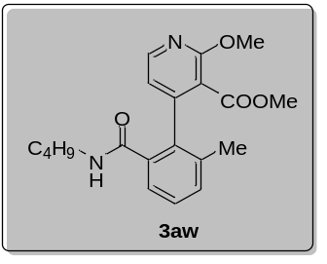
Methyl-4-(2-(butylcarbamoyl)-6-methylphenyl)-2-methoxynicotinate (3aw)
Compound 3aw was prepared following procedure C, starting from 2-methoxynicotinic acid (45.9 mg, 0.3 mmol) and N-butyl-2-iodo-3-methylbenzamide (143.0 mg, 0.45 mmol). The difference is that use Ru(p-cym)(dtbpy)Cl₂ (5 mol%) instead of [Ru(p-cym)l₂]₂ (7.5 mol%) and dtbpy (15 mol%). After purification, 3aw was obtained as colorless liquid (59.8 mg, 56% yield); ¹H NMR (500 MHz, CDCl₃) δ 8.25 (d, J = 5.0 Hz, 1H), 7.43 (d, J = 7.6 Hz, 1H), 7.32 (t, J = 7.6 Hz, 1H), 7.27 (t, J = 9.2 Hz, 1H), 6.99 (d, J = 7.4 Hz, 1H), 6.76 (d, J = 5.2 Hz, 1H), 4.03 (s, 3H), 3.73 (s, 3H), 3.35 – 3.22 (m, 1H), 3.01 – 2.84 (m, 1H), 2.02 (s, 3H), 1.09 – 0.95 (m, 4H), 0.77 (t, J = 6.9 Hz, 3H); ¹³C NMR (125 MHz, CDCl₃) δ 168.9, 168.2, 160.3, 149.3, 148.8, 137.2, 135.1, 133.5, 131.1, 128.7, 125.5, 117.7, 116.5, 54.1, 52.8, 39.2, 31.0, 19.8, 19.7, 13.6; ESI-HRMS (m/z): [M+H]⁺calcd for C₂₀H₂₅N₂O₄, 357.1809, found: 357.1810.

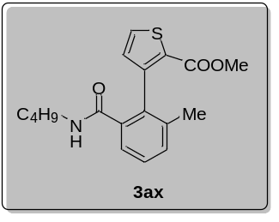
Methyl-3-(2-(butylcarbamoyl)-6-methylphenyl)thiophene-2-carboxylate (3ax)
Compound 3ax was prepared following procedure C, starting from thiophene-2-carboxylic acid (38.4 mg, 0.3 mmol) and N-butyl-2-iodo-3-methylbenzamide (143.0 mg, 0.45 mmol). The difference is that use Ru(p-cym)(dtbpy)Cl₂ (5 mol%) instead of [Ru(p-cym)l₂]₂ (7.5 mol%) and dtbpy (15 mol%). After purification, 3ax was obtained as yellow liquid (49.7 mg, 50% yield); ¹H NMR (500 MHz, CDCl₃) δ 7.57 (d, J = 5.0 Hz, 1H), 7.43 – 7.39 (m, 1H), 7.33 – 7.28 (m, 2H), 6.97 (d, J = 5.0 Hz, 1H), 5.93 (s, 1H), 3.77 (s, 3H), 3.26 – 3.20 (m, 1H), 3.04 – 2.96 (m, 1H), 2.00 (s, 3H), 1.19 – 1.11 (m, 4H), 0.83 (t, J = 7.0 Hz, 3H); ¹³C NMR (125 MHz, CDCl₃) δ 169.4, 162.8, 146.4, 137.1, 136.4, 133.0, 131.3, 131.0, 131.0, 127.9, 127.8, 124.7, 52.1, 39.1, 31.4, 20.1, 19.9, 13.7; ESI-HRMS (m/z): [M+H]⁺calcd for C₁₈H₂₂NSO₃, 332.1315, found: 332.1316.

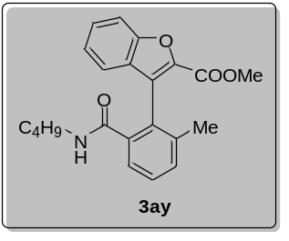
Methyl-3-(2-(butylcarbamoyl)-6-methylphenyl)benzofuran-2-carboxylate (3ay)
Compound 3ay was prepared following procedure C, starting from benzofuran-2-carboxylic acid (48.6 mg, 0.3 mmol) and N-butyl-2-iodo-3-methylbenzamide (143.0 mg, 0.45 mmol). After purification, 3ay was obtained as white solid (34.0 mg, 31% yield); MP = 93 – 95 ºC; ¹H NMR (500 MHz, CDCl₃) δ 7.62 (d, J = 8.4 Hz, 1H), 7.49 (t, J = 6.9 Hz, 2H), 7.42 – 7.38 (m, 2H), 7.32 (d, J = 7.8 Hz, 1H), 7.29 (d, J = 7.2 Hz, 1H), 5.77 (s, 1H), 3.86 (s, 3H), 3.14 – 3.08 (m, 1H), 3.04 – 2.98 (m, 1H), 2.06 (s, 3H), 1.06 – 0.97 (m, 4H), 0.74 (t, J = 6.9 Hz, 3H); ¹³C NMR (125 MHz, CDCl₃) δ 169.0, 160.3, 154.5, 140.5, 138.0, 137.4, 131.4, 128.6, 128.4 (2C), 127.6, 127.4, 125.2, 124.2, 122.1, 112.3, 52.4, 39.2, 31.2, 20.1, 19.8, 13.6; ESI-HRMS (m/z): [M+H]⁺calcd for C₂₂H₂₄NO₄, 366.1700, found: 366.1700.

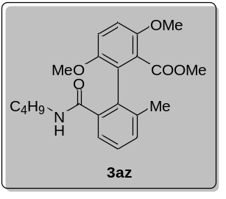
Methyl-2'-(butylcarbamoyl)-3,6-dimethoxy-6'-methyl-[1,1'-biphenyl]-2-carboxylate (3az)
Compound 3az was prepared following procedure A, starting from 2,5-dimethoxybenzoic acid (18.2 mg, 0.1 mmol) and N-butyl-2-iodo-3-methylbenzamide (47.6 mg, 0.15 mmol). Unfortunately, only trace of 3az was obtained.

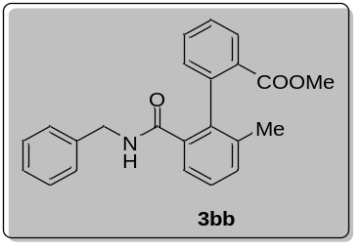
Methyl-2'-(benzylcarbamoyl)-6'-methyl-[1,1'-biphenyl]-2-carboxylate (3bb)
Compound 3bb was prepared following procedure A, starting from benzoic acid (36.6 mg, 0.3 mmol) and N-benzyl-2-iodo-3-methylbenzamide (158.0 mg, 0.45 mmol). After purification, 3bb was obtained as colorless liquid (62.0 mg, 58% yield); ¹H NMR (500 MHz, CDCl₃) δ 7.72 (dd, J = 7.8, 1.0 Hz, 1H), 7.53 (td, J = 7.6, 1.3 Hz, 1H), 7.49 (d, J = 7.4 Hz, 1H), 7.40 (td, J = 7.6, 1.2 Hz, 1H), 7.31 (t, J = 7.6 Hz, 1H), 7.24 (d, J = 7.6 Hz, 1H), 7.19 (d, J = 7.6 Hz, 1H), 7.17 – 7.09 (m, 3H), 6.91 (s, 1H), 6.73 (d, J = 6.6 Hz, 2H), 4.42 (dd, J = 14.6, 7.0 Hz, 1H), 4.06 (dd, J = 14.6, 4.6 Hz, 1H), 3.64 (s, 3H), 1.86 (s, 3H); ¹³C NMR (125 MHz, CDCl₃) δ 169.7, 168.9, 140.3, 137.8, 137.7, 136.6, 135.5, 132.4, 131.0, 130.7, 130.5 (2C), 129.4, 128.3, 127.6 (2C), 127.4, 126.9, 125.3, 52.4, 43.5, 20.1; ESI-HRMS (m/z): [M+H]⁺calcd for C₂₃H₂₂NO₃, 360.1594, found: 360.1595.

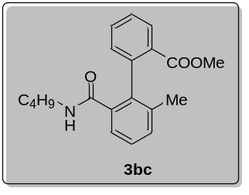
Methyl-2'-(butylcarbamoyl)-6'-methyl-[1,1'-biphenyl]-2-carboxylate (3bc)
Compound 3bc was prepared following procedure A, starting from benzoic acid (36.6 mg, 0.3 mmol) and N-butyl-2-iodo-3-methylbenzamide (143.0 mg, 0.45 mmol). The difference is that use Ru(p-cym)(L8)Cl₂ (10 mol%) instead of [Ru(p-cym)l₂]₂ (5 mol%) and L8 (10 mol%). After purification, 3bc was obtained as white solid (77.0 mg, 79% yield); MP = 80 – 82 ºC; ¹H NMR (500 MHz, CDCl₃) δ 7.85 (d, J = 7.6 Hz, 1H), 7.54 (t, J = 7.6 Hz, 1H), 7.45 (dd, J = 13.2, 7.1 Hz, 2H), 7.30 (t, J = 7.6 Hz, 1H), 7.24 (d, J = 7.6 Hz, 1H), 7.20 (d, J = 7.6 Hz, 1H), 6.56 (s, 1H), 3.77 (s, 3H), 3.22 – 3.12 (m, 1H), 2.97 – 2.83 (m, 1H), 1.89 (s, 3H), 0.98 – 0.92 (m, 4H), 0.73 (d, J = 6.5 Hz, 3H); ¹³C NMR (125 MHz, CDCl₃) δ 169.7, 169.2, 140.4, 137.4, 137.1, 135.3, 132.4, 130.8, 130.7, 130.7, 129.0, 127.6, 127.6, 125.2, 52.5, 39.0, 31.1, 20.1, 19.7, 13.6; ESI-HRMS (m/z): [M+H]⁺calcd for C₂₀H₂₄NO₃, 326.1751, found: 326.1752.

6. Gram Scale Experiment
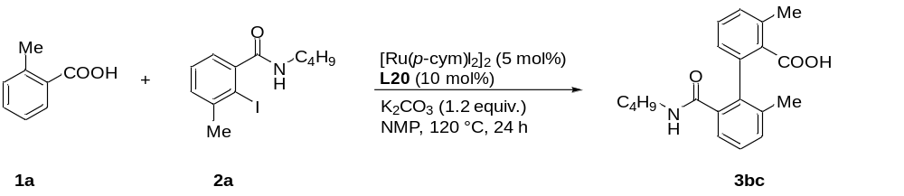
A 80 mL oven-dried Schlenk tube equipped with a magnetic stirring bar, 2-methylbenzoic acid 1a (1.0 g, 7.4 mmol, 1.0 equiv.), N-butyl-2-iodo-3-methylbenzamide 2a (3.5 g, 11.0 mmol, 1.5 equiv.), [Ru(p-cym)l₂]₂ (225.0 mg, 5 mol%), K₂CO₃ (1.2 g, 1.2 equiv.) were added, After flushing the vessel with 3 alternating vacuum and nitrogen purge cycles, L20 (174.0 mg, 10 mol%), NMP (35.0 mL), The resulting mixture was stirred at 120 °C for 24 h. After the reaction was complete, the mixture was allowed to cool to rt. Upon completion, to the reaction mixture was added diluted HCl (2 M, 100.0 mL) with stirring until pH = 1 and extracted twice with ethyl acetate (100.0 mL). The organic phase was dried over MgSO₄, filtered, and concentrated. Repeat extraction operation at least 10 times. The crude product was purified by flash column chromatography (petroleum ether/ethyl acetate/formic acid = 80/20/1) to afford 2'-(butylcarbamoyl)-3,6'-dimethyl-[1,1'-biphenyl]-2-carboxylic acid 3bc (1.9 g, 80% yield) as a white solid.

7. Control Experiments and Mechanistic Studies
1) H/D exchange experiment
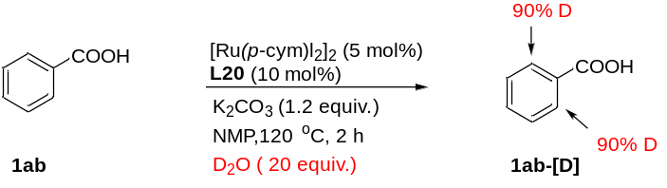
An oven-dried 4 mL vessel was charged with benzoic acid 1ab (0.1 mmol, 12.2 mg), [Ru(p-cym)l₂]₂ (4.9 mg, 5 mol%), K₂CO₃ (16.6 mg, 1.2 equiv.). The tube was purged with N₂ three times, followed by addition L20 (2.4 mg, 10 mol%), D₂O (27.0 uL, 20 equiv.), NMP (1.0 mL). The mixture was stirred at 120 °C for 2 h. The solution was then cooled to room temperature and was purified by silica gel column chromatography afford corresponding 1ab-[D].
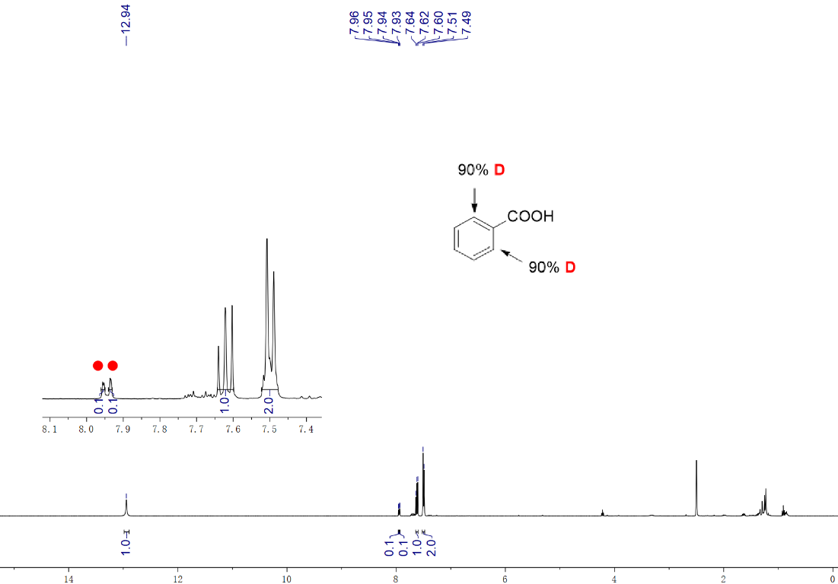

2) KIE experiment
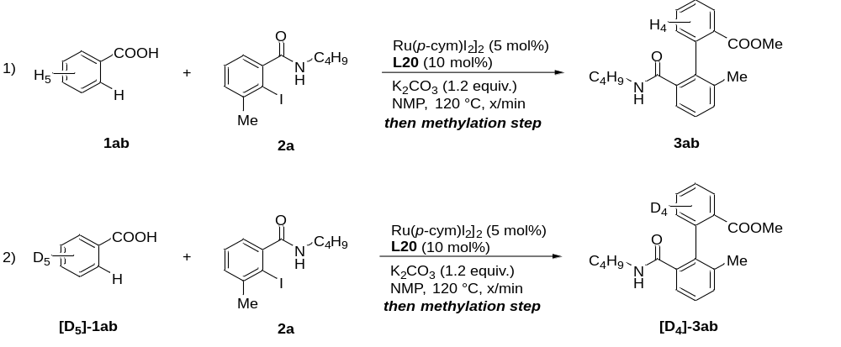
KIE by two parallel reactions: a mixture of benzoic acid 1ab (24.4 mg, 0.2 mmol) or [D₅]-1ab (25.4 mg, 0.2 mmol), N-butyl-2-iodo-3-methylbenzamide 2a (95.1 mg, 0.3 mmol), [Ru(p-cym)I₂]₂ (9.8 mg, 5 mol%), K₂CO₃ (33.1 mg, 1.2 equiv.), after flushing the vessel with 3 alternating vacuum and nitrogen purge cycles, L20 (4.8 mg, 10 mol%), NMP (2.0 mL), the resulting mixture was stirred at 120 °C for x min. And take 200 uL into the reaction flask, added MeI (5.0 equiv.), K₂CO₃ (2.0 equiv.), NMP (1.0 mL), the mixture was stirred at 60 °C in an oil bath for 2 h. After cooling to room temperature, the GC yield (uncorrected) of 3ab or 3ab-[D₄] was determined using tetradecane as the internal standard. KIE value (k_{H}/k_{D} = 1.16) was determined by relative initial rate.
Time / min 3ab / (yield) % 3ab-[D₄] / (yield) %
0 | 0 | 0
15 | 10 | 9
30 | 18 | 16
45 | 22 | 21
60 | 36 | 29
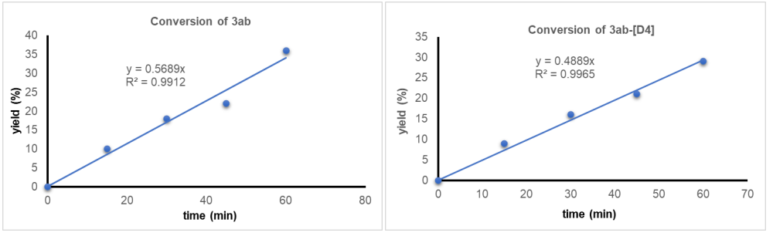

Figure S1. Monitor the yield of product 3ab and 3ab-[D₄].

3) Determination of reaction order on benzoic acid
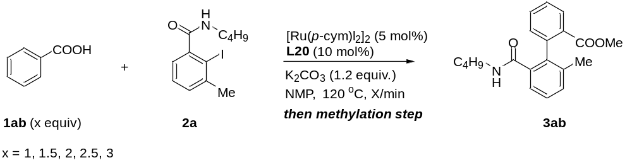
A mixture of benzoic acid 1ab (1.0, 1.5, 2.0, 2.5 or 3.0 equiv., respectively), N-butyl-2-iodo-3-methylbenzamide 2a (63.4 mg, 0.2 mmol), [Ru(p-cym)I₂]₂ (9.8 mg, 5 mol%), K₂CO₃ (33.2 mg, 1.2 equiv.), after flushing the vessel with 3 alternating vacuum and nitrogen purge cycles, L20 (4.8 mg, 10 mol%), NMP (2.0 mL), the resulting mixture was stirred at 120 °C for 0 minute, 15 minutes, 30 minutes, 45 minutes, 60 minutes. And take 200 uL into the reaction vessel, added MeI (5 equiv.), K₂CO₃ (2.0 equiv.), NMP (0.5 mL), the mixture was stirred at 60 °C in an oil bath for 2 h. After cooling to room temperature, the GC yield (uncorrected) of 3ab was determined using tetradecane as the internal standard.

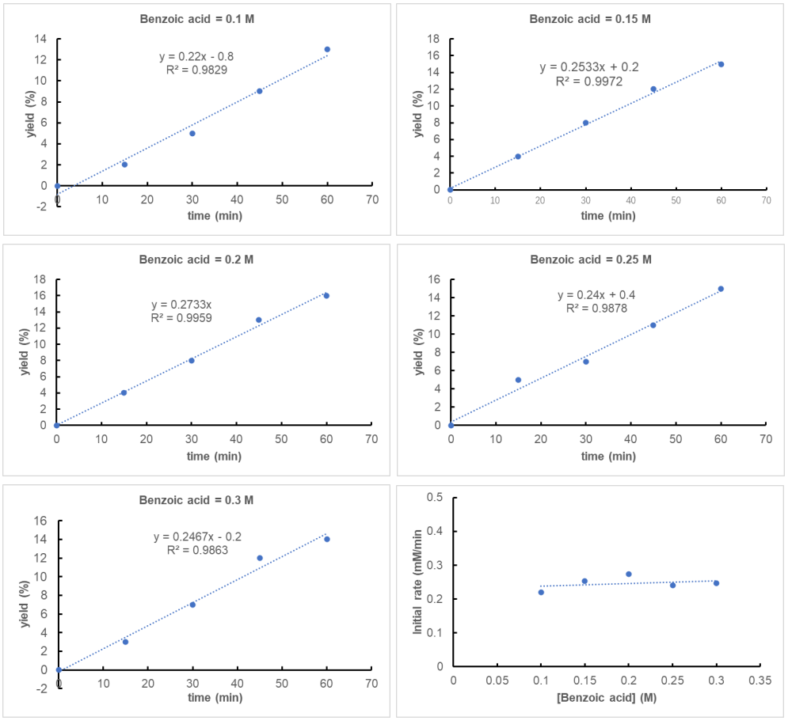
Figure S2. When the concentration of benzoic acid was 0.1 M, 0.15 M, 0.2 M, 0.25 M, 0.3 M, respectively, monitor the yield of product 3ab
The plot showed that the initial rate has a zero-order dependence on benzoic acid.

4) Determination of reaction order on N-butyl-2-iodo-3-methylbenzamide (2a)
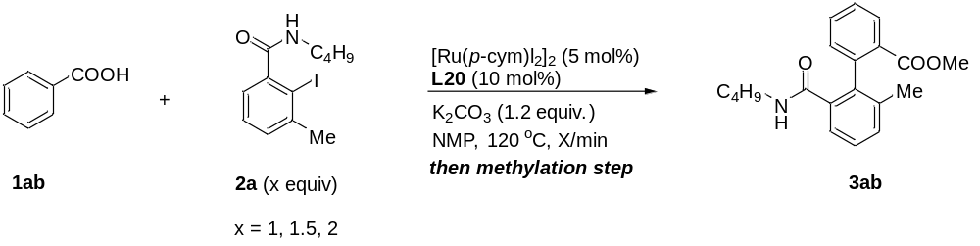
A mixture of benzoic acid 1ab (24.4 mg, 0.2 mmol), N-butyl-2-iodo-3-methylbenzamide 2a (0.2 mmol, 0.3 mmol, 0.4 mmol, respectively), [Ru(p-cym)I₂]₂ (9.8 mg, 5 mol%), K₂CO₃ (33.2 mg, 1.2 equiv.), after flushing the vessel with 3 alternating vacuum and nitrogen purge cycles, L20 (4.8 mg, 10 mol%), NMP (2.0 mL), the resulting mixture was stirred at 120 °C for 0 minute, 15 minutes, 30 minutes, 45 minutes, 60 minutes. And take 200 uL into the reaction vessel, added MeI (5.0 equiv.), K₂CO₃ (2.0 equiv.), NMP (0.5 mL), the mixture was stirred at 60 °C in an oil bath for 2 h. After cooling to room temperature, the GC yield (uncorrected) of 3ab was determined using tetradecane as the internal standard.

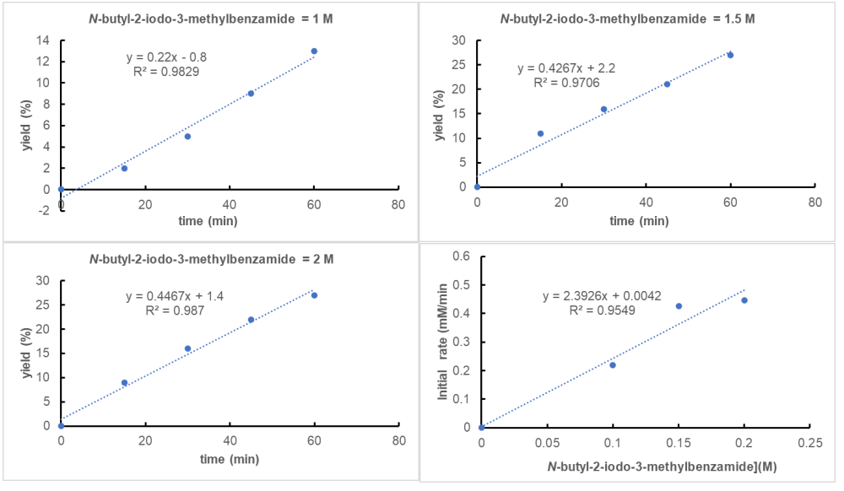
Figure S3. When the concentration of 2a was 0.1 M, 0.15 M, 0.2 M, 0.25 M, 0.3 M, respectively, monitor the yield of product 3ab
The plot showed that the initial rate has a first-order dependence on N-butyl-2-iodo-3-methylbenzamid.

(5) Synthesis of ruthenacycles (Int A) via C–H metallation
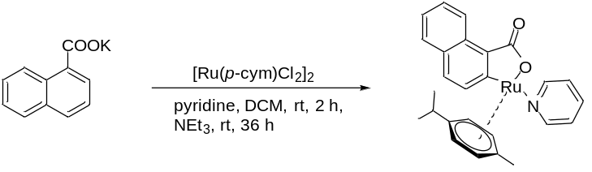
A solution of [RuCl₂(p-cym)]₂ (200.0 mg, 0.5 mmol, 1.0 equiv.) and pyridine (85.0 µL, 1.1 mmol, 2.0 equiv.) in dry DCM (15.0 mL, 0.03 M ) was stirred at 23 °C for 2 h. Subsequently potassium-1-naphthoate (315.0 mg, 1.5 mmol, 3.0 equiv.) and NEt₃ (1.0 mL, 7.0 mmol) were added and the suspension stirred at 23 °C for further 48 h. Filtration over celite and purification by column chromatography (DCM/MeOH: 40/1 → 20/1) yielded the ruthenapentacycle complex (191.6 mg, 79% yield); Physical state: yellow solid; ¹H NMR (400 MHz, CDCl₃) δ 9.52 (d, J = 8.6 Hz, 1H), 8.44 (d, J = 5.2 Hz, 2H), 8.19 (d, J = 8.1 Hz, 1H), 7.70 – 7.67 (m, 2H), 7.37 – 7.33 (m, 1H), 7.26 – 7.14 (m, 2H), 6.76 (t, J = 6.6 Hz, 2H), 5.57 (d, J = 5.7 Hz, 1H), 5.46 (d, J = 5.9 Hz, 1H), 5.23 (d, J = 6.2 Hz, 1H), 4.79 (d, J = 5.6 Hz, 1H), 2.37 – 2.26 (m, 1H), 1.63 (s, 3H), 0.93 (d, J = 6.9 Hz, 6H); ¹³C NMR (100 MHz, CDCl₃) δ 181.4, 180.2, 153.3, 136.5, 135.9, 132.5, 131.4, 130.3, 129.8, 127.5, 125.9, 124.1, 123.6, 123.0, 102.1, 98.3, 87.9, 87.2, 84.8, 79.9, 30.6, 22.4, 22.1, 17.8. The ruthenacycles (Int A) was prepared according the reported procedures.^{[16]}

(6) Cyclometalated ruthenium (II) complex (Int A) as the catalyst
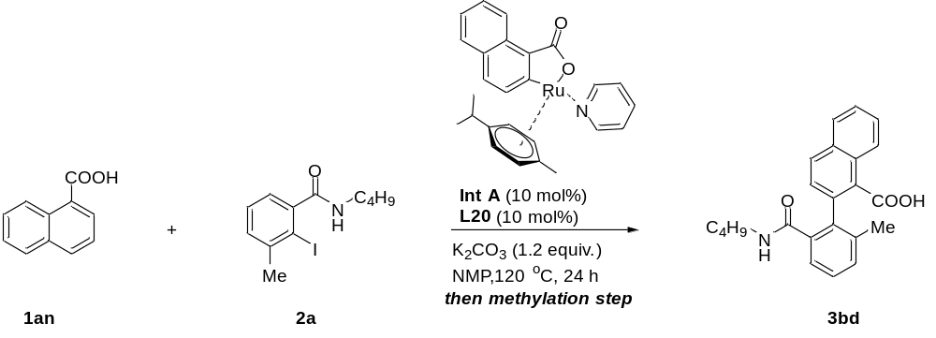
A mixture of 1-naphthoic acid 1an (17.2 mg, 1.0 equiv.), N-butyl-2-iodo-3-methylbenzamide 2a (47.6 mg, 0.15 mmol, 1.5 equiv.), Int A (4.9 mg, 10 mol%), L20 (2.4 mg, 10 mol%), K₂CO₃ (16.6 mg,1.2 equiv.), the tube was purged with N₂ three times, followed by addition of NMP (1.0 mL), the mixture was heated at 120 ºC for 24 hours. The solution was then cooled to room temperature and added MeI (23 uL, 5 equiv.), K₂CO₃ (27.2 mg, 2.0 equiv.), NMP (2.0 mL), the mixture was stirred at 60 °C in an oil bath for 2 h. After cooling to room temperature, the 44% yield of 3bd was determined by GC using tetradecane as the internal standard.

(7) Reaction of a cyclometalated rutheniumm (II) complex (Int A) react with 2a.
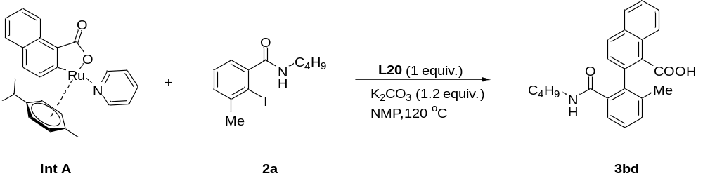
A mixture of Int A (24.3 mg, 0.05 mmol), N-butyl-2-iodo-3-methylbenzamide 2a (23.8 mg, 0.075 mmol, 1.5 equiv.), L20 (11.8 mg, 0.05 mmol), K₂CO₃ (16.6 mg,1.2 equiv.), the tube was purged with N₂ three times, followed by addition of NMP (1.0 mL), the mixture was heated at 120 ºC for 24 hours. The solution was then cooled to room temperature and added MeI (23.0 uL, 5.0 equiv.), K₂CO₃ (27.2 mg, 2.0 equiv.), NMP (2.0 mL), the mixture was stirred at 60 °C in an oil bath for 2 h. After cooling to room temperature, the 20% yield of 3bd was determined by GC using tetradecane as the internal standard and as show in above table.

(8) Preparation of Ru-1
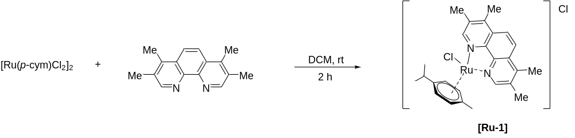
[RuCl₂(p-cym)]₂ (306.0 mg, 0.5 mmol) and 3,4,7,8-tetramethyl-1,10-phenanthroline (236.0 mg, 1.0 mmol) in dichloromethane (50.0 mL) were stirred for 2 h at room temperature. After completion, solvent was removed under reduced pressure, and the residue was dissolved in minimal amount of dichloromethane. Ether was slowly added to afford the desired metal complex after recrystallization. The precipitate was filtered and dried under reduced pressure to yield the Ru-1 (478.0 mg, 88% yield); Physical state: yellow solid; ¹H NMR (500 MHz, CDCl₃) δ 9.89 (s, 2H), 8.06 (s, 2H), 6.46 (d, J = 6.0 Hz, 2H), 6.25 (d, J = 5.9 Hz, 2H), 2.78 (s, 6H), 2.75 (s, 6H), 2.67 – 2.61 (m, 1H), 2.24 (s, 3H), 0.94 (s, 3H), 0.92 (s, 3H); ¹³C NMR (125 MHz, CDCl₃) δ 156.5, 145.8, 144.4, 135.6, 128.8, 123.2, 103.8, 103.6, 86.7, 83.8, 53.4, 31.0, 22.2, 19.0, 17.9, 14.8. The catalyst (Ru-1) was prepared according the reported procedures.^{[17]}

(9) Preparation of Ru-2
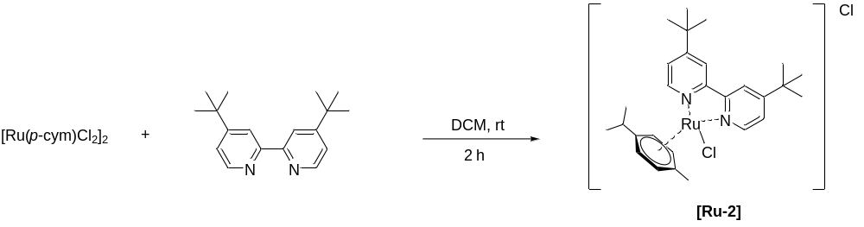
[RuCl₂(p-cym)]₂ (306.0 mg, 0.5 mmol) and 4,4'-di-tert-butyl-2,2'-bipyridine (268.0 mg, 1.0 mmol) in dichloromethane (50.0 mL) were stirred for 2 h at room temperature. After completion, solvent was removed under reduced pressure, and the residue was dissolved in minimal amount of dichloromethane. Ether was slowly added to afford the desired metal complex after recrystallization. The precipitate was filtered and dried under reduced pressure to yield the Ru-2 (494.5 mg, 86% yield); Physical state: yellow solid; ¹H NMR (500 MHz, d⁶-DMSO) δ 9.47 (d, J = 6.1 Hz, 2H), 8.69 (s, 2H), 7.70 (d, J = 5.1 Hz, 2H), 6.22 (d, J = 6.0 Hz, 2H), 6.00 (d, J = 6.0 Hz, 2H), 2.71 – 2.52 (m, 1H), 2.15 (s, 3H), 1.43 (s, 18H), 0.97 (d, J = 6.8 Hz, 6H); ¹³C NMR (125 MHz, d⁶-DMSO) δ 164.4, 156.1, 154.8, 124.7, 121.7, 104.3, 102.9, 86.7, 84.7, 36.1, 30.9, 30.5, 22.1, 18.7. The catalyst (Ru-2) was prepared according the reported procedures.^{[17]}

(10) Radical experiments
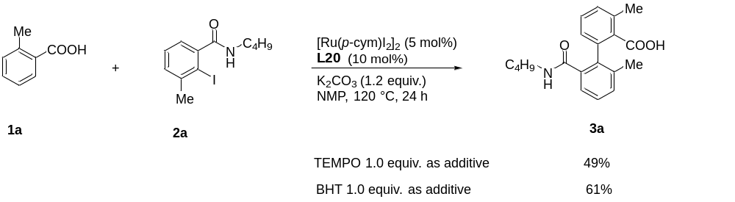
An oven-dried 4 mL vessel was charged with ortho-methylbenzoic acid 1a (13.6 mg, 0.1 mmol), N-butyl-2-iodo-3-methylbenzamide 2a (47.6 mg, 0.15 mmol), [Ru(p-cym)I₂]₂ (4.9 mg, 5 mol%), K₂CO₃ (16.6 mg, 1.2 equiv.), tetramethylpiperidine nitrogen oxide (15.6 mg, 1 equiv.) or 2,6-di-tert-butyl-4-methylphenol (22.0 mg, 1.0 equiv.), after flushing the vessel with 3 alternating vacuum and nitrogen purge cycles, L20 (2.4 mg, 10 mol%), NMP (1.0 mL), the resulting mixture was stirred at 120 °C for 24 h. Most of the carboxylic acid was transformed into the desired product (49% or 61% corrected GC yield, respectively). This result shows that the reaction does not involve free radical processes.

11) Others directing group instead of carboxylate
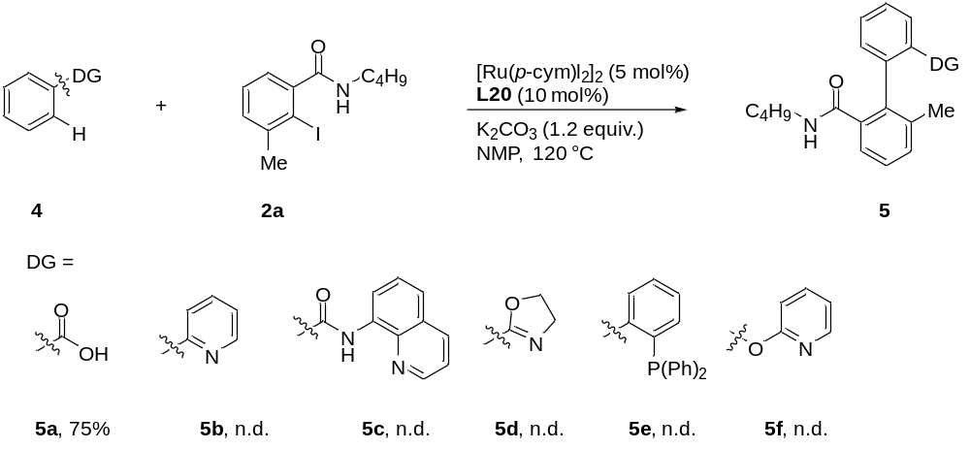
An oven-dried 4 mL vessel was charged with directing groups 4, such as benzoic acid 4a or pyridine 4b or 8-aminoquinoline 4c or oxazole 4d or phosphine-containing directing group 4e or 4f (0.1 mmol), N-butyl-2-iodo-3-methylbenzamide 2a (47.6 mg, 0.15 mmol), [Ru(p-cym)I₂]₂ (4.9 mg, 5 mol%), K₂CO₃ (16.6 mg, 1.2 equiv.), After flushing the vessel with 3 alternating vacuum and nitrogen purge cycles, L20 (10 mol%), NMP (1.0 mL), the resulting mixture was stirred at 120 °C for 24 h. Unfortunately, directing group except carboxylate all failed to assist the C–H arylation. No homo-coupling products of 4b-f were detected, and the starting materials were left. It clearly certificated that the carboxylate as the directing group was critical for coupling with steric hindered aryl halides.

12) The competitive experiment of naphthoic acid vs phenylpyridine react with 2a
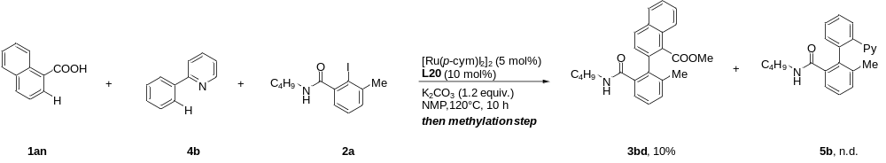
An oven-dried 4 mL vessel was charged with 1-naphthoic acid 1an (17.2 mg, 0.1 mmol), 2-phenylpyridine 4b (15.5 mg, 0.1 mmol), N-butyl-2-iodo-3-methylbenzamide 2a (47.6 mg, 0.15 mmol), [Ru(p-cym)I₂]₂ (4.9 mg, 5 mol%), K₂CO₃ (16.6 mg, 1.2 equiv), after flushing the vessel with 3 alternating vacuum and nitrogen purge cycles, L20 (2.4 mg, 10 mol%), NMP (1.0 mL), the resulting mixture was stirred at 120 °C for 24 h. After cooling to room temperature, added MeI (5 equiv.), K₂CO₃ (2.0 equiv.), NMP (0.5 mL), the mixture was stirred at 60 °C in an oil bath for 2 h. After cooling to room temperature, the 10% GC yield (uncorrected) of 3bd and no product of 5b were determined using tetradecane as the internal standard.

8. Single crystal structure and data
X-ray structure of 3aa (CCDC 2098624)
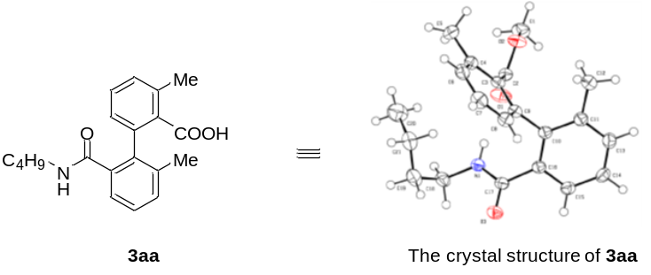
Table S5. Crystal data and structure refinement for 3aa.
ntification code | 3aa
Empirical formula | C₂₁H₂₅NO₃
Formula weight | 339.42
Temperature/K | 170.0
Crystal system | monoclinic
Space group | P2₁/c
a/Å | 11.6932(5)
b/Å | 15.2248(6)
c/Å | 10.8442(4)
α/° | 90
β/° | 110.5400(10)
γ/° | 90
Volume/Å³ | 1807.83(12)
Z | 4
ρ_{calc}g/cm³ | 1.247
μ/mm⁻¹ | 0.083
F(000) | 728.0
Crystal size/mm³ | 0.15 × 0.08 × 0.05
Radiation | MoKα (λ = 0.71073)
2Θ range for data collection/° | 4.582 to 52.826
Index ranges | -12 ≤ h ≤ 14, -19 ≤ k ≤ 19, -13 ≤ l ≤ 11
Reflections collected | 13215
Independent reflections | 3682 [R_{int} = 0.0377, R_{sigma} = 0.0376]
Data/restraints/parameters | 3682/0/230
Goodness-of-fit on F² | 1.046
Final R indexes [I>=2σ (I)] | R₁ = 0.0523, wR₂ = 0.1300
Final R indexes [all data] | R₁ = 0.0747, wR₂ = 0.1465
Largest diff. peak/hole / e Å⁻³ | 0.35/-0.27

Table S6. Fractional atomic coordinates (×10⁴) and equivalent isotropic displacement parameters (Å²×10³) for 3aa. U_{eq} is defined as 1/3 of of the trace of the orthogonalised U_{IJ} tensor.
Atom | x | y | z | U(eq)
O(3) | 1572.0(14) | 5387.3(9) | 2771.1(13) | 34.4(4)
O(2) | 2485.7(14) | 5104.9(10) | 9187.5(13) | 35.8(4)
O(1) | 1297.9(13) | 4770.9(11) | 7140.4(13) | 38.6(4)
N(1) | 1324.1(15) | 4631.5(10) | 4455.8(15) | 27.4(4)
C(10) | 2381.9(17) | 6322.1(12) | 5949.5(17) | 24.0(4)
C(9) | 3393.9(17) | 5683.3(12) | 6580.7(17) | 24.6(4)
C(16) | 1566.7(17) | 6198.9(12) | 4656.9(17) | 24.3(4)
C(17) | 1510.9(17) | 5369.2(12) | 3884.5(17) | 25.4(4)
C(2) | 2281.7(18) | 4977.7(12) | 7913.8(18) | 26.1(4)
C(15) | 745.3(19) | 6858.0(12) | 4025.6(18) | 28.6(4)
C(3) | 3399.5(17) | 5083.3(12) | 7562.3(17) | 24.7(4)
C(11) | 2346.8(18) | 7115.1(12) | 6603.6(18) | 27.8(4)
C(14) | 711(2) | 7634.3(13) | 4674(2) | 32.2(5)
C(13) | 1505(2) | 7760.4(13) | 5958(2) | 32.4(5)
C(4) | 4401.7(19) | 4526.5(12) | 8149.6(18) | 29.2(4)
C(8) | 4416.5(19) | 5722.9(13) | 6206(2) | 31.4(5)
C(18) | 1053(2) | 3792.1(13) | 3769(2) | 33.7(5)
C(6) | 5399.7(19) | 4588.9(14) | 7739(2) | 34.3(5)
C(7) | 5406(2) | 5178.9(14) | 6782(2) | 36.0(5)
C(12) | 3220(2) | 7288.9(14) | 7982(2) | 38.6(5)
C(1) | 1473(2) | 4907.0(15) | 9619(2) | 38.8(5)
C(5) | 4405(2) | 3853.2(14) | 9171(2) | 39.2(5)
C(21) | 3201(2) | 3215.9(15) | 4993(2) | 41.1(5)
C(19) | 2158(2) | 3317.7(15) | 3684(2) | 40.7(5)
C(20) | 2883(3) | 2679.1(18) | 5989(3) | 55.0(7)

Table S7. Anisotropic displacement parameters (Å²×10³) for 3aa. The anisotropic displacement factor exponent takes the form: -2π²[h²a*²U₁₁+2hka*b*U₁₂+…].
Atom | U₁₁ | U₂₂ | U₃₃ | U₂₃ | U₁₃ | U₁₂
O(3) | 45.6(9) | 36.6(8) | 24.4(7) | 0.0(6) | 16.7(6) | 0.4(7)
O(2) | 39.2(9) | 48.5(9) | 21.3(7) | -2.4(6) | 12.5(6) | -5.1(7)
O(1) | 27.9(8) | 62.4(10) | 26.2(7) | -3.1(7) | 10.5(6) | -7.6(7)
N(1) | 33.6(10) | 26.6(8) | 21.5(8) | -0.6(6) | 9.0(7) | -2.2(7)
C(10) | 27.5(10) | 24.8(9) | 23.2(9) | 1.8(7) | 13.0(8) | -1.9(8)
C(9) | 25.4(10) | 27.1(9) | 20.9(9) | -3.4(7) | 7.5(8) | -2.2(8)
C(16) | 25.8(10) | 26.7(9) | 22.6(9) | 1.8(7) | 11.3(8) | -0.6(8)
C(17) | 24.5(10) | 30.5(10) | 20.8(9) | -0.4(7) | 7.5(8) | 1.3(8)
C(2) | 30.0(11) | 25.5(9) | 22.8(9) | 0.5(7) | 9.5(8) | 0.5(8)
C(15) | 31.8(11) | 29.9(10) | 24.5(9) | 3.2(8) | 10.5(8) | 1.5(8)
C(3) | 26.2(10) | 26.5(9) | 20.4(8) | -4.2(7) | 6.8(8) | -3.3(8)
C(11) | 31.4(11) | 27.2(9) | 26.7(9) | 1.3(8) | 12.7(8) | -1.9(8)
C(14) | 39.0(12) | 27.7(10) | 31.5(10) | 8.1(8) | 14.1(9) | 5.7(9)
C(13) | 40.4(13) | 25.4(10) | 35.1(11) | 0.0(8) | 17.8(9) | 1.0(9)
C(4) | 29.7(11) | 27.9(10) | 25.3(9) | -4.1(8) | 4.0(8) | 0.8(8)
C(8) | 30.9(11) | 34.8(11) | 30.7(10) | -0.8(8) | 13.7(9) | -2.5(9)
C(18) | 41.4(13) | 28.8(10) | 29.5(10) | -5.8(8) | 10.6(9) | -6.2(9)
C(6) | 28.3(12) | 34.6(11) | 34.5(11) | -8.1(9) | 4.1(9) | 4.3(9)
C(7) | 27.5(12) | 43.4(12) | 40.9(12) | -6.4(10) | 16.7(9) | -1.7(9)
C(12) | 45.6(14) | 35.2(11) | 31.1(11) | -4.4(9) | 8.7(10) | 1.4(10)
C(1) | 44.5(14) | 49.1(13) | 30.6(10) | 3.0(10) | 23.2(10) | 0.1(11)
C(5) | 46.7(14) | 33.7(11) | 30.4(11) | 5.3(9) | 5.1(10) | 4.8(10)
C(21) | 40.5(13) | 34.6(11) | 49.7(13) | -8.2(10) | 17.7(11) | -1.2(10)
C(19) | 51.2(15) | 33.9(11) | 43.1(12) | -9.5(9) | 24.1(11) | -5.6(10)
C(20) | 61.4(18) | 57.6(16) | 47.2(14) | -2.8(12) | 20.4(13) | -8.0(13)

Table S8. Bond lengths for 3aa.
Atom | Atom | Length/Å |  | Atom | Atom | Length/Å
O(3) | C(17) | 1.235(2) |  | C(2) | C(3) | 1.493(3)
O(2) | C(2) | 1.331(2) |  | C(15) | C(14) | 1.383(3)
O(2) | C(1) | 1.449(3) |  | C(3) | C(4) | 1.405(3)
O(1) | C(2) | 1.204(2) |  | C(11) | C(13) | 1.393(3)
N(1) | C(17) | 1.337(2) |  | C(11) | C(12) | 1.509(3)
N(1) | C(18) | 1.457(2) |  | C(14) | C(13) | 1.389(3)
C(10) | C(9) | 1.499(3) |  | C(4) | C(6) | 1.390(3)
C(10) | C(16) | 1.404(3) |  | C(4) | C(5) | 1.508(3)
C(10) | C(11) | 1.408(3) |  | C(8) | C(7) | 1.382(3)
C(9) | C(3) | 1.401(3) |  | C(18) | C(19) | 1.511(3)
C(9) | C(8) | 1.393(3) |  | C(6) | C(7) | 1.375(3)
C(16) | C(17) | 1.504(3) |  | C(21) | C(19) | 1.520(3)
C(16) | C(15) | 1.392(3) |  | C(21) | C(20) | 1.502(3)

Table S9. Bond angles for 3aa.
Atom | Atom | Atom | Angle/˚ |  | Atom | Atom | Atom | Angle/˚
C(2) | O(2) | C(1) | 115.82(16) |  | C(9) | C(3) | C(2) | 119.54(17)
C(17) | N(1) | C(18) | 122.77(16) |  | C(9) | C(3) | C(4) | 121.25(18)
C(16) | C(10) | C(9) | 121.33(16) |  | C(4) | C(3) | C(2) | 119.01(17)
C(16) | C(10) | C(11) | 119.20(17) |  | C(10) | C(11) | C(12) | 121.34(17)
C(11) | C(10) | C(9) | 118.96(16) |  | C(13) | C(11) | C(10) | 119.45(17)
C(3) | C(9) | C(10) | 124.24(17) |  | C(13) | C(11) | C(12) | 119.19(17)
C(8) | C(9) | C(10) | 117.36(16) |  | C(15) | C(14) | C(13) | 119.94(18)
C(8) | C(9) | C(3) | 118.32(17) |  | C(14) | C(13) | C(11) | 120.83(18)
C(10) | C(16) | C(17) | 123.34(16) |  | C(3) | C(4) | C(5) | 122.00(19)
C(15) | C(16) | C(10) | 120.30(17) |  | C(6) | C(4) | C(3) | 118.29(18)
C(15) | C(16) | C(17) | 116.36(16) |  | C(6) | C(4) | C(5) | 119.68(18)
O(3) | C(17) | N(1) | 123.15(17) |  | C(7) | C(8) | C(9) | 120.72(19)
O(3) | C(17) | C(16) | 121.31(17) |  | N(1) | C(18) | C(19) | 114.43(18)
N(1) | C(17) | C(16) | 115.44(15) |  | C(7) | C(6) | C(4) | 120.93(19)
O(2) | C(2) | C(3) | 113.27(16) |  | C(6) | C(7) | C(8) | 120.5(2)
O(1) | C(2) | O(2) | 122.73(18) |  | C(20) | C(21) | C(19) | 114.1(2)
O(1) | C(2) | C(3) | 123.96(17) |  | C(18) | C(19) | C(21) | 114.50(18)
C(14) | C(15) | C(16) | 120.28(18)

Table S10. Hydrogen atom coordinates (Å×10⁴) and isotropic displacement parameters (Å²×10³) for 3aa.
Atom | x | y | z | U(eq)
H(1) | 1366.33 | 4653.9 | 5281.55 | 33
H(15) | 205.95 | 6774.41 | 3145.45 | 34
H(14) | 144.57 | 8080.89 | 4242.34 | 39
H(13) | 1474.43 | 8293.39 | 6400.4 | 39
H(8) | 4433.5 | 6128.55 | 5546.69 | 38
H(18A) | 471.37 | 3893.77 | 2864.68 | 40
H(18B) | 645.29 | 3407.54 | 4224.26 | 40
H(6) | 6086.76 | 4218.73 | 8126.29 | 41
H(7) | 6096.67 | 5212.63 | 6514.41 | 43
H(12A) | 3016.77 | 6906.83 | 8602.94 | 58
H(12B) | 3154.35 | 7904.62 | 8212.07 | 58
H(12C) | 4057.2 | 7167.98 | 8027.17 | 58
H(1A) | 770.67 | 5273.72 | 9132.64 | 58
H(1B) | 1711.68 | 5027.47 | 10563.58 | 58
H(1C) | 1252.06 | 4286.08 | 9452.13 | 58
H(5A) | 4572.79 | 4143.74 | 10022.39 | 59
H(5B) | 5038.41 | 3413.6 | 9246.72 | 59
H(5C) | 3605.85 | 3564.58 | 8905.96 | 59
H(21A) | 3900.75 | 2936.98 | 4832.29 | 49
H(21B) | 3464.64 | 3806.75 | 5365.12 | 49
H(19A) | 2462.36 | 3641.59 | 3069.23 | 49
H(19B) | 1903.28 | 2726.65 | 3306.91 | 49
H(20A) | 2524.28 | 2119.55 | 5592.37 | 83
H(20B) | 2294.46 | 3001.34 | 6274.43 | 83
H(20C) | 3624.51 | 2566.06 | 6750.7 | 83

X-ray structure of 3za (CCDC 2098617)
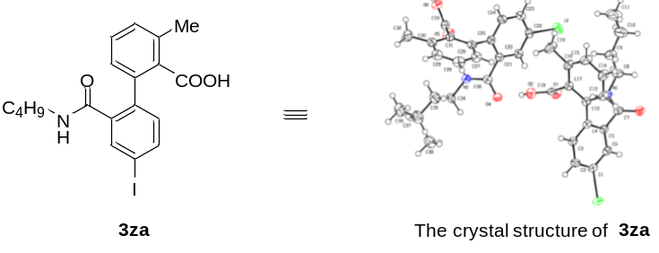

Table S11. Crystal data and structure refinement for 3za.
Identification code | 3za
Empirical formula | C₁₉H₂₀INO₃
Formula weight | 437.26
Temperature/K | 170.0
Crystal system | monoclinic
Space group | P2₁/n
a/Å | 13.0432(3)
b/Å | 19.7182(4)
c/Å | 14.8869(3)
α/° | 90
β/° | 101.4450(10)
γ/° | 90
Volume/Å³ | 3752.61(14)
Z | 8
ρ_{calc}g/cm³ | 1.548
μ/mm⁻¹ | 1.722
F(000) | 1744.0
Crystal size/mm³ | 0.15 × 0.08 × 0.03
Radiation | MoKα (λ = 0.71073)
2Θ range for data collection/° | 3.796 to 52.78
Index ranges | -16 ≤ h ≤ 16, -21 ≤ k ≤ 24, -18 ≤ l ≤ 16
Reflections collected | 28664
Independent reflections | 7638 [R_{int} = 0.0469, R_{sigma} = 0.0447]
Data/restraints/parameters | 7638/0/449
Goodness-of-fit on F² | 1.066
Final R indexes [I>=2σ (I)] | R₁ = 0.0327, wR₂ = 0.0604
Final R indexes [all data] | R₁ = 0.0494, wR₂ = 0.0683
Largest diff. peak/hole / e Å⁻³ | 0.58/-0.69

Table S12. Fractional atomic coordinates (×10⁴) and equivalent isotropic displacement parameters (Å²×10³) for 3za. U_{eq} is defined as 1/3 of of the trace of the orthogonalised U_{IJ} tensor.
Atom | x | y | z | U(eq)
I(1) | 312.3(2) | 4422.8(2) | -1397.0(2) | 33.01(7)
I(2) | 984.0(2) | 8293.4(2) | 3805.3(2) | 41.52(8)
O(1) | 1653.7(16) | 6405.3(12) | 2424.0(15) | 31.7(5)
O(4) | 1632.2(17) | 5366.5(11) | 4310.6(15) | 31.8(5)
O(3) | 1755.2(17) | 7240.8(12) | -735.6(15) | 34.0(5)
O(6) | 3050.8(17) | 6638.3(12) | 8437.7(15) | 33.5(5)
O(2) | 2886.0(16) | 5786.0(12) | 3325.4(15) | 33.5(5)
O(5) | 1728.7(17) | 6275.0(13) | 7363.4(15) | 37.7(6)
N(1) | 1408.5(19) | 7232.8(13) | 697.7(18) | 28.9(6)
N(2) | 1337.0(19) | 5427.0(14) | 5754.4(18) | 29.7(6)
C(1) | 1267(2) | 5061.4(17) | -459(2) | 26.8(7)
C(12) | 3399(2) | 6360.7(16) | 1309(2) | 25.2(7)
C(6) | 1174(2) | 5760.1(16) | -563(2) | 26.7(7)
C(17) | 3425(2) | 6494.4(16) | 2237(2) | 24.3(7)
C(7) | 1665(2) | 6931.3(16) | -27(2) | 26.5(7)
C(26) | 3539(2) | 6035.0(16) | 6405(2) | 25.3(7)
C(21) | 2047(2) | 6401.8(16) | 5153(2) | 25.2(7)
C(22) | 1819(2) | 7563.1(16) | 4688(2) | 27.8(7)
C(31) | 3447(2) | 5899.7(16) | 7303(2) | 23.9(7)
C(13) | 4164(2) | 6643.4(17) | 892(2) | 31.3(8)
C(25) | 2902(2) | 6575.7(16) | 5843(2) | 24.9(7)
C(5) | 1819(2) | 6180.1(16) | 55(2) | 24.6(7)
C(20) | 1524(2) | 6892.7(16) | 4568(2) | 27.4(7)
C(4) | 2594(2) | 5906.7(16) | 753(2) | 24.5(7)
C(36) | 1663(2) | 5684.2(16) | 5038(2) | 25.8(7)
C(2) | 1980(2) | 4784.6(17) | 263(2) | 30.7(7)
C(33) | 2654(2) | 6290.2(16) | 7704(2) | 27.3(7)
C(18) | 2561(2) | 6225.0(17) | 2666(2) | 26.5(7)
C(30) | 4025(2) | 5374.4(17) | 7804(2) | 29.6(7)
C(16) | 4200(2) | 6913.0(18) | 2745(2) | 32.0(8)
C(29) | 4691(2) | 4999.0(18) | 7375(2) | 34.6(8)
C(3) | 2644(2) | 5207.2(17) | 850(2) | 28.6(7)
C(24) | 3185(2) | 7254.8(17) | 5945(2) | 31.1(7)
C(23) | 2640(3) | 7749.2(18) | 5383(2) | 33.1(8)
C(34) | 1037(2) | 4718.1(17) | 5818(2) | 31.3(8)
C(15) | 4941(3) | 7191(2) | 2298(2) | 40.6(9)
C(14) | 4932(3) | 7054(2) | 1393(2) | 40.0(9)
C(8) | 1403(3) | 7966.8(18) | 821(2) | 36.8(8)
C(27) | 4222(2) | 5650.6(18) | 6000(2) | 33.8(8)
C(28) | 4797(3) | 5136.9(19) | 6496(3) | 39.0(9)
C(35) | 1897(3) | 4316.1(19) | 6404(3) | 43.4(9)
C(32) | 3898(3) | 5187.1(19) | 8760(2) | 40.8(9)
C(19) | 4204(3) | 7091(2) | 3731(2) | 49.1(11)
C(9) | 2384(3) | 8175(2) | 1501(3) | 46.3(10)
C(37) | 1585(3) | 3579(2) | 6532(3) | 53.3(11)
C(10) | 2478(3) | 8921(2) | 1673(3) | 57.4(11)
C(11) | 3501(4) | 9101(3) | 2321(4) | 80.9(16)
C(38) | 1185(6) | 3184(4) | 5561(6) | 48(2)
C(39) | 2513(8) | 3320(4) | 7323(6) | 66(3)

Table S13. Anisotropic displacement parameters (Å²×10³) for 3za. The anisotropic displacement factor exponent takes the form: -2π²[h²a*²U₁₁+2hka*b*U₁₂+…].
Atom | U₁₁ | U₂₂ | U₃₃ | U₂₃ | U₁₃ | U₁₂
I(1) | 33.27(12) | 33.48(13) | 30.48(12) | -9.17(10) | 1.97(9) | -3.31(10)
I(2) | 43.21(14) | 32.82(14) | 46.12(15) | 10.58(11) | 3.06(11) | 5.55(11)
O(1) | 19.8(11) | 45.3(15) | 28.7(12) | -0.7(11) | 1.3(9) | 0.2(10)
O(4) | 35.8(12) | 30.8(13) | 29.7(12) | -7.1(10) | 8.7(10) | -6.8(10)
O(3) | 43.1(13) | 30.5(14) | 25.9(12) | 0.8(11) | 0.6(10) | 9.0(11)
O(6) | 31.6(12) | 37.9(15) | 28.8(12) | -7.9(11) | 0.9(10) | 1.6(11)
O(2) | 28.0(12) | 40.4(15) | 32.7(13) | 4.5(11) | 7.7(10) | 0.9(10)
O(5) | 27.4(13) | 51.9(17) | 32.4(13) | -8.3(12) | 2.5(10) | 6.5(11)
N(1) | 30.9(14) | 26.1(15) | 29.3(15) | -5.2(12) | 4.8(12) | 2.3(12)
N(2) | 31.3(14) | 28.8(16) | 29.1(14) | -2.2(12) | 5.8(12) | -6.2(12)
C(1) | 25.6(16) | 30.8(19) | 23.2(16) | -8.1(14) | 3.1(13) | -0.3(14)
C(12) | 20.8(15) | 29.0(18) | 23.9(16) | -2.6(14) | 0.1(13) | 4.8(13)
C(6) | 24.7(16) | 33.7(19) | 20.4(15) | -1.1(14) | 1.7(13) | 4.1(14)
C(17) | 18.2(15) | 30.0(18) | 23.4(16) | 0.6(14) | 1.2(13) | 2.1(13)
C(7) | 21.5(16) | 29.8(19) | 24.9(16) | -5.5(15) | -3.3(13) | 3.9(13)
C(26) | 18.8(15) | 26.2(18) | 29.7(17) | -1.4(14) | 1.7(13) | -1.6(13)
C(21) | 23.0(15) | 27.4(18) | 26.9(16) | -0.7(14) | 8.9(13) | -1.2(13)
C(22) | 28.5(17) | 25.2(18) | 31.1(17) | 5.5(15) | 9.4(14) | 4.9(14)
C(31) | 19.4(15) | 24.5(17) | 26.2(16) | -2.9(14) | 0.6(13) | 0.1(13)
C(13) | 30.8(17) | 38(2) | 25.2(17) | -4.5(15) | 6.3(14) | 1.6(15)
C(25) | 22.8(15) | 28.4(18) | 24.0(16) | 0.0(14) | 6.0(13) | -1.4(13)
C(5) | 24.3(16) | 26.2(18) | 23.4(16) | -2.0(14) | 4.7(13) | 3.1(13)
C(20) | 24.1(16) | 30.4(19) | 27.1(17) | -0.1(14) | 3.6(13) | -0.3(13)
C(4) | 22.5(15) | 30.0(18) | 20.4(15) | -2.5(14) | 3.0(13) | 3.3(13)
C(36) | 20.8(15) | 23.9(17) | 32.2(17) | 0.1(14) | 3.9(13) | 0.8(13)
C(2) | 33.8(18) | 25.9(18) | 31.5(18) | -3.6(15) | 4.7(15) | 2.4(14)
C(33) | 29.3(18) | 25.8(18) | 25.2(16) | 3.4(14) | 1.9(14) | 2.3(14)
C(18) | 27.0(17) | 29.2(19) | 22.5(16) | -9.1(14) | 3.3(14) | -4.9(14)
C(30) | 23.6(16) | 30.2(19) | 32.3(18) | 0.6(15) | -0.7(14) | -1.9(14)
C(16) | 21.8(16) | 47(2) | 25.0(17) | -5.2(16) | 0.4(13) | -3.4(15)
C(29) | 24.1(17) | 33(2) | 43(2) | 1.5(17) | -3.0(15) | 7.7(14)
C(3) | 28.8(17) | 30.4(19) | 24.0(16) | 1.0(15) | -1.5(14) | 4.8(14)
C(24) | 29.5(17) | 30.2(19) | 30.9(18) | -2.2(15) | -0.2(14) | -5.0(14)
C(23) | 37.3(19) | 26.5(19) | 35.3(19) | 0.1(16) | 6.3(16) | -5.8(15)
C(34) | 29.1(17) | 28.7(19) | 35.1(19) | 3.2(15) | 4.0(15) | -7.0(14)
C(15) | 26.5(18) | 57(3) | 37(2) | -11.9(19) | 4.3(15) | -15.1(17)
C(14) | 31.0(18) | 60(3) | 31.5(19) | -4.0(18) | 13.2(16) | -10.7(17)
C(8) | 38.8(19) | 31(2) | 41(2) | -10.7(17) | 7.7(16) | 2.2(16)
C(27) | 24.9(16) | 41(2) | 36.4(19) | -1.2(17) | 8.5(15) | -1.4(15)
C(28) | 27.8(18) | 39(2) | 50(2) | -6.9(18) | 6.7(17) | 8.6(16)
C(35) | 36(2) | 42(2) | 46(2) | 10.3(19) | -5.2(17) | -2.4(17)
C(32) | 47(2) | 38(2) | 33(2) | 9.0(17) | -2.7(17) | 11.1(17)
C(19) | 38(2) | 78(3) | 31(2) | -15(2) | 6.0(17) | -21(2)
C(9) | 50(2) | 45(2) | 41(2) | -10.1(19) | 0.6(18) | -7.4(18)
C(37) | 62(3) | 39(2) | 58(3) | 11(2) | 8(2) | 6(2)
C(10) | 66(3) | 43(3) | 60(3) | -9(2) | 4(2) | -9(2)
C(11) | 83(4) | 61(3) | 85(4) | -11(3) | -17(3) | -30(3)
C(38) | 49(5) | 36(5) | 60(5) | 5(4) | 17(4) | 8(4)
C(39) | 105(8) | 41(5) | 52(5) | 17(4) | 12(5) | 20(5)

Table S14 Bond lengths for 3za.
Atom | Atom | Length/Å |  | Atom | Atom | Length/Å
I(1) | C(1) | 2.096(3) |  | C(21) | C(36) | 1.499(4)
I(2) | C(22) | 2.102(3) |  | C(22) | C(20) | 1.378(4)
O(1) | C(18) | 1.219(4) |  | C(22) | C(23) | 1.384(5)
O(4) | C(36) | 1.245(4) |  | C(31) | C(33) | 1.505(4)
O(3) | C(7) | 1.244(4) |  | C(31) | C(30) | 1.405(4)
O(6) | C(33) | 1.306(4) |  | C(13) | C(14) | 1.384(5)
O(2) | C(18) | 1.314(4) |  | C(25) | C(24) | 1.389(4)
O(5) | C(33) | 1.213(4) |  | C(5) | C(4) | 1.405(4)
N(1) | C(7) | 1.332(4) |  | C(4) | C(3) | 1.387(4)
N(1) | C(8) | 1.459(4) |  | C(2) | C(3) | 1.381(4)
N(2) | C(36) | 1.325(4) |  | C(30) | C(29) | 1.391(4)
N(2) | C(34) | 1.460(4) |  | C(30) | C(32) | 1.510(5)
C(1) | C(6) | 1.389(4) |  | C(16) | C(15) | 1.391(5)
C(1) | C(2) | 1.386(4) |  | C(16) | C(19) | 1.509(4)
C(12) | C(17) | 1.400(4) |  | C(29) | C(28) | 1.370(5)
C(12) | C(13) | 1.393(4) |  | C(24) | C(23) | 1.385(5)
C(12) | C(4) | 1.498(4) |  | C(34) | C(35) | 1.503(5)
C(6) | C(5) | 1.390(4) |  | C(15) | C(14) | 1.372(5)
C(17) | C(18) | 1.499(4) |  | C(8) | C(9) | 1.522(5)
C(17) | C(16) | 1.404(4) |  | C(27) | C(28) | 1.384(5)
C(7) | C(5) | 1.497(4) |  | C(35) | C(37) | 1.532(5)
C(26) | C(31) | 1.391(4) |  | C(9) | C(10) | 1.494(5)
C(26) | C(25) | 1.501(4) |  | C(37) | C(38) | 1.634(9)
C(26) | C(27) | 1.395(4) |  | C(37) | C(39) | 1.595(9)
C(21) | C(25) | 1.401(4) |  | C(10) | C(11) | 1.526(6)
C(21) | C(20) | 1.387(4)

Table S15 Bond angles for 3za.
Atom | Atom | Atom | Angle/˚ |  | Atom | Atom | Atom | Angle/˚
C(7) | N(1) | C(8) | 123.5(3) |  | C(5) | C(4) | C(12) | 120.1(3)
C(36) | N(2) | C(34) | 123.5(3) |  | C(3) | C(4) | C(12) | 121.6(3)
C(6) | C(1) | I(1) | 119.7(2) |  | C(3) | C(4) | C(5) | 118.1(3)
C(2) | C(1) | I(1) | 119.9(2) |  | O(4) | C(36) | N(2) | 123.2(3)
C(2) | C(1) | C(6) | 120.4(3) |  | O(4) | C(36) | C(21) | 121.7(3)
C(17) | C(12) | C(4) | 122.3(3) |  | N(2) | C(36) | C(21) | 115.0(3)
C(13) | C(12) | C(17) | 119.0(3) |  | C(3) | C(2) | C(1) | 119.5(3)
C(13) | C(12) | C(4) | 118.6(3) |  | O(6) | C(33) | C(31) | 114.3(3)
C(1) | C(6) | C(5) | 119.3(3) |  | O(5) | C(33) | O(6) | 124.0(3)
C(12) | C(17) | C(18) | 118.7(3) |  | O(5) | C(33) | C(31) | 121.8(3)
C(12) | C(17) | C(16) | 121.0(3) |  | O(1) | C(18) | O(2) | 124.3(3)
C(16) | C(17) | C(18) | 120.1(3) |  | O(1) | C(18) | C(17) | 122.6(3)
O(3) | C(7) | N(1) | 123.3(3) |  | O(2) | C(18) | C(17) | 113.1(3)
O(3) | C(7) | C(5) | 121.4(3) |  | C(31) | C(30) | C(32) | 122.2(3)
N(1) | C(7) | C(5) | 115.3(3) |  | C(29) | C(30) | C(31) | 117.8(3)
C(31) | C(26) | C(25) | 121.9(3) |  | C(29) | C(30) | C(32) | 119.9(3)
C(31) | C(26) | C(27) | 119.7(3) |  | C(17) | C(16) | C(19) | 121.5(3)
C(27) | C(26) | C(25) | 118.4(3) |  | C(15) | C(16) | C(17) | 118.1(3)
C(25) | C(21) | C(36) | 120.9(3) |  | C(15) | C(16) | C(19) | 120.3(3)
C(20) | C(21) | C(25) | 120.7(3) |  | C(28) | C(29) | C(30) | 121.6(3)
C(20) | C(21) | C(36) | 118.4(3) |  | C(2) | C(3) | C(4) | 121.6(3)
C(20) | C(22) | I(2) | 118.7(2) |  | C(23) | C(24) | C(25) | 121.3(3)
C(20) | C(22) | C(23) | 120.4(3) |  | C(22) | C(23) | C(24) | 119.6(3)
C(23) | C(22) | I(2) | 120.9(2) |  | N(2) | C(34) | C(35) | 111.4(3)
C(26) | C(31) | C(33) | 118.7(3) |  | C(14) | C(15) | C(16) | 121.3(3)
C(26) | C(31) | C(30) | 120.8(3) |  | C(15) | C(14) | C(13) | 120.6(3)
C(30) | C(31) | C(33) | 120.3(3) |  | N(1) | C(8) | C(9) | 109.1(3)
C(14) | C(13) | C(12) | 120.0(3) |  | C(28) | C(27) | C(26) | 119.5(3)
C(21) | C(25) | C(26) | 120.5(3) |  | C(29) | C(28) | C(27) | 120.5(3)
C(24) | C(25) | C(26) | 121.2(3) |  | C(34) | C(35) | C(37) | 112.7(3)
C(24) | C(25) | C(21) | 118.1(3) |  | C(10) | C(9) | C(8) | 114.2(3)
C(6) | C(5) | C(7) | 118.8(3) |  | C(35) | C(37) | C(38) | 112.8(4)
C(6) | C(5) | C(4) | 120.8(3) |  | C(35) | C(37) | C(39) | 102.3(4)
C(4) | C(5) | C(7) | 120.3(3) |  | C(9) | C(10) | C(11) | 111.6(4)
C(22) | C(20) | C(21) | 119.9(3)

Table S16 Hydrogen atom coordinates (Å×10⁴) and isotropic displacement parameters (Å²×10³) for 3za.
Atom | x | y | z | U(eq)
H(6) | 2566.17 | 6822.95 | 8645.66 | 50
H(2A) | 2390.47 | 5687.09 | 3585.83 | 50
H(1) | 1232.48 | 6975.36 | 1125.73 | 35
H(2) | 1299.05 | 5697.95 | 6216.37 | 36
H(6A) | 674.98 | 5949.05 | -1050.43 | 32
H(13) | 4159.85 | 6554.85 | 264.22 | 38
H(20) | 963.42 | 6767.06 | 4086.45 | 33
H(2B) | 2012.38 | 4307.56 | 353 | 37
H(29) | 5083.03 | 4638.02 | 7698.9 | 41
H(3) | 3146.32 | 5014.19 | 1331.86 | 34
H(24) | 3762.93 | 7382.58 | 6408.55 | 37
H(23) | 2829.36 | 8212.96 | 5475.42 | 40
H(34A) | 872.83 | 4518.27 | 5196.07 | 38
H(34B) | 399.43 | 4692.66 | 6082.8 | 38
H(15) | 5464.89 | 7482.8 | 2626.58 | 49
H(14) | 5456.76 | 7241.64 | 1107.89 | 48
H(8A) | 773.07 | 8103.94 | 1052.54 | 44
H(8B) | 1385.15 | 8195.58 | 225.68 | 44
H(27) | 4291.46 | 5740.74 | 5388.02 | 41
H(28) | 5269.95 | 4877.71 | 6225.17 | 47
H(35A) | 2090.48 | 4535.23 | 7012.75 | 52
H(35B) | 2520.86 | 4322.22 | 6118.64 | 52
H(32A) | 4259.49 | 5521.85 | 9197.59 | 61
H(32B) | 4199.53 | 4737.12 | 8917.69 | 61
H(32C) | 3152.89 | 5180.82 | 8784.84 | 61
H(19A) | 3517.68 | 7271.41 | 3782.49 | 74
H(19B) | 4742.92 | 7432.67 | 3941.04 | 74
H(19C) | 4352.57 | 6682.76 | 4111.16 | 74
H(9A) | 2388.35 | 7941.79 | 2090.62 | 56
H(9B) | 3004.15 | 8019.41 | 1269.19 | 56
H(37A) | 1019.53 | 3570.7 | 6888.3 | 64
H(37B) | 2193.11 | 3333.52 | 6891.13 | 64
H(37C) | 1549.18 | 3313.22 | 5962.21 | 64
H(37D) | 902.19 | 3551.65 | 6725.49 | 64
H(10A) | 1882.45 | 9077.32 | 1941.46 | 69
H(10B) | 2443.08 | 9161.08 | 1083.37 | 69
H(11A) | 4092.2 | 8963.13 | 2046.36 | 121
H(11B) | 3538.7 | 8863.03 | 2905.18 | 121
H(11C) | 3530.87 | 9591.3 | 2429.38 | 121
H(38A) | 588.67 | 3426.84 | 5198.07 | 71
H(38B) | 972.3 | 2721.24 | 5681.44 | 71
H(38C) | 1755.22 | 3165.87 | 5220.25 | 71
H(39A) | 3182.23 | 3378.04 | 7126.39 | 99
H(39B) | 2408.93 | 2839.9 | 7446.46 | 99
H(39C) | 2519.76 | 3584.99 | 7881.18 | 99

Table S17 Atomic occupancy for 3za.
Atom | Occupancy |  | Atom | Occupancy |  | Atom | Occupancy
H(37A) | 0.5 |  | H(37B) | 0.5 |  | H(37C) | 0.5
H(37D) | 0.5 |  | C(38) | 0.5 |  | H(38A) | 0.5
H(38B) | 0.5 |  | H(38C) | 0.5 |  | C(39) | 0.5
H(39A) | 0.5 |  | H(39B) | 0.5 |  | H(39C) | 0.5

9. Copies of NMR Spectrums
2-iodo-N-isopropyl-3-methylbenzamide, 2b, ¹H NMR (500 MHz, CDCl₃) and ¹³C NMR (125 MHz, CDCl₃)
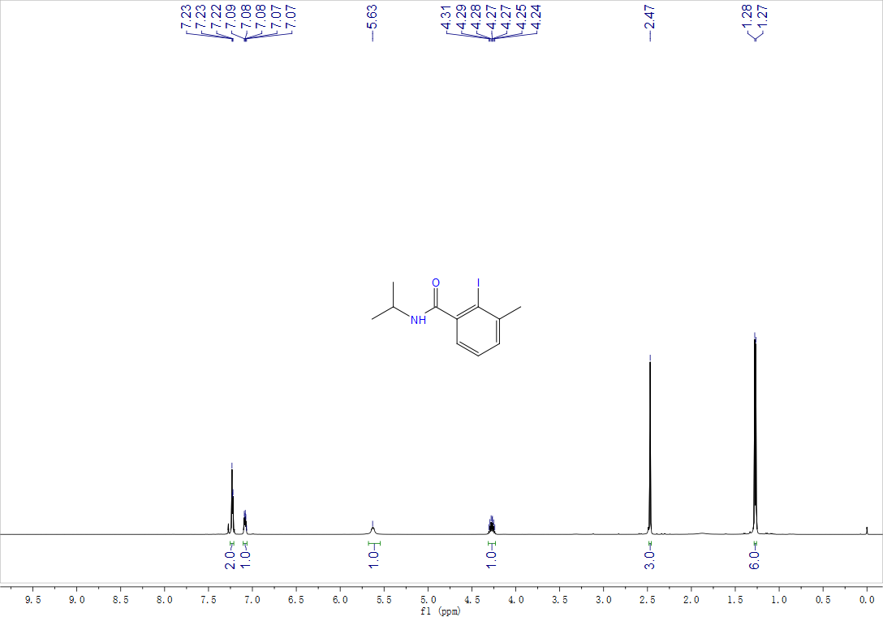
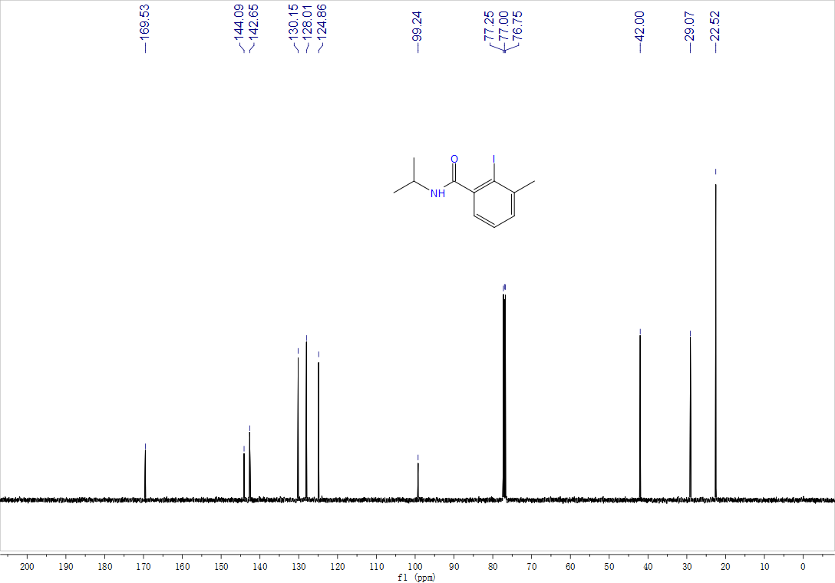
N-(tert-butyl)-2-iodo-3-methylbenzamide, 2c, ¹H NMR (500 MHz, CDCl₃) and ¹³C NMR (125 MHz, CDCl₃)
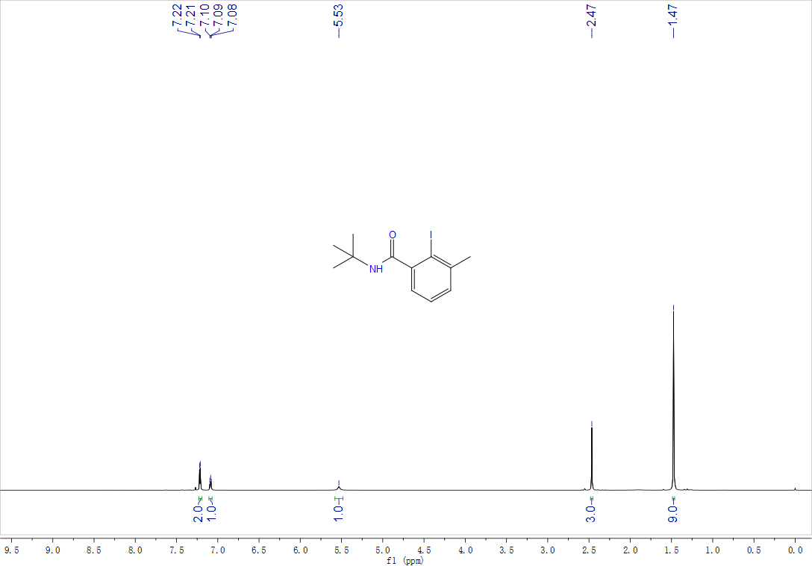

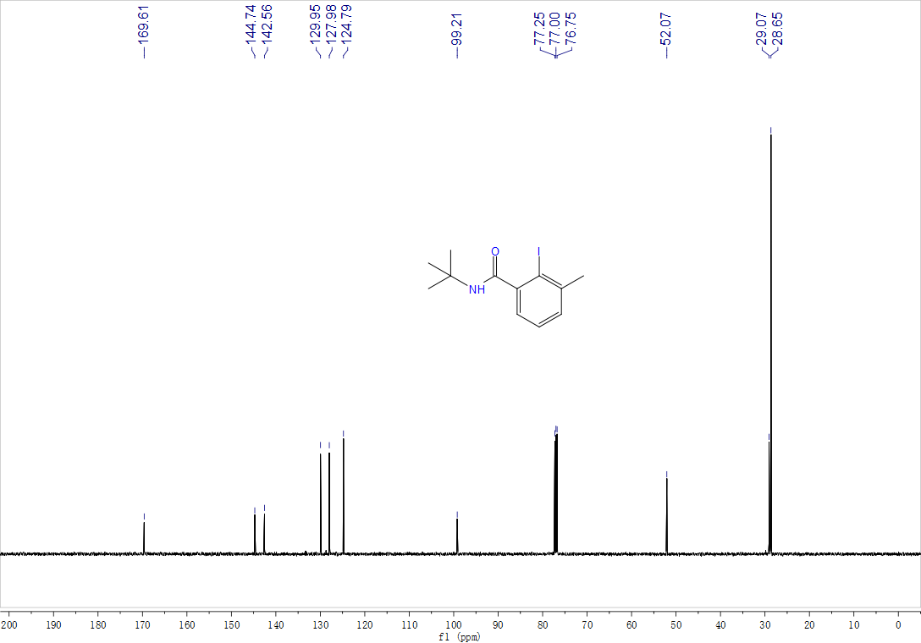
2-bromo-N-butyl-3-methoxybenzamide, 2r, ¹H NMR (400 MHz, CDCl₃) and ¹³C NMR (100 MHz, CDCl₃)
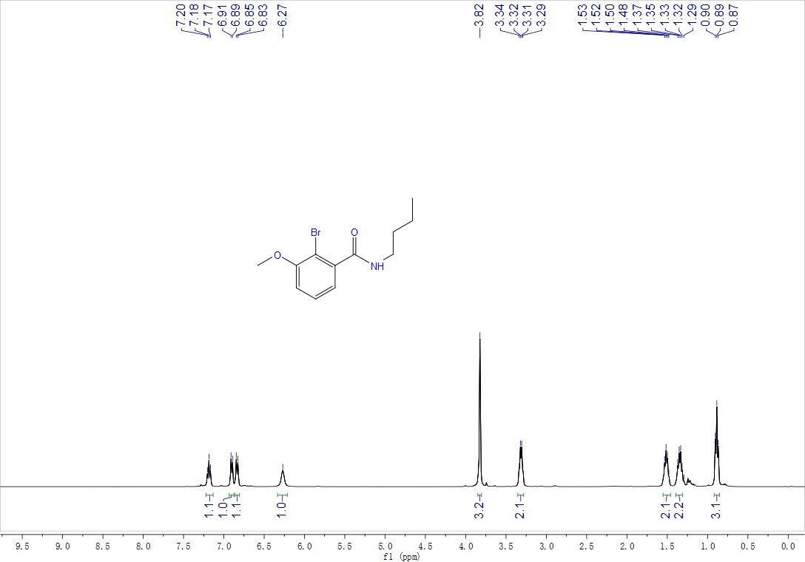
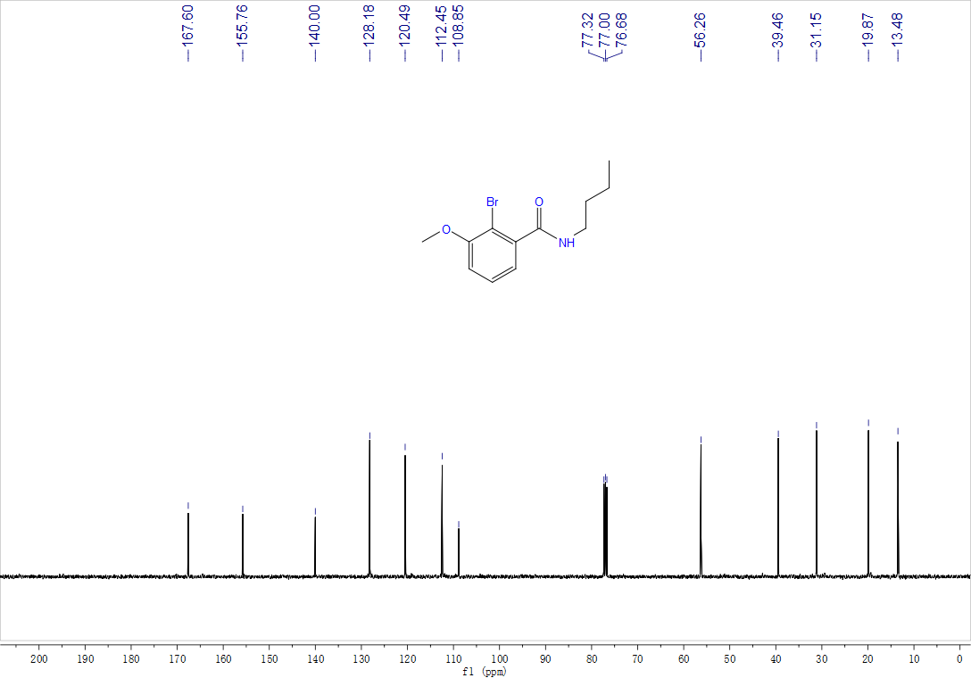
N-butyl-3-chloro-2-iodobenzamide, 2t, ¹H NMR (500 MHz, CDCl₃) and ¹³C NMR (125 MHz, CDCl₃)
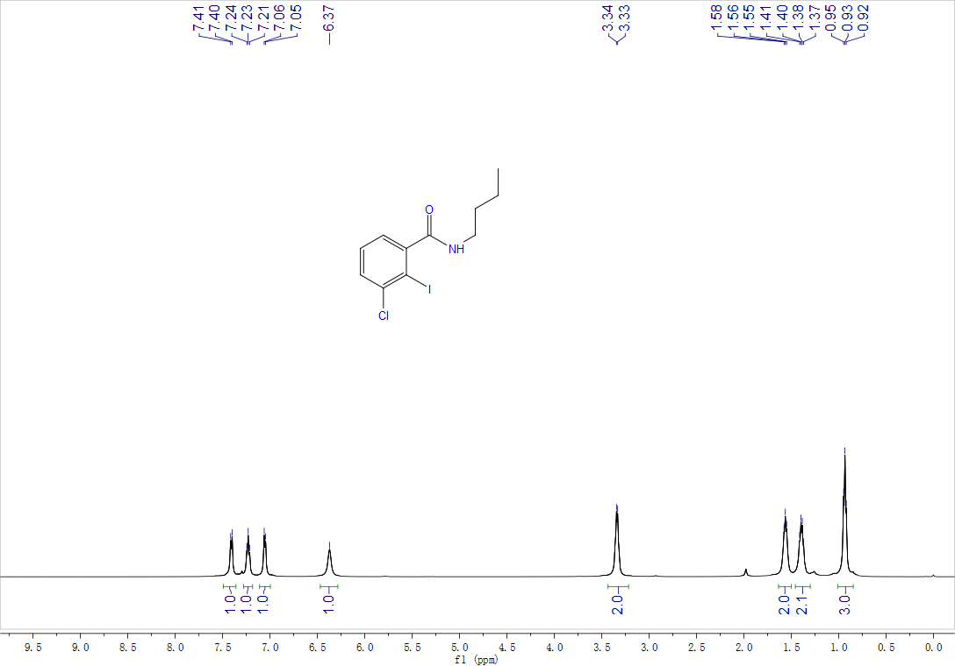

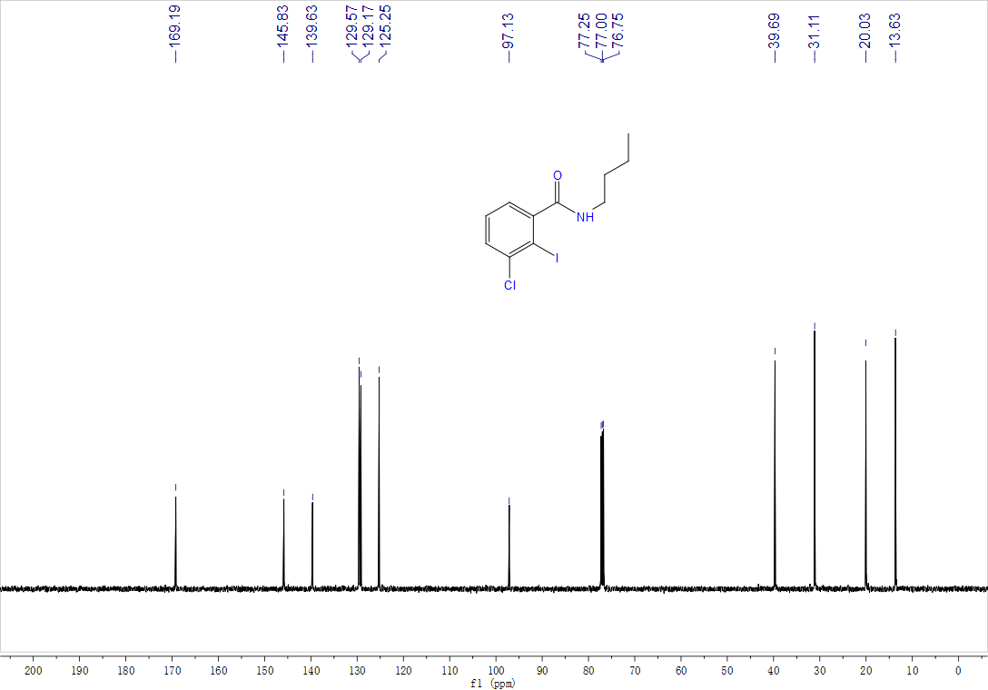
3-fluoro-2-iodo-N-phenylbenzamide, 2v, ¹H NMR (500 MHz, CDCl₃), ¹³C NMR (125 MHz, CDCl₃)
and ¹⁹F NMR (470 MHz, CDCl₃)
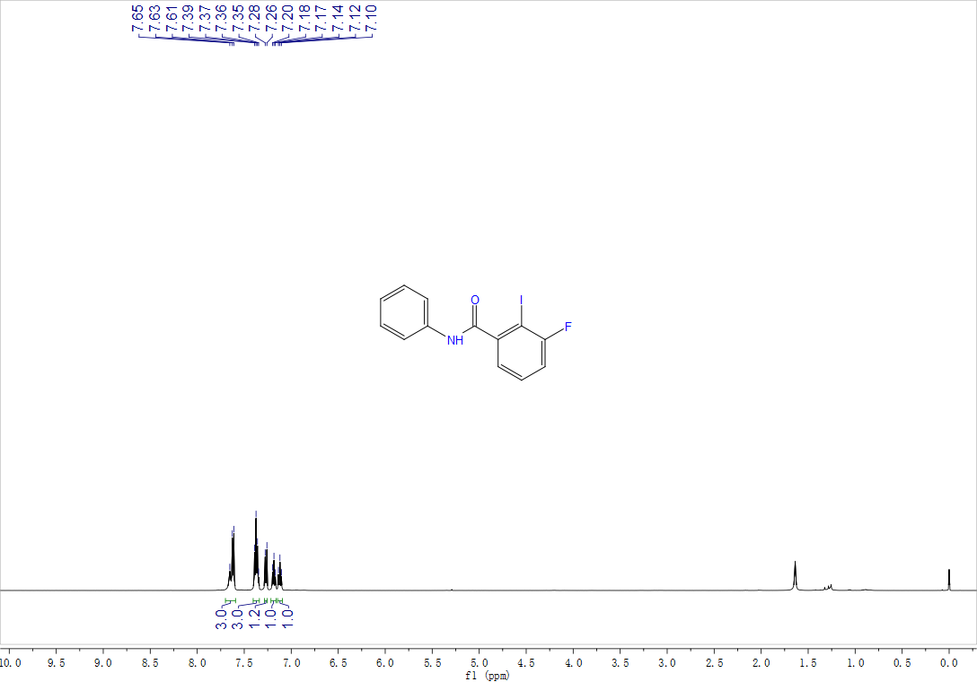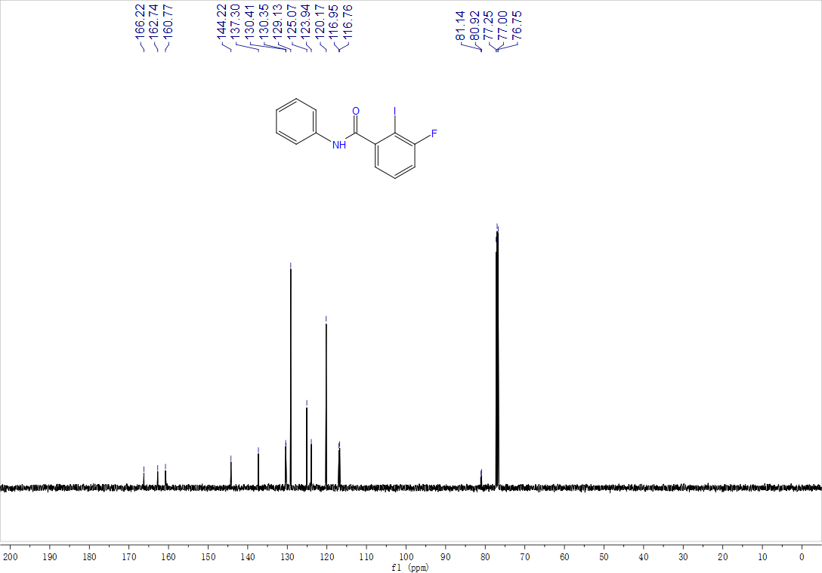

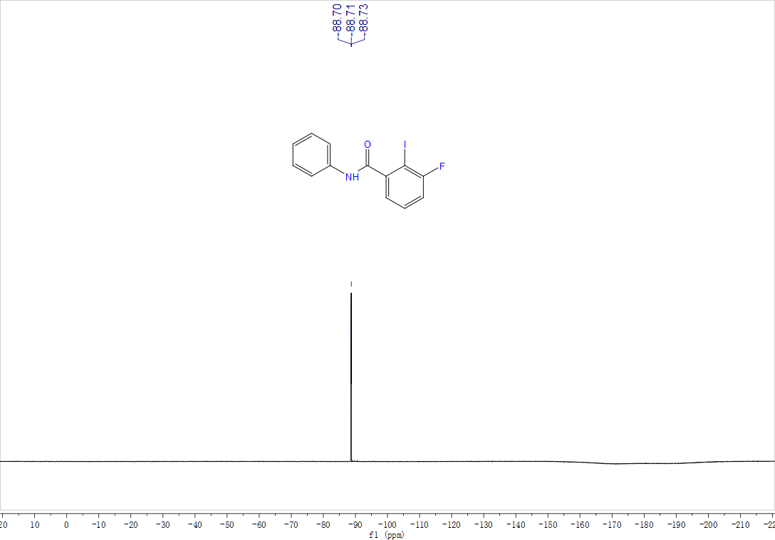

1-bromo-N-phenyl-2-naphthamide, 2w, ¹H NMR (500 MHz, CDCl₃) and ¹³C NMR (125 MHz, CDCl₃)
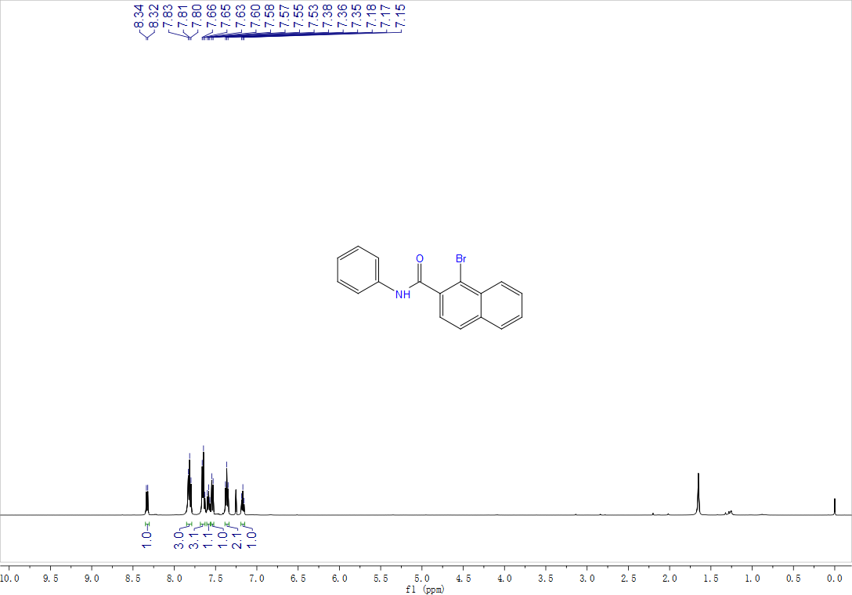
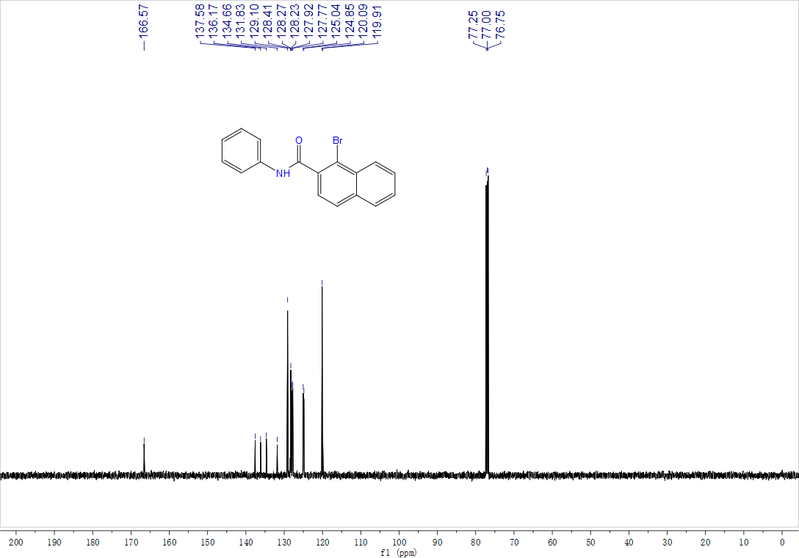
1-bromo-N-butyl-2-naphthamide, 2u, ¹H NMR (500 MHz, CDCl₃) and ¹³C NMR (125 MHz, CDCl₃)
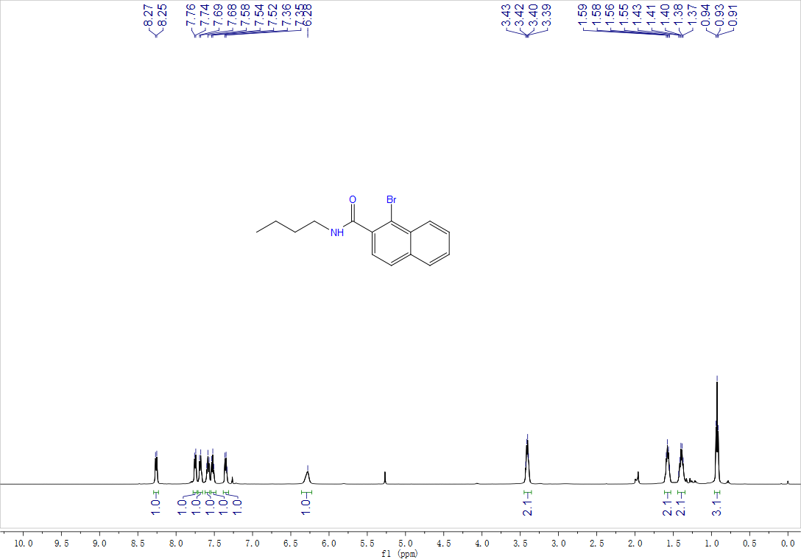

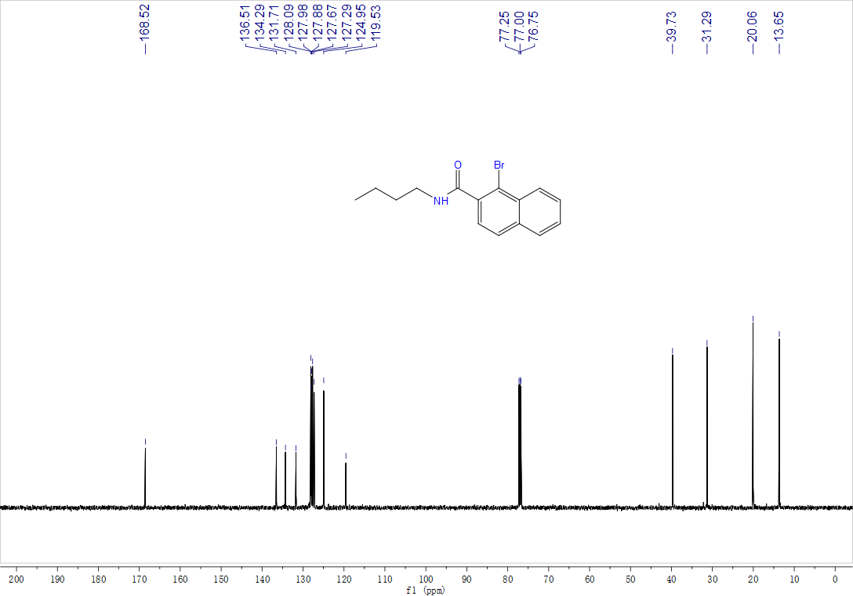
Methyl-1-bromo-2-naphthoate, 2m, ¹H NMR (500 MHz, CDCl₃) and ¹³C NMR (125 MHz, CDCl₃)
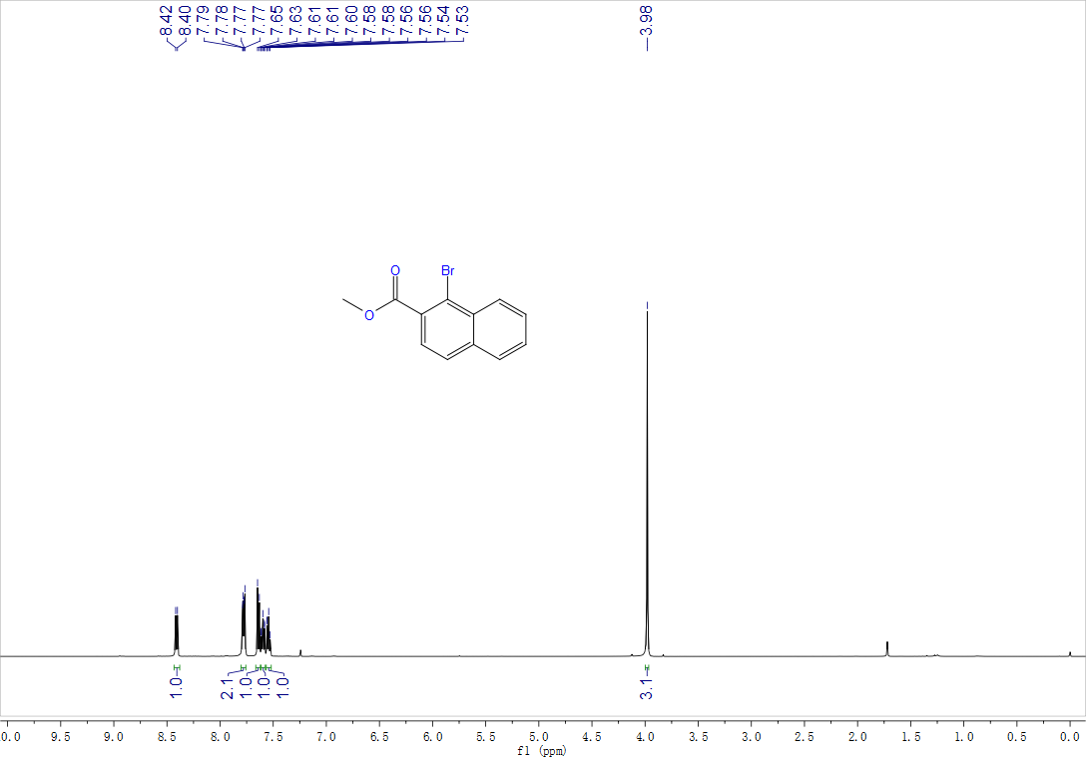

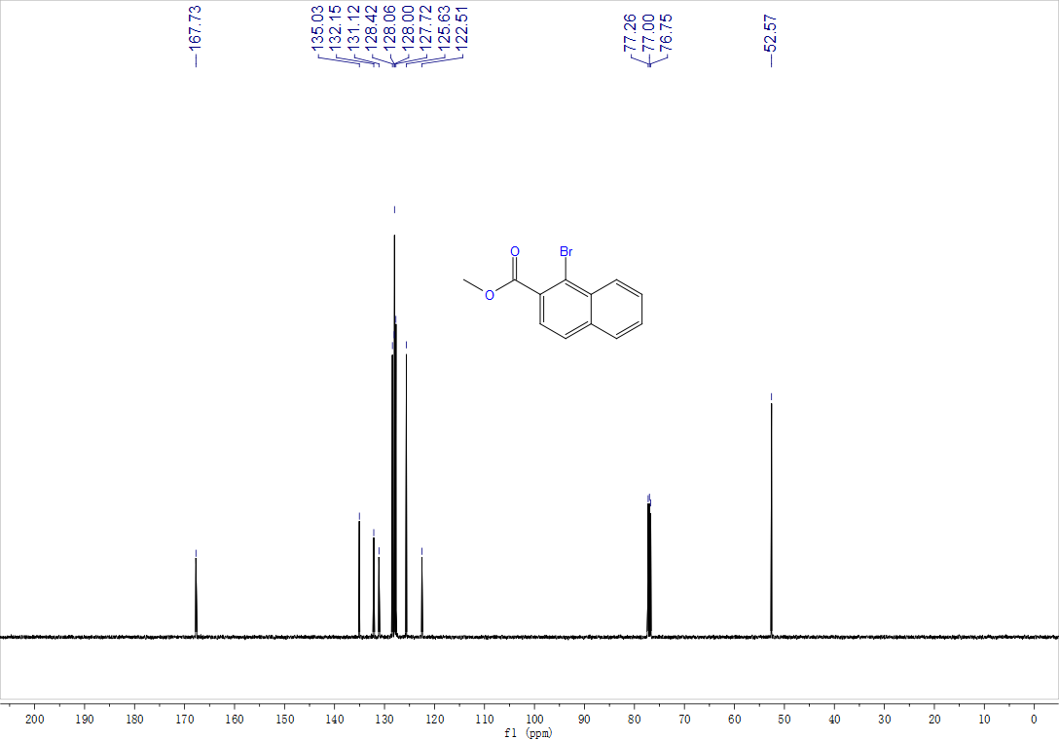

3-amino-N-butyl-2-iodobenzamide, 2s, ¹H NMR (500 MHz, d⁶-DMSO) and ¹³C NMR (125 MHz, d⁶-DMSO)
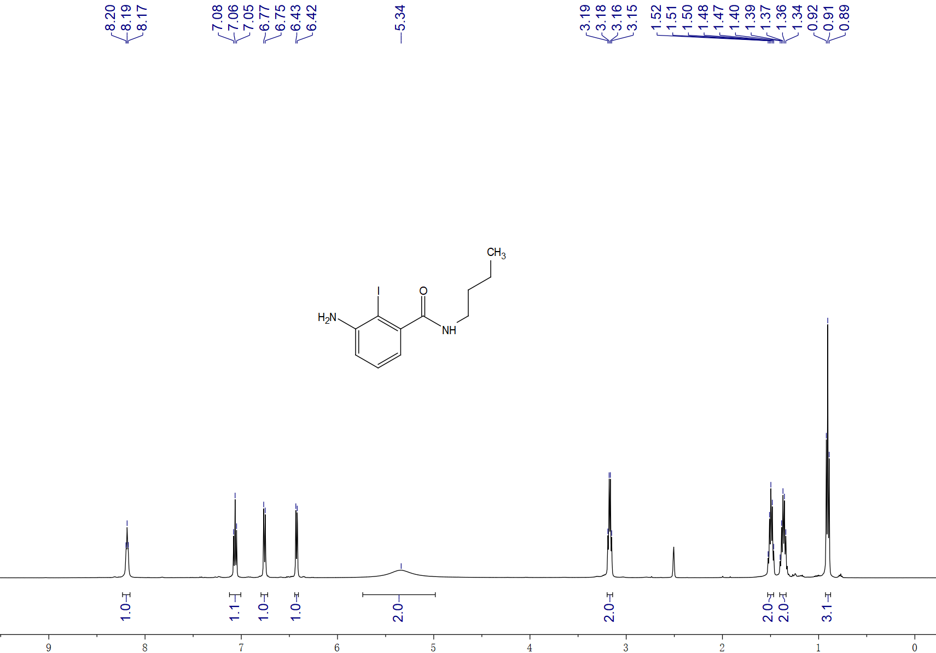

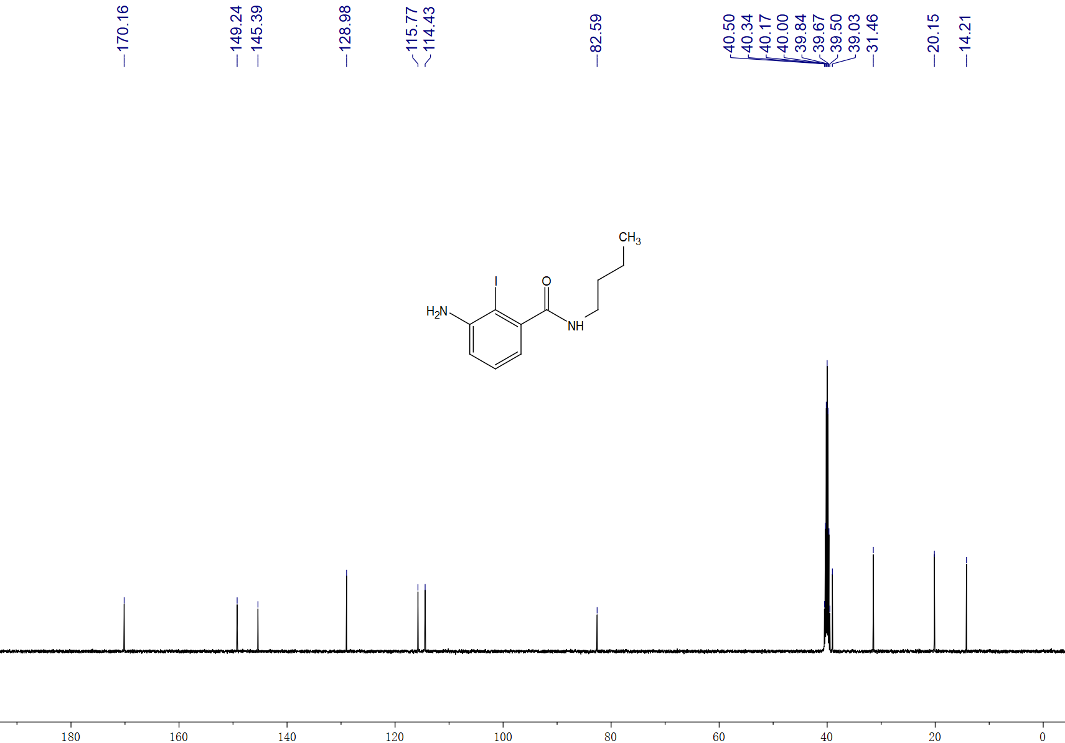

Methyl-2'-(butylcarbamoyl)-3,6'-dimethyl-[1,1'-biphenyl]-2-carboxylate, 3aa, ¹H NMR (400 MHz, CDCl₃) and ¹³C NMR (100 MHz, CDCl₃)
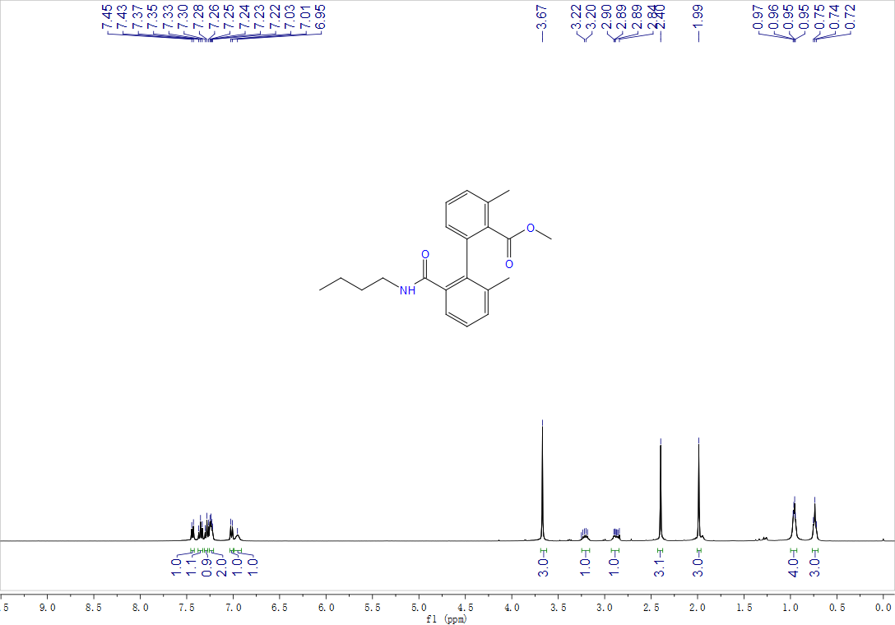

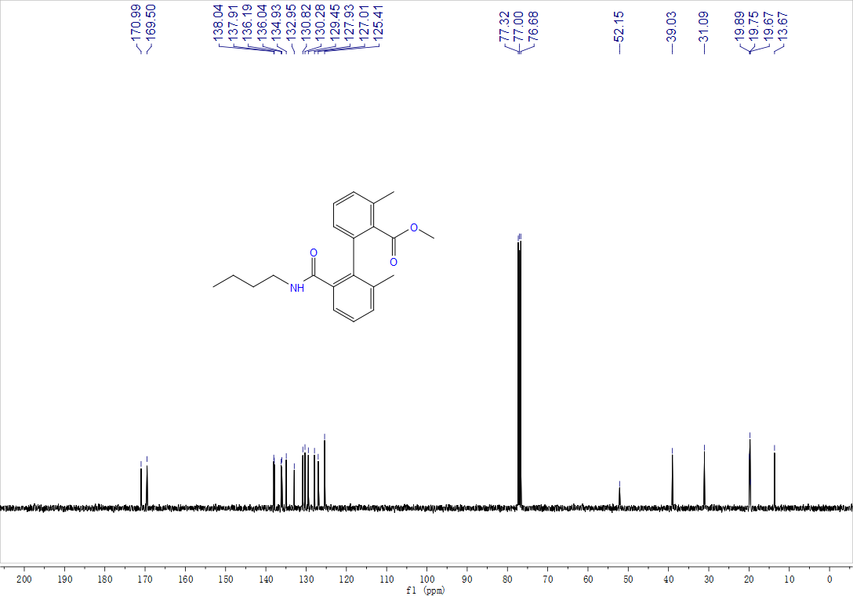
2'-(isopropylcarbamoyl)-3,6'-dimethyl-[1,1'-biphenyl]-2-carboxylic acid, 3ba, ¹H NMR (500 MHz, CDCl₃) and ¹³C NMR (125 MHz, CDCl₃)
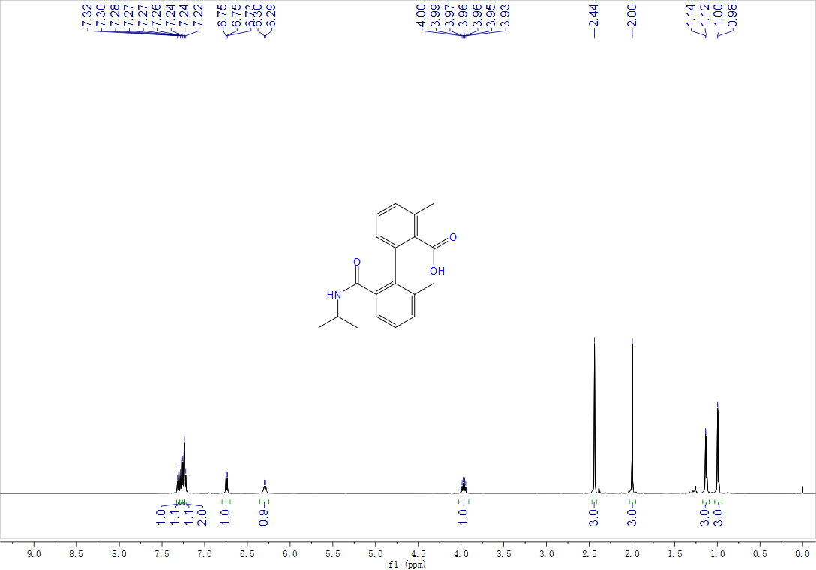

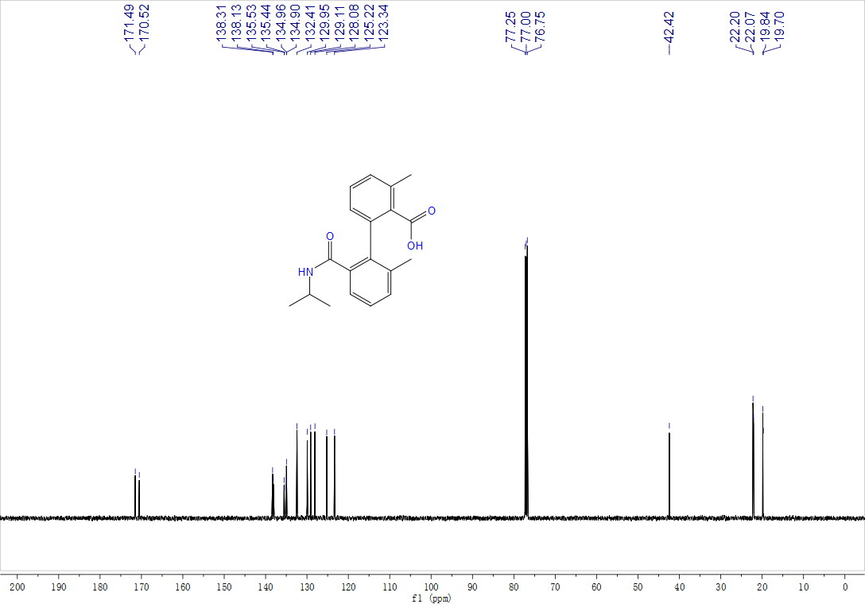
2'-(tert-butylcarbamoyl)-3,6'-dimethyl-[1,1'-biphenyl]-2-carboxylic acid, 3ca, ¹H NMR (500 MHz, CDCl₃) and ¹³C NMR (125 MHz, CDCl₃)
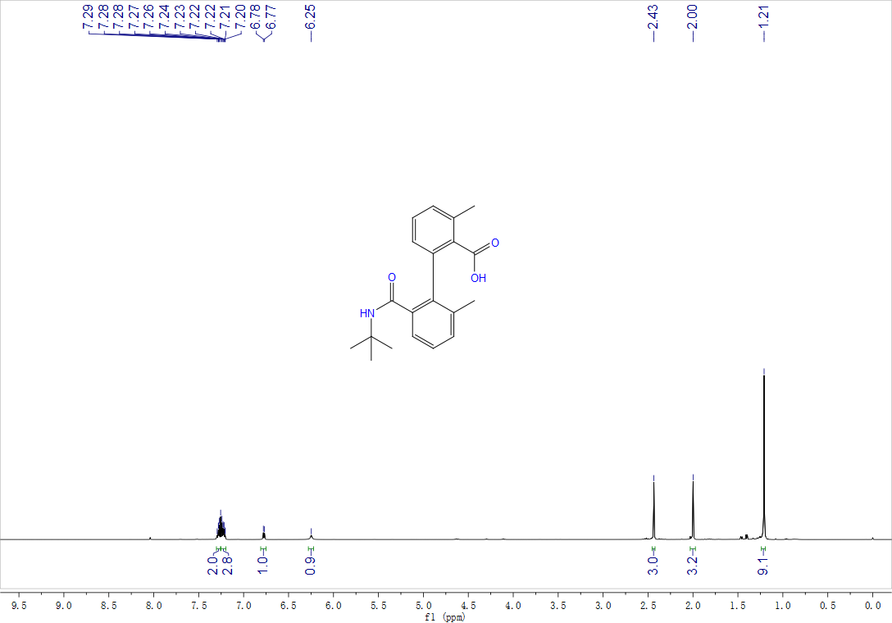

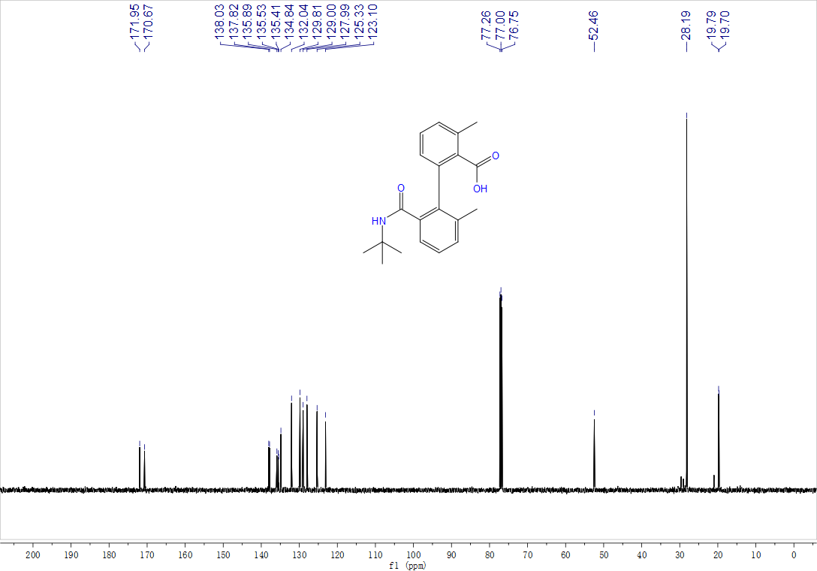
Methyl 2'-(benzylcarbamoyl)-3,6'-dimethyl-[1,1'-biphenyl]-2-carboxylate, 3da, ¹H NMR (500 MHz, CDCl₃) and ¹³C NMR (125 MHz, CDCl₃)
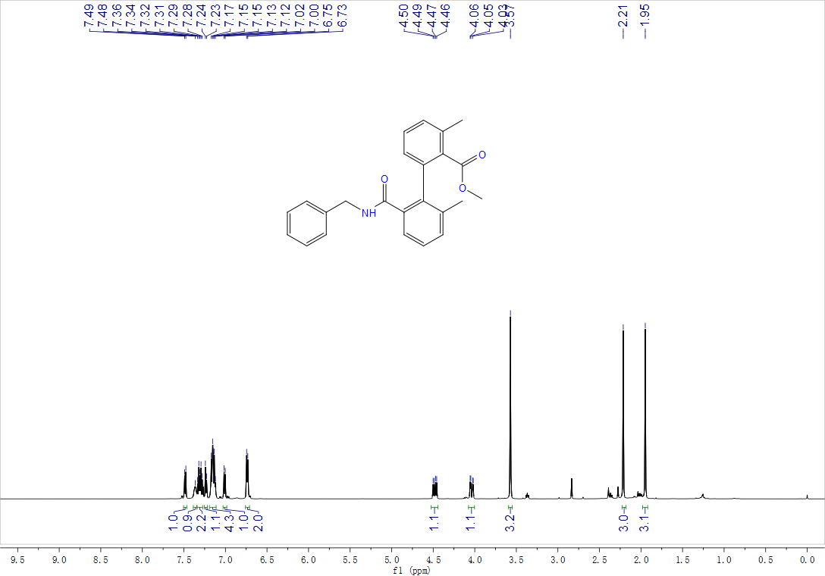

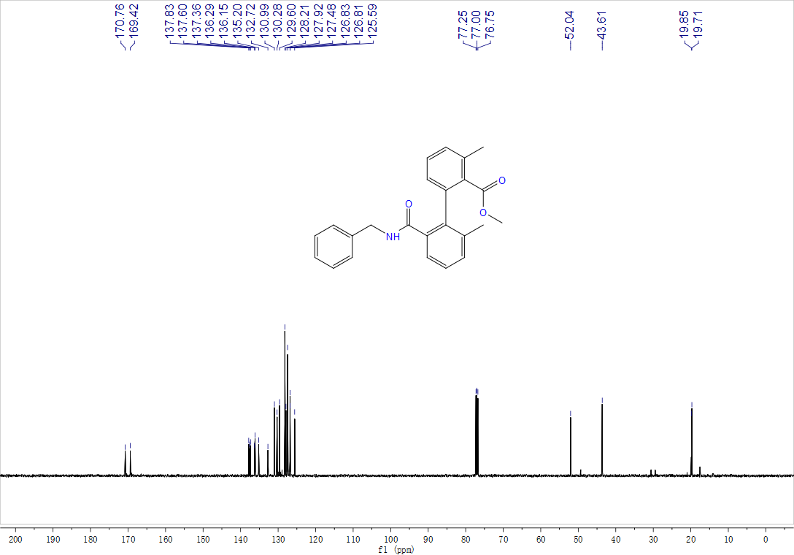
2',3-dimethyl-6'-(phenylcarbamoyl)-[1,1'-biphenyl]-2-carboxylic acid, 3ea, ¹H NMR (400 MHz, CDCl₃) and ¹³C NMR (125 MHz, CDCl₃)
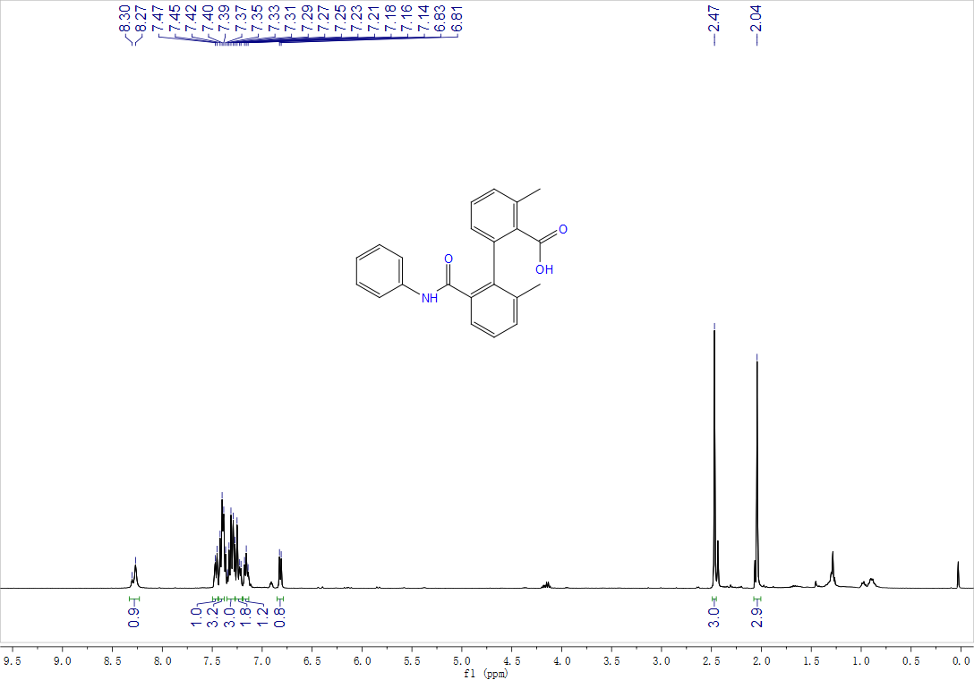

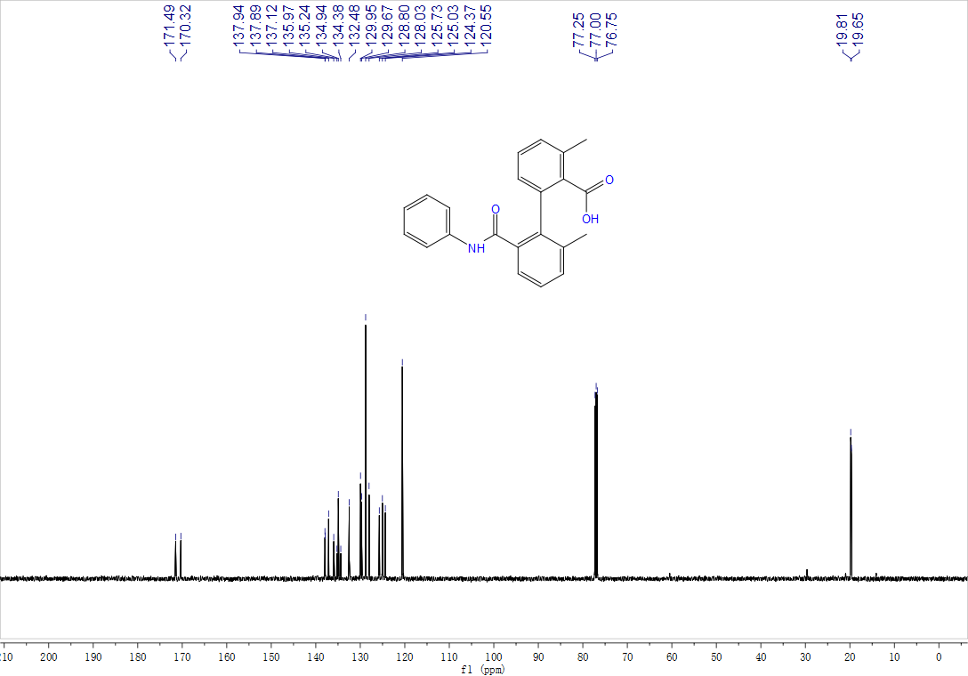

Methyl-2',3-dimethyl-6'-(pyrrolidine-1-carbonyl)-[1,1'-biphenyl]-2-carboxylate, 3fa, ¹H NMR (400 MHz, CDCl₃) and ¹³C NMR (100 MHz, CDCl₃)
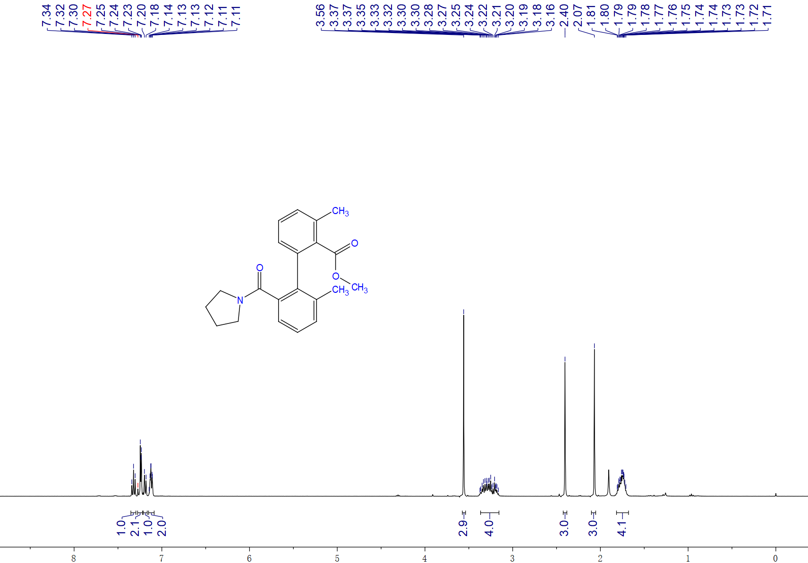

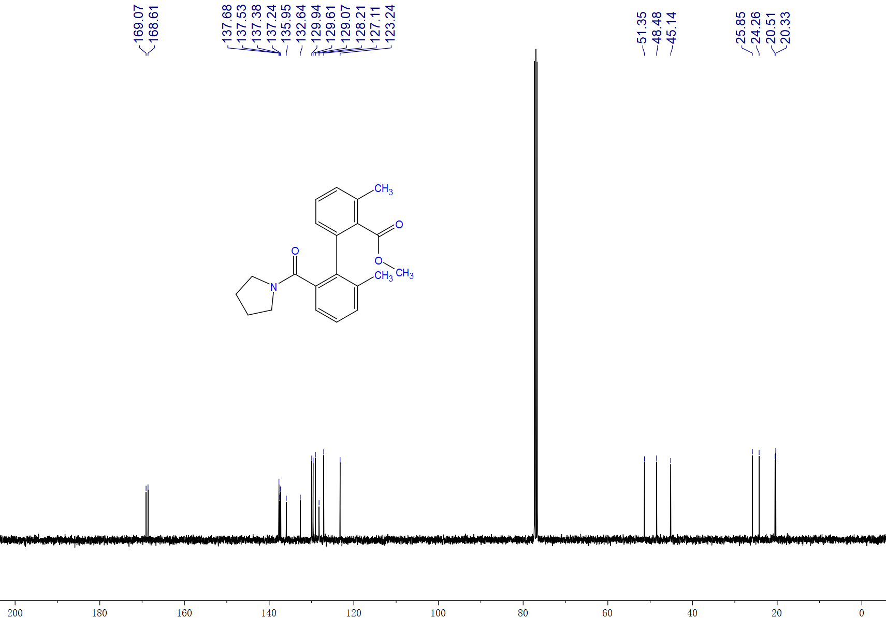

Methyl-2'-carbamoyl-3,6'-dimethyl-[1,1'-biphenyl]-2-carboxylate, 3ga, ¹H NMR (500 MHz, CDCl₃) and ¹³C NMR (125 MHz, CDCl₃)
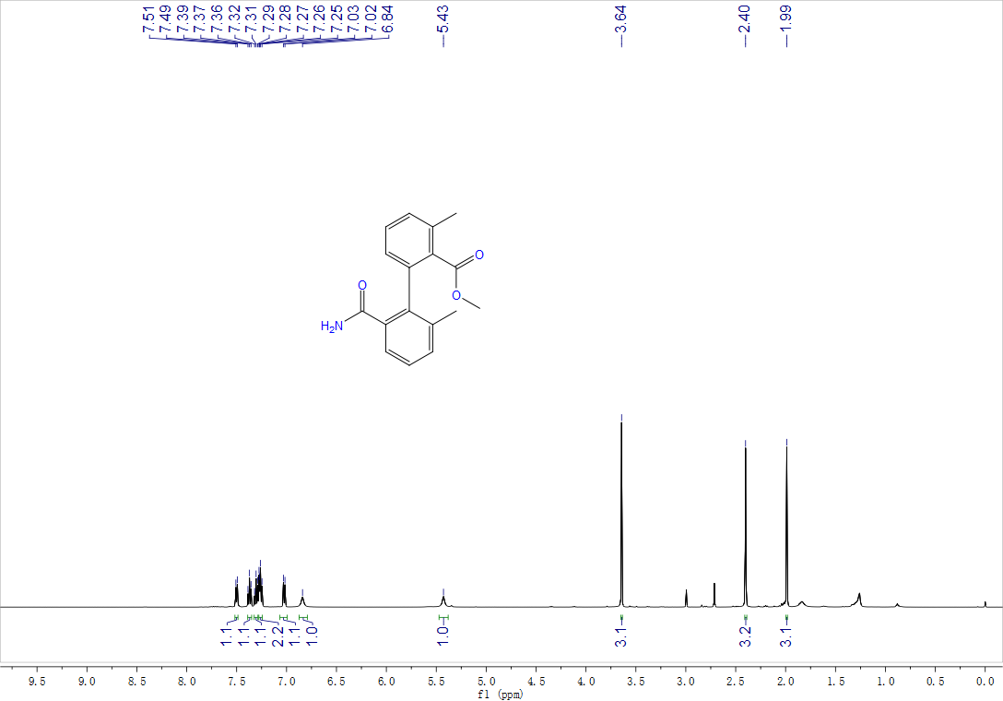

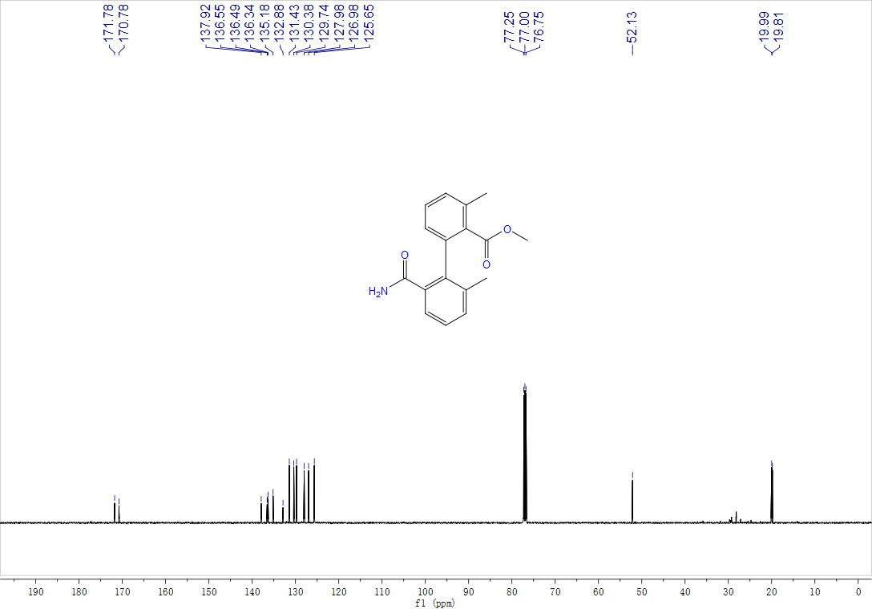

Dimethyl-3,6'-dimethyl-[1,1'-biphenyl]-2,2'-dicarboxylate, 3ia, ¹H NMR (500 MHz, CDCl₃) and ¹³C NMR (125 MHz, CDCl₃)

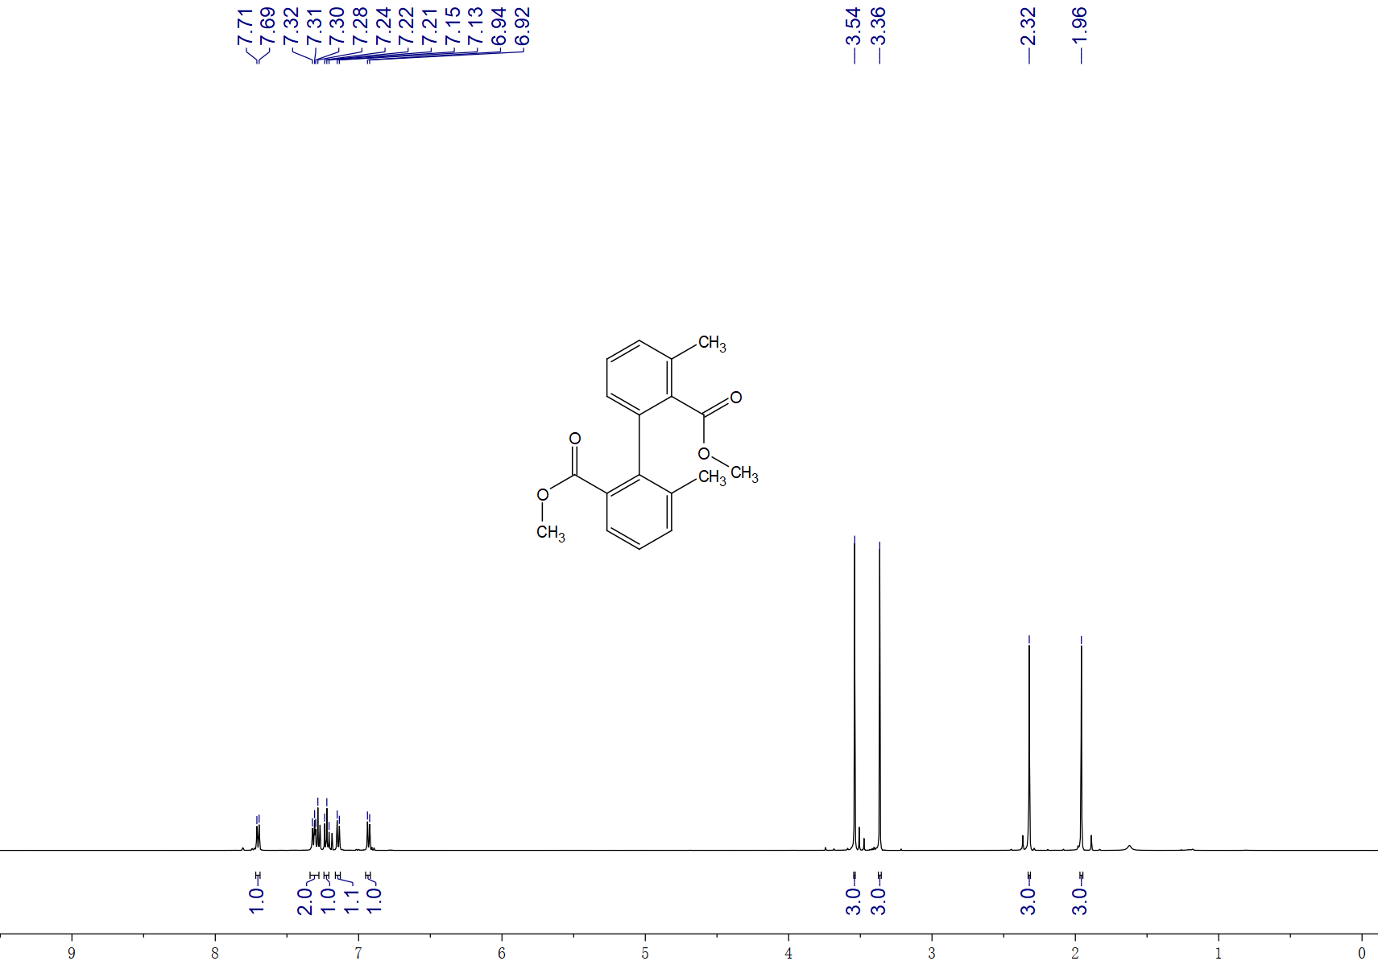

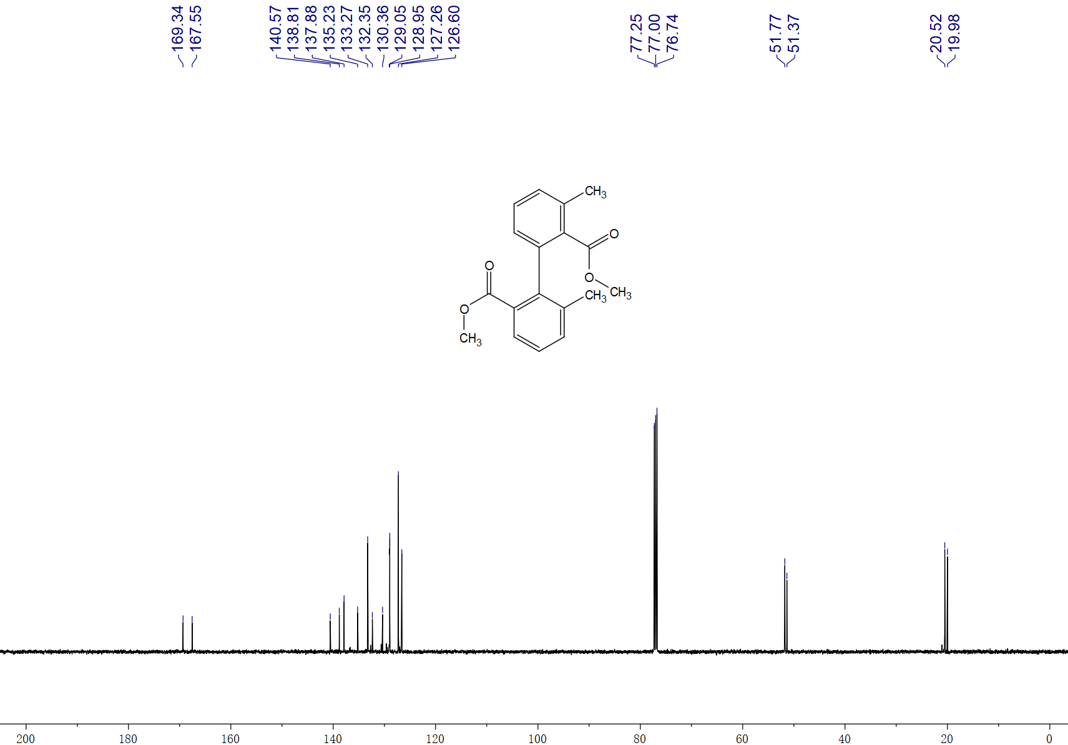

Dimethyl 6'-methoxy-3-methyl-[1,1'-biphenyl]-2,2'-dicarboxylate, 3ja, ¹H NMR (400 MHz, CDCl₃) and ¹³C NMR (100 MHz, CDCl₃)

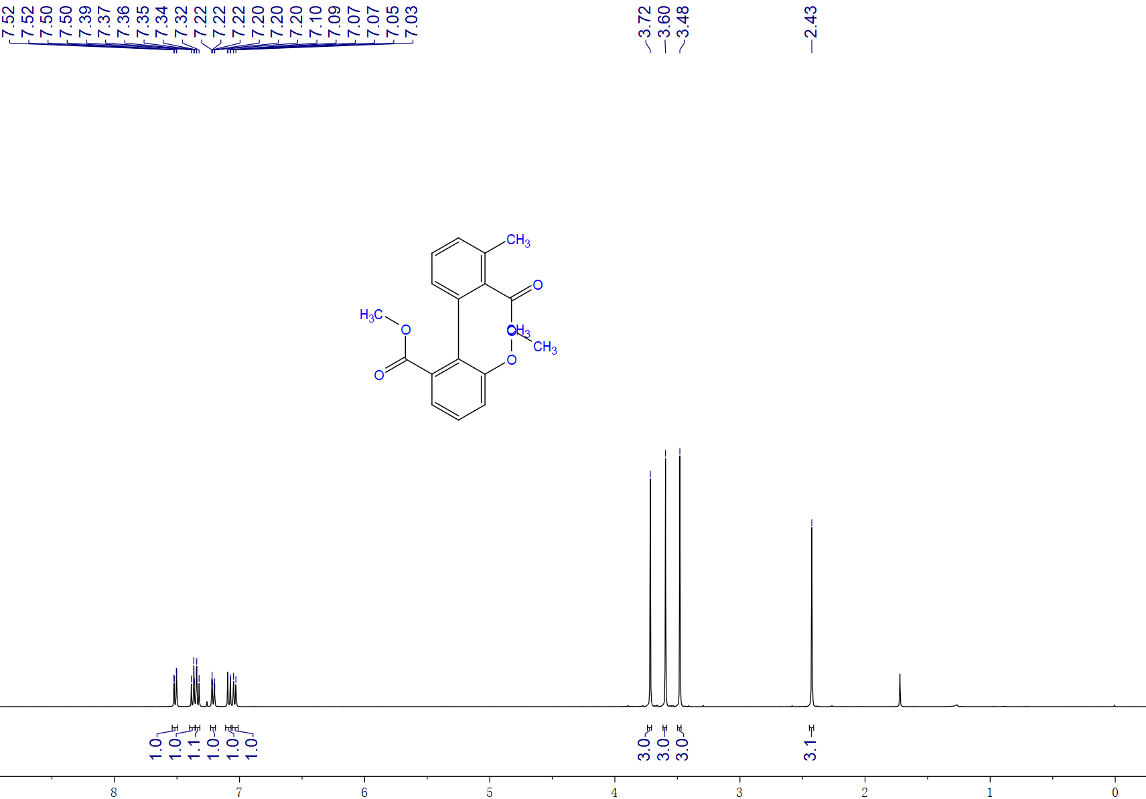

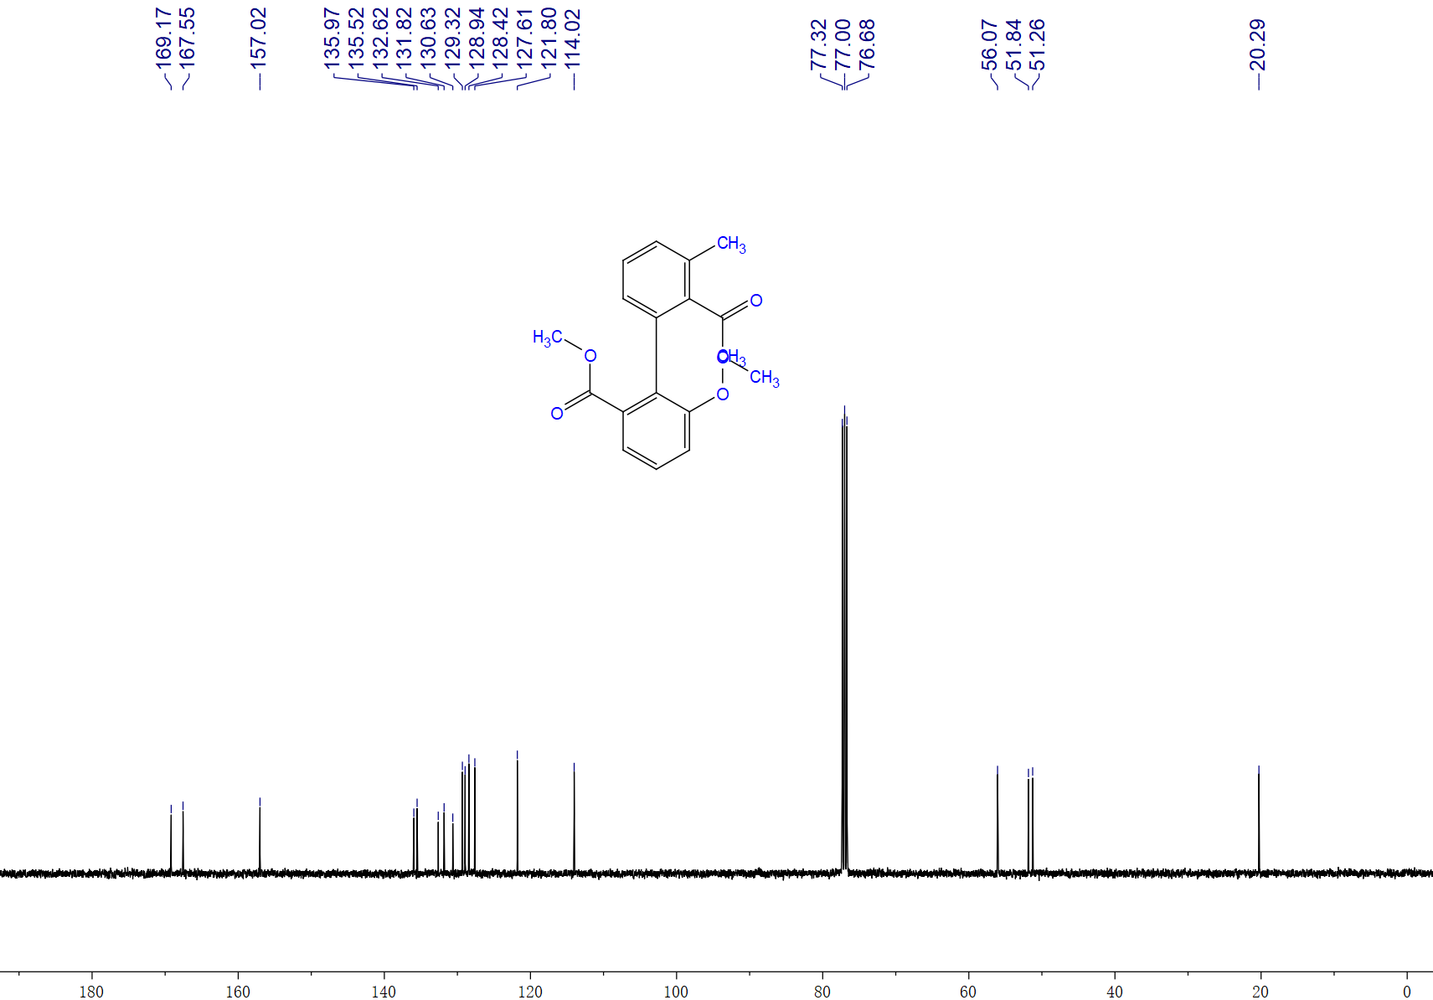

Methyl-1-(2-(methoxycarbonyl)-3-methylphenyl)-2-naphthoate, 3ka, ¹H NMR (500 MHz, CDCl₃), ¹³C NMR (125 MHz, CDCl₃)

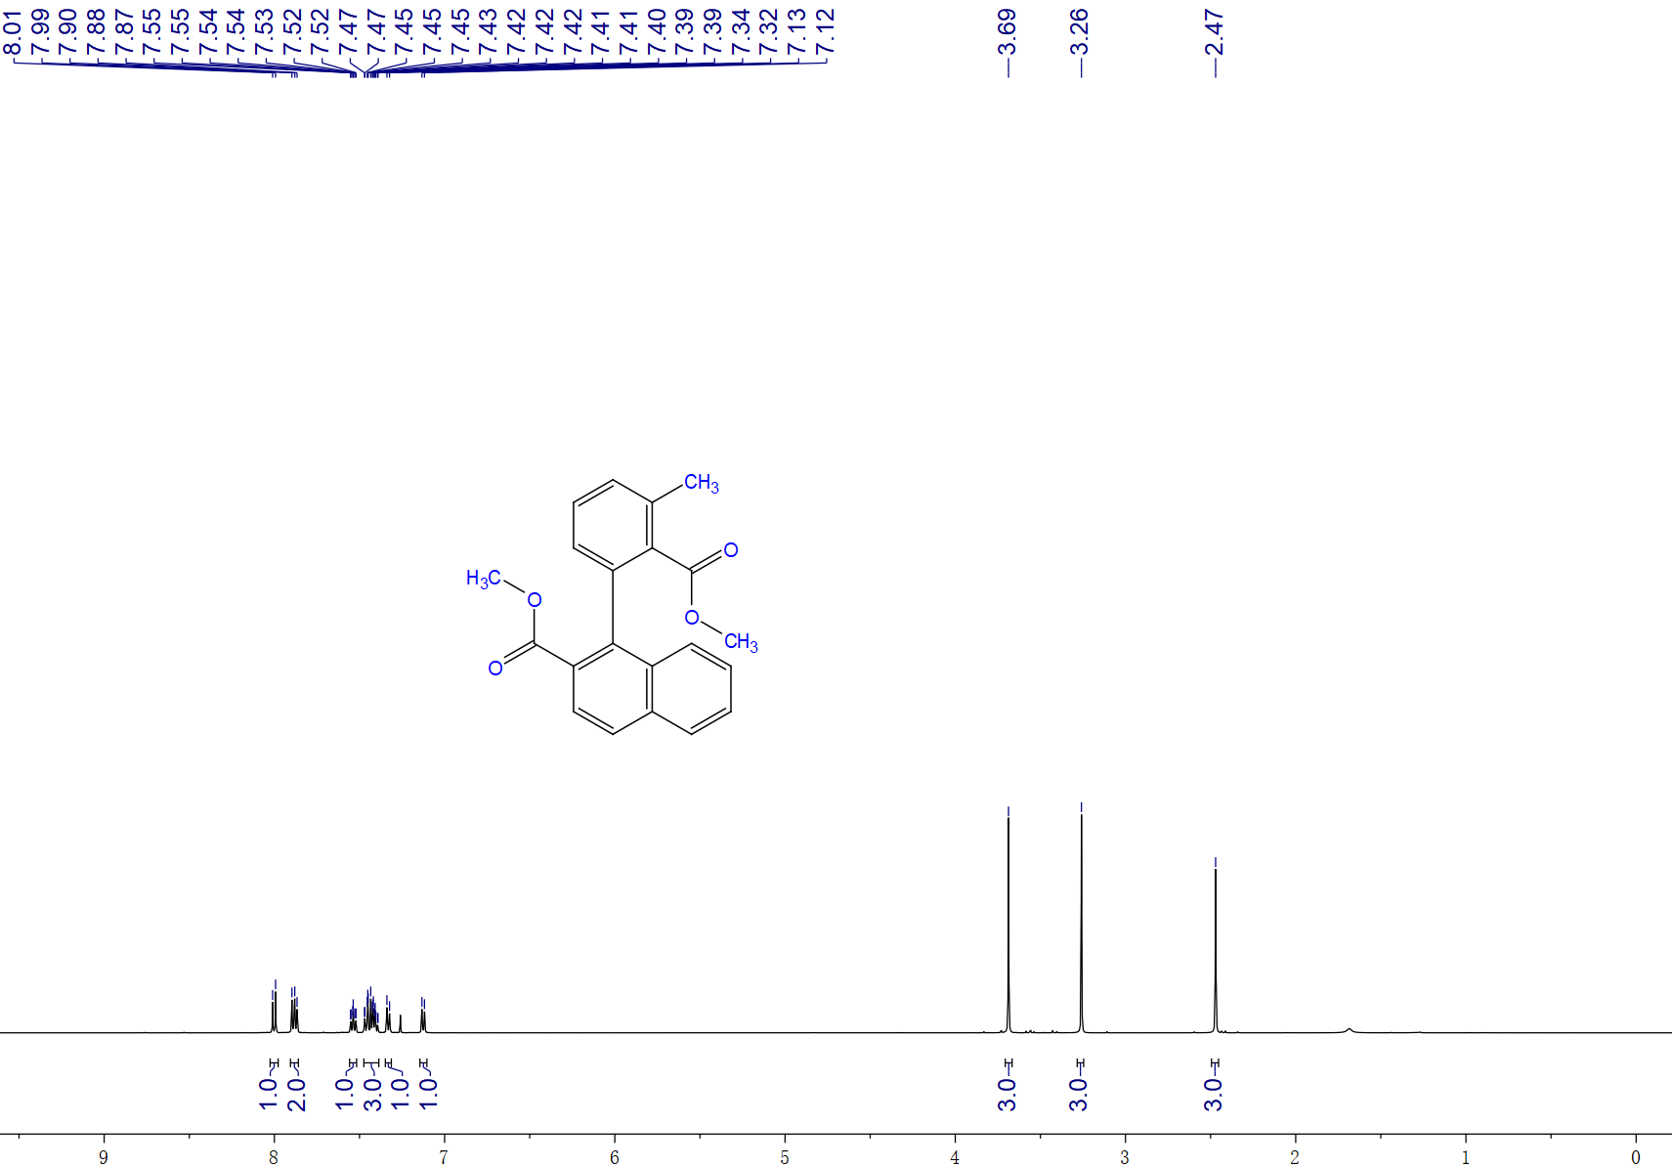

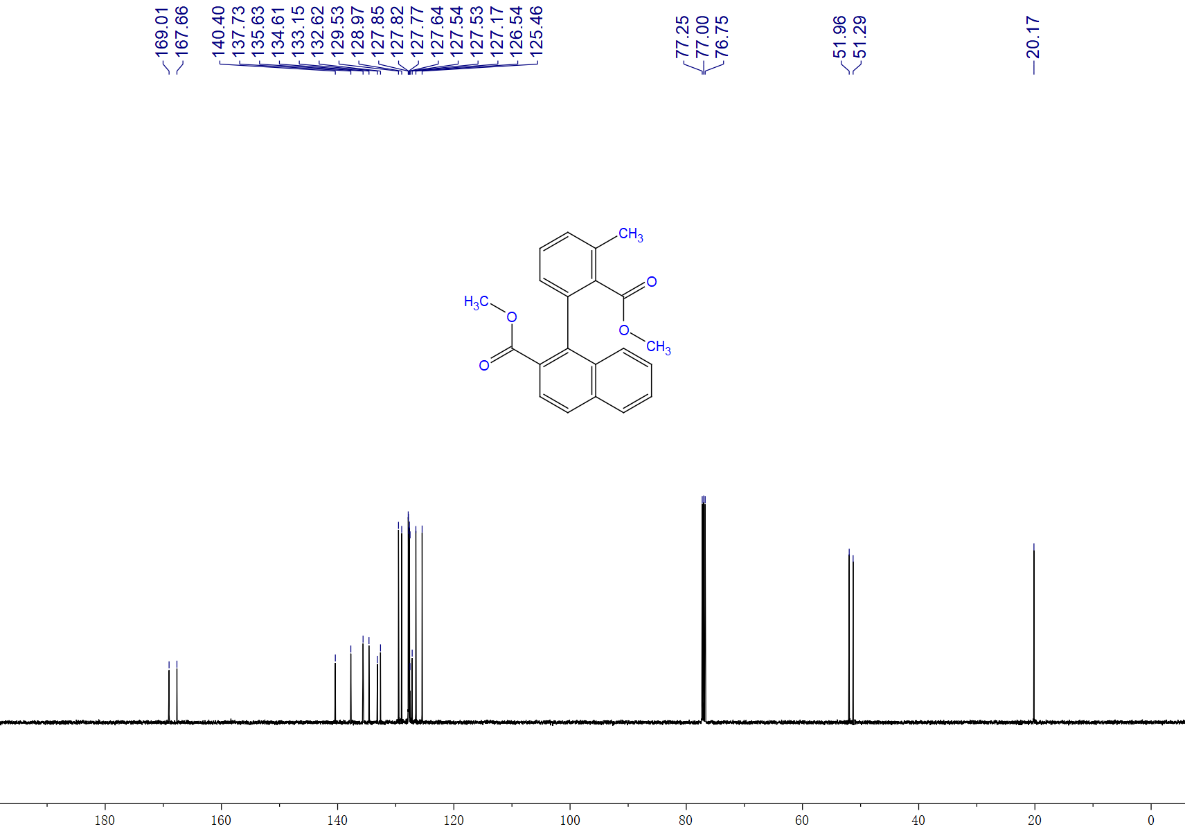

Methyl-2'-acetyl-3,6'-dimethyl-[1,1'-biphenyl]-2-carboxylate, 3na, ¹H NMR (500 MHz, CDCl₃) and ¹³C NMR (125 MHz, CDCl₃)

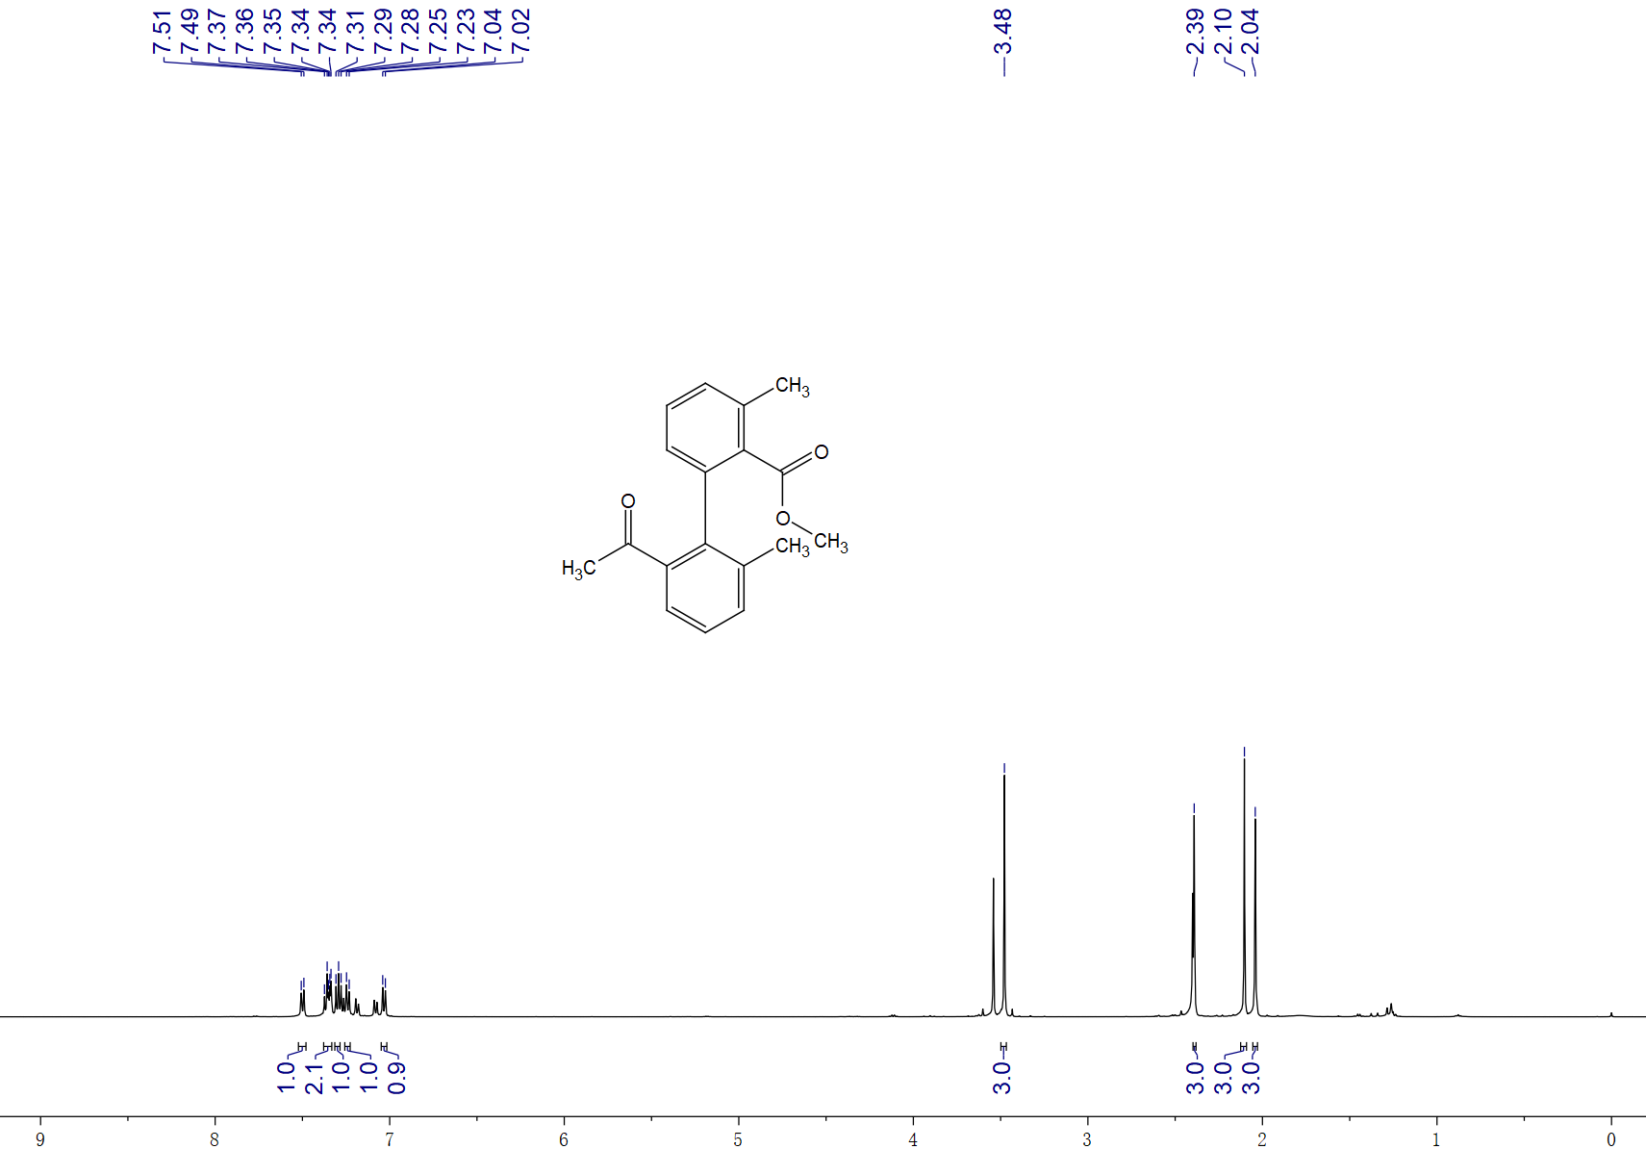

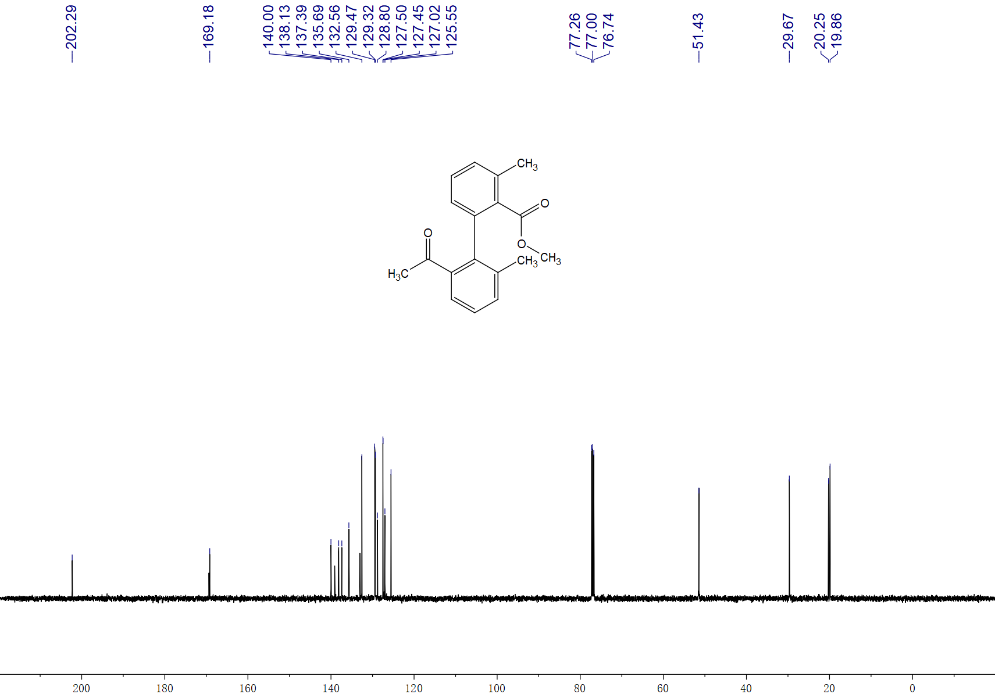

Methyl-2-(2-acetylnaphthalen-1-yl)-6-methylbenzoate, 3oa, ¹H NMR (500 MHz, CDCl₃) and ¹³C NMR (125 MHz, CDCl₃)

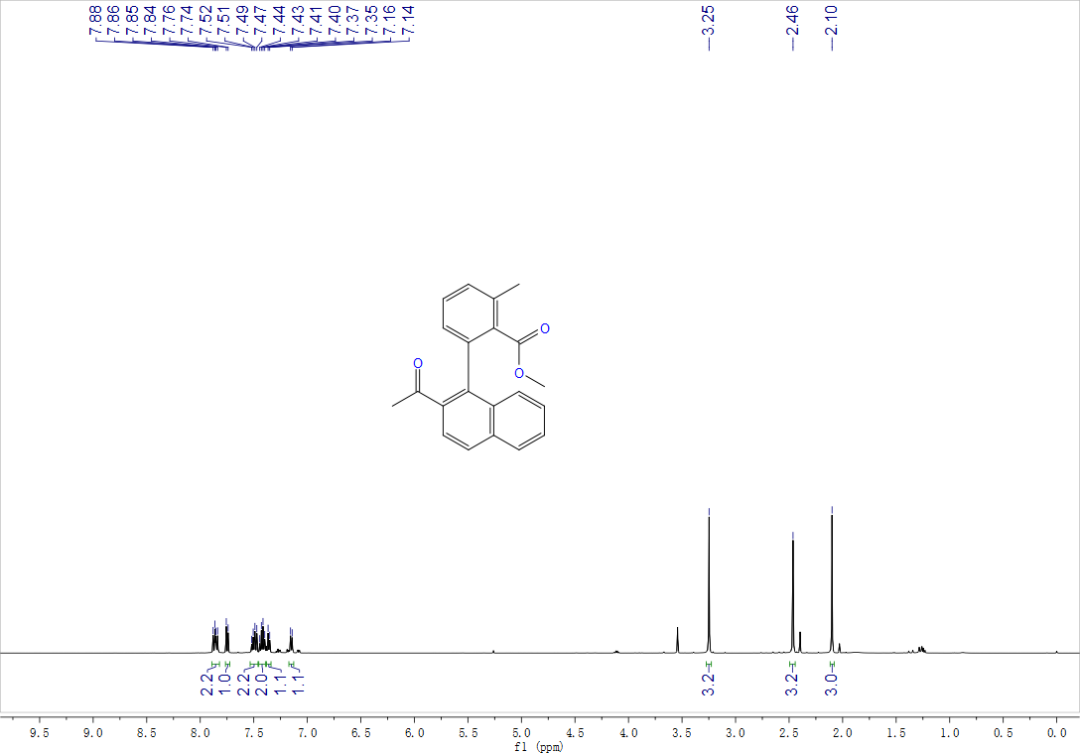

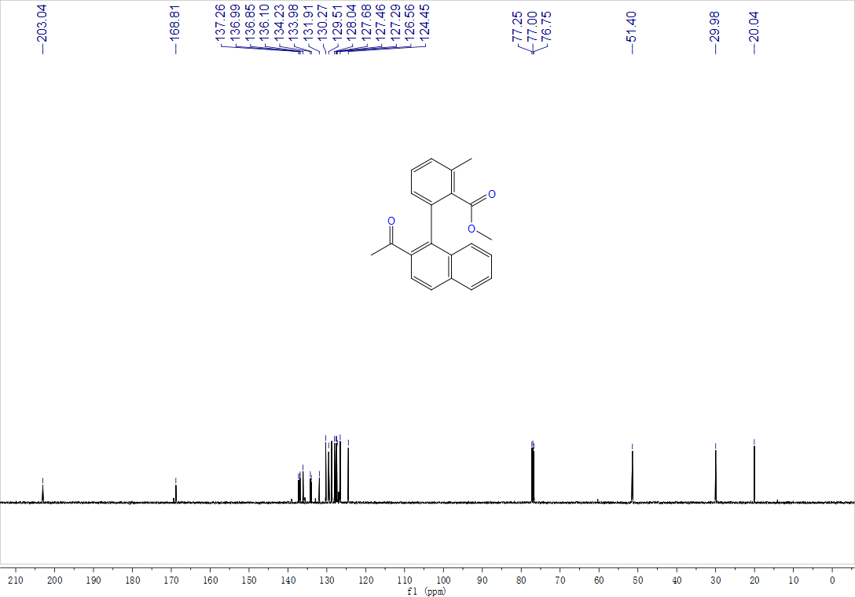

2'-(butylcarbamoyl)-6'-methoxy-3-methyl-[1,1'-biphenyl]-2-carboxylic acid, 3ra, ¹H NMR (500 MHz, CDCl₃) and ¹³C NMR (125 MHz, CDCl₃)
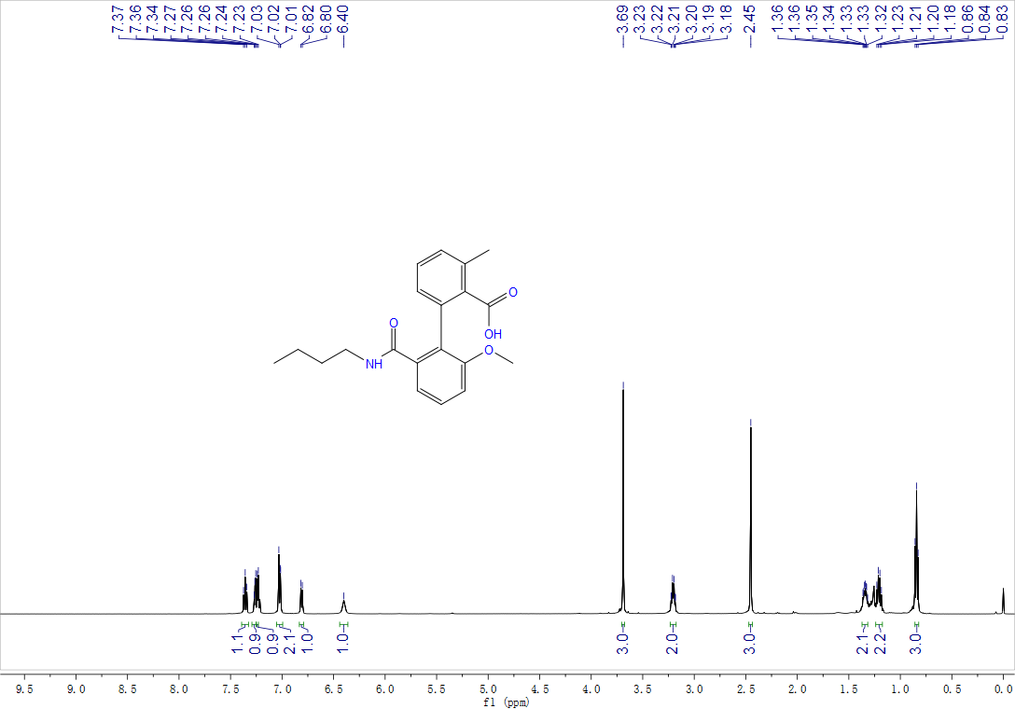

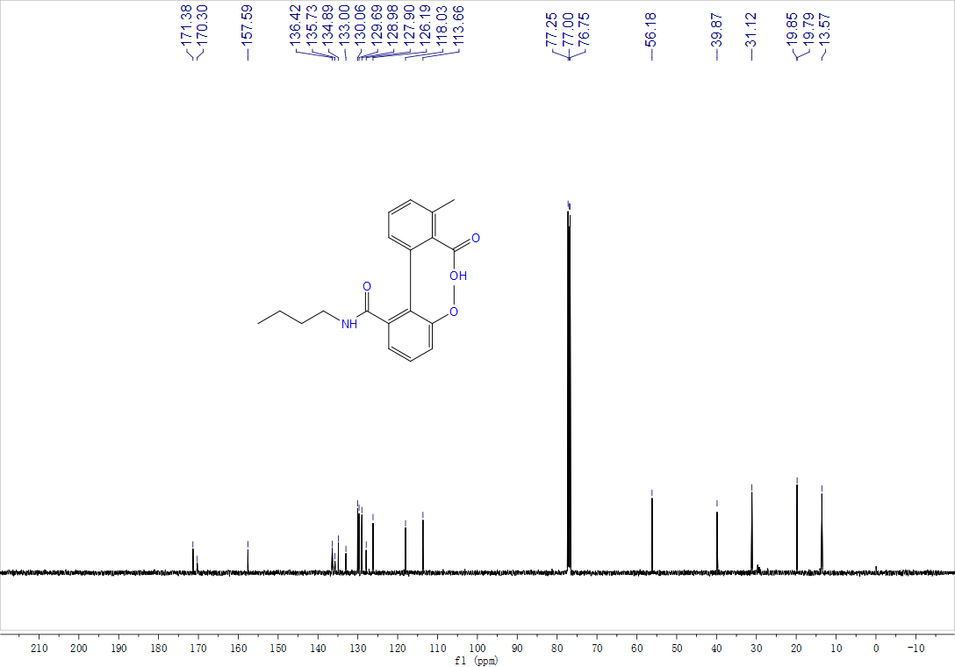
2'-amino-6'-(butylcarbamoyl)-3-methyl-[1,1'-biphenyl]-2-carboxylic acid, 3sa, ¹H NMR (500 MHz, d⁶-DMSO) and ¹³C NMR (125 MHz, d⁶-DMSO)
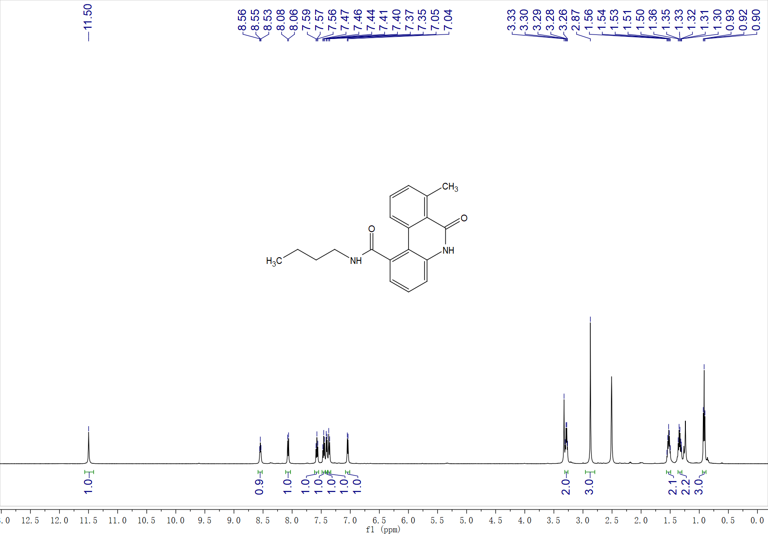

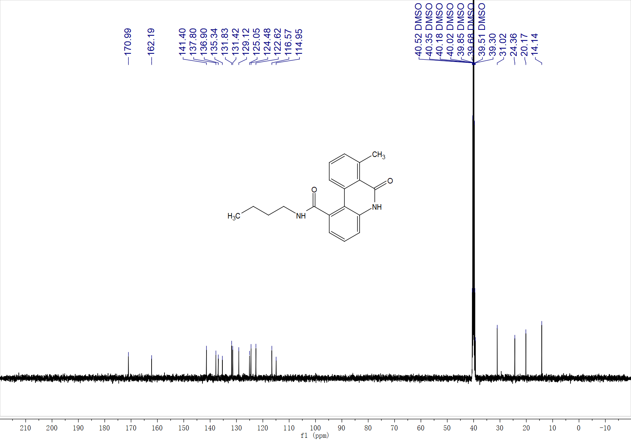

Methyl-2'-(butylcarbamoyl)-6'-chloro-3-methyl-[1,1'-biphenyl]-2-carboxylate, 3ta, ¹H NMR (500 MHz, CDCl₃) and ¹³C NMR (125 MHz, CDCl₃)
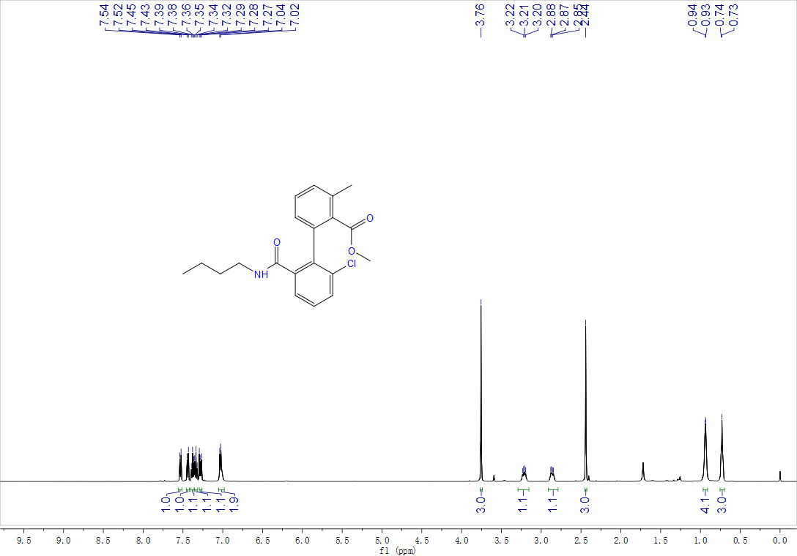

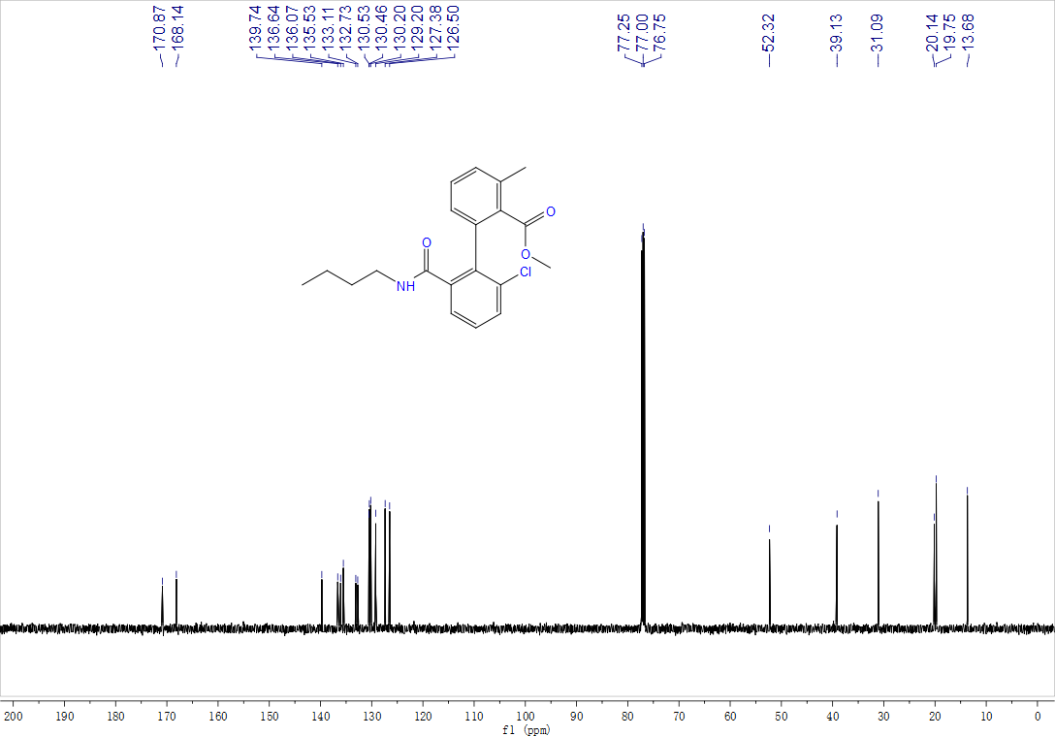

Methyl-2-(2-(butylcarbamoyl)naphthalen-1-yl)-6-methylbenzoate, 3ua, ¹H NMR (500 MHz, CDCl₃) and ¹³C NMR (125 MHz, CDCl₃)

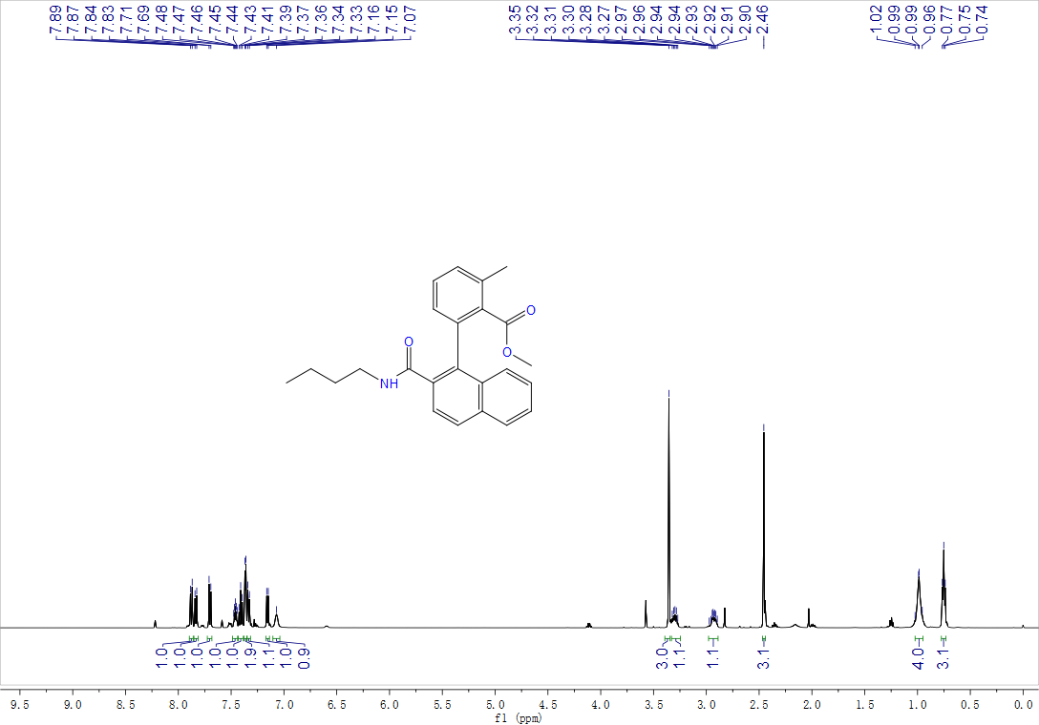

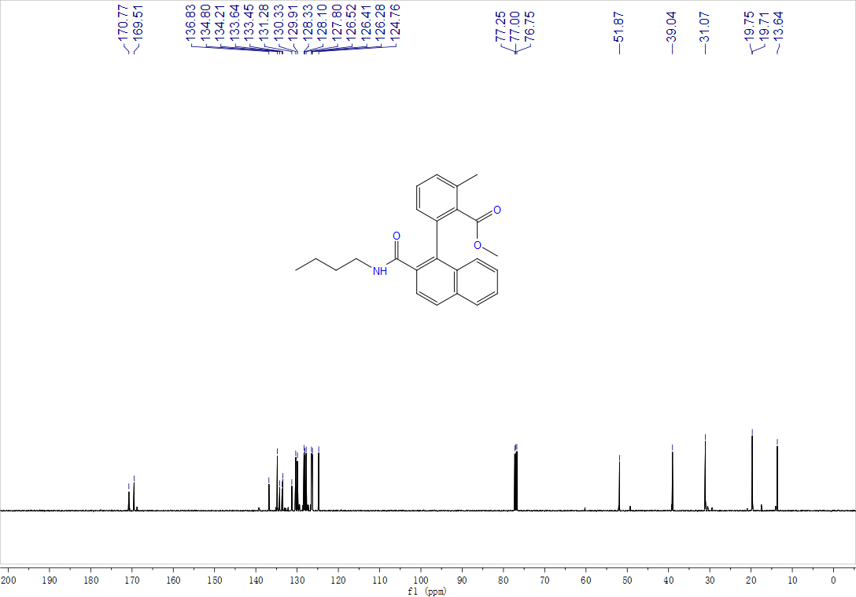

2'-Fluoro-3-methyl-6'-(phenylcarbamoyl)-[1,1'-biphenyl]-2-carboxylic acid, 3va, ¹H NMR (400 MHz, d⁶-DMSO), ¹³C NMR (125 MHz, d⁶-DMSO) and ¹⁹F NMR (471 MHz, d⁶-DMSO)

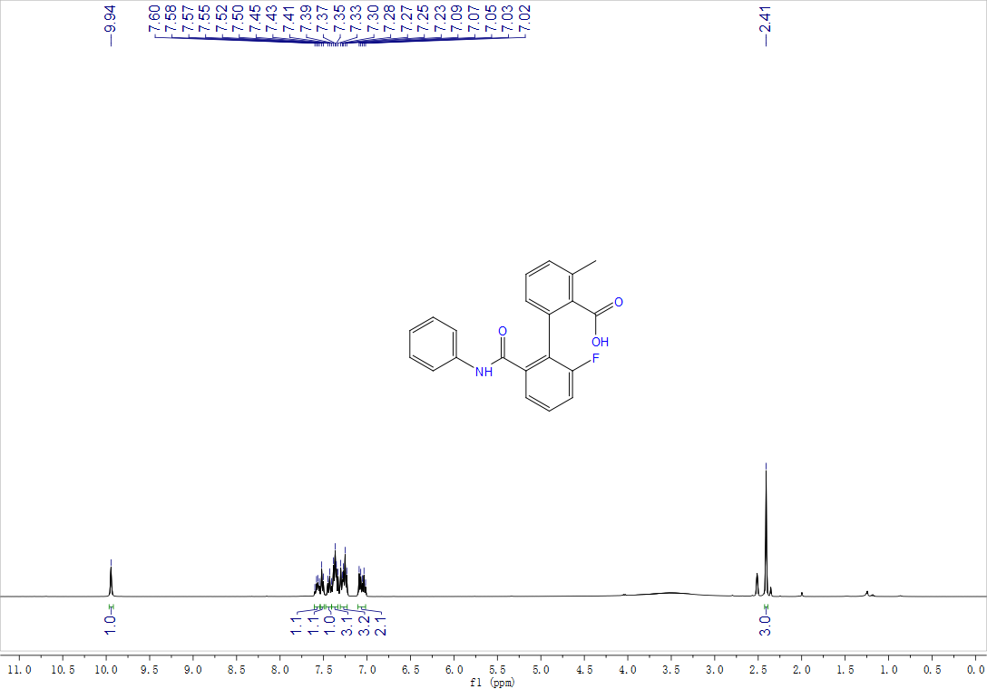

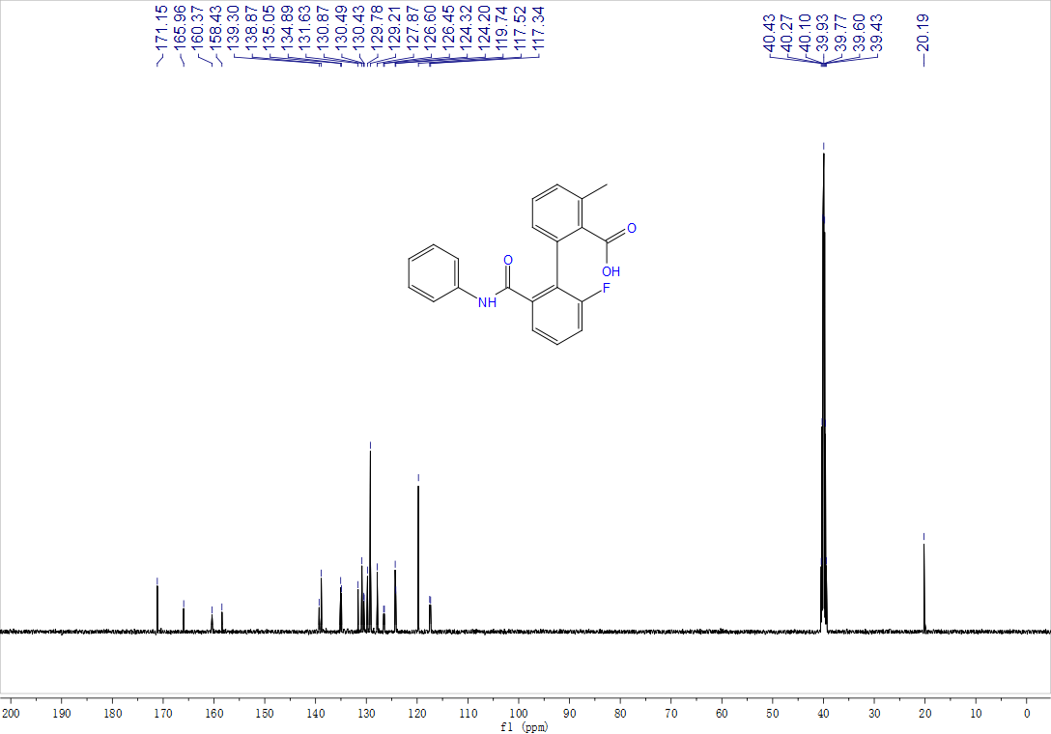

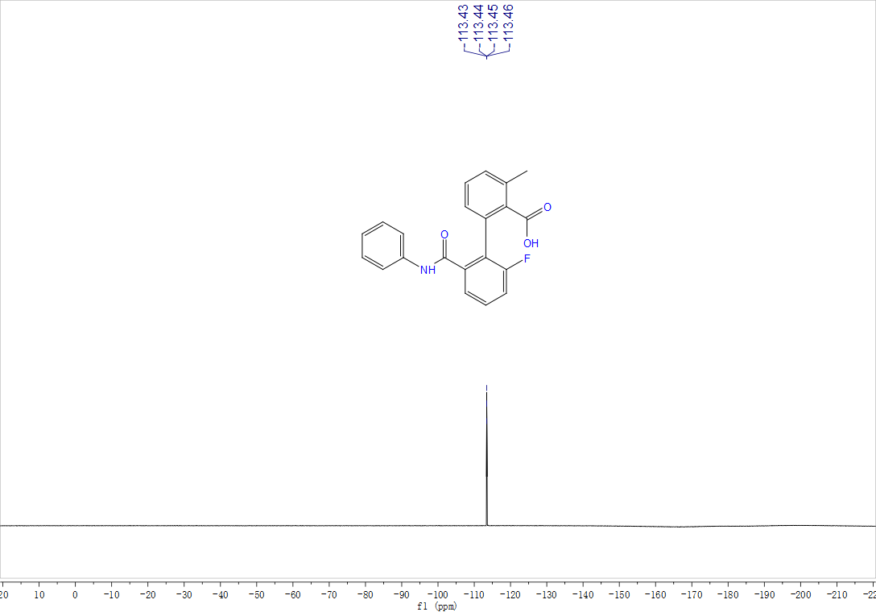
Methyl-2-methyl-6-(2-(phenylcarbamoyl)naphthalen-1-yl)benzoate, 3wa, ¹H NMR (500 MHz, CDCl₃) and ¹³C NMR (125 MHz, CDCl₃)

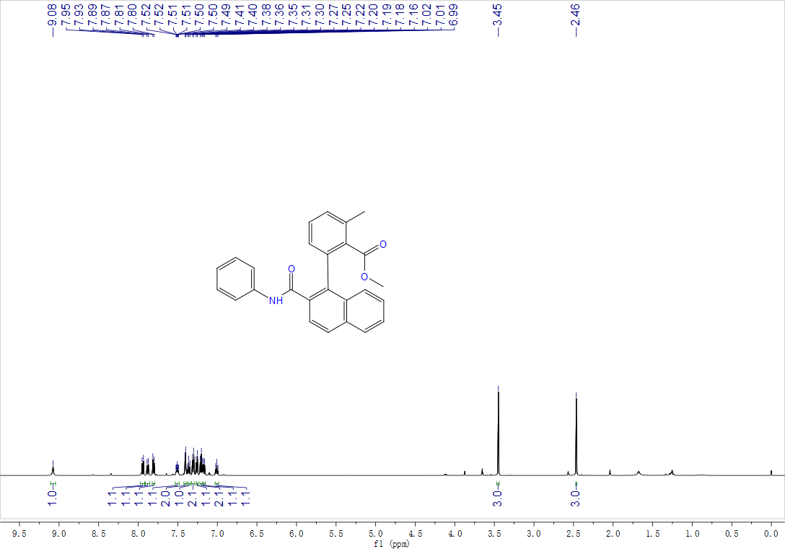

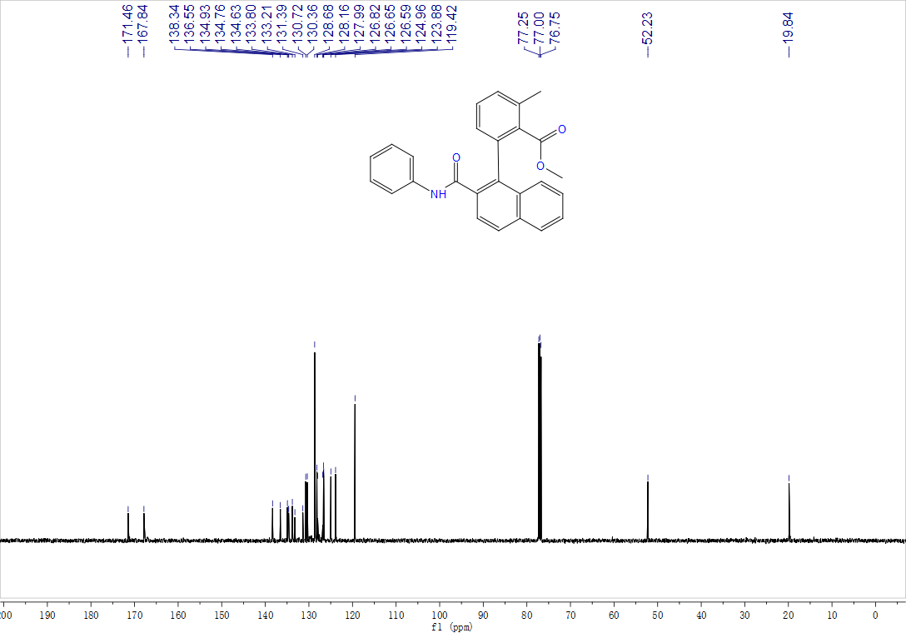
Methyl-3-methyl-2'-pivalamido-[1,1'-biphenyl]-2-carboxylate, 3xa, ¹H NMR (400 MHz, CDCl₃) and ¹³C NMR (125 MHz, CDCl₃)

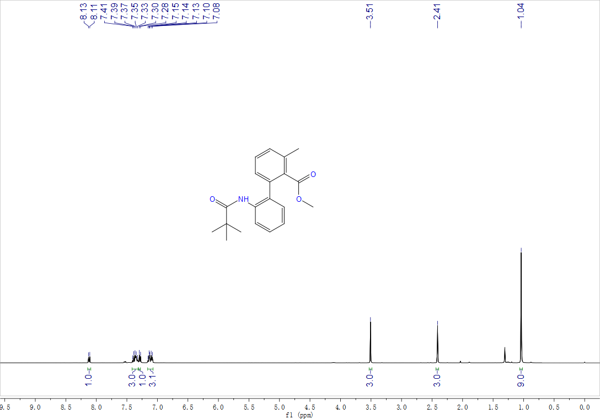

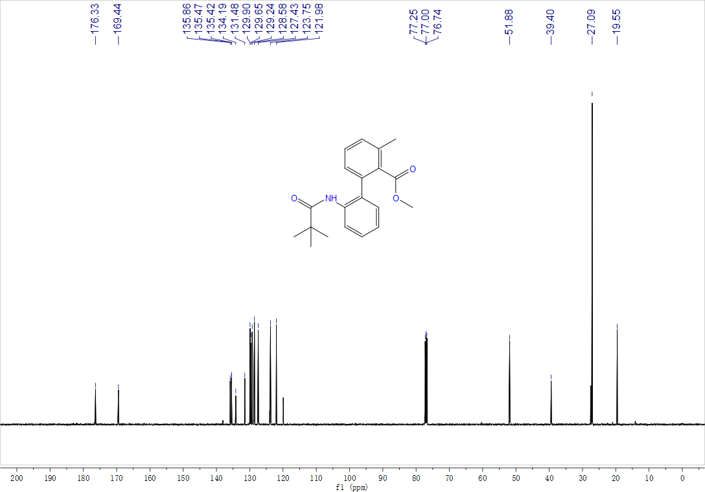

Methyl-2'-((3-cyanophenyl)carbamoyl)-3-methyl-[1,1'-biphenyl]-2-carboxylate, 3ya, ¹H NMR (500 MHz, CDCl₃) and ¹³C NMR (125 MHz, CDCl₃)

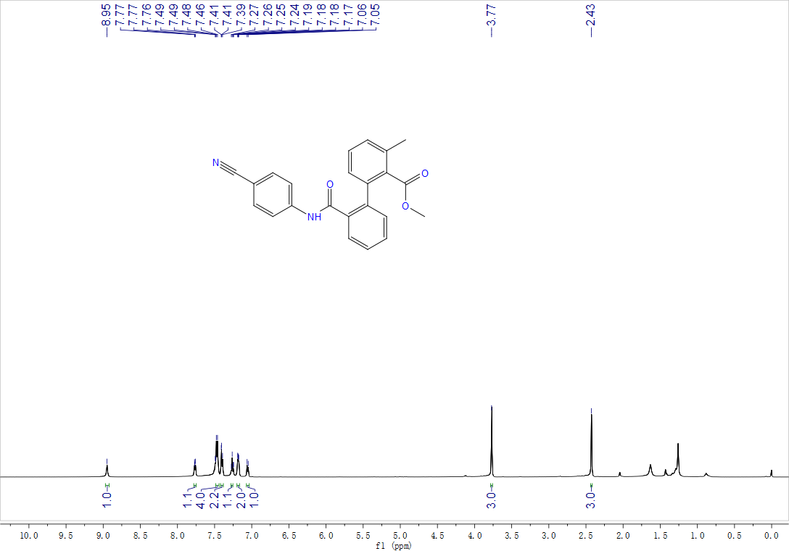

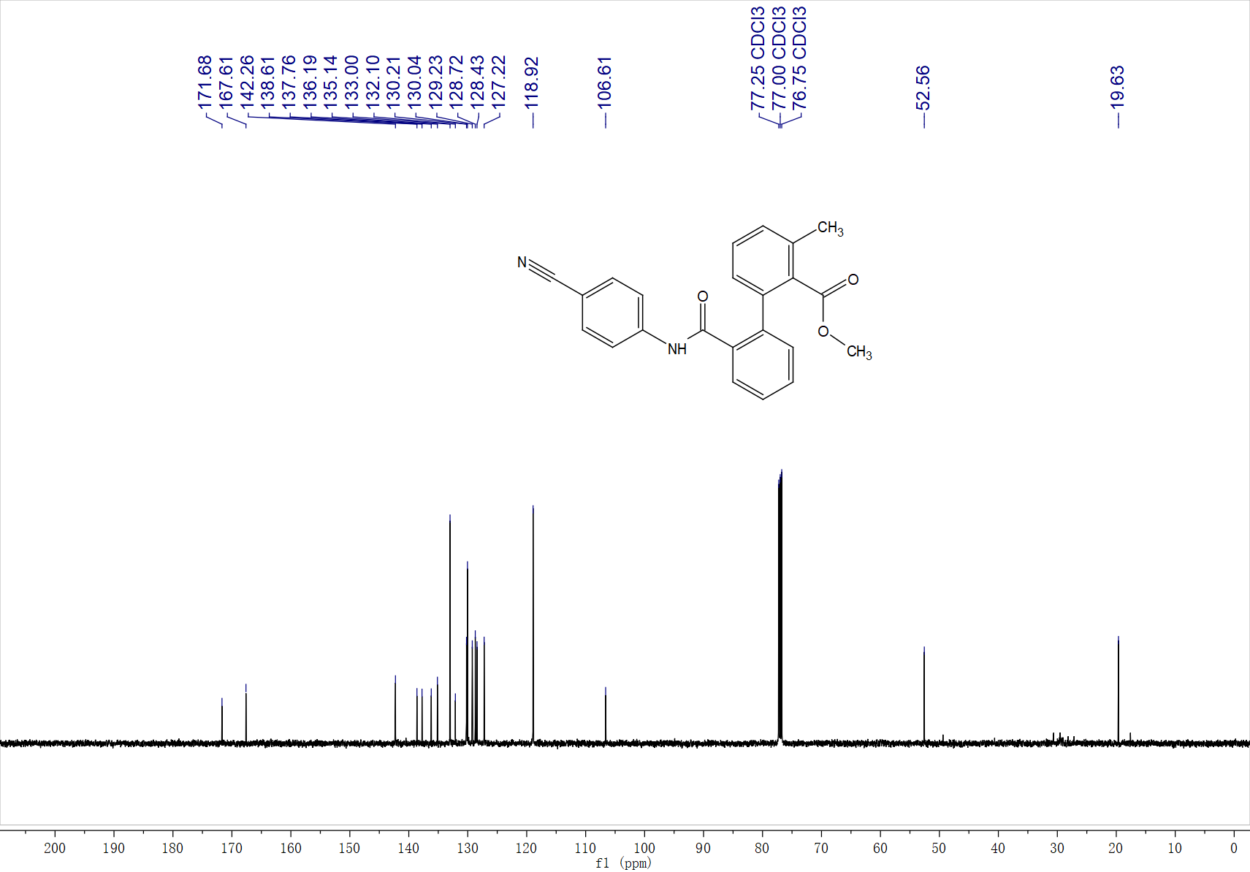

2'-(Butylcarbamoyl)-4'-iodo-3-methyl-[1,1'-biphenyl]-2-carboxylic acid, 3za, ¹H NMR (400 MHz, d⁶-DMSO) and ¹³C NMR (100 MHz, d⁶-DMSO)

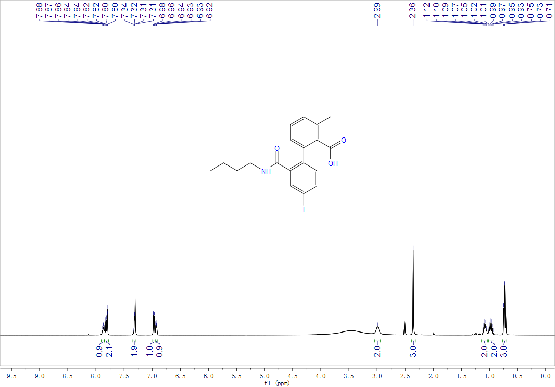

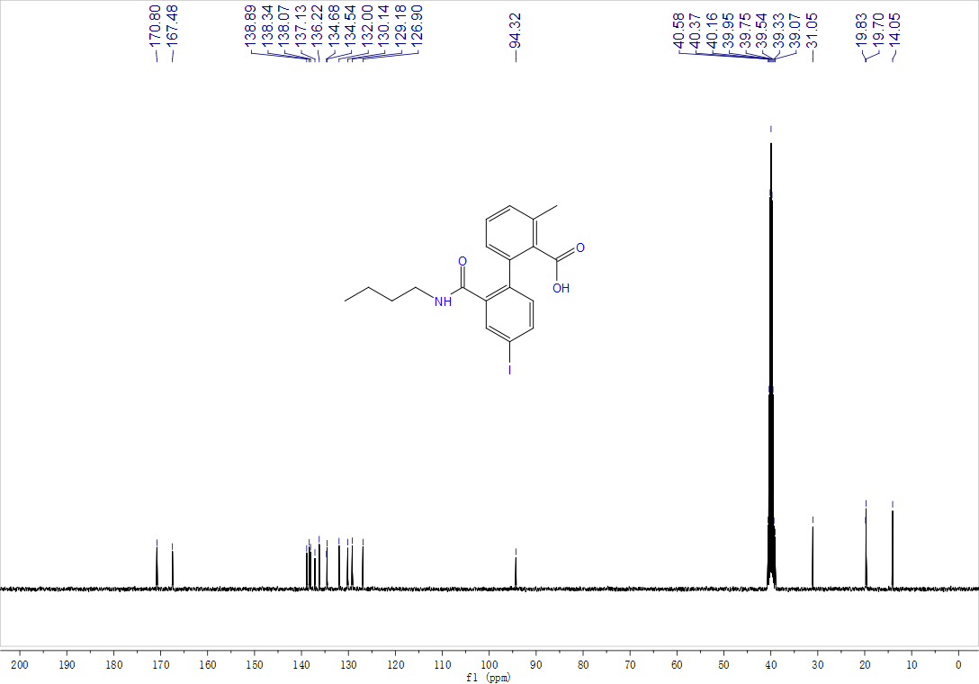

Methyl-3-methyl-[1,1'-biphenyl]-2-carboxylate, 3aaa, ¹H NMR (400 MHz, CDCl₃) and ¹³C NMR (125 MHz, CDCl₃)

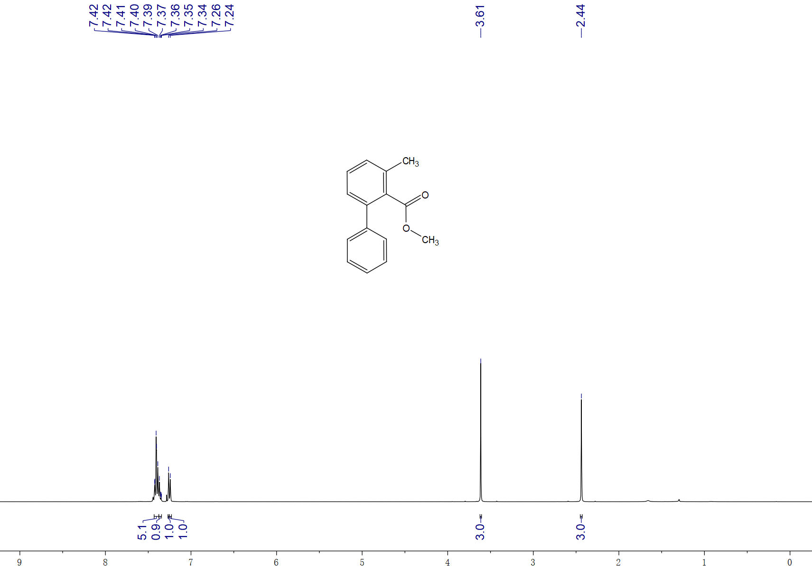

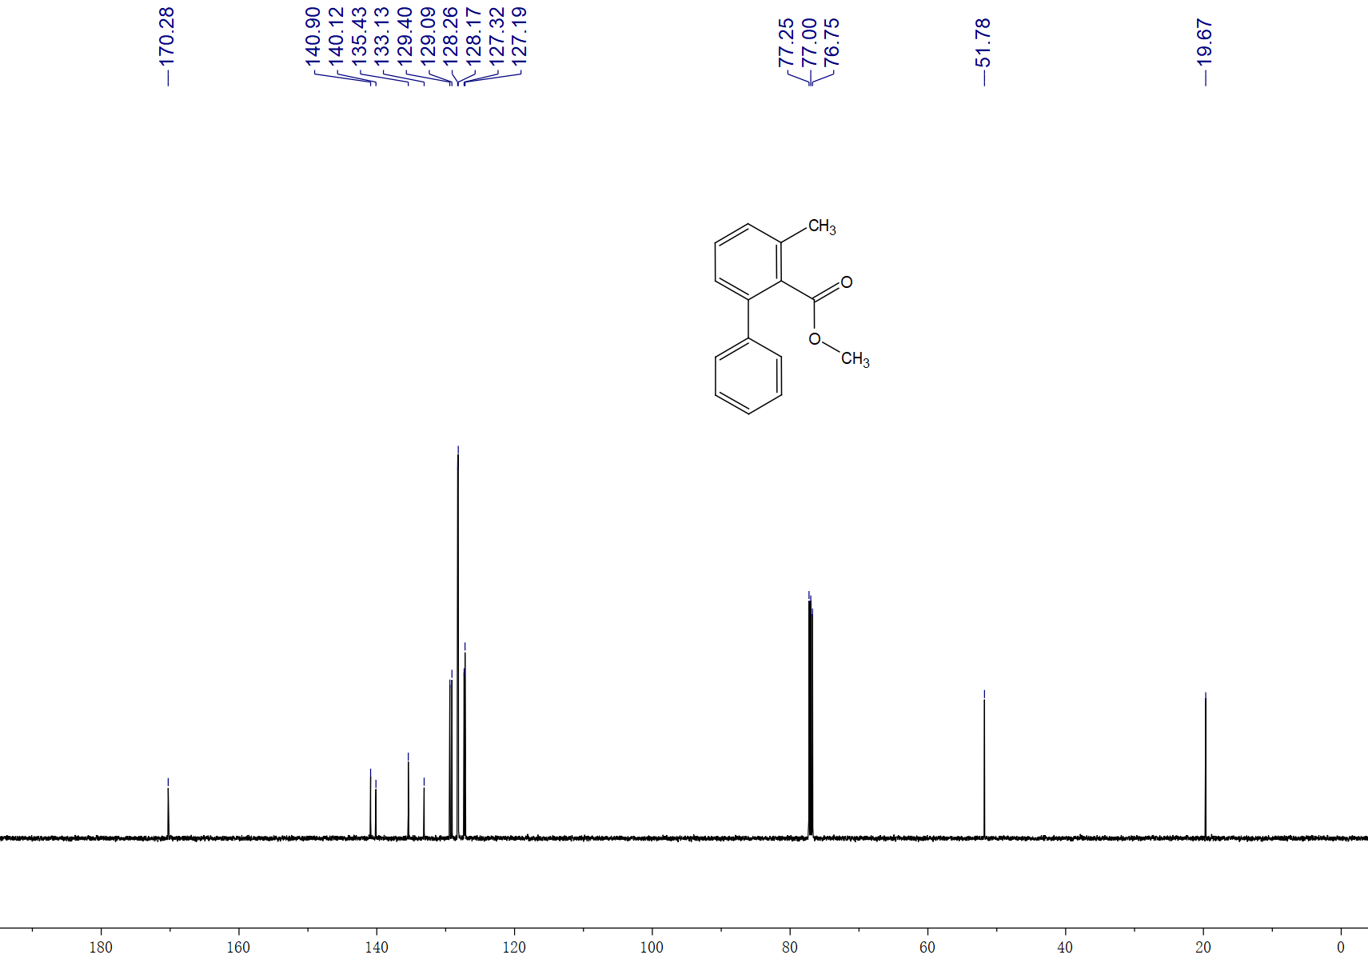
Phenyl-3-methyl-[1,1'-biphenyl]-2-carboxylate, 3aaa', ¹H NMR (400 MHz, CDCl₃) and ¹³C NMR (125 MHz, CDCl₃)

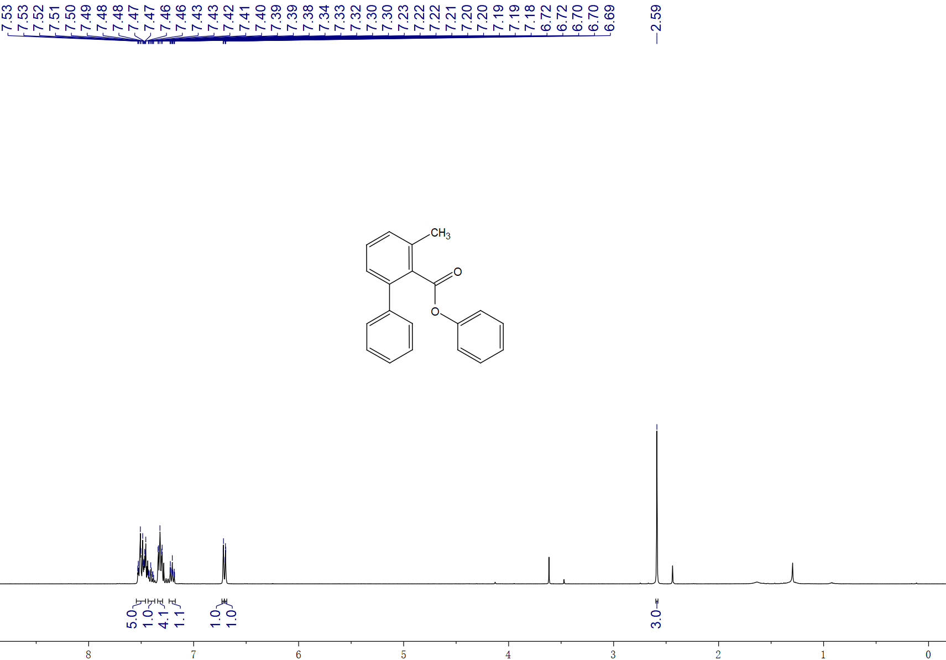

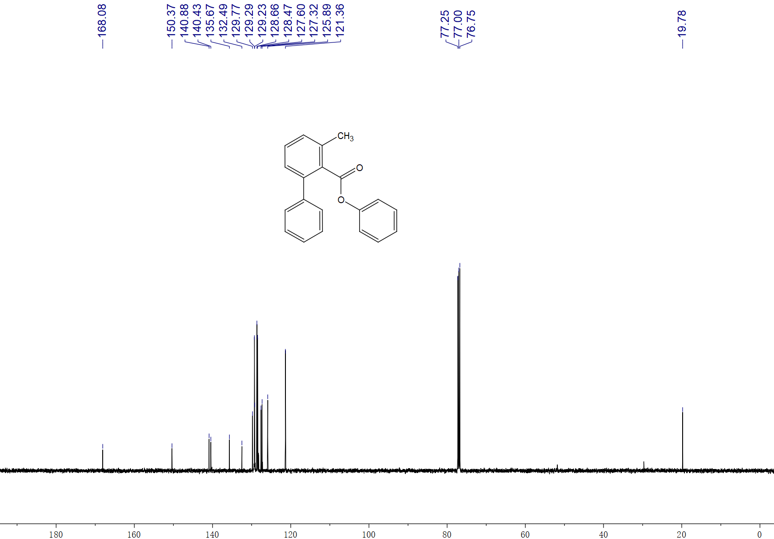

Methyl-2'-methyl-6'-(phenylcarbamoyl)-[1,1'-biphenyl]-2-carboxylate, 3ab, ¹H NMR (500 MHz, CDCl₃) and ¹³C NMR (125 MHz, CDCl₃)

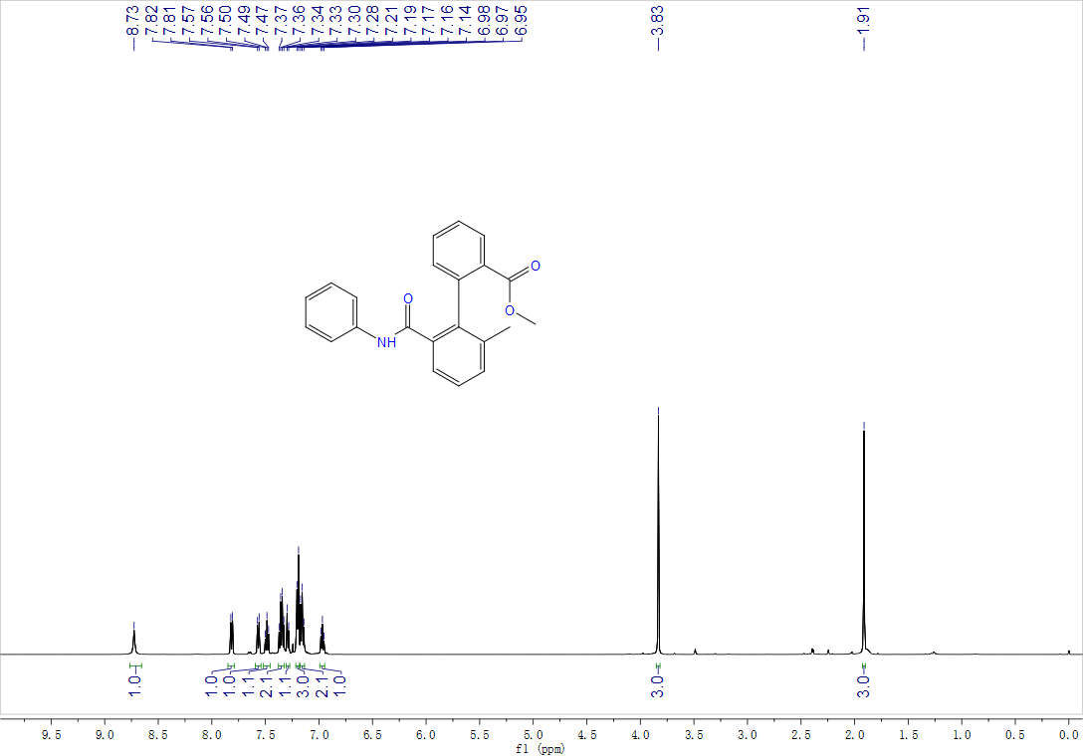

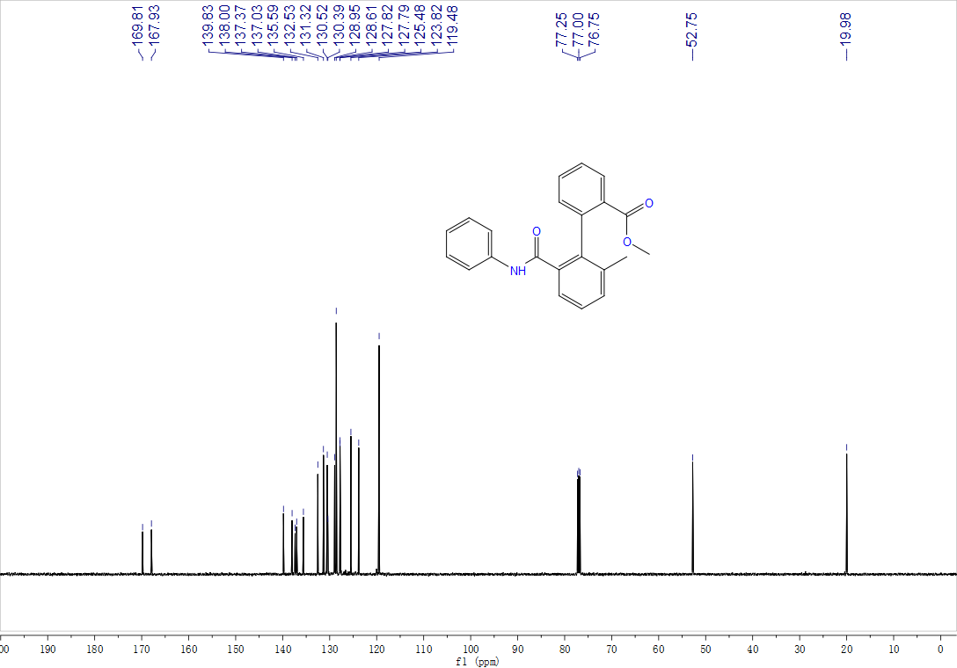

Methyl-2',5-dimethyl-6'-(phenylcarbamoyl)-[1,1'-biphenyl]-2-carboxylate, 3ac, ¹H NMR (500 MHz, CDCl₃) and ¹³C NMR (125 MHz, CDCl₃)

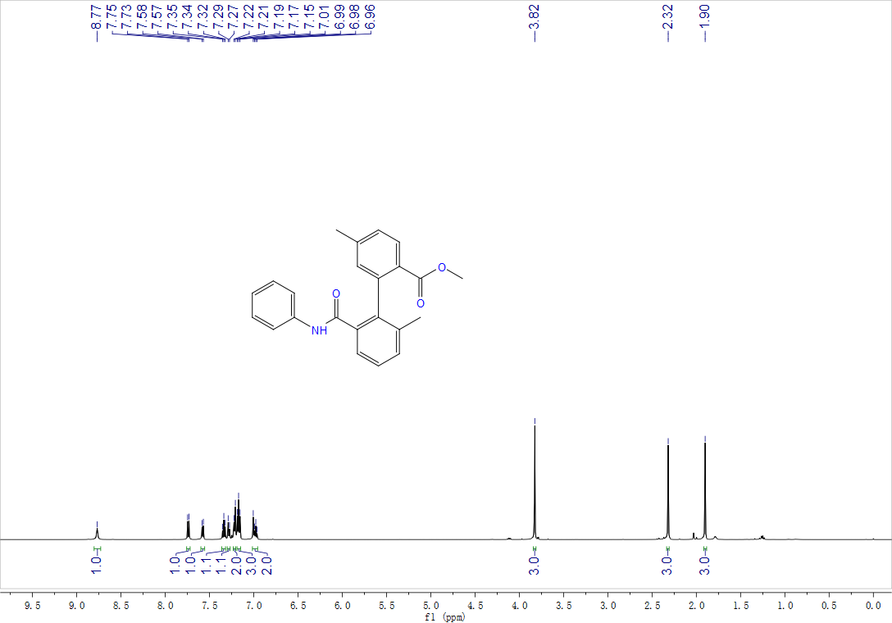

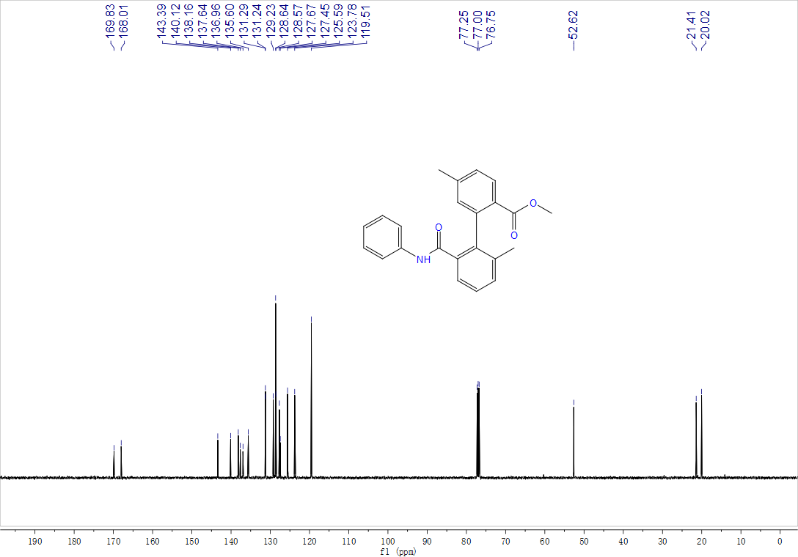
Methyl-5-methoxy-2'-methyl-6'-(phenylcarbamoyl)-[1,1'-biphenyl]-2-carboxylate, 3ad, ¹H NMR (500 MHz, CDCl₃) and ¹³C NMR (125 MHz, CDCl₃)

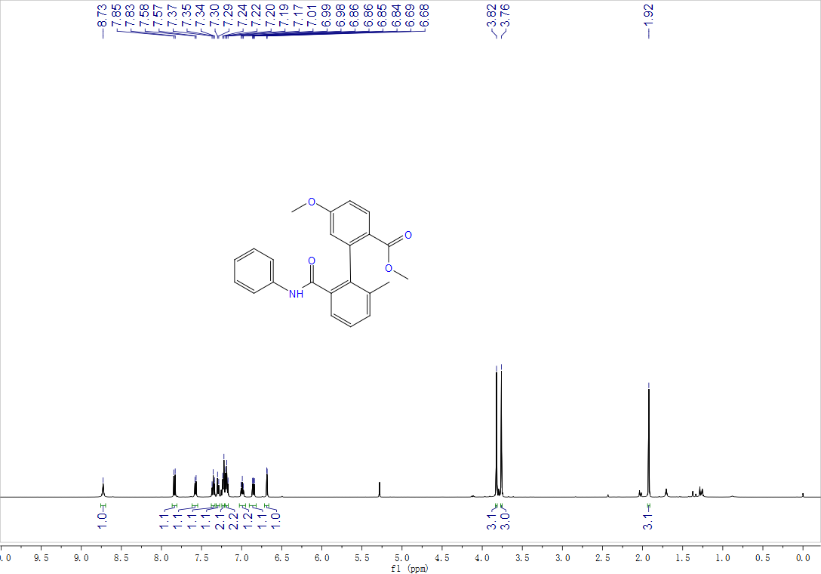

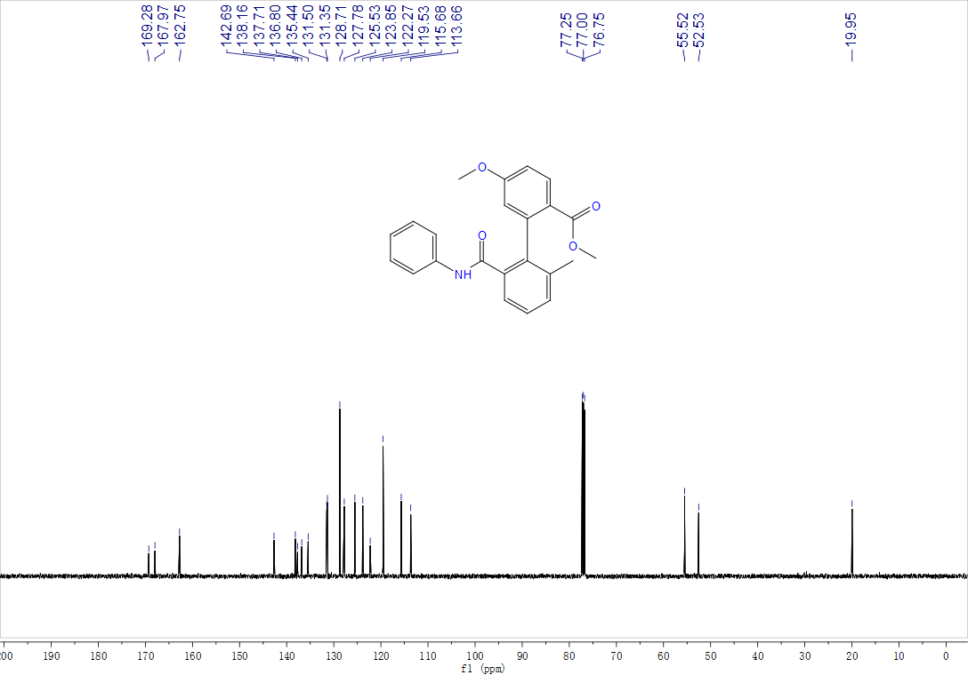
Methyl-2'-methyl-5-(methylthio)-6'-(phenylcarbamoyl)-[1,1'-biphenyl]-2-carboxylate, 3ae, ¹H NMR (500 MHz, CDCl₃) and ¹³C NMR (125 MHz, CDCl₃)

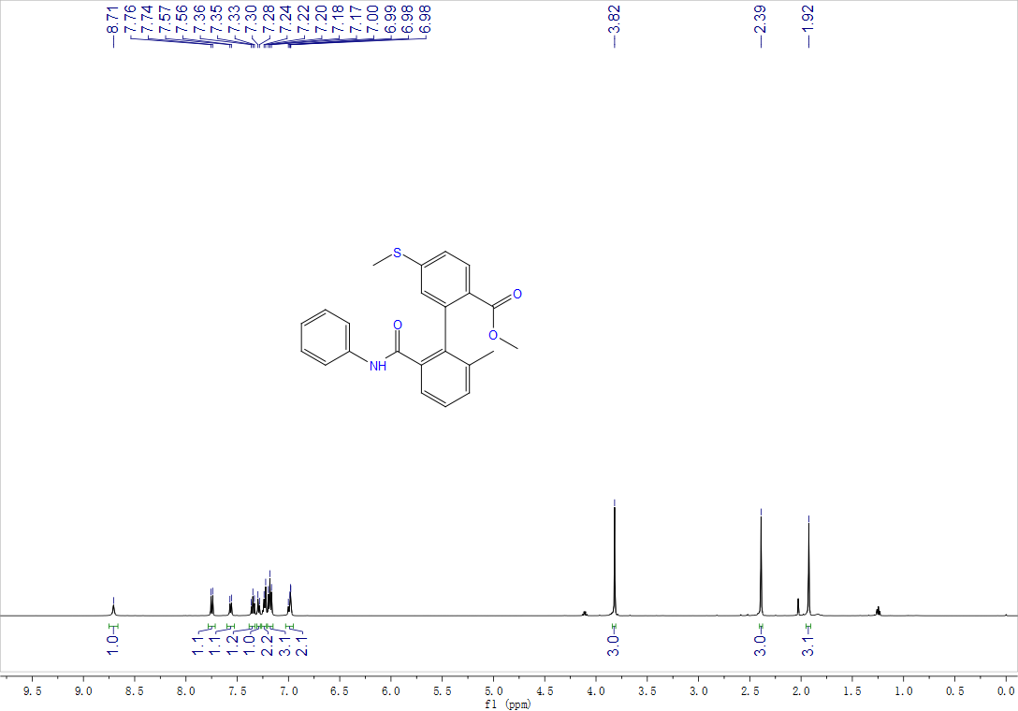

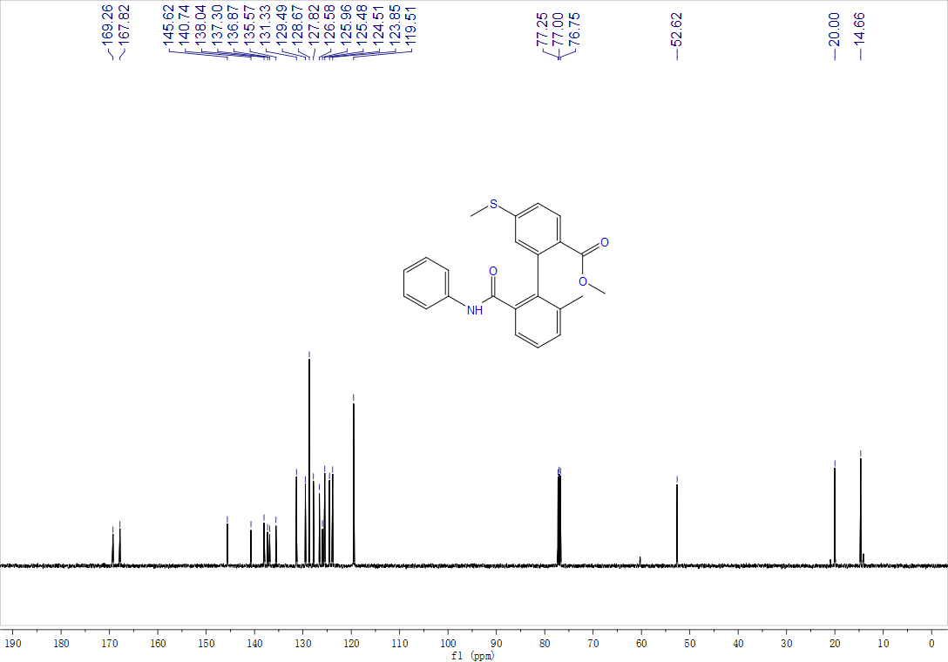
Methyl-5-(dimethylamino)-2'-methyl-6'-(phenylcarbamoyl)-[1,1'-biphenyl]-2-carboxylate, 3af, ¹H NMR (500 MHz, CDCl₃) and ¹³C NMR (125 MHz, CDCl₃)

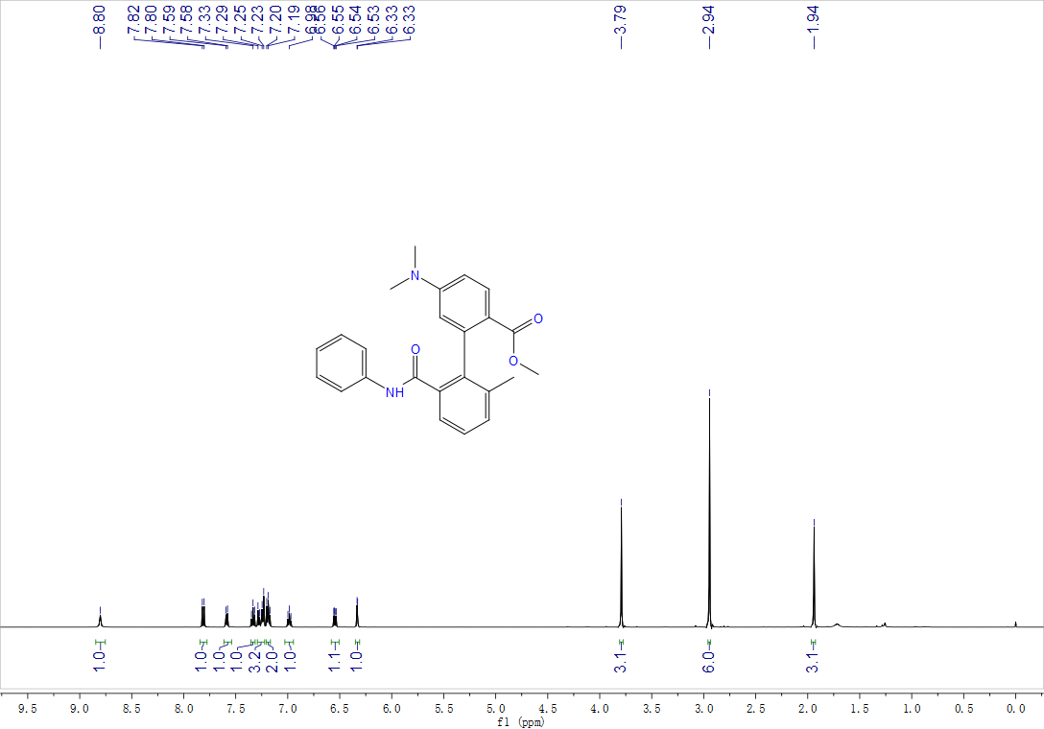

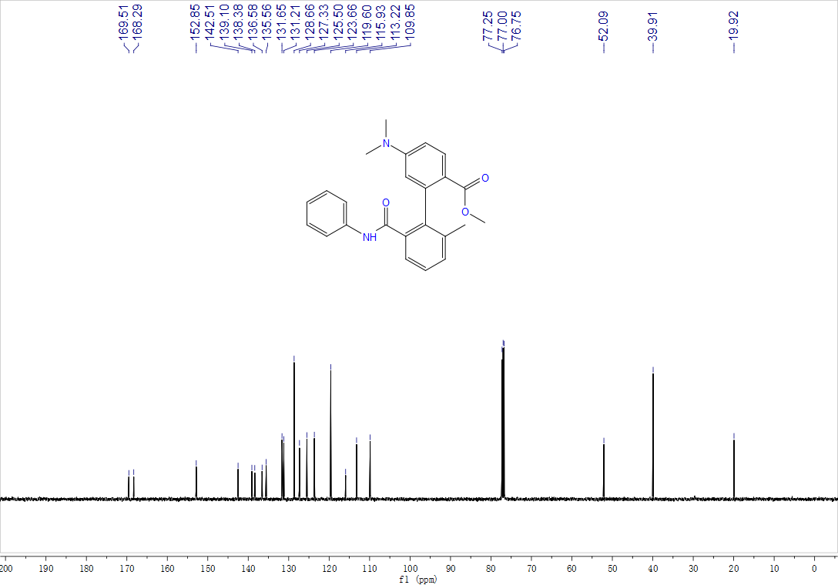
Methyl-5-fluoro-2'-methyl-6'-(phenylcarbamoyl)-[1,1'-biphenyl]-2-carboxylate, 3ag, ¹H NMR (500 MHz, CDCl₃), ¹³C NMR (125 MHz, CDCl₃), ¹⁹F NMR (471 MHz, CDCl₃)

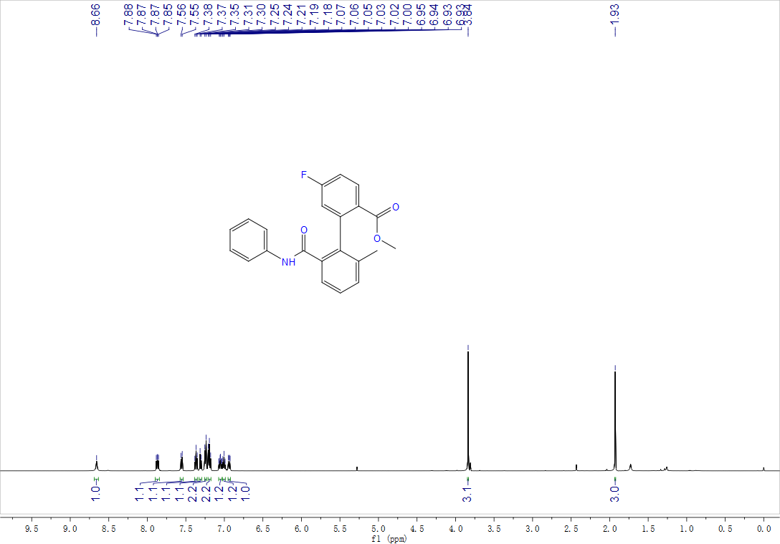

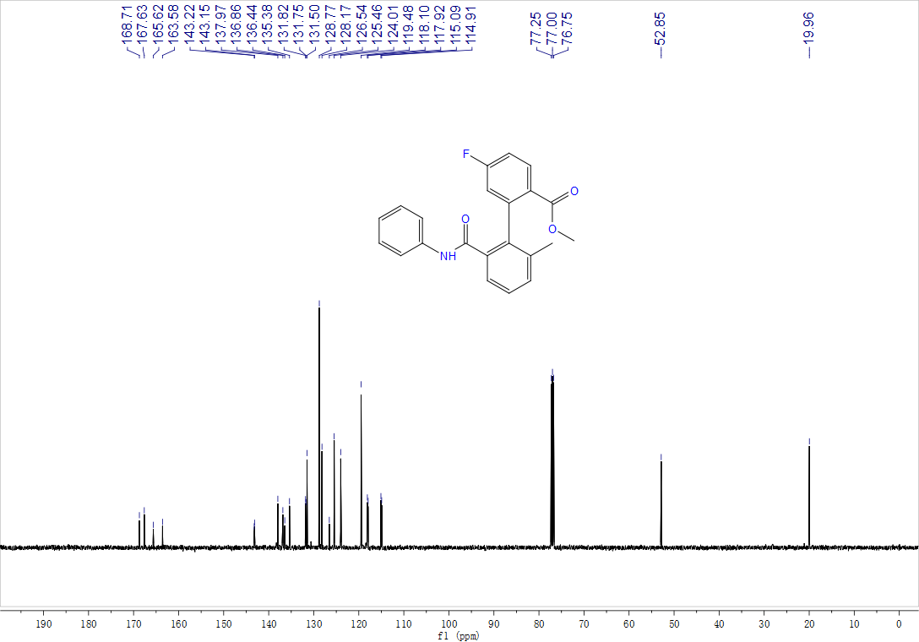

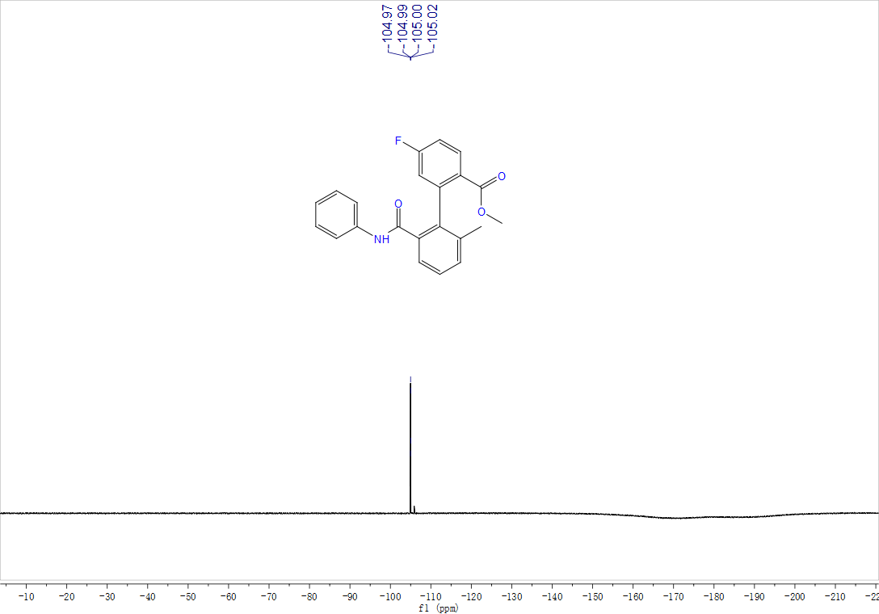

Methyl-5-chloro-2'-methyl-6'-(phenylcarbamoyl)-[1,1'-biphenyl]-2-carboxylate, 3ah, ¹H NMR (500 MHz, CDCl₃) and ¹³C NMR (125 MHz, CDCl₃)

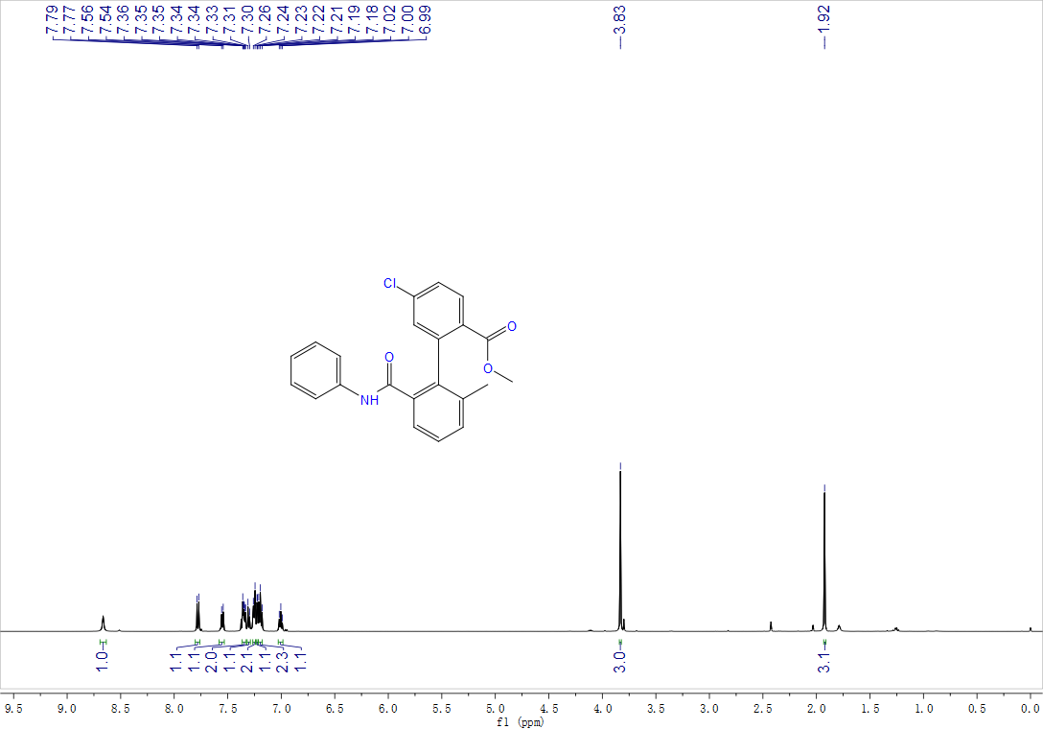

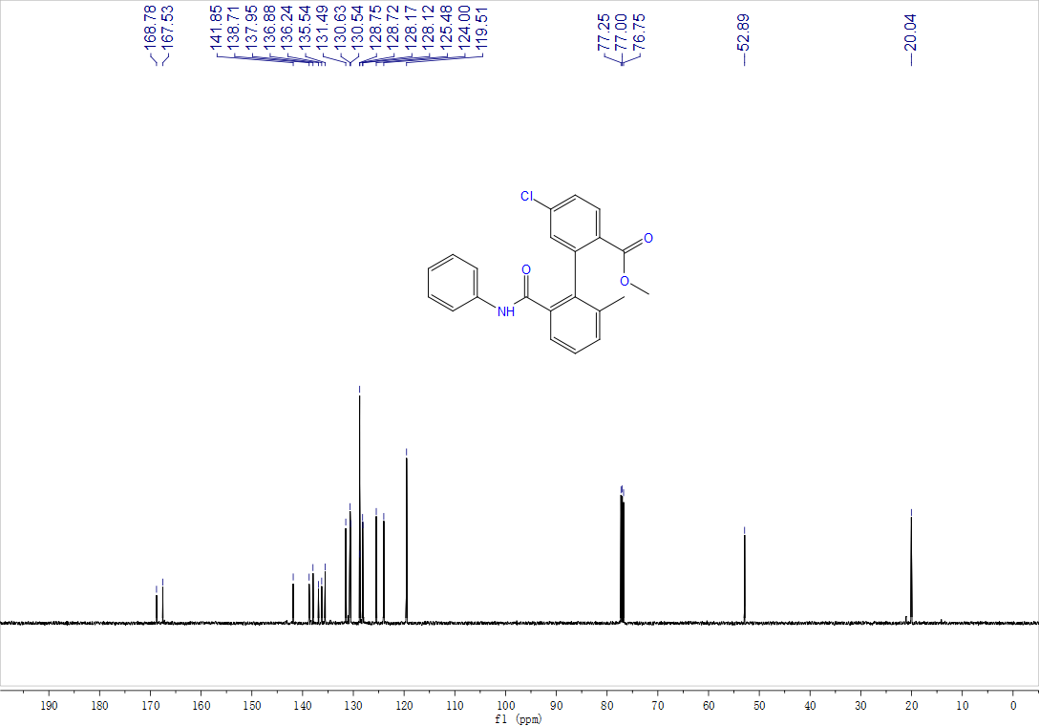
Methyl-5-iodo-2'-methyl-6'-(phenylcarbamoyl)-[1,1'-biphenyl]-2-carboxylate, 3ai, ¹H NMR (500 MHz, CDCl₃) and ¹³C NMR (125 MHz, CDCl₃)

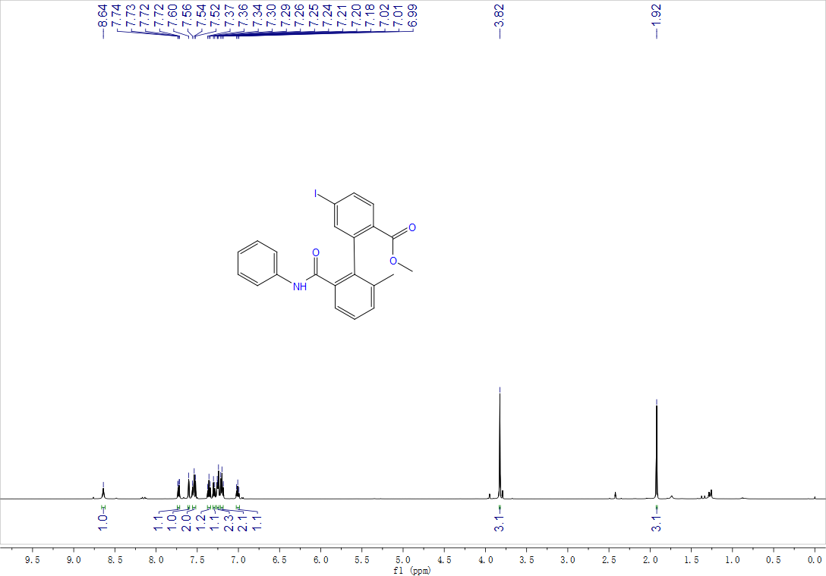

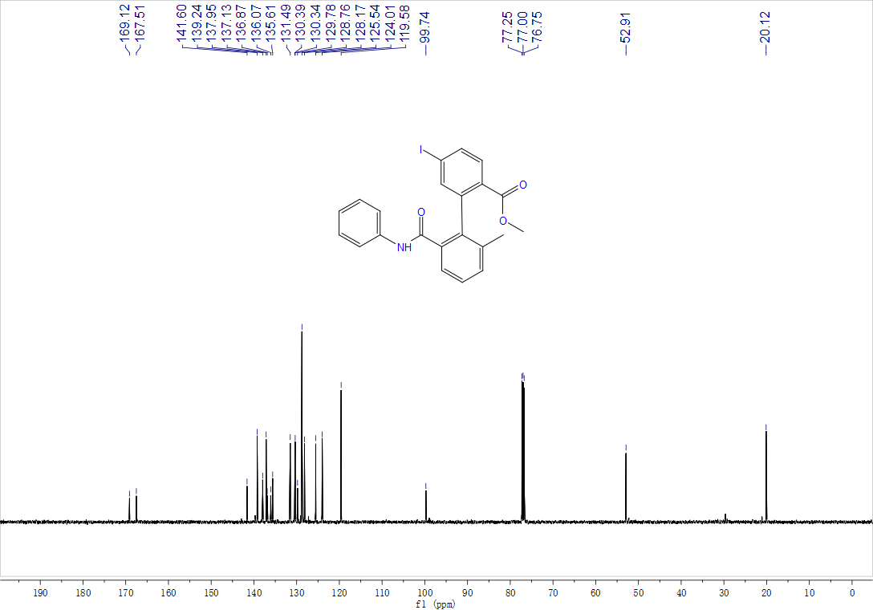

Methyl-3-methoxy-2'-methyl-6'-(phenylcarbamoyl)-[1,1'-biphenyl]-2-carboxylate, 3aj, ¹H NMR (500 MHz, CDCl₃) and ¹³C NMR (125 MHz, CDCl₃)

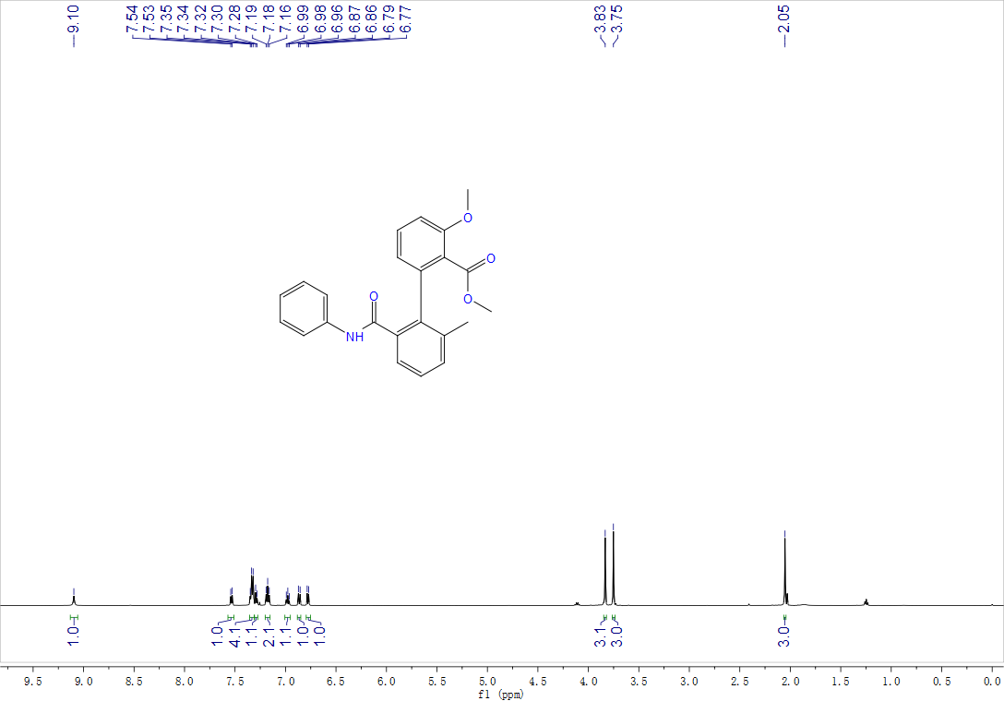

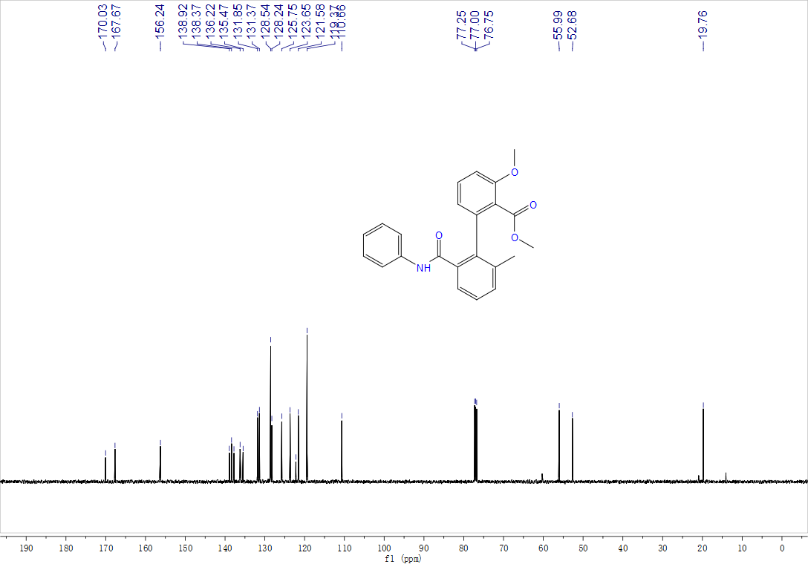

Methyl-2-methyl-6-(phenylcarbamoyl)-[1,1':3',1''-terphenyl]-2'-carboxylate, 3ak, ¹H NMR (500 MHz, CDCl₃) and ¹³C NMR (125 MHz, CDCl₃)

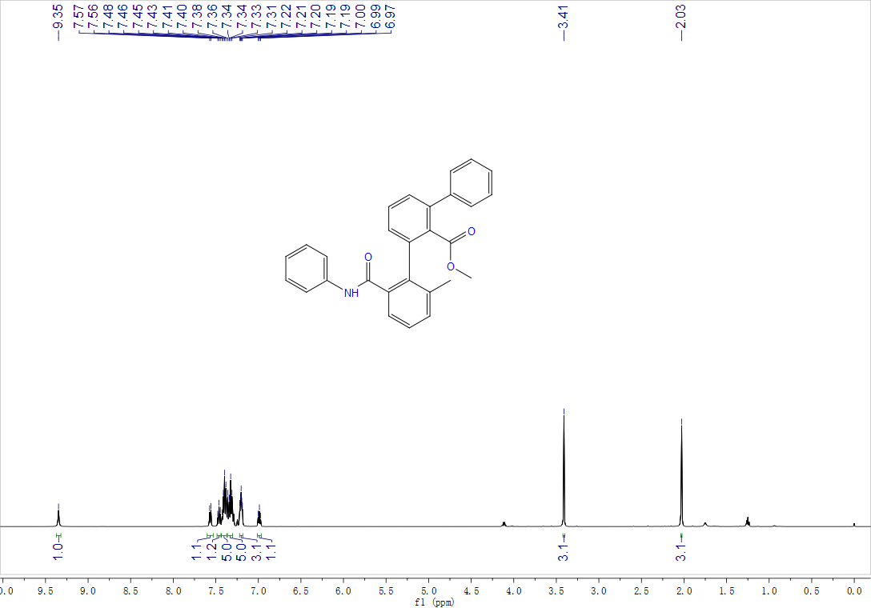

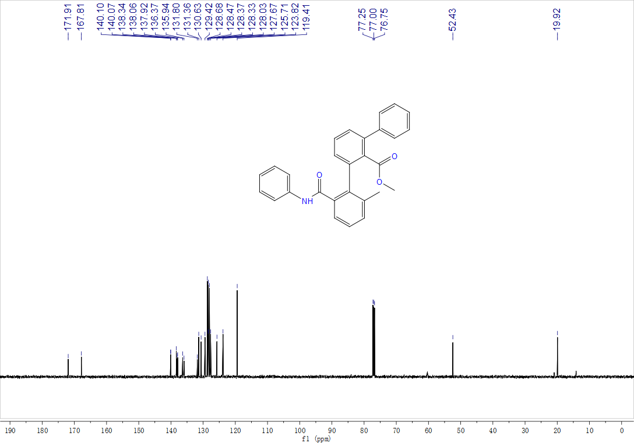

2-(Butylcarbamoyl)-6-methyl-[1,1':3',1''-terphenyl]-2'-carboxylic acid, 3al, ¹H NMR (500 MHz, CDCl₃) and ¹³C NMR (125 MHz, CDCl₃)

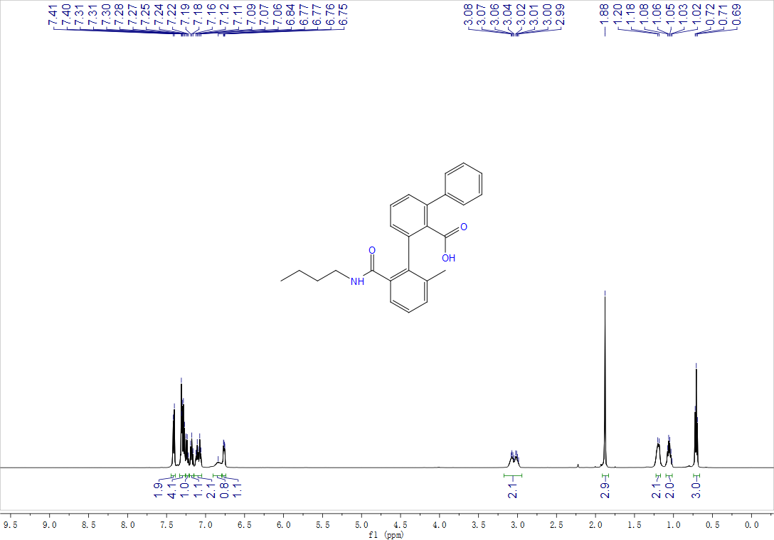

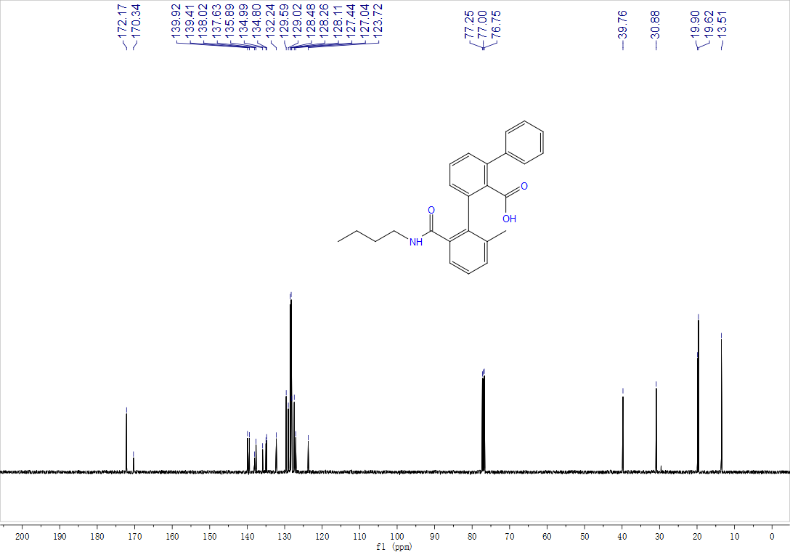

2-(Isopropylcarbamoyl)-6-methyl-[1,1':3',1''-terphenyl]-2'-carboxylic acid, 3am, ¹H NMR (500 MHz, CDCl₃) and ¹³C NMR (125 MHz, CDCl₃)

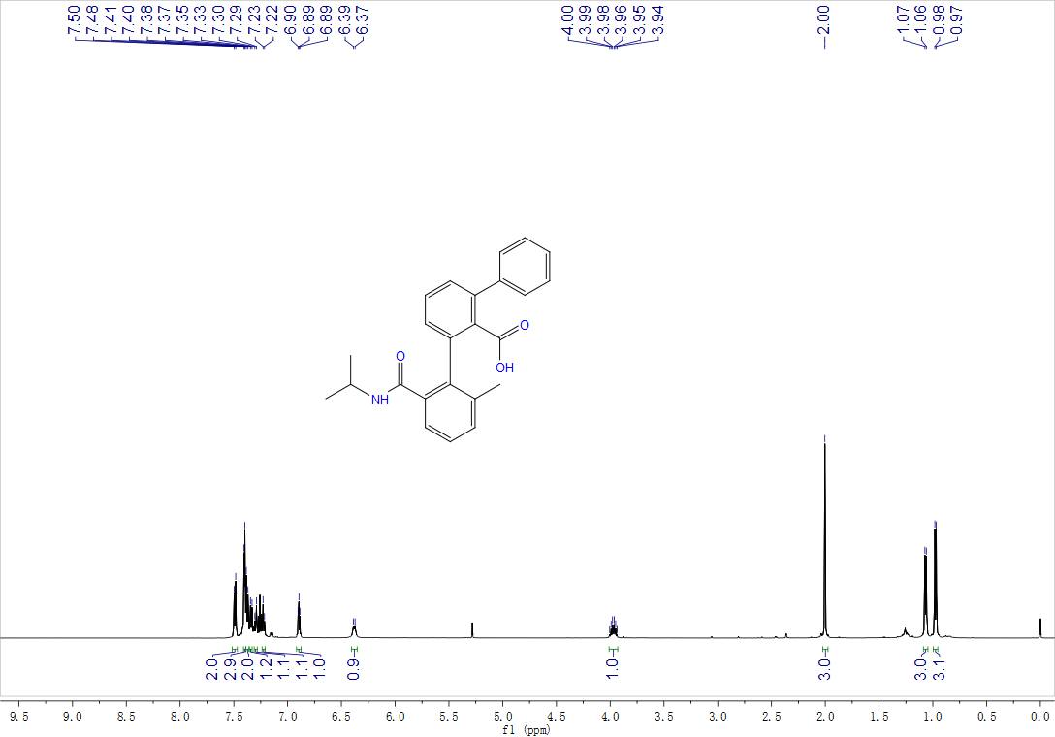

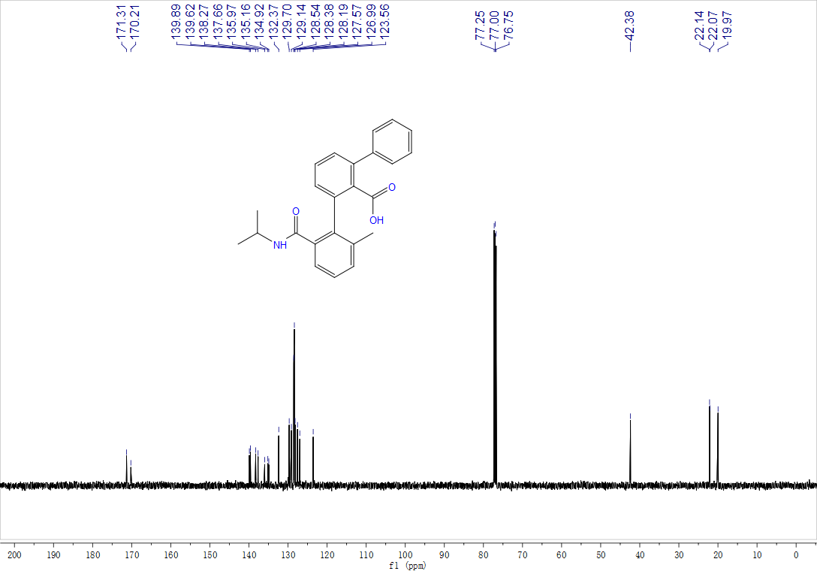

2-(2-Methyl-6-(phenylcarbamoyl)phenyl)-1-naphthoic acid, 3an, ¹H NMR (400 MHz, d⁶-DMSO) and ¹³C NMR (125 MHz, d⁶-DMSO)

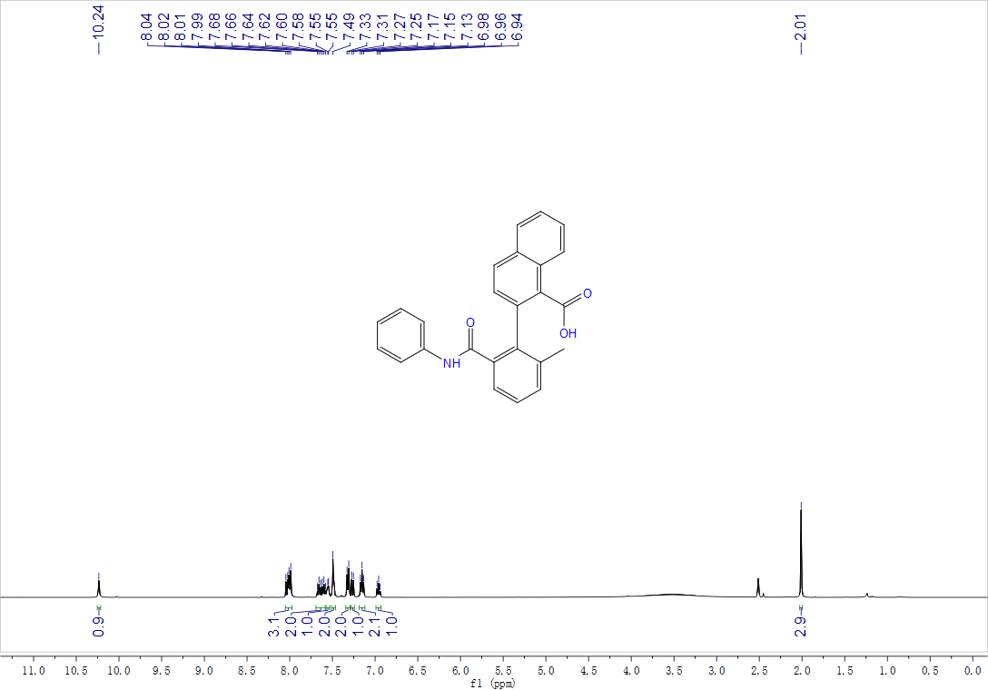

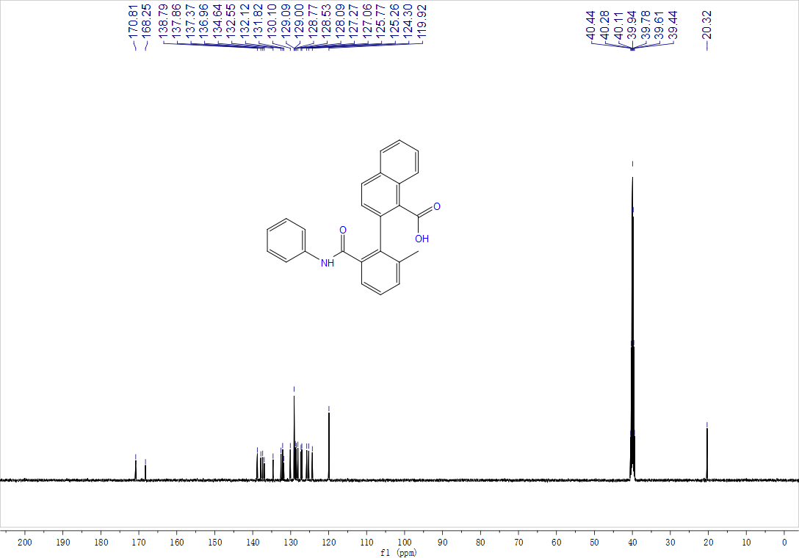

Methyl-3-(2-methyl-6-(phenylcarbamoyl)phenyl)-2-naphthoate, 3ao, ¹H NMR (500 MHz, CDCl₃) and ¹³C NMR (125 MHz, CDCl₃)

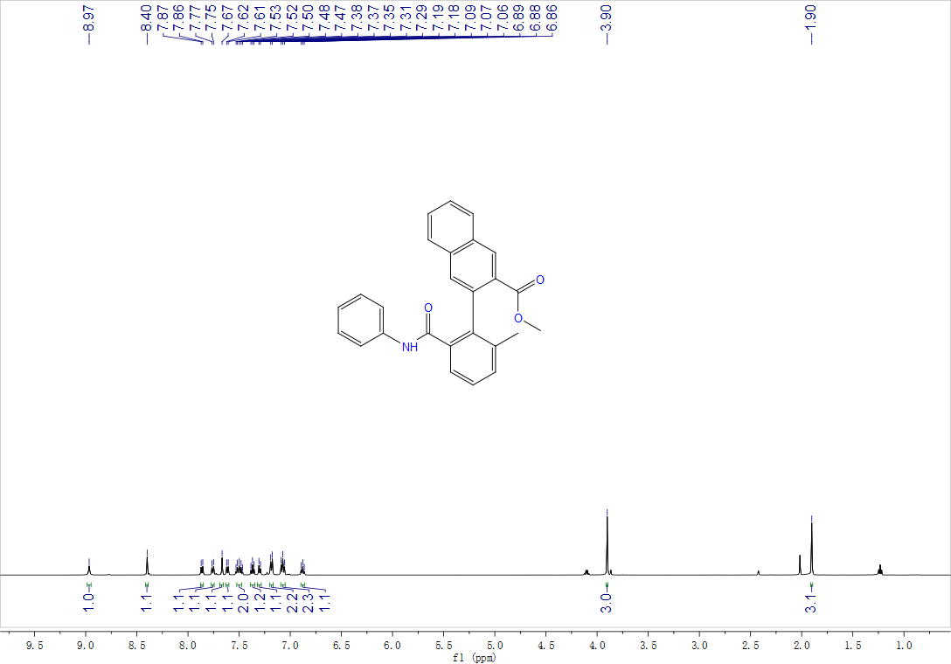

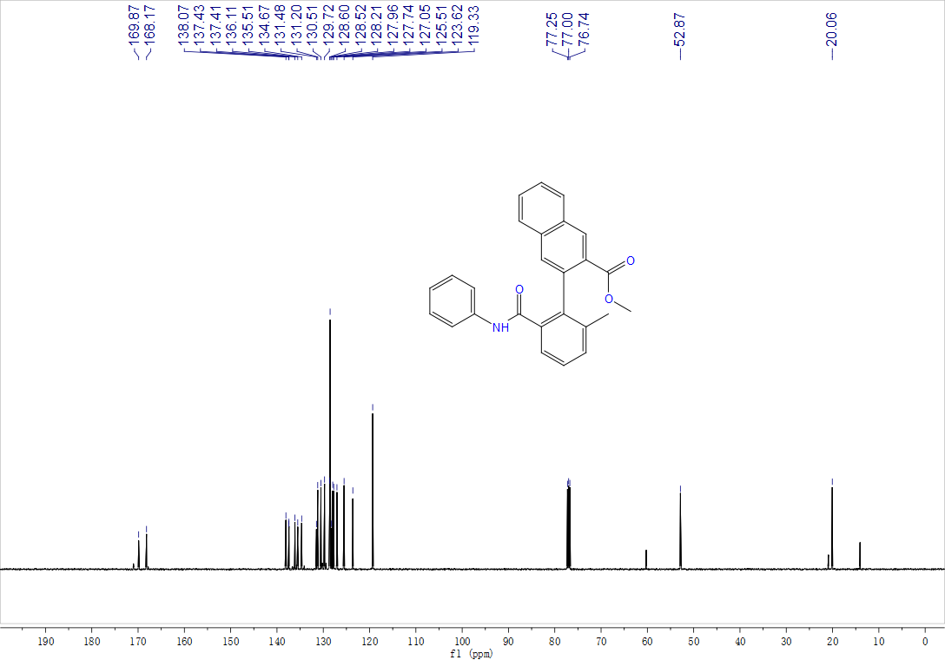

Methyl-2',4-dimethyl-6'-(phenylcarbamoyl)-[1,1'-biphenyl]-2-carboxylate, 3ap, ¹H NMR (500 MHz, CDCl₃) and ¹³C NMR (125 MHz, CDCl₃)

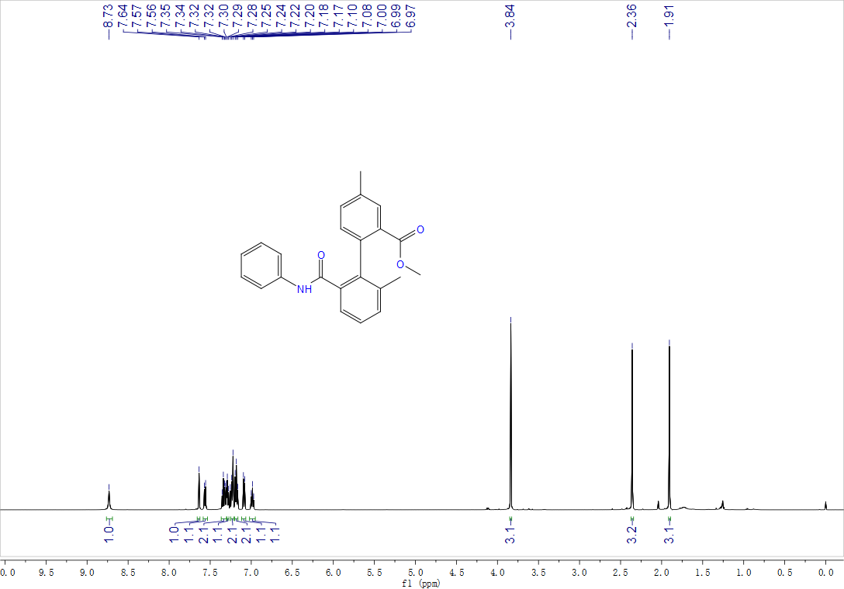

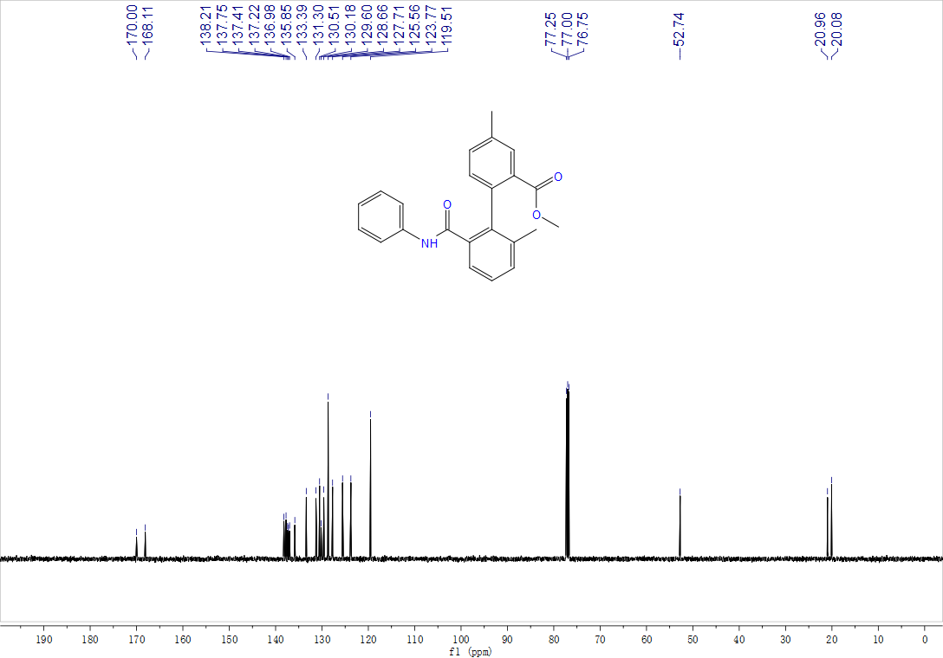

Methyl-4-chloro-2'-methyl-6'-(phenylcarbamoyl)-[1,1'-biphenyl]-2-carboxylate, 3aq, ¹H NMR (500 MHz, CDCl₃) and ¹³C NMR (125 MHz, CDCl₃)

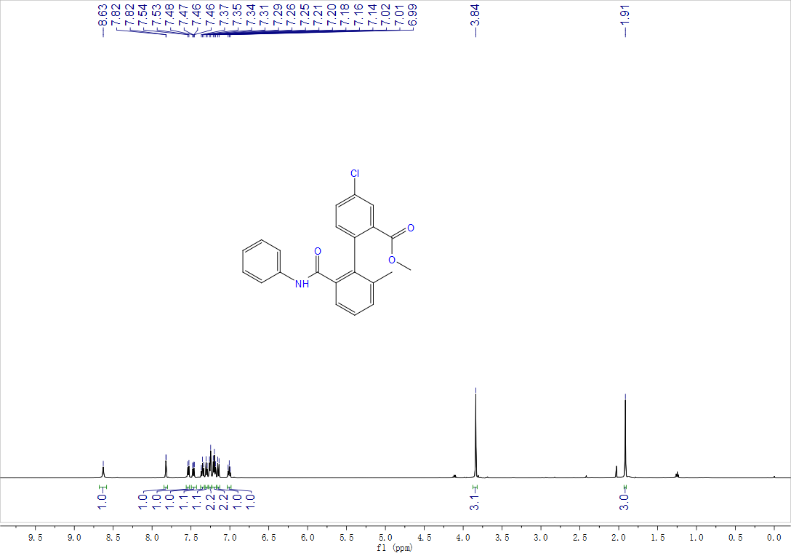

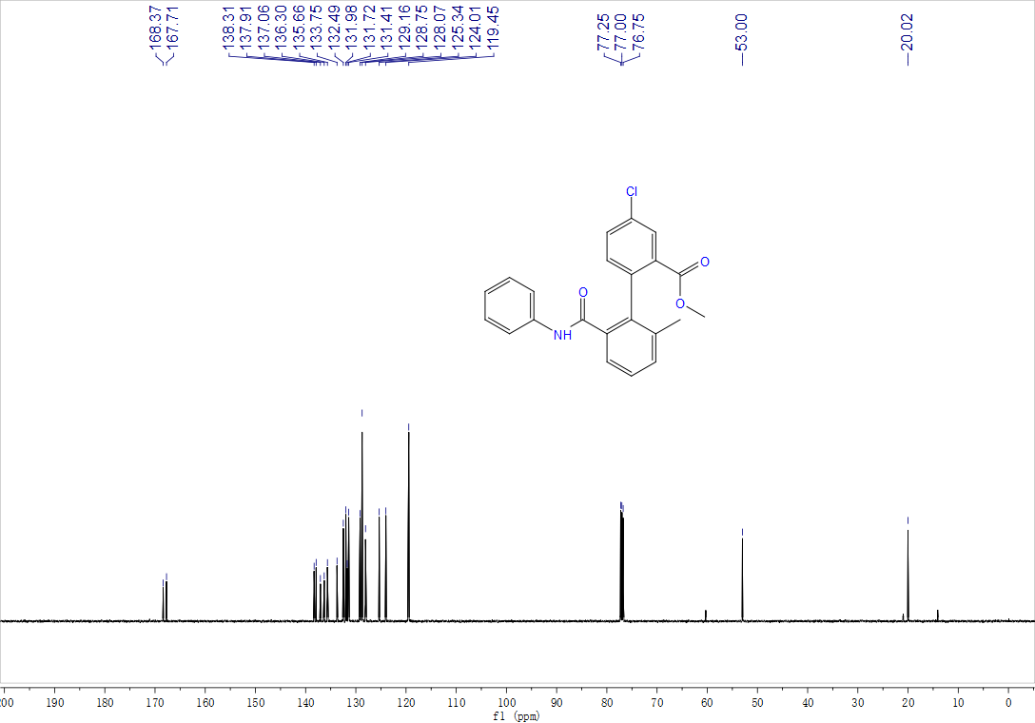

Methyl-2'-(butylcarbamoyl)-6'-methyl-4-(trifluoromethyl)-[1,1'-biphenyl]-2-carboxylate, 3ar, ¹H NMR (500 MHz, CDCl₃), ¹³C NMR (125 MHz, CDCl₃) and ¹⁹F NMR (471 MHz, CDCl₃)

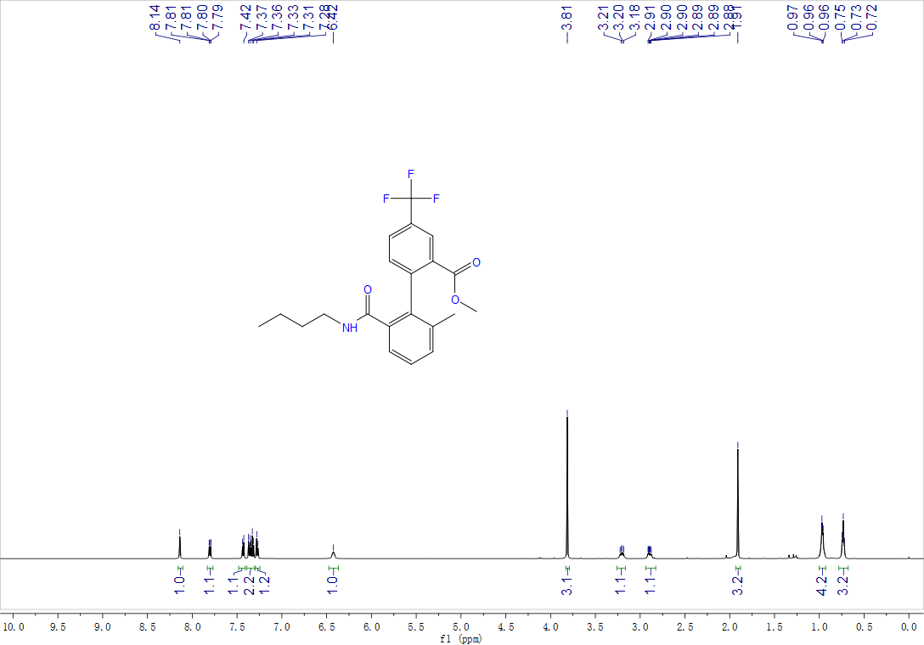

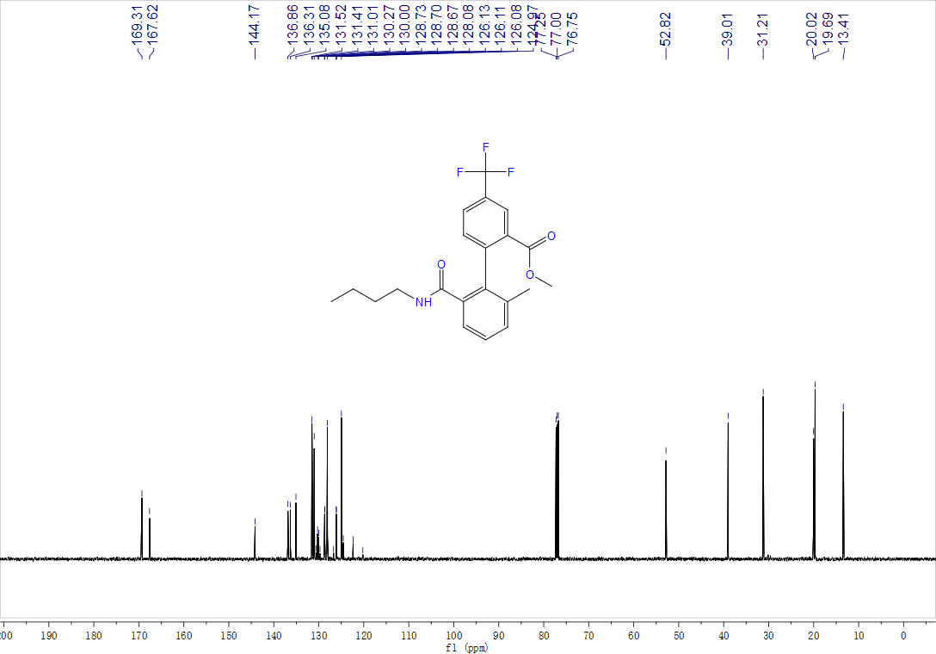

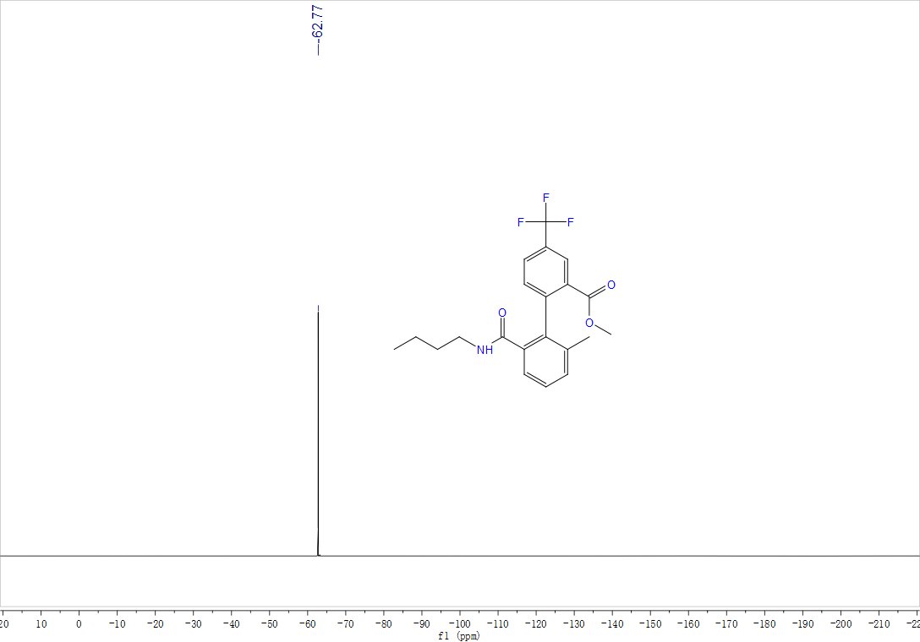
Methyl-3,5-dimethoxy-2'-methyl-6'-(phenylcarbamoyl)-[1,1'-biphenyl]-2-carboxylate, 3as, ¹H NMR (500 MHz, CDCl₃) and ¹³C NMR (125 MHz, CDCl₃)

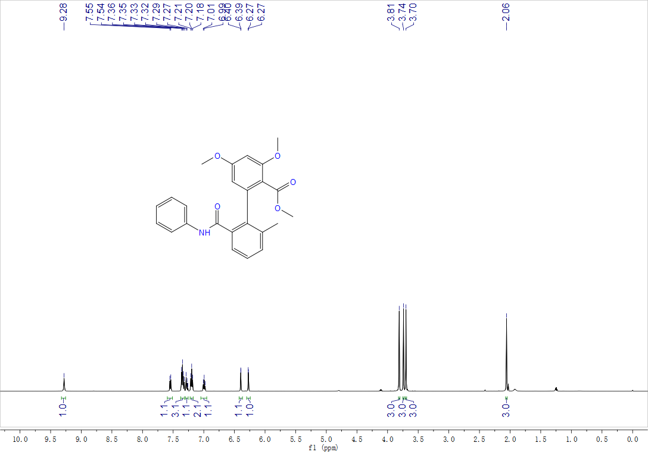

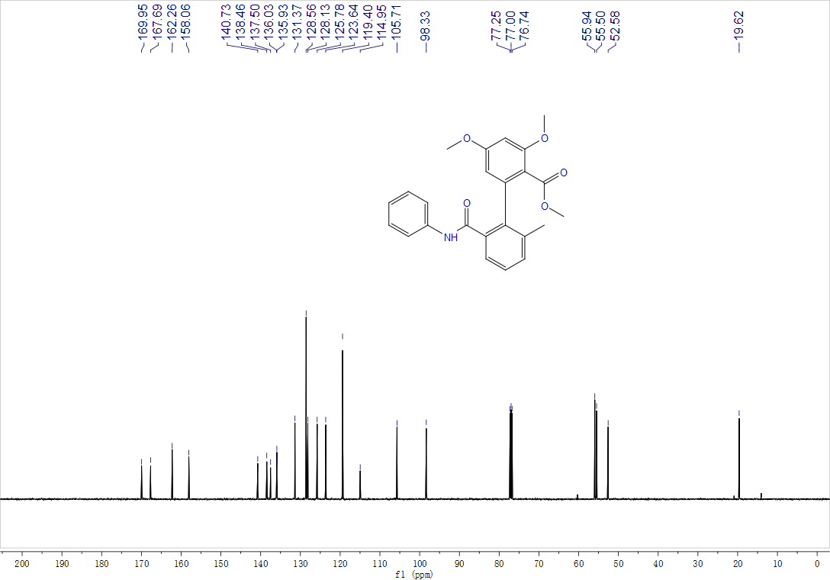
Methyl-5-chloro-3-methoxy-2'-methyl-6'-(phenylcarbamoyl)-[1,1'-biphenyl]-2-carboxylate, 3at, ¹H NMR (500 MHz, CDCl₃) and ¹³C NMR (125 MHz, CDCl₃)

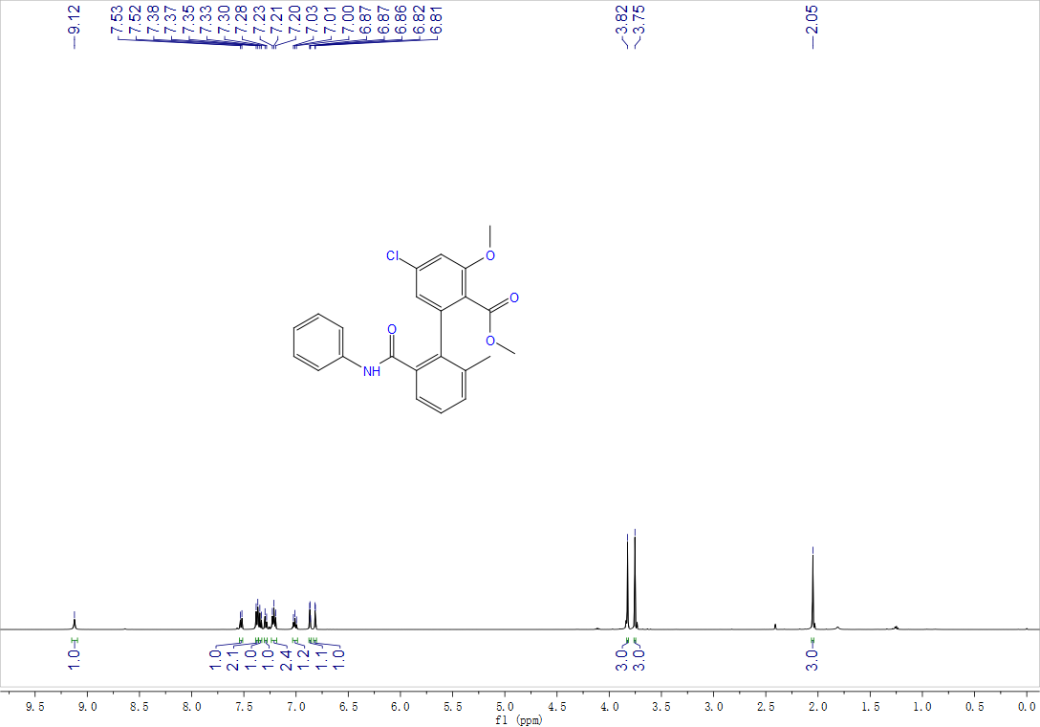

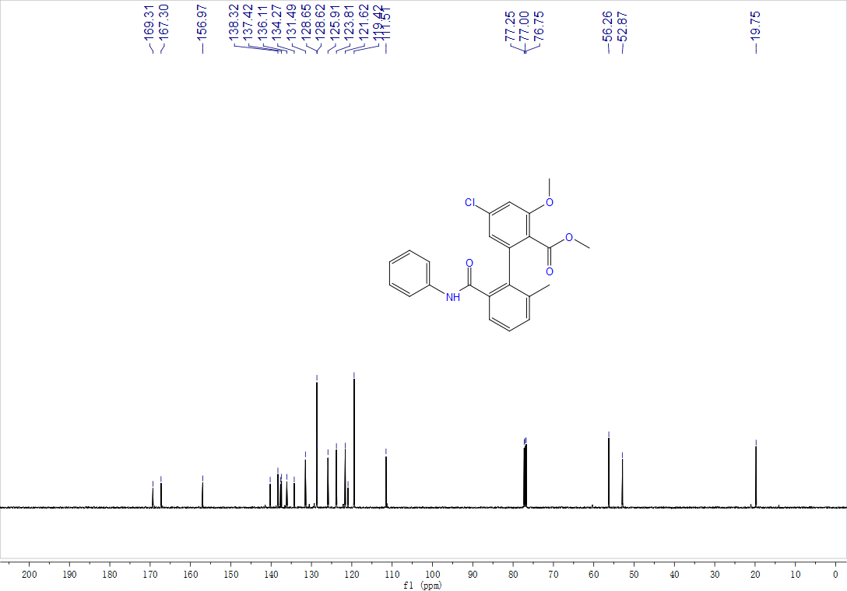
Methyl-5-fluoro-3-methoxy-2'-methyl-6'-(phenylcarbamoyl)-[1,1'-biphenyl]-2-carboxylate, 3au, ¹H NMR (500 MHz, CDCl₃) and ¹³C NMR (125 MHz, CDCl₃)

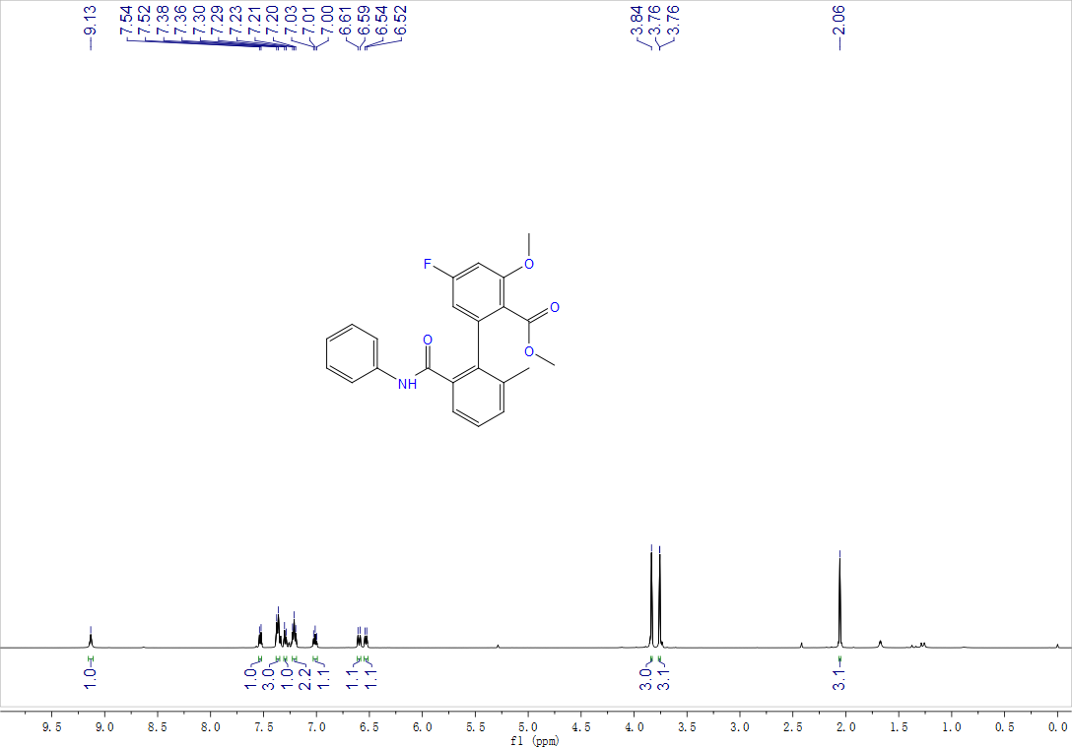

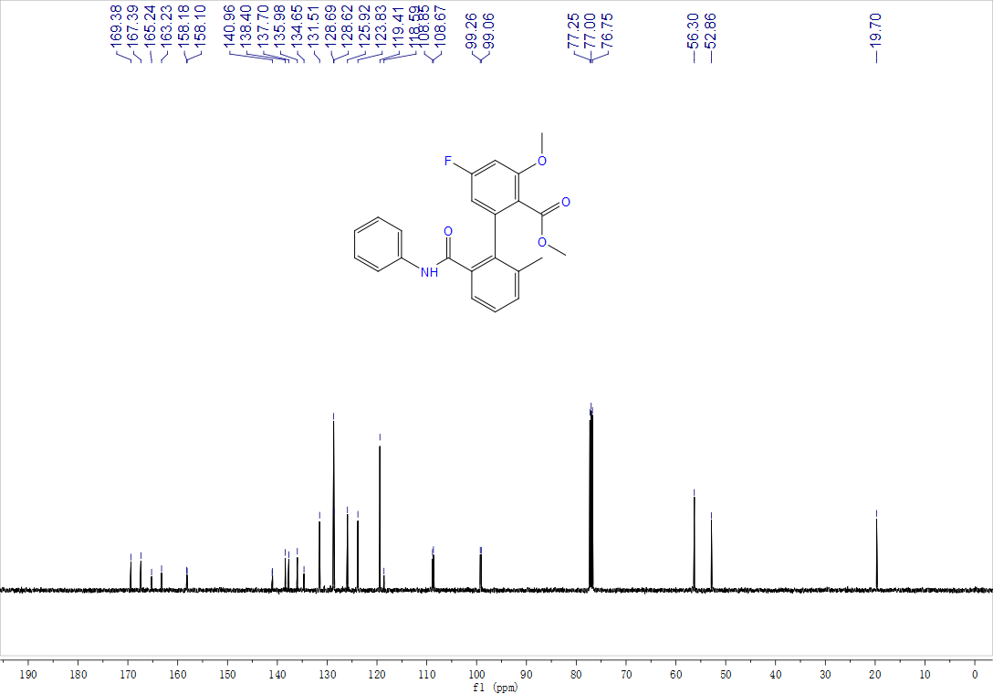

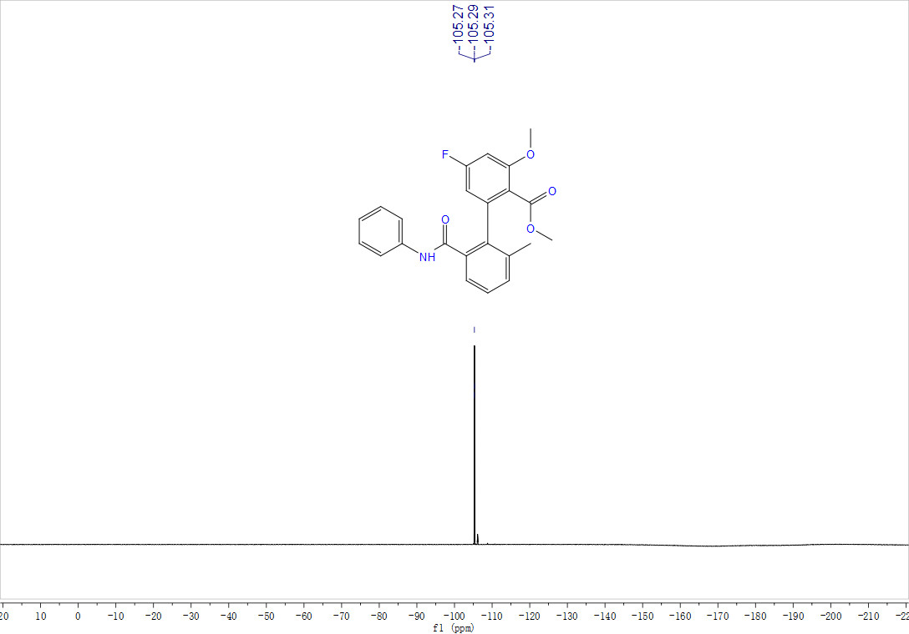

Methyl-4-(2-(butylcarbamoyl)naphthalen-1-yl)-2-methoxynicotinate, 3av, ¹H NMR (500 MHz, CDCl₃) and ¹³C NMR (125 MHz, CDCl₃)

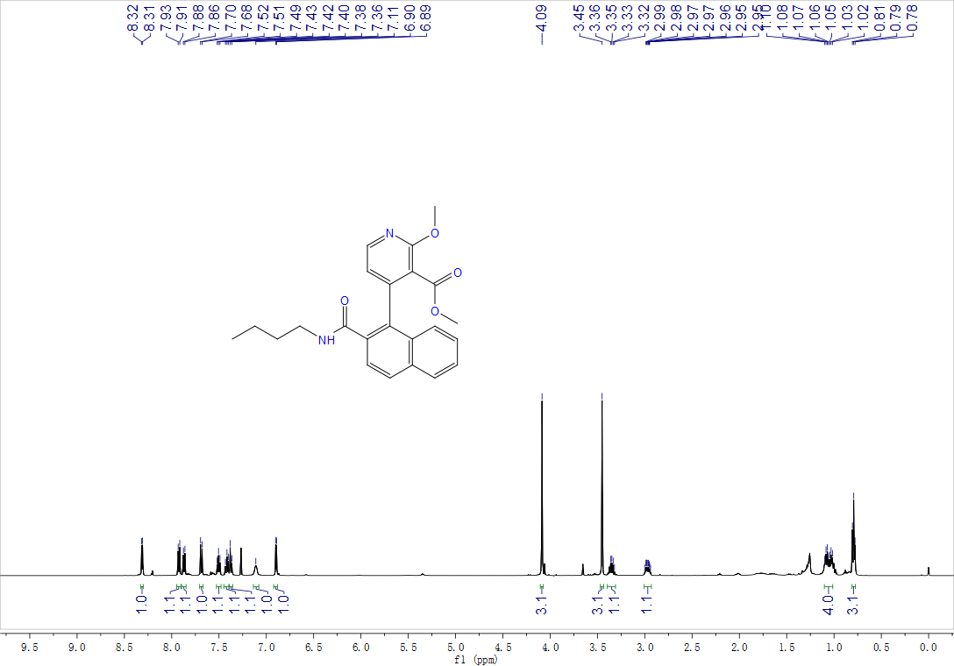

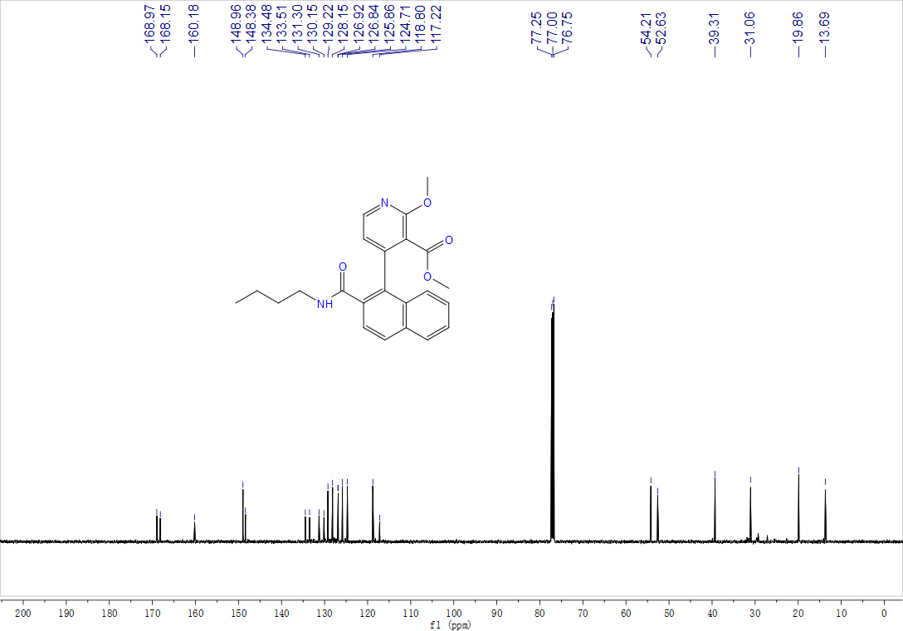

Methyl-4-(2-(butylcarbamoyl)-6-methylphenyl)-2-methoxynicotinate, 3aw, ¹H NMR (500 MHz, CDCl₃) and ¹³C NMR (125 MHz, CDCl₃)

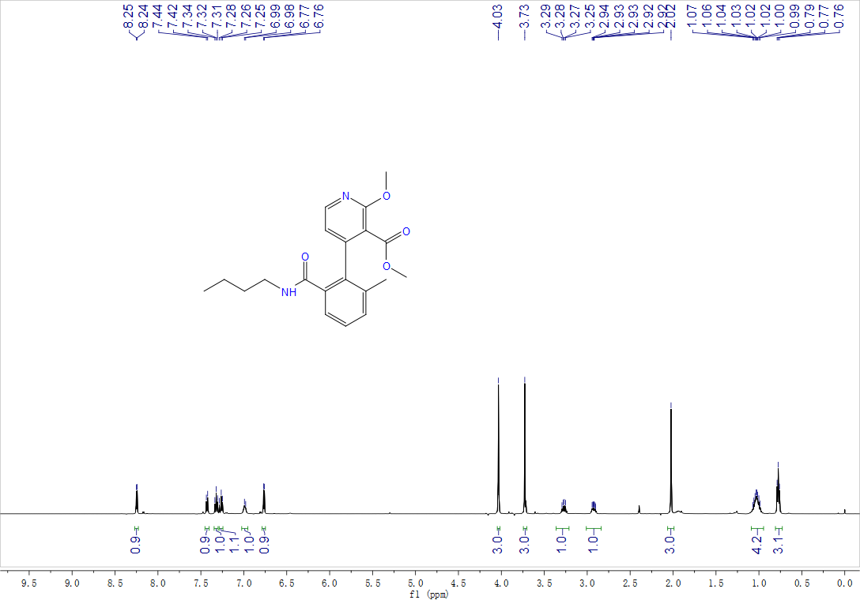

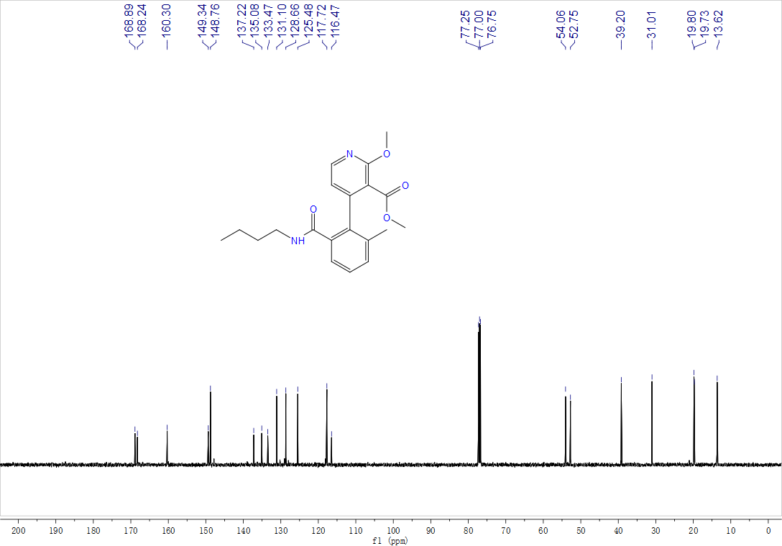

Methyl-3-(2-(butylcarbamoyl)-6-methylphenyl)thiophene-2-carboxylate, 3ax, ¹H NMR (500 MHz, CDCl₃) and ¹³C NMR (125 MHz, CDCl₃)
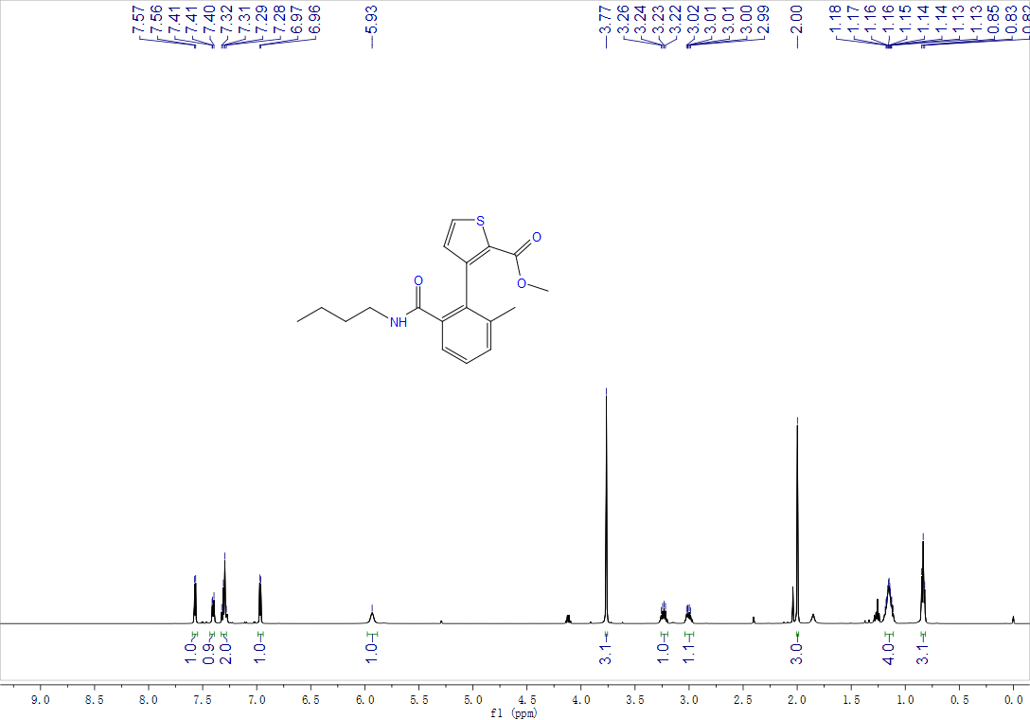

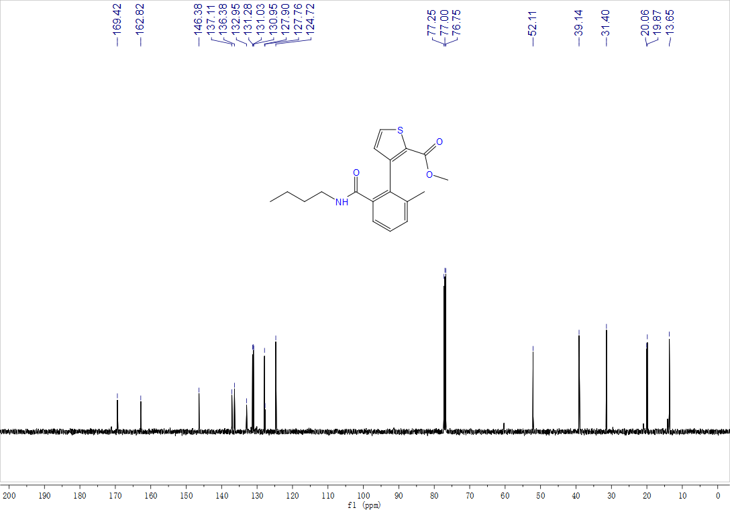

Methyl-3-(2-(butylcarbamoyl)-6-methylphenyl)benzofuran-2-carboxylate, 3ay, ¹H NMR (500 MHz, CDCl₃) and ¹³C NMR (125 MHz, CDCl₃)

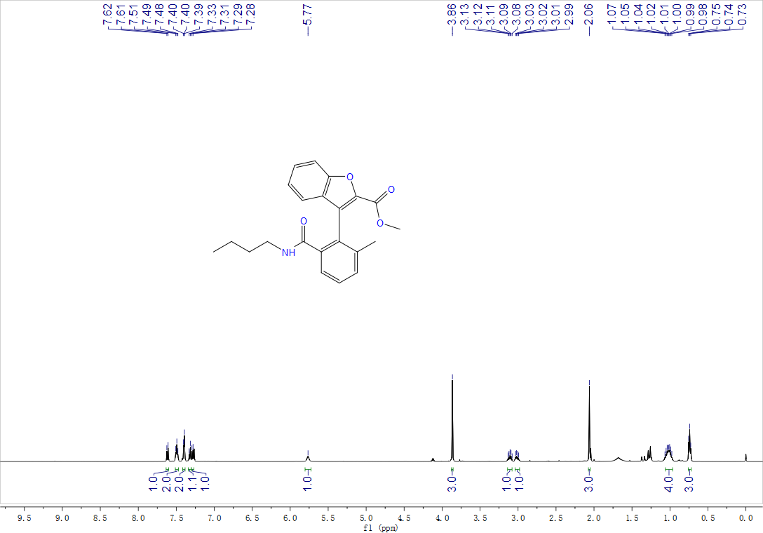

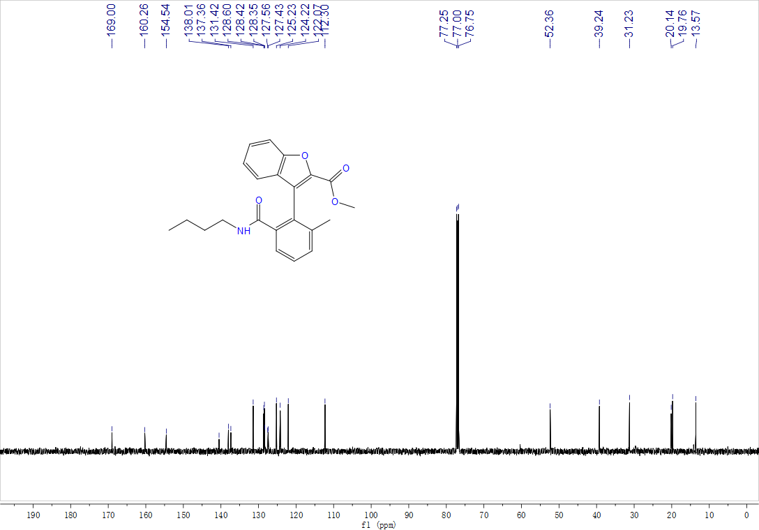

Methyl-2'-(benzylcarbamoyl)-6'-methyl-[1,1'-biphenyl]-2-carboxylate, 3bb, ¹H NMR (500 MHz, CDCl₃) and ¹³C NMR (125 MHz, CDCl₃)

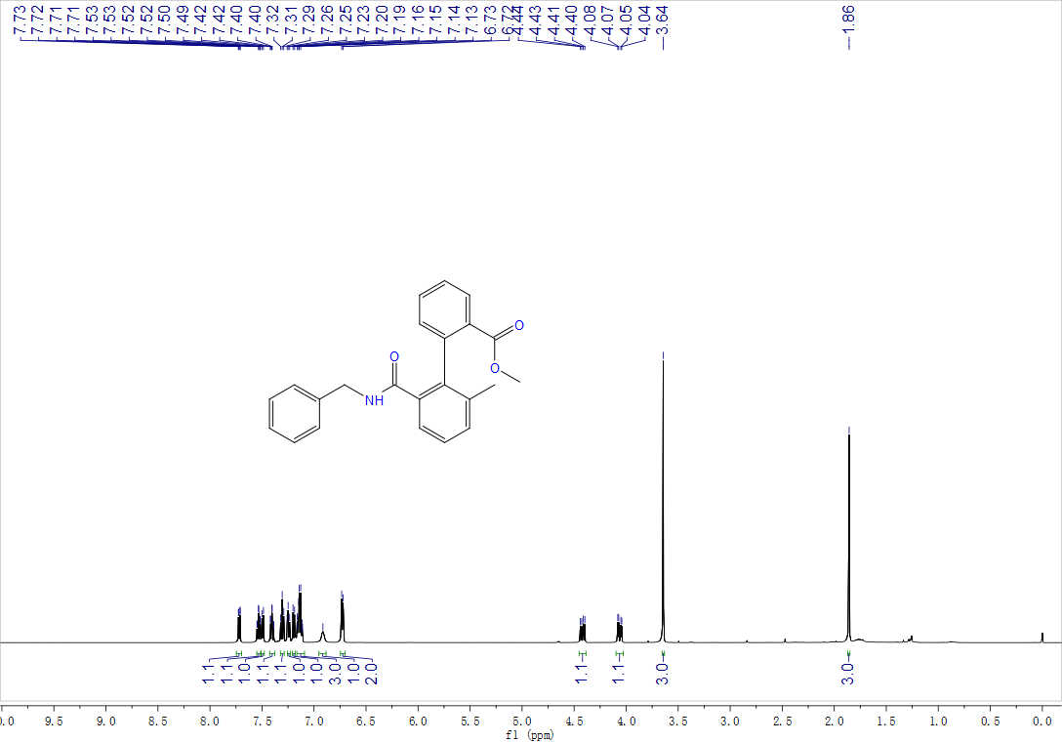

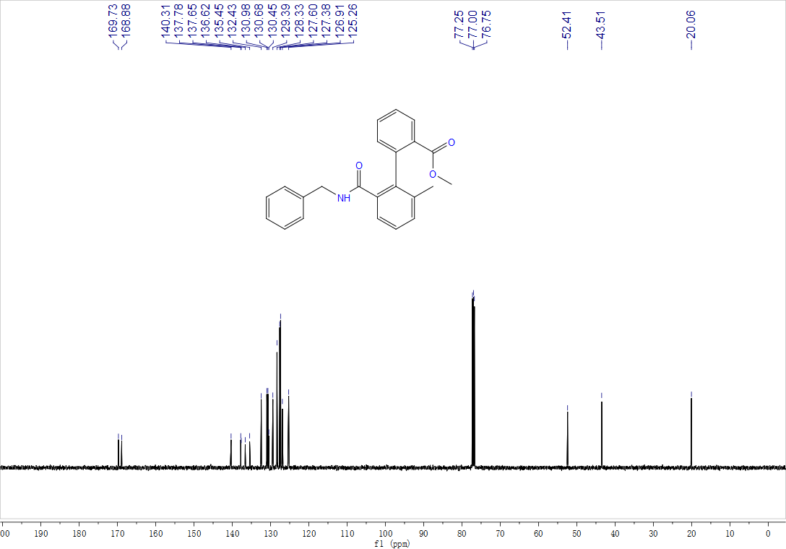

Methyl-2'-(butylcarbamoyl)-6'-methyl-[1,1'-biphenyl]-2-carboxylate, 3bc, ¹H NMR (500 MHz, CDCl₃) and ¹³C NMR (125 MHz, CDCl₃)

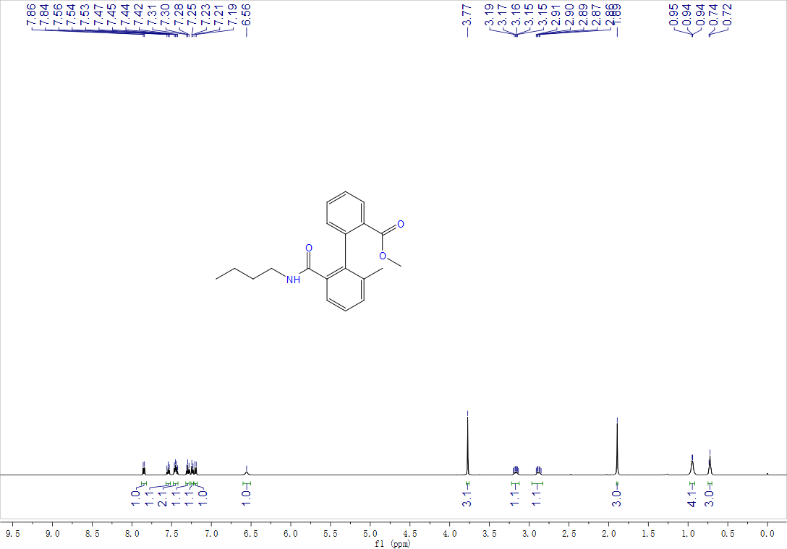

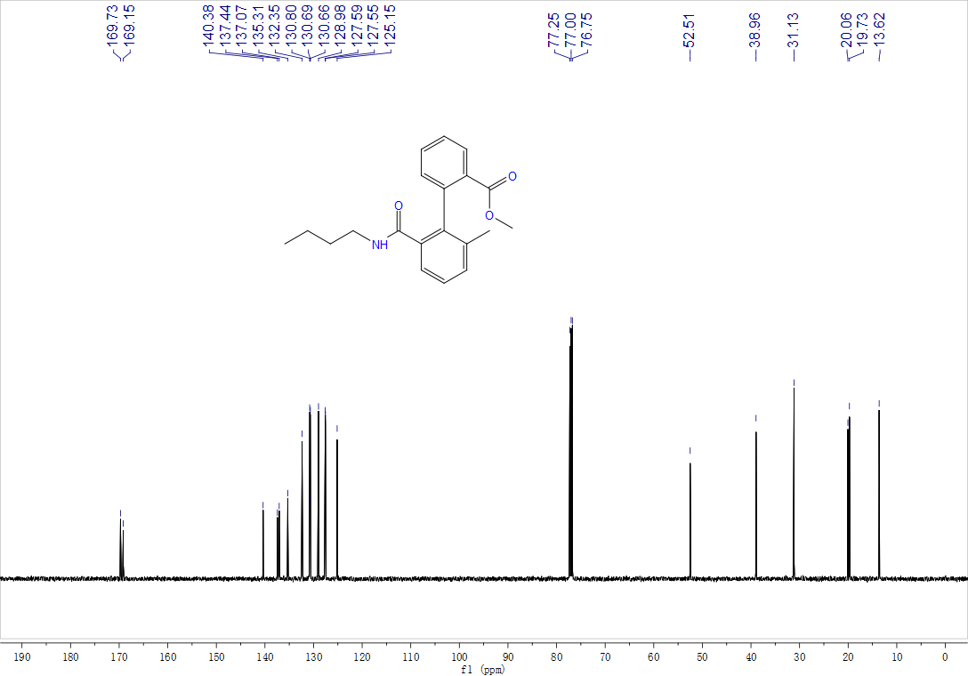
Int A, ¹H NMR (400 MHz, CDCl₃) and ¹³C NMR (100 MHz, CDCl₃)
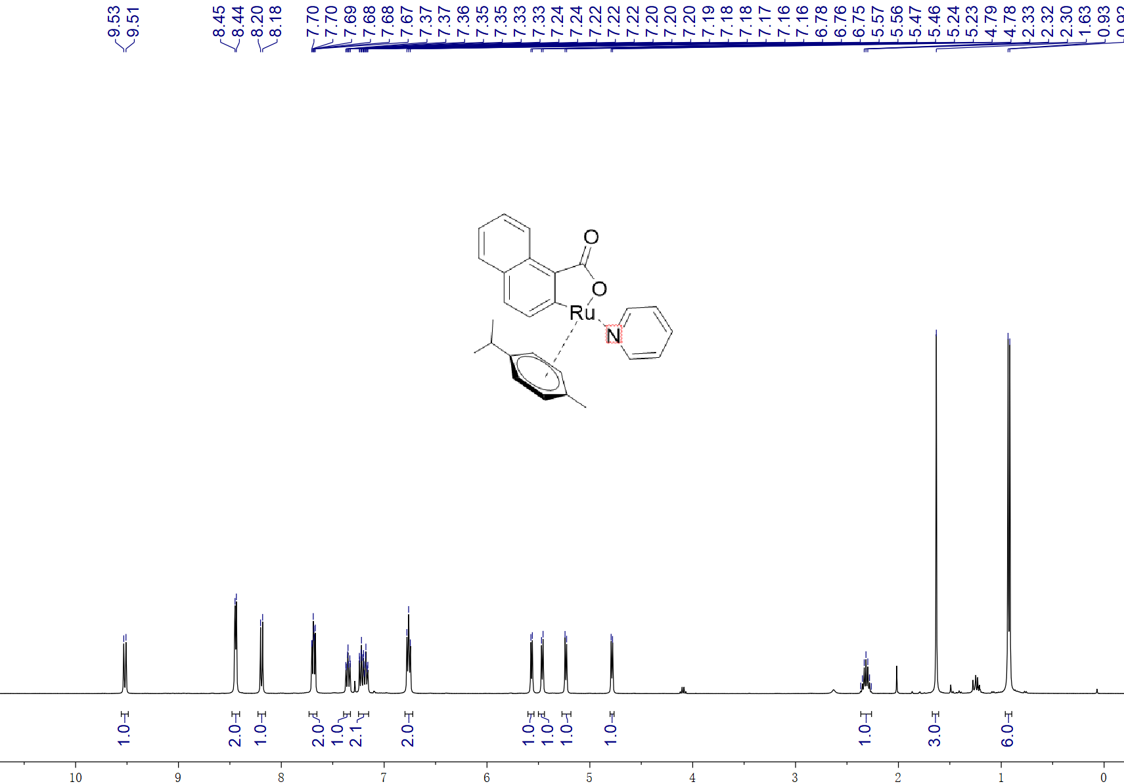

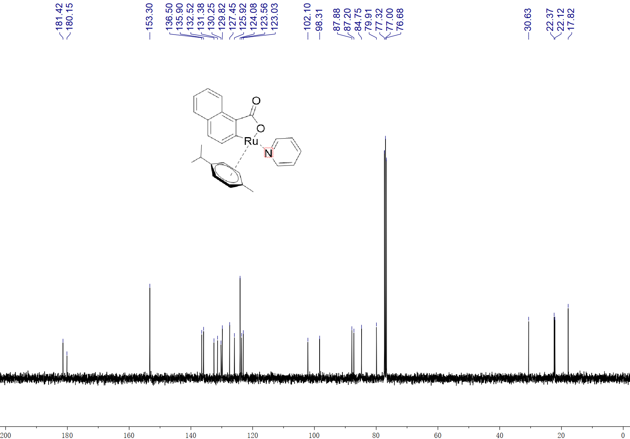

Ru-1, ¹H NMR (500 MHz, CDCl₃) and ¹³C NMR (125 MHz, CDCl₃)

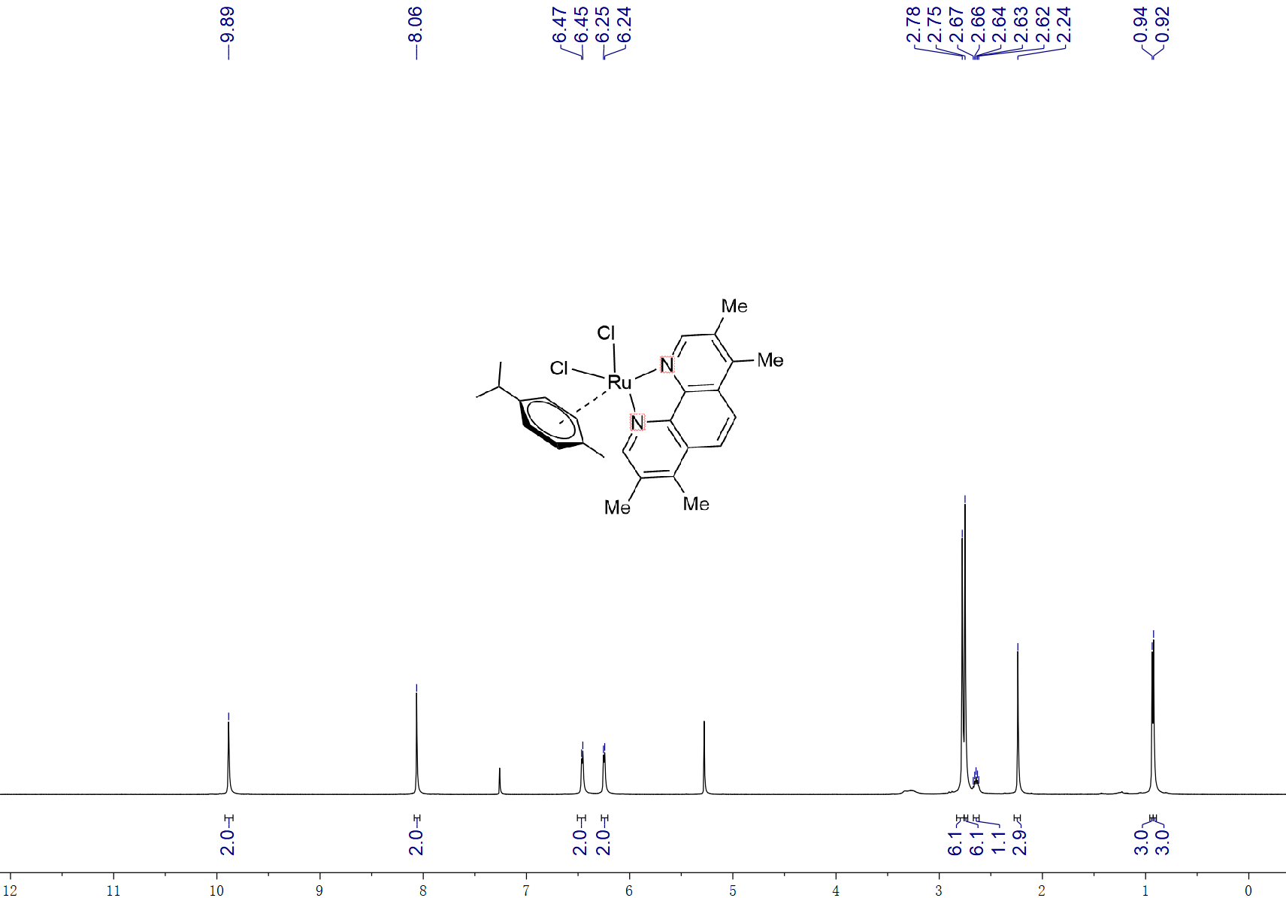

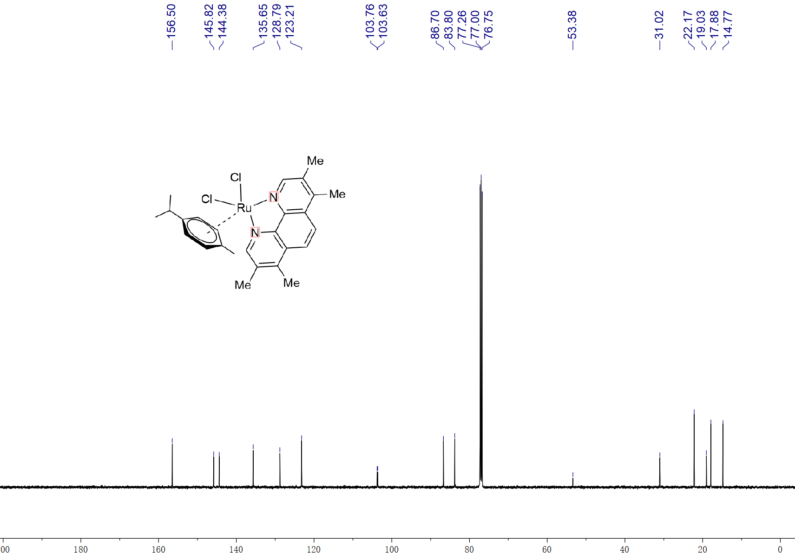

Ru-2, ¹H NMR (500 MHz, d⁶-DMSO) and ¹³C NMR (125 MHz, d⁶-DMSO)

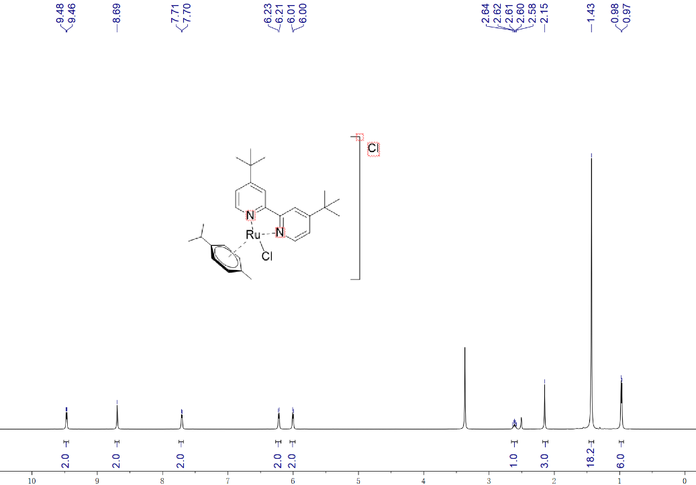

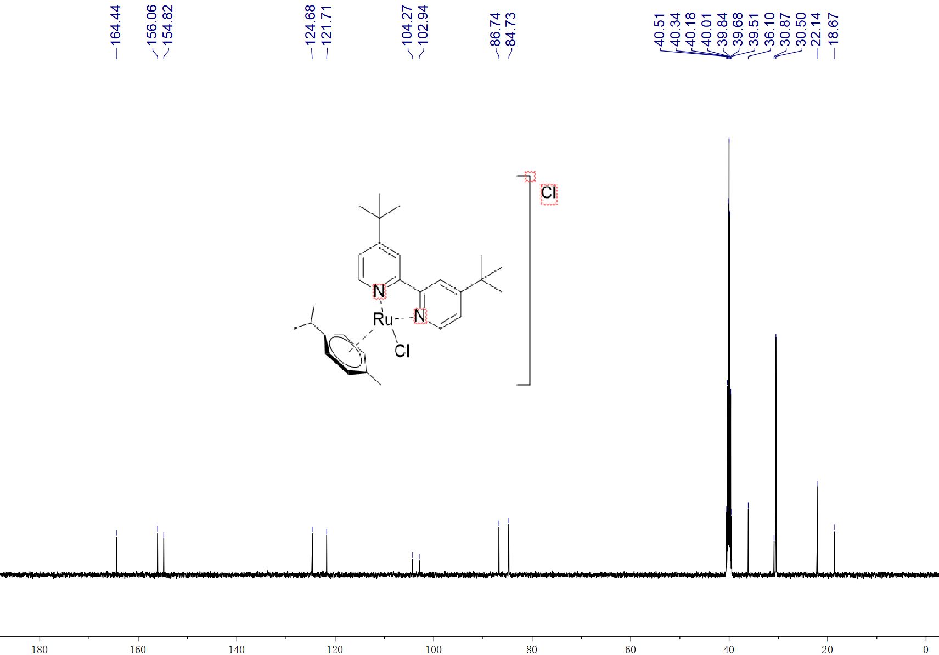

10. Details of DFT Calculations

10.1. Details of DFT calculations
Details of DFT calculations: All structures were fully optimized at PBE0^{[18]}/BSI level using Gaussian 09 program^{[19]}, with Grimme’s D3 empirical dispersion correction^{[20]}. BSI denotes combination of the SDD^{[21]} basis set for Ru and I, and the 6-31G(d,p)^{[22-25]} basis sets for the other atoms. The solution model based on the density (SMD) continuum solvation model^{[26]} using NMP as the solvent (ε=32.55) was employed in calculations. Additionally, single point energies were calculated with ORCA^{[27-28]} package with the ωB97M-V^{[29]}method and def2-TZVPP^{[30]} basis set, using optimized geometries under PBE0/BSI level. All transition states were further conﬁrmed by vibrational analysis and characterized by the only one imaginary frequency. Intrinsic reaction coordinates^{[31]} (IRC) calculations were carried out in order to conﬁrm intermediates along the reaction pathways. All energies discussed in the following parts are Gibbs free energies calculated at 298.15 K and compared to A1 unless otherwise stated. A correction factor of 1.89 kcal/mol was applied for the standard state change from 1 atm to 1 M^{[32]}. Total energies and Cartesian coordinates of all optimized structures are given in Supporting Information (SI).

10.2. The second C-H activation catalyzed by Ru-complex A1
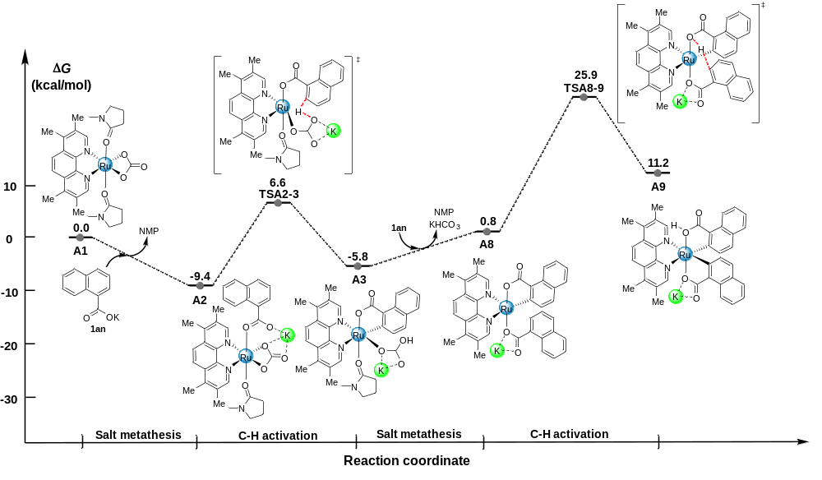Figure S4. The Gibbs free energy profiles of second C-H activation catalyzed by Ru-complex A1 (unit: kcal/mol).

10.3. The oxidative addition assisted by two molecules of aromatic acids
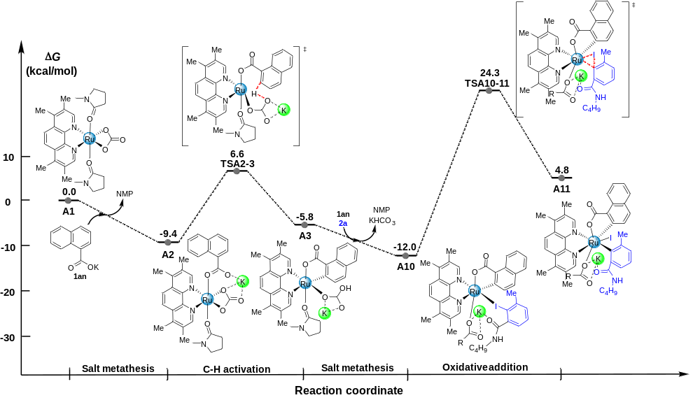
Figure S5. The Gibbs free energy profiles of oxidative addition assisted by two molecules of aromatic acids (unit: kcal/mol).

10.4. The Carboxylate-assisted C−H Arylation with 2,6-disubstituted Aryl Halides Catalyzed by Ru-complex B1
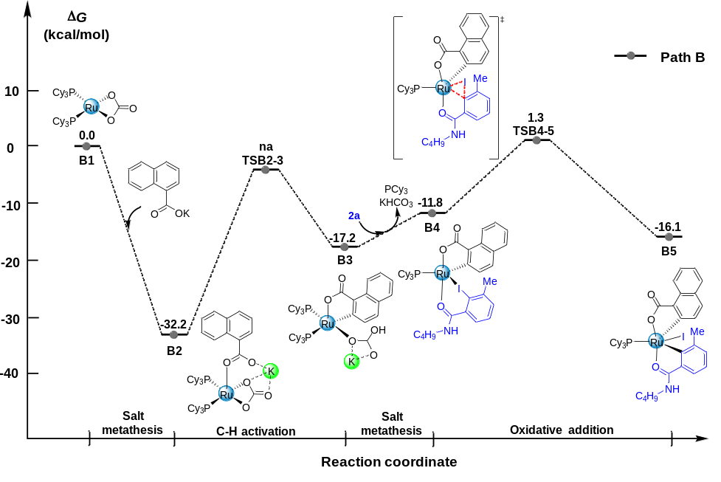
Figure S6. The Gibbs free energy profiles of the carboxylate-assisted C−H arylation with 2,6-disubstituted aryl halides catalyzed by Ru-complex B1 (unit: kcal/mol).

10.5. Energies of all the structures
Table S18. The calculated absolute electronic energies (E, in a.u.), thermal free energies (G, in a.u.), and relative Gibbs energies (ΔG, in kcal/mol) (Calculated at 298.15 K and 1 atm).
Complex | E | G | ΔG
A1 | -1739.6072453 | -1739.0872653 | 0.0
A2 | -2587.5601003 | -2587.0336363 | -9.4
TSA2-3 | -2587.5294558 | -2587.0081768 | 6.6
A3 | -2587.5505205 | -2587.0278335 | -5.8
A4 | -2291.7185672 | -2291.1067952 | 0.6
TSA4-5 | -2291.6909003 | -2291.0771553 | 19.2
A5 | -2291.7323822 | -2291.1178812 | -6.4
A6 | -2857.8737626 | -2857.2476086 | -20.4
TSA6-7 | -2857.8620116 | -2857.2319526 | -10.6
A7 | -2857.8942171 | -2857.2651971 | -31.4
1an | -1173.8834647 | -1173.7702457 | /
2a | -894.5975781 | -894.3852201 | /
KHCO₃ | -864.4579112 | -864.4602472 | /
K₂CO₃ | -1463.8181829 | -1463.8352669 | /
KI | -897.7022176 | -897.7278936 | /
3bd | -1770.2091196 | -1769.8652836 | /
NMP | -325.9479137 | -325.8388947 | /
A8 | -2570.9959365 | -2570.4914515 | 0.8
TSA8-9 | -2570.9537846 | -2570.4514376 | 25.9
A9 | -2570.9804712 | -2570.4749682 | 11.2
A10 | -3465.6444276 | -3464.8940026 | -12.0
TSA10-11 | -1245.4862557 | -1245.1875777 | 24.3
A11 | -3465.5872509 | -3464.8361609 | 4.8
PCy₃ | -1047.0675049 | -1046.6287989 | /
B1 | -2452.9239560 | -2452.0065350 | 0.0
B2 | -3626.8867109 | -3625.8250199 | -32.2
B3 | -3626.8605878 | -3625.8011558 | -17.2
B4 | -2609.9024724 | -2609.0917334 | -11.8
TSB4-5 | -2609.8840390 | -2609.0708550 | 1.3
B5 | -2609.9108724 | -2609.0986744 | -16.1

10.6. Imaginary frequencies of transition states
Table S19. Calculated imaginary frequencies of transition states at PBE0/BSI level.
TSA2-3 | 1132.14i
TSA4-5 | 210.02i
TSA6-7 | 76.69i
TSA8-9 | 1200.22i
TSA10-11 | 195.11i
TSB5-6 | 147.44i

10.7. Cartesian coordinates of all the structures
Table S20. Atomic cartesian coordinates of intermediates and transition states (presented in Å).
----------------------------------------------------------------------

1an
----------------------------------------------------------------------
Coordinates (Angstroms)
X Y Z
----------------------------------------------------------------------
C 1.572130 2.613454 -0.046373
C 2.637224 1.748115 -0.030560
C 2.426321 0.347178 -0.000823
C 1.091385 -0.173300 -0.011336
C -0.002232 0.751998 -0.044014
C 0.257214 2.108133 -0.041054
H 4.532309 -0.132330 0.049542
H 1.736010 3.687515 -0.062757
H 3.658209 2.122490 -0.033399
C 3.526910 -0.546839 0.047003
C 0.928678 -1.583529 0.052258
C 2.016890 -2.421853 0.105369
C 3.330592 -1.904418 0.096362
H -0.076526 -1.986818 0.053276
H 1.864226 -3.496952 0.155537
H 4.179731 -2.581516 0.134796
C -1.454369 0.329464 -0.099789
O -2.299759 1.124778 0.398789
O -1.748927 -0.766362 -0.655958
H -0.583673 2.795512 -0.045151
K -4.258172 -0.572929 0.086487
----------------------------------------------------------------------

2a
----------------------------------------------------------------------
Coordinates (Angstroms)
X Y Z
----------------------------------------------------------------------
C 1.060706 3.301918 0.010035
C -0.003199 2.409480 -0.002287
C 0.233303 1.031900 0.028253
C 1.552065 0.572476 0.053679
C 2.644210 1.448539 0.053207
C 2.363117 2.821220 0.039572
H 0.874337 4.371843 -0.002778
H -1.027681 2.771250 -0.016702
H 3.195702 3.519989 0.047472
C -0.959945 0.124563 0.102297
O -1.157027 -0.613109 1.073578
N -1.800783 0.203892 -0.939763
H -1.596720 0.863843 -1.677129
C 4.067368 0.982282 0.059974
H 4.276454 0.350604 0.930381
H 4.295525 0.386719 -0.831198
H 4.751471 1.834229 0.083534
C -3.075915 -0.489168 -0.945891
H -2.911457 -1.503635 -0.566478
H -3.398610 -0.575247 -1.987540
C -4.136133 0.217641 -0.109953
H -3.772456 0.299006 0.922600
H -4.264456 1.241928 -0.484624
C -5.473080 -0.512117 -0.131845
H -5.331122 -1.540874 0.226258
H -5.825053 -0.594786 -1.169226
C -6.532464 0.180167 0.713825
H -7.485557 -0.359087 0.682628
H -6.221688 0.244085 1.763355
H -6.717077 1.201902 0.361266
I 1.935470 -1.539010 0.009107
----------------------------------------------------------------------

3bd
----------------------------------------------------------------------
Coordinates (Angstroms)
X Y Z
----------------------------------------------------------------------
C -0.990600 -0.939816 -2.059153
C -1.717511 -2.103944 -2.022893
C -2.505228 -2.426781 -0.890875
C -2.527751 -1.528129 0.219738
C -1.752715 -0.338195 0.162835
C -1.005752 -0.042727 -0.964063
H -3.247616 -4.300691 -1.673709
H -0.392903 -0.692960 -2.932859
H -1.699047 -2.791335 -2.864962
C -3.271138 -3.618733 -0.826813
C -3.321323 -1.856341 1.350011
C -4.053770 -3.018159 1.379441
C -4.027811 -3.909341 0.282169
H -3.351520 -1.171054 2.193318
H -4.658728 -3.255473 2.250451
H -4.610031 -4.826172 0.320145
C -1.707898 0.616699 1.336179
O -0.686174 0.572473 2.070546
O -2.660300 1.434081 1.462024
C 1.140287 3.678120 -1.034202
C 1.824469 2.494990 -0.772049
C 1.138827 1.276420 -0.774801
C -0.242382 1.236597 -1.030123
C -0.925579 2.427944 -1.351580
C -0.219222 3.637662 -1.338358
H 1.667721 4.627882 -1.017464
H 2.886755 2.517416 -0.544888
H -0.745796 4.558774 -1.577954
C -2.385263 2.408179 -1.702796
H -2.729246 3.406557 -1.985585
H -2.579993 1.728587 -2.539668
H -2.985497 2.060461 -0.855772
C 1.888704 0.014524 -0.465759
O 1.498623 -0.799353 0.378534
N 3.011571 -0.168934 -1.181865
H 3.284463 0.533456 -1.853889
C 3.878375 -1.310824 -0.962281
H 4.460025 -1.462322 -1.876367
H 3.243801 -2.193484 -0.825599
C 4.799766 -1.147366 0.240355
H 5.431684 -0.261064 0.096039
H 4.185073 -0.959998 1.130146
C 5.669386 -2.378471 0.464921
H 6.285069 -2.557960 -0.427128
H 5.023216 -3.260247 0.572592
C 6.566335 -2.254273 1.687851
H 7.174197 -3.154370 1.831035
H 7.252130 -1.403673 1.596131
H 5.975838 -2.105531 2.599666
K -0.720054 3.209469 2.094948
----------------------------------------------------------------------

A1
----------------------------------------------------------------------
Coordinates (Angstroms)
X Y Z
----------------------------------------------------------------------
Ru -0.232156 -1.089413 -0.356762
C -0.966567 -3.439326 -0.981678
O -0.397123 -2.600183 -1.825603
O -1.118205 -2.923640 0.220425
C -0.487577 0.907318 3.508764
C -0.146954 2.225892 3.196154
C 0.205439 2.514116 1.852468
C 0.171373 1.470988 0.912692
C -0.494415 -0.061601 2.491125
C 0.612702 3.805225 1.377665
C 0.563315 1.683394 -0.435643
C 0.977992 2.948227 -0.883279
C 0.975318 4.012476 0.078634
C 1.382175 3.087286 -2.236081
C 1.353355 1.947170 -3.043178
C 0.928973 0.725571 -2.492622
H 0.639514 4.636941 2.074058
H -0.769780 -1.088852 2.713984
H 1.281374 5.005811 -0.233483
H 0.901053 -0.173483 -3.103081
N -0.193029 0.195060 1.219762
N 0.545853 0.576962 -1.227565
C -0.861817 0.479193 4.897174
H -0.049377 0.664719 5.608028
H -1.742859 1.020200 5.259752
H -1.091900 -0.589027 4.923445
C -0.126226 3.309975 4.226954
H 0.893641 3.682199 4.381950
H -0.734896 4.165059 3.912816
H -0.504472 2.966350 5.190151
C 1.761755 1.969754 -4.486295
H 1.130521 2.646970 -5.072246
H 2.797895 2.304135 -4.606660
H 1.679090 0.972755 -4.927176
C 1.827434 4.419564 -2.751418
H 1.045670 5.175103 -2.613237
H 2.714134 4.771353 -2.211197
H 2.075089 4.386938 -3.812784
O -1.321906 -4.590338 -1.290873
O 1.508004 -2.076640 0.262690
C 2.702683 -1.717681 0.375871
C 3.299834 -0.374401 0.069240
N 3.664541 -2.551866 0.777808
C 4.704088 -0.461190 0.669275
H 2.694410 0.433473 0.481294
H 3.311250 -0.260137 -1.022325
C 4.995237 -1.961947 0.706450
C 3.474757 -3.965475 0.988877
H 4.694652 -0.062528 1.688271
H 5.450988 0.088708 0.094076
H 5.590581 -2.266374 1.571961
H 5.506662 -2.312355 -0.199961
H 3.906764 -4.540440 0.161284
H 3.961269 -4.271205 1.919727
H 2.406995 -4.180121 1.053180
O -2.042933 -0.331118 -1.099947
C -3.164983 -0.305931 -0.538707
C -3.507033 -0.715741 0.865055
N -4.258950 0.150344 -1.149934
C -5.036048 -0.757304 0.856521
H -3.119882 0.058927 1.538443
H -3.024889 -1.660544 1.122074
C -5.418440 0.206154 -0.267643
C -4.264765 0.761503 -2.454910
H -5.478445 -0.470977 1.812293
H -5.377809 -1.766549 0.607272
H -5.559149 1.234760 0.091146
H -6.319745 -0.093384 -0.809407
H -5.046647 0.314851 -3.076327
H -4.453234 1.838328 -2.373103
H -3.294824 0.605166 -2.929513
----------------------------------------------------------------------

A10
----------------------------------------------------------------------
Coordinates (Angstroms)
X Y Z
----------------------------------------------------------------------
Ru -0.187204 0.242895 -0.936061
C -1.948090 1.157151 1.418622
C -3.088725 1.710963 1.938996
C -4.049633 2.333309 1.098301
C -3.786435 2.438814 -0.306057
C -2.566579 1.877318 -0.806083
C -1.669094 1.183021 0.021207
H -5.440349 2.719038 2.700583
H -1.256018 0.650098 2.085513
H -3.293961 1.659995 3.007930
C -5.267860 2.817050 1.630541
C -4.785973 3.049418 -1.111412
C -5.968188 3.499235 -0.564896
C -6.220857 3.385624 0.817691
H -4.601243 3.144398 -2.174374
H -6.717616 3.949888 -1.211632
H -7.158513 3.745319 1.233079
C -2.150224 1.916571 -2.231826
O -1.028053 1.304045 -2.495550
O -2.787893 2.483914 -3.142145
C 2.938678 -2.272354 -3.004882
C 4.078867 -1.489188 -2.822015
C 3.917595 -0.214363 -2.220053
C 2.632227 0.176911 -1.798193
C 1.699667 -1.771555 -2.568015
C 4.995739 0.704287 -2.006999
C 2.423934 1.444332 -1.176575
C 3.484494 2.356373 -1.029873
C 4.786387 1.930263 -1.451890
C 3.224281 3.632769 -0.468625
C 1.908368 3.925008 -0.113411
C 0.926298 2.934132 -0.256278
H 5.999348 0.419491 -2.304584
H 0.797023 -2.355333 -2.739275
H 5.626131 2.604670 -1.322777
H -0.091852 3.129515 0.060934
N 1.531073 -0.598118 -1.969903
N 1.159443 1.715468 -0.743904
C 2.975314 -3.626840 -3.649144
H 3.392402 -3.580434 -4.660978
H 3.589258 -4.330298 -3.075663
H 1.967772 -4.045428 -3.724874
C 5.437915 -1.950987 -3.242993
H 5.843257 -1.309936 -4.034789
H 6.141610 -1.906544 -2.404226
H 5.425009 -2.975521 -3.615569
C 1.500547 5.245666 0.468889
H 1.999337 5.433653 1.426624
H 1.753765 6.076706 -0.198054
H 0.421866 5.274396 0.645058
C 4.338805 4.610628 -0.271816
H 5.175291 4.149903 0.264671
H 4.728618 4.963905 -1.234418
H 4.017933 5.484168 0.296591
C 2.691698 2.109464 2.715779
C 4.059575 2.039711 2.630372
C 4.688757 0.911061 2.046620
C 3.891920 -0.182223 1.581751
C 2.468730 -0.082831 1.688640
C 1.898864 1.052034 2.224503
H 6.689799 1.694863 2.262375
H 2.210286 2.978391 3.155696
H 4.680790 2.851462 3.001093
C 6.098915 0.853285 1.908104
C 4.553221 -1.289104 0.988443
C 5.923393 -1.315974 0.871797
C 6.706863 -0.236716 1.335492
H 3.961088 -2.120367 0.623670
H 6.407885 -2.175085 0.415191
H 7.788201 -0.269822 1.233160
C 1.570415 -1.229579 1.324178
O 0.484755 -1.020993 0.687472
O 1.897565 -2.374271 1.725157
H 0.818044 1.126680 2.277994
K 0.315690 -3.797112 0.195794
C -6.003960 -0.896895 1.263876
C -4.885922 -1.502759 1.819608
C -3.765280 -1.790241 1.030994
C -3.799844 -1.451910 -0.326210
C -4.915220 -0.840764 -0.914314
C -6.012583 -0.573517 -0.085186
H -6.868798 -0.678074 1.883182
H -4.876724 -1.771719 2.871984
H -6.883977 -0.092817 -0.521412
C -2.600267 -2.458485 1.699100
O -2.059448 -3.472123 1.227049
N -2.218927 -1.907579 2.855686
H -2.660006 -1.042673 3.137921
C -4.984305 -0.449324 -2.359220
H -4.242222 0.316354 -2.606766
H -4.801012 -1.305719 -3.017021
H -5.971934 -0.045062 -2.593559
C -1.098549 -2.393744 3.639346
H -0.380384 -2.854933 2.957456
H -1.439104 -3.175548 4.331821
C -0.427679 -1.262459 4.398123
H -0.140742 -0.480076 3.685568
H -1.144543 -0.811079 5.098253
C 0.811249 -1.732039 5.150935
H 1.515728 -2.173021 4.433677
H 0.534858 -2.532434 5.850763
C 1.497382 -0.603479 5.906608
H 2.385852 -0.962298 6.437326
H 1.819701 0.191173 5.223195
H 0.827090 -0.153067 6.648189
I -2.084445 -1.770838 -1.591457
----------------------------------------------------------------------

A11
----------------------------------------------------------------------
Coordinates (Angstroms)
X Y Z
----------------------------------------------------------------------
Ru 0.345453 0.463443 -0.775470
C 3.543897 0.540784 -0.389662
C 4.808877 0.168830 -0.769329
C 5.056640 -0.435243 -2.023614
C 3.964411 -0.608124 -2.924749
C 2.658960 -0.198247 -2.493730
C 2.417295 0.326379 -1.226341
H 7.174766 -0.697980 -1.695116
H 3.439568 1.053789 0.557443
H 5.646234 0.349236 -0.098690
C 6.358775 -0.846289 -2.398423
C 4.230177 -1.204446 -4.184684
C 5.505438 -1.601622 -4.518285
C 6.582708 -1.422142 -3.625169
H 3.411768 -1.346592 -4.879499
H 5.684466 -2.062342 -5.486504
H 7.582169 -1.739422 -3.909799
C 1.470868 -0.251723 -3.359692
O 0.383313 0.146784 -2.746324
O 1.428615 -0.576145 -4.547622
C -3.765847 -0.431825 -2.158858
C -3.773503 -1.828122 -2.154692
C -2.624550 -2.509645 -1.670659
C -1.536830 -1.740766 -1.231376
C -2.623365 0.240050 -1.688660
C -2.505291 -3.932069 -1.569804
C -0.355252 -2.339845 -0.716967
C -0.268081 -3.737057 -0.598554
C -1.384764 -4.511992 -1.054798
C 0.893511 -4.305017 -0.013691
C 1.881637 -3.434269 0.438832
C 1.711071 -2.054279 0.256586
H -3.327283 -4.558604 -1.898082
H -2.578993 1.326848 -1.682252
H -1.336188 -5.592550 -0.975333
H 2.494843 -1.384456 0.575071
N -1.555542 -0.395892 -1.242128
N 0.647641 -1.504274 -0.316117
C -4.931875 0.384938 -2.626485
H -5.820847 0.191621 -2.015714
H -5.190910 0.156229 -3.665451
H -4.706540 1.452596 -2.561774
C -4.952969 -2.613772 -2.626685
H -5.277443 -3.322254 -1.857133
H -4.695049 -3.199702 -3.516818
H -5.799455 -1.974756 -2.877340
C 3.136650 -3.901839 1.112612
H 3.729707 -4.543433 0.452066
H 2.914247 -4.478272 2.016872
H 3.761795 -3.052230 1.399974
C 1.014511 -5.785325 0.134241
H 0.860556 -6.289633 -0.825609
H 0.250814 -6.163626 0.824474
H 1.991160 -6.079936 0.517999
C 1.327240 2.142791 0.015975
C 1.540496 2.423209 1.382402
C 1.461783 3.203257 -0.917454
C 1.914366 3.713639 1.795483
C 1.313422 1.532982 2.577796
C 1.814800 4.479663 -0.460159
C 1.253628 3.073855 -2.406234
C 2.064594 4.741710 0.878881
H 2.073370 3.896190 2.855317
O 0.534406 1.917224 3.466545
N 2.048125 0.420838 2.723916
H 1.900609 5.280569 -1.190657
H 2.093726 2.547729 -2.875110
H 1.180410 4.065344 -2.859360
H 0.347337 2.519191 -2.659262
H 2.360178 5.734708 1.205113
H 2.771528 0.228570 2.048597
I -2.550168 4.491161 -0.972160
C -0.703512 -3.112257 2.793331
C -1.838188 -3.861017 2.605881
C -3.007028 -3.277967 2.054435
C -3.018209 -1.885923 1.725201
C -1.811042 -1.140273 1.905412
C -0.689077 -1.754513 2.416836
H -4.139673 -5.116575 2.066801
H 0.188168 -3.561124 3.221104
H -1.858172 -4.914783 2.873867
C -4.167146 -4.058128 1.819382
C -4.208249 -1.331626 1.186518
C -5.318040 -2.115164 0.975418
C -5.300198 -3.491904 1.288747
H -4.234976 -0.277145 0.937989
H -6.217591 -1.672030 0.556469
H -6.184372 -4.097986 1.110501
C -1.745511 0.329005 1.631115
O -2.670255 1.054455 2.040868
O -0.703960 0.839792 1.065115
H 0.218174 -1.173232 2.524631
C 2.100334 -0.295075 3.987691
H 2.414202 -1.322219 3.775266
H 1.086960 -0.333984 4.397834
C 3.042463 0.361498 4.989525
H 2.733561 1.406211 5.126700
H 4.058441 0.380880 4.572609
C 3.045569 -0.354041 6.334129
H 3.338939 -1.402670 6.188373
H 2.022504 -0.374401 6.733675
C 3.974938 0.302366 7.344768
H 3.961968 -0.226894 8.303765
H 5.010766 0.311438 6.985285
H 3.682619 1.341949 7.535029
K -1.377937 3.370036 2.124675
----------------------------------------------------------------------

A2
----------------------------------------------------------------------
Coordinates (Angstroms)
X Y Z
----------------------------------------------------------------------
Ru 1.087731 -0.310455 -0.641887
C -3.375768 1.468426 -1.703795
C -4.320436 0.868760 -0.908201
C -4.245858 -0.517965 -0.621224
C -3.182384 -1.295512 -1.174421
C -2.190775 -0.634933 -1.960317
C -2.298940 0.714805 -2.216385
H -6.010445 -0.550786 0.625800
H -3.441260 2.529015 -1.930227
H -5.140367 1.446393 -0.488351
C -5.208145 -1.152595 0.205259
C -3.136190 -2.684863 -0.886680
C -4.092752 -3.272457 -0.093328
C -5.135590 -2.499830 0.465018
H -2.337979 -3.283163 -1.314984
H -4.045052 -4.338646 0.111207
H -5.880861 -2.975351 1.097103
C -1.060102 -1.401766 -2.584946
O 0.144636 -1.010845 -2.372677
O -1.336368 -2.354101 -3.334620
C 0.087674 3.876125 -1.227786
C -0.887647 4.096551 -0.251459
C -1.296153 2.988023 0.532443
C -0.684007 1.744736 0.305039
C 0.643934 2.594320 -1.369064
C -2.331730 3.031748 1.523635
C -1.096013 0.582158 1.005880
C -2.131158 0.632210 1.953183
C -2.730345 1.912998 2.195268
C -2.520270 -0.572933 2.592680
C -1.830285 -1.738703 2.254290
C -0.815913 -1.681276 1.283266
H -2.822244 3.977338 1.730571
H 1.408075 2.405254 -2.118439
H -3.524051 1.992143 2.930866
H -0.280550 -2.582361 0.997180
N 0.296846 1.549328 -0.619125
N -0.445807 -0.564148 0.664305
C 0.572255 4.965521 -2.137857
H -0.252854 5.413472 -2.701788
H 1.058437 5.771353 -1.576303
H 1.297795 4.576213 -2.856989
C -1.521447 5.436903 -0.048639
H -2.565292 5.429238 -0.387005
H -1.528760 5.715229 1.010296
H -1.000653 6.222869 -0.596960
C -2.139400 -3.064862 2.881671
H -1.989052 -3.038178 3.966811
H -3.178419 -3.361235 2.702209
H -1.494492 -3.847054 2.472398
C -3.630799 -0.573190 3.595703
H -3.315143 -0.094336 4.531130
H -4.498905 -0.018570 3.226547
H -3.959810 -1.584604 3.836674
C 3.114732 -1.548763 -1.562331
O 2.221377 -2.122056 -0.781624
O 2.827546 -0.318691 -1.881692
O 4.157410 -2.142669 -1.930059
H -1.540276 1.203987 -2.821086
K 3.870628 -4.048382 -0.180675
C 3.765414 1.830396 0.292019
H 2.945196 2.476855 -0.025758
H 4.159088 1.333982 -0.602788
C 4.048796 -0.421034 3.228928
H 4.865655 -1.138145 3.084877
H 4.131815 0.002404 4.234582
H 3.092728 -0.937889 3.137942
N 4.118915 0.628383 2.243226
C 3.273761 0.755080 1.218443
O 2.250522 0.040099 1.094646
C 5.295601 1.479735 2.115891
H 6.140403 0.881943 1.748323
H 5.570619 1.895333 3.089333
C 4.848227 2.538262 1.107486
H 4.416710 3.392514 1.637824
H 5.677452 2.898777 0.496242
----------------------------------------------------------------------

A3
----------------------------------------------------------------------
Coordinates (Angstroms)
X Y Z
----------------------------------------------------------------------
Ru 0.059271 0.365752 0.558093
C 2.518946 -1.084417 1.718807
C 3.825268 -1.492228 1.665248
C 4.688470 -1.074444 0.613749
C 4.183457 -0.195641 -0.397204
C 2.813096 0.220379 -0.302278
C 1.953212 -0.224428 0.725381
H 6.386984 -2.182323 1.346343
H 1.889216 -1.428810 2.538186
H 4.231298 -2.150941 2.432107
C 6.030433 -1.517013 0.562468
C 5.076145 0.187343 -1.433343
C 6.378301 -0.264379 -1.458354
C 6.869880 -1.121608 -0.454169
H 4.710610 0.844721 -2.212538
H 7.035343 0.045702 -2.267793
H 7.899776 -1.467020 -0.485516
C 2.170554 1.170549 -1.238967
O 0.901876 1.395819 -1.025540
O 2.763894 1.806361 -2.140914
C -3.936028 2.293933 -0.144398
C -4.464804 1.481002 -1.146819
C -3.693104 0.370212 -1.578293
C -2.437362 0.146368 -0.981962
C -2.675810 1.973513 0.391518
C -4.121895 -0.545463 -2.592081
C -1.620565 -0.953651 -1.383954
C -2.065951 -1.847813 -2.376457
C -3.347545 -1.600999 -2.968745
C -1.241939 -2.943312 -2.742366
C -0.020195 -3.078725 -2.084812
C 0.340171 -2.135195 -1.110482
H -5.085977 -0.396338 -3.067551
H -2.244901 2.590649 1.176272
H -3.708373 -2.276225 -3.737554
H 1.287464 -2.231967 -0.592149
N -1.940731 0.941044 0.000223
N -0.415923 -1.096326 -0.750395
C -4.655767 3.495024 0.393229
H -4.849424 4.234208 -0.391929
H -5.622748 3.224430 0.831295
H -4.061481 3.982437 1.170646
C -5.802954 1.743726 -1.763334
H -5.720130 1.859708 -2.849868
H -6.487593 0.907115 -1.581500
H -6.267297 2.646383 -1.365645
C 0.937698 -4.196568 -2.373833
H 0.487334 -5.174452 -2.170824
H 1.254022 -4.194211 -3.422497
H 1.834761 -4.106166 -1.755726
C -1.691279 -3.904341 -3.797433
H -2.639244 -4.378986 -3.519339
H -1.856623 -3.391421 -4.752031
H -0.960232 -4.695337 -3.966837
C 0.807397 3.115201 1.402172
O 2.150077 2.993241 1.165358
O 0.207392 2.104868 1.888588
O 0.312861 4.210897 1.098586
H 2.405181 2.068370 1.326782
K 1.503909 4.066971 -1.362862
C -2.186681 -2.291802 1.714843
H -1.576941 -2.650562 0.884896
H -2.973714 -1.649712 1.300525
C -1.126682 -1.137970 5.079172
H -1.874707 -0.437675 5.471165
H -0.879010 -1.860982 5.861067
H -0.227984 -0.581472 4.808554
N -1.625711 -1.831417 3.918627
C -1.370202 -1.456799 2.660529
O -0.583209 -0.526904 2.380486
C -2.690193 -2.821220 4.013310
H -3.630713 -2.329730 4.297269
H -2.448894 -3.561609 4.781235
C -2.742509 -3.407833 2.601451
H -2.092009 -4.285455 2.542655
H -3.752137 -3.713621 2.321310
----------------------------------------------------------------------

A4
----------------------------------------------------------------------
Coordinates (Angstroms)
X Y Z
----------------------------------------------------------------------
Ru -0.063843 -0.049080 -0.717717
C -2.200587 1.094953 1.188637
C -3.423319 1.653478 1.453867
C -4.313363 2.005691 0.402967
C -3.905761 1.802287 -0.955220
C -2.617439 1.217711 -1.191185
C -1.769444 0.818724 -0.144131
H -5.865208 2.708214 1.725802
H -1.543590 0.849227 2.020162
H -3.735947 1.839529 2.480706
C -5.581914 2.565299 0.684801
C -4.816094 2.190470 -1.975483
C -6.045112 2.732138 -1.668242
C -6.440543 2.924128 -0.328532
H -4.519998 2.046045 -3.007887
H -6.720407 3.015068 -2.472647
H -7.413358 3.352604 -0.102036
C -2.029682 1.017661 -2.540748
O -0.807865 0.552081 -2.540857
O -2.605691 1.275038 -3.615285
C 3.606831 -2.294296 -2.102657
C 4.613929 -1.396958 -1.751418
C 4.226388 -0.133873 -1.231473
C 2.853803 0.141469 -1.071517
C 2.267452 -1.914649 -1.904669
C 5.161436 0.884096 -0.857748
C 2.419424 1.401530 -0.554653
C 3.356024 2.396553 -0.213491
C 4.746022 2.088432 -0.376286
C 2.892482 3.648195 0.268819
C 1.514115 3.838547 0.351992
C 0.656940 2.785576 -0.000673
H 6.223408 0.692980 -0.969658
H 1.470884 -2.606463 -2.166043
H 5.483448 2.839576 -0.114808
H -0.416912 2.913363 0.076550
N 1.883721 -0.749876 -1.400630
N 1.071547 1.589979 -0.420863
C 3.889849 -3.652041 -2.673593
H 4.497138 -4.257954 -1.992171
H 4.433521 -3.585410 -3.622371
H 2.959066 -4.194517 -2.860321
C 6.064697 -1.725151 -1.916954
H 6.605348 -1.604245 -0.971664
H 6.536261 -1.055016 -2.645366
H 6.215553 -2.748866 -2.260301
C 0.900704 5.126812 0.814229
H 1.206964 5.966486 0.180916
H 1.196157 5.366907 1.841567
H -0.190653 5.067721 0.787181
C 3.867264 4.714786 0.657330
H 4.420261 5.078972 -0.217058
H 4.606935 4.333605 1.369886
H 3.372150 5.570346 1.117580
C -2.068099 -2.210948 1.202006
C -1.192654 -1.837889 2.228085
C -3.440087 -2.376354 1.414609
C -1.713595 -1.642326 3.513366
C 0.250850 -1.519071 2.032474
C -3.919886 -2.149475 2.710948
C -4.396950 -2.744123 0.322405
C -3.072236 -1.793595 3.751044
H -1.051178 -1.329901 4.315260
O 0.683778 -0.762479 1.134250
N 1.111769 -2.018597 2.920932
H -4.986015 -2.254721 2.894123
H -5.414935 -2.814380 0.712625
H -4.139912 -3.706279 -0.133980
H -4.386474 -1.991652 -0.474506
H -3.471251 -1.623011 4.746425
H 0.767535 -2.624339 3.652213
C 2.521238 -1.661569 2.881433
H 2.877838 -1.803688 1.854492
H 3.052557 -2.374964 3.516045
C 2.787704 -0.226638 3.325950
H 2.090606 0.440783 2.805660
H 2.580645 -0.132767 4.399721
C 4.213915 0.211390 3.019125
H 4.925909 -0.437696 3.546945
H 4.405487 0.069913 1.946964
C 4.469790 1.665226 3.390046
H 5.484506 1.976237 3.117996
H 4.351662 1.829232 4.467791
H 3.765096 2.330608 2.877772
I -1.311313 -2.511828 -0.779579
----------------------------------------------------------------------

A5
----------------------------------------------------------------------
Coordinates (Angstroms)
X Y Z
----------------------------------------------------------------------
Ru -0.340048 -0.680757 -0.233918
C -2.190375 1.194454 1.475100
C -2.958817 2.317016 1.643845
C -3.319362 3.140843 0.548435
C -2.901067 2.762779 -0.762076
C -2.111770 1.573715 -0.904474
C -1.720523 0.814836 0.190575
H -4.397767 4.581363 1.740748
H -1.974023 0.583338 2.344389
H -3.308372 2.587039 2.638257
C -4.090191 4.313313 0.732627
C -3.280059 3.591814 -1.848483
C -4.027343 4.729375 -1.637795
C -4.439523 5.098079 -0.340568
H -2.966510 3.315670 -2.847678
H -4.301607 5.352955 -2.485086
H -5.028380 5.999430 -0.193660
C -1.724075 0.988558 -2.198188
O -1.064124 -0.126018 -2.056108
O -2.003110 1.426642 -3.321322
C 2.681269 -0.796076 -3.632635
C 3.368634 0.404039 -3.459020
C 3.072755 1.177113 -2.306002
C 2.087179 0.704866 -1.421615
C 1.731846 -1.180428 -2.668766
C 3.738699 2.398754 -1.968550
C 1.768960 1.422841 -0.237777
C 2.506923 2.562109 0.132438
C 3.478843 3.049626 -0.800400
C 2.287741 3.130750 1.414213
C 1.406682 2.472710 2.270097
C 0.685716 1.371452 1.784811
H 4.487489 2.798137 -2.644154
H 1.187773 -2.112225 -2.786590
H 4.034079 3.949309 -0.558361
H -0.015081 0.868344 2.436205
N 1.439204 -0.465985 -1.594175
N 0.798755 0.899748 0.551352
C 2.910312 -1.699845 -4.806606
H 3.951141 -2.037284 -4.857009
H 2.683250 -1.192847 -5.750653
H 2.274154 -2.586167 -4.741963
C 4.395577 0.880425 -4.434661
H 5.371124 0.992843 -3.948133
H 4.121223 1.862254 -4.836283
H 4.514591 0.194221 -5.272945
C 1.188326 2.891109 3.692165
H 0.762721 3.898772 3.754328
H 2.129646 2.895495 4.251796
H 0.500065 2.206418 4.194276
C 3.037878 4.349043 1.843291
H 3.048079 5.105470 1.053073
H 4.082280 4.099371 2.069123
H 2.603087 4.798208 2.737058
C -1.788741 -1.509151 1.018243
C -1.274323 -2.008710 2.235355
C -3.169079 -1.667135 0.772359
C -2.094533 -2.571608 3.222738
C 0.178284 -1.980744 2.310726
C -3.967826 -2.239445 1.765168
C -3.828131 -1.258026 -0.513230
C -3.454556 -2.667176 2.990514
H -1.679434 -2.947809 4.154275
O 0.799567 -1.542173 1.290531
N 0.873710 -2.415560 3.352180
H -5.032476 -2.353729 1.568815
H -4.298555 -0.271527 -0.423550
H -4.616125 -1.971403 -0.775997
H -3.114884 -1.216490 -1.337350
H -4.113138 -3.096126 3.739989
H 0.377983 -2.734105 4.172058
C 2.326731 -2.361045 3.399712
H 2.711999 -2.690560 2.429364
H 2.649800 -3.090821 4.146803
C 2.862202 -0.974249 3.735795
H 2.491802 -0.259034 2.991738
H 2.464997 -0.657613 4.709447
C 4.385161 -0.940155 3.757482
H 4.755950 -1.632423 4.525237
H 4.767394 -1.313094 2.797357
C 4.936702 0.455046 4.014164
H 6.031723 0.452031 4.046730
H 4.577754 0.858014 4.968718
H 4.632772 1.151112 3.223613
I -0.777765 -3.476858 -1.329546
----------------------------------------------------------------------

A6
----------------------------------------------------------------------
Coordinates (Angstroms)
X Y Z
----------------------------------------------------------------------
Ru 0.033232 -0.499064 0.090312
C 2.724042 -0.769031 -1.476668
C 4.055031 -0.503017 -1.662958
C 4.828226 0.128622 -0.655742
C 4.200224 0.496803 0.573570
C 2.802528 0.208266 0.735117
C 2.064880 -0.416713 -0.267373
H 6.655785 0.108897 -1.802341
H 2.166780 -1.252062 -2.273753
H 4.539799 -0.775452 -2.598309
C 6.202293 0.400695 -0.857841
C 4.997521 1.137443 1.557323
C 6.332098 1.391632 1.330020
C 6.946675 1.022260 0.116205
H 4.535625 1.423148 2.494361
H 6.920363 1.884189 2.100309
H 8.000866 1.230139 -0.045612
C 2.031789 0.530758 1.955988
O 0.769317 0.210626 1.872249
O 2.487412 1.023393 2.998476
C -3.884264 0.869020 1.802395
C -3.780712 2.255959 1.725810
C -2.665211 2.802508 1.036987
C -1.691185 1.923462 0.527461
C -2.845873 0.082563 1.272628
C -2.494881 4.202294 0.795231
C -0.608889 2.407275 -0.266867
C -0.508166 3.782001 -0.556305
C -1.466218 4.667124 0.034921
C 0.507688 4.227303 -1.442249
C 1.315732 3.261183 -2.032843
C 1.139621 1.917409 -1.666364
H -3.216099 4.902273 1.202794
H -2.922319 -0.998274 1.294245
H -1.382711 5.731755 -0.154365
H 1.786299 1.170571 -2.108299
N -1.769004 0.585093 0.689761
N 0.248169 1.485974 -0.784921
C -5.052701 0.171731 2.432176
H -6.002059 0.511203 2.005857
H -5.094351 0.356701 3.511917
H -4.982666 -0.908805 2.282578
C -4.821464 3.161184 2.302586
H -5.372230 3.675684 1.505897
H -4.364044 3.933515 2.929642
H -5.543634 2.616760 2.911362
C 2.388301 3.587062 -3.028361
H 3.143755 4.254007 -2.598796
H 1.977317 4.084024 -3.913629
H 2.897463 2.677779 -3.358412
C 0.660894 5.682948 -1.742568
H 0.759938 6.263770 -0.819567
H -0.220367 6.064778 -2.271445
H 1.535746 5.881270 -2.361798
C 0.713491 -2.365212 -0.504807
C 0.147453 -2.814123 -1.719568
C 1.542255 -3.256712 0.204808
C 0.442939 -4.070294 -2.264937
C -0.830126 -1.899975 -2.283121
C 1.820864 -4.505350 -0.355719
C 2.158401 -2.936076 1.536858
C 1.300507 -4.914369 -1.584312
H -0.002087 -4.388903 -3.204044
O -1.011978 -0.806207 -1.665612
N -1.559625 -2.148891 -3.366341
H 2.473251 -5.181724 0.194148
H 3.248855 -2.851824 1.459410
H 1.947552 -3.737682 2.253655
H 1.771311 -2.001134 1.931123
H 1.550240 -5.891551 -1.987039
H -1.484647 -3.051188 -3.813684
O -0.645455 -1.822662 1.493442
C -1.551878 -2.801731 1.478798
O -2.259233 -3.017834 0.454927
O -1.649392 -3.416637 2.588108
K -0.224624 -1.355566 3.933470
C -2.678110 -1.285481 -3.717677
H -2.951089 -1.507719 -4.752114
H -2.327169 -0.248844 -3.686275
C -3.868828 -1.468729 -2.779944
H -4.319673 -2.453952 -2.957184
H -3.509005 -1.469843 -1.743942
C -4.915961 -0.374236 -2.940350
H -4.439102 0.601833 -2.773920
H -5.290291 -0.362494 -3.973026
C -6.077031 -0.542148 -1.970635
H -6.814893 0.260031 -2.080812
H -5.724631 -0.527925 -0.931813
H -6.596112 -1.494917 -2.128998
----------------------------------------------------------------------

A7
----------------------------------------------------------------------
Coordinates (Angstroms)
X Y Z
----------------------------------------------------------------------
Ru -0.411404 0.289716 -0.116123
C -0.762880 -3.107437 0.090191
C -0.005104 -3.699583 1.045865
C 0.269812 -3.024752 2.275059
C -0.262320 -1.725886 2.473472
C -1.167443 -1.133086 1.484361
C -1.443774 -1.840025 0.284343
H 1.514186 -4.592943 3.068391
H -0.957513 -3.640771 -0.836096
H 0.424026 -4.683994 0.877708
C 1.117863 -3.596162 3.244903
C 0.097002 -1.035452 3.650419
C 0.945706 -1.604010 4.580953
C 1.456693 -2.895965 4.383953
H -0.282045 -0.035469 3.835924
H 1.214782 -1.044179 5.472368
H 2.119189 -3.338620 5.122490
C -1.806711 0.130911 2.051300
O -1.158271 1.171883 1.643962
O -2.706763 0.138558 2.890341
C 0.436995 4.457716 -1.125292
C 1.770010 4.595410 -0.744651
C 2.443953 3.441070 -0.264255
C 1.730938 2.232504 -0.176539
C -0.179568 3.197512 -1.031640
C 3.821376 3.424140 0.125885
C 2.355201 1.044124 0.289268
C 3.726072 1.031761 0.604821
C 4.432785 2.275786 0.532209
C 4.338586 -0.203702 0.943179
C 3.551997 -1.350127 0.867787
C 2.187350 -1.224114 0.558438
H 4.395081 4.343471 0.076179
H -1.225058 3.063510 -1.293554
H 5.485630 2.298180 0.792765
H 1.576079 -2.111650 0.489385
N 0.435164 2.115716 -0.569547
N 1.568426 -0.069764 0.339263
C -0.390200 5.602156 -1.631849
H -0.010058 5.987111 -2.584894
H -0.397590 6.436424 -0.922175
H -1.425416 5.285381 -1.783843
C 2.493731 5.900627 -0.839974
H 3.281435 5.852126 -1.601625
H 2.978887 6.154197 0.108659
H 1.824996 6.719705 -1.106000
C 4.090439 -2.726375 1.125798
H 4.362558 -2.856817 2.179713
H 4.986239 -2.929245 0.530506
H 3.343104 -3.485608 0.881846
C 5.785216 -0.255097 1.318595
H 6.024369 0.505241 2.068754
H 6.423007 -0.060780 0.447525
H 6.064931 -1.227310 1.725964
C -2.574741 -1.725743 -0.685348
C -2.284469 -1.555256 -2.054879
C -3.890993 -2.001671 -0.287322
C -3.308475 -1.569327 -3.001838
C -0.887037 -1.348240 -2.529699
C -4.901199 -1.999357 -1.255832
C -4.221157 -2.315126 1.142010
C -4.623068 -1.772877 -2.597282
H -3.083159 -1.390089 -4.049427
O -0.030707 -0.619957 -1.953175
N -0.526024 -1.980541 -3.643451
H -5.924706 -2.193968 -0.944077
H -3.572221 -3.107428 1.533738
H -5.257482 -2.651415 1.232828
H -4.086125 -1.442520 1.788135
H -5.424317 -1.768710 -3.330713
H -1.177569 -2.631864 -4.058506
O -2.191414 1.091454 -1.016672
C -3.129633 1.764622 -0.365534
O -3.150385 3.041700 -0.462837
O -3.985157 1.139606 0.340880
K -3.324832 2.812373 2.261690
C 0.826759 -1.898949 -4.169524
H 1.140805 -0.850717 -4.136077
H 0.786007 -2.199480 -5.219734
C 1.808847 -2.768906 -3.391557
H 1.710398 -2.547462 -2.321545
H 1.540065 -3.825157 -3.525182
C 3.251015 -2.536532 -3.822543
H 3.351560 -2.734548 -4.898284
H 3.500129 -1.475972 -3.679546
C 4.235737 -3.399555 -3.047275
H 5.269034 -3.201847 -3.352419
H 4.040811 -4.466784 -3.205500
H 4.166284 -3.206574 -1.970091
----------------------------------------------------------------------

A8
----------------------------------------------------------------------
Coordinates (Angstroms)
X Y Z
----------------------------------------------------------------------
Ru 0.161701 -0.074545 -0.479052
C -2.264170 0.737816 1.227090
C -3.385074 1.483882 1.487304
C -3.855739 2.446791 0.555464
C -3.143925 2.644349 -0.671605
C -1.973210 1.848726 -0.905654
C -1.527576 0.901974 0.021435
H -5.539408 3.037709 1.768633
H -1.927531 0.005343 1.959130
H -3.938651 1.350519 2.415887
C -5.016897 3.209116 0.829599
C -3.650499 3.619011 -1.572492
C -4.782779 4.344957 -1.276354
C -5.478804 4.144066 -0.066397
H -3.122291 3.777971 -2.504530
H -5.145809 5.083394 -1.987598
H -6.371513 4.724206 0.152229
C -1.128564 1.938968 -2.129307
O -0.105189 1.130663 -2.149752
O -1.349742 2.707116 -3.084017
C 3.851780 -2.311870 -1.742877
C 4.868298 -1.484549 -1.266058
C 4.493594 -0.286225 -0.601636
C 3.123569 0.012477 -0.465295
C 2.514994 -1.913161 -1.562344
C 5.436722 0.638504 -0.048208
C 2.697881 1.189833 0.223875
C 3.643072 2.085985 0.758554
C 5.030695 1.768720 0.594339
C 3.186592 3.250896 1.429338
C 1.810470 3.446761 1.523355
C 0.947125 2.489057 0.967612
H 6.497297 0.432577 -0.145581
H 1.711259 -2.542414 -1.936906
H 5.775105 2.447682 0.996299
H -0.126047 2.627435 1.035816
N 2.144711 -0.789617 -0.958203
N 1.353992 1.388368 0.341290
C 4.124684 -3.609351 -2.443295
H 4.703389 -4.292831 -1.812271
H 4.695875 -3.453944 -3.365204
H 3.190183 -4.109913 -2.709768
C 6.314881 -1.829913 -1.428833
H 6.796390 -1.971270 -0.453934
H 6.854014 -1.024360 -1.939479
H 6.453515 -2.744331 -2.005764
C 1.203229 4.642810 2.194135
H 1.522743 5.574868 1.715707
H 1.491053 4.701160 3.249448
H 0.111802 4.600293 2.147727
C 4.168973 4.224262 1.999167
H 4.785237 4.664616 1.206618
H 4.851317 3.730543 2.699938
H 3.675315 5.038263 2.530306
C -2.428358 -1.529639 -1.849190
C -3.624148 -2.161996 -1.638096
C -3.844524 -2.937682 -0.470660
C -2.798648 -3.075592 0.498405
C -1.557355 -2.412233 0.255338
C -1.396858 -1.624232 -0.883281
H -5.867763 -3.462791 -1.004488
H -2.259337 -0.942790 -2.747437
H -4.426982 -2.080137 -2.367222
C -5.090376 -3.574358 -0.252252
C -3.072117 -3.830573 1.670196
C -4.296988 -4.428093 1.854929
C -5.316371 -4.309208 0.886137
H -2.295373 -3.930840 2.418954
H -4.482448 -5.000229 2.760450
H -6.276068 -4.792985 1.046326
C -0.430267 -2.398090 1.227398
O 0.330608 -1.353559 1.182138
O -0.200620 -3.330648 2.026636
K 2.308946 -2.537278 2.434545
H -0.331331 -1.492510 -1.362030
----------------------------------------------------------------------

A9
----------------------------------------------------------------------
Coordinates (Angstroms)
X Y Z
----------------------------------------------------------------------
Ru 0.226292 0.032421 -0.280952
C 2.572526 0.649534 1.542755
C 3.897775 0.726562 1.866035
C 4.917759 0.397755 0.924586
C 4.543033 -0.021467 -0.387828
C 3.136237 -0.089714 -0.692543
C 2.122429 0.232277 0.247538
H 6.535056 0.807756 2.287032
H 1.826150 0.907624 2.292152
H 4.205588 1.045489 2.861200
C 6.281278 0.485633 1.279190
C 5.584758 -0.334250 -1.296327
C 6.910312 -0.238889 -0.921928
C 7.271514 0.171959 0.373564
H 5.330803 -0.650914 -2.300451
H 7.685884 -0.484961 -1.643477
H 8.319027 0.241373 0.653893
C 2.666298 -0.511523 -1.994633
O 1.296115 -0.381703 -2.083329
O 3.266782 -0.938893 -2.971625
C -4.124389 0.062560 -1.381624
C -4.516083 -1.255899 -1.153520
C -3.522619 -2.179113 -0.730336
C -2.197698 -1.725401 -0.562207
C -2.774833 0.408302 -1.191614
C -3.796991 -3.559025 -0.459311
C -1.171444 -2.622013 -0.120371
C -1.464563 -3.979272 0.123133
C -2.816948 -4.416140 -0.058501
C -0.415997 -4.843958 0.533728
C 0.860719 -4.299781 0.666956
C 1.041631 -2.929447 0.413891
H -4.808949 -3.929608 -0.583750
H -2.452387 1.431277 -1.364424
H -3.064063 -5.456031 0.128422
H 2.028740 -2.488303 0.525975
N -1.828174 -0.439110 -0.804603
N 0.072821 -2.098682 0.044217
C -5.081037 1.131631 -1.819369
H -5.888104 1.272230 -1.091825
H -5.547239 0.886966 -2.779978
H -4.564640 2.088625 -1.933374
C -5.929646 -1.709665 -1.343167
H -6.333949 -2.138919 -0.419190
H -5.989623 -2.488793 -2.111851
H -6.584021 -0.891477 -1.644789
C 2.051880 -5.112616 1.078307
H 2.242472 -5.930799 0.375113
H 1.913264 -5.559470 2.069143
H 2.949221 -4.489069 1.116219
C -0.697147 -6.288716 0.803516
H -1.069171 -6.791306 -0.096858
H -1.466365 -6.401632 1.575874
H 0.193091 -6.821139 1.138938
C 0.456155 2.785581 -1.645127
C 0.196057 4.128198 -1.728428
C -0.504223 4.811122 -0.695628
C -0.942928 4.077841 0.453181
C -0.651945 2.674241 0.504496
C 0.033334 2.001364 -0.527229
H -0.419690 6.728121 -1.678626
H 0.996084 2.302091 -2.458685
H 0.524880 4.703887 -2.592924
C -0.766057 6.197475 -0.793949
C -1.632533 4.800340 1.463504
C -1.872449 6.151777 1.338877
C -1.440279 6.865113 0.202872
H -1.968702 4.264122 2.342406
H -2.402155 6.675248 2.131639
H -1.636868 7.930648 0.119243
C -1.050459 1.787849 1.615987
O -0.601520 0.565009 1.540135
O -1.786213 2.113632 2.579748
K -2.612590 -0.374730 2.926188
H 0.973613 -0.750848 -2.920319
----------------------------------------------------------------------

K₂CO₃
----------------------------------------------------------------------
Coordinates (Angstroms)
X Y Z
----------------------------------------------------------------------
C -0.000875 0.811258 0.079119
O -1.120771 1.447853 0.025592
O -0.001014 -0.490199 0.190239
O 1.120168 1.446052 0.023591
K -2.566964 -0.651432 0.141086
K 2.571958 -0.644036 0.139764
----------------------------------------------------------------------

KHCO₃
----------------------------------------------------------------------
Coordinates (Angstroms)
X Y Z
----------------------------------------------------------------------
C -1.029474 0.029495 -0.000168
O -0.455184 1.142683 -0.000436
O -0.498051 -1.109121 -0.000547
O -2.403726 0.088519 0.000346
K 1.881917 -0.017325 0.000299
H -2.723898 -0.824450 0.000419
----------------------------------------------------------------------

KI
----------------------------------------------------------------------
Coordinates (Angstroms)
X Y Z
----------------------------------------------------------------------
I 0.000000 0.000000 0.887741
K 0.000000 0.000000 -2.476329
----------------------------------------------------------------------

NMP
----------------------------------------------------------------------
Coordinates (Angstroms)
X Y Z
----------------------------------------------------------------------
C -1.320300 0.913586 0.138070
H -1.742715 1.694593 -0.498790
H -1.536530 1.182131 1.180483
C 1.917253 -0.881355 -0.010933
H 2.167457 -1.276100 0.982102
H 2.105439 -1.663691 -0.753250
H 2.562227 -0.026406 -0.224021
N 0.547203 -0.447705 -0.070676
C 0.183834 0.851927 -0.007602
O 0.961174 1.810312 -0.039892
C -0.560941 -1.364631 0.138548
H -0.573293 -1.714261 1.181119
H -0.460937 -2.241188 -0.509150
C -1.781661 -0.503970 -0.196965
H -2.000062 -0.581536 -1.266752
H -2.670519 -0.815442 0.355421
----------------------------------------------------------------------

TSA10-11
----------------------------------------------------------------------
Coordinates (Angstroms)
X Y Z
----------------------------------------------------------------------
Ru -0.867914 -0.251110 0.865294
C -2.473744 -0.385956 -1.743339
C -3.490567 -0.869322 -2.521116
C -4.474866 -1.744095 -1.984711
C -4.382080 -2.148126 -0.615159
C -3.292351 -1.636891 0.167167
C -2.363324 -0.742537 -0.368921
H -5.582936 -1.895302 -3.829026
H -1.736119 0.281786 -2.178131
H -3.565418 -0.589089 -3.570708
C -5.535808 -2.218806 -2.791200
C -5.381887 -3.026031 -0.120190
C -6.404865 -3.469055 -0.930244
C -6.489708 -3.066922 -2.278352
H -5.324247 -3.339794 0.914973
H -7.158494 -4.138221 -0.521756
H -7.302967 -3.424605 -2.904309
C -3.048177 -1.986681 1.588018
O -2.034101 -1.366268 2.130391
O -3.728926 -2.787405 2.253388
C 2.390023 -0.237294 4.129528
C 3.294322 -1.167580 3.627115
C 2.937273 -1.858835 2.440438
C 1.717121 -1.541882 1.806231
C 1.204451 0.000864 3.411911
C 3.767414 -2.861839 1.850880
C 1.306052 -2.246841 0.634102
C 2.152694 -3.221880 0.063420
C 3.396077 -3.503721 0.711414
C 1.755183 -3.881532 -1.127226
C 0.494725 -3.584313 -1.630099
C -0.289694 -2.626192 -0.972066
H 4.712885 -3.109851 2.320331
H 0.495994 0.722716 3.807450
H 4.051562 -4.254021 0.283476
H -1.264019 -2.395501 -1.376964
N 0.877847 -0.587124 2.272330
N 0.083036 -1.944806 0.108332
C 2.632758 0.540097 5.388729
H 3.524363 1.171627 5.303673
H 2.783616 -0.120818 6.248849
H 1.782319 1.189850 5.612548
C 4.596292 -1.457256 4.304155
H 5.437215 -1.270997 3.626481
H 4.654918 -2.508484 4.608393
H 4.737988 -0.842607 5.193213
C -0.061632 -4.218734 -2.869077
H -0.088098 -5.310236 -2.786479
H 0.544556 -3.970828 -3.747873
H -1.080741 -3.870165 -3.057132
C 2.668478 -4.855826 -1.798963
H 2.766734 -5.773543 -1.206036
H 3.672526 -4.436434 -1.916885
H 2.303370 -5.136249 -2.787375
C -2.407022 1.791552 0.304180
C -1.991237 2.561494 -0.798709
C -3.781519 1.562907 0.536673
C -2.956198 2.977438 -1.730837
C -0.606186 3.070366 -1.062606
C -4.697710 1.993245 -0.424225
C -4.325523 0.942425 1.787595
C -4.299669 2.683719 -1.562921
H -2.633245 3.566380 -2.584928
O 0.055121 3.689593 -0.214939
N -0.179839 2.940530 -2.330301
H -5.752668 1.790575 -0.252400
H -5.233380 0.371189 1.573493
H -4.595162 1.730161 2.504122
H -3.606092 0.290186 2.279392
H -5.031377 3.019282 -2.291869
H -0.692105 2.319058 -2.938490
I -1.293039 2.114943 2.411400
C 2.040378 -1.150921 -3.958890
C 3.306129 -1.677769 -3.907530
C 4.144019 -1.428033 -2.792689
C 3.678373 -0.608924 -1.711901
C 2.335197 -0.105484 -1.771820
C 1.556959 -0.387539 -2.879373
H 5.767466 -2.622017 -3.564949
H 1.399251 -1.335129 -4.816505
H 3.686960 -2.294252 -4.718411
C 5.441627 -1.998148 -2.735958
C 4.566190 -0.390677 -0.624071
C 5.820626 -0.954352 -0.602847
C 6.267490 -1.770360 -1.663139
H 4.232440 0.226165 0.199273
H 6.472295 -0.774719 0.248646
H 7.258839 -2.213910 -1.628554
C 1.681716 0.652442 -0.638235
O 2.378840 1.259616 0.202703
O 0.406417 0.611324 -0.637060
H 0.537674 -0.017851 -2.904360
C 1.133372 3.393457 -2.746999
H 1.410366 2.815585 -3.633432
H 1.856933 3.149104 -1.960378
C 1.184050 4.885932 -3.051418
H 0.830489 5.439870 -2.172146
H 0.487582 5.110562 -3.870002
C 2.587956 5.346313 -3.423660
H 2.941679 4.769148 -4.289101
H 3.275369 5.112244 -2.598814
C 2.659769 6.833317 -3.739579
H 3.677705 7.136510 -4.008090
H 2.004723 7.093981 -4.579347
H 2.350265 7.438337 -2.878951
K 1.886552 3.395307 1.563298
----------------------------------------------------------------------

TSA2-3
----------------------------------------------------------------------
Coordinates (Angstroms)
X Y Z
----------------------------------------------------------------------
Ru 0.121570 -0.743671 0.204883
C -2.542089 0.220105 1.732297
C -3.787477 0.783299 1.619697
C -4.548294 0.641565 0.429685
C -4.018692 -0.129917 -0.654642
C -2.715367 -0.690253 -0.507260
C -1.952171 -0.489648 0.648325
H -6.210567 1.821844 1.139233
H -1.986039 0.315242 2.662682
H -4.217071 1.346670 2.445709
C -5.824775 1.242554 0.303347
C -4.804395 -0.252611 -1.831984
C -6.038475 0.347637 -1.923448
C -6.559821 1.100912 -0.848976
H -4.414775 -0.833721 -2.660244
H -6.620564 0.240419 -2.835346
H -7.537291 1.567352 -0.937283
C -2.031761 -1.471398 -1.576377
O -0.733227 -1.403968 -1.560706
O -2.622303 -2.197312 -2.397203
C 4.234935 -1.402395 -1.142765
C 4.596691 -0.151595 -1.643667
C 3.631088 0.888440 -1.597796
C 2.364492 0.608791 -1.053934
C 2.945563 -1.576145 -0.612220
C 3.860733 2.215672 -2.084428
C 1.347159 1.604516 -0.993704
C 1.589487 2.898431 -1.492009
C 2.888466 3.169237 -2.034326
C 0.547712 3.861123 -1.438897
C -0.676848 3.453265 -0.914371
C -0.813773 2.140497 -0.436027
H 4.828325 2.463662 -2.508231
H 2.640054 -2.535064 -0.203924
H 3.099119 4.161258 -2.419557
H -1.759787 1.831380 -0.009778
N 2.032133 -0.614099 -0.569976
N 0.154962 1.227949 -0.444695
C 5.164280 -2.579413 -1.147653
H 5.465566 -2.848214 -2.166133
H 6.078208 -2.375637 -0.579239
H 4.680474 -3.452185 -0.701145
C 5.951712 0.110360 -2.220428
H 5.880796 0.365132 -3.284519
H 6.435634 0.955938 -1.719314
H 6.609489 -0.754215 -2.127348
C -1.867146 4.361373 -0.822292
H -1.656978 5.239146 -0.201325
H -2.173225 4.724945 -1.809296
H -2.719199 3.836381 -0.381776
C 0.774862 5.249640 -1.946649
H 1.646519 5.706807 -1.465628
H 0.968460 5.245386 -3.025995
H -0.084846 5.894996 -1.763983
C -0.526971 -3.449289 1.176119
O -1.395716 -2.760617 1.851915
O 0.407883 -2.780149 0.538969
O -0.580458 -4.700153 1.057311
H -1.323430 -1.554588 1.196854
K -0.379937 -4.073936 -1.684964
C 0.614378 1.966103 2.619774
H -0.373917 1.987233 2.159911
H 1.322375 2.415926 1.911842
C 2.319452 -0.675164 4.589283
H 3.405476 -0.530258 4.543349
H 2.033713 -0.857097 5.629176
H 2.049666 -1.543846 3.987138
N 1.628692 0.485857 4.086314
C 1.070059 0.557859 2.875496
O 1.003962 -0.428702 2.107861
C 1.720158 1.781157 4.747556
H 2.736588 2.182426 4.636985
H 1.509360 1.676088 5.815462
C 0.678915 2.616388 4.002006
H -0.291642 2.521321 4.499211
H 0.945087 3.674291 3.966919
----------------------------------------------------------------------

TSA4-5
----------------------------------------------------------------------
Coordinates (Angstroms)
X Y Z
----------------------------------------------------------------------
Ru -0.180768 -0.396746 -0.526816
C -2.228794 1.258371 1.060652
C -3.409106 1.938337 1.196346
C -4.367064 1.962978 0.146362
C -4.072257 1.295317 -1.084747
C -2.809687 0.622946 -1.200865
C -1.907616 0.553526 -0.135453
H -5.797127 3.141659 1.250424
H -1.520310 1.257016 1.885193
H -3.637558 2.472391 2.117465
C -5.599224 2.639999 0.305216
C -5.054647 1.342578 -2.108800
C -6.247793 2.005958 -1.921621
C -6.529541 2.664923 -0.707859
H -4.847808 0.836062 -3.043735
H -6.983691 2.019661 -2.722309
H -7.474229 3.185818 -0.575911
C -2.321262 -0.030339 -2.439673
O -1.112167 -0.519829 -2.346329
O -2.959588 -0.122028 -3.503555
C 3.764134 -2.249622 -1.891584
C 4.632787 -1.185187 -1.663930
C 4.067938 0.066478 -1.301569
C 2.671333 0.156348 -1.140410
C 2.387353 -2.050775 -1.684395
C 4.842918 1.255254 -1.115160
C 2.049761 1.412648 -0.866301
C 2.826536 2.583146 -0.761007
C 4.249819 2.453419 -0.858270
C 2.178359 3.833770 -0.588298
C 0.786001 3.840564 -0.586965
C 0.098154 2.622213 -0.680481
H 5.922764 1.204603 -1.205064
H 1.703554 -2.879591 -1.842777
H 4.865603 3.339256 -0.747802
H -0.983350 2.622368 -0.660519
N 1.846920 -0.908618 -1.290667
N 0.686108 1.429497 -0.771619
C 4.234900 -3.600662 -2.339254
H 4.900928 -4.060473 -1.600581
H 4.787364 -3.539889 -3.283160
H 3.387402 -4.274825 -2.489922
C 6.113002 -1.324597 -1.828488
H 6.646259 -0.920973 -0.961639
H 6.460692 -0.770685 -2.709086
H 6.411208 -2.366265 -1.951501
C -0.022133 5.099109 -0.477761
H 0.193083 5.784718 -1.304362
H 0.189657 5.634702 0.454306
H -1.091937 4.874905 -0.497057
C 2.976987 5.091098 -0.457677
H 3.481661 5.331612 -1.401520
H 3.754519 4.992165 0.306580
H 2.350581 5.942471 -0.189778
C -1.578846 -1.756239 1.295733
C -0.939954 -1.295652 2.461150
C -2.974100 -1.922805 1.250840
C -1.697631 -1.019766 3.604308
C 0.464059 -0.877305 2.372666
C -3.694665 -1.603871 2.403901
C -3.694023 -2.450578 0.048799
C -3.074945 -1.182527 3.579480
H -1.208257 -0.622765 4.489804
O 0.894734 -0.385229 1.294548
N 1.276315 -0.961532 3.423137
H -4.776892 -1.709200 2.376164
H -4.741390 -2.136324 0.062272
H -3.674576 -3.548098 0.032438
H -3.241266 -2.102559 -0.882639
H -3.668627 -0.958796 4.460509
H 0.932094 -1.382684 4.274234
C 2.627822 -0.427619 3.371447
H 3.103227 -0.796346 2.454849
H 3.175929 -0.847294 4.218298
C 2.663739 1.096729 3.395232
H 1.941832 1.479561 2.663933
H 2.338863 1.453414 4.381513
C 4.044565 1.645631 3.059352
H 4.781341 1.272256 3.783703
H 4.352726 1.257464 2.078671
C 4.072209 3.166804 3.032695
H 5.054506 3.545911 2.730293
H 3.843569 3.587162 4.019168
H 3.329393 3.560873 2.329153
I -0.466636 -3.262355 -0.012541
----------------------------------------------------------------------

TSA6-7
----------------------------------------------------------------------
Coordinates (Angstroms)
X Y Z
----------------------------------------------------------------------
Ru 0.001669 -0.798482 -0.083765
C -2.302747 1.023249 1.258401
C -3.334208 1.875827 1.014823
C -4.148179 1.737522 -0.139762
C -3.840299 0.707623 -1.083474
C -2.730401 -0.172094 -0.826050
C -1.978965 -0.064640 0.375825
H -5.420981 3.399731 0.366814
H -1.735686 1.153241 2.172702
H -3.546502 2.681651 1.713335
C -5.217922 2.630167 -0.374028
C -4.644566 0.645826 -2.254699
C -5.678998 1.531563 -2.458403
C -5.978039 2.534610 -1.516029
H -4.436744 -0.123388 -2.985959
H -6.275109 1.450446 -3.363834
H -6.797584 3.225289 -1.693809
C -2.212057 -1.077473 -1.901413
O -0.958958 -1.402364 -1.795086
O -2.900545 -1.513662 -2.835266
C -0.171625 3.557971 -1.181977
C 1.179893 3.873725 -1.282275
C 2.108856 2.802184 -1.207770
C 1.626135 1.502068 -0.965233
C -0.542903 2.228022 -0.923322
C 3.518683 2.967124 -1.397124
C 2.513478 0.389243 -1.004915
C 3.887316 0.564644 -1.249159
C 4.367387 1.902609 -1.412077
C 4.720145 -0.581993 -1.341078
C 4.117880 -1.831543 -1.220861
C 2.735463 -1.897388 -0.983939
H 3.915716 3.963520 -1.555940
H -1.593408 1.992287 -0.851083
H 5.426936 2.066701 -1.575011
H 2.265067 -2.866408 -0.881031
N 0.309519 1.224547 -0.760566
N 1.949406 -0.836235 -0.859318
C -1.494341 -1.350112 1.379533
C -0.908195 -1.039955 2.659964
C -2.402668 -2.453229 1.364689
C -1.280993 -1.688315 3.831558
C 0.256024 -0.150205 2.672136
C -2.754182 -3.073214 2.566318
C -2.234992 -2.695183 3.797567
H -0.777879 -1.452457 4.765545
O 0.941687 -0.049532 1.614605
N 0.627818 0.521942 3.758992
H -3.466158 -3.893901 2.521823
H -2.533030 -3.208958 4.706093
H 0.004557 0.538323 4.553837
C -3.055028 -2.971837 0.129108
H -3.781912 -2.255675 -0.277118
H -2.324444 -3.160804 -0.656343
H -3.587032 -3.903004 0.339027
C 1.717701 1.483864 3.711248
H 2.078903 1.623471 4.733559
H 2.531994 1.041636 3.129548
C 1.281438 2.810564 3.099447
H 0.525840 3.271561 3.749768
H 0.793405 2.612912 2.136403
C 2.443714 3.772416 2.888917
H 2.987513 3.908034 3.833712
H 3.158161 3.325965 2.183932
C 1.983267 5.125257 2.365260
H 1.331197 5.628592 3.088685
H 2.830953 5.789258 2.163847
H 1.416171 5.014319 1.434002
C 4.875585 -3.121929 -1.317623
H 5.690048 -3.161368 -0.586824
H 4.213261 -3.970312 -1.123191
H 5.317706 -3.255471 -2.311253
C 6.188002 -0.423772 -1.573401
H 6.379191 0.134534 -2.496584
H 6.650428 0.140315 -0.755342
H 6.696598 -1.384677 -1.650282
C 1.643126 5.275553 -1.516428
H 2.530375 5.512787 -0.923250
H 1.906890 5.421955 -2.571604
H 0.867487 6.001088 -1.267822
C -1.257795 4.582317 -1.316790
H -1.194760 5.338265 -0.525439
H -1.195672 5.108537 -2.275229
H -2.243286 4.113876 -1.250723
O 0.191981 -2.840068 0.031537
C 1.002700 -3.596600 0.768068
O 1.496044 -3.162726 1.846894
O 1.241554 -4.743286 0.258426
K -0.156270 -4.072322 -2.151690
----------------------------------------------------------------------

TSA8-9
----------------------------------------------------------------------
Coordinates (Angstroms)
X Y Z
----------------------------------------------------------------------
Ru 0.167099 -0.158414 -0.419514
C 2.428590 -0.774323 1.527007
C 3.661537 -1.264567 1.862591
C 4.507697 -1.870445 0.892225
C 4.053940 -1.983051 -0.458975
C 2.743816 -1.474825 -0.771154
C 1.927438 -0.855445 0.193582
H 6.104456 -2.251301 2.289707
H 1.814792 -0.303944 2.292809
H 4.025496 -1.190540 2.886473
C 5.787430 -2.350151 1.253674
C 4.936236 -2.578966 -1.396224
C 6.181233 -3.033525 -1.014774
C 6.618186 -2.924924 0.319219
H 4.618155 -2.671415 -2.427042
H 6.835426 -3.482092 -1.758728
H 7.601686 -3.288484 0.604374
C 2.150434 -1.590403 -2.104798
O 0.904908 -1.062437 -2.235662
O 2.626214 -2.146272 -3.092916
C -3.558334 1.992062 -1.709544
C -4.565123 1.095600 -1.356741
C -4.178843 -0.167739 -0.831622
C -2.805269 -0.450751 -0.686694
C -2.217837 1.606644 -1.524158
C -5.118190 -1.173614 -0.432900
C -2.377178 -1.707256 -0.141842
C -3.321536 -2.682714 0.235808
C -4.710363 -2.371855 0.071154
C -2.854951 -3.918799 0.759953
C -1.478251 -4.110148 0.863756
C -0.623095 -3.065319 0.472198
H -6.179284 -0.976427 -0.542192
H -1.418305 2.294558 -1.785775
H -5.452964 -3.110626 0.352660
H 0.453419 -3.186367 0.559423
N -1.838055 0.434908 -1.036752
N -1.040739 -1.901735 -0.005510
C -3.839973 3.352688 -2.272934
H -4.451195 3.952946 -1.590221
H -4.379562 3.289971 -3.224269
H -2.908672 3.896471 -2.452175
C -6.015521 1.424923 -1.519299
H -6.548138 1.333783 -0.565942
H -6.494803 0.734418 -2.222848
H -6.164999 2.438430 -1.891680
C -0.869674 -5.378348 1.382005
H -1.160121 -6.240965 0.772548
H -1.183583 -5.584165 2.411184
H 0.221698 -5.314598 1.372466
C -3.832468 -4.971839 1.175175
H -4.403108 -5.334499 0.312079
H -4.556314 -4.574996 1.895566
H -3.339031 -5.828702 1.634080
C 2.015433 2.141426 -1.446932
C 2.536822 3.406861 -1.378043
C 2.165352 4.301707 -0.340290
C 1.238724 3.862836 0.656806
C 0.712205 2.532148 0.549088
C 1.068242 1.658713 -0.493779
H 3.409637 5.912997 -1.053384
H 2.340211 1.489504 -2.257853
H 3.252388 3.748712 -2.124183
C 2.707865 5.607296 -0.280318
C 0.909341 4.778880 1.691327
C 1.454762 6.043609 1.723544
C 2.360884 6.471019 0.731905
H 0.216523 4.464057 2.461693
H 1.182362 6.721889 2.528837
H 2.781527 7.472212 0.771459
C -0.218559 1.940700 1.528216
O -0.467990 0.673969 1.342274
O -0.768305 2.541641 2.478002
K -2.631240 0.712290 2.848342
H 0.730408 0.129821 -1.915988
----------------------------------------------------------------------
B1
----------------------------------------------------------------------
Coordinates (Angstroms)
X Y Z
----------------------------------------------------------------------
Ru -0.000005 -1.220435 -0.000163
C -0.000061 -3.794881 -0.000479
O -1.093340 -3.066462 -0.072854
O 1.093274 -3.066600 0.072376
O -0.000125 -5.036267 -0.000880
P 1.825068 0.191444 0.152302
C 2.593613 0.080875 1.849890
C 1.836905 2.019971 -0.191374
C 3.070167 -0.425125 -1.100015
C 1.929520 1.038537 2.849258
C 2.509151 -1.341551 2.417127
H 3.651930 0.360881 1.745914
C 3.164781 2.727231 0.107223
C 1.405485 2.333010 -1.625648
H 1.075920 2.432175 0.483436
C 4.061031 -1.483578 -0.608970
C 2.306614 -0.941592 -2.329222
H 3.657636 0.452525 -1.404734
C 2.610821 0.967556 4.214707
H 0.875953 0.749583 2.965229
H 1.934762 2.072038 2.490694
C 3.182871 -1.440048 3.784005
H 1.446579 -1.612524 2.514683
H 2.948724 -2.070932 1.734118
C 3.023819 4.236447 -0.097824
H 3.945011 2.343442 -0.563930
H 3.505909 2.527166 1.127425
C 1.240338 3.836176 -1.830970
H 2.168053 1.964039 -2.324517
H 0.476736 1.809444 -1.867682
C 5.025187 -1.876114 -1.727858
H 3.516044 -2.377152 -0.283462
H 4.623428 -1.112293 0.254936
C 3.260846 -1.358227 -3.445984
H 1.699250 -1.807446 -2.024544
H 1.608675 -0.182682 -2.699906
C 2.587783 -0.449071 4.777746
H 2.120179 1.662802 4.906935
H 3.651830 1.306737 4.113724
H 3.094159 -2.464849 4.164599
H 4.257976 -1.240869 3.667762
C 2.531600 4.578756 -1.501203
H 3.984738 4.727318 0.099388
H 2.312910 4.630899 0.642501
H 0.933711 4.040603 -2.864190
H 0.430745 4.201946 -1.182921
C 4.276331 -2.385355 -2.956386
H 5.722785 -2.639838 -1.362611
H 5.632602 -1.002782 -2.006880
H 2.690062 -1.756380 -4.293729
H 3.791095 -0.467636 -3.813570
H 3.126361 -0.491184 5.732287
H 1.546961 -0.733355 4.991314
H 2.387124 5.661568 -1.598989
H 3.302871 4.297918 -2.232959
H 4.982531 -2.635033 -3.757582
H 3.751098 -3.316104 -2.697851
P -1.825039 0.191474 -0.152256
C -2.593676 0.081289 -1.849857
C -1.836855 2.019916 0.191817
C -3.070036 -0.425322 1.100033
C -1.929588 1.039191 -2.848996
C -2.509282 -1.340977 -2.417494
H -3.651979 0.361306 -1.745785
C -3.164757 2.727212 -0.106595
C -1.405398 2.332622 1.626156
H -1.075890 2.432288 -0.482914
C -4.061176 -1.483410 0.608748
C -2.306354 -0.942442 2.328887
H -3.657278 0.452320 1.405204
C -2.610961 0.968625 -4.214435
H -0.876043 0.750220 -2.965104
H -1.934760 2.072594 -2.490153
C -3.183051 -1.439071 -3.784372
H -1.446728 -1.611989 -2.515125
H -2.948865 -2.070537 -1.734688
C -3.023811 4.236379 0.098800
H -3.944978 2.343261 0.564476
H -3.505897 2.527372 -1.126836
C -1.240304 3.835747 1.831843
H -2.167923 1.963452 2.324965
H -0.476616 1.809023 1.868007
C -5.025178 -1.876270 1.727652
H -3.516390 -2.376927 0.282750
H -4.623688 -1.111668 -0.254887
C -3.260444 -1.359372 3.445656
H -1.699242 -1.808308 2.023729
H -1.608179 -0.183831 2.699736
C -2.587992 -0.447843 -4.777874
H -2.120342 1.664056 -4.906493
H -3.651955 1.307807 -4.113294
H -3.094385 -2.463771 -4.165247
H -4.258147 -1.239897 -3.668026
C -2.531599 4.578354 1.502261
H -3.984730 4.727295 -0.098294
H -2.312897 4.631006 -0.641428
H -0.933685 4.039934 2.865114
H -0.430727 4.201703 1.183881
C -4.276179 -2.386147 2.955828
H -5.722962 -2.639729 1.362206
H -5.632408 -1.002967 2.007165
H -2.689560 -1.757954 4.293132
H -3.790494 -0.468855 3.813709
H -3.126633 -0.489676 -5.732393
H -1.547187 -0.732091 -4.991581
H -2.387174 5.661148 1.600320
H -3.302855 4.297298 2.233950
H -4.982270 -2.636044 3.757050
H -3.751138 -3.316873 2.696817
----------------------------------------------------------------------

B2
----------------------------------------------------------------------
Coordinates (Angstroms)
X Y Z
----------------------------------------------------------------------
Ru 0.467242 0.080482 0.968090
C -4.037809 -1.361339 -2.849126
C -5.381176 -1.168669 -2.652333
C -5.869622 -0.763426 -1.386329
C -4.962477 -0.553459 -0.294228
C -3.555358 -0.718913 -0.539581
C -3.138255 -1.124585 -1.794488
H -7.923816 -0.729046 -2.044280
H -3.658798 -1.682720 -3.815318
H -6.092363 -1.326330 -3.459634
C -7.261550 -0.567051 -1.197186
C -5.527735 -0.182132 0.956365
C -6.883089 -0.003196 1.107191
C -7.764496 -0.187326 0.021542
H -4.866367 -0.074014 1.803850
H -7.279111 0.277361 2.079998
H -8.832573 -0.039176 0.155081
C -2.488839 -0.420564 0.488308
O -1.310205 -0.335889 -0.004403
O -2.782510 -0.259406 1.690917
C -0.487384 0.310666 3.328006
O -1.037057 0.420275 4.447174
O -0.012489 -0.813210 2.861939
O -0.370715 1.332117 2.509680
K -2.869421 1.938087 3.181203
P 1.468828 -1.796696 0.074099
C 3.167200 -2.086696 0.817588
C 1.751209 -2.007813 -1.755987
C 0.598176 -3.403961 0.544984
C 4.355427 -1.471389 0.074386
C 3.191477 -1.596824 2.272387
H 3.309146 -3.177403 0.809911
C 2.380193 -3.331160 -2.202760
C 0.497986 -1.716784 -2.584127
H 2.469619 -1.209532 -1.983619
C 0.893932 -3.955861 1.946461
C -0.920187 -3.336931 0.352413
H 0.999128 -4.136398 -0.169595
C 5.673360 -1.870382 0.737063
H 4.274592 -0.379070 0.107653
H 4.368445 -1.760832 -0.981184
C 4.505036 -1.957387 2.962422
H 3.061030 -0.504734 2.269749
H 2.352568 -1.999877 2.843413
C 2.733708 -3.274515 -3.688914
H 1.668291 -4.151850 -2.044952
H 3.271194 -3.571807 -1.612045
C 0.827158 -1.668394 -4.074340
H -0.246057 -2.504417 -2.410323
H 0.048464 -0.772611 -2.258455
C 0.253413 -5.332600 2.131494
H 0.499188 -3.268070 2.704188
H 1.970291 -4.046068 2.118279
C -1.565149 -4.709830 0.519081
H -1.337335 -2.654968 1.102727
H -1.178020 -2.925635 -0.625621
C 5.713123 -1.428772 2.196500
H 6.512689 -1.432170 0.183057
H 5.792869 -2.961898 0.679001
H 4.502811 -1.570755 3.989266
H 4.575468 -3.052116 3.040939
C 1.508150 -2.953400 -4.539945
H 3.175655 -4.227593 -4.004205
H 3.502210 -2.504428 -3.847639
H -0.087554 -1.487964 -4.653135
H 1.493535 -0.815198 -4.265935
C -1.251586 -5.301535 1.888467
H 0.470651 -5.703420 3.140871
H 0.719457 -6.040845 1.430807
H -2.650054 -4.626353 0.376132
H -1.195549 -5.385409 -0.266288
H 6.643542 -1.760607 2.673311
H 5.714190 -0.329683 2.238050
H 1.788639 -2.874435 -5.597433
H 0.792859 -3.785577 -4.467168
H -1.676165 -6.308742 1.982507
H -1.729734 -4.684843 2.663297
P 0.888533 1.833080 -0.514732
C -0.647883 2.752038 -1.066556
C 1.837721 1.763735 -2.133349
C 1.946786 3.057957 0.440536
C -1.312098 2.023333 -2.245739
C -1.690072 2.975289 0.037530
H -0.302055 3.738962 -1.406908
C 1.822110 3.048075 -2.973139
C 3.288150 1.333774 -1.917986
H 1.341143 0.970345 -2.707962
C 1.199512 4.108879 1.266274
C 2.916752 2.273608 1.336595
H 2.537328 3.600125 -0.311503
C -2.536809 2.772869 -2.767725
H -1.617317 1.029421 -1.904704
H -0.608472 1.869927 -3.068888
C -2.899336 3.749505 -0.487748
H -2.015059 1.997833 0.405839
H -1.250123 3.506923 0.883580
C 2.540730 2.833608 -4.306772
H 2.324911 3.852851 -2.419118
H 0.804070 3.393004 -3.170863
C 4.003236 1.089248 -3.243294
H 3.828623 2.118852 -1.372469
H 3.320165 0.441044 -1.293709
C 2.174627 5.033261 1.995634
H 0.563131 3.610427 2.007555
H 0.547121 4.707280 0.621317
C 3.879391 3.193120 2.082938
H 2.334362 1.689191 2.066863
H 3.484331 1.549848 0.745495
C -3.553075 3.032348 -1.661933
H -2.996946 2.196448 -3.580309
H -2.219241 3.731811 -3.202609
H -3.628670 3.900673 0.319770
H -2.577725 4.752999 -0.802221
C 3.970765 2.340024 -4.114759
H 2.532695 3.767385 -4.882269
H 1.978313 2.096383 -4.897965
H 5.038158 0.776821 -3.055621
H 3.513738 0.260495 -3.774072
C 3.130664 4.248831 2.887965
H 1.611856 5.765411 2.588164
H 2.753736 5.606922 1.257157
H 4.528097 2.597326 2.737221
H 4.537534 3.690047 1.355379
H -4.398635 3.615655 -2.046443
H -3.961601 2.073405 -1.314224
H 4.441461 2.146082 -5.086370
H 4.562982 3.129823 -3.630452
H 3.837183 4.926858 3.382172
H 2.556862 3.755214 3.685887
H -2.077275 -1.249886 -1.967488
----------------------------------------------------------------------

B3
----------------------------------------------------------------------
Coordinates (Angstroms)
X Y Z
----------------------------------------------------------------------
Ru 0.231517 0.232165 0.445411
C 2.720461 -0.115102 2.231191
C 4.058625 0.026572 2.497592
C 4.977355 0.388950 1.477178
C 4.485931 0.643230 0.157151
C 3.077213 0.510246 -0.067791
C 2.186096 0.095995 0.926387
H 6.704171 0.321146 2.768370
H 2.055958 -0.385947 3.048741
H 4.441550 -0.138724 3.503756
C 6.359179 0.514998 1.754765
C 5.434734 1.006144 -0.836224
C 6.775115 1.115642 -0.535690
C 7.249625 0.873474 0.769588
H 5.082761 1.185306 -1.844469
H 7.477168 1.390868 -1.319429
H 8.309545 0.966118 0.991078
C 2.408950 0.822339 -1.346985
O 1.110397 0.779118 -1.332053
O 3.001223 1.143163 -2.405837
C 1.261927 3.195505 1.135879
O 1.441042 4.082355 2.164971
O 0.521048 2.205385 1.405304
O 1.822543 3.497375 0.069568
H 0.975884 3.733802 2.938807
K 1.793688 3.439818 -2.525363
P -2.114604 1.078729 0.095878
C -3.165225 1.070980 1.658066
C -3.252602 0.324469 -1.181197
C -2.235707 2.901875 -0.380469
C -3.970669 -0.197073 1.954837
C -2.296415 1.385745 2.883876
H -3.889696 1.886958 1.524466
C -4.663013 0.911539 -1.300099
C -2.609935 0.253878 -2.571165
H -3.357752 -0.708102 -0.829312
C -2.207459 3.929602 0.758416
C -1.171932 3.253002 -1.422978
H -3.220616 2.997450 -0.856149
C -4.867001 0.009313 3.175684
H -3.281483 -1.017640 2.183712
H -4.572521 -0.512301 1.096870
C -3.146163 1.569974 4.139838
H -1.593973 0.552008 3.033281
H -1.682710 2.272704 2.717026
C -5.521014 0.049959 -2.227689
H -4.610736 1.924419 -1.720328
H -5.143784 1.004558 -0.320509
C -3.449515 -0.609334 -3.510902
H -2.543692 1.263856 -2.995716
H -1.583815 -0.126187 -2.502099
C -2.388998 5.348965 0.221218
H -1.254835 3.873855 1.294898
H -2.997927 3.722526 1.486143
C -1.364285 4.672306 -1.957176
H -0.202569 3.163198 -0.923138
H -1.183607 2.531243 -2.245935
C -4.036755 0.360632 4.406106
H -5.455471 -0.898056 3.359696
H -5.585594 0.815771 2.970009
H -2.496830 1.763839 5.002827
H -3.774876 2.463663 4.015654
C -4.882232 -0.090519 -3.607247
H -6.524790 0.483667 -2.317127
H -5.649488 -0.945698 -1.779835
H -2.987100 -0.639938 -4.505477
H -3.461765 -1.642793 -3.137062
C -1.334508 5.692233 -0.824794
H -2.350280 6.063558 1.052690
H -3.388025 5.443278 -0.228579
H -0.610321 4.924693 -2.717816
H -2.329307 4.731532 -2.479831
H -4.685429 0.546092 5.270950
H -3.405206 -0.501819 4.666152
H -5.486066 -0.751979 -4.240731
H -4.875112 0.893090 -4.099056
H -1.491077 6.705163 -1.214722
H -0.341132 5.679803 -0.351905
P 0.157524 -2.016226 -0.153221
C 1.345803 -2.676145 -1.448051
C -1.420333 -2.833030 -0.819916
C 0.381975 -3.040322 1.406003
C 0.933065 -2.153791 -2.835805
C 2.853226 -2.472132 -1.269286
H 1.179213 -3.761670 -1.425569
C -1.261461 -4.239673 -1.415475
C -2.514563 -2.874235 0.245431
H -1.761930 -2.163356 -1.618965
C 1.808393 -3.487691 1.732047
C -0.233600 -2.249621 2.572649
H -0.207683 -3.955901 1.259875
C 1.716537 -2.845638 -3.949626
H 1.123032 -1.075063 -2.871664
H -0.139004 -2.285190 -3.012471
C 3.626400 -3.206551 -2.363716
H 3.098564 -1.413592 -1.339829
H 3.193664 -2.798678 -0.285605
C -2.591429 -4.772964 -1.953836
H -0.881286 -4.924180 -0.643548
H -0.536398 -4.253190 -2.232658
C -3.847020 -3.375657 -0.301689
H -2.213773 -3.544704 1.060322
H -2.630982 -1.884608 0.684201
C 1.871456 -4.237633 3.062270
H 2.474161 -2.618485 1.782141
H 2.183658 -4.138107 0.935209
C -0.132668 -2.990025 3.903361
H 0.281895 -1.281386 2.651771
H -1.281387 -2.018532 2.364308
C 3.220602 -2.702618 -3.744651
H 1.419255 -2.432364 -4.921761
H 1.452236 -3.913417 -3.967680
H 4.703050 -3.064201 -2.207016
H 3.437059 -4.287991 -2.293638
C -3.692244 -4.767974 -0.900467
H -2.443035 -5.785161 -2.350322
H -2.902709 -4.148776 -2.804212
H -4.598060 -3.378466 0.498521
H -4.213350 -2.687268 -1.075572
C 1.301442 -3.407346 4.206957
H 2.910665 -4.519047 3.273211
H 1.303552 -5.176078 2.979428
H -0.531934 -2.358408 4.707075
H -0.768510 -3.886523 3.864864
H 3.769414 -3.235390 -4.531183
H 3.494059 -1.639929 -3.826792
H -4.639404 -5.111381 -1.334159
H -3.435181 -5.478192 -0.101274
H 1.346127 -3.969753 5.147714
H 1.920750 -2.509455 4.346307
----------------------------------------------------------------------

B4
----------------------------------------------------------------------
Coordinates (Angstroms)
X Y Z
----------------------------------------------------------------------
Ru 0.115895 0.210796 0.823604
C 1.402501 -0.340596 -1.870686
C 2.507585 -0.398270 -2.677424
C 3.751147 0.163554 -2.275064
C 3.837581 0.834515 -1.013083
C 2.660846 0.893736 -0.197997
C 1.453197 0.273496 -0.583672
H 4.797547 -0.447594 -4.058288
H 0.480009 -0.807843 -2.204893
H 2.456022 -0.896409 -3.644444
C 4.892467 0.066428 -3.103763
C 5.096794 1.383020 -0.648247
C 6.192372 1.266710 -1.476187
C 6.099078 0.604329 -2.716791
H 5.176755 1.898523 0.301626
H 7.143595 1.693021 -1.165774
H 6.971829 0.521028 -3.358955
C 2.557933 1.651195 1.070996
O 1.359392 1.671465 1.586776
O 3.495964 2.265818 1.618793
C 1.829518 -2.729466 0.545837
C 0.709057 -3.089695 -0.207270
C 3.133803 -2.980095 0.109896
C 0.898674 -3.762145 -1.419016
C -0.689750 -2.716041 0.154988
C 3.279091 -3.631905 -1.122497
C 4.348572 -2.569893 0.883904
C 2.182493 -4.031890 -1.874003
H 0.033443 -4.037824 -2.015342
O -1.050490 -1.531554 0.355659
N -1.567167 -3.717059 0.187350
H 4.284360 -3.824576 -1.487979
H 5.257209 -2.846909 0.344199
H 4.377210 -3.047540 1.869812
H 4.364373 -1.486449 1.046186
H 2.327386 -4.541369 -2.821933
H -1.213864 -4.652247 0.031039
I 1.553384 -1.773476 2.439428
P -1.392680 1.611208 -0.071697
C -2.219328 2.440433 1.375169
C -2.805236 0.684658 -0.881318
C -0.887016 2.906691 -1.302569
C -2.548659 1.340636 2.398882
C -1.397368 3.550931 2.034597
H -3.157904 2.886708 1.018886
C -4.222608 1.261888 -0.791239
C -2.471392 0.306150 -2.327493
H -2.809349 -0.249782 -0.305748
C -1.970303 3.943500 -1.619463
C 0.442416 3.589060 -0.961195
H -0.709498 2.312221 -2.212098
C -3.270009 1.904694 3.619994
H -1.605186 0.874174 2.733954
H -3.146616 0.544490 1.939404
C -2.118227 4.109466 3.261808
H -0.414622 3.162249 2.328653
H -1.217441 4.361418 1.321674
C -5.237310 0.259631 -1.344033
H -4.295770 2.197196 -1.358686
H -4.484822 1.499917 0.244527
C -3.481412 -0.699985 -2.872348
H -2.485420 1.205014 -2.958985
H -1.459058 -0.106774 -2.388909
C -1.519468 4.890947 -2.730986
H -2.196410 4.526422 -0.716441
H -2.899853 3.451798 -1.918202
C 0.878364 4.530034 -2.081797
H 0.348403 4.159103 -0.029927
H 1.211196 2.833194 -0.792828
C -2.455526 3.017137 4.271686
H -3.469647 1.100830 4.339062
H -4.248105 2.300019 3.309960
H -1.499781 4.885204 3.729953
H -3.047450 4.601415 2.939316
C -4.905704 -0.163101 -2.771897
H -6.245388 0.689679 -1.297962
H -5.247490 -0.629003 -0.696181
H -3.238462 -0.950986 -3.912298
H -3.400656 -1.631463 -2.294839
C -0.194894 5.567252 -2.394989
H -2.299000 5.640382 -2.915682
H -1.407017 4.319205 -3.663636
H 1.819252 5.021316 -1.804833
H 1.086964 3.939188 -2.986041
H -2.999475 3.440447 5.124944
H -1.522548 2.593296 4.671621
H -5.623532 -0.915050 -3.122870
H -5.010280 0.705219 -3.438529
H 0.123735 6.213625 -3.222225
H -0.332843 6.220011 -1.520666
C -3.002877 -3.553959 0.326109
H -3.316840 -3.954080 1.298080
H -3.214274 -2.482416 0.329024
C -3.746204 -4.252822 -0.802493
H -3.507676 -5.325290 -0.784087
H -3.381344 -3.866555 -1.763129
C -5.254368 -4.058896 -0.706738
H -5.613263 -4.452136 0.253862
H -5.481197 -2.984216 -0.702454
C -6.001834 -4.730789 -1.849163
H -5.824995 -5.812852 -1.859512
H -7.082515 -4.571698 -1.768422
H -5.681006 -4.333857 -2.819746
----------------------------------------------------------------------

B5
----------------------------------------------------------------------
Coordinates (Angstroms)
X Y Z
----------------------------------------------------------------------
Ru 0.378982 0.081140 -0.637360
C 2.640710 1.781707 0.429881
C 3.767946 1.907802 1.201337
C 4.591840 0.790287 1.493803
C 4.236687 -0.501171 0.989729
C 3.052551 -0.608323 0.197920
C 2.264818 0.507300 -0.065218
H 6.015697 1.924366 2.653213
H 2.036924 2.657871 0.216761
H 4.050943 2.880319 1.598435
C 5.757760 0.935201 2.282953
C 5.067388 -1.604717 1.317972
C 6.190707 -1.429230 2.092222
C 6.544881 -0.152052 2.577408
H 4.798007 -2.584856 0.942551
H 6.815358 -2.285673 2.332516
H 7.438128 -0.032417 3.184365
C 2.516000 -1.873085 -0.370504
O 1.325933 -1.739227 -0.859605
O 3.113233 -2.959107 -0.380153
C 1.216974 1.392291 -2.038785
C 0.603939 2.665842 -2.010871
C 2.214457 1.159169 -3.010156
C 0.958083 3.684898 -2.906840
C -0.431667 2.817018 -0.994910
C 2.557869 2.191630 -3.886477
C 2.925507 -0.155207 -3.136577
C 1.945700 3.445640 -3.844561
H 0.463276 4.652679 -2.886978
O -0.698658 1.806763 -0.266862
N -1.104516 3.944715 -0.804885
H 3.331755 2.005730 -4.628798
H 3.681239 -0.272892 -2.350714
H 3.439541 -0.227739 -4.099347
H 2.232189 -0.995136 -3.046930
H 2.237152 4.220652 -4.547254
H -0.836364 4.762673 -1.333068
C -2.058612 4.121846 0.277939
H -2.629280 3.195372 0.384458
H -2.756805 4.904499 -0.031461
C -1.386773 4.490564 1.594750
H -0.636896 3.726505 1.837678
H -0.846950 5.438562 1.469686
C -2.389750 4.608883 2.735577
H -3.173956 5.326472 2.458653
H -2.896049 3.643656 2.872694
C -1.744093 5.042572 4.043751
H -2.479024 5.090929 4.854502
H -1.287231 6.034718 3.949443
H -0.955840 4.345389 4.351257
I -0.835664 -0.683998 -2.991684
P -1.510302 -1.106025 0.598248
C -1.265634 -2.904574 0.978328
C -1.287333 -3.722194 -0.321076
C 0.002743 -3.174234 1.797918
H -2.129136 -3.200164 1.591474
C -1.053979 -5.208499 -0.059476
H -0.505424 -3.346721 -0.991364
H -2.243817 -3.585941 -0.838376
C 0.211547 -4.668923 2.031230
H 0.872594 -2.771924 1.271849
H -0.050792 -2.662601 2.763125
C 0.237624 -5.439356 0.716484
H -1.032654 -5.745603 -1.015558
H -1.898926 -5.617452 0.513574
H 1.145346 -4.820836 2.586559
H -0.599285 -5.056941 2.664920
H 0.388193 -6.509778 0.901923
H 1.091984 -5.095399 0.115116
C -3.184472 -1.034292 -0.203286
C -4.317596 -1.803430 0.483878
C -3.622111 0.401465 -0.506822
H -2.994140 -1.522814 -1.168996
C -5.560622 -1.809801 -0.406238
H -4.570841 -1.323015 1.436360
H -4.020772 -2.832866 0.709800
C -4.875547 0.408722 -1.379991
H -3.831364 0.929207 0.433996
H -2.816703 0.946220 -1.006627
C -6.009597 -0.392577 -0.748992
H -6.369173 -2.355748 0.095197
H -5.336725 -2.359191 -1.331860
H -5.192247 1.443227 -1.561758
H -4.626020 -0.020354 -2.361052
H -6.877333 -0.419128 -1.419140
H -6.338081 0.112157 0.171098
C -1.621603 -0.194335 2.217303
C -2.372553 -0.910621 3.345809
C -0.237089 0.261824 2.703346
H -2.184053 0.712208 1.949557
C -2.483866 -0.014142 4.579280
H -1.837199 -1.828241 3.621010
H -3.370287 -1.216209 3.021852
C -0.354305 1.154748 3.935627
H 0.383145 -0.610663 2.941693
H 0.287635 0.807605 1.911513
C -1.115466 0.459545 5.059186
H -3.003873 -0.554940 5.379411
H -3.106429 0.858916 4.335815
H 0.645872 1.453594 4.272811
H -0.882491 2.077176 3.656949
H -1.225722 1.132747 5.918008
H -0.534383 -0.405714 5.408834
----------------------------------------------------------------------

PCy₃
----------------------------------------------------------------------
Coordinates (Angstroms)
X Y Z
----------------------------------------------------------------------
P 0.014506 -0.119722 -1.053047
C 1.400912 -0.885949 -0.065575
C 1.432850 -2.408101 -0.239011
C 2.738311 -0.276158 -0.504732
H 1.253866 -0.668636 1.001075
C 2.615481 -3.032498 0.501076
H 1.500292 -2.652950 -1.309755
H 0.502212 -2.855548 0.126733
C 3.915159 -0.894176 0.247217
H 2.869518 -0.444291 -1.583768
H 2.731174 0.810647 -0.360863
C 3.942791 -2.410213 0.079515
H 2.629841 -4.116304 0.330330
H 2.475451 -2.888433 1.582141
H 4.856166 -0.453207 -0.104498
H 3.833121 -0.645654 1.315379
H 4.768210 -2.844958 0.656715
H 4.136298 -2.651739 -0.975872
C -1.495188 -1.047420 -0.460769
C -1.753470 -1.072974 1.046170
C -2.742048 -0.563716 -1.211275
H -1.308557 -2.080184 -0.793083
C -2.967795 -1.937344 1.385753
H -1.937413 -0.048869 1.397916
H -0.871333 -1.439948 1.583867
C -3.963077 -1.416626 -0.869006
H -2.951899 0.482181 -0.944979
H -2.560238 -0.579597 -2.293232
C -4.210919 -1.466401 0.636421
H -3.146851 -1.924671 2.468246
H -2.753005 -2.981671 1.116110
H -4.848185 -1.028980 -1.388728
H -3.802651 -2.437948 -1.243397
H -5.063273 -2.119968 0.859761
H -4.485574 -0.461892 0.990555
C -0.210471 1.585700 -0.293447
C 0.322211 1.800749 1.126361
C 0.343953 2.659189 -1.240092
H -1.303444 1.716035 -0.261782
C 0.004730 3.209249 1.629172
H 1.411681 1.663158 1.135879
H -0.092254 1.057145 1.814649
C 0.046189 4.068989 -0.733736
H 1.431444 2.528711 -1.339299
H -0.075318 2.522243 -2.244304
C 0.558043 4.275299 0.688533
H 0.409668 3.344324 2.640026
H -1.085675 3.327194 1.710040
H 0.485033 4.812288 -1.411106
H -1.041323 4.232127 -0.751895
H 0.292740 5.277395 1.047663
H 1.656716 4.222230 0.689736
----------------------------------------------------------------------

TSB4-5
----------------------------------------------------------------------
Coordinates (Angstroms)
X Y Z
----------------------------------------------------------------------
Ru 0.176032 -0.409712 0.849197
C 1.139629 -0.613160 -2.023654
C 2.106949 -0.601516 -2.994235
C 3.462837 -0.314029 -2.682469
C 3.827132 -0.054931 -1.323617
C 2.799081 -0.106631 -0.327643
C 1.460393 -0.356923 -0.659429
H 4.147065 -0.477815 -4.721954
H 0.111831 -0.833874 -2.298247
H 1.846055 -0.805535 -4.031482
C 4.448541 -0.273041 -3.696801
C 5.186111 0.253382 -1.051365
C 6.121125 0.290905 -2.062236
C 5.758221 0.022222 -3.397958
H 5.471077 0.463573 -0.027486
H 7.154385 0.533760 -1.825691
H 6.509103 0.052935 -4.183016
C 3.026646 0.085342 1.123414
O 1.932363 0.066292 1.840861
O 4.134939 0.247964 1.662015
C 0.526842 -2.847607 0.201080
C -0.512262 -3.092914 -0.704699
C 1.802732 -3.393031 0.033394
C -0.272170 -3.882128 -1.830866
C -1.774076 -2.349025 -0.531662
C 2.011690 -4.158769 -1.121744
C 2.916046 -3.227368 1.021570
C 0.996018 -4.414271 -2.038060
H -1.057687 -4.029118 -2.567765
O -1.748779 -1.176858 -0.070107
N -2.914743 -2.938910 -0.875113
H 3.003302 -4.574325 -1.288494
H 3.879549 -3.148027 0.509832
H 2.968028 -4.099345 1.686378
H 2.778435 -2.347562 1.650257
H 1.196800 -5.016043 -2.919251
H -2.866575 -3.881681 -1.237563
I -0.126863 -2.675620 2.521161
P -0.482124 1.739410 0.315880
C -1.405744 2.284093 1.838143
C -2.392035 1.181171 2.251387
C -0.486529 2.632076 3.013712
H -1.967150 3.187518 1.562507
C -3.206812 1.589795 3.474256
H -1.819793 0.271665 2.491671
H -3.056523 0.913647 1.423729
C -1.297465 3.027252 4.247277
H 0.151987 1.769534 3.249847
H 0.180234 3.456899 2.748435
C -2.297718 1.947348 4.645031
H -3.887979 0.775729 3.751169
H -3.836024 2.454699 3.218563
H -0.615321 3.244090 5.078143
H -1.838353 3.960704 4.034623
H -2.892163 2.275344 5.506378
H -1.751751 1.047296 4.963398
C -1.755525 1.761465 -1.062772
C -2.990312 2.655147 -0.872489
C -1.130315 2.029147 -2.438040
H -2.112712 0.724740 -1.063101
C -4.003513 2.385541 -1.985781
H -2.706376 3.714125 -0.890617
H -3.469936 2.475351 0.093419
C -2.139276 1.749747 -3.549305
H -0.818324 3.079405 -2.503385
H -0.232764 1.421531 -2.586175
C -3.400391 2.588911 -3.371477
H -4.879709 3.031546 -1.850536
H -4.359508 1.350131 -1.892951
H -1.679836 1.949000 -4.525120
H -2.403433 0.682438 -3.537146
H -4.136351 2.345302 -4.147367
H -3.146261 3.650505 -3.503526
C 0.708496 3.093756 -0.152535
C 0.045023 4.478533 -0.152844
C 2.033144 3.139975 0.614469
H 0.962698 2.835951 -1.190745
C 0.981327 5.539465 -0.729722
H -0.223586 4.752589 0.875713
H -0.884379 4.469714 -0.727614
C 2.962008 4.200570 0.025973
H 1.861571 3.354181 1.674489
H 2.529179 2.174574 0.561299
C 2.313572 5.579561 0.009712
H 0.489676 6.519355 -0.692674
H 1.161211 5.317787 -1.791475
H 3.898136 4.220145 0.597167
H 3.228784 3.909945 -1.000786
H 2.984688 6.314597 -0.451203
H 2.144554 5.912241 1.044040
C -4.203293 -2.271187 -0.893780
H -4.954296 -2.996358 -0.565233
H -4.176006 -1.466780 -0.153868
C -4.555749 -1.726708 -2.271591
H -3.798830 -0.987686 -2.565950
H -4.503666 -2.543078 -3.004425
C -5.942433 -1.096629 -2.300955
H -5.994017 -0.294387 -1.552656
H -6.685619 -1.845866 -1.996587
C -6.306967 -0.543516 -3.670913
H -7.306487 -0.095699 -3.668378
H -5.598111 0.228675 -3.992042
H -6.299476 -1.332954 -4.431956
----------------------------------------------------------------------

11. References
[1] Li, Y., Pang, H., Wu, D., Li, Z., Wang, W., Wei, H., Fu, Y. & Yin, G. Nickel-catalyzed 1,1-alkylboration of electronically unbiased terminal alkenes. Angew. Chem. Int. Ed. 58, 8872-8876 (2019).
[2] Huang, L., Bismuto, A., Rath, S. A., Trapp, N. & Morandi, B. Ruthenium-catalyzed dehydrogenation through an intermolecular hydrogen atom transfer mechanism. Angew. Chem. Int. Ed. 60, 7290-7296 (2021).
[3] Zhang, C., Pan, H., Klosin, J., Tu, S., Jaganathan, A. & Fontaine, P. P. Synthetic optimization and scale-up of imino–amido hafnium and zirconium olefin polymerization catalysts. Org. Process. Res. Dev. 19, 1383-1391 (2015).
[4] Martinez, A. M., Echavarren, J., Alonso, I., Rodriguez, N., Gomez Arrayas, R. & Carretero, J. C. Rh(I)/Rh(III) catalyst-controlled divergent aryl/heteroaryl C–H bond functionalization of picolinamides with alkynes. Chem. Sci. 6, 5802-5814 (2015).
[5] Montgomery, T. D. & Rawal, V. H. Palladium-catalyzed modular synthesis of substituted piperazines and related nitrogen heterocycles. Org. Lett. 18, 740-743 (2016).
[6] Liu, Z.-S., Hua, Y., Gao, Q., Ma, Y., Tang, H., Shang, Y., Cheng, H.-G. & Zhou, Q. Construction of axial chirality via palladium/chiral norbornene cooperative catalysis. Nat. Catal. 3, 727-733 (2020).
[7] Chiong, H. A., Pham, Q.-N. & Daugulis, O. Two methods for direct ortho-arylation of benzoic acids. J. Am. Chem. Soc. 129, 9879-9884 (2007).
[8] Cornella, J., Righi, M. & Larrosa, I. Carboxylic acids as traceless directing groups for formal meta-selective direct arylation. Angew. Chem. Int. Ed. 50, 9429-9432 (2011).
[9] Dastbaravardeh, N., Toba, T., Farmer, M. E. & Yu, J. Q. Monoselective o-C–H functionalizations of mandelic acid and alpha-phenylglycine. J. Am. Chem. Soc. 137, 9877-9884 (2015).
[10] Zhu, C., Zhang, Y., Kan, J., Zhao, H. & Su, W. Ambient-temperature ortho-C–H arylation of benzoic acids with aryl iodides with ligand-supported palladium catalyst. Org. Lett. 17, 3418-3421 (2015).
[11] Mu, D., Gao, F., Chen, G. & He, G. Palladium-catalyzed β-C–H arylation of alkyl carboxamides with sterically hindered aryl iodides using ortho-sulfinyl aniline auxiliaries. ACS. Catal. 7, 1880-1885 (2017).
[12] Huang, L. & Weix, D. J. Ruthenium-catalyzed C–H arylation of diverse aryl carboxylic acids with aryl and heteroaryl halides. Org. Lett. 18, 5432-5435 (2016).
[13] Mei, R., Zhu, C. & Ackermann, L. Ruthenium(II)-catalyzed C–H functionalizations on benzoic acids with aryl, alkenyl and alkynyl halides by weak-O-coordination. Chem. Commun. 52, 13171-13174 (2016).
[14] Biafora, A., Krause, T., Hackenberger, D., Belitz, F. & Goossen, L. J. Ortho-C–H arylation of benzoic acids with aryl bromides and chlorides catalyzed by ruthenium. Angew. Chem. Int. Ed. 55, 14752-14755 (2016).
[15] Fra, L., Millan, A., Souto, J. A. & Muniz, K. Indole synthesis based on a modified Koser reagent. Angew. Chem. Int. Ed. 53, 7349-7353 (2014).
[16] Warratz, S., Kornhaass, C., Cajaraville, A., Niepotter, B., Stalke, D. & Ackermann, L. Ruthenium(II)-catalyzed C–H activation/alkyne annulation by weak coordination with O₂ as the sole oxidant. Angew. Chem. Int. Ed. 54, 5513-5517 (2015).
[17] Jung, H., Schrader, M., Kim, D., Baik, M.-H., Park, Y. & Chang, S. Harnessing secondary coordination sphere interactions that enable the selective amidation of benzylic C–H bonds. J. Am. Chem. Soc. 141, 15356-15366 (2019).
[18] Adamo, C. & Barone, V. Toward reliable density functional methods without adjustable parameters: the PBE0 model. J. Chem. Phys. 110, 6158-6170 (1999).
[19] Frisch, M. J., Trucks, G. W., Schlegel, H. B., Scuseria, G. E., Robb, M. A., Cheeseman, J. R., Scalmani, G., Barone, V.,Mennucci, B., Petersson, G. A., Nakatsuji, H., Caricato, M., Li, X., Hratchian, H. P., Izmaylov, A. F., Bloino, J., Zheng, G., Sonnenberg, J. L., Hada, M., Ehara, M., Toyota, K., Fukuda, R., Hasegawa, J., Ishida, M., Nakajima, T., Honda, Y., Kitao, O., Nakai, H., Vreven, T., Montgomery Jr., J. A., Peralta, J. E., Ogliaro, F., Bearpark, M., Heyd, J. J., Brothers, E., Kudin, K. N., Staroverov, V. N., Keith, T., Kobayashi, R., Normand, J., Raghavachari, K., Rendell, A., Burant, J. C., Iyengar, S. S., Tomasi, J., Cossi, M., Rega, N., Millam, J. M., Klene, M., Knox, J. E., Cross, J. B., Bakken, V., Adamo, C., Jaramillo, J., Gomperts, R., Stratmann, R. E., Yazyev, O., Austin, A. J., Cammi, R., Pomelli, C., Ochterski, J. W., Martin, R. L., Morokuma, K., Zakrzewski, V. G., Voth, G. A., Salvador, P., Dannenberg, J. J., Dapprich, S., Daniels, A. D., Farkas, O., Foresman, J. B., Ortiz, J. V., Cioslowski, J. & Fox, D. J. Gaussian 09, Revision D. 01 ed.; Gaussian, Inc,Wallingford.: CT 2010.
[20] Grimme, S., Antony, J., Ehrlich, S. & Krieg, H. A consistent and accurate ab initio parametrization of density functional dispersion correction (DFT-D) for the 94 elements H-Pu. J. Chem. Phys. 132, 154104 (2010).
[21] Hay, P. J. & Wadt, W. R. Ab initio effective core potentials for molecular calculations. potentials for K to Au including the outermost core orbitals. J. Chem. Phys. 82, 299-310 (1985).
[22] Ditchfield, R., Hehre, W. J. & Pople, J. A. Self-consistent molecular-orbital methods. IX. an extended gaussian-type basis for molecular-orbital studies of organic molecules. J. Chem. Phys. 54, 724-728 (1971).
[23] Hehre, W. J., Ditchfield, R. & Pople, J. A. self-consistent molecular orbital methods. XII. further extensions of gaussian-type basis sets for use in molecular orbital studies of organic molecules. J. Chem. Phys. 56, 2257-2261 (1972).
[24] Hariharan, P. C. & Pople, J. A. The influence of polarization functions on molecular orbital hydrogenation energies. Theor. Chim. Acta. 28, 213-222 (1973).
[25] Rassolov, V. A., Ratner, M. A., Pople, J. A., Redfern, P. C. & Curtiss, L. A. 6-31G* basis set for third-row atoms. J. Comput. Chem. 22, 976-984 (2001).
[26] Marenich, A. V., Cramer, C. J. & Truhlar, D. G. Universal solvation model based on solute electron density and on a continuum model of the solvent deﬁned by the bulk dielectric constant and atomic surface tensions. J. Phys. Chem. B. 113, 6378-6396 (2009).
[27] Neese, F. Software update: The ORCA program system, version 4.0. WIREs Comput. Mol. Sci. 8, e1327 (2018).
[28] Neese, F., Wennmohs, F., Becker, U. & Riplinger, C. The ORCA quantum chemistry program package. J. Chem. Phys. 152, 224108 (2020).
[29] Mardirossian, N. & Head-Gordon, M. ωB97M-V: a combinatorially optimized, range-separated hybrid, meta-gga density functional with VV10 nonlocal correlation. J. Chem. Phys. 144, 214110 (2016) .
[30] Weigend, F. & Ahlrichs, R. Balanced basis sets of split valence, triple zeta valence and quadruple zeta valence quality for H to Rn: design and assessment of accuracy. Phys. Chem. Chem. Phys. 7, 3297-3305 (2005).
[31] Hratchian, H. P. & Schlegel, H. B. Accurate reaction paths using a hessian based predictor-corrector integrator. J. Chem. Phys. 120, 9918-9924 (2004).
[32] Bryantsev, V. S., Diallo, M. S. & Goddard, W. A. Calculation of solvation free energies of charged solutes using mixed cluster/continuum models. J. Phys. Chem. B 112, 9709-9719 (2008).

