Figure S1 Morphological observations of AR formation in tissue culture plantlets of Malus prunifolia at 20 d. IBA group were continuously cultivated in 3.45 μM IBA and 1.29 μM MT, NPA group were continuously cultivated in 10 μM NPA and 1.29 μM MT, TIBA group were continuously cultivated in 10 μM TIBA and 1.29 μM MT.
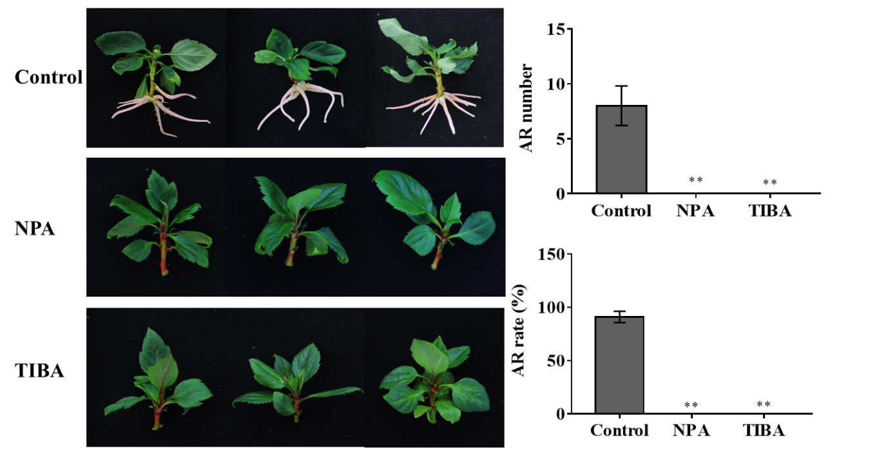

Figure S2 Identification of DNA level of in overexpression MdWOX11 transgenic lines, marker was 2000bp, wild type is named as WT, there are three lines in overexpression MdWOX11 transgenic lines, they are MdWOX11OE-15#, MdWOX11OE-16#, MdWOX11OE-20#, H₂O was set as negative control.
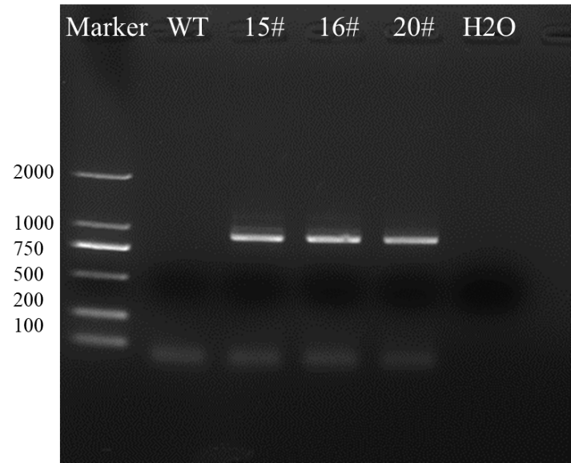

Table S1. Composition of medium.
Treatment | Medium | IBA  （mg/L） | Melatonin  （mg/L） | Sugar  （g/L） | Agar  （g/L）
Control | 1/2 MS | 0.7 | 0 | 20 | 8
MT | 1/2 MS | 0.7 | 0.3 | 20 | 8

Table S2. The gene name (the abbreviation and full name) and the apple MDP number, as well as the species and protein of the homologue on which the apple protein was based on.
Abbreviation name | Full name | Apple MDP number | Source：species | protein：Locus
TDC1 | tryptophan decarboxylase 1 | MDP0000170244 | Manihot esculenta | ANN44945
SNAT | serotonin N-acetyltransferase | MDP0000187484 | Manihot esculenta | ANN44947
HIOMT1 | methyltransferase/hydroxyindole-O-methyltransferase 1 | MDP0000656929 | Manihot esculenta | ANN44952
HIOMT2 | methyltransferase/hydroxyindole-O-methyltransferase 1 | MDP0000208322 | Manihot esculenta | ANN44953
ASMT1 | N-acetylserotonin-Omethyltransferase 1 | MDP0000851398 | Manihot esculenta | ANN44949
ASMT2 | N-acetylserotonin-Omethyltransferase 2 | MDP0000283649 | Manihot esculenta | ANN44950
YUCCA1 | Probable indole-3-pyruvate monooxygenase YUCCA1 | MDP0000295839 | Arabidopsis thaliana | YUC1_ARATH
YUCCA10 | flavin containing monooxygenase YUCCA10-like | MDP0000582079 | Arabidopsis thaliana | ARR1_ARATH
GH3 | Grecthenhagen-3 | MDP0000811081 | Arabidopsis thaliana | XP_028953638
AUX1 | auxin influx carrier 1 | MDP0000749280 | Arabidopsis thaliana | ABF47279
PIN1 | Pin-Formed 1 | MDP0000138035 | Arabidopsis thaliana | OAP14866
PIN3 | Pin-Formed 3 | MDP0000497581 | Arabidopsis thaliana | OAP15729
IAA5 | indole-3-acetic acid inducible 5 | MDP0000213864 | Arabidopsis thaliana | OAP14637
ARF7 | Auxin Response Factors 7 | MDP0000185253 | Arabidopsis thaliana | OAP17736
ARF19 | Auxin Response Factors 19 | MDP0000876321 | Arabidopsis thaliana | OAP07000
WOX5 | WUSCHEL-related homeobox 5 | MDP0000213910 | Arabidopsis thaliana | OAO92914
WOX11 | WUSCHEL-related homeobox 11 | MDP0000136426 | Arabidopsis thaliana | YUC1_ARATH
SHR | SHORT-ROOT | MDP0000840369 | Arabidopsis thaliana | YUC10_ARATH
LBD16 | Lateral Organ Boundaries Domain 16 | MDP0000145761 | Arabidopsis thaliana | CAA67308
LBD29 | Lateral Organ Boundaries Domain 29 | MDP0000131964 | Arabidopsis thaliana | ABR09074
CYCD1;1 | cell cycle regulator | MDP0000231873 | Arabidopsis thaliana | NP_001331451
CYCD3;1 | cell cycle regulator | MDP0000135392 | Arabidopsis thaliana | OAP15151
ARRO1 | Adventitious Rooting Related Oxygenase 1 | MDP0000820500 | Apple | XP_015641726
CRL1 | Charged amino acid-rich leucine zipper 1 | MDP0000299673 | Arabidopsis thaliana | AAG35177
GATA1 | GATA transcription factor 1 | MDP0000190038 | Arabidopsis thaliana | NP_189047
LRP1 | Lateral root primordium (LRP) protein-related 1 | MDP0000312744 | Arabidopsis thaliana | AAA87790
SCR1 | GRAS family transcription factor | MDP0000203826 | Arabidopsis thaliana | SCRA_ARATH
PRP1 | putative pre-mRNA-splicing factor ATP-dependent RNA helicasePRP1 | MDP0000538670 | Poplar | AAT67078

Table S3. Sequence of primers used for expression analysis, F for the former primer, R for the rear primer, MDP number of gene and length of primers.
Gene | MDP | Sequence 5’-3’ | length
TDC1-F | MDP0000170244 | GTGCTTGCATTTGTCCCGAG | 20
TDC1-R | MDP0000170244 | CCCAAAGGCAACAACAGTCG | 20
SNAT-F | MDP0000187484 | ATCTGCACGGTTGCGTCATA | 20
SNAT-R | MDP0000187484 | ACCGGAAGTGGAAGTGCAAA | 20
HIOMT1-F | MDP0000656929 | TTCTCATAGGAGCTTAGTTGCTC | 23
HIOMT1-R | MDP0000656929 | AATGCTCGTCACTCCAGTCG | 20
HIOMT2-F | MDP0000208322 | GTCGATGACTATTTTGTAGTGCTAA | 25
HIOMT2-R | MDP0000208322 | AATGATCGTCACTCCAGTCGT | 21
ASMT1-F | MDP0000851398 | AGGGACGATGACGATGACAAC | 21
ASMT1-R | MDP0000851398 | AGACTGCAACACAACGACCA | 20
ASMT2-F | MDP0000283649 | ATTGTGCCGGGTTTCCTCAT | 20
ASMT2-R | MDP0000283649 | ACATGGTATCAGAGCAGGTTCA | 22
YUCCA1-F | MDP0000295839 | AAGATGAGCGACCCATTCCC | 20
YUCCA1-R | MDP0000295839 | AGGAAAACGAGGGTCAAGCC | 20
YUCCA10-F | MDP0000582079 | CAAGTATCCGATCATTGAC | 22
YUCCA10-R | MDP0000582079 | CCTCTTATGCTGCCTATT | 22
GH3-F | MDP0000811081 | GTGGGGGCAATCTGAAAATCAA | 22
GH3-R | MDP0000811081 | TGAAAAACCTCACTCTTGCGT | 21
AUX1-F | MDP0000749280 | GCAGCACAGAAGCAATCAGAGG | 22
AUX1-R | MDP0000749280 | CCGCCATGCCAGAGGAAGTT | 22
PIN1-F | MDP0000138035 | ATCAACCGCTTCGTCGCTCTC | 22
PIN1-R | MDP0000138035 | AGGCAGAGTGGAGACGGAGAA | 22
PIN3-F | MDP0000497581 | ACAATTCAACAGCAGCAGCA | 22
PIN3-R | MDP0000497581 | CGGTCCCACCAAAAACATGG | 21
IAA5-F | MDP0000213864 | CAGCTCTACGCATCACCACCAA | 22
IAA5-R | MDP0000213864 | CCGCCGCTTGCCTTCTTAGTT | 21
ARF7-F | MDP0000185253 | ACGCCACTTGCTTACAACAGGA | 20
ARF7-R | MDP0000185253 | ACGCCATTGTGAGTGCTTCCAT | 20
ARF19-F | MDP0000876321 | ACGGCTCTGTTGCTCCTAACCA | 22
ARF19-R | MDP0000876321 | CGGCTGCTGCTGTTGCTGAA | 24
WOX5-F | MDP0000213910 | TCCGAACGCCGAGCACTGAT | 20
WOX5-R | MDP0000213910 | TGAAGGGTCTCAATCACTCTTGCC | 24
WOX11-F | MDP0000136426 | CCGAAGCCAGAGCAAATCCT | 20
WOX11-R | MDP0000136426 | TTCAAGGCTTGCCTGCAACT | 20
LBD16-F | MDP0000145761 | CGCCAGCAATGTGTCCAAGTT | 20
LBD16-R | MDP0000145761 | GTGAGCCACGCATCCATAAACG | 19
LBD29-F | MDP0000131964 | CGCCAGCAATGTGTCCAAGTTG | 18
LBD29-R | MDP0000131964 | TGGTGAGCCAGTTGAGCCTTTG | 22
CYCD1;1-F | MDP0000231873 | CCAATGTGCTACCACTCCAACTCC | 20
CYCD1;1-R | MDP0000231873 | GGTGATGATGACGATGGCGAAGAT | 21
CYCD3;1-F | MDP0000135392 | GCGGTGGATTGGATGCTGAGAG | 21
CYCD3;1-R | MDP0000135392 | TGAAGTTGGAGGCTGGACAAGAAC | 24
ARRO1-F | MDP0000820500 | GCTCAGACTCTCCACAAAACTACA | 24
ARRO1-R | MDP0000820500 | ATTGGCATTAGGCTCACTTCTCT | 20
CRL1-F | MDP0000299673 | ACCGATTACGTGCCAACTGT | 20
CRL1-R | MDP0000299673 | TTCGTAGCTGGCTTTGCTGA | 22
PRP1-F | MDP0000538670 | GCTGCTCGTGCCATCCTTCAA | 22
PRP1-R | MDP0000538670 | GGCGTTCCTCTAGCTGTCCAAG | 22
GATA1-F | MDP0000190038 | AGATGAGGATGATGCGGAAGATGT | 24
GATA1-R | MDP0000190038 | CTCCTAATTGCGATGATGGATGCT | 24
LRP1-F | MDP0000312744 | GATGGTGATGGTGATGGCGATGTT | 24
LRP1-R | MDP0000312744 | CTGCGGCGTTGTTGGAAGAAGA | 22
SCR1-F | MDP0000203826 | TCCTTATGCGGTGACTCTGTCCAA | 24
SCR1-R | MDP0000203826 | ACTCTTCTTCACTCGTCGGTTCCT | 24
EF-α-F |  | ATTCAAGTATGCCTGGGTGC | 20
EF-α-R |  | CAGTCAGCCTGTGATGTTCC | 20

