Supporting Information
Suppressed Ion Migration for High-performance X-ray Detectors Based on Atmosphere-Controlled EFG-Grown CsPbBr₃ Single Crystals
Yunqiu Hua, Guodong Zhang*, Xue Sun, Xiang Li, Zhongjun Zhai, Fucai Cui, Jiaxin Liu, Hongjie Liu, and Xutang Tao*
State Key Laboratory of Crystal Materials, Institute of Crystal Materials, Shandong University, Jinan 250100, PR China
E-mail: zgd@sdu.edu.cn, txt@sdu.edu.cn

CsPbBr₃ SC growth by the vertical Bridgman (VB) method. Fig. S1a shows the VB furnace. The pure polycrystalline CsPbBr₃ was achieved by refined by directional crystallization in the refined zone. The pure polycrystalline was then sealed into a quartz ampoule and moved to the two-zone Bridgman furnace for CsPbBr₃ single-crystal growth. The ampoule descended slowly with a speed of 0.5-1 mm h⁻¹ which is beneficial to crystal crystallization. After finishing growth, the temperature cooled down to room temperature for 2-3 days, and the large-size CsPbBr₃ single crystal was obtained by the VB method (Fig. S1b). The crystals grown by the VB method are restricted by the sizes and shapes of ampoules, and the whole growth cycle is 24-28 days.
Fig. S1 a) VB growth furnace. b) CsPbBr₃ single crystal grown by the modified VB method.

CsPbBr₃ SC growth by the edge-defined film-fed growth (EFG) method. The crystals grown by the EFG method depend on the dies in the crucible, rather than the size of the crucibles. Specifically, as was shown in Fig. S2a, the EFG furnace is composed of a quartz growth chamber, a heating system, a temperature measurement control system, a pulling system, a gas delivery system, a pull rod system, a thermal insulation system, and a growth crucible. The nominal wall thickness of the quartz tube was 5 mm to prevent the tube from bursting. The thermocouple was attached to the bottom of the quartz cavity. After the cavity was sealed, the air in the furnace was exhausted through the outlet, and the gas (Ar and HBr) was fed through the inlet.
In the EFG growth process, the furnace, which was sealed completely, was vacuumed purged to 10¹-10² Pa to remove impure gas, and filled with purified protective gas several times. The CsPbBr₃ polycrystals were loaded on the growth crucible equably which was in the bottom of the quartz flange and heated to ~600 °C in an Ar and HBr mixed atmosphere. The evolution of the crystal growth at different growth stages for the cylindrical CsPbBr₃ crystal and the tabular CsPbBr₃ crystal is clearly observed in Fig. S3, S4. The initial stage is the diameter expansion of the seed until it reaches the full die, then the crystal grows equably whose diameter keeps with the die diameter until growth termination in the advanced growth stage. Once the amount of remaining melt became less, the crystal was pulled up to avoid contact with the die. Owing to the large temperature gradient of the EFG furnace, the crystal grows with a higher speed at 5-10 mm h⁻¹ than the VB method. After the crystal growth finished, the temperature cooled down to room temperature for 48 h, therefore the total growth period of a crystal grown by the EFG method was 3-4 days, which is six or seven times shorter than the time which grows crystals by the VB method.
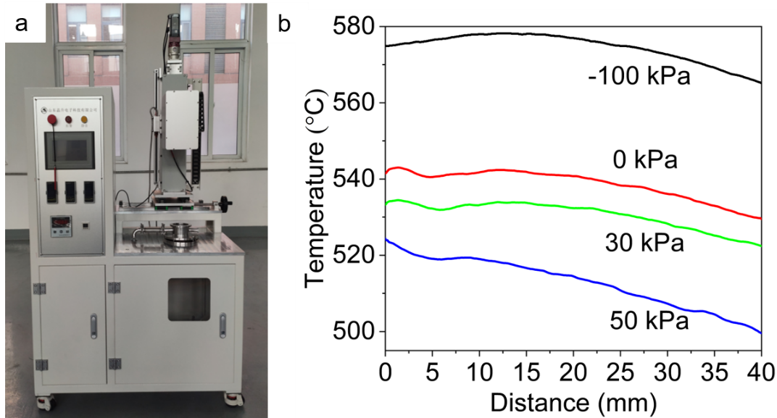
Fig. S2 a) EFG growth furnace, and b) axial thermal profiles at different pressure atmospheres.
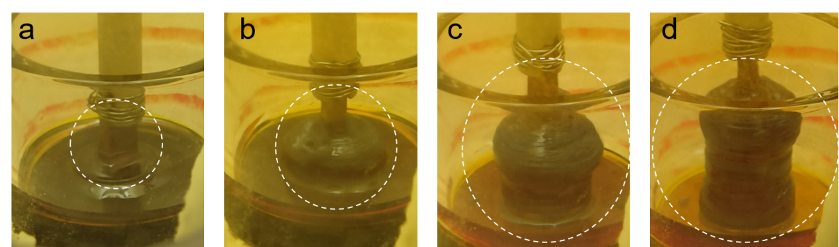
Fig. S3 Evolution of the growth at different growth stages for the cylindrical CsPbBr₃ crystal a) diameter expansion during initial growth, b) reaching full die diameter, c) advanced growth stage, and d) final stage.

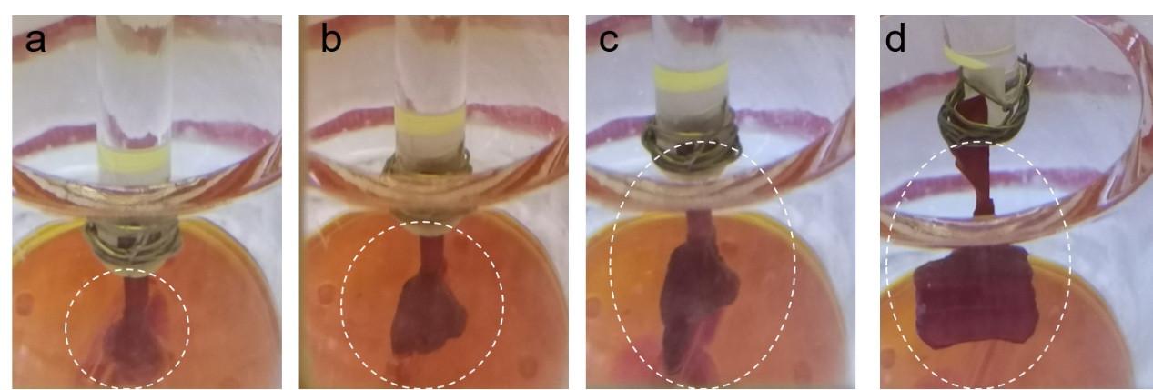
Fig. S4 Evolution of the growth at different growth stages for the rectangular CsPbBr₃ crystal a) diameter expansion during initial growth, b) reaching full die diameter, c) advanced growth stage, and d) final stage.

Fig. S5 PXRD pattern of the CsPbBr₃ crystals grown by the EFG method.
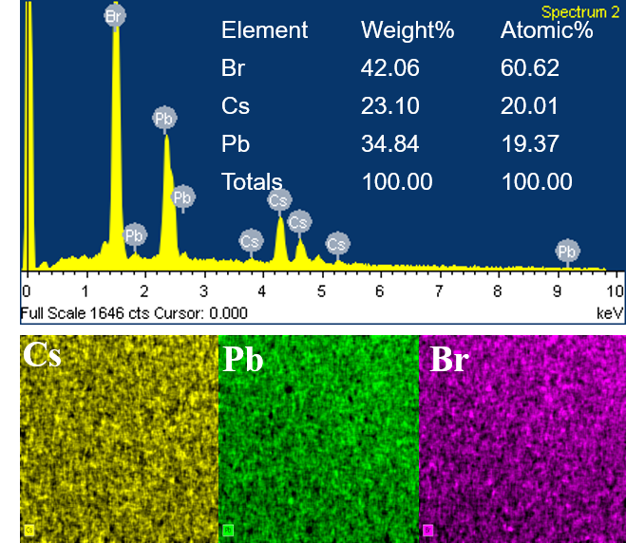
Fig. S6 EDS measurement spectrum results and EDS mapping of the Cs, Pb, and Br elemental distribution of CsPbBr₃ SC.

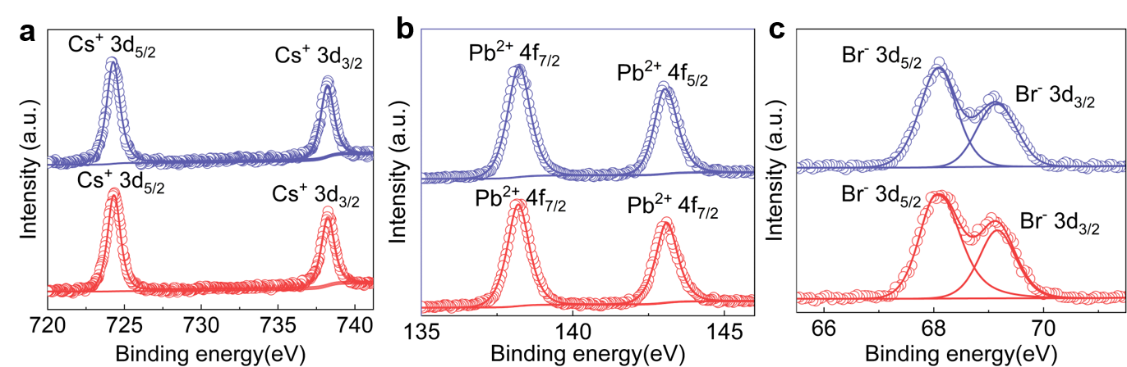
Fig. S7 XPS spectra of Cs 3d, Pb 4f, and Br 3d of EFG- and VB- CsPbBr₃SCs.

Fig. S8 Ultraviolet−visible absorption spectra of the EFG- and VB- CsPbBr₃SCs.
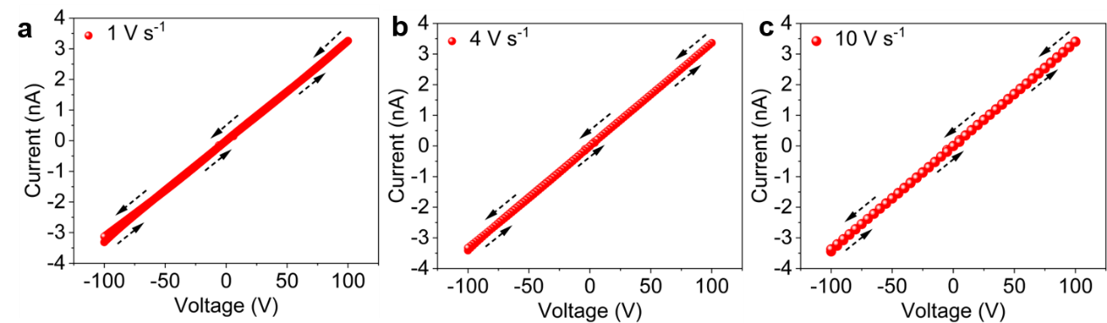
Fig. S9 The current-voltage loops of EFG-CsPbBr₃SCs from -100 to 100 V at the scan rate of a) 1 V s⁻¹, b) 4 V s⁻¹, c) 10 V s⁻¹.

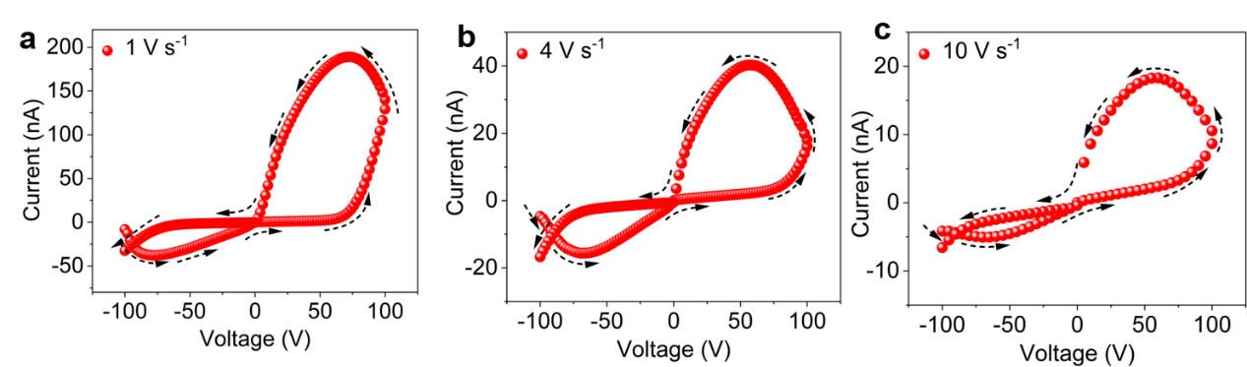
Fig. S10 The current-voltage loops of VB-CsPbBr₃SCs from -100 to 100 V at the scan rate of a) 1 V s⁻¹, b) 4 V s⁻¹, c) 10 V s⁻¹.

Fig. S11 Typical charging−discharging process curve of CsPbBr₃ SC coplanar-structure device in the dark at a range from 268 K to 328 K.

Computational methods. All results of calculations in this work were performed in the framework of the density functional theory (DFT) with the projector augmented plane-wave method, as implemented in the Vienna ab initio simulation package (VASP)¹. The generalized gradient approximation proposed by Perdew–Burke–Ernzerhof (PBE), is selected for the exchange-correlation potential^{2, 3}. The cut-off energy for a plane wave is set to 500 eV. The energy criterion is set to 10⁻⁵ eV in the iterative solution of the Kohn-Sham equation. The Brillouin zone integration is performed using a 2×3×2 k-mesh. All the structures are relaxed until the residual forces on the atoms have declined to less than 0.02 eV/Å. The energy barriers for Br⁻ ion diffusion in the structures were computed by the nudged elastic band (CI-NEB) method with 5 images. The migration path of Br⁻ ions vacancies is shown in Fig. S12.
Fig. 12 Migration path of Br⁻ ion vacancies in CsPbBr₃ crystal, and the black arrow line that represents the migration direction.
Fig. S13 Attenuation coefficients of different materials under the X-ray photon energy from 10-100 MeV.

The X-ray generating and shielding device was fabricated to characterize the X-ray detection capability of the CsPbBr₃ SCs detectors. Fig. S14a exhibited the photograph of the tungsten anode VAREX RAD-14/Leo X-ray tube (upper part of Fig. S14a), Ralco R302L/A beam limiter (lower part of Figure S12a), EMD EPS SYS 50R high-voltage generator (providing high electric field). Our devices were placed under the X-ray beam limiter without any filters when exposed to the X-ray photon energies of 40, 70, and 120 keV. The X-ray radiation window size of the beam limiter was 1 × 1 mm², and the distance between the window and detector was 110 cm. The radiation dose rates were calibrated using the Piranha 655 X-ray machine multifunctional quality detector (Fig. S14b) by adjusting the currents of the tube from 10-25 mA, respectively. The calibration results are listed in Tables S1-S3 for 40, 70, and 120 keV X-ray photons, and the average value of the dose rate was obtained under tested 3 times at each measurement point.
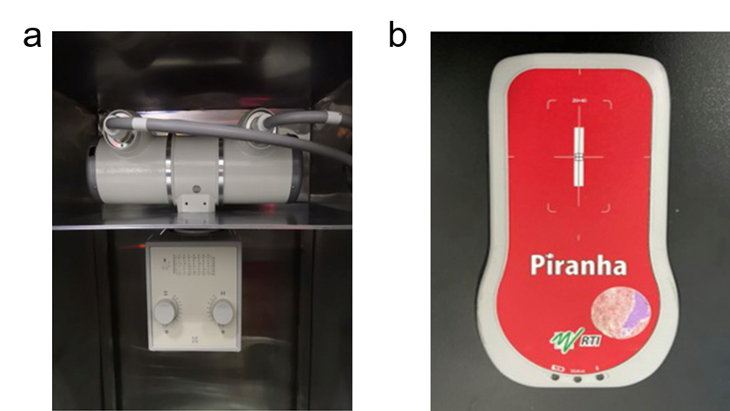
Fig. S14 Photograph of a) the tungsten anode X-ray tube and beam limiter and b) the X-ray machine multifunctional quality detector.

Table S1. Dose rate calibration of 40 keV X-rays.
Tube current  (mA) | Dose rate-1  (μGy s⁻¹) | Dose rate-2  (μGy s⁻¹) | Dose rate-3  (μGy s⁻¹) | Average dose rate  (μGy s⁻¹)
10 | 1.136 | 1.177 | 1.07 | 1.13
12.5 | 1.527 | 1.53 | 1.533 | 1.53
16 | 1.943 | 1.977 | 1.814 | 1.91
20 | 2.412 | 2.464 | 2.355 | 2.41
25 | 3.085 | 3.148 | 2.951 | 3.06
Table S2. Dose rate calibration of 70 keV X-rays.
Tube current  (mA) | Dose rate-1  (μGy s⁻¹) | Dose rate-2  (μGy s⁻¹) | Dose rate-3  (μGy s⁻¹) | Average dose rate  (μGy s⁻¹)
10 | 4.151 | 4.146 | 4.129 | 4.14
12.5 | 5.209 | 5.207 | 5.197 | 5.2
16 | 6.639 | 6.624 | 6.687 | 6.65
20 | 8.417 | 8.304 | 8.538 | 8.42
25 | 10.490 | 10.590 | 10.900 | 10.66
Table S3. Dose rate calibration of 120 keV X-rays.
Tube current  (mA) | Dose rate-1  (μGy s⁻¹) | Dose rate-2  (μGy s⁻¹) | Dose rate-3  (μGy s⁻¹) | Average dose rate  (μGy s⁻¹)
10 | 12.26 | 12.23 | 12.22 | 12.24
12.5 | 15.31 | 15.26 | 15.17 | 15.25
16 | 19.24 | 19.26 | 19.12 | 19.21
20 | 24.23 | 25.02 | 24.06 | 24.44
25 | 30.59 | 31.42 | 30.2 | 30.74

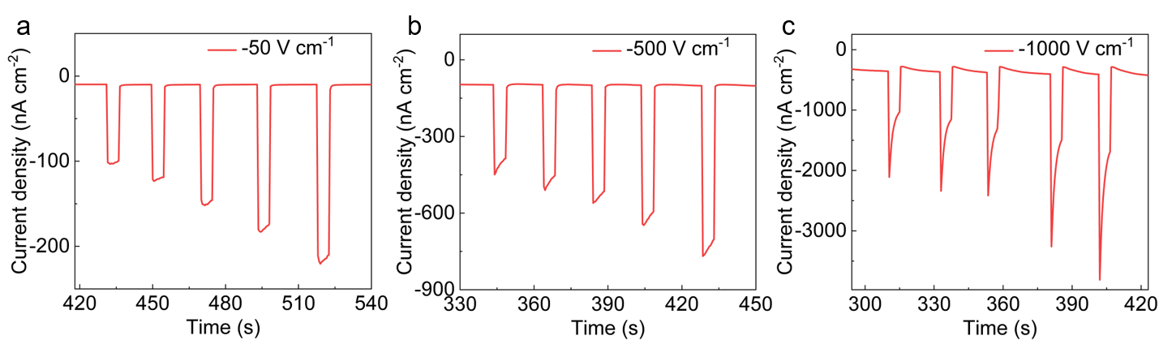
Fig. S15 Device responses of the VB-CsPbBr₃ SCs-based detectors under electric fields ranged from -50 to -1000 V cm⁻¹.

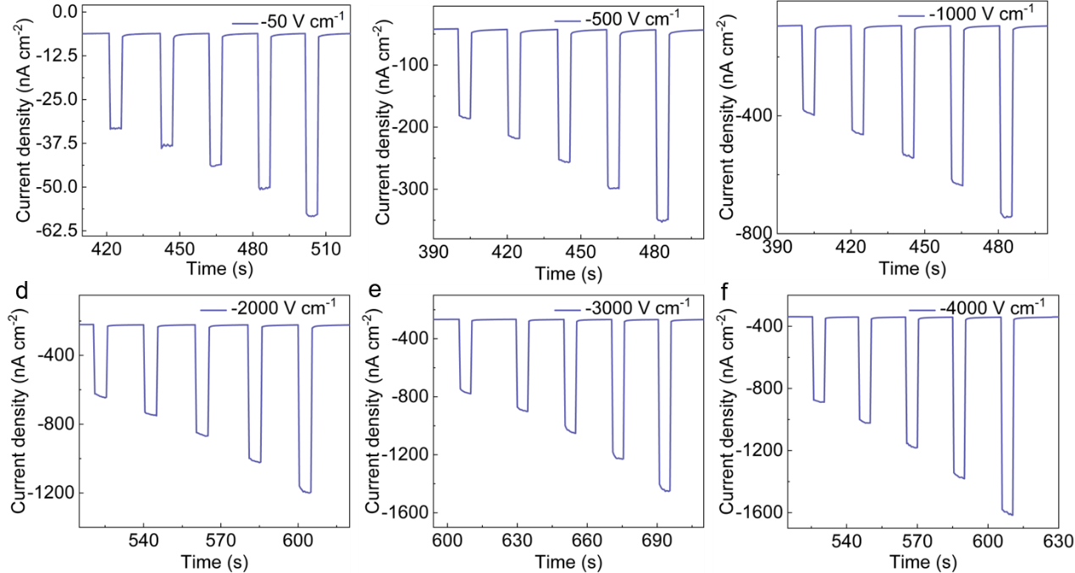
Fig. S16 Device responses of the EFG-CsPbBr₃ SCs-based detectors under electric fields ranged from -50 to -4000 V cm⁻¹.

Fig. S17 X-ray response stability of the VB-CsPbBr₃ SC detector for 120 keV at room conditions.

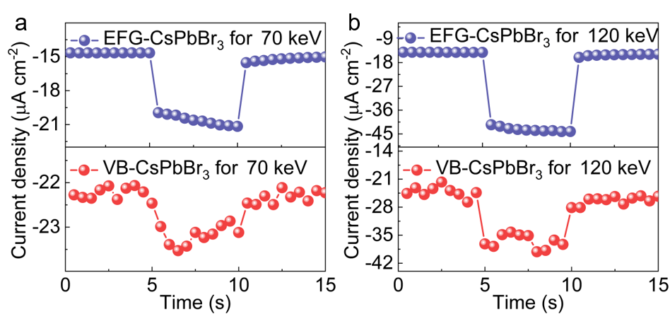
Fig. S18 X-ray response to the lid edge of CsPbBr₃ SCs detectors for a) 70 keV and b) 120 keV X-ray photons.

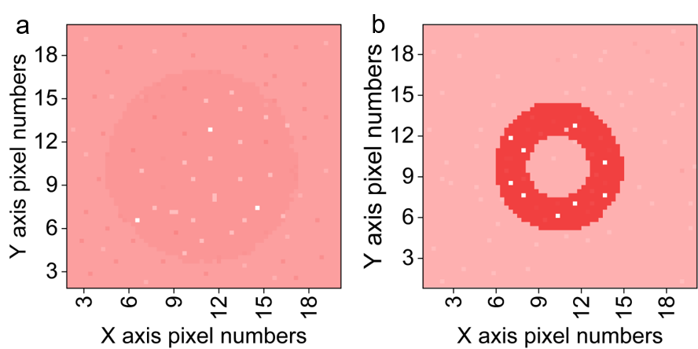
Fig. S19 X-ray images of the objects for VB-CsPbBr₃ SCs detector under a) 70 keV and b) 120 keV X-ray irradiation.

References
- Kresse, G. & Furthmüller, J. Efficient iterative schemes for ab initio total-energy calculations using a plane-wave basis set. Phys. Rev. B 54, 11169–11186 (1996).
- Xiao, R. et al. High-throughput design and optimization of fast lithium ion conductors by the combination of bond-valence method and density functional theory. Sci. Rep. 5, 14227 (2015).
- Chen, D. et al. Tunable electronic structures in BP/MoSSe van der Waals heterostructures by external electric field and strain. Appl. Surf. Sci. 497, 143809 (2019).

