Supplementary Information for

Atomically-ordered plating/stripping enables deep cycling zinc metal batteries

Shuang Chen^{1,2}†, Yufan Xia^{1,2}†, Ran Zeng^{2,3}, Zhen Luo^{1,2}, Xingxing Wu², Xuzhi Hu⁴, Jian R. Lu⁴, Ehud Gazit^{2,5,6}, Hongge Pan^{1,7*}, Zijian Hong¹, Mi Yan^{1,8*}, Kai Tao^{2,3*}, Yinzhu Jiang^{1,2,8*}

Correspondence to: yzjiang@zju.edu.cn (Y. Jiang); kai.tao@zju.edu.cn (K. Tao); mse_yanmi@zju.edu.cn (M. Yan); honggepan@zju.edu.cn (H. Pan)

This PDF file includes:

Supplementary Figs. 1-39
Supplementary Tables 1-6
Captions for Supplementary Movies 1-2
References

Other Supplementary Information for this manuscript include the following:

Supplementary Movies 1-2

Supplementary Fig. 1 | MS spectrum of the synthesized C₁₀-RWW-NH₂. [M+H]⁺ is 699.89.

Supplementary Fig. 2 | MS spectrum of the synthesized C₁₄-RWW-NH₂. [M+H]⁺ is 756.00.

Supplementary Fig. 3 | MS spectrum of the synthesized C₁₈-RWW-NH₂. [M+H]⁺ is 784.04.

Supplementary Fig. 4 | Reversed phase HPLC profile of the synthesized C₁₀-RWW-NH₂ lipopeptide. The purity was measured to be 98.12%. A gradient elution mode was employed. The monitoring wavelength was set at 214 nm, and the flow rate was 1 mL min⁻¹.

Supplementary Fig. 5 | Reversed phase HPLC profile of the synthesized C₁₄-RWW-NH₂ lipopeptide. The purity was measured to be 98.09%.

Supplementary Fig. 6 | Reversed phase HPLC profile of the synthesized C₁₈-RWW-NH₂ lipopeptide. The purity was measured to be 97.84%.

Supplementary Fig. 7 | FTIR spectra of the pristine Zn and SAB-Zn. The results demonstrate that compared to the baseline of the pristine Zn showing no visible IR peaks, typical peaks at ~3620 cm⁻¹ (3280 cm⁻¹), ~3576 cm⁻¹ and 3245 cm⁻¹ (1739 cm⁻¹), respectively corresponding to the symmetric (anti-symmetric) stretching of ν_{(N–H)}, ν_{(O–H)} and ν_{(C–H)}, can be observed in the SAB-Zn case. In addition to the peaks at 780 cm⁻¹,1139 cm⁻¹ and the small one at 1756 cm⁻¹, attributed to the σ_{(C–H)} coupled with the ν_{(C=O)} bending, it can be concluded that the lipopeptide molecules indeed adsorbed onto the Zn surface.

Supplementary Fig. 8 | EDS mapping of SAB-Zn. (a) Secondary-electron image (left panel) and the mixed elemental mapping (right panel) of the SAB-Zn. (b-f) Detailed elemental mapping of the same region as (a): (b) zinc, (c) sulfur, (d) carbon, (e) nitrogen, (f) oxygen. Scale bar: 10 μm.
The results show that all the elements uniformly distribute in the images, thus demonstrating that the SAB was evenly adsorbed on the Zn surface.

Supplementary Fig. 9 | The surface morphology of SAB on Zn surface captured by AFM. (a) C₁₀-RWW-NH₂, (b) C₁₄-RWW-NH₂, and (c) C₁₈-RWW-NH₂.

Supplementary Fig. 10 | Adsorption energy comparison of H₂O and different head amino acid molecules on a Zn(0002) crystal plane. Trp (W), Arg (R) and His (H) residues correspond to the C-terminal moiety of the C₁₄-RWW-NH₂, C₁₄-R-NH₂ and C₁₄-RHH-NH₂ SAB, respectively.

Supplementary Fig. 11 | The corrosion morphology of Zn soaked in the electrolyte solution for 7 days. (a-c) pristine Zn, (d-f) SAB-Zn. Scale bars in (a, d), (b, e) and (c, f) are 20, 10 and 5 μm, respectively.
The results demonstrate that compared to the remarkably rough surface of the pristine Zn, upon introducing SAB, the Zn foil is significantly sustainable against corrosion and remains intact.

Supplementary Fig. 12 | XRD patterns of the pristine Zn and SAB-Zn after soaking in electrolyte for 7 days. The results demonstrate that only XRD peaks corresponding to metallic Zn were present in the SAB-Zn after soaking in electrolyte for 7 days. By contrast, some additional peaks emerged in the pristine Zn case, illustrating the formation of basic zinc sulfate by-products [e.g., ZnSO₄(OH)₆·4H₂O or ZnSO₄(OH)₆·5H₂O] upon corrosion.

.

Supplementary Fig. 13 | Double layer capacity measurements of Zn electrodes in 2.0 M ZnSO₄ solution containing C₁₄-RWW-NH₂ at different concentrations. (a, d) 0 mM, (b, e) 0.1 mM, (c, f) 0.2 mM, (g, j) 0.4 mM, (h, k) 0.8 mM, (i, l) 1.0 mM. (a-c) and (g-i) I-V curves for Zn|Zn symmetric coin cells at a voltage range of -15 mV to 15 mV under various scanning rates. (d-f) and (j-l) Plots of the capacitive currents versus the scan rates corresponding to the CV curves shown in (a-c) and (g-i). (m) Statistical histogram of the lipopeptide concentration-dependent capacity.
The double layer capacitance is calculated by the equation: C = i_{c}/v. In the CV scans, the double layer current i_{c} = dq/dt = d(Cψ)/dt = C(dψ/dt) + ψ(dC/dt), dC/dt = 0, dψ/dt = v. Therefore, i_{c} = Cv. The linear dependence of the capacitive current (i_{c}) on the scan rate (v) can be used to determine the capacity (C). C is obtained from the slope of the i_{c} versus v graphs. Herein, we chose i_{c} = (i_{0v+} - i_{0v-})/2, namely the half value of the current difference during forward scan and negative scan at 0 V.
The results demonstrate that upon increasing the amounts of the lipopeptide, the double layer capacity of the Zn anode gradually attenuated, thus illustrating the adaptive adsorption and coverage of the C₁₄-RWW-NH₂ lipopeptide on the metallic electrode.

Supplementary Fig. 14 | Zeta potential statistics of the Zn powder in 2.0 M ZnSO₄ solution containing C₁₄-RWW-NH₂ at different concentrations. The results show that the Zeta potentials of the Zn powder gradually improved from the original -21.3 mV to -7.4 mV upon increasing the lipopeptide concentrations, thus demonstrating the effective and dynamic electrostatic adsorption of the lipopeptide molecules onto the Zn surface¹.

Supplementary Fig. 15 | De-solvation activation energies of the Zn²⁺ sheath. (a, b) Nyquist plots of (a) pristine Zn and (b) SAB-Zn tested under different temperatures. (c) De-solvation activation energy calculation for pristine Zn and SAB-Zn using the Arrhenius equations.

Supplementary Fig. 16 | Contact angle measurements of (a) Zn and (b) SAB-Zn.

Supplementary Fig. 17 | The electrochemical stability window of SAB-Zn. CV measurements were performed at different C₁₄-RWW-NH₂ concentrations on Ti working electrodes between -1.5 V and 3.5 V at a speed of 10 mV s⁻¹. (a) Overall electrochemical stability window. (b, c) Magnified views of the regions outlined near the anodic and cathodic extremes outlined in (a).

Supplementary Fig. 18 | SEM characterization of the deposition morphologies of Zn plated Zn substrate at elevated capacities (current density: 10 mA cm⁻²). (a-d) Zn deposited on the pristine Zn. (e-h) Zn deposited on the SAB-Zn. (a, e) 0.1 mAh cm⁻². (b, f) 1 mAh cm⁻², (c, g) 5 mAh cm⁻². (d, h) 10 mAh cm⁻². Scale bar: 40 μm.

Supplementary Fig. 19 | SEM characterization of the deposition morphologies of Zn plated Zn substrate at elevated current densities (capacity: 10 mAh cm⁻²). Zn deposition at the current density of (a, e) 0.1 mA cm⁻², (b, f) 1 mA cm⁻², (c, g) 5 mA cm⁻², (d, h) 10 mA cm⁻² on the (a-d) pristine Zn and (e-h) SAB-Zn, respectively. Scale bar: 40 μm.

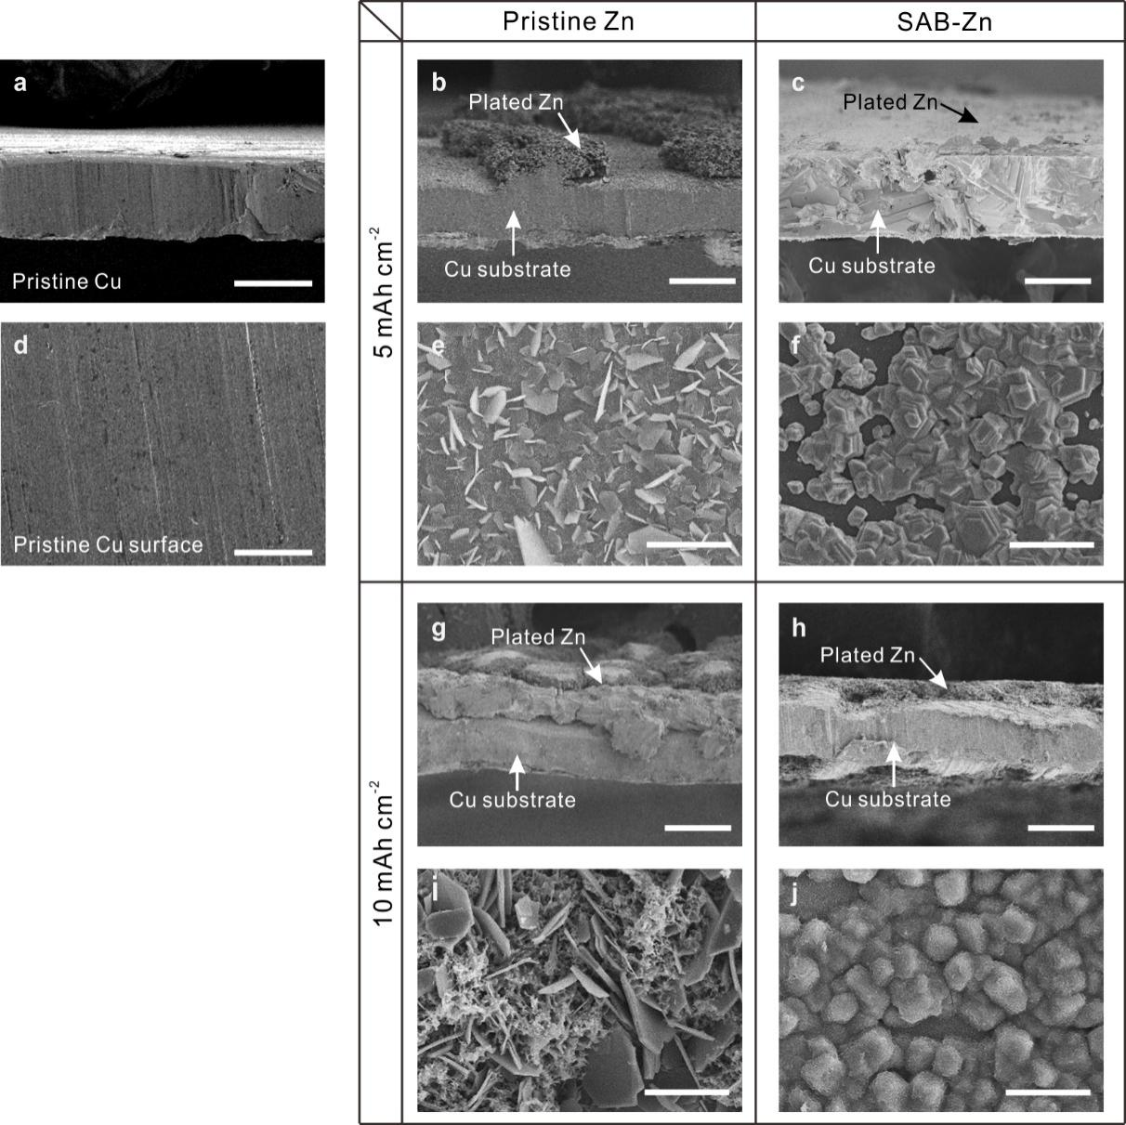
Supplementary Fig. 20 | Cross section and top view SEM images of Zn plated Cu substrate. (a, b, c, g, h) Cross section and (d, e, f, i, j) top view SEM images of Zn plated Cu substrate. (a, d) Pristine Cu. (b-f) 5 mAh cm⁻² and (g-j) 10 mAh cm⁻² of Zn plated Cu. Cross section SEM images were obtained using a tilted SEM sample holder with an angle of 10 degrees. (b, e, g, i) Pristine Zn. (c, f, h, j) SAB-Zn. Scale bars in (a, b, c, g, h) and (d, e, f, i, j) are 50 and 20 μm, respectively.

Supplementary Fig. 21 | Nucleation overpotential analysis of the Zn anode in the absence or presence of SAB. The nucleation process has a crossover point A. The difference between the potentials (B/C) and A corresponds to the nucleation overpotential, which follows the equation:
$r_{crit}=2\frac{γ V_{m}}{F |η|}$
where: γ is the surface energy of the anode/electrolyte interface, V_{m} is the molar volume of Zn, F is the Faraday constant and η is the nucleation overpotential. This equation indicates that the higher the overpotential is, the more difficult the Zn deposits tend to form.
The results show that the overpotential of SAB Zn was increased by 36 mV compared with that of the pristine Zn, thus demonstrating that the SAB can effectively eliminate the dendritic growth and promote the uniform depositions during Zn²⁺ plating.

Supplementary Fig. 22 | Coulombic efficiency of Zn plating/stripping on Zn with (red) and without (black) SAB at a current density of 10 mA cm⁻² and areal capacity of 10 mAh cm⁻². The result demonstrates that compared to the pristine Zn, the SAB-Zn showed a significantly high and stable average reversible Columbic efficiency (CE) of up to 99.4%.

Supplementary Fig. 23 | Concentration-dependent ionic conductivity evolution of C₁₄-RWW-NH₂ solutions containing 2.0 M ZnSO₄. The intersection of the two fitted lines represents the CMC of the lipopeptide.

Supplementary Fig. 24 | Galvanostatic cycling of the SAB-Zn-based symmetric cells in 2.0 M ZnSO₄ electrolyte containing different concentrations of C₁₄-RWW-NH₂. The symmetric cell showed the optimal performance when the concentration of C₁₄-RWW-NH₂ was set at the CMC (0.4 mM).

Supplementary Fig. 25 | TEM image of 1.0 mM C₁₄-RWW-NH₂ solution containing 2.0 M ZnSO₄. The spherical supramolecular structures can be aggregated when the concentration of the lipopeptide surpass its CMC, which interferes the ion mobilities in the electrolyte and contaminates the SAB at the interface². Scale bar: 1 μm.

Supplementary Fig. 26 | Cycling stability of the SAB-Zn based symmetric cells at elevated current densities and capacities. (a) 3 mA cm⁻² & 3 mAh cm⁻², (b) 5 mA cm⁻² & 5 mAh cm⁻², (c) 10 mA cm⁻² & 5 mAh cm⁻² and (d) 20 mA cm⁻² & 10 mAh cm⁻².

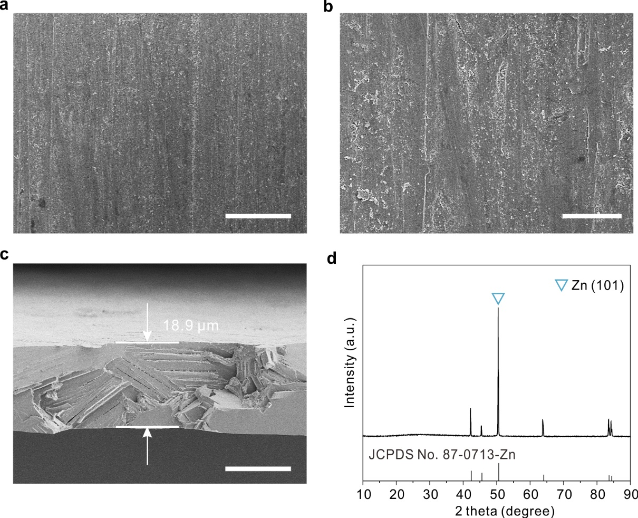

Supplementary Fig. 27 | Characterization of an ultra-thin Zn foil. (a, b) Top view, (c) cross-sectional SEM images and (d) XRD pattern of the ultrathin Zn foil 18.9 μm in thick. Scale bars in (a), (b) and (c) are 50, 20 and 10 μm, respectively.
Supplementary Fig. 28 | Ex-situ SEM morphological analysis after charge/discharge at DOD_{Zn} of 90% for 1 cycle. (a, b, c, g, h, i) 90% Zn stripping from Zn substrate. (d, e, f, j, k, l) Zn stripping/plating on Zn substrate for 1 cycle. (a-f) pristine Zn. (g to l) SAB-Zn. Scale bars in (a, d, g, j), (b, e, h, k) and (g, f, i, l) are 50, 20 and 10 μm, respectively.
The results are consistent with the electrochemically-measured plating/stripping CE, thus suggesting the full and reversible Zn plating/stripping of the SAB Zn anode. In addition, no distinct morphological damages were observed for the SAB-Zn, thus illustrating that upon introduction of SAB, the Zn anode was indeed sustainable against the volume change during plating/stripping.

Supplementary Fig. 29 | Detailed morphological analysis of the Zn anodes. Additional SEM and the corresponding EDX mapping images of the (a-f) pristine Zn and (g-i) SAB-Zn after stripping/plating at 10 mA cm⁻², 10 mAh cm⁻² (90% DOD_{Zn}) in Zn|Zn cells. Note that the elemental analyses of (c and i) Zn, (d and j) O, (e and k) S and (f and l) N selected from the locations are marked as insets in (b and h). Scale bars: 50 μm.
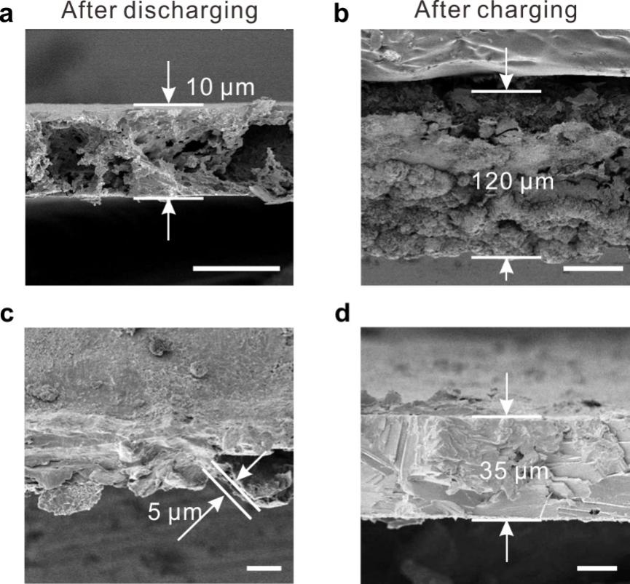

Supplementary Fig. 30 | SEM images of the Zn anodes after charge/discharge at DOD_{Zn} of 90% for 1 cycle. (a, b) Pristine Zn substrate. (c, d) SAB-Zn. Scale bars in (a, c, d) and (b) are 10 and 40 μm, respectively.
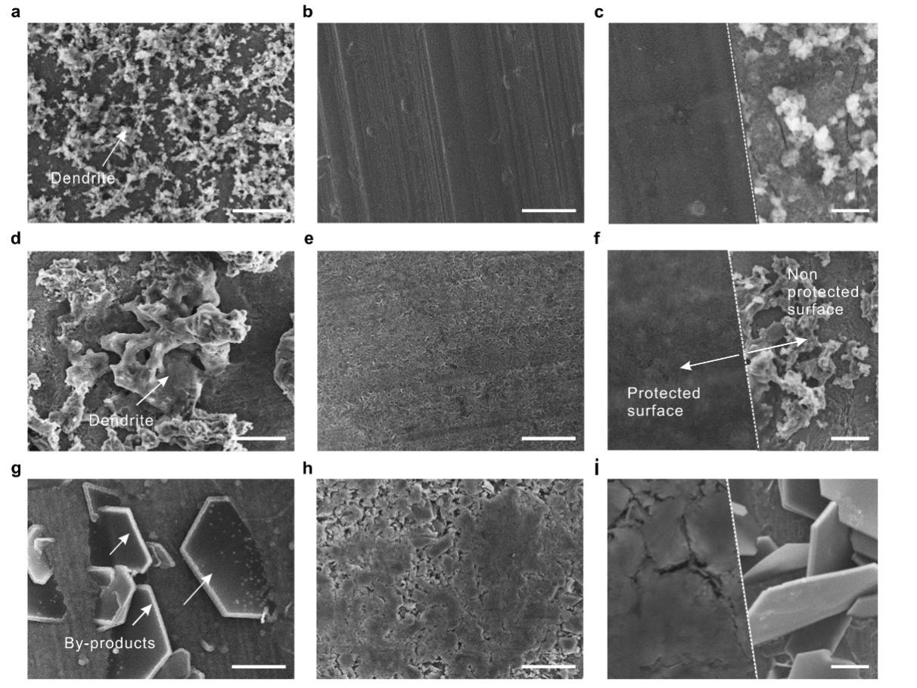

Supplementary Fig. 31 | SEM images of the Zn electrodes after Zn stripping/plating. (a, d, g) pristine Zn and (b, e, h) SAB-Zn after stripping/plating at (a, b) 1, (d, e) 10, and (g, h) 50 cycles. (c, f, i) High-magnification SEM images of the Zn anode after Zn deposition under areal capacity of 1.0 mAh cm⁻² (1.07% DOD_{Zn}) in the absence or presence of SAB. Note that all the samples were cycled at a current density of 1.0 mA cm⁻². Scale bars in (a, b, e) and (d, g, h) are 20 μm and 10 μm, respectively, (c and f) and (i) are 5 μm and 2 μm, respectively.
The results demonstrate that after Zn deposition, extensive dendrites were randomly formed on the pristine Zn surface, while planar and denser Zn deposits were formed in the SAB-Zn case, with no dendrites identified.

Supplementary Fig. 32 | In-situ optical microscopy images of the Zn electrodes after Zn stripping/plating in Zn|Zn cells. (a) The pristine Zn. (b) SAB-Zn. Test conditions: 1 mA cm⁻² with an areal capacity of 1 mAh cm⁻². Scale bar: 400 μm.

Supplementary Fig. 33 | Snapshots from AIMD simulation of water on pristine Zn(0002) surface with a zinc vacancy defect (Supplementary Movie 1).

Supplementary Fig. 34 | Bader charges (the unit of charge is |e|) and charge density differences (isovalue = 1.5 × 10⁻³ e Bohr⁻³). (a, b) Bader charges surface transformation of (a) Trp and (b) H₂O adsorbed on Zn(0002) with a zinc vacancy defect. (c, d) Charge density differences of (c) Trp and (d) H₂O adsorbed on Zn (0002) with a zinc vacancy defect.

Supplementary Fig. 35 | XPS analysis of SAB on Zn surface. XPS spectral regions for C 1s, N 1s, O 1s and Zn 2p at argon (Ar⁺) sputtering depth of (a) 0 nm, (b) 3 nm, (c) 5 nm, (d) 10 nm and (e) 15 nm.
The synthetic peaks areas are constrained reflecting the stoichiometric ratios for the chemical environments within the SAB based on peak-fitted (dashed lines) XPS C 1s spectra. A peak area ratio of 4:1:7:5 was employed for the terminal lipopeptide (red; E_{B} = 284.2 eV), C=O (green; E_{B} = 284.5 eV), C−C (blue; E_{B} = 286.4 eV) and the C−N (grey; E_{B} = 285.5 eV) carbon species respectively³, leading to a conclusive deconvolution of the experimental data. A single peak (E_{B}=~399.5 eV) appeared in the N 1s region, corresponding to surface-bound lipopeptide moieties. In the O 1s spectra, the peaks at 532.3 and 5321.5 eV could be assigned to C−C and C=O species, respectively. XPS spectra from the Zn 2p_{3/2} region of the SAB-Zn surface show that the binding energy of surface zinc species is slightly higher than that of deeper metallic Zn⁰ (2p_{3/2} at ca. 1021.1 eV and 2p_{1/2} ca. 1045.1 eV). This corroborates the high valence state of Zn^{δ+} (0<δ<1) at premier interface, suggesting that a certain fraction of surface Zn⁰ atoms had been converted to a Zn-N complex due to the strong interaction between SAB and Zn.

Supplementary Fig. 36 | Cycling stability of different SAB-Zn in symmetric cells at different current densities and capacities. (a) 1 mA cm⁻² & 1 mAh cm⁻², (b) 5 mA cm⁻² & 5 mAh cm⁻² and (c) 1 mA cm⁻² & 5 mAh cm⁻².

Supplementary Fig. 37 | Electrochemical performance of the Zn|MnO₂ full cells. (a) SEM image of the MnO₂ nanotubes. (b) CV and (c) the charge and discharge profiles of Zn|MnO₂ cells. (d) Long-term cycling performance of batteries using an MnO₂ cathode, 20 μm Zn anode at a current density of 0.5 A g⁻¹. (e) Rate performance of batteries using the MnO₂ cathode at 0.8, 1, 2, 3, 5, 0.8 C, as indicated. (f) Discharge and charge voltage profiles of SAB-Zn|MnO₂ cells at different current densities.

Supplementary Fig. 38 | Electrochemical performance of Zn|NiHCF full cells. (a) SEM image of the NiHCF. (b) CV curves of Zn|NiHCF and SAB-Zn|NiHCF cells. (c, d) Charge and discharge profiles of (c) Zn|NiHCF and (d) SAB-Zn|NiHCF. (e) XRD pattern of the NiHCF. (f) Long-term cycling performance of batteries using NiHCF cathode, 20 μm Zn anode at a current density of 0.5 A g⁻¹.

Supplementary Fig. 39 | Self-discharge test of SAB-Zn|MnO₂ full cells. Storage performance evaluated by resting for 48 h at 100% state of charge, followed by full discharge.

Supplementary Table 1 | Thickness of C₁₄-RWW-NH₂ SAB measured by spectroscopic ellipsometry.
Sample | Thickness (nm) | Adsorbed mass (ng mm⁻²)
C₁₄-RWW-NH₂ | 3.4 ± 0.5 | 3.67

Supplementary Table 2 | Summary of the structural parameters extracted from fitting of the neutron reflectivity curves shown in Fig. 1d of the main text.
 | Substrate | RWW bottom | C₁₄ center | RWW top
t (Å) | 15 | 12 | 10 | 12
VF (%) | - | 80 | 80 | 80
M (ng mm⁻²) | - | 12.96 | 10.80 | 12.96
Note: t, VF and M are the scattering thickness, volume fraction and adsorbed mass, respectively.

Supplementary Table 3 | Previously-published Zn plating/stripping CE and galvanostatic measurements used in Fig. 2h of the main text.
Point number | Reference number | CE | Electrolyte | Plating current density, mA/cm² | Per-cycle plating capacity, mAh/cm² | Number of cycles for galvanostatic charge/discharge (GCD) testing | Cumulative capacity plated (CCP), mAh/cm² | Fraction of Zn passed per cycle during GCD testing | Comments
1 | 4 | 99.70% | Zn(TFSI)₂/acetamide | 0.1 | 0.05 | 500 | 25 | Unspecified | CCP is calculated based on Zn|Zn cell cycling results with 0.1 mA/cm².
2 | 5 | 96.20% | LiTFSI/Zn(TFSI)₂/urea/ H₂O | 0.1 | 0.1 | 1,500 | 150 | 4.50% | CCP is calculated based on Zn/Zn cell cycling results with 0.1 mA/cm². Zn foil is 13.6 mg/cm² (~19 μm).
3 | 6 | 92% | 6M KOH in H₂O | 20 | 1 | 160 | 160 | 1.70% | Zn foil is 100 μm. CCP is calculated based on a CE testing procedure.
4 | 7 | 95.12% | 2M ZnSO₄ in H₂O | 10 | 10 | 35 | 350 | 85% | Zn foil is 20 μm and was treated by polyamide. CCP is calculated based on Zn/Zn cell cycling results with 10 mA/cm².
5 | 8 | 99.68% | 0.5M Zn(OTf)₂ in TEP | 0.5 | 5 | 100 | 500 | 0.34% | Zn foil is 250 μm. CCP is calculated based on Zn/Zn cell cycling results with 0.5 mA/cm².
6 | 9 | 99.2% | 2M ZnSO₄ in H₂O | 20 | 25 | 29 | 725 | 47.5% | Zn foil is 100 μm and was treated by ZnSe overlayer. CCP is calculated based on Zn/Zn cell cycling results with 30 mA/cm².
7 | 10 | 99.5% | dopamine hydrochloride/Zn(CF₃SO₃)₂/H₂O | 30 | 30 | 38 | 1,140 | 85.39% | Zn foil is 60 μm. CCP is calculated based on Zn/Zn cell cycling results with 30 mA/cm².
8 | 11 | 99.7% | NH₄OAc/ZnSO₄ | 1.16 | 1.16 | 125 | 145 | 20% | Zn foil is ~10 μm. CCP is calculated based on Zn/Zn cell cycling results with 20% DOD.
9 | 12 | 99.5% | 2M ZnSO₄ in H₂O | 15 | 48 | 15 | 720 | ~82% | Zn foil is ~100 μm and was treated with ZnP. CCP is calculated based on Zn/Zn cell cycling results with 82% DOD.
10 | 13 | 97.71% | 2M ZnSO₄ in H₂O | 1 | 1 | 250 | 250 | Unspecified | Zn foil is in (002) orientation. CCP is calculated based on Zn/Zn cell cycling results with 1 mA/cm².
11 | 14 | 99.55% | 2M ZnSO₄ in H₂O | 5 | 1.25 | 1,000 | 1,250 | 2.13% | Zn foil is 0.1 mm and was treated by ZnO-3D layer. CCP is calculated based on Zn/Zn cell cycling results with 5 mA/cm².
12 | 15 | 99.7% | water in salt:  Zn(TFSI)₂/LiTFSI/H₂O | 0.2 | 0.04 | 425 | 17 | 0.068% | Zn foil is 0.1 mm.
13 | 16 | 99.5% | ZnCl₂/DMSO/H₂O | 0.5 | 0.5 | 500 | 250 | Unspecified | CCP is calculated based on Zn/Zn cell cycling results with 0.5 mA/cm².
14 | 17 | 99.9% | Zn(OTf)₂/Me₃EtNOTF/H₂O | 0.5 | 0.25 | 1,000 | 250 | Unspecified | CCP is calculated based on CE testing procedure.
15 | 18 | ~100% | 2M Zn(OTf)₂ in H₂O | 10 | 2 | 500 | 1,000 | Unspecified | CCP is calculated based on Zn/Zn cell cycling results with 10 mA/cm².
16 | 19 | 97.2% | Glucose/ZnSO₄ | 5 | 5 | 137 | 685 | 8.54% | Zn foil is 100 μm. CCP is calculated based on Zn/Zn cell cycling results with 5 mA/cm².
17 | 20 | 99.8% | g-C₃N₄/ZnSO₄ | 4 | 6 | 400 | 2,400 | Unspecified | CCP is calculated based on CE testing procedure.
18 | 21 | >99% | 2M ZnSO₄ in H₂O | 4 | 0.8 | 1,000 | 800 | Unspecified | Zn electrodeposition is with a locked crystallographic orientation relation. CCP is calculated based on CE testing procedure.
This work |  | 99.7% | C₁₄-RWW-NH₂/ZnSO₄/H₂O | 20 | 10 | 1,100 | 11,000 | 17.08% | Zn foil is 100 μm. CCP is calculated based on Zn/Zn cell cycling results with10 mA/cm².
 |  |  |  | 20 | 10 | 325 | 3,250 | 90.03% | Zn foil is 18.9 μm. CCP is calculated based on Zn/Zn cell cycling results with 10 mA/cm².

Supplementary Table 4 | Summary of the mean-square displacement data shown in Fig. 3h-j of the main text.
Mean-square displacement (Å²) | x-axis | y-axis | z-axis | Total
Pristine Zn | 0.2 | 0.1 | - | 0.3
SAB-Zn | 0.1 | 0.1 | 0.2 | 0.4
Delocalized SAB-Zn atom | 2.2 | - | 5.3 | 7.2

Supplementary Table 5 | Cell design parameters for 280 Wh L⁻¹ zinc ion full cell based on SAB-Zn|MnO₂.
 | Material | MnO₂
Cathode | 1st discharge capacity / mAh g⁻¹ | 246
Cathode | Active material loading | 95%
Cathode | Cathode weight (each side) / mg cm⁻² | 12.7
Cathode | Areal capacity (each side) / mAh cm⁻² | 3.2
Cathode | Electrode thickness (each side) / μm | 90
Cathode | Number of double side layers | 1
Cathode | Electrode dimension W*L / mm | 100*150
Cu foil | Thickness / um | 15
Anode | Material | Zn
Anode | Specific capacity / mAh g⁻¹ | 218
Anode | Thickness / μm | 20
Anode | Active material loading | 100%
Anode | Areal capacity/ mAh cm⁻² | 11.7
Anode | N/P ratio | 3.5
Anode | Electrode dimension W*L / mm | 100*150
Electrolyte | Material | ZnSO₄
Electrolyte | E/C ratio / μL mAh⁻¹ | 10
Separator | Thickness / um | 30
Cell | Average voltage (1st cycle) / V | 1.36
Cell | Cell energy density / Wh L⁻¹  *based on anode, cathode and separator | 280
* Volumetric energy density is calculated based on equation:
$E_{v}= \frac{V×C}{\sum{T_{i}}}×∆V_{cell}$
where: $V$ is the average output voltage, $C$ is the areal capacity and $T_{i}$ is the thickness of cell components including the anode, cathode and separator.

Supplementary Table 6 | Summary of previously-reported zinc-ion batteries used in Fig. 4d of the main text.
Ref. | Composition | Initial capacity |  |  | Voltage | Cycling |  |  |  | Specific capacity  (Wh kg⁻¹)
Ref. | Composition | Q_{an}  (mAh g⁻¹) | Q_{cat}  (mAh g⁻¹) | Loading  (mg cm⁻²) | Voltage | No. | Retention  (%) | Rate | Time  (h) | Specific capacity  (Wh kg⁻¹)
This work | MnO₂ | 218 | 246 | 12.7 | 1.36 | 500 | 64.7% | 0.5 A g⁻¹ | 500 | 157.5
This work | NiHCF | 12.3 | 87 | 2.0 | 1.38 | 1,000 | 75.6% | 0.5 A g⁻¹ | 1,740 | 14.9
22 | CuO | 41.0 | 292.6 | 2.0 | 0.9 | - | - | 0.2 C | 250 | 32.3
22 | Cu₂S | 9.8 | 336.7 | 2.0 | 0.4 | - | - | 5 C | 100 | 3.8
22 | CuI | 3.0 | 105.6 | 2.0 | 0.3 | - | - | - | - | 0.9
23 | Zn_{0.25}V₂O₅ | 3.8 | 267.6 | 2.0 | 0.6 | 200 | 96.1% | 1 A g⁻¹ | 107 | 2.3
24 | TP-Se | 7.6 | 247.36 | 2.2 | 1.8 | 4,300 | 85.3% | 2 A g⁻¹ | 1,063 | 12.0
25 | ZnNaV₂(PO₄)₃ | 2.6 | 93 | 2.0 | 1.1 | 40 | 96.7% | 0.5 C | 160 | 2.8
26 | Ba_{1.2}V₆O₁₆·3H₂O | 9.3 | 250 | 2.0 | 0.7 | 200 | 75.9% | 0.5 A g⁻¹ | 200 | 6.3
27 | PNAI-MnO₂ | 28.0 | 280 | 2.0 | 1.3 | 200 | ~90% | 0.2 A g⁻¹ | 571 | 33.1
28 | Zn_{0.25}V₂O₅·nH₂O | 103.8 | 279.6 | 5~7 | 0.8 | 1,000 | ~81% | 8 C | 250 | 60.6
20 | Zn_{x}V₂O₅ | 442.9 | 395.3 | 16 | 0.7 | 400 | <70% | - | - | 146.2
29 | β-MnO₂ | - | 135 | 2.0 | 1.35 | - | - | 0.72 A g⁻¹ | 225 | -
30 | γ-MnO₂ | 2.5 | 219 | 2.0 | 1.27 | 40 | 63% | 0.5 mA cm⁻² | - | 3.2
31 | LiFePO₄ | 2.3 | 82 | 1.2~2.0 | 1.1 | 400 | 80% | 2 C | 400 | 2.5
32 | CoMn-PBA | 1.6 | ~58 | 0.8~1.0 | 1.4 | 1,000 | 76.4% | 1 A g⁻¹ | 125 | 2.2
33 | CoFe(CN)₆ | 3.8 | 135 | 2.0 | 1.75 | 2,200 | ~100% | 2 A g⁻¹ | 297 | 6.5
34 | ZnHCF | 747.7 | 65.4 | 8.0 | 1.7 | 100 | 76% | 1 C | 200 | 102.3
35 | V₂O₅ | 7.6 | 170 | 3.2 | 0.85 | 120 | >99% | 0.1 C | 2,400 | 6.2
36 | CuHCF | 4.2 | 60 | 5.0 | 1.73 | 100 | 96.3% | 1 C | 200 | 6.8
37 | FeHCF | 8.4 | 120 | 5.0 | 1.1 | - | - | 0.1 C | - | 8.7
1 | NiHCF | 43.0 | 64.5 | 2.0 | 1.5 | 1,000 | 70% | 0.5 A g⁻¹ | 256 | 38.7
Notes:
* Testing time for this work and references results were evaluated according to the current density.
* Battery specific energy was calculated following equation:
$E = \frac{Q_{cat}×Q_{an}}{Q_{cat}+Q_{an}}×∆V_{cell}$
where: $Q_{cat}$ and $Q_{an}$ are the specific capacities of the active materials constituting the cathodes and anodes, respectively, $∆V_{cell}$ is the difference of the average operating potentials of the cathode and anode, which defines the average discharge voltage of the cell.

Supplementary Movie 1 | Animation of the full AIMD trajectory of water on Zn(0002) (to simulate the pristine Zn). AIMD simulation of water on Zn(0002) illustrating the topmost layer constant fluctuation at nearly the same position.

Supplementary Movie 2 |Animation of the full AIMD trajectory of Trp on Zn(0002) (to simulate the SAB-Zn). AIMD simulation of Trp on Zn(0002) illustrating the extraction of an Zn atom from the topmost layer and the concerted migration of a Zn atom in the second layer. The displacement of the whole layer is correlated with MSD profiles in Fig. 3h-i of the main text
References
1 Lu, H. et al. Amino acid-induced interface charge engineering enables highly reversible Zn anode. Adv. Funct. Mater. 31, 2103514 (2021).
2 Bayaguud, A., Luo, X., Fu, Y. & Zhu, C. Cationic surfactant-type electrolyte additive enables three-dimensional dendrite-free zinc anode for stable zinc-ion batteries. ACS Energy Lett. 5, 3012-3020 (2020).
3 Crudden, C. M. et al. Ultra stable self-assembled monolayers of N-heterocyclic carbenes on gold. Nat. Chem. 6, 409-414 (2014).
4 Qiu, H. et al. Zinc anode-compatible in-situ solid electrolyte interphase via cation solvation modulation. Nat. Commun. 10, 5374 (2019).
5 Zhao, J. et al. “Water-in-deep eutectic solvent” electrolytes enable zinc metal anodes for rechargeable aqueous batteries. Nano Energy 57, 625-634 (2019).
6 Higashi, S., Lee, S. W., Lee, J. S., Takechi, K. & Cui, Y. Avoiding short circuits from zinc metal dendrites in anode by backside-plating configuration. Nat. Commun. 7, 11801 (2016).
7 Zhao, Z. et al. Long-life and deeply rechargeable aqueous Zn anodes enabled by a multifunctional brightener-inspired interphase. Energy Environ. Sci. 12, 1938-1949 (2019).
8 Naveed, A., Yang, H., Yang, J., Nuli, Y. & Wang, J. Highly reversible and rechargeable safe Zn batteries based on a triethyl phosphate electrolyte. Angew. Chem. Int. Ed. 131, 2786-2790 (2019).
9 Yang, X. et al. Interfacial manipulation via in situ grown ZnSe cultivator toward highly reversible Zn metal anodes. Adv. Mater. 33, e2105951 (2021).
10 Zeng, X. et al. Bio-inspired design of an in situ multifunctional polymeric solid-electrolyte interphase for Zn metal anode cycling at 30 mA cm⁻² and 30 mAh cm⁻². Energy Environ. Sci. 14, 5947-5957 (2021).
11 Han, D. et al. A self-regulated interface toward highly reversible aqueous zinc batteries. Adv. Energy Mater. 12, 2102982 (2022).
12 Cao, P. et al. Fast-charging and ultrahigh-capacity zinc metal anode for high-performance aqueous zinc-ion batteries. Adv. Funct. Mater. 31, 2100398 (2021).
13 Zhou, M. et al. Surface-preferred crystal plane for a stable and reversible zinc anode. Adv. Mater. 33, e2100187 (2021).
14 Xie, X. et al. Manipulating the ion-transfer kinetics and interface stability for high-performance zinc metal anodes. Energy Environ. Sci. 13, 503-510 (2020).
15 Wang, F. et al. Highly reversible zinc metal anode for aqueous batteries. Nat. Mater. 17, 543-549 (2018).
16 Cao, L. et al. Solvation structure design for aqueous Zn metal batteries. J. Am. Chem. Soc. 142, 21404-21409 (2020).
17 Cao, L. et al. Fluorinated interphase enables reversible aqueous zinc battery chemistries. Nat. Nanotechnol. 16, 902-910 (2021).
18 Yuan, D. et al. Anion texturing towards dendrite-free Zn anode for aqueous rechargeable batteries. Angew. Chem. Int. Ed. 60, 7213-7219 (2021).
19 Sun, P. et al. Simultaneous regulation on solvation shell and electrode interface for dendrite-free Zn ion batteries achieved by a low-cost glucose additive. Angew. Chem. Int. Ed. 60, 18247-18255 (2021).
20 Zhang, W. et al. Dynamic interphase-mediated assembly for deep cycling metal batteries. Sci. Adv. 7, eabl3752 (2021).
21 Zheng, J. et al. Reversible epitaxial electrodeposition of metals in battery anodes. Science 366, 645-648 (2019).
22 Hao, J. et al. Studying the conversion mechanism to broaden cathode options in aqueous zinc-ion batteries. Angew. Chem. Int. Ed. 60, 25114-25121 (2021).
23 Liang, W. et al. Zn_{0.52}V₂O_{5-a}⋅1.8 H₂O Cathode stabilized by in situ phase transformation for aqueous zinc-ion batteries with ultra-long cyclability. Angew. Chem. Int. Ed. 61, e202207779 (2022).
24 Chen, Z. et al. Anion chemistry enabled positive valence conversion to achieve a record high-voltage organic cathode for zinc batteries. Chem. 8, 2204-2216 (2022).
25 Hu, P. et al. Uncovering the potential of M1-site-activated NASICON cathodes for Zn-ion batteries. Adv. Mater. 32, e1907526 (2020).
26 Wang, X. et al. Boosting zinc-ion storage capability by effectively suppressing vanadium dissolution based on robust layered barium vanadate. Nano. Lett. 20, 2899-2906 (2020).
27 Huang, J. et al. Polyaniline-intercalated manganese dioxide nanolayers as a high-performance cathode material for an aqueous zinc-ion battery. Nat. Commun. 9, 2906 (2018).
28 Kundu, D., Adams, B. D., Duffort, V., Vajargah, S. H. & Nazar, L. F. A high-capacity and long-life aqueous rechargeable zinc battery using a metal oxide intercalation cathode. Nat. Energy 1, 16119 (2016).
29 Islam, S. et al. Facile synthesis and the exploration of the zinc storage mechanism of β-MnO₂ nanorods with exposed (101) planes as a novel cathode material for high performance eco-friendly zinc-ion batteries. J. Mater. Chem. A. 5, 23299-23309 (2017).
30 Alfaruqi, M. H. et al. Electrochemically induced structural transformation in a γ-MnO₂ cathode of a high capacity zinc-ion battery system. Chem. Mater. 27, 3609-3620 (2015).
31 Olbasa, B. W. et al. Highly reversible Zn metal anode stabilized by dense and anion‐derived passivation layer obtained from concentrated hybrid aqueous electrolyte. Adv. Funct. Mater. 32, 2103959 (2021).
32 Zeng, Y. et al. Construction of Co-Mn prussian blue analog hollow spheres for efficient aqueous Zn-ion batteries. Angew. Chem. Int. Ed. 60, 22189-22194 (2021).
33 Ma, L. et al. Achieving high-voltage and high-capacity aqueous rechargeable zinc ion battery by incorporating two-species redox reaction. Adv. Energy Mater. 9, 1902446 (2019).
34 Lu, K., Song, B., Zhang, Y., Ma, H. & Zhang, J. Encapsulation of zinc hexacyanoferrate nanocubes with manganese oxide nanosheets for high-performance rechargeable zinc ion batteries. J. Mater. Chem. A. 5, 23628-23633 (2017).
35 Yan, M. et al. Water-lubricated intercalation in V₂O₅⋅nH₂O for high-capacity and high-rate aqueous rechargeable zinc batteries. Adv. Mater. 30 (2018).
36 Trocoli, R. & La Mantia, F. An aqueous zinc-ion battery based on copper hexacyanoferrate. ChemSusChem 8, 481-485 (2015).
37 Li, X. et al. Toward a practical Zn powder anode: Ti₃C₂T_{x} MXene as a lattice-match electrons/ions redistributor. ACS Nano 15, 14631-14642 (2021).

