Supplementary information:
Biodiversity-production feedback effects lead to intensification traps in agricultural landscapes
A. Burian, C. Kremen, J. S. T. Wu, M. Beckmann, M. Bulling, L. A. Garibaldi, T. Krisztin, Z. Mehrabi, N. Ramankutty, R. Seppelt

Detailed method description
A1: Model structure
General summary
An overview of the model structure is provided in Fig. 1 and this detailed description of the model’s formulation will follow the presentation of key relationships outlined in the figure. The aim of our model was to assess how different land-use scenarios interact with landscape characteristics in their influence on total production (P_{T}) and total biodiversity (B_{T}) in a landscape. Land management was defined as (i) the fraction of land used for agricultural production in a landscape (i.e. working land, WL) and (ii) the external input effort such as fertiliser and pesticide inputs, invested in agricultural production per area (i.e. intensification effort, I_{E}). In our simulations, we only assessed conventional intensification and did not consider options of ecological intensification. Ecological intensification can reach similar or sometimes even higher levels of productivity (e.g. Pywell et al. 2015), but is also frequently related to substantially higher working costs. The integration of working costs and parametrisation of the relationship between ecological intensification and working costs is not trivial and was beyond the scope of this study. I_{E} and WL are also referred to as input variables as they can be determined by land managers.
In our model, crop, soil and biotic characteristics of a landscape are influencing the form of five key relationships (Fig. 1) which together define the response of P_{T} and B_{T} to input variables. In Table S1, the variables which influence these five relationships are summarised, which are further referred to as model constants. Finally, P_{T}, B_{T} and the average yield of cultivated land (defined here as production per area, Y) are computed based on the input variables and model constants and are hence referred to as output variables.
The final mathematical output of the model is P_{T} which was computed based on the formula:
$$P_{T}=WL Y (1)$$
However, P_{T} does not only depend directly on WL and Y but also on a number of first order and second order indirect relationships, which are highlighted in Fig. 1. First order indirect relationships can be summarised by the formula
$$Y=Y_{Max} f_{I_{E}}^{Y}\left(I_{E}\right) f_{B_{T}}^{Y}\left(B_{T}\right) f_{WL}^{Y}\left(WL\right) (2)$$
where Y_{Max} stands for the maximum achievable yield, while $f_{I_{E}}^{Y}\left(∙\right), f_{B_{T}}^{Y}\left(∙\right)$, and $f_{WL}^{Y}\left(∙\right)$ are functions governing the impacts of intensification effort, total biodiversity, and fraction of land used for production on Y, respectively. These terms will be defined further below. Y_{Max} was for simplicity kept at 1 for all landscapes, which led to a normalisation of productivity differences across landscapes. Second order indirect relationships can be denoted as
$$B_{T}= f_{I_{E} WL}^{B}\left(I_{E}, WL\right) (3)$$
Hence, Y and B_{T} can be derived from five pairs of predictor terms (for mathematical reasons, the two predictors affecting biodiversity are summarised in one function in Equation 3), which refer to the five key relationships in Fig. 1. Based on these relationships (detailed functions are explained below), we established for each landscape (i.e., one specific set of model constants) the response of output variables to different land management options (i.e. input variables). Different land management options were evaluated by creating a model grid that contained 10,201 different combinations of input variables. Specifically, both WL and $I_{E}$ ranged from 0 to 100% and were scaled in 1% steps. This land-management matrix contained all possible combinations of WL and $I_{E}$ (101 x 101 combinations). We further refer to the assessment of P_{T}, B_{T} and Y under one given land-use regime (one WL and $I_{E}$combination) in a specific landscape as one model scenario whereas the assessment of all possible land-use regimes in a landscape is referred to as one model run.
Specific description of functional relationships
In this section, we specify, the four functions listed in the equation (2) and (3) representing the five key relationship defined in Fig. 1. Equations 4-11 thereby specify the function in equation (3) and equations (12-16) the functions used in equation (2).
Relationships D (the effect of $I_{E}$on the realised biodiversity in a landscape) and E (the effect on land-use on the potential biodiversity in a landscape) can be summarised as:
$$f_{I_{E} WL}^{B}\left(I_{E}, WL\right) =B_{pot.}^{WL} B_{loss}^{WL} +B_{pot.}^{nonWL} B_{loss}^{nonWL} (4)$$
where $B_{pot.}^{WL} and B_{pot.}^{nonWL}$stand for the potential diversity in WL and nonWL (fraction of non-working land in a landscape) and $B_{loss}^{WL}and B_{loss}^{nonWL}$ stand for the biodiversity loss resulting from conventional intensification in WL and nonWL, respectively.
Relationship E
Relationship E describes the impact of land-use on the potential number of species that can persist in a landscape. In our model, this was implemented by first creating a regional pool of n species that could potentially colonise and co-exist in the landscape. n was set to 10 000 across all of our simulations. Each species in this species pool was characterised by two traits; its habitat requirements ($H_{Ii}$) and its minimum habitat threshold level of existence ($H_{Ti}$). $H_{Ii}$ could be one of three possible categories including (a) species that could only reproduce in semi-natural and natural habitat, i.e. nonWL, (b) species that could only reproduce in WL and (c) species that could reproduce in both WL and non-WL (both). Attribution of species to the three possible categories was a stochastic process based on predefined probabilities. These predefined probabilities (i.e. the expected proportion of species, which are able to reproduce in WL, non-WL and in both habitat types) represents a landscape characteristic (model constant) as they depend on physiochemical conditions shaping community assembly processes (e.g. Kraft et al. 2015). However, we want to emphasise that we define habitat requirements explicitly as the habitat that is required for reproduction (e.g. dead wood, clay soils, etc.). Species that require a certain habitat type for reproduction are still expected to use other habitat types for resource allocation and hence a “natural-habitat species” can have an impact on crop production.
Further, each species in the species pool had a minimum habitat threshold level of existence ($H_{Ti}$), which represented the minimum fraction of suitable habitat ($H_{S}$) a species requires to survive (e.g. a $H_{T}$ of 0.2 indicates that a population of a species needs 20% of suitable habitat in a landscape to persist). The association of a $H_{T}$ to each species was again a stochastic process based on a truncated normal distribution (i.e. only $H_{T}$ values between 0 and 1 were possible), which was defined based on a mean and a standard deviation that was constant within one model scenario. Hence, the expected mean and standard deviation of $H_{T}$ are both further landscape characteristic (model constants, see Table S1).
Based on $H_{Si}$ and $H_{Ii}$ of n species, we compute the species richness that is maintained in WL (${Richness}_{WL}$) and nonWL (${Richness}_{nonWL}$) based on the formula:

$${Richness}_{WL}=\sum_{i = 1}^{n}{1\left(H_{Si}> H_{Ti}, H_{Ii}= WL\right)}+WL 1\left(H_{Ii}=both\right) (5)$$

$${Richness}_{nonWL}=\sum_{i = 1}^{n}{1\left(H_{Si}>H_{Ti}, H_{Ii}= nonWL\right)}+ nonWL 1\left(H_{Ii}=both\right) (6)$$
where 1($∙$) denotes an indicator function which returns the value 1 when the condition is fulfilled and the value 0 if it is not fulfilled. Note that the second term in equation (5) and (6) was included to allocate the species, which can reproduce in both WL and nonWL and hence always have 100 percent suitable habitat available, to WL and nonWL based on the relative ratio of the two habitat types in a model run. ${Richness}_{WL}$ and ${Richness}_{nonWL}$ were then summed to attain ${Richness}_{Total}$, the total potential species richness that can be attained in a landscape given a certain land-use pattern.
Finally, we calculated $B_{pot.}^{WL}$ and $B_{pot.}^{nonWL}$ for each model scenario k of the t total model scenarios in one run (i.e. 10,201) as
$$B_{pot.}^{maxTotal}=\max\left(f_{u} :u= {Richness}_{WL}^{1}+ {Richness}_{nonWL}^{1}, …,{Richness}_{WL}^{t}+{Richness}_{nonWL}^{t}\right)\left(7\right)$$
$B_{pot.}^{WL}= \frac{{Richness}_{WL}^{k}}{B_{pot.}^{maxTotal}} (8)$ $B_{pot.}^{nonWL}= \frac{{Richness}_{nonWL}^{k}}{B_{pot.}^{maxTotal}} \left(9\right)$
which effectively standardised the $B_{pot.}^{WL}$ and $B_{pot.}^{WL}$ by $B_{pot.}^{maxTotal}$, the maximal potentially attainable total species richness in a landscape.
Relationship D
After establishing the potential biodiversity in different habitat types, we compute $B_{loss}^{WL}$ and $B_{loss}^{nonWL}$ which together determine the percentage of biodiversity (i.e. species), which is lost due to conventional intensification. Conventional intensification comprises different activities such as the use of herbicides and insecticides or fertilisers. Our basal assumption was that I_{E} has always a negative impact on B_{T}. However, the shape of this relationship and the maximal impact of I_{E} on biodiversity can be highly variable and depends e.g. on the stress resistance of species in the species pool (landscape characteristic, Fig. 1). In our model, the two model constants Shape_{BI} and Impact_{BI} regulate the shape of the relationship and the maximal effect size of I_{E} on B_{T} independently from each other. Impact_{BI} can be a value between 0 (no impact) and 1 (i.e. when I_{E} is 1 B_{T} is 0). Shape_{BI} values can fall in the range between -1 (strongly convex relationship) and 1 (strongly concave relationships) with 0 representing a linear relationship (Fig. S1).
$B_{loss}^{WL}$ and $B_{loss}^{nonWL}$ are computed separately, because species in WL are directly affected by $I_{E}$ whilst species in nonWL are only affected indirectly via negative spill-over effects (${Spill}_{IE}$) caused e.g. by pesticide applications (Brühl et al. 2021). The decrease of ${Spill}_{IE}$ over space is accounted for by linking the constant to WL. $B_{loss}^{WL}$ and $B_{loss}^{nonWL}$ are hence computed as:

$$B_{loss}^{WL}=\left\{\begin{matrix}1 - {I_{E}}^{\left({Shape}_{BI} + {{6 Shape}_{BI}}^{3} \right) }{ Impact}_{BI}+ {(1-Impact}_{BI}) & if {Shape}_{BI}≥0 \\ {\left(1-I_{E}\right)}^{\left( {|Shape}_{BI}| + {{6 |Shape}_{BI}|}^{3} \right) }{ Impact}_{BI}+ {(1-Impact}_{BI}) & if {Shape}_{BI}<0\end{matrix}\right. (10)$$

$$B_{loss}^{nonWL}=\left\{\begin{matrix}\left(1 - {I_{E}}^{\left({Shape}_{BI} + {{6 Shape}_{BI}}^{3} \right) }{Impact}_{BI}+{(1-Impact}_{BI})\right){WL}^{{Spill}_{IE}} & if {Shape}_{BI}≥0 \\ \left({\left(1-I_{E}\right)}^{\left( {|Shape}_{BI}| + {{6 |Shape}_{BI}|}^{3} \right) }{Impact}_{BI}+{(1-Impact}_{BI})\right){WL}^{{Spill}_{IE}} & if {Shape}_{BI}<0\end{matrix}\right.(11)$$
Based on ${LB}_{WL}$ and ${LB}_{nonWL}$ (derived from equations 7 and 8) as well as $B_{pot.}^{WL}$ and $B_{pot.}^{nonWL}$ (derived from equations 5 and 6), $B_{T}$ can be computed after equation (4) for each scenario in a model run.
Relationship C
Relationship C describes the impact of B_{T} on average Y in an agricultural landscape and is represented by the function $f_{B_{T}}^{Y}\left(B_{T}\right)$ in equation 2. Analogously to the computation of LB_{WL}, we again establish an effect size (Impact_{YB}) and a shape parameter (Shape_{YB}). Impact_{YB} is again scaled from 0 (no reduction in Y when B_{T} is 0) to 1 (Y is 0 when B_{T} is 0). Shape_{YB} ranges from -1 (concave) to 1 (convex relationships; Fig. S6). $f_{B_{T}}^{Y}\left(B_{T}\right)$is expressed as
$$f_{B_{T}}^{Y}\left(B_{T}\right)=\left\{\begin{matrix}{B_{T}}^{\left({Shape}_{YB} + {{6 Shape}_{YB}}^{3} \right) }{ Impact}_{YB}+ {(1-Impact}_{YB}) & if {Shape}_{YB}≥0 \\ {1-\left(1-B_{T}\right)}^{\left( {|Shape}_{YB}| + {{6 |Shape}_{YB}|}^{3} \right) }{ Impact}_{YB} & if {Shape}_{YB}<0\end{matrix}\right. (12)$$
Relationship B
Relationship B represents the impact of $I_{E}$ on Y described by the function $f_{I_{E}}^{Y}\left(I_{E}\right)$in equation 2. Again, the relationship is dependent on two constants representing effect size (Impact_{YI}) and relationship shape (Shape_{YI}). However, in contrast to relationships C and D, we only considered concave relationship shapes for the impact of I_{E} on Y (-1 ≤ Shape_{YI} ≤ 0) as this relationship type is generally conceptually assumed (e.g. Liu et al. 2018) and found in field investigations (Scaife 1968). $f_{I_{E}}^{Y}\left(I_{E}\right)$is expressed as:

$$f_{I_{E}}^{Y}\left(I_{E}\right) ={1-\left(1-I_{E}\right)}^{\left( {|Shape}_{YI}| + {{6 |Shape}_{YI}|}^{3} \right) }{ Impact}_{YI} (13)$$
Relationship A
Finally, modelled landscapes are designed to show heterogeneity in their maximal potential productivity (i.e. not all areas are equally fertile). Areas attributed to WL are always implemented on the most productive land. E.g. a value of 0.2 for WL implies that the 20 most productive percent of the landscape are used for agricultural production. We describe the heterogeneity of potential productivity in modelled landscapes based on a beta-distribution. Beta-distributions are naturally constraint to values ranging between 0 and 1 and the shape of distributions can be described by its mean and variance. However, in contrast to normal distributions, the variance of the beta-distribution is logically constrained to certain values, which results from the limited data-range of the distribution (i.e. if values are restricted to range from 0 to 1, variance cannot be 100). This restriction of the variance becomes stronger when mean values approach 0 or 1 (Fig. S8).
The mean (Ypot_{mean}) and the variance (Ypot_{variance}) of potential productivity values (Ypot) in our landscape again represent landscape characteristics, which are constant within model runs. We used Ypot_{mean} and Ypot_{variance} as input to establish a beta-distribution. Ypot_{mean} ranges naturally, as the mean of a beta distribution, from 0 to 1. For each Ypot_{mean} value, we then compute the maximal variance that mathematically still allows to establish a beta-distribution (Ypot_{varmax}) following the equation

$${Ypot}_{varmax} ={ Ypot}_{mean} \left(1-{ Ypot}_{mean}\right) (14)$$
Ypot_{variance} is then calculated as normalisation of the variance used in the beta-distribution by dividing it by Ypot_{varmax}. Hence, also Ypot_{variance} ranges between 0 and 1. After setting Ypot_{mean} and Ypot_{variance}, we draw s values for z from the parameterised beta-distribution, where s was set to 10 000 across all simulations.
If all drawn z values are ordered from the smallest to the largest value, then the element q that defines the lowest yield potential of all agriculturally used areas ($Y_{pot}^{threshold}$) is calculated as
$$q= WL \left(s+1\right) (15)$$
The $Y_{pot}$ of q (the value drawn from the beta distribution for the element q) is then equivalent with $Y_{pot}^{threshold}$ and $f_{WL}^{Y}\left(WL\right)$ calculated as

$$f_{WL}^{Y}\left(WL\right) = \frac{\sum_{h=1, }^{s}{z 1\left(z_{l}≥Y_{pot}^{threshold}\right)}}{s} (16)$$

Hence, the function $f_{WL}^{Y}\left(WL\right)$in equation (2) amounts to taking the mean of all random draws from the Beta distribution that are larger or equal to working land.
A2 Model parametrisation
T The three main components of our study were (i) the assessment of biodiversity-production relationships in artificial landscapes, (ii) the contextualisation of model results in archetypic case-studies and (iii) a systematic sensitivity analysis to assess underlying mechanisms triggering intensification traps. In the following section, we describe model parametrisation for each of these three components.
Creation and assessment of artificial landscapes
The goal of the assessment of artificial landscapes was to evaluate biodiversity-production relationships in a wide range of conditions and evaluate the impact of variability in landscape characteristics on the risk of intensification traps. Our primary targets in the process of parametrisation were to (i) attain a large number of datasets for the parametrisation of the eight model constants that we focused on, and (ii) ensure that the applied datasets cover a wide range of different crop types and geographic regions.
Our literature search started with the establishment of a list of search terms for each of the key relationships that were parametrised (listed in Table S3). These terms were used as search terms applied to search within title, abstract, keywords and keywords plus of articles in Web of Science. All searches were implemented within the period of 01.12.2022 to 20.03.2023. It was not feasible to implement a full meta-analysis for each model parameter screening all available scientific articles as each search term combination resulted in over thousand returns. Instead, we screened the first hundred returns of each query for potential data sets that filled the requirements for model constant parametrisation (see below for criteria for individual model constants). This search resulted in data that was often biased covering either a limited range of crops (e.g. wheat, rice or maize) or a limited geographic distribution (primarily originating from industrialised countries). If necessary, we, therefore, complemented our data for parametrisation by using snowball searches starting from key references and by using more region or crop type-targeted search terms to attain data from otherwise underrepresented systems. All references used for parametrisation and the resulting values for individual model constants are listed in Appendix 1.
Screened articles were filtered based on the following criteria:
Relationship A was parametrised by screening literature for available datasets that provided multiple yield measurements within an otherwise largely homogenous landscape. We, for example, discarded datasets that contained differences in fertiliser or pesticide applications or that showed large differences in the amount of adjacent natural habitat, which could induce biodiversity-driven yield differences. As we controlled for these factors, the variability of yields reflected largely the variation in the agricultural production potential within a landscape. From each of the resulting datasets, mean and standard deviation were computed, which was used to parametrise Ypot_{mean} and Ypot_{variance}.
Relationships B, C and D where each defined by two parameters, a slope and an effect size parameter (equations 5-8). The slope parameter was determined using datasets that covered a ‘sufficient range’ of the predictor and contained at least 5 different predictor values. In order that a range was considered as sufficiently wide, one of two requirements needed to be fulfilled. Either values ranged from very low values (almost 0) to values that represent the upper range found in natural agroecological landscapes (e.g., in terms of fertiliser applications, etc.). Alternatively, an upper data range was considered as sufficient if it included the saturating section of a non-linear relationship (e.g., in biodiversity – ecosystem function relationships). Once a data-set was considered as suitable for the parametrisation of the slope parameter, we create a fitting grid containing 20301 combinations of parameter values for the shape parameter (ranging from -1 to 1, see Fig. S6) and the effect size parameter (ranging from 0 to 1; both shape and effect size parameters were systematically varied across ranges in steps of 0.01 to create the fitting gird). We then computed for each combination of shape and effect size parameter predictions for the data points in the parametrisation data set and chose the parameter settings that resulted in the lowest deviations between predictions and real values (i.e. lowest sum of square of residuals). This procedure was repeated for each of the available parametrisation data sets (at least 11 per shape parameter of the key relationships B, C and D).
The effect size parameter can be derived from the change of the response variable across a sufficient range of the predictor variable. In that regard, the same principal requirements for the required data range as for the range of slopes were applied, but only two data points were required (upper and lower end of predictor range). A challenge was that the available datasets for the parametrisation of ${Impact}_{YI}$, which represents to joint impact of pesticides and fertilisers, are either quantifying the effect of pesticides or fertilisers. Hence, we assessed the impact of pesticides (number of data sets: 11) and fertilisers (number of data sets: 17) separately and combined the two effects by multiplying the results.
Spill_{IE}, which is required for the parametrisation of relationship B was estimated as 0.9 reflecting that pesticide and other agricultural practices have a spillover effect on natural communities, which is, however, only of moderate importance (Szabo et al. 2012; McArt et al. 2017). The variability of Spill_{IE} across landscapes was set to a standard deviation of 0.1.
The parametrisation of relationship E required to establish the regional species pool and hence, setting habitat requirements and a threshold for persistence, H_{T}, for each species. We created the regional species pool by setting the total number of species to 10,000, which was high enough to avoid stochastic effects having a large impact on model outputs. Further, the average H_{T} across all species was set to 0.25 after Martin et al. (2019) and we determined H_{T} values for individual species by drawing from them from a normal distribution with a standard deviation of 0.4. Non-realistic values of below 0 above 1 for individual species were discarded. Also, the habitat requirement of species, i.e. the habitat that is required to persist, was determined stochastically for each individual species. The expected fraction of species that require either WL, or non-WL or can reproduce in both habitat types was set to values of 0.6, 0.25 and 0.15, respectively and varied stochastically as depicted in Fig. S9.
Although, the establishment of relationship E is rooted in ecological theory, it represents a highly simplified and conceptualised representation of natural systems. Simplification and conceptualisation help to understand mechanistic dependencies in agroecological systems, but made a parametrisation from real-word data difficult. We nonetheless varied the mean H_{T}, its standard deviation and the fraction of different habitat requirements in different model runs to represent the variability in natural systems. Yet, the boundaries of their range were chosen arbitrarily (Fig. S8). Further, we set the variability of mean H_{T} and the variability of its standard deviation to 0.2 and 0.3, respectively.
Consequently, we established for each model constant a mean value and a standard deviation. These mean values and standard deviation were primarily derived from literature values and if this was not possible, they were carefully chosen to reflect variability in real world situations. Based on mean and standard deviation of real-world data, we established distributions assuming normality. Hence, we were able to create via a bootstrap algorithm artificial landscapes, by drawing for each model constant a value from its distribution.
In real-world situations, shape and effect size of the five key relationships in our conceptual framework are influenced by a combination of environmental (e.g. soil chemistry, climate), biotic (e.g. composition of species pools) and crop (e.g. dependency on pollination and natural pest control, crop rotation, etc.) characteristics. Hence, one artificial landscape with one set of model constants reflects one set of environmental conditions paired with a specific natural community configuration and a specific crop cultivation scheme. In our analysis, we established 10,000 different artificial landscapes and analysed the associated risk of intensification traps and trade-offs between biodiversity and production. As the model constant that drive differences between these landscapes, were derived based on a broad and extensive literature analysis of real-world data, we presumed that our analytical procedure captures the variability of crop, soil and biotic landscape characteristics encountered across different biomes and geographic regions.
Selection and model parametrisation of archetypal case-studies
The three archetypal case-studies, the US wheat-belt scenario, the South-East Asian rice scenario and the African small-holder scenario, were selected to represent production systems with largely diverging crop, soil and biotic characteristics from different geographic regions.
One major element that differed across archetypal case-studies was crop diversity. In case of the US wheat-belt scenario, a highly industrialised production system based on a wheat monoculture with little crop rotation was chosen, which is commonly encountered in the Great Plains and Northern US (Bushong et al. 2012; Vocke & Ali 2013). Similarly, also the South-East Asian rice scenario was predominantly based on one main crop, although an upland rice system was chosen that shows greater degrees of crop rotation (Atlin et al. 2006; Saito et al. 2018). In contrast, the African small-holder scenario was conceptualised as diversified agro-pastoralist system, a common production form in humid and sub-humid areas of Sub-Saharan Africa (Thornton & Herrero 2015). In these systems, both crop rotation and intercropping are frequently common practice (Conelly & Chaiken 2000; Isaacs et al. 2016) with often five or more crop types planted in a single field (A. Burian, personal observation; Fig. S10). The level of diversification can be even further enhanced by planting timber and fruit trees (Kuyah et al. 2019).
Archetypal case-studies represent an idealised form of sometimes quite variable production systems (e.g. the US wheat belt stretches over more than thousand km and covers largely different crop varieties with different features; Vocke & Ali 2013). Additionally, parametrisation of individual case-studies with case-study specific data sets was not possible due to data limitations (some of the measurements necessary for parameterisation show a high degree of stochasticity and hence parameterisation form one or a very small number of literature data is not to a robust practice). We therefore chose model constants for archetypal case-studies using the mean and range of literature data (Table S2) as yardstick and qualitative literature evaluation (see below) as reference.
The US wheat-belt scenario was set to have the highest average yield potential and lowest variability of yield potential whereas the African small-holder scenario had the lowest average yield potential and the highest variability of yield potential (note: the yield potential is always normalised to a certain landscape and differences in average yield potential do not denote difference in absolute fertility). These parameters were chosen to reflect the impact of land-use history during past decades, which in the Great Plains through the use of large machinery can drive soil homogenisation (Stover & Henry 2018). In contrast, small-scale farms can be very patchy in e.g. soil qualities and many Sub-Saharan agricultural landscapes show fragmentary degradation due to non-sustainable land-use practices (Siedenburg 2006; Oostendrop & Zaal 2012).
The effect size of conventional intensification on yields was highest for the South-East Asian rice scenario as rice fields have commonly higher N, P and especially K input requirements than wheat fields (Ludemann et al. 2022, considering global crop field areas). The respective effect size was slightly lower for the African small-holder scenario (Table S4, Fig. S1) as crop types commonly include one or even multiple Fabaceae (see Fig. S10), reducing required fertiliser inputs.
The effect size of biodiversity on yields was set to comparatively lower values for the non-pollination dependent wheat and rice production systems than for the diversified African small-holder scenario. However, rice has a higher vulnerability to insect predators (Deutsch et al. 2018) and natural pest control plays frequently an important role in rice paddy systems (Dominik et al. 2017; Zou et al. 2020). Hence, the effect size of biodiversity on yields was set higher for the South-East Asian than for US wheat-belt scenario. The African small-holder scenario was reliant on a diverse mix of crops which included also crops with intermediate to large pollination dependency (e.g. mangos, cashew, beans, pumpkin, melon; Klein et al. 2007; Bishop & Nakagawa 2021), justifying its higher effect size of biodiversity on yields.
Finally, the effect size of conventional intensification on biodiversity was set highest in the African small-holder scenario and lower in the other two case-studies (Table S4). A global assessment of land-use history has shown that historic exposure to disturbance through e.g. agricultural land use results in a higher resistance of communities to land use impacts (Betts et al. 2019). Consequently, the longer land use history in the US and South-East Asian case studies compared to often very recent crop-land extensions in Sub-Saharan Africa (Maitima et al. 2009; Rudel 2013; Montfort et al. 2021) was the justification for this choice. We, nonetheless, acknowledge that the parameters defining the sensitivity of natural systems have been started to be explored (Filgueiras et al. 2021), but are only rudimentary understood. The choices for other model constants are displayed in Table S4 and the resulting key relationships are presented in Fig. S1.
Model parametrisation in sensitivity analysis
The third element of our assessments was the implementation of a systematic sensitivity analysis to evaluate the mechansism underlying the emergence of intensififcation traps. This senstivity analysis targeted each of the five key relationships defined in our conceptual framework (Fig. 1). Relationships A-D had always 2 model constants that together define the shape and effect size of the respective relationship. In a fully factorial design, each of the two variables was changed in steps of 0.01 units between the ranges stated in Table S2. All other model constants were maintained at mean literature values (Table S2; fractions of species’ habitat requirements in the regional species pool were 0.3 for agricultural land, 0.6 for natural habitat and 0.1 for species that could reproduce in both habitat types). For each combination of the two model constants that define one key relationship, a full model run was implemented (i.e. model outputs were computed for all combinations of model inputs). Hence, we could evaluate the response in biodiversity and production in agricultural landscapes to changes in the key relationships defined in our framework.
The senesitivity analysis for relationship E was implemented by altering the expected fractions of species’ habitat requirements in the regional species pool. Possible ranges included 0 - 0.8 for species reproducing only in agricultural land and species that can reproduce in both habitat types. The range for species that require natural habitats for reproduction varied from 0.2 – 1. Habitat requirements were altered in steps of 0.01 units and all possible combinations within the defined ranges of habitat requirement classes were evaluated by implementing a full model run (i.e. model outputs were computed for all combinations of model inputs).
A3 Figures and Tables
Table S1: Model constant that characterise the artificial landscape that is defined per model run (systematic exploration of all possible land-use combinations).
Landscape characteristics | Limits | Explanation
Shape_{BI} | -1 ≤ x ≤ 1 | Impact independent shape of the relationship between B_{T} and I_{E}: -1 one is a strongly concave and +1 a strongly convex nonlinear relationship
Impact_{BI} | 0 ≤ x ≤ 1 | Maximum impact size of I_{E} on B_{T}
Ypot_{mean} | 0 ≤ x ≤ 1 | Mean of potential maximum Y across all areas in a landscape
Ypot_{variance} | 0 ≤ x ≤ 1 | Variance of potential maximum Y across all areas in a landscape
Shape_{YB} | -1 ≤ x ≤ 1 | Impact independent shape of the relationship between Y and B_{T}: -1 one is a strongly concave and +1 a strongly convex nonlinear relationship
Impact_{YB} | 0 ≤ x ≤ 1 | Maximum impact size of B_{T} on Y
Shape_{YI} | 0 ≤ x ≤ 1 | Impact independent shape of the relationship between Y and I_{E}: -1 one is a strongly concave and +1 a strongly convex nonlinear relationship
Impact_{YI} | 0 ≤ x ≤ 1 | Maximum impact size of I_{E} on Y
H_{T.mean} | 0 ≤ x ≤ 1 | Threshold value of existence, representing minimum habitat requirements of a species to persist
H_{T.sd} | 0 ≤ x | Standard deviation of the threshold value of existence
H_{WL} | 0 ≤ x ≤ 100 | Percentage of species in the species pool that only live in WL
H_{non-WL} | 0 ≤ x ≤ 100 | Percentage of species in the species pool that live only in non-WL
H_{both} | 0 ≤ x ≤ 100 | Percentage of species that can live in both WL and non-WL
Spill_{IE} | 0 ≤ x ≤ 2 | Spill-over effects of I_{E} in working land on B_{non-WL}

Table S2: Model constant used for parametrisation of artificial landscapes and the sensitivity analysis. Stated are the number of datasets used (n), the mean and the standard deviation of extracted values. Further, the lower and upper range of model constants in the systematic sensitivity analysis are stated. *: 17 datasets for fertilisation and 11 for pesticide use.
Relationship in Fig. 1 | Model constant | Literature data |  |  | Sensitivity analysis
Relationship in Fig. 1 | Model constant | n | mean | sd |  | Lower range | Upper range
A | Ypot_{mean} | 21 | 0.45 | 0.13 |  | 0.1 | 0.9
A | Ypot_{variance} | 21 | 0.22 | 0.13 |  | 0.01 | 0.99
B | Shape_{YI} | 11 | -0.53 | 0.14 |  | 0.2 | 0.99
B | Impact_{YI} | 27* | 0.23 | 0.28 |  | -1 | 0
C | Shape_{YB} | 17 | -0.36 | 0.40 |  | 0.01 | 0.99
C | Impact_{YB} | 26 | 0.40 | 0.24 |  | -1 | 1
D | Shape_{BI} | 14 | 0.25 | 0.37 |  | 0.2 | 0.99
D | Impact_{BI} | 21 | 0.33 | 0.17 |  | -1 | 1
Table S3: Searched terms used for the literature queries to gather dataset for the parametrisation of key relationships A-D.
Key relationship | Model constants | Search terms
A | Ypot_{mean}, Ypot_{variance} | ("production" OR "productivity") AND ("crop" OR "agricultur*" OR "fruit" OR "hay") AND ("mean" OR "variability" OR "standard deviation" OR "variance")
B | Shape_{YI}, Impact_{YI} | ("production" OR "productivity" OR "Yield") AND ("crop" OR "agricultur*" OR "fruit" OR "hay" OR "fruit") AND ("fertiliser" OR "intensity" OR "intensification" OR "pesticide")
C | Shape_{YB}, Impact_{YB} | ("biodiversity" OR "richness" OR "phylogenetic diversity") AND ((("functionality" OR "function") AND ("agriculture" OR "soil")) OR "pollination" OR "pest control" OR "fertility" OR "flower visits" OR "seed predation"OR"production"OR"productivity")
D | Shape_{BI}, Impact_{BI} | ("sensitivity" OR "resistance" OR "response") AND ("pesticide" OR "herbicide" OR "fungicide" OR "eutrophication" OR "insecticide") AND ("animal" OR "insect" OR "bird" OR "pollinator" OR "fauna" OR "biodiversity" OR "richness")

Table S4: Model constant chosen for the archetypal case-studies in relation to mean literature values.
Relationship in Fig. 1 | Model constant | Mean Literature data | Wheat case-study | Rise case-study | SSA small-holder case-study
A | Ypot_{mean} | 0.45 | 0.70 | 0.65 | 0.40
A | Ypot_{variance} | 0.22 | 0.20 | 0.30 | 0.35
B | Shape_{YI} | -0.53 | -0.60 | -0.40 | -0.30
B | Impact_{YI} | 0.23 | 0.15 | 0.05 | 0.30
C | Shape_{YB} | -0.36 | -0.50 | -0.40 | -0.50
C | Impact_{YB} | 0.40 | 0.70 | 0.40 | 0.30
D | Shape_{BI} | 0.25 | 0.30 | 0.30 | -0.20
D | Impact_{BI} | 0.33 | 0.50 | 0.30 | 0.15
E | H_{WL} | 0.15 | 0.05 | 0.30 | 0.05
E | H_{non-WL} | 0.60 | 0.70 | 0.65 | 0.70
E | H_{both} | 0.25 | 0.25 | 0.05 | 0.25

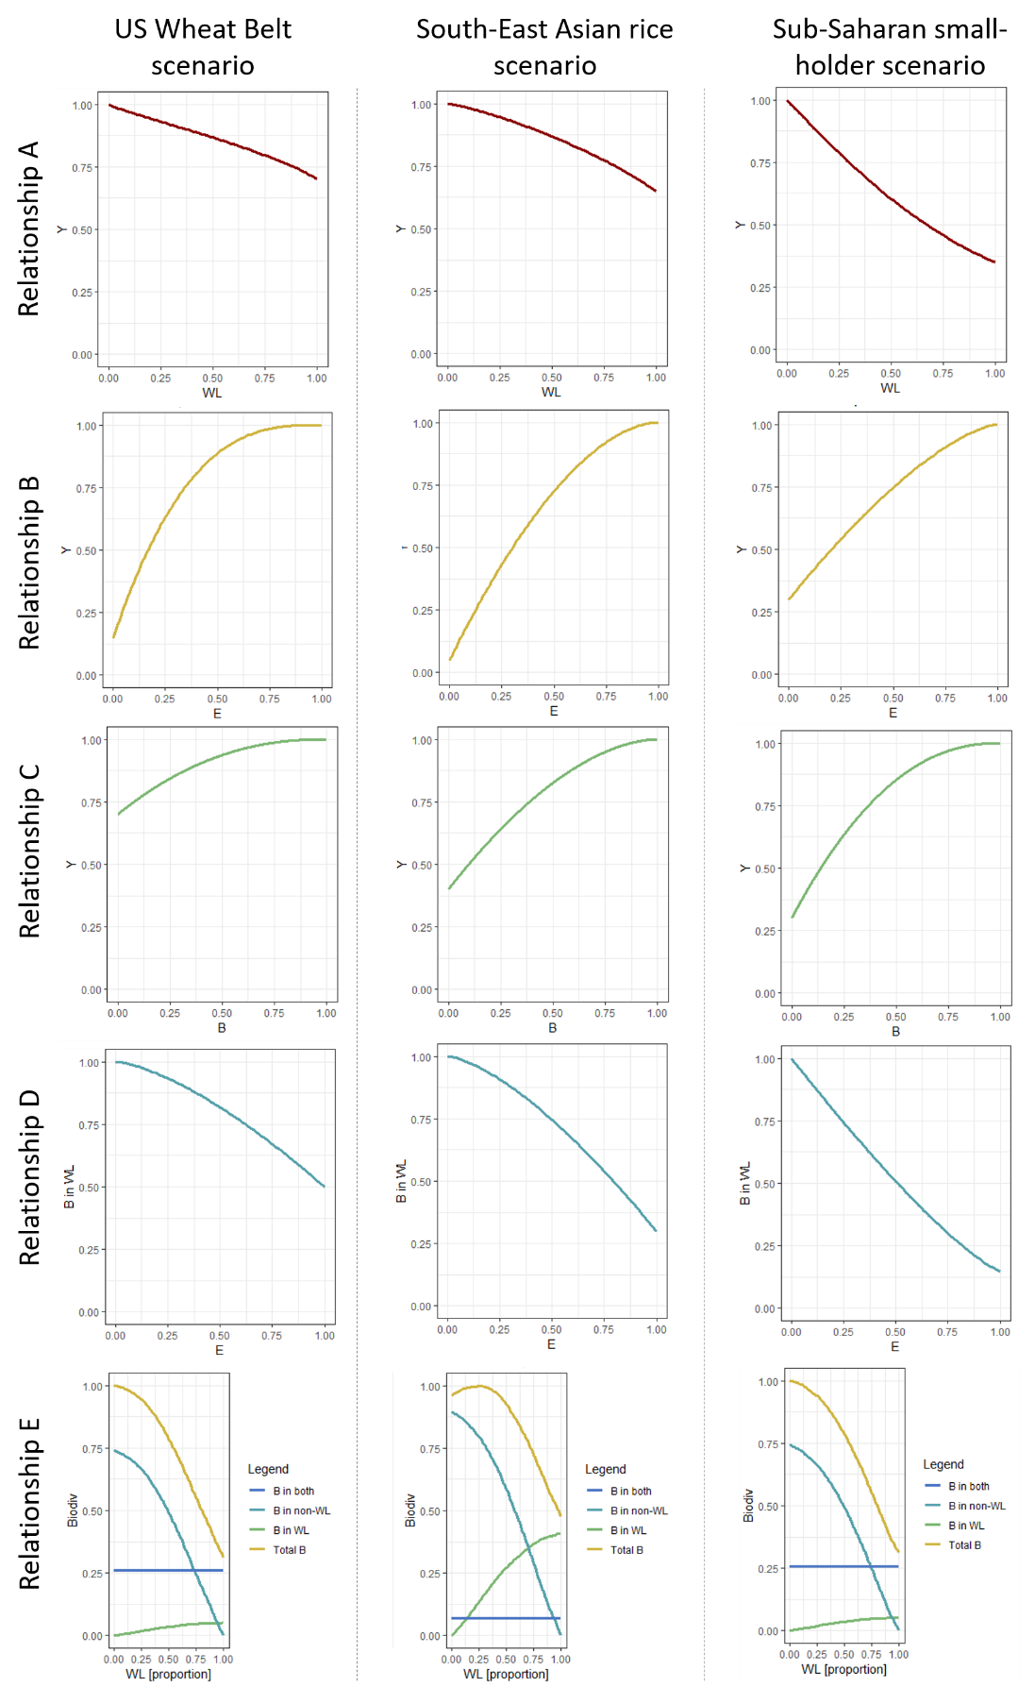
Fig. S1: Visualisation of the five key relationships for the three archetypal case-studies. B stands for biodiversity, WL for working land (i.e. proportion of landscape used for crop production), Y for yield, non-WL for semi-natural and natural habitat (i.e. non-working land).
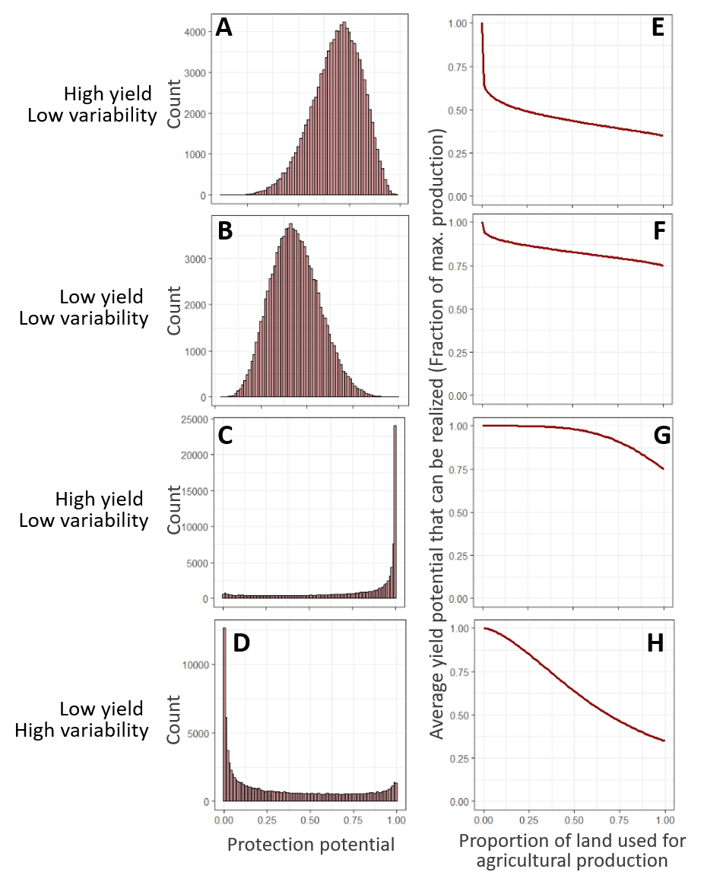
Fig. S2: Examples for the distribution of production potential in agricultural landscapes. A-D display distributions and E-F the respective relationships between average potential yield of used fields and proportion of land used for agriculture (curve is derived from distribution). Parameter settings for mean yield and variance of yields (ranges from 0 to 1) were respectively 0.75 and 0.05 (high yield, low variability), 0.25 and 0.05 (low yield, low variability), 0.75 and 0.5 (high yield, high variability) and 0.25 and 0.5 (low yield, high variability).

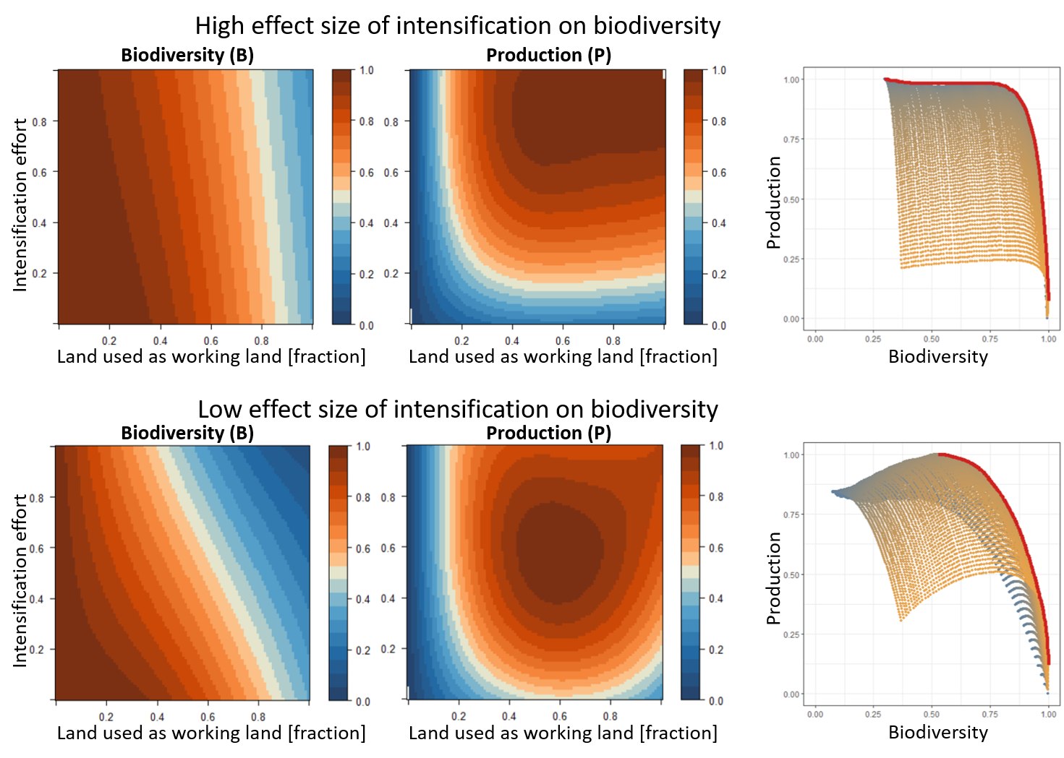
Fig. S3: The dependency of biodiversity and total production on the intensity of conventional intensification and the extent of working lands in two artificial landscapes. The two artificial landscapes have been parametrised based on mean literature values for four of the five key relationships and only differ in the parametrisation for relationship D, defining biodiversity responses to conventional intensification. Both landscapes show a linear impact of intensification on biodiversity but landscape 1 (top) was characterised by an effect size of 0.2 whereas the effect size in landscape 2 (bottom) was 0.8. The consequence is that in landscape 1, intensification traps cannot emerge because the negative impact of yield on biodiversity is to small that negative biodiversity feedback-effects on yields overcome the positive effect of intensification on yields. A contrasting situation is found in landscape 2.

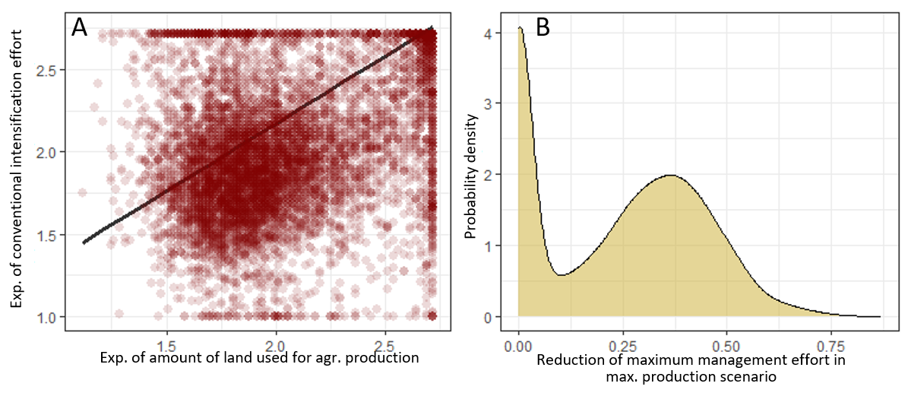
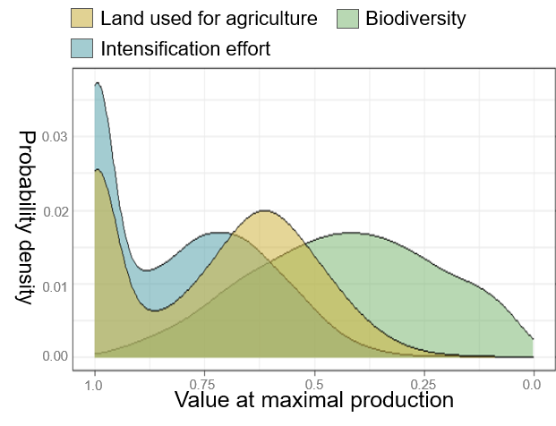
Fig. S4: The land management options that support maximum total food production in 10000 artificial landscapes. (A) The relationship between conventional intensification and the amount of land used for agricultural production, which represent the two components of land management considered in our study. Plotted is the land management that leads to maximal food production. Each point represents an individual landscape. The two land management components were positively related. The result of a type 2 regression (R² = 0.36, p < 0.001) is depicted as black line. (B) The distribution of how strongly optimal land management (highest production) deviates from the maximum management scenario (maximal conventional intensification and agricultural land-use). The difference has been calculated as Euclidian distance and is scaled from 0 to 1 with the latter representing the largest possible distance.
Fig. S5: The distributions of biodiversity values, the amount of land used for agricultural production and the conventional intensification effort that support maximum total food production in 10000 artificial landscapes. Biodiversity values are scaled to the maximum biodiversity that can be reached in a landscape

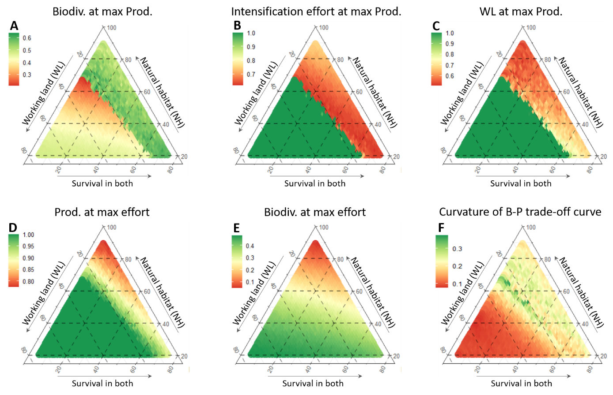
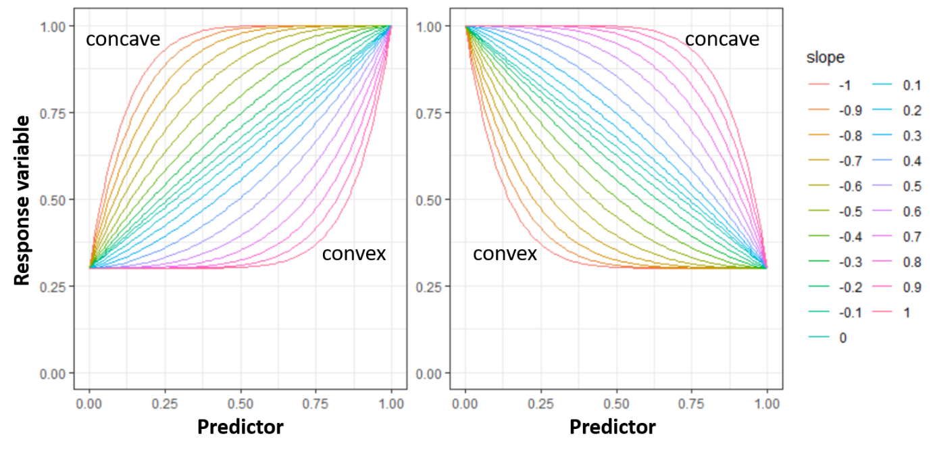
Fig. S7: Model responses to changes in habitat requirements of species in the regional species pool. Habitat requirements are defined as inhabiting (i) natural habitat, (ii) working lands or (iii) the ability to survive in both. Displayed as response variables are (A) biodiversity in the scenario with the highest total crop production, (B) the conventional intensification effort in the scenario with the highest production, (C) the proportion of land used as working land in the scenario with the highest production, (D) the production achieved in the scenario with the maximum management effort (i.e. conventional intensification and agricultural land use are both at their maximum), (E) the biodiversity maintained in the scenario with the maximum management effort and (F) the curvature (i.e. measure for exponential nature) of biodiversity-production trade-off curves.

Fig. S6: Possible shapes of the relationship between predictor and response variable in negative (left) and positive (right) relationships. Extreme endpoints of relationships range between highly concave (shape constant of -1) and highly convex (shape constant of 1) with a shape constant of 0 indicating a linear relationship.
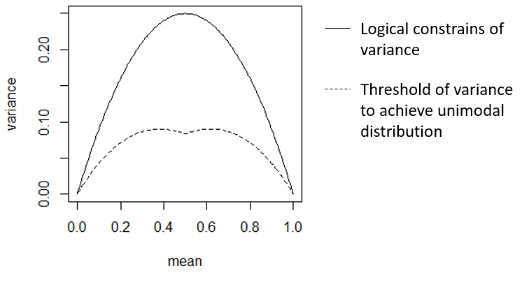
Fig. S8: Logical constrain of variance (solid line) and the variance threshold to achieve unimodal distributions (dashed line) in beta distributions in relation to different mean values.

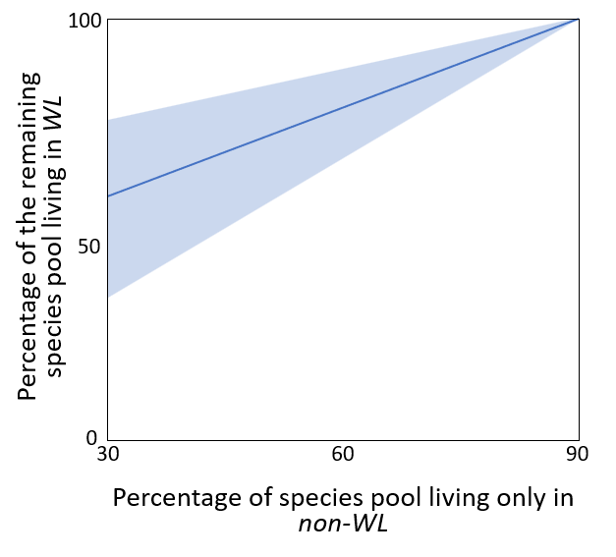
Fig. S9: In the creation of artificial landscapes, the percentage of species that can survive in non-WL ranged between 30 and 90%. 90% would represent a landscape where natural habitat is highly diverse (e.g. tropical rainforest), whilst 30% would indicate that the original natural habitat is relatively poor in species and that transformations into cropland with associated fertilisation can increase species richness (e.g. situation frequently encountered in tropical soils (Barnes et al. 2017)). Further, we set the range of species living in WL to 10-70% of the total species pool. We thereby defined a minimum level of 10% based on the reasoning that there will be always some species that are specialised to the planted crops and that will not be able to persist in natural habitats. Finally, the resulting range of species that can survive in both WL and non-WL was 0-60%. The graph displays the impact of changes in the percentage of species living in non-WL on the percentage of the remaining species that live in WL. The blue line represents expect values and the shaded area its standard deviation in the stochastic landscape creation process.

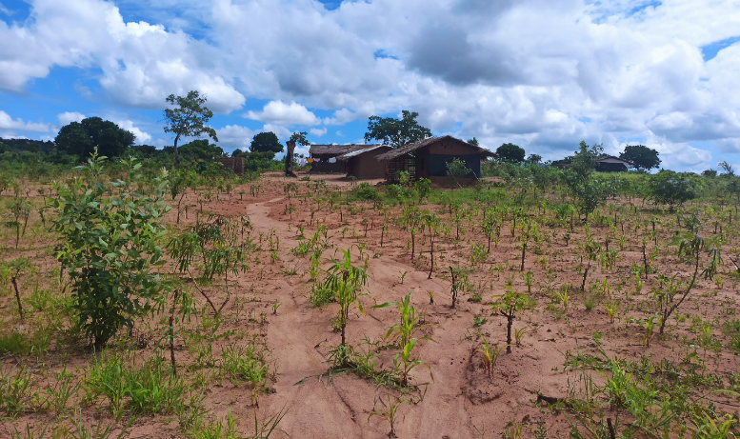
Fig. S10: Example of African small-holder system in Northern Mozambique. Within a small area, cassava is intercropped with maize, bean, peanuts, sweet potatoes and pumpkins. Additionally, cashew, papaya and mango trees as well as other medicinal and timber trees are used to create an agroforestry system that is high in crop diversity at the field level.

References
Atlin, G., Lafitte, H., Tao, D., Laza, M., Amante, M. & Courtois, B. (2006) Developing rice cultivars for high-fertility upland systems in the Asian tropics. Field crops research, 97, 43-52.
Barnes, A.D., Allen, K., Kreft, H., Corre, M.D., Jochum, M., Veldkamp, E., Clough, Y., Daniel, R., Darras, K. & Denmead, L.H. (2017) Direct and cascading impacts of tropical land-use change on multi-trophic biodiversity. Nature Ecology & Evolution, 1, 1511-1519.
Betts, M.G., Wolf, C., Pfeifer, M., Banks-Leite, C., Arroyo-Rodríguez, V., Ribeiro, D.B., Barlow, J., Eigenbrod, F., Faria, D. & Fletcher Jr, R.J. (2019) Extinction filters mediate the global effects of habitat fragmentation on animals. Science, 366, 1236-1239.
Bishop, J. & Nakagawa, S. (2021) Quantifying crop pollinator dependence and its heterogeneity using multi‐level meta‐analysis. Journal of Applied Ecology, 58, 1030-1042.
Brühl, C.A., Bakanov, N., Köthe, S., Eichler, L., Sorg, M., Hörren, T., Mühlethaler, R., Meinel, G. & Lehmann, G.U. (2021) Direct pesticide exposure of insects in nature conservation areas in Germany. Scientific Reports, 11, 1-10.
Bushong, J.A., Griffith, A.P., Peeper, T.F. & Epplin, F.M. (2012) Continuous winter wheat versus a winter canola–winter wheat rotation. Agronomy Journal, 104, 324-330.
Conelly, W.T. & Chaiken, M.S. (2000) Intensive farming, agro-diversity, and food security under conditions of extreme population pressure in Western Kenya. Human Ecology, 28, 19-51.
Deutsch, C.A., Tewksbury, J.J., Tigchelaar, M., Battisti, D.S., Merrill, S.C., Huey, R.B. & Naylor, R.L. (2018) Increase in crop losses to insect pests in a warming climate. Science, 361, 916-919.
Dominik, C., Seppelt, R., Horgan, F.G., Marquez, L., Settele, J. & Václavík, T. (2017) Regional-scale effects override the influence of fine-scale landscape heterogeneity on rice arthropod communities. Agriculture, Ecosystems & Environment, 246, 269-278.
Filgueiras, B.K., Peres, C.A., Melo, F.P., Leal, I.R. & Tabarelli, M. (2021) Winner–loser species replacements in human-modified landscapes. Trends in Ecology & Evolution, 36, 545-555.
Isaacs, K.B., Snapp, S.S., Chung, K. & Waldman, K.B. (2016) Assessing the value of diverse cropping systems under a new agricultural policy environment in Rwanda. Food Security, 8, 491-506.
Klein, A.-M., Vaissiere, B.E., Cane, J.H., Steffan-Dewenter, I., Cunningham, S.A., Kremen, C. & Tscharntke, T. (2007) Importance of pollinators in changing landscapes for world crops. Proceedings of the Royal Society B: Biological Sciences, 274, 303-313.
Kraft, N.J., Adler, P.B., Godoy, O., James, E.C., Fuller, S. & Levine, J.M. (2015) Community assembly, coexistence and the environmental filtering metaphor. Functional ecology, 29, 592-599.
Kuyah, S., Whitney, C.W., Jonsson, M., Sileshi, G.W., Öborn, I., Muthuri, C.W. & Luedeling, E. (2019) Agroforestry delivers a win-win solution for ecosystem services in sub-Saharan Africa. A meta-analysis. pp. 1-18. Springer.
Liu, W., Yang, H., Folberth, C., Müller, C., Ciais, P., Abbaspour, K.C. & Schulin, R. (2018) Achieving high crop yields with low nitrogen emissions in global agricultural input intensification. Environmental science & technology, 52, 13782-13791.
Ludemann, C.I., Gruere, A., Heffer, P. & Dobermann, A. (2022) Global data on fertilizer use by crop and by country. Scientific data, 9, 501.
Maitima, J.M., Mugatha, S.M., Reid, R.S., Gachimbi, L.N., Majule, A., Lyaruu, H., Pomery, D., Mathai, S. & Mugisha, S. (2009) The linkages between land use change, land degradation and biodiversity across East Africa. African Journal of Environmental Science and Technology, 3.
Martin, E.A., Dainese, M., Clough, Y., Báldi, A., Bommarco, R., Gagic, V., Garratt, M.P., Holzschuh, A., Kleijn, D. & Kovács‐Hostyánszki, A. (2019) The interplay of landscape composition and configuration: new pathways to manage functional biodiversity and agroecosystem services across Europe. Ecology letters, 22, 1083-1094.
McArt, S.H., Urbanowicz, C., McCoshum, S., Irwin, R.E. & Adler, L.S. (2017) Landscape predictors of pathogen prevalence and range contractions in US bumblebees. Proceedings of the Royal Society B: Biological Sciences, 284, 20172181.
Montfort, F., Begue, A., Leroux, L., Blanc, L., Gond, V., Cambule, A.H., Remane, I.A. & Grinand, C. (2021) From land productivity trends to land degradation assessment in Mozambique: Effects of climate, human activities and stakeholder definitions. Land Degradation & Development, 32, 49-65.
Oostendrop, R. & Zaal, F. (2012) Farm- and household-level drivers of agricultural innovation in machakos and Kitui districts, Kenya. Sustainable land management in the tropics: Explaining the miracle (eds F. Zaal & K. Burger), pp. 45-64. Ashagte Publishing, Farnham.
Pywell, R.F., Heard, M.S., Woodcock, B.A., Hinsley, S., Ridding, L., Nowakowski, M. & Bullock, J.M. (2015) Wildlife-friendly farming increases crop yield: evidence for ecological intensification. Proceedings of the Royal Society B: Biological Sciences, 282, 20151740.
Rudel, T.K. (2013) The national determinants of deforestation in sub-Saharan Africa. Philosophical Transactions of the Royal Society B: Biological Sciences, 368, 20120405.
Saito, K., Asai, H., Zhao, D., Laborte, A.G. & Grenier, C. (2018) Progress in varietal improvement for increasing upland rice productivity in the tropics. Plant Production Science, 21, 145-158.
Scaife, M. (1968) Maize fertilizer experiments in Western Tanzania. The Journal of Agricultural Science, 70, 209-222.
Siedenburg, J. (2006) The Machakos case study: Solid outcomes, unhelpful hyperbole. Development Policy Review, 24, 75-85.
Stover, H.J. & Henry, H.A. (2018) Soil homogenization and microedges: perspectives on soil‐based drivers of plant diversity and ecosystem processes. Ecosphere, 9, e02289.
Szabo, N.D., Colla, S.R., Wagner, D.L., Gall, L.F. & Kerr, J.T. (2012) Do pathogen spillover, pesticide use, or habitat loss explain recent North American bumblebee declines? Conservation Letters, 5, 232-239.
Thornton, P.K. & Herrero, M. (2015) Adapting to climate change in the mixed crop and livestock farming systems in sub-Saharan Africa. Nature Climate Change, 5, 830-836.
Vocke, G. & Ali, M. (2013) US wheat production practices, costs, and yields: Variations across regions.
Zou, Y., De Kraker, J., Bianchi, F.J., Xiao, H., Huang, J., Deng, X., Hou, L. & Van Der Werf, W. (2020) Do diverse landscapes provide for effective natural pest control in subtropical rice? Journal of Applied Ecology, 57, 170-180.

