Supporting Information

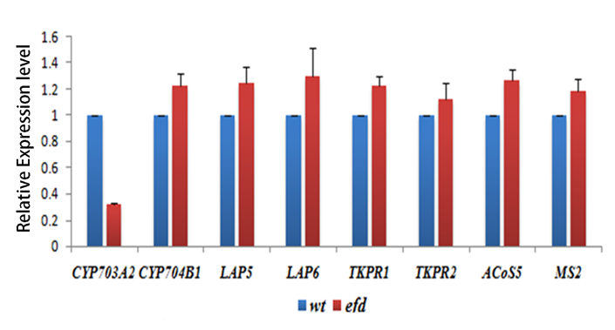

Figure S1. Expression of eight sporopollenin synthesis related genes in wild type and efd. The expression of CYP703A2 was significantly down-regulated in efd compared with that in the wild type. The other seven crucial sporopollenin synthesis related genes showed similar expression level in wild type and efd.

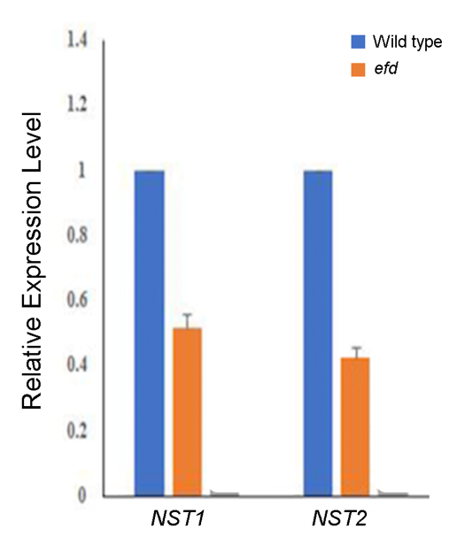

Figure S2. Expression of NST1 and NST2 in the wild type and efd. The expression of NST1 and NST2 were significantly down-regulated in efd.

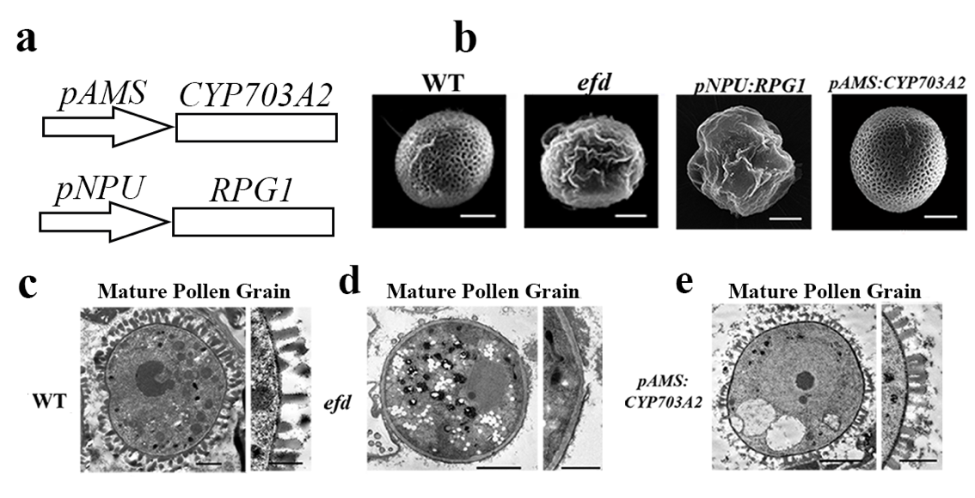

Figure S3. The pollen phenotype of the rescue constructions of CYP703A2 and RPG1/SWEET8 (a), diagrams of constructs: CYP703A2 was constructed under the AMS promoter, and RPG1 was constructed under the NPU promoter. (b), mature pollen grain observation of wild type, efd, and the pNPU: RPG1/SWEET8. No pollen grains were found in the pNPU: RPG1/SWEET8 and the pAMS: CYP703A2 transgenic plants. Bars=10μm. (c)-(e), TEM observations of the mature pollen grains of wild type, efd and pAMS: CYP703A2, respectively. The pAMS: CYP703A2 pollen wall showed obviously restored wall pattern similar to that of the wild type pollen wall. Bars=1μm.

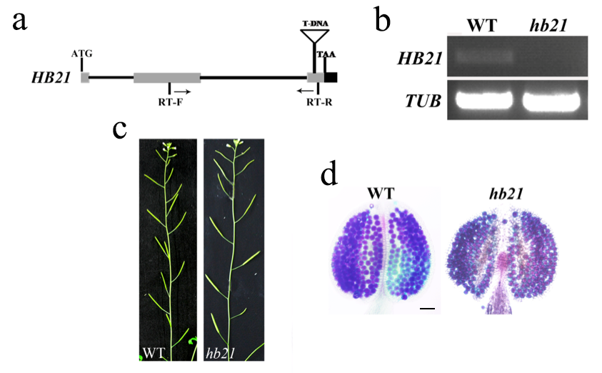

Figure S4. Characterization of HB21 gene and its knockout mutant. (a), gene structure of HB21.The T-DNA location and the identification primers of T-DNA insertion are noted on the gene structure. (b), amplification of HB21 transcripts in both wild type and hb21 buds. hb21 was a knockout mutant. (c), hb21 mutant showed normal fertility in compare with the wild type. (d), the hb21 mutant can produce normal pollen grains in compare with the wild type. Bar=20μm

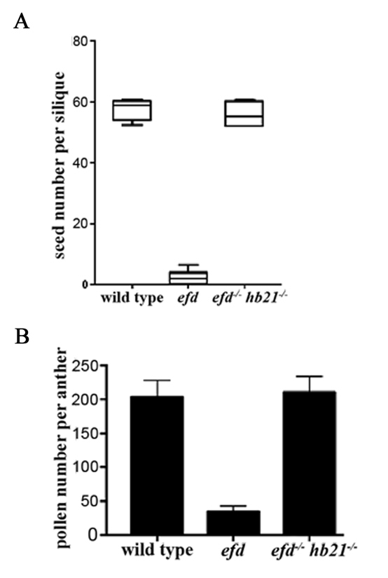
Figure S5. Fertility analysis of wild type, efd and efd hb21 (A), statistics of seed sets per silique in wild type, efd and efd hb21. The seed production was significantly restored in efd hb21 compared with that in the efd single mutant. (B), statistics of pollen production per anther in wild type, efd and efd hb21. The efd hb21 double mutant can produce the normal number of pollen grains which is similar to that in the wild type.

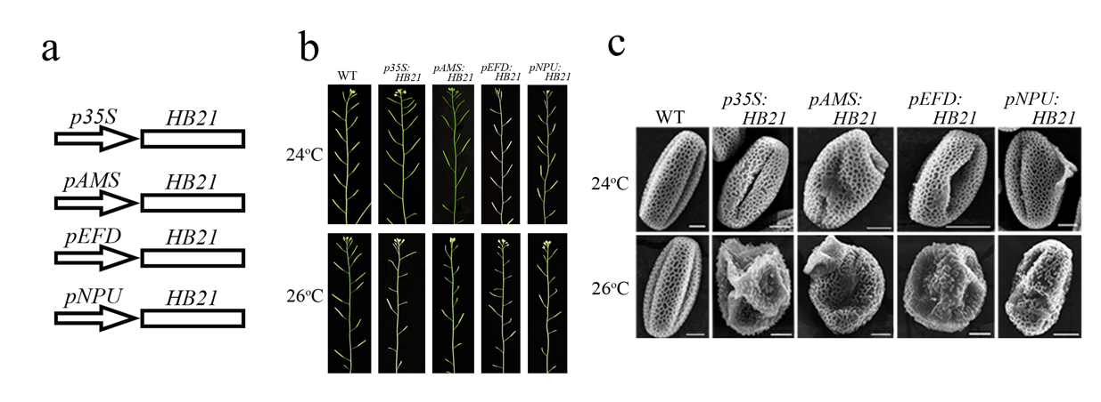
Figure S6. Fertility and pollen wall observations of the constructive and tissue-specific HB21 over-expression lines. (a), the diagrams of four constructs over-expressing HB21 including: p35S:HB21 (constructive promoter), pAMS:HB21 (tapetum-specific promoter), pEFD:HB21 (tapetum and microsporocyte-specific promoter) and pNPU:HB21 (microsporocyte-specific promoter). (b), the fertility images of the transgenic lines under 24ºC and 26ºC, respectively. The fertility of these lines were similar to the wild type under 24ºC, while it is significantly reduced under 26ºC. (c), the SEM observations of pollen surface of these transgenic lines. The pollen wall of these lines was normal under 24ºC. However, it became defective under 26ºC. Bars=10μm.

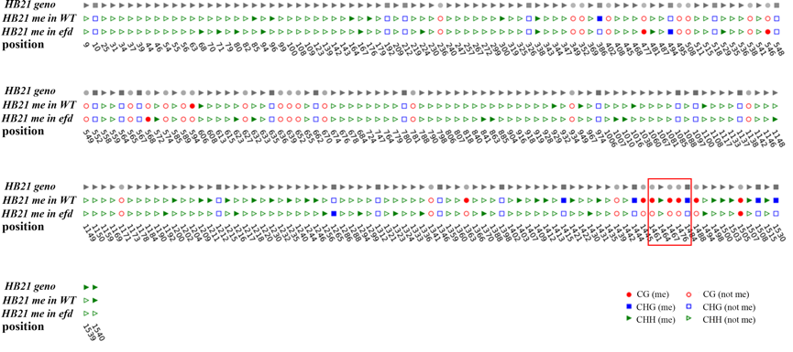
Figure S7. Cytosine methylation pattern of HB21 genomic sequence in wild type and efd. The distribution of cytosine methylation was significantly altered in efd. The number of the methylated cytosine was largely reduced. Particularly, the 1461st, 1464th , 1467th (in the red frame) and 1476th cytosine lost their methylation in efd.

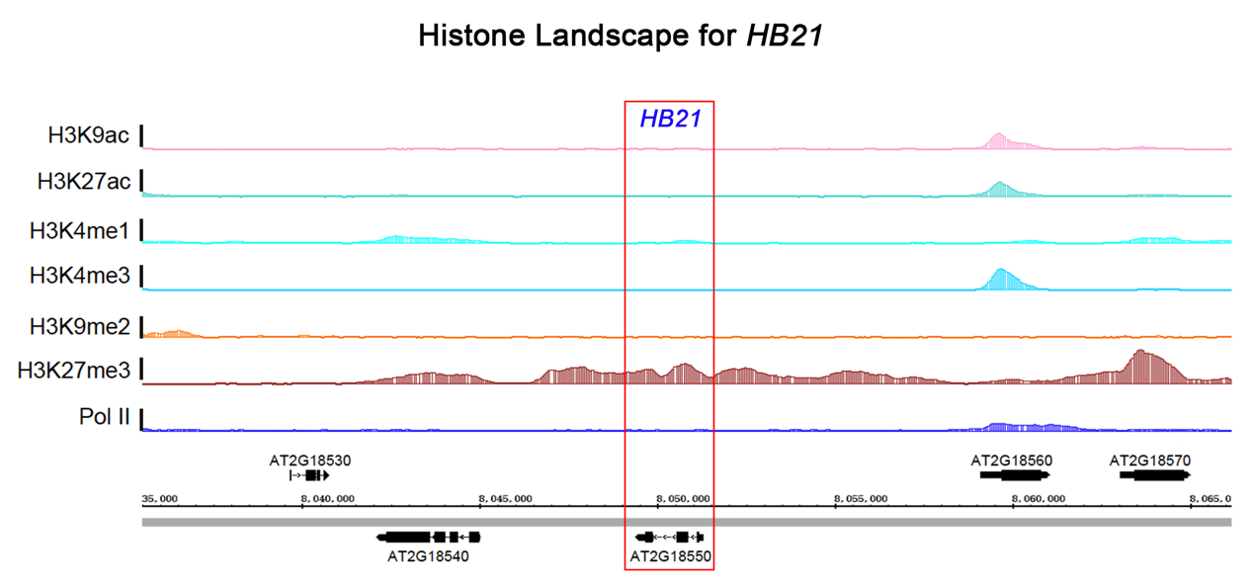
Figure S8. Histone Landscape for HB21. The H3K27me3 was highly deposited on the chromatin areas including HB21. Data was obtained from the study of Zhao et al., 2022.

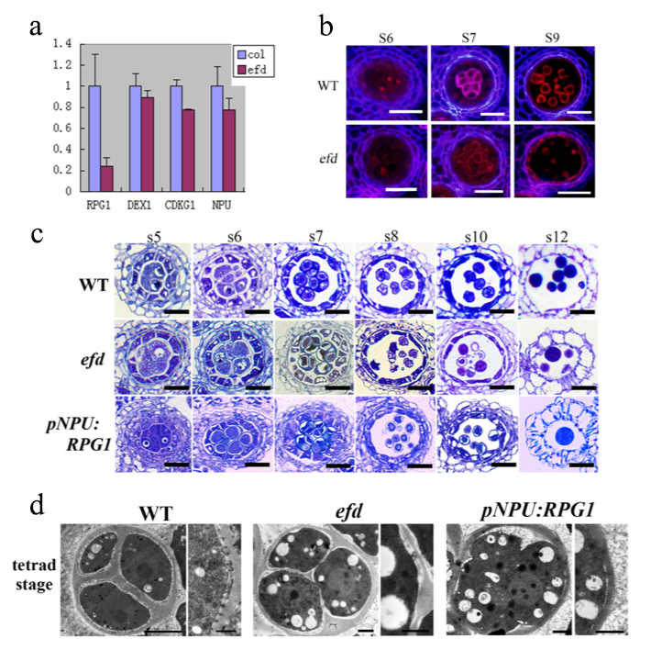

Figure. S9 Pollen wall development in pNPU:RPG1 lines. (a) Relative expression of the critical pollen wall pattern related genes. RPG1 was significantly down-regulated in efd compared with the wild type, while other crucial pollen wall pattern-related genes showed normal expression level in comparison with the wild type. (b) The Tinopal/DIOC2 staining of wild type and efd anthers. At tetrad stage, the wild type tetrad can be stained purple, indicating that the primexine occurred surrounding microspores in tetrads, while the efd tetrads failed to be stained purple. This indicates that the primexine formation in efd is defective. (c) Semi-thin slices of wild type, efd and the pNPU: RPG1 transgenic plant anthers during pollen development. The tetrads can be normally produced in the pNPU: RPG1 transgenic lines, but the pollen were still mostly ruptured similar to that in efd. Bars=50μm (d) TEM observation of wild type, efd and pNPU: RPG1 tetrads. The primexine cannot be observed surrounding the efd microspores in tetrads. The pNPU: RPG1 failed to rescue the primexine defect. Bars=1μm

