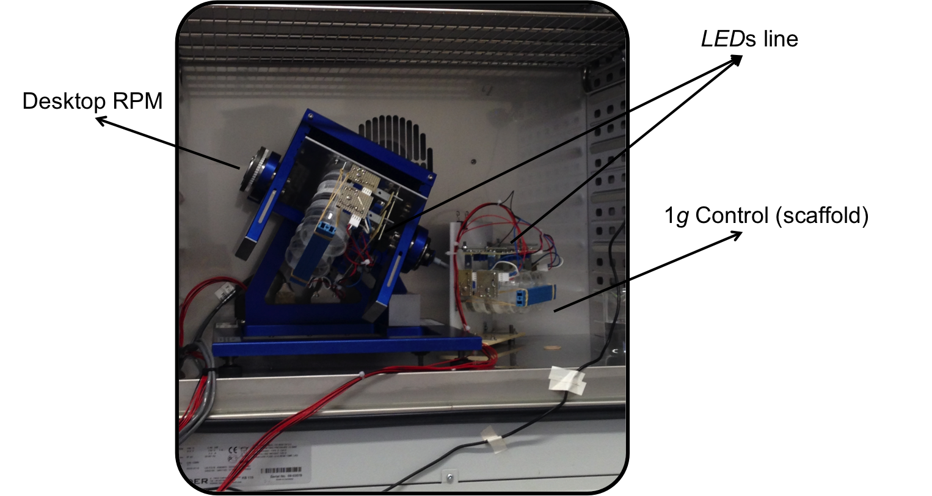
Figure S1. Desktop RPM facility inside incubator along with 1g Control scaffold. The growth of samples inside and outside RPM was under same conditions of temperature, humidity and illumination.

 | Forward | Reverse | Hybridization temperature | Cycle number
5´ETS  (p1/p2) | 5´ AGTCTGGGCAGTCCGTGGGG 3´ | 5´ ATGGCAGCCCACGCAAGCAA 3´ | 62⁰C | 25
5´ETS-P/18S  (p3/p4) | 5´ CGTAACGAAGATGTTCTTGGC 3´ | 5´ ATGCGTCCCTTCCATAAGTC 3´ | 50⁰C | 24
5´ETS/18S  (p5/p6) | 5´ TTGGAACGATTGATGATTTTGAGT 3´ | 5´ TTACACATGCATGGC 3´ | 45⁰C | 25
25s/3´ETS  (p7/p8) | 5´ GTCGCTAAGATTCGAC 3´ | 5´ CCTCGGACCCGGTAAAC 3´ | 50⁰C | 30
3´ETS  (p9/p10) | 5´ GACAGACTTGTCCAAAACGCCCACC 3´ | 5´ CTGGTCGAGGAATCCTGGACGATT 3´ | 55⁰C | 30
eIF1α | 5´ CTAAGGATGGTCAGACCCG 3´ | 5´ CTTCAGGTATGAAGACACC 3´ | 55⁰C | 30
Table S1. Primer sequences used for pre-RNA 45S processing study in plant aerial part. Hybridization or alignment temperature and number of cycles of PCR for each pair of primers are shown.

Gene | Forward | Reverse
EIR1 (PIN2) | 5´ GCAATGTTTAACGCAAGCAA 3´ | 5´GCCTCCTCTTCCTGCTTTCT 3´
TIR1 | 5´ ATTTTGGGATGCTGTTCCTG 3´ | 5´ GAAGCAAGCACCTCAAGACC 3´
CK2A;2 | 5´ ACCAGGATCAGCTCGTCAAA 3´ | 5´ CTTTCTGCTGCCCTGACTTG 3´
CYCB1;2 | 5´ GTGCCTTGCTTATTGCTTCC 3´ | 5´ ATTGCCTTCATCACCAG 3´
NUC1 | 5´ CCGAGAGGAGATAGCAGTGG 3´ | 5´ TCCACGACCACGATCACTT 3´
NUC2 | 5´ CCAAGAGATAGTGATGAGGG 3´ | 5´ CATTACACTTGGTTTGCTGG 3´
FIB1 | 5´ CGTCTTTCGTTCTTCACTTTTAGACAAG 3´ | 5´ GCCCACTACGGCCTCTGTCA 3´
5´ETS  (p11/p12) | 5´ TTGGAACGATTGATGATTTTGAGT 3´ | 5´ GCCTACGAACACTAGCTATCCGA 3´
3´ETS  (p13/p14) | 5´ GAATTCCCAACTTTACACGAGCTC 3´ | 5´ AAGTAATAACATTTAACCTCGAGAGACGAG 3´
25S  (p15/p16) | 5´TGTTCACCCACCAATAGGGAA 3´ | 5´ TCAGTAGGGTAAAACTAACCTGTCTCAC 3´
ACTIN-2 | 5´GCACCCTGTTCTTCTTACCG 3´ | 5´ATCCAGCACAATACCGGTTGTA 3´
Table S2. Primer sequences used to study ribosome biogenesis, cell proliferation, cell growth and auxin polar transport in roots by RT-qPCR.

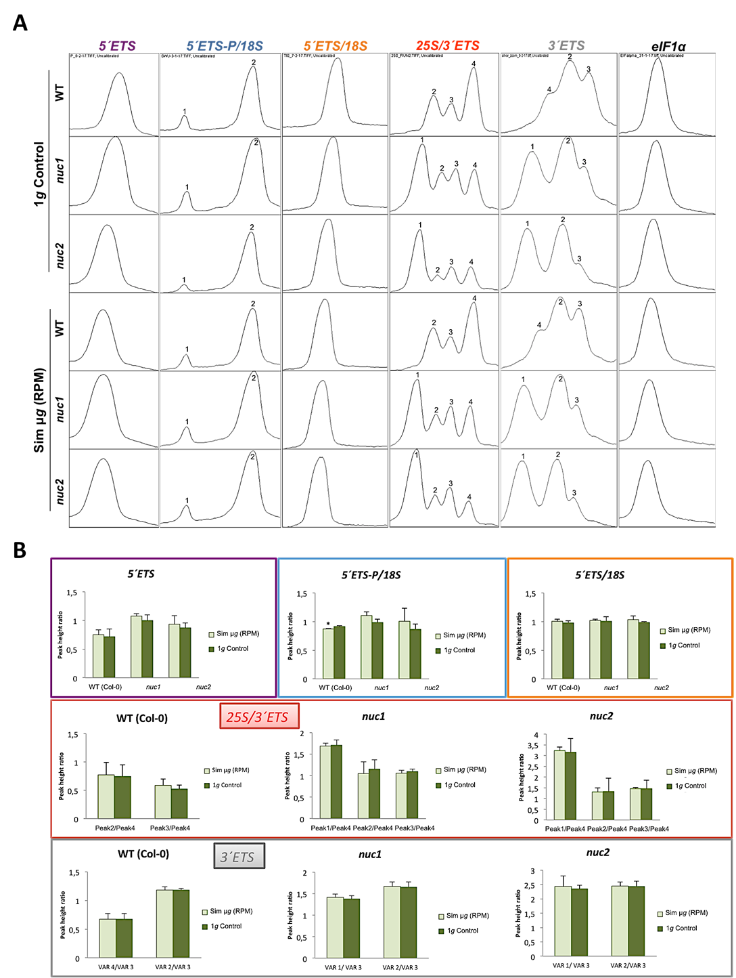
Figure S2. Study by RT-PCR of pre-rRNA processing in aerial part (hypocotyl) of Arabidopsis thaliana seedlings (Col-0, nuc1 and nuc2) grown with photoperiod regime under simulated microgravity and ground gravity level. A) Peaks profile obtained for each amplicon by computational analysis (ImageJ software) where the height of the peak was proportional to the intensity of the bands. B) Peak height ratio for each genotype and experimental condition was calculated for 3´ETS end as the ratio between height of the peak of each PCR product with respect to the smallest band (peak 4 for 3´ETS primers and VAR 3 for all VAR primers). For 5´ETS end this ratio was the ratio of the amplicons height with respect to eIf1α level amplification (standard internal). Bars indicate standard deviation.
* Significant differences in comparison with 1g control (p-value<0.05, T-Student Test) (three biological replicates).

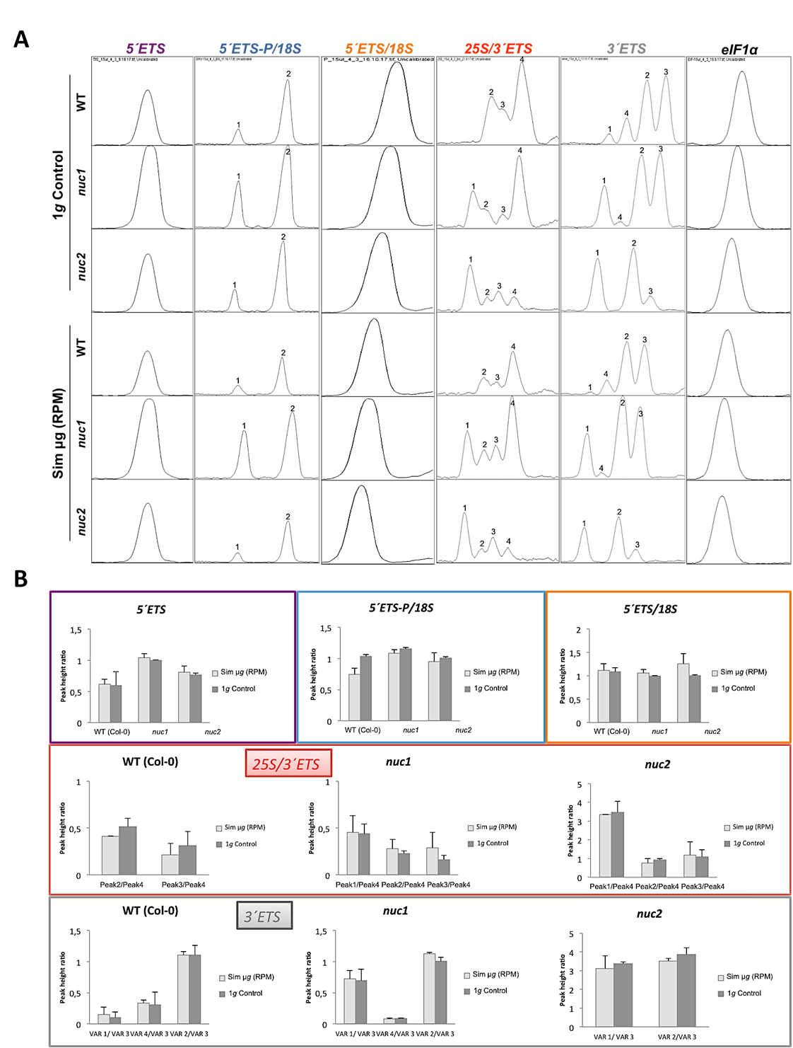
Figure S3. Study by RT-PCR of pre-rRNA processing in aerial part (hypocotyl) (three biological replicates) of Arabidopsis thaliana seedlings (Col-0, nuc1 and nuc2) grown in absence of light under simulated microgravity and ground gravity level. A) Peaks profile obtained for each amplicon by computational analysis (ImageJ software) where the height of the peak was proportional to the intensity of bands. B) Peak height ratio for each genotype and experimental condition was calculated for 3´ETS end as the ratio between height of the peak of each PCR product with respect to the smallest band (peak 4 for 3´ETS primers and VAR 3 for all VAR primers) For the 5´ETS end this ratio was the ratio of the amplicons height with respect to eIf1α level amplification (standard internal). Bars indicate standard deviation.

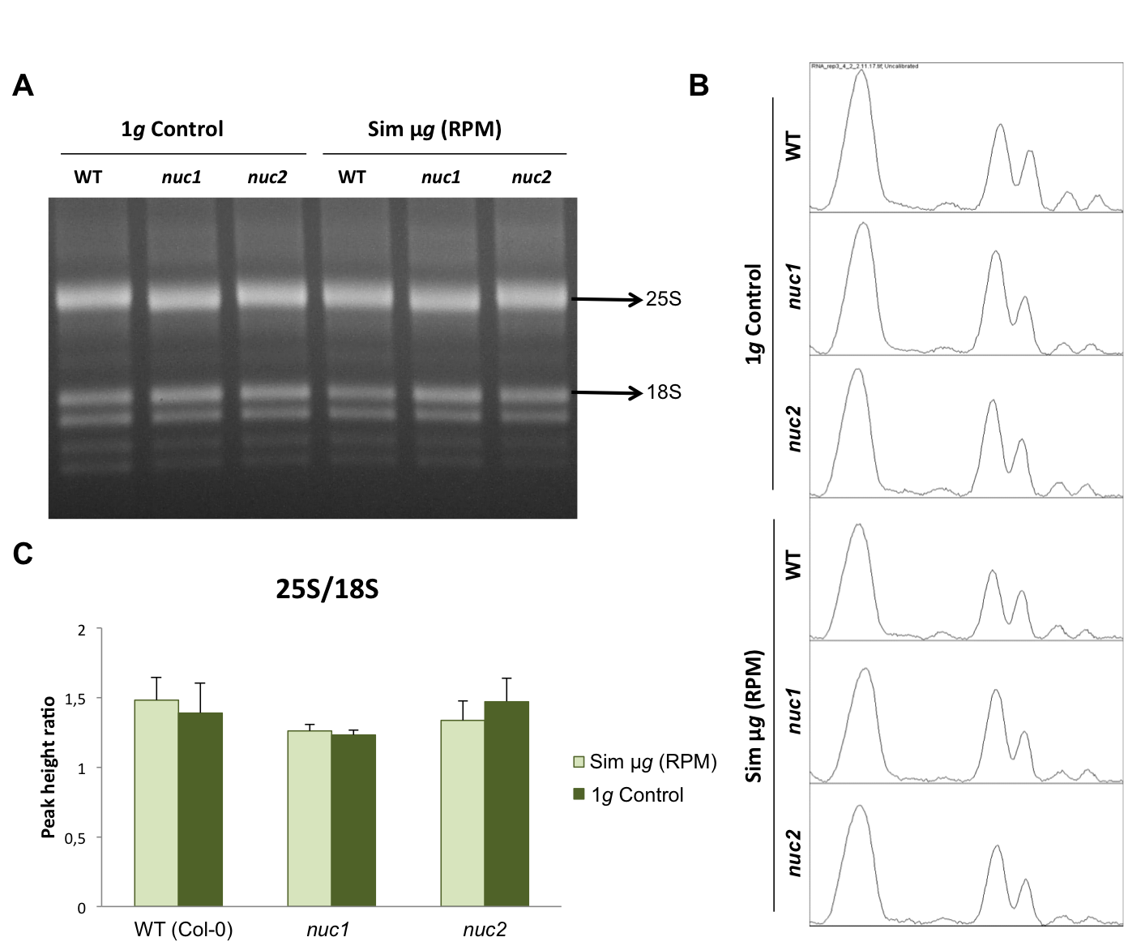
Figure S4. 25S/18S RNA ratio existing in total RNA of plant aerial part in seedlings grown for 6 days under simulated microgravity (RPM) or 1g control and photoperiod regime. A) Images of agarose gels indicating each experimental condition (Sim μg RPM and 1g Control) and each Arabidopsis thaliana line (Col-0, nuc1 and nuc2) used. The original gel was cropped, from the image shown in Figure S8. B) Agarose gel densitometry (peaks profile). C) Average value (three biological replicates) of 25S/18S ratio.

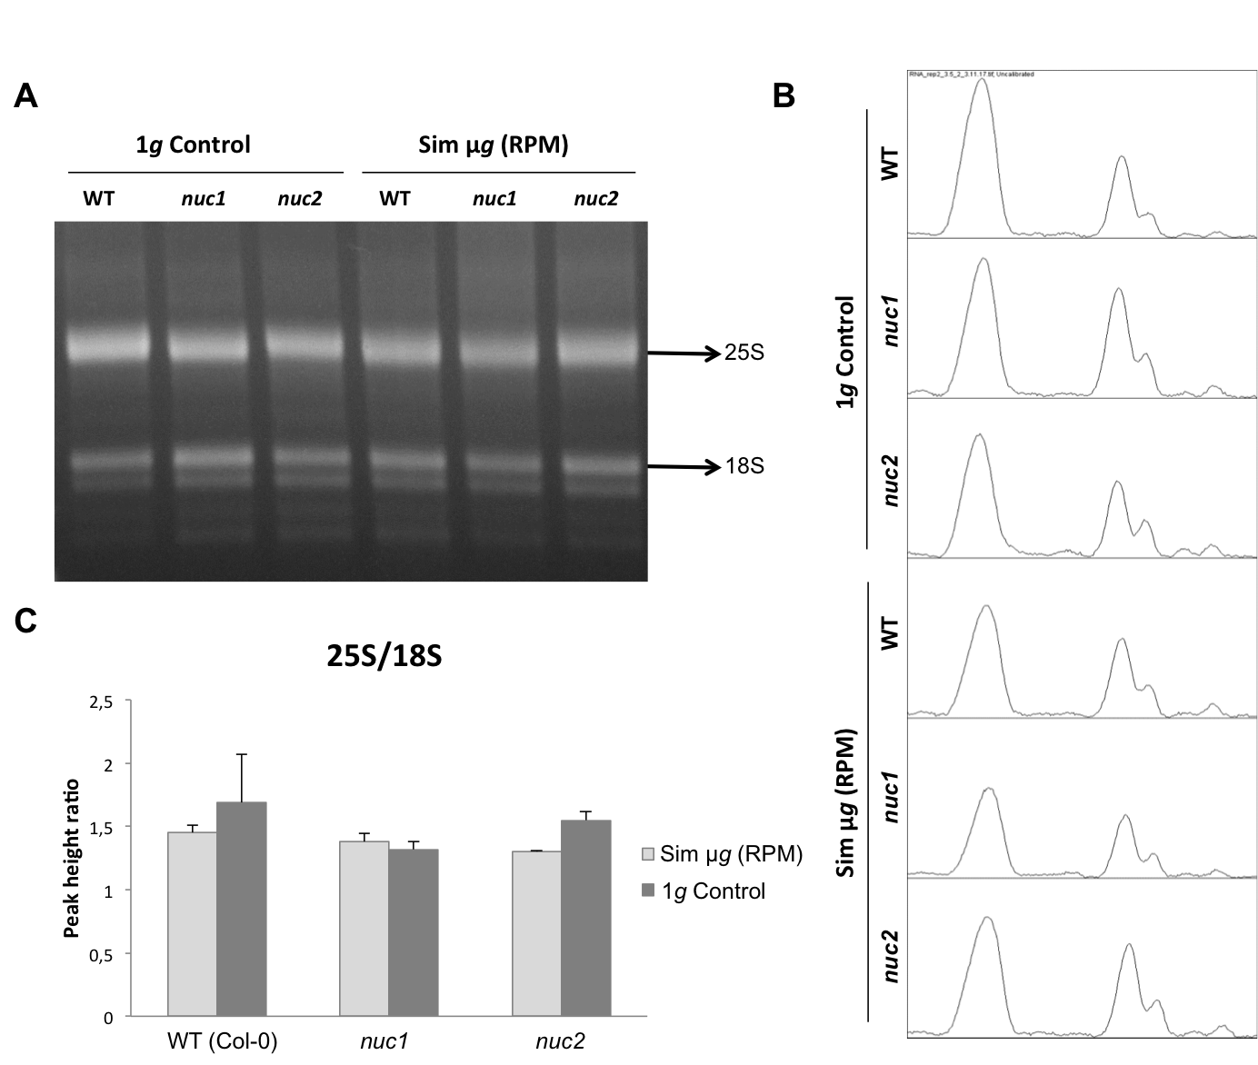
Figure S5. 25S/18S RNA ratio existing in total RNA of plant aerial part in seedlings grown for 6 days under simulated microgravity (RPM) or 1g control and darkness. A) Images of agarose gels indicating each experimental condition (Sim μg RPM and 1g Control) and each Arabidopsis thaliana line (Col-0, nuc1 and nuc2) used. The original gel was cropped, from the image shown in Figure S9. B) Agarose gel densitometry (peaks profile). C) Average value (three biological replicates) of 25S/18S ratio.

5’ETS (down) | 5’ETS-P/18S (up)
5’ETS/18S (up) | 25S/3’ETS (up)
3’ETS | elF1α (up)
Figure S6. Original uncropped gels of the images shown in Figure 3B (Photoperiod). The specific sequences are indicated in each case. In the cases in which the image contains two gels, the image selected for inclusion in Figure 3B is indicated by “up” or “down”.

5’ETS | 5’ETS-P/18S
5’ETS/18S | 25S/3’ETS
3’ETS | elF1α
Figure S7. Original uncropped gels of the images shown in Figure 3C (Darkness). The specific sequences are indicated in each case.

Figure S8. Original uncropped gel of the image shown in Figure S4A.

Figure S9. Original uncropped gel of the image shown in Figure S5A.

