Supplementary Information for:

Instability of Cs_{1-x}FA_{x}PbI₃ quantum dots – the role of ion migration, octahedral tilt and the A-site cation
Weilun Li¹, Mengmeng Hao², Lianzhou Wang², Joanne Etheridge^{1,3,4*}
¹Department of Materials Science and Engineering, Monash University, Victoria, 3800, Australia
²Nanomaterials Centre, Australian Institute for Bioengineering and Nanotechnology, School of Chemical Engineering, The University of Queensland, St Lucia, Queensland, Australia
³Monash Centre for Electron Microscopy, Monash University, Victoria, 3800, Australia
⁴School of Physics and Astronomy, Monash University, Victoria, 3800, Australia
*e-mail: joanne.etheridge@monash.edu (Joanne Etheridge)

This PDF file includes:
Supplementary Note 1 to 11
Supplementary Figures 1 to 11
References

Supplementary Note 1
Quantification of total electron in STEM mode
A precise measurement of the total electron dose applied to a region of interest is essential, if we are to make meaningful TEM measurements of beam-sensitive materials, such as hybrid perovskites. The total electron dose is the number of electrons per second per area (current density) summed over the total time the area is illuminated. Probe current in a TEM can be measured by different methods. The probe current that is used for atomic resolution imaging in STEM of hybrid perovskites is generally much less than 5 pA. In this dose range, measurements made by a direct electron detection camera offers the most precise approach for measuring current, compared with alternative methods such as using a built-in screen amperemeter, Faraday cup or drift tube¹.
In this work, a fast direct detection camera was used – an EMPAD from Thermo Fisher Scientific². Under the same electron-optical imaging conditions used in this work for STEM-ADF imaging, the probe was moved to the vacuum (called “vacuum probe”) and was recorded in the diffraction plane by the EMPAD running at 1000 fps. 10,000 frames of the vacuum probe were collected in a 10 s exposure time and averaged. In this way, all electrons in the incident probe were collected. The intensity unit was then converted to the number of electrons, using the antilog-digital-unit (ADU) determined at 300 kV. Knowing the acquisition time of a single frame (1 ms), the probe current was measured to be 1.48 pA.
To obtain the total dose in STEM mode, we can multiply by the probe dwell time (2 µs) and divide by the exposure area (pixel size = 0.647 Å), to give an estimate of the total dose (44.194 e/Å²).

Quantification of total electron dose in TEM mode
HR-TEM images were collected by a direct detection electron camera (K3-iS from Gatan Inc) in a counting mode. In this mode, the material in the field of view was illuminated uniformly by a broad, parallel electron beam. The total number of electrons hitting the camera was read directly and the total dose of a single frame in (e/Å²) was calculated, with extremely high precision.

Supplementary Note 2
Observation of iodine vacancy √2 x √2 superlattice
The ordered high-low-high image intensities at the Pb²⁺/I⁻ and I⁻ column positions observed in STEM-ADF images suggest that there is a corresponding √2 x √2 superstructure of iodine vacancies, V⁺_{I}. However, this interpretation needs to be checked via image simulations. In particular, the absence of FA⁺ cations at the A-site might influence the image intensity associated with neighbouring columns via dynamical scattering^{3,4}. In the simulated STEM-ADF image containing only ordered V⁻_{FA,} and no iodine vacancies the intensity oscillations at the Pb²⁺/I⁻ and I⁻ column positions are not observed, (Fig. S1(A, B)), inconsistent with the experimental data. In addition, as shown in the crystal model in Fig. S1C, geometrically, when a vacancy is present at the A-site, the four neighbouring I⁻ columns or Pb²⁺/I⁻ columns are symmetry equivalent, due to the cubic symmetry of its unit cell (space group = $pm\overline{3}m$). This means that in the STEM-ADF image, any influence of the central FA vacancies on the neighbouring sites would be equivalent and cannot lead to the experimentally observed ordering pattern of Pb²⁺/I⁻ and I⁻ column intensities. We have similarly performed the simulations with ordered I vacancies (Fig. S1(D-F)), which shows that ordered I vacancies also cannot lead to the ordered pattern at the A-site.
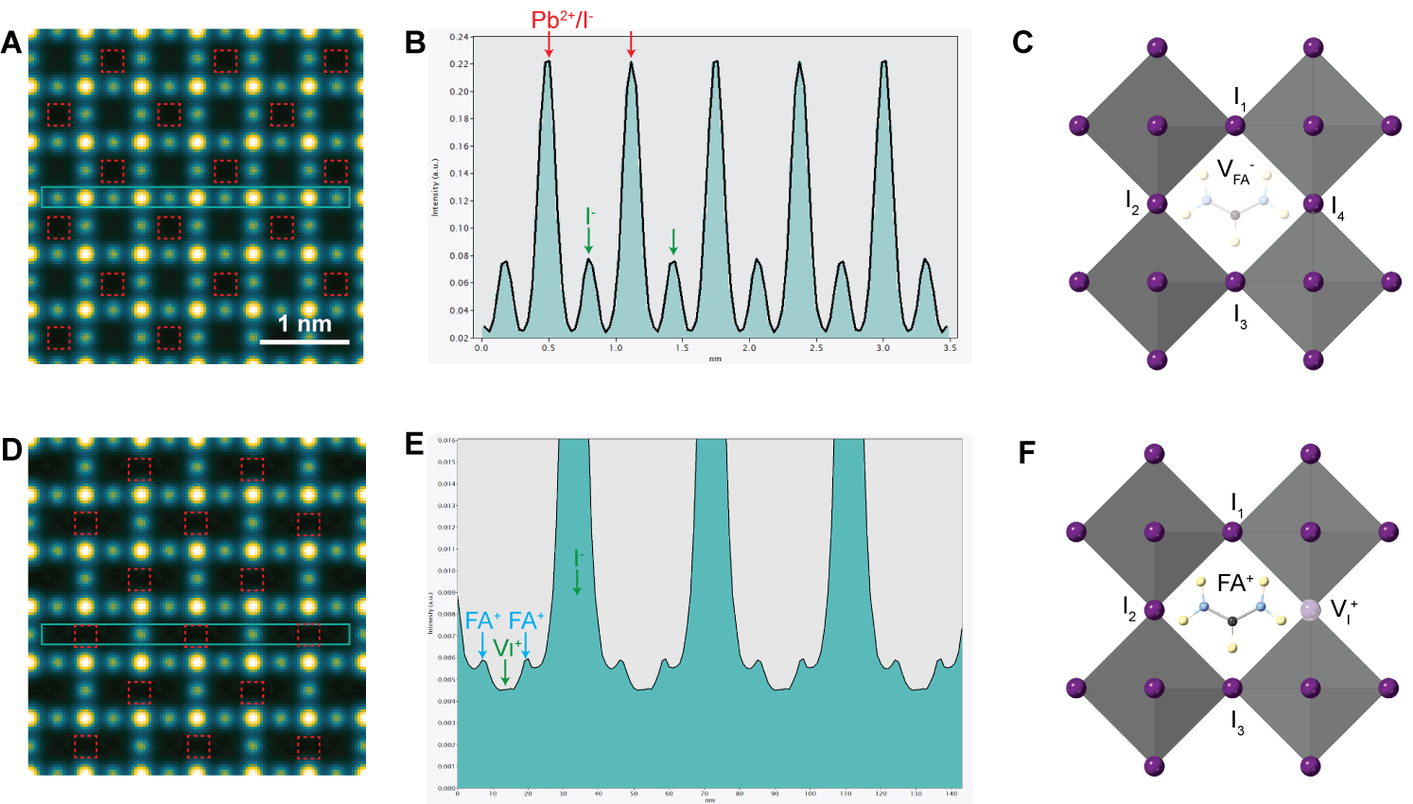
Fig. S1 STEM-ADF simulations of cubic FA_{0.5}PbI₃ QDs with ordered V⁻_{FA}. (A) simulated STEM-ADF under the same imaging conditions as that in Fig. 1. (B) Intensity line profile of the region marked in (A). (C) Crystal model of cubic perovskite structure containing V⁻_{FA}. (D-E) STEM-ADF simulations of the structure with ordered I⁻ vacancies (F).

Supplementary Note 3
Comment regarding determining the dose threshold from the Fourier transform of atomic resolution (S)TEM images
We would like to make an important point here regarding the identification of the electron dose at which damage occurs. It is evident that the structures imaged in Fig. S2A (and in Fig. 1) are not consistent with the established cubic structure of FAPbI₃, despite the use of the lowest achievable dose conditions for STEM-ADF. The observed vacancy superstructure has a lower symmetry presumed to have been induced by exposure to the electron beam. However, the image intensity modulations generated by this superstructure are insufficient to be detectable in the corresponding Fourier transform (FT) of the image, which instead appears to be consistent with the pristine cubic structure (Fig. S2B). That is, the intensity modulation is too subtle to generate visible additional reflections in the FT (that would have been forbidden for the pristine cubic structure, Fig. S2(C,D)).
The electron dose at which additional reflections appear in the FT of TEM images has been commonly used to estimate the dose threshold at which structural change is induced by the electron beam⁵. The observations here are a reminder that important structural changes (such as loss of ions and reordering) can occur well before they are detectable with in the image FT. These changes can initially be too subtle to be detectable as additional (‘forbidden’) reflections in image FTs or potentially in SAED patterns. Hence the electron dose required for damage may be overestimated from image FTs. In the present case of FAPbI₃, it is evident that an ordered vacancy superlattice can be induced with just 44 e/Å².
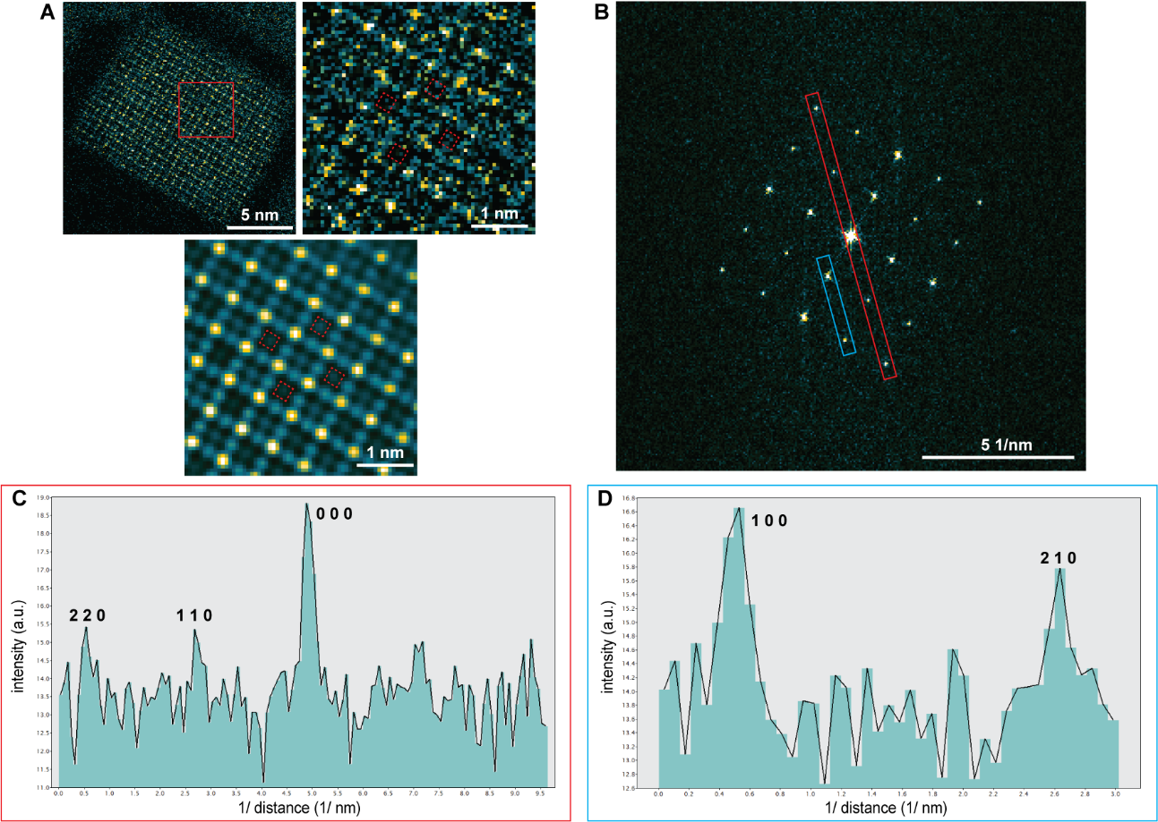
Fig. S2 Cs_{0.5}FA_{0.5}PbI₃ QDs after initial beam damage – the damage is detectable in the image (just) but not in the corresponding Fourier transform. (A) STEM-ADF images (raw image and Bragg-filtered image) of Cs_{0.5}FA_{0.5}PbI₃ QDs taken at 44 e/Å². (B) FT of the STEM-ADF in (A). (C) Intensity line profile from the region highlighted by red shows no additional $1/2, 1/2,0$_{c} reflections that would be associated with the damage. (D) Intensity line profile from the region highlighted by blue shows no additional $3/2, 1/2,0$_{c} reflections that would be associated with the damage.

Supplementary Note 4
Post filtering of low dose STEM-ADF images
Superstructures formed in the material should lead to extra reflections in the corresponding diffraction patterns. In the cubic perovskite structure here, the √2 x √2 ordering of V⁻_{FA} and V⁺_{I} will result in extra reflections at the centre positions among each primary reflections of the cubic structure, for example $1/2, 3/2,0$_{c} and $1/2, 3/2,0$_{c}. However, these extra reflections arising from superstructures can be much weaker in intensity than the primary reflections, making them particularly hard to detect. This is particularly true for the case of Fourier transforms of low-dose STEM-ADF images, where several different sources of noise contribute strongly to the resulting images, such as shot noise.
To reduce the effect of noise, we applied different filters, all of which enhance the contrast from the √2 x √2 superstructures in the image (Fig. S3B-D). It is important that any filtered images should be compared with raw images to make sure that post-filtering does not create features/artefacts that are not present in the original raw images. In Fig. S3, the ordered vacancies are compared and the same superstructure features are present in the raw images as well as the images filtered by different filters. The Bragg-Butterworth filter is possibly the most successful of the three options and also enables the additional reflections (for example $1/2, 3/2,0$_{c} and $1/2, 3/2,0$_{c} ) to be visible in the FT of the image.
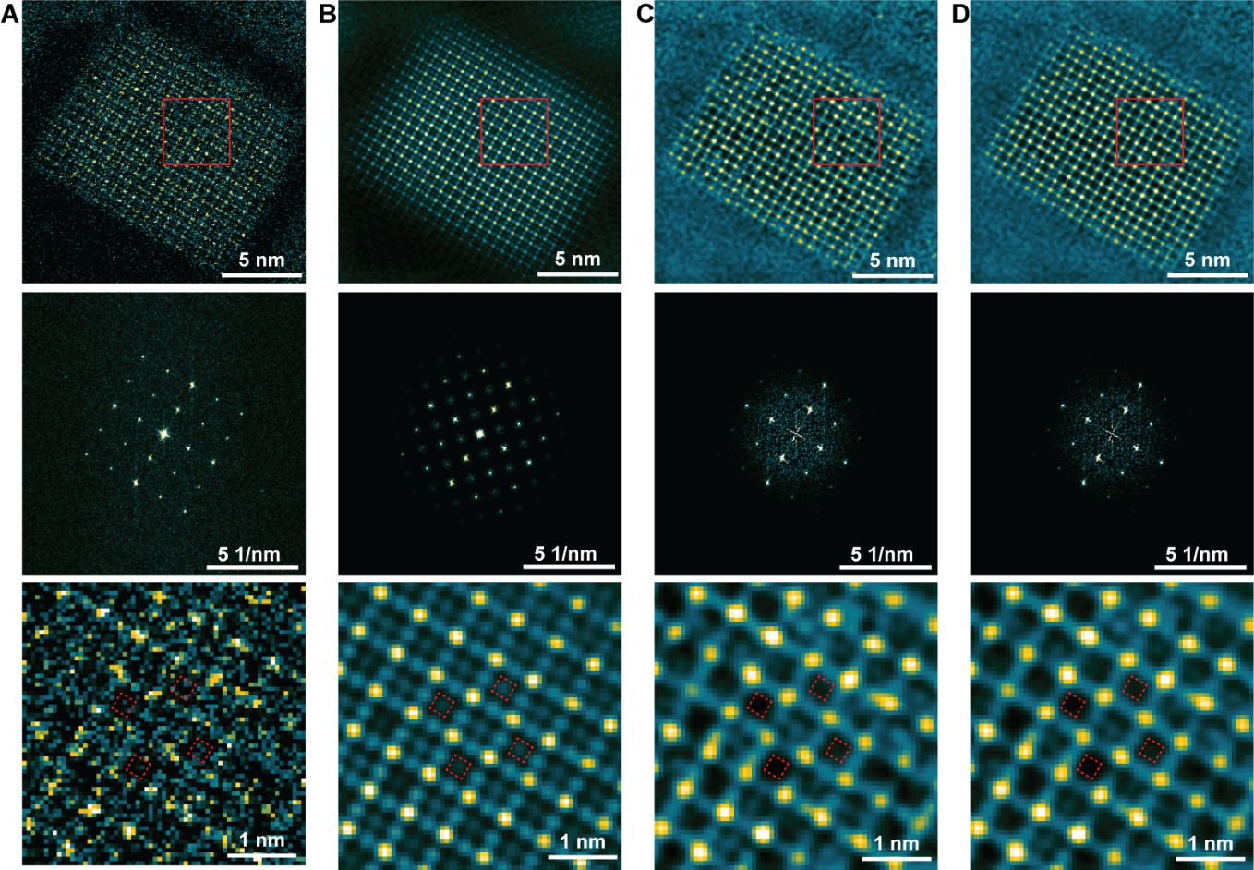
Fig. S3 Post-filtering of an example low dose STEM-ADF image taken from Cs_{0.5}FA_{0.5}PbI₃ QDs, with a total dose at 44 e/Å². (A) Raw STEM-ADF image. (B) Image filtered by a combination of Bragg filter and Butterworth filter. (C) Image filtered by a Winer filter. (D) Image filtered by an average background subtraction filter (ABSF). Corresponding FTs and enlarged images of marked regions are given below the overview images. Dashed squares in the enlarged images refers to V⁻_{FA}.

Supplementary Note 5
HR-TEM image of FAPbI₃ QDs at a total dose of 7.8 e/Å²
By summing the first 6 HR-TEM images, each taken with ~ 1.5 e/Å², the atomic structure of the material can just be resolved and is sufficient to do quantitative measurements (Fig. S4). Although the precision of the column intensity analysis is affected by shot noise at such low dose, it still shows intensity variations and even ordered structures of V⁻_{FA} and V⁺_{I} in local regions. It is possible that these vacancies are intrinsic to the unexposed, pristine FAPbI₃ QDs, for example, if prepared under the conditions of insufficient surface ligand (oleic acid). It could also be possible that they were caused by the electron beam, even at this extremely low dose. It is not possible from this data to know whether one or both explanations are correct. Non-local averaging of unit cells can enhance the SNR of HR-TEM images, which can improve the atomic-resolution HR-TEM image at a dose < 1 e/Å² ⁶. However, applying a non-local averaging method to an image of random vacancies might result in the loss of structural features intrinsic to the pristine material and misinterpretation of the image, so this was not used here.
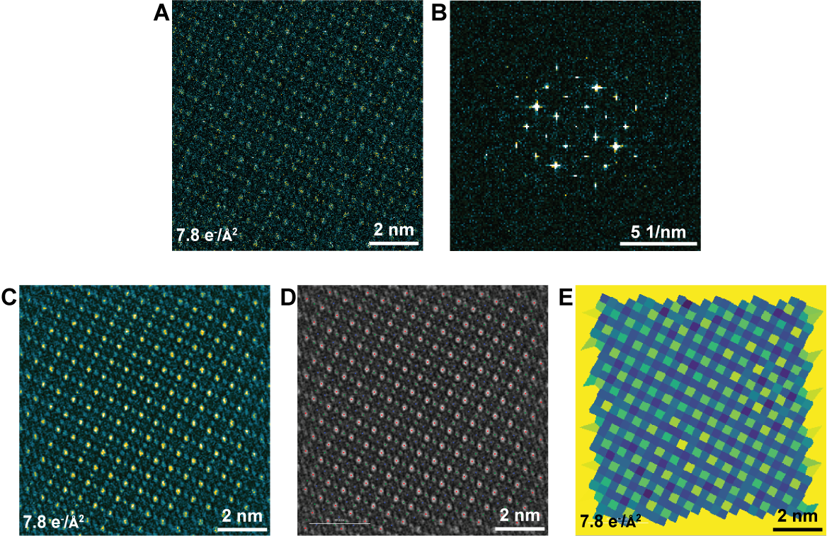
Fig. S4 Extreme low dose HR-TEM images of FAPbI3 QDs. (A) Raw HR-TEM image at 7.8 e/Å². (B) FT of (A). (C) Filtered image of (A). (D) Fitting of atomic column positions. (E) integrated column intensity map.

Supplementary Note 6
Loss and ordering of I⁻ vacancies
The loss and reordering of FA⁺ were found to be complemented by the loss and reordering of I⁻ anions in both Pb²⁺/I⁻ and I⁻ columns. The loss of I⁻ and reordering of V⁺_{I} is evident in the intensity line profiles in Fig. S5. Initially, intensity variations are shown for both I⁻ containing columns, I⁻ and Pb²⁺/I⁻ columns (Fig. S5A). Then ordered (high-low-high) intensity oscillations gradually become clear (Fig. S5(B-D)).
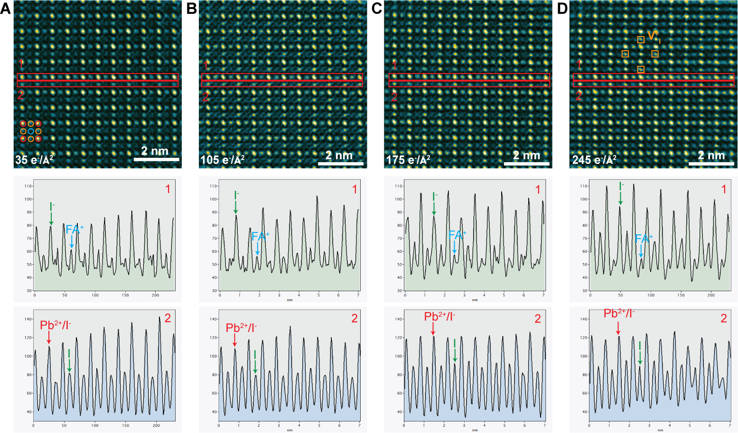
Fig. S5 Atomic-scale HR-TEM images revealing initial loss of I⁻ and subsequent unit cell by cell I⁻ ion migration. (A) 35 e/Å². (B) 105 e/Å². (C) 175 e/Å². (D) 245 e/Å². Intensity line profiles are extracted from region 1 and region 2., respectively.

The migration of I⁻ ions via vacancies V⁺_{I} is shown in the integrated column image intensity maps in Fig. S6. The marked Pb²⁺/I⁻ columns positions have higher intensities (occupied sites) in Fig. S6(A, B); however, they become lower intensity (vacancy sites) later in Fig. S6(C, D), as I⁻ ions migrate to form an ordered √2x√2 pattern of I⁻ ions and V⁺_{I} , complementing that of the FA⁺ cations.
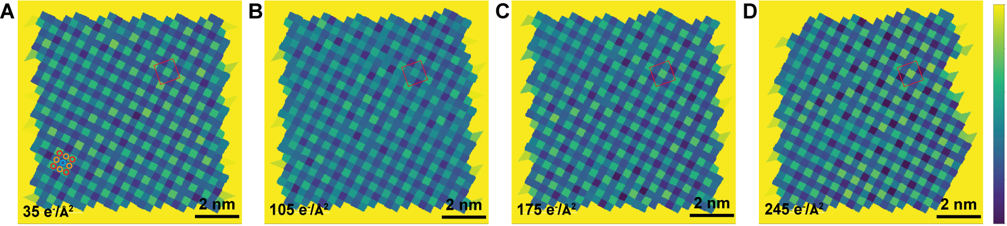
Fig. S6 integrated column intensity maps. (A) 35 e/Å². (B) 105 e/Å². (C) 175 e/Å². (D) 245 e/Å². Red square corners indicate four Pb²⁺/I⁻ columns at its corners.

Supplementary Note 7
Effect of tilt and other parameters on the detection of V⁻_{FA} and V⁺_{I} ordering in the first STEM-ADF image of FAPbI3 QDs
After the first STEM-ADF scan at 44 e/Å², an ordered vacancy pattern in Cs_{0.5}FA_{0.5}PbI₃ QDs is obvious and can be observed directly in the image (Fig. 4A). This is similarly the case for the FAPbI₃ QD in Figure 1 but far less evident in the FAPbI₃ QD in Figure 3A. This is due to the lower signal scattered from the organic FA⁺ cations in STEM-ADF images, which can be seen from the comparison of Fig. 1A and Fig. 1E. This makes the direct observations of an ordered vacancy patterns in FAPbI₃ QDs more challenging, especially when QDs are slightly off-axis. In the acquisition of all (S)TEM images, we follow a strict protocol to ensure minimum dose, in particular, all images are taken ‘blind’, with absolutely NO prior parameter optimization on the QD of interest, including no tilting to zone axis, focusing, adjusting astigmatism etc. This means image acquisition parameters, in particular zone-axis alignment, are often imperfect. Furthermore, the QDs dispersed on the carbon TEM substrate are geometrically unstable and tend to “vibrate” slightly during the acquisition of dose series data. As a result, the ordered vacancy pattern in the STEM-ADF image of FAPbI₃ in Fig. 3A (reproduced here in Fig. S7) is less obvious due to minor mis-orientation from the <001> zone axis. This mis-orientation can be seen from the constant elongation of the “atom shape” into the bottom left direction. However, the intensity line profiles in Fig. S7(C,D) confirm the existence of the √2 x √2 superstructure of V⁻_{FA} and V⁺_{I}.
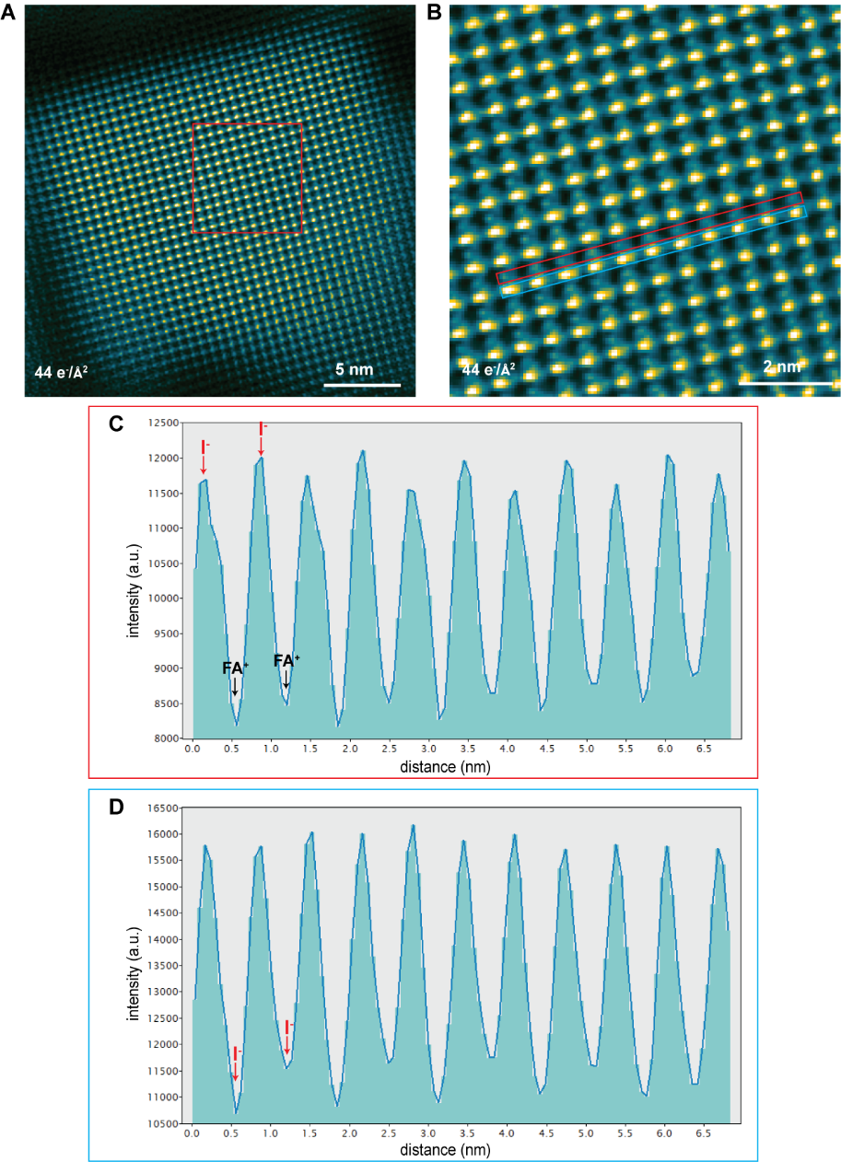
Fig. S7 Intensity line profiles of the STEM-ADF image of FAPbI₃ QDs taken at 44 e/Å². (A) first STEM-ADF image (i.e. Fig. 3A). (B) zoom-in image of the region marked in (A). (C) intensity line profile integrated over I⁻ and FA⁺ columns as marked in (B) by red. (C) intensity line profile integrated over Pb²⁺/I⁻ and I⁻ columns as marked in (B) by blue.
Supplementary Note 8
Superstructure fluctuation in the formation of the intermediate phase 2 in Cs_{0.5}FA_{0.5}PbI₃ QDs
In the STEM-ADF image series of FAPbI₃ QDs (Fig. 3), all $1/2, 3/2,0$_{c} family reflections arising from the octahedral tilt phase become evident at 88 e/Å². However, a similar STEM-ADF image series of Cs_{0.5}FA_{0.5}PbI₃ QDs show fluctuations in the additional reflections (Fig S8). The position and intensity of forbidden reflections due to octahedral tilt changes in the first few scans. Only part of the $1/2, 1/2,0$_{c} family of reflections are evident, even until 220 e/Å².
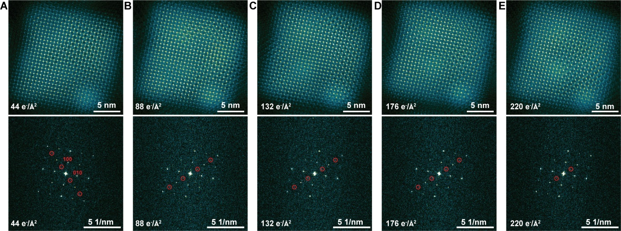
Fig. S8 Atomic-resolution STEM-ADF images of Cs_{0.5}FA_{0.5}PbI₃ QDs. (A) 44 e/Å². (B) 88 e/Å². (C) 132 e/Å². (D) 176 e/Å². (E) 220 e/Å². FTs are given below each image. Additional reflections are marked by red circles.

Supplementary Note 9
STEM-ADF images of Cs_{0.5}FA_{0.5}PbI₃ QDs with higher total dose
At a total dose 1280 e/Å², strong $1/2, 1/2,0$_{c} family reflections are evident indicating the formation of an octahedral tilt intermediated phase (Fig. S9A). However, very weak $1/2, 3/2,0$_{c} reflections are also observed, as further discussed in supplementary note 11. Furthermore, at a total dose of 2340 e/Å², forbidden reflections almost disappear, together with the disappearance of the “flower pattern” in the image (Fig. S9B). The FT at a total dose of 3400 e/Å² shows no forbidden reflections and is consistent with a square perovskite framework, with no octahedral tilt. In addition, the region marked by the red square shows a uniform column image intensity that does not consistent with any phase of the perovskite structure. This will be discussed in detail in supplementary note 10.
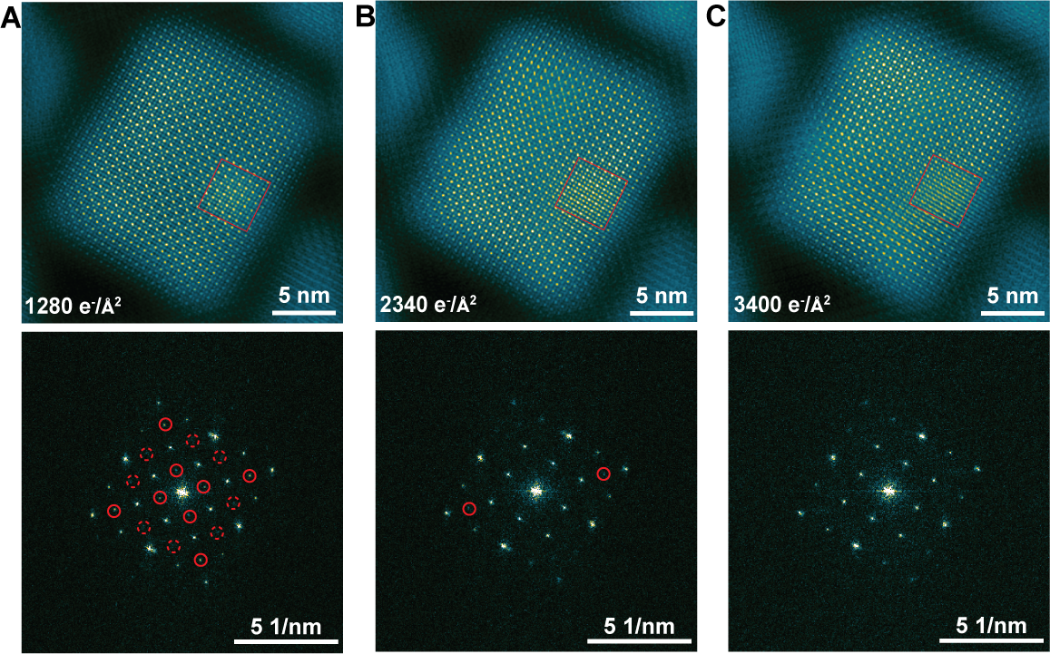
Fig. S9 STEM-ADF images of a representative Cs_{0.5}FA_{0.5}PbI₃ QD after exposure to a high total dose. (A) 1280 e/Å². (B) 2340 e/Å². (C) 3400 e/Å². FTs are given below each image. Additional reflections are marked by red circles.

Supplementary Note 10
Clusters of PbI₂ and Pb
In the STEM-ADF images of QDs taken with the higher levels of total electron dose, clusters with higher intensity can be commonly observed, especially for Cs_{0.5}FA_{0.5}PbI₃. We propose two structures to account for these clusters. As shown in Fig. S10 (same as Fig. 4C), in addition to the reflections that are due to octahedral tilt, we also observe extra reflection at positions that are close to the primary 200_{c} reflections, but further away from the centre reflection. From an inverse FT (IFT) constructed from those reflections, it is evident they arise from a region with a different lattice structure to that of the perovskite phase (Fig. S10C). However, for other clusters in this image and also in Fig. S9, the structure is coherent with the perovskite phase. This suggest these clusters are associated with two different structures.
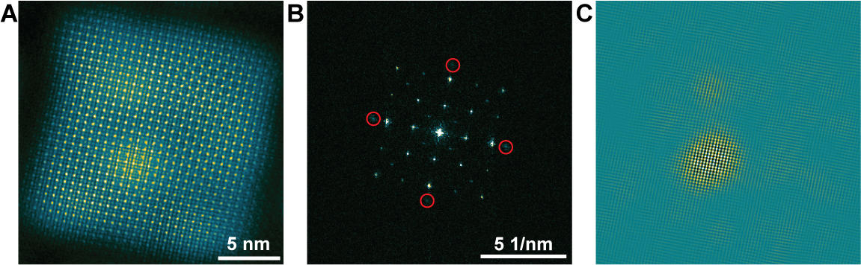
Fig. S10 STEM-ADF image of CsFAPbI3 QD at a total dose of 750 e/Å2 showing higher intensity clusters. (A) STEM-ADF image. (B) FT of (A). (C) IFT of the reflections circled in (B) showing they are associated with a cluster.

The cluster structure that fits coherently with the perovskite lattice is determined to be the PbI2 phase oriented in the [$\overline{4}41$] direction (Fig. S11(A, B, D, E, H)). The other cluster structure that is incoherent with the perovskite lattice is found to be pure Pb in the [0001] direction (Fig. S11(A, C, D, F, G)). It is interesting to note that the coherent PbI₂ occurs more frequently and hence appears to be much more favourable than Pb. In Fig. S4, the incoherent Pb cluster quickly transforms into a coherent PbI₂ cluster, as seen from the lattice image and the disappearance of reflections belonging to Pb (Fig. S4(C, D)).
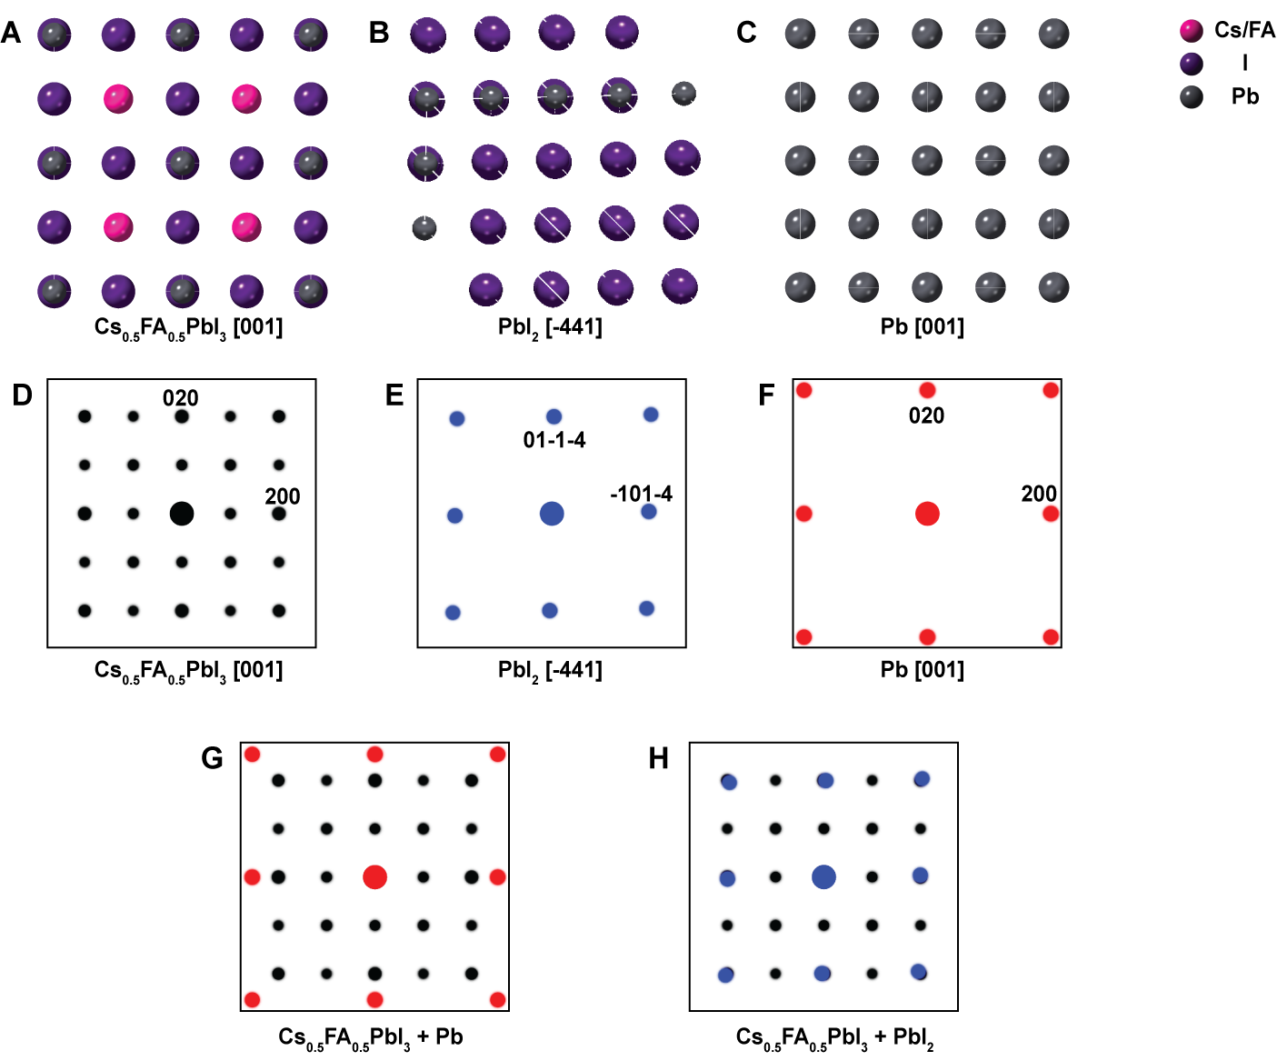
Fig. S11 Structure of PbI2 and Pb. (A) Crystal model of cubic perovskite in the [001] projection. (B) Crystal model of PbI₂ in the [$\overline{4}41$] projection. (C) Crystal model of Pb in the [001] projection. (D-F) simulated diffraction patterns of (A-C). (G) overlap of diffraction patterns in (A, F). (H) overlap of diffraction patterns in (A, E).

Supplementary Note 11
Co-existence of two octahedral tilt modes in Cs_{0.5}FA_{0.5}PbI₃ QDs
We observe two different octahedral modes at the intermediate phase 2. The p4/mbm tetragonal phase is observed primarily in FAPbI3 QDs and the I4/mmm tetragonal phase is only observed in Cs_{0.5}FA_{0.5}PbI₃ QDs. However, in some Cs_{0.5}FA_{0.5}PbI₃ QDs, the p4/mbm tetragonal phase is also observed to co-exist with the I4/mmm phase. Interestingly, the FT of an image of a Cs_{0.5}FA_{0.5}PbI₃ QD containing both phases will lead to $1/2, 1/2,0$_{c} and $1/2, 3/2,0$_{c} reflections. These FT reflections are coincident with those from a √2 x √2 superstructure, raising the possibility that the √2 x √2 superstructure could be mistaken for the coexistence of the two octahedral modes and vice versa. However, these two possible scenarios can be distinguished by generating an inverse Fourier transform (IFT) from the $1/2, 1/2,0$_{c} and $1/2, 3/2,0$_{c} reflections separately, as shown in Fig. S11. This shows that the $1/2, 1/2,0$_{c} and $1/2, 3/2,0$_{c} reflections arise from different regions of the QD (Fig. S10(B, C)). The corresponding enlarged images from the selected regions confirm that they are two tetragonal phases with different octahedral tilt modes (Fig. S10(D, E)).
In the TEM studies of OIHPs, the ordered √2 x √2 superstructure of vacancies (intermediate phase 1), in theory, will lead to both $1/2, 1/2,0$_{c} and $1/2, 3/2,0$_{c} forbidden reflections, although they might have very weak intensity. While the subsequent octahedral tilt phase (intermediate phase 2) will result in either $1/2, 1/2,0$_{c} OR $1/2, 3/2,0$_{c} forbidden reflections, depending on the octahedral tilt mode. Therefore, extreme care needs to be taken while analysing TEM results, especially when some reflections are missing in SAD patterns or FT patterns.
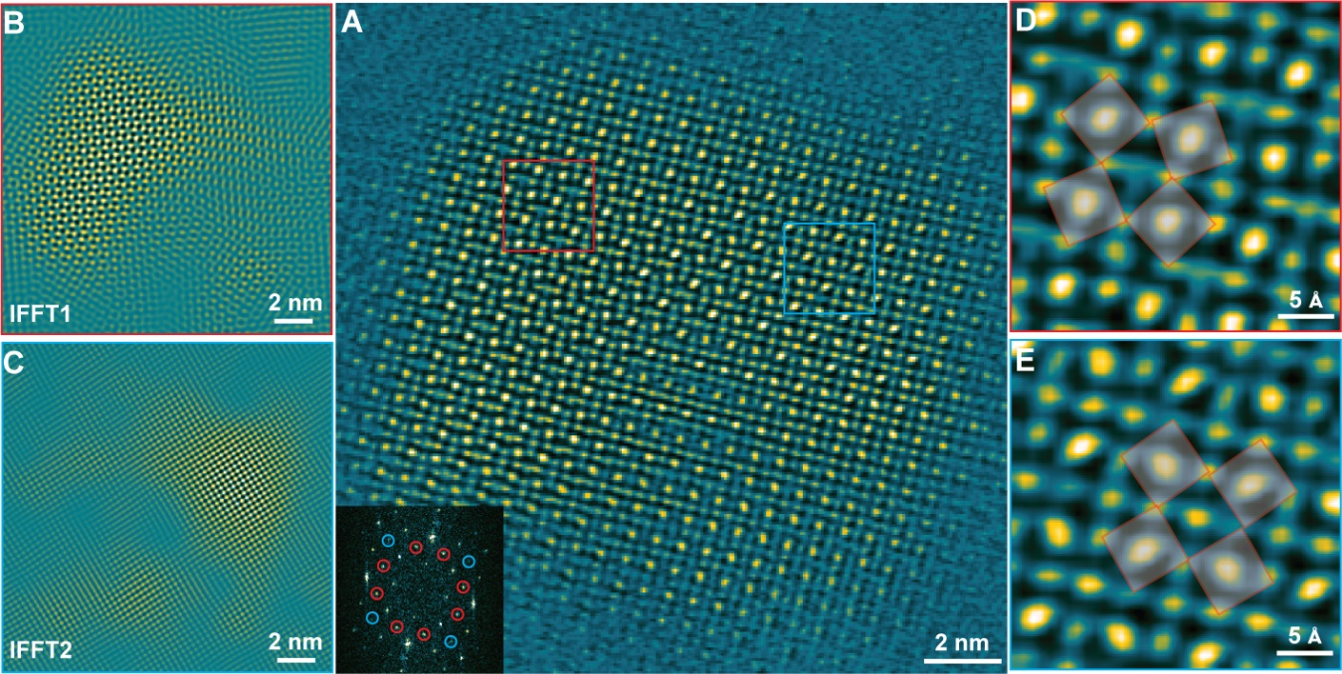
Fig. S11 STEM-ADF image of Cs_{0.5}FA_{0.5}PbI₃ QD with a total dose of 750 e/Å². (A) Overview STEM-ADF of the entire QD, with FT inserted. (B) IFT from the $1/2, 3/2,0$_{c} reflections circled by red. (B) IFT from the $1/2, 1/2,0$_{c} reflections circled by blue. (D) Enlarged image of region that corresponds to $1/2, 3/2,0$_{c} reflections. (E) Enlarged image of region that corresponds to $1/2, 1/2,0$_{c} reflections.

References
(1) Krause, F. F.; Schowalter, M.; Oppermann, O.; Marquardt, D.; Müller-Caspary, K.; Ritz, R.; Simson, M.; Ryll, H.; Huth, M.; Soltau, H.; Rosenauer, A. Precise Measurement of the Electron Beam Current in a TEM. Ultramicroscopy 2021, 223, 113221.
(2) Tate, M. W.; Purohit, P.; Chamberlain, D.; Nguyen, K. X.; Hovden, R.; Chang, C. S.; Deb, P.; Turgut, E.; Heron, J. T.; Schlom, D. G.; Ralph, D. C.; Fuchs, G. D.; Shanks, K. S.; Philipp, H. T.; Muller, D. A.; Gruner, S. M. High Dynamic Range Pixel Array Detector for Scanning Transmission Electron Microscopy. Microsc. Microanal. 2016, 22 (1), 237–249.
(3) Nguyen, D. T.; Findlay, S. D.; Etheridge, J. The Spatial Coherence Function in Scanning Transmission Electron Microscopy and Spectroscopy. Ultramicroscopy 2014, 146, 6–16.
(4) Nguyen, D. T.; Findlay, S. D.; Etheridge, J. A Menu of Electron Probes for Optimising Information from Scanning Transmission Electron Microscopy. Ultramicroscopy 2018, 184, 143–155.
(5) Wu, X.; Ke, X.; Sui, M.; Ke, X. Recent Progress on Advanced Transmission Electron Microscopy Characterization for Halide Perovskite Semiconductors. J. Semicond. 2022, 43 (4), 041106.
(6) Chen, S.; Wu, C.; Han, B.; Liu, Z.; Mi, Z.; Hao, W.; Zhao, J.; Wang, X.; Zhang, Q.; Liu, K.; Qi, J.; Cao, J.; Feng, J.; Yu, D.; Li, J.; Gao, P. Atomic-Scale Imaging of CH3NH3PbI3 Structure and Its Decomposition Pathway. Nat. Commun. 2021, 12 (1), 1–7.

