Extended Data

Obesity-dependent increase in RalA activity disrupts mitochondrial dynamics in white adipocytes

Wenmin Xia, Preethi Veeragandham, Yu Cao, Yayun Xu, Torrey E. Rhyne, Jiaxin Qian, Chao-Wei Hung, Peng Zhao, Ying Jones, Hui Gao, Christopher Liddle, Ruth T. Yu, Michael R. Downes, Ronald M. Evans, Mikael Rydén, Martin Wabitsch, Shannon M. Reilly, Jianfeng Huang and Alan R. Saltiel

Extended Data Figure

Extended Data Fig.1. RalA protein content and activity are increased in obese adipocytes. a, Immunoblotting for RalA in mature adipocytes isolated from iWAT (upper panel) or eWAT (lower panel) of age-matched CD-fed (lean) mice and HFD-fed (obese) mice (n = 3). b, Immunoblotting for active RalA (aRalA) pulled down by GST-^{Δ}RalBP1 agarose beads in iWAT (upper panel) or eWAT (lower panel) of age-matched CD-fed mice (n = 3) and HFD-fed mice (n = 2). c, Regression plot showing correlation of RGL2 mRNA expression with BMI in human abdominal subcutaneous adipose tissues (n = 56). Spearman’s correlation test. d, Box-and-whisker plot showing RGL2 mRNA expression in human abdominal subcutaneous adipose tissues from non-obese and obese women (n = 56). e, Immunoblotting for RalA in inguinal mature adipocyte fraction, eWAT, BAT, and liver from lean mice (n = 3). f, Pull-down assays determining RalA activation. Active RalA was pulled down and blotted in adipose tissue of Rala^{f/f} and Rala^{AKO} mice injected with insulin or saline as control. Adipose tissues were dissected and immediately homogenized for pull down 5 min post injections. Active RalA was also assessed in primary adipocytes treated with insulin for indicated time (n= 2-3). g, Immunostaining of endogenous RalA and GLUT4 in primary adipocytes treated with insulin (100 nM) or vehicle for 30 min, scale bar = 15 μm. h, 2-deoxyglucose (2-DG) uptake in primary adipocytes treated with insulin (100 nM) or vehicle for 30 min (n = 3). The data are shown as the mean ± SEM, *p < 0.05, **p < 0.01 by unpaired t-test.

Extended Data Fig.2. Brown adipocyte specific Rala deletion in mice did not phenocopy Rala^{AKO} mice. a-c, Body weight curve (a), body composition (b) and fat depot weights (c) of CD-fed Rala^{f/f} and Rala^{AKO} mice at the age of 24-weeks (n = 8-12). d, Representative H&E staining images of iWAT, eWAT, and BAT from CD-fed and HFD-fed mice (n = 3), scale bar = 100 μm, representative adipocytes size quantification of iWAT from CD-fed and HFD-fed mice. e, f, Glucose tolerance test (GTT, e) and insulin tolerance test (ITT, f) on CD-fed Rala^{f/f} and Rala^{AKO} mice (n = 8-12). Area under curves (AUC) were calculated from GTT and ITT, respectively. g, Plasma insulin levels in CD-fed Rala^{f/f} and Rala^{AKO} mice (n = 5-9). h, Homeostasis model assessment-estimated insulin resistance (HOMA-IR) was calculated based on fasting glucose and insulin levels from CD-fed Rala^{f/f} and Rala^{AKO} mice (n = 9-11). i, Blood glucose levels in CD-fed mice (n = 5) at indicated states. j, Blood glucose levels in HFD-fed Rala^{f/f} and Rala^{AKO} mice (n = 9-11) at indicated states. k, Immunoblot analysis of RalA in BAT (upper panel) and eWAT (lower panel) of Rala^{f/f} and Rala^{BKO} mice (n = 3). l, m, Body composition (l) and fat depot weights (m) in CD-fed Rala^{f/f} and Rala^{BKO} mice (n = 8-9) at the age of 28 weeks. n, o, GTT (n) and ITT (o) were performed in CD-fed Rala^{f/f} and Rala^{BKO} mice at the age of 26-weeks (n = 8-9). p, Body weight curve of Rala^{f/f} and Rala^{BKO} mice (n = 5-7) fed with HFD for 12 weeks. q, r, Body composition (q) and fat depot and liver weights (r) in HFD-fed Rala^{f/f} and Rala^{BKO} mice (n = 5-7) at the age of 20-21 weeks. s, t, GTT (s) and ITT (t) were performed in HFD-fed Rala^{f/f} and Rala^{BKO} mice (n = 5-7) at the age of 17-weeks or 20-weeks, respectively. The data (except d, k) are presented as the mean ± SEM, *p < 0.05 by unpaired t-test (b, c, e-j, l-o, q, r), or two-way ANOVA with Bonferroni’s multiple comparison as post-test (a, e, f, n-p, s, t).

Extended Data Fig.3. Neither CD-fed Rala^{AKO} mice nor HFD-fed Rala^{BKO} mice show increased energy expenditure. a, Regression plot of energy expenditure (EE) during dark phase against body weight (BW) in CD-fed Rala^{f/f} and Rala^{AKO} mice (n = 8). ANCOVA test using BW as a covariate, group effect p = 0.2805. b-e, BW-normalized oxygen consumption (b), respiratory exchange ratio (RER, c), pedestrian Locomotion (d) and food intake (e) over a two-days period were measured in CD-fed Rala^{f/f} and Rala^{AKO} mice (n = 8) by metabolic cages. f-i, BW-normalized oxygen consumption (f), respiratory exchange ratio (RER, g), pedestrian Locomotion (h) and food intake (i) over a two-days period were measured in HFD-fed Rala^{f/f} and Rala^{AKO} mice (n = 5-8) by metabolic cages. j, Regression plot of EE during dark phase against BW in HFD-fed Rala^{f/f} and Rala^{BKO} mice (n = 5-7). ANCOVA test using BW as a covariate, group effect p = 0.2792. k-n, BW-normalized oxygen consumption (k), respiratory exchange ratio (RER, l), pedestrian Locomotion (m) and food intake (n) over a two-days period were measured in HFD-fed Rala^{f/f} and Rala^{BKO} mice (n = 5-7) by metabolic cages. (o, p) Immunoblotting (o) and quantification (p) of OXPHOS proteins in eWAT of HFD-fed mice (n = 8-12). (q, r) Immunoblotting (q) and quantification (r) of OXPHOS proteins in BAT of HFD-fed mice (n = 10-13). s, Relative mRNA expression of browning-related genes in iWAT, eWAT and BAT of HFD-fed mice (n = 8-13). The data (b-i, k-n, p-s) are shown as the mean ± SEM, *p < 0.05, ***p < 0.001 by unpaired t-test (d, e, h, i, m, n, p-s), or two-way ANOVA with Bonferroni’s multiple comparison as post-test (b, c, f, g, k, l).

Extended Data Fig.4. Absence of RalA in adipocytes did not affect free fatty acid release. a, Oxygen consumption rate (OCR) was measured by Seahorse in differentiated primary adipocytes (n= 8). Calculation of individual OCR in each state was presented. b, Immunoblot analysis of RalA and β-Tubulin in immortalized preadipocytes and differentiated adipocytes. B9, F9, D11 indicate each single cell colony. c, Quantification of mean TMRM fluorescence intensity in primary adipocytes (n = 40-60) and immortalized adipocytes (n = 35-36). Live primary or immortalized adipocytes were stained with TMRM and BODIPY. Confocal images were captured, and fluorescence intensity was determined. d, Time course TMRM intensity quantification in primary and immortalized adipocytes (n = 3). Adipocytes were treated with CL 316,243 (CL) for indicated times. e, f, Quantification of NEFA (e) and free glycerol (f) released into medium from immortalized adipocytes (n = 3). Cells were treated with 1 µM CL, 100 nM insulin, or in combination prior to medium collection. g, h, Plasma levels of NEFA (g) and free glycerol (h) in CD-fed Rala^{f/f} and Rala^{AKO} mice (n = 6). Mice were i.p. injected with CL or vehicle prior to blood sampling. i, j, Plasma levels of NEFA (i) and free glycerol (j) in CD-fed Rala^{f/f} and Rala^{AKO} mice (n = 4-5). Mice were either subjected to ad libitum feeding, overnight fasting or fasting plus insulin injection 15 min prior to harvesting. The data (except b) are shown as the mean ± SEM, *p < 0.05, **p < 0.01, ***p < 0.001, ****p < 0.0001 by unpaired t-test (a, c, e-j) or two-way ANOVA with Bonferroni’s multiple comparison as post-test (d).

Extended Data Fig.5. RalA inhibition did not affect mitochondrial biogenesis in WAT. a, b, Relative mRNA expression of genes corresponding to mitochondrial biogenesis in iWAT (a) and eWAT (b) of HFD-fed Rala^{f/f} and Rala^{AKO} mice (n = 6-9). c-f, Immunoblot analysis (c, d) and quantification (e, f) of phospho-AMPK (T172), total AMPK and β-Tubulin in iWAT (c, e) and eWAT (d, f) of HFD-fed mice (n = 8-12). g, Representative TEM pictures of mitochondria in eWAT of HFD-fed mice, scale bar = 500 nm. h-j, Immunoblot analysis (h) and quantification (i, j) of Opa1 in iWAT of HFD-fed mice (n = 9-10). k-m, Immunoblot analysis (k) and quantification (l, m) of Opa1 in eWAT of HFD-fed mice (n = 9-10). The data (a, b, e, f, I, j, l, m) are shown as the mean ± SEM, *p < 0.05, **p < 0.01 by unpaired t-test.

Extended Data Fig.6. Rala deletion in adipocytes did not affect cAMP production and HSL phosphorylation. a, Immunoblotting for phospho-Drp1 S637, total Drp1 and β-Tubulin immunoblotting in iWAT of HFD-fed Rala^{f/f} and Rala^{AKO} mice (n = 10-13). b, c, Immunoblotting (b) and quantification (c) of phospho-Drp1(S637), total Drp1, and β-Tubulin in eWAT of HFD-fed Rala^{f/f} and Rala^{AKO} mice (n = 8-12). d, e, Immunoblot analysis (d) and quantification (e) of phospho-Drp1 (S637), total Drp1, RalA, and β-Actin in primary adipocytes (n = 4). Adipocytes were differentiated from stromal vascular fraction (SVF) isolated from Rala^{f/f} and Rala^{AKO} mice, and were treated with 1 μM CL for indicated time. f, Determining intracellular cAMP concentrations in differentiated WT and Rala^{AKO} (KO) primary adipocytes (n = 4). Cells were treated with CL for 5 min prior to harvesting. g, h, Immunoblot analysis (g) and quantification (h) of phospho-HSL(S660) and HSL in immortalized adipocytes treated with CL for indicated time (n = 4). i, j, Immunoblot analysis (i) and quantification (j) of phospho-HSL(S660) and HSL in differentiated primary adipocytes treated with CL for indicated time (n = 4). k, l, Immunoblot analysis (k) and quantification (l) of phospho-Drp1 (S637), total Drp1, and β-Actin in 3T3-L1 adipocytes (n = 4). Cells were pretreated with 50 μM RBC8 or DMSO for 30 min, then treated with 5 μM forskolin (Fsk) for indicated time. m, n, DNM1L mRNA expression is correlated with BMI (m) and HOMA (n) in human subcutaneous adipose tissue samples (n = 770). Significance in correlation was assessed by Spearman’s correlation test. o, Box-and-whisker plot of DNM1L mRNA expression in abdominal subcutaneous adipose tissues from non-obese and obese human subjects (n = 770). Benjamini and Hochberg-adjusted p value (adj. p) is 0.014186. Transcriptomics and clinical data (m-o) were directly accessed from GEO database (GSE70353). The data (c, e, f, h, j, l) are shown as the mean ± SEM, *p < 0.05, **p < 0.01, ***p < 0.001 by unpaired t-test (c, e, f, h, j, l).

Extended Data Fig.7. Knockout of RalA increases PP2Aa content. a, Immunoblot analysis of co-immunoprecipitation between Flag-RalA^{WT}, Flag-RalA^{G23V}, or Flag-RalA^{S28N} and Myc-Drp1 in HEK293T cells. b, In vitro dephosphorylation assay in PP2A and Drp1 co-transfected HEK293T cells treated with or without 20 μM forskolin (Fsk) for 1 hr. c, Quantification for immunoblotting of phospho-Drp1 (S637) and total Drp1 in immortalized RalA KO adipocytes with or without RalA reconstitution (n = 3). Adipocytes were treated with 20 μM forskolin for indicated time. d, Quantification of TMRM fluorescence intensity in immortalized RalA KO adipocytes with or without RalA reconstitution (n = 24-34). e, Calculating OCR in each state from immortalized RalA KO adipocytes with or without RalA reconstitution (n = 5-6). f, g, Immunoblot analysis (f) and quantification (g) of PP2Aa, PP2Ab, PP2Ac, and β-Tubulin in iWAT of HFD-fed mice (n = 10-13). The data (c, d, e, g) are shown as the mean ± SEM, *p < 0.05, **p < 0.01, ***p < 0.001, ****p < 0.0001 by unpaired t-test (c, d, e, g).

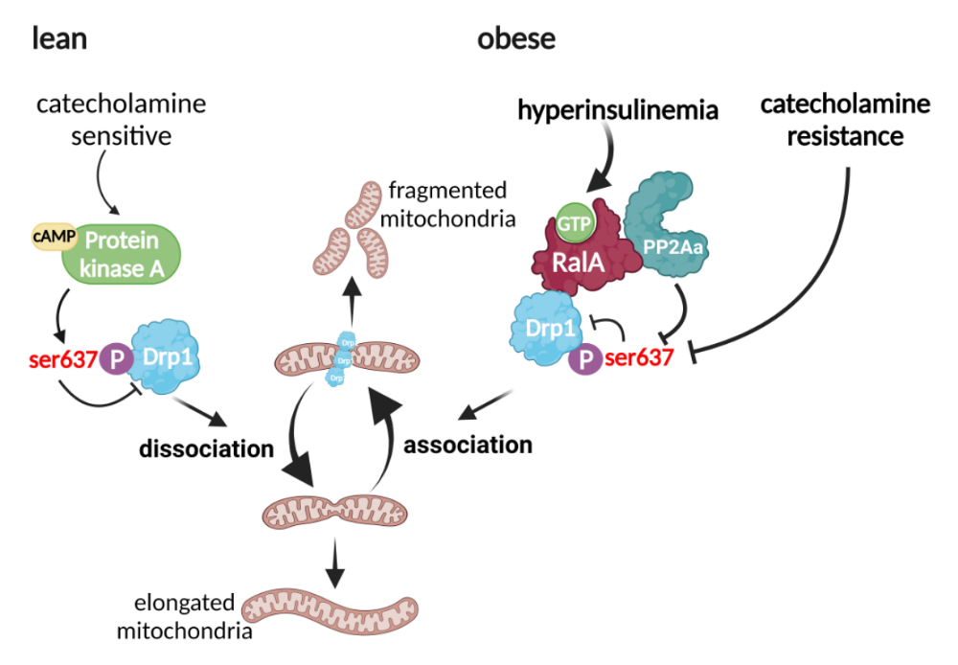

Extended Data Fig.8. Mechanistic model depicting how RalA regulates mitochondrial function in obese adipocytes.
Obesity drives RalA expression and GTP binding activity, leading to its association with PP2Aa, which in turn recruits the catalytic subunit PP2Ac to dephosphorylate Drp1 S637. Also, catecholamine resistance could reduce PKA-catalyzed S637 phosphorylation. The combined effects converging on RalA-PP2A-Drp1signaling axis result in constitutive mitochondrial translocation of Drp1 and fragmented mitochondria in adipocytes from obese subjects.
Extended Data Table
Extended Data Table 1, Real time qPCR primers.
Gene Symbol | Forward | Reverse
G6pc | CGACTCGCTATCTCCAAGTGA | GTTGAACCAGTCTCCGACCA
Pepck | CCACAGCTGCTGCAGAACA | GAAGGGTCGCATGGCAAA
Acc | GGAGATGTACGCTGACCGAGAA | ACCCGACGCATGGTTTTCA
Fasn | GCTGTAGCACACATCCTAGGCA | TCGTGTTCTCGTTCCAGGATC
Scd1 | ATCGCCTCTGGAGCCACAC | ACACGTCATTCTGGAACGCC
Acsl1 | TCCTACAAAGAGGTGGCAGAACT | GGCTTGAACCCCTTCTGGAT
Cpt1a | TGAGTGGCGTCCTCTTTGG | CAGCGAGTAGCGCATAGTG
Cpt1b | CCAAACGTCACTGCCTAAGCT | GGCCGCACAGAATCCAAGTA
Cpt2 | CAACTCGTATACCCAAACCCAGTC | GTTCCCATCTTGATCGAGGACATC
Acadl | TCTTTTCCTCGGAGCATGACA | GACCTCTCTACTCACTTCTCCAG
Adgre1 | CCCCAGTGTCCTTACAGAGTG | GTGCCCAGAGTGGATGTCT
Col1a1 | GCTCCTCTTAGGGGCCACT | CCACGTCTCACCATTGGGG
Col3a1 | CTGTAACATGGAAACTGGGGAAA | CCATAGCTGAACTGAAAACCACC
Rala | ATGGCTGCAAACAAGCCCA | TCCTCTACAAACTCGTCGTACAT
Ucp1 | ACTGCCACACCTCCAGTCATT | CTTTGCCTCACTCAGGATTGG
Cidea | TGACATTCATGGGATTGCAGAC | GGCCAGTTGTGATGACTAAGAC
Prdm16 | CAGCACGGTGAAGCCATTC | GCGTGCATCCGCTTGTG
Ppargc1a | CCACTTCAATCCACCCAGAAA | TATGGAGTGACATAGAGTGTGCT
Cox5b | GCGAAGTAACCTTGAAGCCA | CCGCCCATCTTGCTCAG
Cox8a | CTTCGAGTGGACCTGAGC | CATCTTGACTCCCTGACCTTG
Ndufs7 | CTTCTGTTCACGCTTGATCTTC | GGCTACTACCACTACTCCTACT
Atp5d | AAGATGCCAAAGGCTCCAG | GATGTCCTTCACCTTTGCCT
Cytb | CCTTCATGTCGGACGAGGCTT | TGCTGTGGCTATGACTGCGAA
Nd2 | GCCTGGAATTCAGCCTACTAGC | GGCTGTTGCTTGTGTGACGA
Nd4 | CGCCTACTCCTCAGTTAGCCA | TGATGTGAGGCCATGTGCGA
Cox1 | TAGCCCATGCAGGAGCATCA | TGGCTGGGGGTTTCATGTTGA
Cox2 | ACCTGGTGAACTACGACTGCT | CCTAGGGAGGGGACTGCTCA
Cox3 | CTTCACCATCCTCCAAGCTTCA | AGTCCATGGAATCCAGTAGCCAT
Atp6 | TGGCATTAGCAGTCCGGCTT | ATGGTAGCTGTTGGTGGGCT
Atp8 | TTCCCACTGGCACCTTCACC | TGTTGGGGTAATGAATGAGGCAA
Cyclophilin | GAGCTGTTTGCAGACAAAGTTC | CCCTGGCACATGAATCCTGG

