Supplementary Material
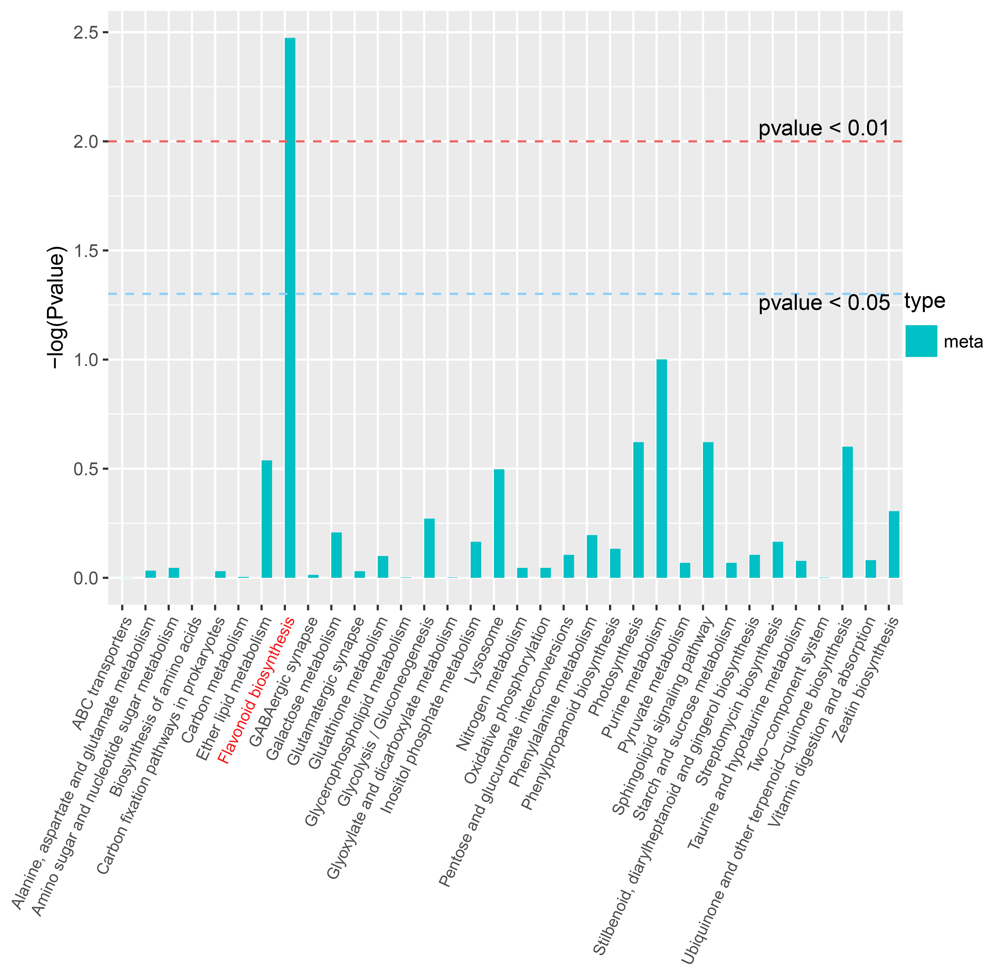
Supplementary Figure S1. KEGG analysis of the differentially accumulated metabolites in X vs. S3.
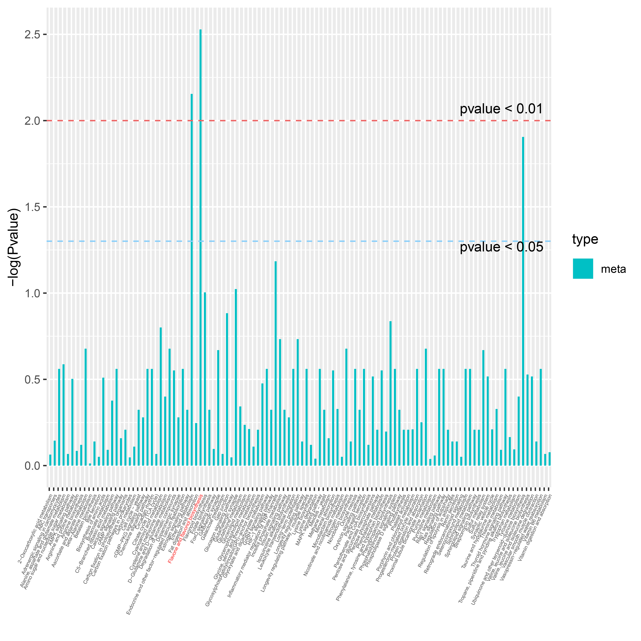
Supplementary Figure S2. KEGG analysis of the differentially accumulated metabolites in S1 vs. S3.
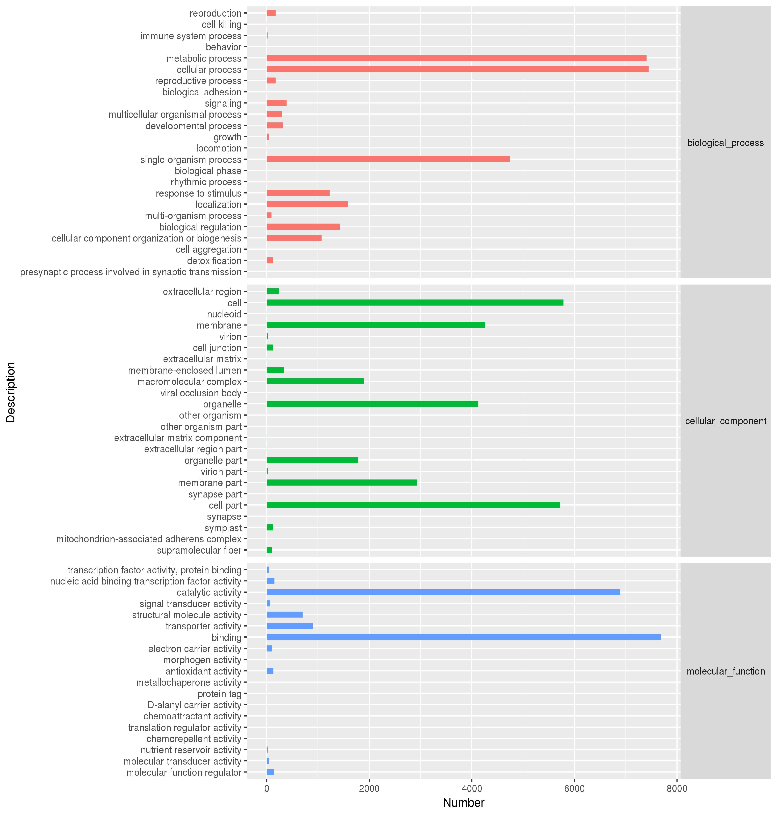
Supplementary Figure S3. Gene ontology enrichment analysis of the unigene.
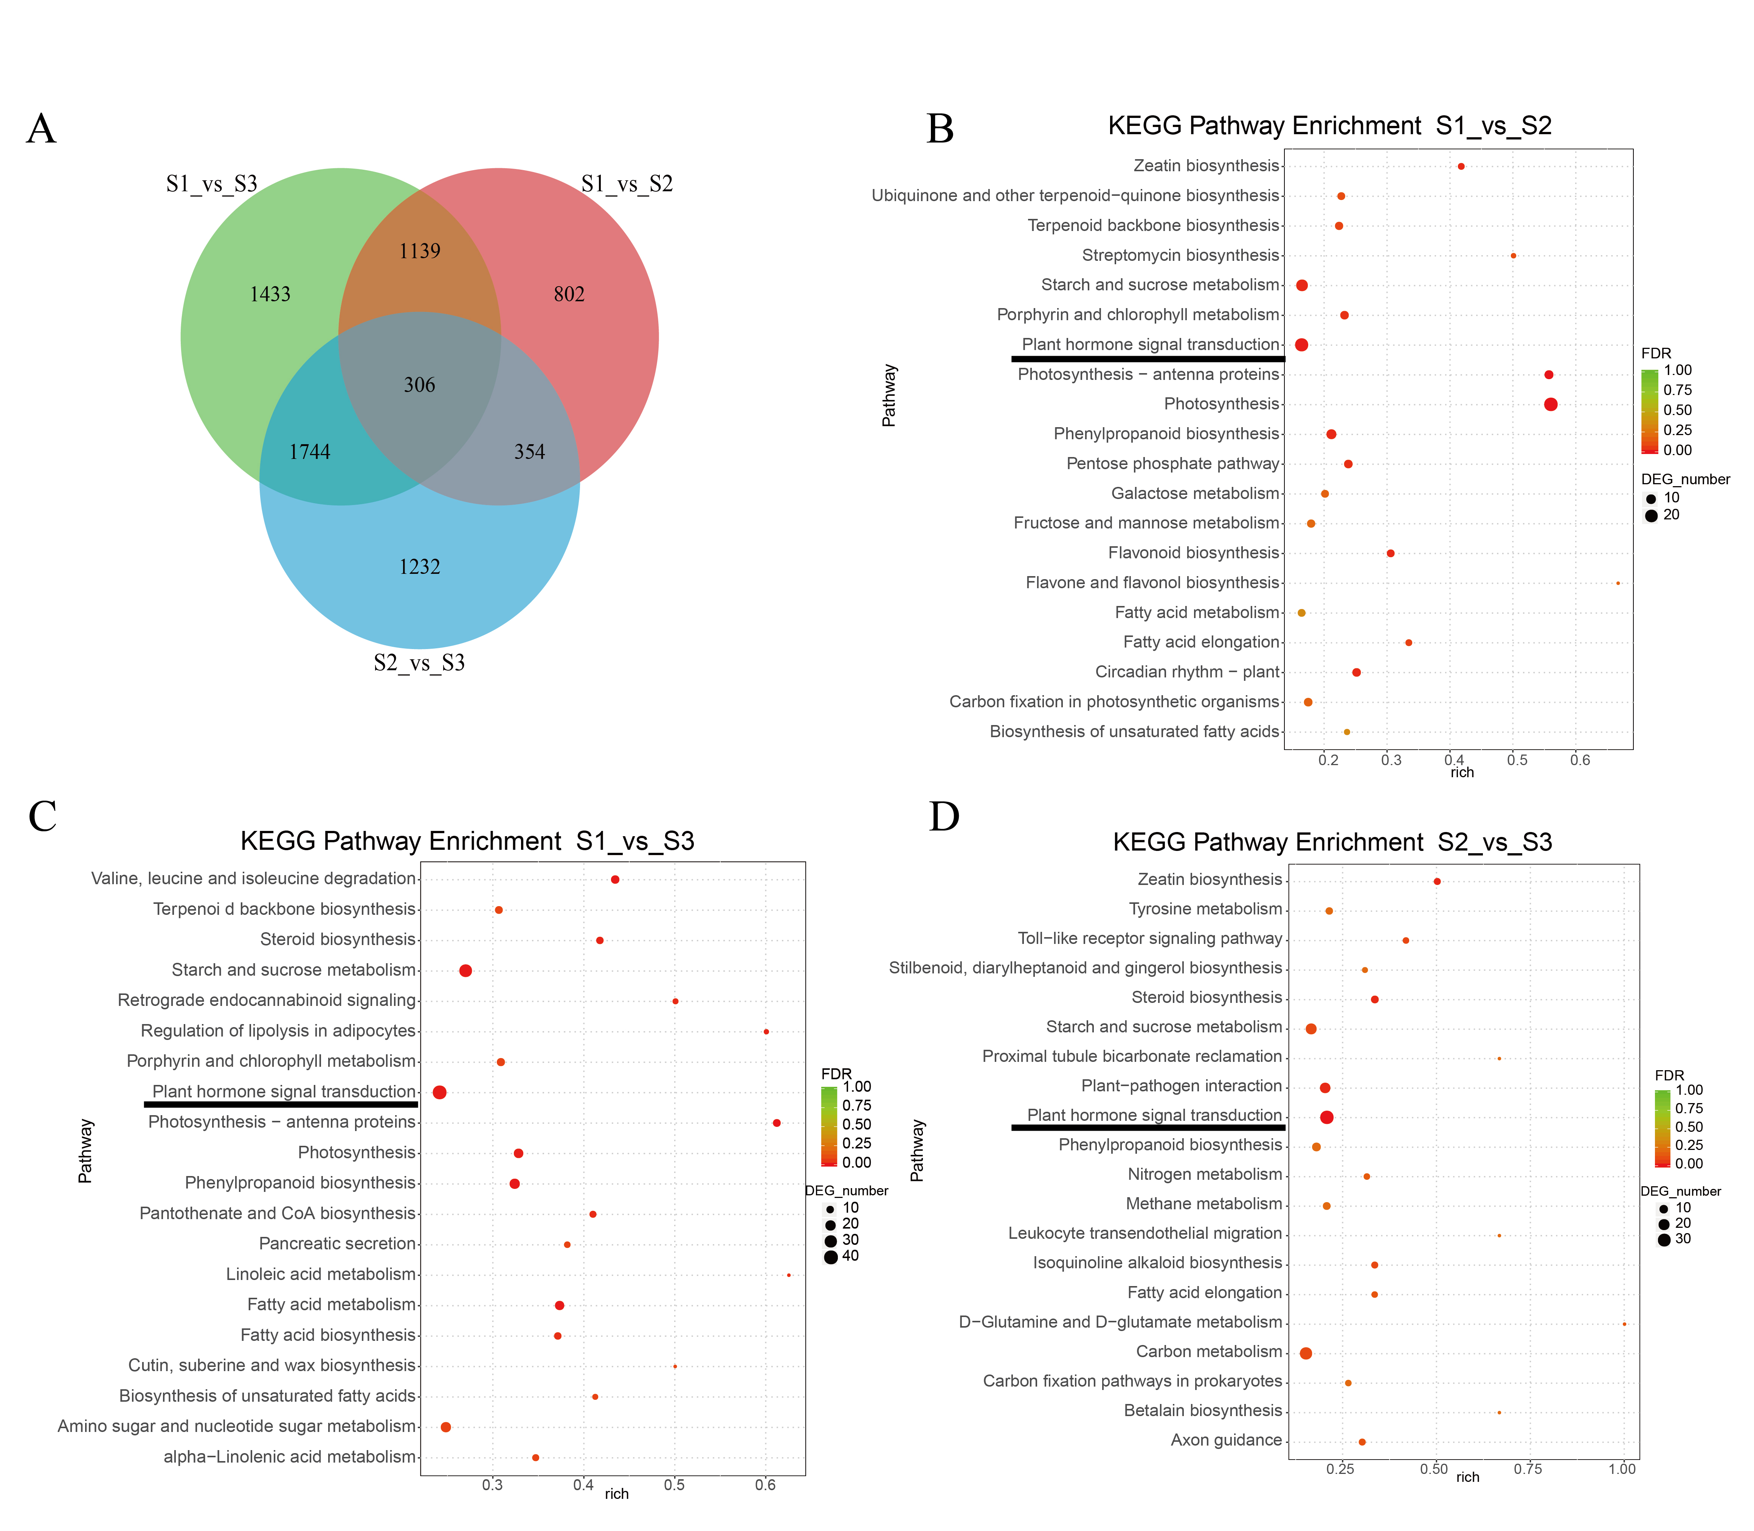
Figure S4. The differentially expressed genes (DEGs) in different stages of flower development. (A): Venn diagram of DEGs in flower development. (B): KEGG Pathway Enrichment in bud petals vs. coloring petals. (C): KEGG Pathway Enrichment in coloring petals vs. pigmented petals. (D): KEGG Pathway Enrichment in bud petals vs. pigmented petals.
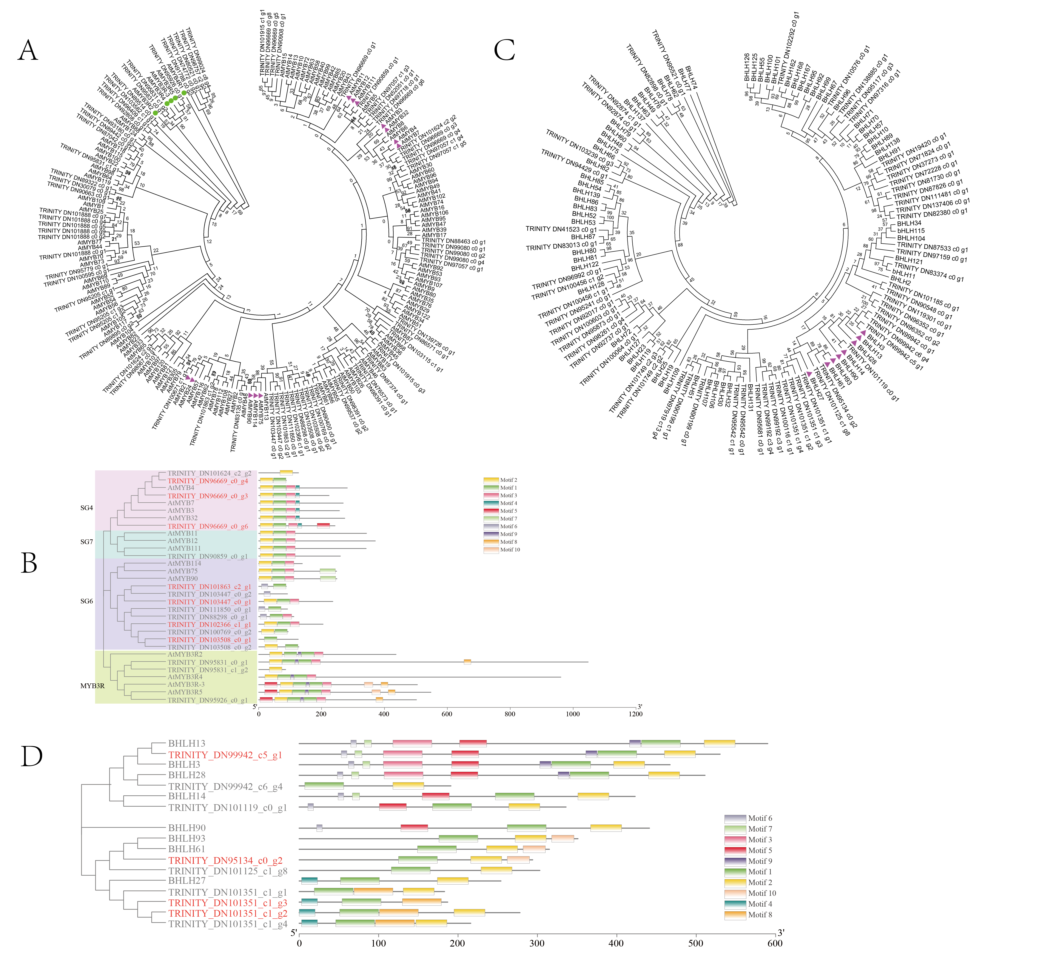
Supplementary Figure S5. Evolutionary tree analysis of transcription factors. (A): MYB evolution analysis of lily and Arabidopsis thaliana; (B): Evolutionary tree analysis of the conserved motif structure of the MYB gene associated with anthocyanin synthesis (C): bHLH evolution analysis of lily and Arabidopsis thaliana; (D): Evolutionary tree analysis of the conserved motif structure of the bHLH gene associated with anthocyanin synthesis.
Supplementary Table S1. The pearson correlation of transcriptome data and RT-qPCR.
Gene name | LvMYB5 | LvMYB7 | LvCHS | LvF3’H | LvDFR | LvANS | Lv3GT | LvGST
Pearson correlation (r) | 0.8205 | 0.8197 | 0.9241 | 0.8025 | 0.8790 | 0.8004 | 0.8006 | 0.9956
Supplementary Table S2. The primers information of 9 genes in this study
Gene | Forward sequence (5'-3') | Reverse sequence (5'-3') | PCR Products(bp)
Actin | GTCCATCCATCGTCCACAG | CCTCAACAAGCCACCTACC | 180
LvDFR | GGGTCCTTTCATCACCTCAAC | CCACTCGCTTCTGGATTCTCA | 165
LvANS | CCAAATGTCCGCAACCTGA | GCCAATGTGGACGAGAAGC | 164
Lv3GT | GGCAACCTTGACTCCGTCTT | GGGGATTGTTGGGTGAGGA | 182
LvCHS | CTCCGTCAACCGCCTCAT | TGATCTCCGAGCAGACCACTA | 125
LvF3H | CACAGCAGGGACAGACACCA | GGCACTTAGGAAGGGGAGG | 166
LvGST | GCCGACCCTTATGACCGT | CGTTGCCTTCTCCTCCTCTT | 117
LvMYB5 | AGTGAAGTGGAGCCGTGTT | TGTGAAGCCTGATGATGAGGT | 146
LvMYB7 | CGACGGCGATGGCTCAACTA | GCTGGGTTACAGGTTGTGGTCT | 153

