Supporting Information
Anti-Tumor Therapy through High ROS Performance induced by Ag Catalase from Boron Cluster with Halloysite Clay Nanotubes
Xuefan Deng^{1,2†}, Xiaoran Xu^{1†}, Shiying Xia², Zhengxi Wang³, Yi Li¹, Xinyu Wang¹, Yujia Tan¹, Pan Liu¹, Lijie Sun⁴, Tianhe Huang¹*, Yongchang Wei¹* and Haibo Zhang²*

¹Department of Radiation and Medical Oncology, Zhongnan Hospital of Wuhan University, Hubei Cancer Clinical Study Center & Hubei Key Laboratory of Tumor Biological Behaviors, Wuhan 430071, China
²College of Chemistry and Molecular Sciences and National Demonstration Center for Experimental Chemistry, Wuhan University, Wuhan 430072, PR China.
³College of Nuclear Technology and Chemical Biology, Hubei University of Science and Technology, Xianning, Hubei, 437100, P. R. China.
⁴Shijiazhuang Siyao Co., Ltd, Shijiazhuang, 050000, P. R. China.
†Contributed equally.
*Corresponding author：
Tianhe Huang, zn004593@whu.edu.cn;
Yongchang Wei, weiyongchang@whu.edu.cn;
Haibo Zhang, haibozhang@whu.edu.cn.

Table of the Content
Materials and Methods 4
Preparation of the Catalysts 4
Preparation of Na₂B₁₂H₁₂ 4
Pretreatment of HNT 4
Preparation of HNT@B₁₂H₁₂ 4
Preparation of HNT@B₁₂H₁₂@Au 4
Preparation of HNT@B₁₂H₁₂@Ag 5
Preparation of HNT@B₁₂H₁₂@Pd 5
Preparation of HNT@B₁₂H₁₂@Ag@ Rhodamine B (RB) 5
Computational details 5
Density function theory (DFT) calculations 5
Cell culture 6
Cell viability test 6
Live/dead assay 6
Cell apoptosis analysis 6
Mitochondrial membrane potential (Δψm) assays 7
Measurement of intracellular ROS levels 7
Measurement of intracellular Hydroxyl radical(·OH) levels 7
Fluorescent tracing 8
Animal Models 8
Statistical analysis 8
Results and Discussion 10
Figure S1. Model 1: Ag₃₈ cluster clean surface 10
Figure S2. Model 1: Ag₃₈ cluster adsorption of H₂O₂ 10
Figure S3. Model 1: Ag₃₈ cluster adsorption of OH 10
Figure S4. Model 2: Ag-SA/halloysite(001) clean surface 11
Figure S5. Model 2: Ag-SA/halloysite (001) adsorption of H₂O₂ 11
Figure S6. Model 2: Ag-SA/halloysite (001) adsorption of OH 11
Figure S7. Model 3: Ag-SA/B (001) clean surface 11
Figure S8. Model 3 : Ag-SA/B (001) adsorption of H₂O₂ 12
Figure S9. Model 3: Ag-SA/B (001) adsorption of OH 12
Figure S10. The PRXD spectra of HNT, HNT@B₁₂H₁₂@Au and HNT@B₁₂H₁₂@Pd 12
Figure S11. FESEM of pure HNT 12
Figure S12. Typical HRTEM of HNT@B₁₂H₁₂@Au (a); HAADF-STEM image of HNT@B₁₂H₁₂@Au (b); and representative B, Au, Al, Si elemental mapping of (c); and typical HRTEM of HNT@B₁₂H₁₂@Pd (d); HAADF-STEM image of HNT@B₁₂H₁₂@Pd (e); and representative B, Pd, Al, Si elemental mapping of (f). 13
Figure S13. The XPS spectra of Au in HNT@B₁₂H₁₂@Au (a); The XPS spectra of Pd in HNT@B₁₂H₁₂@Pd (b). 13
Figure S14. The N₂ adsorption-desorption isotherms of HNT (a) and HNT@B₁₂H₁₂@Au/Ag/Pd (b-d). 14
Figure S15. (a) and (b) Fluorescence images of DCFH-DA staining for B16 cells treated with HNT@B₁₂H₁₂@Ag catalase at gradient concentrations, and the MFI was measured by ImageJ (n=3). (c) and (d) Flow cytometry was used to detect the ROS levels of B16 cells treated with HNT@B₁₂H₁₂@Ag catalase, and the MFI was measured (n=3). 14
Figure S16. B16 cells were treated with various concentrations of HNT@B₁₂H₁₂@Ag, HNT@B₁₂H₁₂@Pd, HNT@B₁₂H₁₂@Au and HNTs, and then cell viability was measured (n=4). The results are presented as mean ± standard deviation (SD). *P < 0.05, **P < 0.01, ***P < 0.001 and ****P < 0.0001 15
Figure S17. (a) Curve of mouse body weight during the treatment (n = 6). (b) HE staining of organs (heart, liver, spleen, lungs, and kidneys) 15
Reference 16

Materials and Methods
All the chemicals and solvents were purchased from Sinopharm Chemical Reagent Co., Ltd, and used without further purification. Ultrapure water was used for all processes. PXRD spectra were obtained on Bruker D8 Advance. Infrared spectra (FT-IR) were obtained on Thermo iS10 (with 16 scans). The XPS spectra of HNT@B₁₂H₁₂@Au/Pd/Ag were recorded on ESCALAB250Xi. The material was prepared into a suspended ethanol solution and dropped on a silicon wafer to air dry. Then, field emission scanning electron microscopy images were collected on Zeiss SIGMA (signal acquisition mode: Inens SE2; acceleration voltage: 5.00 kV). The material was prepared into a suspended aqueous solution and dropped on a self-supporting carbon film, and the HRTEM image was recorded on JEM-2100 Plus. Ag K-edge analysis was performed with Si (111) crystal monochromators at the BL11B beamlines at the Shanghai Synchrotron Radiation Facility (Shanghai, China). Before the analysis at the beamline, samples were pressed into thin sheets 1 cm in diameter and sealed using Kapton tape film. The EPR spectra were recorded using Bruker A300. The XAFS spectra were recorded at room temperature using a four-channel Silicon Drift Detector Bruker 5040. Au L-edge EXAFS spectra were recorded in transmission mode. Negligible changes in the line shape and peak position of Fe K-edge XANES spectra were observed between two scans taken for a specific sample. The XAFS spectra of the standard samples (Ag hydroxide, AgNO₃, and Ag foils) were recorded in transmission mode. We determined that the Au, Pd and Ag load in HNT@B₁₂H₁₂ were 0.44 wt%, 0.59 wt% and 0.54%, respectively.
Preparation of the Catalysts
Preparation of Na₂B₁₂H₁₂: Na₂B₁₂H₁₂was synthesized using a method in the literature ¹.
Pretreatment of HNT：Pure HNT was dispersed in ultrapure water, After ultrasonic sonication in ultrapure water at 300 W for 1500s, the suspension was centrifuged at 5000r/min for 15 min, and the upper layer was centrifuged at 12000r/min for 5 min. After centrifugation, the precipitated HNT was washed 3 times with anhydrous ethanol and ultrapure water alternately to obtain short tubes of HNT.
Preparation of HNT@B₁₂H₁₂: HNT (1000.0 mg) was dispersed in 100 mL 1M HCl at 50°C. After continuous stirring for 48 h, the solids were collected by centrifugation, washed with ultrapure water several times, and then dried under vacuum at 60°C for 12 h to obtain H^{+–}HNT. H^{+–}HNT (781.0 mg) and Na₂B₁₂H₁₂ (600.0 mg) were added in 30 mL of ultrapure water and stirred for 24 h. Then, HNT@B₁₂H₁₂ was collected by filtration and alternate washing with methanol and ultrapure water three times. Then, 827.8 mg HNT@B₁₂H₁₂ was collected by filtration and alternate washing with methanol and ultrapure water three times. The weight loading of element B was determined by XPS to be 21.4%.
Preparation of HNT@B₁₂H₁₂@Au: 200.0 mg of HNT@B₁₂H₁₂ was dispersed in 50 mL of ultrapure water, and a 210 μL sodium chloroaurate (NaAuCl₄) aqueous solution (59.07 mM) was slowly added dropwise under stirring. The reaction was terminated when the solid completely turned dark purple. After filtration, washing, and drying, HNT@B₁₂H₁₂@Au was obtained.
Preparation of HNT@B₁₂H₁₂@Ag: 200.0 mg of HNT was dispersed into 50 mL of ultrapure water, and a 175 μL NaAuCl₄ aqueous solution (55.12 mM) was slowly added dropwise under stirring. The reaction was terminated when the solid completely turned silver gray. After filtration, washing, and drying, HNT@B₁₂H₁₂@Ag was obtained.
Preparation of HNT@B₁₂H₁₂@Pd: 200.0 mg of HNT was dispersed into 50 mL of ultrapure water, and a 275 μL Na₂PdCl₄ aqueous solution (39.64 mM) was slowly added dropwise under stirring. The reaction was terminated when the solid completely turned dark gray. After filtration, washing, and drying, HNT@B₁₂H₁₂@Pd was obtained.
Preparation of HNT@B₁₂H₁₂@Ag@ Rhodamine B (RB): 50.0 mg HNT@ B₁₂H₁₂@Ag and 50.0 mg Rhodamine B were dispersed into 10 mL of ultrapure water, after continuous stirring for 24h under the dark, washing with water, centrifugation was repeated alternately until the upper layer was colorless clear, and HNT@B₁₂H₁₂@Ag@RB was obtained after drying under the dark.

Computational details
Density function theory (DFT) calculations
We have employed the Vienna Ab Initio Package (VASP)^{2, 3} to perform all the density functional theory (DFT) calculations within the generalized gradient approximation (GGA) using the PBE⁴ formulation. We have chosen the projected augmented wave (PAW) potentials^{5, 6} to describe the ionic cores and take valence electrons into account using a plane wave basis set with a kinetic energy cutoff of 400 eV. Partial occupancies of the Kohn−Sham orbitals were allowed using the Gaussian smearing method and a width of 0.05 eV. The electronic energy was considered self-consistent when the energy change was smaller than 10−5 eV. A geometry optimization was considered convergent when the force change was smaller than 0.02 eV/Å. Grimme’s DFT-D3 methodology⁷ was used to describe the dispersion interactions.
Model 1 is an Ag₃₈ cluster in a cubic box of 20 Å. During structural optimizations, the Γ point in the Brillouin zone was used for k-point sampling, and all atoms were allowed to relax.
The equilibrium lattice constants of monoclinic halloysite unit cell were optimized, when using a 5×3×3 Monkhorst-Pack k-point grid for Brillouin zone sampling, to be a=5.221 Å, b=8.676 Å, c=7.119 Å, α=90°, β=95.3°, γ=90°. We then use it to construct a halloysite (001) surface model with p (3×2) periodicity in the x and y directions and one stoichiometric layer in the z direction separated by a vacuum layer in the depth of 15 Å in order to separate the surface slab from its periodic duplicates. Model 2 was built by adding one Ag atom onto this halloysite (001) surface. During structural optimizations, a 2×1×1 k-point grid in the Brillouin zone was used for k-point sampling, and the bottom half stoichiometric layer was fixed while the rest were allowed to relax.
The equilibrium lattice constants of hexagonal B unit cell were optimized, when using a 9×9×3 Monkhorst-Pack k-point grid for Brillouin zone sampling, to be a=4.881 Å, c=12.513 Å. We then use it to construct a B(001) surface model with p(2×2) periodicity in the x and y directions and one stoichiometric layer in the z direction separated by a vacuum layer in the depth of 15 Å in order to separate the surface slab from its periodic duplicates. Model 3 was built by adding one Ag atom onto this B (001) surface. During structural optimizations, a 2×2×1 k-point grid in the Brillouin zone was used for k-point sampling, and the bottom half stoichiometric layer was fixed while the rest were allowed to relax. The model of 1-3 please see Figure S1-9 for details.

Cell culture
B16 (mouse melanoma cells) was purchased from Procell (Cat# CL-0029, Wuhan, China). Cells were cultured in the PRMI 1640 media containing 10% fetal bovine serum (Gibco, Grand Island, NY) with 1% penicillin–streptomycin solution at 37 °C and 5% CO₂.

Cell viability test
The Cell Counting Kit-8 (CCK8) assay kit was purchased from Meilunbio (Cat# MA0218, China). 1.0 × 10⁴ B16 cells per well cultured in 200 μL PRMI 1640 were seeded into a 96-well plate overnight and then incubated with 200 μL fresh medium containing 1× PBS (as control), HNTs and HNT@B₁₂H₁₂@Ag/Pd/Au at different concentrations. After additional 24 h incubation, 20 μL CCK-8 was added into each well, and the B16 cells were then incubated for another 4 h at 37 °C and 5% CO₂. To eliminate the influence of precipitation on the absorbance, supernatant liquid (100 μL) was transferred to a new 96-well cell culture plate. After that, the absorbance of each well at 450 nm was measured by microplate reader (SpectraMax M2, Molecular Devices, China). Mean and standard deviation (SD) of 6 parallels were reported for each sample.

Live/dead assay
The assay was performed using a Calcein-AM/PI Double Stain Kit (YEASEN, Cat# 40747ES76, China). B16 cells were treated with different concentrations (0,200,400, and 600 μg/mL) of HNT@B₁₂H₁₂@Ag for 24 h. Then, the cells were washed with PBS three times and incubated with 2 µM Calcein-AM and 4.5 µM PI for another 30 min out of light. Finally, the results were observed using fluorescence microscopy (Olympus).

Cell apoptosis analysis
The HNT@B₁₂H₁₂@Ag mediated-cell apoptosis effect was analyzed by flow cytometer with Annexin V-FITC Apoptosis Detection Kit (MULTI SCIENCES, Cat# AP101, China). 1 × 10⁶/well cells were seeded in 6-well plates overnight and treated with various concentrations of HNT@B₁₂H₁₂@Ag (0,200,400, and 600 μg/mL) for 24 h. After that, cells were collected, washed with PBS three times, resuspended in the 1 × binding buffer, and incubated with Annexin V-FITC and PI for 5 min at room temperature. All the stained cells were analyzed using a flow cytometer (Beckman Coulter, CytoFLEX, China), and the data were analyzed with FlowJo_V10 software.

Mitochondrial membrane potential (Δψm) assays
Mitochondrial membrane potential assays were performed using the mitochondrial membrane potential detection kit (Beyotime, Cat# C2006, China). B16 was seeded in six-well plates (1 × 10⁶ cells/well) and treated with various concentrations of HNT@B₁₂H₁₂@Ag (0,200,400, and 600 μg/mL) for 24 h. The cells were then collected, washed with PBS three times, and incubated with JC-1 dye for 30 min at 37 °C. Flow cytometry (Beckman Coulter, CytoFLEX, China) was used to measure changes in mitochondrial transmembrane potential.

Measurement of intracellular ROS levels
The intracellular ROS levels were measured using a Reactive Oxygen Species Assay Kit (Beyotime Biotechnology, Cat# S0033S, China). B16 cells were seeded in 6-well plates (1 × 10⁶ cells/well) overnight and treated with various concentrations of HNT@B₁₂H₁₂@Ag (0, 200, 400, and 600 μg/mL) for 8 h. The cells were then collected, washed with PBS three times, and incubated with DCFH-DA for 20min at 37 °C. Flow cytometry (Beckman Coulter, CytoFLEX, China) was used to measure ROS production.
For co-staining, B16 cells were seeded in 12-well plates (5 × 10⁵ cells/well) and treated with various concentrations of HNT@B₁₂H₁₂@Ag (0, 200, 400, and 600 μg/mL) for 8 h. Following the treatment, the cells were incubated with DCFH-DA for 20min at 37°C and then observed using fluorescence microscopy (Olympus).

Measurement of intracellular Hydroxyl radical(·OH) levels
The intracellular ·OH levels were measured using a Hydroxyl radical(·OH) Assay kit (Beijing Baiaolaibo Technology, Cat# HR8841, China). B16 cells were seeded in 6-well plates (1 × 10⁶ cells/well) overnight and treated with various concentrations of HNT@B₁₂H₁₂@Ag (0, 200, 400, and 600 μg/mL) for 8 h. The cells were then collected, washed with PBS three times, and incubated with fluorescent probe O27 for 40min at 37 °C. Flow cytometry (Beckman Coulter, CytoFLEX, China) was used to measure ·OH production.
For co-staining, B16 cells were seeded in 12-well plates (5 × 10⁵ cells/well) and treated with various concentrations of HNT@B₁₂H₁₂@Ag (0, 200, 400, and 600 μg/mL) for 8 h. Following the treatment, the cells were incubated with fluorescent probe O27 for 40min at 37°C.The cells were incubated with Hoechst 33342 (Beyotime Biotechnology, Cat# C1027, China) for 10min, washed with PBS three times, and then observed using fluorescence microscopy (Olympus).

Fluorescent tracing
In order to observe the internalization of HNT@B₁₂H₁₂@Ag inside cells, Fluorescence probe (Rb) was connected with HNT@B₁₂H₁₂@Ag. B16 cells were seeded in 12-well plates (5 × 10⁵ cells/well) and treated with 400 μg/mL of HNT@B₁₂H₁₂@Ag for 8 h. The cells were incubated with DAPI (Biosharp, BL105A, China) for 5min, washed with PBS three times, and then observed using fluorescence microscopy (Olympus).
To detect the cell-uptake levels of HNT@B₁₂H₁₂@Ag-Rb, B16 cells were seeded in 6-well plates (1 × 10⁶ cells/well) overnight and treated with 400 μg/mL of HNT@B₁₂H₁₂@Ag for 8 h. The cells were then collected, washed with PBS three times. Flow cytometry (Beckman Coulter, CytoFLEX, China) was used to measure the mean fluorescence intensity (MFI).

Animal Models
The five-week-old Male C57BL/6JGpt[GF] mice（Strain NO.N000295）were purchased from GemPharmatech Co., Ltd (Nanjing, China). All animal care and experimental procedures were approved by the Experimental Animal Welfare Ethics Committee, Zhongnan Hospital of Wuhan University (Approval ID: ZN2022165) and were in accordance with the National Institute of Health’s Guide for the Care and Use of Laboratory Animals.
To establish the tumor model, 0.5 × 10⁶ B16 cells were implanted subcutaneously into the right back of each mouse. 7 days later, tumor-bearing mouses were randomly divided into two groups (n=6) and received different treatments: saline (100 μL for each mouse) and HNT@B₁₂H₁₂@Ag (15 mg/kg, 100 μL for each mouse). Mice bearing B16 tumors were administrated with saline and HNT@B₁₂H₁₂@Ag (15 mg/kg) every two days through intraperitoneal (i.p.) injection. The treatment duration lasts for 21 days. The mice weights and tumor sizes were also measured every two days. At the end of the study, all mice were sacrificed, and samples were harvested and processed for the subsequent assays. The tumor volume was calculated using the following equation.
volume (mm³) = 0.5 × [length (mm)] × [width (mm)]²

Statistical analysis
For all statistical comparisons, Student's t-test and analysis of variance (ANOVA) were performed using GraphPad Prism 8 for data analysis. P values of < 0.05 were considered statistically significantly different. Statistical significance was delineated as follows: ns not significant; *P < 0.05; **P < 0.01; ***P < 0.001; ****P < 0.0001.

Results and Discussion
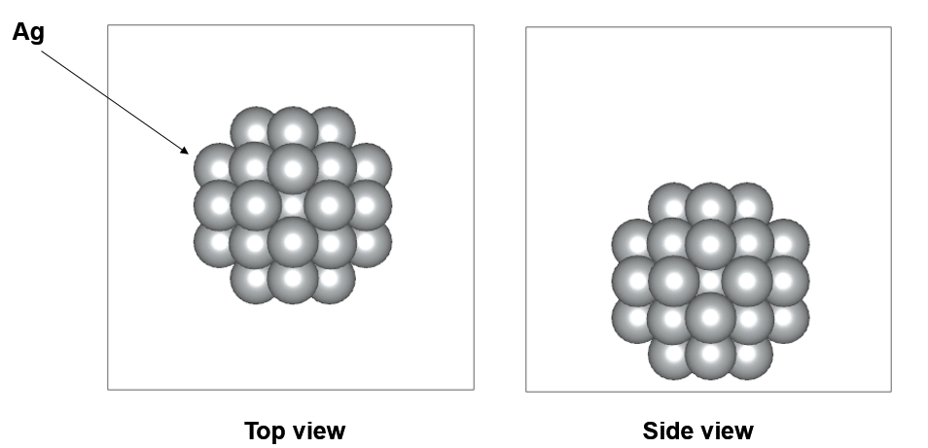
Figure S1. Model 1 : Ag₃₈ cluster clean surface.

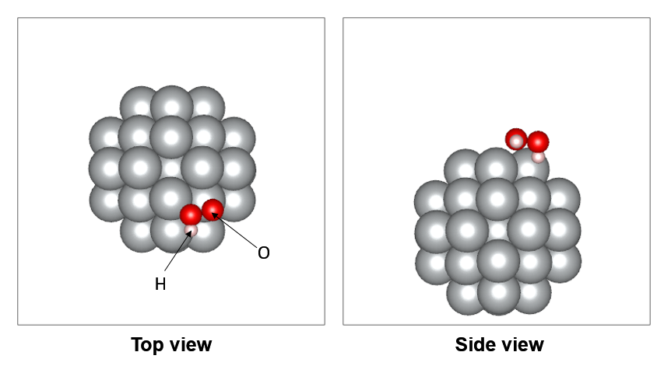
Figure S2. Model 1 : Ag₃₈ cluster adsorption of H₂O₂.
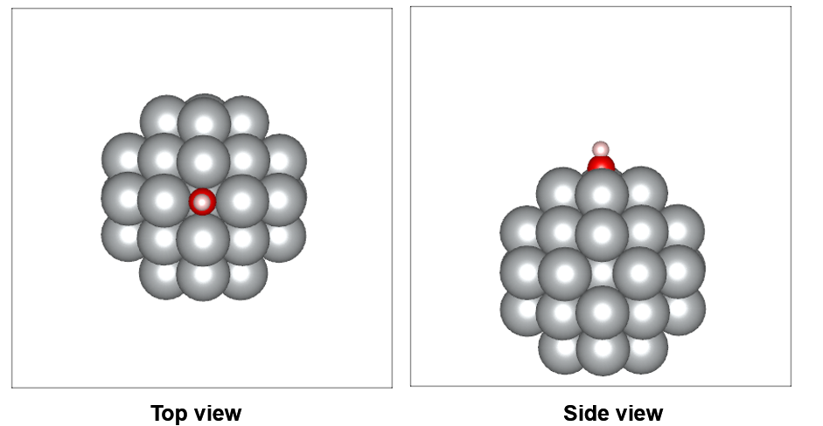
Figure S3. Model 1 : Ag₃₈ cluster adsorption of OH.
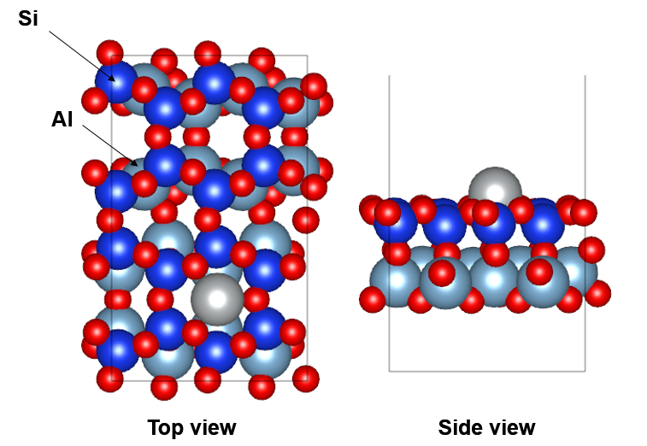
Figure S4. Model 2 : Ag-SA/halloysite(001) clean surface
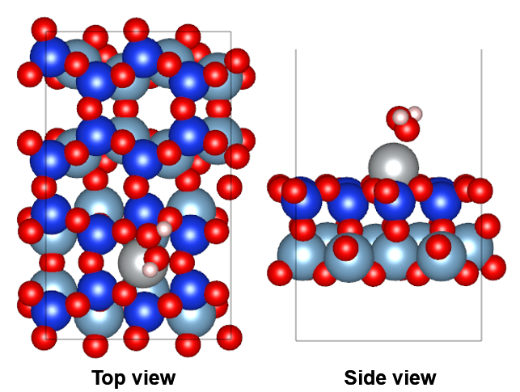
Figure S5. Model 2 : Ag-SA/halloysite (001) adsorption of H₂O_{2.}
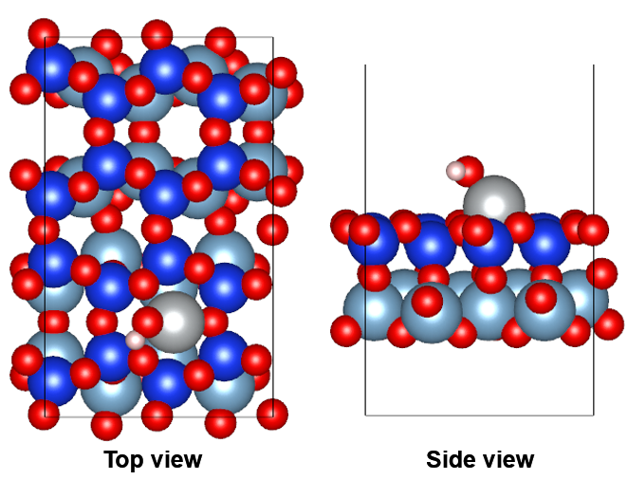
Figure S6. Model 2 : Ag-SA/halloysite (001) adsorption of OH.
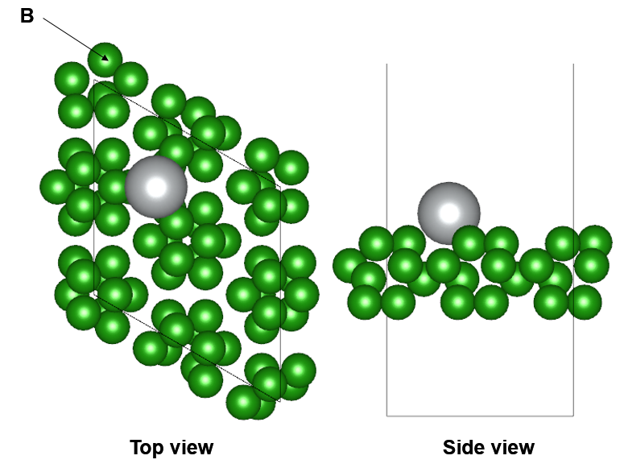
Figure S7. Model 3 : Ag-SA/B (001) clean surface.
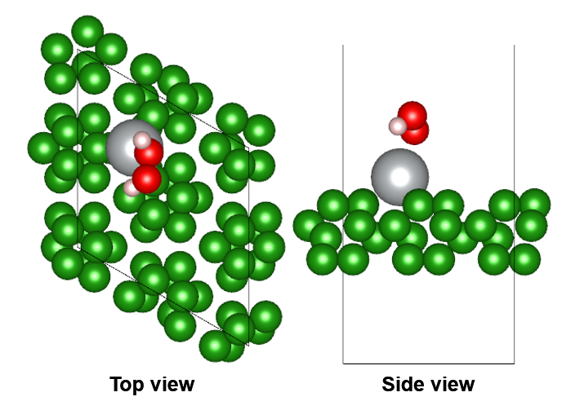
Figure S8. Model 3 : Ag-SA/B (001) adsorption of H₂O₂.

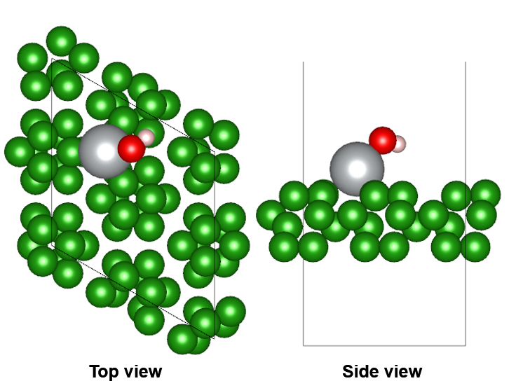
Figure S9. Model 3 : Ag-SA/B (001) adsorption of OH.

Figure S10. The PRXD spectra of HNT, HNT@B₁₂H₁₂@Au and HNT@B₁₂H₁₂@Pd.
Figure S11. FESEM of pure HNT.

Figure S12. Typical HRTEM of HNT@B₁₂H₁₂@Au (a); HAADF-STEM image of HNT@B₁₂H₁₂@Au (b); and representative B, Au, Al, Si elemental mapping of (c); and typical HRTEM of HNT@B₁₂H₁₂@Pd (d); HAADF-STEM image of HNT@B₁₂H₁₂@Pd (e); and representative B, Pd, Al, Si elemental mapping of (f).

Figure S13. The XPS spectra of Au in HNT@B₁₂H₁₂@Au (a); The XPS spectra of Pd in HNT@B₁₂H₁₂@Pd (b).
Figure S14. The N₂ adsorption-desorption isotherms of HNT (a) and HNT@B₁₂H₁₂@Au/Ag/Pd (b-d).

Figure S15. (a) and (b) Fluorescence images of DCFH-DA staining for B16 cells treated with HNT@B₁₂H₁₂@Ag catalase at gradient concentrations, and the MFI was measured by ImageJ (n=3). (c) and (d) Flow cytometry was used to detect the ROS levels of B16 cells treated with HNT@B₁₂H₁₂@Ag catalase, and the MFI was measured (n=3).

Figure S16. B16 cells were treated with various concentrations of HNT@B₁₂H₁₂@Ag, HNT@B₁₂H₁₂@Pd, HNT@B₁₂H₁₂@Au and HNTs, and then cell viability was measured (n=4). The results are presented as mean ± standard deviation (SD). *P < 0.05, **P < 0.01, ***P < 0.001 and ****P < 0.0001

Figure S17. (a) Curve of mouse body weight during the treatment (n = 6). (b) HE staining of organs (heart, liver, spleen, lungs, and kidneys).
Reference
1. Chen, W. D.; Wu, G. T.; He, T.; Li, Z.; Guo, Z. P.; Liu, H. K.; Huang, Z. G.; Chen, P., An improved synthesis of unsolvated NaB3H8 and its application in preparing Na2B12H12. Int. J. Hydrog. Energy 2016, 41 (34), 15471-15476.
2. A, G. K.; Science, J. F. b. J. C. M., Efficiency of ab-initio total energy calculations for metals and semiconductors using a plane-wave basis set - ScienceDirect. 1996, 6 (1), 15-50.
3. Kresse, G. G.; J.J. Furthmüller %J Physical review. B, C. m., Efficient Iterative Schemes for Ab Initio Total-Energy Calculations Using a Plane-Wave Basis Set. 1996, 54, 11169.
4. Perdew, J. P.; Burke, K.; Ernzerhof, M., Generalized Gradient Approximation Made Simple. Phys Rev Lett 1996, 77 (18), 3865-3868.
5. Kresse, G.; Joubert, D. J. P. R. B., From ultrasoft pseudopotentials to the projector augmented-wave method. 1999, 59 (3), 1758-1775.
6. Blchl, P. E. J. P. r. B., Condensed matter, Projector augmented-wave method, Phys. 1995, 50 (24), 17953-17979.
7. Grimme, S.; Antony, J.; Ehrlich, S.; Krieg, H. J. J. o. C. P., A consistent and accurate ab initio parametrization of density functional dispersion correction (DFT-D) for the 94 elements H-Pu. 2010, 132 (15), 154104.

