Supplementary Materials for
Limited water outflux from the subducted slab serpentinite via Mariana arc-basin magmatism
Si-Yu Zhao, Alexandra Yang Yang*, Zhiyuan Zhou, Yoshihiko Tamura, Jin-Long Ma, Yi-Gang Xu, Shao-Wei Zhang, and Tai-Ping Zhao
Contents of this file
Table S1 to S3
Figure S1 to S2
Supplementary Tables
Table S1. Boron contents and isotopes measured for the volcanics from the Mariana Pagan and NW Rota-1 arcs.
Locality | Sample | Latitude (N): | Longitude (E): | Slab Depth (km)ª | B (ppm) | δ¹¹B (‰)
Pagan | HPD1147R01 | 18°13.925′ | 145°52.200′ | -125 | 8.93 | 3.19
Pagan | HPD1147R02 | 18°13.916′ | 145°52.171′ | -125 | 7.45 | 4.25
Pagan | HPD1147R03 | 18°13.892′ | 145°52.133′ | -125 | 3.02 | 2.49
Pagan | HPD1147R04 | 18°13.852′ | 145°52.063′ | -125 | 8.54 | 4.55
Pagan | HPD1147R06 | 18°13.794′ | 145°51.99′ | -125 | 8.19 | 4.74
Pagan | HPD1147R11 | 18°13.487′ | 145°51.599′ | -126 | 8.22 | 4.26
Pagan | HPD1147R12 | 18°13.475′ | 145°51.583′ | -126 | 7.94 | 4.37
Pagan | HPD1147R13 | 18°13.461′ | 145°51.537′ | -126 | 8.21 | 4.71
Pagan | HPD1147R18 | 18°13.252′ | 145°51.075′ | -128 | 11.12 | 5.79
Pagan | HPD1147R18 (duplicate) |  |  |  | 11.17 | 5.56
Pagan | HPD1147R21 | 18°13.234′ | 145°51.022′ | -128 | 4.65 | 3.35
Pagan | HPD1147R23 | 18°13.004′ | 145°50.367′ | -130 | 19.48 | 5.04
Pagan | HPD1148R01 | 17°58.593′ | 145°38.325′ | -167 | 10.79 | 2.31
Pagan | HPD1148R04 | 17°58.624′ | 145°38.327′ | -167 | 14.28 | 3.81
Pagan | HPD1148R04 (duplicate) |  |  |  | 17.98 | 3.86
Pagan | HPD1148R05 | 17°58.625′ | 145°38.314′ | -167 | 47.26 | 4.68
Pagan | HPD1148R06 | 17°58.578′ | 145°38.311′ | -167 | 8.81 | 1.14
NW Rota-1 | HPD488R01 | 14°35.290′ | 144°49.609′ | -210 | 1.37 | 0.47
NW Rota-1 | HPD488R04 | 14°35.318′ | 144°49.595′ | -210 | 3.23 | 0.31
NW Rota-1 | HPD488R05 | 14°35.325′ | 144°49.596′ | -210 | 2.95 | 1.72
NW Rota-1 | HPD488R06 | 14°35.325′ | 144°49.597′ | -210 | 3.01 | 1.96
NW Rota-1 | HPD488R07 | 14°35.325′ | 144°49.598′ | -210 | 1.42 | 0.82
NW Rota-1 | HPD488R08 | 14°35.367′ | 144°49.581′ | -210 | 1.04 | 0.30
NW Rota-1 | HPD480R01 | 14°35.991′ | 144°46.509′ | -222 | 3.51 | 0.96
NW Rota-1 | HPD480R09 | 14°36.077′ | 144°46.023′ | -225 | 3.51 | 1.36
NW Rota-1 | HPD480R10 | 14°36.085′ | 144°46.422′ | -223 | 3.28 | 0.93
NW Rota-1 | HPD488R10 | 14°35.453′ | 144°49.541′ | -210 | 7.77 | 4.19
NW Rota-1 | HPD488R11 | 14°35.453′ | 144°49.541′ | -210 | 1.45 | 2.13
NW Rota-1 | HPD488R12 | 14°35.514′ | 144°49.466′ | -210 | 3.11 | 2.11
NW Rota-1 | HPD488R13 | 14°35.551′ | 144°49.422′ | -210 | 1.21 | 2.63
NW Rota-1 | HPD488R17 | 14°35.604′ | 144°48.102′ | -216 | 5.55 | 2.28
 | HPD488R17 (duplicate) |  |  |  | 5.60 | 1.78
ª Slab depth from Hayes, et al. ¹
Table S2. Compositions (in ppm) of the subducted slab and the water-rich flux released by each layer of the slab.
 | Ba | Nb | B | δ¹¹B (‰) | Cl | F
Slab composition ª
Slab upper crust | 406.97 | 40.86 | 35 | 2.4 | 214 | 334
Slab gabbroic crust | 9.50 | 1.70 | 2.7 | 7.35 | 150 | 72
Slab residues | 45.40 | 4.51 | / | -12.8 | 7 | 126
Slab serpentinite | 0.81 | 0.75 | 52.2 | 12.8 | 1072 | 20
Water-rich flux
Shallow crustal flux ^{b} | 1884.11 | 1.09 | 200 | 7.0 | 3192 | 281
Sub-arc crustal flux ^{b} | 2248.44 | 6.24 | 170 | -3.9 | 1494 | 1354
Residual slab melt ^{c} | 384.75 | 4.14 | 16.8 | -12.8 | 49 | 511
Gabbroic flux ^{d} | 192.31 | 0.49 | 22.9 | 7.35 | 2237 | 401
Serpentinite-derived flux ^{e} | 16.44 | 2.39 | 289 | 12.8 | 15990 | 111
Depleted Mantle ^{f} | 0.563 | 0.1485 | 0.007 | -7.1 | 5 | 12

ª The Ba and Nb contents of the slab upper crust were estimated to be composed of 90% AOC² and 10% sediments³, as suggested by previous studies⁴⁻⁶, while those of the slab gabbroic crust were obtained from Hart, et al. ⁷. Ba and Nb contents of the slab residues were taken from Porter and White ⁸, and those of the slab serpentinite were based on the abyssal serpentinite composition reported by Deschamps, et al. ⁹. The boron content and δ¹¹B value of the slab upper crust, slab residues and slab serpentinite were obtained from Tonarini, et al. ⁵, while those of the gabbroic crust were taken from Hart, et al. ⁷. The Cl and F contents of the slab upper crust were estimated to be composed of 90% AOC¹⁰ and 10% sediment¹¹, while those of gabbroic crust were obtained from Kendrick ¹². The Cl and F contents of the slab residues were taken from Beaudoin, et al. ¹³, and those of the slab serpentinite were obtained from Kendrick, et al. ¹⁴.
^{b} The Ba and Nb contents in the shallow crustal flux were calculated applying a batch dehydration model (F=2%) and using partition coefficients from Kessel, et al. ¹⁵ at 4 GPa, 700 °C , while those in the sub-arc crustal flux were calculated applying a batch melting model with F=10% and using partition coefficients from Kessel, et al. ¹⁵ at 4 GPa, 800 °C, as previously suggested⁴. The boron content and δ¹¹B value of the shallow crustal flux and sub-arc crustal flux were estimated values reported by Tonarini, et al. ⁵, at slab depth of 70 km and 120 km, respectively. The Cl and F contents were calculated using partition coefficients reported by Van den Bleeken and Koga ¹⁶, with $D_{solid/fluid}$=0.048 for Cl; $D_{solid/fluid}$=1.19 for F at shallow depth and D=0.163 for F at sub-arc depth.
^{c} The contents of Ba and Nb in the slab residue melt were calculated applying a batch melting model with F=10% and using partition coefficients from Kessel, et al. ¹⁵ at 6 GPa, 900 °C, as previously suggested⁴. The boron content and δ¹¹B value were obtained from Tonarini, et al. ⁵. The contents of Cl and F in slab residue melt were also calculated applying a batch melting model with F=10%, and the partition coefficients used were from Van den Bleeken and Koga ¹⁶, with D=0.048 for Cl and D=0.163 for F.
^{d} The contents of Ba, Nb, B, Cl and F in gabbroic flux were calculated applying a batch dehydration model with F=2% and using partition coefficients from Kessel, et al. ¹⁵ at 6 GPa, 800 °C, as well as reported by Benton, et al. ¹⁷ and Van den Bleeken and Koga ¹⁶, with D=0.1 for B, D=0.048 for Cl and D=0.163 for F. The value of δ¹¹B was assumed to be in equilibrium with its initial value.
^{e} The contents of Ba, Nb, Cl and F in the slab serpentinite-derived flux were calculated applying a batch dehydration model with F=2% and using partition coefficients reported by Scambelluri, et al. ¹⁸ and Van den Bleeken and Koga ¹⁶. The boron content and δ¹¹B value were obtained from Tonarini, et al. ⁵.
^{f} Trace elements of depleted mantle were obtained from Workman and Hart ¹⁹, while the B contents and δ¹¹B values were obtained from Marschall, et al. ²⁰, and the halogen contents were taken from Kendrick, et al. ²¹.
It should be noted that in the experiments, Cl is significantly lost to the aqueous phase, but F is not¹⁶, resulting in a higher partition coefficient of Cl into the fluid than reported values¹⁶. Therefore, the Cl/F ratio in the fluid may be higher than calculated in this study.

Table S3. Estimations of influx and outflux of water and chlorine in the Mariana subduction zone system.
Input flux
 | H₂O contents (wt%) | Thickness (km) | Density (g/cm³) | H₂O influx  (×10⁷ Tg /Myr) | Cl influx  (×10⁵ Tg /Myr)
Sediment | 3.4 | 0.5 | 1.86 | 0.33 | 0.63
Basaltic crust | 2.5 | 2 | 2.73 | 1.43 | 2.71
Gabbro crust | 0.8 | 4 | 2.9 5 | 0.99 | 1.88
Serpentinized mantle | 2.0 | 24 | 2.52 | 12.7 | 24.1
Outflux flux
 | Magma volume  (km³ /yr) | H₂O contents (wt%) | Cl contents (ppm) | H₂O outflux (×10⁷ Tg /Myr) | Cl outflux (×10⁵Tg /Myr)
Arc volcanics | 0.07 | 3.9 | 1123 | 0.72 | 2.08
Back arc basin basalts | 0.25 | 2.1 | 235 | 1.39 | 1.56
Note
Calculation can be found in the main text and methods.

Supplementary Figures
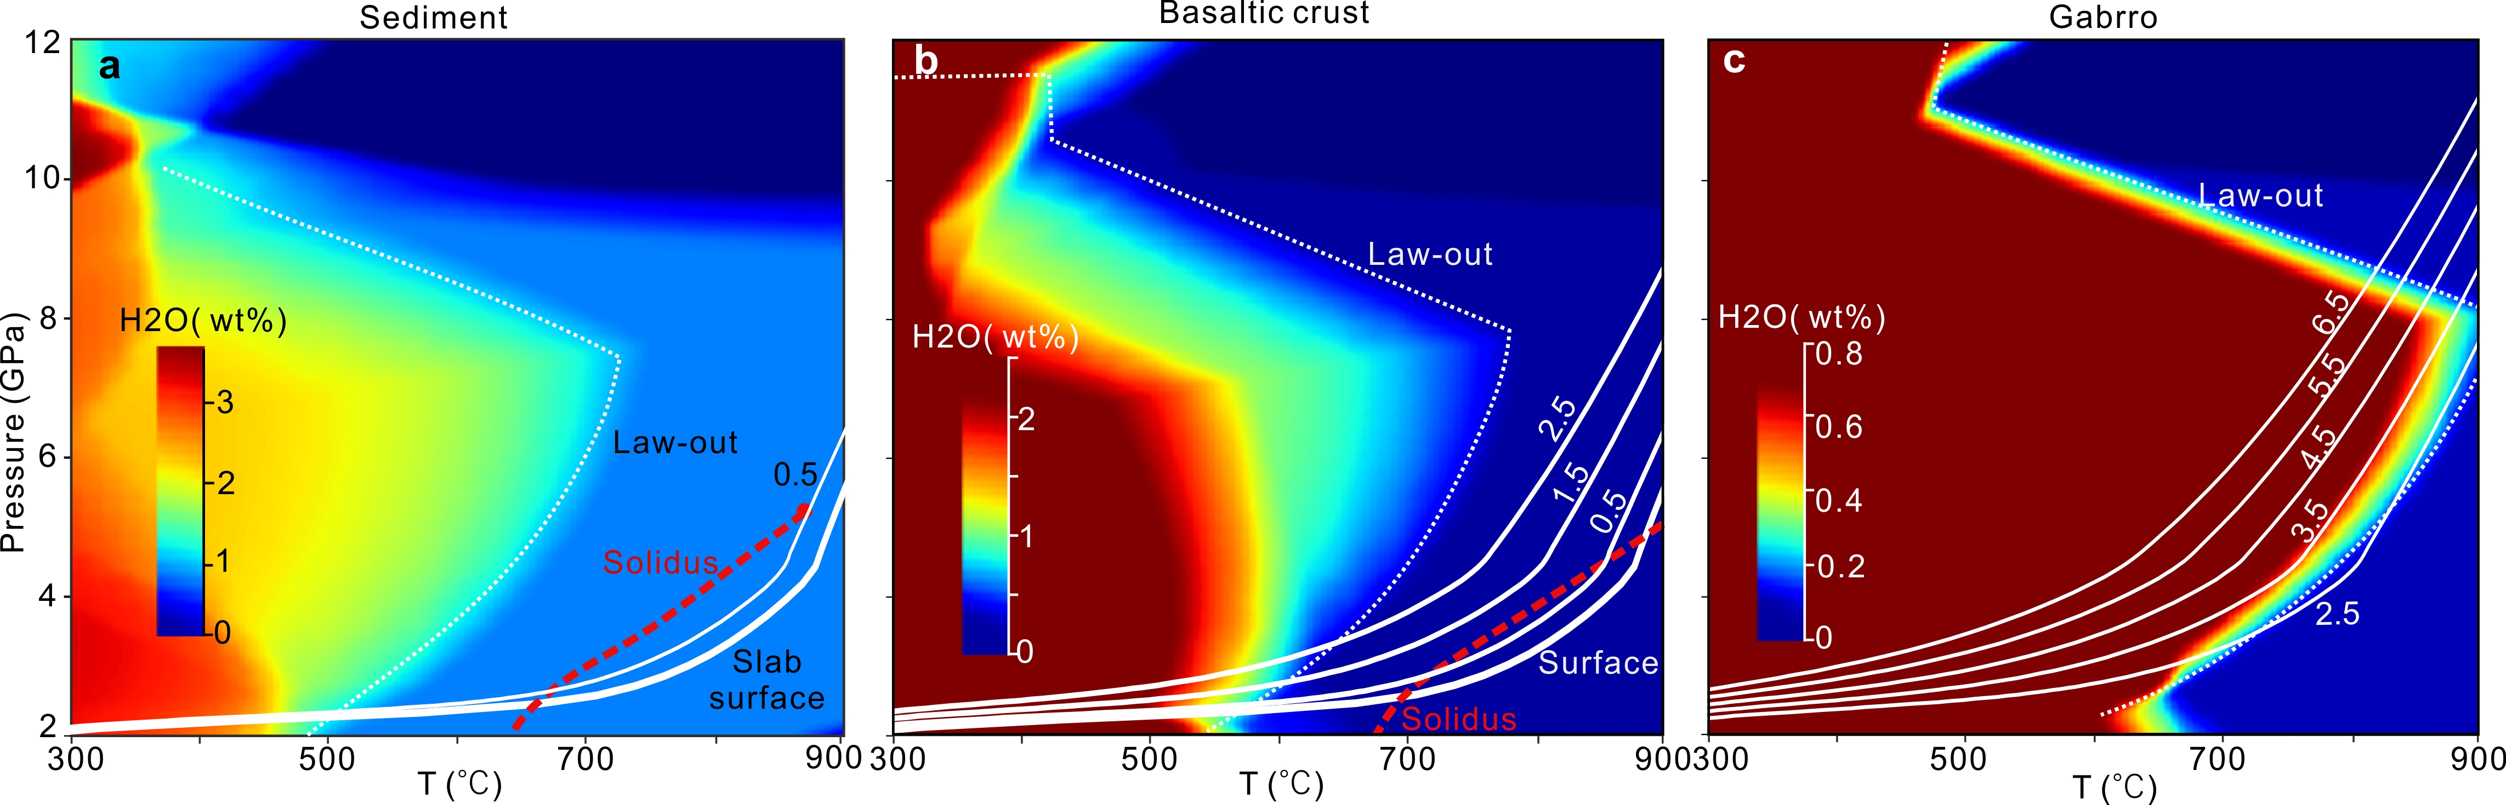
Figure S1. Geotherm of the Mariana slab along with the bound H₂O content in the slab crustal layers. The bound H₂O content in sediment (a), basaltic crust (b) and gabbroic crust (c) were performed using the Perple_X code²² (see Methods). The white lines with numbers represent the geotherm of the Mariana slab, in km beneath slab surface, which was obtained from the model performed by Cerpa, et al. ²³.

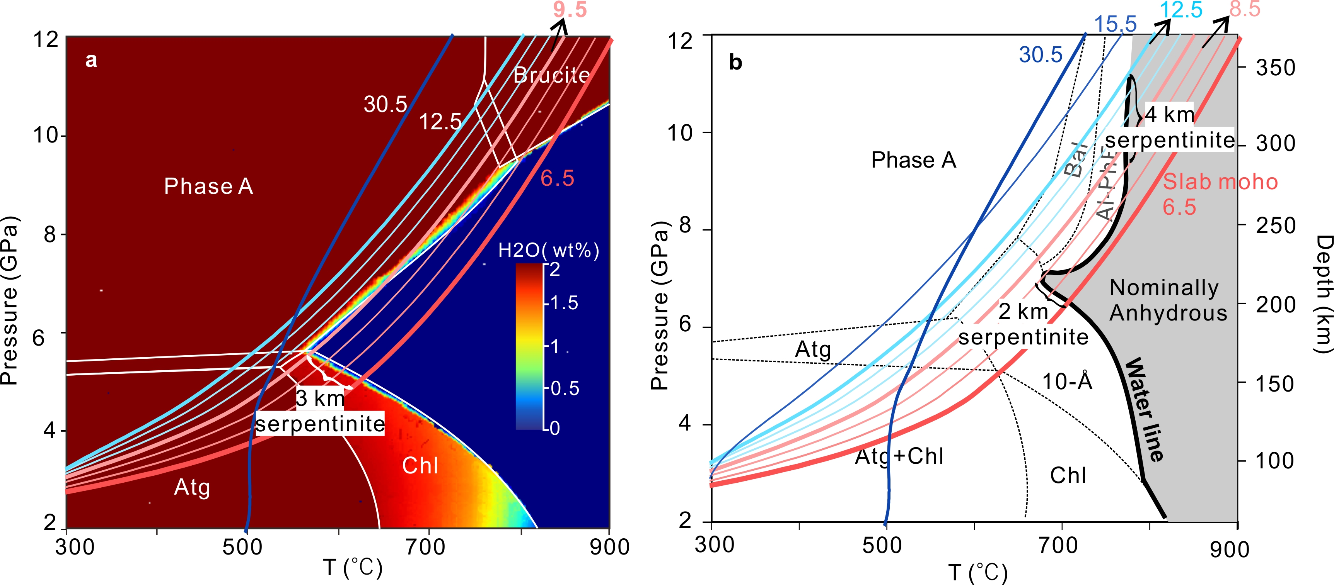
Figure S2. Geotherm of Mariana slab along with the phase diagram of the slab serpentinized lithosphere mantle. a. Thermodynamically modeled phase diagram of slab serpentinite, which was performed using Perple_X. b, Phase diagram of slab serpentinite based on the compiled experimental results from in Cerpa, et al. ²³. Colored lines with numbers represent the geotherm of the Mariana slab, in km beneath slab surface, which was obtained from the model performed by Cerpa, et al. ²³. According to the thermodynamically simulated phase diagram (a), the slab serpentinite undergoes dehydrate at ~5.5 GPa (~170 km) in the Mariana subduction zone through breakdown of antigorite and chlorite. On the other hand, based on the experimental model (b), the slab serpentinite undergoes two stages of dehydration through the breakdown of 10- Å phase in the upper 2 km of slab serpentinite and the breakdown of Al-PhE in underlying 4 km of the slab serpentinite. Here we prefer to use the experimental model (b) instead of the thermodynamic model (a) due to the reasons provided in Cerpa, et al. ²³. law, lawsonite; Atg, antigorite; Chl, chlorite; 10-Å, 10-Å phase; bal, balangeroite; Al-phE, aluminous phase E.
References
1 Hayes, G. P. et al. Slab2, a comprehensive subduction zone geometry model. Science 362, 58-61 (2018).
2 Kelley, K. A., Plank, T., Ludden, J. & Staudigel, H. Composition of altered oceanic crust at ODP Sites 801 and 1149. Geochemistry, Geophysics, Geosystems 4 (2003).
3 Plank, T. in Treatise on Geochemistry (Second Edition) (eds Heinrich D. Holland & Karl K. Turekian) 607-629 (Elsevier, 2014).
4 Li, H.-Y. et al. Molybdenum isotopes unmask slab dehydration and melting beneath the Mariana arc. Nature Communications 12, 6015 (2021).
5 Tonarini, S., Leeman, W. P. & Leat, P. T. Subduction erosion of forearc mantle wedge implicated in the genesis of the South Sandwich Island (SSI) arc: Evidence from boron isotope systematics. Earth and Planetary Science Letters 301, 275-284 (2011).
6 Ishikawa, T. & Tera, F. Two isotopically distinct fluid components involved in the Mariana arc: Evidence from Nb/B ratios and B, Sr, Nd, and Pb isotope systematics. Geology 27, 83-86 (1999).
7 Hart, S. R., Blusztajn, J., Dick, H. J. B., Meyer, P. S. & Muehlenbachs, K. The fingerprint of seawater circulation in a 500-meter section of ocean crust gabbros. Geochimica et Cosmochimica Acta 63, 4059-4080 (1999).
8 Porter, K. A. & White, W. M. Deep mantle subduction flux. Geochemistry, Geophysics, Geosystems 10 (2009).
9 Deschamps, F., Godard, M., Guillot, S. & Hattori, K. Geochemistry of subduction zone serpentinites: A review. Lithos 178, 96-127 (2013).
10 Kendrick, M. A. Halogens in altered ocean crust from the East Pacific Rise (ODP/IODP Hole 1256D). Geochimica et Cosmochimica Acta 261, 93-112 (2019).
11 Kendrick, M. A. in The Role of Halogens in Terrestrial and Extraterrestrial Geochemical Processes: Surface, Crust, and Mantle (eds Daniel E. Harlov & Leonid Aranovich) 591-648 (Springer International Publishing, 2018).
12 Kendrick, M. A. Halogens in Atlantis Bank gabbros, SW Indian Ridge: Implications for styles of seafloor alteration. Earth and Planetary Science Letters 514, 96-107 (2019).
13 Beaudoin, G. M. et al. Global halogen flux of subducting oceanic crust. Earth and Planetary Science Letters 594, 117750 (2022).
14 Kendrick, M. A. et al. Subduction zone fluxes of halogens and noble gases in seafloor and forearc serpentinites. Earth and Planetary Science Letters 365, 86-96 (2013).
15 Kessel, R., Schmidt, M. W., Ulmer, P. & Pettke, T. Trace element signature of subduction-zone fluids, melts and supercritical liquids at 120–180 km depth. Nature 437, 724-727 (2005).
16 Van den Bleeken, G. & Koga, K. T. Experimentally determined distribution of fluorine and chlorine upon hydrous slab melting, and implications for F–Cl cycling through subduction zones. Geochimica et Cosmochimica Acta 171, 353-373 (2015).
17 Benton, L. D., Ryan, J. G. & Tera, F. Boron isotope systematics of slab £uids as inferred from a serpentine seamount, Mariana forearc. Earth and Planetary Science Letters 187, 273-282 (2001).
18 Scambelluri, M., Cannaò, E. & Gilio, M. The water and fluid-mobile element cycles during serpentinite subduction. A review. European Journal of Mineralogy 31, 405-428 (2019).
19 Workman, R. K. & Hart, S. R. Major and trace element composition of the depleted MORB mantle (DMM). Earth and Planetary Science Letters 231, 53-72 (2005).
20 Marschall, H. R. et al. The boron and lithium isotopic composition of mid-ocean ridge basalts and the mantle. Geochimica et Cosmochimica Acta 207, 102-138 (2017).
21 Kendrick, M. A., Scambelluri, M., Hermann, J. & Padrón-Navarta, J. A. Halogens and noble gases in serpentinites and secondary peridotites: Implications for seawater subduction and the origin of mantle neon. Geochimica et Cosmochimica Acta 235, 285-304 (2018).
22 Connolly, J. A. D. The geodynamic equation of state: What and how. Geochemistry, Geophysics, Geosystems 10 (2009).
23 Cerpa, N. G., Arcay, D. & Padrón-Navarta, J. A. Sea-level stability over geological time owing to limited deep subduction of hydrated mantle. Nature Geoscience (2022).

