Supporting Information
A fluorescent/photoacoustic probe for imaging of hydroxyl radical and high-throughput screening of natural products to attenuate acute kidney injury

Han Gao¹, Lei Sun², Jiwei Li¹, Qilin Zhou¹, Haijun Xu*^{,2, 3}, Xiao-Nan Ma¹, Renshi Li*^{,1}, Bo-Yang Yu, and Jiangwei Tian*^{,1}

- State Key Laboratory of Natural Medicines, Jiangsu Key Laboratory of TCM Evaluation and Translational Research, Cellular and Molecular Biology Center, School of Traditional Chinese Pharmacy, China Pharmaceutical University, Nanjing 211198, P.R. China
- Jiangsu Co-innovation Center of Efficient Processing and Utilization of Forest Resources, Key Laboratory of Forestry Genetics & Biotechnology of Ministry of Education, Jiangsu Provincial Key Lab for the Chemistry and Utilization of Agroforest Biomass, College of Chemical Engineering, Nanjing Forestry University, Nanjing 210037, P.R. China
- School of Chemistry and Chemical Engineering, Henan Normal University, Xinxiang, 453002, P.R. China

E-mail addresses: xuhaijun@njfu.edu.cn (H. Xu), li-renshi@cpu.edu.cn (R. Li), jwtian@cpu.edu.cn (J. Tian).

Table of Contents

Chemical Synthesis and Characterization. 3
Supporting Figures and Tables 8
References 44

Chemical Synthesis and Characterization.

Scheme 1. Synthesis of 1a
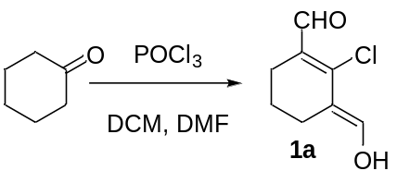
To a chilled solution of dimethylformamide (10 mL, 129 mmol, 5.4 eq.) in 10 mL CH₂Cl₂ under N₂ atmosphere, POCl₃ (10 ml, 107 mmol, 4.5 eq.) in 10 mL CH₂Cl₂ were added dropwise under an ice bath. After 15 min, cyclohexanone (2.5 mL, 24 mmol, 1 eq.) was added, and the resulting mixture was refluxed with vigorous stirring for 8 h at 80 ℃, then poured into ice-cold water, and kept it for 2 hours to obtain 1a as a yellow solid (3.8 g, 91%), and the obtained product could be used for next step directly without further purification. The product was stored in argon at -20 ℃.

Scheme 2. Synthesis of 1b
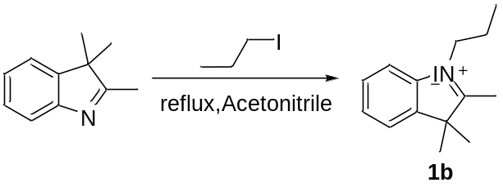
To a solution of 2,3,3-trimethyl-3H-indole (2 g, 12.5 mmol, 1 eq.) in 50 mL acetonitrile, 1-iodopropane (8.3 mL, 62.5 mmol, 5 eq.) was added, and the mixture was heated to reflux with continuous stirring for 14 h. The mixture was dried in vacuum and washed by Et₂O and CH₂Cl₂. The resulting solid was recrystallized with acetone to obtain 1b a light red solid (3.3 g, 80%). ¹H NMR (600 MHz, CDCl₃) δ = 7.53-7.52(m, 1H), 7.40 (d, J = 4.2 Hz, 1H),7.32-7.27 (m, 2H), 4.33 (t, J = 7.2 Hz, 2H), 2.82 (s, 3H), 1.76 (dd, J = 14.4, 7.2 Hz, 2H), 1.37 (s, 6H), 0.79 (t, J = 7.2 Hz, 3H).

Supplementary Fig. 1. ¹H NMR spectrum of compound 1b (600 MHz, CDCl₃).

Scheme 3. Synthesis of 1
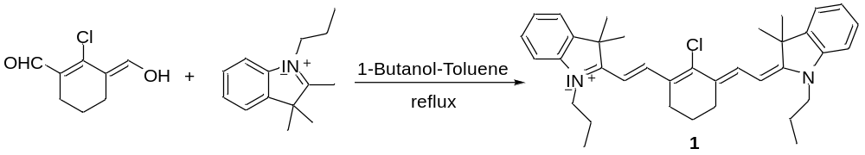
1a (500 mg, 2.9 mmol, 1 eq.) and 1b (1.91 g, 5.81 mmol, 2 eq.) were dissolved in 50 mL solution of BuOH-Toluene (7: 3) under N₂ atmosphere, and the mixture refluxed at 160 ℃ for 18 h with a Dean-Stark condenser. Afterwards, the solvent was evaporated, and the resulting green solid mixture was washed with Et₂O and purified by silica gel flash chromatography (eluent: DCM-MeOH, 50: 1) to obtain 1 as a green solid (1.8 g, 96%). ¹H NMR (600 MHz, CDCl₃) δ = 8.34 (d, J = 14.4 Hz, 2H), 7.40-7.36 (m, 4H), 7.26-7.20 (m, 2H), 7.17 (dd, J = 8.4, 3.6Hz, 2H), 6.26 (d, J = 14.4 Hz, 2H), 4.19 (dd, J = 9.6, 4.8 Hz, 4H), 2.76 (dd, J = 16.2, 10.2 Hz, 4H), 1.78 (s, 2H), 1.72 (s, 12H), 1.60 (s, 4H), 1.07 (t, J = 7.2 Hz, 6H).
Supplementary Fig. 2. ¹H NMR spectrum of compound 1 (600 MHz, CDCl₃).

Scheme 4. Synthesis of 2
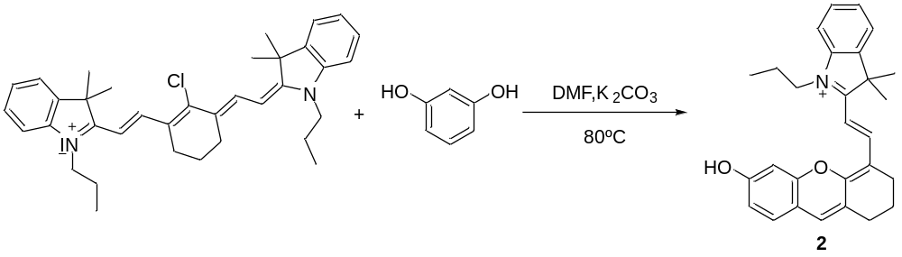
Under N₂; resorcinol (12 mg, 0.11 mmol, 1 eq.) and K₂CO₃ (15 mg, 0.11 mmol, 1 eq.) were dissolved in 10 mL of dimethylformamide, and the mixture was stirred at 80 °C until the solution turned brown. Then, a mixture of 1 (73.4 mg, 0.11 mmol, 1 eq.) was added to the reaction system. The reaction was stirred at 80 °C for 4 h, then allowed to cool to room temperature, and then condensed under reduced pressure, and the residue was purified by silica gel chromatography with CH₂Cl₂/MeOH (100: 1) as eluent to yield 2 (44 mg, 74%). ¹H NMR (600 MHz, CDCl₃) δ = 8.07 (d, J = 13.2 Hz, 1H), 7.32 (s, 1H), 7.30-7.25 (m, 2H). 7.20 (t, J = 9.6 Hz, 1H), 7.05 (t, J = 7.2 Hz, 1H), 6.85 (d, J = 7.8 Hz, 1H), 6.76 (d, J = 8.4 Hz, 1H), 6.55 (s, 1H), 5.65 (d, J = 13.2 Hz, 1H), 3.78 (t, J = 7.2Hz, 2H), 2.64 (td, J = 34.2, 5.4 Hz, 4H), 1.93-1.87 (m, 2H), 1.82 (dd, J = 14.4, 7.2 Hz, 2H), 1.67 (s, 6H), 1.04 (t, J = 7.2 Hz, 3H).

Supplementary Fig. 3. ¹H NMR spectrum of compound 2 (600 MHz, CDCl₃).

Scheme 5. Synthesis of CDIA

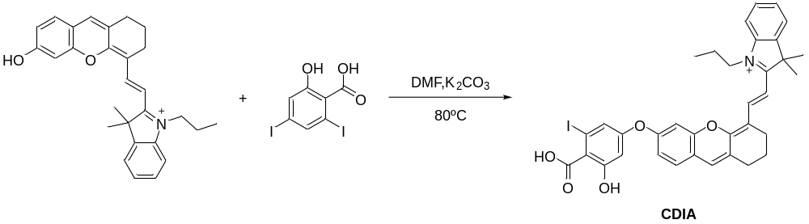
Compound 2 (140 mg, 0.26 mmol, 1 eq.) and K₂CO₃ (196 mg, 1.4 mmol, 5.4 eq.) were mixed and stirred in anhydrous 20 mL dimethylformamide under N₂ atmosphere for 30 min before 3,5-diiodosalicyclic acid (546 mg, 1.4 mmol, 5.4 eq.) dissolved in 5 mL anhydrous dimethylformamide was added via a syringe. The mixture was stirred for 3 h under 80 °C and concentrated under reduced pressure. and the residue was purified by silica gel chromatography with CH₂Cl₂/ MeOH as eluent (100: 1, then 10: 1) to yield CDIA (25 mg, 12 %). ¹H NMR (600 MHz, CDCl₃): δ = 8.79-8.61 (m, 1H), 8.33 (s, 1H), 8.00 (s, 1H), 7.83 (s, 1H), 7.76-7.75 (m, 1H), 7.43-7.28 (m, 4H), 7.10 (d, J = 7.8 Hz, 1H), 7.09-7.04 (m, 1H), 5.98 (d, J = 13.8 Hz, 1H), 4.00 (t, J = 7.2 Hz, 2H), 2.77-2.75 (m, 2H), 2.62-2.60 (m, 2H), 1.95-1.90 (m, 4H), 1.77 (s, 6H), 1.08 (t, J = 7.2 Hz, 3H). ESI-MS: C₃₅H₃₃INO₅ calculated for: 674.1[M – I⁻]; found: 674.3 [M-I⁻]⁺

Supplementary Fig. 4. ¹H NMR spectrum of compound CDIA (600 MHz, CDCl₃).

Supplementary Fig. 5. Mass spectrum of CDIA.

Supporting Figures and Tables

Supplementary Fig. 6. (a) NIR fluorescence images of CDIA (10 µM) incubated with different concentration of •OH in PBS buffer (pH = 7.4) at 37 ºC for 30 min. The fluorescence images were acquired at 720 nm upon excitation at 650 nm. (b) Quantification of NIR fluorescence intensities of CDIA (10 µM) after treatment with various conditions in (a). Data represent mean ± SD (n = 5).

Supplementary Fig. 7. (a) NIR fluorescence images of CDIA (10 µM) incubated with different analytes in PBS buffer (pH = 7.4) at 37 ºC for 30 min. The fluorescence images were acquired at 720 nm upon excitation at 650 nm. (b) Quantification of NIR fluorescence intensities of CDIA (10 µM) after treatment with various conditions in (a). Data represent mean ± SD (n = 5).

Supplementary Fig. 8. (a) NIR fluorescence images of CDIA (10 µM) incubated with different analytes in PBS buffer (pH = 7.4) at 37 ºC for 30 min. The fluorescence images were acquired at 720 nm upon excitation at 650 nm. (b) Quantification of NIR fluorescence intensities of CDIA (10 µM) after treatment with various conditions in (a). Data represent mean ± SD (n = 5).

Supplementary Fig. 9. (a) PA imaging of CDIA (10 μM) with •OH (50 μM) at various pH values at 37 °C for 30 min. (b) The PA spectra of CDIA (10 μM) with •OH (50 μM) at various pH values at 37 °C for 30 min. (c) The PA amplitude plots of CDIA (10 μM) with •OH (50 μM) at various pH values at 37 °C for 30 min. Data represent mean ± SD (n = 5).

Supplementary Fig. 10. (a) PA imaging of CDIA (10 µM) after incubation with varied concentrations of •OH (0−50 μM) in PBS buffer (10 mM, pH 7.4) at 37 °C for 30 min. (b) PA spectra of CDIA (10 µM) after incubation with varied concentrations of •OH (0−50 μM) in PBS buffer (10 mM, pH 7.4) at 37 °C for 30 min. Inset: The relationship between the concentration of •OH and the PA amplitude of CDIA.

b
a
c
Supplementary Fig. 11. (a) HPLC chromatogram of CDIA. (b) HPLC chromatogram of reaction solution of CDIA with •OH. (c) Mass spectrum of reaction solution of CDIA with •OH. Detection of products obtained after reaction of CDIA with •OH.
Supplementary Fig. 12. Investigating the •OH scavenging ability of a) T4; b) T3; c) TEMPO; d) thiourea; e) GSH; f) NAC and g) DMSO with CDIA (10 μM) in PBS buffer (10 mM, pH 7.4) at 37 °C for 30 min. Data represent mean ± SD (n = 5), λ_{ex}/_{em} = 650/720 nm.

Supplementary Fig. 13. Cell viability assay of AML-12, H9c2, HepG2, HUVEC, MCF-7 and HK-2 cells after being incubated with different concentrations of CDIA at 37 ℃ for 24 h. Data represent mean ± SD (n = 5).

Supplementary Fig. 14. MTT assay for the cell viability of HK-2 cells incubated with drugs at different concentrations. Dose-response curves of HK-2 cells after 24 h treatment with 1 ~ 1000 μM (a) CDDP, (b) AAI, (c) CTN, respectively. Data represent means ± SD (n = 5).

Supplementary Fig. 15. Confocal fluorescence images of 75 μM CDDP-treated HK-2 cells co-stained with CDIA and Mito Tracker Green (Pearson’s correlation Rr = 0.8652). Scale bar: 20 μm.

Supplementary Fig. 16. Confocal fluorescence images of 150 μM CDDP-treated HK-2 cells co-stained with CDIA and Lyso Tracker Green (Pearson’s correlation Rr = 0.2532). Scale bar: 20 μm.

Supplementary Fig. 17. Confocal fluorescence images of 75 μM CDDP-treated HK-2 cells co-stained with CDIA and Lyso Tracker Green (Pearson’s correlation Rr = 0.2469). Scale bar: 20 μm.

Supplementary Fig. 18. (a) Confocal fluorescence imaging of HK-2 cells incubated with 10 µM CDIA and 10 µg/mL Hoechst 33342, respectively. After the incubated cells were mounted on the microscope stage, eight images were taken consecutively at 100 s intervals. Scale bar: 20 μm. (b) Fluorescence intensity plots of HK-2 cells incubated with 10 µM CDIA (red) and 10 µg/mL Hoechst 33342 (blue), respectively. Data represent mean ± SD (n = 5).

Supplementary Fig. 19. (a) Merged fluorescence and bright field image during laser irradiation. Scale bar: 20 mm. (b–d) Time course of fluorescence intensity collected at circles 1–3 shown in (a), corresponding to the areas (1–3).

Supplementary Fig. 20. (a) Confocal fluorescence imaging of RAW264.7 cells with untreated, 200 ng/mL PMA or 500 ng/mL PMA for 4 h, then incubated with 10 μM CDIA at 37 °C for 30 min. Scale bar: 20 μm. (b) Fluorescence intensity plots of RAW264.7 cells for different groups. Data represent mean ± SD (n = 5). (c) Flow cytometric assays of RAW264.7 cells for different groups.

Supplementary Fig. 21. (a) Confocal fluorescence imaging of HeLa cells with untreated, 200 ng/mL PMA or 500 ng/mL PMA for 4 h, then incubated with 10 μM CDIA at 37 °C for 30 min. Scale bar: 20 μm. (b) Fluorescence intensity plots of HeLa cells for different groups. Data represent mean ± SD (n = 5). (c) Flow cytometric assays of HeLa cells for different groups.

Supplementary Fig. 22. (a) Confocal fluorescence imaging of HepG2 cells with untreated, 5 mM APAP or 10 mM APAP for 24 h, then incubated with 10 μM CDIA at 37 °C for 30 min. Scale bar: 20 μm. (b) Fluorescence intensity plots of HepG2 cells for different groups. Data represent mean ± SD (n = 5). (c) Flow cytometric assays of HepG2 cells for different groups.

Supplementary Fig. 23. (a) PA imaging of HK-2 cell pellets with untreated, 75 μM CDDP or pre-treated with 10 mM thiourea for 2 h before 75 μM CDDP for 24 h (DMEM/F12 served as control), then incubated with 10 μM CDIA at 37 °C for 30 min. (b) The PA spectra of corresponding cell pellets in figure S23(a). (c) The PA amplitude plots of HK-2 cells for different groups. Data represent mean ± SD (n = 5).

Supplementary Fig. 24. (a) PA imaging of RAW264.7 cell pellets with untreated, 200 ng/mL PMA or 500 ng/mL PMA for 4 h (DMEM served as control), then incubated with 10 μM CDIA at 37 °C for 30 min. (b) The PA spectra of corresponding cell pellets in figure S24(a). (c) The PA amplitude plots of RAW264.7 cells for different groups. Data represent mean ± SD (n = 5).

Supplementary Fig. 25. (a) PA imaging of HeLa cell pellets with untreated, 200 ng/mL PMA or 500 ng/mL PMA for 4 h (DMEM served as control), then incubated with 10 μM CDIA at 37 °C for 30 min. (b) The PA spectra of corresponding cell pellets in figure S25(a). (c) The PA amplitude plots of HeLa cells in different groups. Data represent mean ± SD (n = 5).

Supplementary Fig. 26. (a) PA imaging of HepG2 cell pellets with untreated, 5 mM APAP or 10 mM APAP for 24 h (DMEM served as control), then incubated with 10 μM CDIA at 37 °C for 30 min. (b) The PA spectra of corresponding cell pellets in figure S26(a). (c) The PA amplitude plots of HepG2 cells for different groups. Data represent mean ± SD (n = 5).

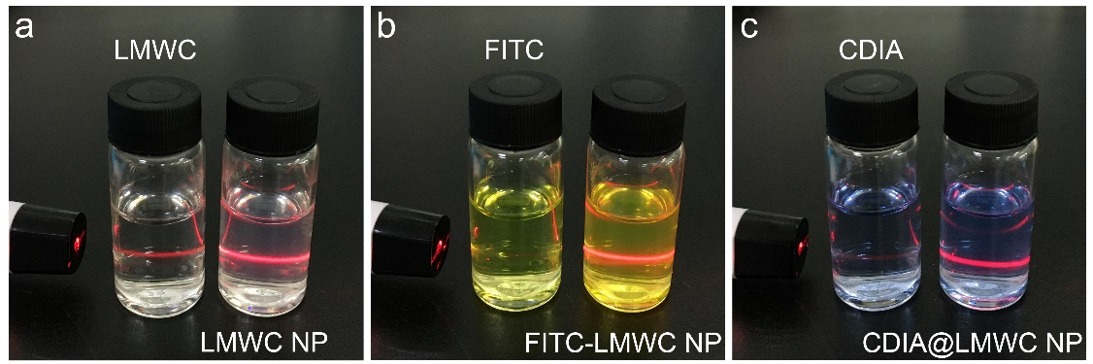
Supplementary Fig. 27. White light images of (a) LMWC NP (20 μg/mL), (b) FITC-LMWC NP (20 μg/mL) and (c) CDIA@LMWC NP (20 μg/mL), respectively. Chitosan particles showed the unique colloid Tyndall phenomenon.

Supplementary Fig. 28. Size distribution of (a) LMWC NP, (b) FITC-LMWC NP, (c) CDIA@LMWC NP, and zeta potential of (d) LMWC NP, (e) FITC-LMWC NP, (f) CDIA@LMWC NP, respectively.

Supplementary Fig. 29. Fluorescence emission spectra of FITC-LMWC NP with different concentrations (λ_{ex} = 490 nm). Inset: The standard curve of FITC-LMWC NP determined by measuring the fluorescence intensity at λ_{ex}/λ_{em} = 490/518 nm.

Supplementary Fig. 30. UV-vis absorption spectra of FITC with different concentrations. Inset: The standard curve of FITC determined by measuring the absorbance at 490 nm.

Supplementary Fig. 31. Long-term-stability study of CDIA@LMWC NP in PBS buffer (10 mM, pH 7.4) and DMEM with 10% FBS at 4 ℃.

Supplementary Fig. 32. Time-dependent fluorescence changes of 10 μM CDIA with 20 μg/mL LMWC NP toward 100 μM •OH in PBS buffer (10 mM, pH 7.4) at 37 °C. Excitation wavelength was 650 nm and the emission wavelength was 720 nm.

Supplementary Fig. 33. Cell viability assay of AML-12, H9c2, HepG2, HUVEC, MCF-7 and HK-2 cells after being incubated with different concentrations of nanoparticles as indicated at 37 ℃ for 24 h. Data represent mean ± SD (n = 5).

Supplementary Fig. 34. (a) Confocal fluorescence imaging of HK-2 cells incubated with different concentrations of FITC-LMWC NP for different time points at 37 °C. Scale bar: 20 μm. (b) Mean pixel intensity plots of different time points when HK-2 cells incubated with different concentrations of FITC-LMWC NP, respectively.

Supplementary Fig. 35. Fluorescence intensity plots of different cells incubated with 20 μg/mL FITC-LMWC NP at 37 °C for 2 h, respectively. Data represent mean ± SD (n = 5).

Supplementary Fig. 36. Confocal fluorescence imaging of live HK-2 cells co-stained with 20 μg/mL FITC-LMWC NP, 100 nM Lyso Tracker Red and 10 µg/mL Hoechst 33342 at different sections through the z-axis.

Supplementary Fig. 37. Confocal fluorescence images of HK-2 cells co-stained with CDIA and Mito Tracker Red (Pearson’s correlation Rr = 0.1861). Scale bar: 20 μm.

Supplementary Fig. 38. Fluorescence intensity plots of HK-2 cells incubated with 20 μg/mL FITC-LMWC NP and different inhibitors (1 μM EDTA, 50 μg/mL LMWC, or 50 μg/mL glucosamine) at 37 °C for 2 h. Data represent mean ± SD (n = 5), *P<0.05, **P<0.01, ***P<0.001 for treatment compared to the control group using one-way ANOVA with multiple comparisons test.

Supplementary Fig. 39. ROS detection for HK-2 cells incubated with different concentrations of (a) CDDP, (b) AAI and (c) CTN for 24 h, respectively, and then incubated with 10 μM H₂DCFDA for 30 min at 37 °C. Data represent means ± SD (n = 5).

Supplementary Fig. 40. (a) Confocal fluorescence imaging of HK-2 cells with untreated, 44 μM AAI or pre-treated with 10 mM thiourea for 2 h before 44 μM AAI for 24 h, then incubated with 20 μg/mL CDIA@LMWC NP at 37 °C for 2 h. Scale bar: 20 μm. (b) Fluorescence intensity plots of HK-2 cells for different groups. Data represent mean ± SD (n = 5). (c) Flow cytometric assays of HK-2 cells for different groups.

Supplementary Fig. 41. (a) Confocal fluorescence imaging of HK-2 cells with untreated, 30 μM CTN or pre-treated with 10 mM thiourea for 2 h before 30 μM CTN for 24 h, then incubated with 20 μg/mL CDIA@LMWC NP at 37 °C for 2 h. Scale bar: 20 μm. (b) Fluorescence intensity plots of HK-2 cells for different groups. Data represent mean ± SD (n = 5). (c) Flow cytometric assays of HK-2 cells for different groups.

Supplementary Fig. 42. (a) PA imaging of CDIA (10 μM) or CDIA@LMWC NP (20 μg/mL) in the absence or presence of •OH (50 μM) in PBS buffer (10 mM, pH 7.4) at 37 °C for 30 min. (b) The PA spectra of CDIA (10 μM) or CDIA@LMWC NP (20 μg/mL) in the absence or presence of •OH (50 μM) in PBS buffer (10 mM, pH 7.4) at 37 °C for 30 min. (c) The PA amplitude plots of CDIA (10 μM) or CDIA@LMWC NP (20 μg/mL) in the absence or presence of •OH (50 μM) in PBS buffer (10 mM, pH 7.4) at 37 °C for 30 min. Data represent mean ± SD (n = 5).

Supplementary Fig. 43. (a) PA imaging of HK-2 cell pellets with untreated, 44 μM AAI or pre-treated with 10 mM thiourea for 2 h before 44 μM AAI for 24 h (DMEM/F12 served as control), then incubated with 20 μg/mL CDIA@LMWC NP at 37 °C for 2 h. (b) The PA spectra of corresponding cell pellets in figure S42(a). (c) The PA amplitude plots of HK-2 cells for different groups. Data represent mean ± SD (n = 5).

Supplementary Fig. 44. (a) PA imaging of HK-2 cell pellets with untreated, 30 μM CTN or pre-treated with 10 mM thiourea for 2 h before 30 μM CTN for 24 h (DMEM/F12 served as control), then incubated with 20 μg/mL CDIA@LMWC NP at 37 °C for 2 h. (b) The PA spectra of corresponding cell pellets in figure S(a). (c) The PA amplitude plots of HK-2 cells for different groups. Data represent mean ± SD (n = 5).

Supplementary Fig. 45. Quantification of NIR fluorescence intensities of CDIA (10 µM) after treatment with PBS and urine, respectively. Data represent mean ± SD (n = 5).

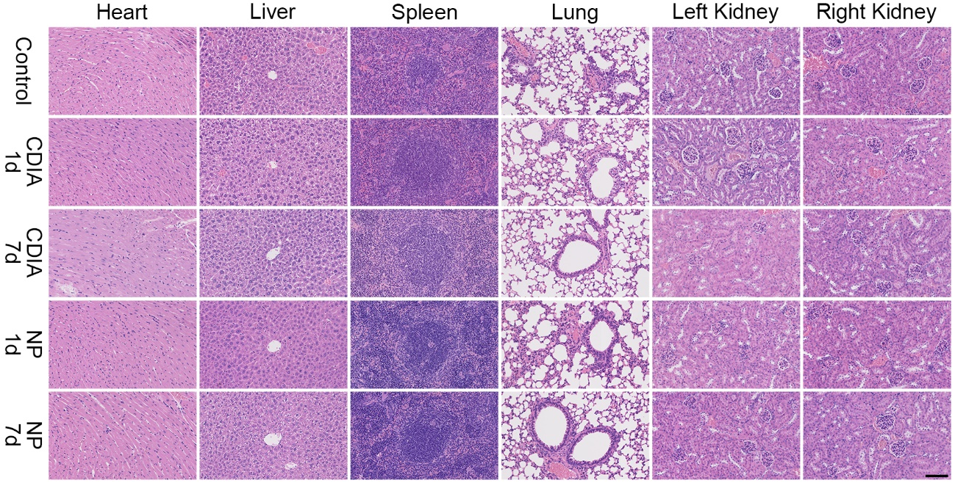
Supplementary Fig. 46. H&E staining images of the main organs from mice after intravenous injected with CDIA (500 μM, 0.2 mL) and CDIA@LMWC NP (20 mg/kg) for 1 d and 7 d, respectively. The images showed that mice have no pathological change in the main organs after injection of CDIA or CDIA@LMWC NP for 1 d and 7 d compared to the control group injected with PBS. Scale bar: 100 μm.

Supplementary Fig. 47. Hemolytic activity of CDIA and CDIA@LMWC NP at different concentrations after incubation with RBCs at 37 ºC for 2 h, respectively.

Supplementary Fig. 48. Body weight changes of mice during different treatments. Data represent mean ± SD (n = 5).

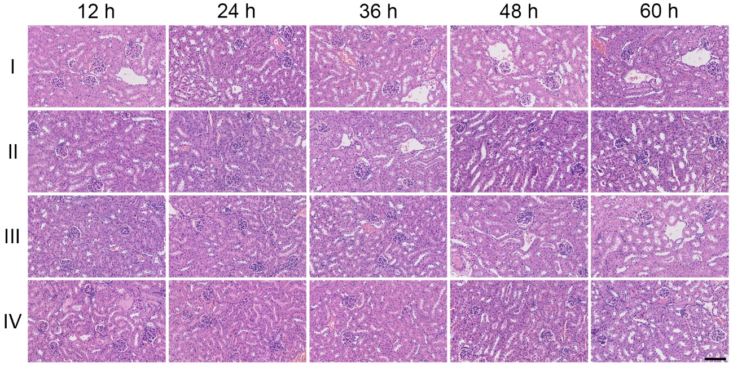
Supplementary Fig. 49. H&E staining images of the kidneys from mice in different groups at different time post-treated with CDDP. n = 5 independent animals/group. Scale bar: 100 μm.

Supplementary Fig. 50. BUN and sCr concentration of the CDDP treated mice in different groups. The graphic showed that only the mice treated with high initial dose of CDDP (group I & group II, 18 mg/kg & 9 mg/kg at first dose, respectively) showed abnormal BUN and sCr increment at 48 h post treatment. Mice treated with multiple injection low dose of CDDP showed similar BUN and sCr level as the control group (treated with PBS). The measurement of BUN and sCr to detect kidney injury was 36 h lag behind the •OH responsive fluorescence-based imaging strategy. Data represent mean ± SD (n = 5), *P<0.05, **P<0.01, ***P<0.001 for treatment compared to the control group using one-way ANOVA with multiple comparisons test.

Supplementary Fig. 51. (a) Ex vivo NIR images of resected organs from mice after treatment of PBS, or post-treatment of CDDP, or NAC and quercetin prior to CDDP administration, followed by i.v injection of CDIA@LMWC NP (10 mg/kg body weight). (b) Signal quantification of resected organs from mice after treatment of PBS, or post-treatment of CDDP, or NAC and quercetin prior to CDDP administration, followed by i.v. injection of CDIA@LMWC NP (10 mg/kg body weight). Mice were dissected, and major organs were resected after 3 h i.v. injection of CDIA@LMWC NP. Data represent mean ± SD (n = 3).

Table S1. Photophysical properties of CDIA.
Probe | λ_{ab} (nm) | λ_{em} (nm) | Stokes shift (nm) | Φ₁/Φ₂
CDIA | 650 | 720 | 70 | 0.01/0.27
Note: λ_{ab} and λ_{em}: wavelength of maximum absorbance and emission, respectively; Φ₁ and Φ₂ are the fluorescence quantum yields in the absence and presence of •OH, respectively.

Table S2. Analytical performance of reported methods and proposed method for •OH detection.
Limit of detection (M) | Linear range (M) | Detection strategy | References
3 × 10^{–8} | 0–1.25 × 10^{–5} | Rhodamine B labeled upconversion nanoprobe | Chen et al.¹
2.1 × 10^{–7} | 0–1 × 10^{–5} | Carminic acid labeled upconversion nanoprobe | Mei et al.²
4.48 × 10^{–6} | 0–2 × 10^{–4} | Fluorescent silicon quantum dots–Ce6 complex probe | Zhao et al.³
7 × 10^{–8} | 0.001–1.6 × 10^{–1} | Coumarin-3-carboxylic acid conjugated carbon nanodots | Zhou et al.⁴
1.2 × 10^{–8} | 0.018–6 × 10^{–6} | Terephthalic acid conjugated graphene quantum dots | Hai et al.⁵
2 × 10^{–9} | 0–5 × 10^{–8} | Methylene blue coated upconversion nanoparticles | Yu et al.⁶
5.87 × 10^{–9} | 0.001–3 × 10^{–5} | An activatable NIR/PA probe | This work

Table S3. Sizes and zeta potentials of different nanoparticles.
Nanoparticles | Hydrodynamic diameter (nm) | Zeta potential (mV)
LMWC NP | 58.3 ± 1.9 | + 37.4
FITC-LMWC NP | 62.7 ± 1.5 | + 36.8
CDIA@LMWC NP | 65.8 ± 2.6 | + 32.9

Table S4. Encapsulation efficiency (EE) and loading content (LC) of CDIA.
Probe | EE (%) | LC (%)
CDIA | 83.62 ± 0.17 | 10.57 ± 0.04

Table S5. Information on the natural compounds in the library used for the high-throughput screening.
Compounds | CAS NO. | Compounds | CAS NO.
Coumarins |  | Steroids
Psoralen | 66-97-7 | Ursodeoxycholic acid | 128-13-2
6,7-Dihydroxycoumarin | 305-01-1 | Testosterone | 58-22-0
Esculin hydrate | 531-75-9 | Alkaloids
Fraxetin | 574-84-5 | Berberine | 633-65-8
6-Hydroxycoumarin | 6093-68-1 | Sinomenine | 115-53-7
Sesquiterpenes |  | Piperine | 94-62-2
Dihydroartemisinin | 81496-81-3 | Rutecarpine | 84-26-4
Curdione | 13657-68-6 | Capsaicin | 404-86-4
Alantolactone | 546-43-0 | 10-Hydroxy camptothecin | 19685-09-7
Artesunate | 88495-63-0 | Polyphenols
Monoterpenes |  | Polydatin | 27208-80-6
Catalpol | 2415-24-9 | Salidroside | 10338-51-9
Perillyl alcohol | 536-59-4 | Resveratrol | 501-36-0
Diterpenes |  | Sinapic acid | 530-59-6
Andrographolide | 5508-58-7 | Ferulic acid | 1135-24-6
Triterpenes |  | Protocatechuic acid | 99-50-3
Oleanolic acid | 508-02-1 | Guaiacol | 90-05-1
Saikosaponin D | 20874-52-6 | p-Hydroxy-cinnamic acid | 7400-08-0
Ginsenoside Re | 257-814-6 | Chlorogenic acid | 327-97-9
Flavones |  | Quinones
(-)-Epicatechin gallate | 1257-08-5 | Tanshinone IIA | 568-72-9
Genistein | 446-72-0 | 5-Hydroxy-2-Methyl-1,4-Naphthoquinon | 481-42-5
Myricetin | 529-44-2 | Rhein | 478-43-3
Luteolin | 491-70-3 | Others
Formononetin | 485-72-3 | Cantharidin | 56-25-7
Isoflavone aglycone | 552-66-9 | Diosbulbin B | 20086-06-0
Naringenin | 93602-28-9 | Astaxanthin | 472-61-7
Curcumin | 458-37-7 | Limonin | 1180-71-8
Chrysin | 480-40-0
Quercetin | 117-39-5
Puerarin | 3681-99-0
Table S6. Detailed sequences of the primers used for qRT-PCR in this research.
Name | Sequence (5’ to 3’)
Human Sirt1_forward primer | TGGCAAAGGAGCAGATTAGTAGG
Human Sirt1_reverse primer | CTGCCACAAGAACTAGAGGATAAGA
Human Nrf2_forward primer | TACTCCCAGGTTGCCCACA
Human Nrf2_reverse primer | CATCTACAAACGGGAATGTCTGC
Human Keap1_forward primer | TTCGCCTACACGGCCTC
Human Keap1_reverse primer | GAAGTTGGCGATGCCGATG
Human HO-1_forward primer | TCTTGGCTGGCTTCCTTAC
Human HO-1_reverse primer | CATAGGCTCCTTCCTCCTTTC
Human DJ-1_forward primer | CCATATGATGTGGTGGTTCTAC
Human DJ-1_reverse primer | ACTTCCACAACCTATTTCATGAG
Human GAPDH_forward primer | GGTGTGAACCATGAGAAGTATGA
Human GAPDH_reverse primer | GAGTCCTTCCACGATACCAAAG

References
[1] Chen, Z.; Liu, Z.; Li, Z.; Ju, E.; Gao, N.; Zhou, L.; Ren, J.; Qu, X. Biomaterials, 2015, 39, 15–22.
[2] Mei, Q.; Li, Y.; Li, B. N.; Zhang, Y. Biosens. Bioelectron. 2015, 64, 88–93.
[3] Zhao, Q.; Zhang, R.; Ye, D.; Zhang, S.; Chen, H.; Kong, J. ACS Appl. Mater. Interfaces, 2017, 9, 2052–2058.
[4] Zhou, D.; Huang, H.; Wang, Y.; Wang, Y.; Hu, Z.; Li, X. J. Mater. Chem. B, 2019, 7, 3737–3744.
[5] Hai, X.; Guo, Z.; Lin, X.; Chen, X.; Wang, J. ACS Appl. Mater. Interfaces, 2018, 10, 5853–5861.
[6] Yu, G.; Feng, N.; Zhao, D.; Wang, H.; Jin, Y.; Liu, D.; Li, Z.; Yang, X.; Ge, K.; Zhang, J. Sci. China: Life Sci., 2021, 64, 434–442.

