Supplementary Information
Ridge-twin boundaries as prolific dislocation sources in low stacking-fault energy metals and alloys
Xiaoqian Fu^{1,9}, Jun Ding^{2,*},Cigdem Ozsoy-Keskinbora^{3,4}, Guang Yang⁵, Yujie Chen¹, Yan Fang¹, Eun Soo Park⁶, Ze Zhang¹, Robert O. Ritchie^{7,8,*}, En Ma^{2,*} and Qian Yu^{1,*}
¹ Center of Electron Microscopy and State Key Laboratory of Silicon Materials, School of Materials Science & Engineering, Zhejiang University, Hangzhou, 310027, China.
² Center for Alloy Innovation and Design (CAID), State Key Laboratory for Mechanical Behavior of Materials, Xi'an Jiaotong University, Xi'an 710049, China.
³ Materials Science Division, Thermo Fisher Scientific, Achtseweg Noord 5, 5651 GG Eindhoven, The Netherlands.
⁴ John A. Paulson School of Engineering and Applied Sciences, Harvard University, Cambridge, MA 02138, USA.
⁵ Thermo Fisher Scientific Inc., 2517 Jinke Road, Shanghai, 201210, China.
⁶ Research Institute of Advanced Materials, Department of Materials Science and Engineering, Seoul National University, Seoul 08826, Republic of Korea.
⁷ Materials Sciences Division, Lawrence Berkeley National Laboratory, Berkeley, CA, 94720, USA.
⁸ Department of Materials Science & Engineering, University of California, Berkeley, CA, 94720, USA.
⁹ Current address: Pico Electron Microscopy Center, School of Materials Science and Engineering, Hainan University, Haikou, Hainan 570228, China.

* Corresponding authors: Jun Ding (dingsn@xjtu.edu.cn), Robert O. Ritchie (roritchie@lbl.gov), En Ma (maen@xjtu.edu.cn), and Qian Yu (yu_qian@zju.edu.cn)

Movie S1. Dislocation activity at twin-twin triple junction during in situ TEM tensile test. The dislocations are generated from twin-twin triple junction and then sluggishly move on coherent twin boundaries with frequent pinning and de-pinning.

Figure S1 | Typical images of ridge-twin structures in different low-SFE materials. (a) Equiatomic CrCoNi medium-entropy alloy. (b) Fe30Mn3Al3Si (wt.%) TWIP steel. (c) Pure Cu. (d) Pure Ag.

Figure S2 | Cross slip of dislocations on a CTB to grain interior. The cross-slipped dislocations are indicated by red arrows.

Figure S3 | Dislocation activities within grains during the deformation process. Strong interactions between dislocations and stacking faults were observed.

Figure S4 | Twin lamellas formed at the junctions of the ridge-twin boundary.

Figure S5 | The HAADF-STEM image showing the atomic structure of the dislocation core. A Burgers circuit analysis shows that the Burgers vector is b = 1/2[-101].

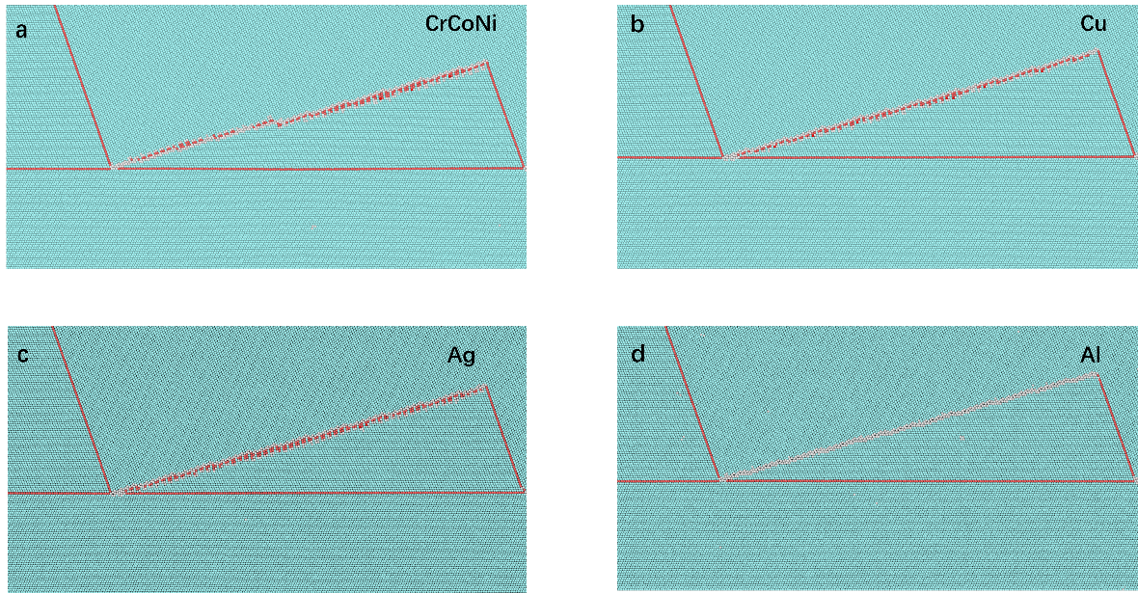
Figure S6 | Atomic configuration of ridge twins constructed in materials with different SFE. (a) CrCoNi medium-entropy alloy. (b) Cu. (c) Ag. (d) Al. The atoms are colored according to common neighbor analysis: blue, red and white atoms represent fcc, hcp and other structures, respectively.

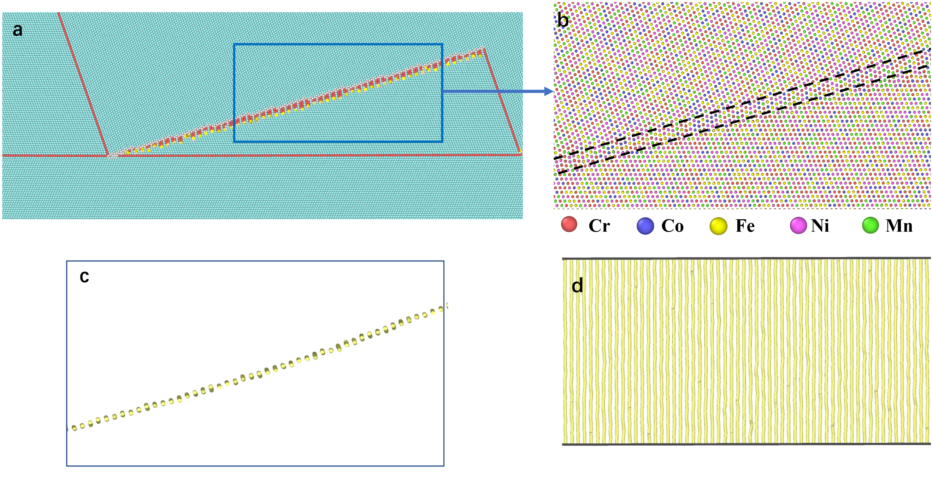
Figure S7 | Atomic configuration and dislocation array on the Σ3{112}-like ITBs in Cr₂₀Mn₁₄Fe₂₆Co₂₆Ni₂₄. (a) Atomic configuration of the ridge-twin structure. (b) Enlarged view of atomic configuration of Σ3{112}-like ITBs (denoted by blue lines) of Cr₂₀Mn₁₄Fe₂₆Co₂₆Ni₁₄ alloy. (c) and (d) are the side view and top view, respectively, of the array of Shockley partials in Σ3{112}-like ITBs.

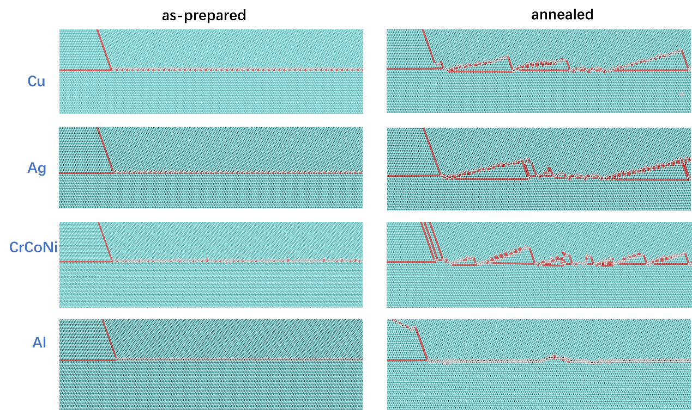
Figure S8 | Observation of the formation of the ridge twins in different SFE materials during annealing by MD simulation. The as-prepared and annealed configurations with Σ9{115}{111} GBs are shown for CrCoNi alloy, Cu, Ag and Al.

Figure S9 |The interfacial energy of ridge twins at various angles for CrMnFeCoNi, CrCoNi, Ag and Cu.

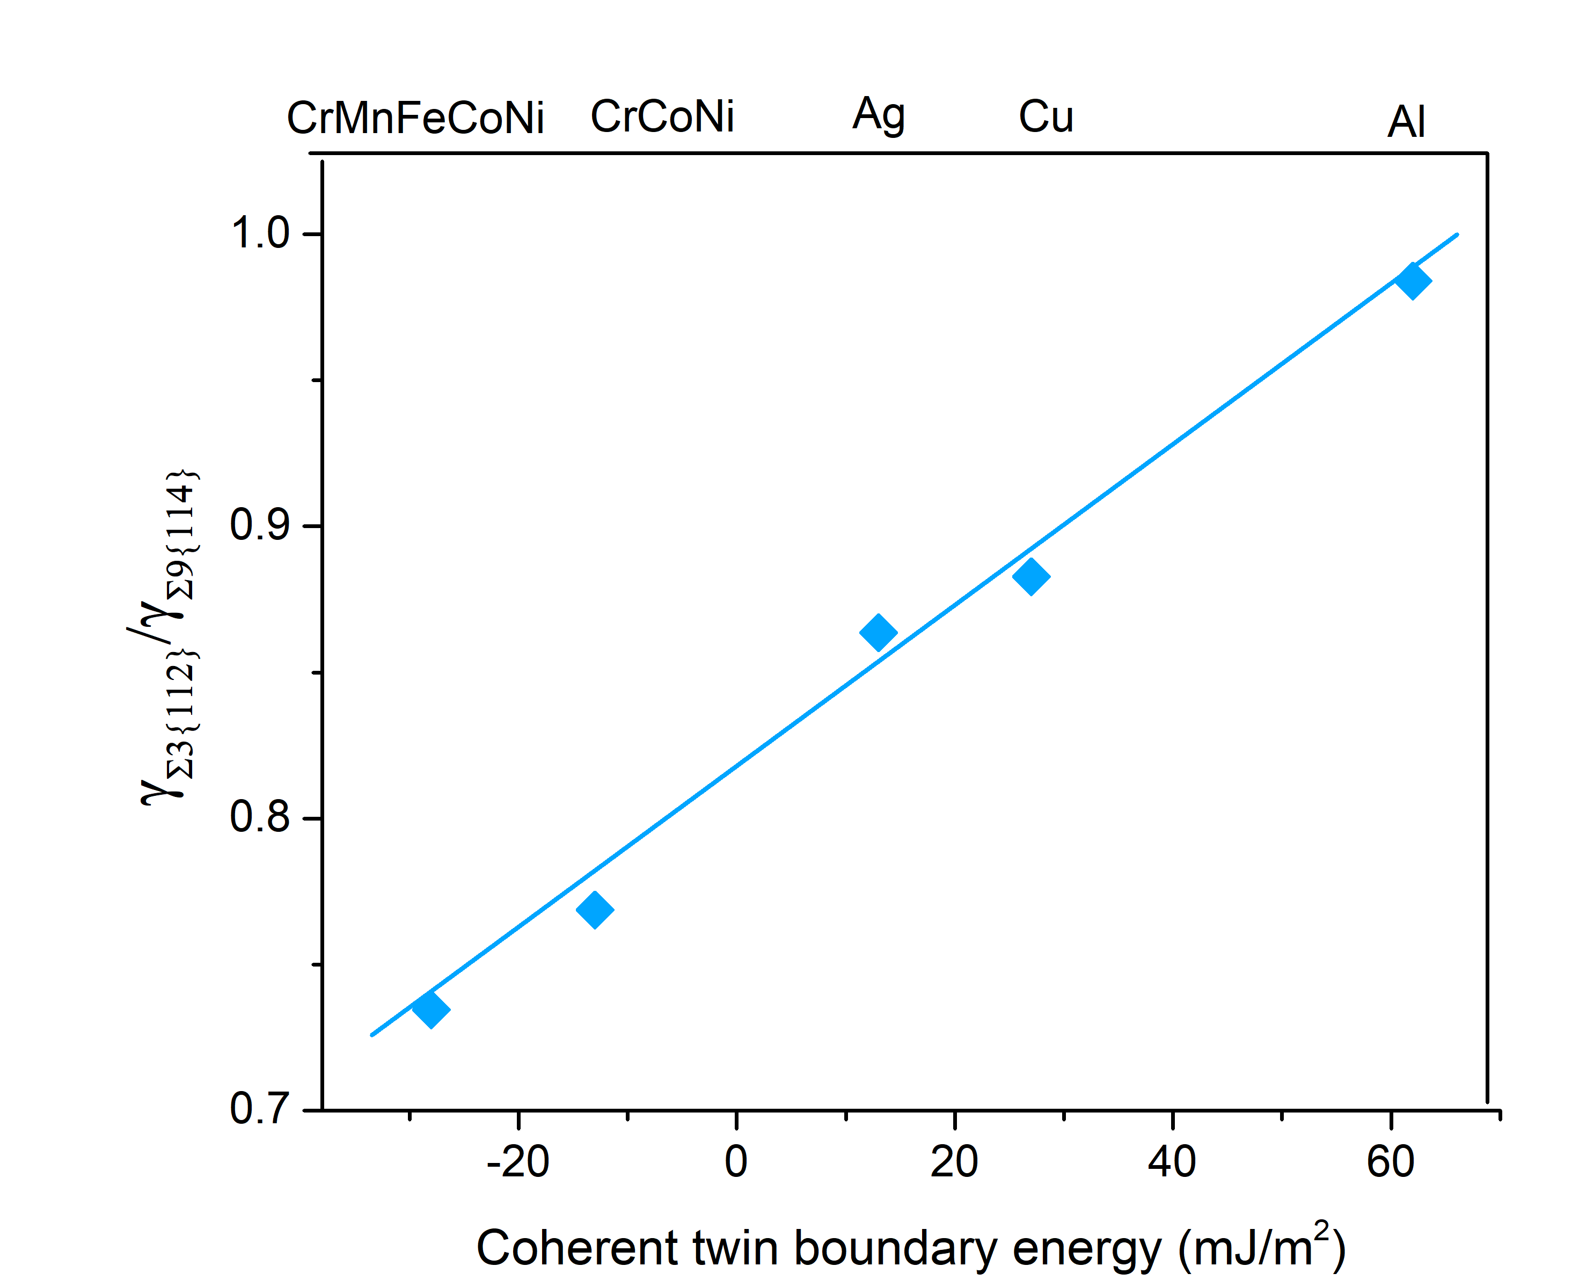
Figure S10 | Interfacial energies related with the coherent twin boundary energies. The ratio of interfacial energy of Σ3{112}-like ITBs and Σ9{114} GB for all the studied materials.

Figure S11 | Stress field of hydrostatic stress and shear stress of ridge twin in pure Ag. A ridge twin with the length of ~60 nm was introduced in the middle (y-direction) of the configuration, which was applied with periodic boundary condition in x and z direction and free surface in y direction. (a) Atomic configuration. (b) Hydrostatic stress and corresponding profile. (c, d) Shear stress and corresponding profile.

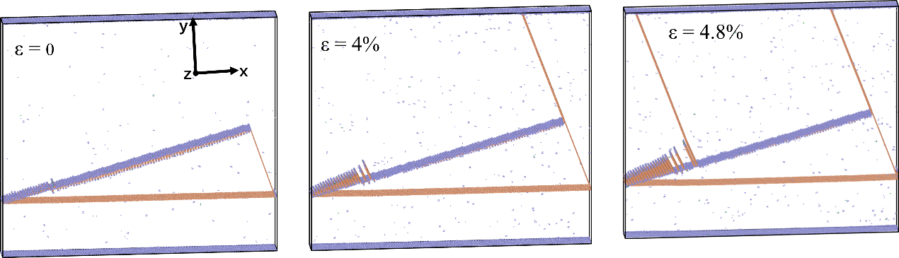
Figure S12 | Tensile deformation of Cr₂₀Mn₁₄Fe₂₆Co₂₆Ni₁₄ alloy by MD simulation. Only non-fcc atoms are colored (orange for hcp atoms and purple for other atoms). A sample of ridge-twin structure with the dimension of ~60 nm in x, ~54 nm in y and 10 nm in z direction, was applied with periodic boundary condition in x and z direction and free surface in y direction. A uniaxial tensile deformation in x axis was applied with the strain rate of 10⁻⁵ /ps at 300 K.

Figure S13 | Atomic configuration of the (a) ridge-twin structure, (b) high-angle grain boundary (GB), Σ5{210} and (c) low-angle GB, Σ25{710} in Cr₂₀Mn₁₄Fe₂₆Co₂₆Ni₁₄ alloy. The tilt axis for high-angle and low-angle GB is <100>. The atoms are colored according to common neighbor analysis: blue, red and white atoms represent fcc, hcp and other structures, respectively. The dimensions for the samples are 61 nm, 54 nm and 10 nm for x, y and z direction, respectively. (d) The critical resolved shear stress (CRSS) for dislocation nucleation from ridge-twin structure, high-angle and low-angle GB within Cr₂₀Mn₁₄Fe₂₆Co₂₆Ni₁₄, CrCoNi and Cu.
Figure S14 | STEM image showing the extended width of dissociated dislocations in Cr₂₀Mn₁₄Fe₂₆Co₂₆Ni₁₄ alloy. The number in the image indicates the measured extended width of stacking faults. The average width of stacking faults is 50.4 nm. The stacking-fault energy is estimated by $γ=\frac{μ{b_{p}}^{2}}{8πd}·\frac{2-ν}{1-ν}·\left(1-\frac{2νcos2θ}{2-ν}\right)$, where μ is the shear modulus, b_{p} is the Burgers vector of the partial dislocation, d is the extended width of stacking faults, ν is Poisson’s ratio, and θ is the angle between the dislocation line and the Burgers vector of the full dislocation. The stacking-fault energy (γ) of the Cr₂₀Mn₁₄Fe₂₆Co₂₆Ni₁₄ alloy is estimated to be about 2.5 mJ/m².

Figure S15 | Comparison of mechanical behavior of Cr₂₀Mn₁₄Fe₂₆Co₂₆Ni₁₄ TWIP high-entropy alloy and Cantor alloy. (a) The engineering uniaxial tensile stress–strain curves for the TWIP-HEA compared to that of the Cantor HEA. (b) The strain hardening rate curve of (a).

Figure S16 | Line profiles of intensity along a Σ3{112}-like ITB. The dark dashed lines marked out the Mn-enriched column, and the pink dashed lines marked out Co- and Ni-enriched columns. The enriched columns repeat every three atomic planes.

Figure S17 | EDS maps and line profile of atomic fraction across the disorder corners. (a) Atomic-resolution STEM HAADF and bright field (BF) images of a ridge twin, taken with <110> zone axis. (b) HAADF image showing the structure at the location connecting two ridge twins and the corresponding EDS maps for Cr, Mn, Fe, Co, and Ni. (c, d) Line profiles of atomic fraction of an individual element taken from the EDS maps in Fig. 4e and S17b. The white dashed boxes in the HAADF image and the black vertical dashed lines in line profiles mark out the Cr-enriched region.

