Supplementary Materials for

Magnetic poles enabled kirigami meta-structure for stable mechanical memory storage with high information density and structural robustness

This file includes:
1. Exploration for the buckling deformation analysis of one-layered kirigami module
2. Exploration for deformation sequence of three-/six-/nine-layered kirigami module
3. Mechanical test for three-layered cylindrical kirigami modules
4 Mechanical test for TPU material used for FEM simulation
5. Fabrications of the 3 by 3 mechanical memory device
6. Structural robustness test for the proposed mechanical memory device

Figs. 1 to 15
Supplementary Text
1. Exploration for the buckling deformation analysis of one-layered kirigami module
The buckling deformation details tuned by shell thickness are given in Supplementary Fig. 1 based on both numerical and experimental methods (Supplementary Fig. 1, a to b). Three distinct shell thickness are picked for comparison (0.8mm, 1.2mm and 1.6mm). From Supplementary Fig. 1c with obvious different results, we know that the shell thickness can be also a candidate to effectively tune the critical buckling force, which as demonstrated in Supplementary Fig. 5 provide us the physical basis for the achievement of deformation sequences in multi-segmented cylindrical kirigami modules.
By maintaining the shell thickness and cut length, we also explored the effect of cut number on the buckling behavior of single cylindrical kirigami module with results displayed in Supplementary Fig. 2. Shown as Supplementary Fig. 2e, force differences are still observed for the force-displacement curves of one-layered kirigami module with 8, 12 or 16 cut number. We find the buckling force is larger for fewer number of cuts. Therefore, we can conclude that the cut number can also be used to tune multi-segmented cylindrical kirigami module with deformation sequences.
Specially, by fixing cut number, we comprehensively explored the mechanical response of one-layered kirigami module by varying only the structural height. From Supplementary Fig. 3, we can see that when fixing cut number we can always much apparently tune the critical buckling force by using different structural heights.
2. Exploration for deformation sequence analysis of three-/six-/nine-layered kirigami module
According to the results from Fig. 2 and Supplementary Figs. 1 to 2, we know that all the structural heights of uncut part (or cut length), shell thickness and cut number can tune the critical buckling force of the one-layered cylindrical kirigami module. Therefore for multi-segments, we implement these three different structural parameters and achieve deformation sequences on multi-segmented (3, 6 and 9) cylindrical kirigami modules. Both experimental and numerical results demonstrate our findings which are exhibited in Fig. 2 and Supplementary Figs. 5 to 8.
Particularly, we note these deformation sequences generated by using different sets of structural parameters also enable the potentials for our designed cylindrical kirigami modules with programmable structural stiffness. And we verify this conclusion in Fig. 3i and Supplementary Fig. 9.

3. Mechanical test for three-layered cylindrical kirigami modules
During the mechanical test of the mechanical behaviors of our proposed cylindrical kirigami modules, some unique structural parts are designed. Shown as Supplementary Fig. 10b, we design the holder (Supplementary Fig. 10b(i)) and insert it into the cylindrical kirigami module to keep the compression always vertically along axial direction. Meanwhile, we design the compressor which shown as Supplementary Fig. 10b(ii) with an enclosed lower structural component to contact with the sample while the top part being compressed. We display the compression process with optical images of two three-segmented samples in Supplementary Fig. 11.

4 Mechanical test for TPU material used for FEM simulation
The simulation details are present in Materials and Methods part. Specially, the material parameters of the 3D printable TPU materials used during FEM simulation are determined through uniaxial stretching test results shown in Supplementary Fig. 10a while the Marlow energy model is used here.

5. Fabrication for 3 by 3 mechanical memory device
The fabrication details for different layered cylindrical kirigami modules and the introduction of permanent magnets are present in the ‘Materials and Methods’ part in main text. Here, we give the construction process of the 3 by 3 mechanical memory device exhibited in Fig. 5. The mechanical memory device is made by (1) 9 certain three-layered cylindrical kirigami modules with permanent magnets, (2) the solid cylindrical column to keep the kirigami unit deforming vertically when being compressed, (3) a box containing the kirigami modules, and (4) 9 extruded compressor to feasibly compress each kirigami unit. Specially, the containing box is constructed by pasting six right-dimensioned acrylic plates. To build the mechanical memory device, the top acrylic plate is well coordinated and cut with 9 holes to place the nine cylindrical kirigami modules (Supplementary Fig. 14).
The unit used for the 3 by 3 mechanical memory device is based on the cylindrical kirigami module with 18mm, 20mm and 22mm heights types of structural segments. We give several representative deformation sequences in Supplementary Fig. 15a and their corresponding experimental counterparts in Supplementary Fig. 15b.

6. Structural robustness test for the proposed mechanical memory device
We experimentally test the structural robustness of the designed mechanical memory device based on the 3 by 3 prototype through heavily throwing some heavy objects and severely shaking with bare hands. Shown as movie S10, even with sudden and heavy mechanical crushing and shaking, the deformed mechanical memory device can perfectly maintain its structural state without any information bits damages (i.e., all deformed modules maintain their deformed state).

Supplementary figures
Supplementary Figure 1. Exploration of buckling behavior of one-layered cylindrical kirigami module through tuning the shell thickness as 0.8mm, 1.2mm and 1.6mm. Scale bar: 2mm

Supplementary Figure 2. Exploration of buckling behavior of one-layered cylindrical kirigami module through tuning cut number as 8, 12, 16. Scale bar: 3mm

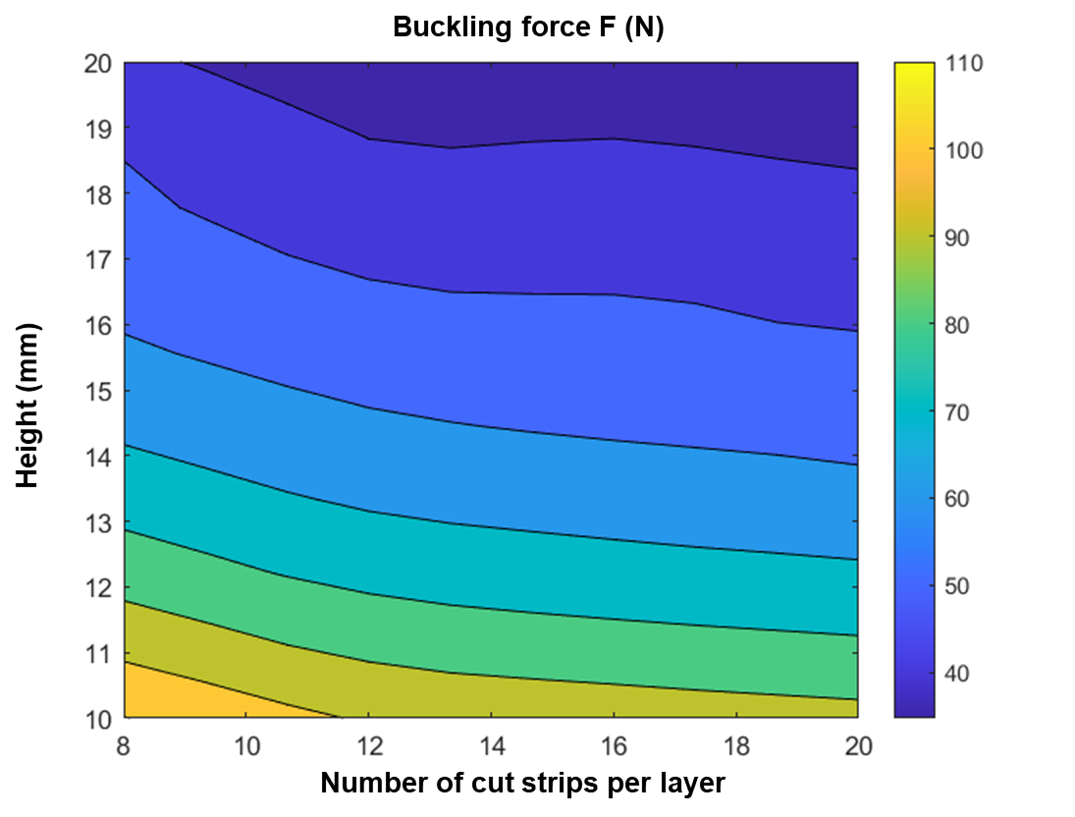
Supplementary Figure 3. Exploration of buckling behavior of one-layered cylindrical kirigami module under the both the influence of cut number and structural height.

Supplementary Figure 4. Exploration of deformation sequences of three-layered cylindrical kirigami modules through designing two different sets of structural segments as (8, 12, 16) in (a) and (12, 8, 16) in (b). Scale bar: 10mm

Supplementary Figure 5. Exploration of deformation sequences of six-layered cylindrical kirigami modules with structural segment as (0.8, 1.2, 1.6, 0.8, 1.2, 1.6)mm. Scale bar: 10mm

Supplementary Figure 6. Exploration of deformation sequences of six-layered cylindrical kirigami modules with structural segment cut number as (16, 12, 8, 16, 12, 8). Scale bar: 10mm

Supplementary Figure 7. Exploration of deformation sequences of nine-layered cylindrical kirigami modules with structural segments shell thickness as (0.8, 0.8, 0.8, 1.2, 1.2, 1.2, 1.6, 1.6, 1.6)mm and (0.8, 1.2, 1.6, 0.8, 1.2, 1.6, 0.8, 1.2, 1.6)mm.

Supplementary Figure 8. Exploration of deformation sequences of nine-layered cylindrical kirigami modules with structural segments structural heights.

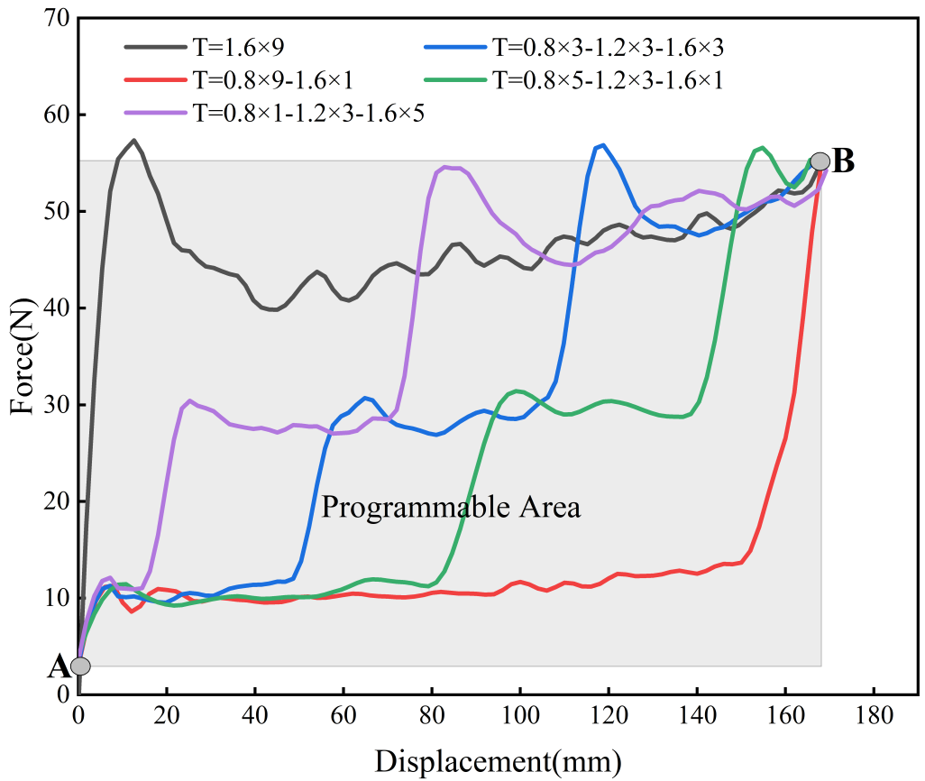
Supplementary Figure 9. Tunable structural stiffness of the nine-segmented cylindrical kirigami module.

Supplementary Figure 10. Experimental test for the TPU material (a) and the extra structural parts for single cylindrical kirigami compression test (b): holder (i) and compressor (ii).

Supplementary Figure 11. Experimental test for single cylindrical kirigami compression test with different structural heights arrangements: (18, 20, 22)mm in (a) and (20, 18, 22)mm in (b). Scale bar: 3mm

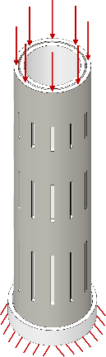

Supplementary Figure 12. FEM simulation details for single cylindrical kirigami compression test with three different structural heights arrangements: (10, 15, 20)mm.

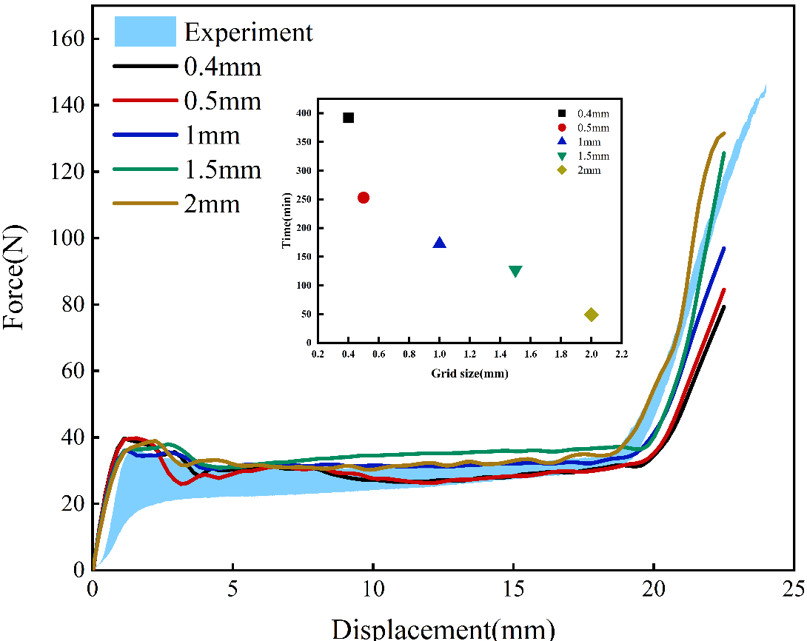
Supplementary Figure 13. Comparisons of FEM simulation results for single cylindrical kirigami compression test with one segment, i.e., 20mm under different mesh sizes.

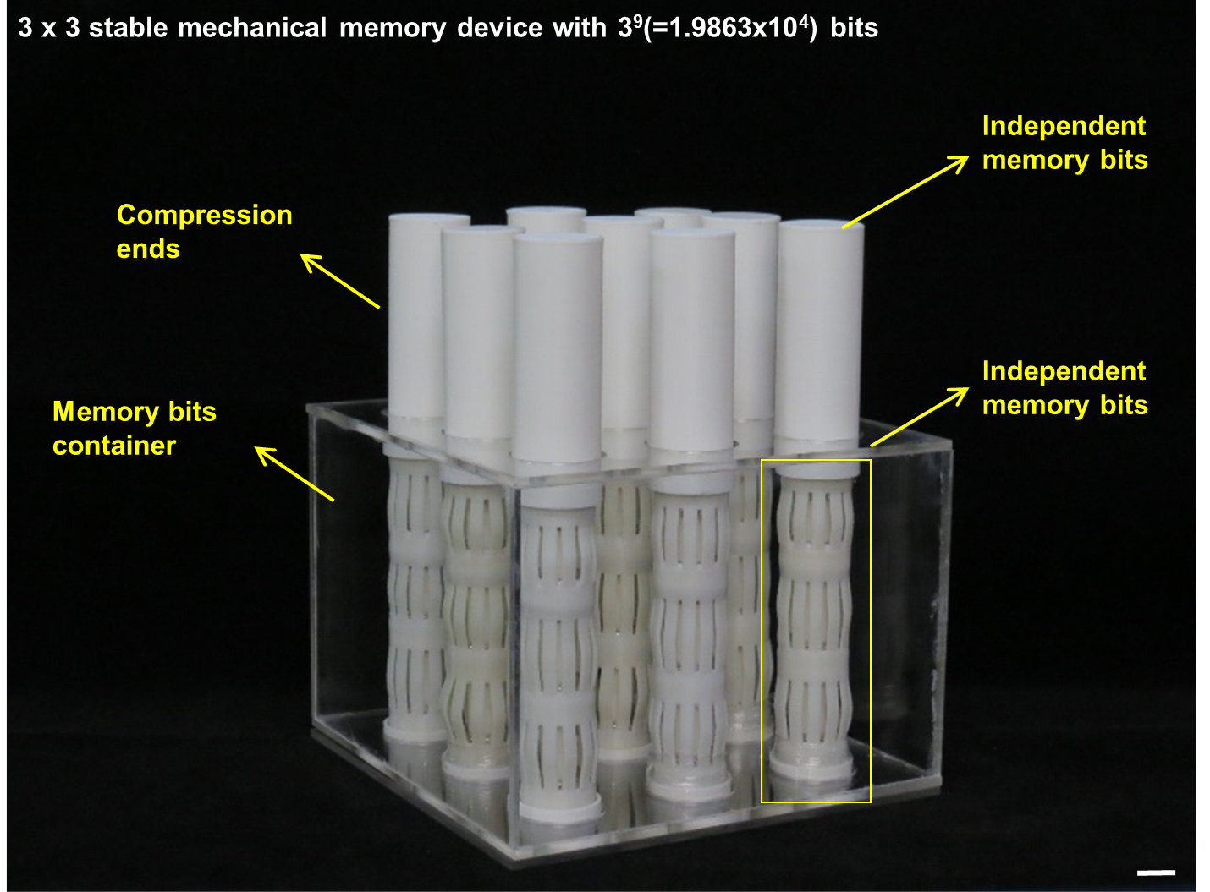

Supplementary Figure 14. Design details of a 3 by 3 mechanical memory devices. Scale bar: 4mm

Supplementary Figure 15. Representative deformation patterns of a 3 by 3 mechanical memory devices. Scale bar: 10mm

