Polygenic risk alters the penetrance of monogenic kidney disease

Supplementary Information

Contents

Supplementary Figures

Supplementary Figure 1…................................................................................ 02
Supplementary Figure 2…................................................................................ 03
Supplementary Figure 3…................................................................................ 04
Supplementary Figure 4…................................................................................ 05
Supplementary Figure 5…................................................................................ 06

Supplementary Tables

Supplementary Table 1 …................................................................................ 07
Supplementary Table 2 …................................................................................ 08
Supplementary Table 3 …................................................................................ 09
Supplementary Table 4 …................................................................................ 10
Supplementary Table 5 …................................................................................ 11
Supplementary Table 6 …................................................................................ 12
Supplementary Table 7 …................................................................................ 13
Supplementary Table 8 …................................................................................ 14
Supplementary Table 9 …................................................................................ 15
Supplementary Table 10 …................................................................................16

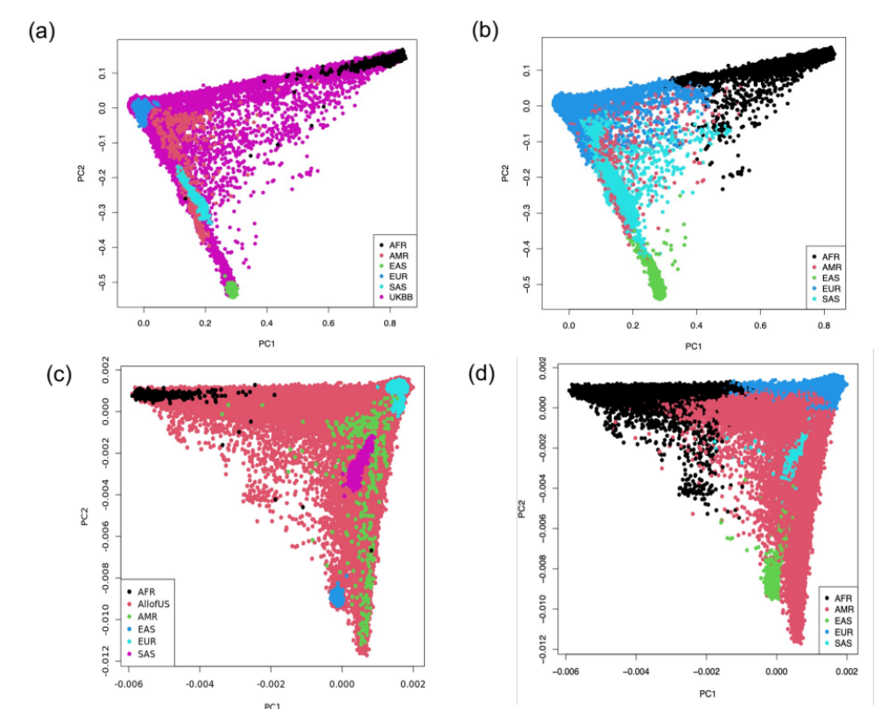
Supplementary Figure 1. PCA projections of the study participants from the UKBB (top) and AoU (bottom) against the 1000 G reference populations: (a) UKBB (N = 460,360) and (c) AoU (N = 165,208) participants plotted against the reference 1000 G populations (N = 2,504), (b) machine learning-assigned ancestry for the UKBB and (d) the AoU datasets. X-axis: PC1; Y-axis: PC2; AFR: African; AMR: Admixed American; EAS: East Asian; EUR: European; and SAS: South Asian.

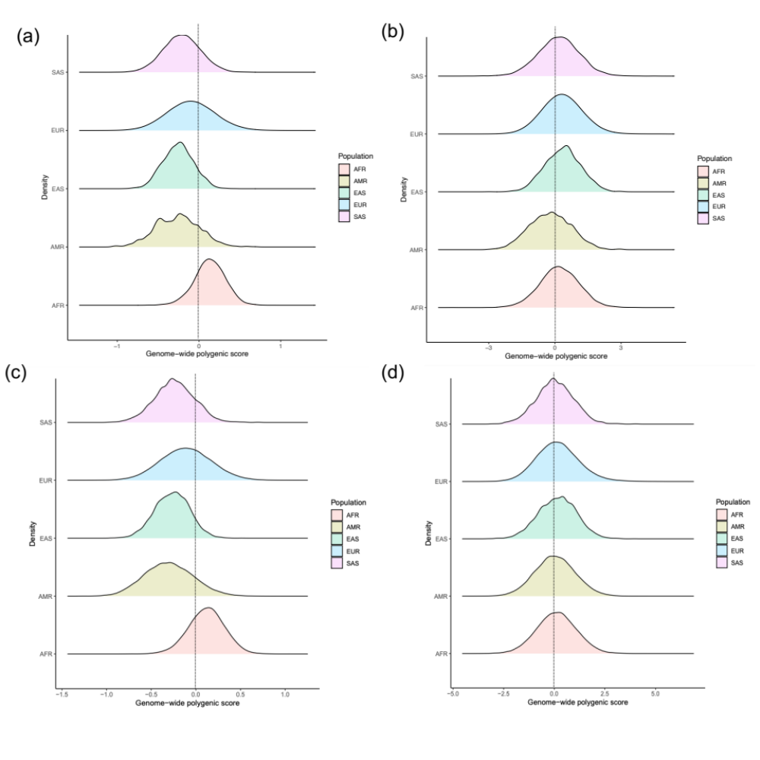
Supplementary Figure 2. Genome-wide Polygenic Score (GPS) distributions by ancestry in the UKBB and AoU datasets: (a) unadjusted and (b) ancestry-adjusted GPS in UKBB (N = 460,360); (c) unadjusted and (d) ancestry-adjusted GPS in AoU (N = 165,208). EUR: European, AFR: African, AMR: Admixed American, EAS: East Asian, and SAS: South Asian.

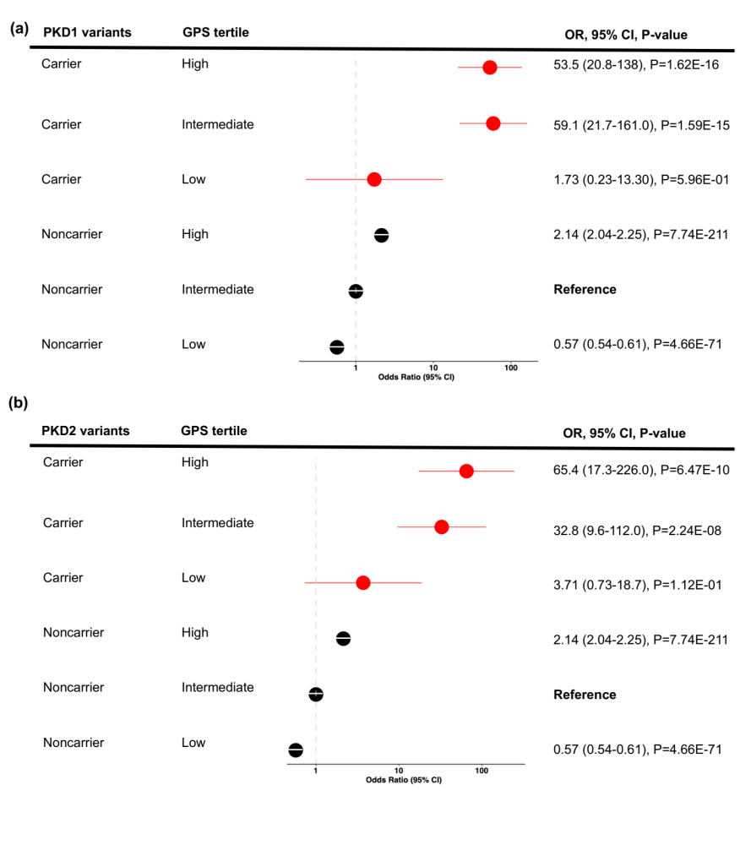Supplementary Figure 3. Polygenic effects on the risk of CKD in M1 variant carriers for (a) PKD1 (N_{total}=109) and (b) PKD2 (N_{total}=63) genes analyzed individually. Each polygenic risk score tertile for carriers was compared to the middle tertile of non-carriers (average population risk). X-axis shows Odds Ratios, the dotted vertical line corresponds to the OR=1.0 (no change in risk compared to the reference). Two-sided P-values derived from fixed effects meta-analysis are not adjusted for multiple testing. CI: Confidence Intervals.

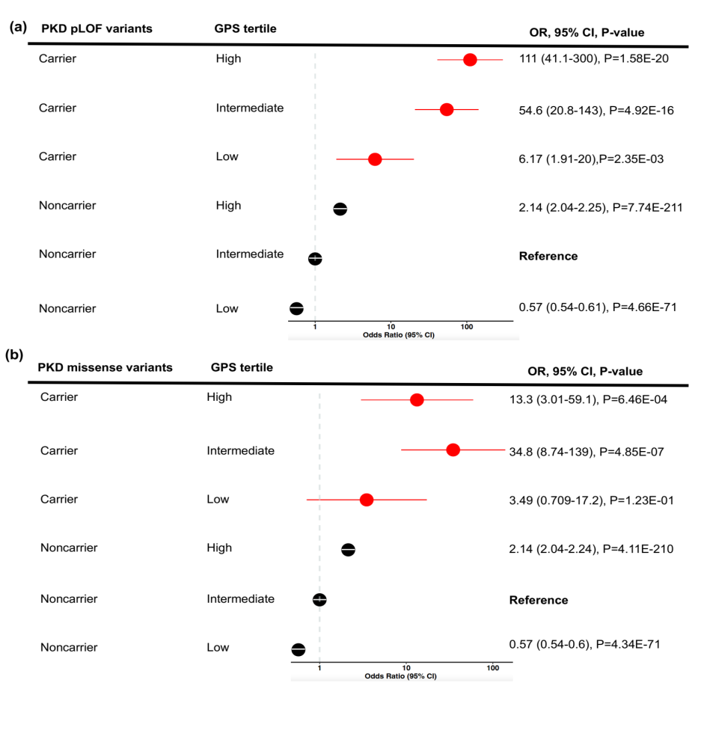Supplementary Figure 4. Polygenic effects on the risk of CKD in M1 variant carriers for (a) ADPKD pLOF variants (N_{total}=111) and (b) ADPKD missense variants (N_{total}=47) were analyzed individually. Each polygenic risk score tertile for carriers was compared to the middle tertile of non-carriers (average population risk). X-axis shows Odds Ratios, the dotted vertical line corresponds to the OR=1.0 (no change in risk compared to the reference). Two-sided P-values derived from fixed effects meta-analysis are not adjusted for multiple testing. CI: Confidence Intervals.

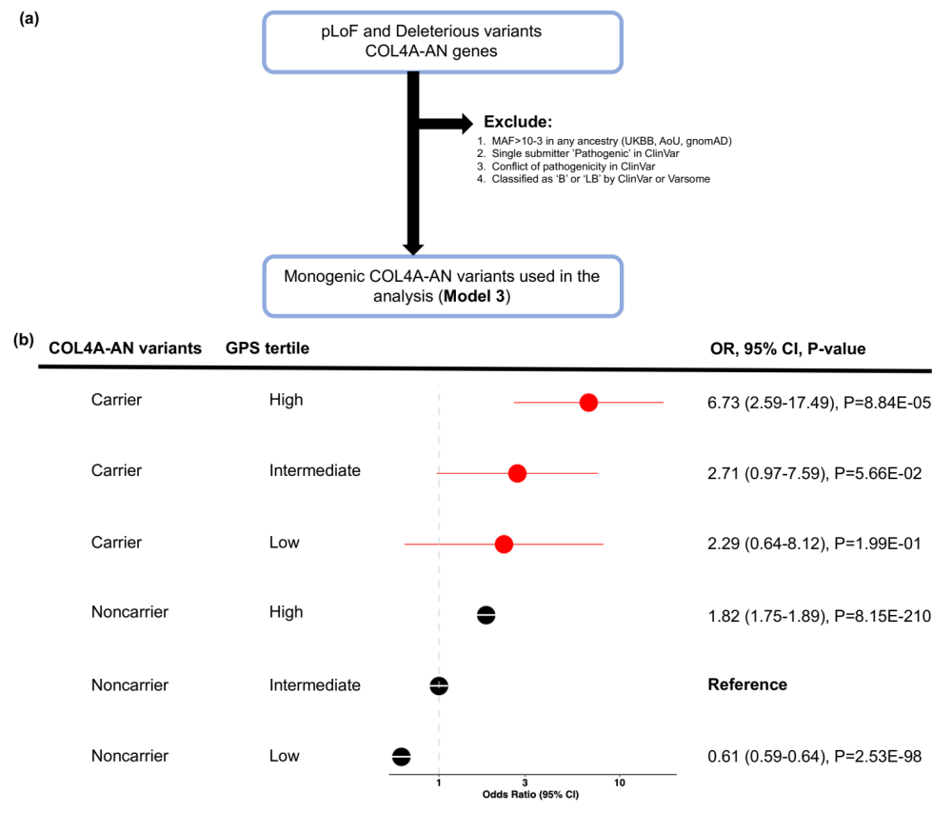
Supplementary Figure 5. Polygenic effects on the risk of CKD among biallelic carriers of COL4A-AN M3 variants (recessive model): (a) M3 qualifying variant filtering strategy; (b) CKD risk for each polygenic risk score tertile compared to the middle tertile in non-carriers (average population risk). The analysis includes N=262,435 UKBB participants (N_{cases}=9,565 and N_{controls}=252,870) and N=34,603 AoU participants (N_{cases}=11,830 and N_{controls}=22,773). The non-carriers with intermediate polygenic score (middle tertile) served as the reference group for all calculations. X-axis shows odds ratios; the dotted vertical line corresponds to the OR=1.0 (no change in risk compared to the reference). P-values correspond to the fixed effects meta-analysis between the two cohorts. P-values are two-sided and are not corrected for multiple testing. GPS: Genome-wide Polygenic Score.

Supplementary Table 1: M1, M2, and M3 variant carriers and their characteristics in the UKBB and AoU datasets. The counts include only individuals with a valid phenotype (case/control) label that was included in the analyses. Note that the non-carrier group is common to all three variant models and excludes any M1, M2, and M3 variant carriers.
Cohorts | N Total | N Cases (%) | N Controls (%) | Female | Diabetes | Mean Age in Years (Range)
UK Biobank | 277,165 | 10,123 (3.6%) | 267,042 (96.4%) | 54% | 6% | 56.5 (40-69)
ADPKD M1 Carriers | 115 | 36 (31.3%) | 79 (68.7%) | 60% | 11% | 54.6
ADPKD M2 Carriers | 125 | 39 (31.2%) | 86 (68.8%) | 62% | 11% | 53.7
ADPKD M3 Carriers | 256 | 45 (17.5%) | 211 (82.5%) | 56% | 7% | 54.4
ADPKD Non-carriers | 264,158 | 9,565 (3.6%) | 252,870 (96.4%) | 55% | 6% | 54.6
COL4-AN M1 Carriers | 1,214 | 62 (5.1%) | 1,152 (94.9%) | 55% | 7% | 54.9
COL4-AN M2 Carriers | 1,350 | 65 (4.8%) | 1,285 (95.2%) | 55% | 7% | 54.5
COL4-AN M3 Carriers | 1,830 | 100 (5.4%) | 1,730 (94.6%) | 57% | 7% | 54.5
COL4-AN Non-carriers | 264,239 | 9,646 (3.6%) | 254,593 (96.4%) | 54% | 6% | 56.5
All of Us | 34,603 | 11,830 (3.41%) | 22,773 (96.59%) | 60% | 11% | 54.9 (18-89)
ADPKD M1 Carriers | 7 | 5 (71.4%) | 2 (28.6%) | 71% | 14% | 60.5
ADPKD M2 Carriers | 14 | 5 (35.7%) | 9 (64.3%) | 64% | 14% | 59.6
ADPKD M3 Carriers | 11 | 7 (63.3%) | 4 (36.7%) | 73% | 27% | 64.7
ADPKD Non-carriers | 34,588 | 11,820 (3.4%) | 22,768 (96.6%) | 60% | 11% | 54.1
COL4-AN M1 Carriers | 78 | 37 (47.4) | 41 (52.6%) | 58% | 23% | 56.0
COL4-AN M2 Carriers | 106 | 47 (44.3%) | 59 (55.7%) | 65% | 21% | 54.5
COL4-AN M3 Carriers | 226 | 72 (31.8%) | 154 (68.2%) | 65% | 20% | 54.4
COL4-AN Non-carriers | 34,539 | 11,800 (3.4%) | 22,739 (96.6%) | 60% | 11% | 54.9

Supplementary Table 2. Imputation of the AoU dataset using phase 3 1000 Genomes project reference panel (all populations): numbers of variants per chromosome before and after imputation by minor allelic frequency (MAF) and imputation quality (R2).

Chromosomes | Array SNPs | Imputed SNPs  (MAF>=0.00 and R2>=0) | Imputed SNPs  (MAF=0.001 and R2=0.30) | Imputed SNPs  (MAF=0.001 and R2=0.80) | Imputed SNPs  (MAF=0.01 and R2=0.80)
1 | 89688 | 3738240 | 2040921 | 1509280 | 909349
2 | 99772 | 4057613 | 2231592 | 1704713 | 1003370
3 | 84384 | 3355939 | 1879863 | 1455774 | 863987
4 | 76774 | 3338265 | 1899659 | 1474223 | 876432
5 | 69273 | 3032422 | 1704339 | 1320209 | 766074
6 | 82492 | 2954410 | 1694019 | 1328952 | 799683
7 | 63934 | 2753497 | 1539955 | 1158989 | 694545
8 | 60000 | 2651561 | 1470694 | 1135036 | 669886
9 | 49556 | 2063096 | 1121854 | 842974 | 505766
10 | 56241 | 2334090 | 1296803 | 986085 | 595717
11 | 56476 | 2333242 | 1286023 | 978430 | 581944
12 | 53025 | 2242720 | 1256253 | 945606 | 572855
13 | 40542 | 1661700 | 944885 | 726461 | 434997
14 | 36097 | 1535592 | 841576 | 636776 | 383314
15 | 35262 | 1404164 | 757414 | 555375 | 335228
16 | 38698 | 1549316 | 822821 | 591403 | 358495
17 | 33636 | 1345835 | 721632 | 495211 | 307640
18 | 33408 | 1319629 | 739218 | 551084 | 334086
19 | 24882 | 1084535 | 585112 | 379198 | 247001
20 | 27606 | 1047613 | 577463 | 420925 | 258119
21 | 16391 | 653791 | 353514 | 253922 | 159090
22 | 16388 | 652195 | 343797 | 234264 | 148765
Total | 1,144,525 | 43,371,225 | 26,109,407 | 19,684,890 | 11,806,343

Supplementary Table 3: Genetic ancestry of the AoU dataset based on supervised machine learning with labeled phase 3 1000 Genomes project reference panel for training.
Ancestry | N (%) | Age  (Mean in years) | Sex  (% Female)
EUR (European) | 94,376 (57) | 58.82 | 60.03
AFR (African) | 36,380 (22) | 51.90 | 57.68
AMR (Admixed American) | 28,807 (17) | 47.73 | 67.89
EAS (East Asian) | 3,940 (2) | 47.04 | 63.76
SAS (South Asian) | 1,705 (1) | 45.76 | 50.35
Total | 165,208 | 50.25 | 59.94

Supplementary Table 4: Overall frequencies of APOL1 G1 and G2 risk alleles and risk genotypes by ancestry and cohort.
Dataset | Ancestry | APOL1- 1072A>G (rs73885319) | APOL1- 1200T>G (rs60910145) | APOL1-1212- del6 (rs71785313) | APOL1 risk genotype (G1G1, G1G2, or G2G2)
UKBB
 | African (AFR) | 0.28 | 0.28 | 0.15 | 0.12
 | Europeans (EUR) | 3.75E-05 | 1.96E-04 | 2.91E-05 | <0.01
AoU
 | African (AFR) | 0.233 | 0.232 | 0.139 | 0.12
 | Admixed American (AMR) | 0.022 | 0.022 | 0.018 | 0.003
 | Europeans (EUR) | 7.58E-04 | 7.58E-04 | 5.19E-04 | <0.01

Supplementary Table 5: GPS Re-optimization Analysis. The table summarizes associations of candidate polygenic scores with CKD in the UKBB re-optimization dataset (70% of UKBB Europeans after excluding all ADPKD/COL4A-AN qualifying variant carriers). Odds ratio (OR) per standard deviation (SD) of each risk score and area under the receiver-operator curve (AUC) were calculated in the UKBB optimization dataset of 175,835 Europeans excluding QV carriers and after adjustment for age, sex, diabetes, first four principal components of ancestry and genotyping batch; AUC crude was calculated for the risk score component alone without any covariates; variance explained is estimated as a Nagelkerke pseudo-R2 and refers to the variance in case-control status explained by the risk score alone excluding covariate contributions; r2: linkage disequilibrium pruning threshold; rho: tuning parameter to model the proportion of variants assumed to be causal; the best performing score is highlighted in bold red.

Method | Parameter | N variants | OR* per SD of GPS | P-value | AUC (Adjusted*) | AUC (Crude) | Variance Explained
P+T | P=1.0E-01 | 89,880 | 1.85 | P<1.00E-300 | 0.8392 | 0.6508 | 0.0438
P+T | P=1.0E-02 | 21,764 | 1.85 | P<1.00E-300 | 0.8399 | 0.6518 | 0.0442
P+T | P=1.0E-03 | 7,486 | 1.79 | P<1.00E-300 | 0.8380 | 0.6446 | 0.0405
P+T | P=1.0E-04 | 3,598 | 1.78 | P<1.00E-300 | 0.8374 | 0.6422 | 0.0394
P+T | P=1.0E-05 | 2,111 | 1.76 | P<1.00E-300 | 0.8366 | 0.6396 | 0.0378
P+T | P=1.0E-06 | 1,407 | 1.75 | P<1.00E-300 | 0.8365 | 0.6390 | 0.0372
P+T | P=1.0E-07 | 1,028 | 1.76 | P<1.00E-300 | 0.8362 | 0.6388 | 0.0370
P+T | P=1.0E-08 | 753 | 1.74 | P<1.00E-300 | 0.8353 | 0.6362 | 0.0355
P+T | P=3.0E-02 | 41,426 | 1.86 | P<1.00E-300 | 0.8400 | 0.6527 | 0.0450
P+T | P=3.0E-03 | 11,918 | 1.83 | P<1.00E-300 | 0.8391 | 0.6492 | 0.0428
P+T | P=3.0E-04 | 4,971 | 1.79 | P<1.00E-300 | 0.8378 | 0.6436 | 0.0401
P+T | P=3.0E-05 | 2,675 | 1.76 | P<1.00E-300 | 0.8369 | 0.6404 | 0.0385
LDPred | rho=1.0E+00 | 5,440,627 | 1.84 | P<1.00E-300 | 0.8387 | 0.6512 | 0.0433
LDPred | rho =1.0E-01 | 5,440,627 | 1.20 | P=2.60E-44 | 0.8168 | 0.5472 | 0.0039
LDPred | rho =1.0E-02 | 5,440,627 | 1.16 | P=1.03E-28 | 0.8161 | 0.5385 | 0.0025
LDPred | rho =1.0E-03 | 5,440,627 | 1.14 | P=4.78e-24 | 0.8157 | 0.5334 | 0.0020
LDPred | rho =3.0E-01 | 5,440,627 | 1.72 | P<1.00E-300 | 0.8339 | 0.6348 | 0.0342
LDPred | rho =3.0E-02 | 5,440,627 | 1.12 | P=1.05E-18 | 0.8155 | 0.5287 | 0.0016
LDPred | rho =3.0E-03 | 5,440,627 | 1.16 | P=5.98E-31 | 0.8161 | 0.5385 | 0.0027
* Adjusted for age, sex, diabetes, the first four principal ancestry components and genotyping batch.

Supplementary Table 6: The effect of ADPKD qualifying variant (QV) carrier status on the risk of CKD in the UK Biobank and the All of Us datasets. The ORs were adjusted for age, sex, diabetes, PCs of ancestry, and genotyping array or batch; the two-sided P-values correspond to the association tests of carrier status as a predictor of CKD and are not corrected for multiple testing; M1 includes only pLOF, and ‘P’ variants (N_{total}=122 carriers); M2 includes pLOF, ‘P’, and ‘LP’ variants (N_{total}=139 carriers); M3 includes pLOF and all deleterious missense variants as defined by 5 prediction algorithms, Revel >0.7, and not previously classified as ‘B’ or ‘LB’ by ClinVar (N_{total}=267 carriers). All comparisons are made in reference to the common group of non-carriers (N_{total}=297,539). CI: Confidence Intervals.

 | ADPKD M1 carriers  OR (95%CI), P | ADPKD M2 carriers  OR (95%CI), P | ADPKD M3 carriers  OR (95%CI), P
UKBB | 18.2 (11.5-28.6), P=5.1E-36 | 17.3 (11.1-27.0), P=4.8E-36 | 7.1 (4.95-10.2), P=1.8E-26
AoU | 8.36 (1.84-37.4), P=5.9E-03 | 6.11 (1.47-25.4), P=1.3E-02 | 3.13 (0.70-14.1), P=1.4E-01
Meta-analysis | 17.1 (11.1-26.4), P=1.8E-37 | 15.8 (10.3-24.2), P=5.2E-37 | 6.77 (4.76-9.60), P=1.0E-26

Supplementary Table 7: Effects of GPS on the risk of CKD in the ADPKD M1, M2, and M3 variant carriers in the meta-analysis of UKBB and AoU. All effect estimates were calculated in reference to the middle tertile of non-carriers (average risk) and were adjusted for age, sex, diabetes, PCs of ancestry, and genotyping array or batches. Two-sided P-values correspond to fixed effects meta-analysis and are not corrected for multiple testing.
Model | Cases/Controls | OR per SD (95% CI), P-value | GPS Tertile | OR (95% CI), P-value
Noncarrier
 | 21,901/275,638 | 1.72 (1.69-1.76), P<E-300 | Tertile 1 | 0.62 (0.59-0.65), P=3.9E-96
 |  |  | Tertile 2 | Reference
 |  |  | Tertile 3 | 1.82 (1.75-1.89), P=3.4E-208
M1
 | 41/81 | 2.28 (1.55-3.37), P=2.7E-05 | Tertile 1 | 3.03 (1.03-8.95), P=4.4E-02
 |  |  | Tertile 2 | 35.8 (16.8-76.4), P=2.0E-20
 |  |  | Tertile 3 | 54.4 (26.2-113.1), P=9.6E-27
M2
 | 44/95 | 2.21 (1.37-3.58), P=3.3E-05 | Tertile 1 | 4.99 (1.94-12.8), P=8.6E-04
 |  |  | Tertile 2 | 24.1 (11.5-50.5), P=3.0E-17
 |  |  | Tertile 3 | 49.4 (24.0-101.6), P=3.1E-26
M3
 | 52/215 | 5.25 (2.31-11.9), P=7.4E-05 | Tertile 1 | 1.89 (0.77-4.63), P=1.6E-01
 |  |  | Tertile 2 | 8.52 (4.73-15.3), P=8.8E-13
 |  |  | Tertile 3 | 21.8 (12.4-38.1), P=4.7E-27

Supplementary Table 8: The effect of COL4A-AN qualifying variant (QV) carrier status on the risk of CKD in the UK Biobank and the All of Us datasets. The ORs were adjusted for age, sex, diabetes, PCs of ancestry, and genotyping array or batch; the two-sided P-values correspond to the association tests of carrier status as a predictor of CKD and are not corrected for multiple testing; M1 includes only pLOF, and ‘P’ variants (N_{total}=1,292 carriers); M2 includes pLOF, ‘P’, and ‘LP’ variants (N_{total}=1,458 carriers); M3 includes pLOF and all deleterious missense variants as defined by 5 prediction algorithms, Revel >0.7, and not previously classified as ‘B’ or ‘LB’ by ClinVar (N_{total}=2,056 carriers); M3 recessive model (N_{total}=127) includes biallelic carriers of M3 variants for COL4A3 or COL4A4, or M3 hemizygous males. All comparisons are made in reference to the common group of non-carriers (N_{total}=298,778).

Datasets | COL4A-AN M1 carriers  OR (95%CI), P | COL4A-AN M2 carriers  OR (95%CI), P | COL4A-AN M3 carriers  OR (95%CI), P | COL4A-AN M3 recessive  OR (95%CI), P
UKBB | 1.41 (1.15-1.74), P=1.1E-03 | 1.34 (1.03-1.73), P=3.0E-02 | 1.55 (1.26-1.92), P=5.0E-05 | 3.10 (1.66-5.78), P=4.2E-04
AoU | 1.21 (0.82-1.79), P=3.3E-01 | 1.05 (0.67-1.61), P=8.2E-01 | 1.29 (0.90-1.85), P=1.6E-01 | 6.69 (1.23-36.4), P=2.8E-02
Meta | 1.37 (1.13-1.64), P=8.5E-04 | 1.25 (1.00-1.56), P=4.9E-02 | 1.48 (1.23- 1.77), P=2.6E-05 | 3.38 (1.88-6.08), P=4.7E-05

Supplementary Table 9: Effects of GPS in the COL4-AN M1, M2, and M3 variant carriers in the meta-analysis of UKBB and AoU. All effect estimates were calculated in reference to the middle tertile of non-carriers (average risk) and were adjusted for age, sex, diabetes, PCs of ancestry, and genotyping array or batches. Two-sided P-values correspond to fixed effects meta-analysis and are not corrected for multiple testing.
 | Model | Cases/Controls |  | OR per SD (95% CI), P-value |  | GPS Tertile |  | OR (95% CI), P-value
 | Noncarrier
 |  | 21,446/277,332 |  | 1.70 (1.68-1.73), P<E-300 |  | Tertile 1 |  | 0.61 (0.59-0.64), P=2.5E-98
 |  |  |  |  |  | Tertile 2 |  | Reference
 |  |  |  |  |  | Tertile 3 |  | 1.82 (1.75-1.89), P=8.1E-210
 | M1
 |  | 99/1,193 |  | 1.78 (1.22-2.58), P=2.4E-03 |  | Tertile 1 |  | 1.08 (0.63-1.86), P=7.7E-01
 |  |  |  |  |  | Tertile 2 |  | 1.66 (1.03-2.68), P=3.7E-02
 |  |  |  |  |  | Tertile 3 |  | 2.53 (1.66-3.85), P=1.4E-05
 | M2
 |  | 112/1,344 |  | 2.47 (1.56-3.94), P=1.3E-04 |  | Tertile 1 |  | 0.66 (0.40-1.07), P=9.6E-02
 |  |  |  |  |  | Tertile 2 |  | 1.26 (0.84-1.88), P=5.3E-01
 |  |  |  |  |  | Tertile 3 |  | 2.55 (1.83-3.56), P=3.1E-08
 | M3
 |  | 172/1,884 |  | 1.93 (1.26-2.95), P=2.3E-03 |  | Tertile 1 |  | 1.10 (0.57-2.12), P=7.7E-01
 |  |  |  |  |  | Tertile 2 |  | 1.45 (0.82-2.55), P=2.0E-01
 |  |  |  |  |  | Tertile 3 |  | 2.77 (1.73-4.46), P=2.7E-05
 | M3 (recessive)
 |  |  | 21/106 | 1.19 (0.69-2.07), P=5.2E-01 |  |  | Tertile 1 |  | 2.29 (0.64-8.12), P=2.0E-01
 |  |  |  |  |  |  | Tertile 2 |  | 2.71 (0.97-7.59), P=5.6E-02
 |  |  |  |  |  |  | Tertile 3 |  | 6.73 (2.59-17.5), P=8.8E-05

Supplementary Table 10: GPS effect estimates for each COL4A gene under the M1 model. Only UKBB data was included due to low case counts in the AoU dataset. The P-values are two-sided and not adjusted for multiple testing.

Gene | Cases/controls | OR per SD (95% CI), P-value | GPS Tertile | OR (95% CI), P-value
COL4A3
 | 12/211 | 1.37 (0.60-3.14), P=4.5E-01 | Tertile 1 | 1.70 (0.65-4.43), P=2.8E-01
 |  |  | Tertile 2 | 1.20 (0.36-3.98), P=7.7E-01
 |  |  | Tertile 3 | 2.00 (0.70-5.72), P=1.9E-01
COL4A4
 | 16/313 | 1.49 (0.73-3.03), P=2.7E-01 | Tertile 1 | 0.86 (0.264-2.78), P=7.9E-01
 |  |  | Tertile 2 | 1.69 (0.70-4.05), P=2.3E-01
 |  |  | Tertile 3 | 2.23 (0.98-5.06), P=5.6E-02
COL4A3 or 4
 | 28/524 | 1.91 (0.90-4.09), P=9.3E-02 | Tertile 1 | 0.94 (0.41-2.18), P=8.8E-01
 |  |  | Tertile 2 | 1.54 (0.78-3.02), P=2.1E-01
 |  |  | Tertile 3 | 2.43 (1.31-4.52), P=5.0E-03
COL4A5
 | 3/32 | 1.97 (0.18-21.10), P=5.7E-01 | Tertile 1 | 3.46 (0.40-29.8), P=2.5E-01
 |  |  | Tertile 2 | 1.35E-04 (2.6E-82-7.0E73), P=9.2E-01
 |  |  | Tertile 3 | 11.0 (2.02-60.2), P=5.6E-03

