Supplementary Information
We report below additional analyses on (a) the temporal measures of children’s behavior during the experiments and (b) the gender effects related to children’s cheating behavior. These were ad hoc analyses because we did not preregister them and hence their results are reported here.
Temporal measures of children’s behaviors
For children who cheated, we calculated cheating latencies by counting the number of seconds from when the experimenter left the room to the occurrence of the cheating behavior (with the values ranging from 0 to 300). The cheating latencies were classified as the same if the two coders reported values that differed by no more than one second. For both measures, the inter-coder agreement was 100%.
We also calculated waiting time. For these calculations, we included children who cheated as well as children who did not cheat. Specifically, for children who cheated, their waiting time was identical to their cheating latency (i.e., the number of seconds from when the experimenter left the room to the occurrence of the cheating behavior). For children who did not cheat, their waiting time was counted as 300 seconds.
In addition to waiting time, we also calculated leaving time for all children by counting the number of seconds from the time when children finished the last problem of the counting test to the time when they went to the nearby room to retrieve the experimenter. We did so to compare the time taken by children who cheated and children who did not cheat to call the experimenter after they finished the counting test.

Cheating latency
The cheating rates and the means and standard deviations of the cheating latencies for each condition in the five studies are shown in Table S1. The mean cumulative percentages and standard errors of children who cheated as a function of cheating latency are shown in Figure S1. (Note that non-cheaters are excluded from this figure). Across the eight conditions, most of the cheating (i.e., by about 70% of children who cheated) occurred within 100 seconds.

Table S1. Cheating rates and cheating latencies (seconds) for each condition in the five studies.
Condition | Cheating Rate | Cheating Latency (second)  M (SD)
Study1
Answer key experimental | 34.1% (14/41) | 103.93 (70.99)
Control | 61% (25/41) | 62.24 (47.51)
Study 2
House key experimental | 36.6% (15/41) | 93.20 (68.55)
House key control | 63.4% (26/41) | 72.27 (39.14)
Study 3
Modified house key experimental Version 1 | 39% (16/41) | 81.75 (68.54)
House key control | 65.9% (27/41) | 76.30 (51.67)
Study 4
Modified house key experimental Version 2 | 53.7% (22/41) | 77.73 (33.89)
Study 5
Modified house key experimental Version 3 | 48.8% (20/41) | 67.45 (47.51)
Total | 50.3% (165/328) | 77.06 (52.56)
It appeared that the conditions did not have a significant effect on latency. To confirm this observation, we conducted the following analysis. Given that the data were overall heavily skewed to the left, we used the negative binomial regression model with log link in the Generalized Estimating Equations module of SPSS Version 26. The main effect of condition was indeed not significant, Wald χ²(df = 7) = 7.20, p = .408.
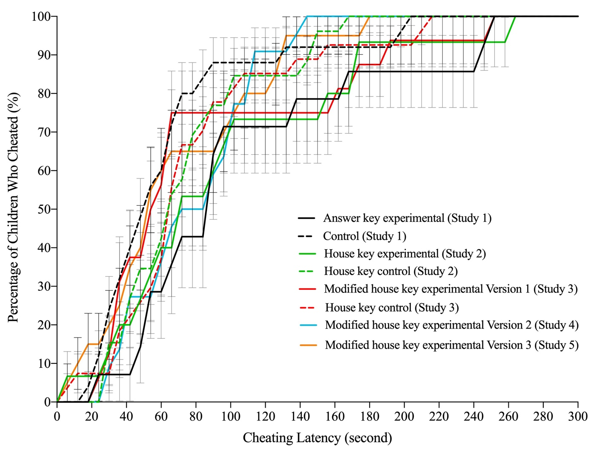
Figure S1. The mean cumulative percentages and standard errors of children who cheated as a function of cheating latency for each condition in the five studies.

Waiting time
Figure S2 showed the cumulative percentages of all children as a function of waiting time. As we can see from this figure, the number of children who cheated across the eight conditions did not differ at the beginning of the waiting period (i.e., the first 40 seconds). Subsequently, the waiting time differences emerged as expected because more children cheated in the control conditions of Studies 1, 2, and 3 than in the three experimental (i.e., answer key experimental condition of Study 1, house key experimental condition of Study 2, and modified house key experimental (Version 1) condition of Study 3). As a result, the waiting time decreased in the control conditions (because more children failed to wait and cheated). In addition, there is little variation in waiting time across the three experimental conditions.

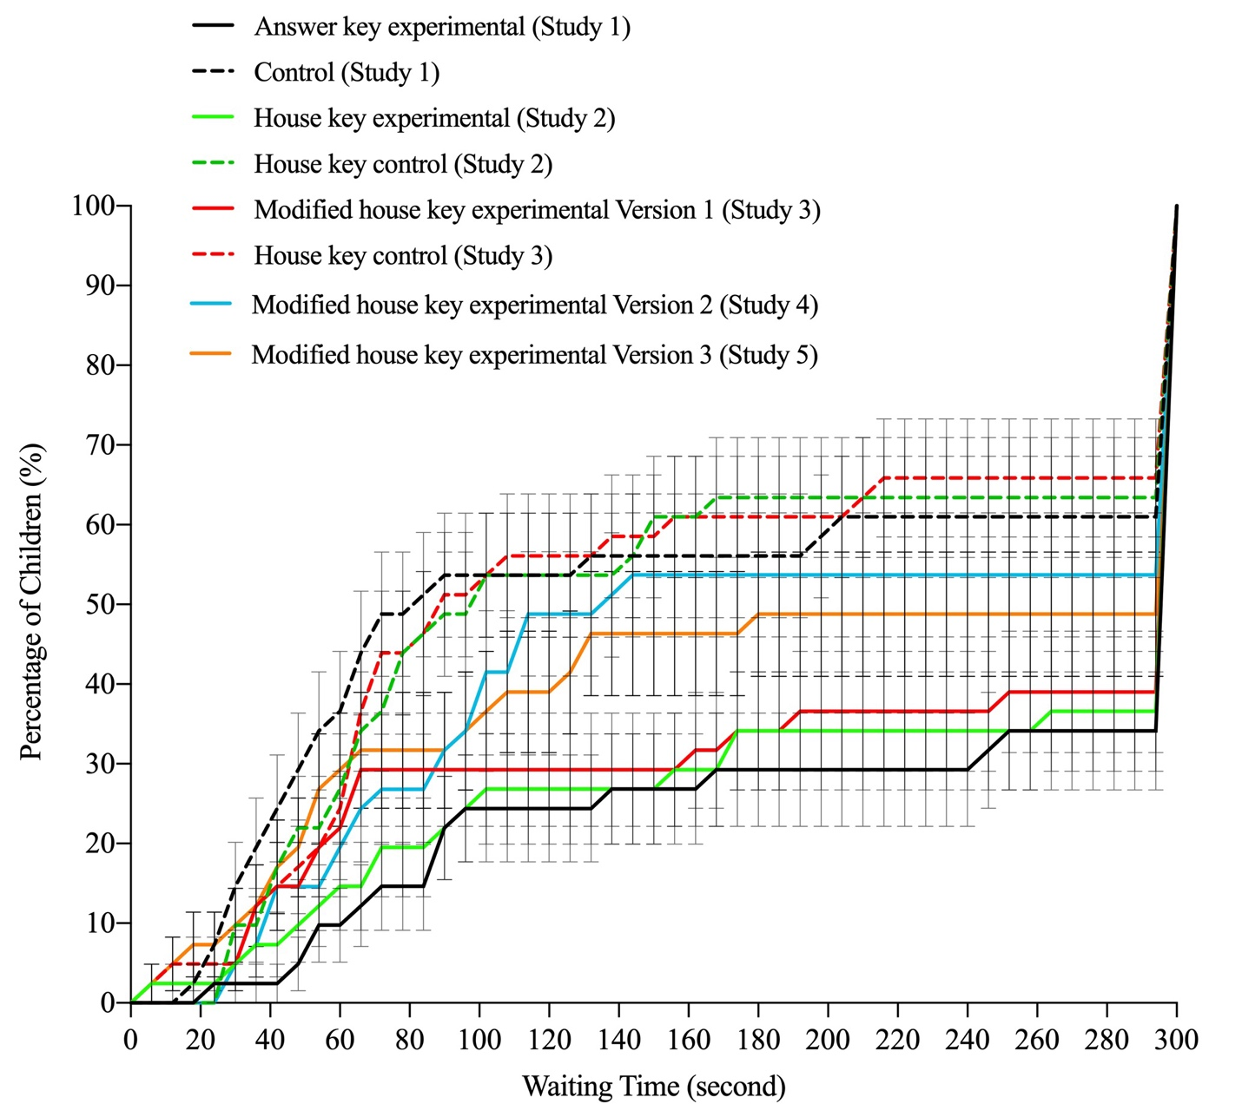
Figure S2. The mean cumulative percentages and standard errors of children as a function of waiting time for each condition in the five studies.

Leaving time
We also calculated leaving time (i.e., the number of seconds from the time when children finished the last problem of the counting test to the time when they got up to retrieve the experimenter from the next room) for all children.
The mean leaving time (seconds) and standard deviation for each condition in the five studies are shown in Table S2. The cumulative percentages of all children as a function of leaving time and standard errors in the five studies are shown in Figure S3.

Table S2. Leaving time (seconds) for each condition in the five studies.
Condition | Number of children who retrieved the experimenter | Leaving time (second)  M (SD)
Study1
Answer key experimental | 35/41 | 22.85 (27.11)
Control | 34/41 | 26.13 (40.13)
Study 2
House key experimental | 34/41 | 21.07 (14.53)
House key control | 34/41 | 18.03 (15.39)
Study 3
Modified house key experimental Version 1 | 33/41 | 24.53 (22.64)
House key control | 39/41 | 20.71 (19.50)
Study 4
Modified house key experimental Version 2 | 36/41 | 21.47 (29.27)
Study 5
Modified house key experimental Version 3 | 35/41 | 21.70 (24.13)
Total | 280/328 | 22 (25.04)

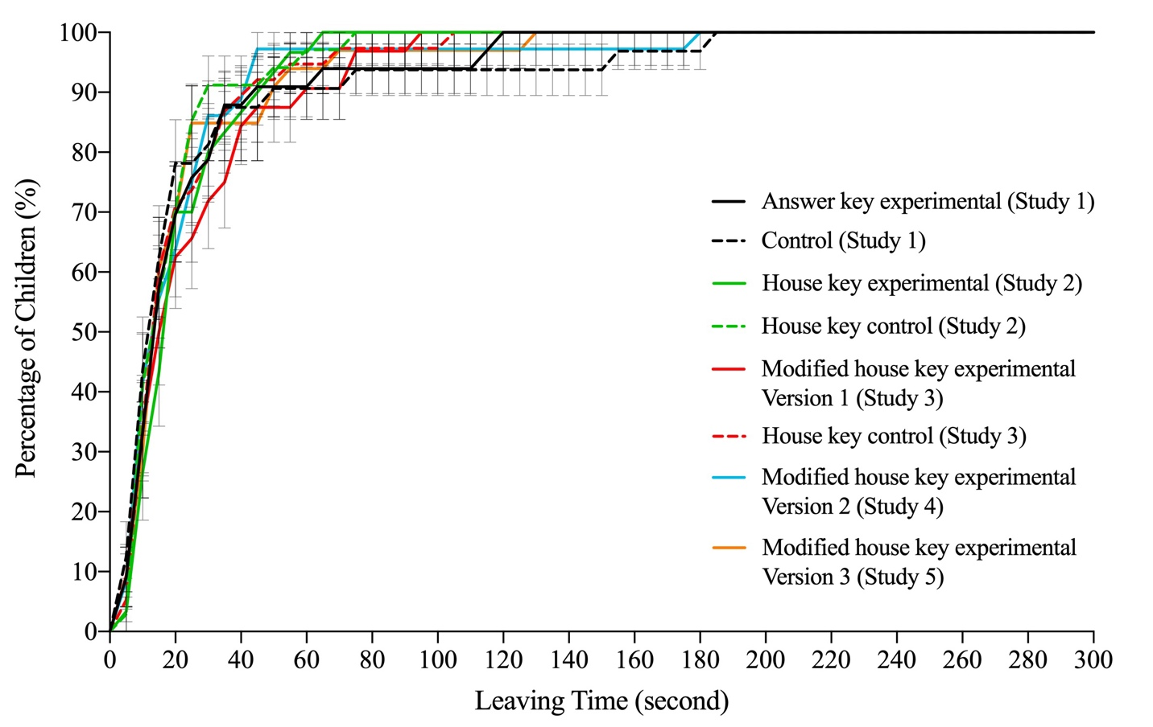
Figure S3. The mean cumulative percentages and standard errors of children as a function of leaving time in the five studies.
Figure S3 shows that the mean leaving time did not vary across the eight conditions. Most of the children decided to retrieve the experimenter in the first 50 seconds after they finished the counting test.
To examine the effect of condition on leaving time, we conducted the following analysis. Given that the data of leaving time were overall heavily skewed to the left, we again used the negative binomial regression model with log link in the Generalized Estimating Equations module to analyze the data, with the condition as the predictor variable, and the leaving time as the predicted variable. The main effect of condition was not significant, Wald χ²(df = 7) = 2.86, p = .897. Overall, these results suggest that the condition did not significantly influence children’ leaving time.
It should be noted that six children went to call back the experimenter without finishing the last problem, 27 children did not leave the room after finishing the last problem, and 21 did not finish the last problem nor call back the experimenter. They were all excluded from the above analysis.
Taken together, the data in Figures S1, S2 and S3, show that variation among the conditions emerged for children’s decision to either cheat or not cheat, but not for the latency of cheating or for how quickly children sought the experimenter following test completion.

Gender effect
Table S3 shows the cheating occurrence, cheating latencies, waiting time, and leaving time broken down by gender group across the five studies.
To examine the effect of gender on children’s cheating occurrence (whether children cheated or not), as well as the cheating latencies, waiting time, and leaving time, we conducted the following ad hoc analyses.
For the cheating occurrence, we conducted chi-squared analyses for each study and found only one significant difference in cheating occurrence between girls and boys in Study 2, χ² (1, N = 82) = 3.95, p = .047, η² = 0.05, with a higher percentage of girls cheating than boys (61% vs. 39%, for girls and boys, respectively). However, there were no significant gender differences in the other studies (ps > .05), indicating the gender effects may be small or even possibly spurious.
To examine the effect of gender on children’s cheating latencies, waiting time, and leaving time, we conducted separate Generalized Estimating Equations (GEE) analyses. For cheating latencies and waiting time, the gender effect was not significant for any of the studies (ps > .05). For leaving time, in Studies 2 and 5, girls took longer to retrieve the experimenter than boys (Wald χ²(df = 1) = 7.49, p = .006 and Wald χ²(df = 1) = 4.24, p = .039, for Studies 2 and 5, respectively). However, gender differences in leaving time were not significant in the other studies (ps > .1).
Given these results, before drawing any conclusions about gender related effects, it is crucial for future studies to preregister and evaluate specifically the effects of gender on children’s decision to cheat and the temporal measures of their behavior during the experiments.
Table S3. Cheating rate, cheating latency, waiting time, and leaving time for each gender group in the five studies.
Subgroup | Cheating rate | Cheating latency (second)  M (SD) | Waiting time (second)  M (SD) | Leaving time (second)  M (SD)
Study 1
Girls | 51% | 68.06 (42.63) | 198.90 (119.76) | 26.66 (34.29)
Boys | 44% | 84.27 (70.27) | 189.63 (119.89) | 22.69 (34.00)
Study 2
Girls | 61% | 85.12 (59.06) | 168.98 (115.56) | 23.97 (17.73)
Boys | 39% | 71.81 (39.00) | 210.95 (115.20) | 14.94 (9.89)
Study 3
Girls | 63% | 88.20 (68.85) | 167.63 (117.05) | 25.18 (24.90)
Boys | 43% | 64.61 (34.78) | 199.12 (120.01) | 19.89 (16.27)
Study 4
Girls | 55% | 78.27 (32.29) | 178.05 (115.57) | 25.05 (38.98)
Boys | 52% | 77.18 (37.00) | 183.29 (116.99) | 17.47 (11.48)
Study 5
Girls | 60% | 60.75 (42.77) | 156.45 (124.58) | 27.78 (29.96)
Boys | 38% | 77.50 (55.32) | 215.24 (115.45) | 14.40 (11.65)
Note. Significant gender differences are bolded.

