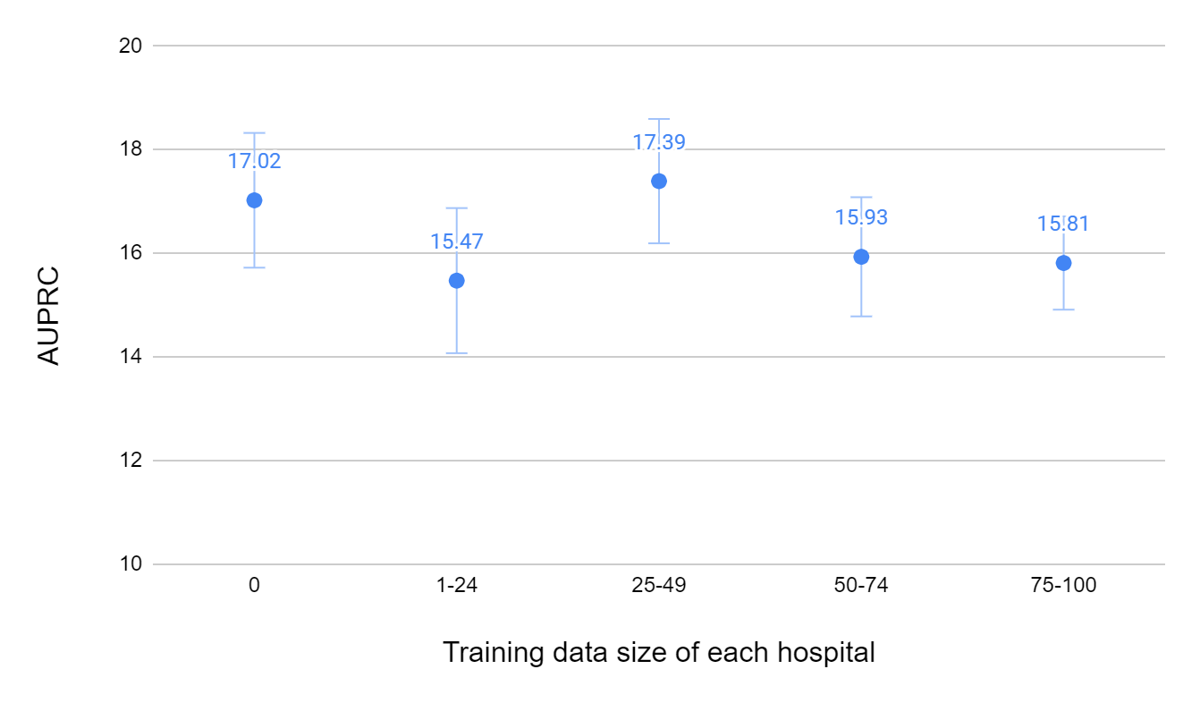
Supplementary Figure 1. AUPRC of intentional self-harm among PTSD patients from more than 1,200 health care facilities. Facilities are grouped by the number of patients in the pretraining cohort. There are 57 patients in a facility on average. The AUPRC is consistent among different hospitals, even for those hospitals which had no patients in the pretraining cohort.

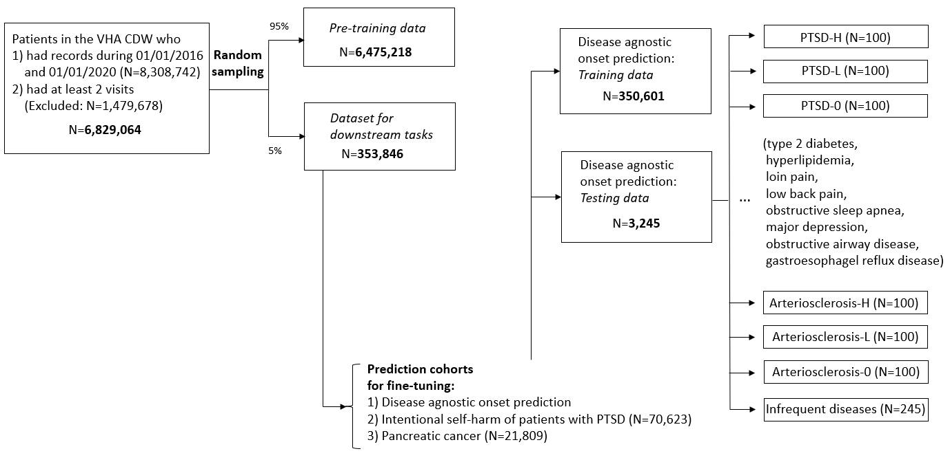

Supplementary Figure 2. Cohort for pretraining and cohort for disease-agnostic onset prediction.

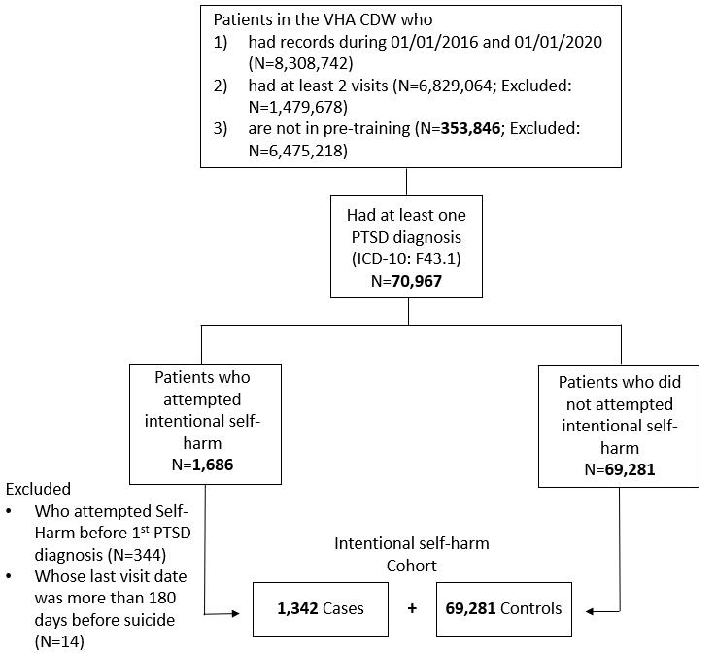

Supplementary Figure 3. Cohort intentional self-harm of patients with PTSD. Intentional self-harms (cases) are selected by patients with codes in Supplementary Table 5.

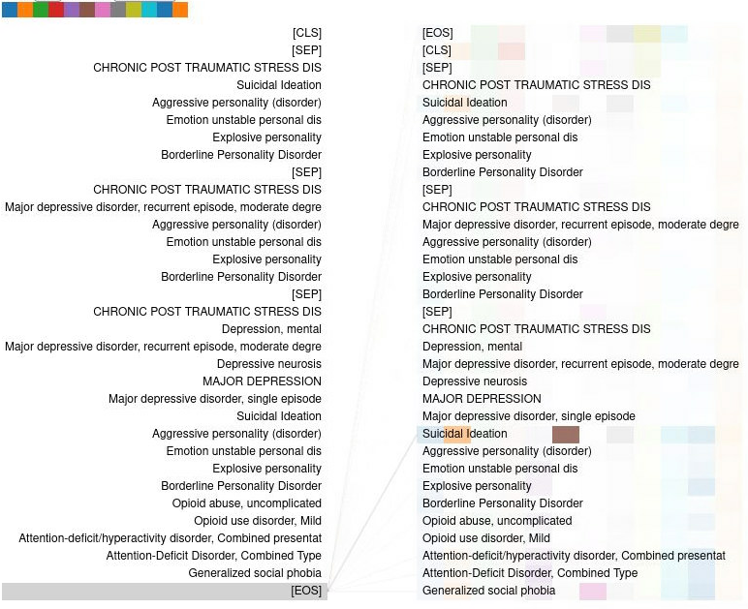
Supplementary Figure 4. Intentional self-harm prediction: An example of how decoder layer2 attention (of head6 in brown) attends between intentional self-harm [EOS] and suicidal ideation for a single patient. Right and left columns represent input and output of an attention, respectively. Color of the block represents different heads, and intensity of the block represents attention weights of the specific head. Enformer finds high attention intensity between intentional self-harm and suicidal ideation and predicts this patient will attempt self-harm within 30 days with probability 0.89 after softmax.

Characteristic | Pretrain |  | Finetune
Characteristic | train | DOAP | Intentional self-harm among PTSD | Pancreatic Cancer
Number of patients | 6.5M | 353.8k | 70.6k | 21.8k
Number of visits | 255.3M | 13.1M | 707.0k | 236.9k
Number of codes | 1.1B | 59.2M | 3.1M | 1.0M
Supplementary Table 1. Statistics on our VHA cohorts. Values are rounded up to the nearest hundreds.

Models |  | Copy | BERT | Enformer
Chronic PTSD | R | 57.27 | 68.19 | 80.73
 | 0 | 11.23 | 17.82 | 24.49
Type 2 diabetes | R | 32.42 | 55.97 | 68.57
 | 0 | 6.52 | 23.39 | 30.5
Hyperlipidemia | R | 31.74 | 57.52 | 67.66
 | 0 | 8.64 | 22.48 | 30.36
Loin pain | R | 46.81 | 64.77 | 73.03
 | 0 | 7.33 | 23.9 | 40.07
Low back pain | R | 44.98 | 67.99 | 73.79
 | 0 | 7.09 | 22.52 | 41.5
Obstructive sleep apnea | R | 58.29 | 76.1 | 86.02
 | 0 | 4.85 | 23.69 | 42.14
Depression | R | 57.18 | 73.54 | 85.25
 | 0 | 4.78 | 26.69 | 50.36
Obstructive airway disease | R | 41.7 | 63.83 | 69.74
 | 0 | 6.07 | 24.88 | 32.22
Gastroesophageal reflux | R | 39.47 | 58.23 | 69.04
 | 0 | 7.38 | 24.38 | 40.22
Arteriosclerosis | R | 45.05 | 62.17 | 74.64
 | 0 | 7.12 | 21.81 | 41.72
Uncommon disease/outcome | 0 | 26.54 | 33.56 | 48.58

Supplementary Table 2. Disease/outcome agnostic prediction: Jaccard similarity scores on different pretraining objectives for the 10 common and 10 uncommon diseases in Table 1. Many common diseases are chronic in nature. We therefore study whether prior history of the same disease has an impact on prediction performance, where R is recurrent and 0 is new disease onset.

Ablations |  | Encoder decoder model
 |  | /w Code masking | /w Visit masking | /w Visit masking
 |  |  |  | /w Date embedding
Chronic PTSD | R | 76.32 | 79.49 | 80.73
 | 0 | 21.01 | 23.12 | 24.49
Type 2 diabetes | R | 60.98 | 66.45 | 68.57
 | 0 | 25.03 | 28.76 | 30.5
Hyperlipidemia | R | 60.46 | 68.02 | 67.66
 | 0 | 24.51 | 32.44 | 30.36
Loin pain | R | 68.75 | 71.52 | 73.03
 | 0 | 24.4 | 39.84 | 40.07
Low back pain | R | 71.37 | 72.03 | 73.79
 | 0 | 24.83 | 43.7 | 41.5
Obstructive sleep apnea | R | 84.48 | 86.56 | 86.02
 | 0 | 31.46 | 37.23 | 42.14
Depression | R | 77.65 | 81.38 | 85.25
 | 0 | 38.46 | 47.8 | 50.36
Obstructive airway disease | R | 64.59 | 67.7 | 69.74
 | 0 | 27.38 | 32.79 | 32.22
Gastroesophageal reflux | R | 64.56 | 68.9 | 69.04
 | 0 | 24.45 | 41.14 | 40.22
Arteriosclerosis | R | 67.63 | 72.73 | 74.64
 | 0 | 23.25 | 41.48 | 41.72
Uncommon disease/outcome | 0 | 38.99 | 46.73 | 48.58

Supplementary Table 3. Ablation study of Enformer on disease/outcome agnostic prediction. Our Enformer contains three components: 1) encoder-decoder model 2) visit masking 3) date embedding.

Threshold P | Sensitivity |  | Specificity |  | Positive predictive value
Threshold P | % | (SE) | % | (SE) | % | (SE)
Logistic regression
0.1 | 10.95 | 2.93 | 90.75 | 0.61 | 2.17 | 0.63
0.2 | 25.81 | 2.47 | 84.37 | 0.69 | 2.47 | 1.45
0.6 | 75.19 | 0.47 | 59.14 | 0.75 | 2.50 | 0.30
Enformer
0.1 | 42.25 | 1.93 | 99.16 | 0.40 | 8.45 | 0.40
0.2 | 61.24 | 2.23 | 96.28 | 0.70 | 6.12 | 0.33
0.6 | 93.41 | 0.82 | 73.72 | 0.32 | 3.11 | 0.04
Supplementary Table 4. Operating characteristics at a range of thresholds for logistic regression model and our Enformer applied in the test data to predict intentional self-harm among PTSD patients.

Characteristic | Group | Unique Patients, No. | Unique Patients, % | AUPRC
Gender | Male | 61,452 | 87.01% | 16.4 (0.44)
Gender | Female | 9,171 | 12.99% | 15.4 (0.83)
Age | 18-29 | 2,425 | 3.43% | 14.99 (0.75)
Age | 30-39 | 13,830 | 19.58% | 16.29 (0.94)
Age | 40-49 | 10,887 | 15.42% | 16.09 (0.27)
Age | 50-59 | 13,126 | 18.59% | 16.05 (0.86)
Age | 60-69 | 18,657 | 26.42% | 16.78 (0.12)
Age | 70-79 | 8,269 | 11.71% | 16.34 (0.31)
Age | 80+ | 3,429 | 4.86% | 17.97 (0.77)
Marital Status | Divorced | 25,011 | 35.41% | 16.45 (0.55)
Marital Status | Married | 18,068 | 25.58% | 16.28 (0.61)
Marital Status | Never Married | 21,774 | 30.83% | 16.48 (0.48)
Marital Status | Separated | 3,943 | 5.58% | 16.22 (0.63)
Marital Status | Missing | 1,827 | 2.59% | 16.06 (0.74)
Race | White | 47,599 | 67.39% | 16.30(0.46)
Race | Black | 10,765 | 15.24% | 17.15(0.62)
Race | Hispanic | 6,174 | 8.74% | 16.41(0.36)
Race | Asian | 748 | 1.05% | 16.38(0.41)
Race | Missing | 5,337 | 7.55% | 16.13(0.98)
Supplementary Table 5. Socio-demographics and Enformer performance: Intentional self-harm cohort. Mean (standard deviation) of AUPRC is reported.

Supplementary Table 6. ICD-10 codes used to identify intentional self-harm.

ICD 10 | Description
T14.91 | Suicide attempt
T36.0X | Poisoning by penicillins, intentional self-harm, initial encounter
T36.1X | Poisoning by cephalosporins and other beta-lactam antibiotics, intentional self-harm, initial encounter
T36.2X | Poisoning by chloramphenicol group, intentional self-harm, initial encounter
T36.3X | Poisoning by macrolides, intentional self-harm, initial encounter
T36.4X | Poisoning by tetracyclines, intentional self-harm, initial encounter
T36.5X | Poisoning by aminoglycosides, intentional self-harm, initial encounter
T36.6X | Poisoning by rifampicins, intentional self-harm, initial encounter
T36.7X | Poisoning by antifungal antibiotics, systemically used, intentional self-harm, initial encounter
T36.8X | Poisoning by other systemic antibiotics, intentional self-harm, initial encounter
T36.92 | Poisoning by unspecified systemic antibiotic, intentional self-harm, initial encounter
T37.0X | Poisoning by sulfonamides, intentional self-harm, initial encounter
T37.1X | Poisoning by antimycobacterial drugs, intentional self-harm, initial encounter
T37.2X | Poisoning by antimalarials and drugs acting on other blood protozoa, intentional self-harm, initial encounter
T37.3X | Poisoning by other antiprotozoal drugs, intentional self-harm, initial encounter
T37.4X | Poisoning by anthelminthics, intentional self-harm, initial encounter
T37.5X | Poisoning by antiviral drugs, intentional self-harm, initial encounter
T37.8X | Poisoning by other specified systemic anti-infectives and antiparasitics, intentional self-harm, initial encounter
T37.92 | Poisoning by unspecified systemic anti-infective and antiparasitics, intentional self-harm, initial encounter
T38.0X | Poisoning by glucocorticoids and synthetic analogues, intentional self-harm, initial encounter
T38.1X | Poisoning by thyroid hormones and substitutes, intentional self-harm, initial encounter
T38.2X | Poisoning by antithyroid drugs, intentional self-harm, initial encounter
T38.3X | Poisoning by insulin and oral hypoglycemic [antidiabetic] drugs, intentional self-harm, initial encounter
T38.4X | Poisoning by oral contraceptives, intentional self-harm, initial encounter
T38.5X | Poisoning by other estrogens and progestogens, intentional self-harm, initial encounter
T38.6X | Poisoning by antigonadotrophins, antiestrogens, antiandrogens, not elsewhere classified, intentional self-harm, initial encounter
T38.7X | Poisoning by androgens and anabolic congeners, intentional self-harm, initial encounter
T38.80 | Poisoning by unspecified hormones and synthetic substitutes, intentional self-harm, initial encounter
T38.81 | Poisoning by anterior pituitary [adenohypophyseal] hormones, intentional self-harm, initial encounter
T38.89 | Poisoning by other hormones and synthetic substitutes, intentional self-harm, initial encounter
T38.90 | Poisoning by unspecified hormone antagonists, intentional self-harm, initial encounter
T38.99 | Poisoning by other hormone antagonists, intentional self-harm, initial encounter
T39.01 | Poisoning by aspirin, intentional self-harm, initial encounter
T39.09 | Poisoning by salicylates, intentional self-harm, initial encounter
T39.1X | Poisoning by 4-Aminophenol derivatives, intentional self-harm, initial encounter
T39.2X | Poisoning by pyrazolone derivatives, intentional self-harm, initial encounter
T39.31 | Poisoning by propionic acid derivatives, intentional self-harm, initial encounter
T39.39 | Poisoning by other nonsteroidal anti-inflammatory drugs [NSAID], intentional self-harm, initial encounter
T39.4X | Poisoning by antirheumatics, not elsewhere classified, intentional self-harm, initial encounter
T39.8X | Poisoning by other nonopioid analgesics and antipyretics, not elsewhere classified, intentional self-harm, initial encounter
T39.92 | Poisoning by unspecified nonopioid analgesic, antipyretic and antirheumatic, intentional self-harm, initial encounter
T40.0X | Poisoning by opium, intentional self-harm, initial encounter
T40.1X | Poisoning by heroin, intentional self-harm, initial encounter
T40.2X | Poisoning by other opioids, intentional self-harm, initial encounter
T40.3X | Poisoning by methadone, intentional self-harm, initial encounter
T40.4X | Poisoning by other synthetic narcotics, intentional self-harm, initial encounter
T40.5X | Poisoning by cocaine, intentional self-harm, initial encounter
T40.60 | Poisoning by unspecified narcotics, intentional self-harm, initial encounter
T40.69 | Poisoning by other narcotics, intentional self-harm, initial encounter
T40.7X | Poisoning by cannabis (derivatives), intentional self-harm, initial encounter
T40.8X | Poisoning by lysergide [LSD], intentional self-harm, initial encounter
T40.90 | Poisoning by unspecified psychodysleptics [hallucinogens], intentional self-harm, initial encounter
T40.99 | Poisoning by other psychodysleptics [hallucinogens], intentional self-harm, initial encounter
T41.0X | Poisoning by inhaled anesthetics, intentional self-harm, initial encounter
T41.1X | Poisoning by intravenous anesthetics, intentional self-harm, initial encounter
T41.20 | Poisoning by unspecified general anesthetics, intentional self-harm, initial encounter
T41.29 | Poisoning by other general anesthetics, intentional self-harm, initial encounter
T41.3X | Poisoning by local anesthetics, intentional self-harm, initial encounter
T41.42 | Poisoning by unspecified anesthetic, intentional self-harm, initial encounter
T41.5X | Poisoning by therapeutic gases, intentional self-harm, initial encounter
T42.0X | Poisoning by hydantoin derivatives, intentional self-harm, initial encounter
T42.1X | Poisoning by iminostilbenes, intentional self-harm, initial encounter
T42.2X | Poisoning by succinimides and oxazolidinediones, intentional self-harm, initial encounter
T42.3X | Poisoning by barbiturates, intentional self-harm, initial encounter
T42.4X | Poisoning by benzodiazepines, intentional self-harm, initial encounter
T42.5X | Poisoning by mixed antiepileptics, intentional self-harm, initial encounter
T42.6X | Poisoning by other antiepileptic and sedative-hypnotic drugs, intentional self-harm, initial encounter
T42.72 | Poisoning by unspecified antiepileptic and sedative-hypnotic drugs, intentional self-harm, initial encounter
T42.8X | Poisoning by antiparkinsonism drugs and other central muscle-tone depressants, intentional self-harm, initial encounter
T43.01 | Poisoning by tricyclic antidepressants, intentional self-harm, initial encounter
T43.02 | Poisoning by tetracyclic antidepressants, intentional self-harm, initial encounter
T43.1X | Poisoning by monoamine-oxidase-inhibitor antidepressants, intentional self-harm, initial encounter
T43.20 | Poisoning by unspecified antidepressants, intentional self-harm, initial encounter
T43.21 | Poisoning by selective serotonin and norepinephrine reuptake inhibitors, intentional self-harm, initial encounter
T43.22 | Poisoning by selective serotonin reuptake inhibitors, intentional self-harm, initial encounter
T43.29 | Poisoning by other antidepressants, intentional self-harm, initial encounter
T43.3X | Poisoning by phenothiazine antipsychotics and neuroleptics, intentional self-harm, initial encounter
T43.4X | Poisoning by butyrophenone and thiothixene neuroleptics, intentional self-harm, initial encounter
T43.50 | Poisoning by unspecified antipsychotics and neuroleptics, intentional self-harm, initial encounter
T43.59 | Poisoning by other antipsychotics and neuroleptics, intentional self-harm, initial encounter
T43.60 | Poisoning by unspecified psychostimulants, intentional self-harm, initial encounter
T43.61 | Poisoning by caffeine, intentional self-harm, initial encounter
T43.62 | Poisoning by amphetamines, intentional self-harm, initial encounter
T43.63 | Poisoning by methylphenidate, intentional self-harm, initial encounter
T43.69 | Poisoning by other psychostimulants, intentional self-harm, initial encounter
T43.8X | Poisoning by other psychotropic drugs, intentional self-harm, initial encounter
T43.92 | Poisoning by unspecified psychotropic drug, intentional self-harm, initial encounter
T44.0X | Poisoning by anticholinesterase agents, intentional self-harm, initial encounter
T44.1X | Poisoning by other parasympathomimetics [cholinergics], intentional self-harm, initial encounter
T44.2X | Poisoning by ganglionic blocking drugs, intentional self-harm, initial encounter
T44.3X | Poisoning by other parasympatholytics [anticholinergics and antimuscarinics] and spasmolytics, intentional self-harm, initial encounter
T44.4X | Poisoning by predominantly alpha-adrenoreceptor agonists, intentional self-harm, initial encounter
T44.5X | Poisoning by predominantly beta-adrenoreceptor agonists, intentional self-harm, initial encounter
T44.6X | Poisoning by alpha-adrenoreceptor antagonists, intentional self-harm, initial encounter
T44.7X | Poisoning by beta-adrenoreceptor antagonists, intentional self-harm, initial encounter
T44.8X | Poisoning by centrally-acting and adrenergic-neuron-blocking agents, intentional self-harm, initial encounter
T44.90 | Poisoning by unspecified drugs primarily affecting the autonomic nervous system, intentional self-harm, initial encounter
T44.99 | Poisoning by other drug primarily affecting the autonomic nervous system, intentional self-harm, initial encounter
T45.0X | Poisoning by antiallergic and antiemetic drugs, intentional self-harm, initial encounter
T45.1X | Poisoning by antineoplastic and immunosuppressive drugs, intentional self-harm, initial encounter
T45.2X | Poisoning by vitamins, intentional self-harm, initial encounter
T45.3X | Poisoning by enzymes, intentional self-harm, initial encounter
T45.4X | Poisoning by iron and its compounds, intentional self-harm, initial encounter
T45.51 | Poisoning by anticoagulants, intentional self-harm, initial encounter
T45.52 | Poisoning by antithrombotic drugs, intentional self-harm, initial encounter
T45.60 | Poisoning by unspecified fibrinolysis-affecting drugs, intentional self-harm, initial encounter
T45.61 | Poisoning by thrombolytic drug, intentional self-harm, initial encounter
T45.62 | Poisoning by hemostatic drug, intentional self-harm, initial encounter
T45.69 | Poisoning by other fibrinolysis-affecting drugs, intentional self-harm, initial encounter
T45.7X | Poisoning by anticoagulant antagonists, vitamin K and other coagulants, intentional self-harm, initial encounter
T45.8X | Poisoning by other primarily systemic and hematological agents, intentional self-harm, initial encounter
T45.92 | Poisoning by unspecified primarily systemic and hematological agent, intentional self-harm, initial encounter
T46.0X | Poisoning by cardiac-stimulant glycosides and drugs of similar action, intentional self-harm, initial encounter
T46.1X | Poisoning by calcium-channel blockers, intentional self-harm, initial encounter
T46.2X | Poisoning by other antidysrhythmic drugs, intentional self-harm, initial encounter
T46.3X | Poisoning by coronary vasodilators, intentional self-harm, initial encounter
T46.4X | Poisoning by angiotensin-converting-enzyme inhibitors, intentional self-harm, initial encounter
T46.5X | Poisoning by other antihypertensive drugs, intentional self-harm, initial encounter
T46.6X | Poisoning by antihyperlipidemic and antiarteriosclerotic drugs, intentional self-harm, initial encounter
T46.7X | Poisoning by peripheral vasodilators, intentional self-harm, initial encounter
T46.8X | Poisoning by antivaricose drugs, including sclerosing agents, intentional self-harm, initial encounter
T46.90 | Poisoning by unspecified agents primarily affecting the cardiovascular system, intentional self-harm, initial encounter
T46.99 | Poisoning by other agents primarily affecting the cardiovascular system, intentional self-harm, initial encounter
T47.0X | Poisoning by histamine H2-receptor blockers, intentional self-harm, initial encounter
T47.1X | Poisoning by other antacids and anti-gastric-secretion drugs, intentional self-harm, initial encounter
T47.2X | Poisoning by stimulant laxatives, intentional self-harm, initial encounter
T47.3X | Poisoning by saline and osmotic laxatives, intentional self-harm, initial encounter
T47.4X | Poisoning by other laxatives, intentional self-harm, initial encounter
T47.5X | Poisoning by digestants, intentional self-harm, initial encounter
T47.6X | Poisoning by antidiarrheal drugs, intentional self-harm, initial encounter
T47.7X | Poisoning by emetics, intentional self-harm, initial encounter
T47.8X | Poisoning by other agents primarily affecting gastrointestinal system, intentional self-harm, initial encounter
T47.92 | Poisoning by unspecified agents primarily affecting the gastrointestinal system, intentional self-harm, initial encounter
T48.0X | Poisoning by oxytocic drugs, intentional self-harm, initial encounter
T48.1X | Poisoning by skeletal muscle relaxants [neuromuscular blocking agents], intentional self-harm, initial encounter
T48.20 | Poisoning by unspecified drugs acting on muscles, intentional self-harm, initial encounter
T48.29 | Poisoning by other drugs acting on muscles, intentional self-harm, initial encounter
T48.3X | Poisoning by antitussives, intentional self-harm, initial encounter
T48.4X | Poisoning by expectorants, intentional self-harm, initial encounter
T48.5X | Poisoning by other anti-common-cold drugs, intentional self-harm, initial encounter
T48.6X | Poisoning by antiasthmatics, intentional self-harm, initial encounter
T48.90 | Poisoning by unspecified agents primarily acting on the respiratory system, intentional self-harm, initial encounter
T48.99 | Poisoning by other agents primarily acting on the respiratory system, intentional self-harm, initial encounter
T49.0X | Poisoning by local antifungal, anti-infective and anti-inflammatory drugs, intentional self-harm, initial encounter
T49.1X | Poisoning by antipruritics, intentional self-harm, initial encounter
T49.2X | Poisoning by local astringents and local detergents, intentional self-harm, initial encounter
T49.3X | Poisoning by emollients, demulcents and protectants, intentional self-harm, initial encounter
T49.4X | Poisoning by keratolytics, keratoplastics, and other hair treatment drugs and preparations, intentional self-harm, initial encounter
T49.5X | Poisoning by ophthalmological drugs and preparations, intentional self-harm, initial encounter
T49.6X | Poisoning by otorhinolaryngological drugs and preparations, intentional self-harm, initial encounter
T49.7X | Poisoning by dental drugs, topically applied, intentional self-harm, initial encounter
T49.8X | Poisoning by other topical agents, intentional self-harm, initial encounter
T49.92 | Poisoning by unspecified topical agent, intentional self-harm, initial encounter
T50.0X | Poisoning by mineralocorticoids and their antagonists, intentional self-harm, initial encounter
T50.1X | Poisoning by loop [high-ceiling] diuretics, intentional self-harm, initial encounter
T50.2X | Poisoning by carbonic-anhydrase inhibitors, benzothiadiazides and other diuretics, intentional self-harm, initial encounter
T50.3X | Poisoning by electrolytic, caloric and water-balance agents, intentional self-harm, initial encounter
T50.4X | Poisoning by drugs affecting uric acid metabolism, intentional self-harm, initial encounter
T50.5X | Poisoning by appetite depressants, intentional self-harm, initial encounter
T50.6X | Poisoning by antidotes and chelating agents, intentional self-harm, initial encounter
T50.7X | Poisoning by analeptics and opioid receptor antagonists, intentional self-harm, initial encounter
T50.8X | Poisoning by diagnostic agents, intentional self-harm, initial encounter
T50.90 | Poisoning by unspecified drugs, medicaments and biological substances, intentional self-harm, initial encounter
T50.99 | Poisoning by other drugs, medicaments and biological substances, intentional self-harm, initial encounter
T50.A1 | Poisoning by pertussis vaccine, including combinations with a pertussis component, intentional self-harm, initial encounter
T50.A2 | Poisoning by mixed bacterial vaccines without a pertussis component, intentional self-harm, initial encounter
T50.A9 | Poisoning by other bacterial vaccines, intentional self-harm, initial encounter
T50.B1 | Poisoning by smallpox vaccines, intentional self-harm, initial encounter
T50.B9 | Poisoning by other viral vaccines, intentional self-harm, initial encounter
T50.Z1 | Poisoning by immunoglobulin, intentional self-harm, initial encounter
T50.Z9 | Poisoning by other vaccines and biological substances, intentional self-harm, initial encounter
T51.0X | Toxic effect of ethanol, intentional self-harm, initial encounter
T51.1X | Toxic effect of methanol, intentional self-harm, initial encounter
T51.2X | Toxic effect of 2-Propanol, intentional self-harm, initial encounter
T51.3X | Toxic effect of fusel oil, intentional self-harm, initial encounter
T51.8X | Toxic effect of other alcohols, intentional self-harm, initial encounter
T51.92 | Toxic effect of unspecified alcohol, intentional self-harm, initial encounter
T52.0X | Toxic effect of petroleum products, intentional self-harm, initial encounter
T52.1X | Toxic effect of benzene, intentional self-harm, initial encounter
T52.2X | Toxic effect of homologues of benzene, intentional self-harm, initial encounter
T52.3X | Toxic effect of glycols, intentional self-harm, initial encounter
T52.4X | Toxic effect of ketones, intentional self-harm, initial encounter
T52.8X | Toxic effect of other organic solvents, intentional self-harm, initial encounter
T52.92 | Toxic effect of unspecified organic solvent, intentional self-harm, initial encounter
T53.0X | Toxic effect of carbon tetrachloride, intentional self-harm, initial encounter
T53.1X | Toxic effect of chloroform, intentional self-harm, initial encounter
T53.2X | Toxic effect of trichloroethylene, intentional self-harm, initial encounter
T53.3X | Toxic effect of tetrachloroethylene, intentional self-harm, initial encounter
T53.4X | Toxic effect of dichloromethane, intentional self-harm, initial encounter
T53.5X | Toxic effect of chlorofluorocarbons, intentional self-harm, initial encounter
T53.6X | Toxic effect of other halogen derivatives of aliphatic hydrocarbons, intentional self-harm, initial encounter
T53.7X | Toxic effect of other halogen derivatives of aromatic hydrocarbons, intentional self-harm, initial encounter
T53.92 | Toxic effect of unspecified halogen derivatives of aliphatic and aromatic hydrocarbons, intentional self-harm, initial encounter
T54.0X | Toxic effect of phenol and phenol homologues, intentional self-harm, initial encounter
T54.1X | Toxic effect of other corrosive organic compounds, intentional self-harm, initial encounter
T54.2X | Toxic effect of corrosive acids and acid-like substances, intentional self-harm, initial encounter
T54.3X | Toxic effect of corrosive alkalis and alkali-like substances, intentional self-harm, initial encounter
T54.92 | Toxic effect of unspecified corrosive substance, intentional self-harm, initial encounter
T55.0X | Toxic effect of soaps, intentional self-harm, initial encounter
T55.1X | Toxic effect of detergents, intentional self-harm, initial encounter
T56.0X | Toxic effect of lead and its compounds, intentional self-harm, initial encounter
T56.1X | Toxic effect of mercury and its compounds, intentional self-harm, initial encounter
T56.2X | Toxic effect of chromium and its compounds, intentional self-harm, initial encounter
T56.3X | Toxic effect of cadmium and its compounds, intentional self-harm, initial encounter
T56.4X | Toxic effect of copper and its compounds, intentional self-harm, initial encounter
T56.5X | Toxic effect of zinc and its compounds, intentional self-harm, initial encounter
T56.6X | Toxic effect of tin and its compounds, intentional self-harm, initial encounter
T56.7X | Toxic effect of beryllium and its compounds, intentional self-harm, initial encounter
T56.81 | Toxic effect of thallium, intentional self-harm, initial encounter
T56.89 | Toxic effect of other metals, intentional self-harm, initial encounter
T56.92 | Toxic effect of unspecified metal, intentional self-harm, initial encounter
T57.0X | Toxic effect of arsenic and its compounds, intentional self-harm, initial encounter
T57.1X | Toxic effect of phosphorus and its compounds, intentional self-harm, initial encounter
T57.2X | Toxic effect of manganese and its compounds, intentional self-harm, initial encounter
T57.3X | Toxic effect of hydrogen cyanide, intentional self-harm, initial encounter
T57.8X | Toxic effect of other specified inorganic substances, intentional self-harm, initial encounter
T57.92 | Toxic effect of unspecified inorganic substance, intentional self-harm, initial encounter
T58.02 | Toxic effect of carbon monoxide from motor vehicle exhaust, intentional self-harm, initial encounter
T58.12 | Toxic effect of carbon monoxide from utility gas, intentional self-harm, initial encounter
T58.2X | Toxic effect of carbon monoxide from incomplete combustion of other domestic fuels, intentional self-harm, initial encounter
T58.8X | Toxic effect of carbon monoxide from other source, intentional self-harm, initial encounter
T58.92 | Toxic effect of carbon monoxide from unspecified source, intentional self-harm, initial encounter
T59.0X | Toxic effect of nitrogen oxides, intentional self-harm, initial encounter
T59.1X | Toxic effect of sulfur dioxide, intentional self-harm, initial encounter
T59.2X | Toxic effect of formaldehyde, intentional self-harm, initial encounter
T59.3X | Toxic effect of lacrimogenic gas, intentional self-harm, initial encounter
T59.4X | Toxic effect of chlorine gas, intentional self-harm, initial encounter
T59.5X | Toxic effect of fluorine gas and hydrogen fluoride, intentional self-harm, initial encounter
T59.6X | Toxic effect of hydrogen sulfide, intentional self-harm, initial encounter
T59.7X | Toxic effect of carbon dioxide, intentional self-harm, initial encounter
T59.81 | Toxic effect of smoke, intentional self-harm, initial encounter
T59.89 | Toxic effect of other specified gases, fumes and vapors, intentional self-harm, initial encounter
T59.92 | Toxic effect of unspecified gases, fumes and vapors, intentional self-harm, initial encounter
T60.0X | Toxic effect of organophosphate and carbamate insecticides, intentional self-harm, initial encounter
T60.1X | Toxic effect of halogenated insecticides, intentional self-harm, initial encounter
T60.2X | Toxic effect of other insecticides, intentional self-harm, initial encounter
T60.3X | Toxic effect of herbicides and fungicides, intentional self-harm, initial encounter
T60.4X | Toxic effect of rodenticides, intentional self-harm, initial encounter
T60.8X | Toxic effect of other pesticides, intentional self-harm, initial encounter
T60.92 | Toxic effect of unspecified pesticide, intentional self-harm, initial encounter
T61.02 | Ciguatera fish poisoning, intentional self-harm, initial encounter
T61.12 | Scombroid fish poisoning, intentional self-harm, initial encounter
T61.77 | Other fish poisoning, intentional self-harm, initial encounter
T61.78 | Other shellfish poisoning, intentional self-harm, initial encounter
T61.8X | Toxic effect of other seafood, intentional self-harm, initial encounter
T61.92 | Toxic effect of unspecified seafood, intentional self-harm, initial encounter
T62.0X | Toxic effect of ingested mushrooms, intentional self-harm, initial encounter
T62.1X | Toxic effect of ingested berries, intentional self-harm, initial encounter
T62.2X | Toxic effect of other ingested (parts of) plant(s), intentional self-harm, initial encounter
T62.8X | Toxic effect of other specified noxious substances eaten as food, intentional self-harm, initial encounter
T62.92 | Toxic effect of unspecified noxious substance eaten as food, intentional self-harm, initial encounter
T63.00 | Toxic effect of unspecified snake venom, intentional self-harm, initial encounter
T63.01 | Toxic effect of rattlesnake venom, intentional self-harm, initial encounter
T63.02 | Toxic effect of coral snake venom, intentional self-harm, initial encounter
T63.03 | Toxic effect of taipan venom, intentional self-harm, initial encounter
T63.04 | Toxic effect of cobra venom, intentional self-harm, initial encounter
T63.06 | Toxic effect of venom of other North and South American snake, intentional self-harm, initial encounter
T63.07 | Toxic effect of venom of other Australian snake, intentional self-harm, initial encounter
T63.08 | Toxic effect of venom of other African and Asian snake, intentional self-harm, initial encounter
T63.09 | Toxic effect of venom of other snake, intentional self-harm, initial encounter
T63.11 | Toxic effect of venom of gila monster, intentional self-harm, initial encounter
T63.12 | Toxic effect of venom of other venomous lizard, intentional self-harm, initial encounter
T63.19 | Toxic effect of venom of other reptiles, intentional self-harm, initial encounter
T63.2X | Toxic effect of venom of scorpion, intentional self-harm, initial encounter
T63.30 | Toxic effect of unspecified spider venom, intentional self-harm, initial encounter
T63.31 | Toxic effect of venom of black widow spider, intentional self-harm, initial encounter
T63.32 | Toxic effect of venom of tarantula, intentional self-harm, initial encounter
T63.33 | Toxic effect of venom of brown recluse spider, intentional self-harm, initial encounter
T63.39 | Toxic effect of venom of other spider, intentional self-harm, initial encounter
T63.41 | Toxic effect of venom of centipedes and venomous millipedes, intentional self-harm, initial encounter
T63.42 | Toxic effect of venom of ants, intentional self-harm, initial encounter
T63.43 | Toxic effect of venom of caterpillars, intentional self-harm, initial encounter
T63.44 | Toxic effect of venom of bees, intentional self-harm, initial encounter
T63.45 | Toxic effect of venom of hornets, intentional self-harm, initial encounter
T63.46 | Toxic effect of venom of wasps, intentional self-harm, initial encounter
T63.48 | Toxic effect of venom of other arthropod, intentional self-harm, initial encounter
T63.51 | Toxic effect of contact with stingray, intentional self-harm, initial encounter
T63.59 | Toxic effect of contact with other venomous fish, intentional self-harm, initial encounter
T63.61 | Toxic effect of contact with Portuguese man-o-war, intentional self-harm, initial encounter
T63.62 | Toxic effect of contact with other jellyfish, intentional self-harm, initial encounter
T63.63 | Toxic effect of contact with sea anemone, intentional self-harm, initial encounter
T63.69 | Toxic effect of contact with other venomous marine animals, intentional self-harm, initial encounter
T63.71 | Toxic effect of contact with venomous marine plant, intentional self-harm, initial encounter
T63.79 | Toxic effect of contact with other venomous plant, intentional self-harm, initial encounter
T63.81 | Toxic effect of contact with venomous frog, intentional self-harm, initial encounter
T63.82 | Toxic effect of contact with venomous toad, intentional self-harm, initial encounter
T63.83 | Toxic effect of contact with other venomous amphibian, intentional self-harm, initial encounter
T63.89 | Toxic effect of contact with other venomous animals, intentional self-harm, initial encounter
T63.92 | Toxic effect of contact with unspecified venomous animal, intentional self-harm, initial encounter
T64.02 | Toxic effect of aflatoxin, intentional self-harm, initial encounter
T64.82 | Toxic effect of other mycotoxin food contaminants, intentional self-harm, initial encounter
T65.0X | Toxic effect of cyanides, intentional self-harm, initial encounter
T65.1X | Toxic effect of strychnine and its salts, intentional self-harm, initial encounter
T65.21 | Toxic effect of chewing tobacco, intentional self-harm, initial encounter
T65.22 | Toxic effect of tobacco cigarettes, intentional self-harm, initial encounter
T65.29 | Toxic effect of other tobacco and nicotine, intentional self-harm, initial encounter
T65.3X | Toxic effect of nitroderivatives and aminoderivatives of benzene and its homologues, intentional self-harm, initial encounter
T65.4X | Toxic effect of carbon disulfide, intentional self-harm, initial encounter
T65.5X | Toxic effect of nitroglycerin and other nitric acids and esters, intentional self-harm, initial encounter
T65.6X | Toxic effect of paints and dyes, not elsewhere classified, intentional self-harm, initial encounter
T65.81 | Toxic effect of latex, intentional self-harm, initial encounter
T65.82 | Toxic effect of harmful algae and algae toxins, intentional self-harm, initial encounter
T65.83 | Toxic effect of fiberglass, intentional self-harm, initial encounter
T65.89 | Toxic effect of other specified substances, intentional self-harm, initial encounter
T65.92 | Toxic effect of unspecified substance, intentional self-harm, initial encounter
T71.11 | Asphyxiation due to smothering under pillow, intentional self-harm, initial encounter
T71.12 | Asphyxiation due to plastic bag, intentional self-harm, initial encounter
T71.13 | Asphyxiation due to being trapped in bed linens, intentional self-harm, initial encounter
T71.15 | Asphyxiation due to smothering in furniture, intentional self-harm, initial encounter
T71.16 | Asphyxiation due to hanging, intentional self-harm, initial encounter
T71.19 | Asphyxiation due to mechanical threat to breathing due to other causes, intentional self-harm, initial encounter
T71.22 | Asphyxiation due to being trapped in a car trunk, intentional self-harm, initial encounter
T71.23 | Asphyxiation due to being trapped in a (discarded) refrigerator, intentional self-harm, initial encounter
X71.0X | Intentional self-harm by drowning and submersion while in bathtub, initial encounter
X71.1X | Intentional self-harm by drowning and submersion while in swimming pool, initial encounter
X71.2X | Intentional self-harm by drowning and submersion after jump into swimming pool, initial encounter
X71.3X | Intentional self-harm by drowning and submersion in natural water, initial encounter
X71.8X | Other intentional self-harm by drowning and submersion, initial encounter
X71.9X | Intentional self-harm by drowning and submersion, unspecified, initial encounter
X72.XX | Intentional self-harm by handgun discharge, initial encounter
X73.0X | Intentional self-harm by shotgun discharge, initial encounter
X73.1X | Intentional self-harm by hunting rifle discharge, initial encounter
X73.2X | Intentional self-harm by machine gun discharge, initial encounter
X73.8X | Intentional self-harm by other larger firearm discharge, initial encounter
X73.9X | Intentional self-harm by unspecified larger firearm discharge, initial encounter
X74.01 | Intentional self-harm by airgun, initial encounter
X74.02 | Intentional self-harm by paintball gun, initial encounter
X74.09 | Intentional self-harm by other gas, air or spring-operated gun, initial encounter
X74.8X | Intentional self-harm by other firearm discharge, initial encounter
X74.9X | Intentional self-harm by unspecified firearm discharge, initial encounter
X75.XX | Intentional self-harm by explosive material, initial encounter
X76.XX | Intentional self-harm by smoke, fire and flames, initial encounter
X77.0X | Intentional self-harm by steam or hot vapors, initial encounter
X77.1X | Intentional self-harm by hot tap water, initial encounter
X77.2X | Intentional self-harm by other hot fluids, initial encounter
X77.3X | Intentional self-harm by hot household appliances, initial encounter
X77.8X | Intentional self-harm by other hot objects, initial encounter
X77.9X | Intentional self-harm by unspecified hot objects, initial encounter
X78.0X | Intentional self-harm by sharp glass, initial encounter
X78.1X | Intentional self-harm by knife, initial encounter
X78.2X | Intentional self-harm by sword or dagger, initial encounter
X78.8X | Intentional self-harm by other sharp object, initial encounter
X78.9X | Intentional self-harm by unspecified sharp object, initial encounter
X79.XX | Intentional self-harm by blunt object, initial encounter
X80.XX | Intentional self-harm by jumping from a high place, initial encounter
X81.0X | Intentional self-harm by jumping or lying in front of motor vehicle, initial encounter
X81.1X | Intentional self-harm by jumping or lying in front of (subway) train, initial encounter
X81.8X | Intentional self-harm by jumping or lying in front of other moving object, initial encounter
X82.0X | Intentional collision of motor vehicle with other motor vehicle, initial encounter
X82.1X | Intentional collision of motor vehicle with train, initial encounter
X82.2X | Intentional collision of motor vehicle with tree, initial encounter
X82.8X | Other intentional self-harm by crashing of motor vehicle, initial encounter
X83.0X | Intentional self-harm by crashing of aircraft, initial encounter
X83.1X | Intentional self-harm by electrocution, initial encounter
X83.2X | Intentional self-harm by exposure to extremes of cold, initial encounter
X83.8X | Intentional self-harm by other specified means, initial encounter

