Supplementary Materials

Redox coupling of metals drives rate enhancement in thermochemical oxidative dehydrogenation

Isaac T. Daniel¹†, Bohyeon Kim²†, Mark Douthwaite¹*, Samuel Pattisson¹, Richard J. Lewis¹, Joseph Cline³, David J. Morgan¹, Donald Bethell¹, Christopher J. Kiely^{2,3}, Steven McIntosh²*, and Graham J. Hutchings¹*

Corresponding author: Mark Douthwaite (douthwaitejm@cardiff.ac.uk), Steven McIntosh (mcintosh@lehigh.edu) and Graham J. Hutchings (hutch@cardiff.ac.uk).

This file includes:

Supplementary Fig. 1 - 5
Supplementary Scheme 1 and 2
Supplementary Tables 1 to 3

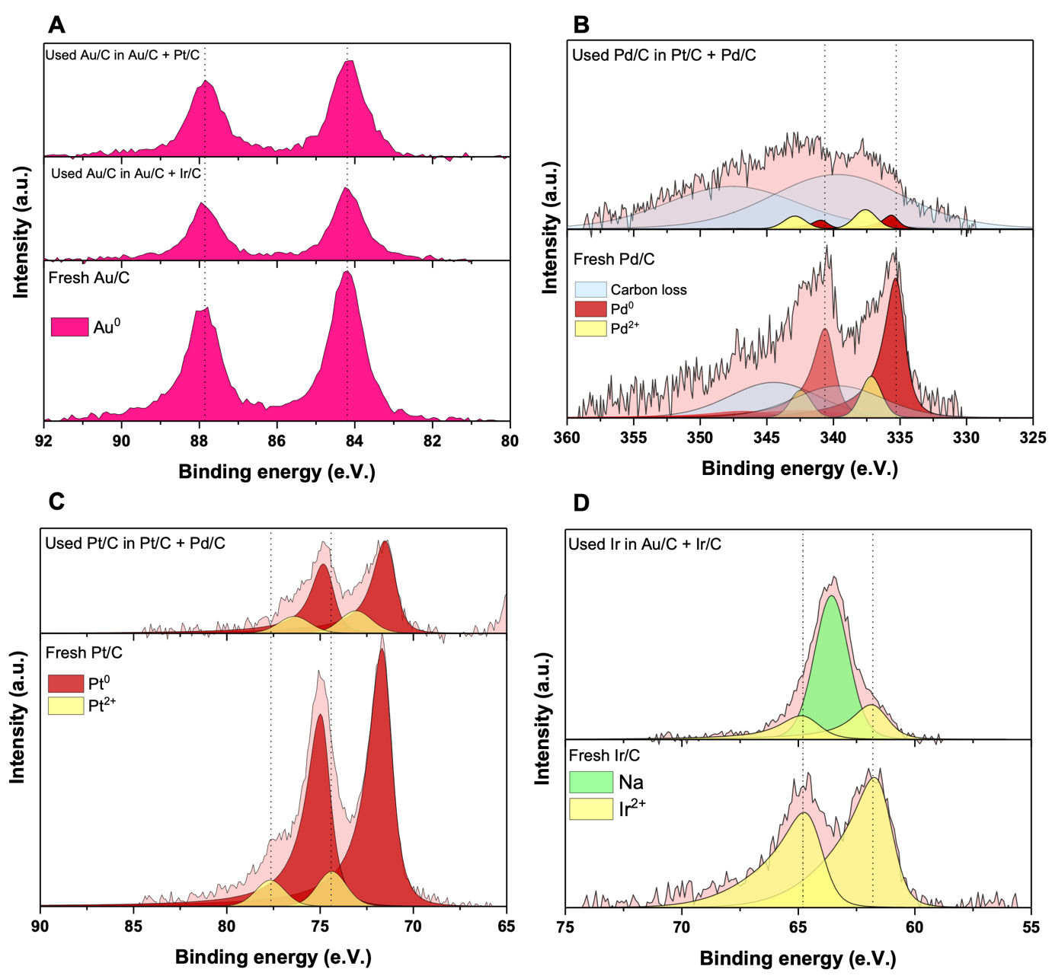
Supplementary Fig. 1. XPS spectra from fresh and used samples of catalysts. (A) Au 4f region from fresh monometallic Au/C, used Au/C + Ir/C physical mixture and used Au/C + Pt/C physical mixture, with the expected binding energy for the metallic Au highlighted by the dashed lines. (B) Pd 3d region for fresh monometallic Pd/C and used Pd/C + Pt/C physical mixture, with metallic Pd highlighted by the dashed lines. (C) Pt 4f region for fresh monometallic Pt/C and used Pt/C + Pd/C physical mixture, with Pt²⁺ peaks highlighted by the dashed lines. (D) Ir 4f region for fresh monometallic Ir/C and used Ir/C + Au/C physical mixture, with Ir²⁺ peaks highlighted by the dashed lines.

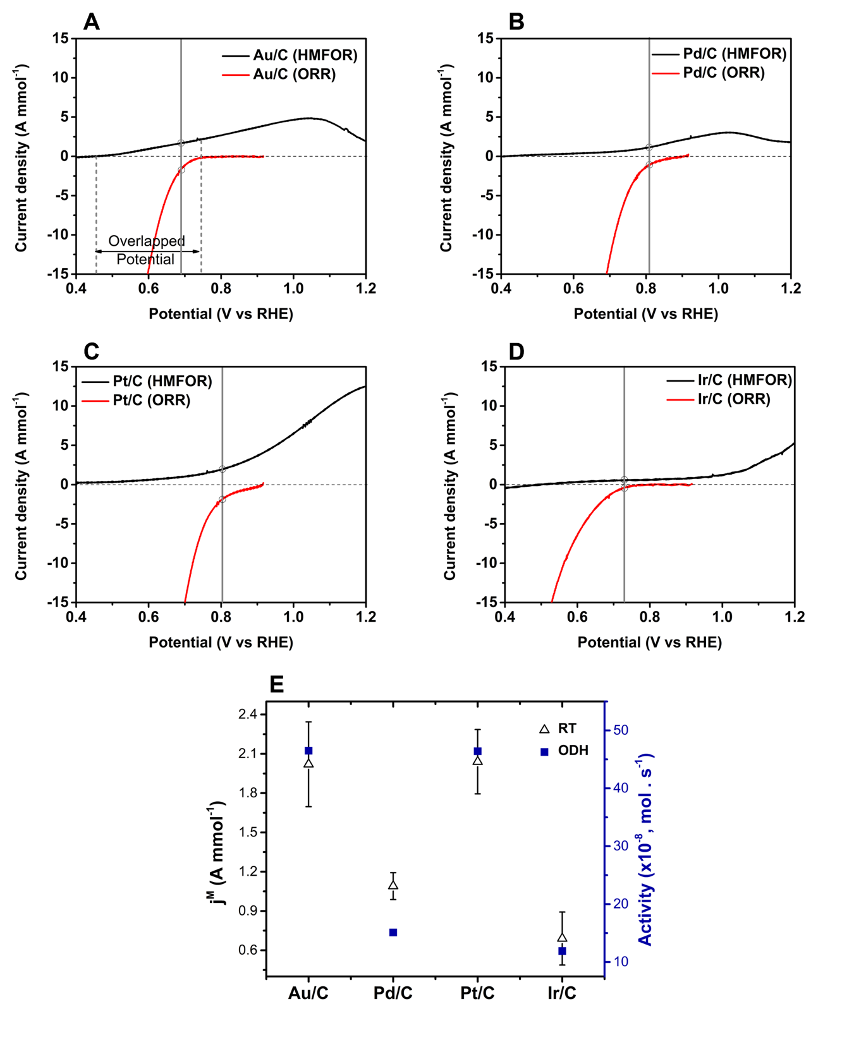
Supplementary Fig. 2. Linear sweep voltammetry curves of (A) Au/C, (B) Pd/C, (C) Pt/C, and (D) Ir/C for HMFOR (black line) and ORR (red line). Reaction conditions (HMFOR): 0.4 M NaHCO₃, 0.1 M HMF, 50 mL min⁻¹ of N₂. Reaction conditions (ORR): 0.4 M NaHCO₃, 50 mL min⁻¹ of O₂. All LSV curves were measured at room temperature with a scan rate of 10 mV s⁻¹. (E) Comparison between the j^{M} and ODH activity at room temperature.

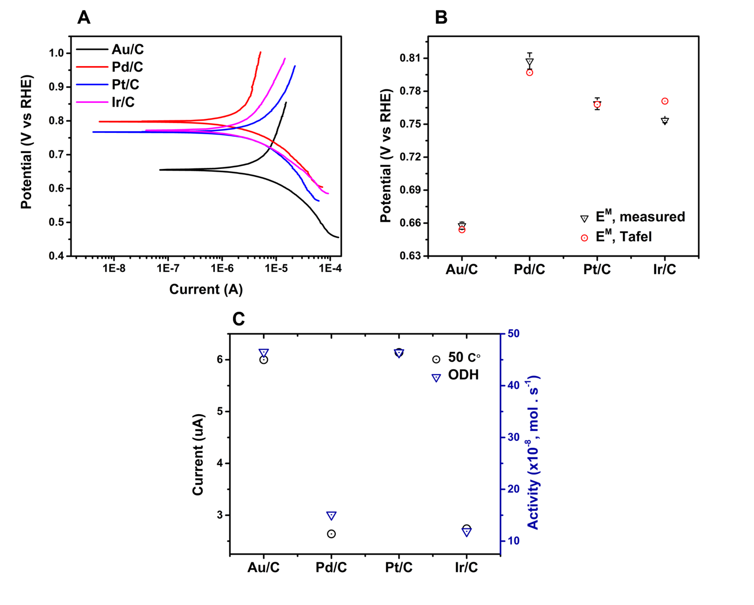
Supplementary Fig. 3. Tafel plots of (A) the various monometallic catalysts, (B) corresponding comparison of measured E^{M} and E^{M} values obtained from the Tafel plot, and (C) comparison of current and ODH activity. Reaction conditions: NaHCO₃ (0.4 M), HMF (0.1 M), O₂ (50 mL min⁻¹), 50 ℃.

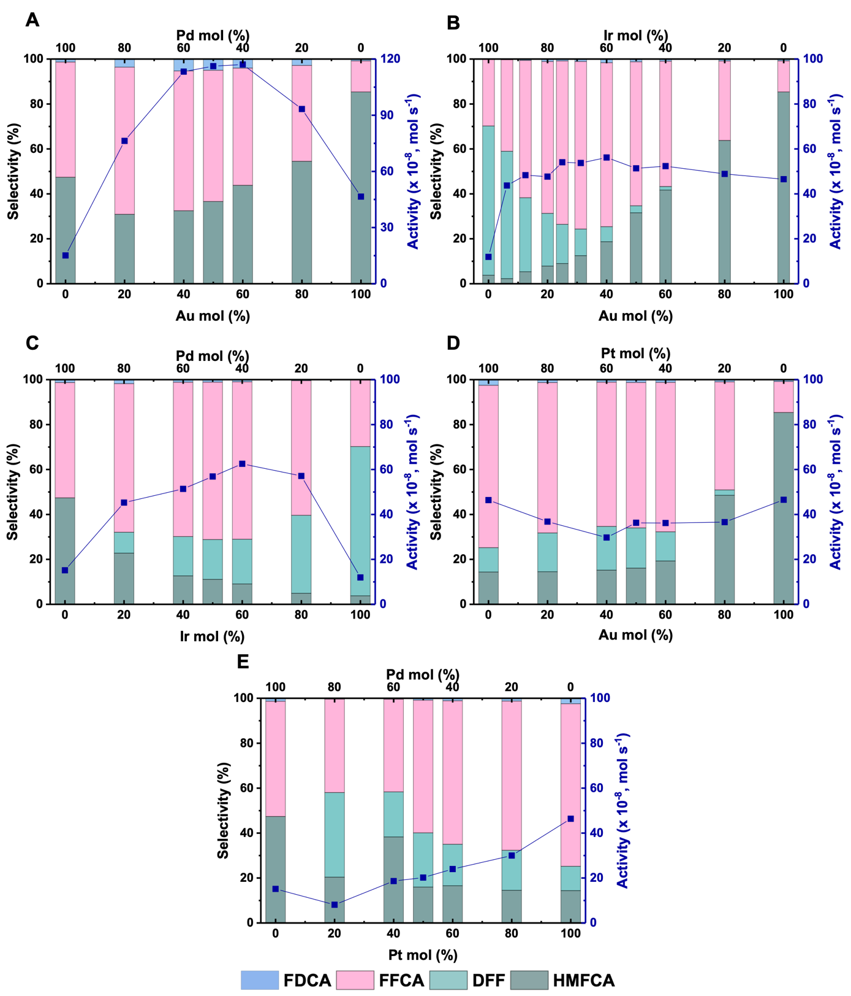
Supplementary Fig. 4. Activity and selectivity of the five physically mixed binary catalytic systems. (A) Au/C + Pd/C, reproduced with permission (5) (B) Au/C + Ir/C, (C) Pd/C + Ir/C, (D) Au/C + Pt/C, and (E) Pt/C + Pd/C. Reaction conditions: H₂O (16 mL), HMF (0.1 M), NaHCO₃ (0.4 M), 3 bar O₂, 80 ˚C, 30 minutes. The total metal content is constant in these bimetallic systems (HMF : metal = 200 : 1 (mol : mol)). The sum of the monometallic activities are taken from the monometallic activities of each respective metal, for the specific molar quantity. All catalysts have approximately 1 wt.% total metal loading.

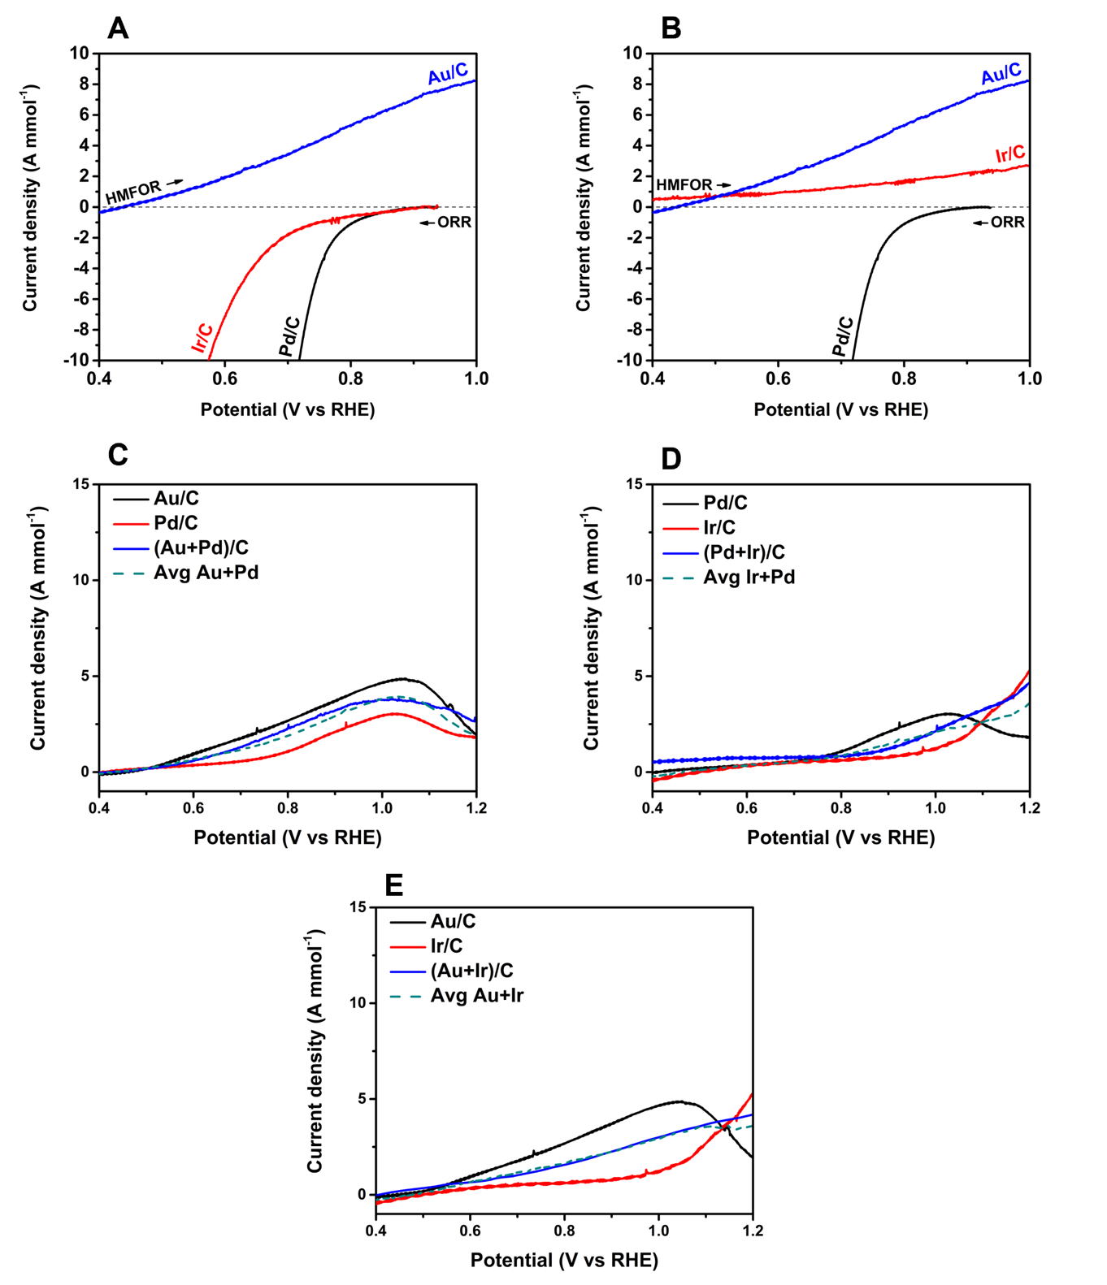
Supplementary Fig. 5. Linear sweep voltammetry curves at 50 ℃ of (A) Au/C (HMFOR), Pd/C (ORR), and Ir/C (ORR), and (B) Au/C (HMFOR), Ir/C (HMFOR), and Pd/C (ORR). (A) explains why ORR of Ir/C is limiting compared to that of Pd/C and (B) explains why HMF OR of Ir/C is limiting compared to that of Au/C. HMFOR LSVs at room temperature (RT) for (C) Au/C, Pd/C, Au/C + Pd/C; (D) Pd/C, Ir/C, Ir/C + Pd/C; (E) Au/C, Ir/C and Au/C + Ir/C. The average value of the respective monometallic catalysts is also given (dashed lines). Reaction conditions (HMFOR): 0.4 M NaHCO₃, 0.1 M HMF, 50 mL min⁻¹ of N₂. Reaction conditions (ORR): 0.4 M NaHCO₃, 50 mL min⁻¹ of O₂.

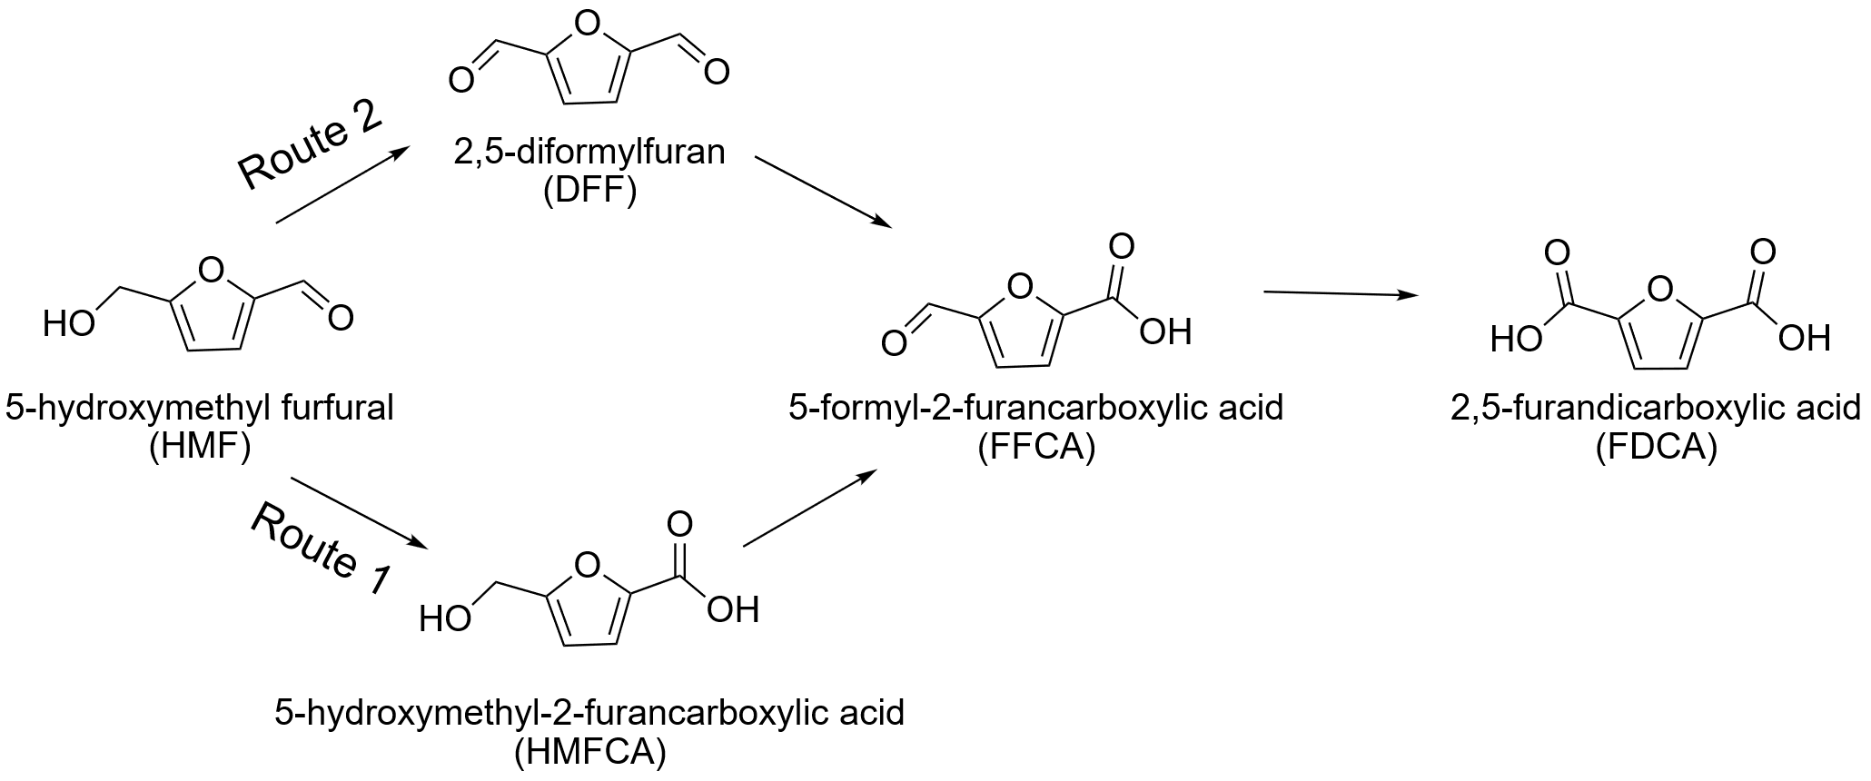
Supplementary Scheme 1. The ODH of HMF can proceed via two pathways, with either the aldehyde (Route 1) or alcohol (Route 2) moiety transformed first to produce 2,5-diformylfuran (DFF) or 5-hydroxymethyl-2-furancarboxylic acid (HMFCA), respectively.

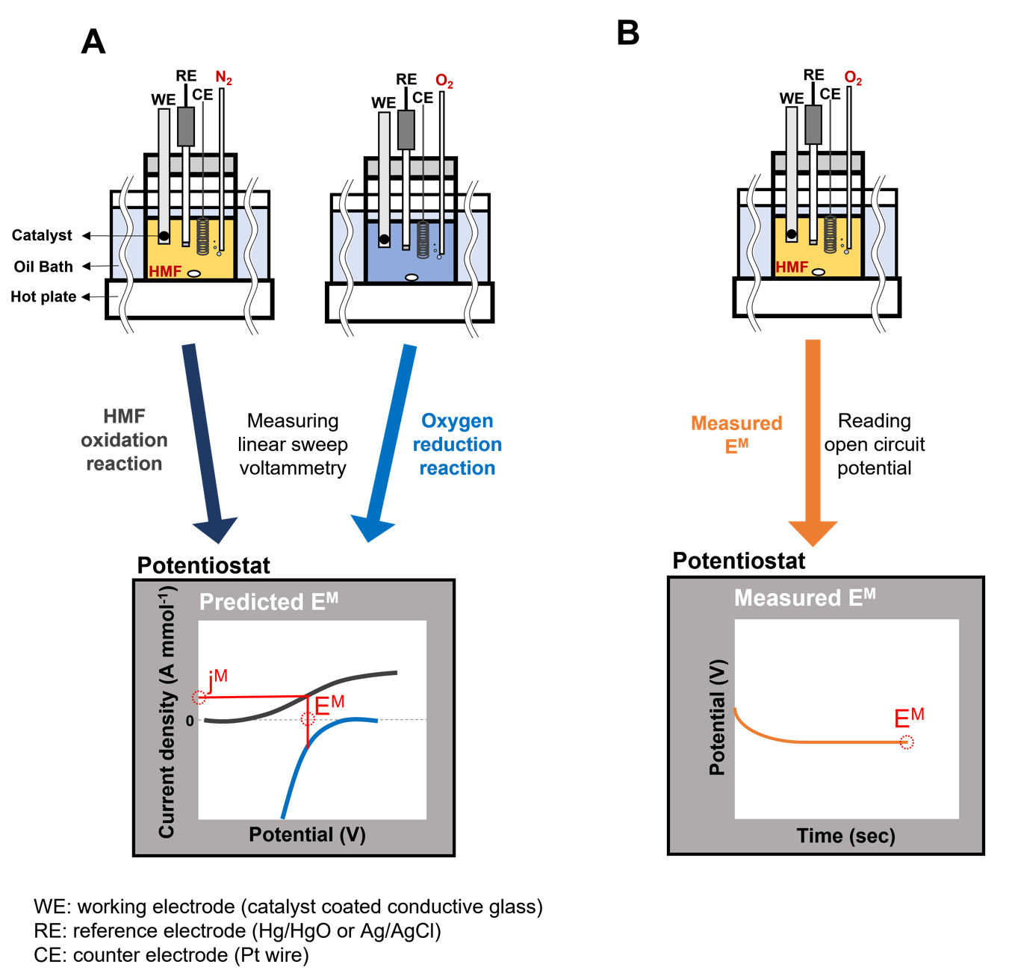
Supplementary Scheme 2: Experimental configurations utilized in electrochemical measurements.

Catalyst | Au/C | Pd/C | Ir/C | Pt/C
Weight percent of metal by ICP-MS | 1.01 | 1.04 | 0.94 | 1.01

Supplementary Table 1. ICP-MS analysis of each of the four monometallic catalysts used in this study. Target weight of 1 wt.%.

Catalytic System | ORR Onset Potential (V) | HMFOR Onset Potential (V) | Mixed Potential, E^{M} (V), measured* | Mixed Potential, E^{M} (V), predicted** | Mixed Current Density, j^{M}  (A mmol⁻¹),  predicted**
Au/C | 0.72 | 0.47 | 0.658 ± 0.003 | 0.670 ± 0.013 | 3.1 ± 0.39
Pd/C | 0.84 | 0.68 | 0.808 ± 0.007 | 0.800 ± 0.009 | 1.23 ± 0.28
Pt/C | 0.86 | 0.56 | 0.769 ± 0.005 | 0.770 ± 0.014 | 3.1 ± 0.16
Ir/C | 0.82 | 0.46 | 0.753 ± 0.002 | 0.730 ± 0.002 | 1.27 ± 0.09
*¹ The measured E^{M} was obtained with 0.1 M HMF, and 0.4 M NaHCO₃ solution under O₂.
**² The predicted E^{M} and j^{M} values are taken from Fig. 2 for each monometallic catalytic system.

Supplementary Table 2. The ORR and HMFOR onset potential, and the predicted E^{M} and j^{M} values for each monometallic catalyst from Fig. 2. Reaction conditions can be found in caption for Fig. 2. Measured E^{M} values are included for comparison.

Catalytic PM System (x & y) | Molar Ratio (x : y) | Activity Enhancement (x 10⁻⁸, mol s⁻¹)
Au/C + Pd/C | 1 : 1 | 90.9
Ir/C + Pd/C | 3 : 2 | 51.8
Au/C + Ir/C | 2 : 3 | 36.5

Supplementary Table 3. Maximum activity enhancement at the associated molar ratio observed for the three bimetallic catalytic systems that show evidence of a CORE effect. Full reaction data be found in Supplementary Fig. 6. Reaction conditions: H₂O (16 mL), HMF (0.1 M), NaHCO₃ (0.4 M), 3 bar O₂, 80 ˚C, 30 minutes.

