Supplementary Information for

Melt-quenched Carboxylate Metal-Organic Framework Glasses
Min Hyuk Kim†, Hwa-Sub Lee‡, Dong-Hyun Seo§, Eun-chae Jeon*‡, and Hoi Ri Moon*⊥
†Department of Chemistry, Ulsan National Institute of Science and Technology (UNIST), Ulsan 44919, Republic of Korea.
‡School of Materials Science and Engineering, University of Ulsan, 93 Daehak-ro, Nam-gu, Ulsan 44610, Republic of Korea
§Major of Nano-Mechatronics, University of Science and Technology, 217, Gajeong-ro, Yuseong-gu, Daejeon 34113, Republic of Korea
Department of Chemistry and Nano Science, Ewha Womans University, Seoul 03760, Republic of Korea

*E-mail: hoirimoon@unist.ac.kr

Supplementary Notes 1. Synthesis of C-M-adp
C-Mg-adp was synthesized as previously reported with some modifications.^{[1]} Adipic acid ((HOOC)(CH₂)₄(COOH)) (0.053 g, 0.36 mmol) was dissolved in 4 mL of DMA and mixed with a solution of Mg(NO₃)₂·6H₂O (0.084 g, 0.33 mmol) in 2 mL of MeOH. The mixed solution was sonicated for 10 min and then heated in a Teflon-lined vessel in an autoclave at 120 °C for 24 h before being cooled to room temperature. Colorless block-shaped crystals formed, which were filtered and briefly washed with the DMA than MeOH. The yield was 48 mg (41%). As-synthesized MOF was then dried overnight in a vacuum oven at 60 °C, resulting in crystals with less solvent but the identical structure, C-Mg-adp.
For the synthesis of C-Mn-adp, adipic acid (0.054 g, 0.37 mmol) was dissolved in 4 mL of DMA, and mixed with a solution of Mn(NO₃)₂·4H₂O (0.072g, 0.29 mmol) in 1 mL of MeOH. The mixed solution was sonicated for 10 min and then heated in an aluminum seal-capped glass jar at 110 °C for 24 h before being cooled to room temperature, resulting in the formation of pale pink crystals.
Similarly, for C-Co-adp, adipic acid (0.050 g, 0.34 mmol) was dissolved in 4 mL of N,N-dimethylformamide (DMF), and mixed with a solution of CoCl₂·6H₂O (0.081g, 0.34 mmol) in 2 mL of EtOH. The mixed solution was sonicated for 10 min and then heated in an aluminum seal-capped glass jar at 100 °C for 24 h before being cooled to room temperature. This resulted in the formation of pink crystals and a purple polycrystalline solid formed.
For C-Tb-adp, adipic acid (0.058 g, 0.40 mmol) and Tb(NO₃)₃·5H₂O (0.018g, 0.41 mmol) were dissolved in 5 mL of DMF. The solution was sonicated for 10 min and then heated in a Teflon-lined vessel in an autoclave at 100 °C for 24 h before being cooled to room temperature. Colorless crystals formed.
All C-M-adp compounds were filtered and briefly washed with their respective mother liquors, and then vacuum dried overnight at 60 °C.

Supplementary Notes 2. Thermal analyses of MOFs
All thermal analyses (TGA, DSC) were performed under inert gas conditions, preventing oxidation during the heating process. The samples were prepared as a dried powder form, but some pore solvents remained in samples.
The TGA was performed at a scan rate of 1 °C min⁻¹, 5 °C min⁻¹ and 10 °C min⁻¹ for determine the T_{d}, using a TGA Q50 from TA Instruments (Fig. S1, 2 and S16).
The DSC were performed using a DSC Q200 from TA Instrument, for evaluated the T_{m} and T_{g} of C-Mg-adp and C-Mn-adp, also, DSC 4000 from PerkinElmer, for calculated the dynamic fragility (m) of G-Mg-adp with various heating rate (3-40 °C min⁻¹) and measured the thermal behavior of C-M-adp MOFs (10 °C min⁻¹). The T_{m} and T_{g} of C-Mg-adp and C-Mn-adp referred to the onset temperature of the melting peak and the glass transition peak (Fig. 1b, S3 and S17).
Supplementary Notes 3. Characterization of MOFs and MOF glasses
XRPD data were collected on a Bruder D2 phaser diffractometer at 30 kV and 10 mA for Cu Kα (λ = 1.54050 Å), with a step size of 0.02° in 2θ. In-situ variable temperature XRPD (VT-XRPD) were measured on a RIGAKU Smart Lab diffractometer for Cu Kα under N₂ atmosphere (Fig. 1c, S4 and S15).
Solution ¹H Fourier-transform (FT) NMR experiments were carried out on a 400 MHz Bruker spectrometer, at the UNIST Central Research Facilities (UCRF) in Ulsan National Institute of Science and Technology (UNIST). All samples were prepared after digestion using deuterium chloride solution (35%, in D₂O) and then dissolved in DMSO-d₆ solvent. Also, Infrared spectra were recorded with a ThermoFisher Scientific iS10 FT-IR spectrometer (Fig. S7 and S18).
SEM images were obtained on a SU-7000 FE-SEM from Hitachi, at the UNIST UCRF. To decrease charging effects, the samples were sputtered with platinum prior to the measurement (Fig. 1e, S5-6 and S19-20).
Total scattering data have been collected on a PANalytical B.V Empyrean X-ray diffractometer at 60 kV and 36 mA (3.6 kW) for Ag Kα (λ = 0.559407 Å, Q max ~ 22 Å⁻¹), with a step size of 0.06° in 2θ (scan range: 2-148 °) using GaliPIX3D detector. From these data, pair distribution functions (PDF) in the form G(r) have been calculated by PANalytical HighScore Plus. The PDF data represented the short-range order and long-range order correlation (up to at r ~ 99 Å) for all samples (Fig. 2 and S8). Published structure for the mother structure of C-Mg-adp was used to create the simulated PDF data in PDFgui. A simulated partial PDF was also created in PDFgui, which represents the correlation between specific atoms in the structure (Fig. S9-11).
The gas adsorption−desorption isotherms were measured at 77 K (H₂, N₂) and 273K (CO₂) using liquid nitrogen and ice bath each, on a BELSORP-MAX. Prior to the adsorption measurement, the samples were evacuated at 110 °C under vacuum (p < 10⁻⁵ mbar) for overnight for C-Mg-adp and G-Mg-adp (Fig. S21).

Supplementary Figures
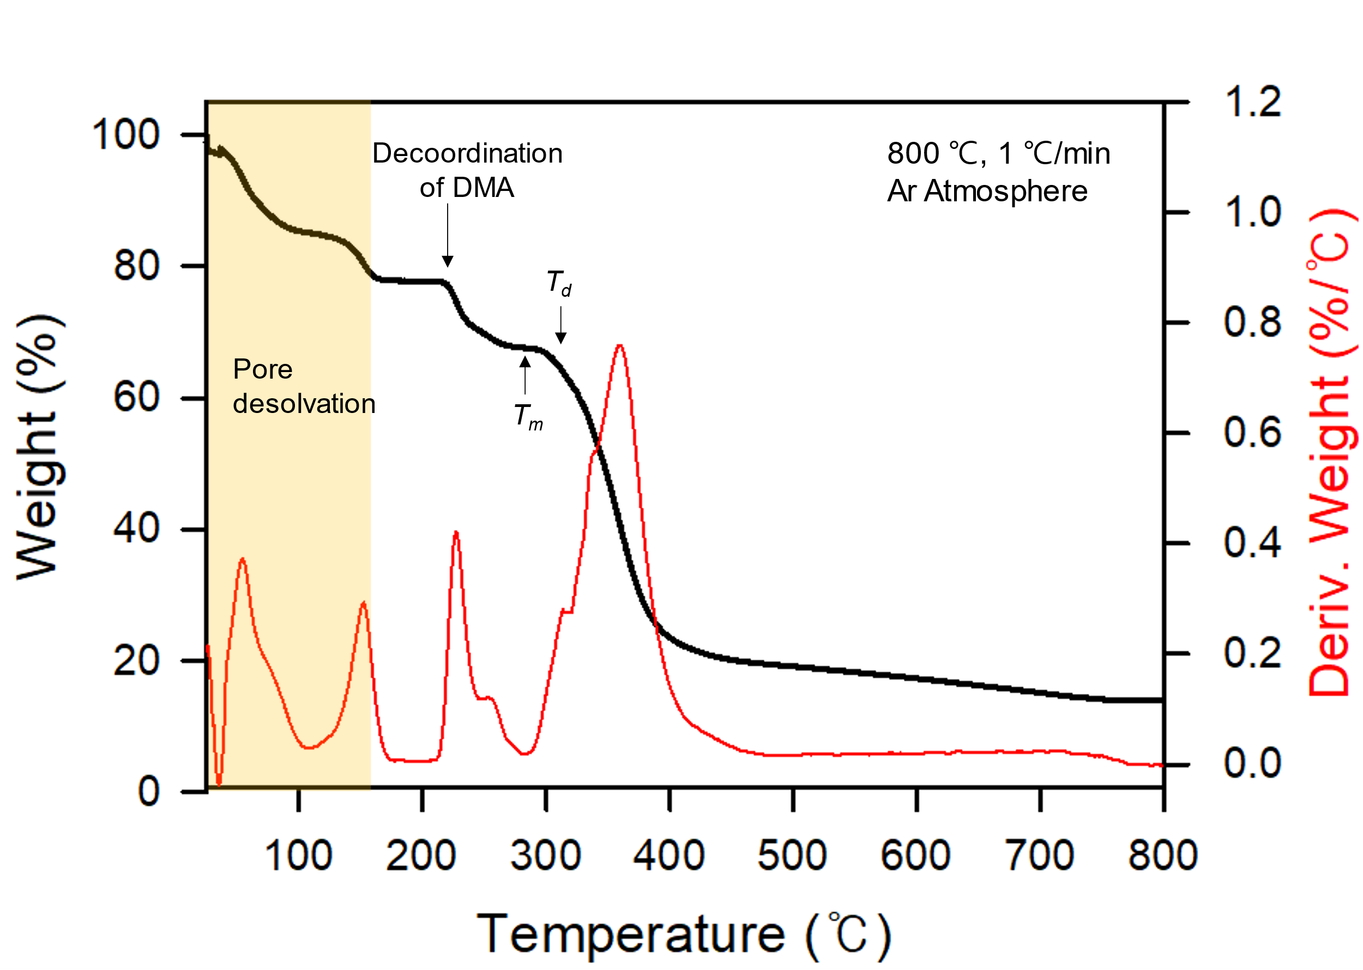
Figure S1. TGA data of C-Mg-adp. T_{d} was evaluated at 330℃, which showed abrupt weight loss on TGA.

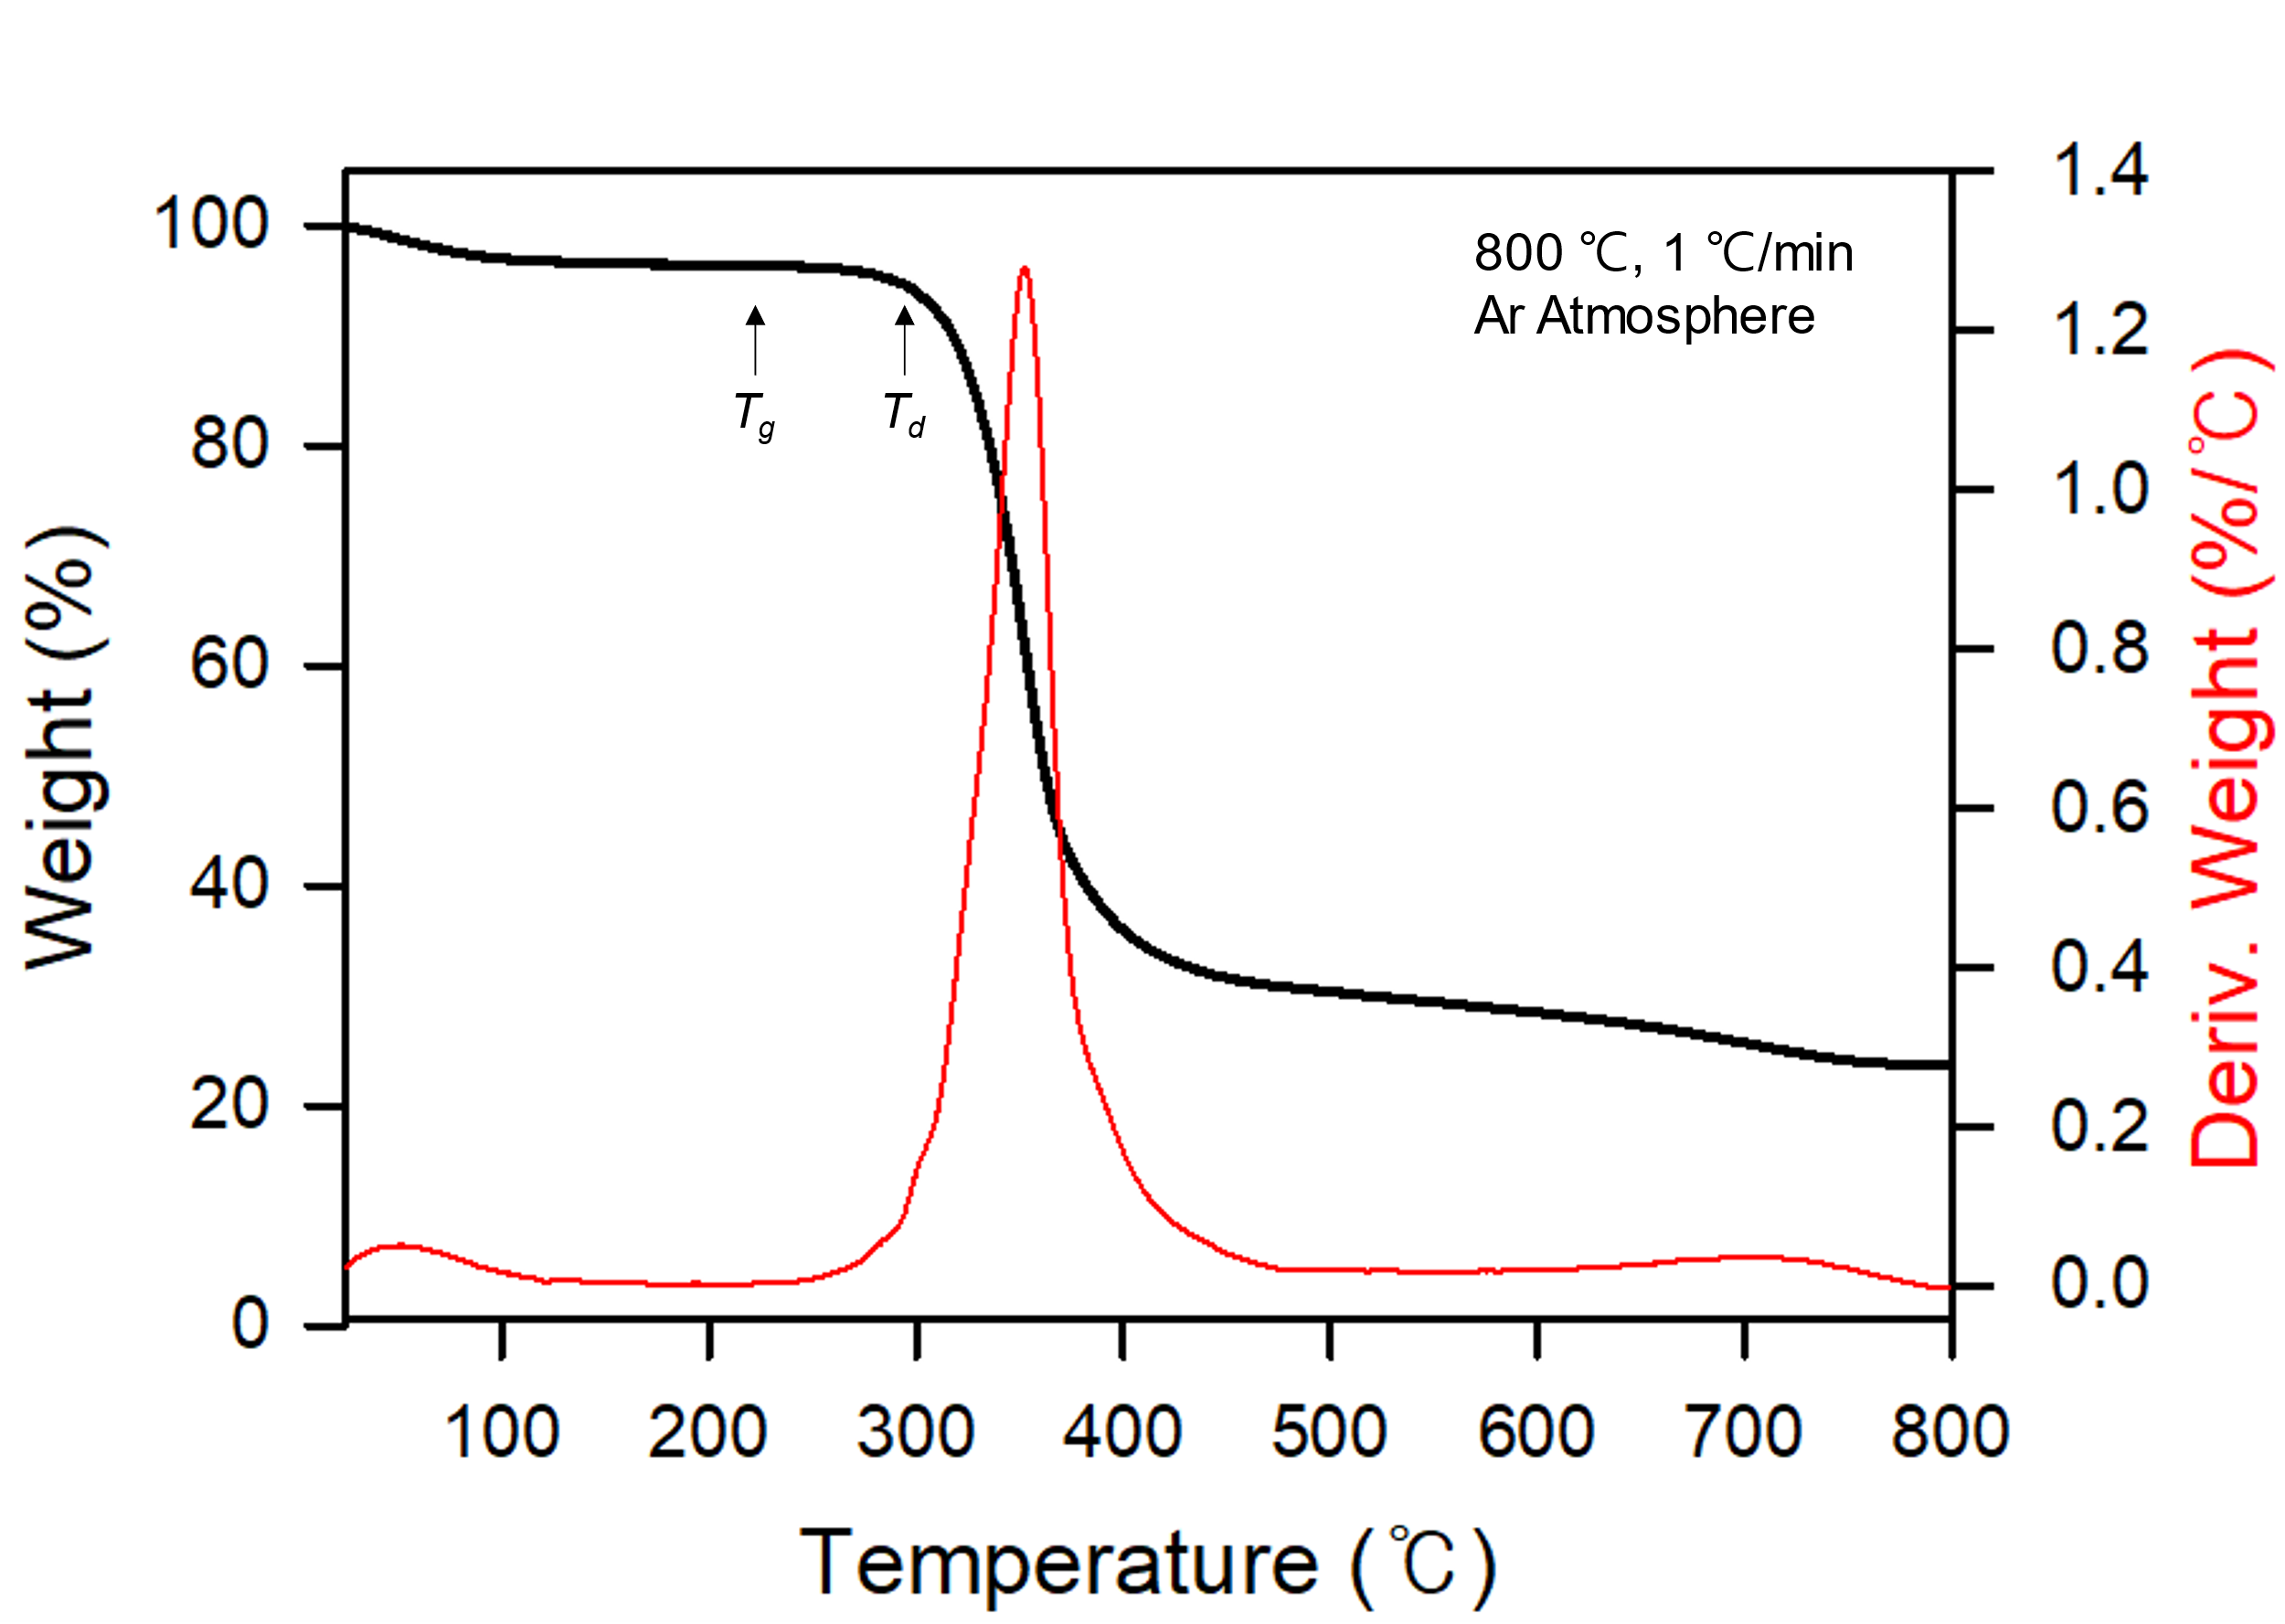
Figure S2. TGA data of G-Mg-adp.
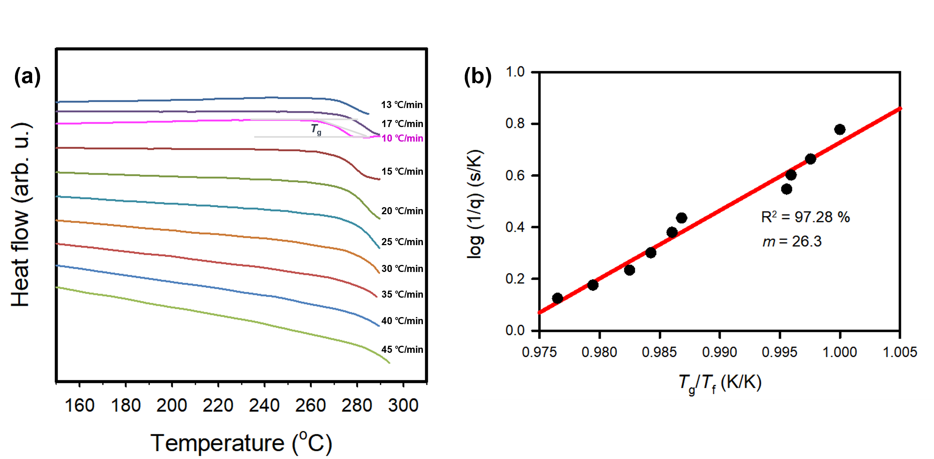
Figure S3. The determination of liquid fragility index (m) from DSC measurements of G-Mg-adp. (a) DSC data using various heating rates. The calorimetric fictive temperature (T_{f}) obtained using heating rate of 10 K/min is defined as T_{g} on log (1/q) vs. T_{g}/ T_{f} plot. (b) Fragilities of G-Mg-adp, determined as the of log(1/q) vs. T_{g}/ T_{f} plot.
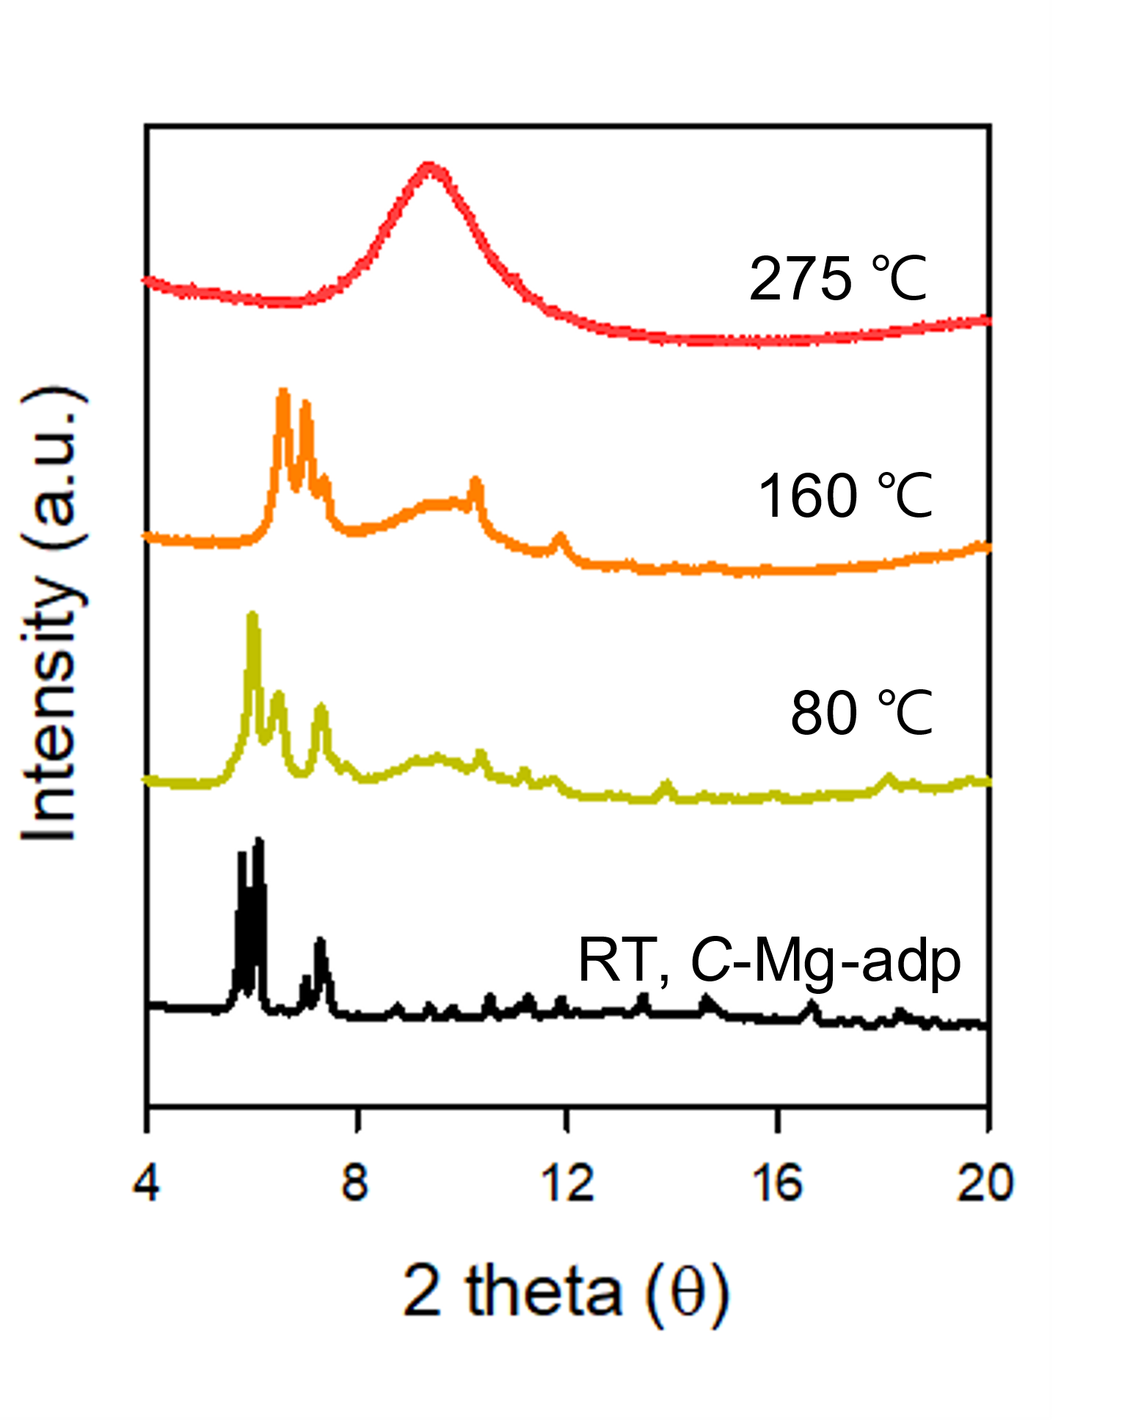
Figure S4. VT-XRPD data of C-Mg-adp.
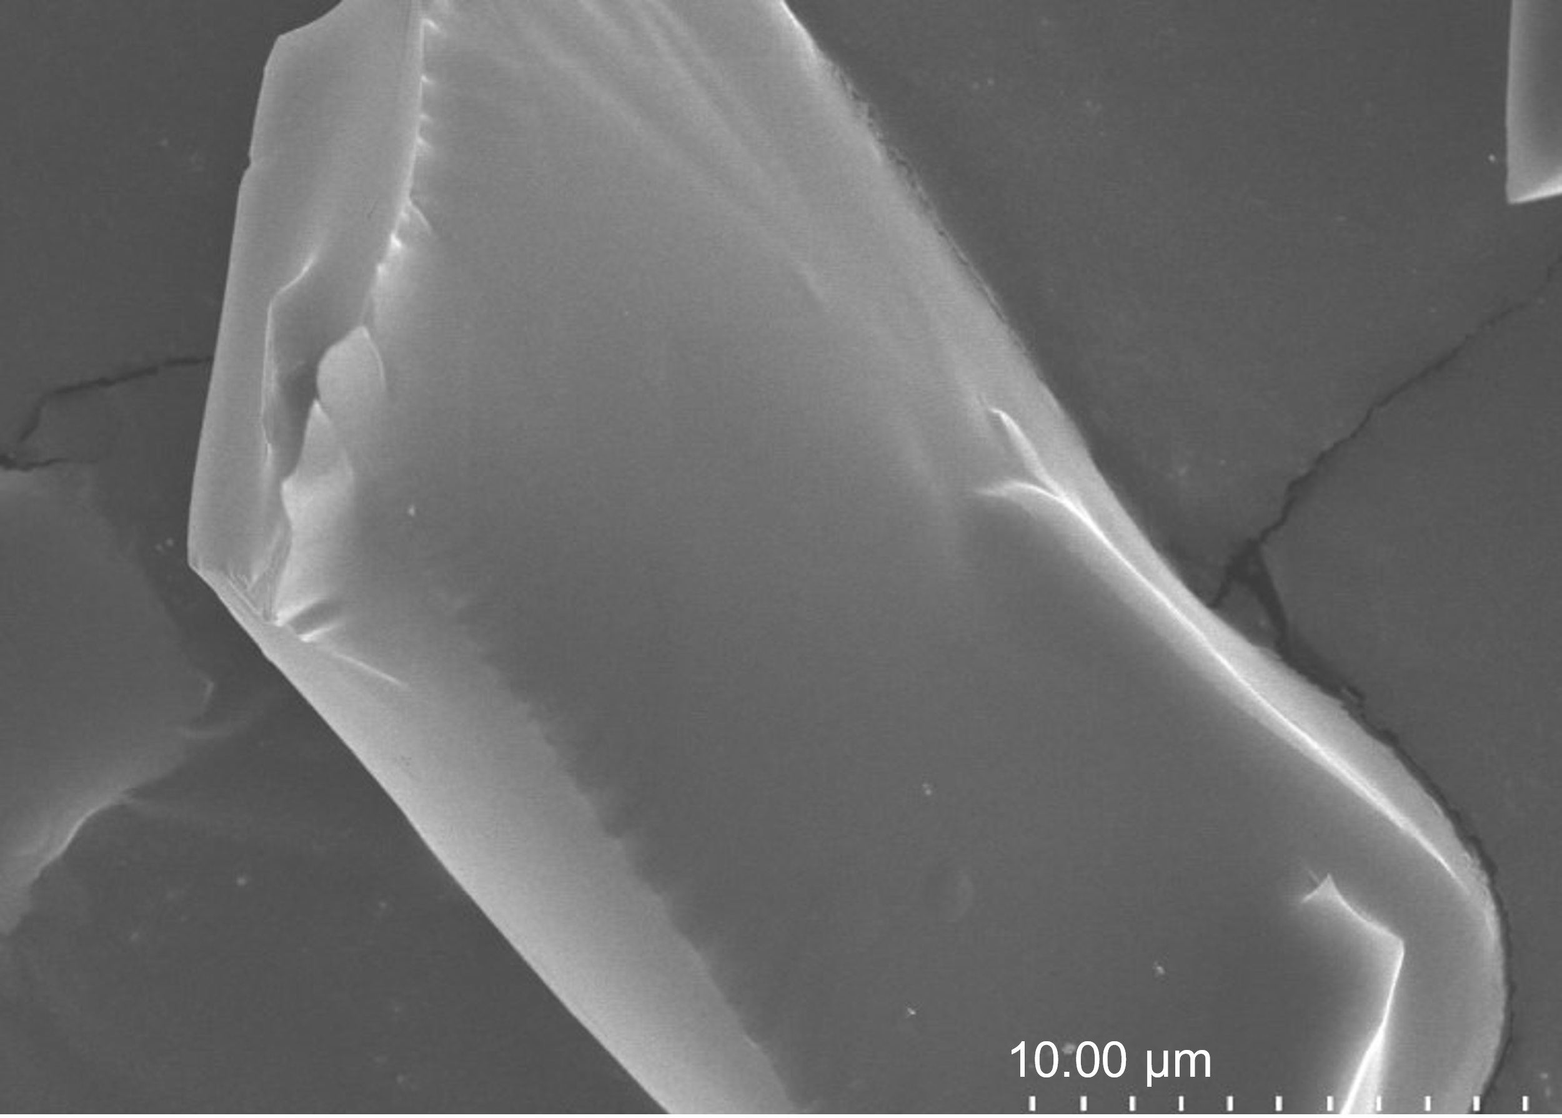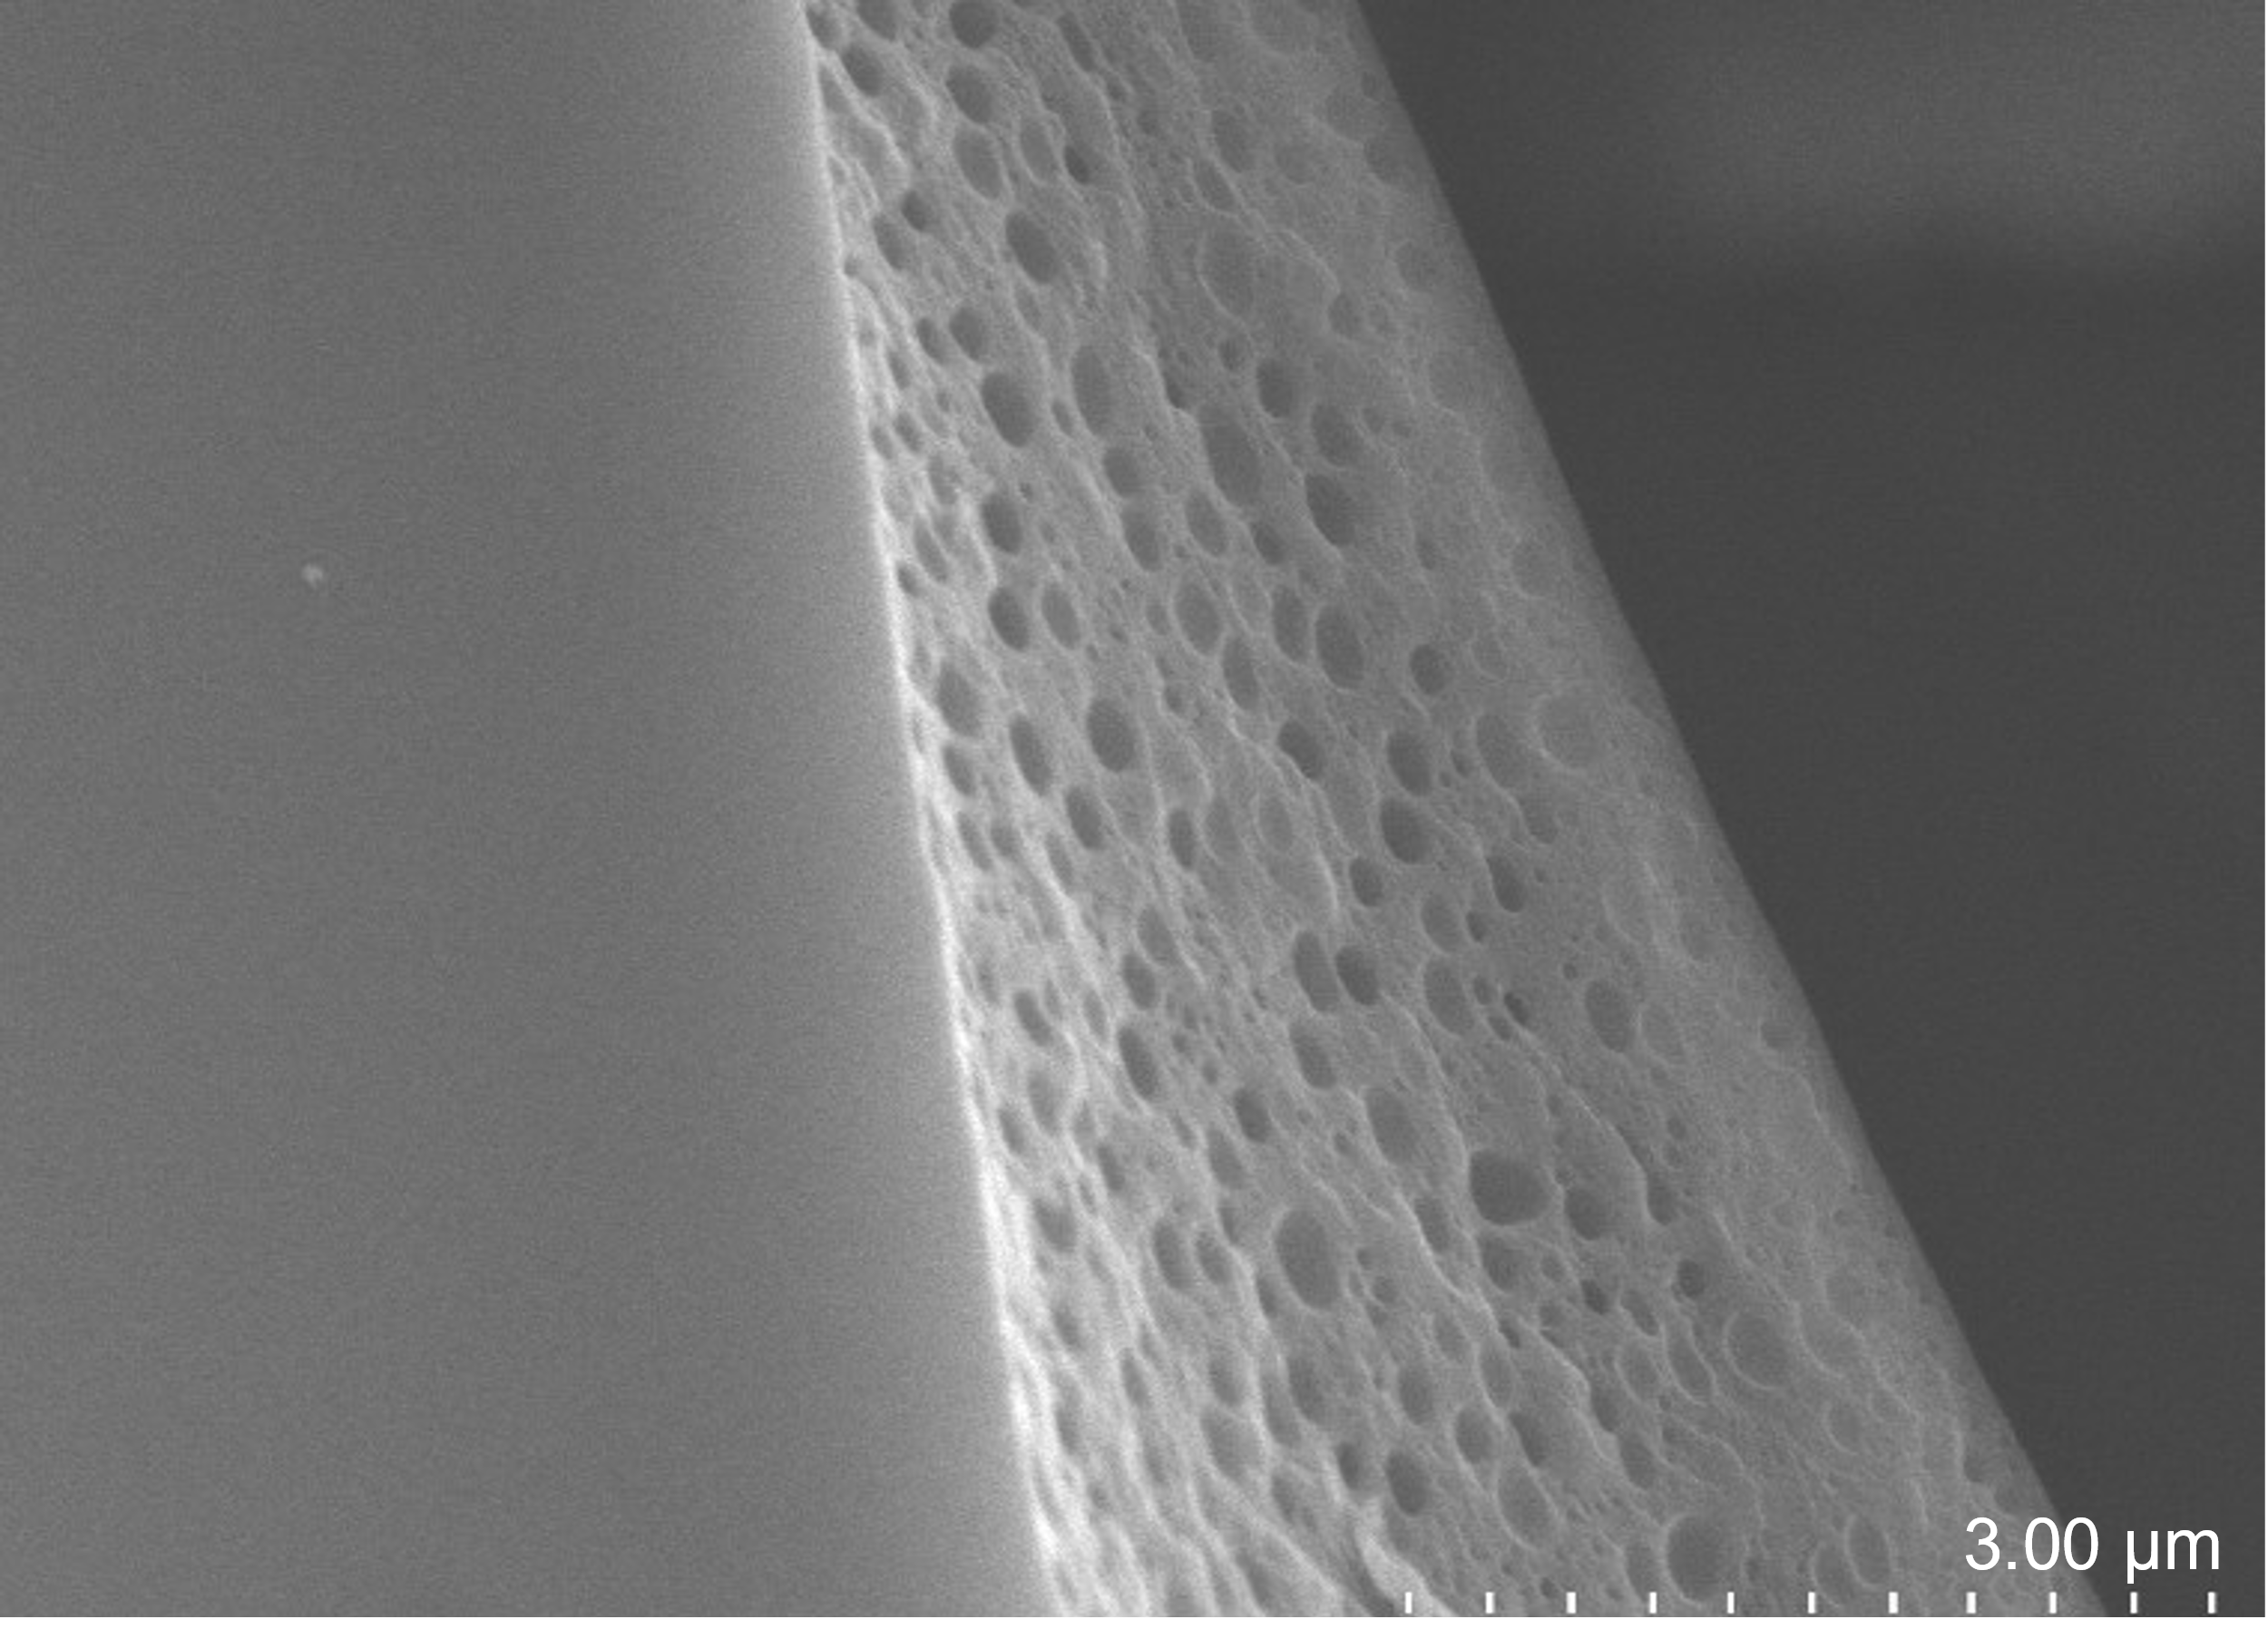
Figure S5. SEM images of G-Mg-adp was heated at T_{m} for 0 minutes (top) and 1 hour (bottom).

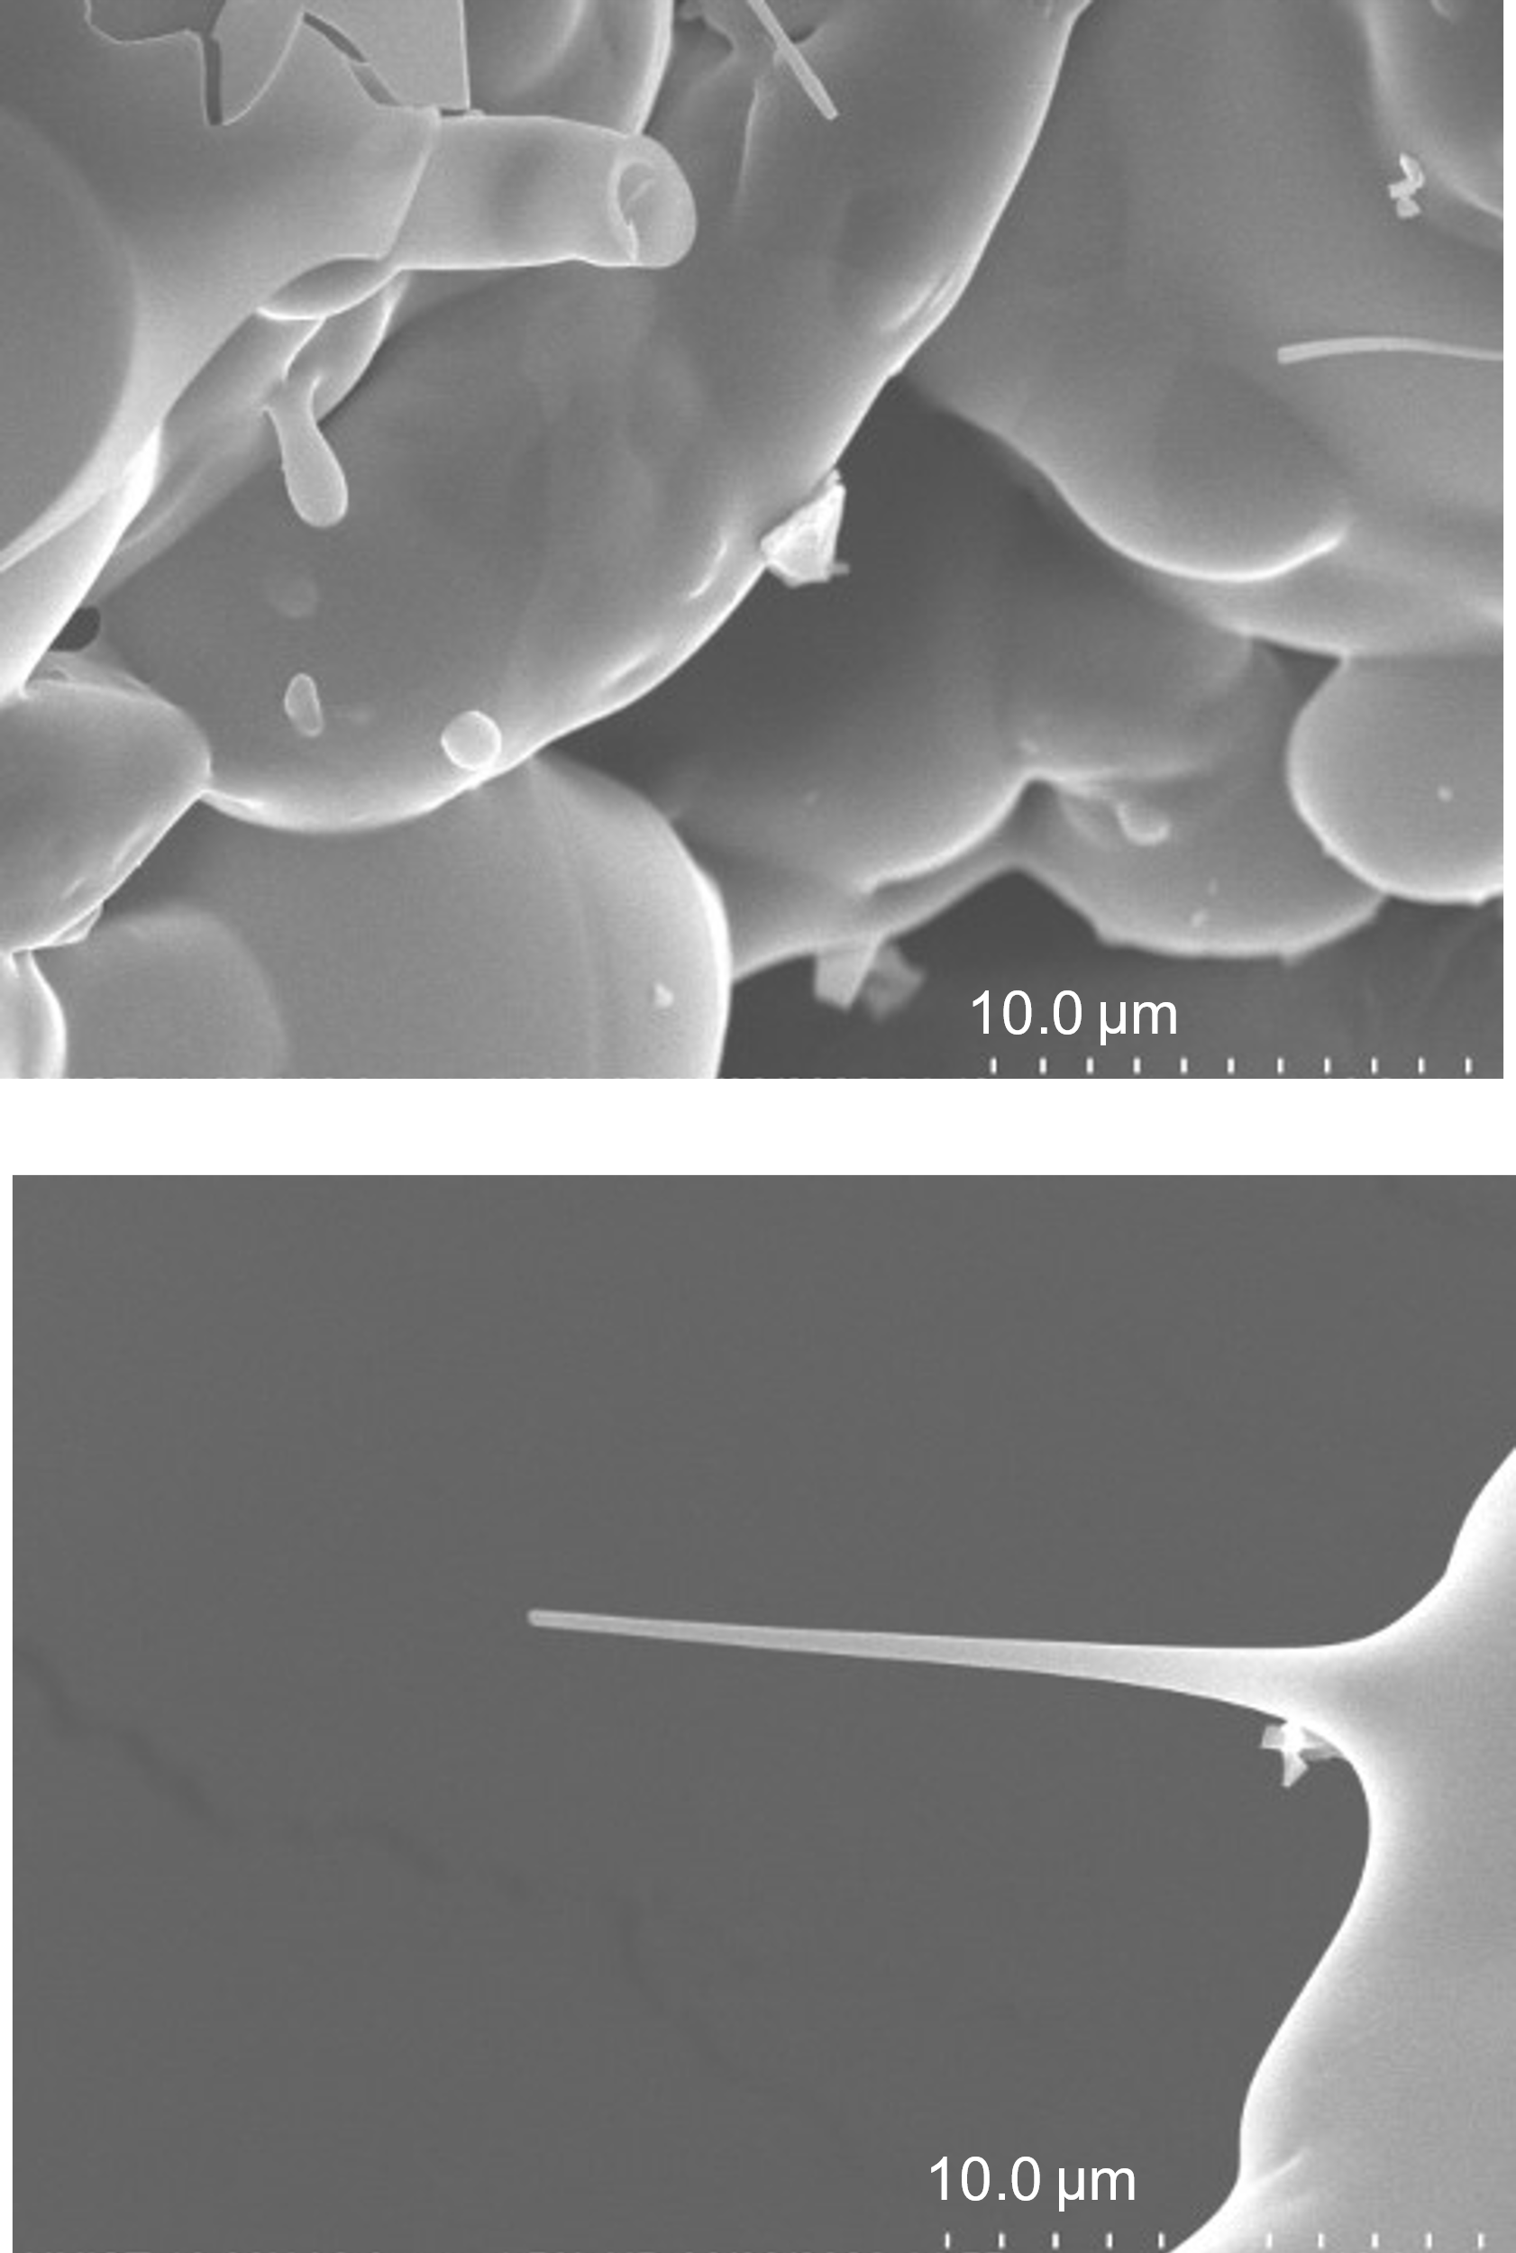
Figure S6. SEM images of G-Mg-adp with rapid quenching via argon blowing. Stalactite-like and puffed shapes are occurred from viscous fluid, suggesting a melted phase of Mg-adp.

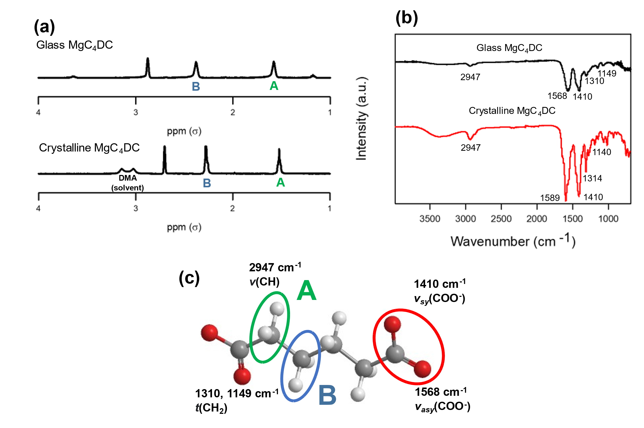

Figure S7. (a) NMR and (b) FT-IR spectrum data of C-Mg-adp (bottom) and G-Mg-adp (top). (c)
Represents the moieties within adipate ligand corresponding to each peak in the NMR and FT-IR data.

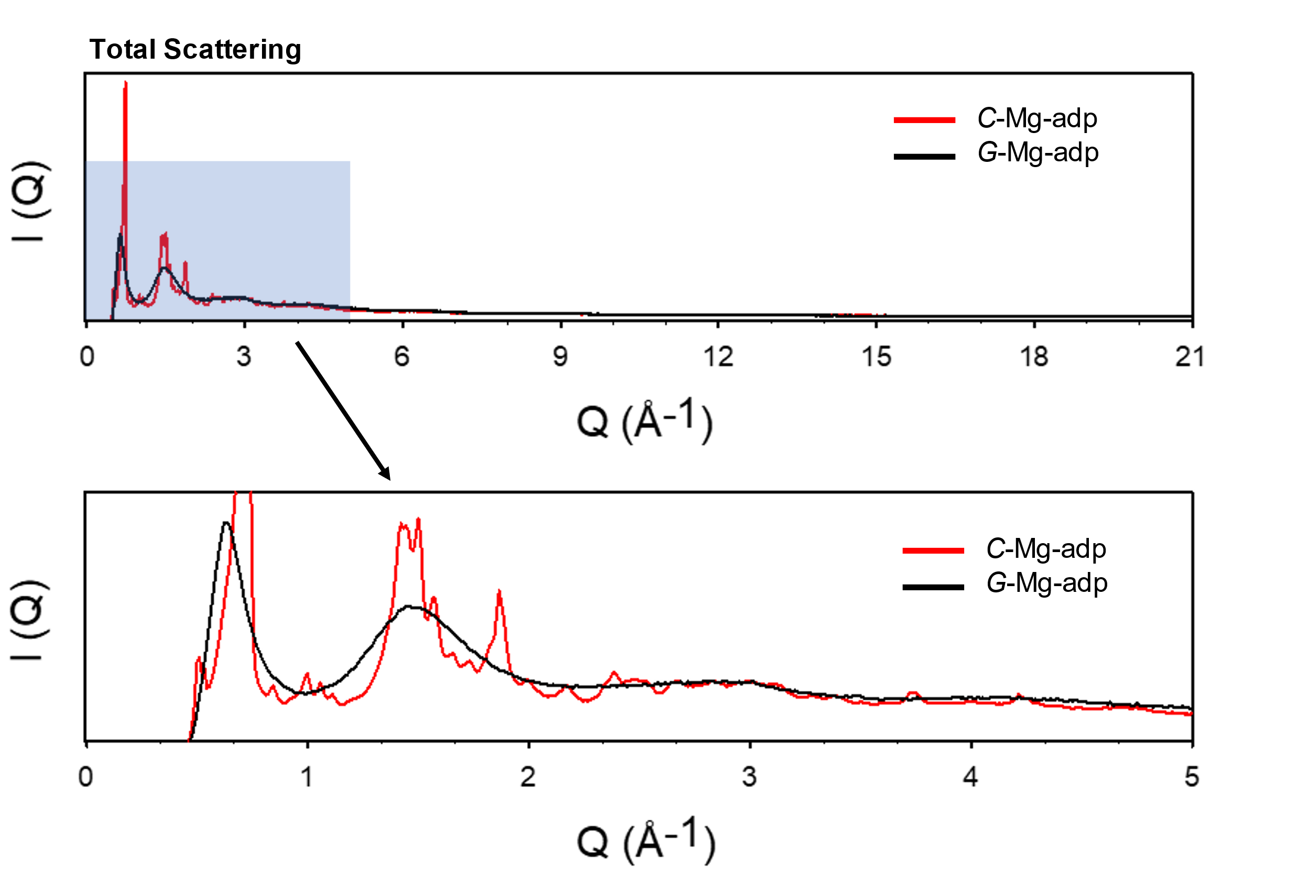
Figure S8. Total scattering data of C-Mg-adp (red) and G-Mg-adp (black). Top: full shot of total scattering. Bottom: magnified total scattering data in low Q area, which corresponded to long-range order.

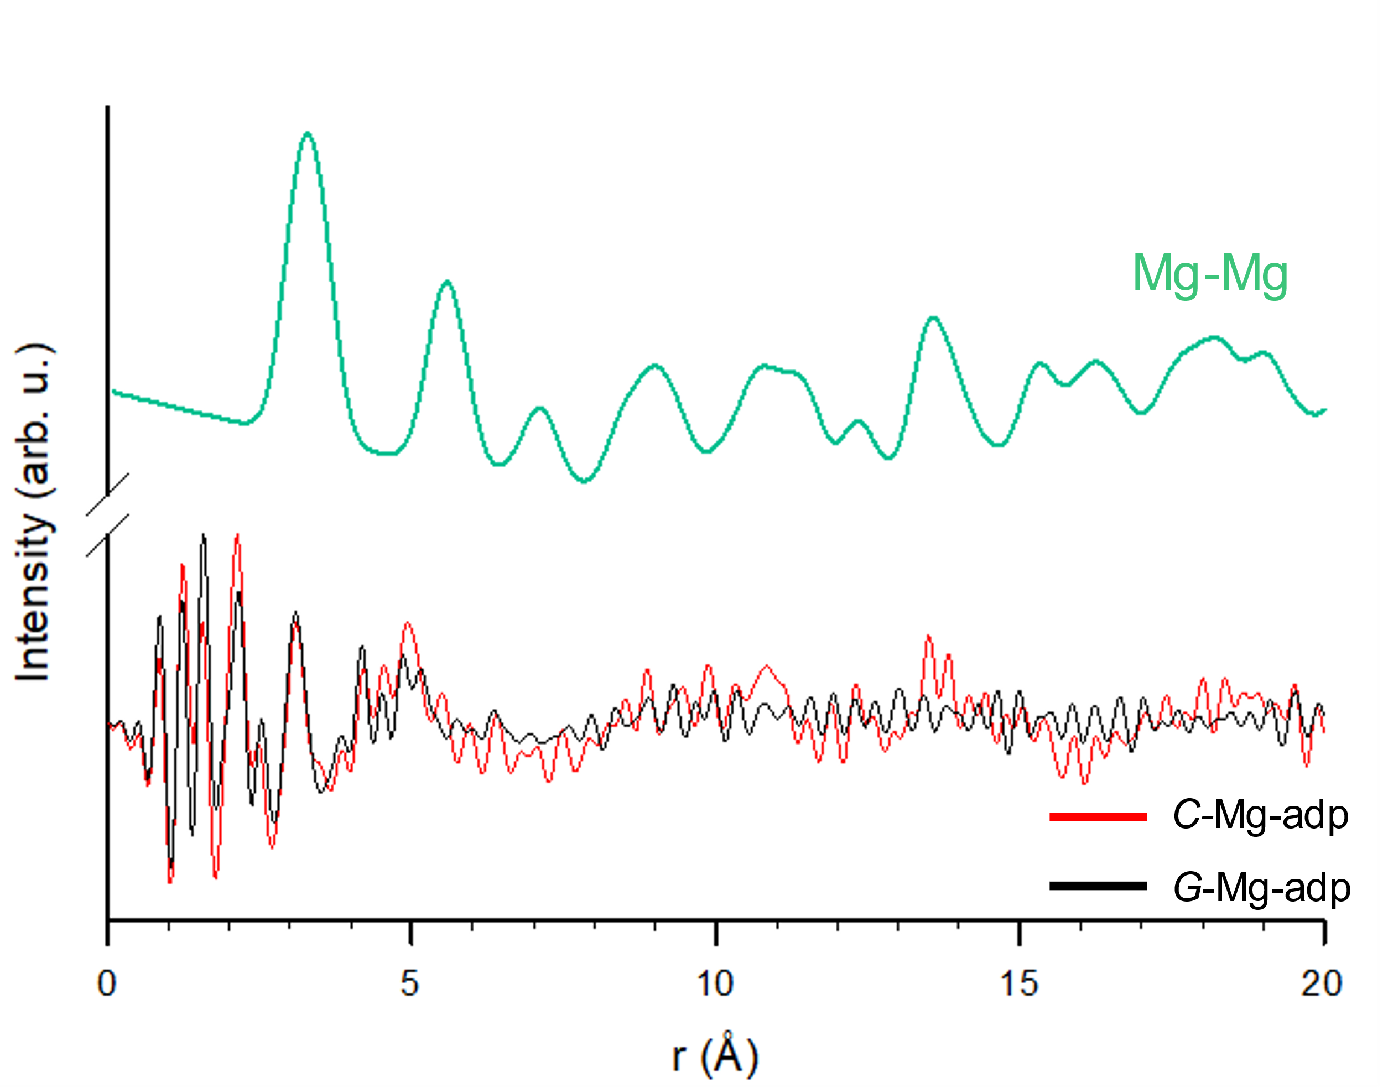
Figure S9. Simulated partial PDF, G(r) of Mg ⋯ Mg on C-Mg-adp and experimental PDF data of C-Mg-adp (red) and G-Mg-adp (black).

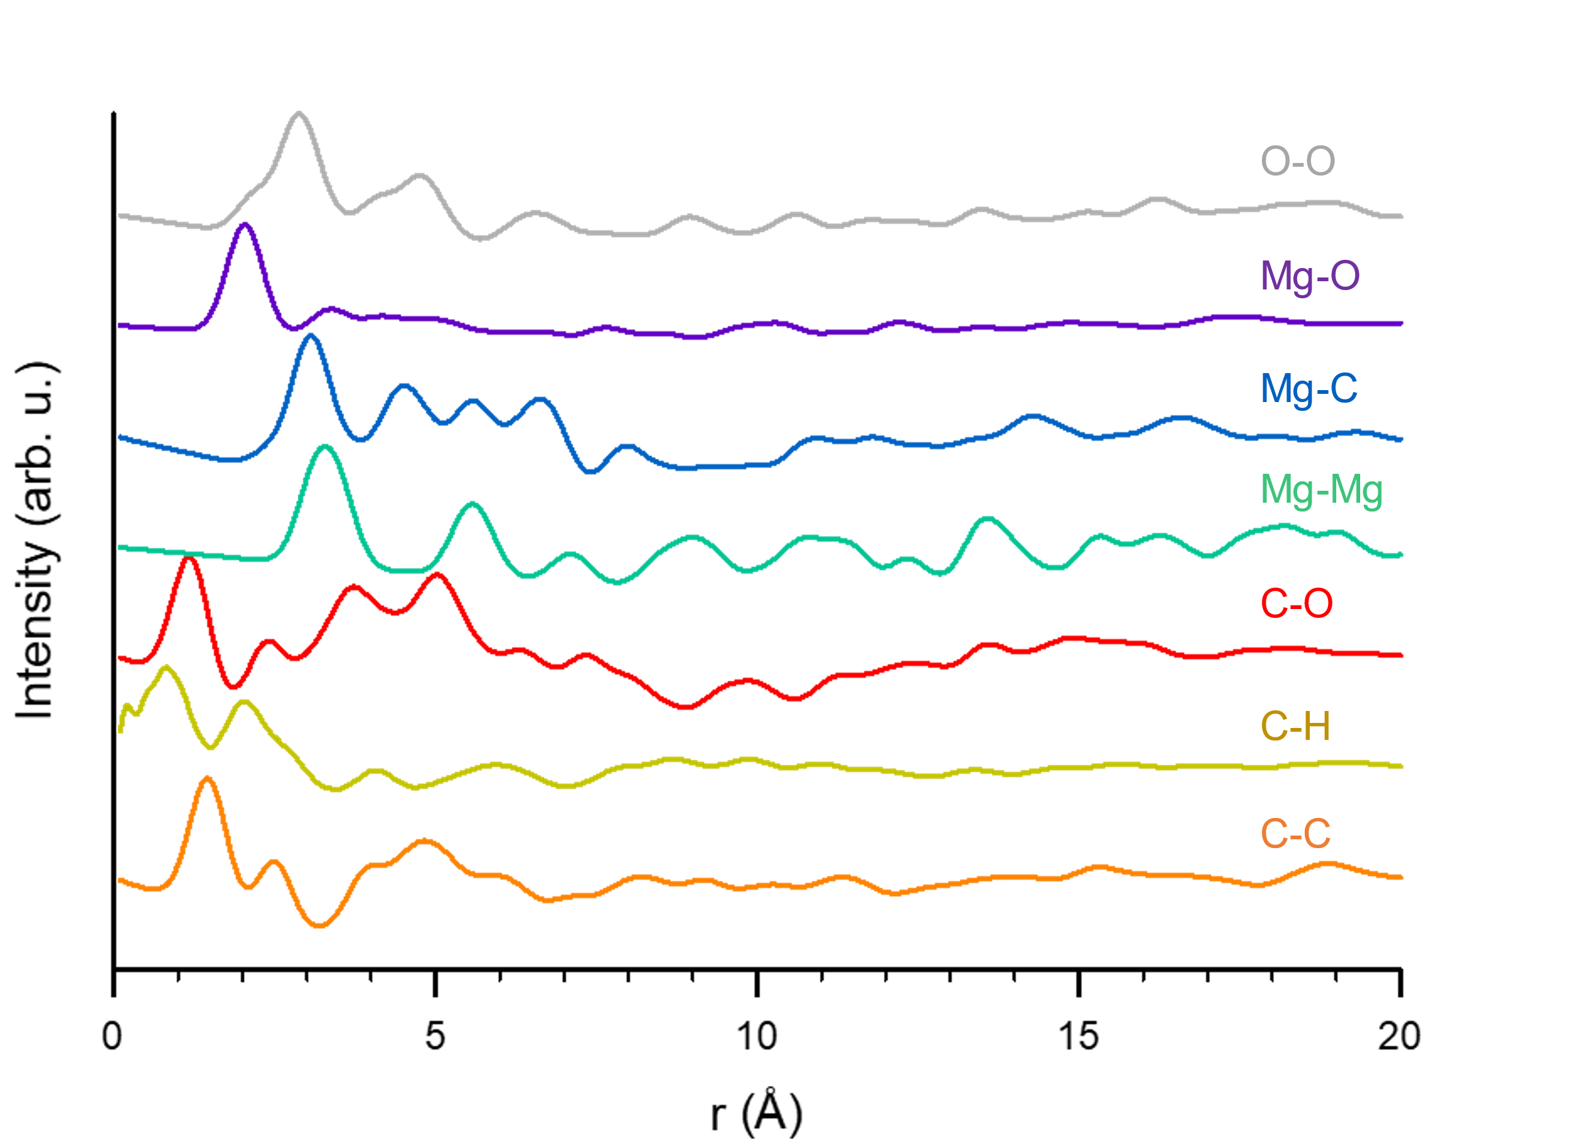
Figure S10. Simulated partial pair distributional functions of C-Mg-adp with PDFgui. Each line represents only the correlation between specific atoms.

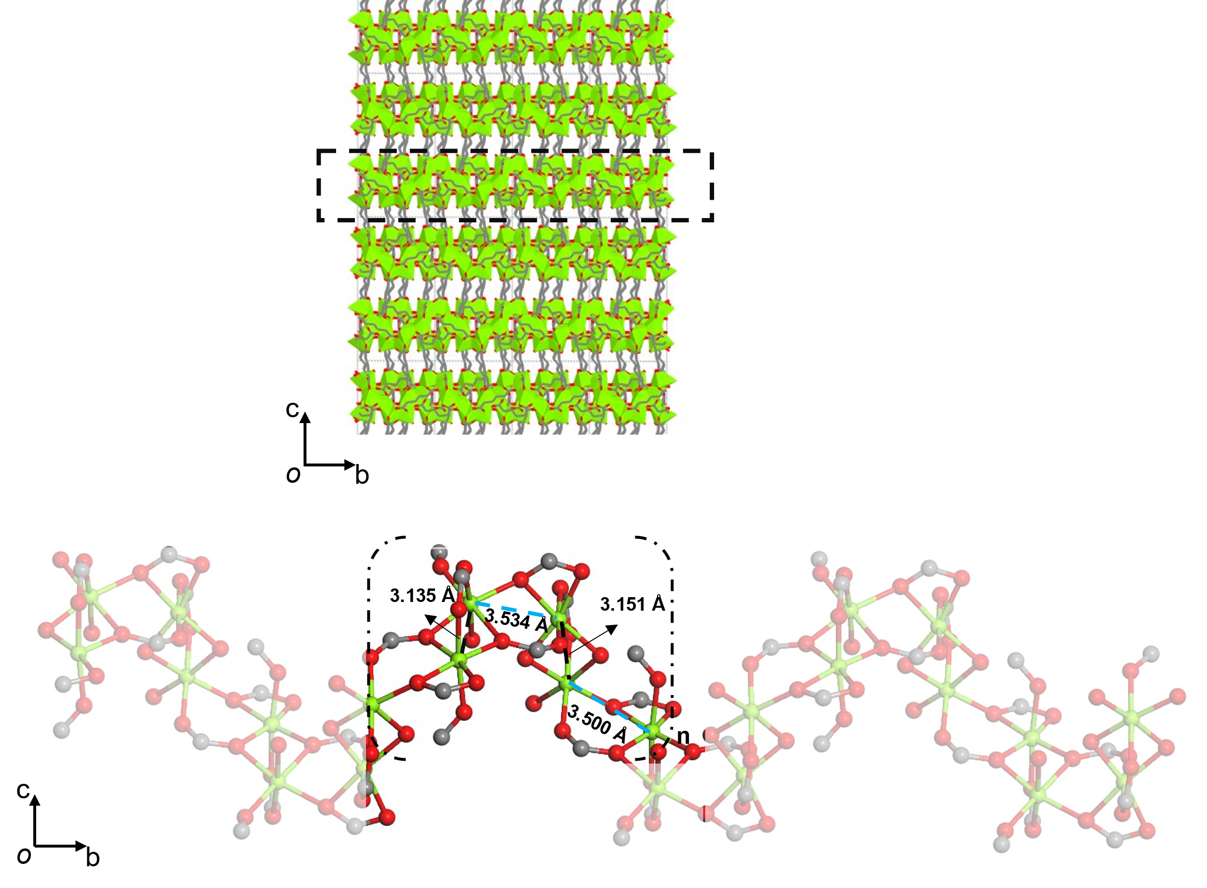
Figure S11. Single-crystal X-ray structure of [Mg₄(adipate)₄(DMA)(H2O)]· 5DMA·2MeOH·4H₂O viewed from the a axis showing the infinity 1D Mg-O chains along b axis. (top) Mg ⋯ Mg distances in the 1D Mg-O chain. Hydrogen and carbon atoms of (CH₂)_{n} chain are omitted for clarity. (bottom)

Figure S12. Load-Depth Curves of G-Mg-adp with nanoindentation tests.

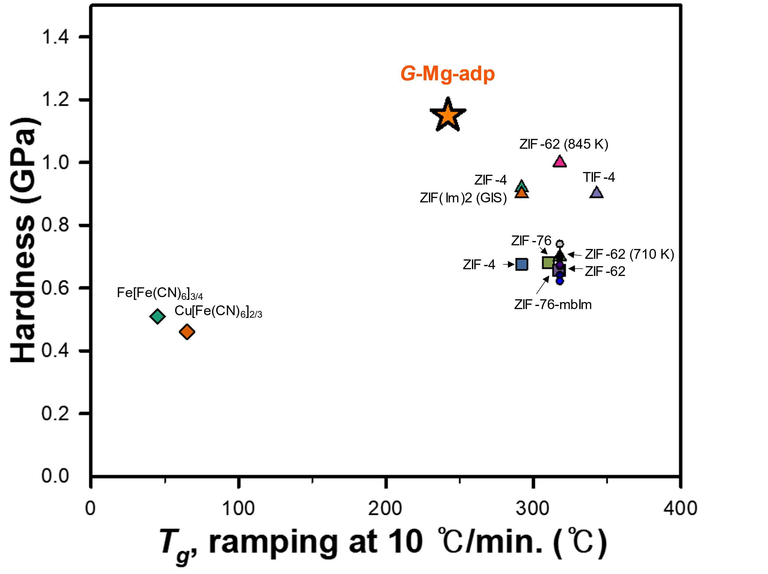
Figure S13. Glass transition temperature-Hardness correlation chart for metal coordination glasses. Note: The circle symbols represent the difference in values ​​according to the change of preparation conditions and hardness test conditions in ZIF-62 glass.

Figure S14. Detail chart of Hardness-Modulus correlation to coordination polymer glasses. Crossed bars indicate the standard deviation for each value. The values ​​in this chart were compiled from the references shown in Table S2.
Figure S15. XRPD data of C-M-adp (M: Mn²⁺, Co²⁺, Tb³⁺), G-Mn-adp and amorphized Co-adp.

Figure S16. TGA data of C-M-adp. The symbols inserted in the figure represent T_{m} and T_{g} of C-Mn-adp, respectively.

Figure S17. The DSC curves of C-M-adp MOFs: C-Co-adp (yellow, top), C-Tb-adp (blue, top), and C-Mn-adp (bottom). The inset curve in the DSC curve of C-Mn-adp represents the glass transition peak of the second upscan in the subsequent cycle.

Figure S18. FT-IR spectrum data of C-Mn-adp (bottom) and G-Mn-adp (top). The peak marked in the spectra is attributed to DMA, which is a solvent and is absent in G-Mn-adp.
Figure S19. SEM images of G-Mn-adp, which was heated at its T_{m} for 0 minutes.

Figure S20. SEM images of C-Co-adp (left) and thermally amorphized phase (right), which was heated at 220 ℃ for 10 minutes.

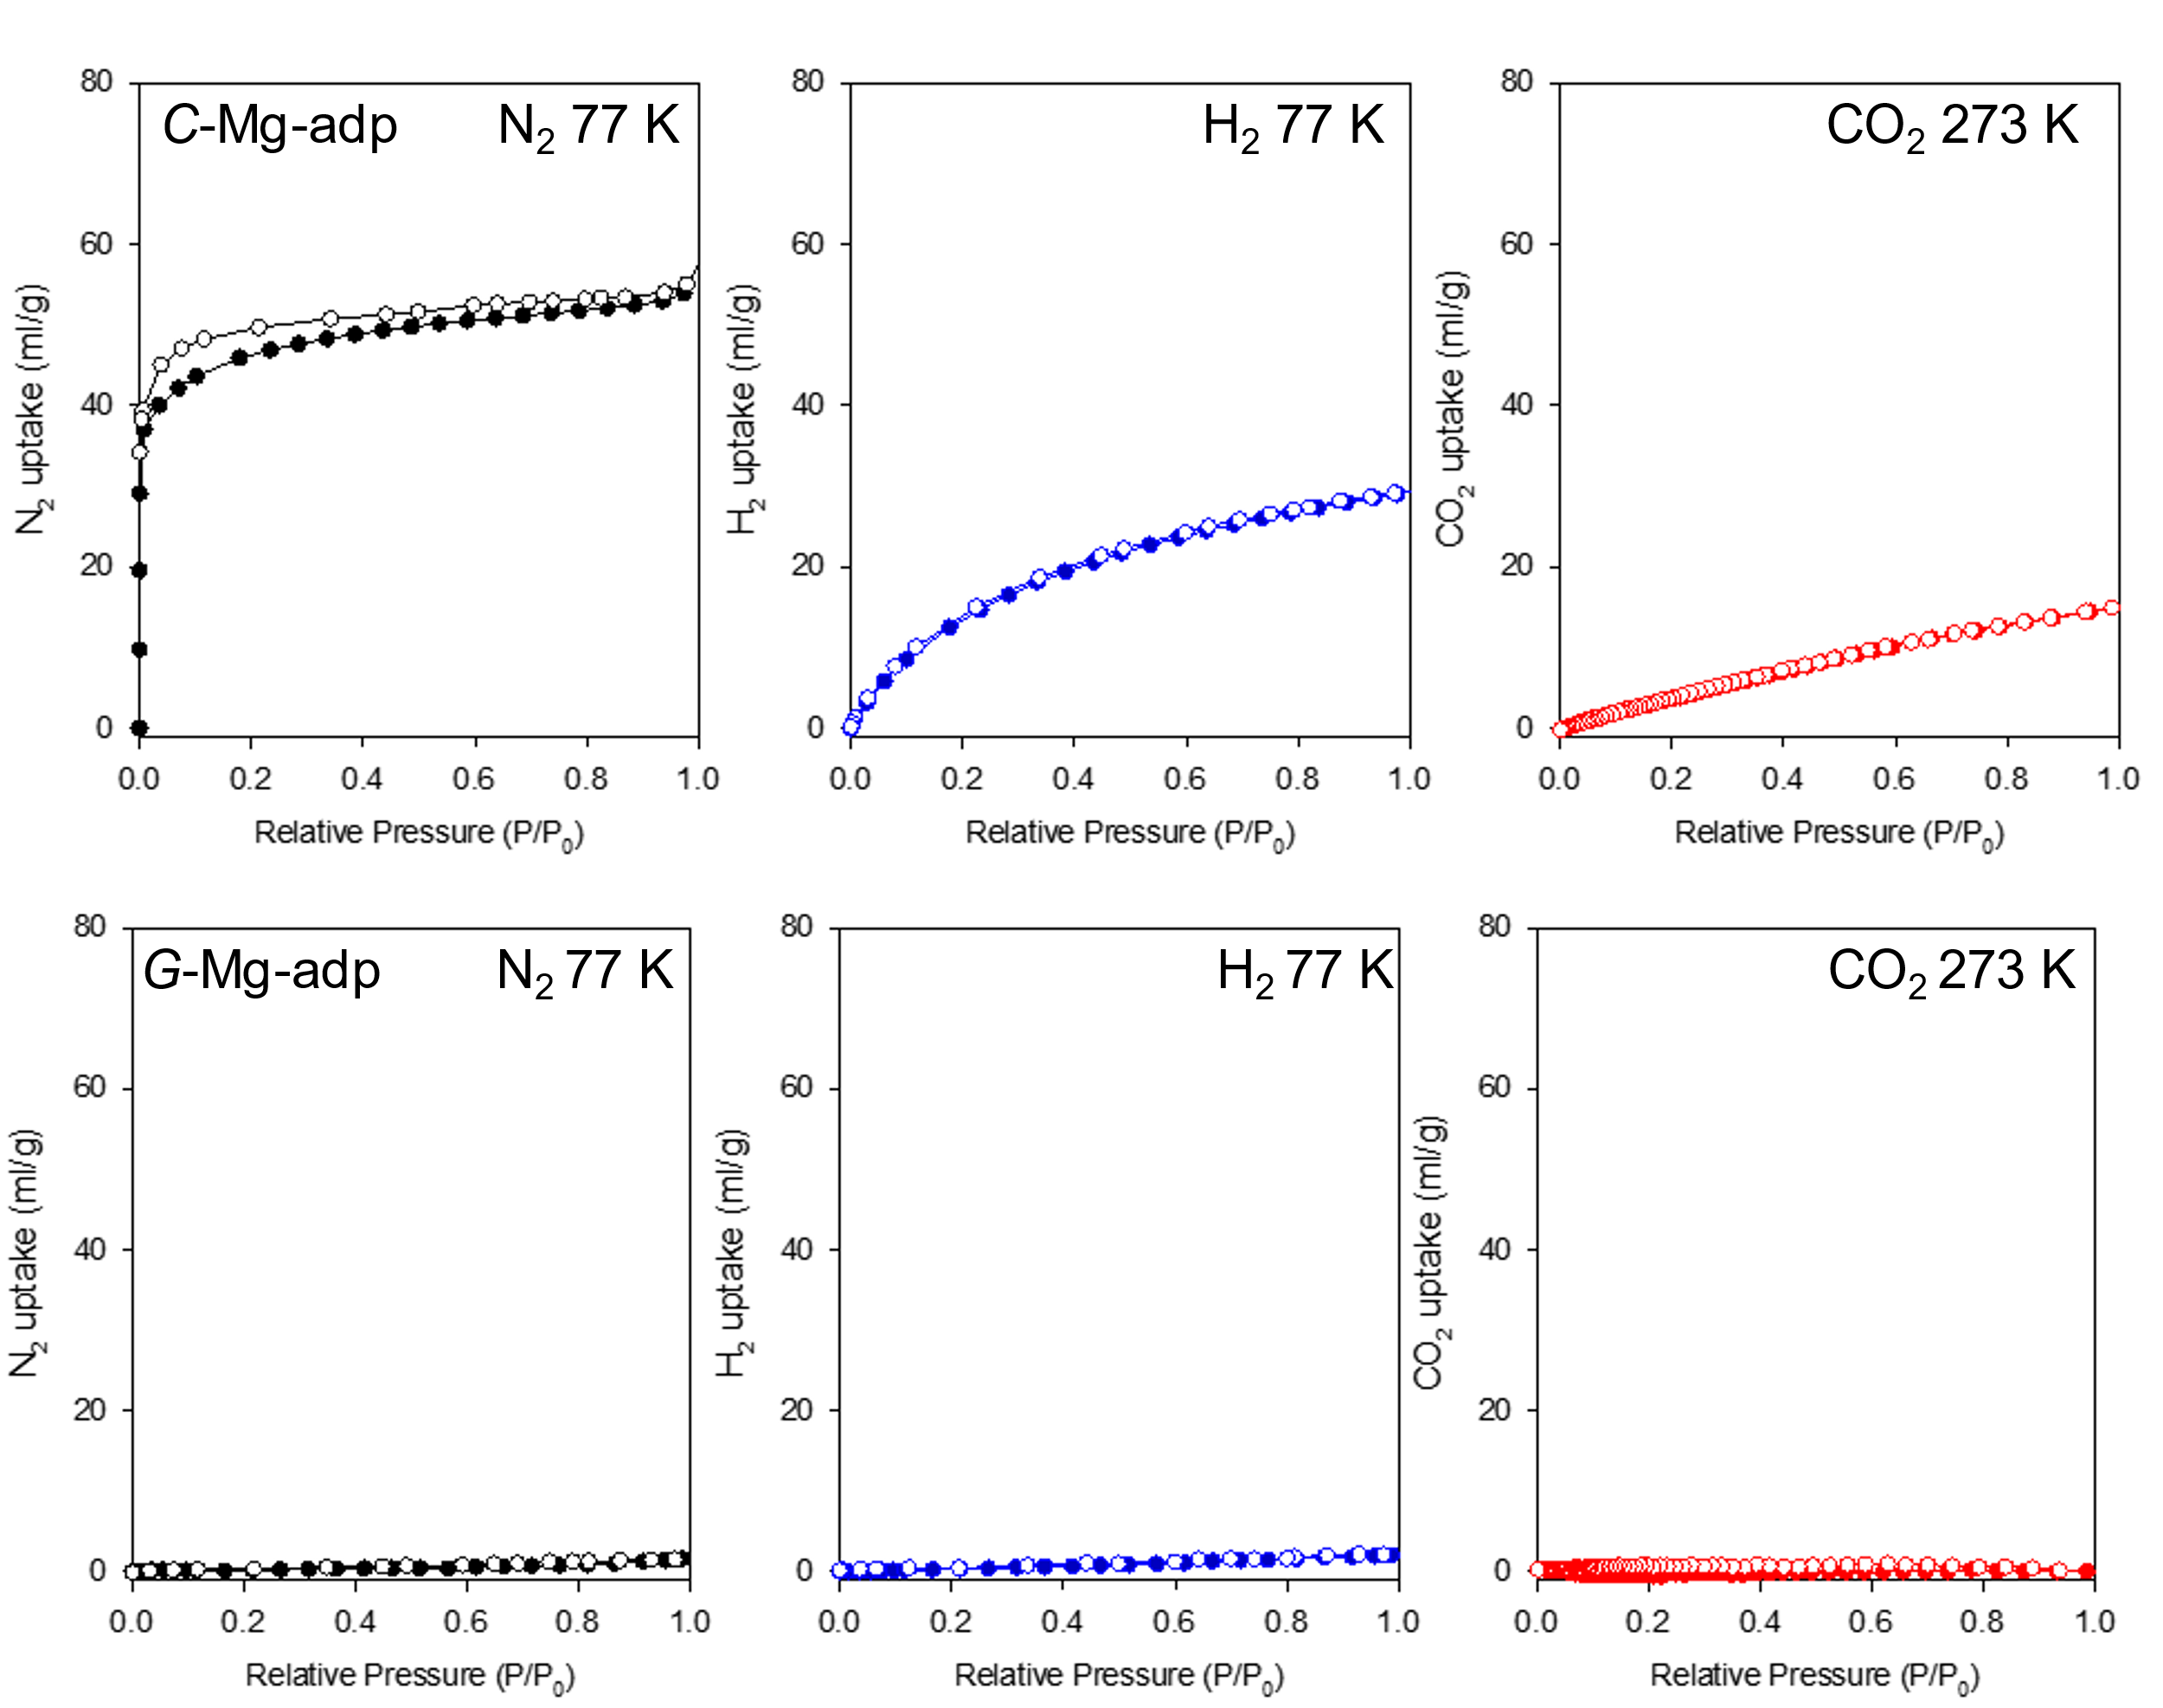
Figure S21. Gas adsorption measurements of C-Mg-adp (top) and G-Mg-adp (bottom), isotherm data (Inset: isotherm temperature) for N₂ (left), H₂ (middle), and CO₂ (right), with filled and hollow circles represent adsorption and desorption points, respectively.

Table S1. Mechanical properties of G-Mg-adp evaluated by nanoindentation tests. Values in parentheses represent standard deviations. Maximum load is 20 mN. Wx values which mean the absorbed energy during deformation were calculated by integrating the load-depth graph in Supplementary Fig. 12. W_{total} and W_{elastic} were the area of a loading curve and an unloading curve, respectively. W_{plastic} was a difference of W_{total} and W_{elastic}.

W_{total} (J) | 64.40 (± 0.1507) *10⁻¹⁰
W_{elastic} (J) | 28.39 (± 0.9339) *10⁻¹⁰
W_{plastic} (J) | 36.00 (± 0.8595) *10⁻¹⁰
W_{elastic}/W_{total} (arb. u.) | 0.441(± 0.014)
Hardness (H) (GPa) | 1.18 (± 0.051)
Elastic modulus (E) (GPa) | 18.29 (± 0.342)
H/E (arb. u.) | 0.065 (± 0.004)
H²/E (GPa) | 0.076 (± 0.008)

Table S2. The elastic modulus, hardness, and physical derivatives for various glass materials are presented. The standard deviation is represented within parentheses, and when not mentioned in the reference, it is not indicated. Please refer to the attached references for each symbol to understand the physical meaning of the derivative.

Sample | H (GPa) | E (GPa) | H/E  (arb. u.)^{[7]} | H ²/E  (GPa) ^{[8]} | H³/E² (GPa) ^{[9]} | (E*H)^{1/2}  (GPa) ^{[10]} | Ref.
G-Mg-adp | 1.18 | 18.29 | 0.065 | 0.076 | 0.0044 | 4.617 | This work
ZIF-4 | 0.92  (± 0.03) | 8.2 (± 0.2) | 0.112 | 0.103 | 0.103 | 2.746 | [11]
ZIF(Im)₂  (GIS) | 0.9 (± 0.02) | 8.5 (± 0.2) | 0.106 | 0.095 | 0.0953 | 2.765 | [11]
TIF-4 | 0.9 (± 0.06) | 7.9 (± 0.3) | 0.114 | 0.0102 | 0.103 | 2.666 | [11]
ZIF-62  (710 K) | 0.7 (± 0.04) | 6.1 (± 0.2) | 0.115 | 0.081 | 0.0803 | 2.066 | [11]
ZIF-62  (845 K) | 1 (± 0.1) | 8.8 (± 0.4) | 0.114 | 0.114 | 0.114 | 2.966 | [11]
ZIF-4 | 0.676 (± 0.009) | 6.89 (± 0.1) | 0.0981 | 0.066 | 0.0663 | 2.158 | [12]
ZIF-62 | 0.656 (± 0.005) | 6.58 (± 0.02) | 0.0997 | 0.065 | 0.0654 | 2.077 | [12]
ZIF–76 | 0.682 (± 0.01) | 6.29 (± 0.07) | 0.108 | 0.074 | 0.0739 | 2.071 | [12]
ZIF-76-mbIm | 0.658 (± 0.006) | 6.12 (± 0.02) | 0.108 | 0.071 | 0.0707 | 2.006 | [12]
ZIF-62 (compressed) | 0.7 (± 0.02) | 7.54 (± 0.03) | 0.093 | 0.065 | 0.065 | 2.297 | [13]
ZIF-62  (annealed) | 0.67 (± 0.02) | 6.67 (± 0.02) | 0.1 | 0.067 | 0.0673 | 2.114 | [13]
ZIF-62  (standard) | 0.74 (± 0.03) | 6.77 (± 0.02) | 0.109 | 0.081 | 0.0809 | 2.238 | [13]
ZIF-62  (10 mN)ª | 0.674 (± 0.007) | 5.59 (± 0.02) | 0.121 | 0.081 | 0.0813 | 1.941 | [14]
ZIF-62  (20 mN) ª | 0.641 (± 0.006) | 5.47 (± 0.02) | 0.117 | 0.075 | 0.0751 | 1.873 | [14]
ZIF-62  (40 mN) ª | 0.622 (± 0.005) | 5.32 (± 0.02) | 0.117 | 0.073 | 0.0727 | 1.819 | [14]
Fe[Fe]_{3/4}-g ^{b} | 0.51 | 7.6 | 0.067 | 0.034 | 0.0342 | 1.969 | [15]
Cu[Fe]_{2/3}-g ^{b} | 0.46 | 5.7 | 0.081 | 0.037 | 0.0371 | 1.619 | [15]
Adipic acid (100) | - | 11.53(± 0.49) | - | - | - |  | [16]
Adipic acid (110) | 0.3 | 10.39 | 0.029 | 0.0087 | 0.0087 | 1.766 | [17]
ª Max load on nanoindentation test
^{b} Vickers hardness

References for Supporting Information
[1] (a) Kim, T. K.; Lee, K. J.; Cheon, J. Y.; Lee, J. H.; Joo, S. H.; Moon, H. R. J. Am. Chem. Soc., 2013, 135, 8940–8946.
(b) Kim, T. K.; Lee, J. L.; Choi, M.; Park, N.; Moon, D.; Moon, H. R. New J. Chem., 2013, 37, 4130-4139.
[2] Farrow, C. L.; Juhas, P.; Liu, J. W.; Bryndin, D.; Božin, E. S.; Bloch, J.; Proffen, T.; Billinge, J. Phy. Condens. Matter, 2007, 19, 335219.
[3] Degen, T.; Sadki, M.; Bron, E.; König, U.; Nénert, G. Powder Diffr., 2014, 29, S13–S18.
[4] To, T.; Sørensen, S. S.; Stepniewska, M.; Qiao, A.; Jensen, L. R.; Bauchy, M.; Yue, Y.; Smedskjaer, Nat. Commun., 2020, 11, 2593.
[5] Frentzel-Beyme, L.; Kolodzeiski, P.; Weiß, J.-B.; Schneemann, A.; Henke, S. Nat. Commun., 2022, 13, 7750
[6] (a) Zheng, Q.; Mauro, J. C.; Yue, Y. J. Non. Cryst. Solids., 2017, 456, 95-100
(b) Qiao, A.; Bennet, T. D.; Tao, H.; Krajnc, A.; Mali, G.; Doherty, C. M.; Thornton, A. W.; Mauro, J. C.; Greaves, G. N.; Yue, Y. Sci. Adv., 2018, 4, eaao6827
[7] (a) Finkin, E. Examination of abrasion resistance criteria for some ductile metals. 1974;
(b) L.O. Affonso. Machinery Failure Analysis Handbook – Sustain Your Operations and Maximize Uptime. Gulf Publishing Company, USA, 2006.
[8] Oyen, M. L.; Cook, R. F. J. Mech. Behav. Biomed. Mater. Elsevier BV, 2009.
[9] Tsui T.Y.; Pharr G.M.; Oliver, W.C.; Bhatia C.S.; White R.L.; Anders A., Brown I.G. MRS Proceedings, 1994, 356, 767.
[10] (a) Karothu, D. P.; Mahmoud Halabi, J.; Ahmed, E.; Ferreira, R.; Spackman, P. R.; Spackman, M. A.; Naumov, P. Angew. Chem. Int. Ed, 2022, 134(10), e202113988.
(b) Labonte, D.; Lenz, A. K.; Oyen, M. L. Acta biomaterialia, 2017, 57, 373-383.
[11] Bennett, T. D.; Yue, Y.; Li, P.; Qiao, A.; Tao, H.; Greaves, N. G.; Richards, T.; Lampronti, G. I.; Redfern, S. A.; Blanc, F. d. r. J. Am. Chem. Soc. 2016, 138 (10), 3484-3492
[12] Li, S., Limbach, R.; Longley, L.; Shirzadi, A. A.; Walmsley, J. C.; Johnstone, D. N.; … & Bennett, T. D. J. Am. Chem. Soc , 2019, 141(2), 1027-1034.
[13] Qiao, A.; To, T.; Stepniewska, M.; Tao, H.; Calvez, L.; Zhang, X.; … Yue, Y. Phys. Chem. Chem. Phys., 2021, 23, 16923-16931.
[14] Stepniewska, M.; Januchta, K.; Zhou, C.; Qiao, A.; Smedskjaer, M. M.; Yue, Y. Pros. Natl. Acad. Sci. U.S.A., 2020, 117(19), 10149-10154.
[15] Ma, N.; Ohtani, R.; Le, H. M.; Sørensen, S. S.; Ishikawa, R.; Kawata, S.; ... ; Horike, S. Nat. Commun., 2022, 13(1), 4023.
[16] Mishra, M. K.; Ramamurty, U.; Desiraju, G. R. Chem. Asian J. 2015, 10 (10), 2176-2181.
[17] Mishra, M. K.; Varughese, S.; Ramamurty, U.; Desiraju, G. R. J. Am. Chem. Soc. 2013, 135 (22), 8121-8124.
[18] Degen, T.; Sadki, M.; Bron, E.; König, U.; Nénert, G. Powder Diffr. 2014, 29 (S2), S13-S18.

