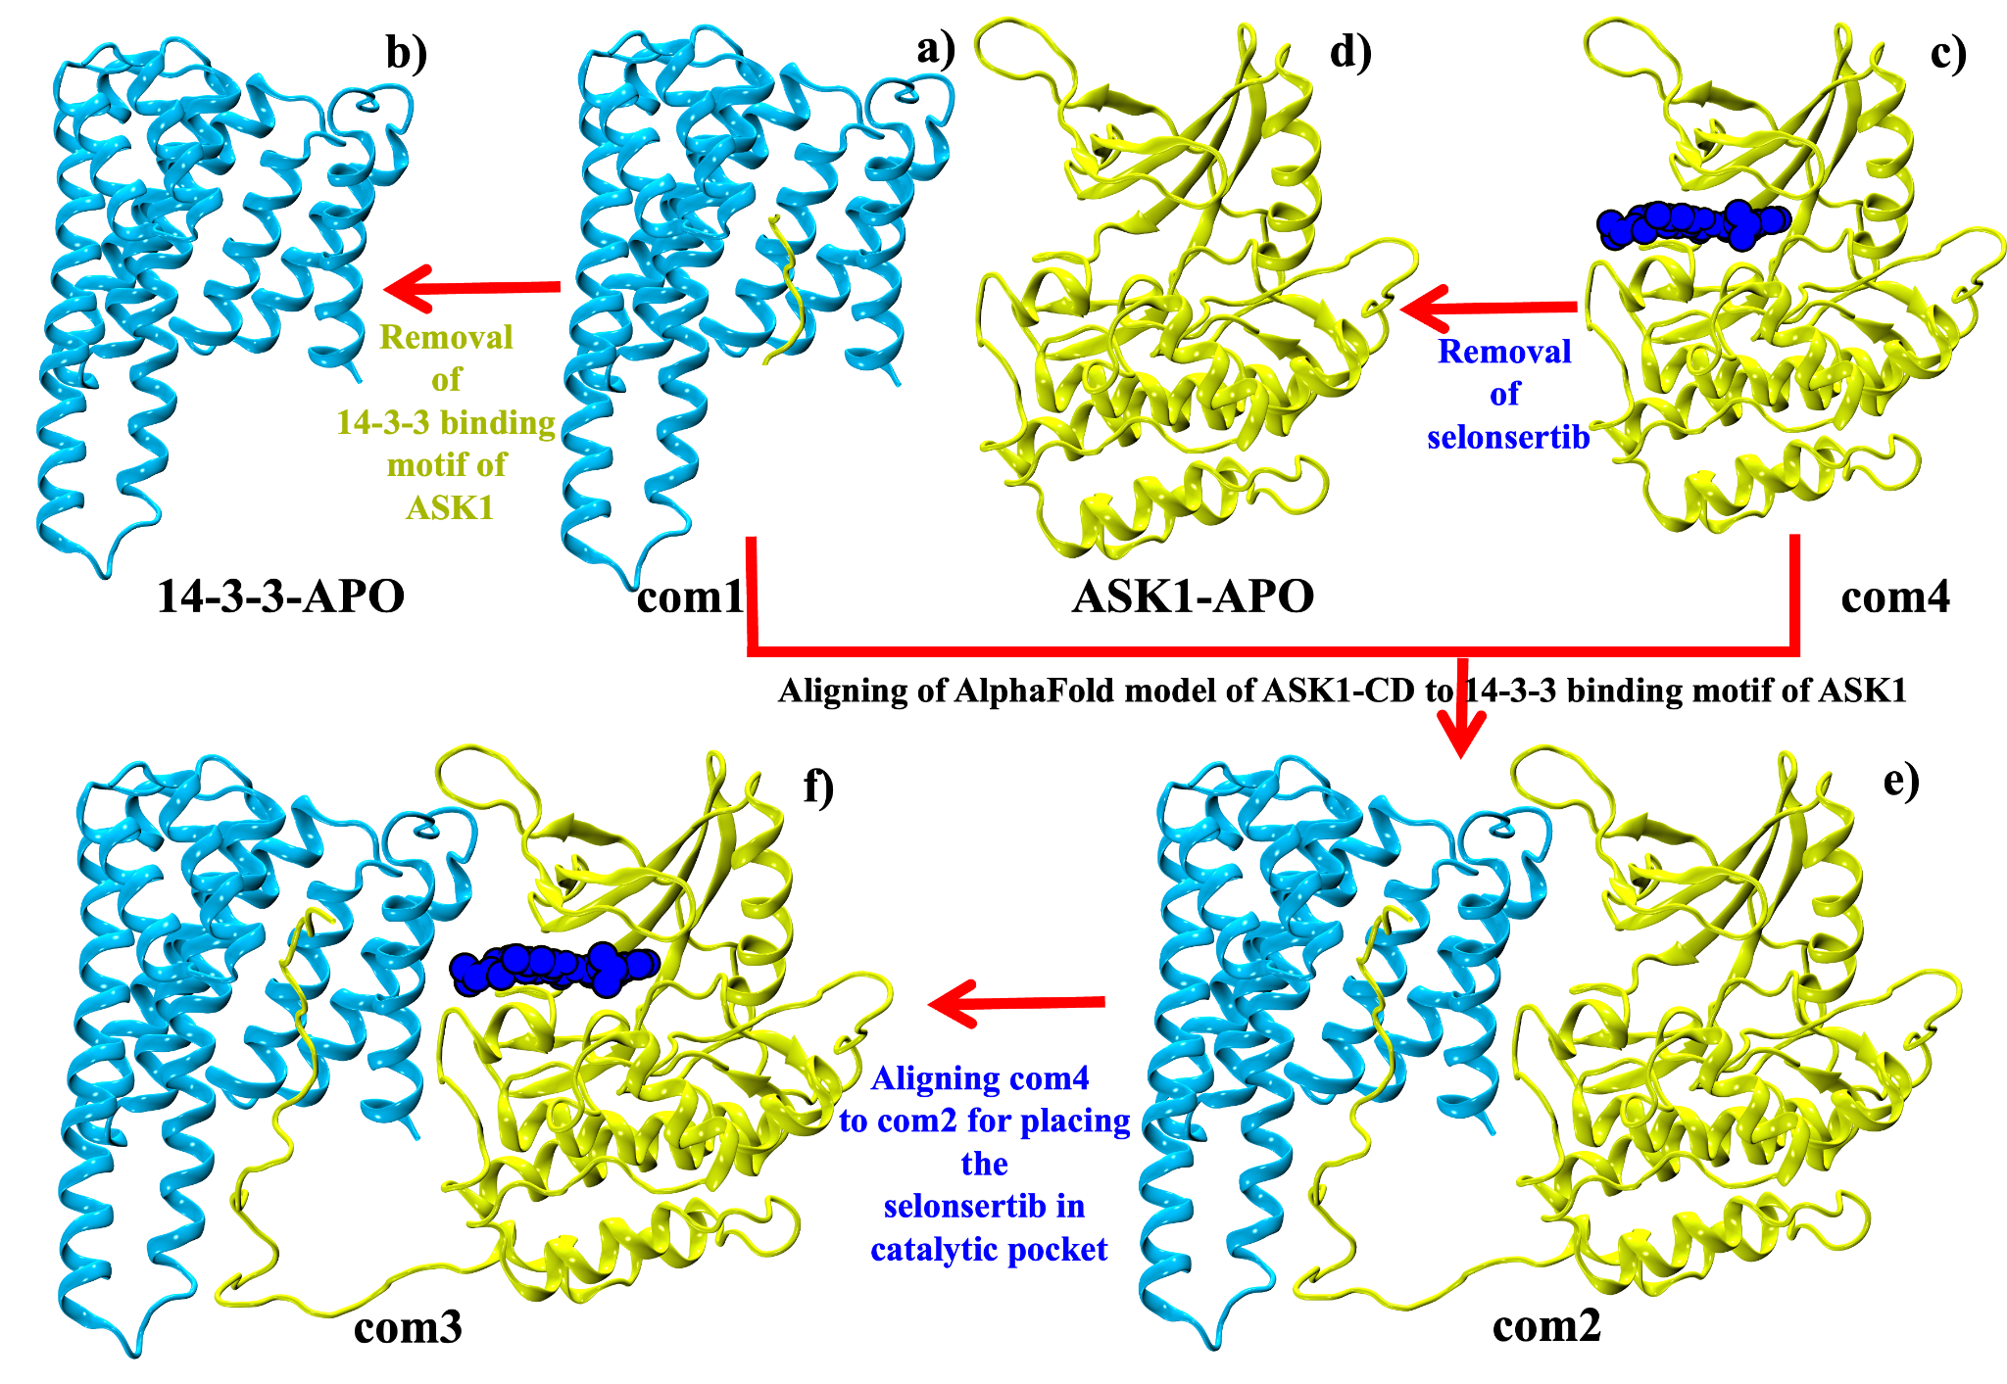

Supplementary Figure 1: This schematic representation illustrates the different systems of 14-3-3 and ASK1-CD in this study. The apo systems include the 14-3-3 protein (b) and ASK1-CD (d) without any ligand or peptide bound to them. The complex systems consist of the 14-3-3 protein in complex with ASK1 peptide (a), ASK1-CD in complex with selonsertib (b), 14-3-3 protein in complex with ASK1-CD (e), and 14-3-3 protein in complex with both ASK-CD and selonsertib (f). The color codes represent the different components of the systems: 14-3-3 protein (cyan), ASK1-CD (yellow), selonsertib (blue), and ASK1 peptide (yellow). These systems were used for molecular dynamics simulations to investigate the binding interactions between 14-3-3 and ASK1-CD with and without selonsertib.
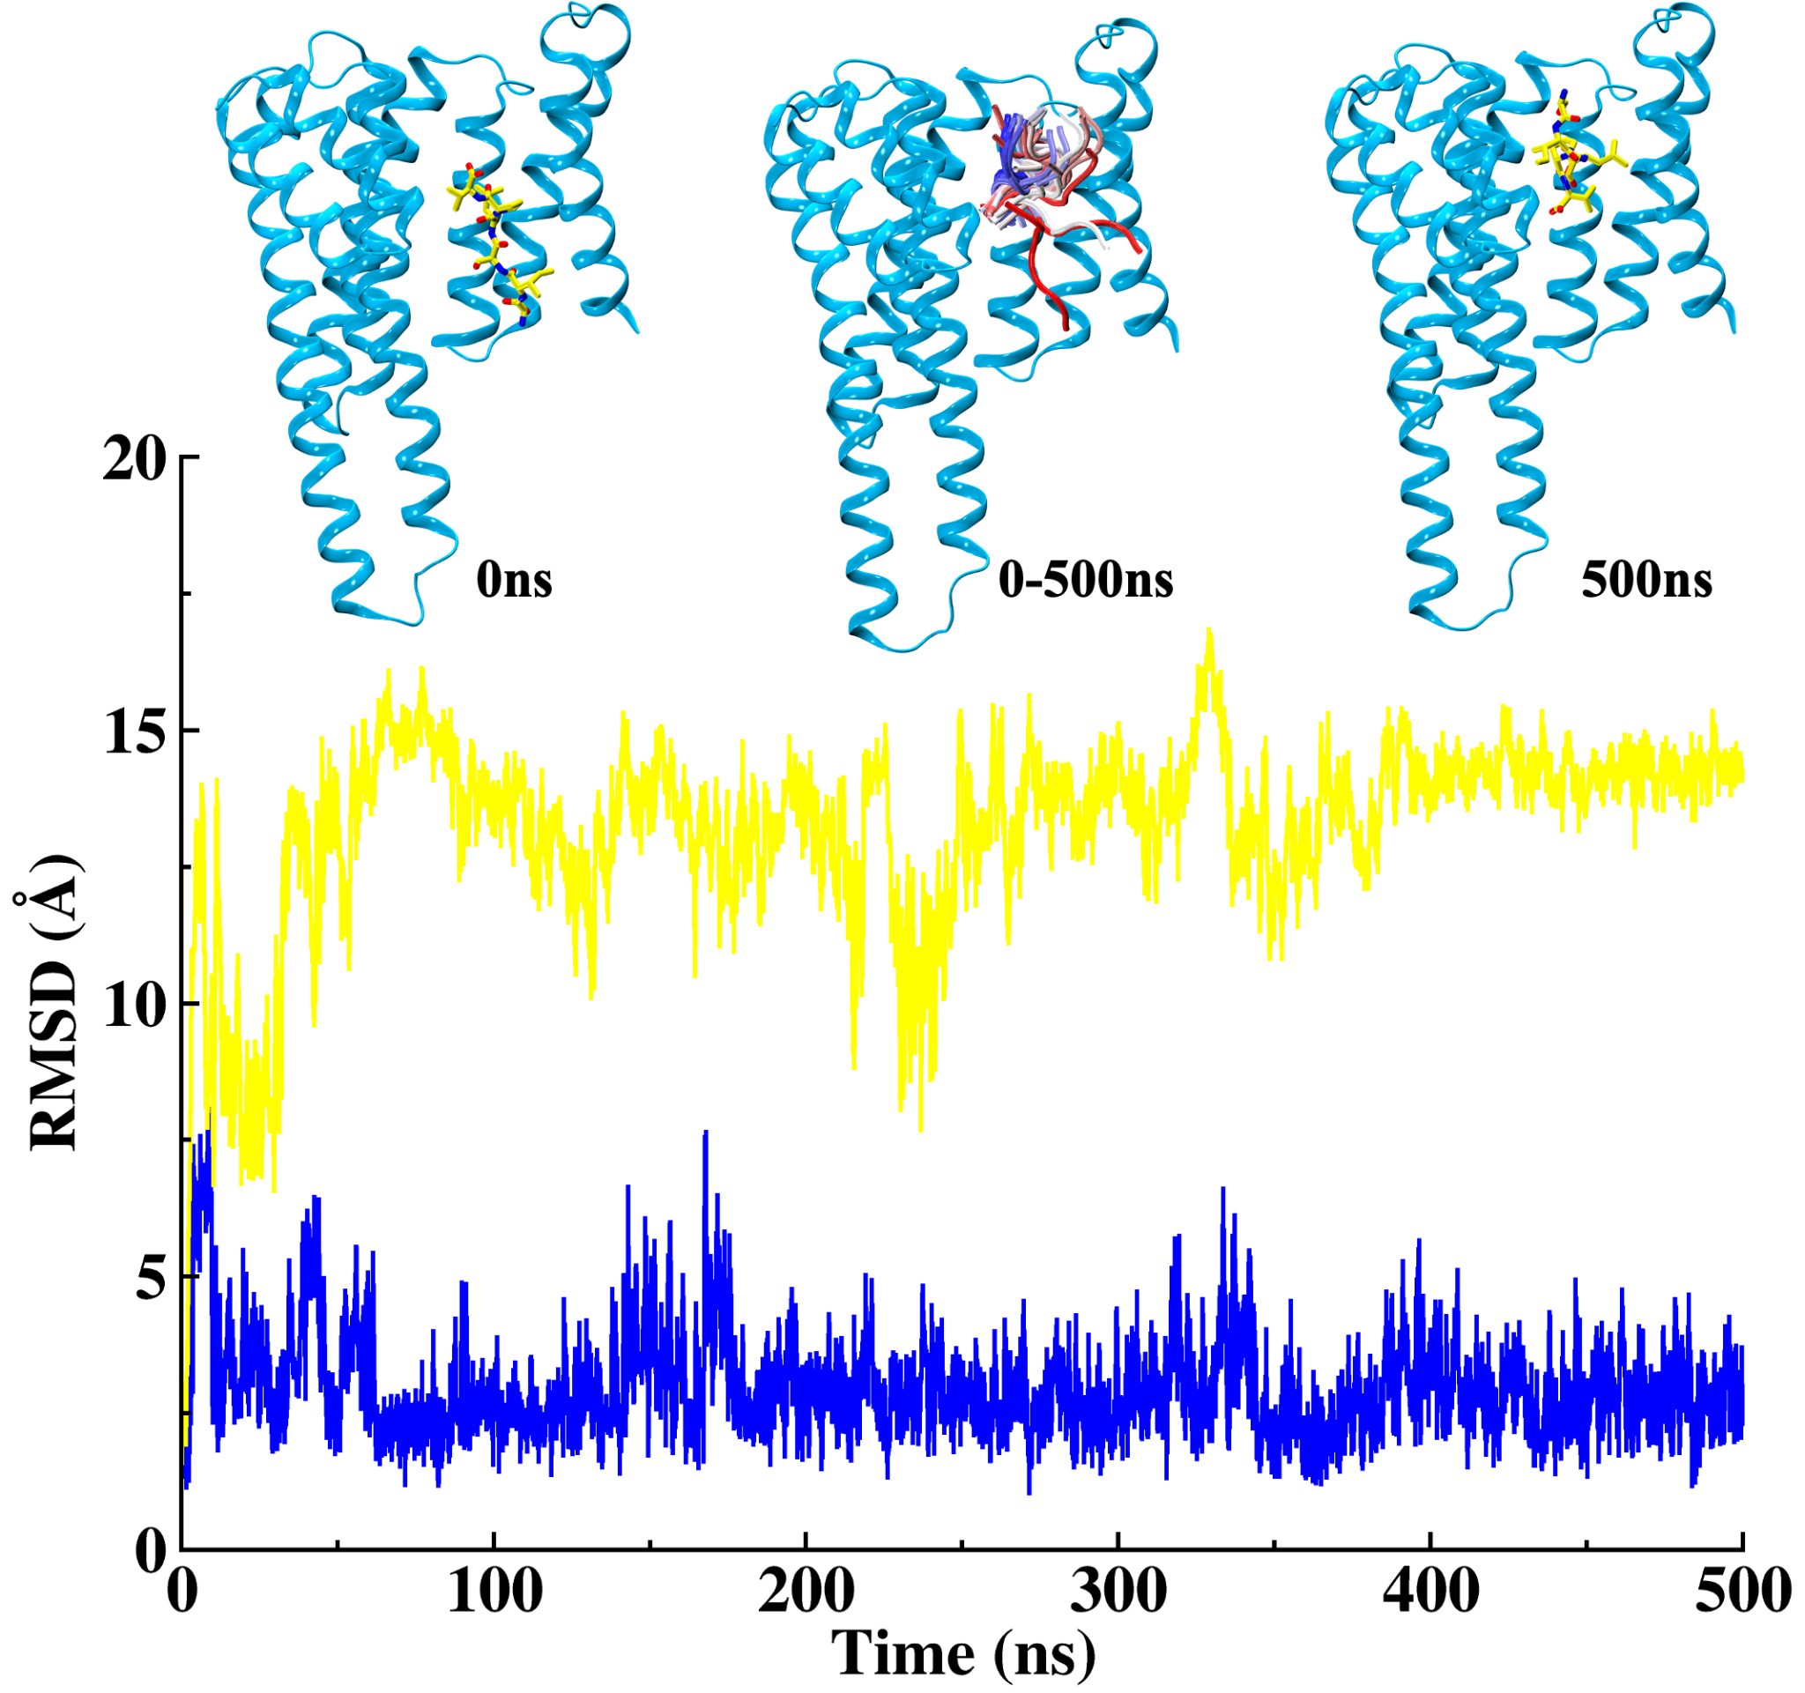
Supplementary Figure 2: RMSD Analysis of S966 Non-Phosphorylation of 14-3-3 Protein (blue color) and ASK1 Peptide (yellow color). The figure shows the RMSD values of the non-phosphorylated complex over time, with the complex shown at 0 ns and 500 ns, as well as a sampling of the peptide from 0 to 500 ns. The non-phosphorylation of S966 destabilizes the complex, as indicated by the higher and unstable RMSD value of the peptide.

