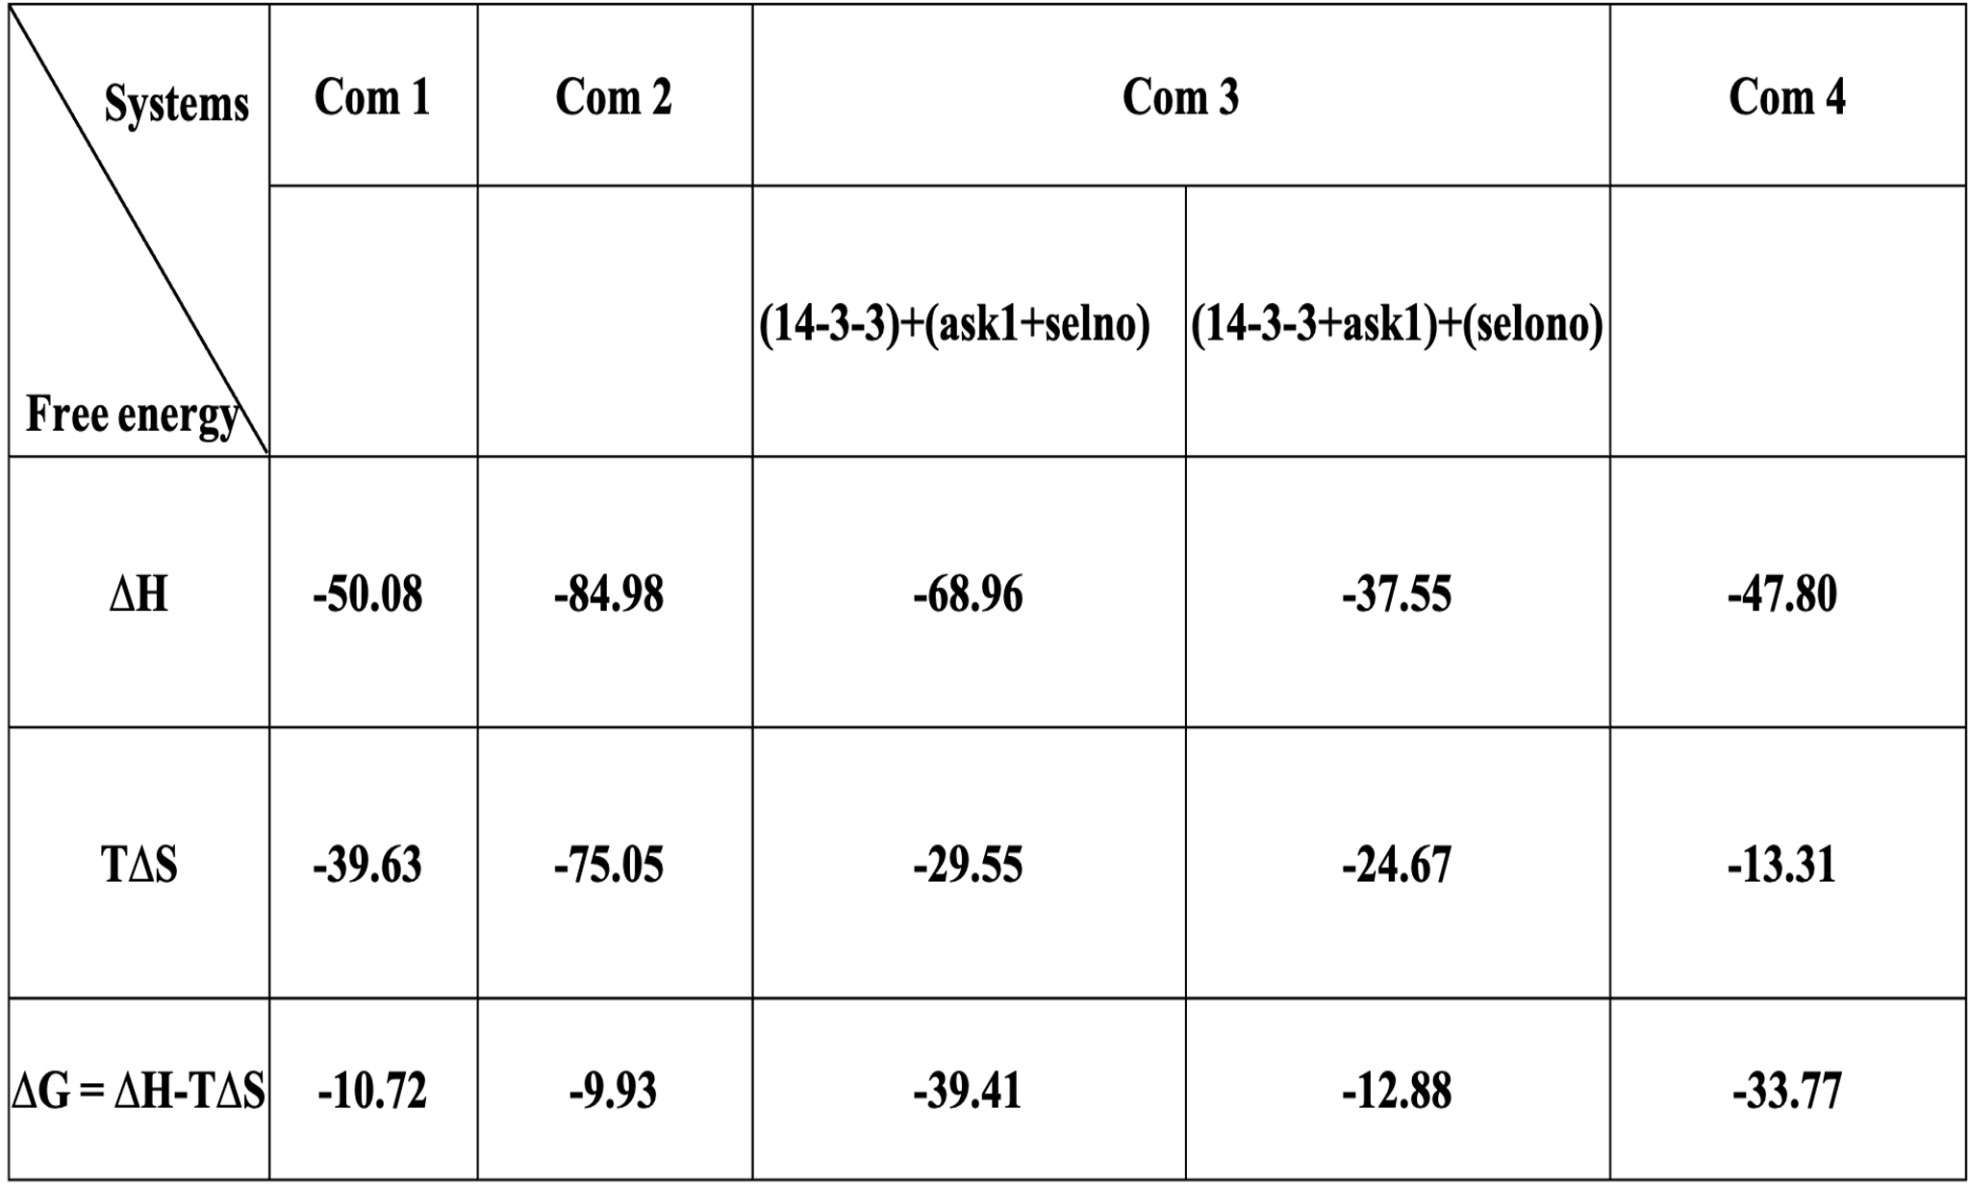
Table 1: MM/PBSA Analysis of the 14-3-3 and ASK1 Systems. The table shows the contribution of each component, including enthalpy (ΔH) and entropy (TΔS), to the binding free energy (ΔG) for each complex. The values for each component are listed in kcal/mol, and the total ΔG is also provided.

 |  | K 3 | K 11 | E 14 | E 17 | N 38 | E 39 | E 40 | R 41 | V 46 | K 49 | R 55 | R 56 | R 60 | K 68 | E 84 | E 87 | R 91 | E 113 | K 120 | K 122 | D 124
 | COM1 |  |  | 0.58 |  |  |  |  |  | -0.80 | -9.71 | -0.52 | -14.97 | -1.02 |  |  |  |  |  | 1.71 |  | 4.16
 | COM2 |  | -0.51 |  |  | -0.66 |  |  | 0.98 |  | -5.09 |  | -1.06 |  |  |  |  |  |  | 5.90 |  | 2.19
 | COM3
 | COM3 | -0.51 | -0.67 | 0.71 | 0.59 |  | 0.73 | 0.59 | -0.72 |  | -14.20 | -0.74 | -19.22 | -2.02 | -0.55 | 0.56 | 0.65 | -0.58 | 0.79 | -1.60 | -0.56 | 9.14
 |  | R 127 | Y 128 | E 131 | D 143 | K 157 | K 158 | E 159 | H 164 | P 165 | I 166 | R 167 | G 169 | L 172 | N 173 | V 176 | Y 179 | E 180 | F 196 | E 198 | I 200 | A 201
 | COM1 | -20.39 | -7.56 | 3.21 |  |  |  |  |  |  |  |  |  | -1.77 | -0.62 | -2.33 | -0.52 | 1.70
 | COM2 | -15.93 | -5.80 | 0.65 |  | -0.51 | -0.51 | 0.63 | -0.74 | -1.04 | -1.27 | -0.54 | 1.09 | -2.30 | 2.14 | -2.39 | -1.40 | 2.99 | -0.72 | 0.66 | -0.98 | -1.08
 | COM3
 | COM3 | -23.80 | -8.05 | 5.03 | 0.50 |  |  | 0.54 |  |  |  | -0.56 | 0.63 | -1.59 | 0.84 | -2.26 | -3.89 | 4.32 |  |  | -0.95
 |  | E 202 | L 203 | D 204 | E 208 | E 209 | Y 211 | K 212 | D 213 | T 215 | L 216 | I 217 | M 218 | Q 219 | L 220 | R 222 | D 223 | N 224 | T 226 | L 227 | W 228 | S 230
 | COM1 |  |  |  |  |  |  |  |  |  |  | -0.68 |  |  | -1.16 |  | 0.58 | -2.14
 | COM2 | -0.85 | -4.44 | 2.51 | 9.18 | 1.35 |  | -0.67 | 4.04 | -1.17 | -0.99 | -1.61 | -1.62 | -2.45 | -2.13 | -1.88 | 1.14 | -2.93 | -0.51 | -3.45 | -2.24
 | COM3 |  |  |  |  |  |  | 0.85
 | COM3 | 0.60 | -0.77 |  | 11.50 | 1.05 | -2.66 | -2.33 | 0.91 | -1.48 | 1.00 |  | -0.74 |  | -3.65 | -2.03 | 4.36 | -4.55 | -1.16 | -5.36 | -1.05 | 4.07
 |  | R 659 | E 662 | E 663 | D 669 | E 672 | D 674 | E 676 | D 678 | E 679 | D 682 | R 683 | L 686 | G 687 | K 688 | G 689 | V 694 | R 698 | D 699 | V 704 | R 705 | A 707
 | COM1
 | COM2 | -1.23 | 0.50 | 0.51 |  | 0.59 |  | 1.61 | 0.81 | 0.76 | 0.60 | -0.66 |  |  | -0.59 |  |  | -7.97 |  | -0.82 | -6.84
 | COM3 |  |  |  |  |  |  |  |  |  |  |  | -2.41 | -1.74 | -0.79 |  | -1.62 |  |  |  | 0.75
 | COM3 | -0.93 |  |  | 0.55 | 0.62 | 0.81 | 12.69 | 8.03 | 0.98 | 0.58 | -0.69 |  |  | -0.51 |  |  | -2.29 | 0.87 |  | -7.48
 | COM4 |  |  |  |  |  |  |  |  |  |  |  | -1.96 |  |  | -0.77 | -1.98 |  |  |  | -0.74 | -0.81
 |  | K 709 | E 710 | E 725 | K 730 | K 733 | K 735 | V 738 | K 751 | M 754 | E 755 | Q 756 | V 757 | P 758 | G 759 | G 760 | R 767 | K 769 | K 774 | D 775 | E 777 | K 785
 | COM1
 | COM2 | -0.74 | 0.52 | 0.68 |  | -0.56 | -0.64 |  | -0.54 |  | 0.73 |  |  | -1.83 | -0.89 |  | -0.87 | -0.70 | -0.68 | 0.80 | 0.62 | -0.80
 | COM3 |  |  |  |  |  |  |  |  |  |  | 0.59 | 2.53 | -1.54 | -0.62 | -0.66
 | COM3 | -0.52 | 0.53 |  | -0.52 | -0.65 | -0.74 |  | -0.55 |  | 0.89 |  |  |  |  |  | -0.53 | -0.74 | -0.56 | 0.68 | 0.68 | -0.83
 | COM4 | 0.95 |  |  |  |  |  | -0.85 |  | -1.28 | 1.74 | -1.75 | 0.71 | -1.59 | -0.97 | -0.84
 |  | E 789 | K 792 | D 803 | K 805 | D 807 | L 810 | T 813 | Y 814 | S 815 | K 819 | S 821 | D 822 | D 863 | E 873 | K 878 | E 910 | K 917 | D 935 | E 936 | K 939 | K 943
 | COM1
 | COM2 | 0.66 | -0.55 | 0.51 | -0.57 | 0.71 |  | -0.51 | -3.22 | -0.52 | -0.71 |  | 0.67 | 0.52 | 0.61 | -0.51 | 0.51 |  | 0.50 |  | -0.52 | -0.61
 | COM3 |  |  |  |  |  | -1.88 | -0.59
 | COM3 | 0.61 | -0.51 |  |  |  |  |  | -4.22 |  | -0.95 |  |  |  | 0.56 |  | 0.53 | -0.51 | 0.57 | 0.56 | -0.55 | -2.20
 | COM4 |  |  |  |  |  | -2.45 |  |  |  |  | 0.69 | -0.89
 |  | K 944 | K 945 | K 946 | K 950 | S 952 | A 953 | L 954 | E 960 | L 962 | R 963 | S 964 | I 965 | SEP 966 | L 967 | P 968 | V 969 | P 970 | V 971 | L 972 | V 973 | STB 974
 | COM1 |  |  |  |  |  |  |  |  |  |  | 0.69 | -0.83 | 13.93 |  | -0.92 | -0.72
 | COM2 | -0.54 | -0.97 | -0.59 | -0.65 |  |  | -3.00 | 0.63 |  | -3.10 | -2.69 | -1.43 | 11.83 | -1.08 |  | -1.44 | -2.33 | -3.31 | -2.69 | 0.54
 | COM3 |  |  |  |  |  |  |  |  |  |  |  |  |  |  |  |  |  |  |  | 0.51 | -22.03
 | COM3 | -0.64 | -0.94 | -1.14 | -1.11 | -2.44 | -1.19 |  | 0.60 | -3.15 | -0.67 | -0.55 | 0.55 | 17.83 | -1.21 | -1.51 |  |  |  |  |  | -1.81
 | COM4 |  |  |  |  |  |  |  |  |  |  |  |  |  |  |  |  |  |  |  |  | -26.42

Table 2: Per Residue Energy Contribution of 14-3-3 (1-230 AA) and ASK1 (231-973) Systems. This table displays the contribution of each residue to the binding free energy (ΔG) for each complex, listed in units of kcal/mol. Residues with a very high energy contribution (greater than 5 kcal/mol) are highlighted in red. The cell colors represent the type of system, and residues that contribute to the interaction in the crystal structure are shown in cyan.

