Supplementary Information for:
Traces of Human Attitudes in Contemporary and Historical Word Embeddings (1800-2000)

Tessa E.S. Charlesworth^{1,2 *}, Kirsten Morehouse¹, Vaibhav Rouduri¹, William Cunningham²

¹ Harvard University, Cambridge, MA
² University of Toronto, Toronto, ON
* corresponding author: Tessa E. S. Charlesworth (tessa_charlesworth@fas.harvard.edu)

All analysis scripts can be accessed at the project’s OSF page: https://osf.io/9kg5h/ (for view-only link during peer review: https://osf.io/9kg5h/?view_only=10f7b39be5fa4cb0bdbb3cce7bbc2460)

Table of Contents
Primary analyses: Full model results 3
Historical analyses: Full model results 10
Additional information on inter-metric reliability 12

Primary analyses: Full model results

Table S1.
Testing hypothesis H1b: Incremental relationships predicting language representations from implicit and explicit attitudes.
 | Median | 95% CI |  | % in ROPE | % outside ROPE
 | Median | low | high | % in ROPE | % outside ROPE
Intercept | 0 | -0.16 | 0.16 | 82.71 | 17.29
Implicit attitudes | 0.46 | 0.29 | 0.65 | 0 | 100
Explicit attitudes | -0.03 | -0.22 | 0.14 | 73.79 | 26.21

Table S2.
Testing hypothesis H1c: Interaction between implicit and explicit attitudes to predict language representations.
 | Median | 95% CI |  | % in ROPE | % outside ROPE
 | Median | low | high | % in ROPE | % outside ROPE
Intercept | -0.02 | -0.10 | 0.15 | 79.42 | 20.58
Implicit attitudes | 0.46 | 0.29 | 0.64 | 0 | 100
Explicit attitudes | -0.03 | -0.20 | 0.15 | 75.84 | 24.16
Implicit X Explicit | 0.06 | -0.10 | 0.21 | 74.08 | 25.92

Table S3.
Repeating analyses for all 36 individual language representations: Implicit attitude estimates
Source of estimate | Median | 95% CI |  | % in ROPE | % outside ROPE
Source of estimate | Median | low | high | % in ROPE | % outside ROPE
gcc1_weat_short_vec | 0.50 | 0.26 | 0.73 | 0 | 100
gcc1_weat_long_vec | 0.35 | 0.10 | 0.61 | 0 | 100
gcc1_mac_diff_short | 0.55 | 0.31 | 0.78 | 0 | 100
gcc1_mac_diff_long | 0.59 | 0.37 | 0.81 | 0 | 100
gcc2_weat_short_vec | 0.43 | 0.19 | 0.68 | 0 | 100
gcc2_weat_long_vec | 0.29 | 0.02 | 0.56 | 0 | 94
gcc2_mac_diff_short | 0.54 | 0.30 | 0.77 | 0 | 100
gcc2_mac_diff_long | 0.54 | 0.32 | 0.77 | 0 | 100
gwiki_weat_short_vec | 0.33 | 0.08 | 0.60 | 1 | 99
gwiki_weat_long_vec | 0.23 | -0.03 | 0.51 | 15 | 85
gwiki_mac_diff_short | 0.59 | 0.36 | 0.81 | 0 | 100
gwiki_mac_diff_long | 0.47 | 0.23 | 0.72 | 0 | 100
gtwit_weat_short_vec | 0.31 | 0.07 | 0.57 | 3 | 97
gtwit_weat_long_vec | 0.31 | 0.07 | 0.57 | 2 | 98
gtwit_mac_diff_short | 0.54 | 0.30 | 0.77 | 0 | 100
gtwit_mac_diff_long | 0.51 | 0.26 | 0.75 | 0 | 100
wnews_weat_short_vec | 0.35 | 0.11 | 0.60 | 0 | 100
wnews_weat_long_vec | 0.36 | 0.12 | 0.62 | 0 | 100
wnews_mac_diff_short | 0.70 | 0.50 | 0.90 | 0 | 100
wnews_mac_diff_long | 0.64 | 0.44 | 0.85 | 0 | 100
wbooks_weat_short_vec | 0.33 | 0.05 | 0.60 | 3 | 97
wbooks_weat_long_vec | 0.28 | 0.00 | 0.55 | 7 | 93
wbooks_mac_diff_short | 0.51 | 0.26 | 0.75 | 0 | 100
wbooks_mac_diff_long | 0.44 | 0.19 | 0.70 | 0 | 100
ftwiki_weat_short_vec | 0.41 | 0.16 | 0.66 | 0 | 100
ftwiki_weat_long_vec | 0.28 | 0.02 | 0.53 | 6 | 94
ftwiki_mac_diff_short | 0.60 | 0.39 | 0.82 | 0 | 100
ftwiki_mac_diff_long | 0.63 | 0.41 | 0.85 | 0 | 100
ftcc_weat_short_vec | 0.46 | 0.22 | 0.71 | 0 | 100
ftcc_weat_long_vec | 0.42 | 0.17 | 0.67 | 0 | 100
ftcc_mac_diff_short | 0.55 | 0.32 | 0.78 | 0 | 100
ftcc_mac_diff_long | 0.63 | 0.42 | 0.86 | 0 | 100
pnyt_weat_short_vec | 0.33 | 0.07 | 0.62 | 2 | 98
pnyt_weat_long_vec | 0.34 | 0.06 | 0.62 | 2 | 98
pnyt_mac_diff_short | 0.41 | 0.16 | 0.66 | 0 | 100
pnyt_mac_diff_long | 0.40 | 0.13 | 0.66 | 0 | 100

Table S4.
Repeating analyses for all 36 individual language representations: Explicit attitude estimates
Source of estimate | Median | 95% CI |  | % in ROPE | % outside ROPE
Source of estimate | Median | low | high | % in ROPE | % outside ROPE
gcc1_weat_short_vec | 0.25 | 0.00 | 0.51 | 11 | 89
gcc1_weat_long_vec | 0.15 | -0.14 | 0.43 | 34 | 66
gcc1_mac_diff_short | 0.14 | -0.14 | 0.42 | 36 | 64
gcc1_mac_diff_long | 0.16 | -0.12 | 0.44 | 31 | 69
gcc2_weat_short_vec | 0.20 | -0.06 | 0.47 | 20 | 80
gcc2_weat_long_vec | 0.11 | -0.17 | 0.39 | 43 | 57
gcc2_mac_diff_short | 0.12 | -0.17 | 0.40 | 40 | 60
gcc2_mac_diff_long | 0.17 | -0.11 | 0.45 | 28 | 72
gwiki_weat_short_vec | 0.02 | -0.25 | 0.30 | 56 | 44
gwiki_weat_long_vec | 0.11 | -0.18 | 0.39 | 42 | 58
gwiki_mac_diff_short | 0.29 | 0.03 | 0.56 | 05 | 95
gwiki_mac_diff_long | 0.17 | -0.11 | 0.45 | 28 | 72
gtwit_weat_short_vec | 0.22 | -0.04 | 0.49 | 16 | 84
gtwit_weat_long_vec | 0.10 | -0.18 | 0.36 | 46 | 54
gtwit_mac_diff_short | 0.25 | -0.01 | 0.51 | 10 | 90
gtwit_mac_diff_long | 0.22 | -0.04 | 0.48 | 17 | 83
wnews_weat_short_vec | 0.01 | -0.25 | 0.27 | 58 | 42
wnews_weat_long_vec | 0.11 | -0.18 | 0.38 | 42 | 58
wnews_mac_diff_short | 0.15 | -0.13 | 0.43 | 33 | 67
wnews_mac_diff_long | 0.10 | -0.18 | 0.38 | 45 | 55
wbooks_weat_short_vec | 0.12 | -0.20 | 0.44 | 38 | 62
wbooks_weat_long_vec | 0.17 | -0.11 | 0.45 | 30 | 70
wbooks_mac_diff_short | 0.35 | 0.09 | 0.60 | 0 | 100
wbooks_mac_diff_long | 0.17 | -0.10 | 0.45 | 29 | 71
ftwiki_weat_short_vec | 0.16 | -0.12 | 0.45 | 30 | 70
ftwiki_weat_long_vec | 0.05 | -0.23 | 0.33 | 52 | 48
ftwiki_mac_diff_short | 0.14 | -0.13 | 0.42 | 35 | 65
ftwiki_mac_diff_long | 0.09 | -0.18 | 0.36 | 47 | 53
ftcc_weat_short_vec | 0.22 | -0.05 | 0.50 | 16 | 84
ftcc_weat_long_vec | 0.10 | -0.18 | 0.38 | 45 | 55
ftcc_mac_diff_short | 0.06 | -0.21 | 0.34 | 51 | 49
ftcc_mac_diff_long | 0.08 | -0.19 | 0.35 | 47 | 53
pnyt_weat_short_vec | 0.18 | -0.10 | 0.47 | 26 | 74
pnyt_weat_long_vec | 0.03 | -0.25 | 0.32 | 56 | 44
pnyt_mac_diff_short | 0.15 | -0.13 | 0.43 | 33 | 67
pnyt_mac_diff_long | 0.19 | -0.09 | 0.46 | 26 | 74

Table S5.
Testing hypothesis H2: Interaction between implicit attitudes and domain to predict language representations.
 | Median | 95% CI |  | % in ROPE | % outside ROPE
 | Median | low | high | % in ROPE | % outside ROPE
Intercept | 0.16 | -0.10 | 0.42 | 30 | 70
Implicit attitudes | 0.58 | 0.24 | 0.91 | 0 | 100
Domain: Abstract | -0.36 | -0.75 | 0.02 | 7 | 93
Domain: Concrete | -0.29 | -0.71 | 0.12 | 16 | 84
Implicit X Abstract | 0 | -0.40 | 0.41 | 41 | 59
Implicit X Concrete | -0.39 | -0.86 | 0.07 | 9 | 91

Table S6.
Testing hypothesis H2: Interaction between explicit attitudes and domain to predict language representations.
 | Median | 95% CI |  | % in ROPE | % outside ROPE
 | Median | low | high | % in ROPE | % outside ROPE
Intercept | 0.07 | -0.26 | 0.38 | 45 | 55
Explicit attitudes | -0.007 | -0.43 | 0.41 | 37 | 63
Domain: Abstract | -0.001 | -0.45 | 0.44 | 36 | 64
Domain: Concrete | -0.28 | -0.77 | 0.21 | 18 | 82
Explicit X Abstract | 0.30 | -0.19 | 0.80 | 17 | 83
Explicit X Concrete | -0.01 | -0.56 | 0.53 | 30 | 70

Table S7.
Testing hypothesis H2b: Incremental predictive relationships with two interactions between explicit attitudes and domain, and between implicit attitudes and domain, to predict language representations.
 | Median | 95% CI |  | % in ROPE | % outside ROPE
 | Median | low | high | % in ROPE | % outside ROPE
Intercept | 0.19 | -0.08 | 0.45 | 24 | 76
Implicit attitudes | 0.65 | 0.28 | 1.01 | 0 | 100
Domain: Abstract | -0.37 | -0.76 | 0.00 | 5 | 95
Domain: Concrete | -0.33 | -0.74 | 0.11 | 13 | 87
Explicit attitudes | -0.23 | -0.58 | 0.13 | 21 | 79
Implicit X Abstract | -0.09 | -0.52 | 0.38 | 33 | 67
Implicit X Concrete | -0.44 | -0.93 | 0.07 | 8 | 92
Explicit X Abstract | 0.26 | -0.17 | 0.69 | 19 | 81
Explicit X Concrete | 0.15 | -0.33 | 0.60 | 29 | 71

Table S8.
Testing hypothesis H2c: Interaction between implicit attitudes, explicit attitudes and domain to predict language representations.
 | Median | 95% CI |  | % in ROPE | % outside ROPE
 | Median | low | high | % in ROPE | % outside ROPE
Intercept | 0.21 | -0.08 | 0.49 | 21 | 79
Implicit attitudes | 0.63 | 0.21 | 1.04 | 0 | 100
Explicit attitudes | -0.28 | -0.78 | 0.20 | 18 | 82
Domain: Abstract | -0.39 | -0.80 | 0.04 | 6 | 94
Domain: Concrete | -0.37 | -0.79 | 0.07 | 9 | 91
Implicit X Explicit | -0.08 | -0.63 | 0.44 | 30 | 70
Implicit X Abstract | -0.07 | -0.56 | 0.42 | 32 | 68
Implicit X Concrete | -0.39 | -0.94 | 0.17 | 11 | 89
Explicit X Abstract | 0.33 | -0.21 | 0.88 | 15 | 85
Explicit X Concrete | 0.26 | -0.34 | 0.84 | 19 | 81
Implicit X Explicit X Abstract | 0.07 | -0.49 | 0.66 | 27 | 73
Implicit X Explicit X Concrete | 0.25 | -0.36 | 0.87 | 20 | 80

Table S9.
Additional explicit belief predictors of language representations
Belief item | Median | 95% CI |  | % in ROPE | % outside ROPE
Belief item | Median | low | high | % in ROPE | % outside ROPE
Evaluation summary (A v B) | 0.13 | -0.07 | 0.33 | 36 | 64
Valence (A v B) | 0.12 | -0.08 | 0.32 | 41 | 59
Warmth (A v B) | 0.13 | -0.07 | 0.32 | 39 | 61
Liking (A v B) | 0.15 | -0.05 | 0.34 | 30 | 70
Importance (A v B) | -0.08 | -0.27 | 0.12 | 58 | 42
Think about (A v B) | -0.07 | -0.26 | 0.13 | 60 | 40
Certainty (A v B) | 0.07 | -0.11 | 0.27 | 60 | 40
Stability (A v B) | -0.13 | -0.32 | 0.08 | 38 | 62
Identify with (A v B)) | 0.03 | -0.17 | 0.24 | 68 | 32
Polarity (A v B) | 0.18 | -0.03 | 0.38 | 20 | 80
Others’ prefer (A v B) | 0.27 | 0.09 | 0.46 | 1 | 99
Cultural summary (A v B) | 0.34 | 0.16 | 0.52 | 0 | 100
Cultural pressure (A v B) | -0.16 | -0.35 | 0.04 | 27 | 73
Others’ pressure (A v B) | 0.07 | -0.11 | 0.27 | 59 | 41
Positive to A | -0.21 | -0.41 | -0.03 | 9 | 91
Positive to B | -0.05 | -0.25 | 0.16 | 64 | 36
Warm to A | -0.22 | -0.41 | -0.02 | 10 | 90
Warm to B | -0.05 | -0.25 | 0.16 | 64 | 36
Liking of A | -0.24 | -0.42 | -0.04 | 6 | 94
Liking of B | -0.04 | -0.24 | 0.17 | 67 | 33
Cultural attitudes to A | -0.30 | -0.49 | -0.12 | 0 | 100
Cultural attitudes to B | 0.20 | 0.01 | 0.40 | 14 | 86
Cultural pressure to A | 0.27 | 0.09 | 0.46 | 1 | 99
Cultural pressure to B | 0.15 | -0.05 | 0.34 | 30 | 70
Cultural att 1 to A | -0.32 | -0.50 | -0.13 | 0 | 100
Cultural att 1 to B | 0.18 | -0.01 | 0.37 | 20 | 80
Cultural att 2 to A | -0.33 | -0.51 | -0.15 | 0 | 100
Cultural att 2 to B | 0.20 | -0.01 | 0.39 | 15 | 85
Cultural att 3 to A | -0.34 | -0.51 | -0.16 | 0 | 100
Cultural att 3 to B | 0.18 | -0.01 | 0.38 | 18 | 82
Cultural att 4 to A | -0.25 | -0.44 | -0.06 | 3 | 97
Cultural att 4 to B | 0.18 | -0.02 | 0.37 | 21 | 79
Cultural att 6 to A | -0.27 | -0.46 | -0.09 | 1 | 99
Cultural att 6 to B | 0.20 | 0.00 | 0.39 | 14 | 86
Others’ prefer 1 (A v B) | 0.30 | 0.12 | 0.49 | 0 | 100
Others’ prefer 2 (A v B) | 0.23 | 0.04 | 0.43 | 6 | 94
Others’ prefer 3 (A v B) | 0.30 | 0.13 | 0.48 | 0 | 100
Others’ prefer 4 (A v B) | 0.23 | 0.03 | 0.41 | 7 | 93
Others’ prefer 5 (A v B) | 0.17 | -0.03 | 0.36 | 22 | 78
Others’ prefer 6 (A v B) | 0.25 | 0.05 | 0.44 | 5 | 95

Table S10.
Additional explicit belief predictors of language representations: Reduced estimates after controlling for implicit attitudes
Belief item | Median | 95% CI |  | % in ROPE | % outside ROPE
Belief item | Median | low | high | % in ROPE | % outside ROPE
Evaluation summary (A v B) | -0.04 | -0.20 | 0.13 | 76 | 24
Valence (A v B) | -0.04 | -0.20 | 0.13 | 76 | 24
Warmth (A v B) | -0.05 | -0.22 | 0.13 | 72 | 28
Liking (A v B) | -0.02 | -0.19 | 0.15 | 78 | 22
Importance (A v B) | -0.13 | -0.28 | 0.02 | 33 | 67
Think about (A v B) | -0.10 | -0.26 | 0.05 | 48 | 52
Certainty (A v B) | -0.02 | -0.18 | 0.14 | 81 | 19
Stability (A v B) | -0.04 | -0.19 | 0.11 | 79 | 21
Identify with (A v B)) | -0.03 | -0.20 | 0.12 | 78 | 22
Polarity (A v B) | 0.14 | -0.02 | 0.29 | 30 | 70
Others’ prefer (A v B) | 0.13 | -0.03 | 0.30 | 33 | 67
Cultural summary (A v B) | 0.19 | 0.03 | 0.36 | 10 | 90
Cultural pressure (A v B) | -0.08 | -0.24 | 0.08 | 59 | 41
Others’ pressure (A v B) | 0.13 | -0.03 | 0.29 | 37 | 63
Positive to A | -0.11 | -0.27 | 0.05 | 46 | 54
Positive to B | -0.14 | -0.30 | 0.02 | 31 | 69
Warm to A | -0.09 | -0.25 | 0.08 | 55 | 45
Warm to B | -0.14 | -0.29 | 0.03 | 31 | 69
Liking of A | -0.10 | -0.28 | 0.06 | 48 | 52
Liking of B | -0.12 | -0.28 | 0.04 | 37 | 63
Cultural attitudes to A | -0.20 | -0.36 | -0.05 | 7 | 93
Cultural attitudes to B | 0.05 | -0.12 | 0.23 | 71 | 29
Cultural pressure to A | 0.12 | -0.04 | 0.29 | 38 | 62
Cultural pressure to B | 0.04 | -0.12 | 0.20 | 76 | 24
Cultural att 1 to A | -0.19 | -0.35 | -0.02 | 13 | 87
Cultural att 1 to B | -0.02 | -0.20 | 0.16 | 77 | 23
Cultural att 2 to A | -0.21 | -0.36 | -0.06 | 5 | 95
Cultural att 2 to B | 0.00 | -0.18 | 0.17 | 77 | 23
Cultural att 3 to A | -0.22 | -0.38 | -0.07 | 3 | 97
Cultural att 3 to B | -0.01 | -0.19 | 0.16 | 77 | 23
Cultural att 4 to A | -0.17 | -0.33 | -0.02 | 17 | 83
Cultural att 4 to B | 0.06 | -0.10 | 0.22 | 70 | 30
Cultural att 6 to A | -0.20 | -0.35 | -0.05 | 6 | 94
Cultural att 6 to B | 0.11 | -0.06 | 0.27 | 46 | 54
Others’ prefer 1 (A v B) | 0.17 | 0.00 | 0.33 | 19 | 81
Others’ prefer 2 (A v B) | 0.15 | 0.00 | 0.31 | 24 | 76
Others’ prefer 3 (A v B) | 0.17 | 0.01 | 0.33 | 19 | 81
Others’ prefer 4 (A v B) | 0.07 | -0.10 | 0.24 | 64 | 36
Others’ prefer 5 (A v B) | -0.01 | -0.18 | 0.17 | 80 | 20
Others’ prefer 6 (A v B) | 0.10 | -0.07 | 0.27 | 52 | 48

Historical analyses: Full model results

Table S11.
Change across decades in the correlation between language representations and implicit attitudes.
 | Median | 95% CI |  | % in ROPE | % outside ROPE
 | Median | low | high | % in ROPE | % outside ROPE
Intercept | 0.43 | 0.37 | 0.50 | 0 | 100
Decade | 0.0036 | 0.00 | 0.0064 | 100 | 0

Table S12.
Change across decades in the correlation between language representations and explicit attitudes.
 | Median | 95% CI |  | % in ROPE | % outside ROPE
 | Median | low | high | % in ROPE | % outside ROPE
Intercept | 0.07 | 0.02 | 0.11 | 94.92 | 5.08
Decade | 0.0081 | 0.0061 | 0.010 | 100 | 0

A | B
Figure S1. Correlations between contemporary implicit (A) and explicit (B) attitudes and historical language, by decade and metric of valence. Red lines indicate correlations for MAC-Long; orange lines for MAC-short; dark blue lines for WEAT-long; light blue lines for WEAT-short. Correlations are systematically stronger between all historical decades and contemporary data for implicit attitudes (panel A) than for explicit attitudes (panel B). Additionally, correlations are generally stronger for MAC estimates than for WEAT estimates.

Table S13.
Change across decades in the correlation between language representations and implicit attitudes, moderated by domain.
 | Median | 95% CI |  | % in ROPE | % outside ROPE
 | Median | low | high | % in ROPE | % outside ROPE
Intercept | 0.44 | 0.33 | 0.54 | 0 | 100
Decade | 0.01 | 0.00 | 0.02 | 100 | 0
Domain: Concrete | 0.005 | -0.14 | 0.16 | 83.58 | 16.42
Domain: Groups | 0.21 | 0.06 | 0.37 | 6 | 94.00
Decade X Concrete | -0.03 | -0.05 | -0.02 | 100 | 0
Decade X Groups | -0.03 | -0.04 | -0.01 | 100 | 0

Table S14.
Change across decades in the correlation between language representations and explicit attitudes, moderated by domain.
 | Median | 95% CI |  | % in ROPE | % outside ROPE
 | Median | low | high | % in ROPE | % outside ROPE
Intercept | 0.22 | 0.13 | 0.30 | 0 | 0
Decade | 0.006 | 0.00 | 0.01 | 100 | 0.22
Domain: Concrete | -0.28 | -0.41 | -0.16 | 0 | 47.00
Domain: Groups | -0.35 | -0.48 | -0.22 | 0 | 0.40
Decade X Concrete | -0.004 | -0.01 | 0.02 | 100 | 0
Decade X Groups | -0.002 | -0.01 | 0.01 | 100 | 0.02

Figure S2. Change estimates of the correlation magnitude between additional explicit belief scales and language representations. Gray lines indicate 95% credible intervals around slope estimates, blue dots indicate median slope estimate. Higher scores indicate that the correlation has increased; lower scores (below zero) indicate that the correlation has decreased across decades. No additional explicit belief scale had a slope posterior estimate with >95% outside the region of practical equivalence, indicating that the relationships between language representations and explicit belief scales has been largely stable across historical language, much like the other estimates of both implicit and explicit attitudes.

Additional information on inter-metric reliability

Each of the four language metrics (WEAT-short, WEAT-long, MAC-short, MAC-long) were applied to nine contemporary corpora. As such, we are equipped to see whether the estimated valence from one metric is generally correlated with the estimated valence from the three other metrics as well (Figure S4), as would be expected if the metrics are providing robust estimates of valence in language. Additionally, in looking at the differences across metrics we can reveal whether some metrics may be more useful and reliable – at least in the sense of offering more consistency across diverse corpora – than others. Similarly, we are equipped to address whether some corpora have more consistent estimates of valence across the metrics (Figure S3), thereby shedding light on whether some sorts of language may provide more robust measures of valence (in that they are not broadly affected by whichever specific metric is used).

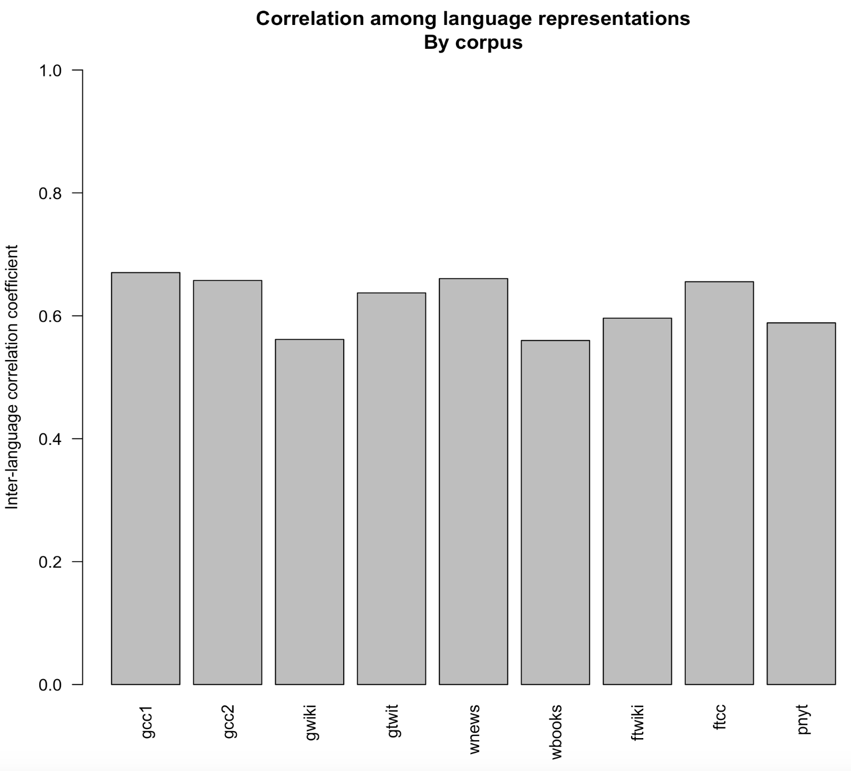
Figure S3. Correlations among language metrics by contemporary corpora. Higher values indicate stronger correlations among the four language metrics (WEAT-short, WEAT-long, MAC-short, MAC-long) within that corpus, indicating that the corpus gives reliable estimates. The codes for corpora are as follows: “gcc1” = GloVe Common Crawl 840B, “gcc2” = GloVe Common Crawl 42B, “gwiki” = GloVe Wikipedia, “gtwit” = GloVe Twitter, “wbooks” = word2vec Books, “wnews” = word2vec News, “fcc” = fastText Common Crawl, “ftwiki” = fastText Wikipedia, “pnyt” = PPMI NYT.

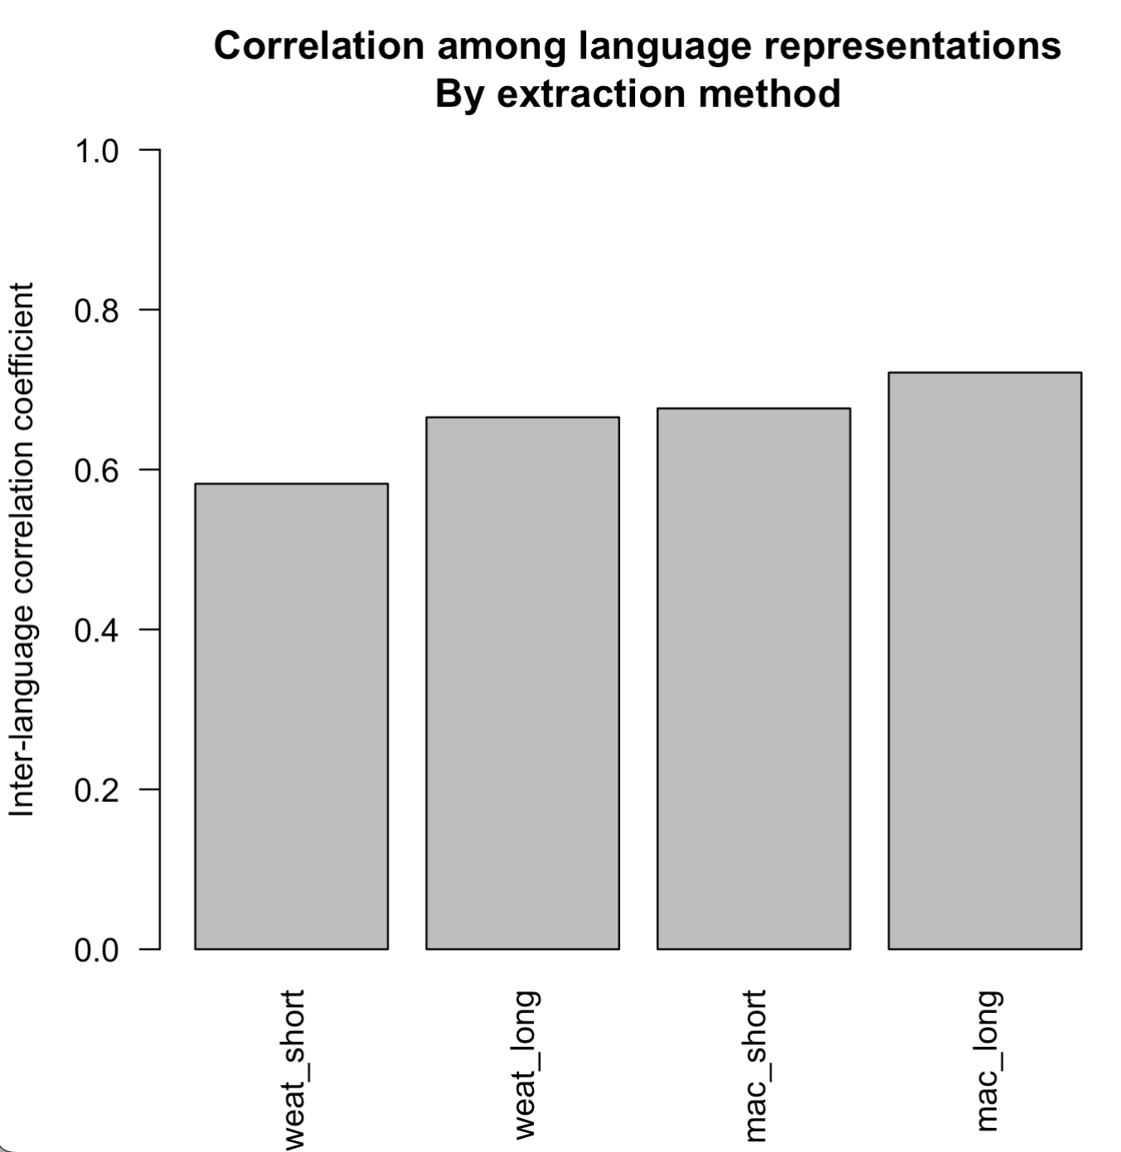
Figure S4. Correlations among corpora by language metric. Higher values indicate stronger correlations among the nine contemporary corpora for each of the metrics (WEAT-short, WEAT-long, MAC-short, MAC-long), indicating that that metric gives more reliable estimates across corpora.

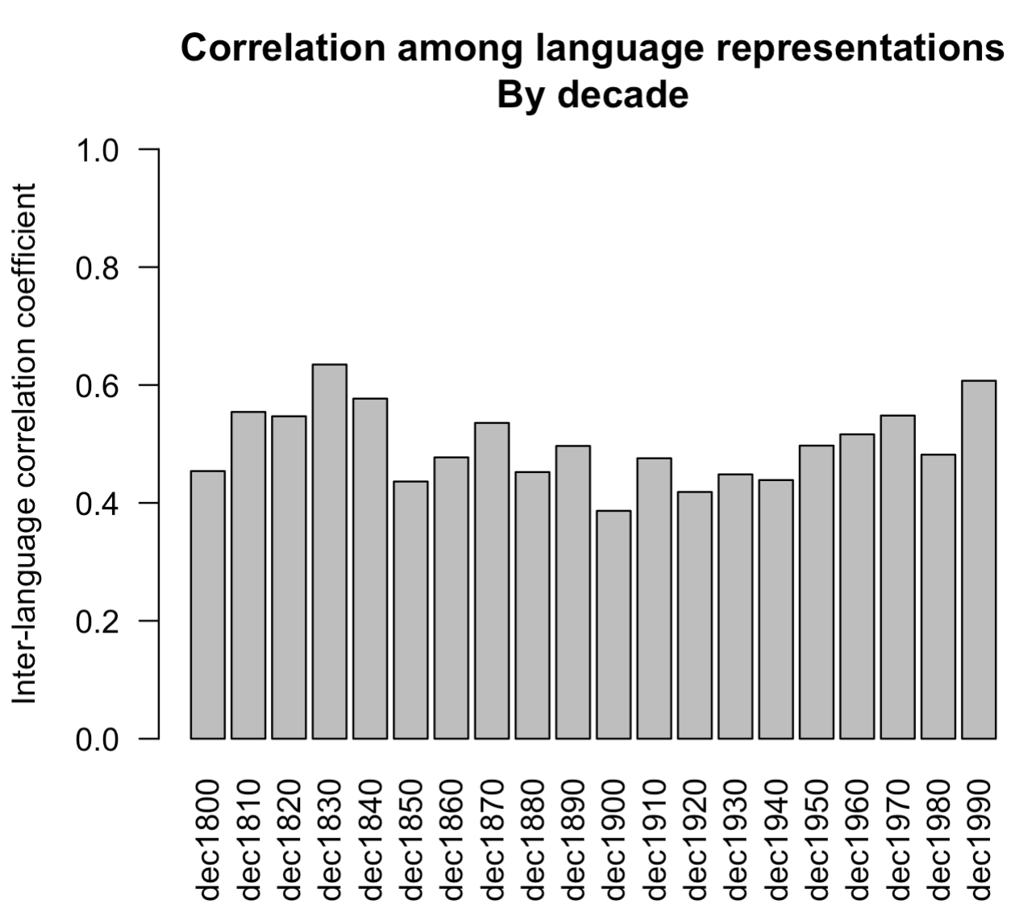
Figure S5. Correlations among the book corpora by decade. Higher values indicate stronger correlations across the four metrics (WEAT-short, WEAT-long, MAC-short, MAC-long) for a given decade of book text. The higher the score, the more reliable the estimates from that decade.

