SUPPLEMENTARY INFORMATION

Treeline displacement may affect lake dissolved organic matter processing at high latitudes and altitudes

Núria Catalán^{1,2}, Carina Rofner³, Charles Verpoorter⁴, María Teresa Pérez³, Thorsten Dittmar^{6,7}, Lars Tranvik¹, Ruben Sommaruga³ and Hannes Peter^{3,6*}
¹Limnology, Department of Ecology and Genetics, University of Uppsala, Uppsala, Sweden
²Present address: Institute of Environmental Assessment and Water Research (IDAEA), CSIC, Barcelona, Spain
³Lake and Glacier Ecology Research Group, Department of Ecology, Universität Innsbruck, Innsbruck, Austria
⁴Université Littoral Cote d’Opale, CNRS, Université Lille, UMR 8187, Laboratoire d’Océanologie et de Géosciences, Wimereux, F629300 Wimereux, France
⁵Institute for Chemistry and Biology of the Marine Environment (ICBM), University of Oldenburg, Oldenburg, Germany
⁶River Ecosystems Laboratory, École Polytechnique Fédérale de Lausanne (EPFL), Lausanne, Switzerland
⁷Helmholtz Institute for Functional Marine Biodiversity (HIFMB) at the University of Oldenburg, Oldenburg, Germany
*corresponding author

INDEX
S. I. 1.- Optical spectroscopy and PARAFAC model
S. I. 2.- Reactivity continuum models on bulk DOC
S. I. 3.- FT-ICR MS data treatment
S.I. 4.- Microbial respiration

S. I. 1.- Optical spectroscopy and PARAFAC model
PARAFAC modelling
Scatter peaks and outliers were removed and each sample normalized to its total fluorescence prior to fitting a PARAFAC model. The appropriate number of components was determined by visual inspection of the residuals and of the components' behavior as organic fluorophores (Lakowicz, 2006; Murphy et al., 2013). The model was then validated by split-half analysis and random initialization with 10 iterations. We interpreted the components based on their fluorescence maxima, and compared them (TCC = 96%) with the matched emission and excitation spectra in the OpenFluor database of components previously identified in natural aquatic systems (https://openfluor.lablicate.com/), in order to search for quantitative matches with previously published and validated PARAFAC models (Murphy et al., 2014).
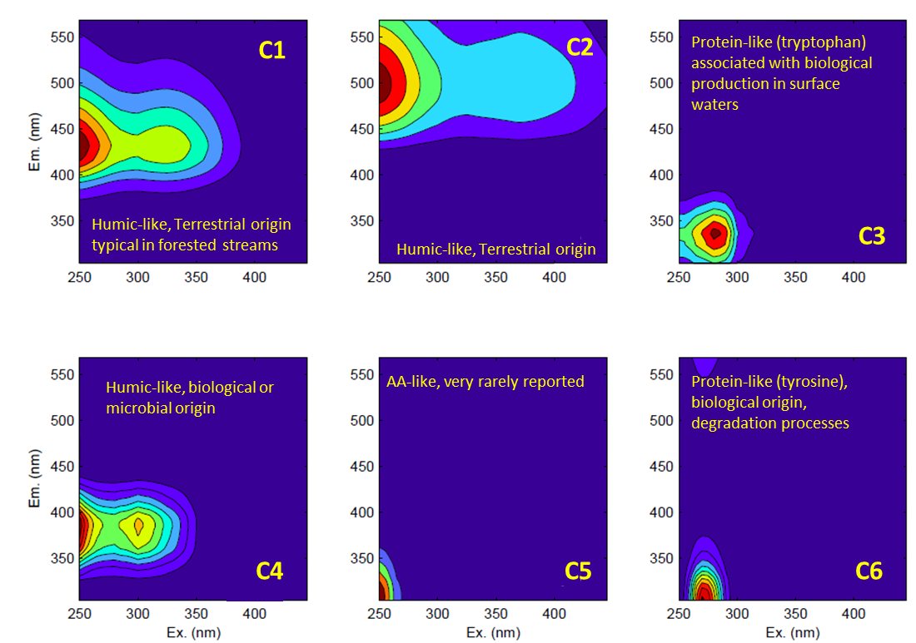
Supplementary Figure S1. Fingerprints of the 6 components identified in the PARAFAC model. The model is available at the OpenFluor database under accession number: XXXXXX
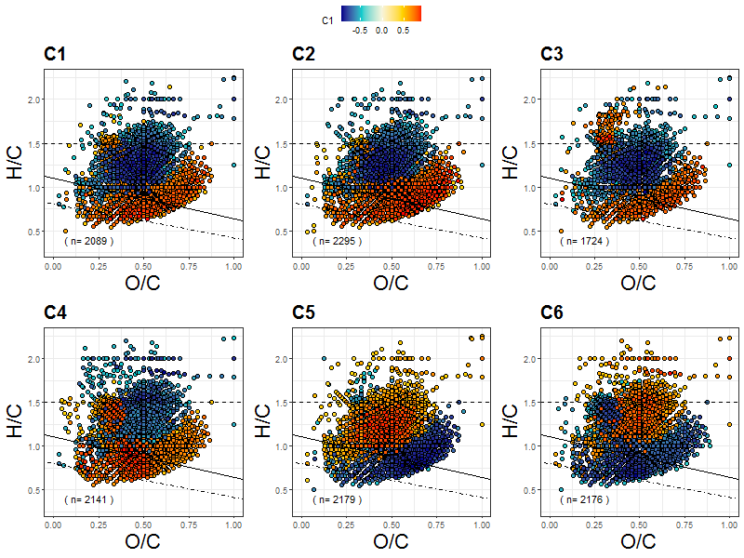
Supplementary Figure S2. Van Krevelen diagrams showing significant (p<0.05) Spearman rank correlations between individual compound intensity and PARAFAC components. Significance of Spearman correlations have been corrected for multiple comparisons. Lines separate compound groups as in Figure 1 (main text).

S. I. 2.- Reactivity continuum models on bulk DOC
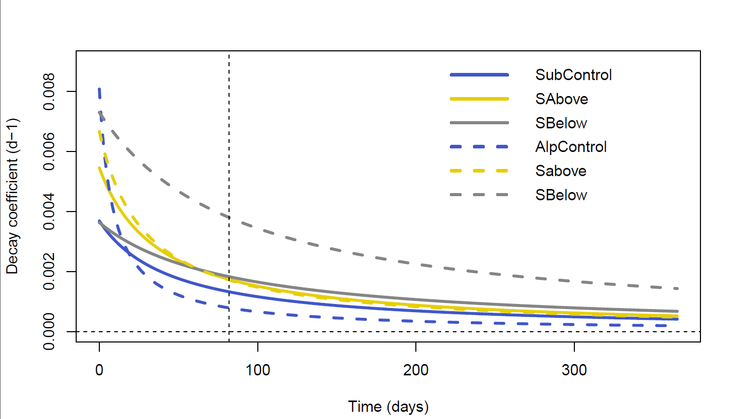
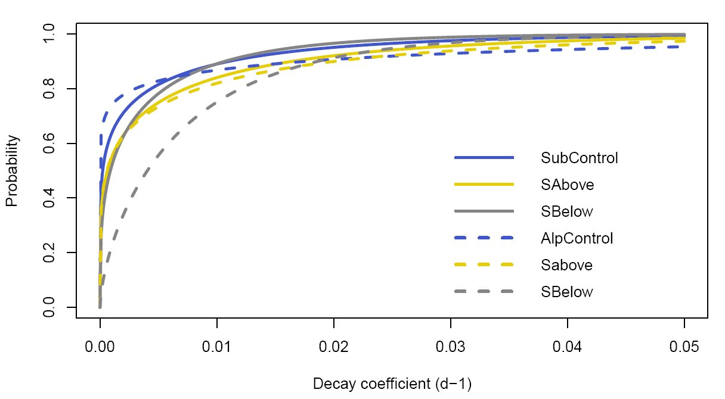
Supplementary Figure S3. Modelled decay coefficients (d⁻¹) (a) and probability distribution of decay coefficients (b) obtained from the reactivity continuum modeling of bulk DOC concentration for the different treatments and at each location. Model parameters are provided in Supplementary Table S1.

Supplementary Table S1. Parameter of the reactivity continuum model of DOC degradation during long-term-incubations of samples amended with soil above (S-Above) and below (S-Below) the treeline and their corresponding, unamended lake water control in the subarctic and alpine lake.
 | Subarctic lake |  |  |  | Alpine lake
 | Control | S-Above | S-Below |  | Control | S-Above | S-Below
α (days)ª | 45.88±1.61 | 38.32±1.72 | 83.02±1.73 |  | 8.84±2.67 | 28.43±3.11 | 88.95±2.33
ν^{b} | 0.169±0.009 | 0.209±0.016 | 0.301±0.039 |  | 0.715±0.002 | 0.189±0.025 | 0.65±0.28
k (d⁻¹)^{c} | 0.0037±0.0002 | 0.0055±0.0005 | 0.0036±0.0005 |  | 0.0081±0.002 | 0.0067±0.0011 | 0.0073±0.0032
Values for the model parameters are predicted estimates and associated standard errors (SEs). SE for k correspond to the combined errors of α and ν
ª average lifetime of the more reactive compounds
^{b} relative preponderance of the most persistent compounds
^{c} initial apparent decay coefficient

Supplementary Figure S4. Van Krevelen diagram depicting significant (p<0.05) Spearman rank correlations between individual compounds and bulk organic carbon decay rates. Rank correlations were corrected for multiple comparisons. Decay rates correspond to the output of the reactivity continuum models fit for the long-term incubations for the times sampled during the in-situ incubation (0, 6, 24 and 72 hours). Since individual compounds can overlap in Van Krevelen space, points are plotted in order by absolute values of ρ, such that stronger correlations are displayed on top.

S. I. 3.- FT-ICR MS data treatment
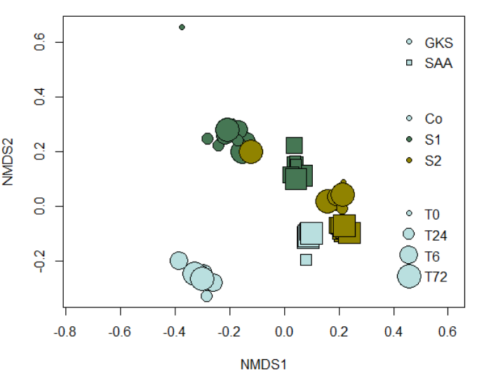
Supplementary Figure S5. Non-metric dimensional scaling (NMDS) on the Bray Curtis distances calculated for normalized peaks intensity. Stress= 0.084. For Subarctic samples (SAA), replicates A at times 0 and 72 h (indicated with a red arrow) were considered outliers based on this result.

S.I. 3.2.- Exponential fits on individual compounds
In order to assess the degradation and accumulation/production of each individual compound during the short-term incubation, we followed the procedure described in (Mostovaya et al., 2017). Briefly, according to the reactivity continuum model underlying hypothesis (Koehler et al., 2012), an exponential model was fitted to each individual compound using the gnls function of the nlme package in R. Model fit was evaluated according to its RMSE and the p-value of the fitted coefficient, models with RMSE > 0.358 and/or p-value > 0.05 were not considered. A more stringent criteria was used as the models were built upon four time points. The distribution of k obtained for each replicate was then tested against and idealized random distribution of intensities and only validated if those were significantly different using a Kolmogorov-Smirnoff test (ks.test; Supplementary Figure S5).
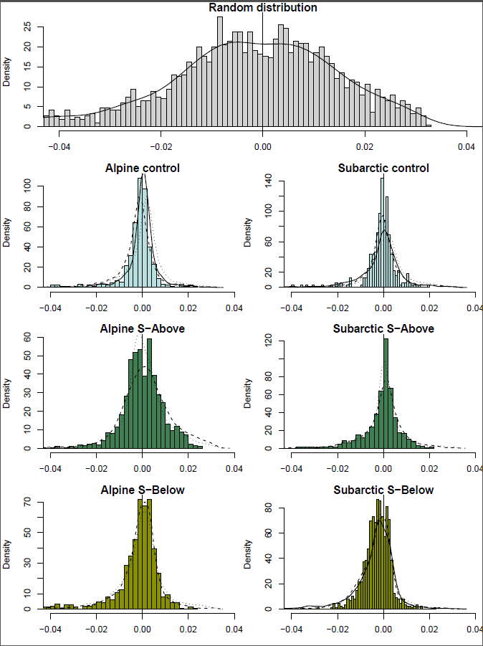
Supplementary Figure S6. Distribution of exponential coefficients k (h⁻¹) for the two lakes and three treatments. The distribution for the randomized dataset is also provided. The histogram corresponds to the first replicate available in all cases. Density lines for all the replicates available for a given site and treatment are plotted, with replicate A being a solid line, replicate B a dashed line and replicate C a dotted line. Differences between distributions of each treatment and site were examined using non-parametric Kruskal–Wallis tests with a post-hoc multiple comparison Dunn’s test (Supplementary Table S2).

Supplementary Table S2. Non-parametric Kruskal–Wallis tests with post-hoc comparisons (Dunn’s test) on differences in distributions of k between sample pairs.
 | Alpine Control | Alpine  S-Above |  |  |  | Subarctic  Control | Subarctic S-Above
Alpine  S-Above | -3.14 |  |  |  | Subarctic  S-Above | -3.09
Alpine  S-Above | p<0.01 |  |  |  | Subarctic  S-Above | p<0.01
Alpine  S-Below | 0.92 | 3.70 |  |  | Subarctic  S-Below | 2.04 | 4.91
Alpine  S-Below | p=-0.18 | p<0.01 |  |  | Subarctic  S-Below | p=0.02 | p<0.01

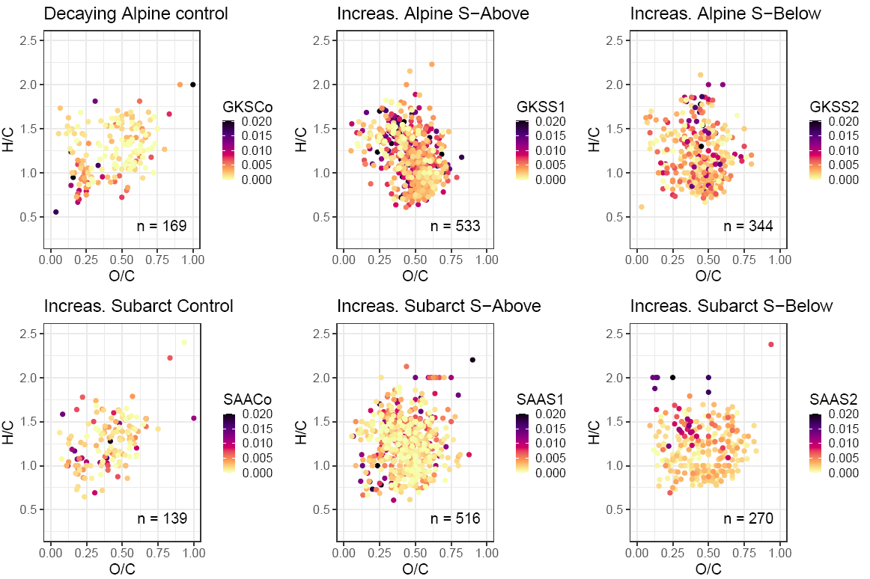
Supplementary Figure S7. Van Krevelen diagrams of compounds that increased over time in the different incubations.

S. I. 3.3. Chemodiversity

Supplementary Figure S8. Rank-intensity plots showing the distribution of relative intensity of control (orange), S-Above (turquois) and S-Below (red) treatments at the initial timepoint in the Alpine (a) and Subarctic (b) lake. Note the log-scale of the y-axis and the few (~10) high-intensity compounds, particularly in the S-Above treatment.

Supplementary Figure S9. Dendrogram of chemical similarity of all DOM compounds underlying chemodiversity estimation. Compound categories are color-coded (see legend) while continuous values (m/z, H:C, O:C, modified Aromaticity Index and Double Bond Equivalent) are show as colored gradients with low values being bright colors. For the calculation of chemodiversity, the total branch length in the dendrogram connecting 3000 randomly sampled DOM compounds was measured using the R function treedive.
a
b

Supplementary Figure S10. Chemodiversity increased proportionately with increasing subsample size (a). The results for n=3000 (1:1 line) are reported in the main text. Panel b provides a comparison between the chemodiversity index and Rao’s Quadratic Entropy measure of chemodiversity (Tanentzap et al., 2019) which takes relative peak intensity into account.

S.I. 4.-Microbial respiration
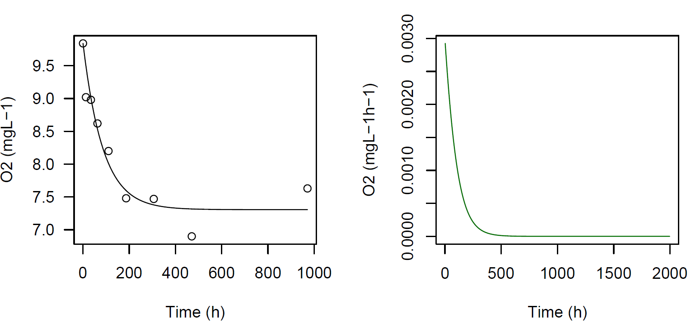
c
b
a
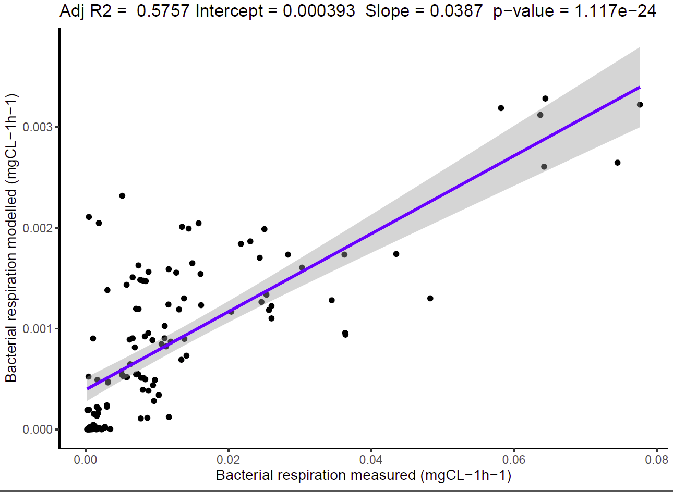

Supplementary Figure S11. Bacterial respiration rates calculation. Oxygen concentration was measured regularly during the incubation for the replicate 3 of the S-Above treatment of the Sub-Arctic site (a) using a Microx system (PreSens, Germany). The line corresponds to the non-linear fit. Bacterial respiration rates were calculated in two different ways. Method I: Respiration rates were obtained for the same replicate as the slope at each point of the curve (b). Note that modelled values are shown to up to 2000 h. For this, we fitted a non-linear model to the oxygen concentration time series for each replicate using the drm function of the drc package in R. Then, we calculated the slope of each point of the model and extracted the values for the measured time points to obtain the corresponding instantaneous bacterial respiration rates. Additionally, for each oxygen measurement, the Microx system was maintained in the sample for up to 5 minutes (Method II). We fitted a linear model to the measured O₂ during these periods and considered the slope of these models as bacterial respiration rate of that time point. When comparing bacterial respiration rates obtained using the two methods, we found significant correlation between Method I and Method II (c). However, we also found a difference of one order of magnitude in terms of respiration rate magnitude between both methods. We believe this is an effect of the short measurement period used in Method II, which can lead to overestimation of oxygen consumption rates (Pollard, 2013). Moreover, when comparing the values with previous studies using similar setups (Berggren et al., 2012; del Giorgio and Cole, 1998; Guillemette and del Giorgio, 2011), we find the rates obtained with Method I to fall within a similar range and thus use them preferentially in this study.

Assessing differences between treatments in the long-term incubations.
Data from long-term incubations (bacterial respiration, production rates and optical spectroscopy parameters) was analyzed using linear mixed effects models (lme function from nlme package; Pinheiro et al. 2020). The model contained the linear and interaction terms of site (Sub-Arctic or Alpine) and treatment (Control, S_Above and S_Below) as well as time as a random effect. We included a first-order temporal autoregressive process and a variance function allowing for different variances of the response variable per level of fixed effect when needed. Models were checked using diagnostic residual plots and the significance of the fixed effects was tested using an anova against a null model containing only the random effect (Crawley, 2012). Collinearity was assessed by checking VIF values (vif function of the car package). The final model structure was selected by model comparison.

References
Berggren, M., Lapierre, J.-F., del Giorgio, P. a., 2012. Magnitude and regulation of bacterioplankton respiratory quotient across freshwater environmental gradients. The ISME Journal 6, 984–993. https://doi.org/10.1038/ismej.2011.157
Crawley, M.J., 2012. The R Book.
del Giorgio, P. a., Cole, J.J., 1998. Bacterial growth efficiency in natural aquatic systems. Annual Review of Ecology and Systematics 29, 503–541. https://doi.org/10.1146/annurev.ecolsys.29.1.503
Guillemette, F., del Giorgio, P. a., 2011. Reconstructing the various facets of dissolved organic carbon bioavailability in freshwater ecosystems. Limnology and Oceanography 56, 734–748. https://doi.org/10.4319/lo.2011.56.2.0734
Koehler, B., Von Wachenfeldt, E., Kothawala, D.N., Tranvik, L.J., 2012. Reactivity continuum of dissolved organic carbon decomposition in lake water. Journal of Geophysical Research: Biogeosciences 117, 1–14. https://doi.org/10.1029/2011JG001793
Lakowicz, J.R., 2006. Principles of Fluorescence Spectroscopy, 3rd ed.
Mostovaya, A., Hawkes, J.A., Koehler, B., Dittmar, T., Tranvik, L.J., 2017. Emergence of the Reactivity Continuum of Organic Matter from Kinetics of a Multitude of Individual Molecular Constituents. Environmental Science & Technology 11571−11579. https://doi.org/10.1021/acs.est.7b02876
Murphy, K.R., Stedmon, C.A., Graeber, D., Bro, R., 2013. Fluorescence spectroscopy and multi-way techniques. PARAFAC. Anal. Methods 5, 6557–6566. https://doi.org/10.1039/C3AY41160E
Murphy, K.R., Stedmon, C.A., Wenig, P., Bro, R., 2014. OpenFluor– an online spectral library of auto-fluorescence by organic compounds in the environment. Anal. Methods 6, 658–661. https://doi.org/10.1039/C3AY41935E
Pollard, P.C., 2013. In situ rapid measures of total respiration rate capture the super labile doc bacterial substrates of freshwater. Limnology and Oceanography: Methods 11, 584–593. https://doi.org/10.4319/lom.2013.11.584
Tanentzap, A.J., Fitch, A., Orland, C., Emilson, E.J.S., Yakimovich, K.M., Osterholz, H., Dittmar, T., 2019. Chemical and microbial diversity covary in fresh water to influence ecosystem functioning. PNAS 116, 24689–24695. https://doi.org/10.1073/pnas.1904896116

