Supplementary Information (SI) for
Optimizing Industrial Structure to Achieve Sustainable and Low-carbon Goal for Resource Development
Xin Xie¹, Shanying Hu^{1,*}, Qisheng Zhu¹, Hang Fu¹
1, Center for Industrial Ecology, Department of Chemical Engineering, Tsinghua University, Beijing
100084, China
∗ Corresponding author: Prof. Shanying Hu
Phone & Fax: (+)86 10 62794513
E-mail: hxr-dce@tsinghua.edu.cn

Number of Pages: 56
Number of Figures: 27
Number of Tables: 6

Appendix A.1. Model introduction
In this study, we develop a resource-based regional industrial economy development optimization model (RRIEDOM), which is a bottom–up model that integrates a material flow model, network analysis, and optimization to achieve multiple economic, environmental, and resource objectives. The main target of this model is to find out an optimal solution to utilize the local resources and to find out a minimal cost transition path of adjustment of local industries. There are seven sections of RRIEDOM: resource endowment investigation, establishment of the node information database, interactive inference, establishment of available technologies database, core nodes identification, construction of superstructure, multi-objective optimization, and scenario setting. The following parts will give a detailed description of each section.
Fig.S1. Framework of RRIEDOM. There are seven sections of RRIEDOM: resources endowment investigation, interactive inference, construction of available technologies database, core nodes identification, construction of superstructure, multi-objective optimization, and scenario setting.

Appendix A.2. Nomenclature
Parks
park-1 | Geermu industrial park
park-2 | Dachaidan industrial park
park-3 | Delhi industrial park
park-4 | Ulan industrial park

Sets
i | nodes | /1*184/
j | resources | /1*255/
a | parks | /park-1, park-2, park-3, park-4/
t | years | /2025*2055/
k | energy category | /steam, diesel oil, biomass, coke, coal/
M | industry category | /Saline lake industry, Organic chemical industry, Inorganic chemical industry, Metal smelting and processing industry, Lithium deep processing industry, Comprehensive waste utilization industry/
Subsets
$${Node}_{i,m}$$ | Nodes in the industry category m
$${Outreso}_{i,j}$$ | Output of resource j of node i
$${Inreso}_{i,j}$$ | Input of resource j of node i
Variables
$x_{i,a,t}$ | The size factor of node i in park a of year t
Park-level
$${TGV}_{a,t}$$ | Gross value of industrial output of park a in year t
$${TCE}_{a,t}$$ | Total amount of carbon emission of park a in year t
$${TWC}_{a,t}$$ | Total amount of freshwater consumption of park a in year t
$${TEC}_{a,t}$$ | Total amount of electricity consumption of park a in year t
$${TSG}_{a,t}$$ | Total amount of solid waste output of park a in year t
$${TIN}_{a,t}$$ | Total amount of capital investment of park a in year t
$${TP}_{a,t}$$ | Total amount of profit of park a in year t
$${TEN}_{a,t}$$ | Total amount of energy consumption of park a in year t
$${TWW}_{a,t}$$ | Total amount of sewage of park a in year t
$${TWWI}_{a,t}$$ | Total amount of investment of sewage infrastructure of park a in year t
$${TWWE}_{a,t}$$ | Total amount of electricity consumption of sewage infrastructure of park a in year t
$${TWWAC}_{a,t}$$ | Total amount of annual cost of sewage infrastructure of park a in yeart
$${TWI}_{a,t}$$ | Freshwater consumption intensity of park a in year t
$${TCI}_{a,t}$$ | Carbon emission intensity of park a in year t
$${TELI}_{a,t}$$ | Electricity consumption intensity of park a in year t
$${TENI}_{a,t}$$ | Energy consumption intensity of park a in year t
$${TSI}_{a,t}$$ | Solid waste output intensity of park a in year t
$${TWP}_{a,t}$$ | Freshwater productivity of park a in year t
$${TEP}_{a,t}$$ | Energy productivity of park a in year t

Industry-level
$${GV}_{a,t,m}$$ | Gross value of industrial output of industry m in park a in year t
$${CE}_{a,t,m}$$ | Total amount of carbon emission of industry m in park a in year t
$${WC}_{a,t,m}$$ | Total amount of freshwater consumption of industry m in park a in year t
$${EC}_{a,t,m}$$ | Total amount of electricity consumption of industry m in park a in year t
$${SG}_{a,t,m}$$ | Total amount of solid waste output of industry m in park a in year t
$${IN}_{a,t,m}$$ | Total amount of capital investment of industry m in park a in year t
$$P_{a,t,m}$$ | Total amount of profit of industry m in park a in year t
$${EN}_{a,t,m}$$ | Total amount of energy consumption of industry m in park a in year t
$${WW}_{a,t,m}$$ | Total amount of sewage of industry m in park a in year t
$${WWI}_{a,t,m}$$ | Total amount of investment of sewage infrastructure of industry m in park a in year t
$${WWE}_{a,t,m}$$ | Total amount of electricity consumption of sewage infrastructure of industry m in park a in year t
$${WWAC}_{a,t,m}$$ | Total amount of annual cost of sewage infrastructure of industry m in park a in yeart
$${WI}_{a,t,m}$$ | Freshwater consumption intensity of industry m in park a in year t
$${CI}_{a,t,m}$$ | Carbon emission intensity of industry m in park a in year t
$${ELI}_{a,t,m}$$ | Electricity consumption intensity of industry m in park a in year t
$${ENI}_{a,t,m}$$ | Energy consumption intensity of industry m in park a in year t
$${SI}_{a,t,m}$$ | Solid waste output intensity of industry m in park a in year t
$${WP}_{a,t,m}$$ | Freshwater productivity of industry m in park a in year t
$${EP}_{a,t,m}$$ | Energy productivity of industry m in park a in year t

Node-level
$${NGV}_{a,t,i}$$ | Gross value of industrial output of node i in park a in year t
$${NCE}_{a,t,i}$$ | Amount of carbon emission of node i in park a in year t
$${NCEE}_{a,t,i}$$ | Amount of carbon emission due to the electricity consumption of node i in park a in year t
$${NCES}_{a,t,i}$$ | Amount of carbon emission due to the steam heating of node i in park a in year t
$${NCED}_{a,t,i}$$ | Amount of carbon emission due to the direct emission from the process of node i in park a in year t
$${NCEO}_{a,t,i}$$ | Amount of carbon emission due to other fuels consumption of node i in park a in year t
$$N{WC}_{a,t,i}$$ | Amount of freshwater consumption of node i in park a in year t
$${NEC}_{a,t,i}$$ | Amount of electricity consumption of node i in park a in year t
$${NSG}_{a,t,i}$$ | Amount of solid waste output of node i in park a in year t
$${NIN}_{a,t,i}$$ | Amount of capital investment of node i in park a in year t
$${NP}_{a,t,i}$$ | Amount of profit of node i in park a in year t
$${NEN}_{a,t,i}$$ | Amount of energy consumption of node i in park a in year t
$${NWW}_{a,t,i}$$ | Amount of sewage of node i in park a in year t
$${NEXP}_{a,t,i}$$ | Cost of node i of park a in year t
$${NEC}_{a,t,i}$$ | Cost of energy consumption of node i of park a in year t
$${NRC}_{a,t,i}$$ | Cost of raw material of node i of park a in year t
$${NSWC}_{a,t,i}$$ | Cost of solid waste disposal of node i of park a in year t
$${NFWC}_{a,t,i}$$ | Cost of freshwater consumption of node i of park a in year t
$${NIDC}_{a,t,i}$$ | Cost of investment depreciation of node i of park a in year t
$${NOVC}_{a,t,i}$$ | Other variable costs of node i of park a in year t

Parameters
$${PP}_{j}$$ | Current price of resource j
$${PEP}_{j,a,t}$$ | Amount of initial supply of resources j of park a in year t
$${PN}_{i,j}$$ | Amount of input/output of resource j of node i with respect to the reference resource per unit production
$${PWC}_{i}$$ | Amount of freshwater consumption of node i with respect to the reference resource per unit production
$${PWCF}_{i}$$ | Factors of sewage output of node i
$${PSWO}_{i}$$ | Amount of solid waste output of node i with respect to the reference resource per unit production
$${PEEC}_{i}$$ | Amount of electricity consumption of node i with respect to the reference resource per unit production
$$P{INC}_{i}$$ | Amount of capital investment of node i with respect to the reference resource per unit production
$${PEEC}_{k,m}$$ | Cost of the use of energy k per unit
$$PFWC$$ | Cost of industrial water use
$$P{NEC}_{i}$$ | Cost of energy consumption of node i of park a in year t with respect to the reference resource per unit production
$${PRC}_{i}$$ | Cost of resources consumption of node i of park a in year t with respect to the reference resource per unit production
$${PSWC}_{i}$$ | Cost of solid waste disposal of node i of park a in year t with respect to the reference resource per unit production
$${PFWC}_{I}$$ | Cost of freshwater consumption of node i of park a in year t with respect to the reference resource per unit production
$${PIDC}_{i}$$ | Cost of investment depreciation of node i of park a in year t with respect to the reference resource per unit production
$${POVC}_{i}$$ | Other variable costs of node i of park a in year t with respect to the reference resource per unit production
$${PEC}_{i,k}$$ | Amount of consumption of energy k of node i with respect to the reference resource per unit production
$${PCC}_{k}$$ | Carbon emission factor of energy k
$${PCEP}_{a,t}$$ | Constraint of energy productivity of park a in year t
$${PCWP}_{a,t}$$ | Constraint of freshwater productivity of park a in year t
$${PCWI}_{a,t}$$ | Constraint of freshwater consumption intensity of park a in year t
$${PCEI}_{a,t}$$ | Constraint of energy consumption intensity of park a in year t
$${PTWC}_{a,t}$$ | Constraint of total fresh water consumption of park a in year t
$${PLBN}_{a,t,i}$$ | Lower bound of node i of park a in year t
$${PUBN}_{a,t,i}$$ | Upper bound of node i of park a in year t
$${MINE}_{a,t}$$ | Minimal economic growth goal of park a in year t
$${MAXIN}_{a,t}$$ | Maximal capital investment input of park a in year t
$${POD}_{i}$$ | Period of depreciation of node i
$$PWWI$$ | Sewage infrastructure capital investment per unit sewage disposal
$$PWWA$$ | Sewage infrastructure annual operational cost per unit sewage disposal
$$PWWE$$ | Sewage infrastructure annual electricity consumption per unit sewage disposal

Appendix A.3. Optimization Mathematical Model
The complete non-linear programming (NLP) model consists of: (i) the network design constraints for the production of all nodes and resources, (ii) the policy constraints of parks in different years, (iii) the constraints of nodes bounds, (iv) the economic output and cost functions of parks, industries, and nodes levels, (v) the environmental impact functions of parks, industries, and nodes levels, (vi) the resources consumption functions of parks, industries, and nodes levels, (vii) the intensity and productivity functions of parks, (viii) objective function.
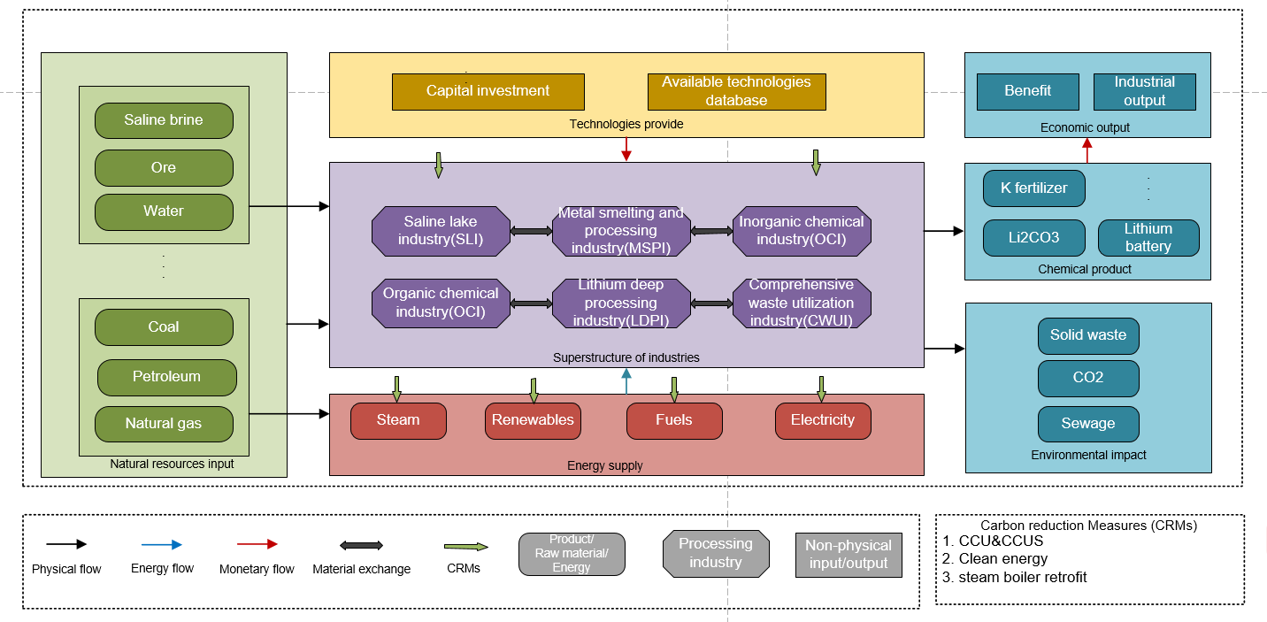
Fig.S2. Framework of the multi-objective NLP model.

Network Design Constraints
Equations for superstructure network design, that allow all the consumptions of resource j of all nodes to be constrained are shown in Equations A.1. The total amount of the consumption of resource j does not be allowed to exceed the initial supply amount of resource j. ${PN}_{i,j}$ is the element of a sparse matrix that saves the information of nodes’ input/output associated with resources:
$$\begin{aligned}\sum_{i}{{PN}_{i,j}x_{i,a,t}}+{PEP}_{j,a,t} ≥0 ∀j,a,t \#\left(A.1\right)\end{aligned}$$
Policy, Economic, and Resources Consumption Constraints
Equations for policy constraints, that allow to constraint the minimal economic goal, max capital investment, resources consumption, park-level intensity function of resources consumption and contaminants output, park-level productivity function of resources consumption are shown in Equations A.2 to A.8. The intensity and productivity of parks should comply with the statutory regulation stipulated by the government. And each park has an economic development target and a total fixed capital investment limit:
$$\begin{aligned}{TWI}_{a,t}≤{PCWI}_{a,t} ∀a,t\#\left(A.2\right)\end{aligned}$$
$$\begin{aligned}{TENI}_{a,t}≤{PCEI}_{a,t} ∀a,t\#\left(A.3\right)\end{aligned}$$
$$\begin{aligned}{TWP}_{a,t}≥{PCWP}_{a,t} ∀a,t\#\left(A.4\right)\end{aligned}$$
$$\begin{aligned}{TEP}_{a,t}{≥PCEP}_{a,t} ∀a,t\#\left(A.5\right)\end{aligned}$$
$$\begin{aligned}{TWC}_{a,t}≤P{TWC}_{a,t} ∀a,t\#\left(A.6\right)\end{aligned}$$
$$\begin{aligned}{TGV}_{a,t}≥{MINE}_{a,t} ∀a,t\#\left(A.7\right)\end{aligned}$$
$$\begin{aligned}{TIN}_{a,t}≤{MAXIN}_{a,t} ∀a,t\#\left(A.8\right)\end{aligned}$$
Nodes Bounds
Equations A.9 set the lower and upper bounds of nodes of all nodes. During the optimization, a node may change its size between the lower and upper bounds. And the upper bounds are set according to the current maximal commercial capacity of related technologies:
$$\begin{aligned}{PLBN}_{a,t,i}≤x_{i,a,t}≤{PUBN}_{a,t,i} ∀a,i,t\#\left(A.9\right)\end{aligned}$$
Economic Output and Cost Functions
Park-level
There are three indicators (gross value of industrial output (${TGV}_{a,t})$, total capital investment (${TIN}_{a,t}$), total profit (${TP}_{a,t}$) ) selected as the description of industrial park economic development, These three indicators are calculated according to Equation A.10 to A.12.
$$\begin{aligned}{TGV}_{a,t}= \sum_{m}{{GV}_{a,t,m}}∀a,t\#\left(A.10\right)\end{aligned}$$
$$\begin{aligned}{TIN}_{a,t}=\sum_{m}{{IN}_{a,t,m}}∀a,t\#\left(A.11\right)\end{aligned}$$
$$\begin{aligned}{TP}_{a,t}=\sum_{m}{P_{a,t,m}}∀a,t\#\left(A.12\right)\end{aligned}$$
Industry-level
A total of six industry categories are involved in the superstructure of network optimization, which is saline lake industry (SLI), organic chemical industry (OCI), inorganic chemical industry (IOCI), metal smelting and processing industry (MSPI), lithium deep processing industry (LDPI), and comprehensive waste utilization industry (CWUI). The gross value of industrial output (${GV}_{a,t,m})$, capital investment (${IN}_{a,t,m}$), and profit ($P_{a,t,m}$) for each industry is the sum of its subset of nodes. The relevant equations are shown below from A.13 to A.15:
$$\begin{aligned}{GV}_{a,t,m}= \sum_{i}{{NGV}_{a,t,i}} ∀a, t, i∈{Node}_{i,m}\#\left(A.13\right)\end{aligned}$$
$$\begin{aligned}{IN}_{a,t,m}= \sum_{i}{{NIN}_{a,t,i}} ∀a, t, i∈{Node}_{i,m}\#\left(A.14\right)\end{aligned}$$
$$\begin{aligned}P_{a,t,m}= \sum_{i}{{NP}_{a,t,i}} ∀a, t, i∈{Node}_{i,m}\#\left(A.15\right)\end{aligned}$$
Node-level
The economic dimension of each node is described in terms of the gross value of industrial output (${NGV}_{a,t,i}$), profit (${NP}_{a,t,i}$), and capital investment (${NIN}_{a,t,i}$). In regard as ${NGV}_{a,t,i}$, the economic value of resources out from node i is considered and calculated with the size factor according to the current price. As for ${NP}_{a,t,i}$. The fixed cost and variable cost (${NEXP}_{a,t,i})$of each node (including raw material cost (${NRC}_{a,t,i}$) , investment depreciation (${NIDC}_{a,t,i}$), water use cost (${NFWC}_{a,t,i}$), solid waste treatment cost (${NSWC}_{a,t,i}$), energy use cost (${NEC}_{a,t,i}$), other costs (${NOVC}_{a,t,i}$)) can be calculated by Equation A.16 to A.24, and the profit of node i is the total output value minus the total cost of the production process. And ${NIN}_{a,t,i}$, the capital investment of node
i , is calculated based on reference resource per unit production with size factor. Equations for node-level economic dimensions are shown in Equations A.16 to A.24:
$$\begin{aligned}{NGV}_{a,t,i}=\sum_{j}{{Outreso}_{i,j}}x_{i,a,t}{PP}_{j} ∀a,t,i\#\left(A.16\right)\end{aligned}$$
$$\begin{aligned}{NP}_{a,t,i}= \sum_{j}{{Outreso}_{i,j}}x_{i,a,t}{PP}_{j}-{NEXP}_{a,t,i} ∀a,t,i\#\left(A.17\right)\end{aligned}$$
$${NEXP}_{a,t,i}=\left({NRC}_{a,t,i}+{NIDC}_{a,t,i}+{NFWC}_{a,t,i}+{NSWC}_{a,t,i}+{NEC}_{a,t,i}+{NOVC}_{a,t,i}\right)x_{i,a,t} ∀a,t,i$$
$$\begin{aligned}{NRC}_{a,t,i}=\sum_{j}{{Inreso}_{i,j}x_{i,a,t}{PP}_{j}} ∀a,t,i\#\left(A.18\right)\end{aligned}$$
$$\begin{aligned}{NIDC}_{a,t,i}=\frac{{NIN}_{a,t,i}}{{POD}_{i }}∀a,t,i\#\left(A.19\right)\end{aligned}$$
$$\begin{aligned}{NSWC}_{a,t,i}= {NSG}_{a,t,i}{PSWC}_{i} ∀a,t,i\#\left(A.20\right)\end{aligned}$$
$$\begin{aligned}{NFWC}_{a,t,i}={PFWC}_{i}x_{i,a,t} ∀a,t,i\#\left(A.21\right)\end{aligned}$$
$$\begin{aligned}{NEC}_{a,t,i}={PEC}_{i,k}x_{i,a,t} ∀a,t,i,k\#\left(A.22\right)\end{aligned}$$
$$\begin{aligned}{NOVC}_{a,t,i}={POVC}_{i}x_{i,a,t} ∀a,t,i\#\left(A.23\right)\end{aligned}$$
$$\begin{aligned}{NIN}_{a,t,i}=P{INC}_{i}x_{i,a,t} ∀a,t,i\#\left(A.24\right)\end{aligned}$$

Environmental Impact Functions
Park-level
Carbon emission (${TCE}_{a,t}$), sewage output (${TWW}_{a,t}$), solid waste output (${TSG}_{a,t}$), sewage infrastructure capital investment (${TWWI}_{a,t}$), sewage infrastructure annual operation cost (${WWAC}_{a,t,m}$), and sewage infrastructure annual electricity consumption (${TWWE}_{a,t}$) are considered in environmental impact functions in park-level. The relevant equations for environmental impact functions are shown in Equations A.25 to A.30:
$$\begin{aligned}{TCE}_{a,t}= \sum_{m}{{CE}_{a,t,m}} ∀a,t\#\left(A.25\right)\end{aligned}$$
$$\begin{aligned}{TWW}_{a,t}= \sum_{m}{{WW}_{a,t,m}} ∀a,t\#\left(A.26\right)\end{aligned}$$
$$\begin{aligned}{TSG}_{a,t}= \sum_{m}{{SG}_{a,t,m}} ∀a,t\#\left(A.27\right)\end{aligned}$$
$$\begin{aligned}{TWWI}_{a,t}= \sum_{m}{{WWI}_{a,t,m}} ∀a,t\#\left(A.28\right)\end{aligned}$$
$$\begin{aligned}{WWAC}_{a,t,m}= \sum_{m}{{WWAC}_{a,t,m}} ∀a,t\#\left(A.29\right)\end{aligned}$$
$$\begin{aligned}{TWWE}_{a,t}= \sum_{m}{{WWE}_{a,t,m}} ∀a,t\#\left(A.30\right)\end{aligned}$$
Industry-level
Six environmental impact functions (${CE}_{a,t,m}, {WW}_{a,t,m}$, ${SG}_{a,t,m}$, ${WWI}_{a,t,m}, {WWAC}_{a,t,m}$, ${WWE}_{a,t,m}$) are selected to describe the environmental cost of different industry (SLI, OCI, IOCI, MSPI, LDPI, CWUI), the equations are shown in Equation A.31 to A.36:
$$\begin{aligned}{CE}_{a,t,m}= \sum_{i}{{NCE}_{a,t,i} ∀a,t, i∈}{Node}_{i,m}\#\left(A.31\right)\end{aligned}$$
$$\begin{aligned}{WW}_{a,t,m}= \sum_{i}{{NWW}_{a,t,i} ∀a,t, i∈}{Node}_{i,m}\#\left(A.32\right)\end{aligned}$$
$$\begin{aligned}{SG}_{a,t,m}= \sum_{i}{{NSG}_{a,t,i} ∀a,t, i∈}{Node}_{i,m}\#\left(A.33\right)\end{aligned}$$
$$\begin{aligned}{WWI}_{a,t,m}= {WW}_{a,t,m}{PWWI ∀a,t,i∈Node}_{i,m}\#\left(A.34\right)\end{aligned}$$
$\begin{aligned}{WWAC}_{a,t,m}= {WW}_{a,t,m}PWWA ∀a,t,i∈{Node}_{i,m}\#\left(A.35\right)\end{aligned}$
$$\begin{aligned}{WWE}_{a,t,m}= {WW}_{a,t,m}{PWWE ∀a,t,i∈Node}_{i,m}\#\left(A.36\right)\end{aligned}$$
Node-level
According to the IPCC instructions for carbon emissions, at the node level, the carbon emission (${NCE}_{a,t,i}$) for each node is further divided into four categories: (i) the carbon emission due to the electricity consumption of node production process (${NCEE}_{a,t,i}$), (ii) the carbon emission due to the steam heating of node production process (${NCES}_{a,t,i}$), (iii) the carbon emission due to the direct emission from the production process of node (${NCED}_{a,t,i}$), (iv) the carbon emission due to fuels consumption for the production process of node (${NCEO}_{a,t,i}$). The emission factors of each energy consumption are considered in the calculation. Sewage output (${NWW}_{a,t,i}$), solid waste output (${NSG}_{a,t,i}$) are two functions to describe the environmental impact of nodes. Equations are shown in Equations A.38 to A.44:
$$\begin{aligned}{NCE}_{a,t,i}= {NCEE}_{a,t,i}+{NCES}_{a,t,i}+{NCED}_{a,t,i}+{NCEO}_{a,t,i} ∀a,i,t\#\left(A.38\right)\end{aligned}$$
$$\begin{aligned}{NCEE}_{a,t,i}= {PEEC}_{i}x_{i,a,t}{PCC}_{electricity} ∀a,i,t\#\left(A.39\right)\end{aligned}$$
$$\begin{aligned}{NCES}_{a,t,i}={PEC}_{i,steam}x_{i,a,t}{PCC}_{steam} ∀a,i,t\#\left(A.40\right)\end{aligned}$$
$$\begin{aligned}{NCED}_{a,t,i}= {Outreso}_{i,{CO}_{2}}x_{i,a,t} ∀a,i,t\#\left(A.41\right)\end{aligned}$$
$$\begin{aligned} {NCEO}_{a,t,i}= {PEC}_{i,k,k≠steam}x_{i,a,t}{PCC}_{k,k≠steam} ∀a,i,t\#\left(A.42\right)\end{aligned}$$
$$\begin{aligned}{NWW}_{a,t,i}={PWCF}_{i}{PWC}_{i}x_{i,a,t} ∀a,i,t\#\left(A.43\right)\end{aligned}$$
$$\begin{aligned}{NSG}_{a,t,i}= {PSWO}_{i}x_{i,a,t} ∀a,i,t\#\left(A.44\right)\end{aligned}$$

Resources Consumption Functions
Park-level
Freshwater consumption (${TWC}_{a,t}$), energy consumption (${TEN}_{a,t},$converted to tce), and electricity consumption (${TEC}_{a,t}$) are included in the resources consumption functions at the park level for the measure of industrial park resources consumption.
$$\begin{aligned}{TWC}_{a,t}= \sum_{m}{{WC}_{a,t,m}} ∀a,t\#\left(A.45\right)\end{aligned}$$
$$\begin{aligned}{TEN}_{a,t}= \sum_{m}{{EN}_{a,t,m}} ∀a,t\#\left(A.46\right)\end{aligned}$$
$$\begin{aligned}{TEC}_{a,t}= \sum_{m}{{EC}_{a,t,m}} ∀a,t\#\left(A.47\right)\end{aligned}$$

Industry-level
At the industry level, there are three functions to describe the industry resources consumption, namely, freshwater consumption (${WC}_{a,t,m}),$ energy consumption (${EN}_{a,t,m}$), and electricity consumption (${EC}_{a,t,m}$).
$$\begin{aligned}{WC}_{a,t,m}= \sum_{i}{N{WC}_{a,t,i}} ∀a,t,i∈{Node}_{i,m}\#\left(A.48\right)\end{aligned}$$
$$\begin{aligned}{EN}_{a,t,m}= \sum_{i}{N{WC}_{a,t,i}} ∀a,t,i∈{Node}_{i,m}\#\left(A.49\right)\end{aligned}$$
$$\begin{aligned}{EC}_{a,t,m}= \sum_{i}{{NEC}_{a,t,i}} ∀a,t,i∈{Node}_{i,m}\#\left(A.50\right)\end{aligned}$$

Node-level
At the node level, there are three functions to measure the nodes’ resources consumption degree, namely, freshwater consumption ($N{WC}_{a,t,i}),$ energy consumption (${NEN}_{a,t,i}$), and electricity consumption (${NEC}_{a,t,i}$). The relevant equations are Equations A.51 to A.53:
$$\begin{aligned}N{WC}_{a,t,i}= \sum_{i}{{PWC}_{i}}x_{i,a,t} ∀a,t\#\left(A.51\right)\end{aligned}$$
$$\begin{aligned}{NEN}_{a,t,i}= \sum_{i}{\sum_{k}{{PEC}_{i,k}}x_{i,a,t}} ∀a,t\#\left(A.52\right)\end{aligned}$$
$$\begin{aligned}{NEC}_{a,t,i}= \sum_{i}{{PEEC}_{i}}x_{i,a,t} ∀a,t\#\left(A.53\right)\end{aligned}$$
Intensity and Productivity Functions
The intensity of resource consumption measures the amount of resources consumed per unit of economic output, and through these functions, the relationship between resource consumption and economic development at the park level can be traced, while constraints can be placed on the intensity of given resource consumption. The functions of productivity can measure the economic output per unit of resource consumption, and can measure the degree of optimal allocation of resources in the industrial network. The intensity/productivity of freshwater, solid waste, carbon emission, electricity, and energy is selected. The equations are Equations A.54 to A.67:
Park-level
$$\begin{aligned}{TELI}_{a,t}= {{TEC}_{a,t}}/{{TGV}_{a,t}} ∀a,t\#\left(A.54\right)\end{aligned}$$
$$\begin{aligned}{TENI}_{a,t}= {{TEN}_{a,t}}/{{TGV}_{a,t}} ∀a,t\#\left(A.55\right)\end{aligned}$$
$$\begin{aligned}{TSI}_{a,t}= {{TSG}_{a,t}}/{{TGV}_{a,t}} ∀a,t\#\left(A.56\right)\end{aligned}$$
$$\begin{aligned}{TWI}_{a,t}= {{TWC}_{a,t}}/{{TGV}_{a,t}} ∀a,t\#\left(A.57\right)\end{aligned}$$
$$\begin{aligned}{TEP}_{a,t}= {{TGV}_{a,t}}/{{TEN}_{a,t}} ∀a,t\#\left(A.58\right)\end{aligned}$$
$$\begin{aligned}{TWP}_{a,t}= {{TGV}_{a,t}}/{{TWC}_{a,t}} ∀a,t\#\left(A.59\right)\end{aligned}$$
$$\begin{aligned}{TCI}_{a,t}= {{TCE}_{a,t}}/{{TGV}_{a,t}} ∀a,t\#\left(A.60\right)\end{aligned}$$
Industry-level
$$\begin{aligned}{ELI}_{a,t,m}= {{NEC}_{a,t,i}}/{{GV}_{a,t,m}} ∀a,t, i∈{Node}_{i,m}\#\left(A.61\right)\end{aligned}$$
$$\begin{aligned}{ENI}_{a,t,m}= {{EN}_{a,t,m}}/{{GV}_{a,t,m}} ∀a,t, i∈{Node}_{i,m}\#\left(A.62\right)\end{aligned}$$
$$\begin{aligned}{SI}_{a,t,m}= {{SG}_{a,t,m}}/{{GV}_{a,t,m}} ∀a,t, i∈{Node}_{i,m}\#\left(A.63\right)\end{aligned}$$
$$\begin{aligned}{WI}_{a,t,m}= {{WC}_{a,t,m}}/{{GV}_{a,t,m}} ∀a,t, i∈{Node}_{i,m}\#\left(A.64\right)\end{aligned}$$
$$\begin{aligned}{EP}_{a,t,m}= {{GV}_{a,t,m}}/{{EN}_{a,t,m}} ∀a,t, i∈{Node}_{i,m}\#\left(A.65\right)\end{aligned}$$
$$\begin{aligned}{WP}_{a,t,m}= {{GV}_{a,t,m}}/{{WC}_{a,t,m}} ∀a,t, i∈{Node}_{i,m}\#\left(A.66\right)\end{aligned}$$
$$\begin{aligned}{CI}_{a,t,m}= {{CE}_{a,t,m}}/{{GV}_{a,t,m}} ∀a,t, i∈{Node}_{i,m}\#\left(A.67\right)\end{aligned}$$

Objective Function
The model is solved to minimize the intensity functions and maximize the economic output, which is a multi-objective optimization problem. For this purpose, the objective function is designed as Equation A.68 to A.73:
$$\begin{aligned}U_{{TGV}_{a,t}}= \frac{{TGV}_{a,t}-{TGV}_{a,t}^{min}}{{TGV}_{a,t}^{max}-{TGV}_{a,t}^{min}} ∀a,t\#\left(A.68\right)\end{aligned}$$
$$\begin{aligned}U_{{TWI}_{a,t}}= \frac{{TWI}_{a,t}^{max}-{TWI}_{a,t}}{{TWI}_{a,t}^{max}-{TWI}_{a,t}^{min}} ∀a,t\#\left(A.69\right)\end{aligned}$$
$$\begin{aligned}U_{{TENI}_{a,t}}= \frac{{TENI}_{a,t}^{max}-{TENI}_{a,t}}{{TENI}_{a,t}^{max}-{TENI}_{a,t}^{min}} ∀a,t\#\left(A.70\right)\end{aligned}$$
$$\begin{aligned}U_{{TWI}_{a,t}}= \frac{{TWI}_{a,t}^{max}-{TWI}_{a,t}}{{TWI}_{a,t}^{max}-{TWI}_{a,t}^{min}} ∀a,t\#\left(A.71\right)\end{aligned}$$
$$\begin{aligned}U_{{TSI}_{a,t}}= \frac{{TSI}_{a,t}^{max}-{TSI}_{a,t}}{{TSI}_{a,t}^{max}-{TSI}_{a,t}^{min}} ∀a,t\#\left(A.72\right)\end{aligned}$$
$$\begin{aligned}U= U_{{TGV}_{a,t}}+U_{{TWI}_{a,t}}+U_{{TENI}_{a,t}}+U_{{TWI}_{a,t}}+U_{{TSI}_{a,t}} ∀a,t\#\left(A.73\right)\end{aligned}$$

The resulting optimization problem is:
$$\begin{aligned}\max{ U} \left(Equation A.*\right)\#\left(A.74\right)\end{aligned}$$
$$\begin{aligned} s.t.{ Equations A.*-A.*}\#\left(A.75\right)\end{aligned}$$

Appendix A.4. Method of the Construction of Eco-industrial Network
Construction Order
This study is oriented to the Qinghai industrial park, where the industrial system is built on a large scale, involving a large number of resources and energy, processes, and input and output materials, so there will be massive material combinations of the material group, and the amount of operations for interactive inference with the node information database is huge. In this study, the idea of building each industrial chain step by step in a certain order and finally forming an industrial network is to reduce the complexity of construction: (i) only the information database of the industrial node needs to be called when building a certain industrial chain, thus reducing the amount of reasoning in the interactive process and distributing the inference amount to each round of construction; (ii) the material groups are also reduced before the interactive inference, i.e., the materials in the initial material group that do not appear in the material group of the target industry node information base are removed, thus reducing the invalid material combinations in the interaction process.
The saline lake industry (SLI) directly uses the main resources (saline brine, etc.), and the nodes involved in its industry produce a large number of basic chemicals (such as sodium hydroxide, hydrochloric acid, etc.), so it is in a basic position in the whole industrial system, and the construction of the industrial system starts with the interactive reasoning process of the original material group and the information base of the nodes of the saline lake resource industry.
In the first step, the primary material group and SLI node information base are inferred interactively, new nodes are selected, new materials are added to the material group, new material combinations are generated, and new nodes will likely be selected, repeating this process until finally no nodes are selected, then the construction of the basic industry network (i.e., saline lake resource industry network) is completed. After the construction is completed, the output materials of the selected nodes are added to the total material group.
The second step is to select the industry for the next round of construction, call its node information base, use the material information of this node information base to reduce the total material group, remove the materials that do not appear in this node information base, and form a new initial material group, and reason with this material group and this industry node information base until no new node is selected and this round of construction is completed.
In the third step, repeat the second step until the industrial networks of all target industries are built, then the construction of the whole industrial network is completed.

Material group
A material group is a collection containing various materials and their basic information that contains number (e.g., M1) substance name (e.g., saline lake brine), etc. The number is used to facilitate the composition of material combinations and search in order to avoid duplicate materials in the material group due to different nomenclature of the same substance (e.g.,NaOH and sodium hydroxide), the name of the substance needs to be standardized and unified to achieve accurate search.
There are four types of material groups, namely, primary material group (PM group), initial material group (IM group), node information base material group (NIBM group), and total material group (TM group). The PM group consists of materials directly produced from the resources and energy available in the target area and used in primary industrial processes. The IM group is directly used in each round of construction to form material combinations, interact with the node information database, and determine the material group of selected nodes. Regardless of the sequence of building each industrial network, the PM group is the IM group of the first round of building until the final overall industrial network. The NIBM group contains all the material information (including raw materials and output materials) incorporated into the node in the node information database of a certain industry. In the interactive inference process, as the nodes are continuously selected, the output materials of the selected nodes will also be added into the material group, and the material group composed of all the materials of the selected nodes and the original materials is the TM group.

Node information database
In this study, a “node” is used to represent a specific industrial process/technology. The input/output of the node contains the raw materials required to produce the product and other materials involved in the industrial process (CO₂, sewage, solid waste, etc) and the substances such as process water, energy supply media such as electricity and steam of both direct and indirect resources interaction.
Fig.S3 Node information schematic diagram – sodium carbonate by ammonia-soda process. Blue lines show the indirect material and pollutant of the input/output of nodes, e.g., energy supply media ( electricity or steam). black lines show the direct material and pollutant of nodes, such as limestone, sodium chloride, etc.
In order to build a reasonable industrial network, all currently known advanced processes/technologies should be taken into consideration, so a node information database should include all nodes. Depending on the industries, different industrial node information databases are generated and called when the industrial network construction is carried out step by step. Since the resource endowment and accessible raw materials may be different in different regions, not all nodes in the industry node information database will necessarily be extracted into the industry system by the interactive inference process. In order to reasonably reduce the amount of operations in the interactive reasoning process, the number scale of each industry node information database is constrained with no more than 100 nodes during the construction process. The node information database can be expanded with the continuous accumulation of new technologies. There are 6 node information databases, which are SLI information database, OCI information database, IOCI information database, MSPI information database, LDPI information database, and CWUI information database.
Interactive inference
The interactive inference is defined as followed: (i) randomly select several (no more than 4) materials in the IM group to form a material combination and compare the material combination with the input material combinations of all nodes in the industrial node information database, (ii) if the input material combination of the node equals the randomly selected material combination, the node will be selected into the industrial chain network, (iii) add the output materials of all selected nodes into the IM group and new material combinations are generated due to the addition of new materials, (iv) repeat the above comparison, selection and addition process until the material combinations constructed by the final material group can no longer make the nodes in the industrial node information database selected, then the inference process of this round of industrial chain network construction is completed.
The interactive inference of the construction of industrial chain will continuously carried out until the industrial chains of all target industries are constructed, and all of the industrial chains of will finally form the industrial network. The logic diagram of interactive inference is shown in Fig.S*.
Fig.S4 Interactive inference logic diagram
Node information database
The industry node information database stores all the nodes to be selected for several target industries. Nodes are identified based on current industry networks, introduced technologies involved in planning, and emerging technologies with potential in the future. The main content of 6 node information databases is shown as followed:
- SLI information database: the extraction and preparation of potassium, sodium, magnesium and calcium salts;
- OCI information database: the production of coal chemical, natural gas chemical, petrochemical and benzene chemical, plastic chemical and other basic organic chemical products;
- IOCI information database: the production of monomers and compounds of fluorine, phosphorus, boron, silicon and other elements and new material chemical;
- MSPI information database: smelting, deep processing and preparation of related compounds of lead, zinc, strontium, copper, nickel, cobalt and other metals;
- LDPI information database: lithium extraction from saline brine, preparation of lithium salt and industrial process of lithium battery;
- CWUI information database: comprehensive utilization of difficult bulk waste generated by the industrial network.
SLI information database
The SLI information database includes 56 nodes, mainly potassium chloride, potassium sulfate, potassium magnesium fertilizer, potassium nitrate and other potash production, the nodes as shown in Table S.*.
Table S.1 The SLI information database
No. | Nomenclature | No. | Nomenclature
1 | N - Saltern to carnallite | 29 | N - Kainite
2 | N - KCl by reverse-current trip flotation | 30 | N - Potash magnesium sulphate fertilizer
3 | N - K₂SO₄ by double decomposition | 31 | N - KClO₄
4 | N - K₂CO₃ by electrolysis process | 32 | N - NaClO₃
5 | N - KOH | 33 | N - NaCl
6 | N - KMnO₄ | 34 | N - C₄H₇NaO₄ from Na₂CO₃
7 | N - K by substitution method | 35 | N - Na₂S₂O₃ from Na₂S
8 | N - NaNO₃ by neutralization | 36 | N - Na₂S₂O₃ from Na₂SO₃
9 | N - KNO₃ | 37 | N - K₂SO₄ from saline lake
10 | N - Chlor-alkali industry | 38 | N - Potassium Oleate
11 | N - Production of ADC foaming agent | 39 | N - Na₂S₂O₄ from HCOONa
12 | N - PVC by calcium carbide | 40 | N - Na₂S₂O₃ from Na₂CO₃
13 | N - HCl | 41 | N- C₂H₂ from calcium carbide
14 | N - Production of calcium carbide | 42 | N - Compound fertilizer
15 | N - Na₂CO₃ by alkaline process | 43 | N - HCOONa from CO
16 | N - Na bY electrolysis | 44 | N - Na₂O₂
17 | N - Dehydration of old brine | 45 | N - Ca by electrolysis
18 | N - Mg by electrolysis | 46 | N - Na₂SO₄ from mirabilite
19 | N - Downsteam of MgCO₃ | 47 | N - Sodium polysulfide
20 | N - Mg(OH)₂ by NH₃ precipitation | 48 | N - Na₂CO₃ by ammoniasoda process
21 | N - Downstream of Mg(OH)₂ | 49 | N - NaNO₃ by neutralization
22 | N - MgO | 50 | N - MgCO₃ by MgCl2
23 | N - Fireclay brick by MgO | 51 | N - NaNH₂
24 | N - Magnesium alloy and pressure contact-die-casting | 52 | N - Na₂S
25 | N - MgSO₄ | 53 | N - Downsteam of CaCl₂
26 | N - Limestone calcination | 54 | N - CaCl₂ from waste ammonia liquid
27 | N - CaO | 55 | N - KNO₃ by neutralization
28 | N - Reinforced glass | 56 | N - Recovery of K and Na from K tail salt

OCI information database
The OCI information database includes 103 nodes, The main processes of SLI are coal-based , mainly N-Coking, N-MTO, N-Syngas from coal. The OCI nodes as shown in Table S.
Table S.2 The SLI information database
No. | Nomenclature | No. | Nomenclature
1 | N - Coking | 53 | N - CH₃OH from coal
2 | N - MTO | 54 | N - NH₃ from coal
3 | N - Syngas from coal | 55 | N - Urea from NH₃
4 | N - PVC by oxy-chlorination | 56 | N - Direct coal liquefaction
5 | N - F-T synthesis | 57 | N - Natural gas from coal
6 | N - DME from CH₃OH | 58 | N - Dimethyl ether from coal
7 | N - Thermal cracking of natural gas (1) | 59 | N - Thermal cracking of natural gas (2)
8 | N - Hexamethylenetetramine | 60 | N - Dimethyl carbonate by methanol carbonyl process
9 | N - DMC by direct alcoholysis of urea | 61 | N - Dimethyl carbonate by indirect urea method
10 | N - Oil refining (1) | 62 | N - Oil refining (2)
11 | N - Oil refining (3) | 63 | N - Oil refining (4)
12 | N - Oil refining (5) | 64 | N - Polypropylene
13 | N - CH₃OH to aromatics | 65 | N - CH₃OH from natural gas
14 | N - HNO₃ by ammoxidation | 66 | N - CPP
15 | N - PET synthesis | 67 | N - PPS from Na₂S
16 | N - Polyethylene | 68 | N - CPE
17 | N - Glycol from coal | 69 | N - Glycol from ethylene oxide
18 | N - Ethylene oxide by oxidation | 70 | N - Ethylene oxide by chlorohydrin method
19 | N - Styrene by ethylbenzene dehydrogenation | 71 | N - Paraxylene by toluene disproportionation method
20 | N - P-phthalic acid | 72 | N - Methylmercaptan
21 | N - Methionine | 73 | N - Lead stearate
22 | N - Calcium stearate | 74 | N - Dioctyl phthalate
23 | N - Dioctyl sebacate | 75 | N - Cadmium stearate
24 | N - Triphenyl phosphite | 76 | N - Barium stearate
25 | N - HCN by light oil cracking method | 77 | N - HCN from CH₄ and NH₃
26 | N - Acrylonitrile by propylene ammoxidation | 78 | N - Acetonitrile from NH₃ and CH₃COOH
27 | N - Acetonitrile from NH₃ and C₃H₈ | 79 | N - Acetonitrile from C₃H₈
28 | N - NaCN from HCN | 80 | N - Acetone cyanohydrin
29 | N - Methacrylate by acetone cyanohydrin method | 81 | N - Methyl methacrylate from C₃H₆
30 | N - Polymethacrylate | 82 | N - CH₃COOH from CH₃OH
31 | N - Acetone by C₃H₆ | 83 | N - Acetone and phenol
32 | N - Bisphenol A | 84 | N - Epoxy resin
33 | N - Epichlorohydrin from C₃H₆ | 85 | N - Epichlorohydrin by acetic acid propylene ester method
34 | N - Epichlorohydrin from glycerol | 86 | N - Nitrochlorobenzene
35 | N - Nitrophend | 87 | N - Nitrobenzene
36 | N - Orlon | 88 | N - Acrylamide
37 | N - ABS | 89 | N - PAM
38 | N - Ethylbenzene by benzene alkylation | 90 | N - Formaldehyde
39 | N - Polystyrene | 91 | N - Styrene butadiene rubber
40 | N - Aniline by catalytic hydrogenation of nitrobenzen | 92 | N - Isocyanate
41 | N - Polyurethane | 93 | N - PVC from C₃H₆
42 | N - Rubber absorber antioxidant | 94 | N - Downstream of nitrochlorobenzene
43 | N - CPVC | 95 | N - UPVC
44 | N - Pipe CPVC | 96 | N - CPVC pipe
45 | N - Plate CPVC | 97 | N - PVC plate
46 | N - Speciality resin | 98 | N - PVC wire
47 | N - PVC plastic doors and windows | 99 | N - Chloromethane
48 | N - Methyl acetate from CH₃OH | 100 | N - Ethyl alcohol from C₂H₄
49 | N - CH₃CH₂OH from CH₃COOH | 101 | N - Ethyl alcohol from CH₃COOH
50 | N - Diethyl carbonate | 102 | N - Ethyl methyl carbonate by ester exchange method
51 | N - Ethylene carbonate | 103 | N - Ethylene carbonate ethylene oxide
52 | N - Propylene carbonate

IOCI information database
The IOCI information database includes 88 nodes. The OCI nodes as shown in Table S.
Table S.3 The IOCI information database
No. | Nomenclature | No. | Nomenclature
1 | N - HF from fluorspar | 45 | N - Hydrofluoric acid from HF
2 | N - Electronic grade HF | 46 | N - NF3 by synthesis
3 | N - NF3 by electrolysis | 47 | N - NaF from Na2SiF6
4 | N - KF by neutralization | 48 | N - KF from K2SiF6
5 | N - NH4F from NH3 and HF | 49 | N - NH4HF2 from H2SiF6
6 | N - Acidolysis of silicate | 50 | N - H2SiF6 by SiF4 hydrolysis
7 | N - SiF4 from Na2SiF6 | 51 | N - SiF4 from fluorspar
8 | N - Na2SiF6 | 52 | N - UF4
9 | N - UF6 | 53 | N - F2 by electrolysis
10 | N - KHF2 from KOH | 54 | N - H₃PO₄ by wet process
11 | N - Na5P3O10 | 55 | N - CaHPO4 from CaCl2
12 | N - CaHPO4 from CaCO3 | 56 | N - NaH2PO4
13 | N - (NaPO3)6 | 57 | N - Na3PO4
14 | N - Tributyl phosphate | 58 | N - H3PO3
15 | N - KH2PO4 from K2CO3 | 59 | N - KH2PO4 from KOH
16 | N - Na2HPO3·5H2O | 60 | N - (NH4)3PO4
17 | N - Ammonium polyphosphate from (NH4)3PO4 | 61 | N - Ammonium polyphosphate from H₃PO₄
18 | N - Ammonium polyphosphate from H3PO4 | 62 | N - BPO4
19 | N - PF5 from HF | 63 | N - PF5 from CaF2
20 | N - PCl3 | 64 | N - PCl5
21 | N - P | 65 | N - FePO4
22 | N - S | 66 | N - H3BO3 from ludwigite and HCl
23 | N - H3BO3 from ludwigite | 67 | N - H3BO3 from saline brine
24 | N - B2O3 | 68 | N - B
25 | N - BF3 from B2O3 | 69 | N - BF3 by pyrolytic process
26 | N - 10B acid | 70 | N - 11B acid
27 | N - B₄C | 71 | N - BN from borax and NH4Cl
28 | N - Boronnitride | 72 | N - BCl3
29 | N - KBH4 | 73 | N - NaBH4 by schlesinger method
30 | N - NaBH4 | 74 | N - KBF4 from HF
31 | N - KBF4 | 75 | N - LiBF4
32 | N - Borax | 76 | N - Borax by alkali carbonate method
33 | N - Si for industry | 77 | N - Polysilicon by siemens method
34 | N - Monocrystalline Si | 78 | N - Quartz sand
35 | N - Silicon materials | 79 | N - Optical fiber
36 | N - Silica gel | 80 | N - Organosilicon
37 | N - Downstream of organosilicon | 81 | N - Silane
38 | N - Na2O·nSiO2 | 82 | N - Glass
39 | N - SiO2 | 83 | N - Silica white by precipitation
40 | N - Silica white by gas phase method | 84 | N - Black silicon carbide
41 | N - Green silicon carbide | 85 | N - Crystal by hydrothermal synthesis
42 | N - Glimmer | 86 | N - Quartz product
43 | N - Downstream of quartz | 87 | N - Glass microspheres
44 | N - Silicocalcium | 88 | N - Ferrosilicon

MSPI information database
The MSPI information database includes 48 nodes. The MSPI nodes as shown in Table S.
Table S.4 The MSPI information database
No. | Nomenclature | No. | Nomenclature
1 | N - SrCO3 by carbon reduction | 25 | N - SrCO3 by double decomposition
2 | N - Sr(NO3)2 | 26 | N - Sr(OH)2
3 | N - SrO2 | 27 | N - SrO
4 | N - SrCl2 | 28 | N - SrCrO4 from SrCl2
5 | N - SrCrO4 | 29 | N - SrTiO3
6 | N - Strontium ranelate | 30 | N - Sr
7 | N - Lead-zinc ore dressing | 31 | N - Pb
8 | N - Zinc leaching | 32 | N - Lead accumulator
9 | N - Cable sheath | 33 | N - Pb profile
10 | N - PbO | 34 | N - Lead alloy
11 | N - Pb compound | 35 | N - PbO2
12 | N - PbO2 by thermal oxidation method | 36 | N - Zinc alloy
13 | N - Hot-galvanizing | 37 | N - Brass
14 | N - ZnO | 38 | N - Zn profile
15 | N - Brass profile | 39 | N - Beneficiation of nickel cobalt ore
16 | N - Ni | 40 | N - Low grade Ni matte by blowing
17 | N - High grade Ni matte by grinding-flotation | 41 | N - Electrolysis of nickel concentrate
18 | N - Copper concentrate electrolysis | 42 | N - NiSO4
19 | N - Ni(OH)₂ | 43 | N - Ni(CO)4
20 | N - Co₃O₄ | 44 | N - ZnO from waste bearing zinc
21 | N - Al₂O₃ | 45 | N - Al by electrolysis
22 | N - Al profile | 46 | N - Copper pyrometallurgy
23 | N - Hydrometallurgical Cu refining | 47 | N - H2SO4
24 | N - AlCl3 | 48 | N - AlF3

LDPI information database
The LDPI information database includes 40 nodes. The LDPI nodes as shown in Table S.
Table S.5 The LDPI information database
No. | Nomenclature | No. | Nomenclature
1 | N - Li2CO3 from saline brine | 21 | N - LiOH
2 | N - LiCl | 22 | N - LiClO4
3 | N - CH3COOLi | 23 | N - Li2SO4
4 | N - LiBr | 24 | N - LiI from LiOH
5 | N - LiI from Li2CO3 | 25 | N - LiF from LiOH
6 | N - LiF from Li2CO3 | 26 | N - LiNO3 from LiOH
7 | N - LiNO3 from Li2CO3 | 27 | N - Li₃PO₄ from LiOH
8 | N - Li₃PO₄ from Li2CO3 | 28 | N - Li and Al alloy
9 | N - Li and Mg alloy | 29 | N - LiH2PO4
10 | N - LiO3P | 30 | N - Li
11 | N - Lithium foil | 31 | N - LiH
12 | N - LiAlH4 | 32 | N - Downstream of Li+
13 | N - Li4Ti5O12 | 33 | N - LiFePO4
14 | N - NMC | 34 | N - LiNiO2
15 | N - LiMn2O4 | 35 | N - Lithium nickel cobalt aluminum oxide
16 | N - LiCoO2 | 36 | N - LiPF6 from ion exchange method
17 | N - LiPF6 from PF5 | 37 | N - C4BLiO8
18 | N - LiBF4 from BF3 | 38 | N - Cathode material of lithium ion batteries
19 | N - Anode materials for lithium-ion batteries | 39 | N - Li-ion battery separator material
20 | N - Lithium-ion battery electrolyte | 40 | N - Lithium ion battery

CWUI information database
The CWUI information database includes 23 nodes. The CWUI nodes as shown in Table S.
Table S.6 The CWUI information database
No. | Nomenclature | No. | Nomenclature
1 | N - Dinas bricks | 13 | N - Geomembrane
2 | N - Concrete | 14 | N - Magnesium oxychloride cement
3 | N - PE tube | 15 | N - Cement from coalgangue
4 | N - Pyrites from coalgangue | 16 | N - Molecular sieve from coalgangue
5 | N - Baking-free bricks from coalgangue | 17 | N - AlCl3 from coalgangue
6 | N - Manure from coalgangue | 18 | N - Ca(OH)2 from carbide slag
7 | N - Al2(SO4)3 from coalgangue | 19 | N - Epoxyethane
8 | N - CaCO3 from carbide slag | 20 | N - Cement from carbide slag
9 | N - K2SO4 by IMI method | 21 | N - Molten salt
10 | N - Extraction of Rb and Cs | 22 | N - Refine of Rb
11 | N - Refine of Cs | 23 | N - Fly ash disposal
12 | N - Aerated block

The superstructure of industrial network
The initial resource conditions for the construction of the industrial network superstructure are set as follows: saline lake brine, coal, natural gas, petroleum, natural sulfur, mannite, limestone, fluorite, silica, column boron magnesite, phosphate ore, graphite, feldspar, azurite, lead-zinc ore, nickel-cobalt ore, bauxite, copper ore, and iron ore.
1st round construction: call SLI information database. After 11 times interactive inferences, there are 55 nodes selected into the superstructure and 72 resources added to the material group. The superstructure of SLI is shown in Figure.5.
Fig.S5 SLI superstructure
2st round construction: call OCI information database. After 10 times interactive inferences, there are 90 nodes selected into the superstructure and 105 resources added to the material group. The superstructure of OCI is shown in Figure.6.
Fig.S6 OCI superstructure

3st round construction: call IOCI information database. After 8 times interactive inferences, there are 77 nodes selected into the superstructure and 81 resources added to the material group. The superstructure of IOCI is shown in Figure.7.
Fig.S7 IOCI superstructure
4st round construction: call MSPI information database. After 8 times interactive inferences, there are 40 nodes selected into the superstructure and 54 resources added to the material group. The superstructure of MSPI is shown in Figure.8.
Fig.S8 MSPI superstructure
5st round construction: call LDPI information database. After 7 times interactive inferences, there are 36 nodes selected into the superstructure and 39 resources added to the material group. The superstructure of LDPI is shown in Figure.9.
Fig.S9 LDPI superstructure
6st round construction: call CWUI information database. After 3 times interactive inferences, there are 22 nodes selected into the superstructure and 30 resources added to the material group. The superstructure of CWUI is shown in Figure.10.
Fig.S10 CWUI superstructure
After six rounds of the construction of industrial network, the superstructure network of 322 nodes is finally obtained, the detailed material group and node information is provided in SI. Six industries (SLI, OCI, IOCI, MSPI, LDPI, and CWUI) are numbered as A, B, C, D, E, F, respectively.
The superstructure of each industry shows the input materials and the output products/by products of each node and the connection of different nodes, the direct output of pollutant (e.g. solid waste, sewage) and indirect consumption (e.g. electricity, energy and water consumption) are neglected in the visualization of industrial superstructure for simplicity. The connection of nodes represents the symbiosis that there are materials of the source nodes provided for the target nodes.

The construction of core superstructure
The superstructure of each industry describes all the possible processes and industry chains of the utilization of initial resources (e.g. saline lake brine, coal, natural gas, petroleum) which are transformed into products/by-products of higher economic value. Only the core network needs to be included in the optimization, the core network is the network constituted by the core nodes that are the nodes with higher betweenness centrality (BC) and degree centrality (DC) in the network. The node with higher betweenness centrality as well as degree centrality is in the core position in the network. In order to identify the core nodes in the network and consider the possible future cascading failures when designing the network, the social network analysis (SNA) method is introduced to design the network’s core superstructure.
The degree centrality represents the number of nodes linking to other nodes, more specifically, in this study, it is the number of links of nodes acquiring materials from other nodes, the number of links delivering materials to others. The equation of degree centrality is shown in Equation A.
$\begin{aligned}{DC}_{i}= \frac{\sum_{j=1}^{N}{x_{ij}}}{N-1}, i≠j\# \left(A.76\right)\end{aligned}$
The node with high betweenness centrality measures the degree of the node's control over the core link utilization, and the node with high betweenness centrality fails in one point of operation, which will affect the operation of multiple industrial links and may generate cascading failures. The equation of betweenness centrality (BC) is shown in Equation A.*.
$${BC}_{i}=\frac{2×\sum_{j≤k}{\frac{g_{jk\left(i\right)}}{g_{ik}}}}{\left(N-1\right)\left(N-2\right)}, i≠j\&k$$
According to the node material exchange each industrial network, the adjacency matrix of each network is determined, and the network topology structure and the DC and BC of each node are obtained in combination with UCINET 6.0.

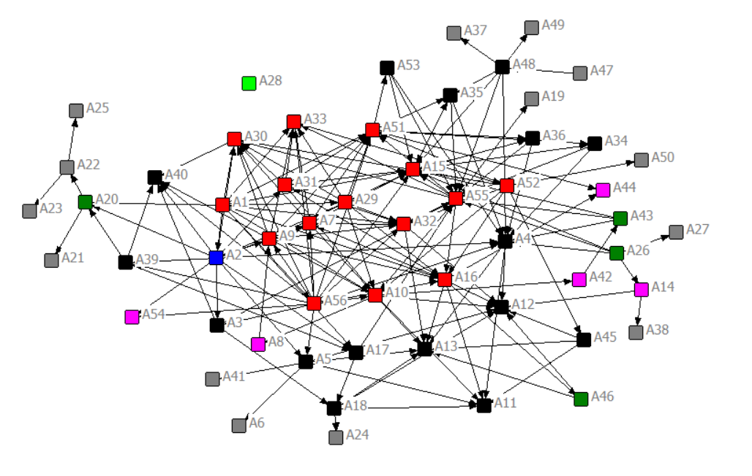
Fig.S11 SLI topological structure
Table.S1 The DC and BC of each nodes in SLI network.
No. | Nomenclature | DC(%) | BC(%) | Core nodes identificaion
A1 | N - Saltern to carnallite | 12.73 | 0.16 | 1
A2 | N - KCl by reverse-current trip flotation | 12.73 | 0.64 | 1
A3 | N - K2SO4 by double decomposition | 4.55 | 0.19 | 1
A4 | N - K2CO3 by electrolysis process | 12.73 | 1.12 | 1
A5 | N - KOH | 8.18 | 0.34 | 1
A6 | N - KMnO4 | 0.91 | 0 | 0
A7 | N - K by substitution method | 9.09 | 0.94 | 1
A8 | N - NaNO₃ by neutralization | 3.64 | 0.72 | 1
A9 | N - KNO₃ | 10 | 1.13 | 1
A10 | N - Chlor-alkali industry | 15.46 | 4.13 | 1
A11 | N - Production of ADC foaming agent | 6.36 | 0 | 0
A12 | N - PVC by calcium carbide | 10.91 | 0 | 1
A13 | N - HCl | 10 | 0 | 1
A14 | N - Production of calcium carbide | 2.73 | 0.05 | 1
A15 | N - Na2CO3 by alkaline process | 16.36 | 1.71 | 1
A16 | N - Na bY electrolysis | 12.73 | 2.39 | 1
A17 | N - Dehydration of old brine | 4.55 | 1.22 | 1
A18 | N - Mg by electrolysis | 5.46 | 0.54 | 1
A19 | N - Downsteam of MgCO3 | 0.91 | 0 | 0
A20 | N - Mg(OH)2 by NH3 precipitation | 4.55 | 0.67 | 1
A21 | N - Downstream of Mg(OH)2 | 0.91 | 0 | 0
A22 | N - MgO | 2.73 | 0.4 | 1
A23 | N - Fireclay brick by MgO | 0.91 | 0 | 0
A24 | N - Magnesium alloy and pressure contact-die-casting | 0.91 | 0 | 0
A25 | N - MgSO4 | 0.91 | 0 | 0
A26 | N - Limestone calcination | 4.55 | 0 | 0
A27 | N - CaO | 0.91 | 0 | 0
A28 | N - Reinforced glass | 0 | 0 | 0
A29 | N - Kainite | 10.91 | 0 | 1
A30 | N - Potash magnesium sulphate fertilizer | 12.73 | 0.65 | 1
A31 | N - KClO4 | 8.18 | 1.04 | 1
A32 | N - NaClO3 | 10 | 0.97 | 1
A33 | N - NaCl | 7.27 | 0 | 1
A34 | N - C4H7NaO4 from Na2CO3 | 4.55 | 0.43 | 1
A35 | N - Na2S2O3 from Na2S | 5.46 | 0.43 | 1
A36 | N - Na₂S₂O₃ from Na₂SO₃ | 4.56 | 0.43 | 1
A37 | N - Na₂S₂O₃ from Na₂S | 0.91 | 0 | 0
A38 | N- C2H2 from calcium carbide | 0.91 | 0.2 | 1
A39 | N - K2SO4 from saline lake | 4.55 | 0 | 0
A40 | N - Compound fertilizer | 5.46 | 0 | 1
A41 | N - Potassium Oleate | 0.91 | 0 | 0
A42 | N - HCOONa from CO | 1.82 | 0.88 | 0
A43 | N - Na2S2O4 from HCOONa | 3.64 | 0.94 | 1
A44 | N - Na2O2 | 1.82 | 0 | 0
A45 | N - Ca by electrolysis | 3.64 | 0.04 | 1
A46 | N - NaNH2 | 2.73 | 0 | 0
A47 | N - Na2SO4 from mirabilite | 0.91 | 0 | 0
A48 | N - Na2S | 6.36 | 1.04 | 1
A49 | N - Sodium polysulfide | 0.91 | 0 | 0
A50 | N - Downsteam of CaCl2 | 0.91 | 0 | 0
A51 | N - Na2CO3 by ammoniasoda process | 12.73 | 4.81 | 1
A52 | N - CaCl2 from waste ammonia liquid | 9.09 | 2.24 | 1
A53 | N - NaNO3 by neutralization | 3.64 | 0.1 | 1
A54 | N - KNO3 by neutralization | 1.82 | 0 | 0
A55 | N - MgCO3 by MgCl2 | 16.36 | 10.08 | 1
A56 | N - Recovery of K and Na from K tail salt | 15.46 | 0.16 | 1

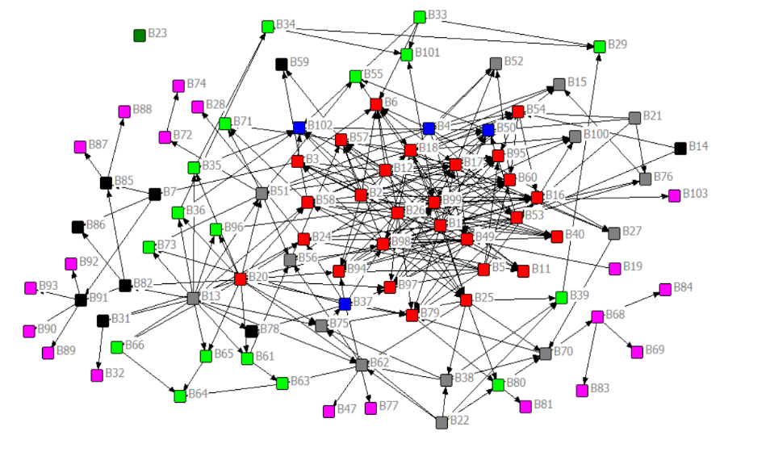
Fig.S12 OCI topological structure
Table.S2 The DC and BC of each nodes in OCI network.
No. | Nomenclature | DC(%) | BC(%) | Core nodes identificaion
B1 | N - Coking | 10.56 | 0 | 1
B2 | N - CH3OH from coal | 7.78 | 0 | 1
B3 | N - MTO | 5 | 4.58 | 1
B4 | N - NH3 from coal | 6.67 | 0 | 1
B5 | N - Syngas from coal | 5 | 0 | 1
B6 | N - Urea from NH3 | 6.11 | 1.06 | 1
B7 | N - PVC by oxy-chlorination | 2.22 | 3.82 | 0
B11 | N - DME from CH3OH | 3.33 | 0 | 0
B12 | N - Dimethyl ether from coal | 7.78 | 0 | 1
B13 | N - Thermal cracking of natural gas (1) | 8.89 | 0 | 1
B14 | N - Thermal cracking of natural gas (2) | 1.11 | 0 | 0
B15 | N - Hexamethylenetetramine | 2.22 | 0 | 0
B16 | N - Dimethyl carbonate by methanol carbonyl process | 5.56 | 0.55 | 1
B17 | N - DMC by direct alcoholysis of urea | 10.56 | 3.55 | 1
B18 | N - Dimethyl carbonate by indirect urea method | 10.56 | 3.55 | 1
B19 | N - Oil refining (1) | 0.56 | 0 | 0
B20 | N - Oil refining (2) | 10.56 | 0 | 1
B21 | N - Oil refining (3) | 2.22 | 0 | 0
B22 | N - Oil refining (4) | 3.33 | 0 | 0
B23 | N - Oil refining (5) | 0 | 0 | 0
B24 | N - Polypropylene | 6.67 | 0.45 | 1
B25 | N - CH3OH to aromatics | 6.67 | 6.42 | 1
B26 | N - CH3OH from natural gas | 10.56 | 0 | 1
B27 | N - HNO3 by ammoxidation | 2.22 | 0.35 | 1
B28 | N - CPP | 0.56 | 0 | 0
B29 | N - PET synthesis | 1.67 | 0 | 0
B31 | N - Polyethylene | 1.67 | 0.03 | 1
B32 | N - CPE | 0.56 | 0 | 0
B33 | N - Glycol from coal | 2.22 | 0 | 0
B34 | N - Glycol from ethylene oxide | 2.22 | 1.69 | 1
B35 | N - Ethylene oxide by oxidation | 2.22 | 0.04 | 1
B36 | N - Ethylene oxide by chlorohydrin method | 2.22 | 0.04 | 1
B37 | N - Styrene by ethylbenzene dehydrogenation | 5 | 3.34 | 1
B38 | N - Paraxylene by toluene disproportionation method | 3.33 | 0 | 0
B39 | N - P-phthalic acid | 2.22 | 0.38 | 1
B40 | N - Methylmercaptan | 3.33 | 0 | 0
B47 | N - Triphenyl phosphite | 0.56 | 0 | 0
B49 | N - HCN by light oil cracking method | 6.11 | 1.72 | 1
B50 | N - HCN from CH4 and NH3 | 4.44 | 0.32 | 1
B51 | N - Acrylonitrile by propylene ammoxidation | 5.56 | 1.57 | 1
B52 | N - Acetonitrile from NH3 and CH3COOH | 2.22 | 0 | 0
B53 | N - Acetonitrile from NH3 and C3H8 | 6.67 | 2.41 | 1
B80 | N - Isocyanate | 2.22 | 0.48 | 1
B81 | N - Polyurethane | 0.56 | 0 | 0
B82 | N - PVC from C3H6 | 2.78 | 0.23 | 1
B83 | N - Rubber absorber antioxidant | 0.56 | 0 | 0
B84 | N - Downstream of nitrochlorobenzene | 0.56 | 0 | 0
B85 | N - CPVC | 2.22 | 0.95 | 1
B86 | N - UPVC | 1.11 | 0 | 0
B87 | N - Pipe CPVC | 0.56 | 0 | 0
B88 | N - CPVC pipe | 0.56 | 0 | 0
B89 | N - Plate CPVC | 0.56 | 0 | 0
B90 | N - Pipe CPVC | 0.56 | 0 | 0
B91 | N - Speciality resin | 3.33 | 1.9 | 1
B92 | N - PVC wire | 0.56 | 0 | 0
B93 | N - PVC plastic doors and windows | 0.56 | 0 | 0
B94 | N - Chloromethane | 7.22 | 0 | 1
B95 | N - Methyl acetate from CH3OH | 5 | 0.5 | 1
B96 | N - Ethyl alcohol from C2H4 | 1.67 | 0.4 | 1
B97 | N - CH3CH2OH from CH3COOH | 5 | 1.05 | 1
B98 | N - Ethyl alcohol from CH3COOH | 11.67 | 8.12 | 1
B99 | N - Diethyl carbonate | 12.78 | 10.32 | 1
B100 | N - Ethyl methyl carbonate by ester exchange method | 2.22 | 0 | 0
B101 | N - Ethylene carbonate | 2.22 | 2.87 | 1
B102 | N - Ethylene carbonate ethylene oxide | 4.44 | 0 | 1
B103 | N - Propylene carbonate | 1.11 | 0 | 0

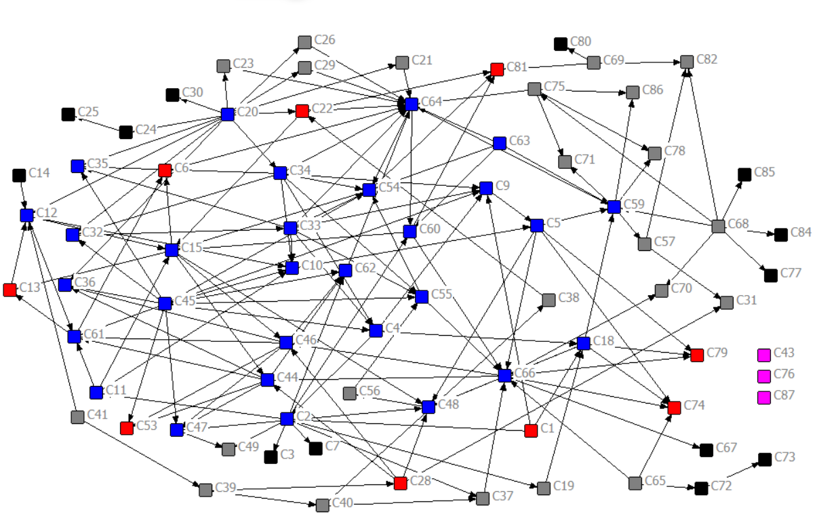
Fig.S13 IOCI topological structure
Table.S3 The DC and BC of each nodes in IOCI network.
No. | Nomenclature | DC(%) | BC(%) | Core nodes identificaion
C1 | N - HF from fluorspar | 1.97 | 0 | 0
C2 | N - Hydrofluoric acid from HF | 6.58 | 1.54 | 1
C3 | N - Electronic grade HF | 0.66 | 0 | 0
C4 | N - NF3 by synthesis | 4.61 | 1.33 | 0
C5 | N - NF3 by electrolysis | 4.61 | 2.35 | 1
C6 | N - NaF from Na2SiF6 | 1.97 | 1.39 | 1
C7 | N - KF by neutralization | 0.66 | 0 | 0
C9 | N - NH4F from NH3 and HF | 3.95 | 0.21 | 1
C10 | N - NH4HF2 from H2SiF6 | 3.95 | 1.81 | 1
C11 | N - Acidolysis of silicate | 2.63 | 0.35 | 1
C12 | N - H2SiF6 by SiF4 hydrolysis | 4.61 | 2.98 | 1
C13 | N - SiF4 from Na2SiF6 | 1.97 | 2.07 | 1
C14 | N - SiF4 from fluorspar | 0.66 | 0 | 0
C15 | N - Na2SiF6 | 6.58 | 6.12 | 1
C18 | N - F2 by electrolysis | 5.92 | 1.63 | 1
C19 | N - KHF₂ from KOH | 1.32 | 0.14 | 1
C20 | N - H₃PO₄ by wet process | 7.9 | 0 | 1
C21 | N - Na5P3O10 | 1.32 | 0.03 | 1
C22 | N - CaHPO4 from CaCl2 | 3.29 | 1.11 | 1
C23 | N - CaHPO4 from CaCO3 | 1.32 | 0.03 | 1
C24 | N - NaH2PO4 | 1.32 | 0.02 | 1
C25 | N - (NaPO3)6 | 0.66 | 0 | 0
C26 | N - Na3PO4 | 1.32 | 0.03 | 1
C28 | N - H3PO3 | 3.29 | 0.51 | 1
C29 | N - KH2PO4 from K2CO3 | 1.32 | 0.03 | 1
C30 | N - KH2PO4 from KOH | 0.66 | 0 | 0
C31 | N - Na2HPO3·5H2O | 1.32 | 0 | 0
C32 | N - (NH4)3PO4 | 3.29 | 0.05 | 1
C33 | N - Ammonium polyphosphate from (NH4)3PO4 | 5.92 | 0.75 | 1
C34 | N - Ammonium polyphosphate from H₃PO₄ | 5.92 | 0.34 | 1
C35 | N - Ammonium polyphosphate from H3PO4 | 2.63 | 0 | 0
C36 | N - BPO4 | 2.63 | 0 | 0
C37 | N - PF5 from HF | 1.97 | 0.47 | 1
C38 | N - PF5 from CaF2 | 1.32 | 0.46 | 1
C39 | N - PCl3 | 1.97 | 0.24 | 1
C40 | N - PCl5 | 1.97 | 0.32 | 1
C41 | N - P | 1.32 | 0 | 0
C43 | N - S | 0 | 0 | 0
C44 | N - H₃BO₃ from ludwigite and HCl | 5.26 | 3.28 | 1
C45 | N - H3BO3 from ludwigite | 7.9 | 0 | 1
C46 | N - H3BO3 from saline brine | 5.26 | 3.28 | 1
C47 | N - B2O3 | 3.29 | 0.79 | 1
C48 | N - B | 4.61 | 2.39 | 1
C49 | N - BF3 from B2O3 | 1.32 | 0 | 0
C53 | N - B₄C | 1.97 | 0 | 0
C54 | N - BN from borax and NH4Cl | 5.26 | 2.72 | 1
C55 | N - Boronnitride | 3.95 | 2.48 | 1
C56 | N - BCl3 | 1.32 | 0 | 0
C57 | N - KBH4 | 1.97 | 1.61 | 1
C59 | N - NaBH4 | 5.92 | 4.8 | 1
C60 | N - KBF4 from HF | 3.95 | 3.68 | 1
C61 | N - KBF4 | 4.61 | 1.42 | 1
C62 | N - LiBF4 | 3.29 | 2.45 | 1
C63 | N - Borax | 2.63 | 0 | 0
C64 | N - Borax by alkali carbonate method | 9.21 | 8.84 | 1
C65 | N - Si for industry | 1.97 | 0 | 0
C66 | N - Polysilicon by siemens method | 9.21 | 7.49 | 1
C67 | N - Monocrystalline Si | 0.66 | 0 | 0
C68 | N - Quartz sand | 4.61 | 0 | 1
C69 | N - Silicon materials | 1.97 | 0 | 0
C70 | N - Optical fiber | 1.32 | 0 | 0
C71 | N - Silica gel | 1.32 | 0 | 0
C72 | N - Organosilicon | 1.32 | 0.02 | 1
C73 | N - Downstream of organosilicon | 0.66 | 0 | 0
C74 | N - Silane | 2.63 | 0 | 0
C75 | N - Na2O·nSiO2 | 3.29 | 0.47 | 1
C76 | N - Glass | 0 | 0 | 0
C77 | N - SiO2 | 0.66 | 0 | 0
C78 | N - Silica white by precipitation | 1.32 | 0 | 0
C79 | N - Silica white by gas phase method | 2.63 | 0 | 0
C80 | N - Black silicon carbide | 0.66 | 0 | 0
C81 | N - Green silicon carbide | 2.63 | 0 | 0
C82 | N - Crystal by hydrothermal synthesis | 1.97 | 0 | 0
C84 | N - Quartz product | 0.66 | 0 | 0
C85 | N - Downstream of quartz | 0.66 | 0 | 0
C86 | N - Glass microspheres | 1.32 | 0 | 0
C87 | N - Silicocalcium | 0 | 0 | 0

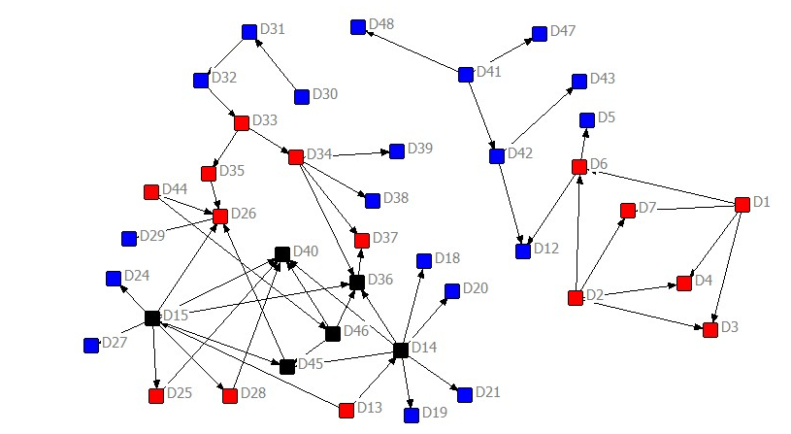
Fig.S14 MSPI topological structure
Table.S4 The DC and BC of each nodes in MSPI network.
No. | Nomenclature | DC(%) | BC(%) | Core nodes identificaion
D1 | N - SrCO3 by carbon reduction | 5.13 | 0 | 1
D2 | N - SrCO3 by double decomposition | 5.13 | 0 | 1
D3 | N - Sr(NO3)2 | 2.56 | 0 | 0
D4 | N - Sr(OH)2 | 2.56 | 0 | 0
D5 | N - SrO2 | 1.28 | 0 | 0
D6 | N - SrO | 5.13 | 0.27 | 1
D7 | N - SrCl2 | 2.56 | 0 | 0
D12 | N - Sr | 2.56 | 0 | 0
D13 | N - Lead-zinc ore dressing | 2.56 | 0 | 0
D14 | N - Pb | 10.26 | 0.41 | 1
D15 | N - Zinc leaching | 11.54 | 0.54 | 1
D18 | N - Pb profile | 1.28 | 0 | 0
D19 | N - PbO | 1.28 | 0 | 0
D20 | N - Lead alloy | 1.28 | 0 | 0
D21 | N - Pb compound | 1.28 | 0 | 0
D24 | N - Zinc alloy | 1.28 | 0 | 0
D25 | N - Hot-galvanizing | 2.56 | 0 | 0
D26 | N - Brass | 6.41 | 0.74 | 1
D27 | N - ZnO | 1.28 | 0 | 0
D28 | N - Zn profile | 2.56 | 0 | 0
D29 | N - Brass profile | 1.28 | 0 | 0
D30 | N - Beneficiation of nickel cobalt ore | 1.28 | 0 | 0
D31 | N - Ni | 2.56 | 0.68 | 1
D32 | N - Low grade Ni matte by blowing | 2.56 | 1.22 | 0
D33 | N - High grade Ni matte by grinding-flotation | 3.85 | 1.62 | 1
D34 | N - Electrolysis of nickel concentrate | 6.41 | 1.08 | 1
D35 | N - Copper concentrate electrolysis | 2.56 | 0.54 | 1
D36 | N - NiSO₄ | 6.41 | 0.34 | 1
D37 | N - Ni(OH)₂ | 2.56 | 0 | 0
D38 | N - Ni(CO)₄ | 1.28 | 0 | 0
D39 | N - Co₃O₄ | 1.28 | 0 | 0
D40 | N - ZnO from waste bearing zinc | 6.41 | 0 | 1
D41 | N - Al₂O₃ | 3.85 | 0 | 1
D42 | N - Al by electrolysis | 3.85 | 0.14 | 1
D43 | N - Al profile | 1.28 | 0 | 0
D44 | N - Copper pyrometallurgy | 2.56 | 0 | 0
D45 | N - Hydrometallurgical Cu refining | 5.13 | 0.27 | 1
D46 | N - H2SO4 | 5.13 | 0.27 | 1
D47 | N - AlCl3 | 1.28 | 0 | 0
D48 | N - AlF3 | 1.28 | 0 | 0

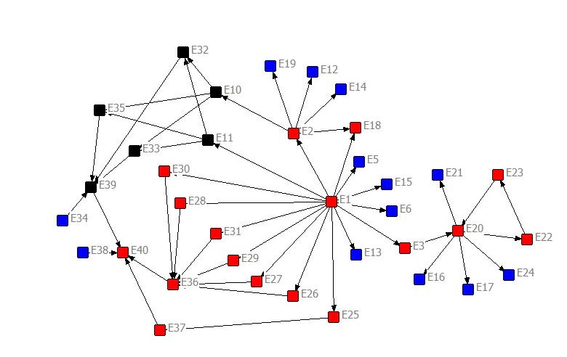
Fig.S15 LDPI topological structure
Table.S5 The DC and BC of each nodes in LDPI network.
No. | Nomenclature | DC(%) | BC(%) | Core nodes identificaion
E1 | N - Li2CO3 from saline brine | 21.43 | 0 | 1
E2 | N - LiOH | 8.57 | 0.34 | 1
E3 | N - LiCl | 2.86 | 0.59 | 1
E5 | N - CH3COOLi | 1.43 | 0 | 0
E6 | N - Li2SO4 | 1.43 | 0 | 0
E10 | N - LiF from LiOH | 5.71 | 0.42 | 1
E11 | N - LiF from Li2CO3 | 5.71 | 0.34 | 1
E12 | N - LiNO3 from LiOH | 1.43 | 0 | 0
E13 | N - LiNO3 from Li2CO3 | 1.43 | 0 | 0
E14 | N - Li₃PO₄ from LiOH | 1.43 | 0 | 0
E15 | N - Li₃PO₄ from Li2CO3 | 1.43 | 0 | 0
E16 | N - Li and Al alloy | 1.43 | 0 | 0
E17 | N - Li and Mg alloy | 1.43 | 0 | 0
E18 | N - LiH2PO4 | 2.86 | 0 | 0
E19 | N - LiO3P | 1.43 | 0 | 0
E20 | N - Li | 10 | 1.77 | 1
E21 | N - Lithium foil | 1.43 | 0 | 0
E22 | N - LiH | 2.86 | 0.25 | 1
E23 | N - LiAlH4 | 2.86 | 0.42 | 1
E24 | N - Downstream of Li+ | 1.43 | 0 | 0
E25 | N - Li4Ti5O12 | 2.86 | 0.1 | 1
E26 | N - LiFePO4 | 2.86 | 0.03 | 1
E27 | N - NMC | 2.86 | 0.03 | 1
E28 | N - LiNiO2 | 2.86 | 0.03 | 1
E29 | N - LiMn2O4 | 2.86 | 0.03 | 1
E30 | N - Lithium nickel cobalt aluminum oxide | 2.86 | 0.03 | 1
E31 | N - LiCoO2 | 2.86 | 0.03 | 1
E32 | N - LiPF6 from ion exchange method | 4.29 | 0.2 | 1
E33 | N - LiPF₆ from PF₅ | 4.29 | 0.2 | 1
E34 | N - C4BLiO8 | 1.43 | 0 | 0
E35 | N - LiBF4 from BF3 | 4.29 | 0.2 | 1
E36 | N - Cathode material of lithium ion batteries | 10 | 0.58 | 1
E37 | N - Anode materials for lithium-ion batteries | 2.86 | 0.1 | 1
E38 | N - Li-ion battery separator material | 1.43 | 0 | 0
E39 | N - Lithium-ion battery electrolyte | 7.14 | 0.59 | 1
E40 | N - Lithium ion battery | 5.71 | 0 | 0

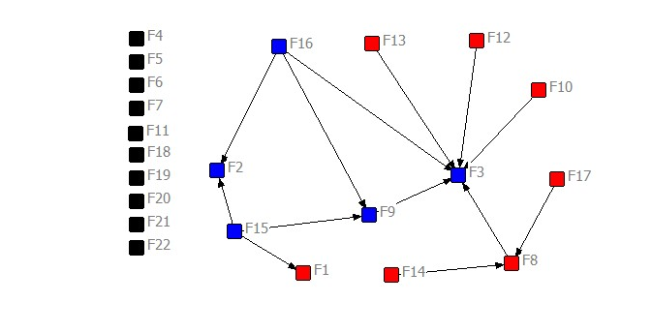
Fig.S16 CWUI topological structure
Table.S6 The DC and BC of each nodes in CWUInetwork.
No. | Nomenclature | DC(%) | BC(%) | Core nodes identificaion
F1 | N - Dinas bricks | 2.38 | 0 | 0
F2 | N - Aerated block | 4.76 | 0 | 1
F3 | N - Concrete | 14.29 | 0 | 1
F4 | N - Geomembrane | 0 | 0 | 0
F5 | N - PE tube | 0 | 0 | 0
F6 | N - Magnesium oxychloride cement | 0 | 0 | 0
F7 | N - Pyrites from coalgangue | 0 | 0 | 0
F8 | N - Cement from coalgangue | 7.14 | 0.48 | 1
F9 | N - Baking-free bricks from coalgangue | 7.14 | 0.24 | 1
F10 | N - Molecular sieve from coalgangue | 2.38 | 0 | 0
F11 | N - Manure from coalgangue | 0 | 0 | 0
F12 | N - AlCl3 from coalgangue | 2.38 | 0 | 0
F13 | N - Al2(SO4)3 from coalgangue | 2.38 | 0 | 0
F14 | N - Epoxyethane | 2.38 | 0 | 0
F15 | N - CaCO3 from carbide slag | 7.14 | 0 | 1
F16 | N - Cement from carbide slag | 7.14 | 0 | 1
F17 | N - K2SO4 by IMI method | 2.38 | 0 | 0
F18 | N - Molten salt | 0 | 0 | 0
F19 | N - Extraction of Rb and Cs | 0 | 0 | 0
F20 | N - Refine of Rb | 0 | 0 | 0
F21 | N - Refine of Cs | 0 | 0 | 0
F22 | N - Fly ash disposal | 0 | 0 | 0

Appendix A.5. Scenario settings
To meet the exigencies of climate policy and accomplish decarbonization within the ambit of development, we have pondered various approaches. These include: i) gradually decarbonizing from the initial high-energy-consuming industrial structure through model guidance, by regulating node size, eradicating inefficient nodes, and cultivating high-efficiency nodes through heuristic strategies; ii) gradually decarbonizing by introducing certain measures of carbon reduction, such as CCUS, clean electricity, and steam boiler retrofit. We analyze the reduction effects of these two approaches both separately and in conjunction, while contemplating the evolutionary trend of the industrial structure by allotting the degree of implementation of these measures at different junctures, so as to foster a dynamic evolution of the industrial structure that pursues sustainable developmental objectives. Here, our sustainable developmental objective is defined as maximizing economic objectives while minimizing energy consumption, resource consumption, and environmental impact as much as feasible. For instance, in the process of developing the same amount of brine from the saline lake, we can augment the economic added value of raw materials by implementing measures such as extending the industrial chain, regulating the industrial structure, introducing high-end nodes, and eliminating inefficient processes. This will enable scarce resources to realize long-term development with heightened economic value. We have formulated six scenarios from S0-S5, with the original structure referring to the industrial structure of resource-based regions under empirical development, which refers to the development mode of roughly planning resource exploitation according to traditional expert decision-making judgment and based on economic benefits and resource endowment.
S0 represents the development of the resource-rich region based on the pre-existing industrial structure, which has been subjected to unreasonable development and growth in the past. This scenario aims to inherit the industrial structure of the previous development pattern, while also following RRIEDOM's guidance for further development.
S1 also inherits the pre-existing industrial structure of the resource-rich region, but differs from S0 in that it continues to follow the traditional empirical pattern of development, rather than RRIEDOM's guidance. This allows for a comparison to be made between the two approaches.
S2 involves developing the resource-rich region based on the pre-existing industrial structure, while also following RRIEDOM's guidance for subsequent development. However, the original industrial structure is gradually modified during the development process, such as eliminating backward nodes and adding capacity to advantageous nodes, over a set transformation period of 5 years.
Similarly, the S3 scenario also involves developing the resource-rich region based on the pre-existing industrial structure and following RRIEDOM's guidance for subsequent development, but the industrial structure is modified over a longer set transformation period of 10 years. This scenario is designed to observe the differences between short-term and long-term industrial structure transformation, and to compare with the S2 scenario.
The S4 scenario represents the most ideal approach, assuming a completely undeveloped resource location and incorporating the existing technical information base. This scenario calls for resource development using RRIEDOM's guidance and the most efficient nodes.
Finally, S5 scenario is similar to S5, similar to S2, but with a transition period of 20 years to investigate a further prospective.

Appendix A.6. Supplementary results
We randomly selected two panels of data for the time interval to create the Fig.17 In order to show the transition from the original local industrial structure to the optimal structure guided by RRIEDOM, it is theoretically possible to plot each year, but we randomly selected two profiles for brevity. We also plot all types of products and production that can be produced by the industrial network under the optimal structure, as well as the size/capacity of each node (Fig.18), electricity consumption (Fig.19), solid waste generation (Fig.20), water consumption (graph), capital investment (Fig.21), energy consumption (Fig.22), profit (Fig.23), production value (Fig.24) and carbon emissions (Fig.25). And the rest results are provided in the excel attachment.
Fig.S17 Transition from original structure to optimal structure, the transition structure 1 and transition structure 2 are randomly selected as examples to illustrate the process of transition.

Fig.S18 main products and the capacity of the optimal industrial structure, including CPVC, PE, KOH, NaOH.

Fig.S19 Capacity of each node of the optimal industrial structure.

Fig.S20 Electricity consumption of each node of the optimal industrial structure.

Fig.S21 Solid waste output of each node of the optimal industrial structure.

Fig.S22 Freshwater consumption of each node of the optimal industrial structure.

Fig.S23 Capital investment of each node of the optimal industrial structure.

Fig.S24 Energy consumption of each node of the optimal industrial structure.
Fig.S25 Profit of each node of the optimal industrial structure.

Fig.S26 Industrial output of each node of the optimal industrial structure.

Fig.S27 Carbon emission of each node of the optimal industrial structure.

