Supplementary Information for manuscript “The Growing Threat of Global Urban Heat Island Effects in Lower-Middle and Low-Income Countries”

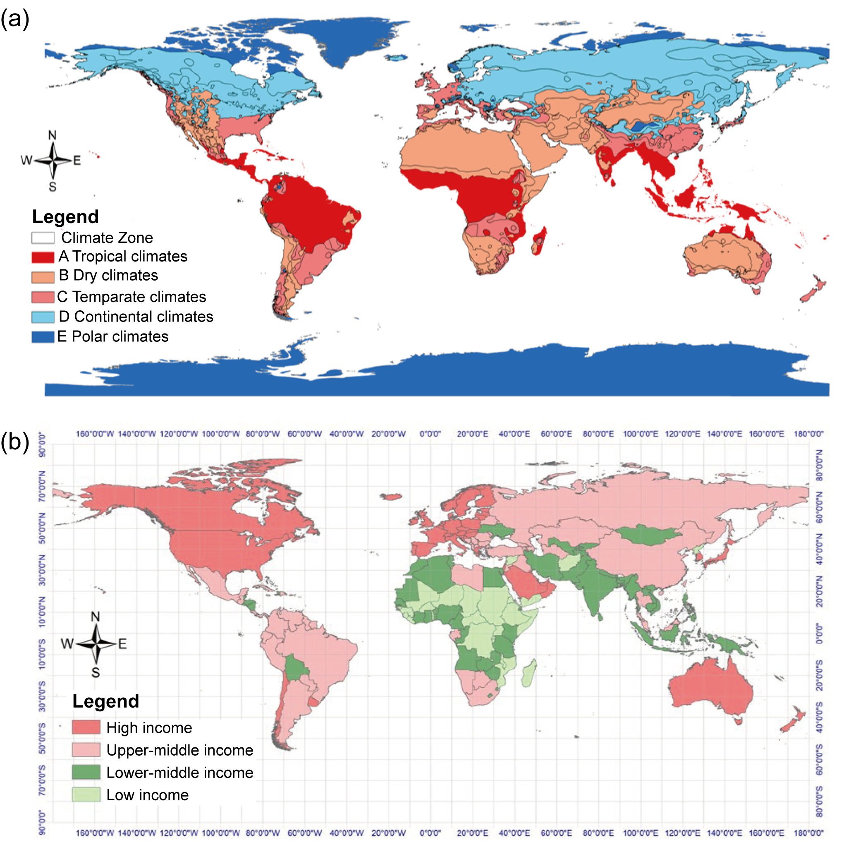
Supplementary Figure 1 | World map of five Köppen climate zones and four economic levels. a The Köppen climate classification divides global climates into five main climate groups, with each group being divided based on seasonal precipitation and temperature patterns. The five main groups are A (tropical), B (arid), C (temperate), D (continental), and E (polar). b The map data are classified using the World Bank Atlas method estimates of 2021 gross national income (GNI) per capita (current US dollars). The World Bank classifies all 189 World Bank member countries, plus 28 other economies with populations of more than 30,000, as low-income (less than $1,085), lower-middle-income ($1,086–$4,255), upper-middle-income ($4,256– $13,205) or high-income (more than $13,205) as per GNI per capita in 2021.

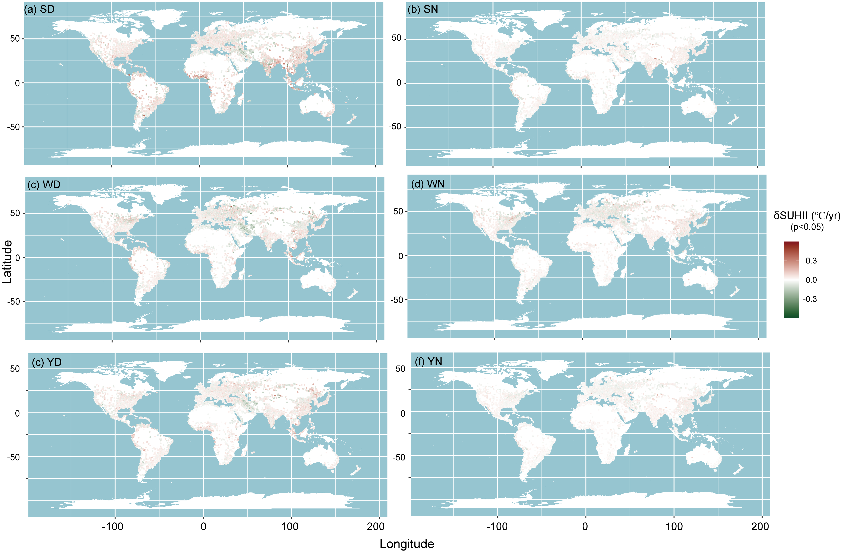
Supplementary Figure 2 | Global SUHII changes from 2003 to 2018. Sen's slope values within 95% confidence interval (p < 0.05) were calculated as changing rates (℃ / yr), with darker red indicating a stronger increasing trend in SUHII, and darker green indicating a stronger decreasing trend: a summer daytime (SD), b summer nighttime (SN), c winter daytime (WD), d winter nighttime (WN), e yearly daytime (YD) and f yearly nighttime (YN).

Supplementary Table 1 | The top 5 countries with the largest number of urban grids and the most experiencing increasing trends at multiple time intervals.
Top 5 countries with the most urban grids |  | Top 5 fastest-increasing countries
 |  | YD |  | YN |  | SD |  | SN |  | WD |  | WN
America | (24.20%) | America | (24.20%) | China | (20.90%) | America | (27.20%) | America | (24.20%) | America | (18.90%) | China | (28.90%)
China | (10.70%) | Japan | (16.20%) | America | (18.30%) | Japan | (14.70%) | China | (20.30%) | Japan | (14.10%) | America | (15.80%)
Russia | (6.53%) | China | (10.90%) | India | (13.40%) | China | (14.20%) | Russia | (8.67%) | China | (11.10%) | India | (11.10%)
Germany | (4.76%) | Brazil | (5.39%) | Brazil | (3.36%) | Russia | (5.72%) | Ukraine | (4.18%) | India | (6.90%) | Brazil | (3.33%)
Japan | (4.26%) | India | (3.90%) | Russia | (2.83%) | Turkey | (3.49%) | Japan | (3.34%) | Brazil | (6.62%) | Mexico | (2.67%)
Total | (50.45%) | Total | (60.59%) | Total | (58.79%) | Total | (65.31%) | Total | (60.69%) | Total | (57.62%) | Total | (61.80%)

Supplementary Figure 3 | The intra-climate-zone SUHII trends of increasing, decreasing and their differences over 2003 - 2018.
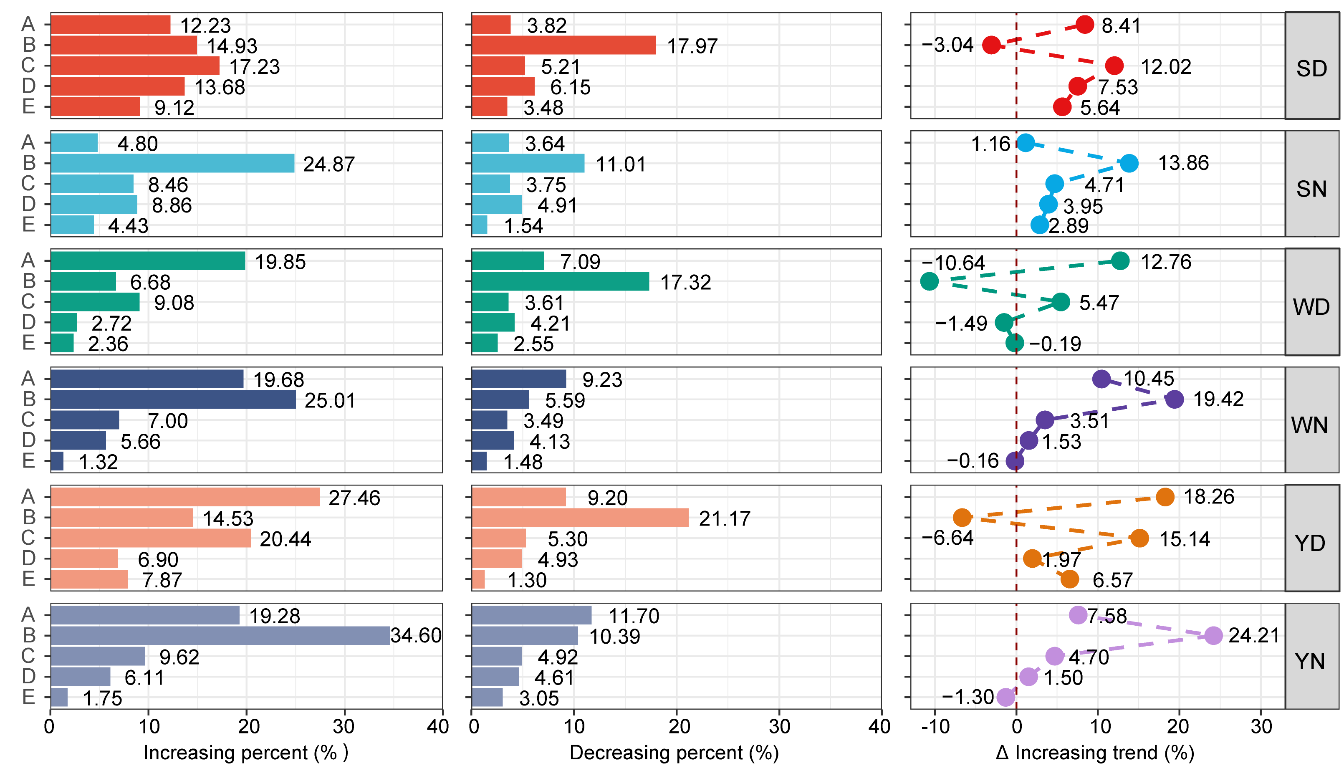

Supplementary Table 2 | The description of the used multivariate mixture cluster models. Parameterisations of the within-group covariance matrix Σ_{k} for multidimensional data available in the mclust package, and the corresponding geometric characteristics.
