Table 1. Assessment of the ability of MuTect filter, FFPolish, SOBDetector, and DEEPOMICSⓇ FFPE
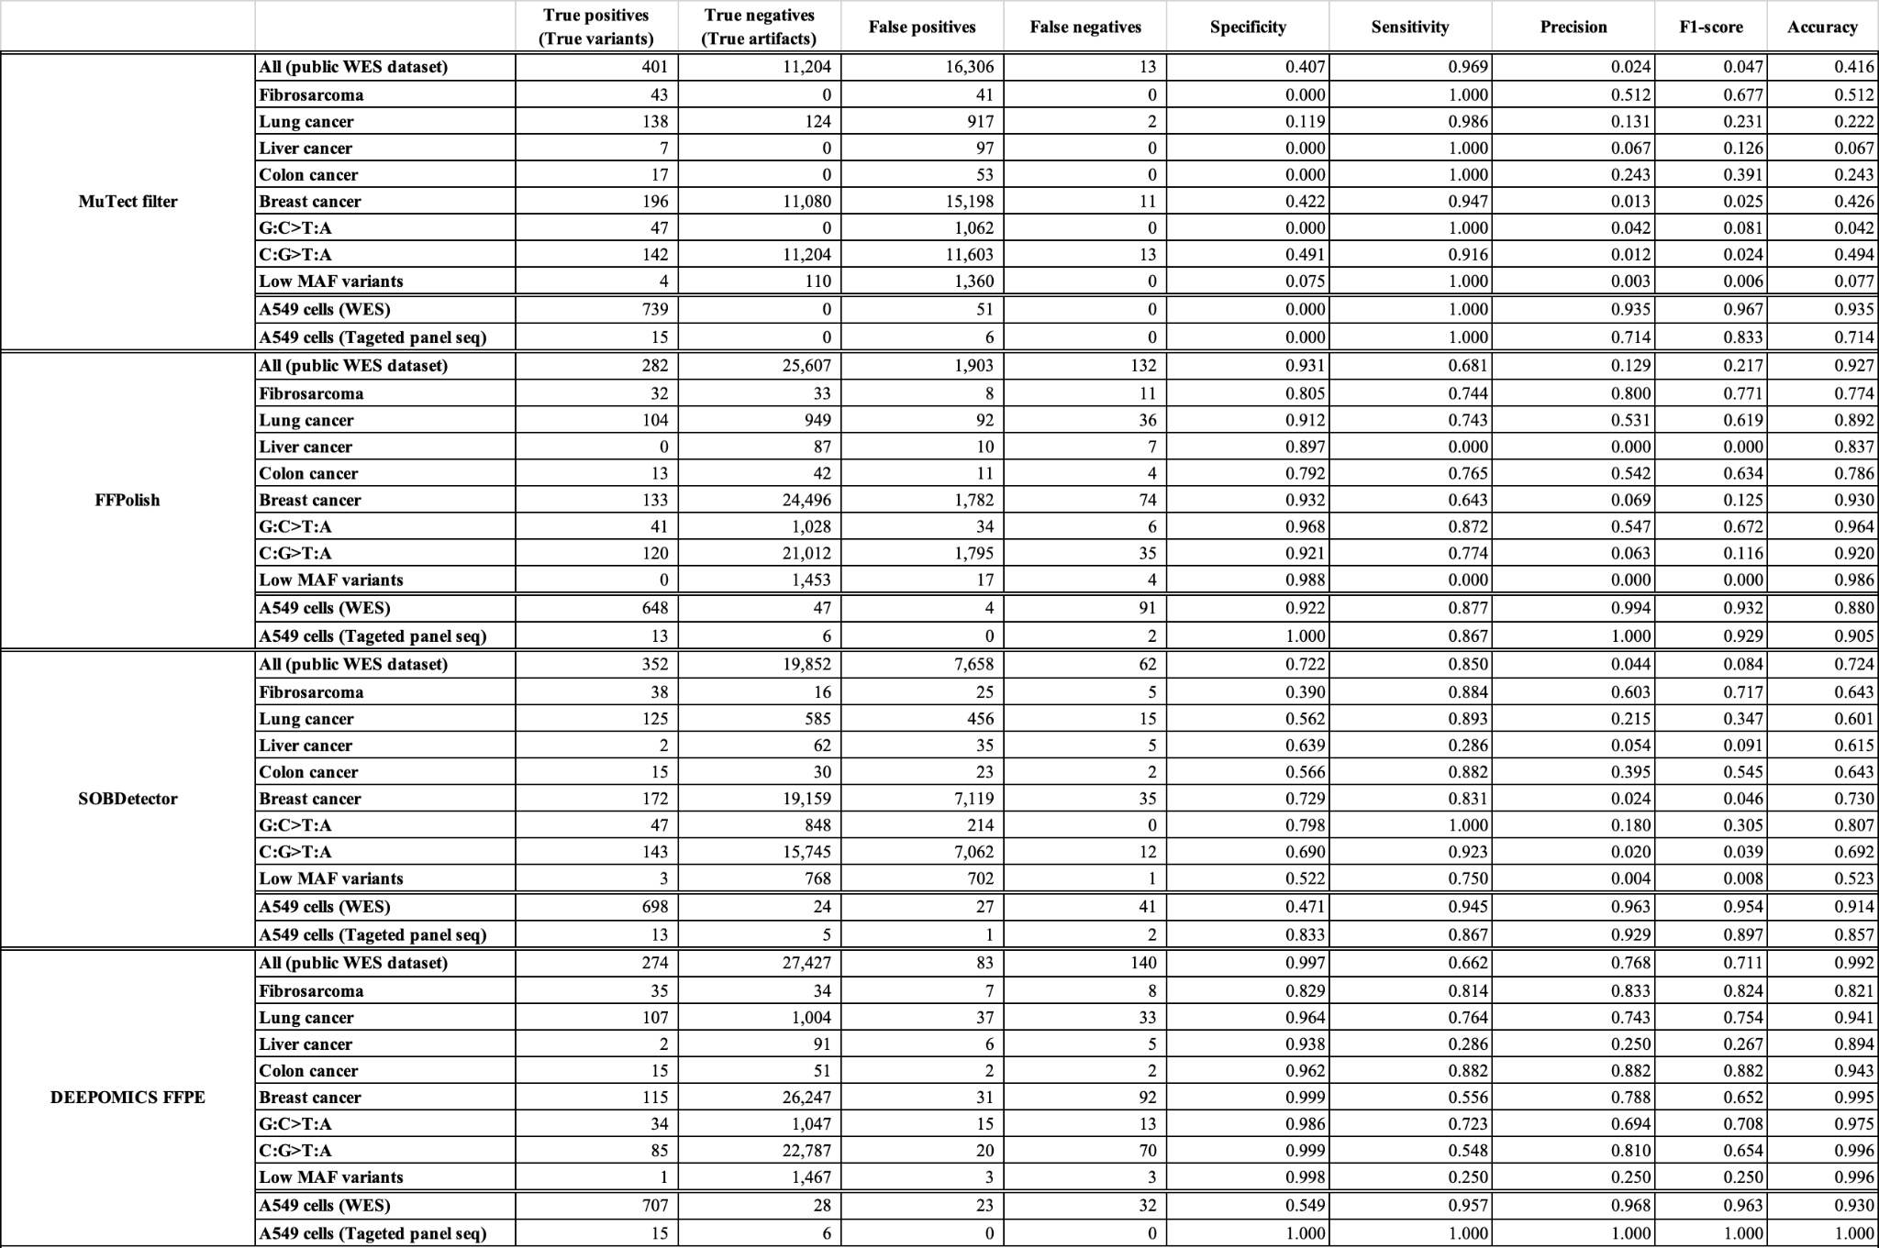

Table 2. List of validated variants in the standard material and the results of the inference of the indicated tools.
