Earthworms do not increase greenhouse gas emissions (CO₂ and N₂O) in an ecotron experiment simulating a realistic three crop rotation system

Supplementary information file containing:

- Supplementary results
- Supplementary Tables S1-S4
- Supplementary Figures S1-S8

Supplementary results
Intercrop between the wheat and mustard crops (intercrop_1)
NEE weekly fluxes values were negative during the whole intercrop, indicating a net CO₂ release from the macrocosms to the atmosphere due to higher Reco than GPP during daytime in this period with very little vegetation (Fig. S2A). The NEE weekly fluxes were significantly affected by Week (P-value < 0.001; Table S3), and the EW_T and EW_B treatments, decreasing with EW_BM (P-value = 0.012; Table S3) and being increased by anecic earthworms (P-value = 0.031; Table S3). The cumulative NEE emissions reached -403.38 (±63.37), -366.90 (±33.85) and -343.66 (±65.95) g CO₂ m⁻² in the control, anecic and endogeic earthworm treatment levels, respectively, and were neither influenced by EW_T nor EW_BM. The GPP weekly fluxes (Fig. S2C) only varied with the experimental Week (P-value < 0.001; Table S3). The cumulative GPP fluxes reached 324.83 (±35.76), 375.67 (±37.66) and 428.96 (±50.43) g CO₂ m⁻² in the control, anecic and endogeic earthworm treatment levels, respectively, and were not influenced neither by the earthworm biomass nor by the earthworm treatment (Table S3; Fig. S2D).
Reco weekly emissions followed quite similar dynamics to GPP, showing a progressive decrease in absolute value with time (Fig. S2E), and were also influenced by Week (P-value < 0.001; Table S3). The earthworm treatment marginally significantly affected Reco (P-value = 0.062; Table S3), with a tendency of lower Reco values (i.e., indicating higher respiration) in both anecic and endogeic treatment levels relative to control. However, the cumulative Reco fluxes reached 753.30 (±29.89), 773.84 (±42.45) and 807.04 (±35.80) g CO₂ m⁻² in the control, anecic and endogeic earthworm treatment levels, respectively, and neither EW_T nor EW_BM showed any statistically significant effects (Table S3; Fig. S2F).
The weekly N₂O emissions oscillated around 0.2 g m⁻² day⁻¹ in the control and anecic treatments and around 0.1 g m⁻² day⁻¹ in the endogeic earthworm treatment level from the beginning of the intercrop period until the beginning of October, where all levels converged around 0.2 g m⁻² day⁻¹ and progressively decreased henceforth (Fig. S2G). Weekly N₂O emissions were significantly influenced by the EW_T×Week two-way interaction (P-value < 0.001; Table S3), the fitted interaction slopes indicating some weeks with decreased emissions relative to control at the beginning of the intercrop and increased emissions relative to control at the end of the intercrop only in the endogeic treatment level. The cumulative N₂O fluxes reached 19.46 (±3.35), 19.96 (±6.01) and 10.12 (±1.83) g m⁻² in the control, anecic and endogeic earthworm treatment levels, respectively, and showed a marginally statistically significant effect of EW_T (P-value = 0.07; Table S3), N₂O emissions being significantly lower in the endogeic EW_T level, but the effect size is arguably large (-48%) relative to control (Fig. S2H).
Weekly ET fluxes followed the apparition and growth of weeds after the harvest of the previous culture, peaking twice at the beginning of August and the end of September, similar to the GPP fluxes (Fig. S2I). Weekly ET fluxes were significantly influenced by the EW_T×Week two-way interaction (P-value < 0.001; Table S3), the fitted interaction slopes indicating an increase in ET fluxes relative to control in both anecic and endogeic treatment levels mainly at the beginning and the end of the intercrop. Cumulative ET fluxes reached 208.89 (±4.24), 210.05 (±1.72) and 206.68 (±5.70) kg H₂O m⁻² in the control, anecic and endogeic earthworm treatment levels, respectively, and were found to decrease with earthworm biomass (P-value < 0.001; Table S3).
WUE rate varied throughout the intercrop period depending on the environmental conditions and the development of the weed with values between 0.2 and 7 g CO₂ kg H₂O⁻¹ m⁻² day⁻¹ (Fig. S2K). WUE fluxes only significantly varied with Week (P-value < 0.001; Table S3). The cumulative WUE reached 265.61 (±35.07), 300.71 (±35.20) and 341.47 (±19.65) g CO₂ kg H₂O⁻¹ m⁻² in the control, anecic and endogeic earthworm treatment levels, respectively, and showed no statistically significant effects neither of EW_T nor EW_BM (Table S3; Fig. S1L).

Intercrop between the mustard and maize crops (intercrop_2)
The NEE weekly fluxes during this period were both negative and positive, depending on the evolution of the leftover crop biomass and weed development after the harvest (Fig. S3A). The NEE weekly fluxes were marginally influenced by EW_T (P-value = 0.09), with the NEE values being statistically marginally higher in the endogeic EW_T level relative to control, in addition to a Week effect (P-value < 0.001; Table S4). The cumulative NEE emissions reached -0.05 (±12.52), 13.12 (±24.92) and 35.53 (±14.60) g CO₂ m⁻² in the control, anecic and endogeic earthworm treatment levels, respectively, but the high variability observed within the EW_T levels led to no significant effects of EW_T nor EW_BM (Table S4; Fig. S3B). The GPP weekly fluxes (Fig. S3C) were only influenced by Week (P-value < 0.001; Table S4). The cumulative GPP fluxes reached 197.66 (±4.24), 237.13 (±42.31) and 299.89 (±42.56) g CO₂ m⁻² in the control, anecic and endogeic earthworm treatment levels, respectively, and showed a marginally statistically significant effect of EW_T (P-value = 0.0749; Table S4), the GPP emissions being significantly higher in the endogeic earthworm treatment level (+51.7%; Fig. S3D) relative to control.
Reco weekly emissions started to increase in absolute value for all EW_T levels at the beginning of April and reached in the end of April values four times as high as in late March, to slowly decrease henceforth (Fig. S3E). Reco weekly emissions were significantly affected by the EW_T×Week interaction (P-value = 0.001; Table S4) with a couple of weeks where both anecic and endogeic earthworms marginally increased Reco emissions. The cumulative Reco fluxes reached 215.86 (±15.46), 243.65 (±36.36) and 288.09 (±34.36) g CO₂.m⁻² in the control, anecic and endogeic earthworm treatment levels, respectively, and showed no statistically significant effects neither of EW_T nor EW_BM (Table S4; Fig. S3F).
The weekly N₂O emissions oscillated around 0.4 g m⁻² day⁻¹ for all treatments (Fig. S3G) and were significantly influenced by the Week×EW_T interaction (P-value = 0.004; Table S4), the fitted interaction slopes indicating several weeks where the emissions were higher in the anecic treatment relative to control. The cumulative N₂O fluxes reached 24.15 (±3.84), 19.11 (±0.46) and 21.76 (±0.35) g m⁻² in the control, anecic and endogeic earthworm treatment levels, respectively and were found to decrease with earthworm biomass (P-value < 0.001; Table S4).
Weekly ET fluxes increased from 1 kg H₂O m⁻² day⁻¹ to 2.5 the first month of the intercrop period while GPP emissions were decreasing during this time, indicating that soil evaporation was the main contributor to ET during this period, then plateaued henceforth (Fig. S3I). In addition to statistically significant weekly fluctuations (P-value < 0.001; Table S4), ET slightly decreased with earthworm biomass (P-value = 0.002; Table S4) but increased in the anecic treatment relative to control (P-value = 0.015; Table S4). Cumulative ET fluxes reached 114.23 (±1.88), 118.06 (±1.55) and 111.40 (±2.95) kg H₂O m⁻² in the control, anecic and endogeic earthworm treatment levels, respectively, and were not influenced by earthworm treatment or earthworm biomass (Table S4; Fig. S3J).
Weekly WUE rates showed a 50% decrease in all EW_T levels as the spontaneous vegetation started growing the first week of April and slightly increased until the end of April to decrease henceforth (Fig. S3K). Weekly WUE rates only varied with the experimental Week (P-value < 0.001; Table S4). The cumulative WUE reached 132.97 (±9.79), 125.73 (±14.56) and 170.72 (±9.57) g CO₂ kg H₂O⁻¹ m⁻² in the control, anecic and endogeic earthworm treatment levels, respectively, and showed a statistically significant EW_T effect (P-value = 0.031; Table S4) with cumulated WUE being significantly higher in the endogeic earthworm treatment level relative to control (+28%; Fig. S3L).

Supplementary tables

Table S1: Spontaneous vegetation biomass (DW g m-2) in intercop_1 (between wheat and mustard) and intercrop_2 (between mustard and maize) weighted after manual weeding in each macrocosm. The manual weeding took place at the beginning of each intercrop.
Treatment | Macrocosm | Biomass (g DW m-2)
Intercrop_1
ANECIC | 1 | 0
ANECIC | 4 | 6.1775
ANECIC | 5 | 6.16
ANECIC | 7 | 7.835
ENDOGEIC | 2 | 8.465
ENDOGEIC | 6 | 9.8125
ENDOGEIC | 10 | 4.1
ENDOGEIC | 12 | 6.145
CONTROL | 3 | 14.47
CONTROL | 8 | 7.1325
CONTROL | 9 | 1.1825
CONTROL | 11 | 4.96
Intercrop_2
ANECIC | 1 | 6.94
ANECIC | 4 | 4.704
ANECIC | 5 | 34.67
ANECIC | 7 | 36.186
ENDOGEIC | 2 | 30.73
ENDOGEIC | 6 | 73.094
ENDOGEIC | 10 | 5.414
ENDOGEIC | 12 | 22.782
CONTROL | 3 | 31.13
CONTROL | 8 | 32.57
CONTROL | 9 | 4.592
CONTROL | 11 | 4.086

Table S2: Physico-chemical analysis results of the anaerobic digestate used as fertilizer on the wheat crop.
Physico-chemical parameters
Parameter | Unit | on dry basis | on raw basis
Humidity | % |  | 92.3
Dry matter | % |  | 7,7
Volatil Matter | % | 62.5 | 4.8
Mineral Matter | % | 37.5 | 2.9
Organic carbon | % | 31.2 | 2.4
Conductivity | µS cm |  | 5.28
pH at 25°C | pH Unit |  | 8.5
Nitrogen
Kjeldahl Nitrogen | % N | 6.16 | 0.474
Ammoniacal Nitrogen | % N | 1.82 | 0.14
Organic Nitrogen | % N | 4.34 | 0.334
C/N |  |  | 5.1
Other elements
Phosphorous | % P₂O₅ | 3.02 | 0.23
Potassium | % K₂O | 9.07 | 0.7
Calcium | % CaO | 3.5 | 0.27
Magnesium | % MgO | 1.58 | 0.12
Sulfur | % SO₃ | 1.97 | 0.15
Sodium | % Na₂O | 0.43 | 0.033
Equivalent g kg⁻¹ or kg ton⁻¹
Dry matter | g kg⁻¹ |  | 76.6
Volatil Matter | g kg⁻¹ | 624.6 | 48.1
Kjeldahl Nitrogen | g kg⁻¹ | 61.6 | 4.74
Ammoniacal Nitrogen | g kg⁻¹ | 18.2 | 1.4
Organic Nitrogen | g kg⁻¹ | 43.4 | 3.34
Phosphorous | g kg⁻¹ | 30.2 | 2.3
Potassium | g kg⁻¹ | 90.7 | 7
Calcium | g kg⁻¹ | 35 | 2.7
Magnesium | g kg⁻¹ | 15.8 | 1.2
Sulfur | g kg⁻¹ | 19.7 | 1.5
Sodium | g kg⁻¹ | 4.3 | 0.33

Table S3: Minimal adequate models (F-values) for (i) weekly time series as affected by the sampling week (Week), earthworm biomass (EW_B), treatment (EW_T) and their interactions, and (ii) cumulative emissions as affected by the earthworm biomass (EW_B) and treatment (EW_T) in the intercrop between wheat and mustard. “NA” stands for non-applicable. ***P < 0.001; **P < 0.01; *P< 0.05; +P < 0.1.
Weekly time series
Source | NEE | GPP | Reco | N₂O | ET | WUE
Week | F_{19/209} = 274.03*** | F_{19/209} = 26.86*** | F_{19/209} = 110.21*** | F_{18/162} = 71.45*** | F_{19/171} = 440.21*** | F_{19/209} = 115.75***
EW_BM | F_{1/8} = 10.34*** | NA | F_{1/8} = 0.55 | NA | F_{1/8} = 1.29 | NA
EW_T | F_{2/8} = 31.19*** | NA | F_{2/8} = 4 | F_{2/9} = 2.61 | F_{2/8} = 6.59*** | NA
EW_T×Week | NA | NA | NA | F_{36/162} = 3.03*** | F_{38/171} = 2.26*** | NA
Cumulative
EW_BM | NA | NA | NA | F_{1/8} = 2.62 | F_{1/8} = 28.68*** | NA
EW_T | NA | NA | NA | F_{2/8} = 3.78+ | F_{2/8} = 0.59 | NA

Table S4: Minimal adequate models (F-values) for (i) weekly time series as affected by the sampling week (Week), earthworm biomass (EW_B), treatment (EW_T) and their interactions, and (ii) cumulative emissions as affected by the earthworm biomass (EW_B) and treatment (EW_T) in the intercrop between mustard and maize. “NA” stands for non-applicable. ***P < 0.001; **P < 0.01; *P< 0.05; +P < 0.1.
Weekly time series
Source | NEE | GPP | Reco | N₂O | ET | WUE
Week | F_{7/77} = 50.32*** | F_{7/77} = 8.07*** | F_{7/63} = 311.67*** | F_{4/36} = 177.78*** | F_{7/77} = 144.11*** | F_{7/77} = 15.78***
EW_BM | NA | NA | NA | F_{1/8} = 66.83*** | F_{1/8} = 20.07*** | F_{1/8} = 0.12
EW_T | F_{2/9} = 2.44 | NA | F_{2/9} = 1.13 | F_{2/8} = 20.23*** | F_{2/8} = 7.46*** | F_{2/8} = 2.04
EW_T$×$Week | NA | NA | F_{14/63} = 3.03*** | F_{8/36} = 3.57*** | NA | NA
Cumulative
EW_BM | NA | NA | NA | F_{1/10} = 92.61*** | NA | NA
EW_T | NA | F_{2/9} = 3.5+ | NA | NA | F_{2/9} = 2.21 | F_{2/9} = 5.19***

Supplementary figures
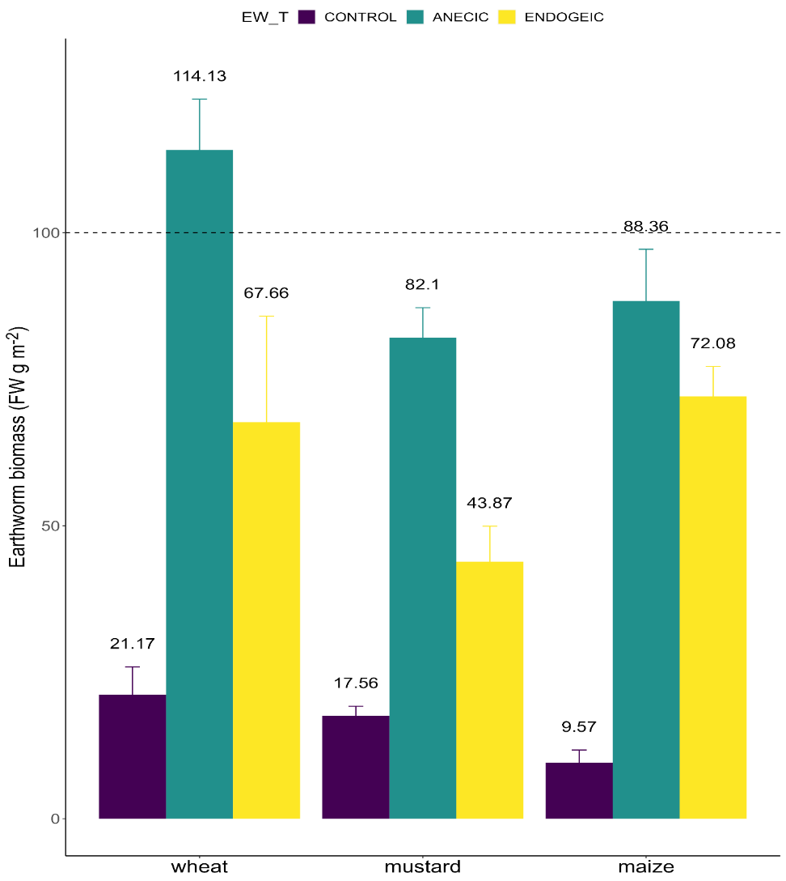
Figure S1: Earthworm biomass (FW g m⁻²) weighted after electrical extraction at the end of each crop in each earthworm treatment (EW_T) level. Data represent means ± SEM of four replicates. A horizontal dashed line at 100 g FW indicates the minimum targeted biomass for earthworms. If a replicate had earthworm biomass below this target, additional earthworms were added to reach the desired biomass level. After sampling, all earthworms were returned to the lysimeters, except in the control group, where they were removed.
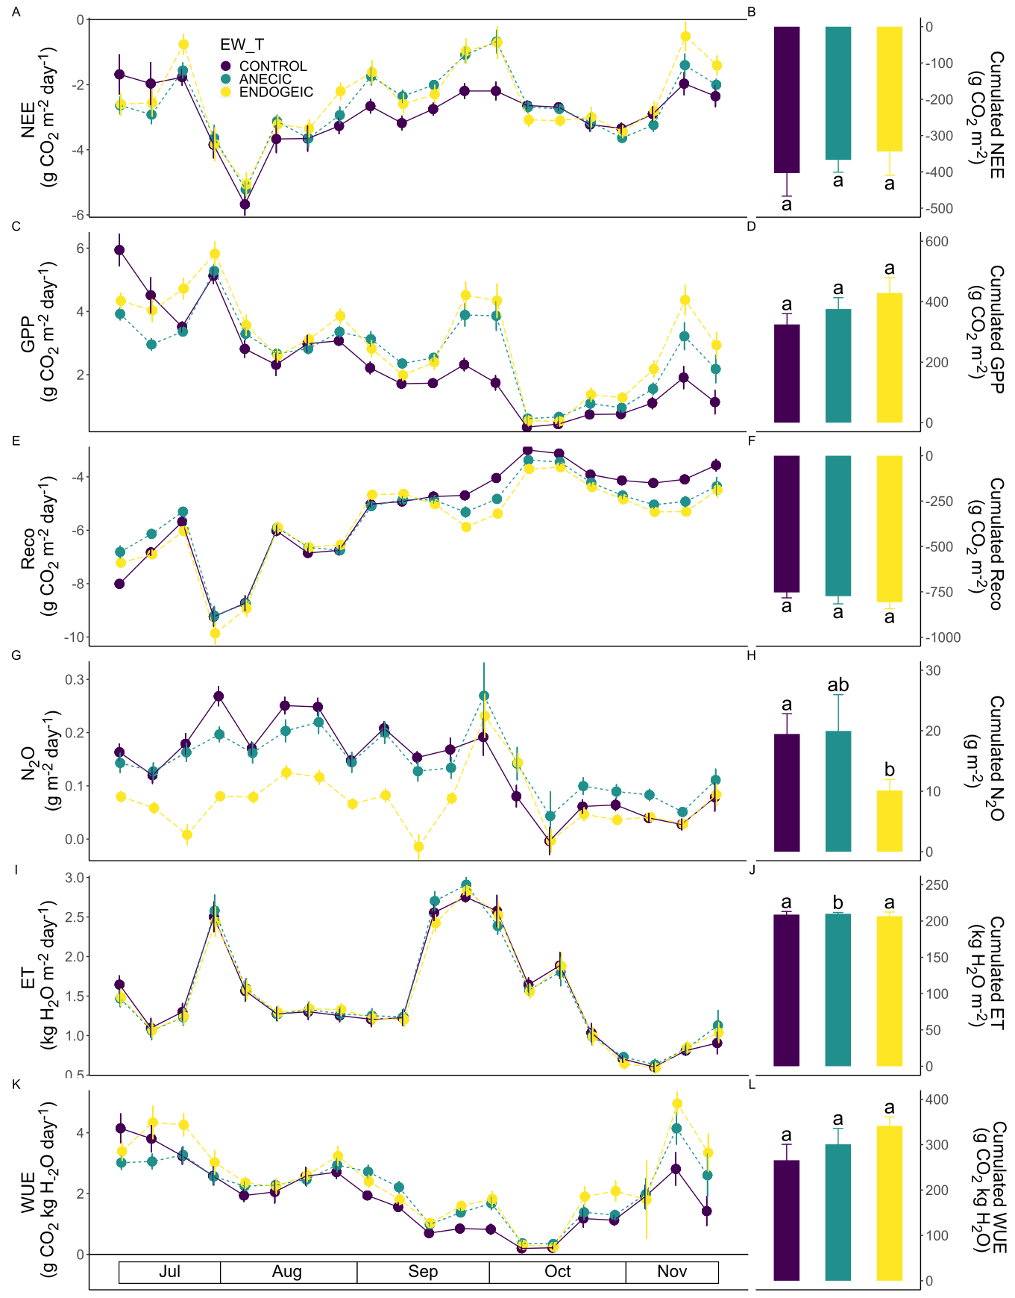

Figure S2: Weekly dynamics (Left, lines) and cumulative fluxes (Right, bars) of carbon, N₂O and water as affected by the earthworm treatment (EW_T) in the intercrop between wheat and mustard. (A,B) NEE. (C,D) GPP. (E,F) Reco. (G,H) N₂O. (I,J )ET. (K,L) WUE. Data represent means ± SEM of four replicates. Different letters above bars denote significant differences between individual means. Horizontal bottom bars represent the experimental periods (crop growing season).
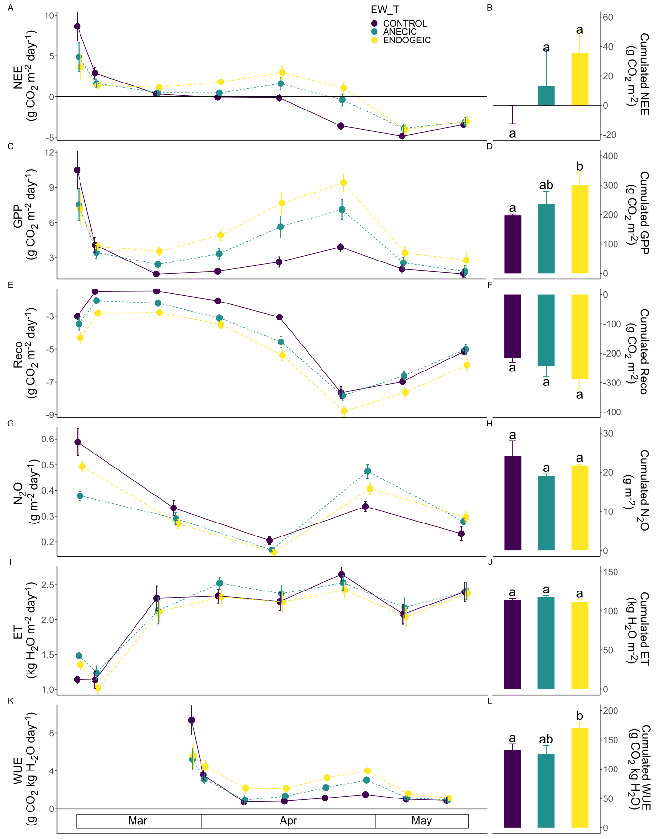

Figure S3: Weekly dynamics (Left, lines) and cumulative fluxes (Right, bars) of carbon, N₂O and water as affected by the earthworm treatment (EW_T) in the intercrop between mustard and maize. (A,B) NEE. (C,D) GPP. (E,F) Reco. (G,H) N₂O. (I,J )ET. (K,L) WUE. Data represent means ± SEM of four replicates. Different letters above bars denote significant differences between individual means. Horizontal bottom bars represent the experimental periods (crop growing season).
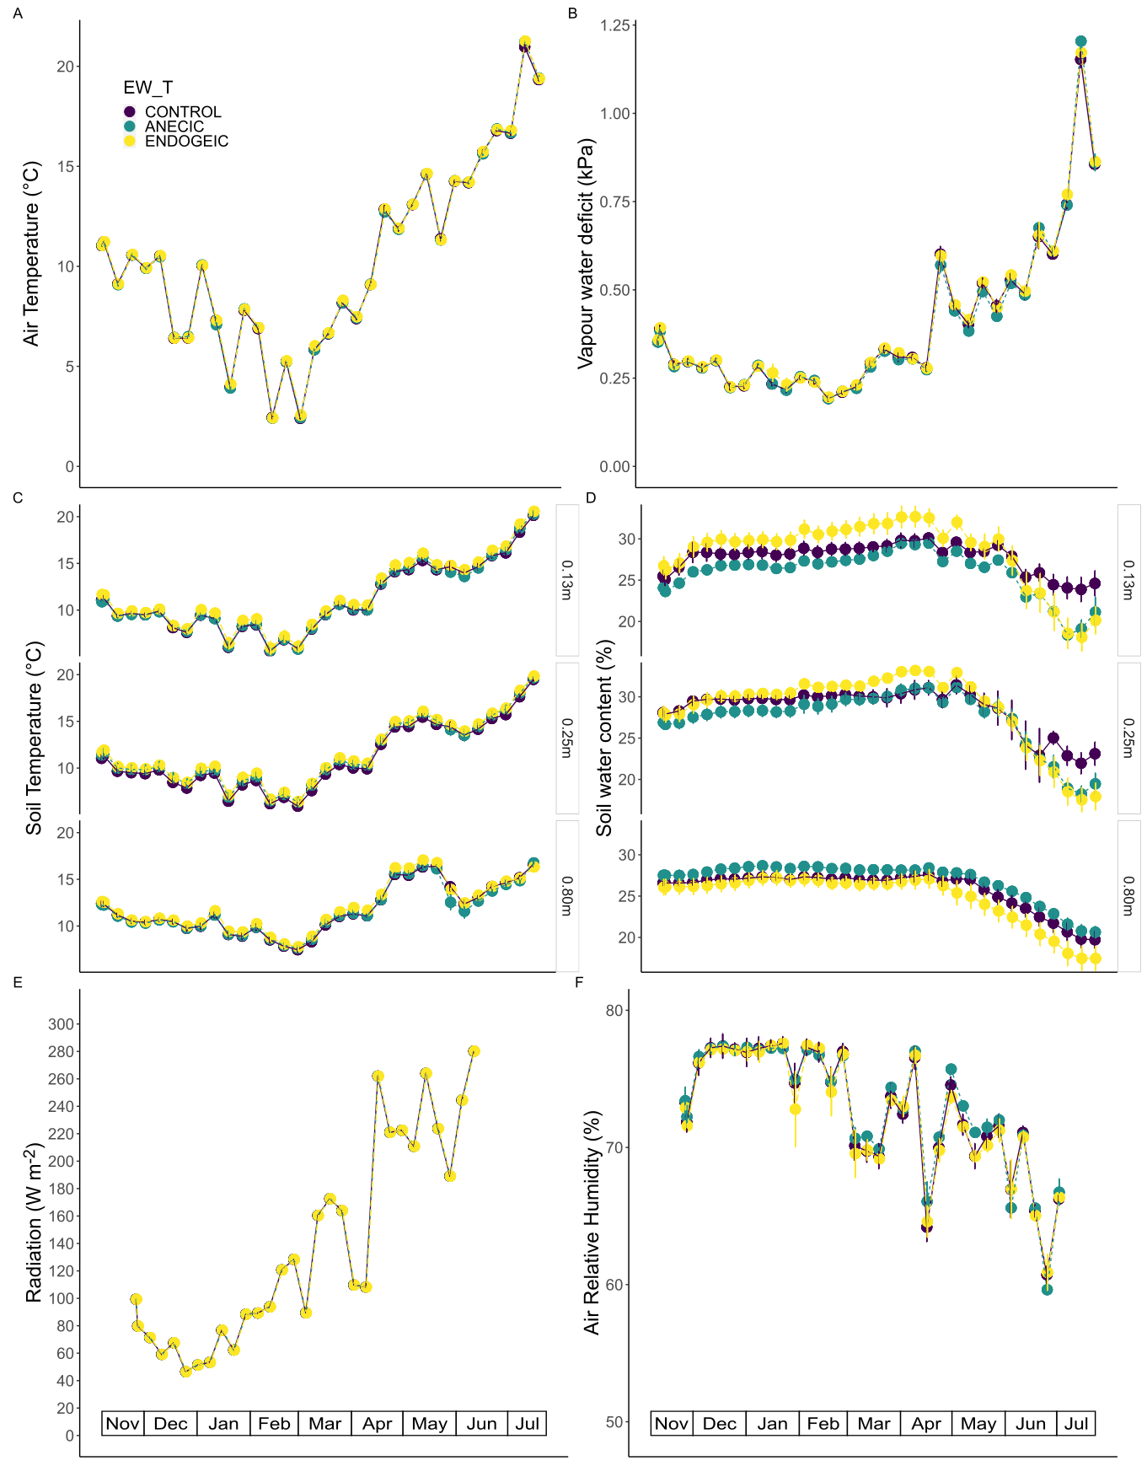

Figure S4: Weekly dynamics of environmental variables as affected by the earthworm treatment (EW_T) in the wheat crop. (A) Radiation. (B) Air humidity. (C) Air temperature. (D) VPD. (E) Soil temperature. (F) Soil water content. Data represent means ± SEM of four replicates. Horizontal bottom bars represent the experimental periods (crop growing season).
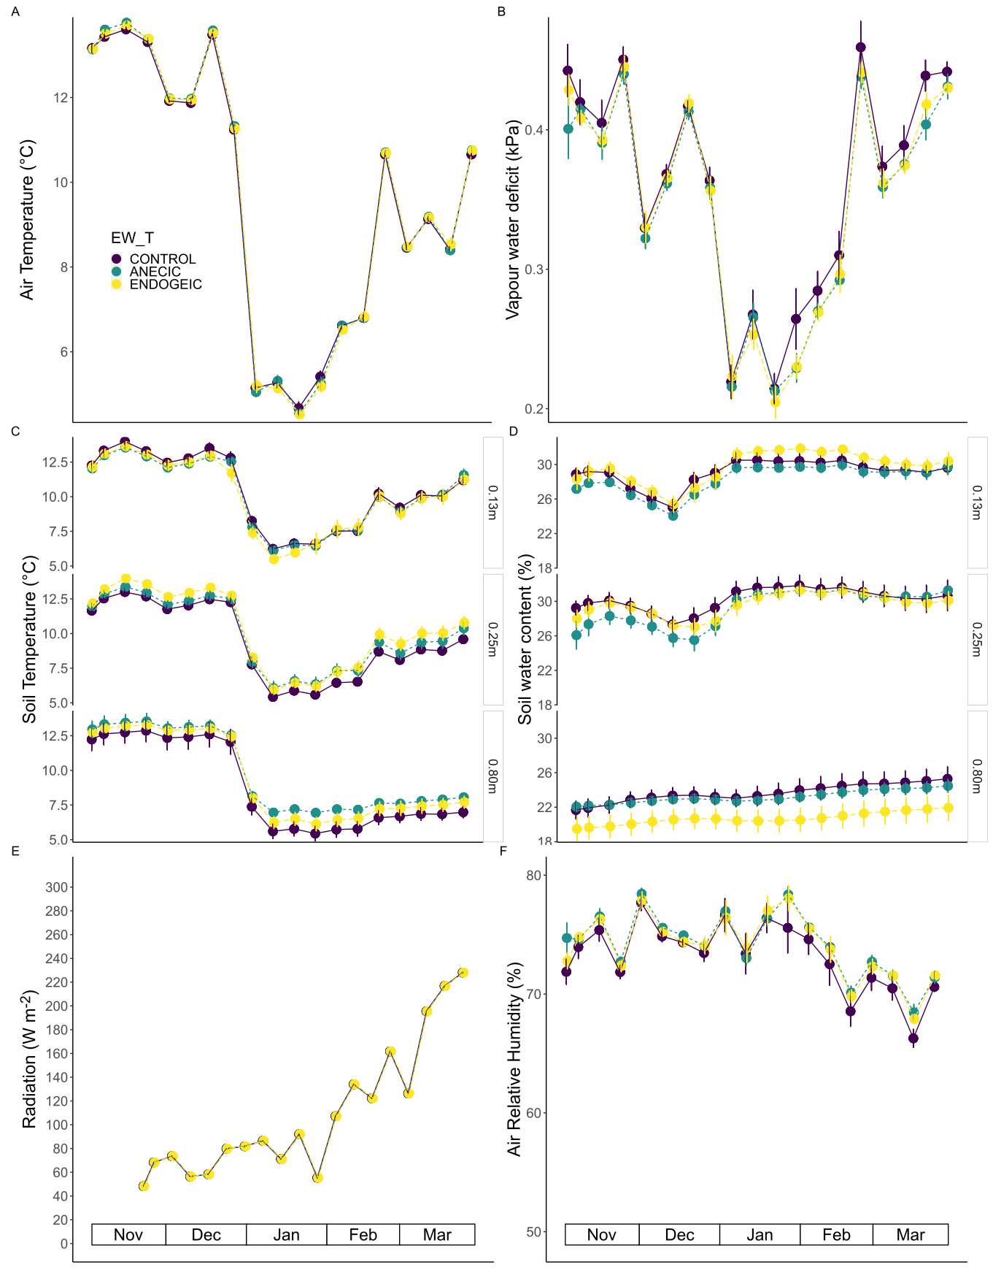

Figure S5: Weekly dynamics of environmental variables as affected by the earthworm treatment (EW_T) in the mustard crop. (A) Radiation. (B) Air humidity. (C) Air temperature. (D) VPD. (E) Soil temperature. (F) Soil water content. Data represent means ± SEM of four replicates. Horizontal bottom bars represent the experimental periods (crop growing season).
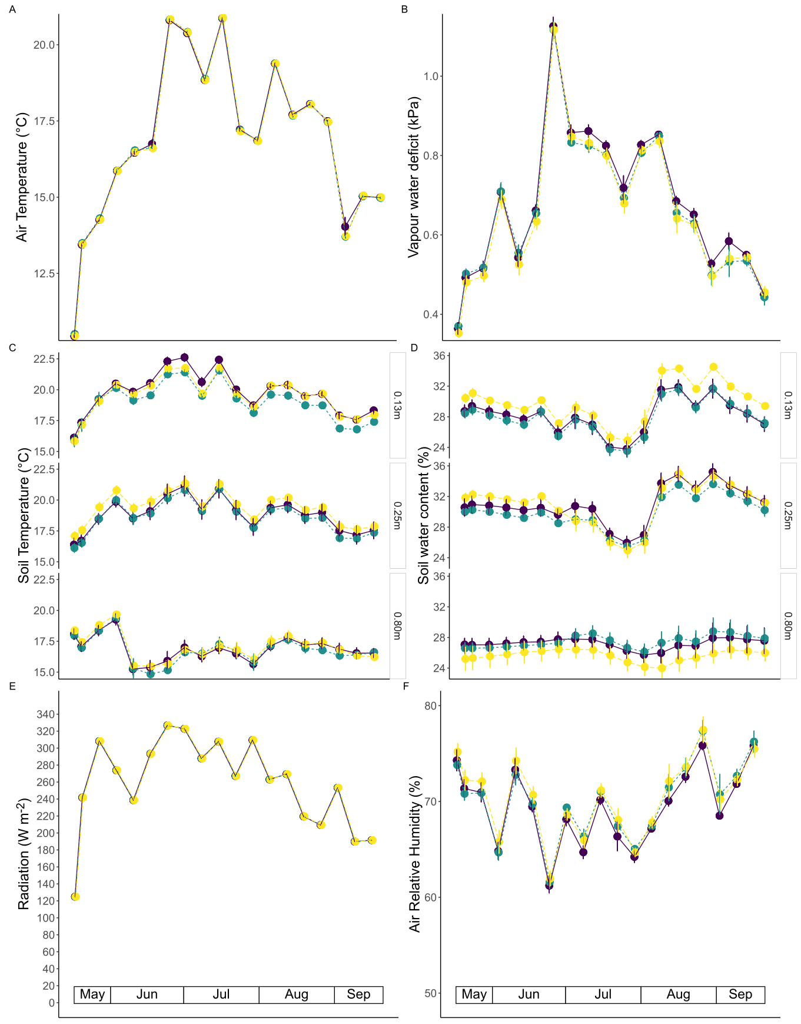
Figure S6: Weekly dynamics of environmental variables as affected by the earthworm treatment (EW_T) in the maize crop. (A) Radiation. (B) Air humidity. (C) Air temperature. (D) VPD. (E) Soil temperature. (F) Soil water content. Data represent means ± SEM of four replicates. Horizontal bottom bars represent the experimental periods (crop growing season).
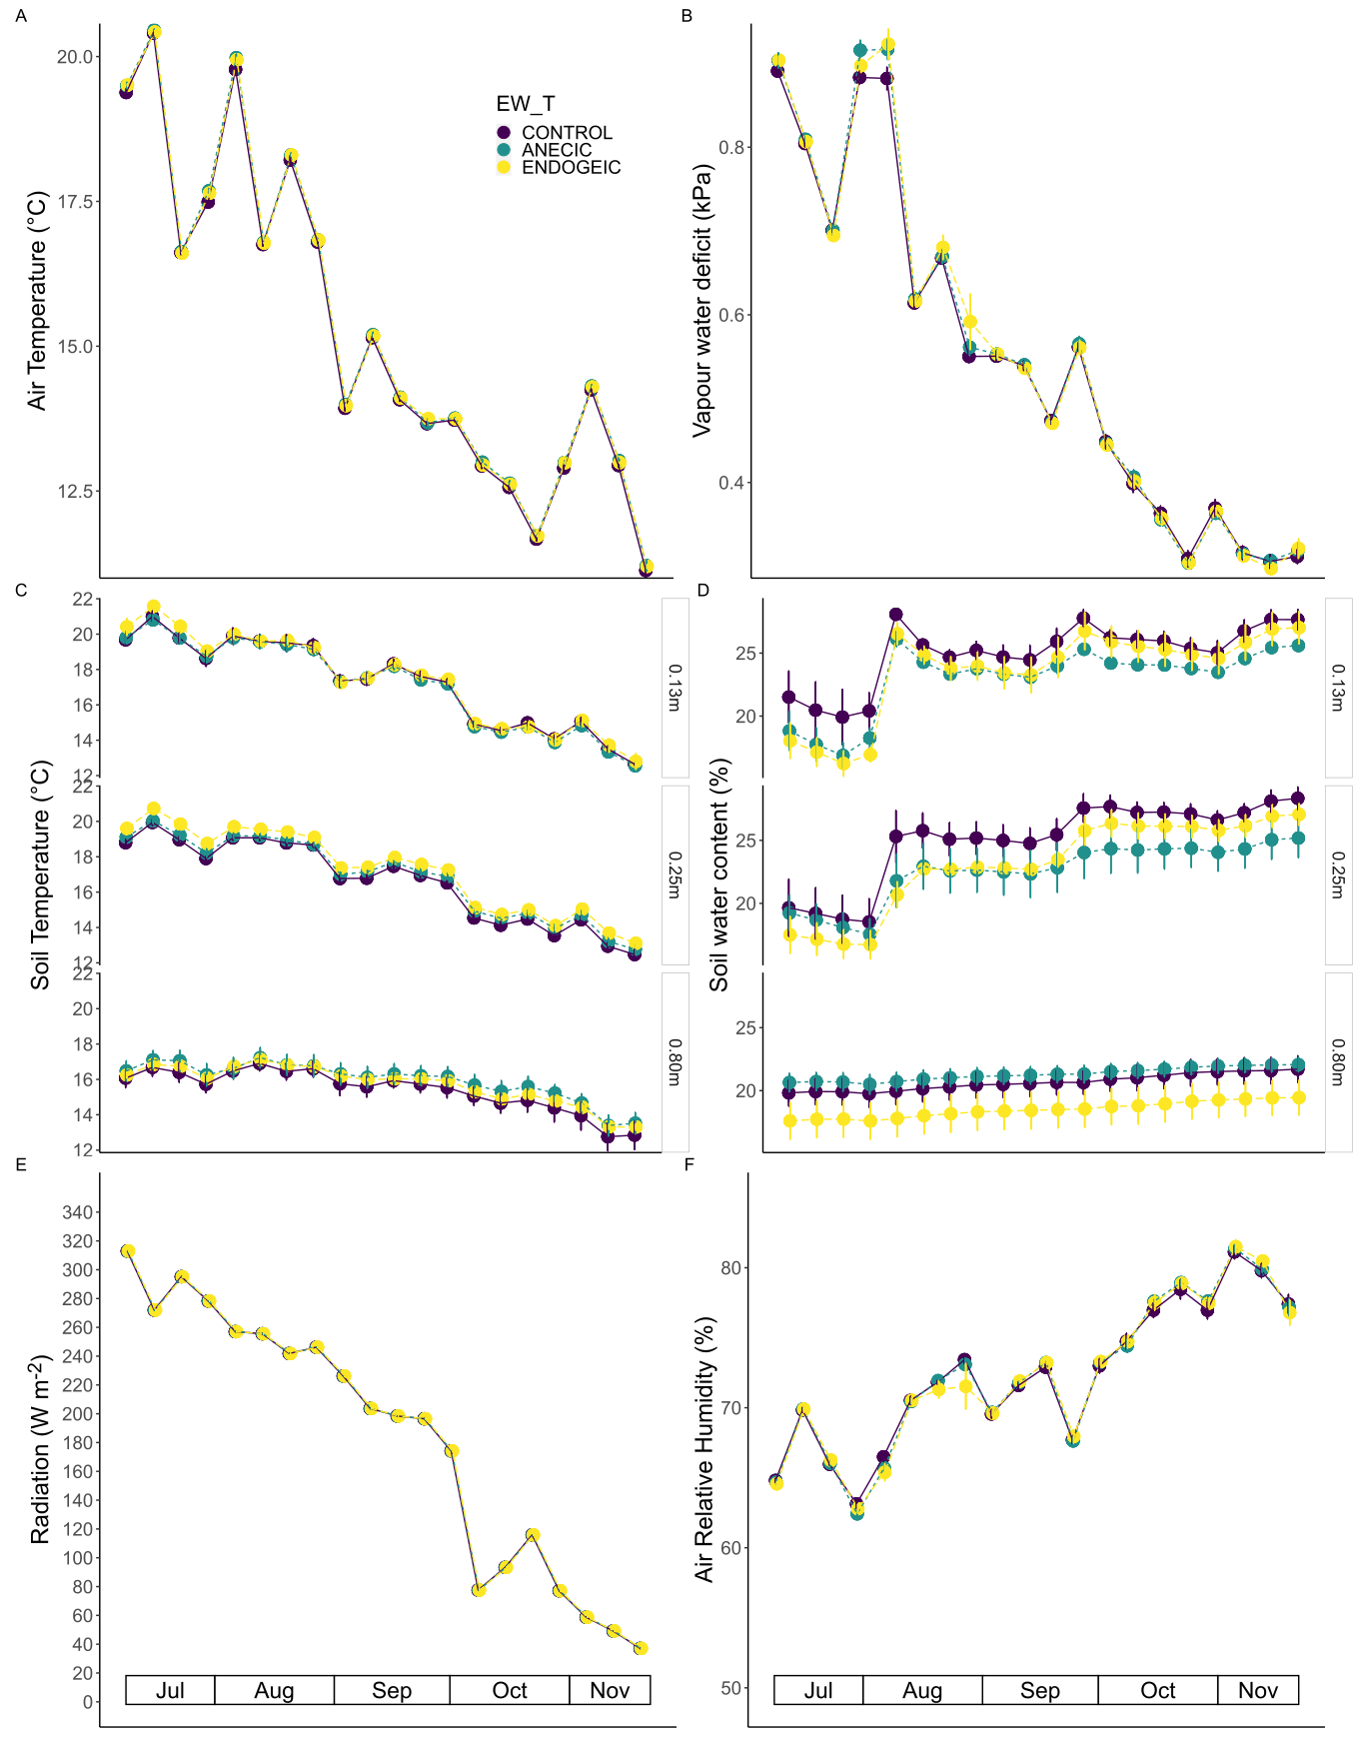

Figure S7: Weekly dynamics of environmental variables as affected by the earthworm treatment (EW_T) in the in the intercrop between wheat and mustard. (A) Radiation. (B) Air humidity. (C) Air temperature. (D) VPD. (E) Soil temperature. (F) Soil water content. Data represent means ± SEM of four replicates. Horizontal bottom bars represent the experimental periods (crop growing season).
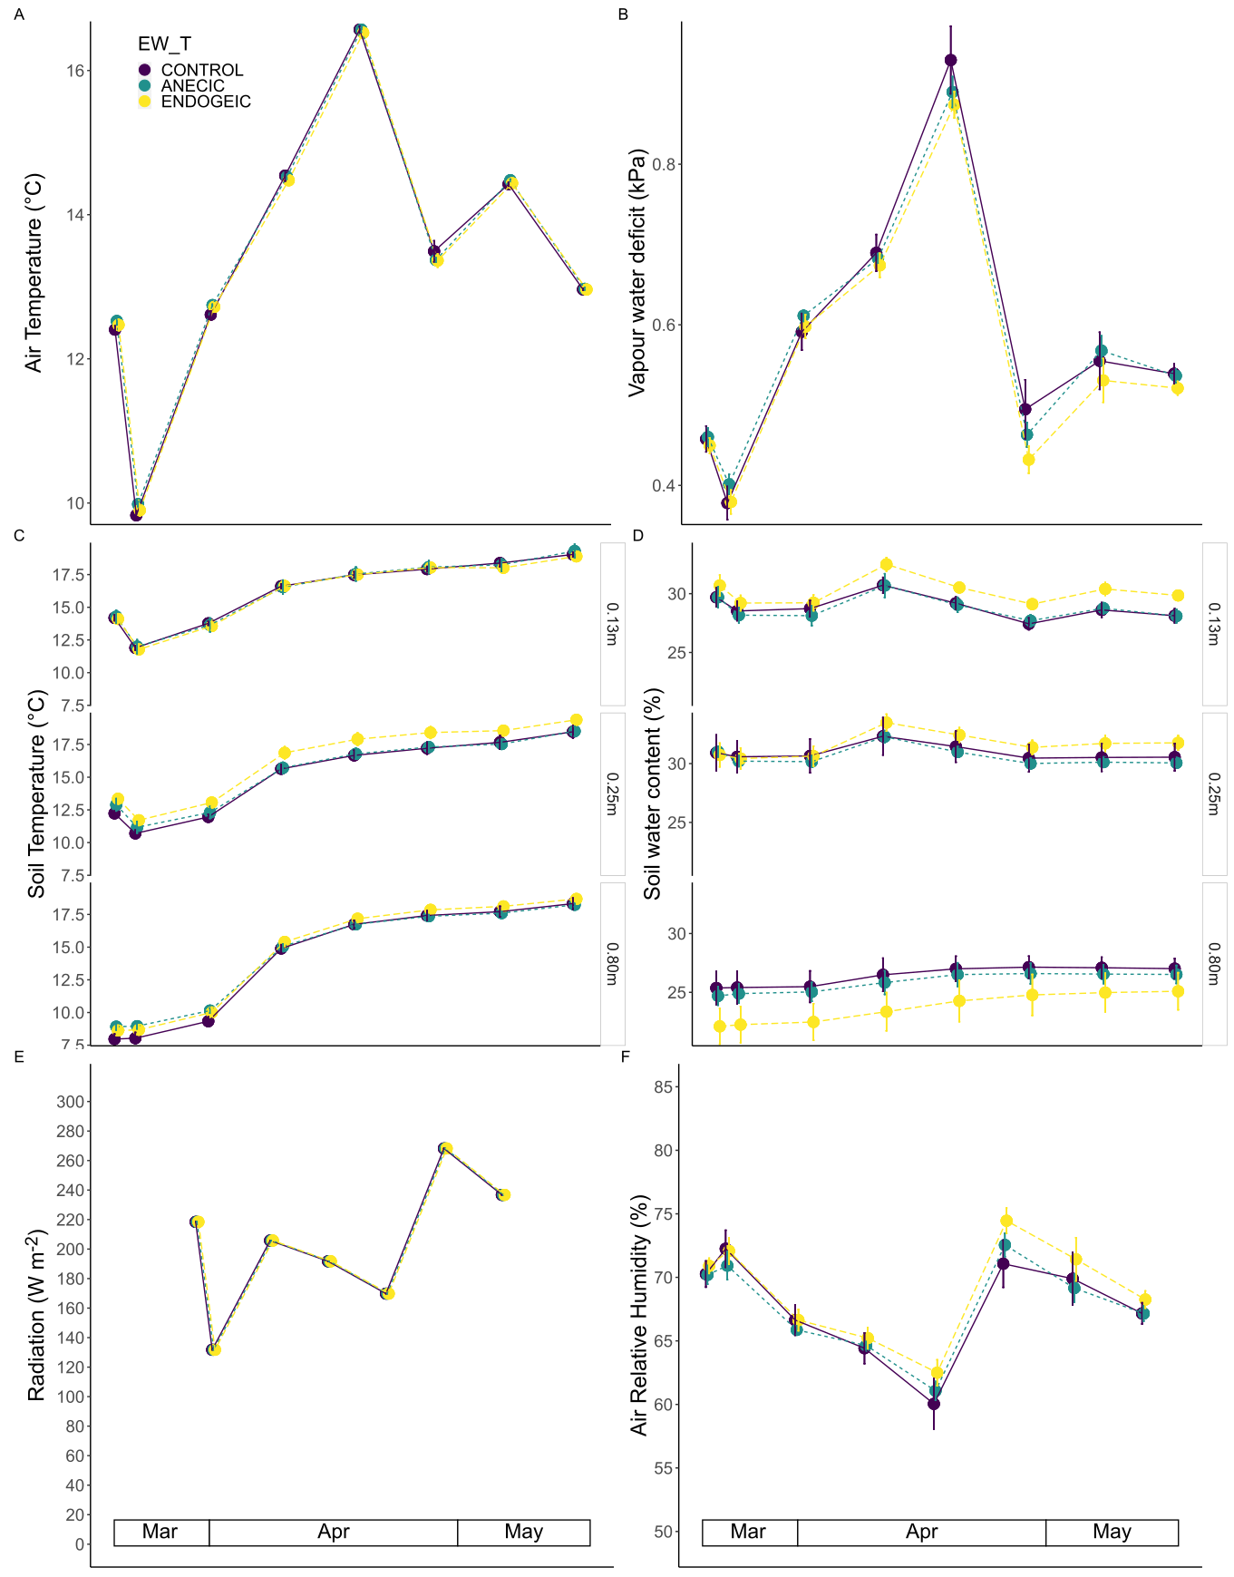
Figure S8: Weekly dynamics of environmental variables as affected by the earthworm treatment (EW_T) in the in the intercrop between mustard and maize. (A) Radiation. (B) Air humidity. (C) Air temperature. (D) VPD. (E) Soil temperature. (F) Soil water content. Data represent means ± SEM of four replicates. Horizontal bottom bars represent the experimental periods (crop growing season).

