Supplementary Figure S1. Correlations between GReX-PSs computed at different thresholds for each tissue.
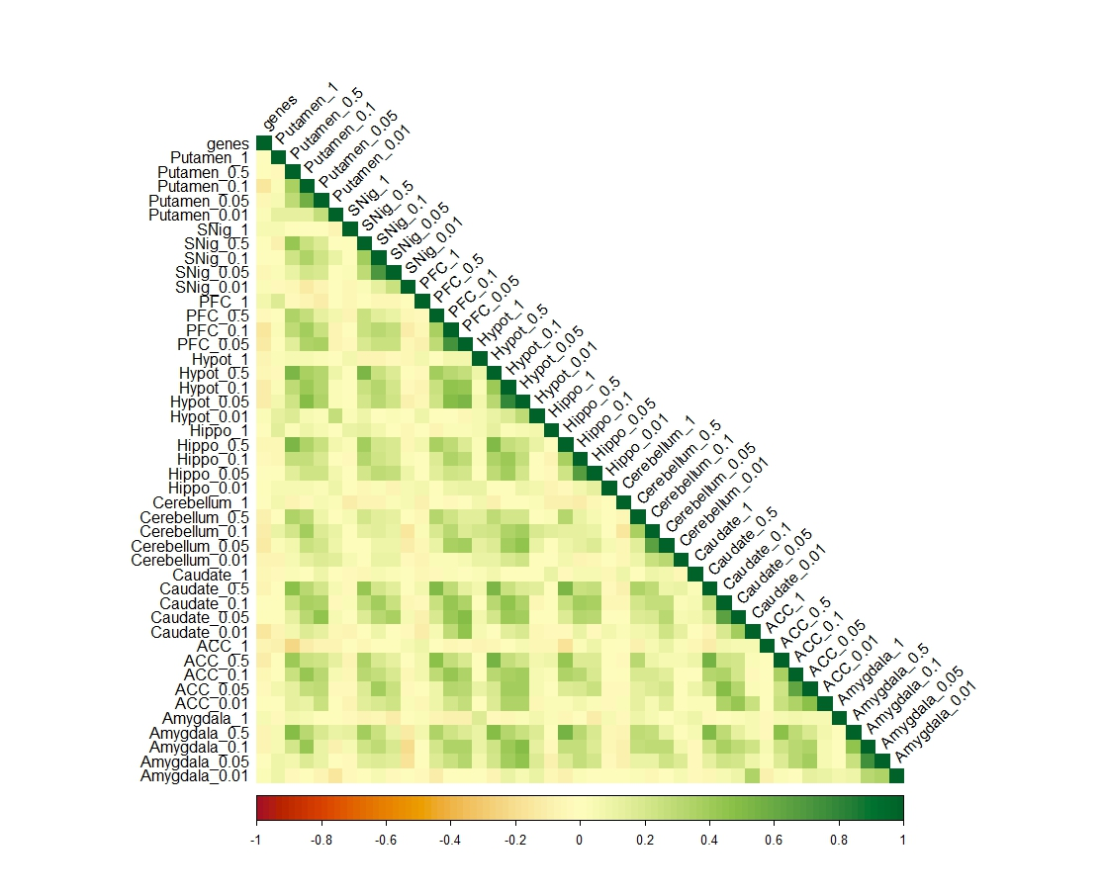

Supplementary Figure S2. Protein–Protein Interaction networks and the top five significant terms of the Biological Processes enrichment analysis of (a) Substantia Nigra, (b) Hippocampus, (c) Amygdala and (d) Prefrontal Cortex. Red cluster represents cluster without functionality
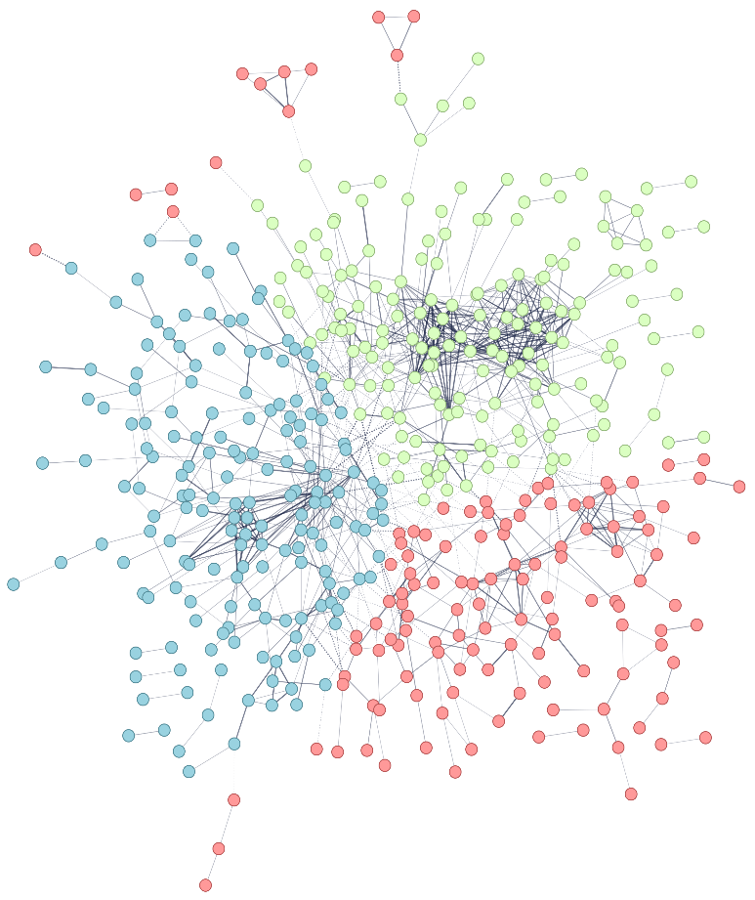
Cluster 1
Cluster 2
(a)

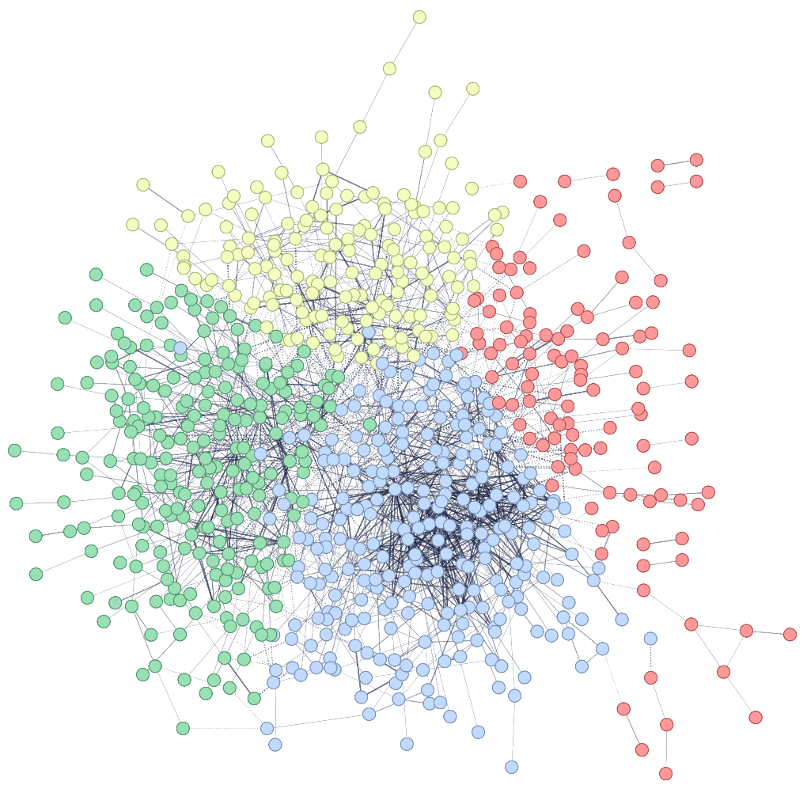
Cluster 1
Cluster 2
Cluster 3
(b)

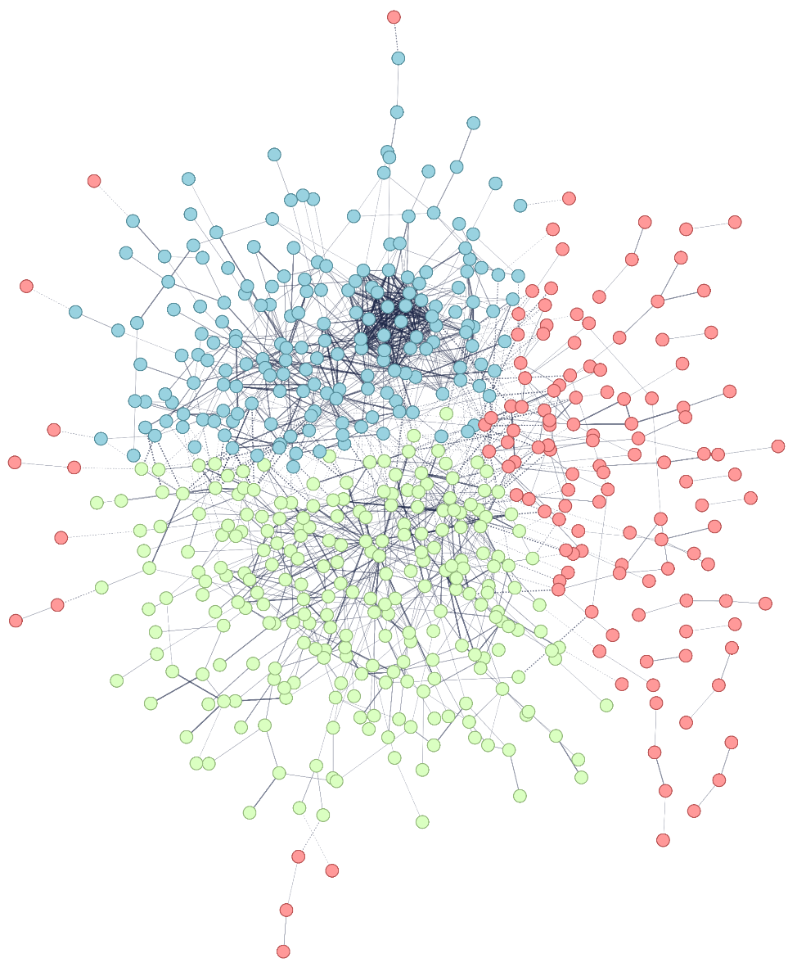
Cluster 1
Cluster 2
(c)

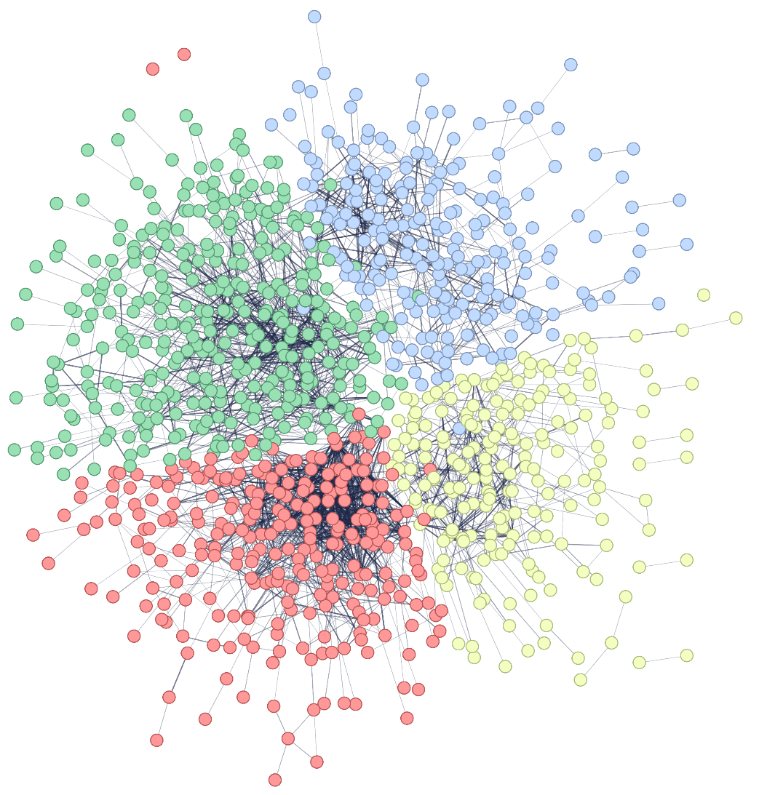
Cluster 1
Cluster 2
Cluster 3
(d)

