Supplementary materials

Material & Methods
The research described herein complies with all relevant ethical regulations. Additionally, we declare that all specimens used in this study were obtained with informed consent. We obtained informed consent from the next kin under protocols No. 12-24 (the Department of Health and Mental Hygiene for the Office of the Chief Medical Examiner for the State of Maryland) and No. 20111080 (the Western Institutional Review Board for the Offices of the Chief Medical Examiner for Kalamazoo Michigan, University of North Dakota in Grand Forks North Dakota, and Santa Clara County California). We obtained samples at the Clinical Brain Disorder Branch (CBDB) at the National Institute of Mental Health (NIMH) from the Northern Virginia and District of Columbia Medical Examiners’ Office, according to NIH Institutional Review Board guidelines (Protocol #90-M-0142). The LIBD received the tissues by donation under the terms of a material transfer agreement. The Institutional Review Board of the University of Maryland at Baltimore and the State of Maryland approved the study protocols that collected these brain regions (11–13). Details of case selection, curation, diagnosis, and anatomical localization and dissection can be found in previous publications from our research group (11–13).

BrainSeq consortium RNA-sequencing data processing
We surveyed covariates, FASTQ files, SNP array genotypes, RNA degradation metrics obtained with the qSVA methodology (21), phenotype information, and raw counts (gene, transcript, exon, and exon-exon junction) for the caudate, dentate gyrus, DLPFC, and hippocampus from the BrainSeq Consortium (11, 13) and http://research.libd.org/dg_hippo_paper/data.html (12).

BrainSeq consortium genotype imputation
Samples were genotyped and imputed as part of the full LIBD cohort, using procedures as previously described (11, 13, 14). Briefly, samples were genotyped on four different types of Illumina microarrays over the years (HumanHap650, Human1M, HumanOmni2.5, or HumanOmni5-Quad BeadChips). We merged samples genotyped by the same type of microarray and followed standard pre-imputation quality control (QC) to remove low quality (Hardy-Weinberg equilibrium p-value < 1×10⁻⁶) and low frequency (minor allele frequency [MAF] < 0.005) variants. We converted genotype positions from hg19 to hg38 with liftOver (46). Once converted, we imputed genotypes, separately by genotyping array, on the Trans-Omics for Precision Medicine (TOPMed) imputation server (7, 47, 48) using the Haplotype Reference Consortium (HRC) reference panels. We phased genotypes per chromosome using eagle (version 2.4; (49)). We performed post-imputation QC of each imputed dataset for Black and White American samples separately.
We filtered out variants with low-quality imputation scores (R² < 0.8) and removed variants: 1) MAF less than 0.05, 2) missing call frequencies greater than 0.1, or 3) Hardy-Weinberg equilibrium below p-value of 1e-10 using PLINK2 (v2.00a3LM; (50)). We then merged imputed genotypes across four genotyping platforms based on overlapping filtered imputed variants. This resulted in 6,225,756 and 6,097,532 common variants for Black and White American donors, respectively.

BrainSeq consortium DNA methylation data processing
We generated WGBS datasets in our previous studies for three adult brain regions (DLPFC, hippocampus and caudate). Details about study samples, data generation, and data processing have been described in our prior reports (15, 51). Briefly, we assessed quality control with FastQC. Following assessment with FastQC, we removed adapter content with Trim Galore (52). We aligned trimmed reads with Arioc (53) to the hg38 genome build (GRCh38.p12) and removed duplicate alignments with SAMBLASTER (54). After removing duplicates, we filtered alignments with samtools (55) (v1.9) to include only primary alignments with a mapping quality (MAPQ) ≥ 5. From these filtered alignments, we extracted methylation data using Bismark methylation extractor (56). Following methylation extraction, we processed and combined DNA methylation proportions across samples using bsseq (v1.18; (57)), an R/Bioconductor package. We locally smoothed methylation data with BSmooth using default parameters. We filtered the resulting CpG data to remove: 1) CpGs within the blacklist regions and 2) CpGs with coverage < 3.

Subject selection and details
We selected samples per brain region using five common inclusion criteria: 1) RiboZero RNA-sequencing library preparation, 2) recent African ancestry, 3) TOPMed imputed genotypes available, 4) adults (age > 17) and 5) diagnosis of neurotypical control. This resulted in a total of 425 samples from 151 unique individuals across the caudate (n=121), dentate gyrus (n=47), DLPFC (n=123), and hippocampus (n=133). Subject details are summarized in Table S1.

Estimation of genome-wide admixture levels
We estimated the admixture proportion for each individual based on SNPs that were informative with respect to ancestry using the STRUCTURE program. We selected 1,634 such SNPs based on genetic information downloaded from the 1000 Genomes CEU (Northern Europeans from Utah) and AFR (African ancestry superpopulation, including Esan, Gambian, Luhyu, Mende, and Yoruba populations) samples. Markers were chosen based on the following criteria: 1) absolute difference (δ) in allele frequency between the two ancestry populations > 0.5; 2) r² between each pair of SNPs < 0.1 within each population; 3) p-value > 0.01 for testing Hardy-Weinberg equilibrium within each population; and 4) successfully imputed in our brain samples (info > 0.8). The structure was run within a two-ancestry population model with 5,000 burn in and 10,000 iterations.

Estimation of local ancestry
We used RFMIX (58), a discriminative modeling approach for rapid and robust local-ancestry inferences, to infer local ancestry in our admixed samples using the European and African ancestry samples from the 1000 Genomes project (59) as reference. We extracted the posterior probability of African ancestry at each SNP per haplotype from the Forward–Backward output of RFMIX. Local ancestry for a genomic region was then estimated as the average African ancestry across all SNPs within the region. As RFMIX also computed and output a global ancestry estimate for each sample, we compared global ancestry estimates between STRUCTURE and RFMIX and observed a high correlation between estimates from the two programs (Spearman correlation, ρ = 0.99).

Differential expression analysis

Cell-type deconvolution analysis
Deconvolution was performed with the ReferenceBasedDecomposition function from the R package BisqueRNA version 1.0.4 (60), using the use.overlap = FALSE option. The single cell reference data set used is single nucleus RNA-seq from the 10X protocol, which includes tissue from eight donors and five brain regions (61). The ten cell types considered in the deconvolution of the tissue were astrocytes (Astro), endothelial (Endo), microglia (Micro), macrophage (Macro), mural cells (Mural), oligodendrocytes (Oligo), oligodendrocyte progenitor cells (OPC), T cells (Tcell), excitatory neurons (Excit), and inhibitory neurons (Inhib). Marker genes were selected by first filtering for genes common between the bulk data and the reference data and then calculating the ratio of the mean expression of each gene in the target cell type over the highest mean expression of that gene in a non-target cell type. The 25 genes with the highest ratios for each cell type were selected as markers.

Quality control and identification of relevant confounders
To evaluate potential sources of confounding for expression and genetic ancestry, we first correlated technical and RNA quality variables available from the downloaded R variables and removed highly correlated variables (Pearson, r > 0.95) present in two or more brain regions. Following this, we retained variables common across the four brain regions. In addition to these variables, we also accounted for hidden variables using the downloaded qSVA (Fig. S22 and Equation 1; k=13, 6, 9, and 14, for the caudate, dentate gyrus, DLPFC, and hippocampus, respectively). We have found qSVs also accurately correct for observed variables like batch effect and cell-type composition (13, 21).
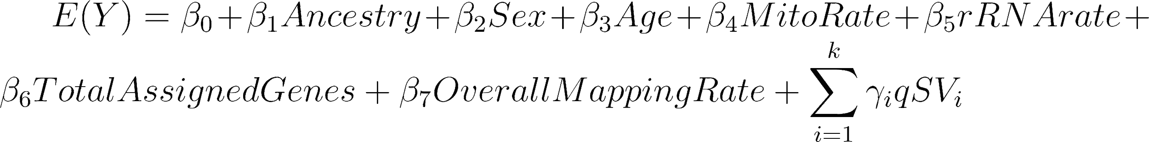
Equation 1
Given the potential influence of cell composition on gene expression, we also examined cell-type proportion associated with genetic ancestry and any potential confounding effects on gene expression. To this end, we performed cell-type deconvolution (Data S13). When we examined the Black American population, we found that the majority of cell types across brain regions showed no correlation with genetic ancestry (Fig. S23), and only oligodendrocytes in the DLPFC showed a significant association (Spearman, p-value < 0.05) with genetic ancestry. In contrast, when we included White American donors, we found that seven of the ten cell types showed a significant association (Spearman, p-value < 0.05) with genetic ancestry in at least one brain region (Fig. S24). These cell-type proportions also showed high correlation with confounders (Fig. S25). As such, our model also accounted for cell-type proportions for each brain region (Fig. S26).

Global ancestry-associated differential expression analysis
We performed differential expression analysis using mash modeling in R. Initially, we determined effect size and standard error of effect size using limma-voom modeling as previously described (13). Briefly, we filtered low-expressing genes using filterByExpr from edgeR (62, 63) and normalized library size. Next, we applied voom normalization (64) as a model of genetic ancestry adjusted for age, RNA quality (mitochondria mapping rate, gene assignment rate, genome mapping rate, rRNA mapping rate, and hidden variance using qSVA; Equation 1). Following voom normalization, we fit the model using eBayes and extracted out effect size (log fold-change) and standard error of effect size from the model (Equation 2) by brain region for each feature (gene, transcript, exon, and junction).
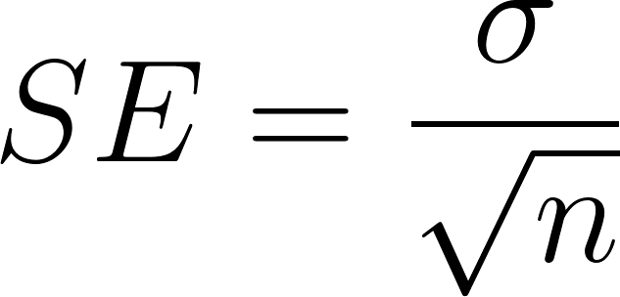
Equation 2
Next, we implemented mash modeling using mashr (v0.2.57) for each feature using the limma-voom extracted effect sizes and standard errors across brain regions. We learned the correlation structure across the brain regions used all features as an unbiased representation of the results to account for overlapping samples. Following this, we calculated the canonical covariances. A strong set of features was determined condition by condition using mash_1by1, and data-driven covariance was calculated with the strong set of features. Once calculated, we fit the mash model to the full set of features and computed the posterior summaries for all features. Features were considered significant if they had a lfsr less than 0.05.

Local ancestry-associated differential expression analysis
For local ancestry differential expression analysis, we first calculated a local African ancestry score per feature (i.e., gene, transcript, exon, and junction. Here, we averaged all haplotypes within a 200kbp window of each feature using the RFMIX results. Following this estimate of local African ancestry per feature, we applied a separate linear model per feature using Equation 1 modified for local ancestry. We limited our analysis to features tested for global ancestry differential expression. As each model was per feature, we replaced voom normalized with CPM log-normalized counts. We fit our model with limma lmFit and extracted effect size and standard error for downstream mash modeling as described in “Global ancestry-associated differential expression analysis”. We compared local and global ancestry DE results and found large overlap (Fig. S27).

Expression residualization
For residualized expression, we regressed out covariates from voom normalized expression using a null model (Equation 3) and applied a z-score normalization as previously described (13).
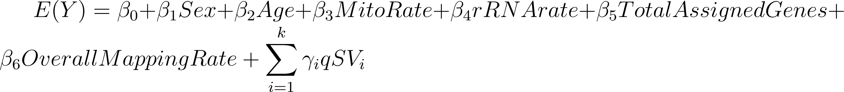
Equation 3

Cell-type enrichment analysis
To understand the cellular context of ancestry-associated DEGs in the human brain, we performed cell-type enrichment analysis by leveraging existing gene expression data from 39 broad categories of cell types from the mice central and peripheral nervous system (65). Specifically, we examined the overlap between DEGs and cell-type-specific genes for each cell type defined in a previous study (66). We assessed enrichment for each brain cell type using a two-sided, Fisher’s exact test. We corrected for multiple testing with Benjamini-Hochberg.

Public data comparison and enrichment analysis
For public data comparison, we downloaded the ancestry-associated DEGs in immune cells (19). Similar to cell-type enrichment analysis, we assessed enrichment with our ancestry-associated DEGs using a two-sided, Fisher’s exact test and corrected for multiple testing with Benjamini-Hochberg.

Binary contrast of Black and White Americans
For internal validation of global ancestry-associated DE features (i.e., gene, transcript, exon, and junction), we performed differential expression analysis with a combination of Black and White American individuals using mash. Similar to “Global ancestry-associated differential expression analysis”, we determined effect size and standard error of effect size using limma-voom modeling. Here, we replaced the continuous variable genetic ancestry with the binary, self-reported race. Additionally, we selected individuals with limited admixture by including: 1) Black Americans with African genetic ancestry greater than or equal to 0.8 and 2) White American with European genetic ancestry greater than 0.99. To limit the influence of the larger sample size compared to “Global ancestry-associated differential expression analysis”, we randomly sampled ten times without replacement to approximately the admixed Black American-only analysis sample size. Following extraction of effect sizes and standard errors, we implemented mash modeling for each feature across brain regions as described in “Global ancestry-associated differential expression analysis”.

Weighted correlation network analysis
We performed a signed-network WGCNA (24) analysis using residualized expression to generate the co-expression network with neurotypical control individuals (n=151 Black Americans) in a single block by brain region. For this analysis, we filtered genes and outlier individuals with the WGCNA function goodSamplesGenes. Following this, we applied additional sample filtering based on sample expression with a total Z-normalized distance of 2.5 or greater from other samples. After evaluating power and network connectivity for each brain region, we selected a soft power of 12.
For network construction, we used bicor correlation and the following parameters: 1) mergeCutHeight set to 0.3 for the dentate gyrus and default values for the caudate, DLPFC, and hippocampus and 2) minModuleSizeset to 30 for the dentate gyrus and default values for the caudate, DLPFC, and hippocampus. We set all other parameters to default values. The co-expression network was made using Pearson correlation values for the caudate (117 samples; 19,883 genes), dentate gyrus (46 samples; 18,747 genes), DLPFC (121 samples; 20,070 genes), and hippocampus (128 samples; 19,794 genes). We determined significant associations with ancestry using a linear model that correlates ancestry proportions (see Estimation of genome-wide admixture levels) with module eigengenes.
For each module, we calculated overlap enrichment/depletion with ancestry-associated DEGs (at FDR < 0.05) separated by direction of effect (such as DEGs that are upregulated in AA, upregulated in EA, or upregulated in either ancestry) using the two-sided Fisher’s exact test in Python with SciPy (67) stats module. The following p-values were corrected using statsmodels (68) stats module with the Benjamini-Hochberg method in Python.
When we examine the most significantly enriched modules for ancestry-associated DEGs upregulated in Black American individuals across brain regions, we found the cyan module (enriched for response to virus) for the caudate; the pink module (enriched for wound healing and cell migration) for the dentate gyrus; the saddlebrown module (enriched for cellular response to virus) for the DLPFC; and the yellow module (enriched for cilium movement and assembly) for the hippocampus (Figure S7A and Data S4). In contrast, when we examined the most significantly enriched modules for ancestry-associated DEGs downregulated in proportion to Black American individuals across brain regions, we found the greenyellow module (enriched for inflammatory response) for the caudate; the saddlebrown module (enriched for immune response) for the dentate gyrus; the pink module (enriched for immune response) for the DLPFC; and the blue module (enriched for immune response) for the hippocampus (Figure S7B and Data S4). Although the caudate and DLPFC showed modules enriched for immune response for both directions of effect, the most significantly enriched non-gray module (two-sided, Fisher’s exact test) was associated with a specific direction of effect consistent with DE analysis for the caudate (cyan module, DEGs upregulated in African ancestry) and DLPFC (pink module, DEGs downregulated in African ancestry).

Gene term enrichment analysis

Differential expression analysis: gene term enrichment
We determined significant enrichment for gene sets using the gene set enrichment analysis (GSEA) (69, 70), which is less susceptible to gene length bias because it uses permutation enrichment within gene sets. In this study, we performed GSEA with gseGO (GO gene set database) from the clusterProfiler package (71) and gseDGN (DisGeNET gene set database (23)) from the DOSE package (72). We defined the gene set “universe” as all unique genes tested for differential expression. When examining isoform-level enrichment (transcript, exon, or junction), we selected, for each unique gene, the feature with the largest absolute effect size. For gseGO, minimal gene set size (minGSSize) was set to 10, maximum gene set size (maxGSSize) set to 500, and p-value cutoff set to 0.05. For gseDGN, minGSSize was set to five and p-value cutoff to 0.05. We used the default settings for all other parameters.

Co-expression network analysis: gene term enrichment
For gene term enrichment analysis, we used GOATOOLS Python package (73) using hypergeometric tests with the GO database. Similar to “Differential expression analysis: gene term enrichment”, we defined the gene set universe as all unique genes tested from differential expression analysis.

Enrichment of evolutionary constraint
For evolutionary constraint enrichment analysis, we downloaded genome aggregation database (gnomAD; v2) gene- and transcript-level loss-of-function metrics (27). We assessed enrichment with the observed/expected loss-of-function upper bound fraction (LOEUF) using the decile bins. Additionally, we tested correlation between ancestry-associated differentially expressed features (i.e., genes and transcripts) and the LOEUF with a two-sided Pearson’s correlation. We corrected both statistical tests for multiple testing using Benjamini-Hochberg.

Expression quantitative trait loci analysis
We performed all cis-eQTL mapping for neurotypical controls (Black American individuals, age > 17; Table S1) using tensorQTL, which leverages GPUs to substantially increase computational speed (74). Initially, we filtered low expression as previously described (13) using the GTEx Python script (i.e., eqtl_prepare_expression.py) with modifications for isoform-level genomic features (i.e., transcripts, exons, and junctions). This script retained features with expression estimates greater than 0.1 transcripts per million (TPM) in at least 20% of samples and aligned read counts of six or more. Additionally, this script used Python functions defined by rnaseqnorm.py to normalize counts with TMM, a Python port of edgeR function.
To generate the TPM files as input for the eqtl_prepare_expression.py, we used effective length (Equation 4). For genes and exons, we calculated effective length (Equation 5) using mean insert size from Picard tools CollectInsertSizeMetrics (http://broadinstitute.github.io/picard/). For junctions, we fixed effective length at 100. After calculating effective length, we dropped any feature with an effective length less than or equal to one.
$TPM = 1e6 ×\frac{Count / Effective Length}{Σ(Count / Effective Length)}$ Equation 4
$Effective Length = Length - [Mean Insert Size] + 1$ Equation 5

Main effect analysis
For main effect cis-eQTL mapping, we quantified the effects of unobserved confounding variables on expression after adjusting for sex, population stratification (SNP PCs 1-5), and k unobserved confounding variables on expression. We determined these variables via num.sv function (vfilter set to 50,000) from sva, an R/Bioconductor package (75), and principal components analysis (PCA) of expression for each feature. To identify cis-eQTL, we implemented nominal mapping, adjusting for covariates with a mapping window within 0.5 Mb of the TSS of each feature and a minor allele frequency ≥ 0.01. The tensorQTL used a two-sided t-test to estimate the nominal p-value for each variant-gene pair. To generate a subset of “strong” signals for downstream mash modeling in R, we also performed adaptive permutations. Following this, the empirical p-values were corrected for multiple testing across features using Storey’s q-value method (76, 77). This resulted in a file with the top variant for each feature. In addition to this permutation analysis, we also performed conditional analysis. This resulted in additional feature-variant pairs to generate our set of “strong” associations for mash modeling.

Ancestry-dependent interaction analysis
For genetic ancestry-dependent cis-eQTL mapping, we used the confounders generated from main effect analysis but removed variables associated with population stratification (SNP PCs 1-5). To identify genetic ancestry-dependent cis-eQTL, we implemented nominal mapping, adjusting for covariates with a mapping window within 0.5 Mb of the TSS of each feature and a MAF greater than or equal to 0.05. To generate a subset of strong signals for downstream mash modeling, we performed eigenMT (78) by setting run_eigenmt to True. This resulted in a file with the top variant for each feature.

Integration with mash modeling in R
To assess sharing across brain regions and to increase our power to detect main and interacting eQTL effects within admixed Black American only individuals, we used multivariate adaptive shrinkage framework as previously described (13). We extracted effect sizes and standard errors for these effect sizes from the nominal results for either main or interacting cis-eQTL. To specify a correlation structure across brain regions (i.e., overlapping sample donors), we used the estimate_null_correlation_simple function prior to fitting the mash model. The mash model included both the canonical covariance matrices and the data-driven covariance matrices learned from our data.
We defined the data-driven covariance matrices as the top four PCs from the PCA performed on the “strong” signals. For gene level analysis, we defined a set of “strong” tests running a simple condition-by-condition (mash_1by1) analysis as described in “Differential expression analysis”. For isoform-level analysis (i.e., transcript, exon, and junction), we defined a set of “strong” tests using either the results from permutation or eigenMT analyses. Specifically, for main effect analysis, the set of “strong” tests were selected if a feature-variant pair was present in at least one brain region within permutation or conditional analyses. For interaction analysis, we selected the set of “strong” tests if a feature-variant pair was present in at least one brain region from the eigenMT top associations.
To learn the mixture weights and scaling for the main and interacting effects, we initially fit the mash model with a random set (i.e., unbiased representation of the results) of the nominal eQTL results (i.e., 5% for gene-variant pairs and 1% for transcript-, exon-, and junction-variant pairs). We next fitted these mixture weights and scaling to all of the main and interacting eQTL results in chunks. Following model fitting, we extracted posterior summaries and measures of significance (i.e., lfsr). We considered main and interacting eQTL significant if the lfsr was less than 0.05.

Genetic control of ancestry effects on expression
We estimated the predicted cis-genetic population differences in expression by first computing predicted expression from genotype dosage (0, 1, or 2; see below). With these predicted expression values, we performed differential expression for genetic ancestry using a model analogous to Equation 1 (see Global ancestry-associated differential expression analysis) to obtain predicted genetic ancestry effects. We extracted the observed population differences in expression from the effect sizes estimated after applying mash as described in “Ancestry-associated differential expression analysis”.

Expression residualization for prediction models
To generate residualized expression for our prediction models, we fit a linear model with lmFit from limma to normalized expression (see Expression quantitative trait loci analysis) and covariates (see Differential expression analysis; Equation 3). Using this model, we regressed out covariates from normalized expression using the residuals function in R (version 4.0.3).

Calculating predicted expression using genetic variants in a linear model
For our linear model, we extracted the posterior effect size of the top genetic variant from the mash model for each feature (gene, transcript, exon, and junction). We imputed residualized expression using an individual’s genotype dosage (j) and feature (i) posterior effect size (Equation 6) using PyTorch (79).
$predicted expression_{i,j} = effect size{ (eQTL)}_{i} * genotype_{j}$ Equation 6

Calculating predicted expression using genetic variants in an elastic net model
We selected all genetic variants within ± 500kb of the gene body. We removed variants with missing genotypes and filtered variants based on a MAF threshold of 0.01 and a Hardy-Weinberg equilibrium below a p-value of 1e-5. We used an elastic net model, ideal for relatively smaller sample sizes. For our elastic net model, we fitted a sparse linear regression model using big_spLinReg from the bigstatsr R package (v1.5.12; (80)). We tuned the alpha parameter using a sequence of 20 alphas (i.e., 0.05 to 1 using 0.05 step size). Additionally, we used four sets for the “Cross-Model Selection and Averaging” procedure. We averaged feature weights for genetic variants across k-folds (five folds for each of the caudate, DLPFC, and hippocampus; and three folds for dentate gyrus). We imputed residualized expression with these feature weights (i) and an individual’s genotype dosage (j) (Equation 7). We calculated the correlation coefficient (r) using Pearson's correlation on the test samples for each k-fold.
$predicted expression_{i,j} = variant weight_{i} * genotype_{j}$ Equation 7

Linkage disequilibrium score regression
We performed stratified LD score regression (S-LDSC) (30) to evaluate global ancestry-associated DEGs for their enrichment for heritability of complex traits, mainly focused on 17 brain and five immune-related traits as a positive control. We downloaded GWAS summary statistics of each trait from the sources listed in Data S14. Following recommendations from the LDSC resource website (https://alkesgroup.broadinstitute.org/LDSCORE/), we ran S-LDSC for each list of candidate genes. We used the baseline LD model v2.2 that included 97 annotations to control for the LD between variants with other functional annotations in the genome. To remove other potential confounding factors in our analysis,we also included one annotation of all protein-coding genes.
To capture the regulatory regions of each gene, we defined gene intervals as a region spanning 500 kb upstream of the gene's start position and 50 kb downstream of its end position. We used HapMap Project Phase 3 SNPs as regression SNPs and 1000 Genomes SNPs of European ancestry samples as reference SNPs. We downloaded all SNPs from the LDSC resource website.
We ran S-LDSC for all ancestry-associated DEGs and conducted separate runs for DEGs of protein-coding and non-coding genes.

Differential methylation and environmental control of genetic ancestry

Variably methylated region analysis
To identify environmental-driven VMRs, we used only our admixed Black American neurotypical individuals (caudate [n=89], DLPFC [n=69], and hippocampus [n=69]). We considered approximately 24 million CpGs that had sequencing coverage of > 5 reads in > 80% samples of each brain region. We also excluded CpGs within ENCODE “blacklist” regions from analysis. We selected the top one million variable CpGs to compute principal components (PC) based on smoothed DNAm levels while removing the variation due to global ancestry of our primary variable of interest. Specifically, we regressed out global ancestry from each variable CpG and the residual DNAm was used for PC analysis. To capture CpGs whose variation of DNAm level was potentially driven by unknown environmental factors, we computed standard deviation for residualized DNAm levels of each CpG after regressing out top five PCs to remove variations due to batch effects and biological factors. We then selected the top 1% variable CpGs for calling VMRs for each brain region using the regionFinder3 function of bsseq and VMRs, retaining VMRs with more than five CpGs for further analysis. We estimated the DNAm level of each VMR by the total number of reads supporting methylated cytosine divided by the total number of reads supporting either methylated or unmethylated cytosine in the region.

Differentially methylated region analysis
For differentially methylated region analysis, we applied a linear model on VMRs (see Variably methylated region analysis) as a function of: 1) global genetic ancestry, 2) local genetic ancestry, 3) sex, 4) age, and 5) top five principal components of DNAm derived from top one million variable CpGs. We corrected both statistical tests for multiple testing using Benjamini-Hochberg.

Functional enrichment analysis
We associate biological functions to global ancestry-associated DMRs using rGREAT (v2.0.2) (82), an R/bioconductor package. Specifically, we selected significant DMRs (FDR < 0.05) and converted them into genomic ranges format with the plyranges (v1.18.0) (83), an R/Bioconductor package. Following this conversion and filtering, we applied the great function from rGREAT with the MSigDB Canonical Pathway C5 (70) gene ontology database with background set to human genome (hg18) autosomal chromosomes. We extracted enrichment results using the getEnrichmentTable function and plotted region-gene associations with plotRegionGeneAssociation function from the rGREAT package.

Evaluating environmental impact of global ancestry-associated DEGs
To evaluate the impact of unknown environmental factors on global ancestry-associated DEGs, we first annotated the VMRs using annotate_regions and basic genes hg38 annotation from the R/Bioconduction package annotatr (v1.24.0) (84) after converting to genomic ranges with plyranges. Following annotation, we estimated P_{ST} (19). P_{ST} is essentially the partial coefficient of determination. As such, we estimated the P_{ST} statistic for each gene with Equation 8. We calculated the P_{ST} statistics for ancestry before and after including the residualized VMRs annotated to an ancestry-associated DEG. The residual was derived from raw DNAm levels of each VMR by regressing out known biological factors (local ancestry, age, sex), as well as potential batch effects and other unknown biological factors captured by the top five principal components of DNAm levels. Following this, we calculated ΔP_{ST} to extract the fraction of change associated with the environment (Equation 9).
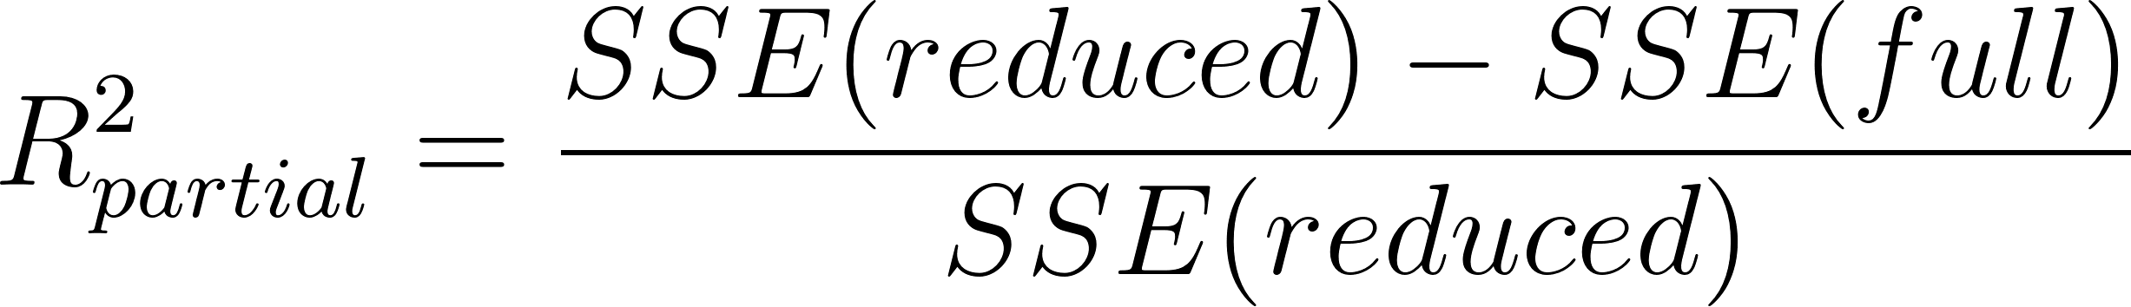
Equation 8
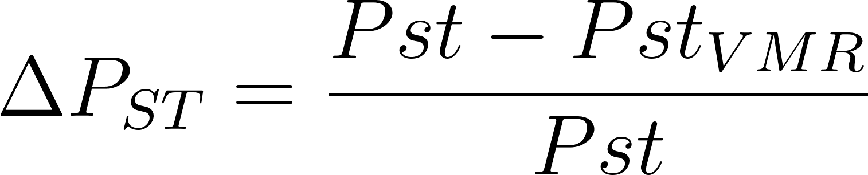
Equation 9

Graphics
We used R to generate all plots. We generated UpSet plots using ComplexHeatmap (v2.10.0; (85)). To generate Circos plots, we used circlize (v0.4.15; (86)). We generated enrichment heatmaps, gene term enrichment, error plots, boxplots, and scatterplots using a combination of ggplot2 (v3.3.6; (87)) and ggpubr (v0.4.15; (88)). For pairwise comparison plots, we used corrplot (v0.92; (89)). We generated meta plots using the mashr function mash_plot_meta.

Code availability
All code and Jupyter Notebooks are available through GitHub at https://github.com/LieberInstitute/aanri_phase1.git with more detail.

Supplementary Figures
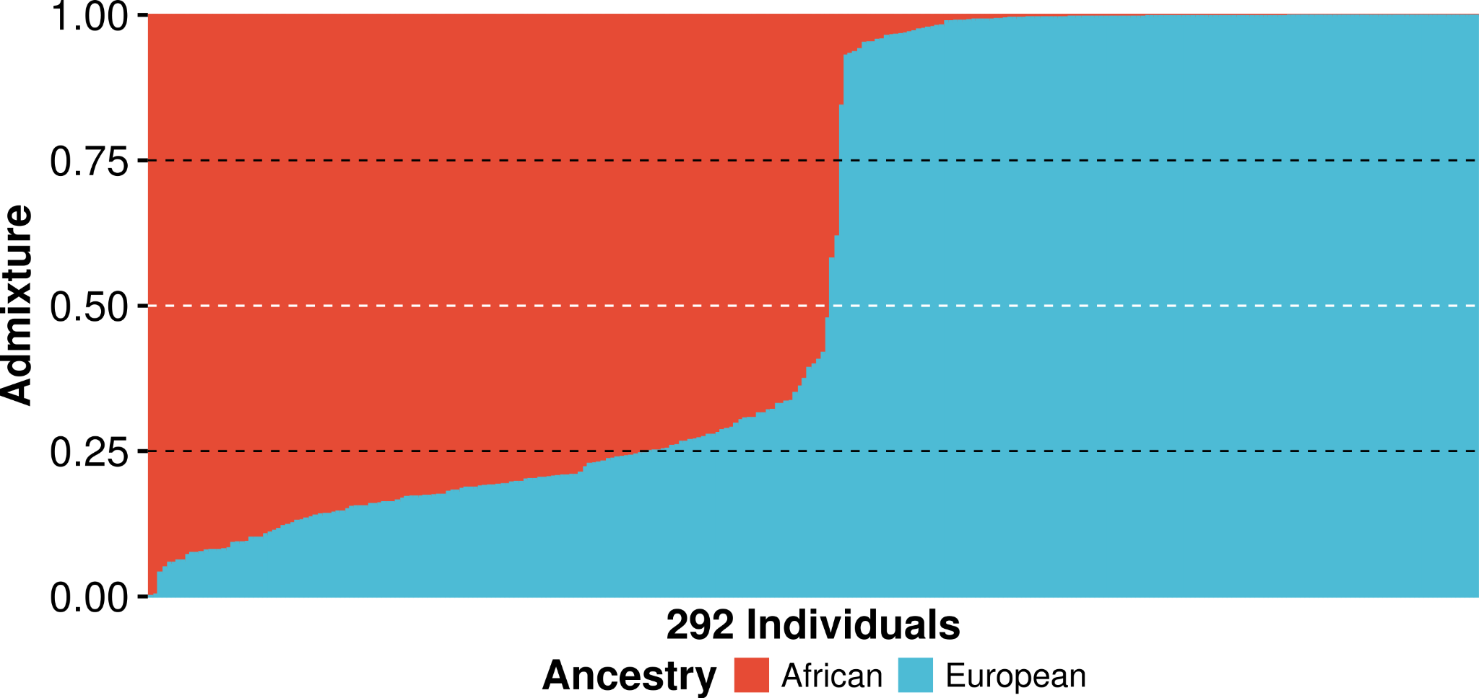
Fig. S1: Genetic ancestry estimates for Black and White American neurotypical individuals. Histogram showing estimated African and European ancestry for each unique neurotypical individual across the caudate, dentate gyrus, DLPFC, and hippocampus.

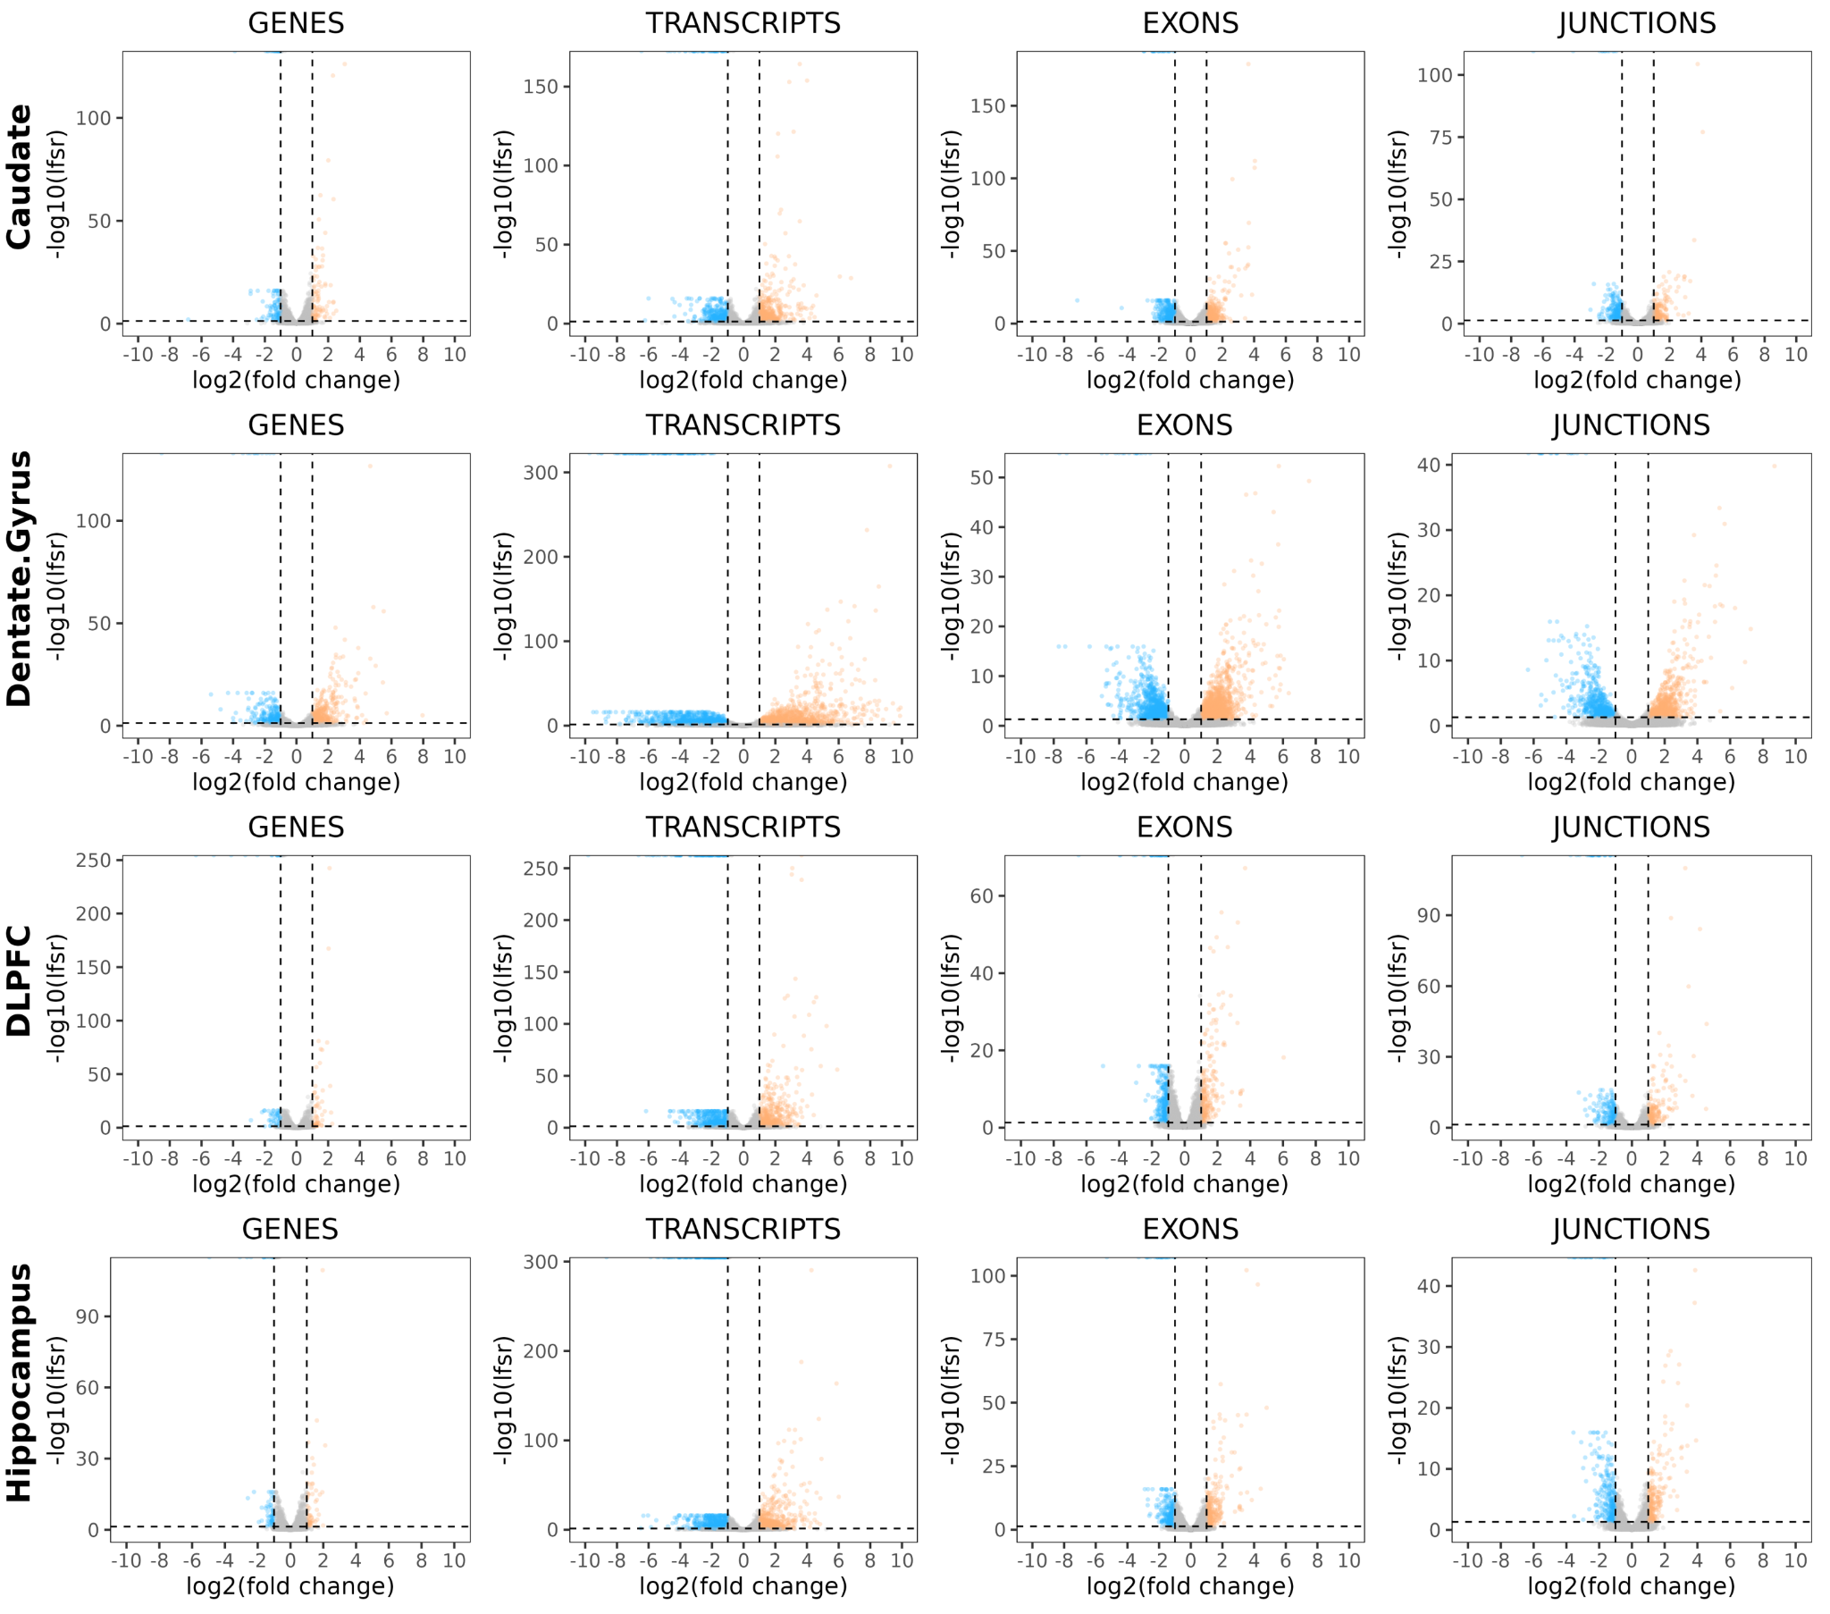
Fig. S2: Extensive global ancestry-associated differential expression across brain regions and features (i.e., gene, transcript, exon, and junction). Volcano plot of effect size (log₂ of fold change) estimated from mash modeling and significance (-log₁₀ of lfsr) with features associated with increased AA (blue) or EA (orange) proportions.

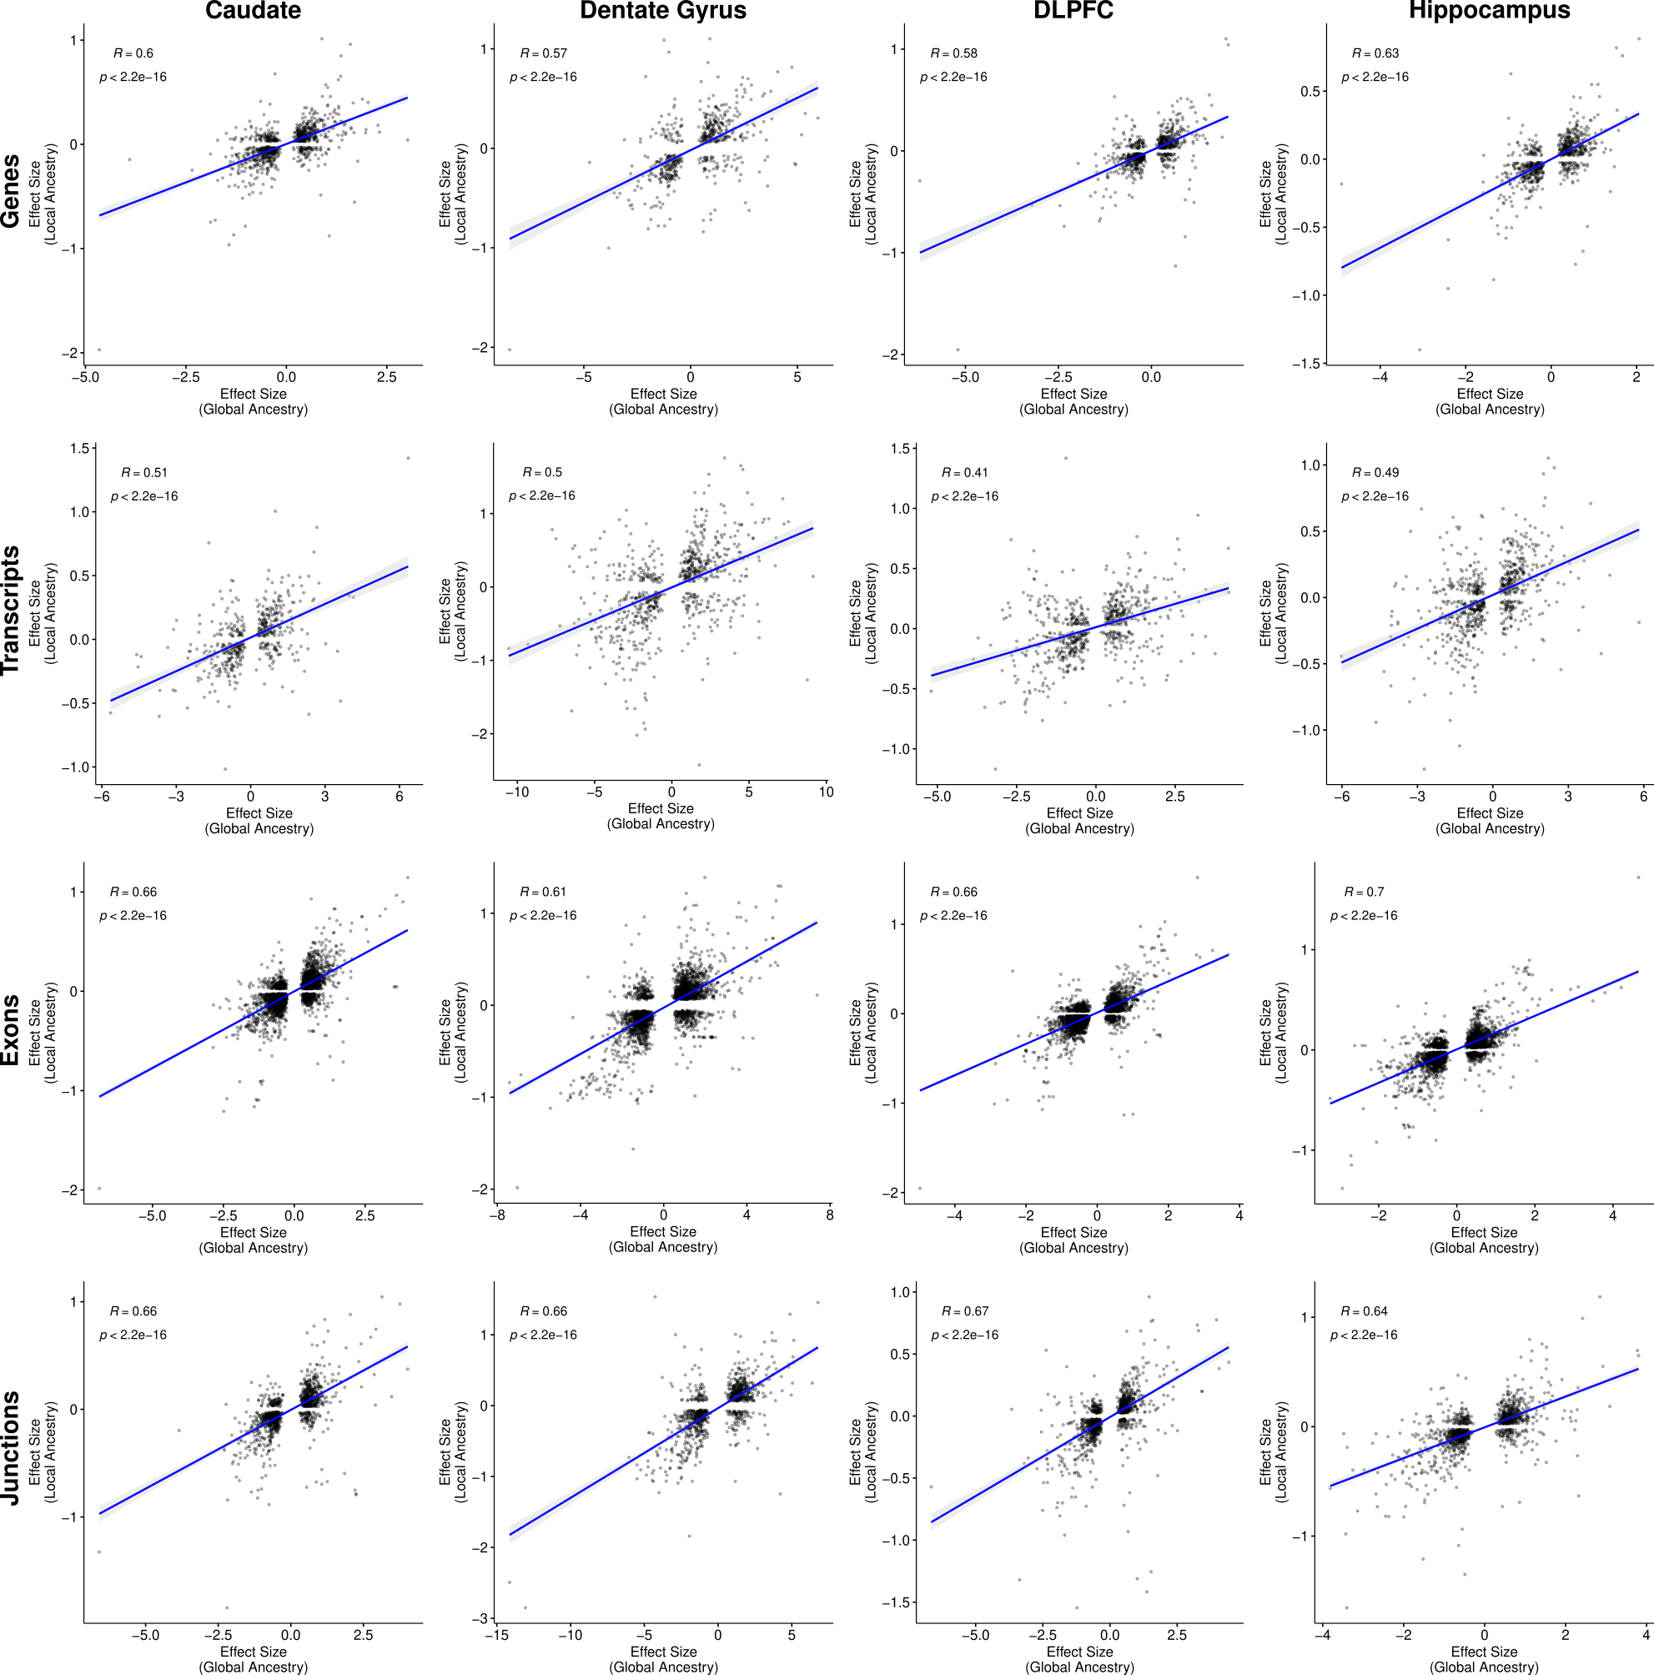
Fig. S3: Significant correlation between global and local ancestry shared features with local ancestry showing smaller effect sizes. Correlation (two-sided, Spearman) of local ancestry-associated DE features (i.e., gene, transcript, exon, and junction) effect sizes (y-axis) versus global ancestry-associated DE features effect sizes (x-axis) across brain regions. A fitted trend line is presented in blue as the mean values +/- standard deviation. The standard deviation is shaded in light gray.

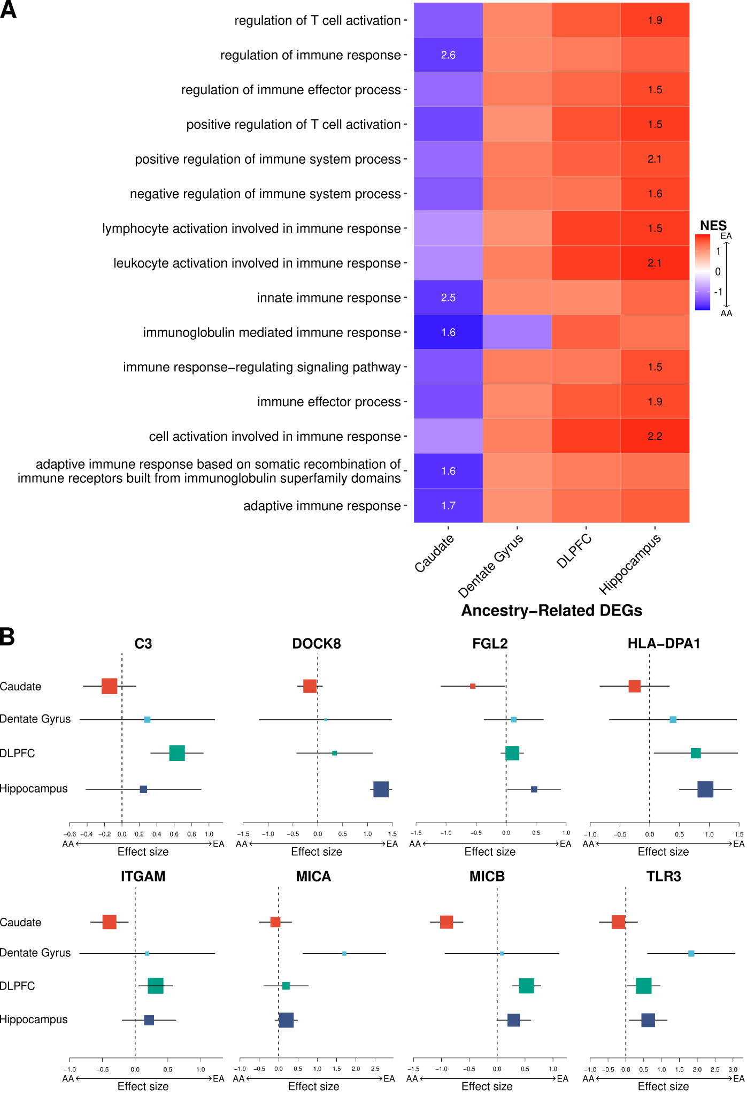
Fig. S4: Immune-related pathways show consistent direction of effect expression across brain regions. A. Heatmap showing direction of effect (increase AA proportion [blue] or increased EA proportion [red]) associated with immune-related GO terms across brain regions. Significant enrichments (GSEA, q-values < 0.05; -log₁₀ transformed) annotated within tiles. B. Metaplot showing examples of immune-related genes associated with significantly enriched pathways (GSEA enrichment analysis) across brain regions.

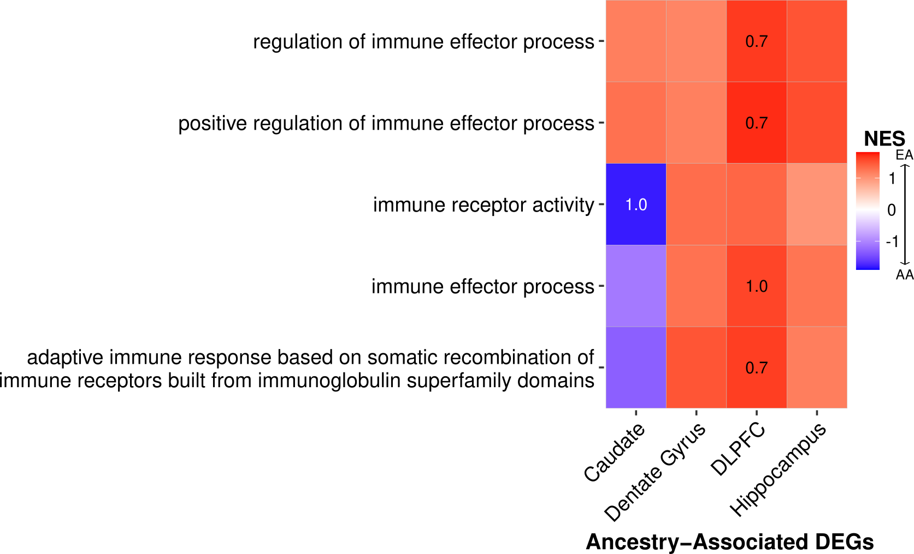
Fig. S5: Local ancestry expression show similar pattern of direction of effect in immune-related pathways across brain regions as global ancestry. Heatmap showing direction of effect (increase AA proportion [blue] or increased EA proportion [red]) associated with immune-related GO terms across brain regions. Enrichment trends (GSEA, q-values < 0.25; -log₁₀ transformed) annotated within tiles.

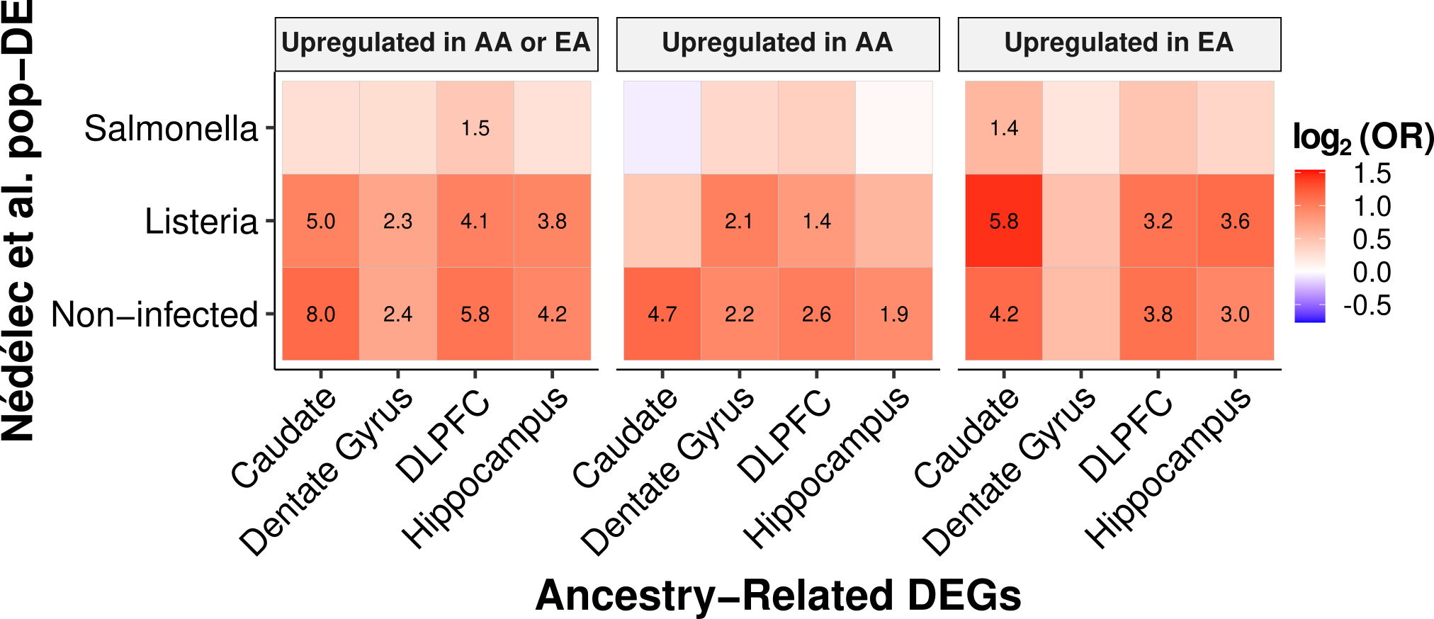
Fig. S6: Significant enrichment of ancestry-associated DEGs with population differences in immune responses. Heatmaps showing significant enrichment (red; two-sided, Fisher’s exact test with p-values corrected for multiple testing with Benjamini-Hochberg) of ancestry-associated DEGs (adjusted p-value < 0.05) and population differences in primary macrophages (19) separated by infection status and direction of effect. Significant enrichments (two-sided, Fisher’s exact test with FDR corrected p-values -log₁₀ transformed) annotated within tiles.

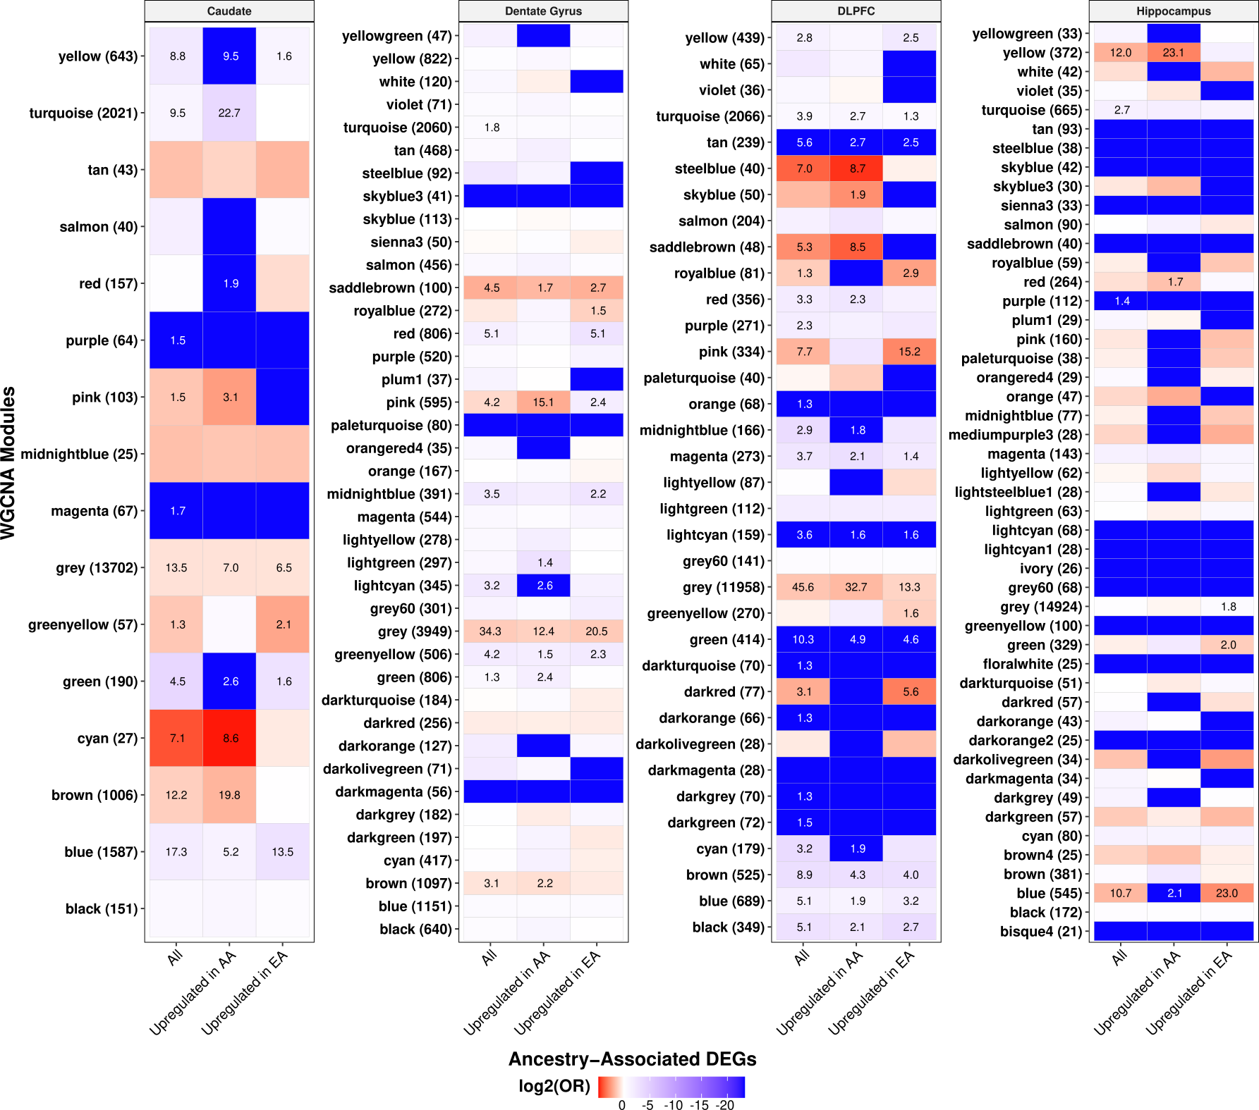
Fig. S7: Extensive enrichment of gene co-expression modules with ancestry-associated DEGs in admixed Black American individuals across brain regions. Heatmap of enrichment analysis (two-sided, Fisher’s exact test with p-values corrected for multiple testing with Benjamini-Hochberg) showing significant enrichment (red) and depletion (blue) across WGCNA modules for ancestry-associated DEGs (adjusted p-value < 0.05) separated by direction of effect. Significant enrichments (two-sided, Fisher’s exact test with FDR corrected p-values -log₁₀ transformed) annotated within tiles.
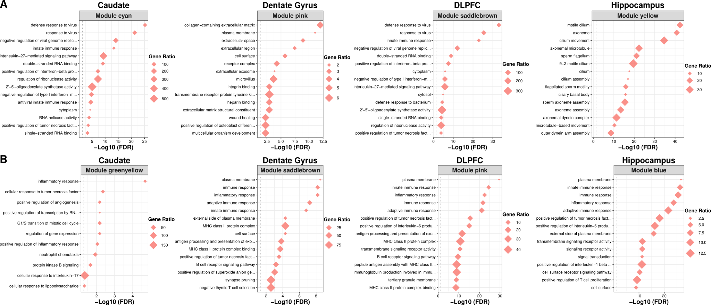
Fig. S8: Functional enrichment of gene co-expression network modules and ancestry-associated DEGs in admixed Black American across brain regions. Top 15 enriched GO terms for most significantly enriched WGCNA module for ancestry-associated DEGs that show A. upregulation with increasing AA proportion or B. upregulation with increasing EA proportion.
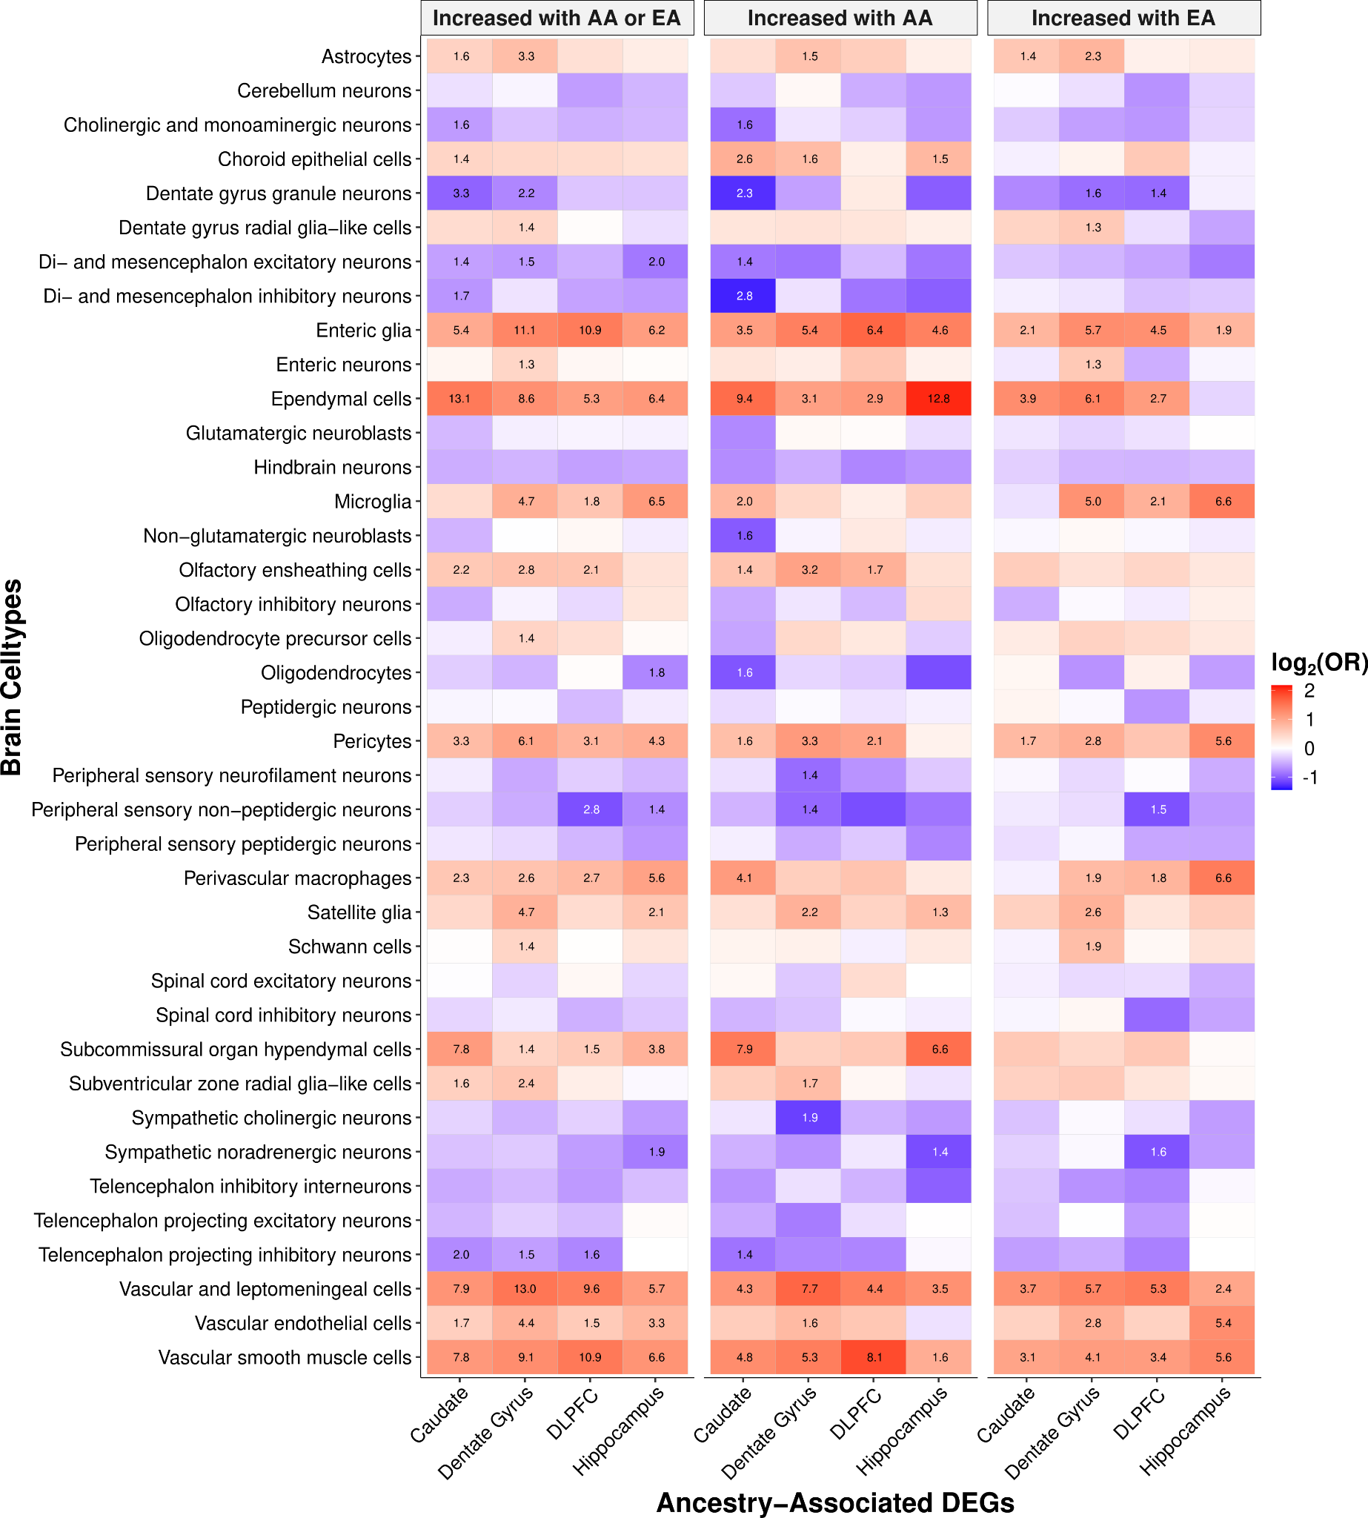
Fig. S9: Global ancestry-associated DEGs show significant enrichment of immune-related cell types (i.e., microglia and macrophages). Heatmap showing enrichment analysis (two-sided, Fisher’s exact test with p-values corrected for multiple testing with Benjamini-Hochberg) of significantly enriched (red) or depleted (blue) across brain cell types (25) for ancestry-associated DEGs (adjusted p-value < 0.05) separated by direction of effect. Significant enrichments (two-sided, Fisher’s exact test with FDR corrected p-values -log10 transformed) annotated within tiles.

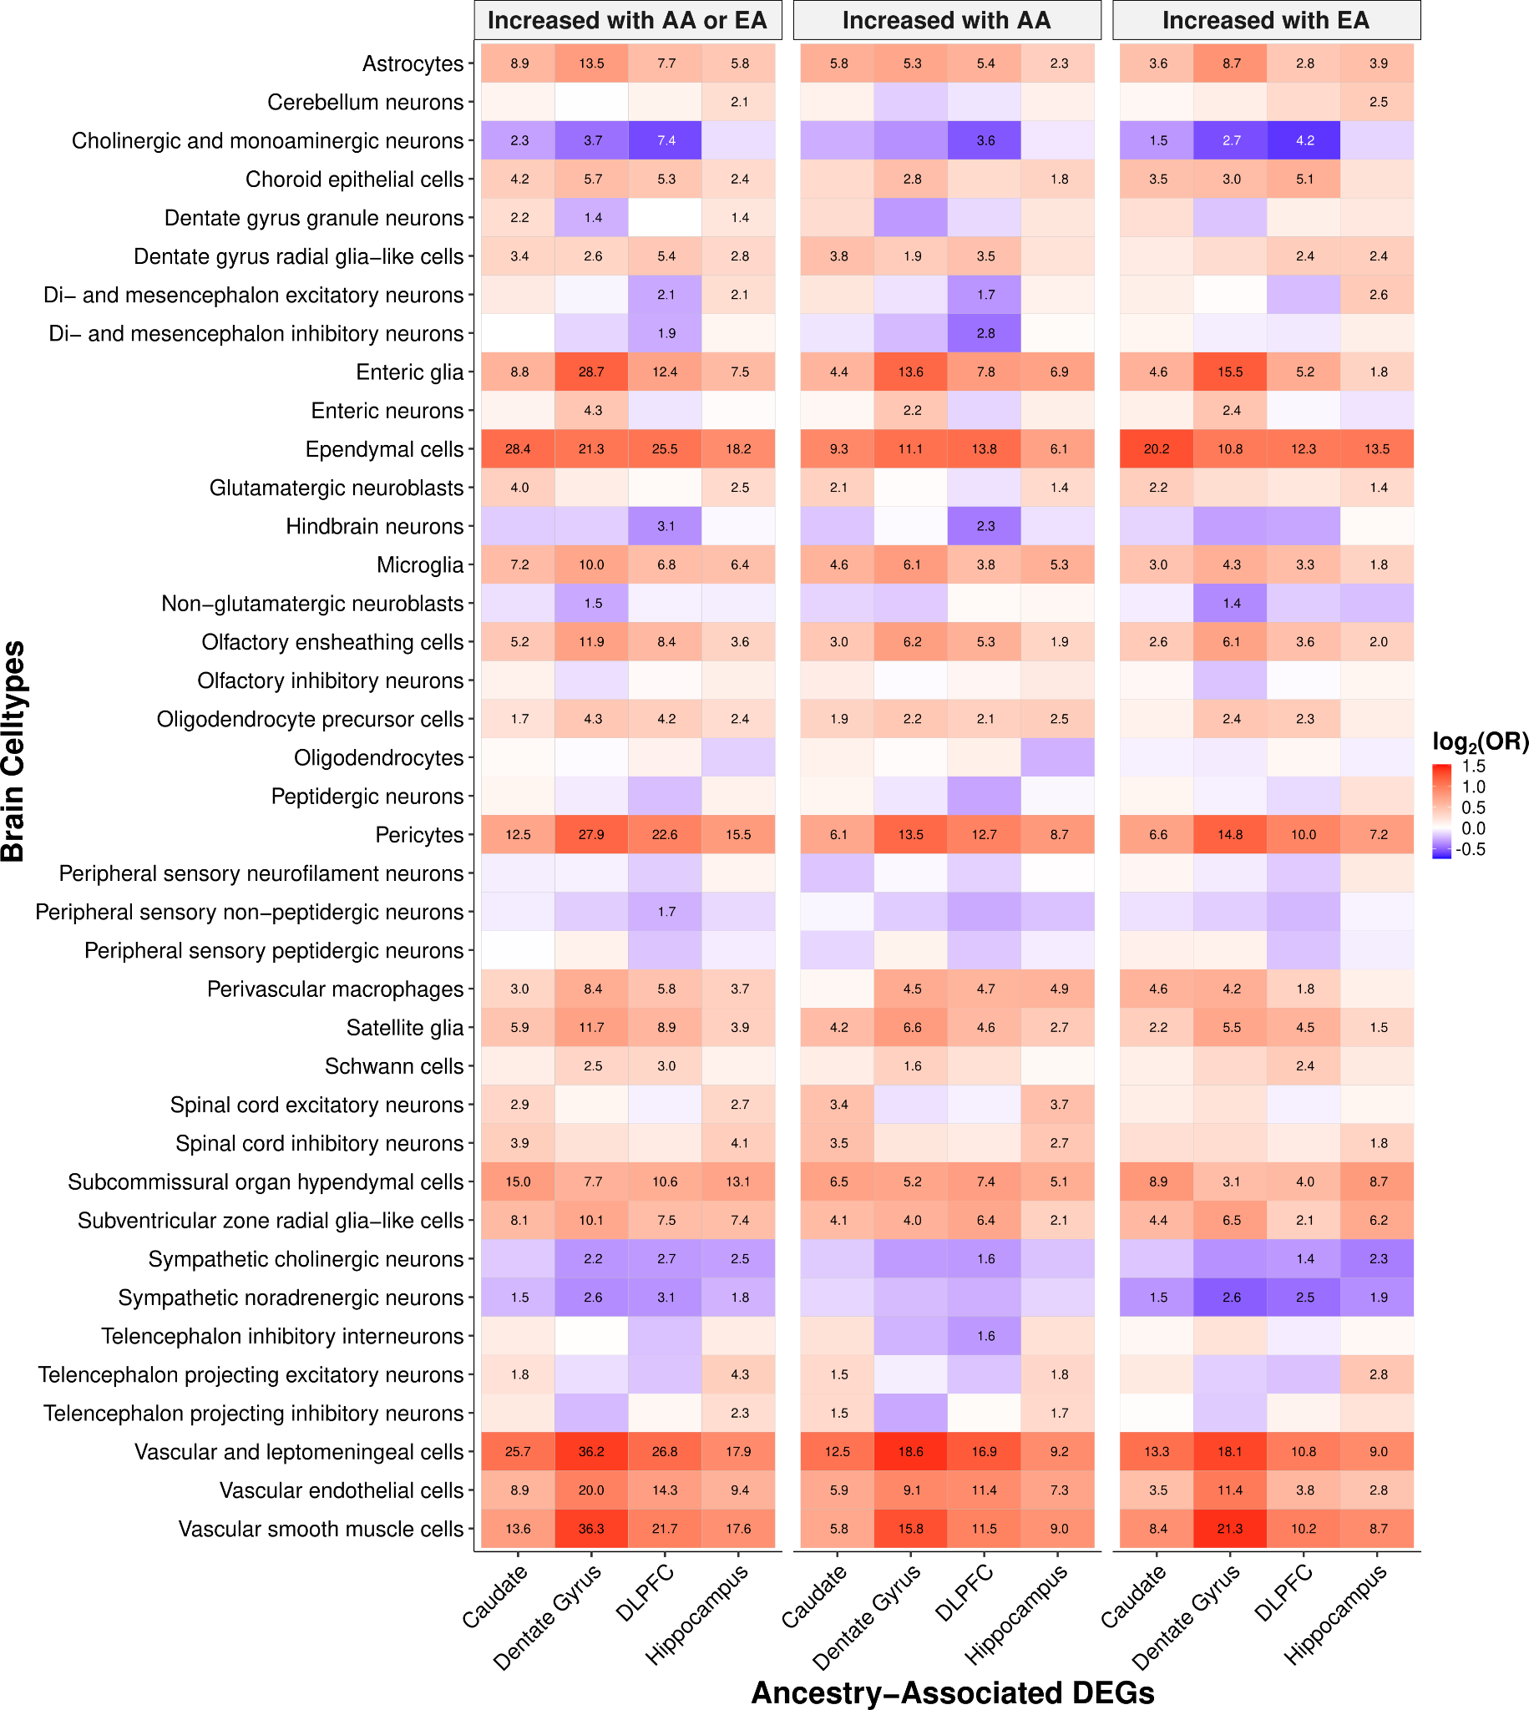
Fig. S10: Local ancestry-associated DEGs show significant enrichment of immune-related cell types (i.e., microglia and macrophages). Heatmap showing enrichment analysis (two-sided, Fisher’s exact test with p-values corrected for multiple testing with Benjamini-Hochberg) of significantly enriched (red) or depleted (blue) across brain cell types (25) for ancestry-associated DEGs (adjusted p-value < 0.05) separated by direction of effect. Significant enrichments (two-sided, Fisher’s exact test with FDR corrected p-values -log10 transformed) annotated within tiles.
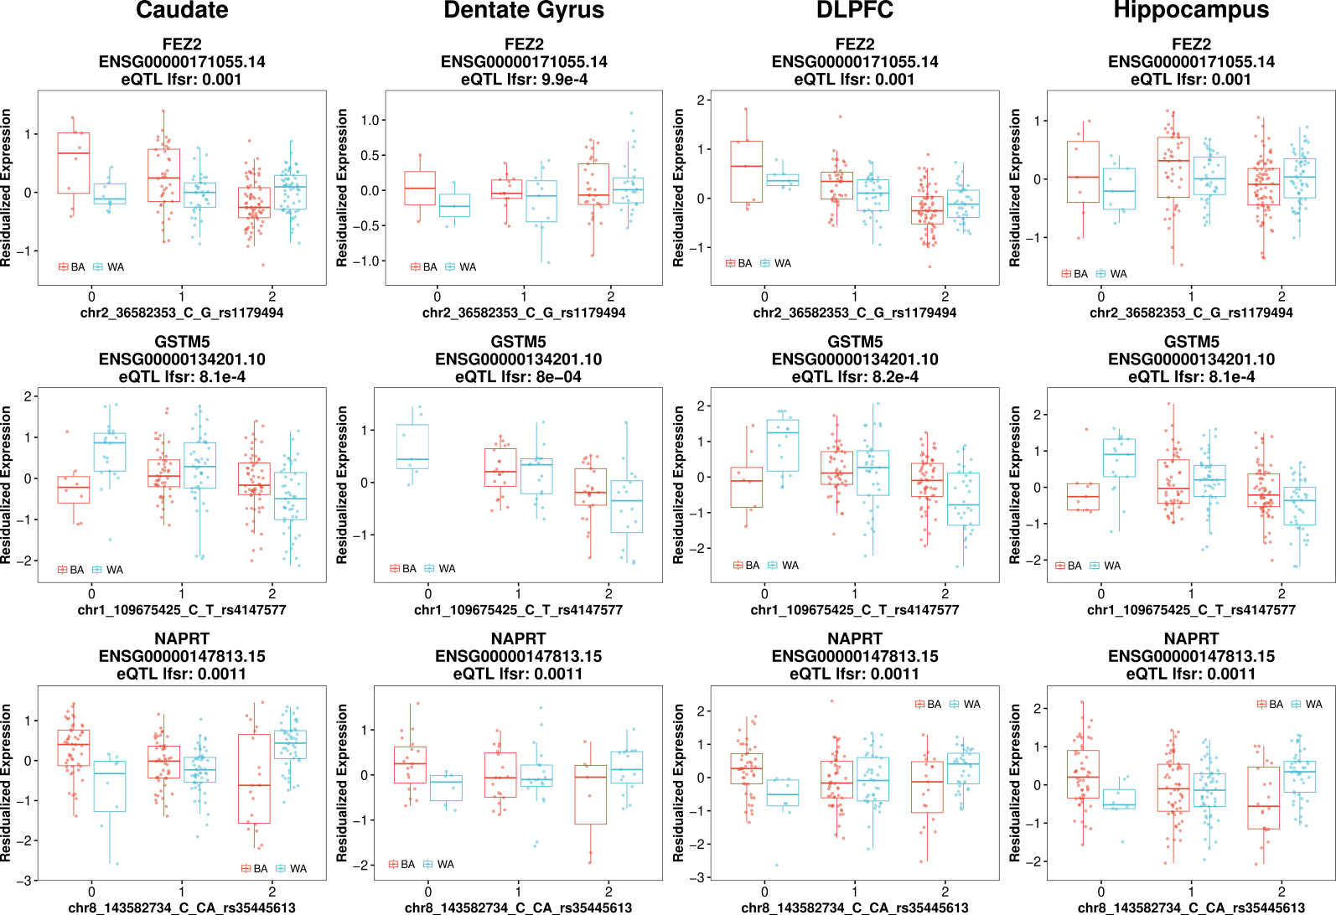
Fig. S11: Ancestry-dependent eQTL examples showing shared direction of effect across brain regions. Boxplot of the most significant variant per eGene showing ancestry-dependent eQTL using combined (Black [red] and White [blue] Americans).

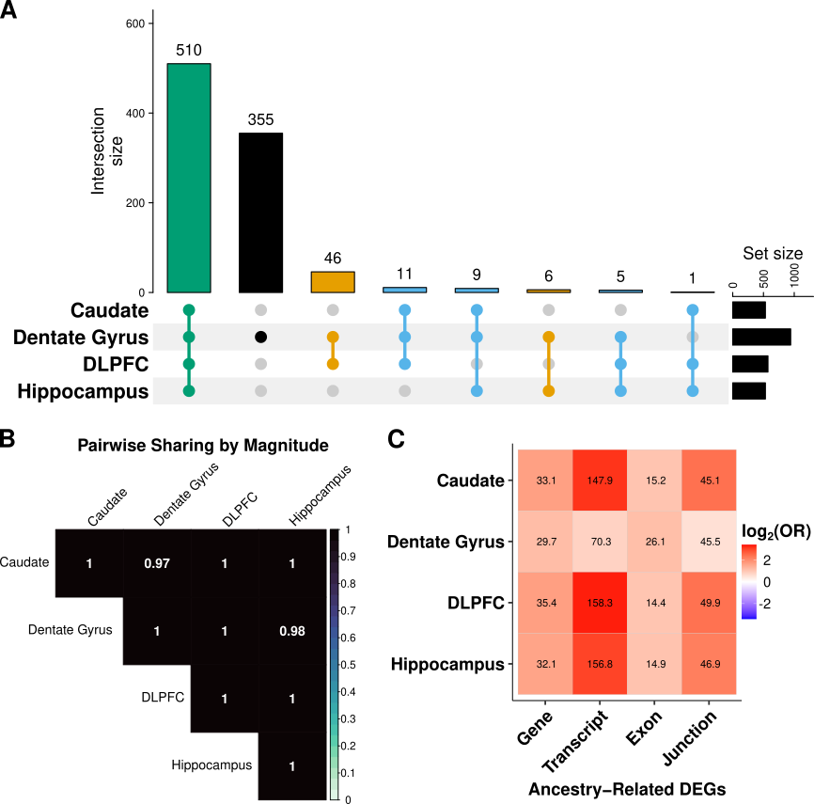
Fig. S12: Ancestry-dependent eQTL shared across brain regions and enriched for main effect eQTL. A. UpSet plot showing sharing of eGenes across brain regions. B. Heatmap showing significant sign matched. C. Enrichment heatmap of ancestry-dependent eGenes with ancestry-associated DEGs; significant enrichments (two-sided, Fisher’s exact test with FDR corrected p-values -log₁₀ transformed) annotated within tiles.

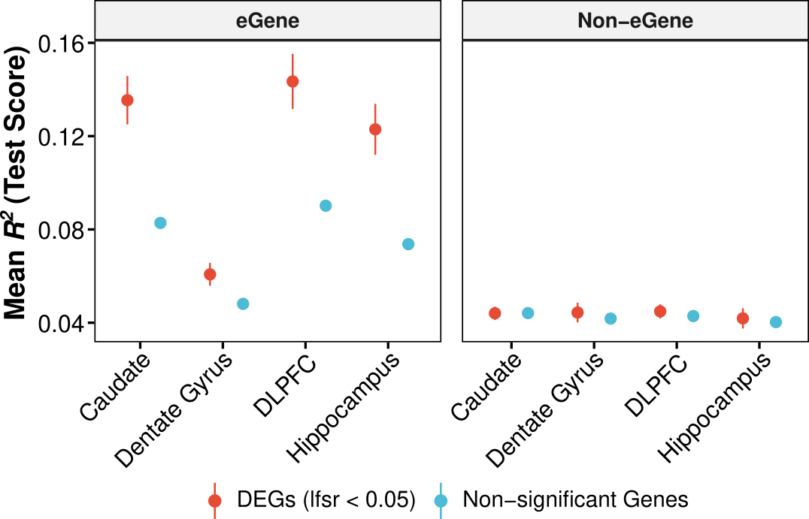
Fig. S13: Summary of test R2 for elastic net model separated by genes with an eQTL and those without. Error bars correspond to 95% confidence intervals. eGene are unique genes associated with an eQTL. DEGs are global ancestry-associated differential expressed genes.
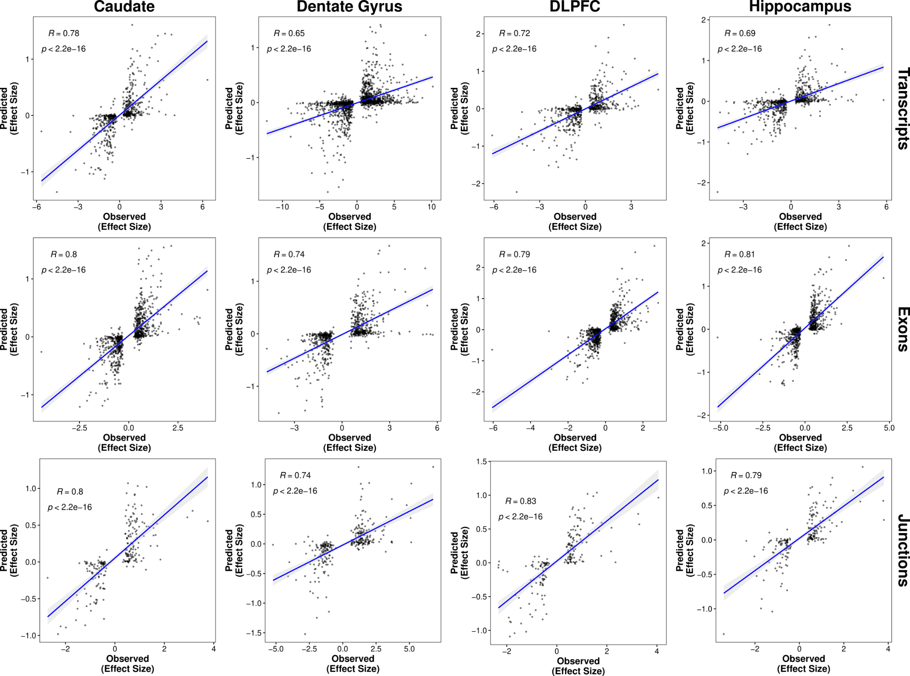
Fig. S14: Elastic net model captures more genetic contribution of genetic ancestry-associated expression changes in the brain on the isoform level. Correlation (two-sided, Spearman) of elastic net predicted (y-axis) versus observed (x-axis) global ancestry-associated differences in expression among ancestry-associated DE features (i.e., transcript, exon, and junction) with an eQTL across brain regions. A fitted trend line is presented in blue as the mean values +/- standard deviation. The standard deviation is shaded in light gray.
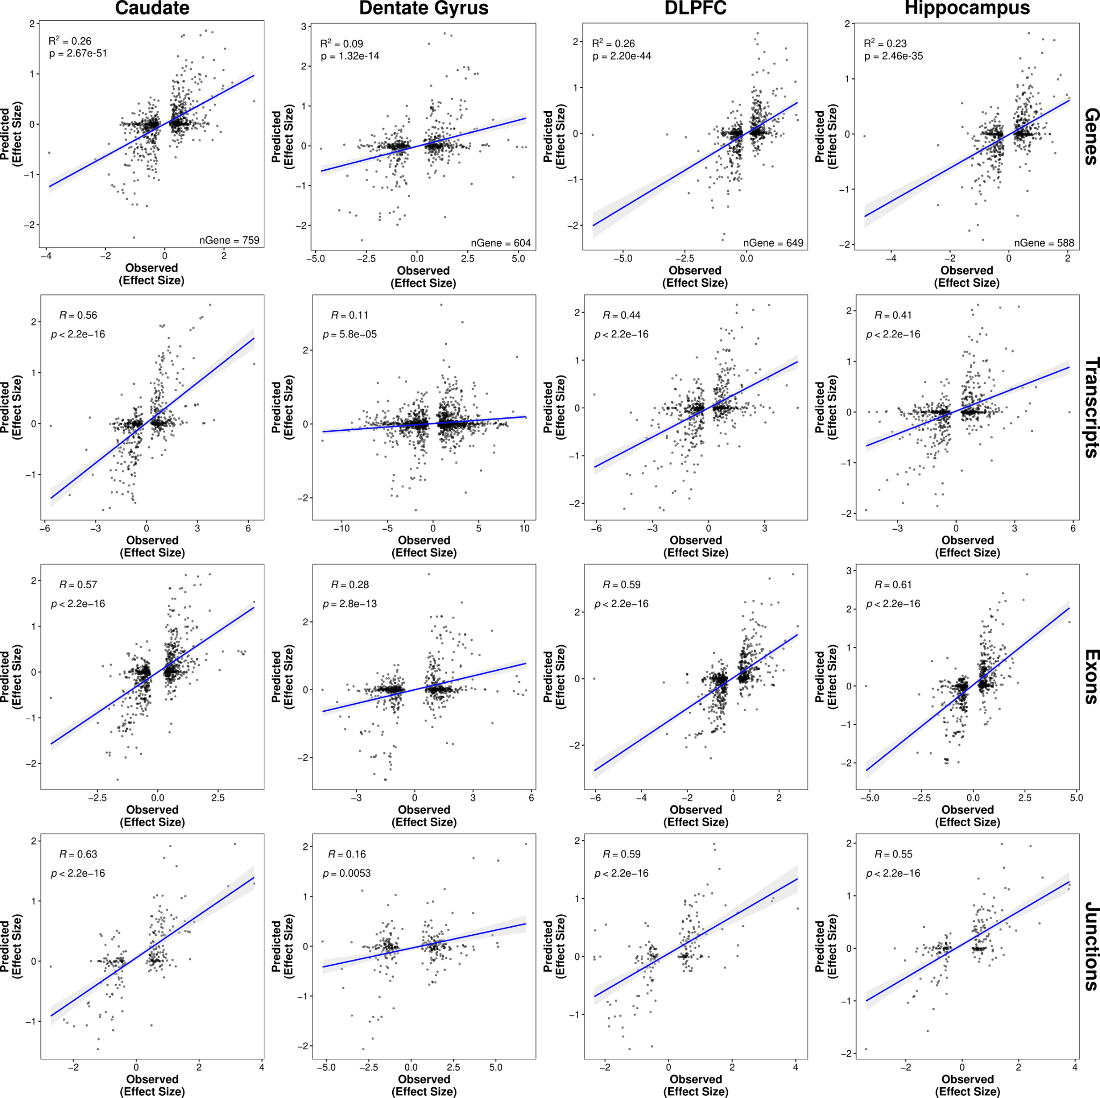
Fig. S15: The most significant eQTL explains roughly 20% of genetic ancestry expression differences in the brain. Correlation (two-sided, Spearman) of cis-predicted (y-axis) versus observed (x-axis) global ancestry-associated differences in expression among ancestry-associated DE features (i.e., gene, transcript, exon, and junction) with an eQTL across brain regions. A fitted trend line is presented in blue as the mean values +/- standard deviation. The standard deviation is shaded in light gray.

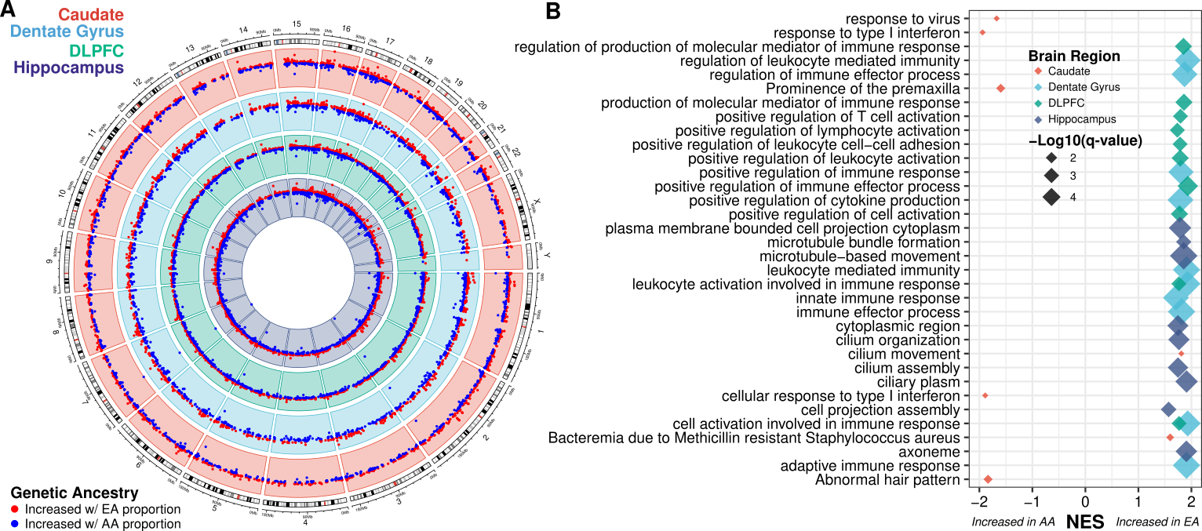
Fig. S16: Extensive ancestry-associated expression changes across the brain highlighting impact of environment. A. Circos plot showing ancestry DEGs from binary internal replication analysis across the caudate (red), dentate gyrus (blue), DLPFC (green), and hippocampus (purple). B. Gene set enrichment analysis of differential expression analysis across brain regions, highlighting terms associated with increased AA (African ancestry) or EA (European ancestry) proportions.

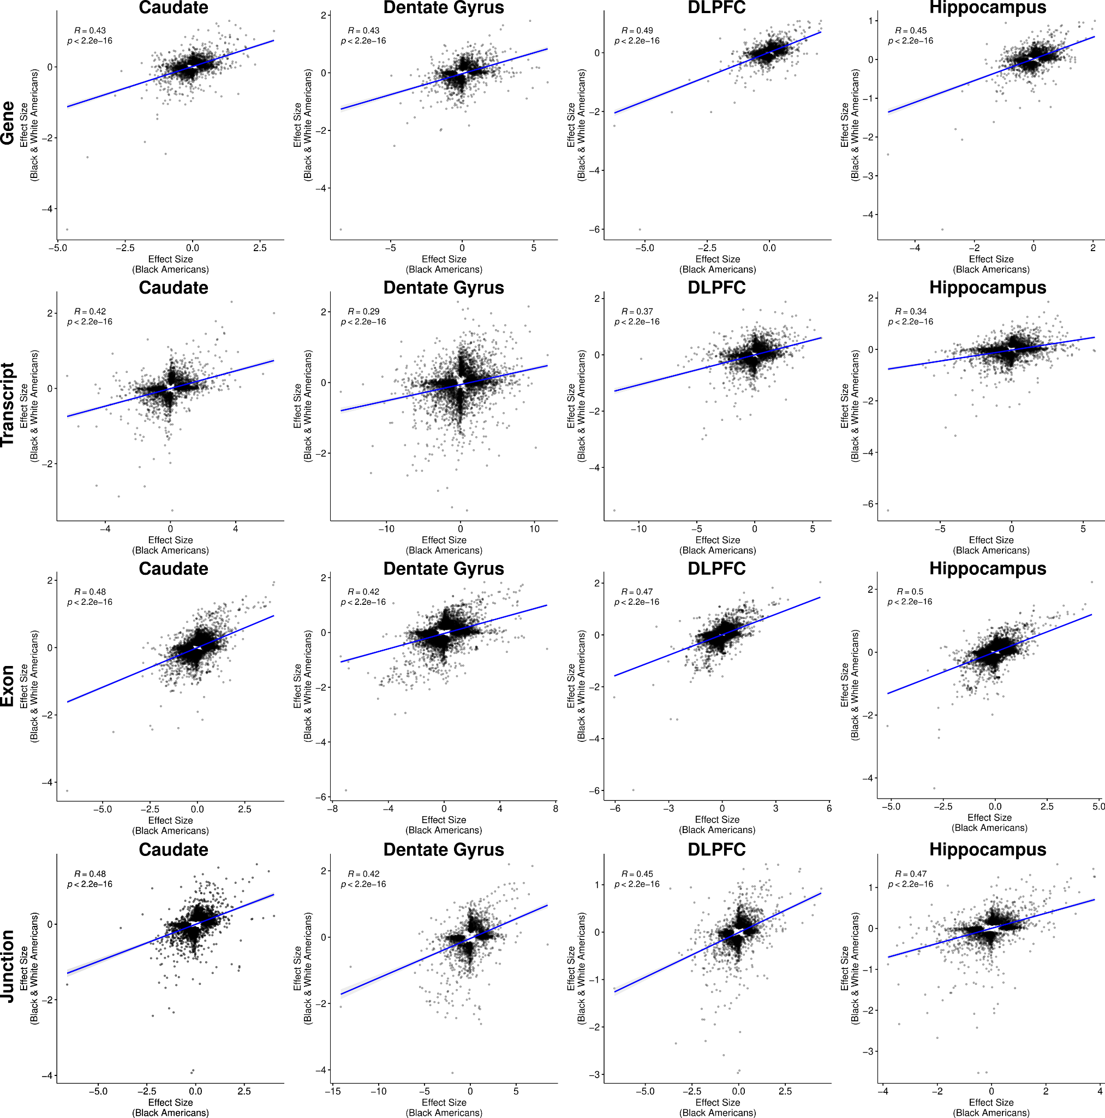
Fig. S17: Significant correlation of effect sizes between genetic ancestry association in admixed Black American individuals and self-reported race between Black and White Americans. Scatter plot showing significant correlation (two-sided, Spearman correlation) between Black American-only analysis (x-axis) and combined analysis (Black and White Americans; y-axis) for each brain region and feature (i.e., gene, transcript, exon, and junction). A fitted trend line is presented in blue as the mean values +/- standard deviation. The standard deviation is shaded in light gray.
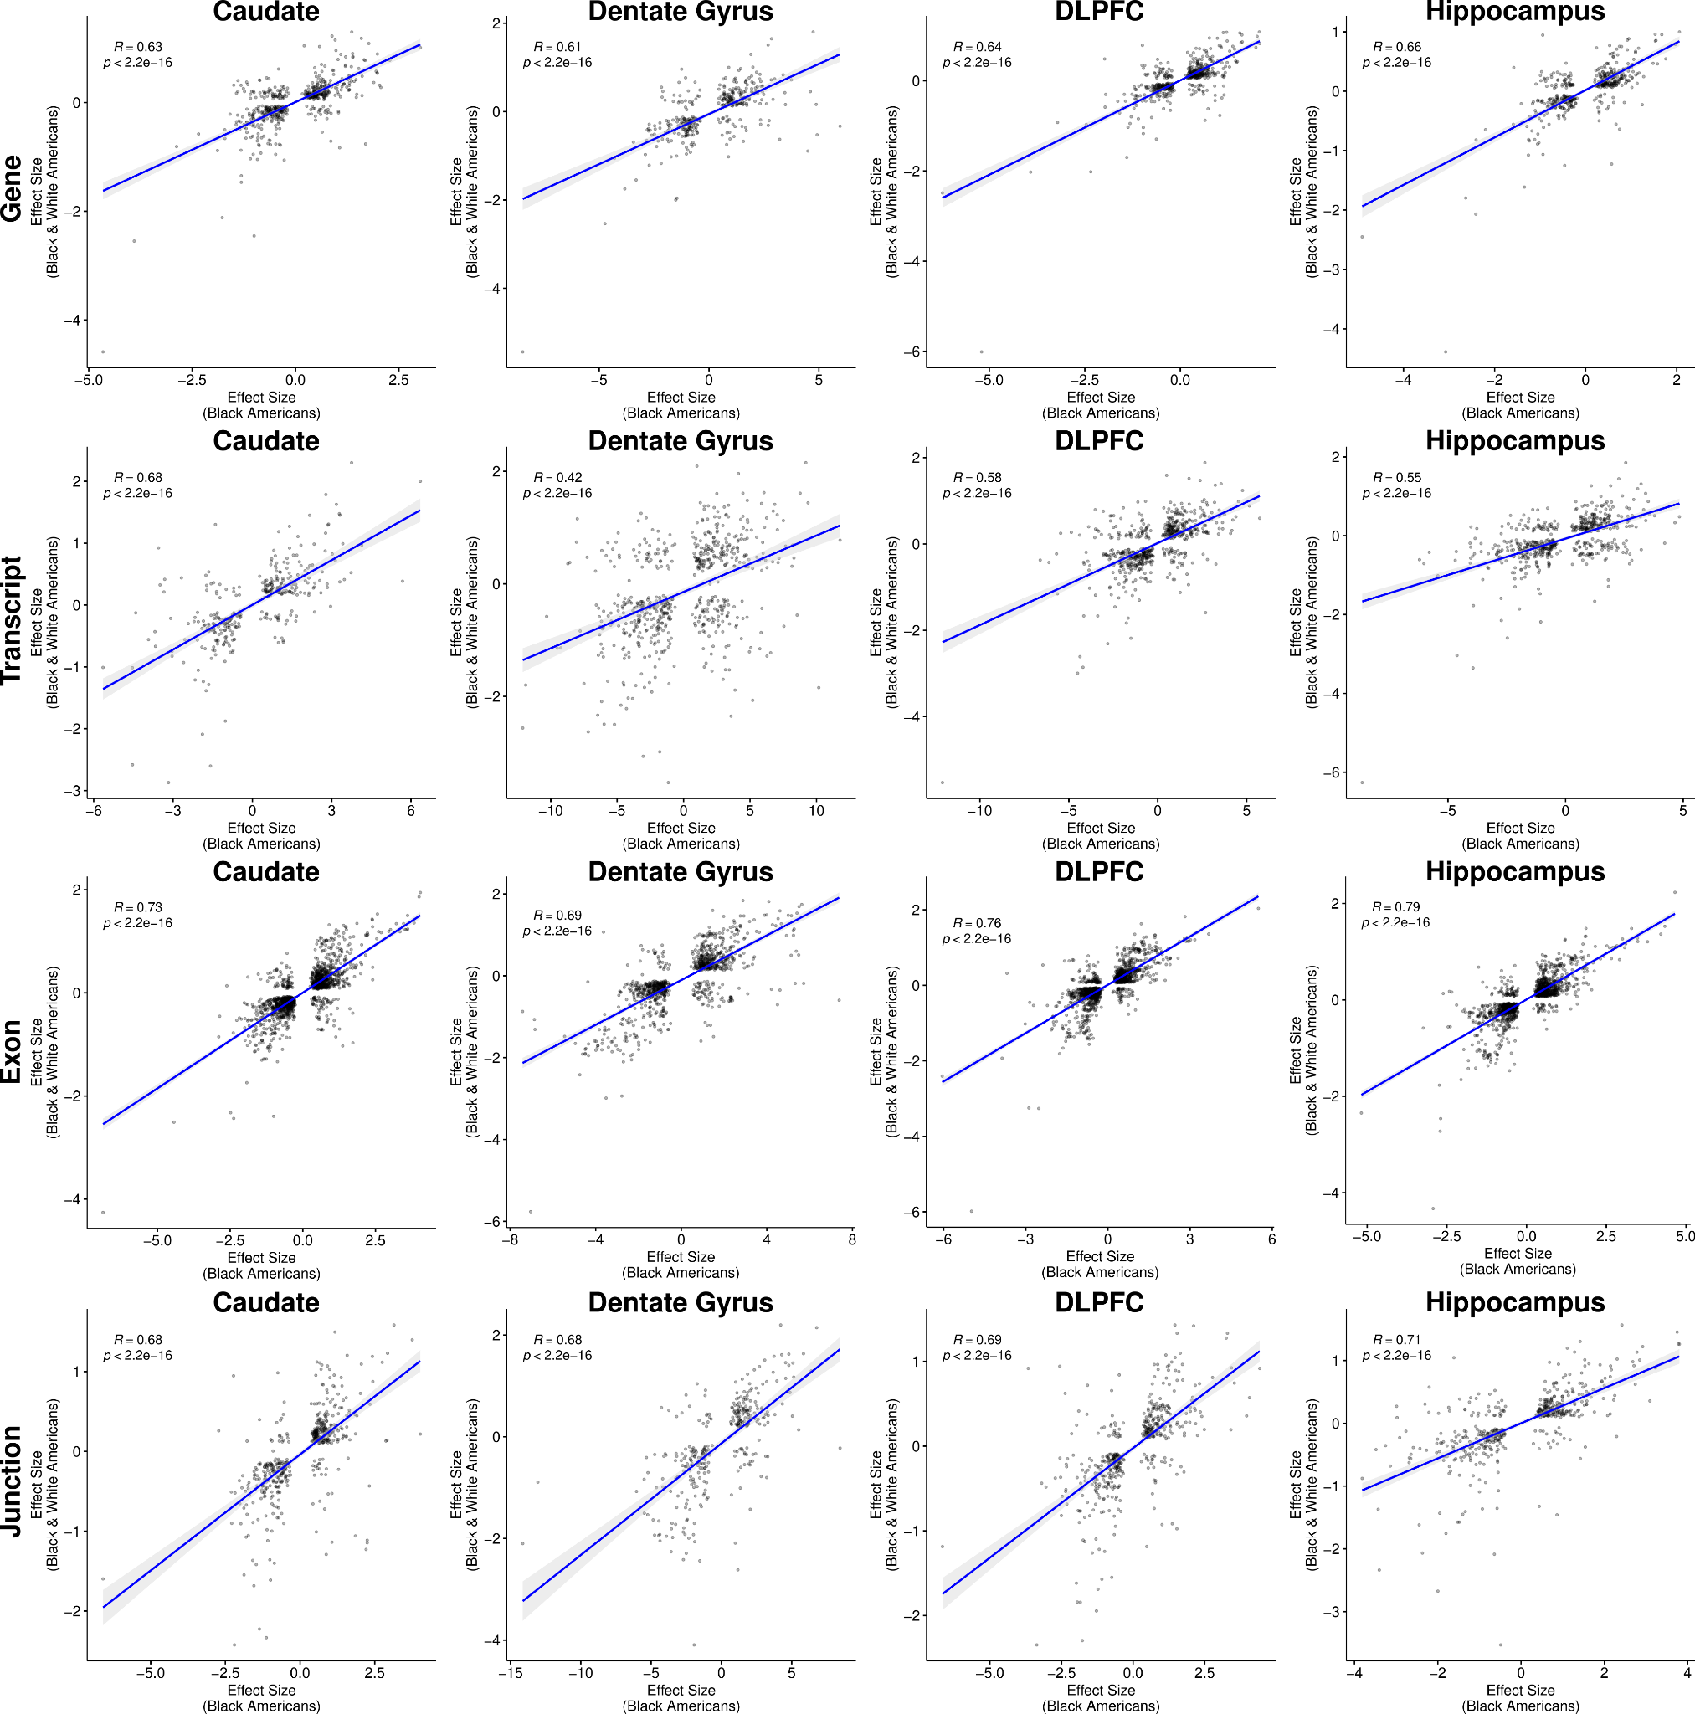
Fig. S18: Increased correlation of effect sizes for shared features between genetic ancestry association in admixed Black American individuals and self-reported race between Black and White Americans. Scatter plot showing significant correlation (two-sided, Spearman correlation) between Black American-only analysis (x-axis) and combined analysis (Black and White Americans; y-axis) for each brain region and feature (i.e., gene, transcript, exon, and junction). A fitted trend line is presented in blue as the mean values +/- standard deviation. The standard deviation is shaded in light gray.

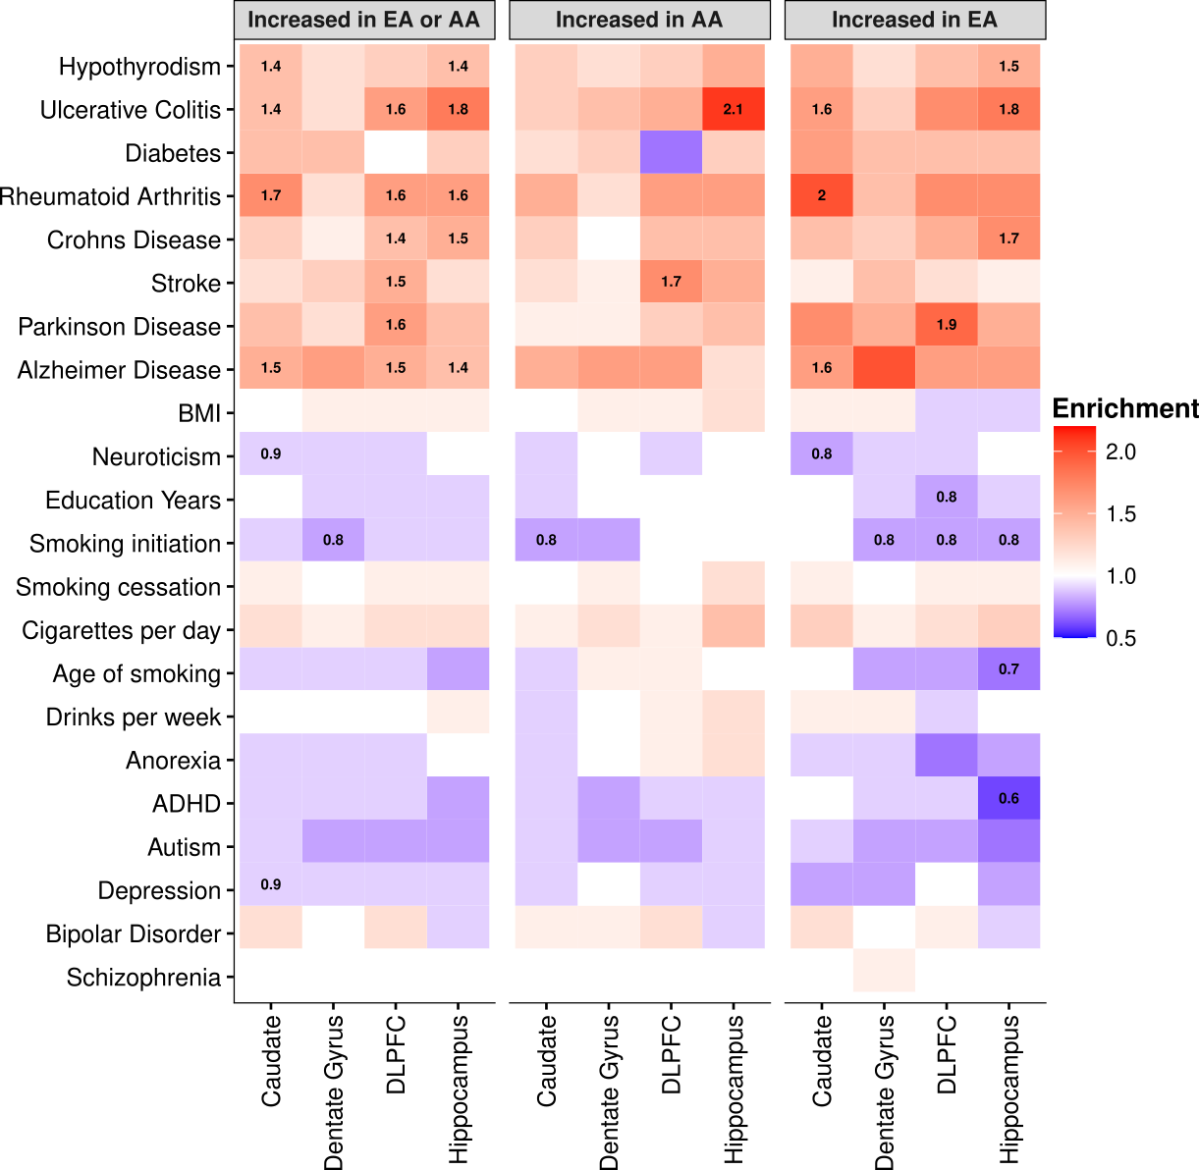
Fig. S19: Global ancestry-associated DEGs show general enrichment for heritability of neurological and immune-related traits. Heatmap for ancestry-associated DEGs that show no enrichment (red) nor depletion (blue) for heritability of brain- and immune-related traits from S-LDSC analysis. Numbers within tiles are levels of enrichment (> 1) or depletion (< 1) that are significant after multiple testing correction (FDR < 0.05). The left panel shows results for all DEG in each brain region. The middle and right panels show results for DEG increased with AA or EA proportions for each brain region, respectively.
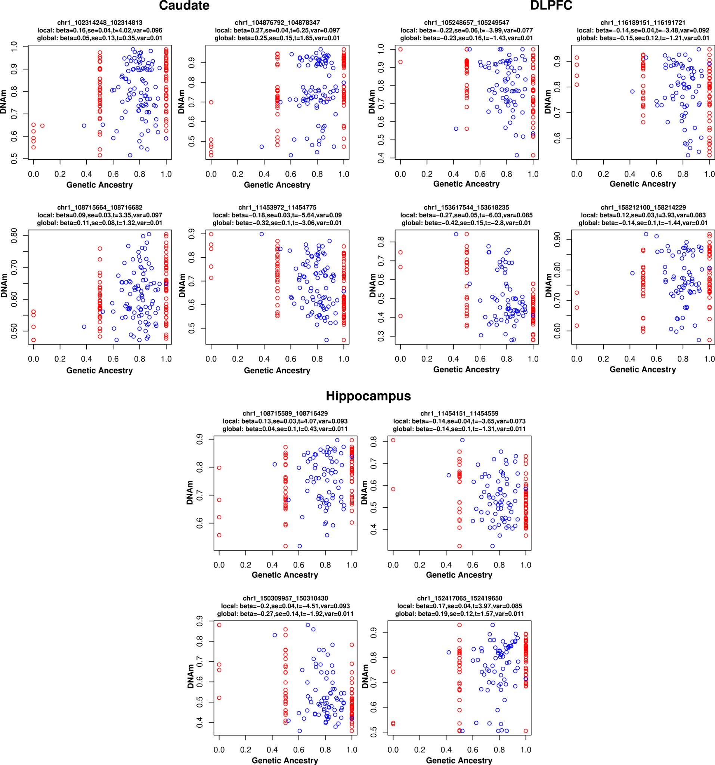
Fig. S20: Local ancestry is more variable than global ancestry. Example scatter plots showing local (red) and global (blue) ancestry associated with DNAm across brain regions. DMR test results (effect size [beta], standard error [se], and variance [var]) annotated on top of each example VMR.

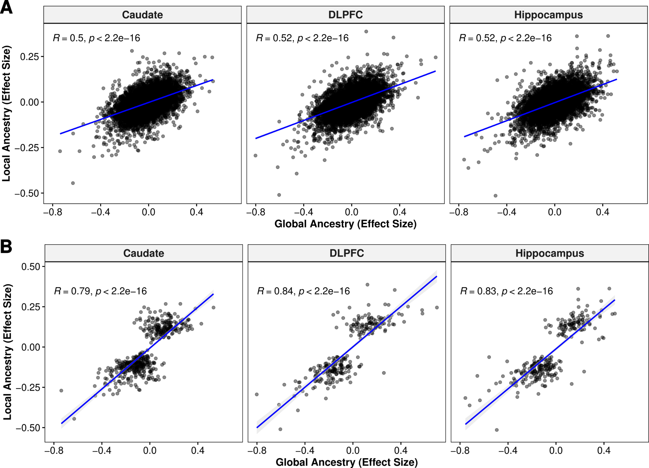
Fig. S21: Significant correlation of DNAm levels between local and global ancestry-associated DMRs across brain regions. Scatter plot comparing global (x-axis) and local (y-axis) for A. all ancestry-associated DMRs and B. significant ancestry-associated DMRs (FDR < 0.05). A fitted trend line is presented in blue as the mean values +/- standard deviation. The standard deviation is shaded in light gray.

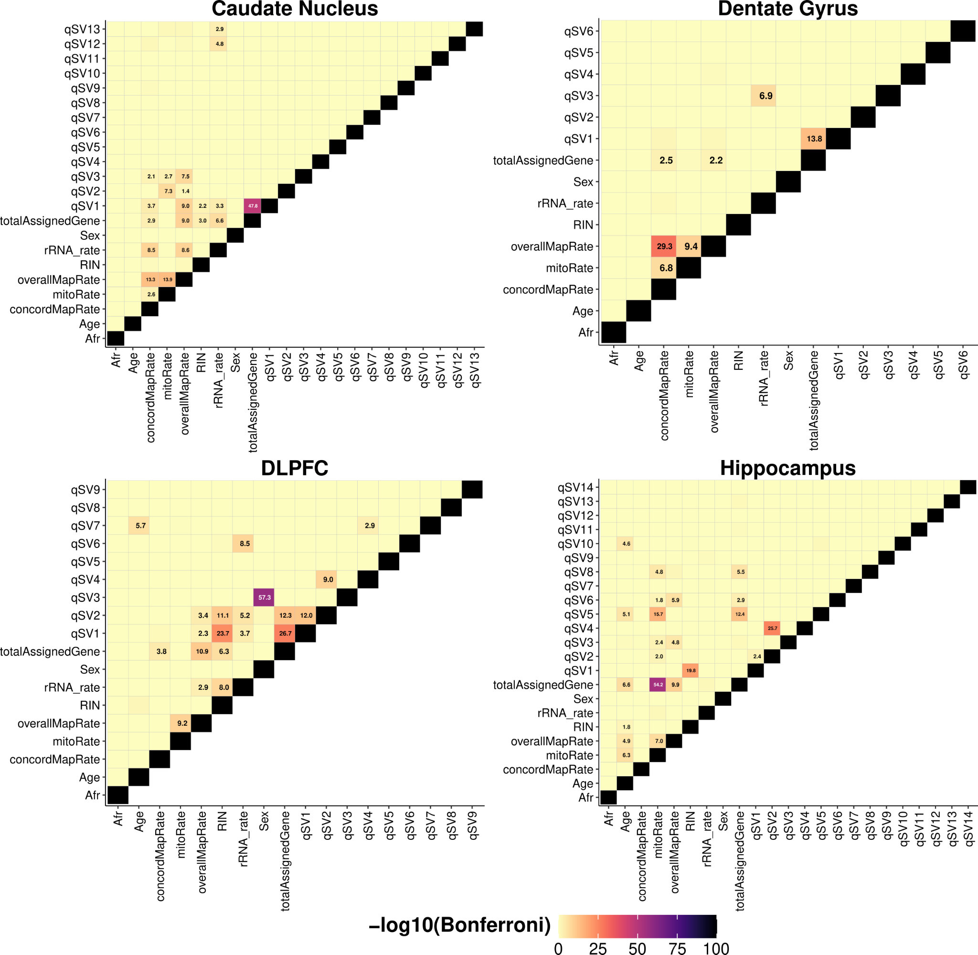
Fig. S22: Limited correlation between covariates across brain regions. Heatmap showing correlation between covariates across brain regions (linear regression, Bonferroni corrected p-values). Significant correlations (-log₁₀ transformed) are denoted in each tile.

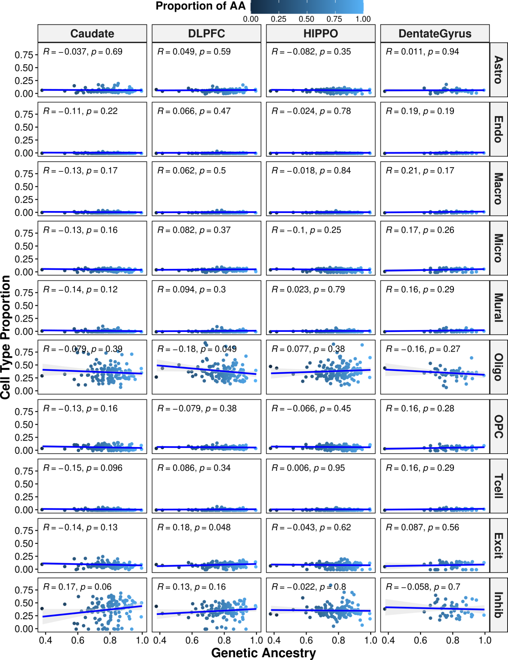
Fig. S23: Cell-type proportions show no correlation with genetic ancestry in Black American donors across brain regions. Scatter plot showing no correlation (two-sided, Spearman) between genetic ancestry and cell-type proportion across the brain. A fitted trend line is presented in blue as the mean values +/- standard deviation. The standard deviation is shaded in light gray. Astro: astrocytes. Endo: endothelial. Micro: microglia. Macro: macrophage. Mural: mural cells. Oligo: oligodendrocytes. OPC: oligodendrocyte progenitor cells. Tcell: T cells. Excit: excitatory neurons. Inhib: inhibitory neurons.
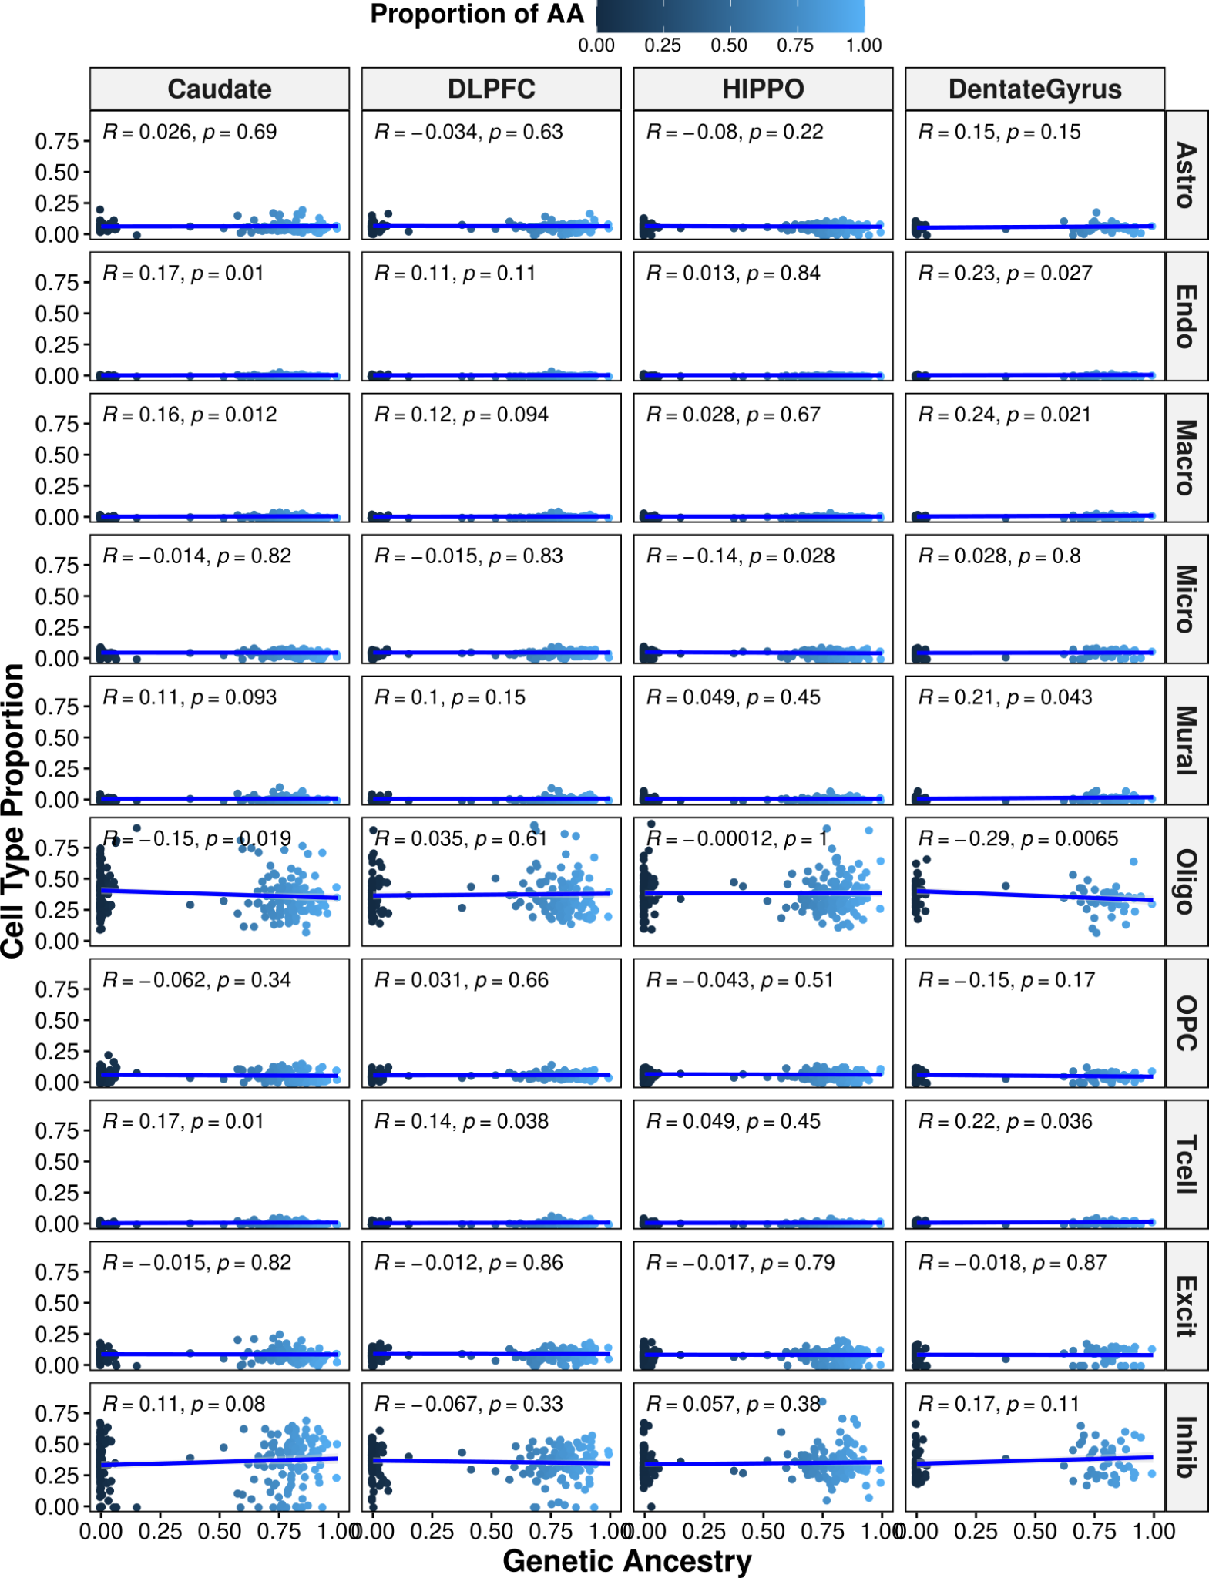
Fig. S24: Significant correlation of several cell-type proportions with genetic ancestry in Black American and White American donors across brain regions. Scatter plot showing correlation (two-sided, Spearman) between genetic ancestry and cell-type proportion across the brain. A fitted trend line is presented in blue as the mean values +/- standard deviation. The standard deviation is shaded in light gray. Astro: astrocytes. Endo: endothelial. Micro: microglia. Macro: macrophage. Mural: mural cells. Oligo: oligodendrocytes. OPC: oligodendrocyte progenitor cells. Tcell: T cells. Excit: excitatory neurons. Inhib: inhibitory neurons.
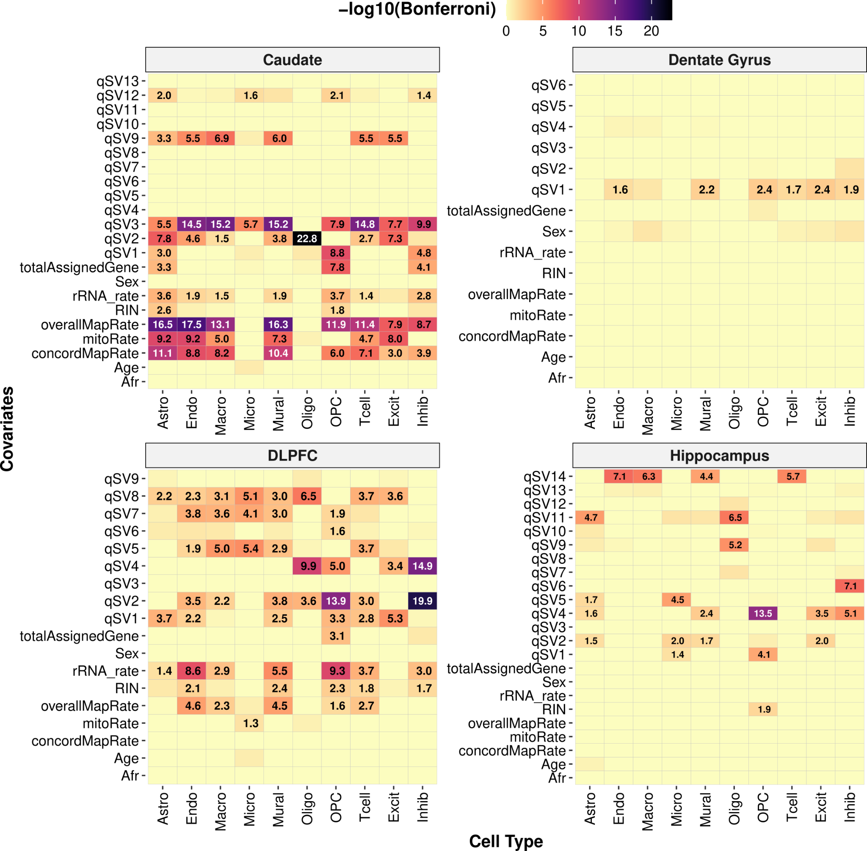
Fig. S25: Significant correlation between cell-type proportion and model covariations. Heatmap of correlation between covariates and cell-type proportion across the brain (linear regression, Bonferroni corrected p-values). Significant correlations (-log₁₀ transformed) are denoted in each tile. Astro: astrocytes. Endo: endothelial. Micro: microglia. Macro: macrophage. Mural: mural cells. Oligo: oligodendrocytes. OPC: oligodendrocyte progenitor cells. Tcell: T cells. Excit: excitatory neurons. Inhib: inhibitory neurons.

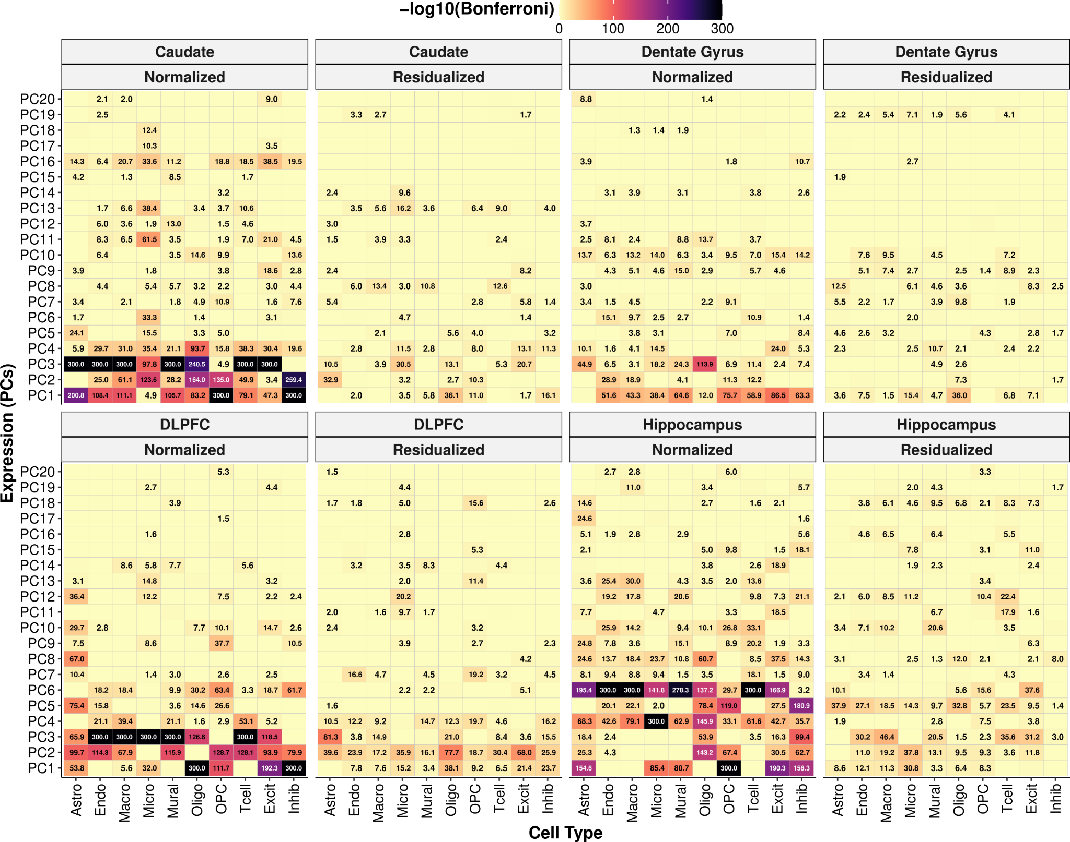
Fig. S26: Cell-type proportion partially corrected for by covariates. Heatmap of correlation between PCA of gene expression and cell-type proportions before (normalized) and after (residualized) adjusting for covariates including qSVs across brain regions (linear regression, Bonferroni corrected p-values). Significant correlations (-log₁₀ transformed) are denoted in each tile. Astro: astrocytes. Endo: endothelial. Micro: microglia. Macro: macrophage. Mural: mural cells. Oligo: oligodendrocytes. OPC: oligodendrocyte progenitor cells. Tcell: T cells. Excit: excitatory neurons. Inhib: inhibitory neurons.

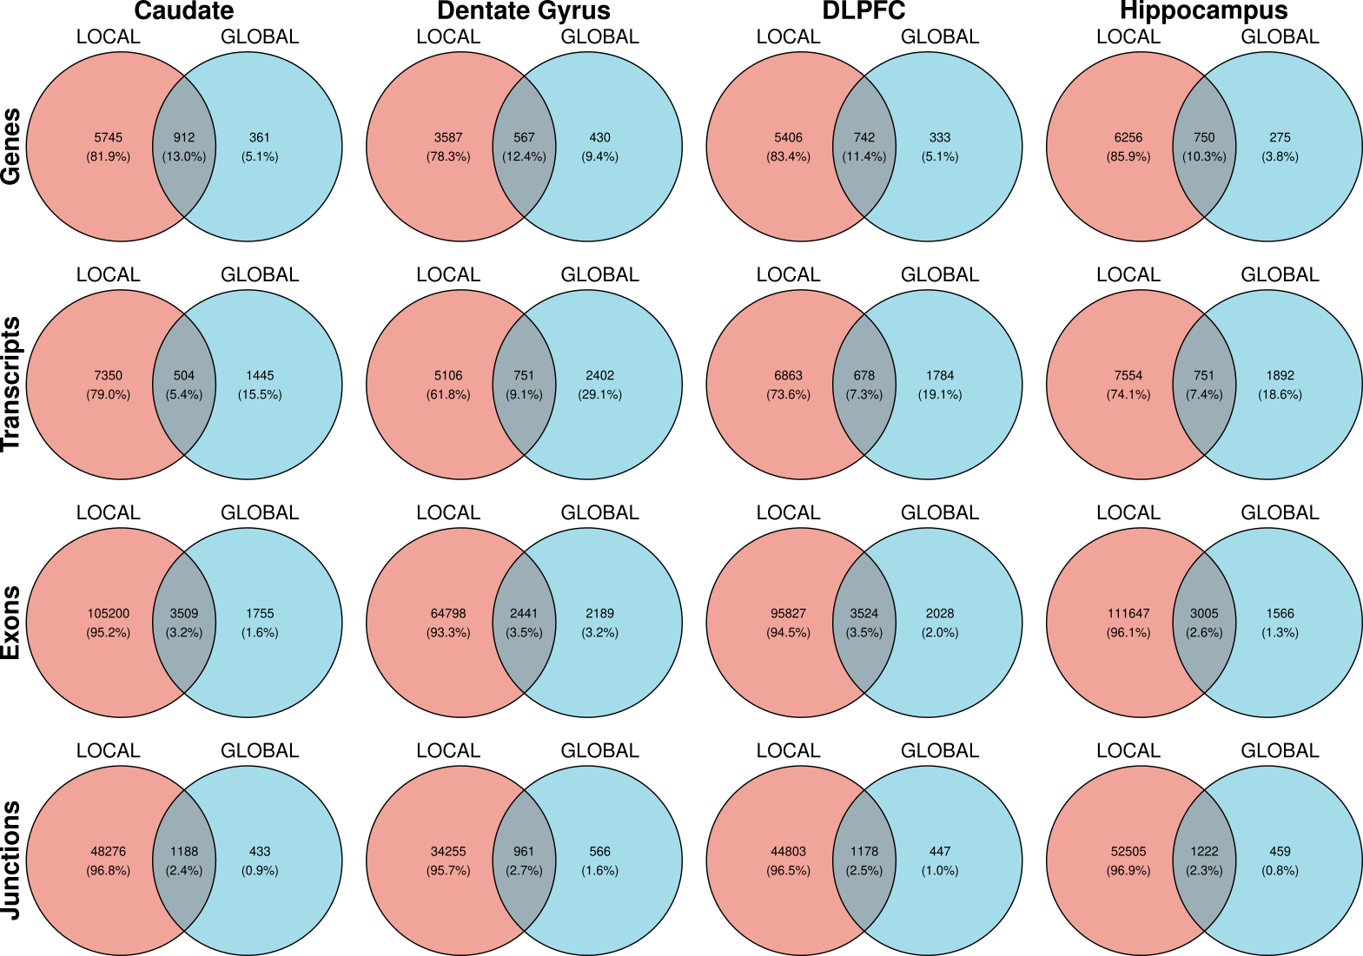
Fig. S27: The majority of global ancestry-associated DE features are detected with local ancestry analysis. Venn diagram showing the overlap between local ancestry-associated DE features (i.e., gene, transcript, exon, and junction) and global ancestry-associated DE features across brain regions.

Supplementary Tables
Table S1: Black American sample characteristics for adult (age > 17) neurotypical control postmortem caudate, dentate gyrus, DLPFC, and hippocampus (11–13). Abbreviations: RNA integrity number (RIN).
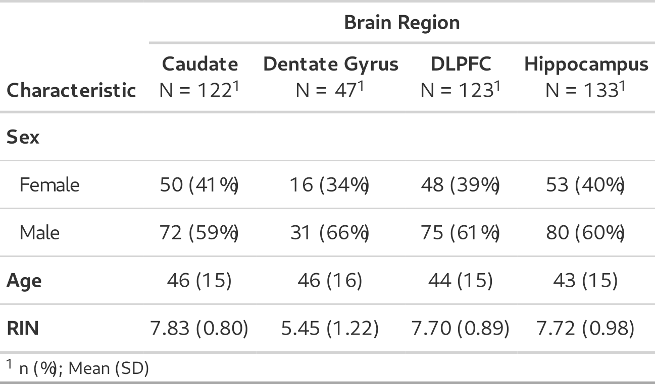

Table S2. Summary of global ancestry-associated differential expression results (lfsr < 0.05) by feature (gene, transcript, exon, and exon-exon junction) for ancestry differences within admixed AA (n=151) in the caudate (n=122), dentate gyrus (n=47), DLPFC (n=123), and hippocampus (n=133). The number of unique genes associated with transcript, exon, or junction is in parentheses.
Brain Region | Gene | Transcript (Geneid) | Exon (Geneid) | Junction (Geneid)
Caudate | 1,273 | 1,949 (1,728) | 5,264 (2,991) | 1,621 (1,116)
Dentate Gyrus | 997 | 3,153 (2,701) | 4,630 (2,737) | 1,527 (1,105)
DLPFC | 1,075 | 2,462 (2,126) | 5,552 (3,140) | 1,625 (1,138)
Hippocampus | 1,025 | 2,643 (2,263) | 4,571 (2,717) | 1,681 (1,177)

Table S3. Summary of local ancestry-associated differential expression results (lfsr < 0.05) by feature (gene, transcript, exon, and exon-exon junction) for ancestry differences within admixed AA (n=149) in the caudate (n=120), dentate gyrus (n=45), DLPFC (n=121), and hippocampus (n=131). The number of unique genes associated with transcript, exon, or junction is in parentheses.
Brain Region | Gene | Transcript (Geneid) | Exon (Geneid) | Junction (Geneid)
Caudate | 6,657 | 7,854 (5,746) | 108,709 (12,287) | 49,464 (8,385)
Dentate Gyrus | 4,154 | 5,857 (4,613) | 67,239 (10,974) | 35,216 (7,918)
DLPFC | 6,148 | 7,541 (5,561) | 99,351 (12,051) | 45,981 (8,282)
Hippocampus | 7,006 | 8,305 (5,996) | 114,652 (12,411) | 53,727 (8,510)

Table S4: Summary of main effect cis-eQTL (lfsr < 0.05) in Black American admixed individuals (n=148) by feature (gene, transcript, exon, and exon-exon junction) across the caudate (n=120), dentate gyrus (n=45), DLPFC (n=121), and hippocampus (n=131). eFeature: unique feature. eGene: unique gene ID.
 |  | Caudate | Dentate Gyrus | DLPFC | Hippocampus
Gene | eQTL | 698,047 | 605,755 | 728,533 | 688,628
Gene | eFeature | 10,867 | 11,664 | 11,173 | 10,408
Gene | eGene | 10,867 | 11,664 | 11,173 | 10,408
Transcript | eQTL | 934,240 | 1,062,967 | 968,814 | 940,405
Transcript | eFeature | 17,759 | 32,342 | 18,422 | 17,581
Transcript | eGene | 10,369 | 14,674 | 10,710 | 10,320
Exon | eQTL | 1,503,349 | 1,532,590 | 1,551,027 | 1,461,400
Exon | eFeature | 29,203 | 37,894 | 30,091 | 27,560
Exon | eGene | 10,423 | 12,675 | 10,612 | 9,927
Junction | eQTL | 502,183 | 601,181 | 496,775 | 480,246
Junction | eFeature | 11,135 | 25,694 | 10,831 | 10,165
Junction | eGene | 3,084 | 4,768 | 3,022 | 2,874

Table S5: Summary of ancestry-dependent cis-eQTL (lfsr < 0.05) in Black American admixed individuals (n=148) by feature (gene, transcript, exon, and exon-exon junction) across the caudate (n=120), dentate gyrus (n=45), DLPFC (n=121), and hippocampus (n=131). eFeature: unique feature. eGene: unique gene ID.
 |  | Caudate | Dentate Gyrus | DLPFC | Hippocampus
Gene | eQTL | 3,281 | 5,484 | 3,441 | 3,371
Gene | eFeature | 531 | 942 | 573 | 531
Gene | eGene | 531 | 942 | 573 | 531
Transcript | eQTL | 3,849 | 28,102 | 3,853 | 4,315
Transcript | eFeature | 617 | 4,443 | 619 | 716
Transcript | eGene | 580 | 3,529 | 582 | 671
Exon | eQTL | 2,353 | 4,346 | 2,189 | 2,196
Exon | eFeature | 510 | 773 | 483 | 483
Exon | eGene | 330 | 481 | 314 | 312
Junction | eQTL | 2,452 | 61,494 | 2,609 | 3,111
Junction | eFeature | 436 | 8,427 | 508 | 613
Junction | eGene | 275 | 4,748 | 332 | 419

Table S6. Black and White Americans sample breakdown for adult (age > 17) neurotypical control postmortem caudate, dentate gyrus, DLPFC, and hippocampus (11–13). Abbreviations: Female (F), Male (M), Black American (BA), White American (WA), and RNA integrity number (RIN).
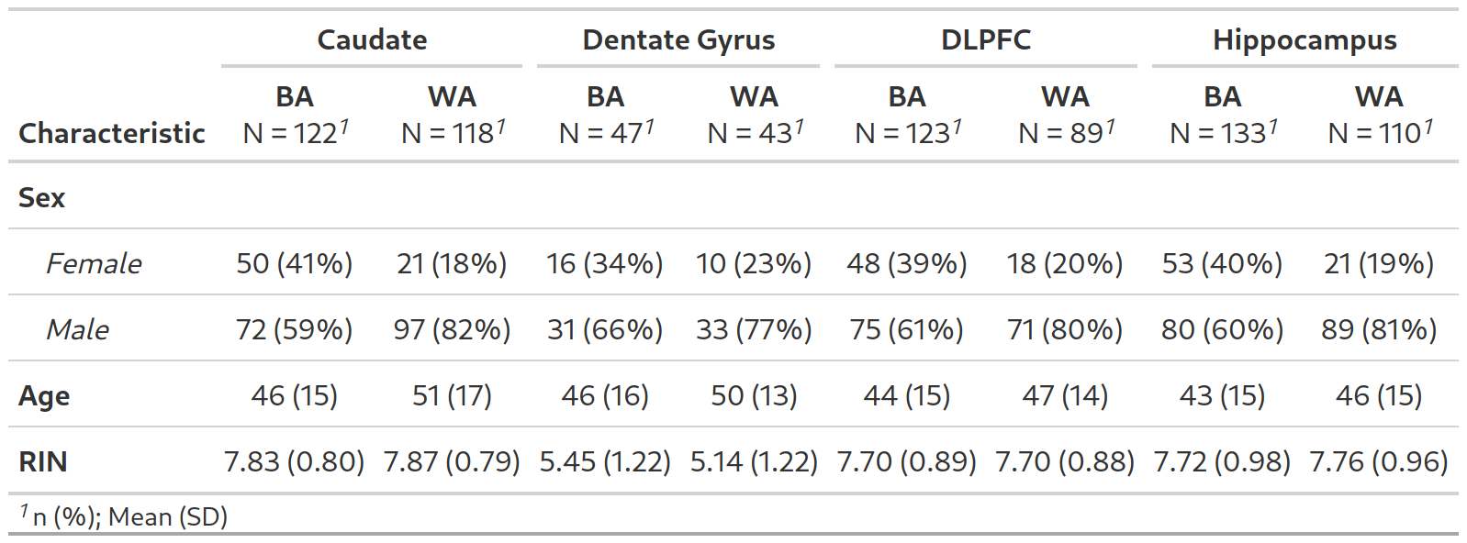

Table S7. Summary of differential expression results (lfsr < 0.05) by feature (gene, transcript, exon, and exon-exon junction) for ancestry differences in the caudate (n=240), dentate gyrus (n = 90), DLPFC (n=212), and hippocampus (n=243). The number of unique genes associated with transcript, exon, or junction is in parentheses.
Brain Region | Gene | Transcript (Geneid) | Exon (Geneid) | Junction (Geneid)
caudate | 4,238 | 7,752 (5,451) | 30,858 (9,303) | 9,426 (4,181)
Dentate Gyrus | 3,395 | 9,758 (6,543) | 23,407 (8,145) | 7,770 (3,848)
DLPFC | 4,226 | 9,396 (6,288) | 31,834 (9,524) | 9,467 (4,231)
Hippocampus | 4,025 | 9,456 (6,370) | 29,340 (9,095) | 9,034 (4,071)

Supplementary Data
- Data S1. BrainSeq_ancestry_4features_4regions_allFeatures.txt.gz: Compressed text file of differential expression analysis after mash modeling for global genetic ancestry (continuous) across the caudate, dentate gyrus, DLPFC, and hippocampus for four features (gene, transcript, exon, and junction).
- Data S2. BrainSeq_ancestry_local_4features_4regions_allFeatures.txt.gz: Compressed text file of differential expression analysis after mash modeling for local genetic ancestry (continuous by feature) across the caudate, dentate gyrus, DLPFC, and hippocampus for four features (gene, transcript, exon, and junction).
- Data S3. DE_functional_enrichment_ancestry_AAonly.xlsx: Excel file of GO-term enrichment and gene set enrichment analysis (GSEA) for genetic ancestry (continuous) differentially expressed genes across the caudate, dentate gyrus, DLPFC, and hippocampus.
- Data S4. WGCNA_functional_enrichment_analysis_ancestry_AAonly.xlsx: Excel file of GO-term enrichment for genetic ancestry-associated WGCNA modules across brain regions.
- Data S5. WGCNA_DEG_enrichment_modules_GO_analysis.tar.gz: Compressed directory of ancestry-associated DEGs enriched for WGCNA module functional enrichment results (i.e., GO-term enrichment) for the caudate, dentate gyrus, DLPFC, and hippocampus.
- Data S6. BrainSeq_main_eQTL_4features_4regions_significant.txt.gz: Compressed text file of main effect eQTL results (lfsr < 0.05), variant-feature pairs across the caudate, dentate gyrus, DLPFC, and hippocampus for four features (gene, transcript, exon, and junction).
- Data S7. BrainSeq_ancestry_dependent_eQTL_4features_4regions_significant.txt.gz: Compressed text file of genetic ancestry-dependent eQTL results (lfsr < 0.05), variant-feature pairs across the caudate, dentate gyrus, DLPFC, and hippocampus for four features (gene, transcript, exon, and junction).
- Data S8. BrainSeq_ancestry_binary_4features_4regions_allFeatures.txt.gz: Compressed text file of binary differential expression analysis (10 permutations) for genetic ancestry (binary) across the caudate, dentate gyrus, DLPFC, and hippocampus for four features (gene, transcript, exon, and junction).
- Data S9. DE_binary_validation_functional_enrichment_ancestry_AA_EA.xlsx: Excel file of GO-term enrichment and GSEA for internal validation for genetic ancestry (binary) differentially expressed genes across the caudate, dentate gyrus, DLPFC, and hippocampus for four features (gene, transcript, exon, and junction).
- Data S10. BrainSeq_DEancestry_LDSC_AAonly.xlsx: Excel file of stratified LD score regression of admixed Black American differential expression analysis separated by direction of effect (all DEGs, upregulated in AA, or upregulated in EA) for genes (SNP proportion > 0.01) across the caudate, dentate gyrus, DLPFC, and hippocampus.
- Data S11. DMR_functional_enrichment_localAncestry_AAonly.xlsx: Excel file of GO-term enrichment for genetic ancestry differential methylation regions across the caudate, DLPFC, and hippocampus.
- Data S12. BrainSeq_DMR_glocal_local_comparison.tar.gz: Compressed directory of PDF of scatter plots comparing DNAm association with local and global ancestry for the caudate, DLPFC, and hippocampus. Plots are annotated with genetic ancestry DMR test results.
- Data S13. BrainSeq_est_prop_Bisque.Rdata: R variable containing estimated cell type proportions using Bisque for the caudate, dentate gyrus, DLPFC, and hippocampus.
- Data S14. gwas_summary_statistics_ldsc.xlsx: Excel file of GWAS summary statistics for heritability enrichment analysis.

