Supplementary Information of: “Microbial iron reduction under oxic conditions: when microfluidics meets geochemistry”
Giulia Ceriotti^{1,3}, Alice Bosco Santos^{1,3}, Sergey M Borisov², Jasmine Berg¹
¹Institute of Earth Surface Dynamics, University of Lausanne, Switzerland
²Institute of Analytical Chemistry and Food Chemistry, Graz University of Technology, Austria
³These authors contributed equally

Microfluidic reactor fabrication
We designed a straight channel shape as depicted in Figure. The chosen design was printed onto a microfluidic master using classical soft lithography in a clean room with a final thickness of 100 μm. We used the microfluidic master to mold PDMS (Sylgard 184 Silicone Elastomer mixed with 10 w/w % of curing agent; supplier: Dow Corning, Midland, MI) and replicate the straight channel as many times as needed.
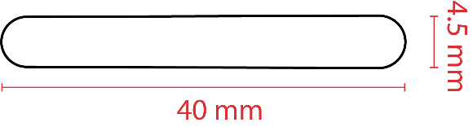
Figure S 1. Design of the straight channel printed onto microfluidic master.
The PDMS chip engraved with the straight channel shape was then assembled to a glass slide using plasma bonding. When needed, the PDMS chip was bonded to a glass slide equipped with an O₂ planar sensor, previously prepared as described in Section S2.
The two ends of the obtained microfluidic reactor were connected to 4-cm long Tygon tubing (Cole-Palmer, inner/outer diameter 0.02/0.04 inches).
After saturation of the microfluidic reactor with the liquid medium, each extremity of the tubing was sealed with a stopper. The latter was produced using a 1cm-long Tygon tube half filled with NOA-81 glue (THORLABS) cured for 5 minutes under UV LED (365 nm, M365LP1, THORLABS). The cured glue created a fluid-impermeable barrier, acting as a stopper, and was connected to the microfluidic reactor extremities using a steel fitting (23G Fluid Adapter, Elveflow).

Sensor details and calibration

Oxygen planar sensor – microfluidic reactor
The transparent O₂ planar sensor integrated into the microfluidic reactor was obtained by screen-printing a homogeneous solution of two luminescent dyes in solid matrix polymer (polystyrene) onto a glass slide (75mm x 25 mm) suitable for microscopy to obtain a homogenous layer with a thickness below 5 μm and shaped as a rectangle (26mm x 4mm). The exact composition of the coating solution can be found in Ceriotti et al., (2022). The two dyes composing the sensor are excited by the same wavelength (450 nm) but show emission peaking at distinct wavelengths. The first dye (a phosphorescent Pt(II) porphyrin) emits a spectrum with a peak at 660 nm and its peak signal intensity (I_{O2}) is quenched as a function of the O₂ concentration of the fluid in contact with the sensor. The second dye (fluorescent coumarin) is characterized by the emission spectrum that peaks at 500 nm. The peak signal intensity of coumarin dye (I_{Ref}) is insensitive to the oxygen concentration of the fluid in contact with the sensor.
The concentration of O₂ is given as a function of the ratio R = I_{O2}/ I_{Ref} so that the sensor reading is purified from possible emission fluctuations caused by factors other than O₂ concentration variations (e.g., optical aberration, fluctuations in light intensity, etc.).
Optical configurations and video-microscopy technical details used for capturing O₂ planar sensor signal are reported in Section S3.
Sensor calibration was performed through a two-point procedure. Air-saturated calibration solution was prepared in a Schott bottle by shaking and exposing to air 10 mL of sterile growth medium (20 mM PIPES, 15mM ferrihydrite, 10X Luria Bertani broth) three times. When air-saturated, the medium presented an O₂ concentration equal to 8.4 mg/L measured with TROX430 sensor, Pyroscience. A similar amount of sterile medium was amended with 100 mg of sodium sulfite (Na₂SO₃, Sigma Aldrich) to prepare the anoxic calibration solution (O₂ concentration = 0 mg/L).
The two calibration solutions were injected into a microfluidic reactor integrated with an O₂ planar sensor in sequence (starting with the air-saturated one). Images of the sensor luminescent signals were collected in 10 different locations along the channel length and post-processed (see Section S4 for procedures) to obtain the values of the ratio R corresponding to an O₂ concentration of 8.35 mg/L and 0 mg/L.
Values of O₂ concentration and ratio R were interpolated with an exponential law following previous works using MATLAB Curve Fitting App (Ceriotti et al., 2022; Larsen et al., 2011)
$$O_{2} concentration \left[\frac{mg}{L}\right]= 33.73e^{-2R}-2.975$$

Oxygen spot sensor – batch reactor
We used oxygen spot sensors OXSP5 supplied by PyroScience. Sensors were connected to a laptop equipped with the software PyroWorkbench using the PyroScience Oxygen meter FireSting-O₂ (4 ports).
Spot sensor calibration was performed according to supplier guidelines, using the built-in two-point calibration procedure of PyroWorkbench. The calibration solutions were prepared using the same protocol presented above for microfluidic planar sensors.

Video-microscopy setup and optical configurations
Video-microscopy was performed with an inverted automated scope Eclipse Ti-E2, Nikon, controlled by NIS-Element software and equipped with i) a 10X objective; and ii) a CMOS DS-Qi2 (Nikon) with a sensor area of 36.0 mm x 23.9 mm and an actual pixel size of 7.3 μm and exposure time fixed at 200 ms. Images were taken at 10 locations every hour along the channel longitudinal direction, stitching together 4 pictures at each location to capture a more extensive area obtaining a final size of 9871 x 6365 pixels (corresponding to an area of ~ 5.2 mm²) for each image.
The scope automatically switched between 4 different optical configurations:
- Bright Field (BF). This optical configuration used a diascopic scheme illuminating the device with the white LED light source at 0.5% of the maximum intensity. Opaque elements like ferrihydrite minerals were visible as dark objects on a white background.
- Adjusted Phase Contrast (a-PC). The same illumination source employed in BF was used at 64,3% of its maximum intensity combined with a Nikon Ph3 phase contrast plate compared to the ring (a Ph1) present in the selected objective. With this optical configuration, we detected all elements with an optical density different from the liquid medium, meaning that ferrihydrite minerals and microbial cells appeared as bright objects on a dark background.
- Fluorescence at 500 nm (F₅₀₀) and 660 nm (F₆₆₀). These optical configurations used an episcopic illumination scheme to capture the signals of the reference and the O₂-sensitive dyes, composing the O₂ planar sensor. A blue LED (440 ± 20 nm, Lumencor SPECTRA X Light Engine) illuminates the microfluidic reactor. This wavelength excited the luminescent dyes composing the O₂ planar sensor. The luminescent signal is filtered by Semrock bandpass emission filters (448 ± 20 nm for the reference and 650 ± 13 for the O₂ sensitive signals).

Image processing and computation of bulk parameters
Image processing was performed in the Matlab environment with in-house produced codes.
Ferrihydrite spatial organization. The images captured with BF configuration were normalized to the highest pixel value recorded within each image so that each pixel attained a value between 0 and 1. The pdf (probability density function) of pixel value distribution and its 10th percentile (p₁₀) were computed. All pixels with a value smaller than p₁₀ were identified as dark objects, i.e., ferrihydrite minerals. A binary matrix (FE_OX) with the same size as the original BF image for each acquisition time was generated to store ferrihydrite mineral spatial organization with a value equal to 0 for pixels associated with ferrihydrite minerals and 1 otherwise.
Biomass spatial organization and bulk microbial growth. Images collected with a-PH configuration were normalized to the maximum pixel value recorded in each image to obtain pixel values between 0 and 1. Pixels with higher values are associated with microbial and minerals, i.e., objects with an optical density more elevated than the liquid medium. These objects were identified by setting a threshold at 0.3 (chosen on preliminary assessment using images collected at t = 0 hours) and forcing all pixel values smaller than 0.3 to 0. To distinguish microorganisms from mineral spatial distribution, we multiplied the thresholded a-PC image by the FE_OX matrix associated with the exact location and acquisition time. In the resulting map (BIO), only pixels associated with biomass presence showed values larger than 0.
Bulk microbial growth (BG_{Bulk}) was computed for each acquisition time (t) by processing the corresponding matrix BIO as follows
$${BG}_{Bulk}(t)=\frac{\sum_{i=1}^{N}{BIO(i, t)}}{BG_0 \sum_{i=1}^{N}{FE_OX(i, t)} }$$
where i is the image pixel counter, N is the total number of pixels of the image, and BG_{Bulk} (t=0) is equal to
$$BG_0=\frac{\sum_{i=1}^{N}{BIO(i, t=0)}}{\sum_{i=1}^{N}{FE_OX(i, t=0)} }$$
O₂ concentration maps and bulk O₂ concentration. Spatial distributions of the ratio R were computed by dividing the images collected with F₆₆₀ configuration by those collected with F₅₀₀ one, pixel by pixel. O₂ concentration maps (OX) were obtained by applying the planar sensor calibration curve equation to each pixel value of R spatial maps.
Bulk O₂ concentration (O_{2,Bulk}(t)) was computed for each acquisition time (t) by processing the corresponding matrix OX as follows
$$O_{2,Bulk}(t)=\frac{\sum_{i=1}^{N}{OX(i, t)}}{N }$$

Ferrozine assay – microfluidic reactor
A sample of > 70 μL was obtained by extracting and mixing the medium incubated in 5 replicates of the microfluidic reactor and treated in the following way:
- An aliquot of 80.6 μL of 0.1 M HCl was added to 70 μL of the sample in a 1.5mL Eppendorf centrifuge conical tube to lysis bacteria cells and desorbed Fe(II) from other minerals' surfaces during a 15 min reaction time;
- The solution was centrifuged for 15 minutes at 12 00 rpm in a microcentrifuge to separate solids from the liquid phase;
- An aliquot of 140 μL of the supernatant is pipetted into a micro-well of a Greiner Microplate (96 wells, PS, F-bottom, clear) and mixed with 20 μL of Ferrozine.
- After 10 minutes of contact time, the sample’s absorbance at 560 nm (ABS₅₆₀) was measured using a Spark® Multimode Microplate Reader.
The absorbance measurements are translated into Fe(II) concentrations by applying the following calibration curve
$$Fe\left(II\right) concentration \left[mM\right]=1.67 {ABS}_{560}-0.061$$
The calibration curve was obtained by interpolating the absorbance measured for 6 calibration solutions (Fe(II) concentrations = 0, 0.1, 0.2, 0.5, 1, 3 mM) obtained by dissolving Fe-sulfate into the sterile medium, processed according to the same protocol applied to the samples. As O₂ can oxidize Fe(II), the determination of its concentrations might be underestimated (Posner, 1953; Porsch and Kappler, 2011).

Ferrozine and Coomassie assays – batch reactor
A sample of 300 μL was pipetted from the batch reactor with sterile material under the laminar-flow hood and transferred in a 1.5 mL Eppendorf centrifuge conical tube and mixed with 345 μL of 0.1 M HCl to lysis bacteria cells and desorbed Fe(II) from other minerals' surfaces during a 15 min reaction time.
Protein concentration was measured as follows:
- After 15 minutes of reaction time with 0.1 M, an aliquot of 150 μL was pipetted into a micro-well of a Greiner Microplate (96 wells, PS, F-bottom, clear) and mixed with 150 μL of Coomassie brilliant blue G-250.
- After 10 minutes of contact time, the sample’s absorbance at 595 nm (ABS₅₉₅) was measured using a Spark® Multimode Microplate Reader.
- Protein concentration was computed through the following calibration curve
$$Protein concentration \left[\frac{μg}{mL}\right]=68.7 {ABS}_{595}-18.1$$
The protein concentration calibration curve was obtained following the protocol of Thermo Scientific.
The concentration of Fe(II) was determined according to the following procedure:
- After transferring the aliquot used for the Coomassie assay, the solution was centrifuged 15 minutes at 12 00 rpm in a microcentrifuge to separate solids from the liquid phase.
- An aliquot of 280 μL of the supernatant is pipetted into a micro-well of a Greiner Microplate (96 wells, PS, F-bottom, clear) and mixed with 20 μL of Ferrozine.
- After 10 minutes of contact time, the sample’s absorbance at 560 nm (ABS₅₆₀) was measured using a Spark® Multimode Microplate Reader.
The concentration of Fe(II) was computed from ABS₅₆₀ by applying the calibration curve:
$$Fe\left(II\right) concentration \left[mM\right]=1.11 {ABS}_{560}$$
The calibration curve was obtained by interpolating the absorbance measured for 6 calibration solutions (Fe(II) concentrations = 0, 0.1, 0.2, 0.5, 1, 3 mM) obtained by dissolving Fe-sulfate into the sterile medium, processed according to the same protocol applied to the samples.

Definition of anoxic micro-site percentage and its detection limit
To check if anoxic micro-sites are formed, each O₂ concentration map (OX) was characterized in terms of the percentage of anoxic surface (P_{AS} [%]). In this work, we assumed to be anoxic the space characterized by an O₂ concentration ≤ 0.32 mg/L, a threshold traditionally associated with the onset of microoxic conditions (Berg et al., 2022). To this end, we generated a binary matrix (ANOX) with the same size as the O2 concentration map as follows
$$ANOX\left(i\right)= \left\{\begin{aligned}1 if OX\left(i\right)≤0.32 \frac{mg}{L} \\ 0 if OX\left(i\right)>0.32 \frac{mg}{L}\end{aligned} for i=1,…,N\right.$$
where i is the pixel counter, and N is the total number of pixels of the O₂ concentration map. The resulting matrix ANOX identified all the pixels where the onset of anoxic conditions was observed (i.e., with O₂ concentration ≤ 0.32 mg/L). The percentage of anoxic volume results from
$$P_{AS}(t)=\frac{\sum_{i=1}^{N}{ANOX(i, t)}}{\sum_{i=1}^{N}{OX(i, t)} }100$$
Small impurities entrapped in the microfluidic reactor, burnt pixels of the camera sensor, and imperfections of the O₂ planar sensor surface may locally interfere with the reading of the O₂ concentration and generate background noise in the computation of P_{AS}. To estimate the order of magnitude of the P_{AS} background noise, we saturated a microfluidic reactor equipped with the O₂ planar sensor with a sterile air-saturated medium solution (20 mM PIPES, 15 mM ferrihydrite and 10X LB with O₂ concentration = 8.4 mg/L). To prepare the air-saturated solution, we used the same procedure reported in Section S2. Images of the sensor luminescent signals were collected in 10 different locations along the longitudinal direction of the channel and post-processes to obtain the corresponding O₂ concentration maps, as described in Section S4. We computed the corresponding P_{AS} by applying the procedure reported above. Results are reported in Table S1, along with their mean value.
Table S 1 P_{AS} values computed for an air-saturated sterile medium in 10 different locations and their mean value.
Image | 1 | 2 | 3 | 4 | 5 | 6 | 7 | 8 | 9 | 10 | Mean Value
P_{AS}[%] | 1.1x10⁻⁴ | 2.0x10⁻⁴ | 7.1x10⁻⁶ | 1.4x10⁻⁵ | 0 | 7.6 x10⁻³ | 2.1x10⁻³ | 1.8x10⁻⁴ | 0 | 0 | 1.0x10⁻³

Based on this assessment, we defined the value of P_{AS} = 1.0x10⁻³ as a technical detection limit for identifying anoxic micro-site formation. Any value of P_{AS} falling below the detection limit was considered indistinguishable from the background noise and, therefore, was not related to the actual formation of anoxic conditions.

Bulk O₂ concentration in the batch incubations
In the S. oneidensis batch incubations, a drop in O₂ concentrations from 6-7 mg/L to < 2 mg/L in the first 8 h is observed in 5 replicates, fast recovering the initial value within the following 16h (first 24h, see Figure S2). Therefore, O₂ uptake by aerobic growth of S. oneidensis during the exponential growth phase outcompetes the O₂ supplied by diffusion from the headspace due to a lesser efficient stirring and gas exchange. During the stationary growth phase (24-168 hours), bacterial O₂ uptake was slower and always well-compensated by air supply. As a result, O₂ bulk concentration was stabilized at around 6-7 mg/L in all replicates. No measurement fell below 0.53 mg/L, and for at least 93% of the experiment duration, all replicated presented fully oxic conditions (i.e., O2 concentration above 1.95 mg/L, Berg et al., 2022). Two replicates experienced fully oxic conditions for 100% of the time, and a Fe(II) pool was formed like in the other replicates. Therefore, we exclude that the initial bulk O₂ concentration drop displayed in some replicates has any impact on triggering of Fe(III) reduction induced by S. oneidensis.
Air-saturation O₂ levels (8.4 mg/L) were always maintained in the negative controls confirming the role played by microbial respiration in the dynamics of O₂ bulk concentration observed in the S. oneidensis experiments.
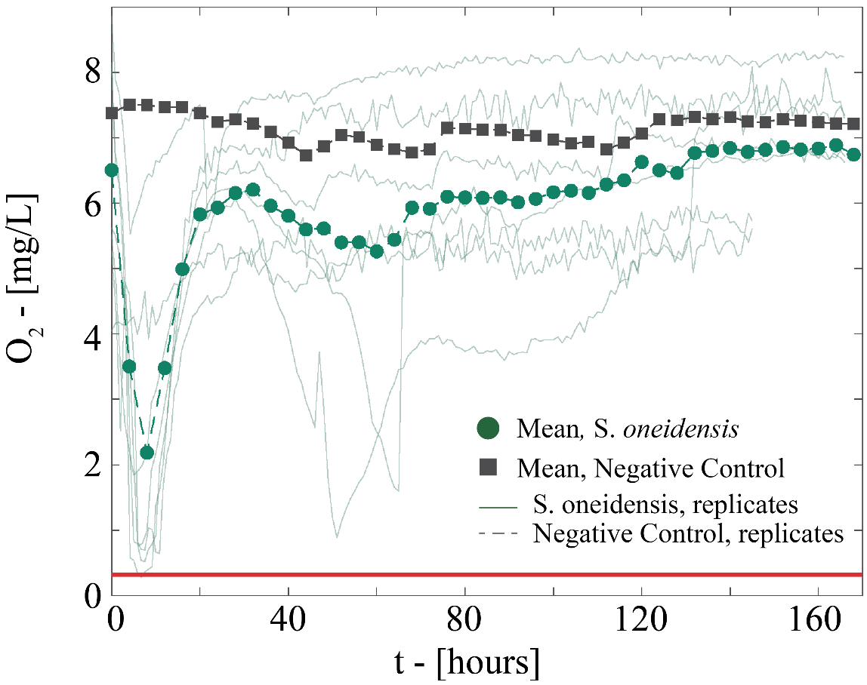
Figure S 2 Measurements of O₂ bulk concentration for each replicate of well-mixed batch reactor incubating S. oneidensis and the corresponding mean value. Similar data are reported for the negative controls. The solid red line indicates the threshold for microoxic conditions.

References
Berg, J. S. et al. How low can they go? Aerobic respiration by microorganisms under apparent anoxia. FEMS Microbiology Reviews 46, fuac006 (2022).
Ceriotti, G., Borisov, S. M., Berg, J. S. & de Anna, P. Morphology and size of bacterial colonies control anoxic microenvironment formation in porous media. Environmental Science & Technology 56, 17471-17480 (2022).
Larsen, M., Borisov, M.S., Grunwald, B., Klimant, I., & Glud, R.N. A simple and inexpensive high resolution color ratiometric planar optode imaging approach: application to oxygen and pH sensing. Limnology and Oceanography: Methods 9, 348-360 (2011).
Porsch, K. & Kappler, A. FeII oxidation by molecular O₂ during HCl extraction. Environmental Chemistry 8(2),190-197 (2011).
Posner, A.M. The kinetics of autoxidation of ferrous ions in concentrated HCl solutions. Transactions of the Faraday Society, 49, 382-388 (1953).

