Supplementary Figures
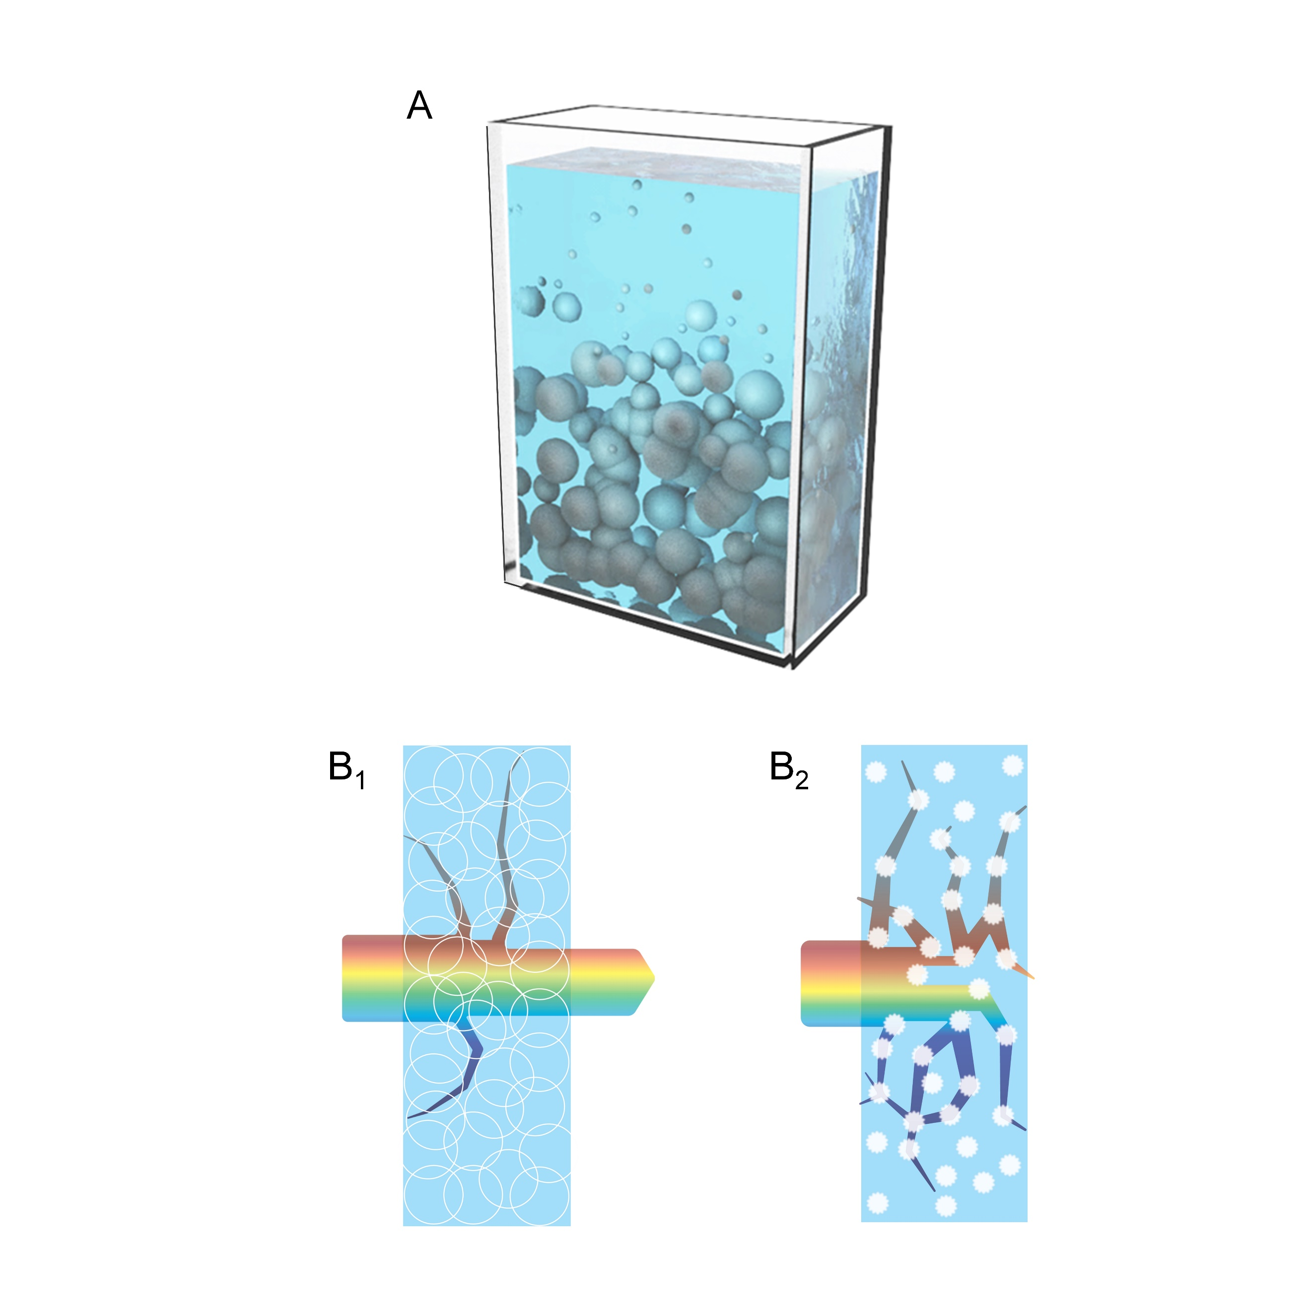

Supplementary Fig. 1 A, Schematic of smart window using pNIPAm hydrogel nano/microparticles and its limits concerning structure integrity and dehydration. The pNIPAm hydrogel particles suspension requires rigid and transparent container and vigorous encapsulation. B, Schematic of light management mechanism for pNIPAm hydrogel particles before and after phase transition.

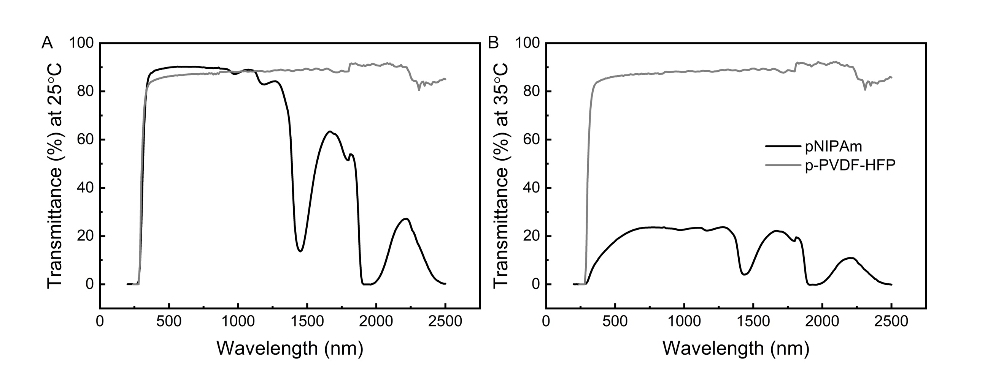
Supplementary Fig. 2 Transmittance spectra of pNIPAm hydrogel film and p-PVDF-HFP polymer film at (A) 25 °C and (B) 35 °C.
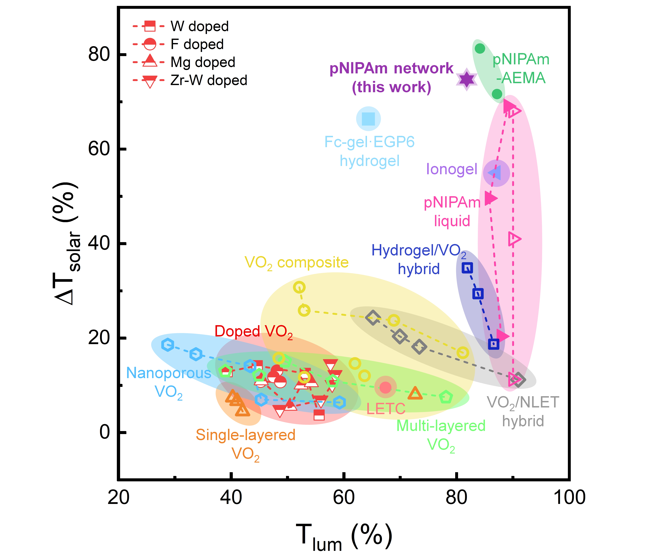
Supplementary Fig. 3 Thermochromic performance (solar transmittance modulation, ΔT_{solar}, after phase transition, and luminous transmittance, T_{lum}, before phase transition) in some of the best-reported films: single-layered VO₂ films,^{1, 2, 3} multi-layered VO₂ films,^{1, 2, 4, 5} doped VO₂ films,^{6, 7, 8, 9} nanoporous VO₂ films,¹⁰ VO₂ composite films,^{11, 12} VO₂/nickel (II)-based ligand exchange hybrid (NLET) films,³ liquid pNIPAm films,^{13, 14} pNIPAm-2-aminoethylmethacrylate hydrochloride (pNIPAm-AEMA) films,¹⁵ hydrogel/VO₂ composite films,¹⁶ ionogel films,¹⁷ ferrocene modified ethylene glycol-modified pillar[6]arene (Fc-gel·EGP6),¹⁸ ligand exchange of thermochromic films (LETC),¹⁹ and the pNIPAm-AEMA films.¹⁵ Hollow and half-hollow symbols indicate the ΔT_{solar} of thermochromic films at phase transition temperature from 60˚C to 100˚C. Solid symbols indicate the thermochromic films with low phase transition temperature (≤ 40˚C). In particular, the ΔT_{solar} of most pNIPAm liquids, ionogels, LETC, and Fc-gel·EGP6 are acquired at the phase transition temperature of 40˚C, while the ΔT_{solar} of the pNIPAm hydrogel network is obtained at 35˚C in this work.

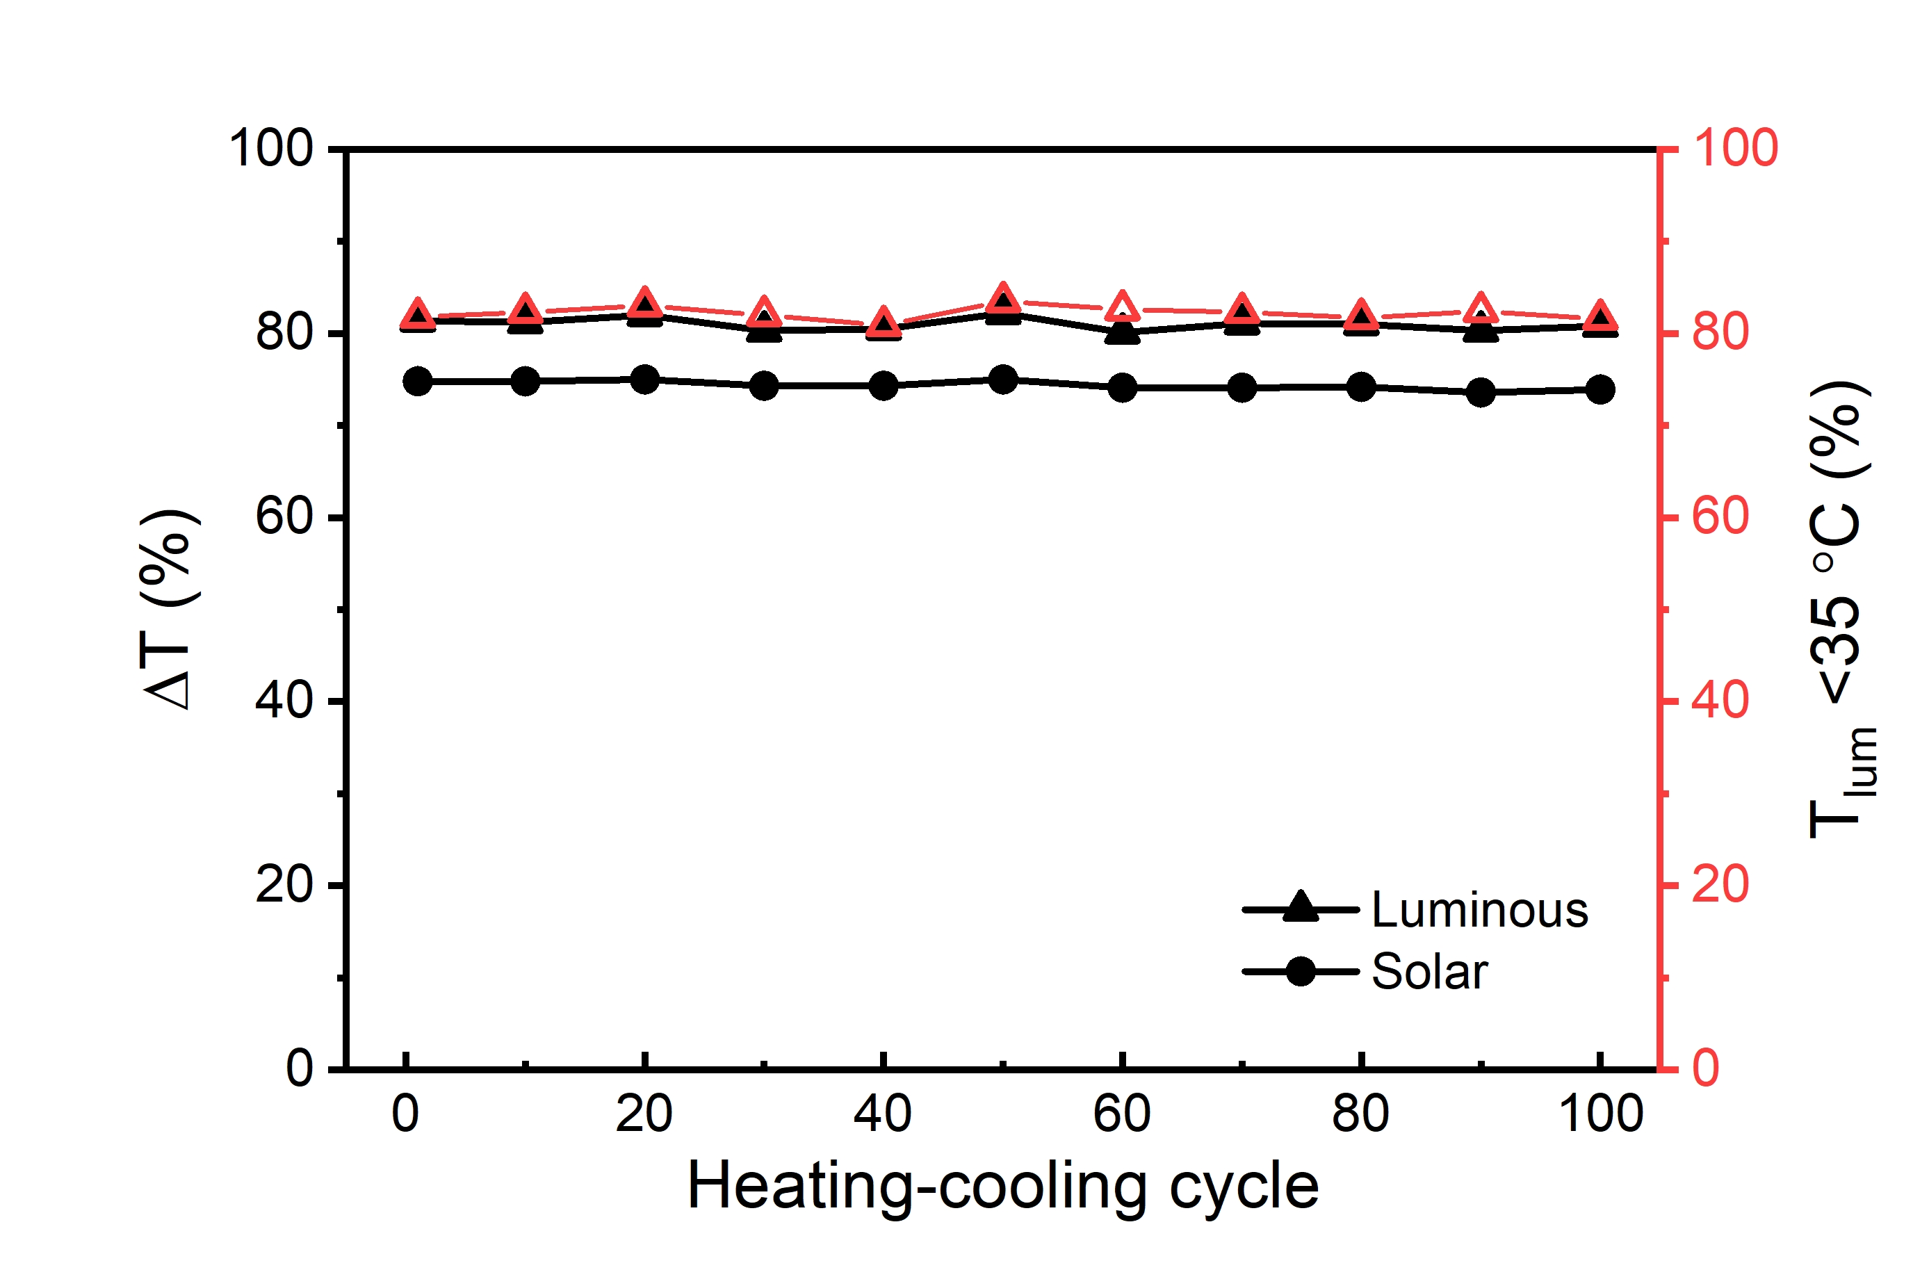
Supplementary Fig. 4 Transmittance modulations (ΔT_{lum} and ΔT_{solar}) and T_{lum} before phase transition of the pNIPAm/p-PVDF-HFP measured after every 10 heating-cooling cycles.

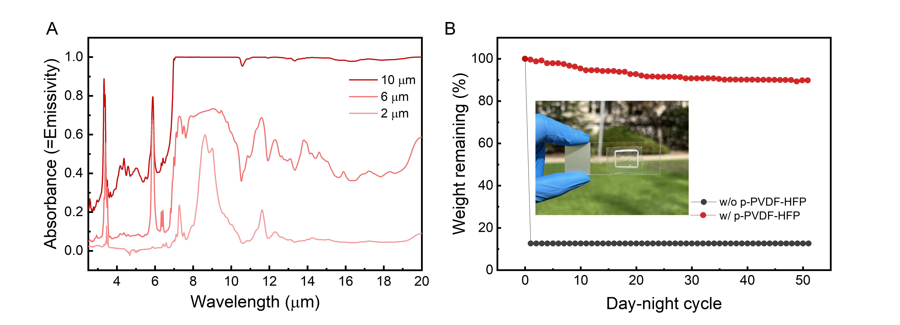
Supplementary Fig. 5 A, Spectral emissivity of p-PVDF-HFP with various thicknesses. B, Weight change of pNIPAm hydrogel protected by p-PVDF-HFP sealing film after day-night cycles.

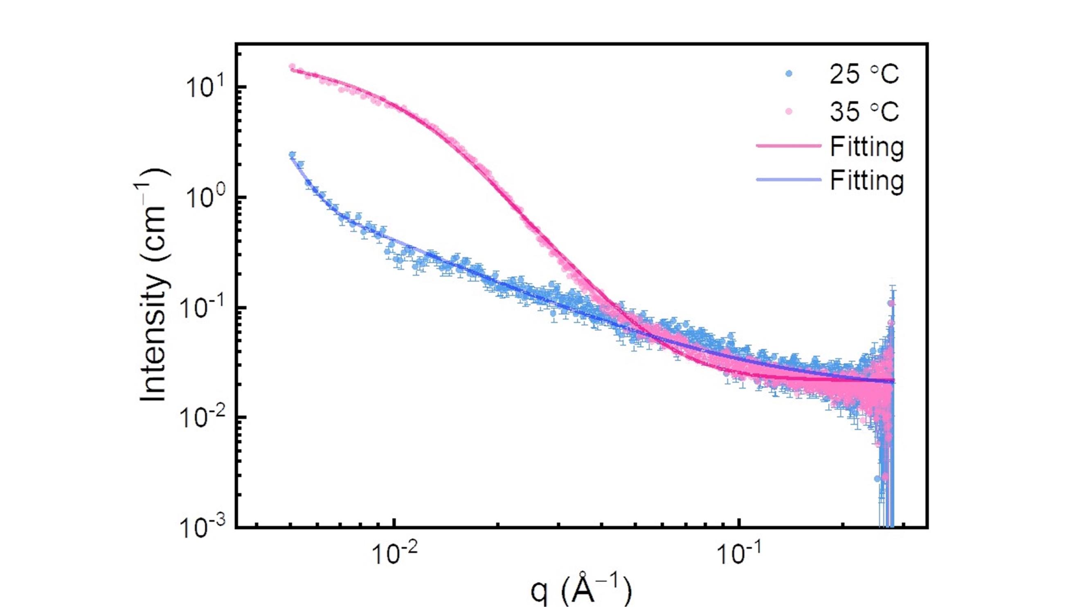
Supplementary Fig. 6 SAXS intensity profiles in logarithmic scale of pNIPAm hydrogel network at 25 °C and 35 °C and corresponding fitting plots.

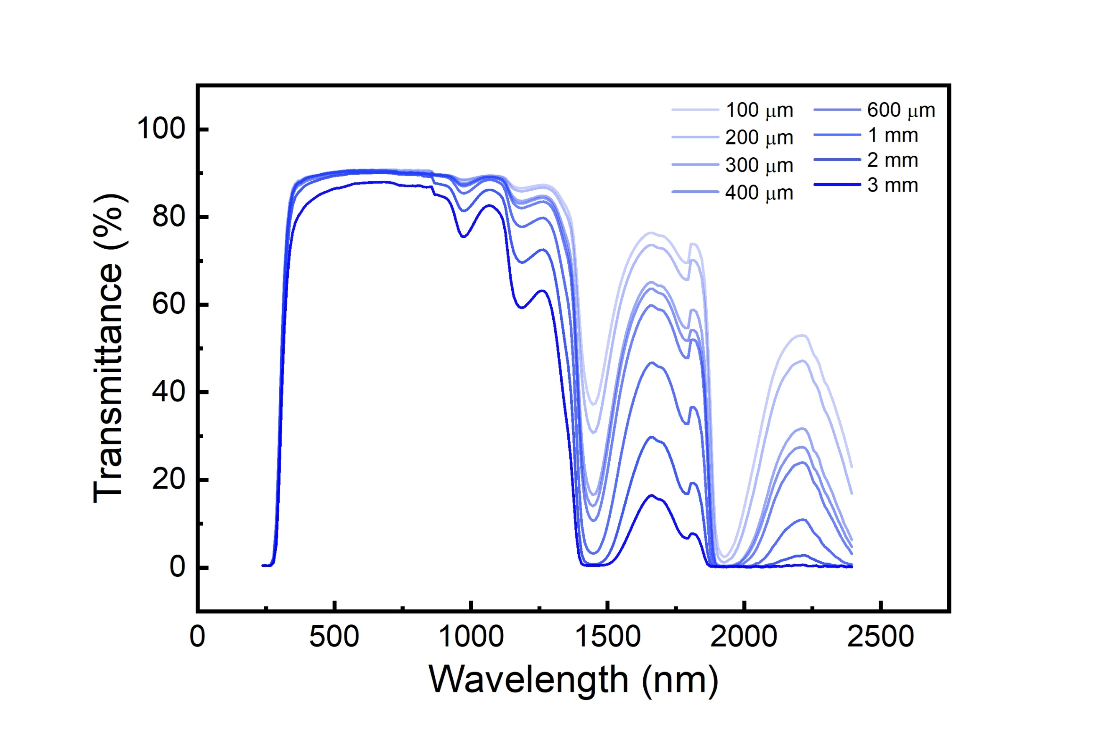
Supplementary Fig. 7 Transmittance spectra of pNIPAm hydrogel network at room temperature with various thicknesses.

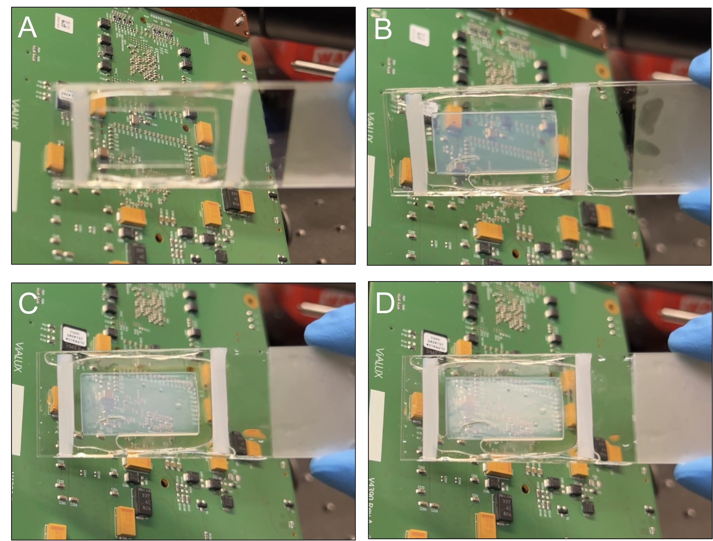
Supplementary Fig. 8 Optical images of pNIPAm hydrogel film undergoing a phase change from room temperature (A) to above 35 °C (B–D).

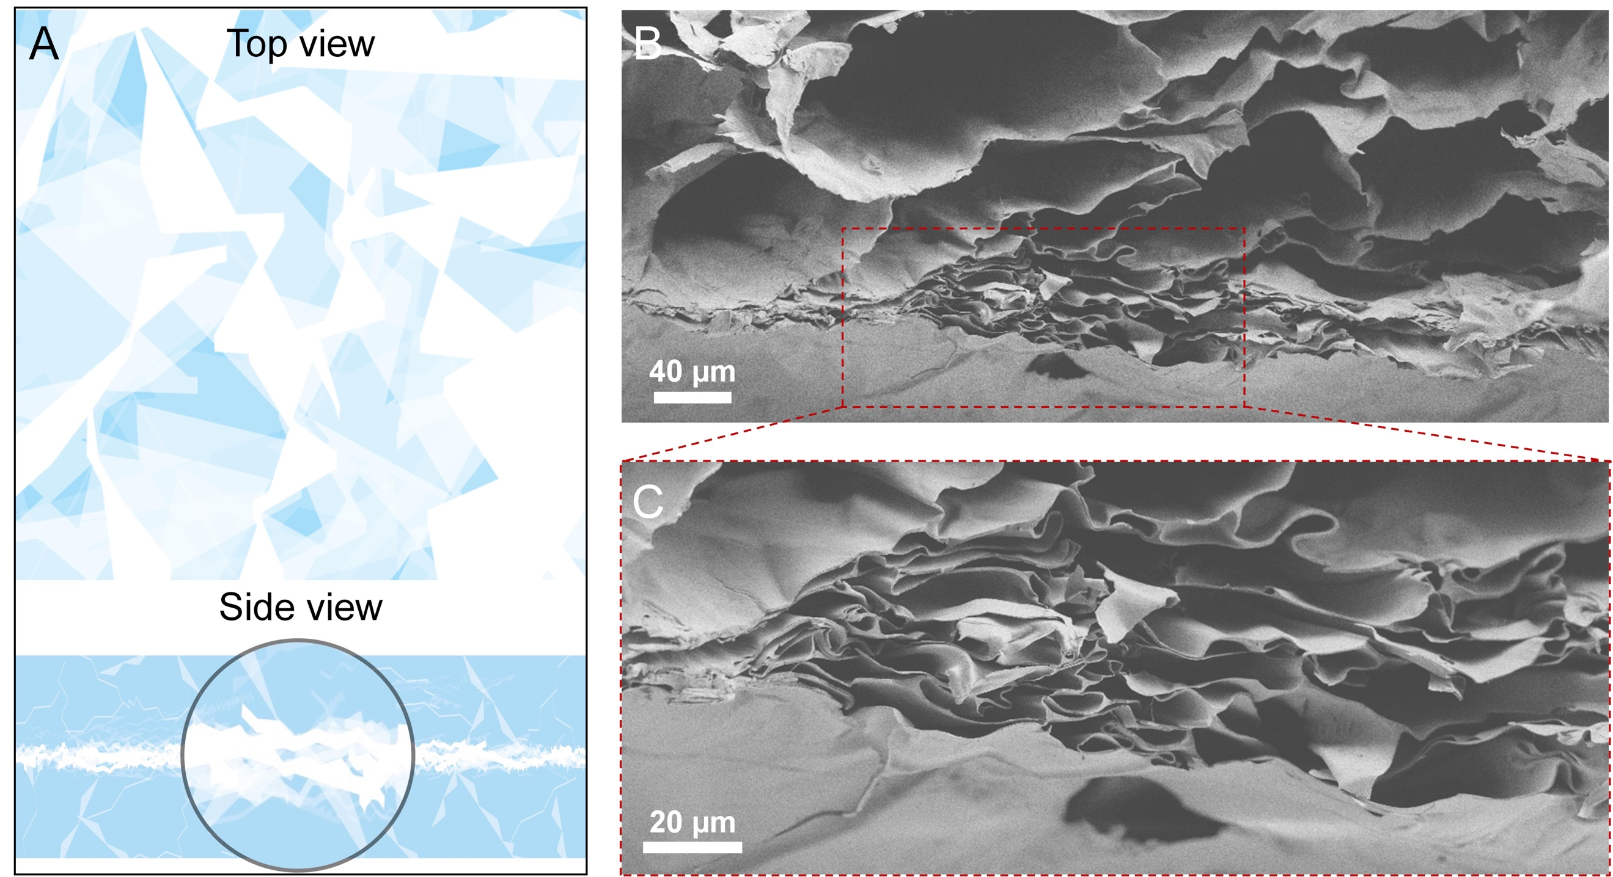
Supplementary Fig. 9 A, Schematic of pNIPAm hydrogel network from top and side views, where the magnified area indicates the location of cross-section SEM images captured. B and C, Cross-section SEM images of freeze-dried pNIPAm-polyacrylamide double network under different magnifications. The pNIPAm flakes collapsed and were compressed at high temperatures while this morphology was preserved by curing the second hydrogel of polyacrylamide (PAm). Thus, we could image the de-swollen pNIPAm network even after freeze-drying the sample.

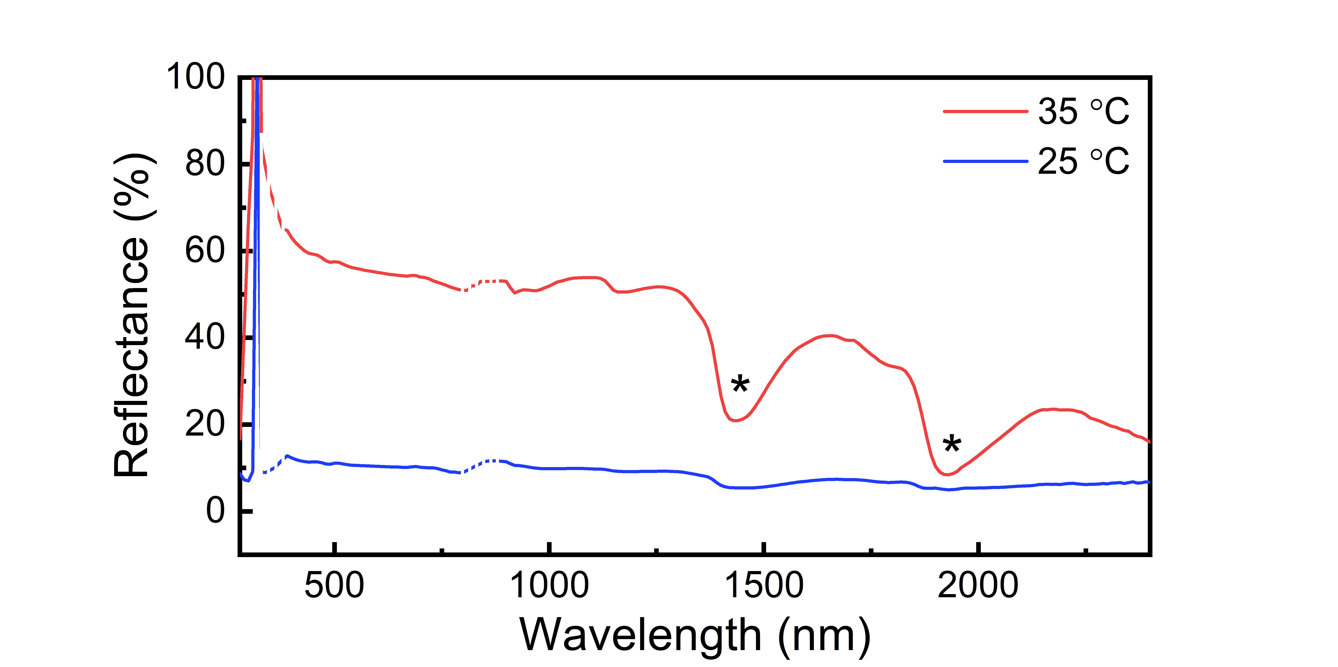
Supplementary Fig. 10 Hemispherical reflectance spectrum of pNIPAm hydrogel network at 25 °C and 35 °C measured using an integrating sphere. The peaks of water absorption are marked (*). Possible experimental fluctuations concerning UV-Vis-NIR switching detectors are indicated by the dotted-line.

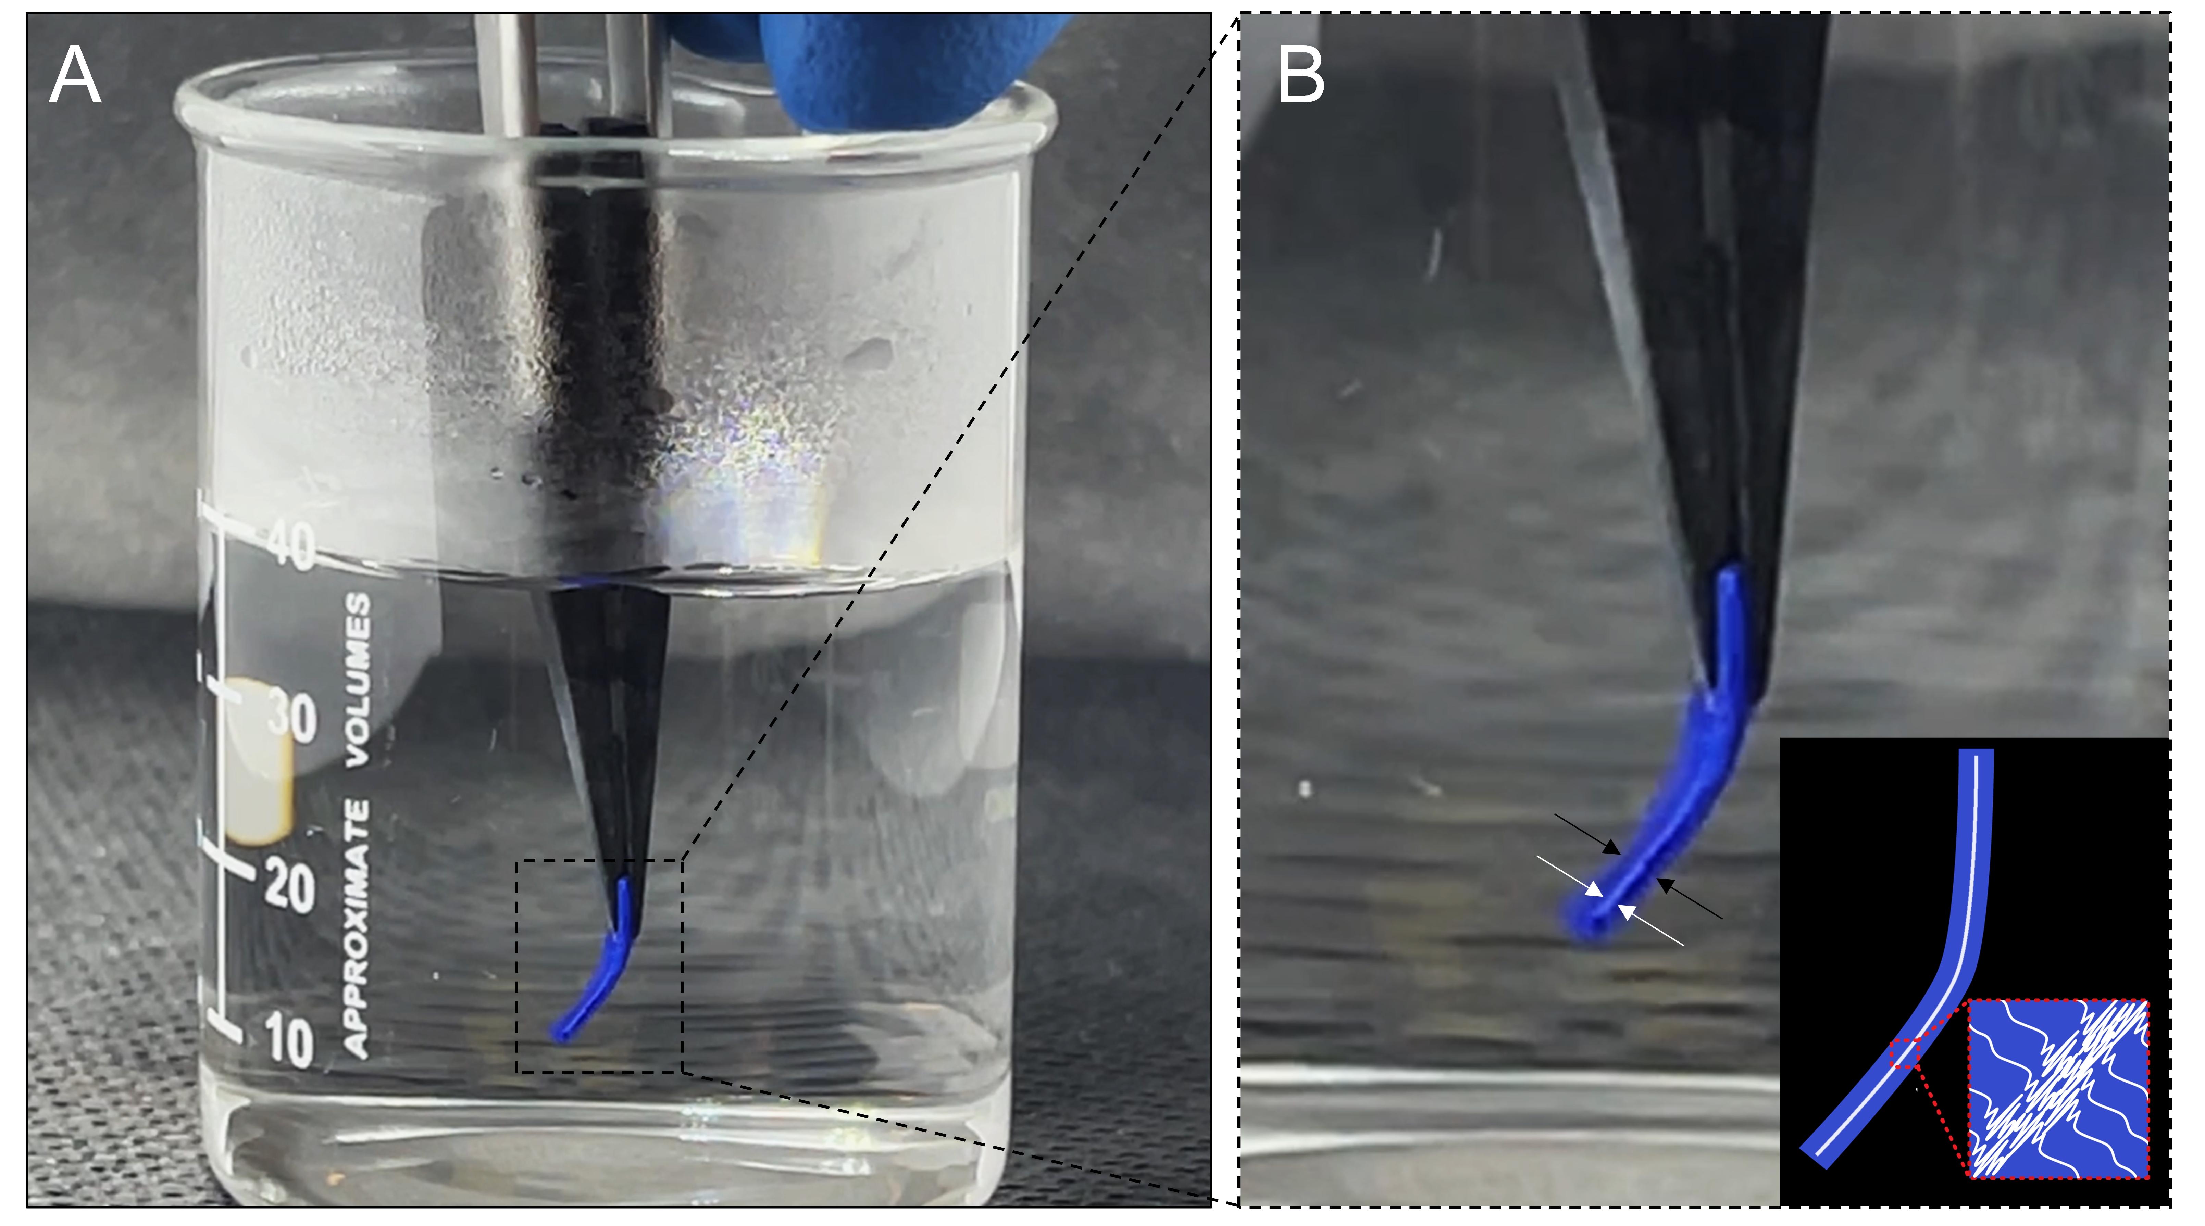
Supplementary Fig. 11 A, Optical image of a blue-dyed pNIPAm hydrogel with a thickness of ~ 1mm in warm water (>35 °C) and B, its magnified image revealing a white middle layer of pNIPAm network in between two blue hydrogel layers. Insert shows the schematic diagram of blue-dyed pNIPAm hydrogel with collapsed polymers.

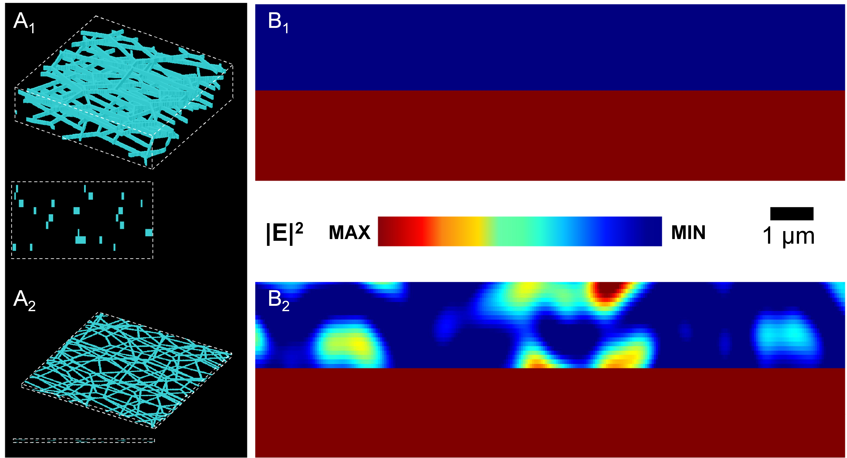
Supplementary Fig. 12 A, PNIPAm hydrogel network models with water ratios of (A₁) 90% and (A₂) 35%. B, Corresponding electric field distribution of pNIPAm hydrogel networks under normal light (at 1636 nm) incidence.

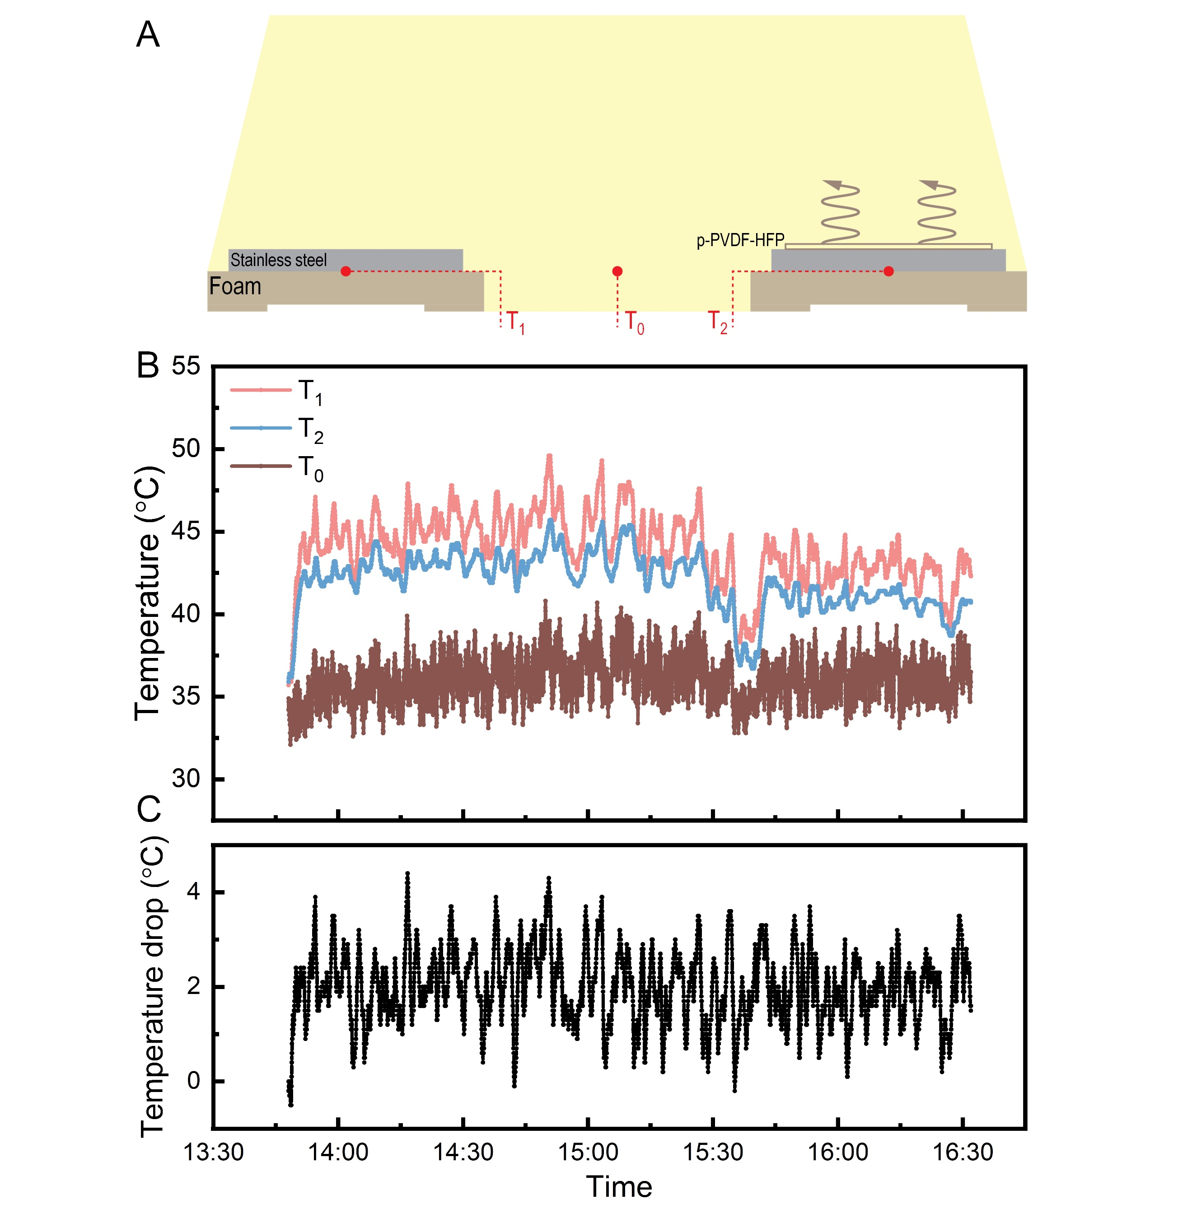
Supplementary Fig. 13 A, Schematic of the experimental setup for monitoring temperatures of the stainless steel with and without p-PVDF-HFP and ambient air. B, Temperature profiles for the bare stainless steel, the stainless steel covered by a p-PVDF-HFP thin film, and ambient air on July 19, 2022. C, T₁−T₂ during the measurement period.
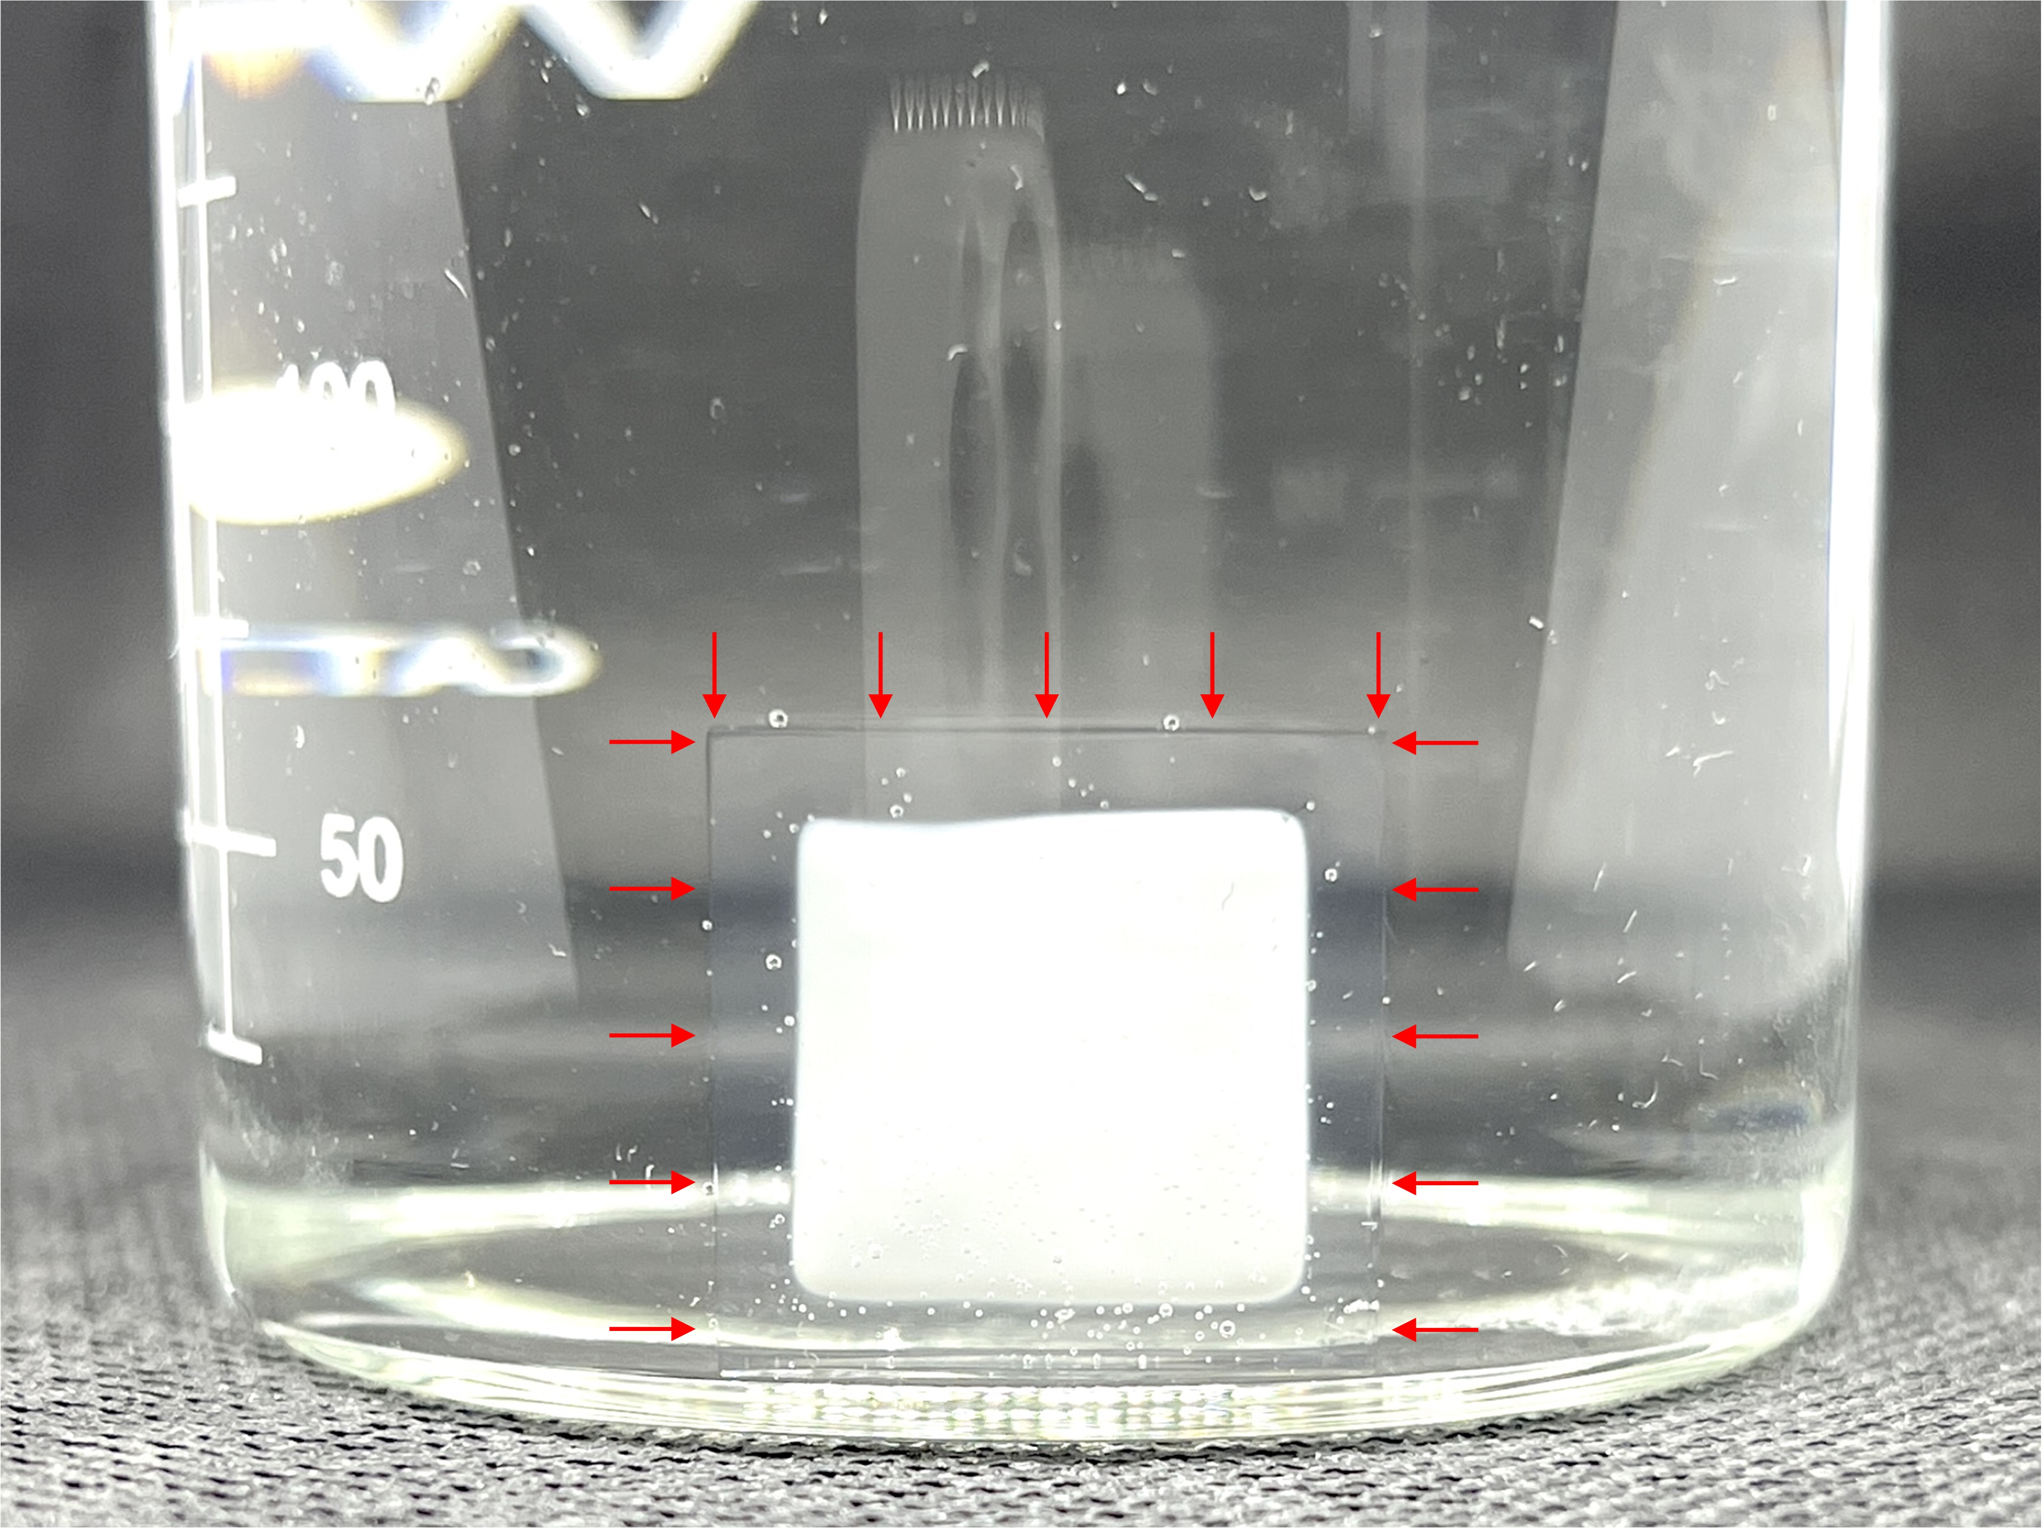
Supplementary Fig. 14 Optical image of a bulk pNIPAm hydrogel during solvent exchange. The transparent region indicates that the DMSO is replaced by water completely, but the solvent exchange is happening in the region of white.

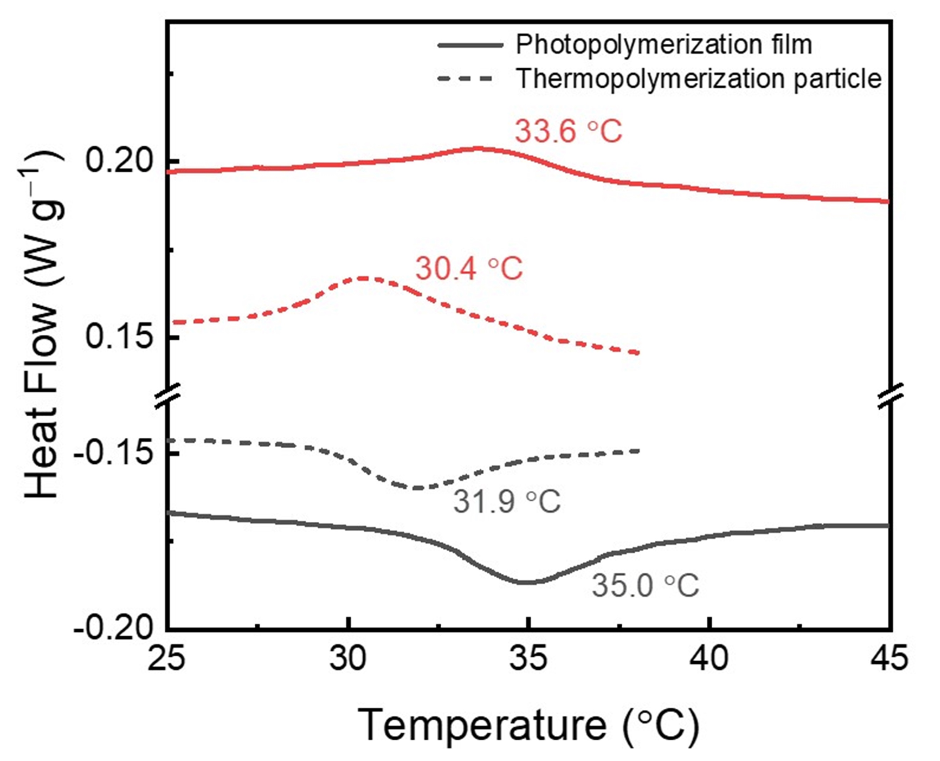
Supplementary Fig. 15 DSC measurements for pNIPAm hydrogel network (solid line) and pNIPAm nanoparticles (dashed line).

Supplementary References:
1. Mlyuka N, Niklasson GA, Granqvist C-G. Thermochromic multilayer films of VO2 and TiO2 with enhanced transmittance. Sol. Energ. Mat. Sol. C 93, 1685-1687 (2009).
2. Chen Z, et al. VO2-based double-layered films for smart windows: optical design, all-solution preparation and improved properties. Sol. Energ. Mat. Sol. C 95, 2677-2684 (2011).
3. Zhu J, et al. Hybrid films of VO 2 nanoparticles and a nickel (ii)-based ligand exchange thermochromic system: excellent optical performance with a temperature responsive colour change. New J. Chem. 41, 830-835 (2017).
4. Mlyuka NR, Niklasson GA, Granqvist CG. Thermochromic VO2‐based multilayer films with enhanced luminous transmittance and solar modulation. Physica Status Solidi (a) 206, 2155-2160 (2009).
5. Liu C, et al. Index-tunable anti-reflection coatings: Maximizing solar modulation ability for vanadium dioxide-based smart thermochromic glazing. J Alloy Compd. 731, 1197-1207 (2018).
6. Zhou Y, Ji S, Li Y, Gao Y, Luo H, Jin P. Microemulsion-based synthesis of V 1− x W x O 2@ SiO 2 core–shell structures for smart window applications. J. Mater. Chem. C 2, 3812-3819 (2014).
7. Dai L, et al. F-doped VO 2 nanoparticles for thermochromic energy-saving foils with modified color and enhanced solar-heat shielding ability. Phys. Chem. Chem. Phys. 15, 11723-11729 (2013).
8. Zhou J, et al. Mg-doped VO 2 nanoparticles: hydrothermal synthesis, enhanced visible transmittance and decreased metal–insulator transition temperature. Phys. Chem. Chem. Phys. 15, 7505-7511 (2013).
9. Shen N, et al. The synthesis and performance of Zr-doped and W–Zr-codoped VO 2 nanoparticles and derived flexible foils. J. Mater. Chem. A 2, 15087-15093 (2014).
10. Kang L, Gao Y, Luo H, Chen Z, Du J, Zhang Z. Nanoporous thermochromic VO2 films with low optical constants, enhanced luminous transmittance and thermochromic properties. ACS Appl. Mater. Inter. 3, 135-138 (2011).
11. Zhu J, et al. Composite film of vanadium dioxide nanoparticles and ionic liquid–nickel–chlorine complexes with excellent visible thermochromic performance. ACS Appl. Mater. Inter. 8, 29742-29748 (2016).
12. Gao Y, et al. VO2-Sb:SnO2 composite thermochromic smart glass foil. Energy Environ. Sci. 5, 8234-8237 (2012).
13. Zhou Y, Cai Y, Hu X, Long Y. Temperature-responsive hydrogel with ultra-large solar modulation and high luminous transmission for “smart window” applications. J. Mater. Chem. A 2, 13550-13555 (2014).
14. Zhou Y, et al. Liquid thermo-responsive smart window derived from hydrogel. Joule 4, 2458-2474 (2020).
15. Li X-H, Liu C, Feng S-P, Fang NX. Broadband light management with thermochromic hydrogel microparticles for smart windows. Joule 3, 290-302 (2019).
16. Zhou Y, Cai Y, Hu X, Long Y. VO 2/hydrogel hybrid nanothermochromic material with ultra-high solar modulation and luminous transmission. J. Mater. Chem. A 3, 1121-1126 (2015).
17. Lee HY, et al. Thermochromic Ionogel: A New Class of Stimuli Responsive Materials with Super Cyclic Stability for Solar Modulation. Chem. Mater. 29, 6947-6955 (2017).
18. Wang S, et al. Warm/cool-tone switchable thermochromic material for smart windows by orthogonally integrating properties of pillar [6] arene and ferrocene. Nat. Commun. 9, (2018).
19. Harlan J. Byker PHO, Jr.Douglas A. Vander GriendBrad S. VeldkampDerick D. Winkle Ligand exchange thermochromic, (LETC), systems. US Pat. (2006).

