Supporting Information
Resorbable Barrier Polymers for Flexible Bioelectronics
Samantha M. McDonald¹, Quansan Yang², Yen-Hao Hsu¹, Shantanu P. Nikam¹, Ziying Hu², Zilu Wang³, Darya Ashegali¹, Tiffany Yen¹, Andrey V. Dobyrnin³, John A. Rogers^{2,4*} and Matthew L. Becker^{1,5,6,7*}

¹ Department of Chemistry, Duke University, Durham, NC 27708, United States
² Department of Materials Science and Engineering, Northwestern University, Evanston, IL, 60208 USA

³ Department of Chemistry, University of North Carolina-Chapel Hill, Chapel Hill, NC 27599, USA

⁴ Department of Biomedical Engineering and Neurological Surgery, Northwestern University, Evanston, IL, 60208 USA

⁵Thomas Lord Department of Mechanical Engineering and Materials Science, Duke University, Durham, NC 27708, USA

⁶Department of Biomedical Engineering, Duke University, Durham, NC 27708, USA

⁷Department of Orthopedic Surgery, Duke University, Durham, NC 27708, USA

Corresponding Authors
Matthew L. Becker, PhD
Hugo L. Blomquist Distinguished Professor
Duke University
Department of Chemistry, Thomas Lord Department of Mechanical Engineering & Material Science, Department of Biomedical Engineering and Department of Orthopaedic Surgery
308 Research Drive
Durham, NC 27708
(919) 681-3812
matthew.l.becker@duke.edu

John A. Rogers, PhD
Louis Simpson and Kimberly Querrey Professor
Northwestern University
Querrey Simpson Institute for Bioelectronics
Departments of Mechanical Engineering, Material Science and Engineering, Biomedical Engineering
Evanston, IL, 60208, USA
jrogers@northwestern.edu

CONTENTS
Experimental & Methods. Materials ……………………………………………………………..………..…….S3
Experimental & Methods. Synthetic Methods ………………………………………………...…………..…….S4
Experimental & Methods. Instrumental Methods ………………………………………………………..……...S6
Experimental & Methods. Simulation Methods …………………………………………...……………..….….S9
Scheme S1. Proposed Mechanism for Thiol-yne Copolymerization ……………………….……..………..…….S9
Figure S1. The ¹H NMR spectrum of 0% C_{ss}………………………………………………….….………..…….S10
Figure S2. SEC chromatogram of 0% C_{ss} ………………………………………………………….……..…..…S11
Figure S3. The ¹H NMR spectrum of 10% C_{ss} …………………………………………………….…………….S12
Figure S4. SEC chromatogram of 10% C_{ss} ………….…………………………………………..………………..S13
Figure S5. The ¹H NMR spectrum of 15% C_{ss} .……………………………………………………………....….S14
Figure S6. SEC chromatogram of 15% C_{ss} ……………………………………………………………..…….…..S15
Figure S7. The ¹H NMR spectrum of 20% C_{ss} …………………………………………………..………….…….S16
Figure S8. SEC chromatogram of 20% C_{ss} ……………………………………………………………………....S17
Figure S9. The ¹H NMR spectrum of 25% C_{ss} ……………………………………………………….………….S18
Figure S10. SEC chromatogram of 25% C_{ss} …………………………………………………………..………....S19
Figure S11. The ¹H NMR spectrum of 30% C_{ss} ……………………………………………………….………...S20
Figure S12. SEC chromatogram of 30% C_{ss} ………………………………………………………….…………S21
Figure S13. The ¹H NMR spectrum of 40% C_{ss} ………………………………………………………...………...S22
Figure S14. SEC chromatogram of 40% C_{ss} …………………………………………………………..…………S23
Figure S15. The ¹H NMR spectrum of 50% C_{ss} ………………………………………………………..………...S24
Figure S16. SEC chromatogram of 50% C_{ss} ……………………………………………………………..………S25
Figure S17. The ¹H NMR spectrum of 60% C_{ss} ………………………………………………………….……...S25
Figure S18. SEC chromatogram of 60% C_{ss} ……………….………………………………………..……………S27
Figure S19. The ¹H NMR spectrum of 100% C_{ss} …………………………………………………….…………...S28
Figure S20. SEC chromatogram of 100% C_{ss} ……………….……………………………………………………S29
Figure S21. Overlapped TGA data of all synthesized polymers……………………………………………..……S30
Figure S22. Overlapped DSC thermograms of all synthesized polymers ……………………………...…..……S31
Figure S23. Stress vs. strain curves for all synthesized polymers ……………………………………………….S32
Figure S24. Control experiments for Variable Cooling Rate DSC Experiments…..…………………………….S33
Figure S25. In vitro degradation studies………………………………………..…..……………………………S34
Figure S26. Variable cooling rate DSC of 60% C_{ss} C_{ss} …………………………………………………………S35 Figure S27. VT-WAXS experiments of 60% C_{ss}…………………………………………………………………S35
Figure S28. XRD of 10-25% C_{ss}…………………………………………………….……………………………S36
Figure S29. Representative Hoffman-Weeks extrapolation………………………………………………………S36
Figure S30.2D Scattering Patterns for 20% Css…………………………………………………………………..S37
Figure S31.Partial Charge Distributions for Monomer Sequences………………………………………...……..S37
Table S1. Simulated Equilibrium Phase Structure for C_{ss} Coolymer Melts …………………………….………..S38
Figure S32. Additional Scattering Functions for Other Copolymer Compositions ………………………..……..S38
Figure S33. Variable Temperature WAXS for 20% C_{ss} Copolymers ……………………………………..……..S39
Figure S34. DSC Thermograms of Melt-Pressed 20% C_{ss} ………//////////////……………………………..……..S40
References……….……………………………………………………………………………...………………..S40

EXPERIMENTAL & METHODS
Materials

All reagents and solvents were used as received without further purification except 1,10-decanedithiol which was distilled under vacuum before use. The chloroform-d (CDCl₃) was purchased from Cambridge Isotopes Laboratories, Inc . Diethyl ether (Et₂O), isopropyl alcohol (^{i}PrOH), and dichloromethane (CH₂Cl₂) were purchased from EMD Millipore. Ethyl acetate (EtOAc), sodium sulfate (Na₂SO₄), sodium bicarbonate (NaHCO₃), ammonium chloride (NH₄Cl), propiolic acid, sulfuric acid, 1,8-diazabicyclo[5.4.0]undec-7-ene (DBU), hexanes, butylated hydroxytoluene (BHT), succinic acid, 1,3-propanediol (>98%) were purchased from Sigma-Aldrich. Chloroform (CHCl3) was purchased from VWR Chemicals (99% with amylene as inhibitor) and Fischer Scientific (HPLC grade, 99.5+% with amylene as inhibitor), 3-mercapto-1-propanol (>97%), 1,10-decanedithiol (>98%), were purchased from Tokyo Chemical Industry Ltd.
Synthetic Methods
Synthesis of 1,3-propane diyl dipropiolate (C_{3A})
The synthetic procedure for C_{3A} was reported previously.²⁰ Briefly, a 500 mL one-neck round bottom flask was charged with 1,3-propanediol (20.000 g, 0.263 mol), propiolic acid (50.000 g, 0.714 mol), and two drops of H₂SO₄ in approximately 200 mL of toluene. The mixture was heated to reflux (120-130 °C) overnight with a Dean-Stark trap to collect the water byproduct. The reaction solution was cooled to ambient temperature and neutralized with a saturated solution of sodium bicarbonate, then extracted into ethyl acetate three times. The organic phase was collected, dried over magnesium sulfate, gravity filtered, and reduced in volume to dryness. The collected crude product was then purified through silica column chromatography using ethyl acetate: hexanes (1:3, v/v; R_{f} = 0.45) as an eluent. The first spot was distilled under vacuum (0.02 Torr, 106 °C) to yield a colorless oil (39.80 g, 84.0 %). ¹H NMR (500 MHz, CDCl₃) δ 4.29 (t, J = 10 Hz, 4H), 2.91 (s, 2 H), 2.07 (quint, J = 10 Hz, 2 H).
Synthesis of Bis(3-mercaptopropyl) succinate (C_{ss})
The synthetic procedure for C_{ss} was reported previously.¹⁸ Succinic acid (15.000 g, 0.127 mol), 3-mercapto-1-propanol (25.000 g, 0.271 mol), and two drops of H₂SO₄ were added to a round-bottom flask (250 mL) precharged with toluene (180 mL). The mixture was then heated to reflux (120 °C) with a Dean-Stark trap overnight to collect the water byproduct. The reaction solution was cooled to ambient temperature and neutralized with a saturated solution of sodium bicarbonate, then extracted into ethyl acetate three times. The organic phase was collected, dried over magnesium sulfate, gravity filtered, and reduced in volume to dryness. The collected crude product was then purified through silica column chromatography using ethyl acetate: hexanes (2:3, v/v; R_{f} = 0.45). The final product was further purified by distillation under high vacuum (0.02 Torr, 150 °C) to yield a colorless oil (26.70 g, 79.1 %). ¹H NMR (500 MHz, CDCl₃) δ 4.20 (t, J = 10 Hz, 4 H), 2.62-2.57 (m, 8 H), 1.93 (quint, J = 10 Hz, 4 H), 1.39 (t, J = 10 Hz, 2 H).
Representative procedure for thiol-yne step-growth polymerization
80% Cis, 20% C_{ss} copolymer was synthesized as follows: C_{ss} (0.715 g, 0.268 mmol), C_{3A} (2.42 g, 13.4 mmol) and C_{10S} (2.21 g, 10.7 mmol) were added to an oven-dried 100 mL round bottom flask with 25 mL CHCl₃. The solution was then cooled to -15 °C (ice and sodium chloride mixture) with stirring for 15 min. DBU (20 μL, 0.134 mmol) was diluted in a small amount of CHCl₃ and added dropwise due to the exothermicity of the reaction. Additional CHCl₃ was added as needed (i.e., following increases in viscosity which rendered the stir bar unable to mix the reaction solution). 5 min after full addition of DBU, the reaction was allowed to warm to room temperature and stirred under ambient conditions for 2 hours. A few drops of C_{3A} was added prior to quenching to cap terminating thiols, then BHT (225 mg, 10.22 × 10⁻⁵ mol) was added to quench the catalyst. Polymer was precipitated directly from the reaction mixture with diethyl ether (400 mL) and collected by decanting the supernatant. The pale-yellow polymer was then dried under high vacuum at ambient temperature for 24 h (20% C_{SS}, 8.81 g, 90 %). SEC (CHCl₃, based on PS standards) M_{n} = 32.5 kDa, M_{w} = 72.8 kDa, Ð_{M} = 2.1. DSC: T_{g} = -7.3 °C, T_{c} = 30.3 °C, T_{m} = 99.3 °C. TGA: T_{d} = 348°C. Tensile tests: E₀ = 57.2 ± 4.4 MPa, ε_{break} = 1700 ± 31 %, UTS = 40.5 ± 2.2 MPa.
0% C_{ss}: The polymer was prepared by the general procedure described above. ¹H NMR (CDCl₃, 500 MHz) % cis ~ 80 with 0% C_{ss} incorporation. SEC (CHCl₃) M_{n} = 33.1 kDa, M_{w} = 72.8 kDa, Ð_{M} = 2.2. DSC: T_{g} = -6.8 °C, T_{c} = 61.4 °C, T_{m} = 112.4 °C. TGA: T_{d} = 351 °C. Tensile tests: E₀ = 65.8 ± 0.6 MPa, ε_{break} = 1457 ± 112 %, UTS = 32.2 ± 3.9 MPa.
10% C_{ss}: The polymer was prepared by the general procedure described above. ¹H NMR (CDCl₃, 500 MHz) % cis ~ 80 with 10% C_{ss} incorporation. SEC (CHCl₃) M_{n} = 32.1 kDa, M_{w} = 81.3 kDa, Ð_{M} = 2.5. DSC: T_{g} = -9.7 °C, T_{c} = 54.0 °C, T_{m} = 102.3 °C. TGA: T_{d} = 354 °C. Tensile tests: E₀ = 105.2 ± 1.4 MPa, ε_{break} = 1105 ± 67 %, UTS = 26 ± 0.1 MPa.
15% C_{ss}: The polymer was prepared by the general procedure described above. ¹H NMR (CDCl₃, 500 MHz) % cis ~ 80 with 15% C_{ss} incorporation. SEC (CHCl₃) M_{n} = 23.6 kDa, M_{w} = 54.5 kDa, Ð_{M} = 2.3. DSC: T_{g} = -10.1 °C, T_{c} = 44.1 °C, T_{m} = 95.4 °C. TGA: T_{d} = 357 °C. Tensile tests: E₀ = 93.1 ± 2.1 MPa, ε_{break} = 1384 ± 108 %, UTS = 25 ± 0.5 MPa.
25% C_{ss}: The polymer was prepared by the general procedure described above. ¹H NMR (CDCl₃, 500 MHz) % cis ~ 80 with 25% C_{ss} incorporation. SEC (CHCl₃) M_{n} = 34.0 kDa, M_{w} = 89.0 kDa, Ð_{M} = 2.2. DSC: T_{g} = -9.1 °C, T_{c} = 26.1 °C, T_{m} = 93.1 °C. TGA: T_{d} = 359 °C. Tensile tests: E₀ = 67.2 ± 1.7 MPa, ε_{break} = 1506 ± 37 %, UTS = 25 ± 3.4 MPa.
30% C_{ss}: The polymer was prepared by the general procedure described above. ¹H NMR (CDCl₃, 500 MHz) % cis ~ 80 with 30% C_{ss} incorporation. SEC (CHCl₃) M_{n} = 29.1 kDa, M_{w} = 60.4 kDa, Ð_{M} = 2.1. DSC: T_{g} = -7.3 °C, T_{c} = 18.5 °C, T_{m} = 88.9 °C. TGA: T_{d} = 349 °C. Tensile tests: E₀ = 40.9 ± 3.5 MPa, ε_{break} = 1638 ± 33 %, UTS = 28.3 ± 1.2 MPa.
40% C_{ss}: The polymer was prepared by the general procedure described above. ¹H NMR (CDCl₃, 500 MHz) % cis ~ 80 with 40% C_{ss} incorporation. SEC (CHCl₃) M_{n} = 26.7 kDa, M_{w} = 57.0 kDa, Ð_{M} = 2.1. DSC: T_{g} = -7.4 °C, T_{c} = 12.7 °C, T_{m} = 82.5 °C. TGA: T_{d} = 349 °C. Tensile tests: E₀ = 36.2 ± 2.0 MPa, ε_{break} = 2110 ± 50 %, UTS = 36.2 ± 4.1 MPa.
50% C_{ss}: The polymer was prepared by the general procedure described above. ¹H NMR (CDCl₃, 500 MHz) % cis ~ 80 with 50% C_{ss} incorporation. SEC (CHCl₃) M_{n} = 45.4 kDa, M_{w} = 94.9 kDa, Ð_{M} = 2.1. DSC: T_{g} = -9.7 °C, T_{c} = 21.5 °C, T_{m} = 74.2 °C. TGA: T_{d} = 348 °C. Tensile tests: E₀ = 36.2 ± 2.0 MPa, ε_{break} = 1943 ± 155 %, UTS = 37.4 ± 4.5 MPa.
60% C_{ss}: The polymer was prepared by the general procedure described above. ¹H NMR (CDCl₃, 500 MHz) % cis ~ 80 with 60% C_{ss} incorporation. SEC (CHCl₃) M_{n} = 29.0 kDa, M_{w} = 71.7 kDa, Ð_{M} = 2.5. DSC: T_{g} = -12.2 °C. TGA: T_{d} = 342 °C. Tensile tests: E₀ = 12.0 ± 1.4 MPa, ε_{break} = 2077 ± 78 %, UTS = 20.5 ± 0.6 MPa.
100% C_{ss}: The polymer was prepared by the general procedure described above. ¹H NMR (CDCl₃, 500 MHz) % cis ~ 80 with 100% C_{ss} incorporation. SEC (CHCl₃) M_{n} = 62.0 kDa, M_{w} = 86.8 kDa, Ð_{M} = 1.4. DSC: T_{g} = -12.6 °C. TGA: T_{d} = 358 °C. Tensile tests: E₀ = 4.6 ± 0.3 MPa, ε_{break} = 1886 ± 147 %, UTS = 8.4 ± 1.9 MPa.

Instrumental Methods
Nuclear Magnetic Resonance (NMR) Spectroscopy ¹H NMR spectra were acquired on a 500 MHz Bruker NMR spectrometer at 298 K in deuterated chloroform. 16 scans were acquired with a 3-second relaxation delay.
Size Exclusion Chromatography (SEC) Molecular weight was determined by SEC using an EcoSEC HLC-8320GPC (Tosoh Bioscience LLC, King of Prussia, PA) with a TSKgel GMH_{HR}-M mixed bed column, refractive index (RI) detector and poly(styrene) standards. ~3 mg/mL samples were prepared using HPLC grade chloroform for injection with a 0.5 mL/min flow rate at 40 °C.
Thermogravimetric Analysis (TGA) Degradation temperatures for each of the copolymers were determined using TGA on a TA Instruments Discovery TGA550 (TA Instruments – Waters L.L.C, New Castle, DE). Unless otherwise noted, 5 – 10 mg samples were used with a ramp rate of 20°C/min from room temperature to 800°C. Degradation temperature was determined from the onset of the step transition.
Differential Scanning Calorimetry (DSC) Thermal transitions (T_{g}, T_{m}, and T_{c}) were determined from the centers of the transitions acquired by DSC (first cooling and second heating cycle) on a TA Instruments Discovery DSC250 (TA Instruments – Waters L.L.C., New Castle, DE). Unless otherwise noted, 5 – 10 mg samples were used with a ramp rate of 10 °C/min for both the heating and cooling cycles.
Variable Cooling DSC Variable cooling DSC experiments were performed to investigate the effect of cooling rate on crystallization on samples between 5 – 8 mg. The heating ramp rate was maintained at 10 °C/min across the same temperature distribution for each sample. Then various cooling rates were set to examine how T_{c} shifted as a result. Three control experiments were performed to establish the validity of these results. The first was a 4 cycle DSC experiment with 10 °C/min heating and cooling rate which confirmed there was no shift in T_{c} because of thermally cycling the material. The second control experiment was another DSC experiment to establish the reproducibility of the T_{c} shift. The polymer was cooled at some slow cooling rate followed by a set heating cycle then cooled quickly. After the next heating cycle, it was cooled at the same slow cooling rate to which showed no difference in T_{c} shift between the two slow cooling cycles. Lastly, SEC was performed on the DSC-cycled samples with an uncycled control to confirm there was minimal thermal degradation. See Appendix C.9
Spin Coating Spin-coating was performed on a Laurell Technologies Corporation HL650Mz-23NPPB spin coater with two 5-second 500 rpm at 500 rpm/s cycles followed by one 3-second 2000 rpm at 1500 rpm/s cycle and finally one 30-second 5000 rpm at 2000 rpm/s cycle. The lower speed cycles were performed to reduce the wobble of the spinning substrate when accelerating.
Compression Molding Melt press films were prepared on a bubble magic 5” x 5” pneumatic heat press (70 psi) between Teflon sheets, poly(acrylic acid) spin-coated Kapton sheets, or Mefine FEP film 10 – 20 °C above their melting temperature (as determined by DSC). Fast cooling was performed by removing pressed film and placing between two cold metal plates on the benchtop until cool. Slow cooling was performed by setting the instrument to room temperature and maintaining pressure until temperature was below 40 °C.
Extrusion Filaments were prepared on a Thermo Scientific HAAKE MiniCTW extruder typically 10 – 20 °C above the polymer’s melting temperature (determined by DSC).
Contact Angle A ramé-hart instrument co. contact angle goniometer was used with DROPimage Pro software to calculate and image the contact angles of 5 μL of water, ethylene glycol, and glycerol on the polymer films. DROPimage Pro fits the shape of the droplet on the polymer film and measures the tangent angle between the solid-liquid interface.
Tensile Testing Dogbones were punched from 0.5 mm thick films using a Pioneer Die-tecs die following ASTM D-638-V. Tensile Instron universal testing machine (UTM) at room temperature with a 1 kN load cell at 10 mm/min displacement rate. Young’s Modulus was determined by dividing the stress by the strain % at 5 % strain for each replicate. Ultimate tensile strength was determined from the maximum stress observed, and elongation at break was determined from the strain % observed at break.
X-ray Diffraction (XRD) XRD was performed using a Panalytical X-Pert PRO MRD HR XRD system in a two-theta analysis configuration with a Cu K-alpha source, ½° divergence slit, and Xe proportion detector. The diffraction pattern was collected from 10 – 80° with a 0.05 step size at 1 s/step.
Method for Calculating Lamellar Thicknesses
Lamellar thicknesses were determined from XRD of 15-25% C_{ss} by the Debye-Scherrer equation:
$$l=\frac{0.9λ}{FWHMcos\frac{θ}{2}}$$

Small-, and Wide-Angle X-ray Scattering (SAXS, WAXS) SAXS, and WAXS were performed on a SAXSLab Ganesha system with a Cu 50kV Xenocs Genix ULD SL X-ray point source and a 170 μm pixel-spaced, single-photon counting Dectris Pilatus 300k 20 Hz detector. This was done in a 2 slit configuration where the distance between the sample and the detector was approximately 101, and 1041 mm for WAXS, and SAXS, respectively. 1D averaging of SAXS data was carried out by averaging across all azimuths with linear x-axis binning. Spectra-by-spectra reduction and corrections for sample transmission, sample thickness and absolute intensity factor were all included as part of 1D averaging using saxsgui software v2.23.33. To accurately determine the momentum transfer corresponding to the peak intensities in SAXS/WAXS spectrums the patterns were modeled using Fityk software. A spline was used to flatten the baseline and gaussian distributions (7 for WAXS, 2 for SAXS) were used to model the pattern by minimizing the residual. Degree of crystallinity was determined from this fitting by taking dividing the crystalline guassian areas by the crystalline and amorphous guassian areas.
Atomic Force Microscopy (AFM) AFM was performed in tapping mode with Budget Sensors Tap300GD-G tips (resonant frequency = 300 kHz, force constant = 40 N/m) on an Asylum Cypher ES Environmental atomic force microscope.
Dynamic Vapor Sorption (DVS) DVS was performed on a TA Q5000 SA sorption analyzer with 5-20 mg of polymer film at 25°C and 0% relative humidity (RH) for 10 minutes. RH was then ramped at 25°C 0.5% min⁻¹ from 0% RH to 97.5% RH. 97.5% RH was maintained for 120 minutes after this point. PET control was provided by TA instruments with DHR relative humidity accessory.

Molecular Dynamics Simulations Methods
All simulations were performed as follows:
- Randomly paced N_{chain} copolymer chains inside a cubic simulation box with size L=200 
- Changed all non-bonded interactions between coarse-grained beads into WCA potential (_{LJ}=1.0 k_{B}T and r_{cut}=2^{1/6}  followed by the system relaxation under NVT ensemble conditions (a1) for duration 10000τ_{LJ}.
- Gradually decreased the simulation box to achieve the density 0.1  and relaxed the system for another 1000 τ_{LJ}.
- Changed nonbonded interaction between coarse-grained beads to the parameters shown in Table 2, and increased the system temperature to 2.0 in energy units followed by the system relaxation lasting 1000 τ_{LJ}.
- Switched to NPT ensemble (a2) with the temperature T=2.0 and relaxed the system for additional 5000 τ_{LJ}.
- After the system was fully relaxed at T=2.0 under NPT ensemble conditions, we performed series of annealing cycles to reach an equilibrium. In each annealing cycle, the simulation temperature T was decreased from T_{max}=2.0 to T_{min}=1.0 during simulation run lasting 10000 τ_{LJ}. After the first annealing cycle was completed, the second cycle began with T_{max}=1.9 and then repeat the cycle until T_{min}=1.0.
- After completing the annealing cycles, a simulation run at T=1.0 was performed for data collection.

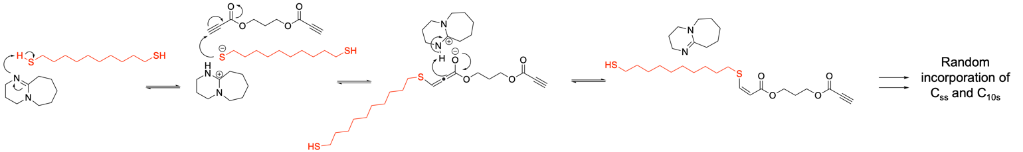
Scheme S1. Proposed mechanism as suggested previously which accounts for the high cis content observed for the DBU-catalyzed thiol-yne click polymerizations.¹⁻³ Shown is one addition cycle which would be repeated many times randomly between C_{3A} species with either C_{10s} or C_{ss}.
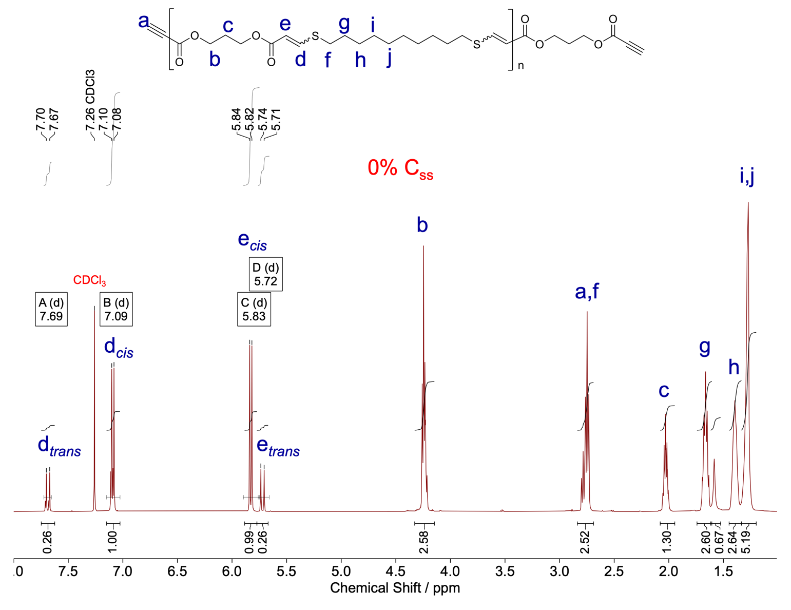

Figure S1. The ¹H NMR spectra of 0% C_{SS} shows the 81% cis content for the thiol-yne step-growth polymer. Cis- content can be calculated by the J coupling constants of the respective resonances. Resonance f, g, h, i, and j are from the dithiol monomer (C_{10S}) and resonance a, b, and c are from the 1,3-propane dipropiolate monomer (C_{3A}). The polymer reveals cis %/ trans % = 81 %: 19 % in CHCl₃ with 1 mol% DBU (CDCl₃, 500 MHz).

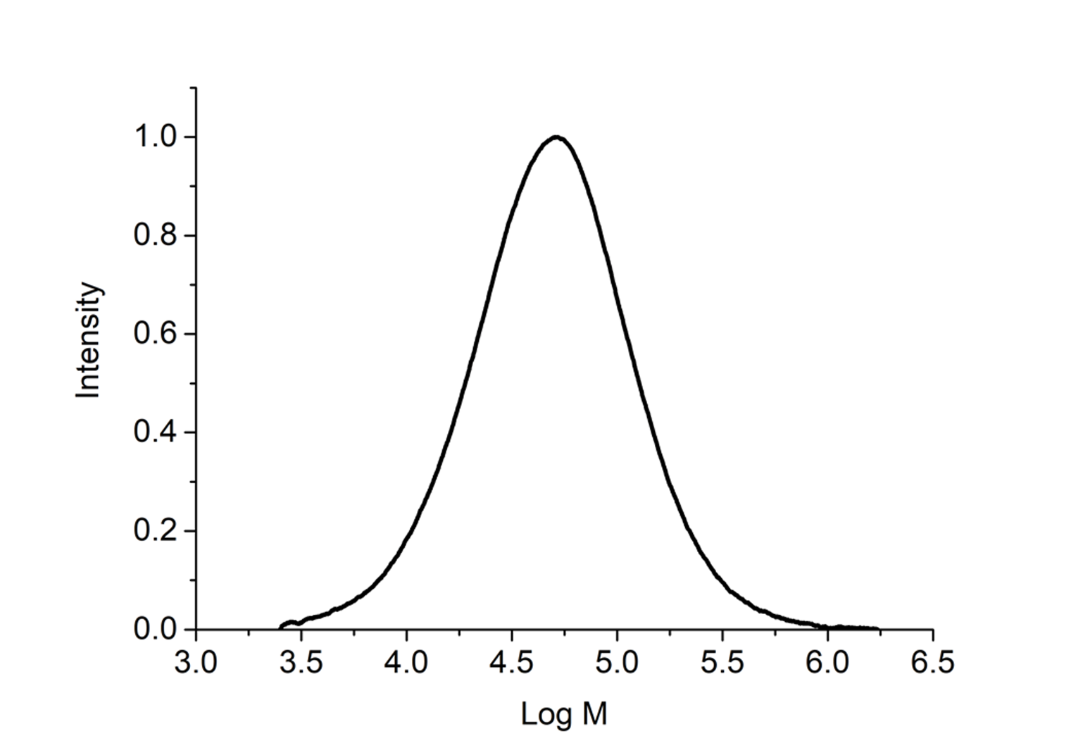
Figure S2. SEC chromatogram of 0% C_{SS} of thiol-yne step-growth polymer; M_{n} = 32.5 kDa, M_{w} = 72.8 kDa, Ð_{M} = 2.24 (SEC CHCl₃, based on PS standards).

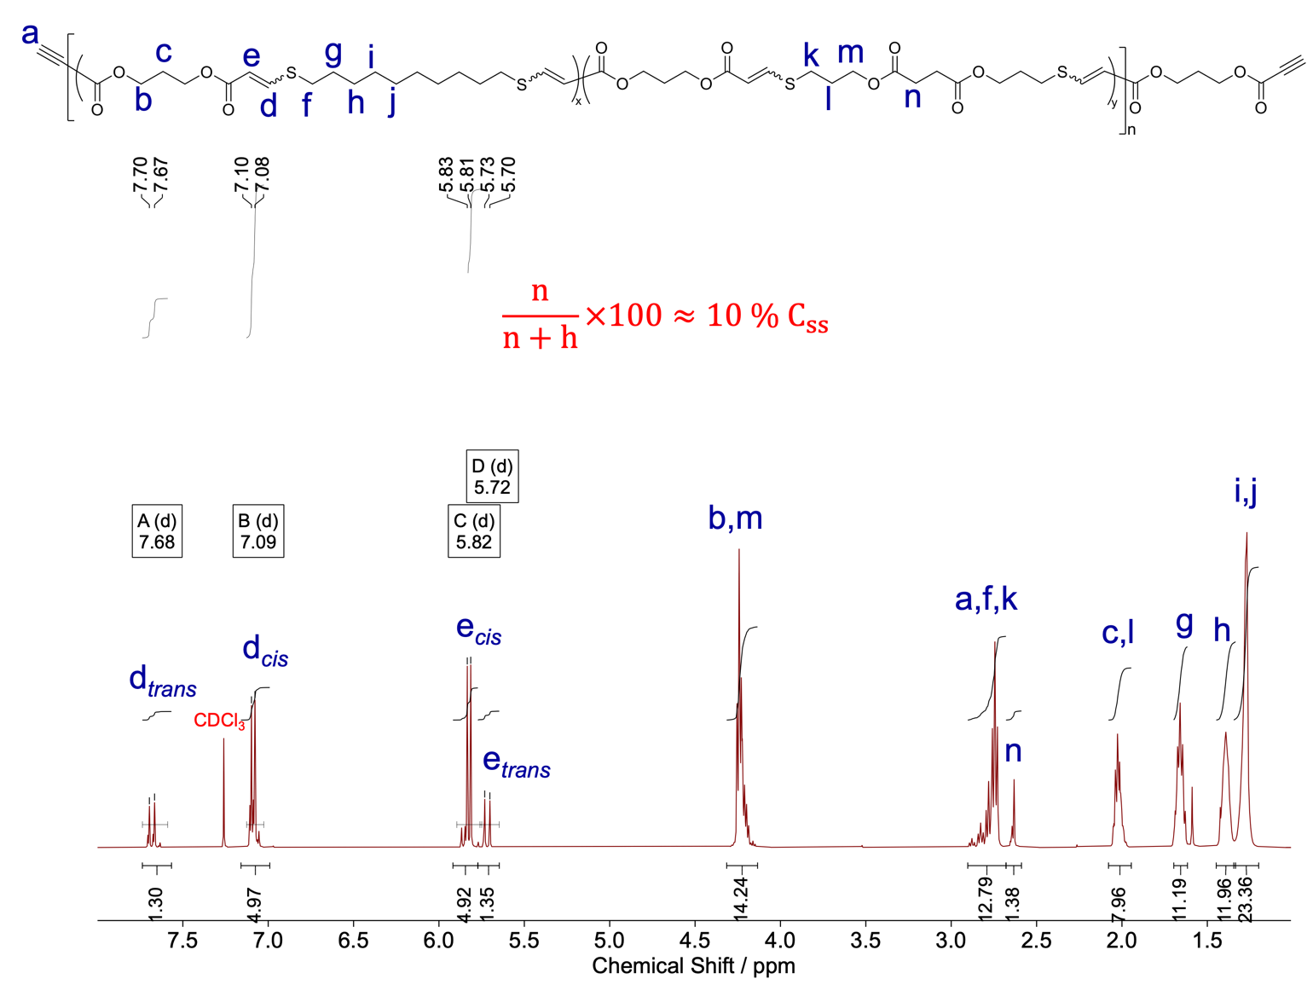
Figure S3. The ¹H NMR spectra of 10% C_{SS} shows the 80% cis content for the thiol-yne step-growth copolymer with 10% incorporation of C_{SS} in CHCl₃ with 1 mol% DBU. The ratio of resonance n (from C_{SS}) to resonance h (from C_{10S}) displays 10%: 90% that affords a polymer 10% incorporation of C_{SS} (CDCl₃, 500 MHz).
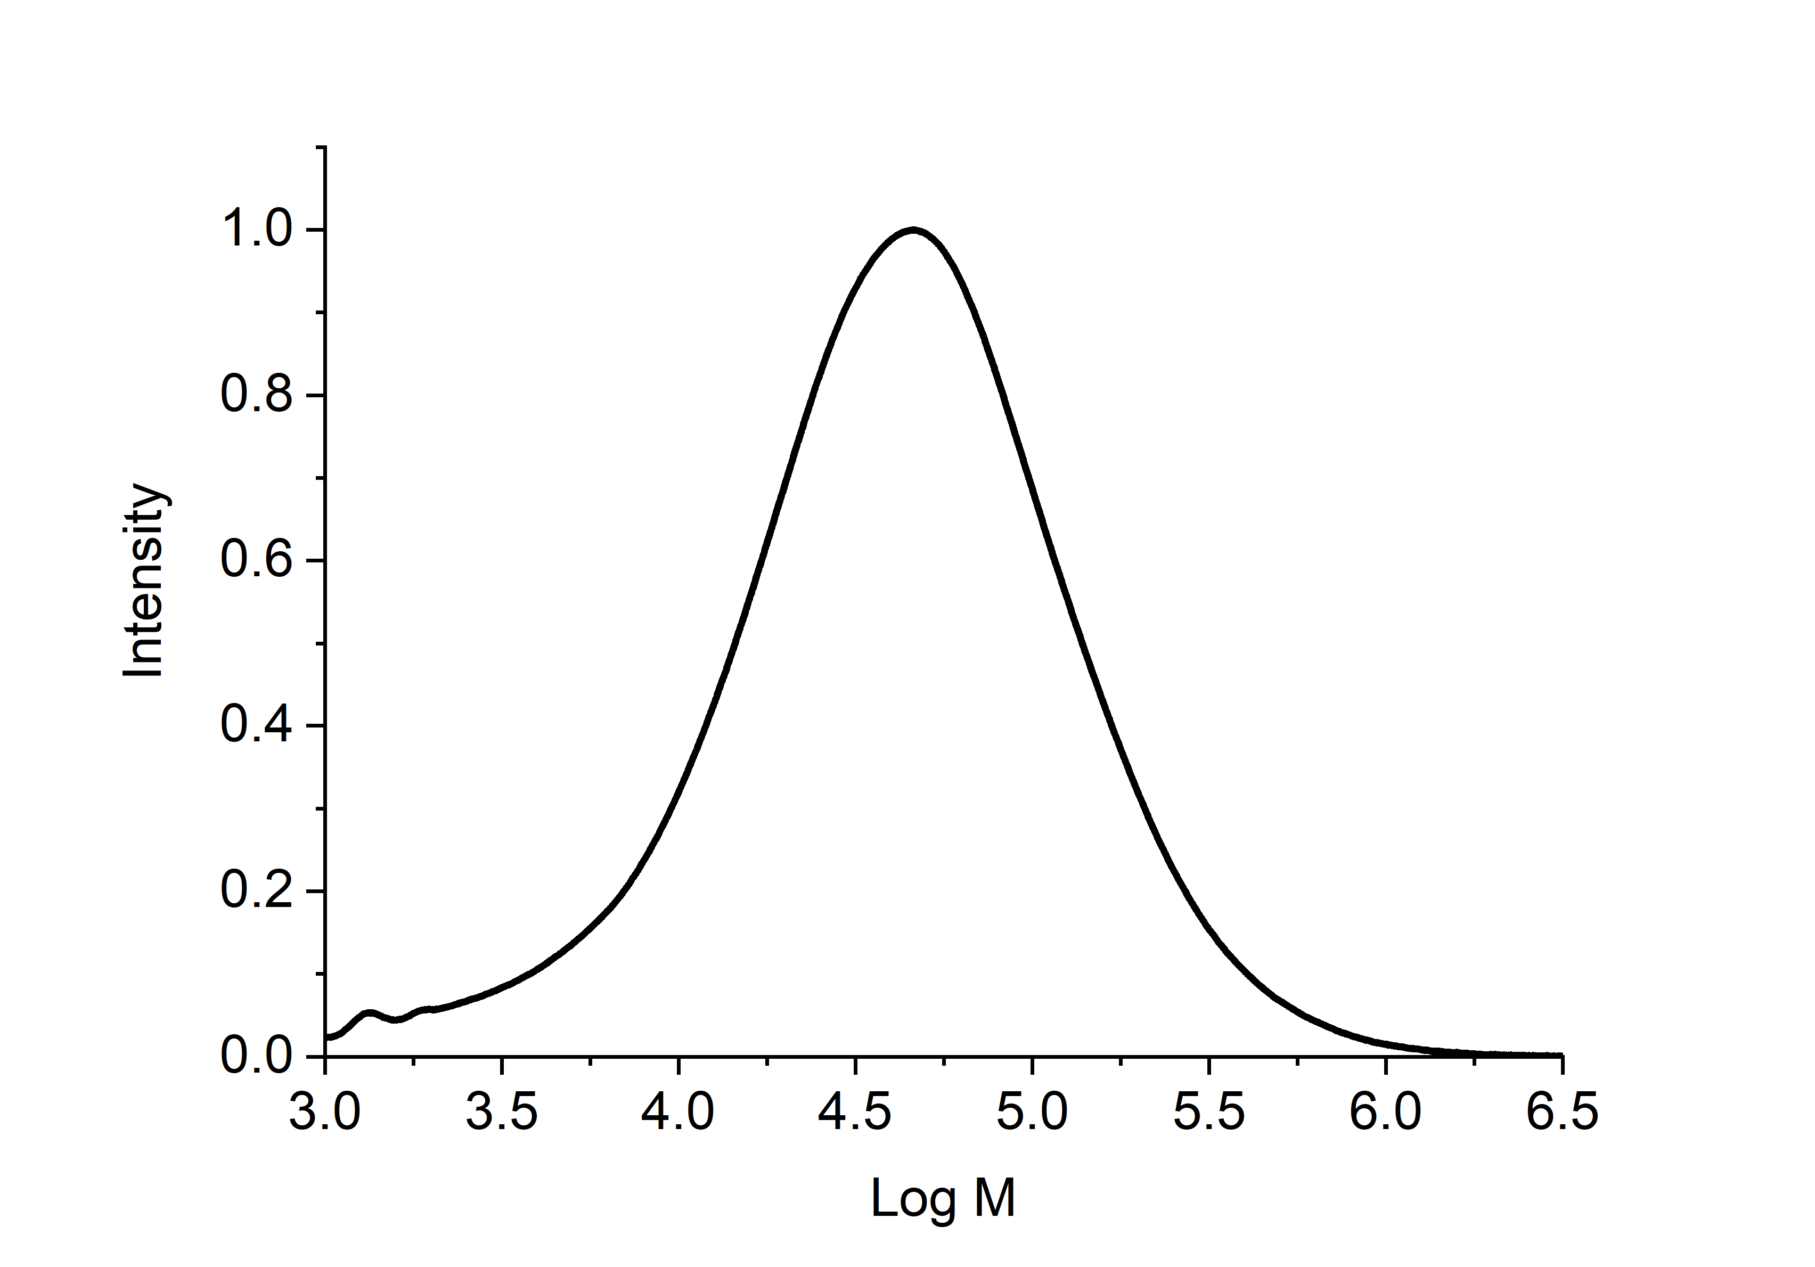
Figure S4. SEC chromatogram of 10% C_{SS} of thiol-yne step-growth polymer; M_{n} = 32.1 kDa, M_{w} = 81.3 kDa, Ð_{M} = 2.51. (SEC CHCl₃, based on PS standards).

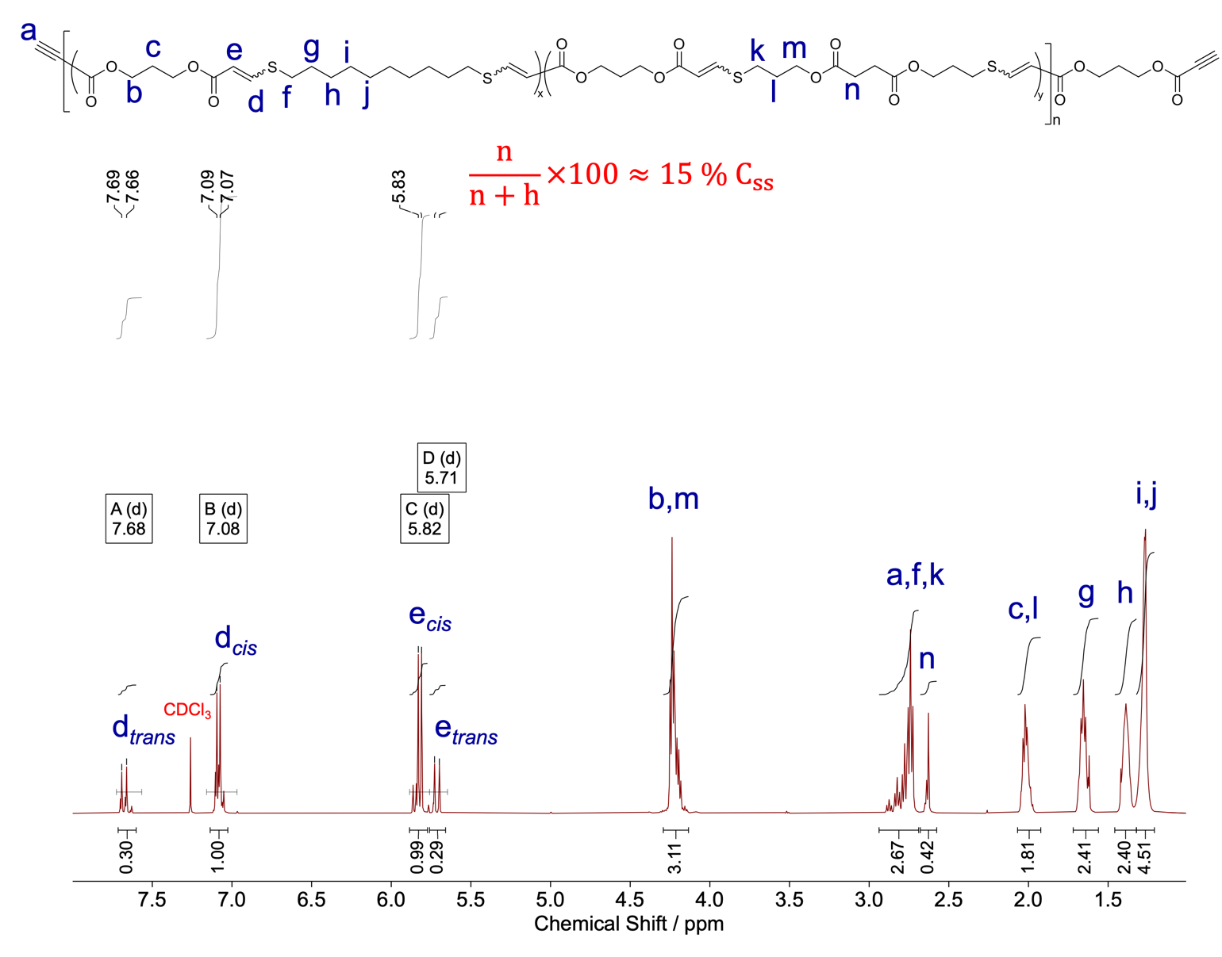
Figure S5. The ¹H NMR spectra of 15% C_{SS} shows the 80% cis content for the thiol-yne step-growth copolymer with 15% incorporation of C_{SS} in CHCl₃ with 1 mol% DBU. The ratio of methylene resonance n (from C_{SS}) to methylene resonance h (from C_{10S}) displays 15%: 85% that affords polymer 15% incorporation of C_{SS} (CDCl₃, 500 MHz).
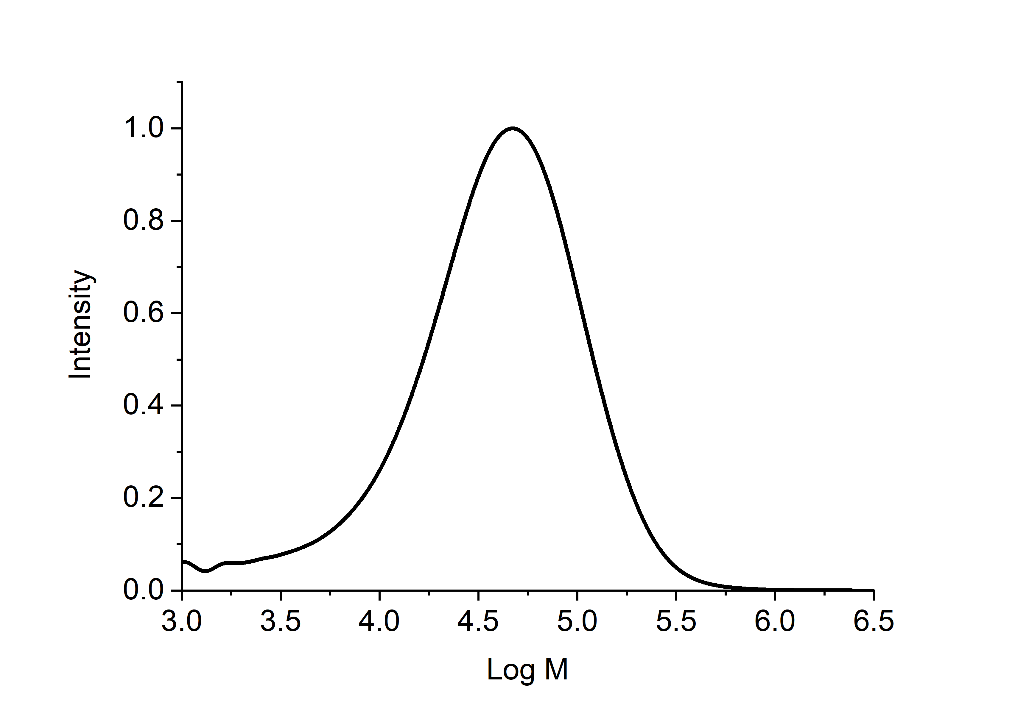
Figure S6. SEC chromatogram of 15% C_{SS} of thiol-yne step-growth polymer; M_{n} = 23.6 kDa, M_{w} = 54.5 kDa, Ð_{M} = 2.30. (SEC CHCl₃, based on PS standards).
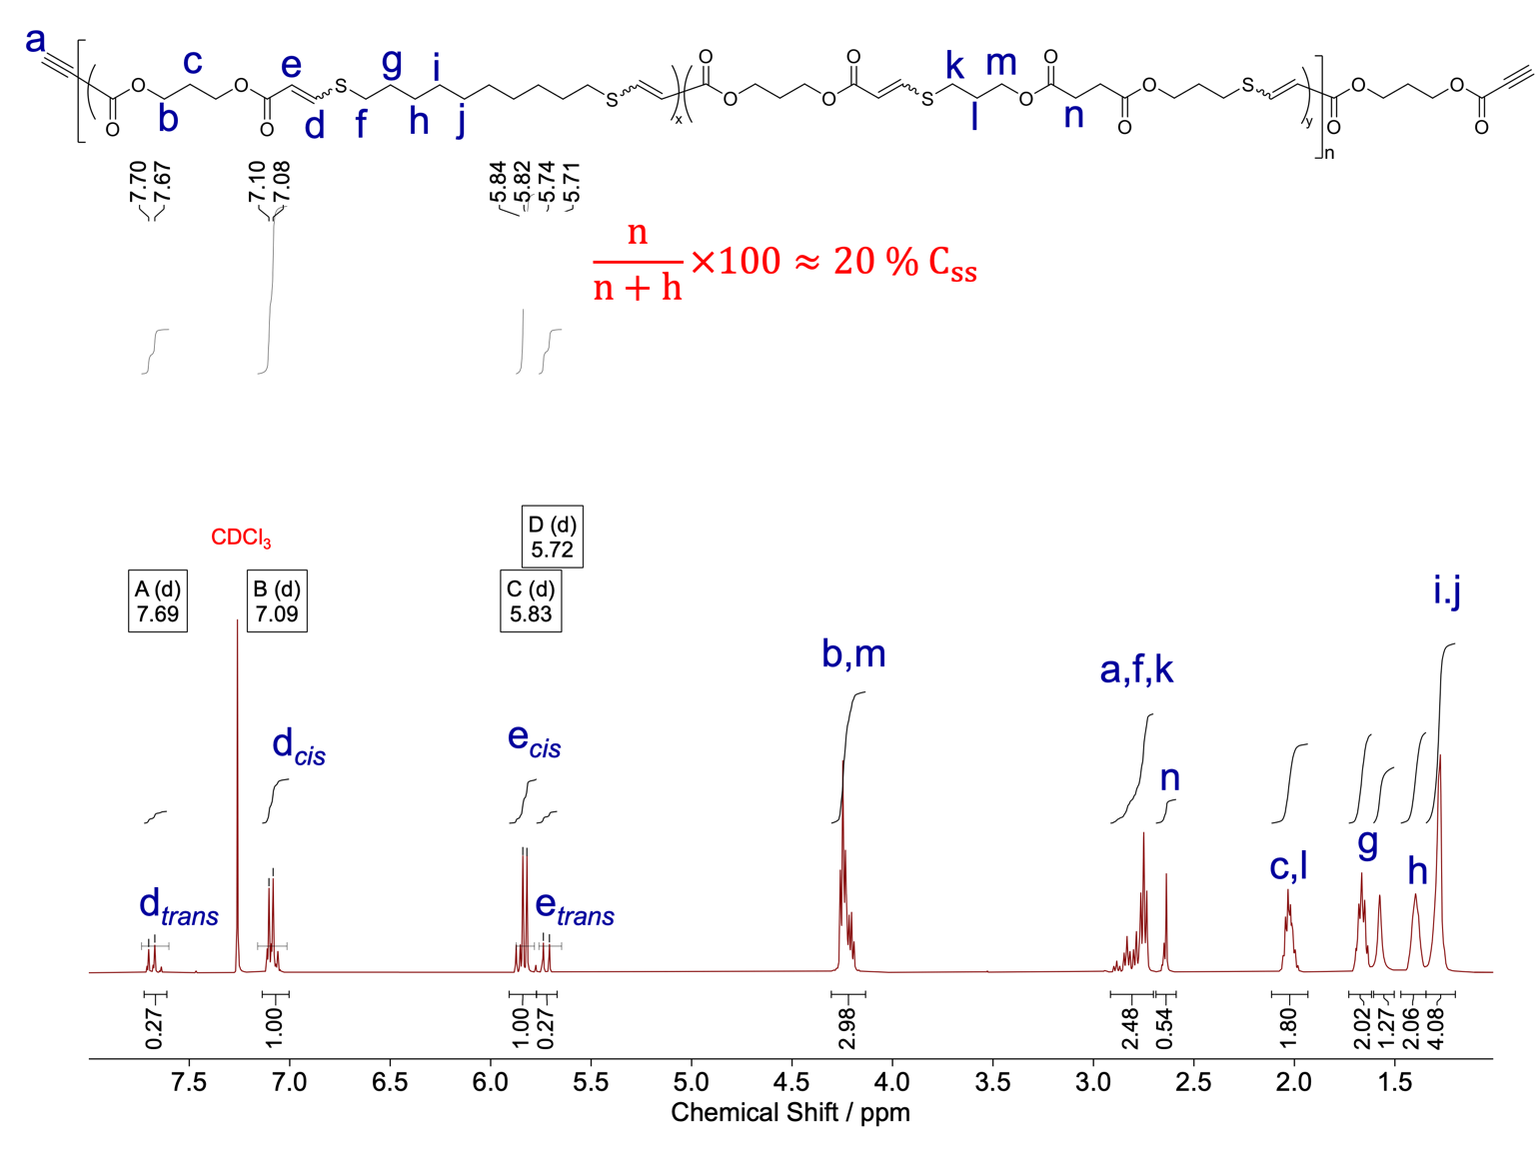
Figure S7. The ¹H NMR spectra of 20% C_{SS} shows the 80% cis content for the thiol-yne step-growth copolymer with 20% incorporation of C_{SS} in CHCl₃ with 1 mol% DBU. The ratio of methylene resonance n (from C_{SS}) to methylene resonance h (from C_{10S}) displays 20%: 80% that affords polymer with 20% incorporation of C_{SS} (CDCl₃, 500 MHz).

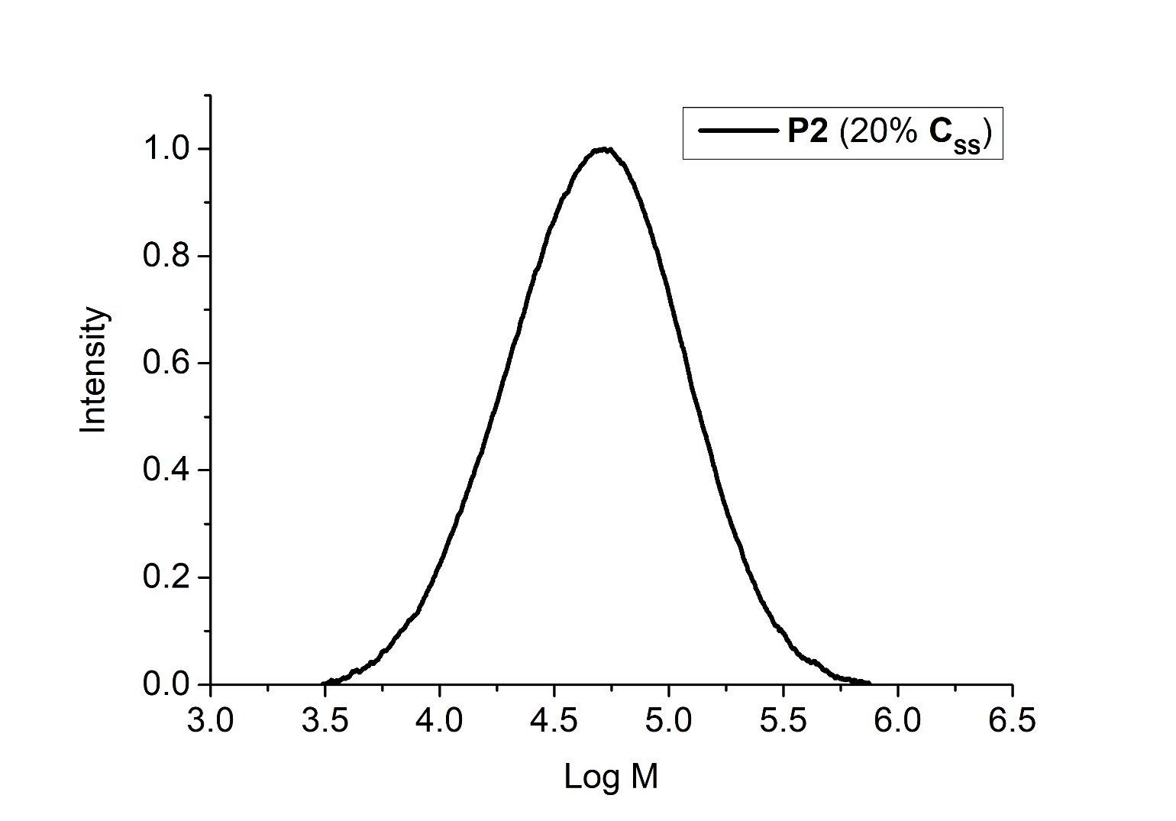Figure S8. SEC chromatogram of 20% C_{SS} of thiol-yne step-growth polymer with 20% incorporation of C_{SS}; M_{n} = 32.6 kDa, M_{w} = 68.6 kDa, Ð_{M} = 2.10 (SEC CHCl₃, based on PS standards).
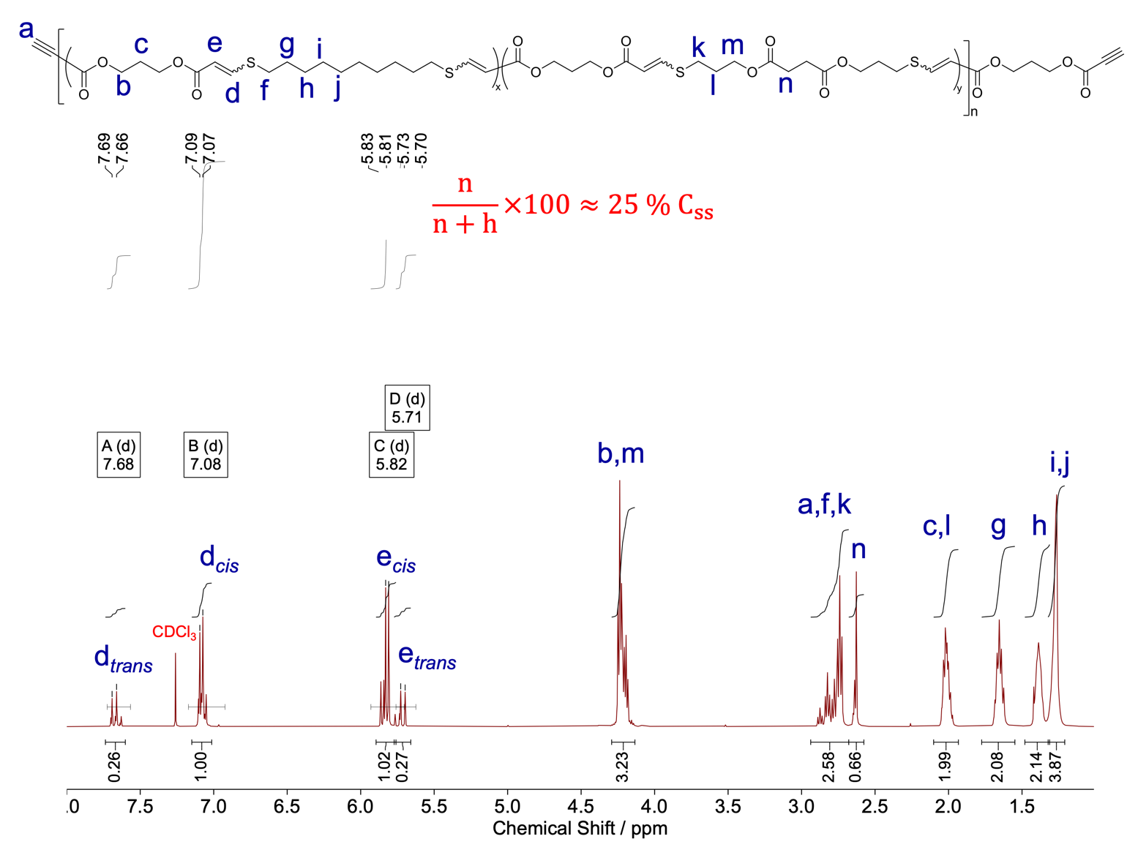
Figure S9. The ¹H NMR spectra of 25% C_{SS} shows the 80% cis content for the thiol-yne step-growth copolymer with 25% incorporation of C_{SS} in CHCl₃ with 1 mol% DBU. The ratio of methylene resonance n (from C_{SS}) to methylene resonance h (from C_{10S}) displays 25%: 75% that affords polymer with 25% incorporation of C_{SS} (CDCl₃, 500 MHz).
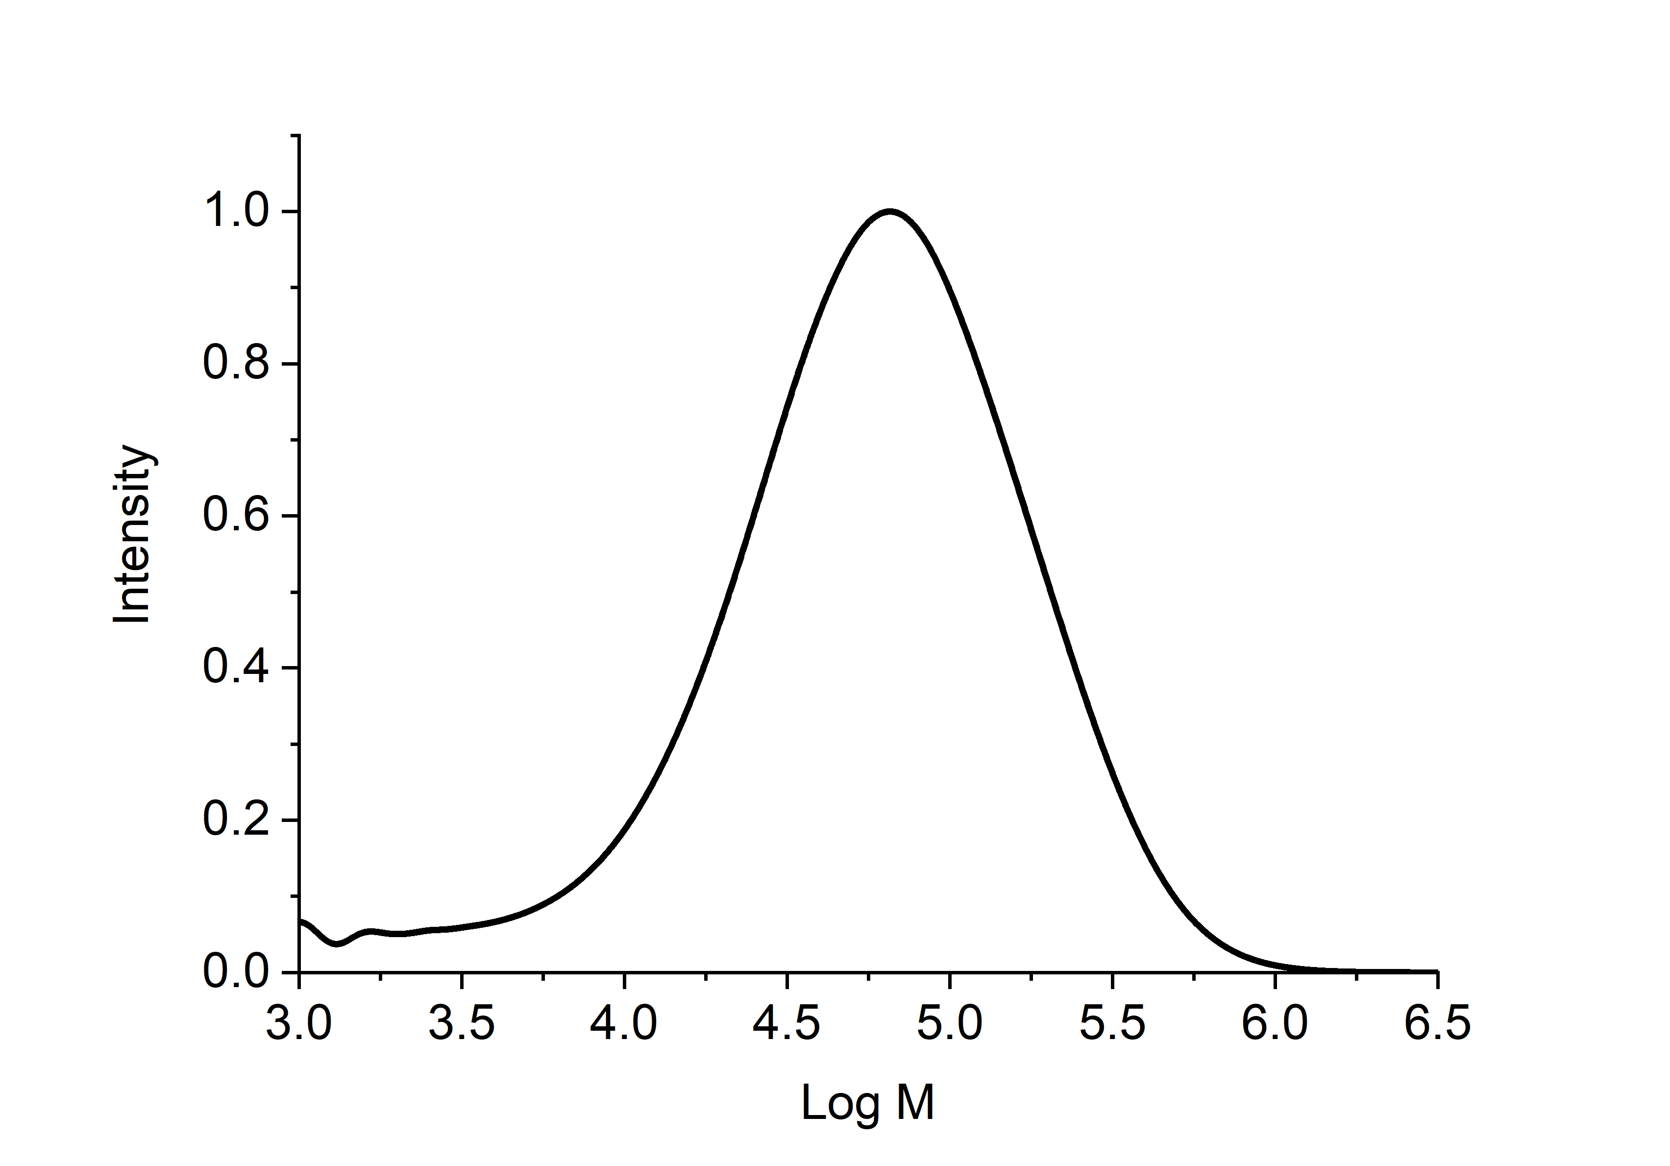
Figure S10. SEC chromatogram of 25% C_{SS} of thiol-yne step-growth polymer; M_{n} = 34.0 kDa, M_{w} = 89.0 kDa, Ð_{M} = 2.62. (SEC CHCl₃, based on PS standards).

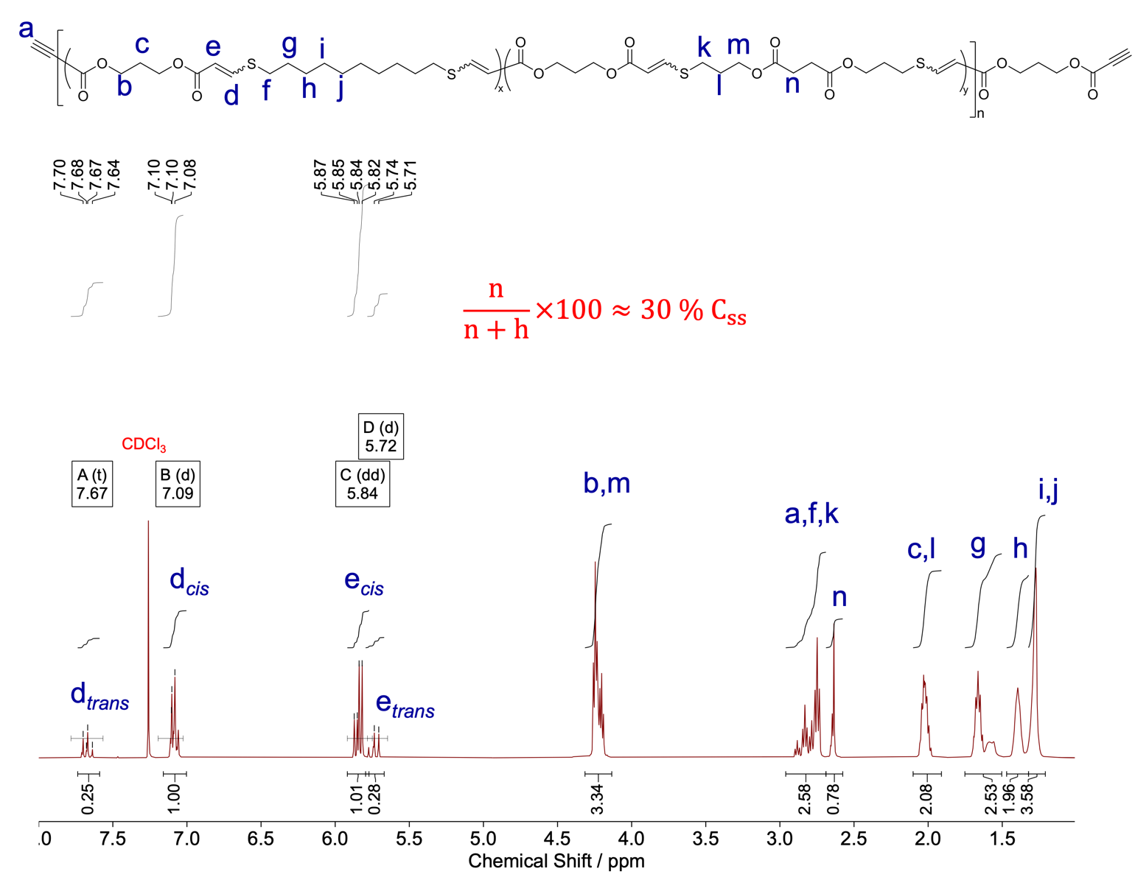
Figure S11. The ¹H NMR spectra of 30% C_{SS} shows the 80% cis content for the thiol-yne step-growth copolymer with 30% incorporation of C_{SS} in CHCl₃ with 1 mol% DBU. The ratio of methylene resonance n (from C_{SS}) to methylene resonance h (from C_{10S}) displays 30%: 70% that affords polymer with 30% incorporation of C_{SS} (CDCl₃, 500 MHz).
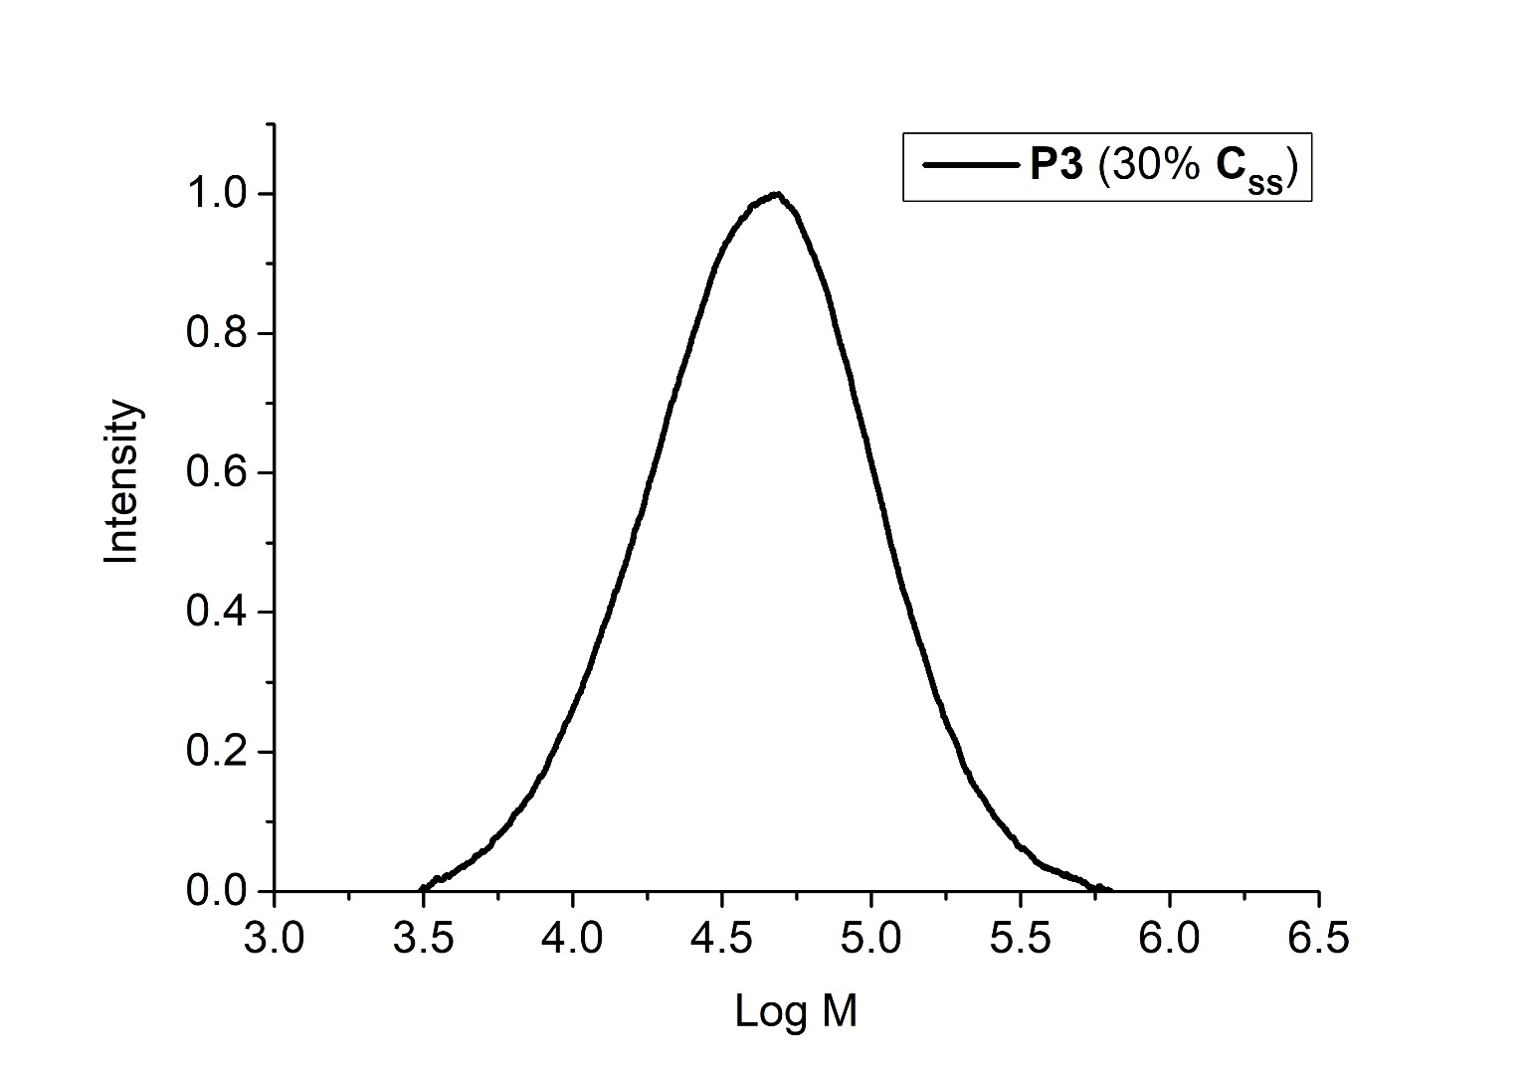
Figure S12. SEC chromatogram of 30% C_{SS} of thiol-yne step-growth polymer with 30% incorporation of C_{SS}; M_{n} = 29.1 kDa, M_{w} = 60.4 kDa, Ð_{M} = 2.08 (SEC CHCl₃, based on PS standards).

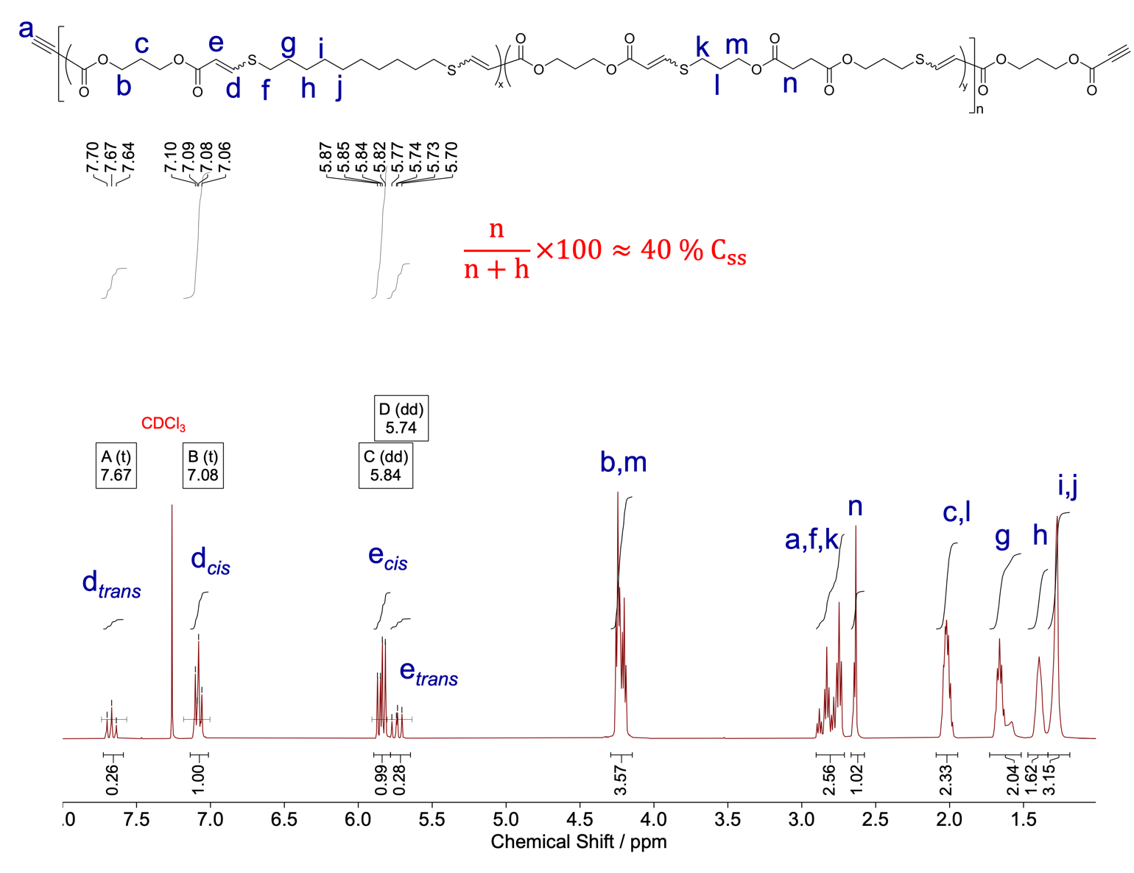
Figure S13. The ¹H NMR spectra of 40% C_{SS} shows the 80% cis content for the thiol-yne step-growth copolymer with 40% incorporation of C_{SS} in CHCl₃ with 1 mol% DBU. The ratio of methylene resonance n (from C_{SS}) to methylene resonance h (from C_{10S}) displays 40%: 60% that affords polymer with 40% incorporation of C_{SS} (CDCl₃, 500 MHz).

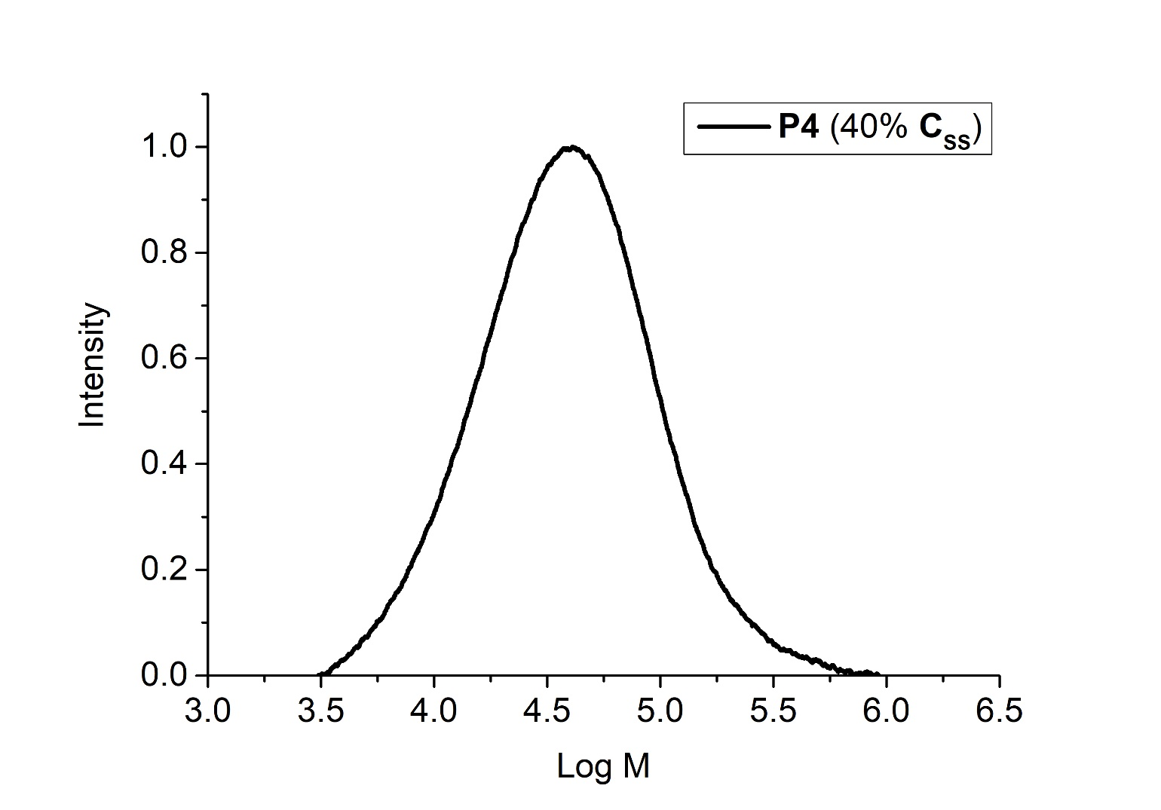
Figure S14. SEC chromatogram of 40% C_{SS} of thiol-yne step-growth polymer with 40% incorporation of C_{SS}; M_{n} = 26.7 kDa, M_{w} = 57.0 kDa, Ð_{M} = 2.13 (SEC CHCl₃, based on PS standards).

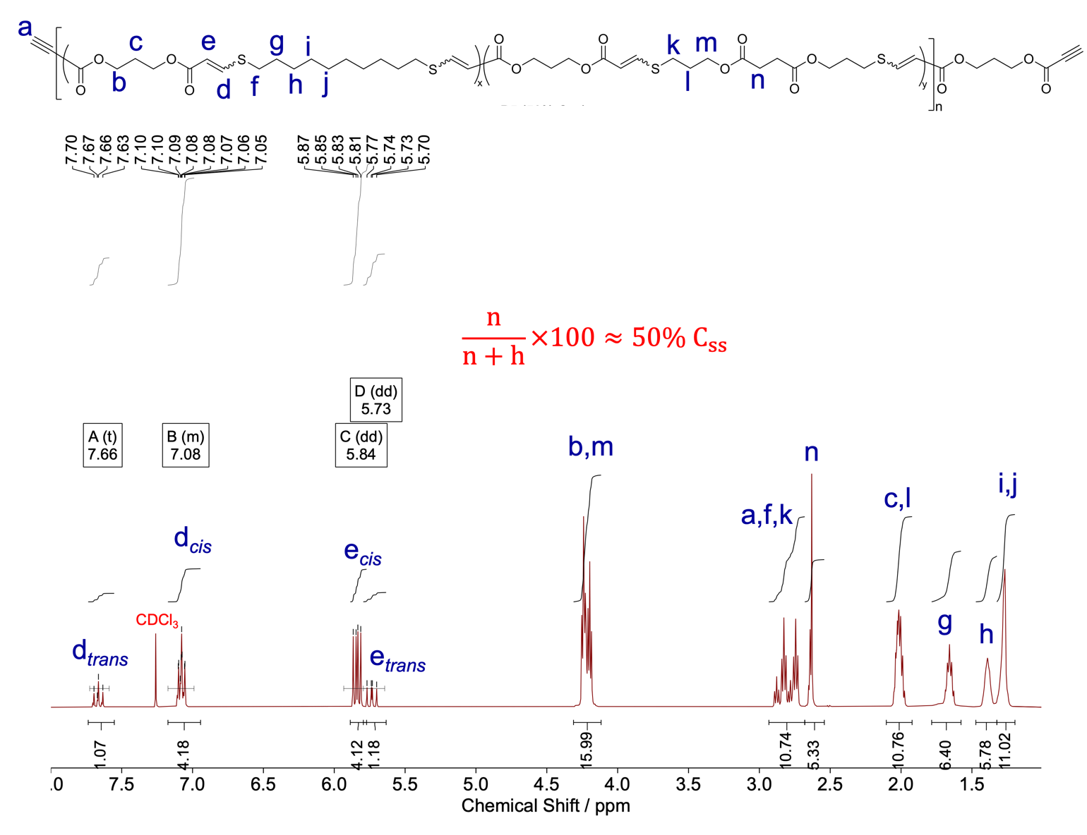
Figure S15. The ¹H NMR spectra of 50% C_{SS} shows the 80% cis content for the thiol-yne step-growth copolymer with 50% incorporation of C_{SS} in CHCl₃ with 1 mol% DBU. The ratio of methylene resonance n (from C_{SS}) to methylene resonance h (from C_{10S}) displays 49%: 51% that affords polymer with 49% incorporation of C_{SS} (CDCl₃, 500 MHz).

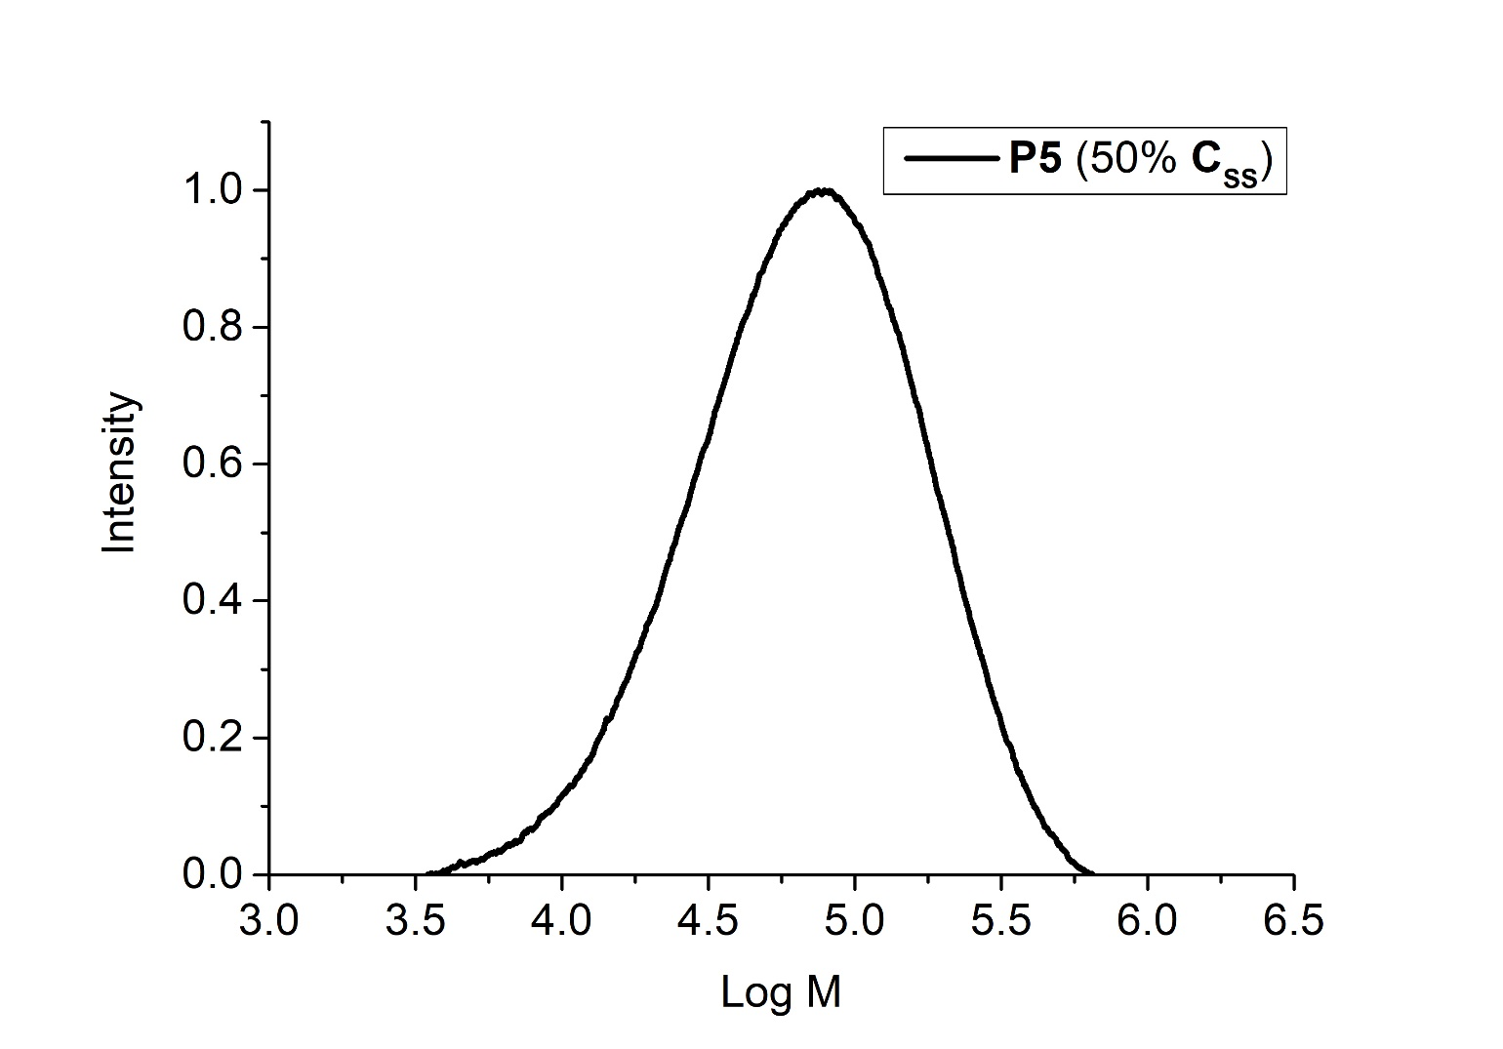
Figure S16. SEC chromatogram of 50% C_{SS} of thiol-yne step-growth polymer with 50% incorporation of C_{SS}; M_{n} = 45.4 kDa, M_{w} = 94.9 kDa, Ð_{M} = 2.09 (SEC CHCl₃, based on PS standards).
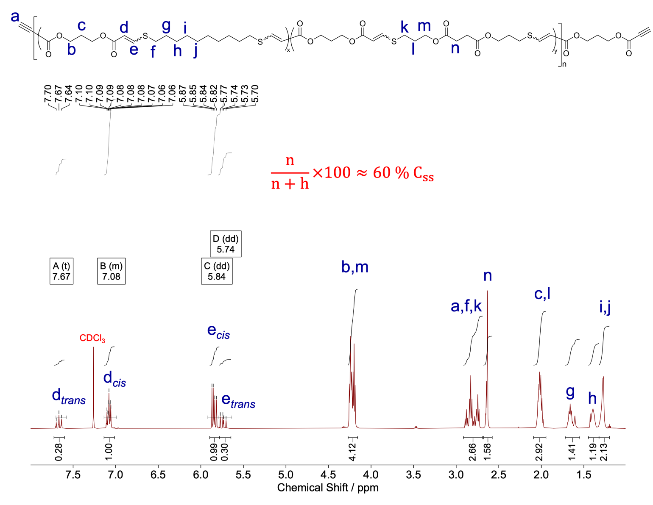
Figure S17. The ¹H NMR spectra of 60% C_{SS} shows the 80% cis content for the thiol-yne step-growth copolymer with 60% incorporation of C_{SS} in CHCl₃ with 1 mol% DBU. The ratio of methylene resonance n (from C_{SS}) to methylene resonance h (from C_{10S}) displays 60%: 40% that affords polymer with 60% incorporation of C_{SS} (CDCl₃, 500 MHz).

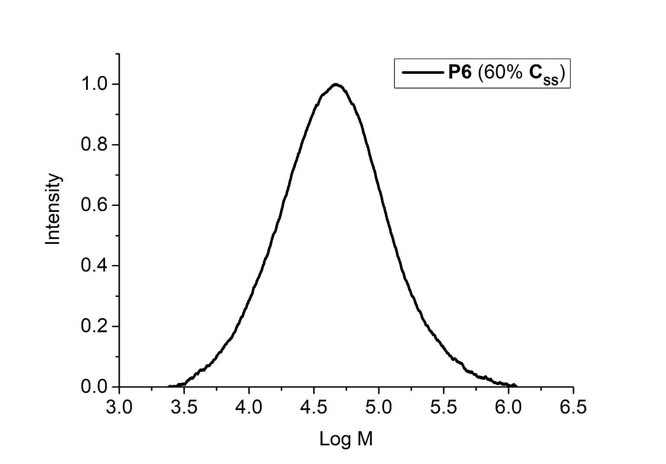
Figure S18. SEC chromatogram of 60% C_{SS} of thiol-yne step-growth polymer with 60% incorporation of C_{SS}; M_{n} = 29.0 kDa, M_{w} = 71.7 kDa, Ð_{M} = 2.47 (SEC CHCl₃, based on PS standards).

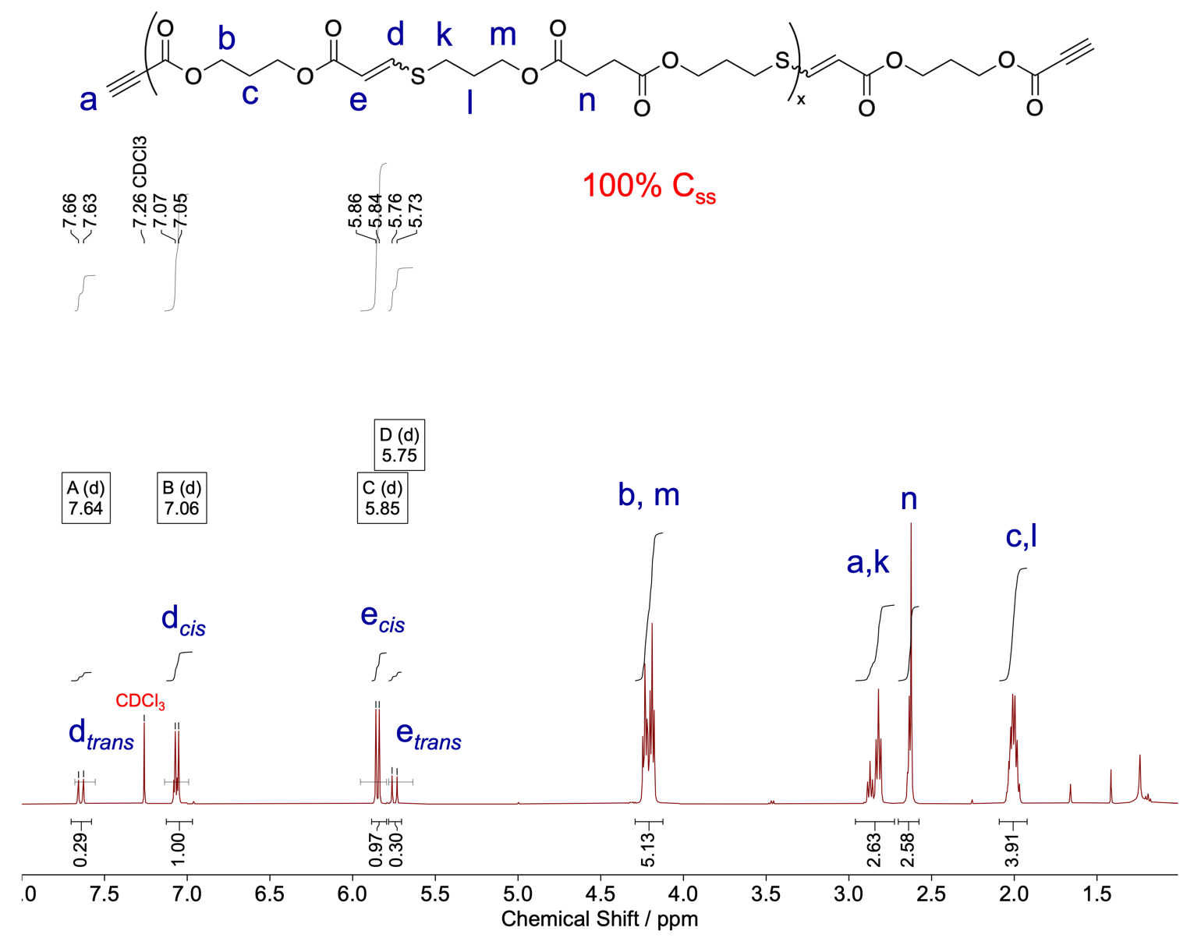
Figure S19. The ¹H NMR spectra of 100% C_{SS} shows the 80% cis content for the thiol-yne step-growth copolymer with 100% incorporation of C_{SS} in CHCl₃ with 1 mol% DBU.

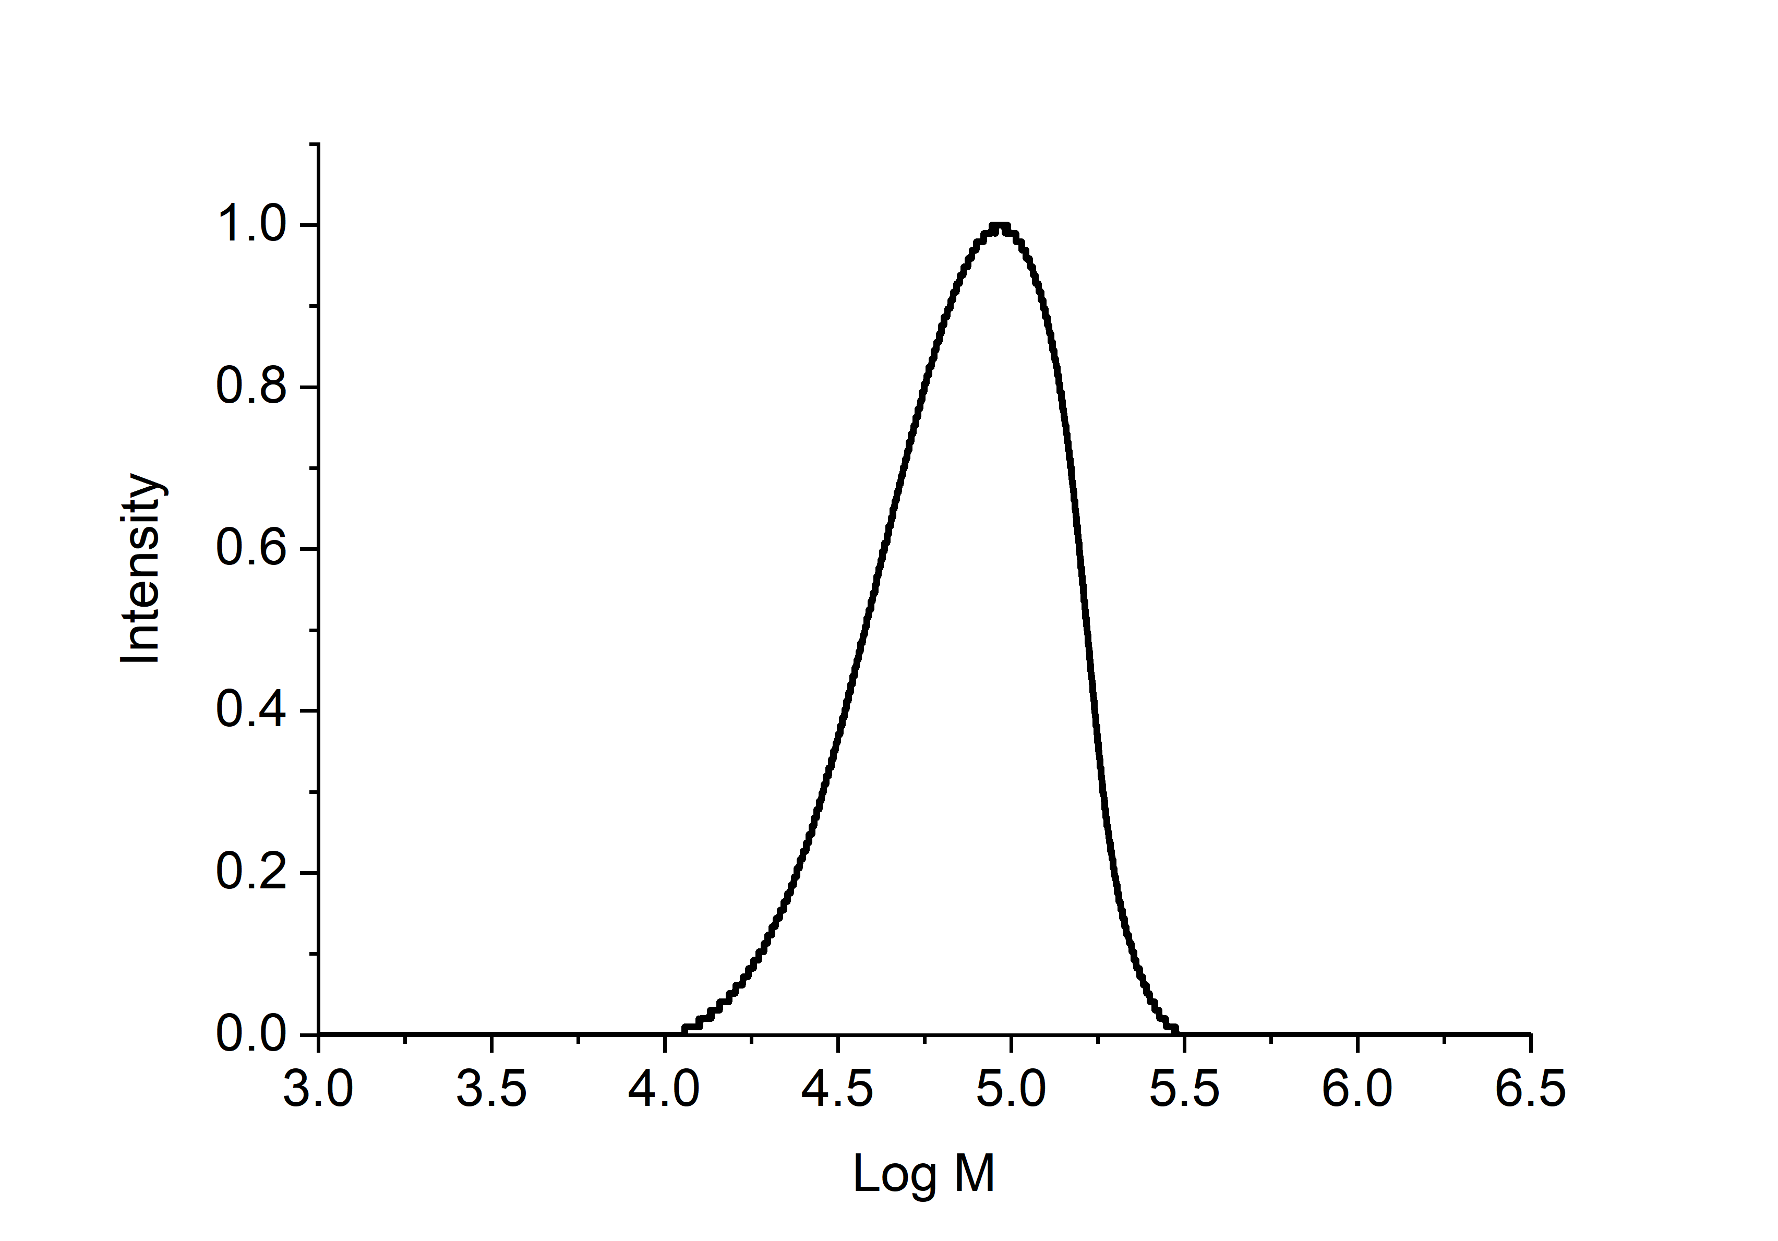
Figure S20. SEC chromatogram of 100% C_{SS} of thiol-yne step-growth polymer with 100% incorporation of C_{SS}; M_{n} = 62.0 kDa, M_{w} = 86.8 kDa, Ð_{M} = 1.4 (SEC CHCl₃, based on PS standards).
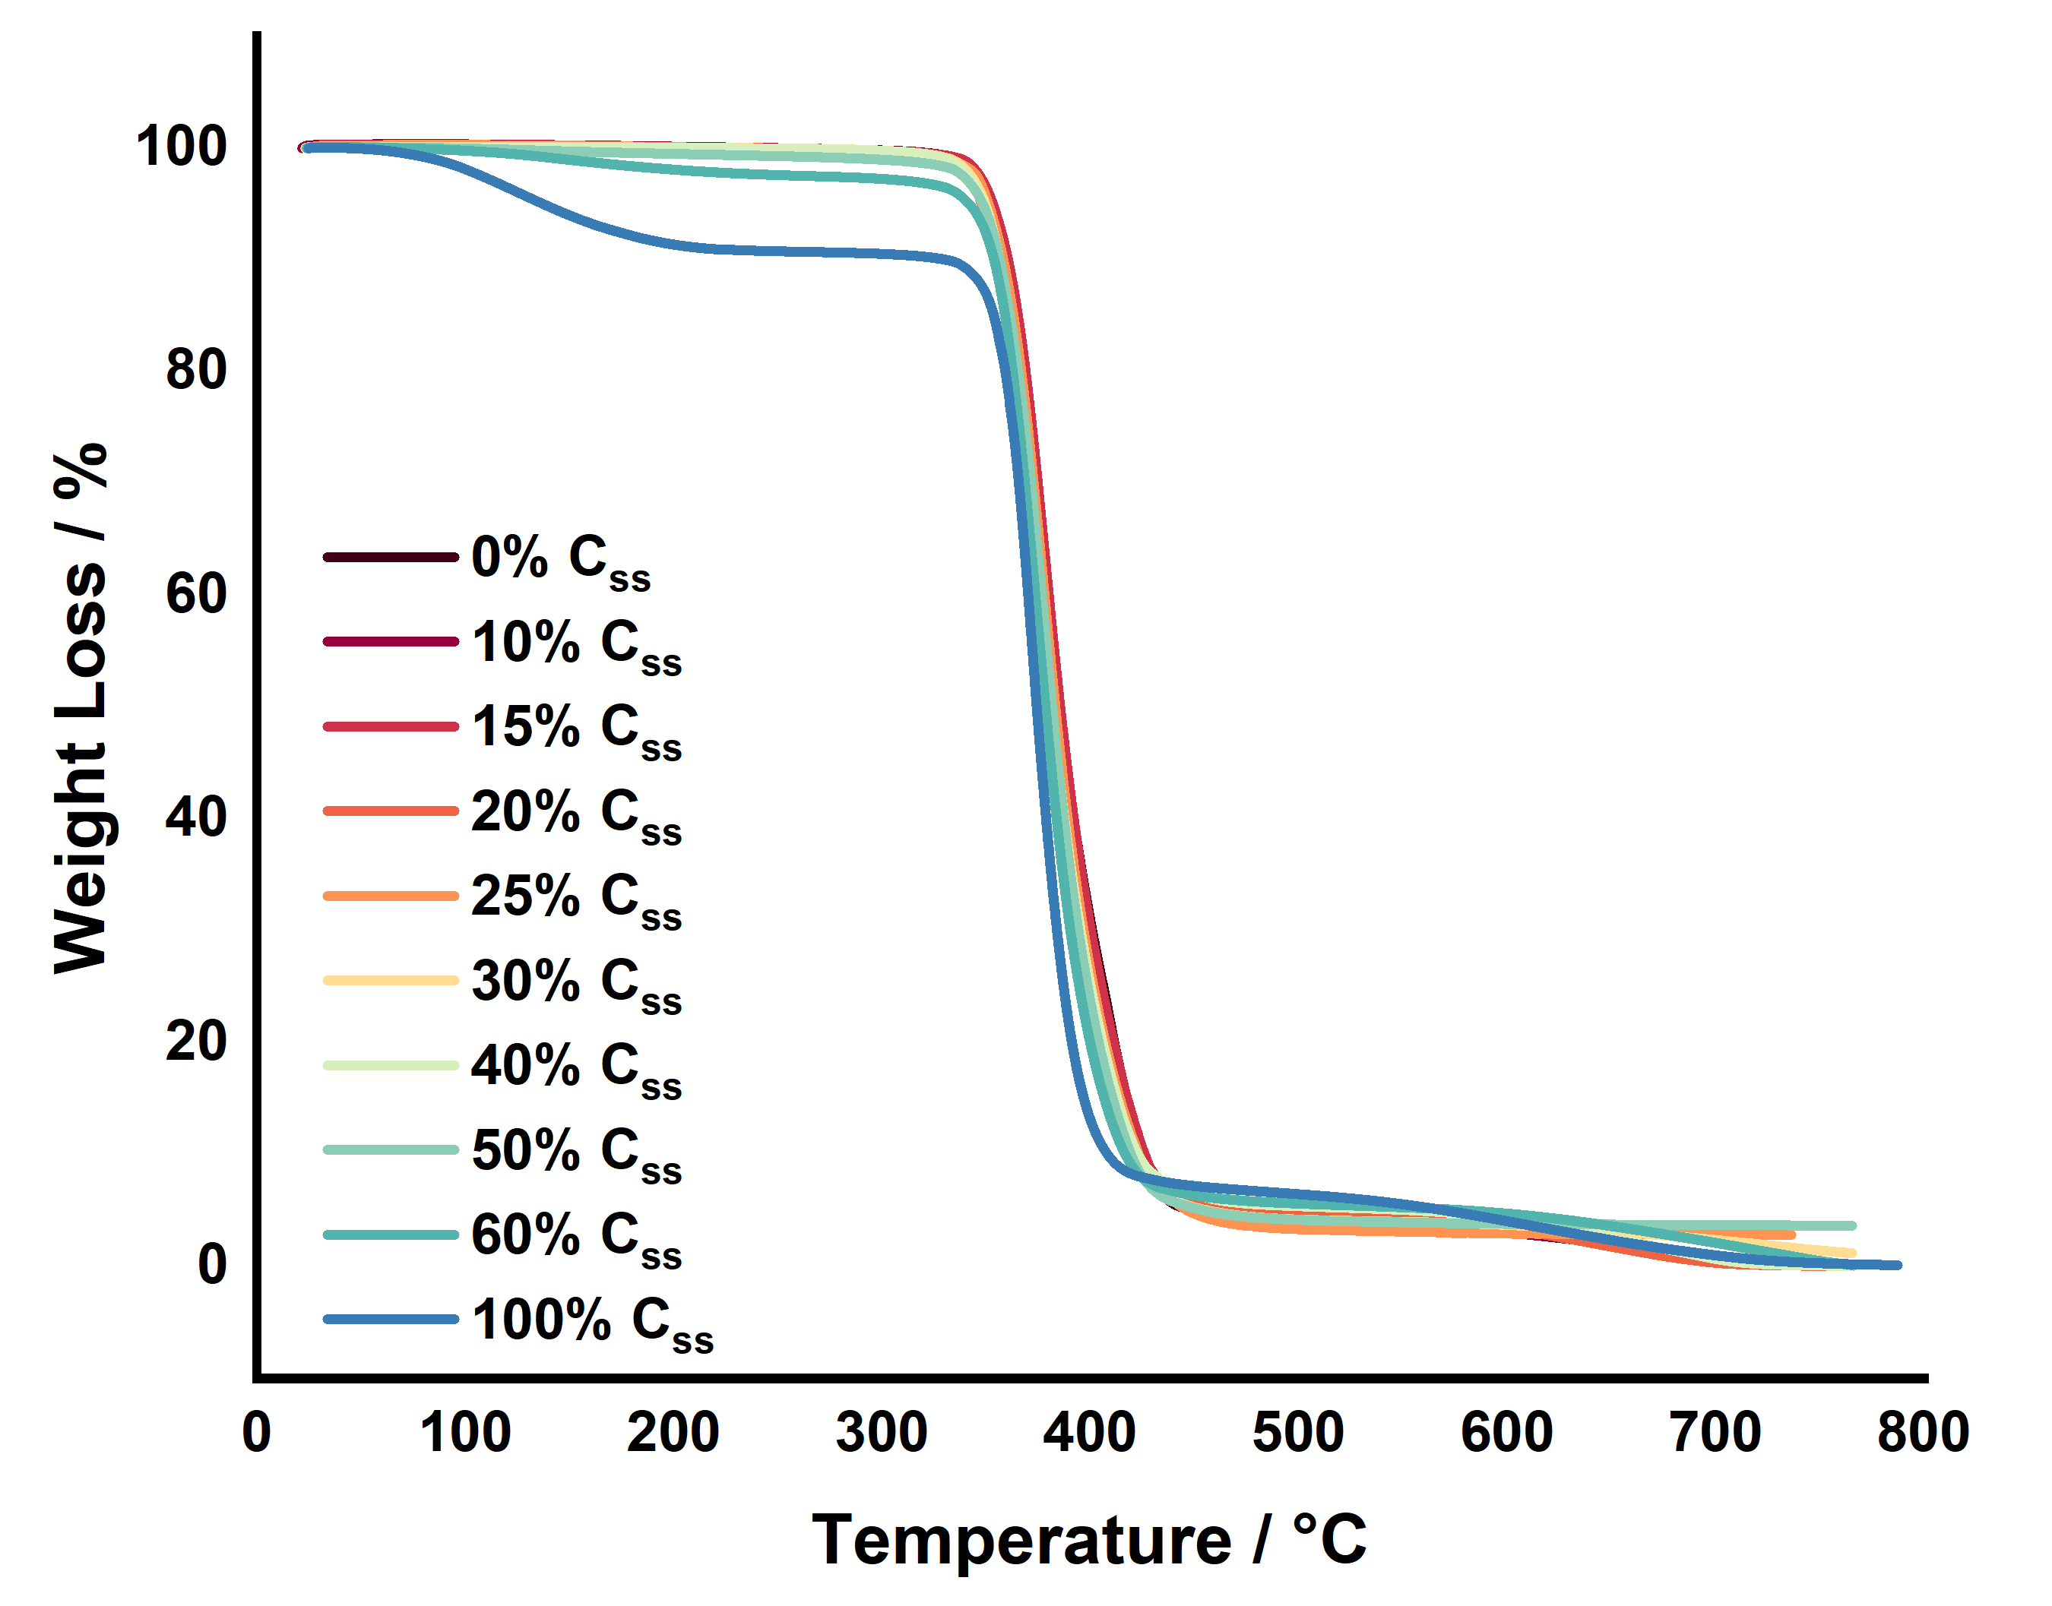
Figure S21. Overlapped data of thermogravimetric analysis (TGA) of all synthesized polymers were performed to determine the degradation temperature and profile for each species.

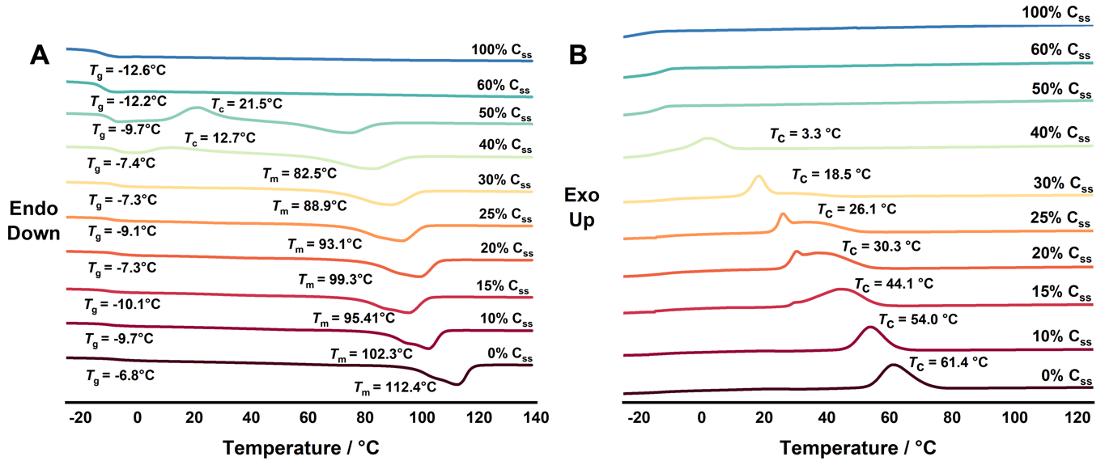
Figure S22. Differential scanning calorimetry (DSC) thermograms of all synthesized polymers to determine glass transition, melting, and crystalline temperature for each species by 2 cycles of heating. Shown is the second heating cycle (A) and first cooling cycle (B).

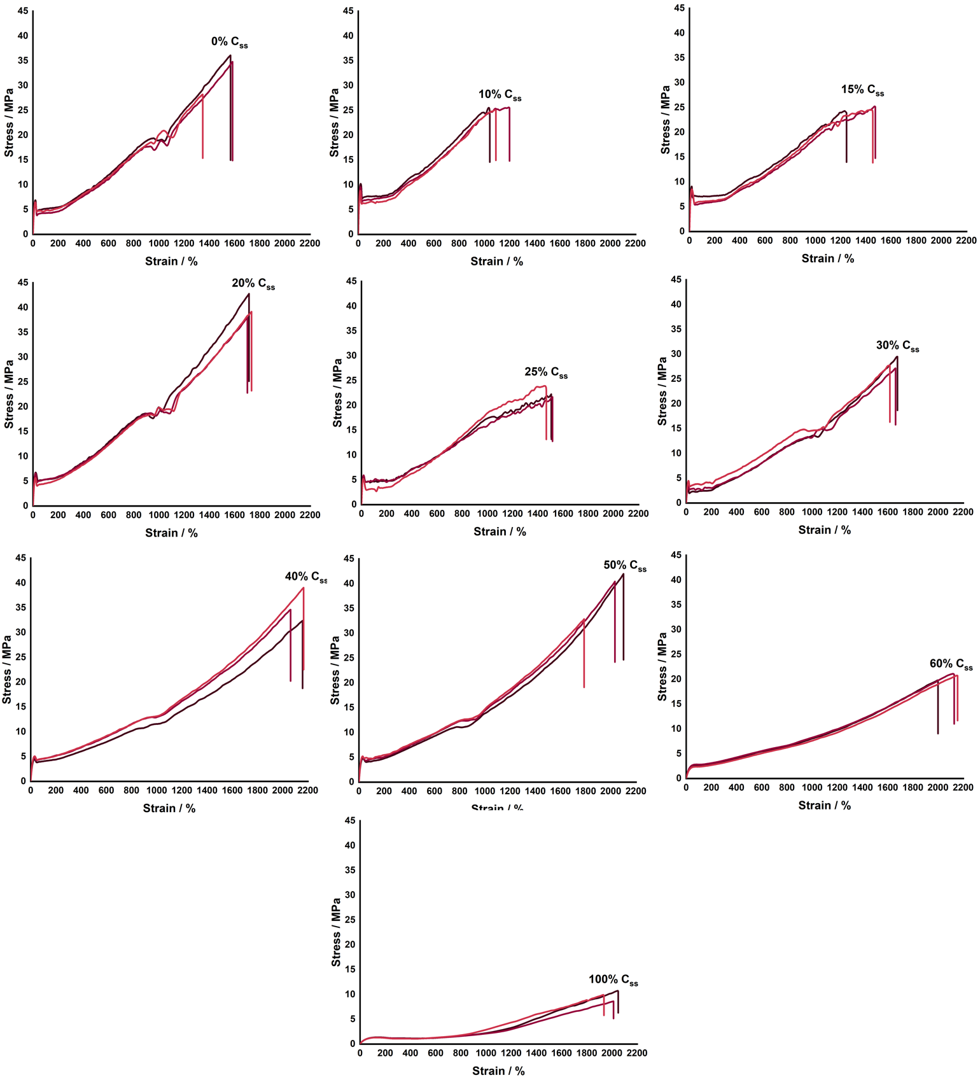
Figure S23. Stress vs. strain curves for (co)polymers for all synthesized copolymers tested at 10 mm/min. Data for 3 samples are shown to illustrate the reproducibility.
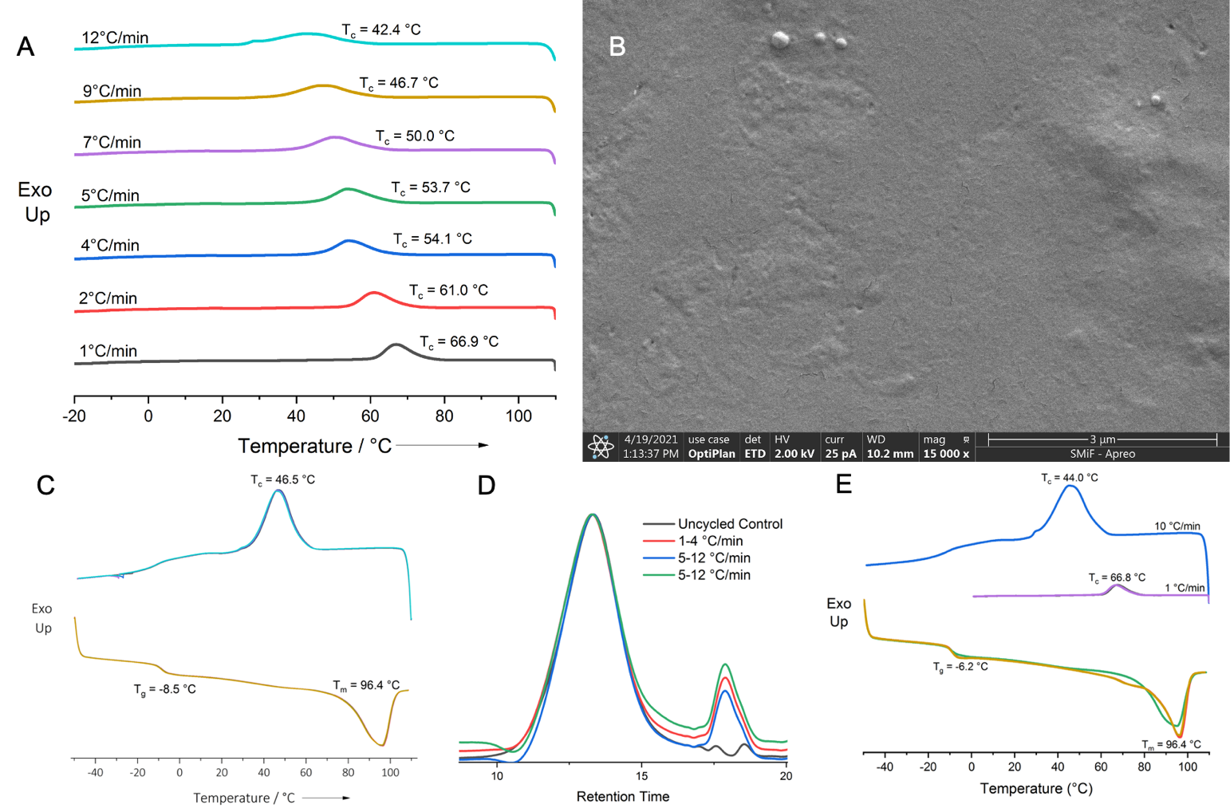
Figure S24. Investigation into the effect of cooling rate on crystallization of 20% C_{ss}. A. Cooling DSC thermograms from the variable cooling rate DSC experiments outlined previously B. SEM image of DSC cooled 20% C_{ss} C. DSC thermogram of 20% C_{ss} cycled four times to confirm stability throughout cycling D. SEC chromatogram of uncycled and cycled 20% C_{ss} to confirm minimal molecular weight loss after cycling E. DSC thermogram to confirm the reproducibility of the T_{c} shift

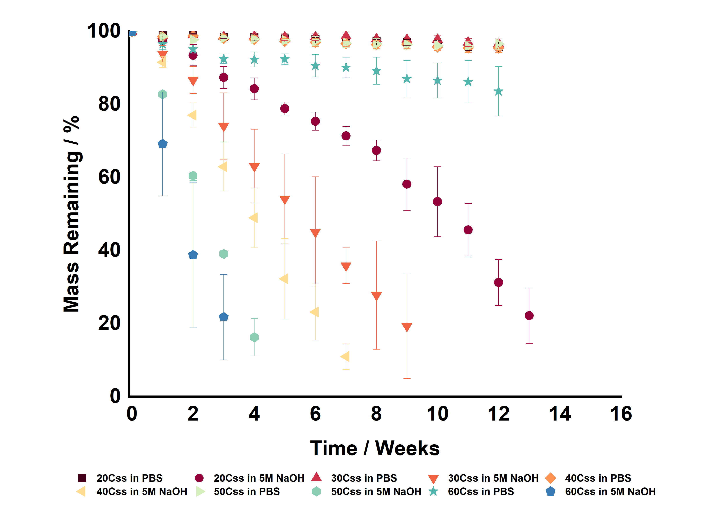
Figure S25. In vitro degradation studies under accelerated (5M NaOH) and physiological conditions (PBS) for a subset of C_{ss} copolymers.

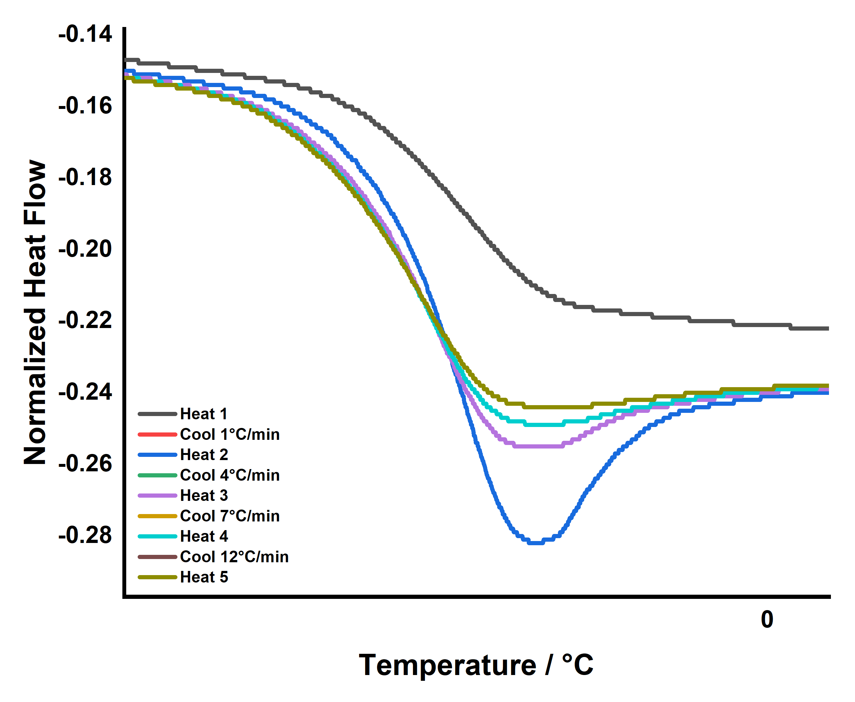
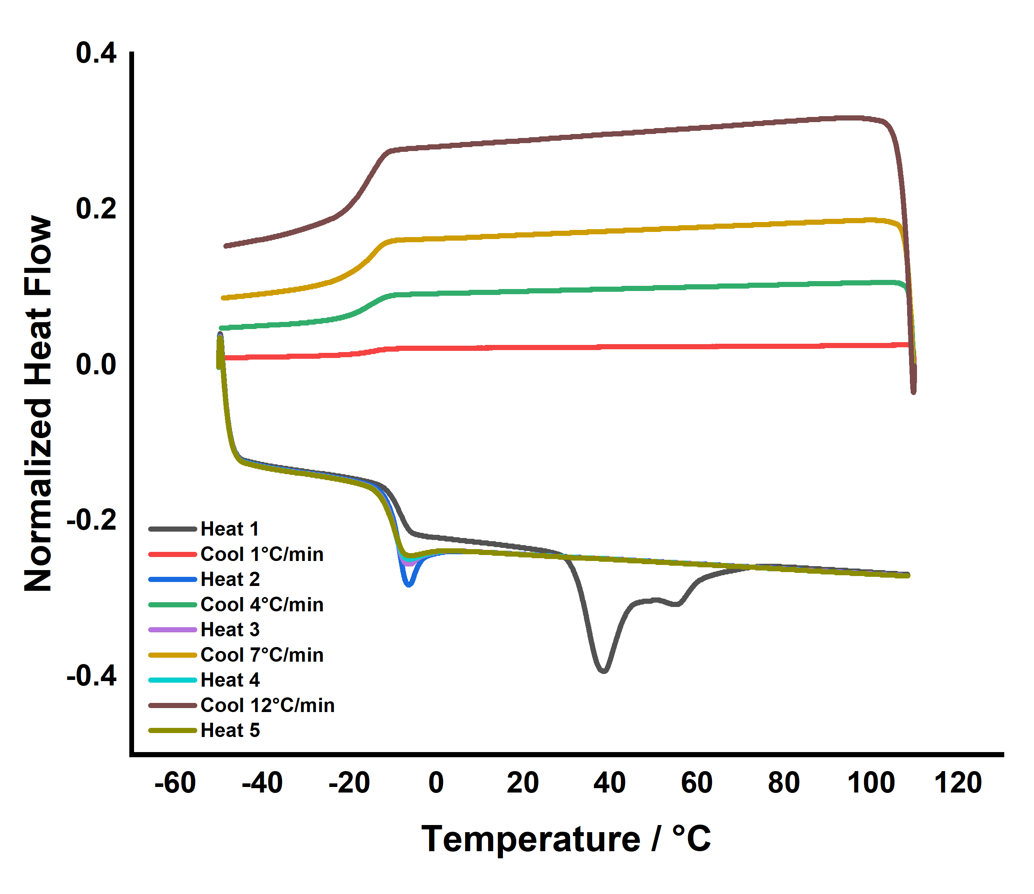

Figure S26. Variable cooling rate DSC experiment of 60% C_{ss} showing that a “melt”-like transition at the T_{g} dependent on cooling rate and could be attributed to molecular relaxation of the polymer from stresses/order introduced to it through slow cooling.⁴
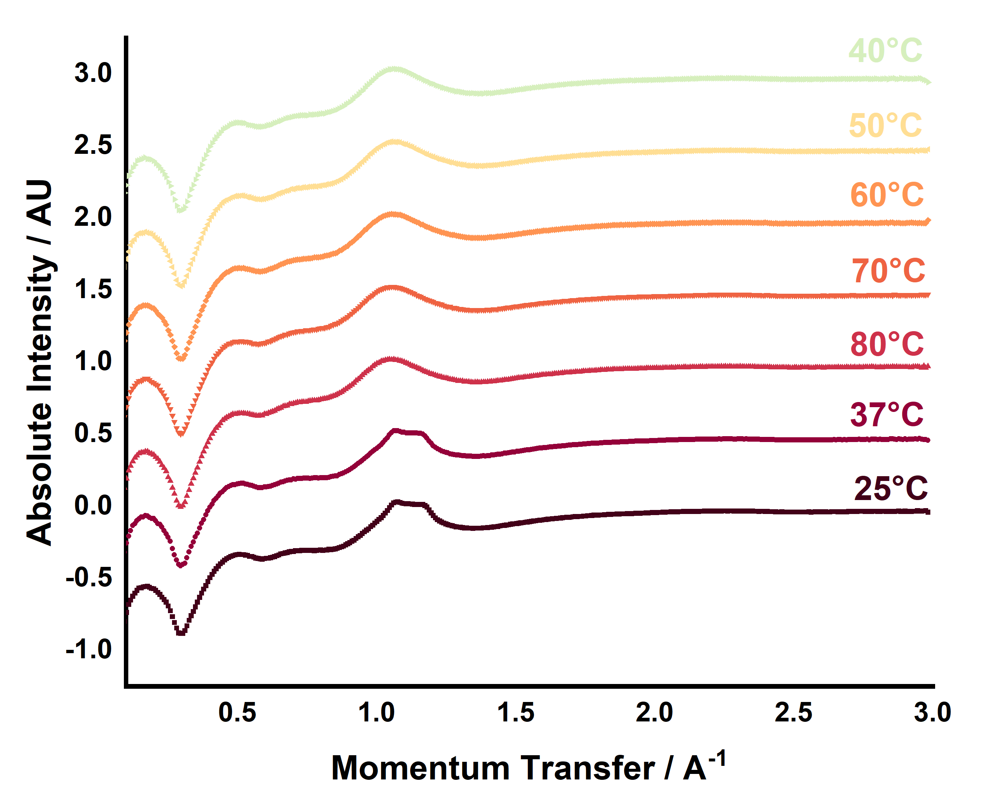

Figure S27. VT-WAXS experiments of 60% C_{ss} showing changes in the short-range order as a result of heating

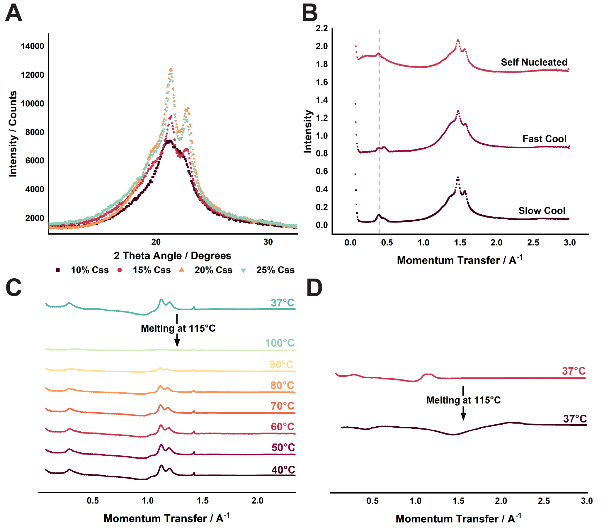

Figure S28. X-ray diffraction of 10-25% C_{ss} showing that 20% C_{ss} is the most crystalline copolymer.

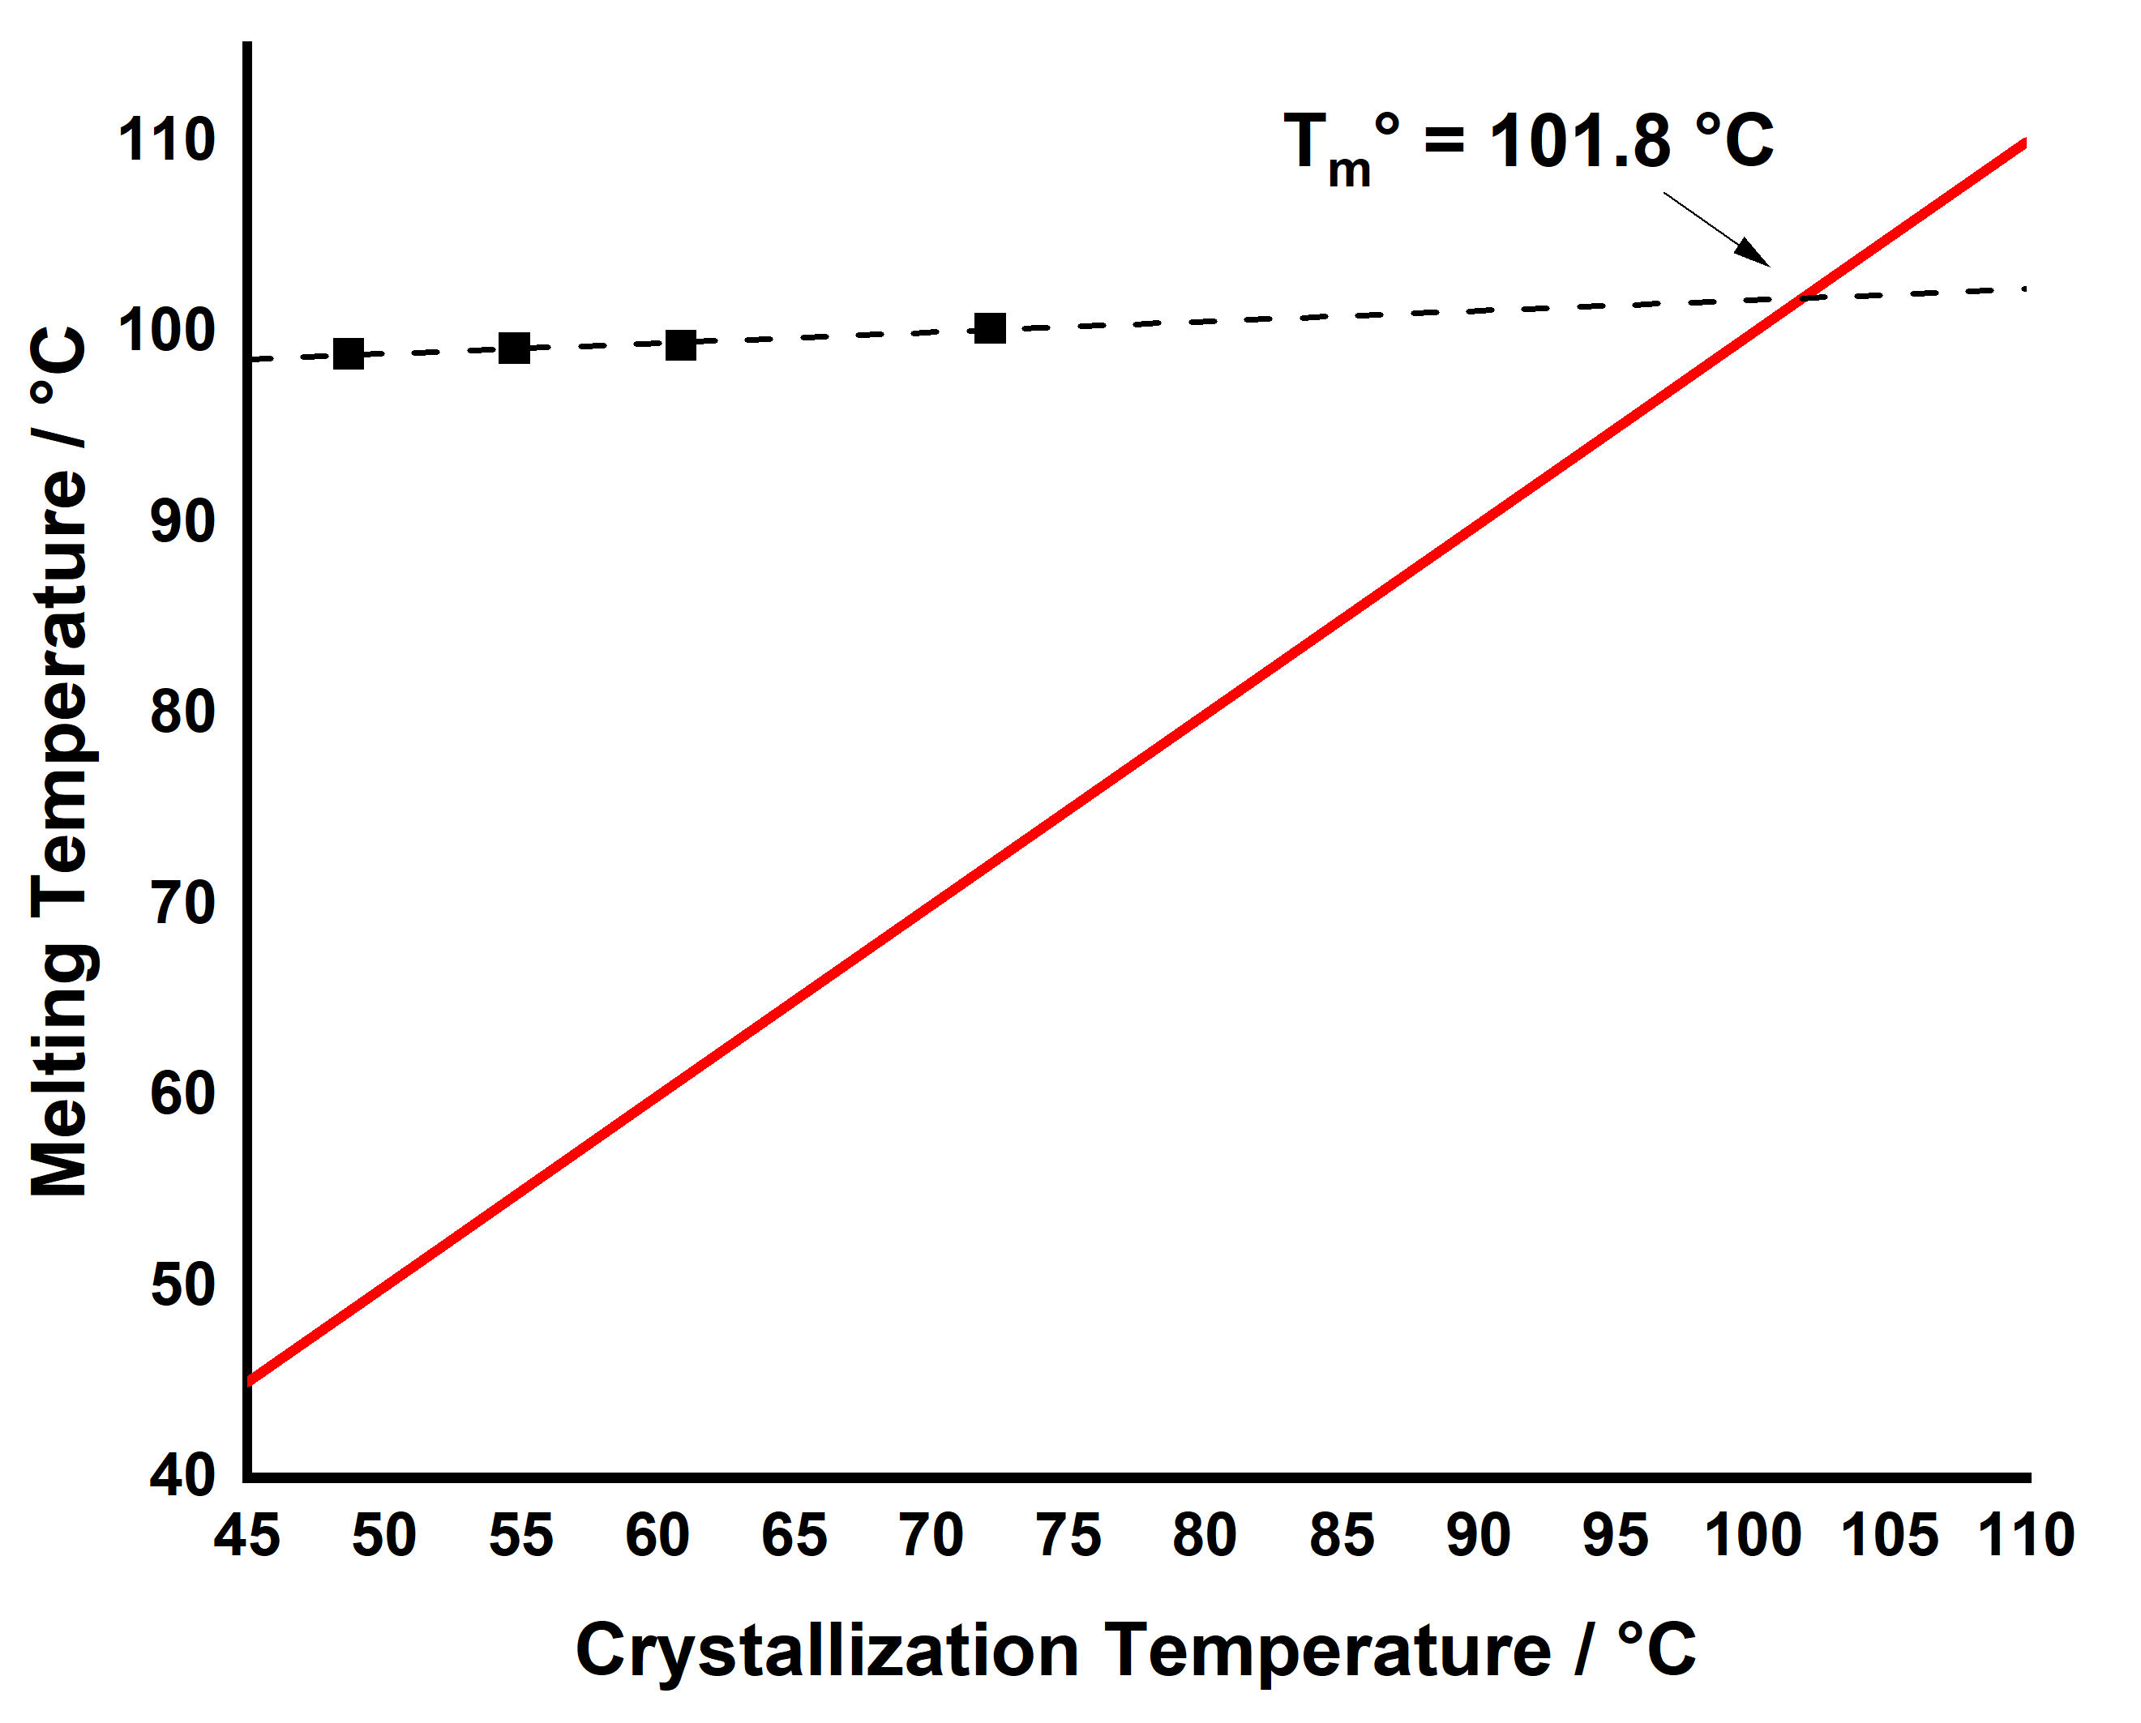

Figure S29. Representative Hoffman-Weeks extrapolation for $T_{m}^{°}$ shown in Table 2

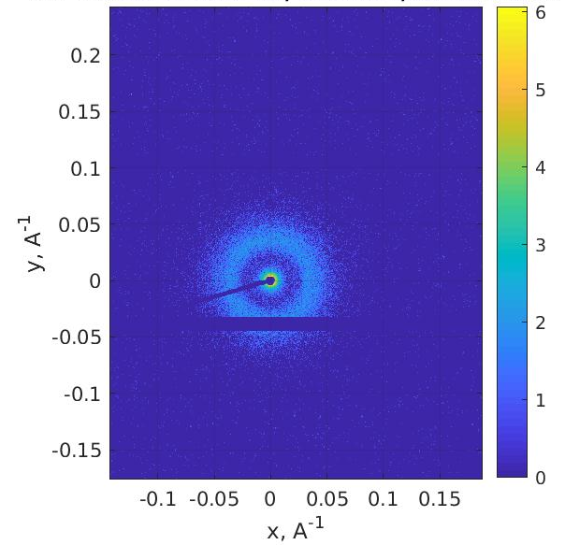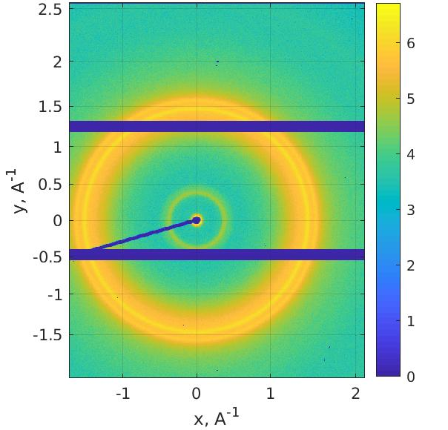
Figure S30. 2D SAXS (left) and WAXS (right) Scattering Patterns of 20% C_{ss} copolymer

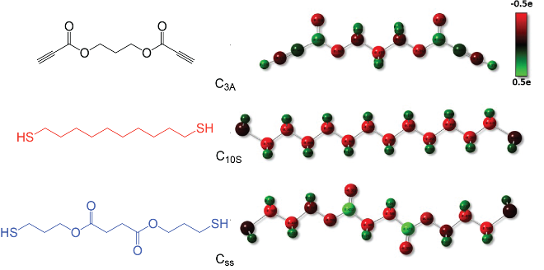
Figure S31. Partial charge distribution for selected monomer sequences. Magnitudes of the partial charges are shown by color coding (from red to green).

Table S1. Overview of the equilibrium states of the copolymer melt system.
x | y | N_{total} | L [σ] | Phase Structure (phase A)
6 | 6 | 153,600 | 56.2 | Lamella
6 | 9 | 192,000 | 61.0 | Perforated Lamella
6 | 12 | 230,400 | 65.0 | Gyroid
6 | 18 | 307,200 | 71.7 | Thread/Cylinder
6 | 36 | 268,800 | 68.8 | Spherical/Island

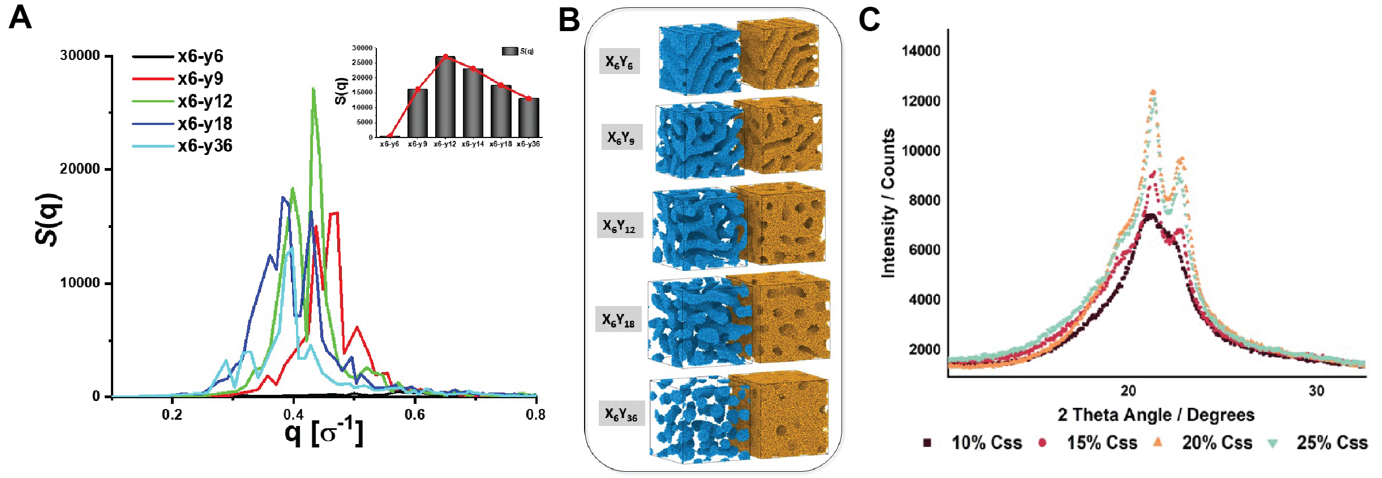
Figure S32. Self-assembly in block copolymer systems: A. Scattering function S(q) for five self-assembled structures (lamellae, perforated lamellae, gyroid, cylinder, sphere). Inset shows the largest peak height of S(q). Largest peak height corresponds to the gyroid structure. B. Equilibrium structures of the block copolymers with different compositions. (A and B microphases are shown separately for clarity). C. X-ray diffraction of 10 – 25% C_{ss} showing that the 20% C_{ss} copolymer exhibits the greatest amount of crystallinity.

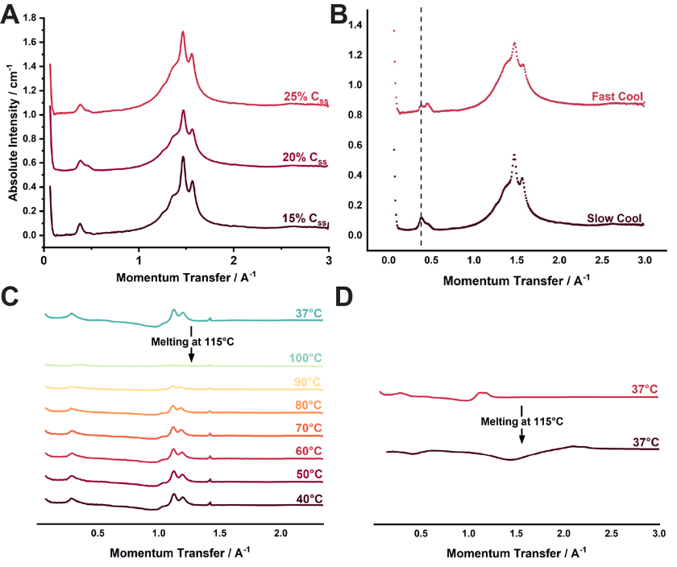
Figure S33. Wide Angle X-Ray Scattering (WAXS) and Compiled Crystalline Properties of 15-25% C_{ss} Copolymers. A. WAXS of slow cooled 15-25% C_{ss}. B. WAXS of 20% C_{ss} self-nucleated by DSC, and melt-pressed with slow and fast cooling showing larger dimensional feature for both controlled cooling methods. C. VT-WAXS pattern of 20% C_{ss} showing crystal growth via stepped (slow) cooling where the temperatures indicate the temperature at which the scan was taken. D. VT-WAXS pattern of 20% C_{ss} showing crystal growth via fast cooling where the temperatures indicate the temperature at which the scan was taken. Greater crystallinity is observed in the slow cooled sample.

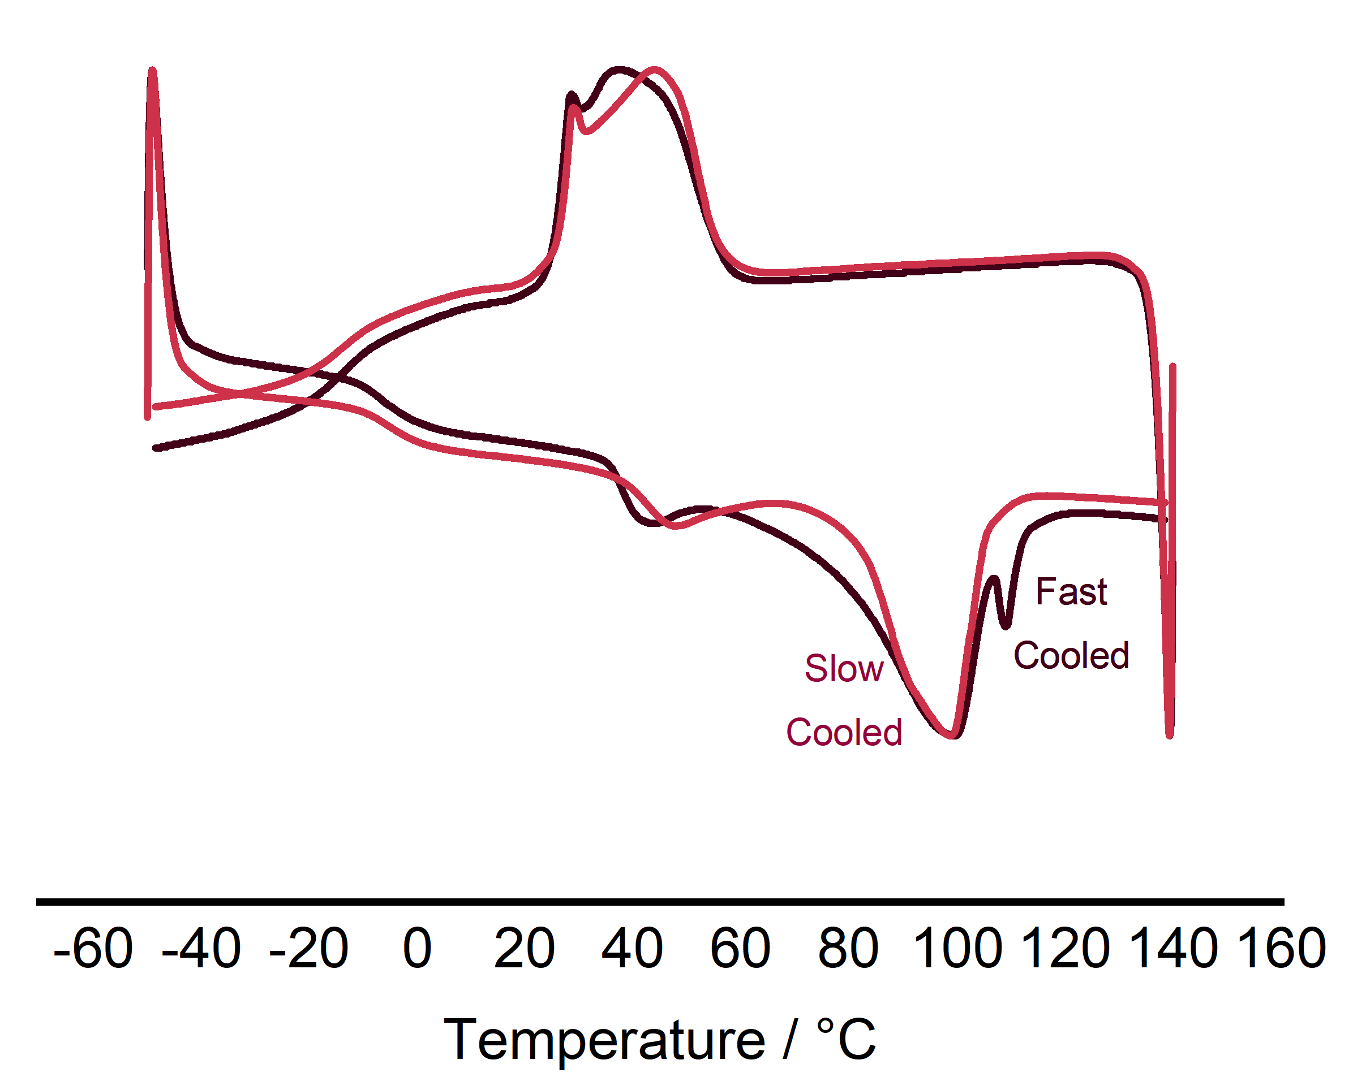
Figure S34. DSC Thermograms for the Slow-Cooled and Fast-Cooled Melt-Pressed 20% C_{ss} Copolymers The first-heating cycle was used to observe the thermal properties imparted from the melt-processing method used to prepare the tested films. The slow-cooled sample exhibits one polymorph as indicated by the single distribution observed as the T_{m} curve. The fast-cooled sample shows one dominant polymorph but two overall as demonstrated by the bimodal T_{m} distribution.

REFERENCES
1. Worch, J. C.; Stubbs, C. J.; Price, M. J.; Dove, A. P., Click Nucleophilic Conjugate Additions to Activated Alkynes: Exploring Thiol-yne, Amino-yne, and Hydroxyl-yne Reactions from (Bio)Organic to Polymer Chemistry. Chem Rev 2021, 121 (12), 6744-6776.
2. Daglar, O.; Gunay, U. S.; Hizal, G.; Tunca, U.; Durmaz, H., Extremely Rapid Polythioether Synthesis in the Presence of TBD. Macromolecules 2019, 52 (9), 3558-3572.
3. Truong, V. X.; Dove, A. P., Organocatalytic, regioselective nucleophilic "click" addition of thiols to propiolic acid esters for polymer-polymer coupling. Angew Chem Int Ed Engl 2013, 52 (15), 4132-6.
4. C.Thomas, L., Interpreting Unexpected Events and Transitions in DSC Results. Instruments, T., Ed. Vol. TA039.

