Supplemental Information
Contents
Supplemental Figures
Figure S1. GCAM transportation sector structure
Figure S2. Population and GDP assumptions
Figure S3. CO₂ and GHG emissions and temperature change
Figure S4. Transportation direct and indirect CO₂ emissions
Figure S5. FT-biofuel and e-fuel costs
Figure S6. Transportation service by technology for additional modes
Figure S7. Transportation service by technology for the total sector
Figure S8. Transportation sector fuel use by fuel type
Figure S9. Transportation hydrogen use by mode
Figure S10. Transportation biofuel and e-fuel use by mode
Figure S11. Agricultural and biomass production, sensitivity scenarios
Figure S12. Transportation service by technology for aviation and shipping, sensitivity scenarios
Figure S13. Transportation service by technology for additional modes, sensitivity scenarios
Figure S14. Alternative fuel blending mandates imposed for aviation and shipping
Supplemental Tables
Table S1. Cumulative CO₂ emissions from transport, 2020 to 2100
Table S2. Cumulative non-CO₂ emissions from transport, 2020 to 2100
Table S3. Cumulative service provided by transport mode, 2020 to 2100
Table S4. Cumulative service provided by transport mode, 2020 to 2050
Table S5. Cumulative CO₂ emissions by sector, 2020 to 2100
Table S6. Cumulative CO₂ emissions by sector, 2020 to 2047
Table S7. Aviation and shipping consumption of FT-biofuels and e-fuels
Table S8. Biofuel and e-fuel fraction of refined liquids used in non-transport sectors
Supplemental Experimental Procedures
Shipping and aviation technology assumptions
Supplemental References

Supplemental Figures
Figure S1: GCAM transportation sector structure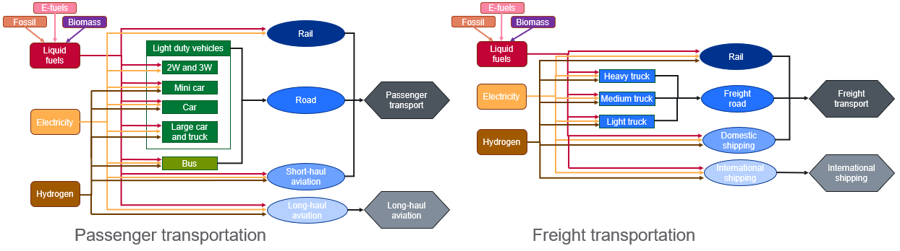
Figure S1. The structure of the transportation sector in GCAM, including key fuel options for the sector. The nesting structure allows for mode-shifting—alongside fuel shifting—between grouped modes or sub-modes in response to climate policies. International shipping and long-haul aviation are grouped separately from all other freight and passenger modes. We show the primary fuel options for transport, across all modes, in this figure; in some regions, coal is also a fuel choice for freight rail, as is natural gas for passenger road modes and light freight trucks.

Figure S2: Population and GDP assumptions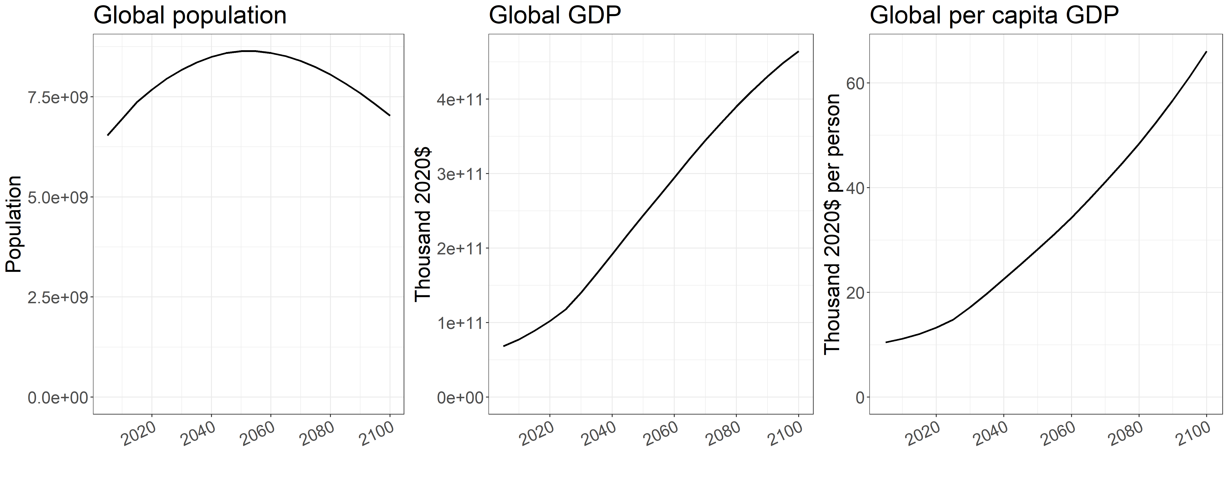Figure S2. Population and GDP assumptions used in all primary scenarios, aligned with SSP1.

Figure S3: CO₂ and GHG emissions and temperature change 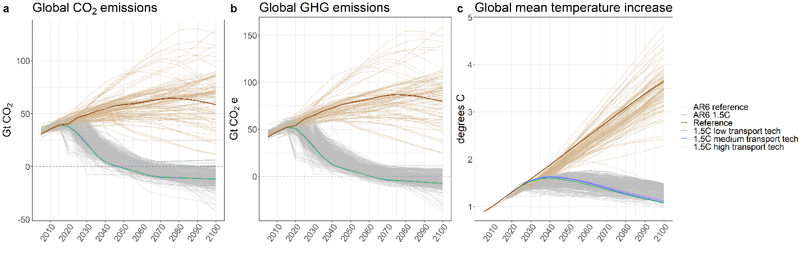Figure S3. (a) Global CO₂ emissions, including both fossil fuel and industry sources and land use change, (b) global total greenhouse gas emissions, and (c) the resulting global mean temperature increase, in the four primary scenarios in our analysis compared to the scenarios in the IPCC AR6 database¹ that are consistent with limiting end-of-century warming to 1.5°C (light gray) and that represent a continuation of baseline trajectories (light brown). Global warming potentials used for the non-CO₂ greenhouse gases are from the AR5 report.

Figure S4: Transportation direct and indirect CO₂ emissions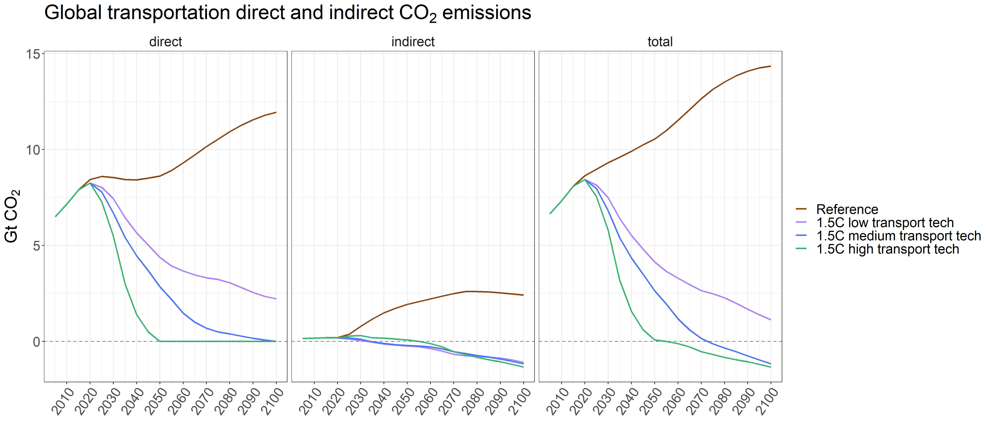
Figure S4. Global direct and indirect CO₂ emissions from the transportation sector in the primary scenarios.

Figure S5: FT-biofuel and e-fuel costs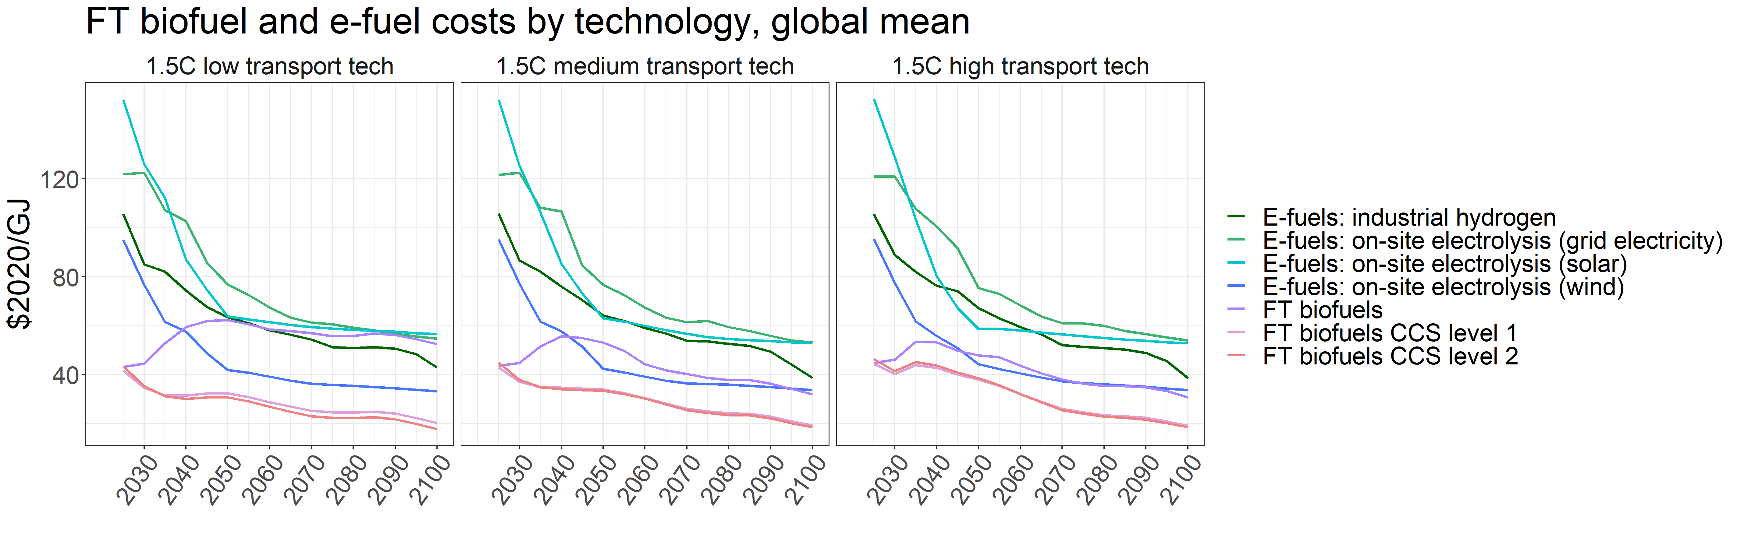Figure S5. Global mean of FT-biofuel and e-fuel costs by production technology. The different CCS levels indicate varied carbon removal fractions, with level 2 technologies employing carbon capture on a more expansive set of CO₂ sources and thus yielding a higher removal fraction than level 1 technologies.
Figure S6: Transportation service by technology for additional modes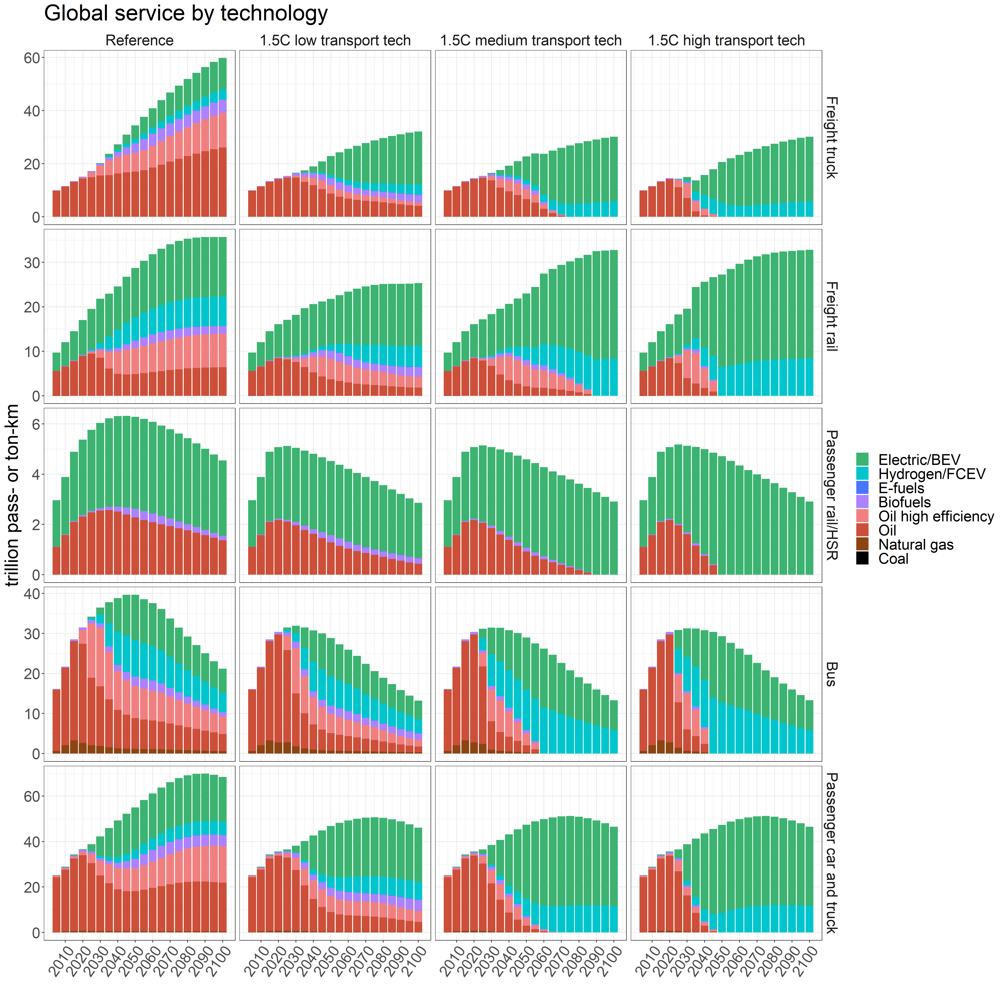Figure S6. Global service provided by technology for freight trucks, freight rail, passenger rail and high-speed rail (HSR), buses, and passenger cars and trucks across the four scenarios. Note the different y-axis scales and units for each mode; units are trillion passenger-kilometers for passenger modes and trillion ton-kilometers for freight modes. Also note that coal is used exclusively in freight rail prior to 2025 at very low levels, and thus does not appear visibly in the figure.

Figure S7: Transportation service by technology for the total sector 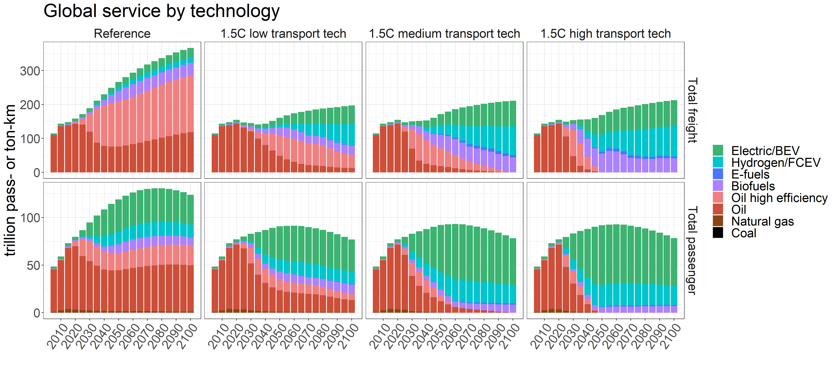Figure S7. Global service provided by technology for the full transportation sector, separated into freight transport and passenger transport, across the four scenarios. Note the different y-axis scales and units; units are trillion passenger-kilometers for passenger transport and trillion ton-kilometers for freight transport. Also note that coal is used exclusively prior to 2025 at very low levels, and thus does not appear visibly in the figure.

Figure S8: Transportation sector fuel use by fuel type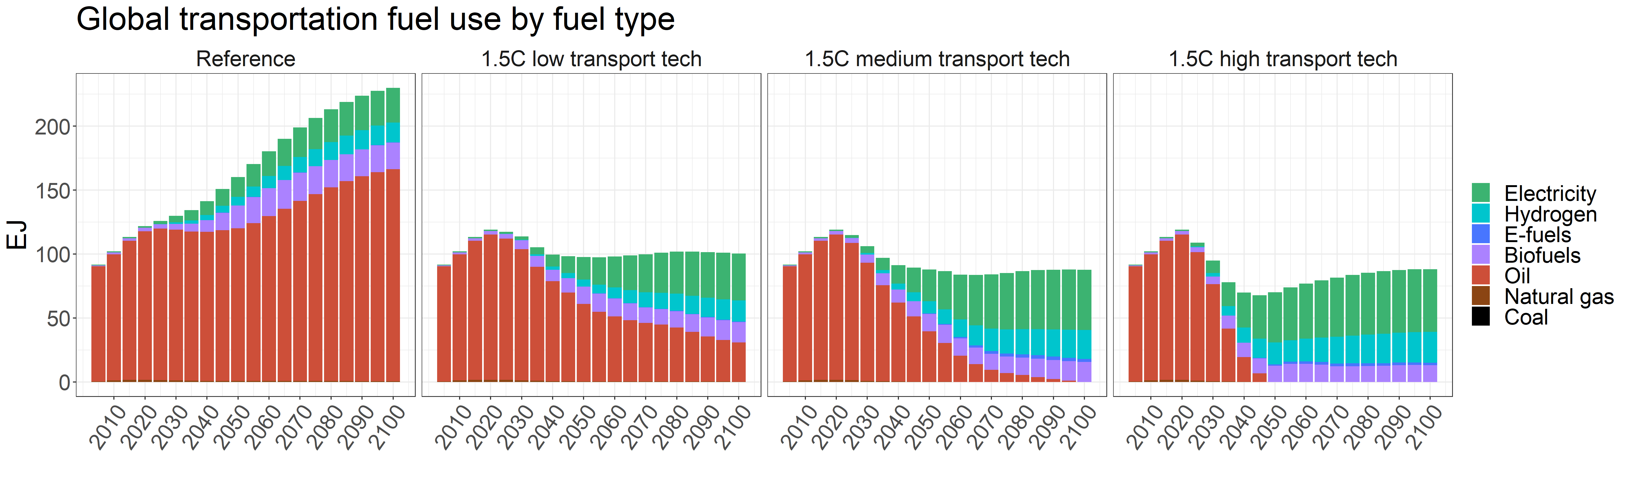Figure S8. Global fuel use by the transportation sector across the four scenarios. Note that coal is used exclusively prior to 2025 at very low levels, and thus does not appear visibly in the figure.

Figure S9: Transportation hydrogen use by mode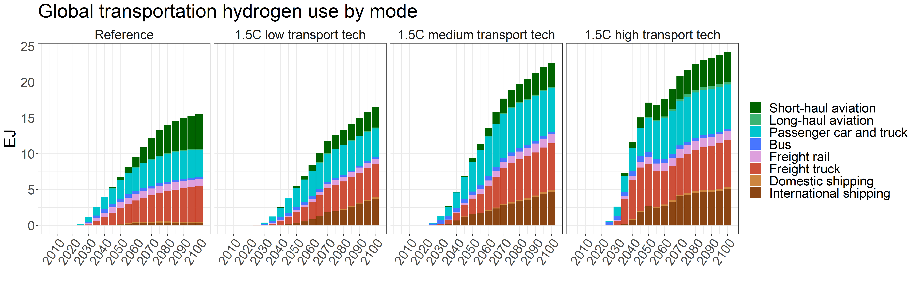Figure S9. Global hydrogen consumption by transportation mode across the four scenarios.

Figure S10: Transportation biofuel and e-fuel use by mode 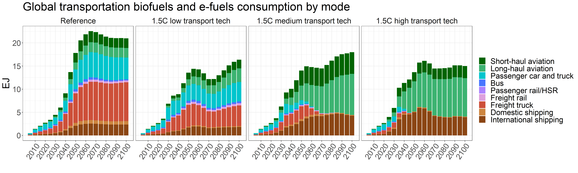Figure S10. Global aggregated biofuels and e-fuels consumption by transportation mode across the four scenarios.

Figure S11: Agricultural and biomass production, sensitivity scenarios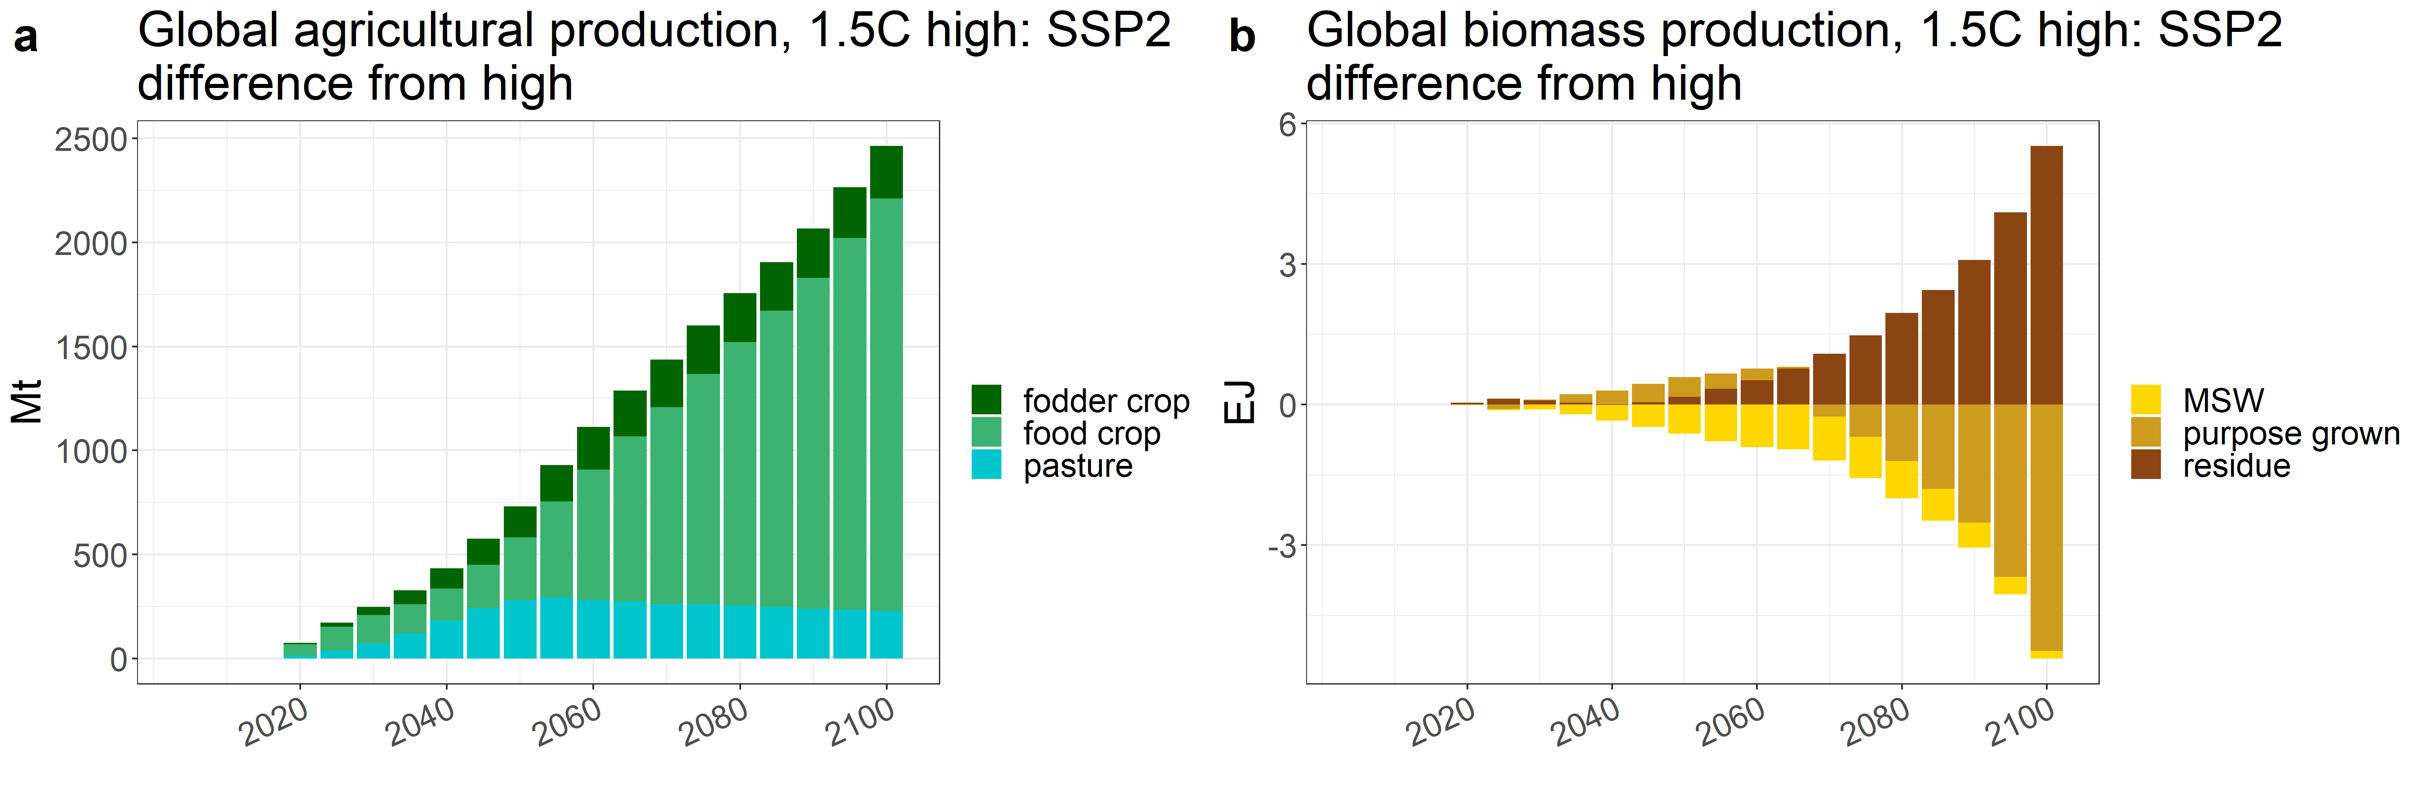
Figure S11. (a) Global agricultural production and (b) global biomass production in the SSP2 sensitivity scenario, shown as a difference from the production in the standard high transportation technology scenario. Positive values indicate higher production in the SSP2 sensitivity scenario than in the standard high scenario.

Figure S12: Transportation service by technology for aviation and shipping, sensitivity scenarios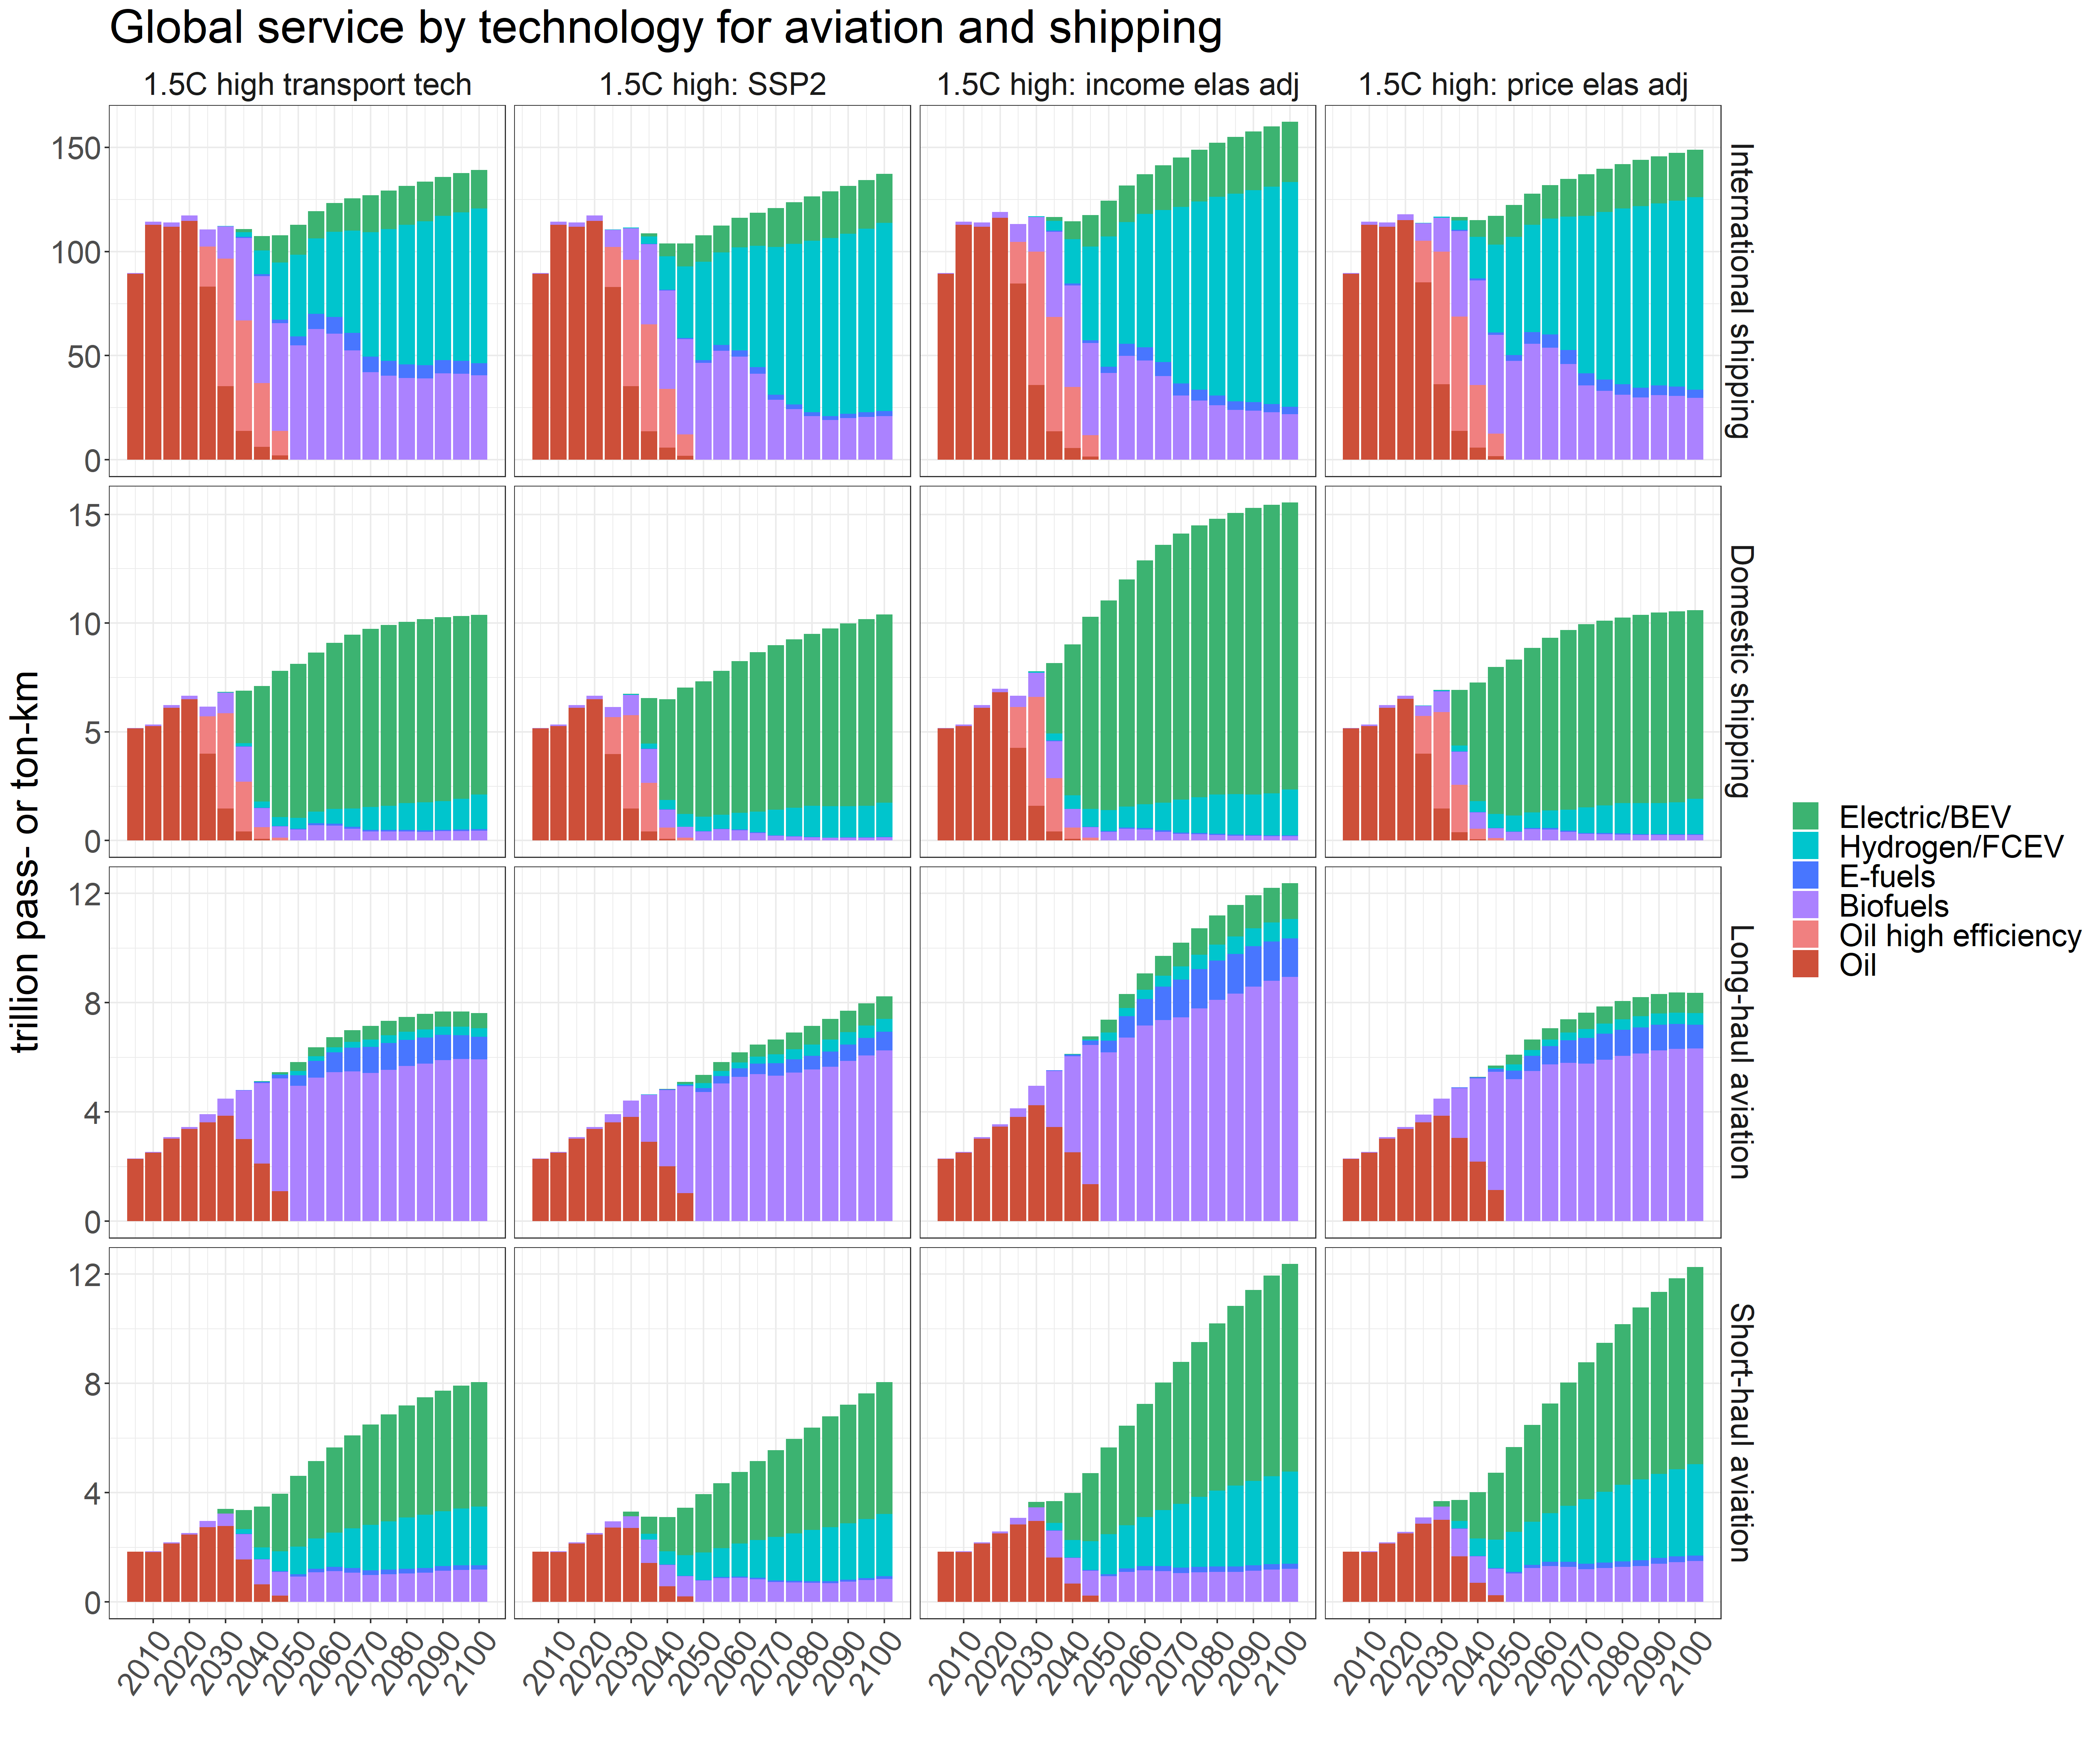
Figure S12. Global service provided by technology for international and domestic shipping and long-haul and short-haul aviation in the high transportation technology scenario and the sensitivity scenarios. Note the different y-axis scales and units for each mode; units are trillion passenger-kilometers for aviation and trillion ton-kilometers for shipping.

Figure S13: Transportation service by technology for additional modes, sensitivity scenarios 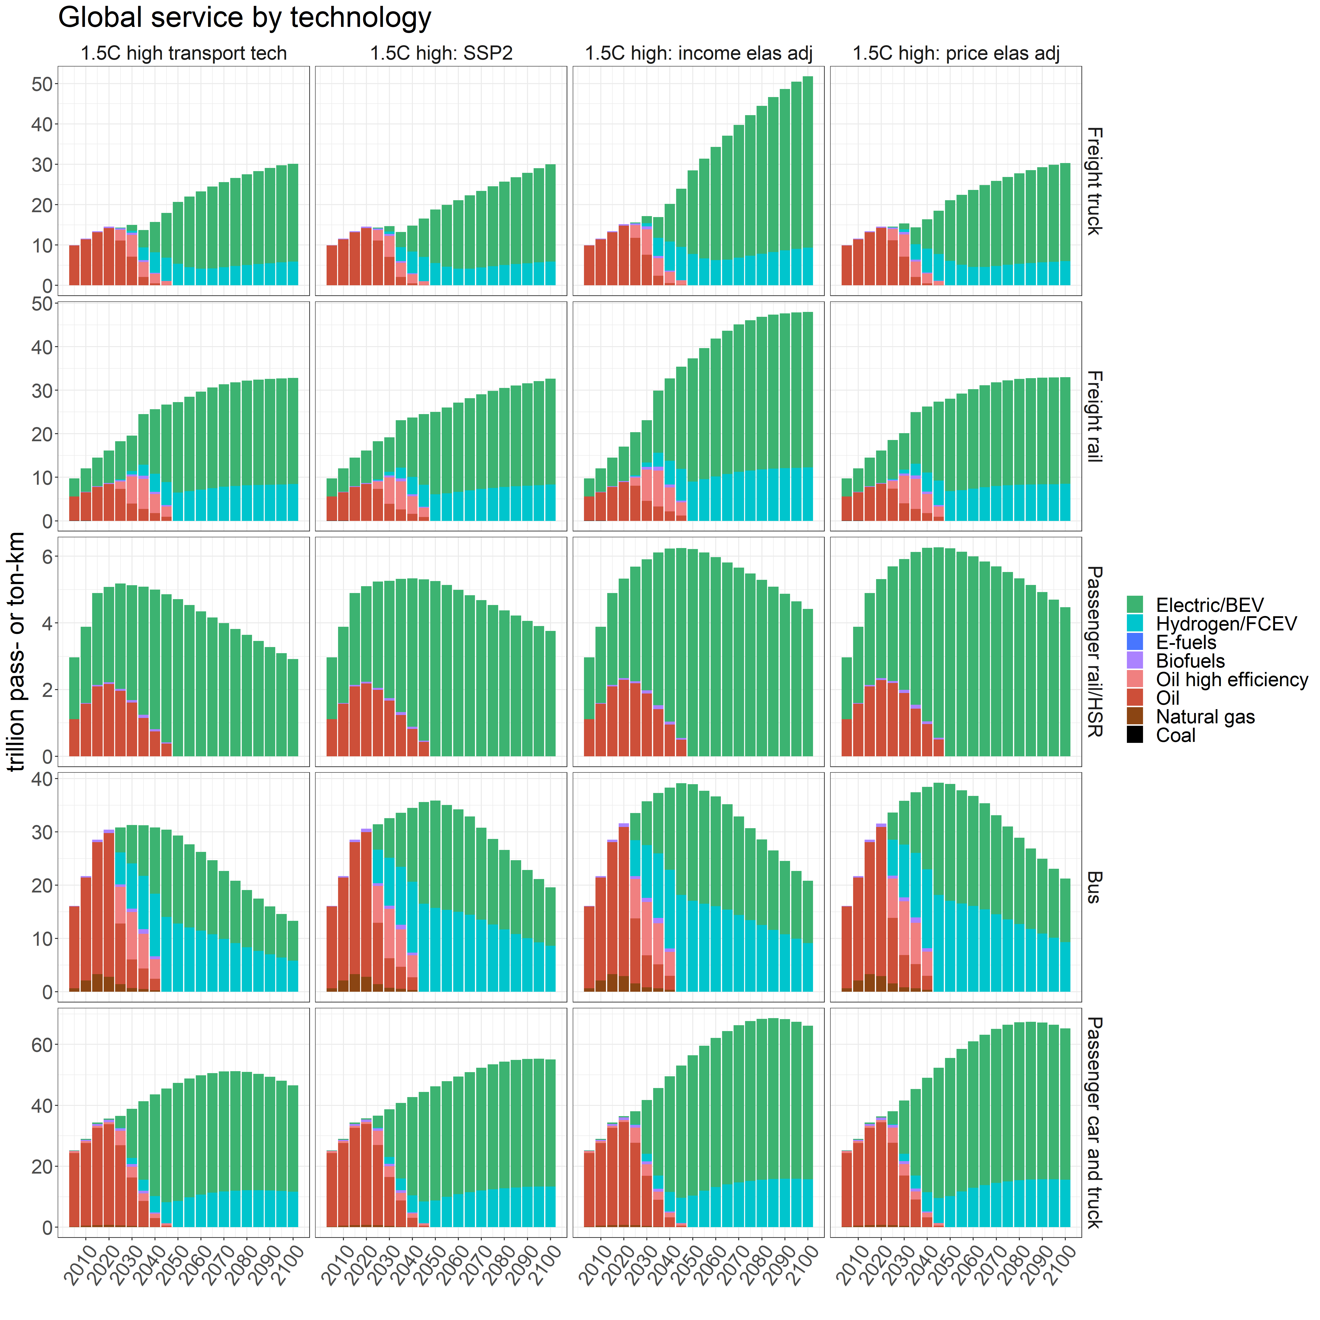
Figure S13. Global service provided by technology for freight trucks, freight rail, passenger rail and high-speed rail (HSR), buses, and passenger cars and trucks in the high transportation technology scenario and the sensitivity scenarios. Note the different y-axis scales and units for each mode; units are trillion passenger-kilometers for passenger modes and trillion ton-kilometers for freight modes. Also note that coal is used exclusively in freight rail prior to 2025 at very low levels, and thus does not appear visibly in the figure.

Figure S14: Alternative fuel blending mandates imposed for aviation and shipping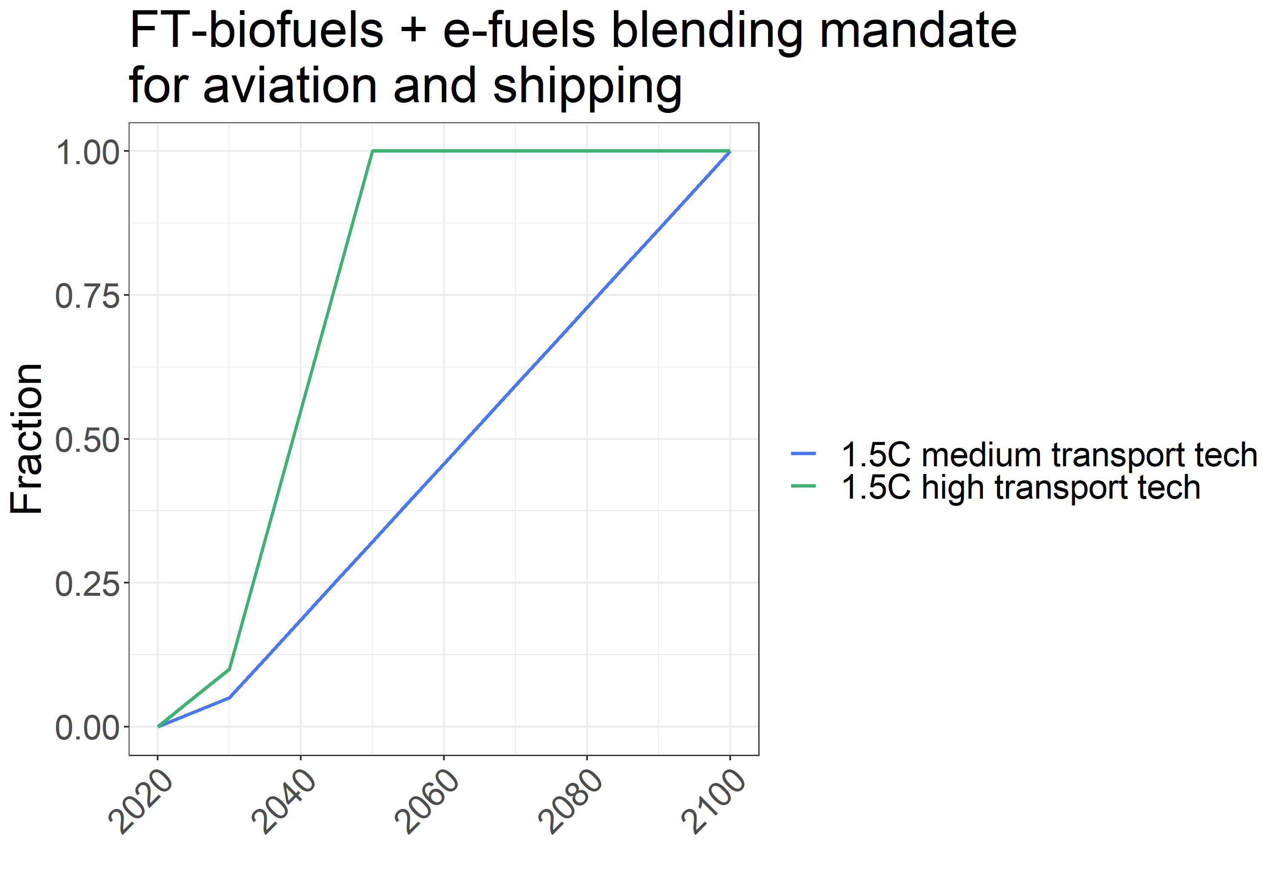
Figure S14. Scenario assumptions for the minimum fraction of liquid fuels consumed by aviation and shipping that must be generated from FT-biofuels or e-fuels. Only the scenarios with alternative fuel mandates are shown.

Supplemental Tables

Table S1: Cumulative CO₂ emissions from transport, 2020 to 2100
Table S1. Cumulative CO₂ emissions, 2020 to 2100, from each transportation mode in each scenario.
Mode | Units | Reference | 1.5°C low | 1.5°C medium | 1.5°C high
Bus | Gt CO₂ | 21.6 | 14.4 | 7.6 | 5.5
Passenger car and truck | Gt CO₂ | 204.3 | 110.2 | 59.7 | 40.7
Passenger rail/HSR | Gt CO₂ | 2.9 | 1.7 | 1.1 | 0.6
Short-haul aviation | Gt CO₂ | 77.0 | 32.2 | 19.7 | 7.9
Long-haul aviation | Gt CO₂ | 68.4 | 35.4 | 20.2 | 8.0
Freight rail | Gt CO₂ | 14.3 | 8.2 | 6.1 | 3.2
Freight truck | Gt CO₂ | 285.7 | 109.9 | 71 | 31.9
Domestic shipping | Gt CO₂ | 25.5 | 5.2 | 3.3 | 2.0
International shipping | Gt CO₂ | 87.8 | 40.9 | 24.0 | 13.0
Total | Gt CO₂ | 787.4 | 358.1 | 212.8 | 112.8

Table S2: Cumulative non-CO₂ emissions from transport, 2020 to 2100
Table S2. Cumulative non-CO₂ emissions, 2020 to 2100, from the total transportation sector in each scenario.
Non-CO₂ gas | Units | Reference | 1.5°C low | 1.5°C medium | 1.5°C high
BC | Tg | 128.7 | 26.7 | 21.1 | 13.4
CH4 | Tg | 141.3 | 62.1 | 35.1 | 19.9
CO | Tg | 11595.9 | 2950.4 | 2209.1 | 1583.7
N2O | Tg | 25.4 | 12.4 | 8.6 | 5.5
NH3 | Tg | 27 | 15.6 | 10.7 | 7.9
NMVOC | Tg | 2272.2 | 576.1 | 423.3 | 309.3
NOx | Tg | 3752.2 | 1050.2 | 819.7 | 578.0
OC | Tg | 50.6 | 11.5 | 8.3 | 5.4
SO2 | Tg | 297.8 | 145.5 | 104.2 | 85.1

Table S3: Cumulative service provided by transport mode, 2020 to 2100
Table S3. Cumulative service provided by each transportation mode, 2020 to 2100, in each scenario. The “no policy, tech + behavior change” scenario is a comparison scenario that incorporates the economy-wide behavioral and technological changes used in the 1.5°C scenarios (e.g., reduced demand for transportation services, lower population growth), except for the advanced transportation technology assumptions. Thus, the difference between the reference scenario and the “no policy, tech + behavior change” scenario highlights the effect of the non-transportation-technology assumptions on service provision. The differences between the 1.5°C scenarios and the “no policy, tech + behavior change” scenario isolate the effects of the carbon policy and the transportation technology changes.
Mode | Units | Reference | No policy, tech + behavior change | 1.5°C low | 1.5°C medium | 1.5°C high
Bus | Trillion pass-km | 2700 | 1962 | 1990 | 1996 | 1996
Passenger car and truck | Trillion pass-km | 4710 | 3833 | 3719 | 3757 | 3763
Passenger rail/HSR | Trillion pass-km | 465 | 339 | 337 | 341 | 345
Short-haul aviation | Trillion pass-km | 774 | 597 | 422 | 449 | 444
Long-haul aviation | Trillion pass-km | 856 | 622 | 494 | 520 | 506
Freight rail | Trillion ton-km | 2412 | 1732 | 1819 | 2090 | 2266
Freight truck | Trillion ton-km | 3190 | 2183 | 1982 | 1899 | 1804
Domestic shipping | Trillion ton-km | 1515 | 1062 | 487 | 644 | 704
International shipping | Trillion ton-km | 15646 | 13659 | 9471 | 10001 | 9889
Total passenger | Trillion pass-km | 9506 | 7354 | 6960 | 7063 | 7055
Total freight | Trillion ton-km | 22764 | 18635 | 13759 | 14633 | 14663

Table S4: Cumulative service provided by transport mode, 2020 to 2050
Table S4. Cumulative service provided by each transportation mode, 2020 to 2050, in each scenario.
Mode | Units | Reference | No policy, tech + behavior change | 1.5°C low | 1.5°C medium | 1.5°C high
Bus | Trillion pass-km | 1148 | 942 | 956 | 953 | 952
Passenger car and truck | Trillion pass-km | 1418 | 1309 | 1260 | 1271 | 1278
Passenger rail/HSR | Trillion pass-km | 188 | 154 | 152 | 153 | 156
Short-haul aviation | Trillion pass-km | 172 | 155 | 108 | 112 | 107
Long-haul aviation | Trillion pass-km | 201 | 174 | 145 | 148 | 147
Freight rail | Trillion ton-km | 715 | 575 | 598 | 606 | 703
Freight truck | Trillion ton-km | 745 | 610 | 559 | 561 | 489
Domestic shipping | Trillion ton-km | 396 | 324 | 146 | 178 | 218
International shipping | Trillion ton-km | 4670 | 4378 | 3285 | 3448 | 3434
Total passenger | Trillion pass-km | 3127 | 2733 | 2620 | 2637 | 2639
Total freight | Trillion ton-km | 6526 | 5887 | 4588 | 4792 | 4845

Table S5: Cumulative CO₂ emissions by sector, 2020 to 2100
Table S5. Cumulative CO₂ emissions, 2020 to 2100, from each sector in each scenario. LULUCF stands for land use, land use change, and forestry.
Sector | Units | Reference | 1.5°C low | 1.5°C medium | 1.5°C high
Buildings | Gt CO₂ | 218.8 | 57.8 | 83.3 | 97.6
CO₂ removal | Gt CO₂ | -0.8 | -360.5 | -370.4 | -374.1
Electricity | Gt CO₂ | 1901.4 | 34.8 | 71.7 | 109.0
Hydrogen | Gt CO₂ | 70.9 | -61.8 | -44.0 | -40.9
Industry | Gt CO₂ | 1215.0 | 203.9 | 281.0 | 332.3
LULUCF | Gt CO₂ | 110.2 | -233.0 | -233.9 | -234.3
Other energy supply | Gt CO₂ | 393.8 | -3.0 | -5.0 | -7.2
Transportation | Gt CO₂ | 787.4 | 358.1 | 212.8 | 112.8
Total | Gt CO₂ | 4696.6 | -3.6 | -4.5 | -4.8

Table S6: Cumulative CO₂ emissions by sector, 2020 to 2047
Table S6. Cumulative CO₂ emissions, 2020 to 2047 (the year in which net zero CO₂ emissions are achieved in the medium and high scenarios), from each sector in each scenario. The low scenario achieves net zero CO₂ emissions in 2048. LULUCF stands for land use, land use change, and forestry.
Sector | Units | Reference | 1.5°C low | 1.5°C medium | 1.5°C high
Buildings | Gt CO₂ | 84.3 | 38.4 | 42.3 | 51.0
CO₂ removal | Gt CO₂ | -0.1 | -43.4 | -43.5 | -43.4
Electricity | Gt CO₂ | 522.0 | 101.2 | 110.0 | 131.2
Hydrogen | Gt CO₂ | 8.5 | -6.7 | -4.5 | -1.3
Industry | Gt CO₂ | 384.8 | 180.8 | 191.5 | 214.3
LULUCF | Gt CO₂ | 103.4 | -32.2 | -34.7 | -37.9
Other energy supply | Gt CO₂ | 78.9 | 33.6 | 31.2 | 27.0
Transportation | Gt CO₂ | 237.9 | 187.3 | 164.4 | 112.5
Total | Gt CO₂ | 1419.7 | 459.1 | 456.6 | 453.4

Table S7: Aviation and shipping consumption of FT-biofuels and e-fuels
Table S7. Fraction of all FT-biofuels and e-fuels produced that are consumed by aviation and shipping, in selected years.
Scenario | Year | Fraction of FT-biofuels and e-fuels consumed by aviation | Fraction of FT-biofuels and e-fuels consumed by shipping
1.5°C medium | 2025 | 0.50 | 0.50
1.5°C medium | 2050 | 0.64 | 0.36
1.5°C medium | 2075 | 0.69 | 0.31
1.5°C medium | 2100 | 0.75 | 0.25
1.5°C high | 2025 | 0.51 | 0.49
1.5°C high | 2050 | 0.62 | 0.38
1.5°C high | 2075 | 0.71 | 0.29
1.5°C high | 2100 | 0.73 | 0.27

Table S8: Biofuel and e-fuel fraction of refined liquids used in non-transport sectors
Table S8. Fraction of refined liquids supply that comes from biofuels and e-fuels for non-transportation sectors (electricity, industry, buildings, and other energy supply) by year and scenario.
Year | Reference | 1.5°C low | 1.5°C medium | 1.5°C high
2015 | 0.02 | 0.02 | 0.02 | 0.02
2020 | 0.02 | 0.02 | 0.02 | 0.02
2025 | 0.03 | 0.03 | 0.03 | 0.03
2030 | 0.04 | 0.06 | 0.05 | 0.04
2035 | 0.05 | 0.09 | 0.08 | 0.07
2040 | 0.07 | 0.10 | 0.09 | 0.08
2045 | 0.10 | 0.14 | 0.11 | 0.09
2050 | 0.13 | 0.18 | 0.14 | 0.11
2055 | 0.14 | 0.21 | 0.15 | 0.13
2060 | 0.15 | 0.22 | 0.16 | 0.14
2065 | 0.14 | 0.22 | 0.16 | 0.14
2070 | 0.14 | 0.21 | 0.15 | 0.14
2075 | 0.13 | 0.21 | 0.14 | 0.14
2080 | 0.12 | 0.24 | 0.15 | 0.14
2085 | 0.12 | 0.27 | 0.15 | 0.15
2090 | 0.12 | 0.30 | 0.17 | 0.16
2095 | 0.11 | 0.33 | 0.19 | 0.18
2100 | 0.11 | 0.35 | 0.21 | 0.20

Supplemental Experimental Procedures

Shipping and aviation technology assumptions
Full documentation of the assumptions for advanced technologies, for all transportation modes, is available in the GCAM documentation². We include information on the non-fuel costs and energy intensities for shipping and aviation technologies in Table S9, as we emphasize transition pathways for those modes in our analysis. Electric and hydrogen-powered aviation and shipping costs are based on existing literature^{3,4}, where available, or are estimated based on the cost ratio between conventional and advanced technologies for modes with similar drivetrains.
Table S9. Shipping and aviation non-fuel costs and energy intensities for the United States. Values are interpolated between the years shown in the table. Note that hydrogen aircraft and electric long-haul aircraft are not introduced until 2035 and thus do not have values reported in 2030.
Mode | Technology | Energy intensity (MJ/vkm) |  |  | Non-fuel cost (2020$/vkm)
Mode | Technology | 2030 | 2035 | 2050 | 2030 | 2035 | 2050
Short-haul aviation | Liquid fuels | 280 | 280 | 280 | 16.15 | 16.63 | 16.64
Short-haul aviation | BEV | 280 | 280 | 280 | 22.26 | 22.11 | 19.61
Short-haul aviation | Hydrogen | N/A | 280 | 280 | N/A | 21.89 | 16.62
Long-haul aviation | Liquid fuels | 333 | 313 | 313 | 21.50 | 22.16 | 22.16
Long-haul aviation | BEV | N/A | 313 | 313 | N/A | 73.68 | 49.43
Long-haul aviation | Hydrogen | N/A | 313 | 313 | N/A | 80.72 | 44.80
Domestic shipping | Liquid fuels | 309 | 303 | 297 | 1.64 | 1.64 | 1.64
Domestic shipping | Liquid fuels - high efficiency | 267 | 265 | 261 | 2.05 | 1.76 | 1.67
Domestic shipping | BEV | 167 | 166 | 163 | 13.64 | 7.05 | 6.67
Domestic shipping | FCEV | 222 | 221 | 218 | 4.36 | 3.73 | 2.82
International shipping | Liquid fuels | 2072 | 2062 | 2031 | 29.69 | 29.69 | 29.69
International shipping | Liquid fuels - high efficiency | 1658 | 1649 | 1625 | 37.12 | 31.98 | 30.27
International shipping | BEV | 1036 | 1031 | 1015 | 247.46 | 127.92 | 121.06
International shipping | FCEV | 1381 | 1374 | 1354 | 79.19 | 67.61 | 51.17

Supplemental References
1. Byers, Edward et al. AR6 Scenarios Database. (2022) doi:10.5281/ZENODO.5886911.
2. Kyle, P., Fuhrman, J., Wolfram, P., O’Rourke, P. & Kholod, N. Core Model Proposal #359: Hydrogen and transportation technology update. (2022).
3. Royal Netherlands Aerospace Centre. Destination 2050: A Route To Net Zero European Aviation. https://reports.nlr.nl/server/api/core/bitstreams/c9002b7e-224f-420c-b6da-ab6aecd48ea2/content (2021).
4. Schäfer, A. W. et al. Technological, economic and environmental prospects of all-electric aircraft. Nat Energy 4, 160–166 (2019).

