Supplementary information to:
“Climate change impacts on ocean light in Arctic ecosystems beyond sea ice”
Trond Kristiansen¹, Øystein Varpe^{2,3}, Elizabeth R. Selig⁴, Benjamin J. Laurel⁵, William J. Sydeman¹, Michaela I. Hegglin^{6,7}, and Phil Wallhead⁸

1 Farallon Institute, Petaluma, USA
2 Department of Biological Sciences, University of Bergen, Bergen, Norway
3 Norwegian Institute for Nature Research, Bergen, Norway
4 Stanford Center for Ocean Solutions, Stanford University, Stanford, USA
5 Alaska Fisheries Science Center, NOAA, Newport, USA
6 Institute of Energy and Climate Research, IEK-7 Stratosphere, Research Centre Julich, Julich, Germany
7 Department of Meteorology, University of Reading, Reading, UK
8 Norwegian Institute for Water Research, Oslo, Norway

CMIP6 model | Institution | Experiment ID | Member ID
ACCESS-ESM1-5 | Australian Community Climate and Earth System Simulator ¹ | SSP2-4.5, SSP5-8.5 | r1i1p1f1
CanESM5 | The Canadian Earth System Model version 5 ² | SSP2-4.5, SSP5-8.5 | r10i1p2f1
MPI-ESM1-2-LR | Max Planck Institute Earth System Model Low-res ³ | SSP2-4.5, SSP5-8.5 | r2i1p1f1
UKESM1-0-LL | U.K. Community Earth System Modeling for CMIP6 ⁴ | SSP2-4.5, SSP5-8.5 | r1i1p1f2
Table S1: An overview of the CMIP6 models, experiment, and ensemble members used to derive the shortwave light calculations in the ocean. For each model, two climate experiments were used, the SSP2-4.5 and SSP5-8.5, while the ensemble member id varied between models.

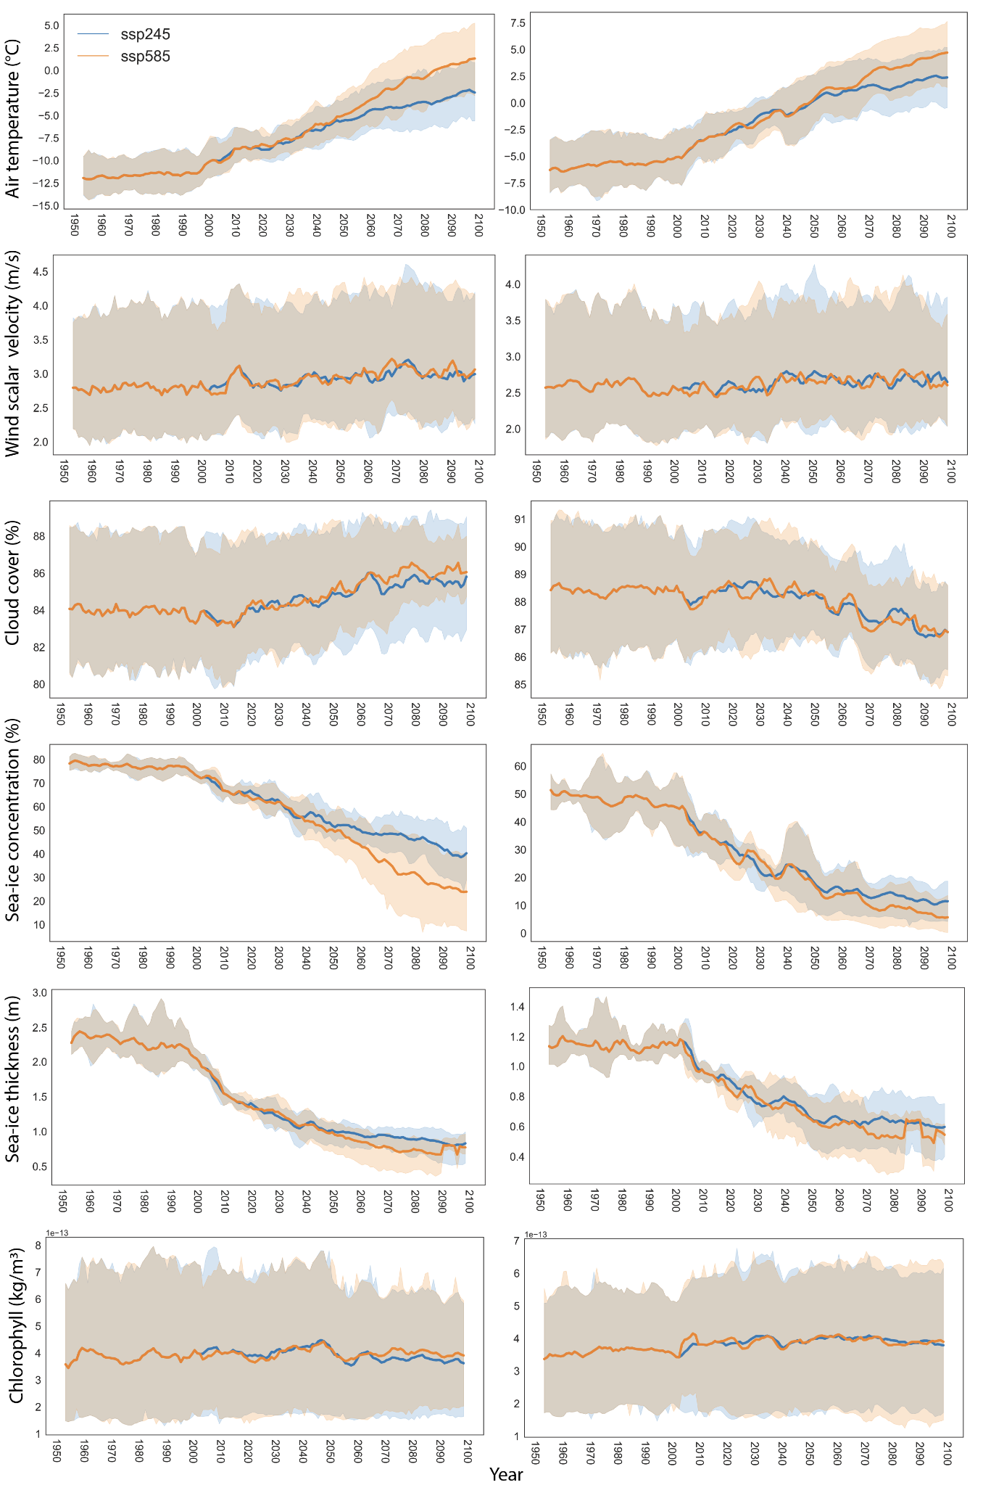Figure S1: Large-scale changes in physics and biology. Annual ensemble average shown with 95th percentile confidence intervals across CMIP6 models/realizations (Table 1) averaged over the Northern Bering/Chukchi LME (left), and the Barents Sea LME (right). The panels show projected values of a) air temperature (C), b) wind velocity (m/s), c) cloud cover (%), d) sea-ice concentration (%), e) sea ice thickness (m), f), and chlorophyll (kg/m³) used as input to the Radiative Transfer Model.

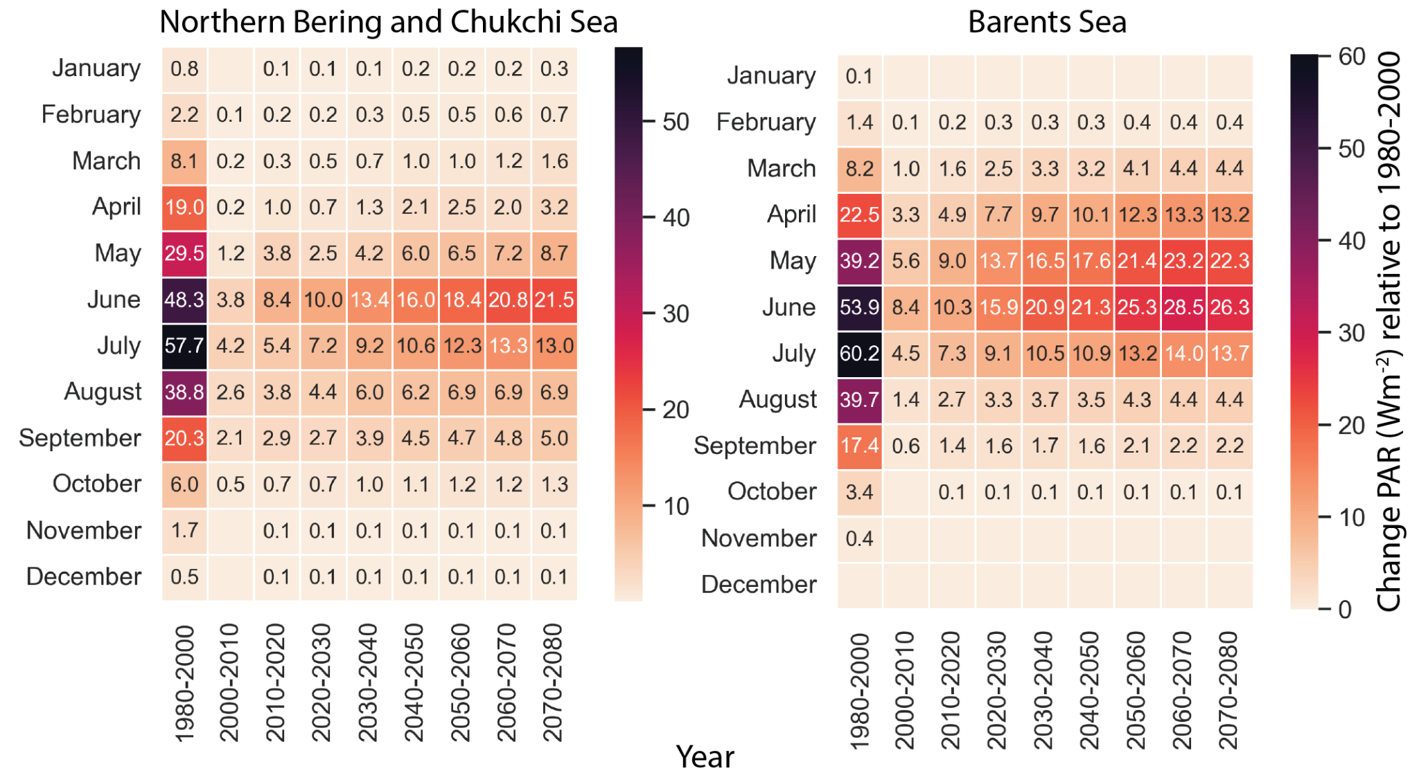

Figure S2: Seasonal changes in ocean light. Heatmaps showing the historical (1980-2000) monthly mean (leftmost column of each heatmap) and future decadal average changes in PAR (Wm⁻²) for Northern Bering/Chukchi (left) and Barents Seas (right). Changes relative to historical values (1980-2000) are shown for each decade between 2000-2090 at 10-year intervals. Months with no change relative to historical values have no annotated values. Heatmap depicts only results for SSP2-4.5.

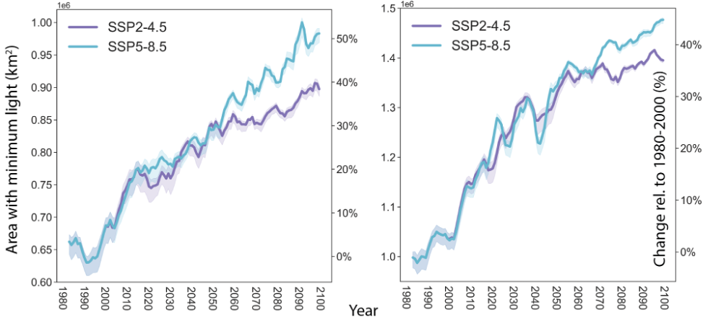
Figure S3: Temporal changes in area with minimum light. Expected changes in the total area (km²) that receives on average more than 0.1 Wm⁻² PAR per year to illustrate the overall changes in the light environment; the left axis shows the total area in km², while the right axis shows the percentage change in the area relative to the average area for the period 1980-2000. The large marine ecosystems shown are the Northern Bering/Chukchi (left) and Barents Seas (right) for two scenarios of climate change, SSP2-4.5 (purple) and SSP5-8.5 (light blue). Average values are shown as thicker lines with a 95th percentile confidence interval in shading and values are averaged across the LME with a 5-year rolling mean applied.
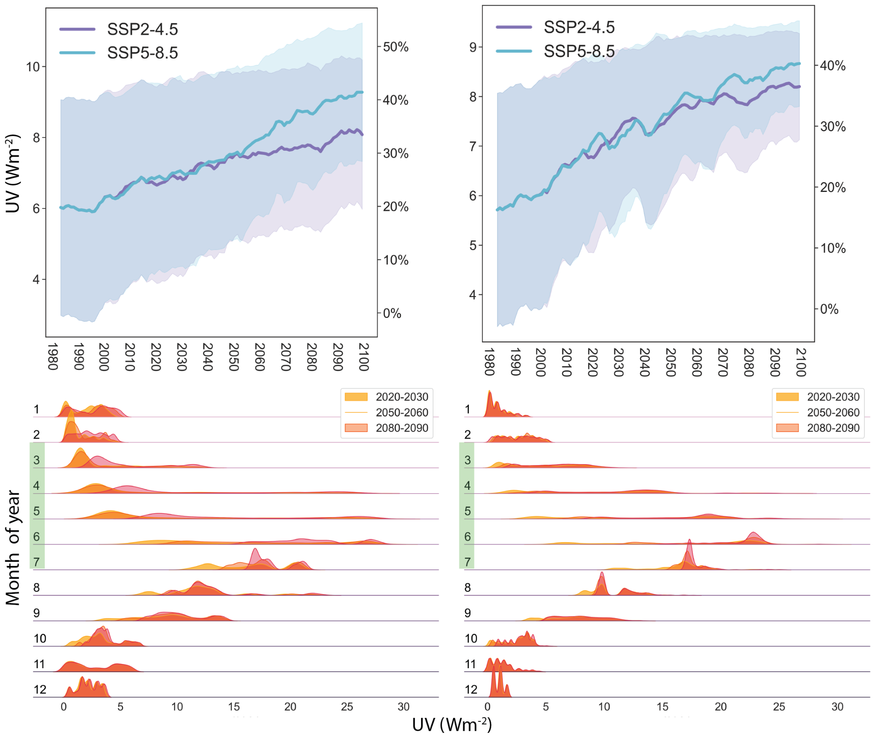
Figure S4: Temporal changes in UV. Upper panels: Expected changes in UV (Wm⁻²) light in the ocean for the Eastern Bering (left), Northern Bering/Chukchi LME (middle), and the Barents Sea LME (right) for two scenarios of climate change, SSP2-4.5 (blue) and SSP5-8.5 (orange). Average values are shown as thicker lines with a 95th percentile confidence interval in shading and values are averaged across the LME with a 5-year rolling mean applied. The scale on the right show changes (%) relative to historical values (1980-2000). Lower panels: Monthly averaged distribution of UV for three time periods 2020-2030, 2050-2060, and 2080-2090 for the areas of the Eastern Bering Sea, the Northern Bering/Chukchi Sea, and Barents Sea LMEs. The Gaussian probability distributions can cause values to be less than zero.

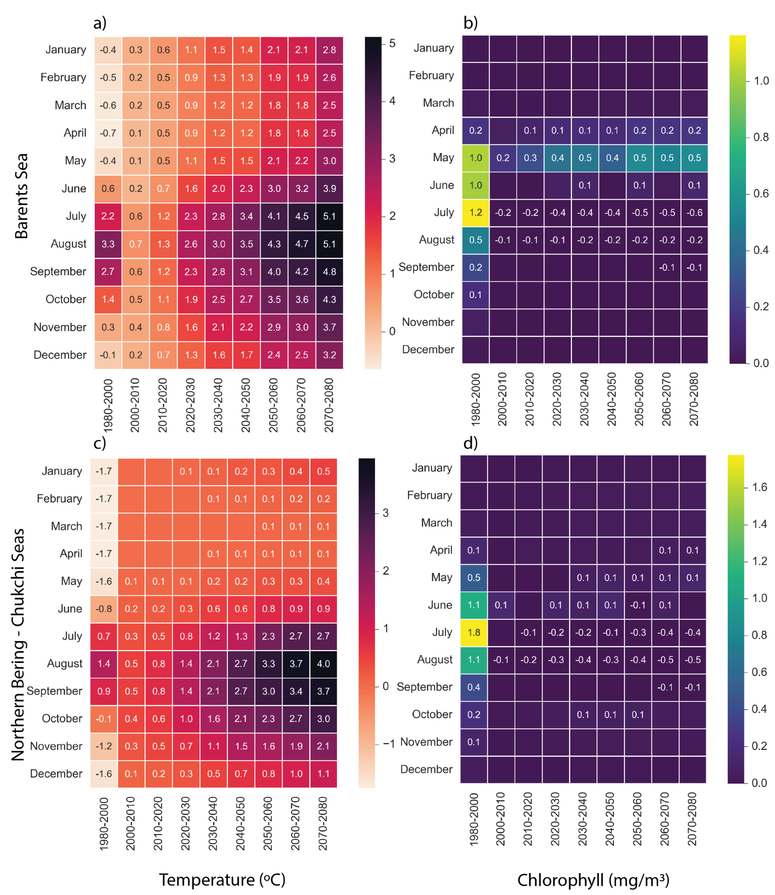
Figure S5: Expected changes in temperature and chlorophyll abundance under SSP2-4.5. Heatmaps show the historical (1980-2000) monthly mean (leftmost column of each heatmap) and future decadal average changes in temperature (ºC) in (a) the Barents Sea and (b) Northern Bering/Chukchi Sea and chlorophyll (mg/m³) for (c) Barents and (d) Northern Bering/Chukchi Seas under SSP2-4.5. Changes relative to historical values (1980-2000) are shown for each decade between 2000-2090 at 10-year intervals. Months with no change relative to historical values have no annotated value.

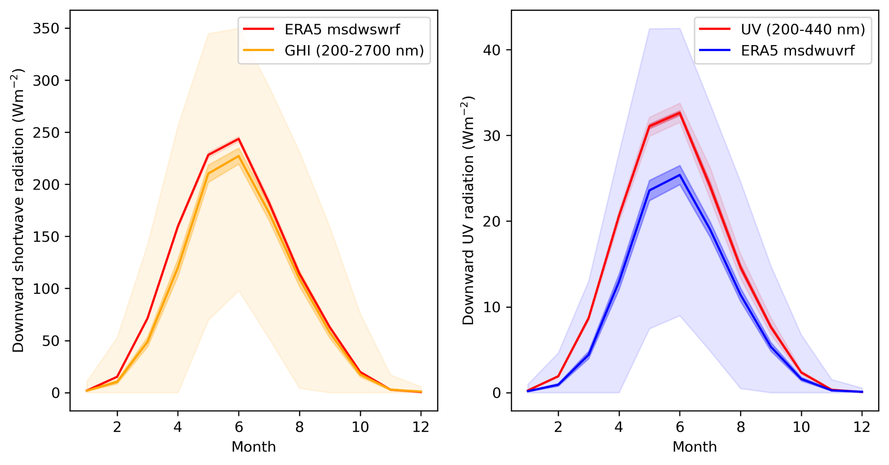
Figure S6: Comparison ERA5 and calculated shortwave radiation Northern Bering/Chukchi Sea. Calculated incoming shortwave radiation (GHI, 200-2700 nm) using historical CMIP6 model results compared with ERA5 mean downward shortwave radiation at the surface (msdwswsrf) for the Northern Bering/Chukchi Sea LME (left). On the right is the calculated UV (280-440 nm) irradiance compared with the ERA5 equivalent mean shortwave downward UV at the surface (msdwuvrf). Darker shaded areas indicate the 95% confidence interval, while the transparent larger shaded area indicates the 1-99% percentiles of the GHI and UV.

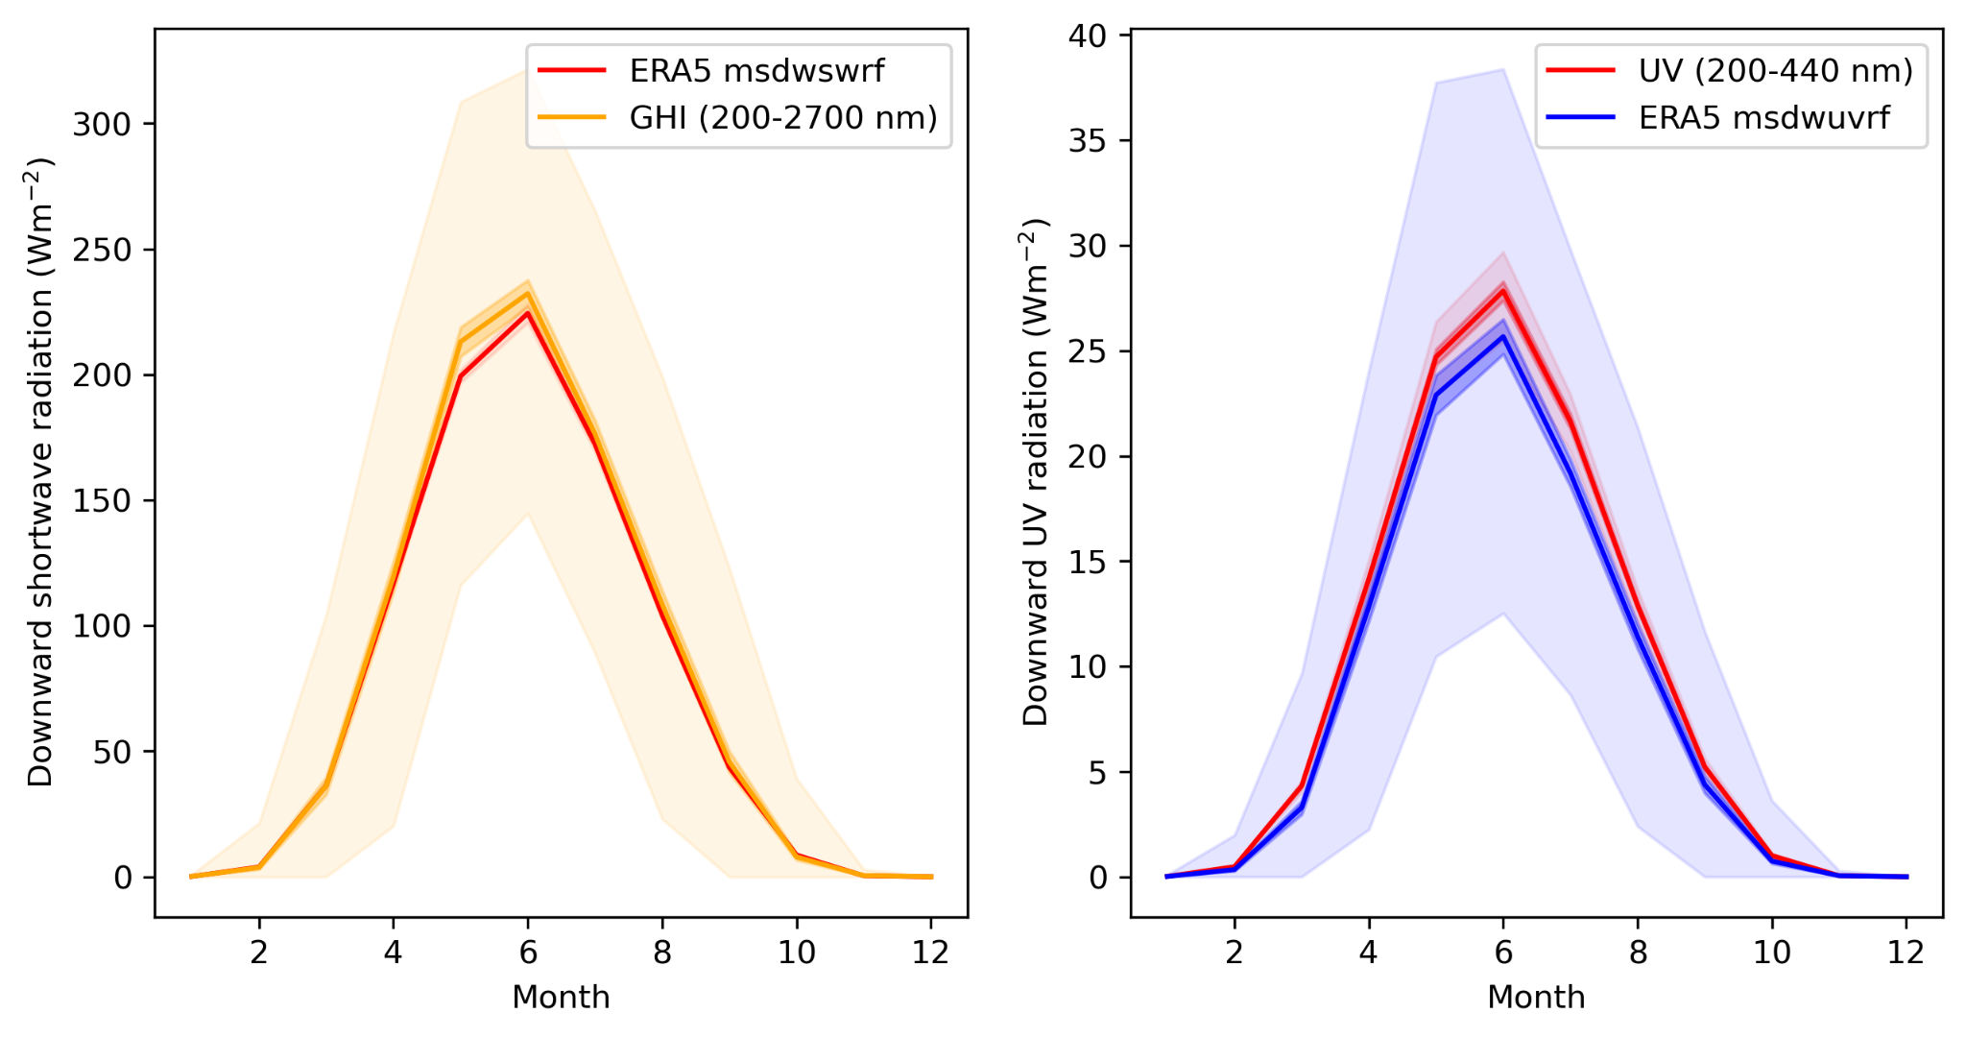
Figure S7: Comparison ERA5 and calculated shortwave radiation Barents Sea. Calculated incoming shortwave radiation (GHI, 200-2700 nm) using historical CMIP6 model results compared with ERA5 mean downward shortwave radiation at the surface (msdwswsrf) for the Barents Sea LME (left). On the right is the calculated UV (280-440 nm) irradiance compared with the ERA5 equivalent mean shortwave downward UV at the surface (msdwuvrf). Strongly shaded areas indicate the 95% confidence interval, while the transparent larger shaded area indicates the 1-99% percentiles of the GHI and UV.

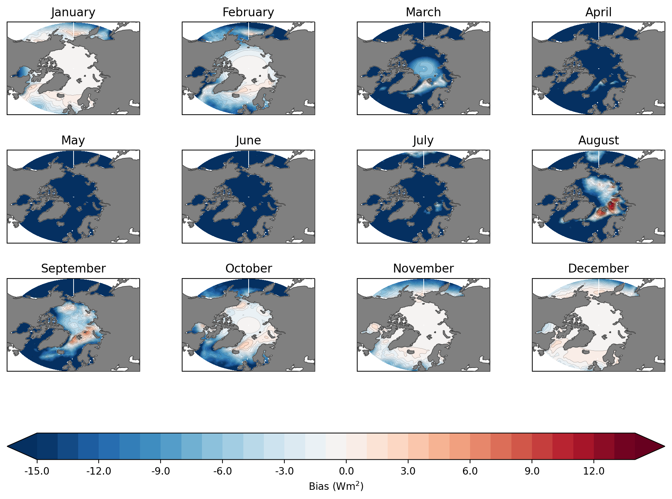Figure S8: Bias shortwave radiation (GHI) between ERA5 and model. Calculated bias (W/m2) in incoming shortwave radiation (GHI, 200-2700 nm) between historical CMIP6 model results compared with ERA5 mean downward shortwave radiation at the surface (msdwswsrf) North of 40ºN for the period 1979-2020.

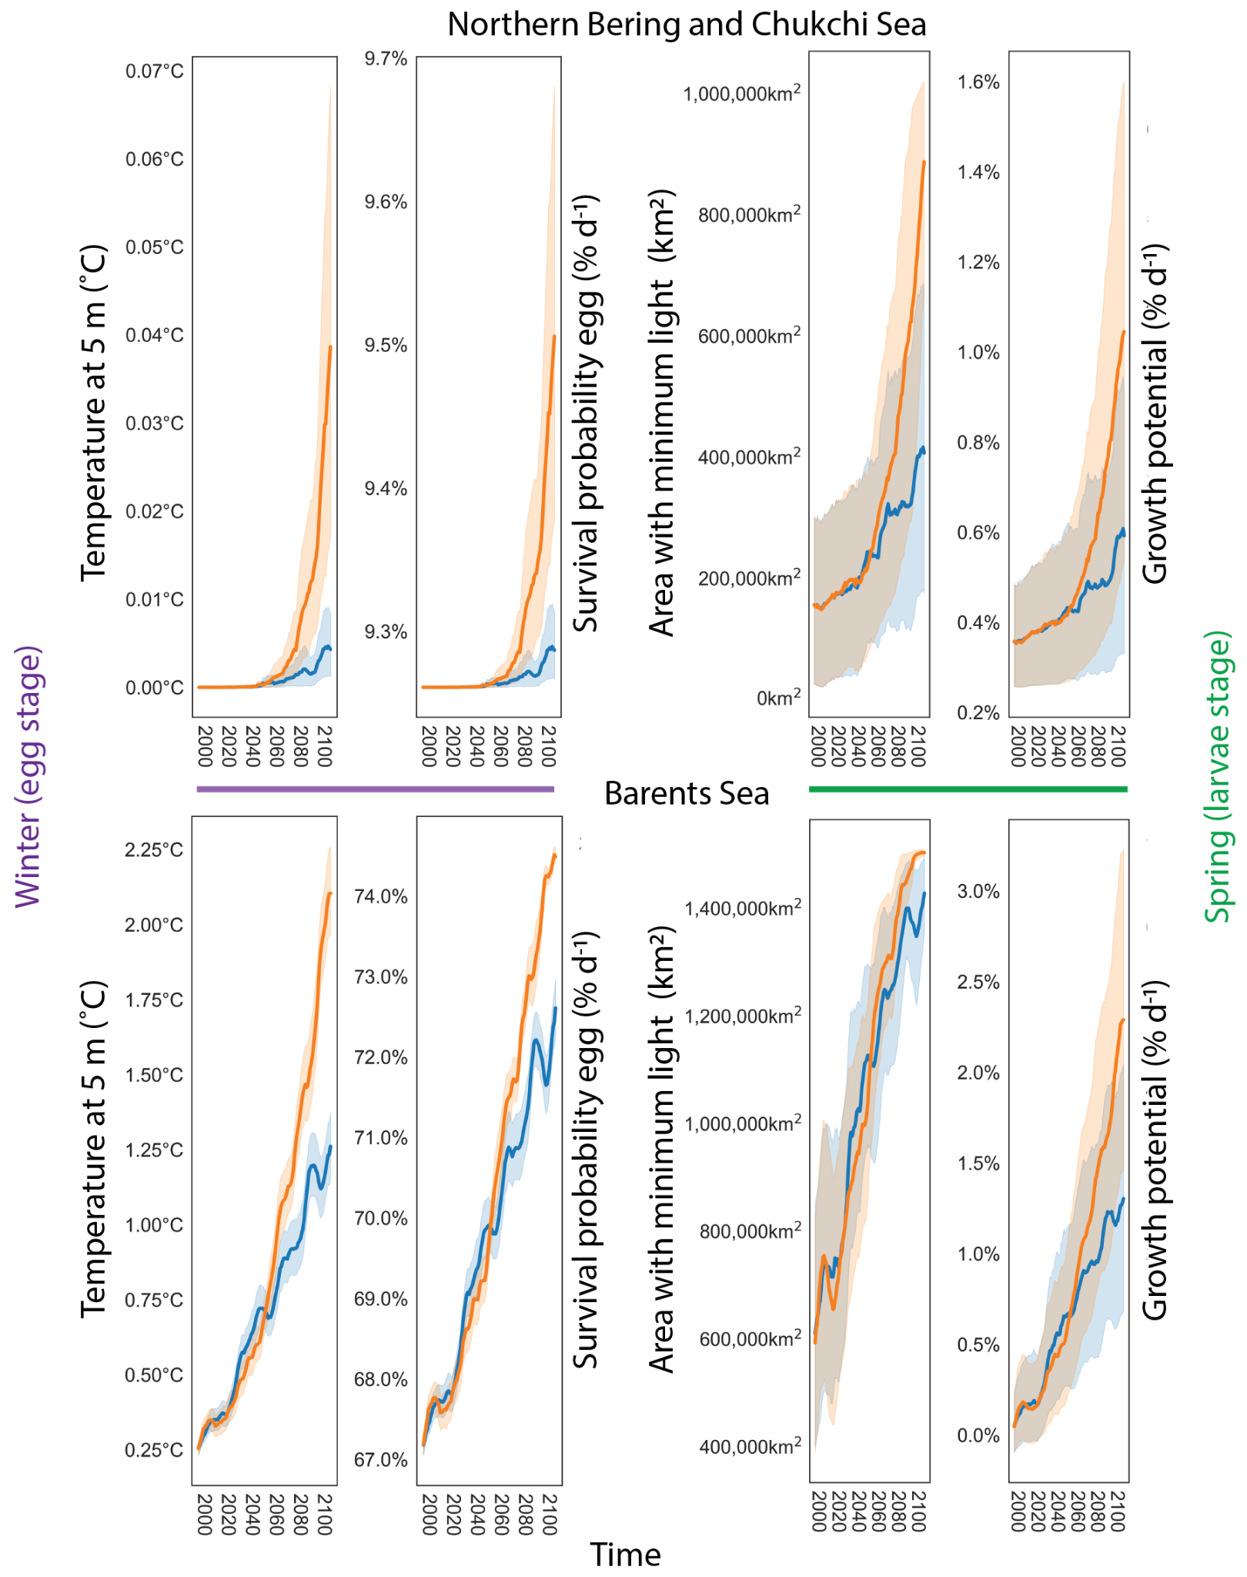
Figure S9: Impacts of temperature and light on the egg survival and larval growth potential for Walleye pollock and Atlantic Cod. Northern Bering/Chukchi Sea (Walleye pollock, top panels) and Barents Sea (Atlantic cod, lower panels): Left panels show ocean temperature (ºC) at 5 m depth and potential egg survival (% d ⁻¹) during winter (Jan, Feb, Mar). The right panels show the percent change in open water with a minimum PAR threshold required for larval visual feeding at 5 m depth and juvenile growth potential during spring (Apr, May, Jun) (% d ⁻¹) of Pacific cod (upper panel) and Atlantic cod (lower panel). Thick lines show the average values across all winter or spring months for each scenario SSP2-4.5 (blue) and SSP5-8.5 (orange) while shaded regions show the 95th percentile within the winter/spring months. Survival during the egg stage and growth potential was calculated using functional relationships from laboratory studies and observations^{44,45}.

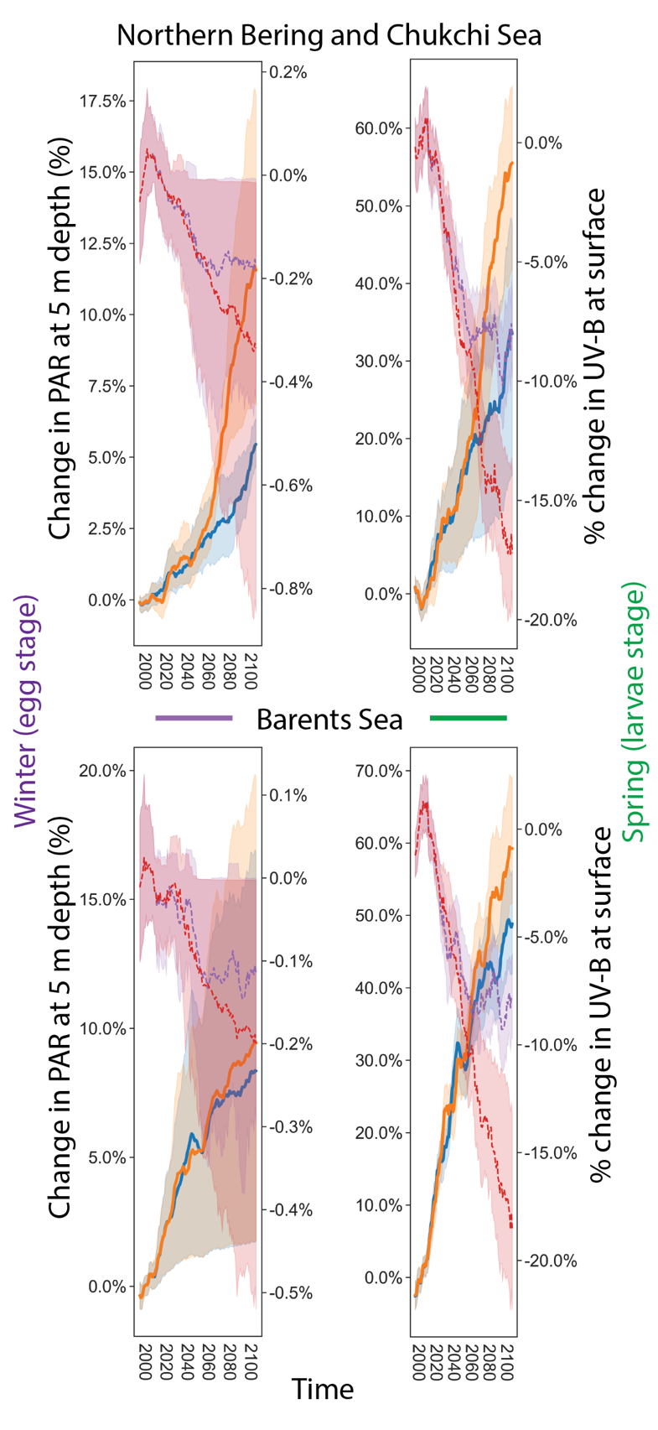
Figure S10: Temporal changes in PAR and UV-B at 5 m depths. Northern Bering/Chukchi (top panels) and Barents Seas (lower panels): Left panels show percent change (%, left axis) in visible light (PAR) for each scenario SSP2-4.5 (blue) and SSP5-8.5 (orange) at 5 m depth relative the 1980-2000 average for the winter months (Jan, Feb, Mar) assuming an attenuation coefficient of k=0.18. The right axis shows the percent relative change in UV-B irradiance at the surface (purple color, %) relative to 1980-2000. The right panel shows similar to the left but for spring months (Apr, May, Jun). Thick lines show the 5-year running mean across all winter or spring months for each scenario SSP2-4.5 (blue, purple) and SSP5-8.5 (orange, red) while shaded regions show the 95th percentile within the winter/spring months.

1. Ziehn, T. et al. The Australian Earth System Model: ACCESS-ESM1.5. doi:10.1071/ES19035.
2. Swart, N. C. et al. The Canadian Earth System Model version 5 (CanESM5.0.3). Geosci. Model Dev. 12, 4823–4873 (2019).
3. Mauritsen, T. et al. Developments in the MPI-M Earth System Model version 1.2 (MPI-ESM1.2) and Its Response to Increasing CO2. J Adv Model Earth Syst 11, 998–1038 (2019).
4. Sellar, A. A. et al. UKESM1: Description and evaluation of the U.k. earth system model. J. Adv. Model. Earth Syst. 11, 4513–4558 (2019).
5. McCrystall, M. R., Stroeve, J., Serreze, M., Forbes, B. C. & Screen, J. A. New climate models reveal faster and larger increases in Arctic precipitation than previously projected. Nat. Commun. 12, 6765 (2021).
6. Dai, A., Luo, D., Song, M. & Liu, J. Arctic amplification is caused by sea-ice loss under increasing CO2. Nat. Commun. 10, 121 (2019).

