Supplementary material

Details on drop-out ratio during the testing process
Sample 1
People who did not complete the experiment were most likely to drop out by not completing the microphone test (85 participants:44% of drop out, 11.7% of the original sample). Of these, 28 participants left the experiment before the start of the microphone test (14.5% of drop out, 3.9% of the original sample). There were two participants who recorded that their microphone did not work (1.04% of drop out, 0.1% of the original sample). Sixty-two participants left during the speech task (32.1% of drop out, 8.6% of the original sample) whereas another sixteen participants left after they had completed the speech task (8.3% of drop out, 2.2% of the original sample; Figure 1).
Sample 2
Participants who did not complete the experiment were most likely to drop out before the microphone test (11 participants (44% of drop out, 6% of the original sample). There were no participants who recorded that their microphone did not work but six participants exited the experiment during the microphone test (24% of drop out, 4.7% of the original sample). Six participants left during the speech task (24% of drop out, 4.7% of the original sample). Two participants left after they had completed the speech task (8% of drop out, 1.2% of the original sample) (Figure 1).

Feasibility markers
 | Sample1 |  | Sample2
N | 723 |  | 181
Drop out | 193 (26.7%) |  | 25 (13.8%)
 | % of drop out | % of original sample | % of drop out | % of original sample
Before microphone test | 14.5% | 3.9% | 44% | 6%
At microphone test | 44% | 11.7% | 24% | 4.7%
Microphone does not work | 1.04% | 0.1% | 0% | 0%
At speech description task | 32.1% | 8.6% | 24% | 4.7%
After speech task | 8.3% | 2.2% | 8% | 1.2%
 | N | % of original sample | N | % of original sample
Excluded bad quality recordings | 84 | 11.6% | 12 | 6.6%

Table 1
Feasibility markers

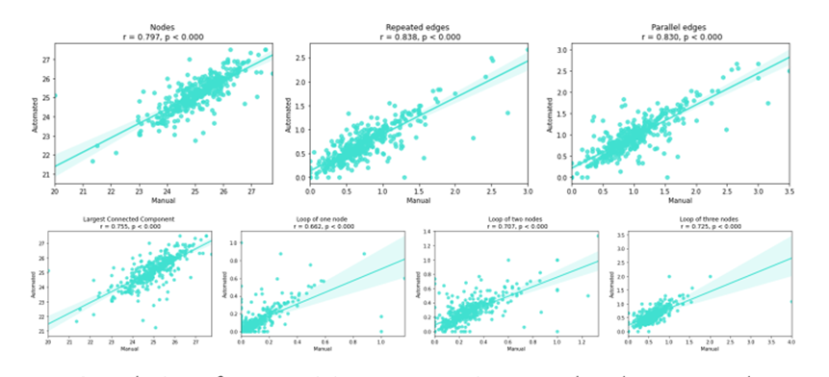

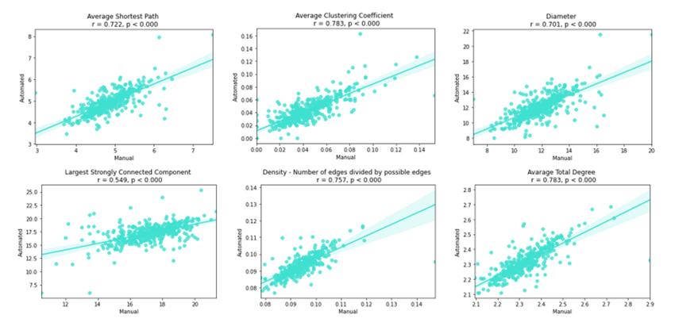

Figure 1
Correlations of speech connectivity markers in automated and manual transcriptions, Sample 1

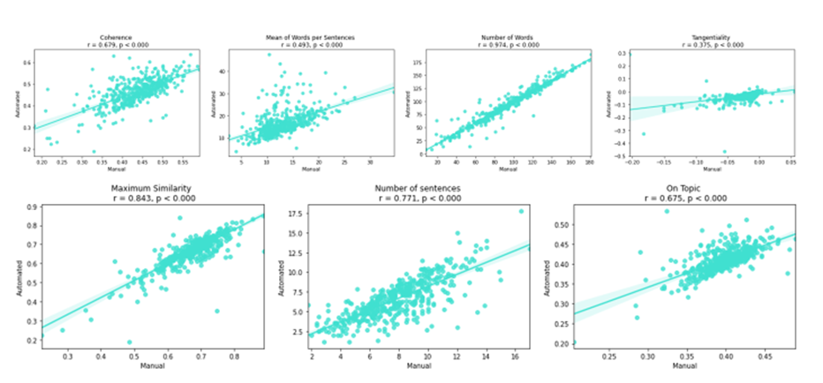

Figure 2
Correlations of semantic coherence markers in automated and manual transcriptions, Sample 1

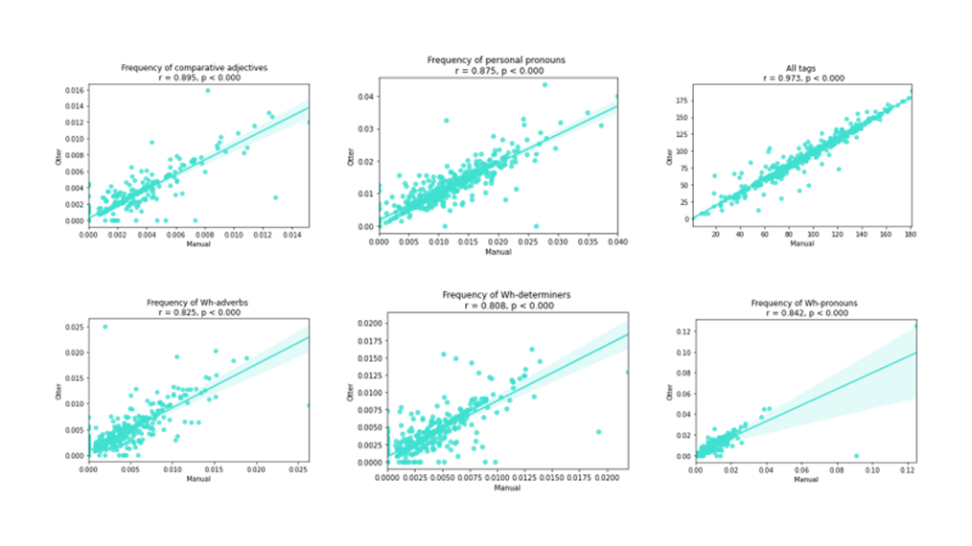

Figure 3
Correlations of syntactic markers in automated and manual transcriptions, Sample 1

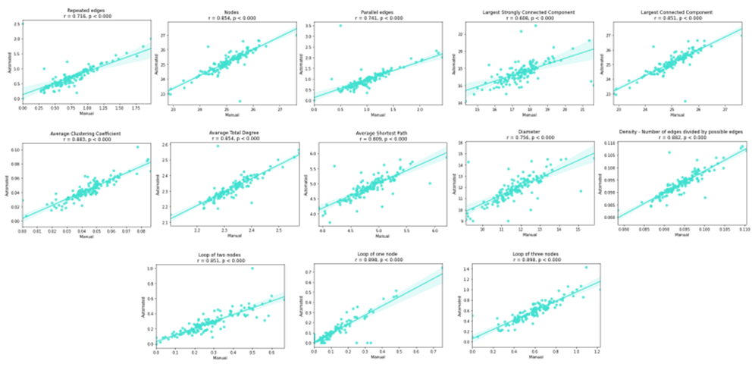

Figure 4
Correlations of speech connectivity markers in automated and manual transcriptions, Sample 2

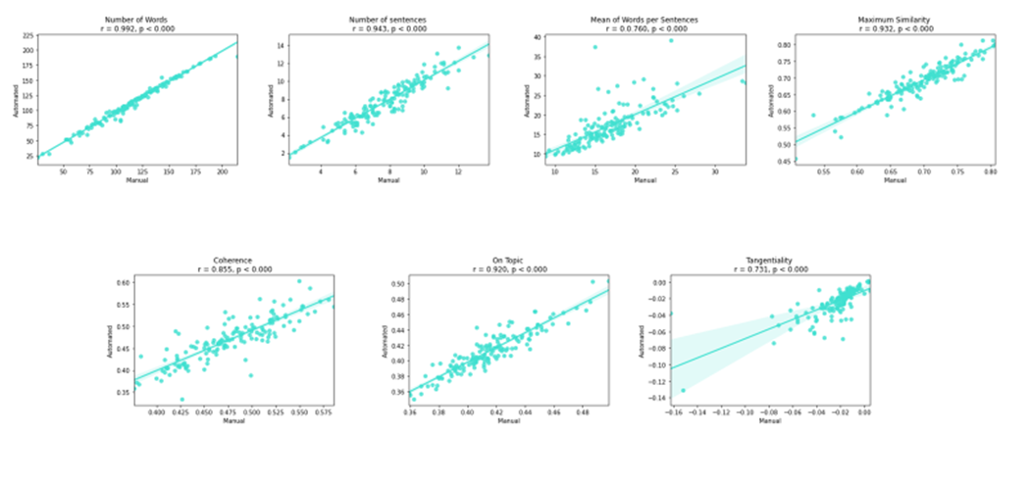

Figure 5
Correlations of semantic coherence markers in automated and manual transcriptions, Sample 2

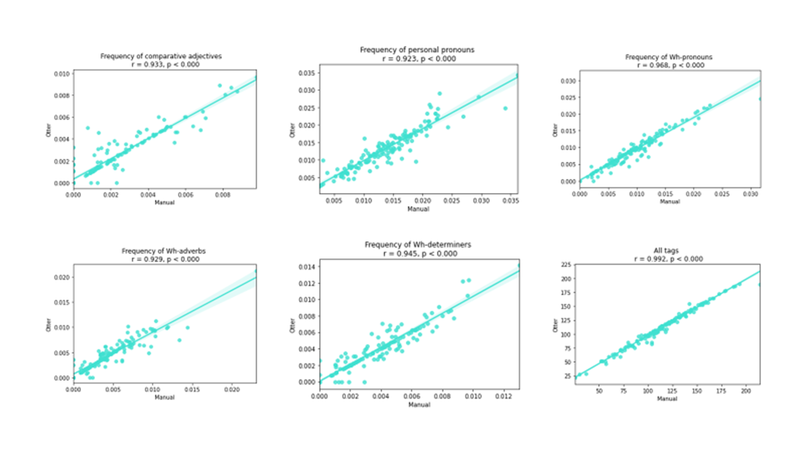

Figure 6
Correlations of syntactic markers in automated and manual transcriptions, Sample 2

Relation of speech markers with demographic measures

Age

Significant relationship between speech markers and age
Sample 1
Manual transcriptions | Automated transcripts
Loop of one node (r = 0.113) | Frequency of Wh-adverbs (r = - 0.105)
Largest Strongly Connected Component  (r = 0.105) | Frequency of personal pronouns (r = 0.100)
Average Clustering Coefficient (r = 0.095)
Frequency of Wh-determiners measures
(r = -0.096)
Sample 2
Nodes (r = 0.182) | Number of sentences (r = 0.213)
Largest Connected Component  (r = 0.180) | Mean of words per sentences (r = - 0.208)
Largest Strongly Connected Component  (r = - 0.201) | Coherence (r = - 0.183)
Average Total Degree (r = - 0.170) | Tangentiality (r = 0.222)
Density (r = - 0.170) | Frequency of Wh-pronouns (r = 0.244)
Diameter (r = 0.214)
Average Shortest Path (r = 0.208)
Frequency of Wh-determiners (r = -0.165)
Frequency of Wh-pronouns (r = 0.199)

Table 2
Significant relationship between speech markers and age

Education

Significant relationship between speech markers and education level
Sample 1
Manual transcriptions | Automated transcripts
All tags ( r = 0.113) | All tags (r = 0.127)
Number of Words (r = 0.129) | Number of Words (r = 0.129)
Nodes (r = -0.118) | Nodes (r = - 0.137)
Largest Connected Component (r = - 0.116) | Largest Connected Component (r = - 0.147)
Average Total Degree (r = 0.119) | Average Total Degree (r = 0.120)
Density (r = 0.126) | Density (r = 0.122)
Diameter (r = - 0.149) | Diameter (r = - 0.135)
Average Shortest Path (r = - 0.158) | Average Shortest Path (r = - 0.141)
Mean Number of Words /Sentences  (r = 0.114) | Loop of two nodes (r = 0.113)
Sample 2
Frequency of Wh-pronouns (r = - 0.193) | Frequency of Wh-pronouns (r = - 0.212)

Table 3
Significant relationship between speech markers and education level

Gender

Significant differences in speech markers between genders
Sample 1
Manual transcriptions | Automated transcripts
Number of words (t = -2.386) | Number of words (t = -2.491)
All tags (t = -2.437) | All tags (t = -2.404)
Largest Strongly Connected Component
(t = -2.429)
 | Number of Sentences (t = -3.846)
Sample 2
Loop of one node (t = 4.936) | Loop of one node (t = 4.315)
 | Mean Words per Sentences ( t = 2.774)

Table 4
Significant differences in speech markers between genders

Correlation of speech markers with each other

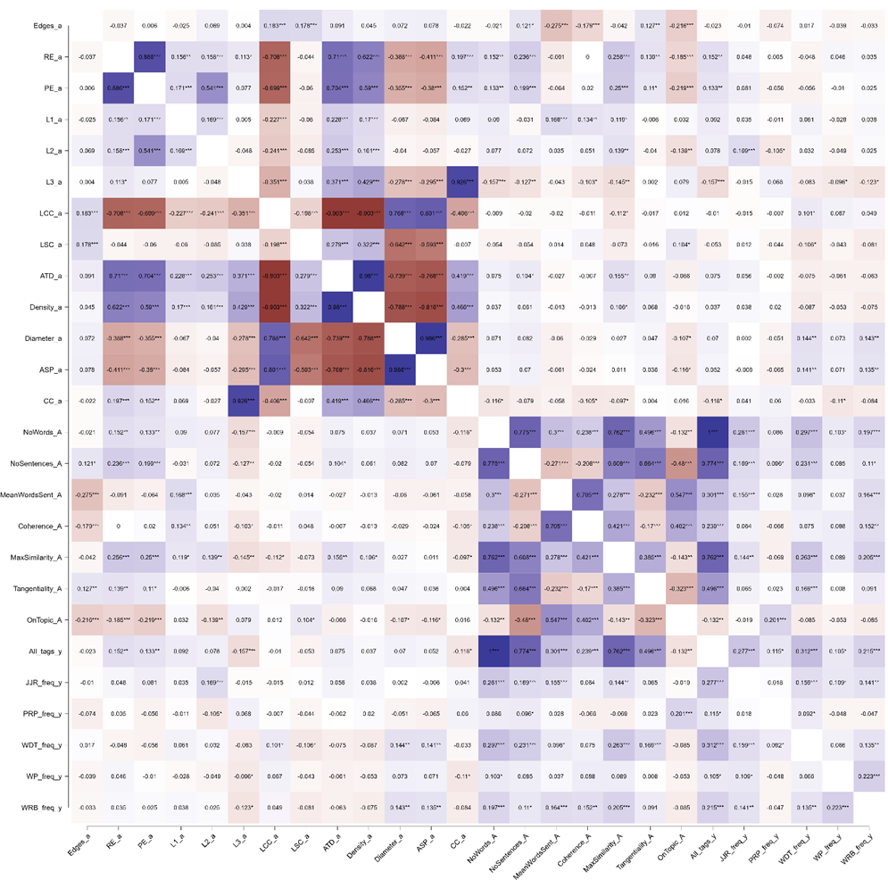
Figure 7
Correlation of speech features with each other in Sample 1
Spearman's rho heatmap

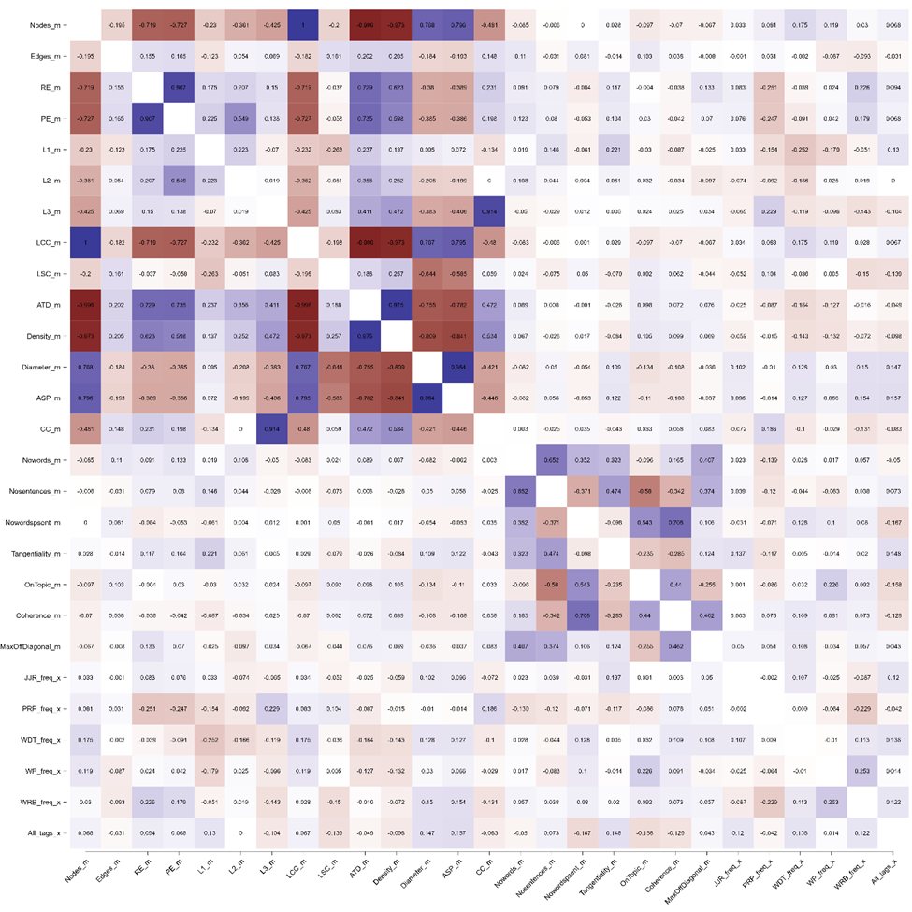

Figure 8
Correlation of speech features with each other in Sample 2
Spearman's rho heatmap

