Supplementary Information
for
Proton motive force dissipation drives flavodiiron proteins to the thylakoid membrane for ferredoxin-powered O₂ photoreduction
Lauri Nikkanen, Serhii Vakal, Anita Santana-Sánchez, Michal Hubacek, Yingying Wang, Marko Böhm, Kirstin Gutekunst, Tiina A. Salminen, and Yagut Allahverdiyeva

Including:
Supplementary Figures 1–13
Supplemenatry Table 1

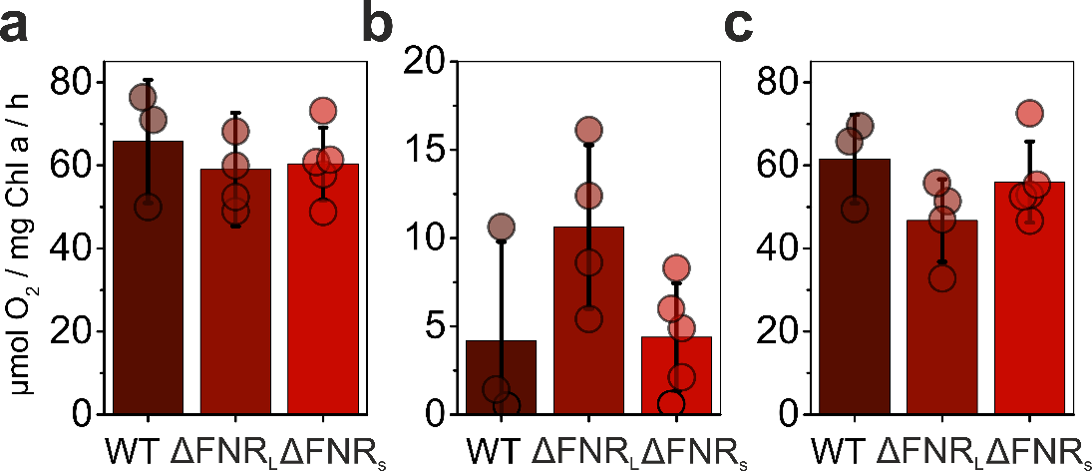
Supplementary Figure 1. Dissection of O₂ uptake in FNR mutant strains with MIMS. (A) Total O₂ uptake maximum at the peak during the first minute of illumination. (B) Dark respiration, measured as the average O₂ uptake during 2 min in darkness. (C) Maximum O₂ photoreduction (C=A-B). Values are from the same MIMS experiments as those in Figure 1B, and are averages of 3 (WT), 4 (ΔFNR_{L}), and 5 (ΔFNR_{S}) biological replicates +/- standard deviation. Individual replicate data points are shown as circles.

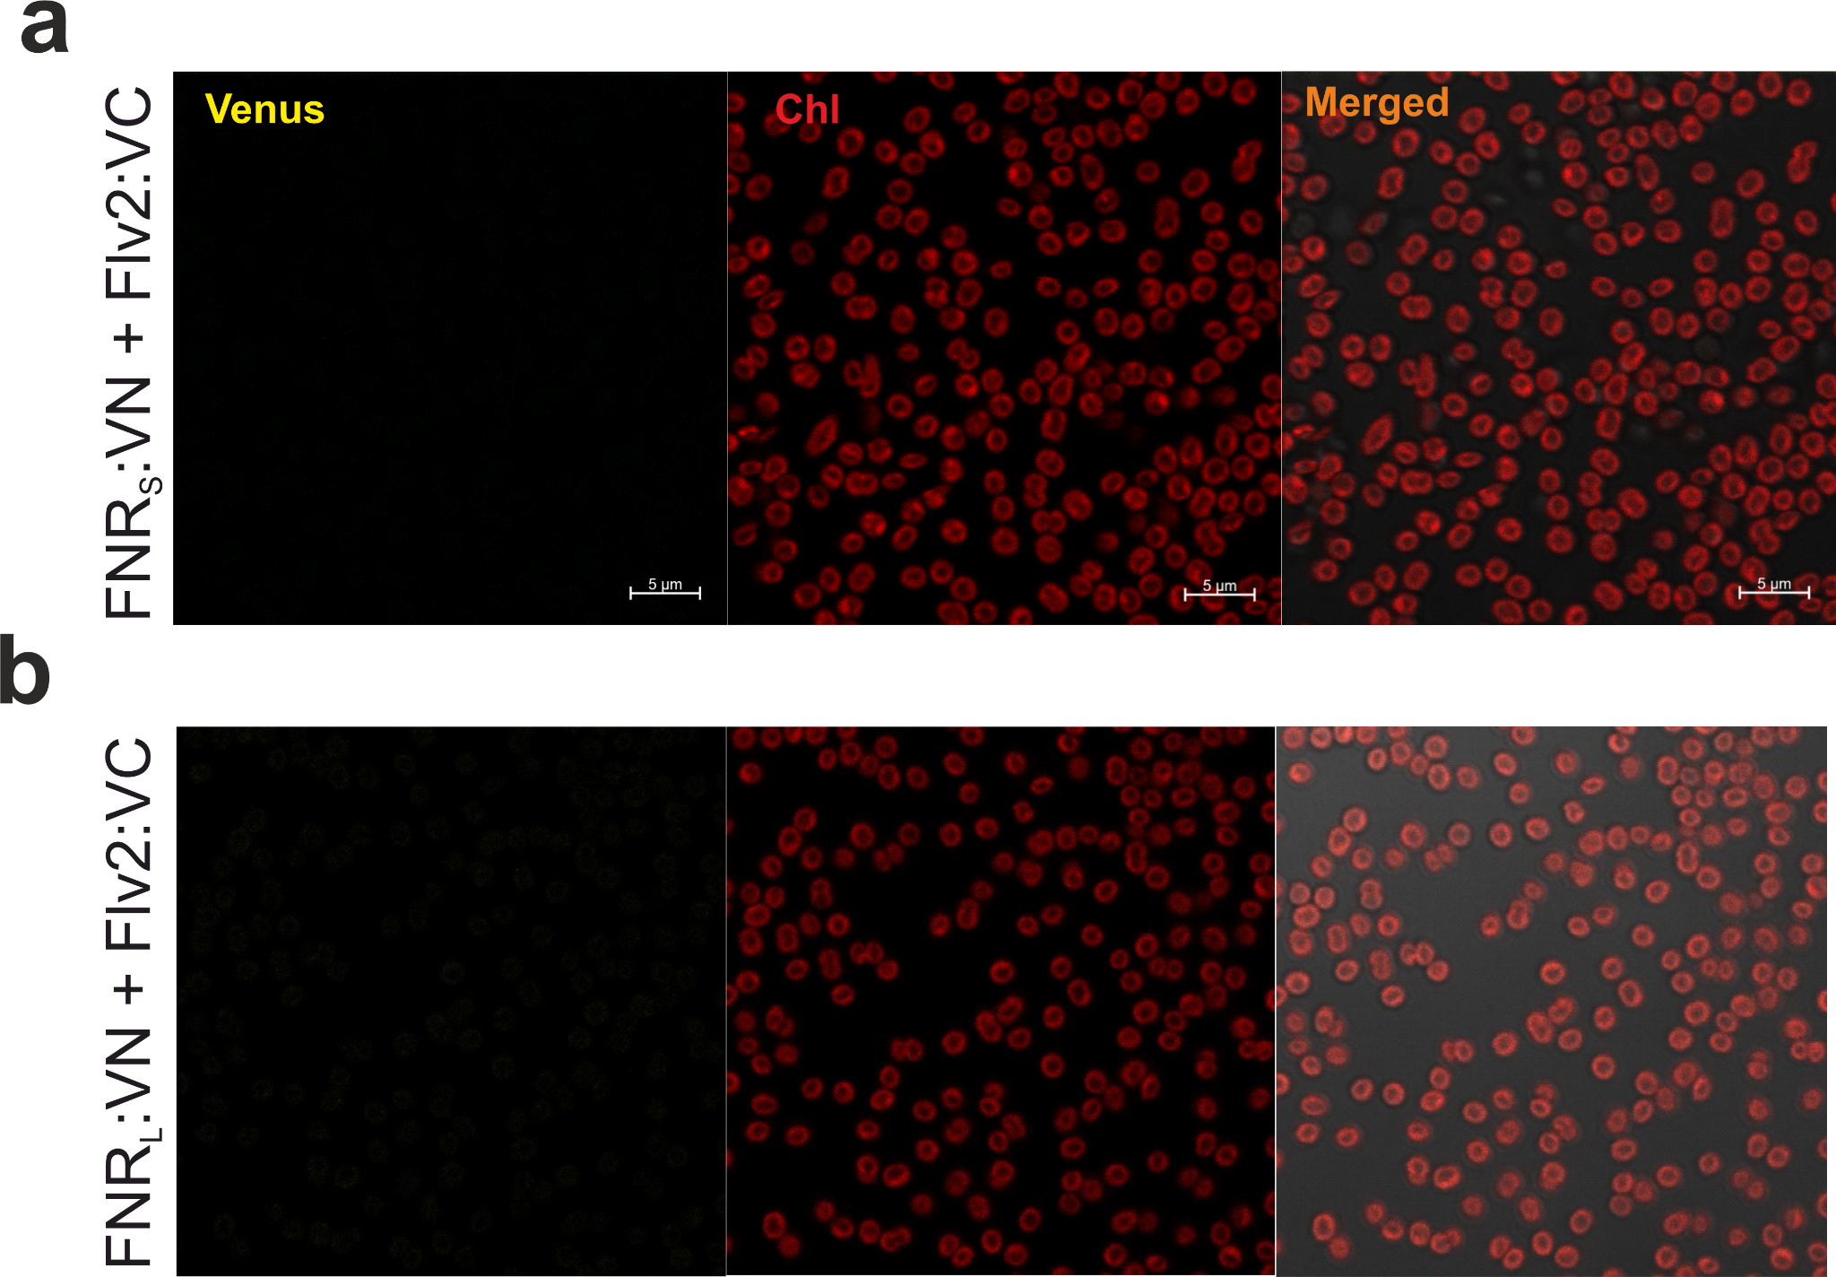
Supplementary Figure 2. BiFC tests between FNR and Flv2. Representative confocal micrographs from 3 independent experiments are presented, showing chlorophyll a (Chl) autofluorescence emanating from the thylakoid membranes in the left panel, fluorescence from re-assembled Venus I152L fluorescent proteins in the middle, and overlaid Chl and Venus fluorescence on the right panel. (a) BiFC test between FNR_{S}:VN and Flv:VC. (b) BiFC test between FNR_{L}:VN and Flv2::VC.

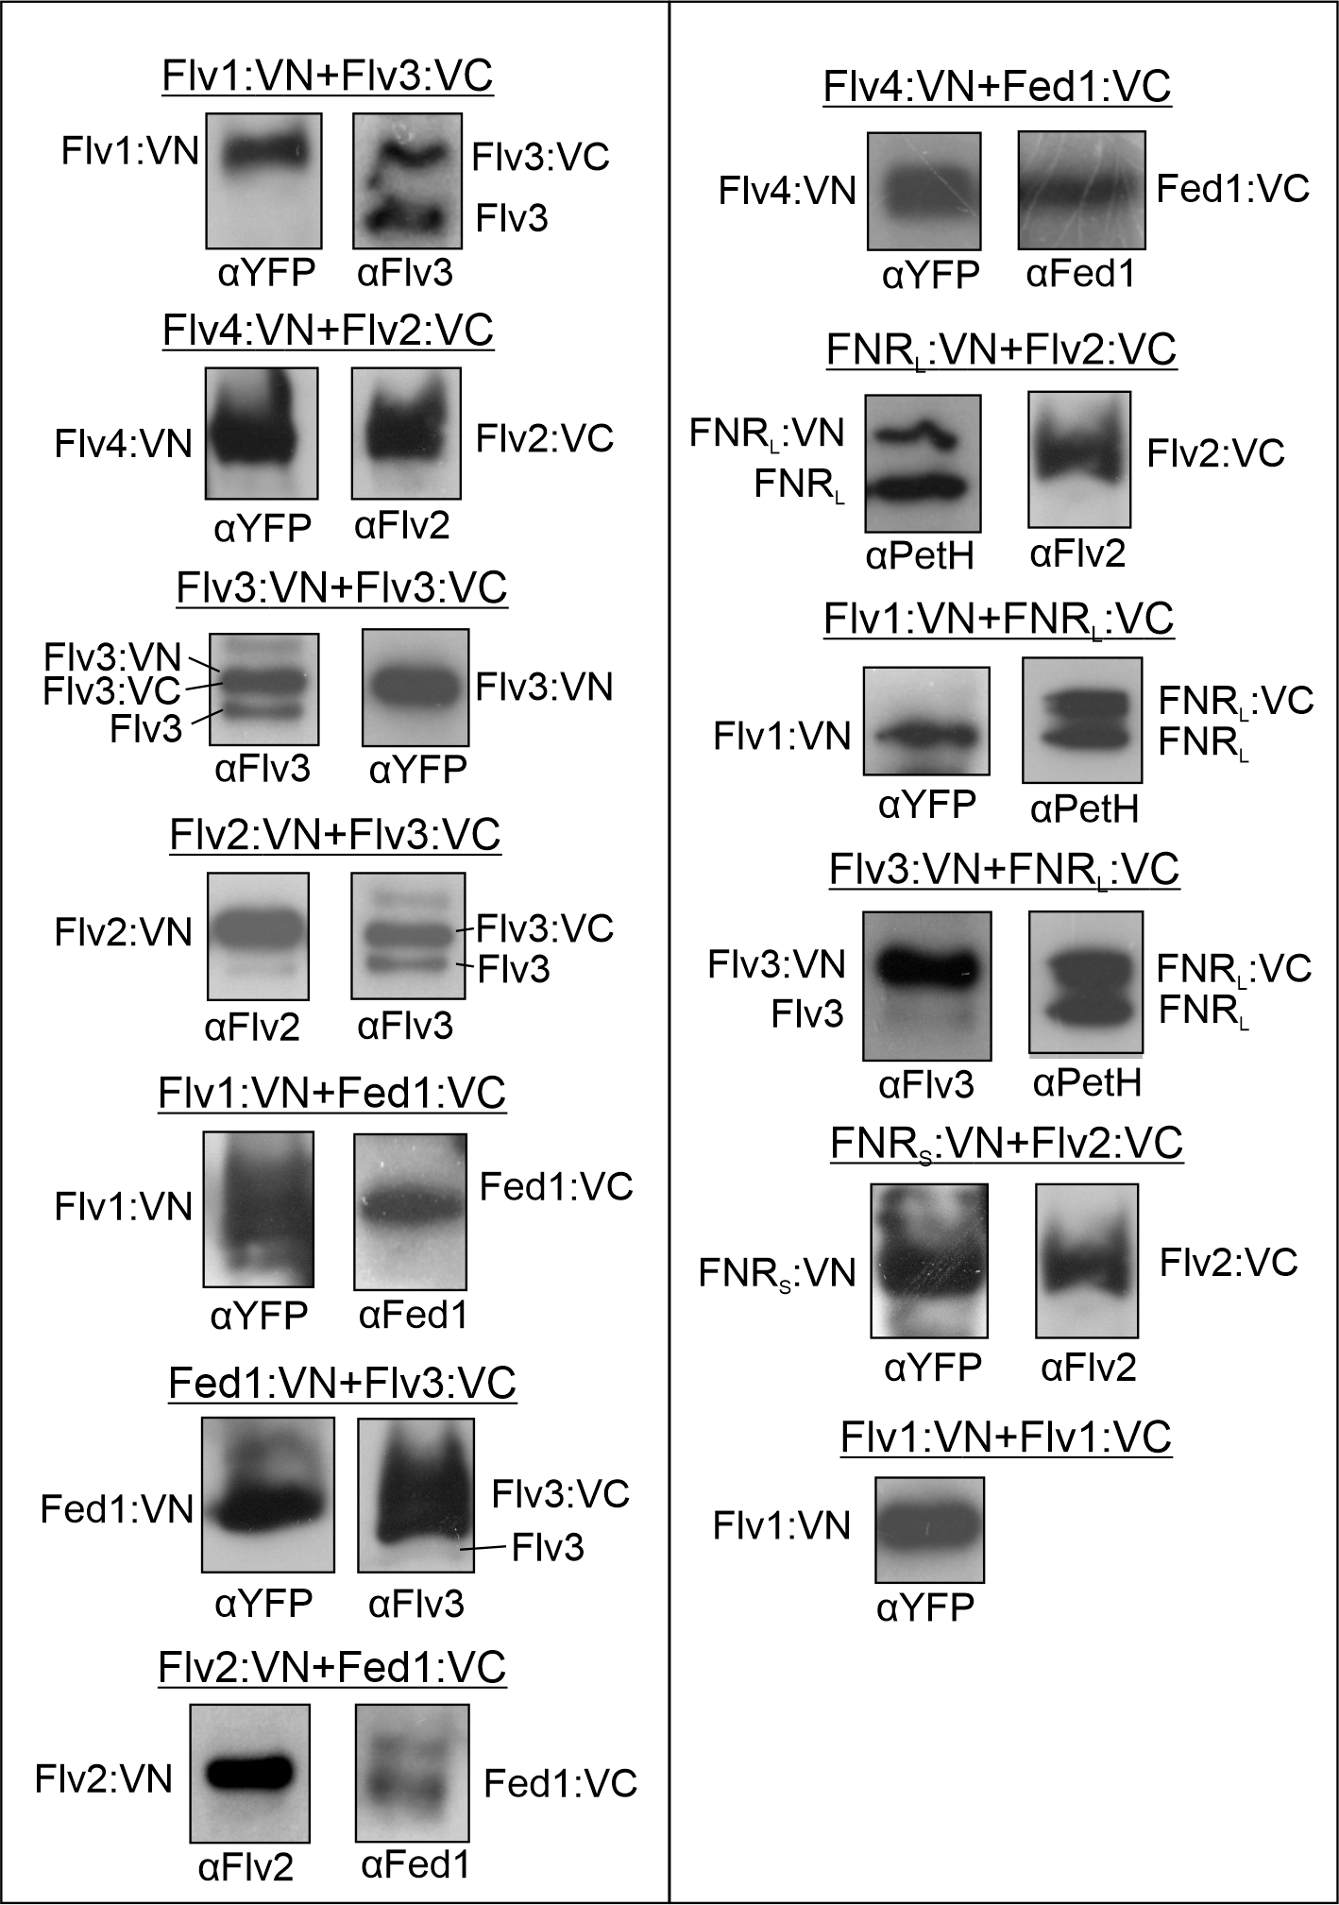
Supplementary Figure 3. Verification of expression of BiFC fusion constructs by immunoblotting. Total proteins were extracted from samples used for BiFC experiments, separated by SDS-PAGE and probed with specific antibodies. The blot for Flv1:VC is missing due to lack of a reliable antibody against Flv1. For full-sized Western blots, see the Source Data.

a
b
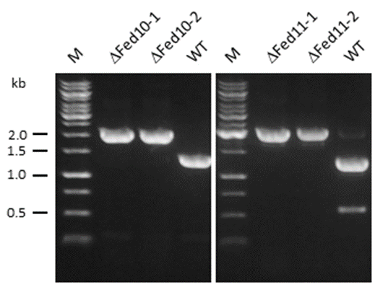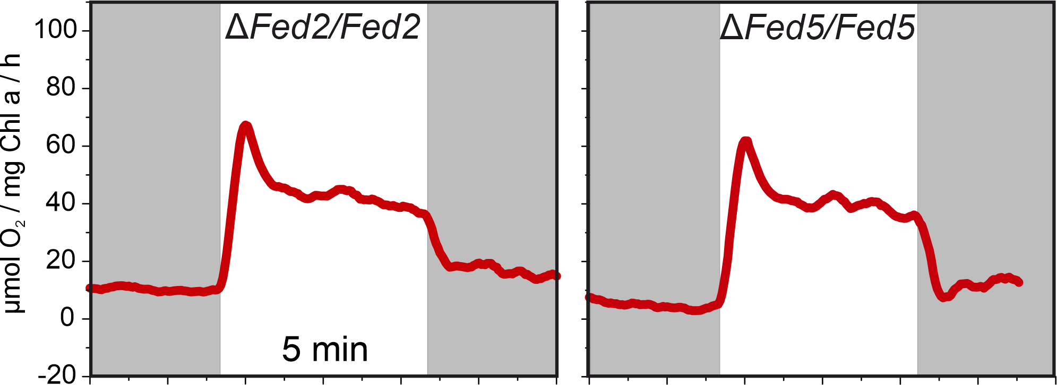
Supplementary Figure 4. Characterisation of Fed mutants. (a) PCR analysis of the ΔFed10 and ΔFed11 mutant strains and the wild type (WT). (b) Light-induced O₂ uptake in partially segregated Fed2 and Fed5-deficient cells. Experiments were performed as in Figures 1 and 2.

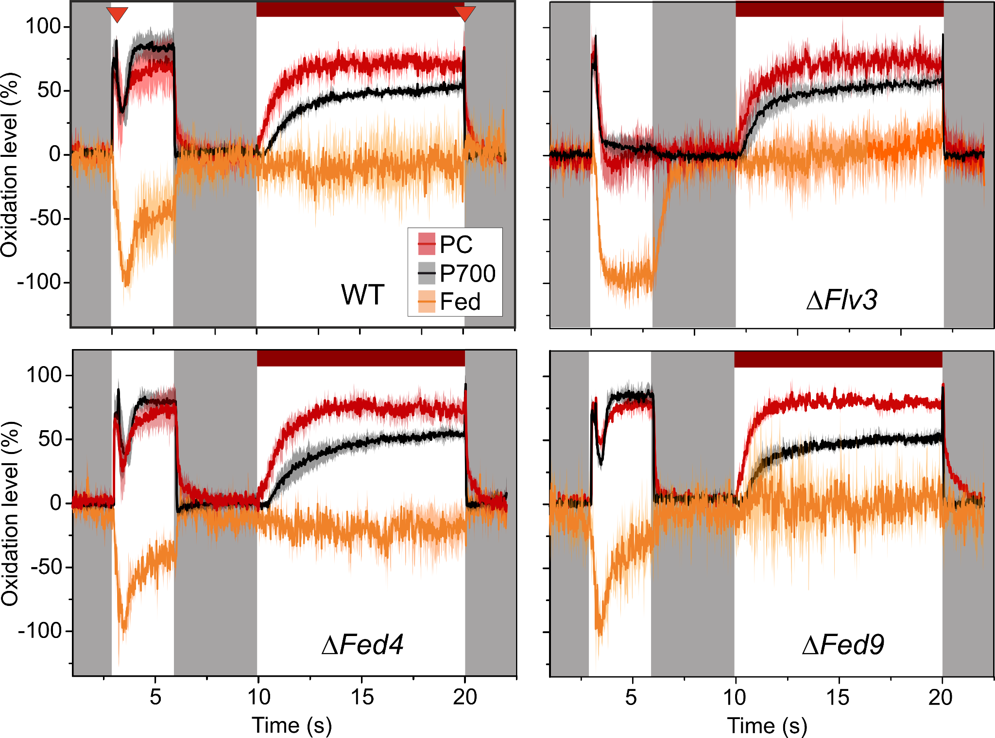
Supplementary Figure 5. Redox changes of PC, P700, and Fed in WT, ∆Fed4, ∆Fed9 and ∆Flv3 cells. Cells grown in air level CO₂ concentration for 4 days were harvested and resuspended in fresh BG-11 pH 7.5 with Chl concentration adjusted to 15 µg/ml. PC, P700, and Fed redox changes were deconvoluted from near-infrared absorbance differences measured with a DUAL-KLAS-NIR spectrophotometer. A modified NIRMAX protocol was used, consisting of a 3 s illumination with 1750 µmol photons m⁻²s⁻¹ actinic with a multiple turnover pulse after 200 ms (indicated by the red triangle in the WT panel) to fully reduce the Fed pool, 3 s darkness, followed by 10 s of illumination under far red light with another multiple turnover flash at the end of the illumination period to fully oxidise P700 and PC. The traces are normalised to the maximal oxidation values of PC and P700 and maximal reduction of Fed. Averaged traces from 3 biological replicates are shown, with standard deviation as the shadowed area.

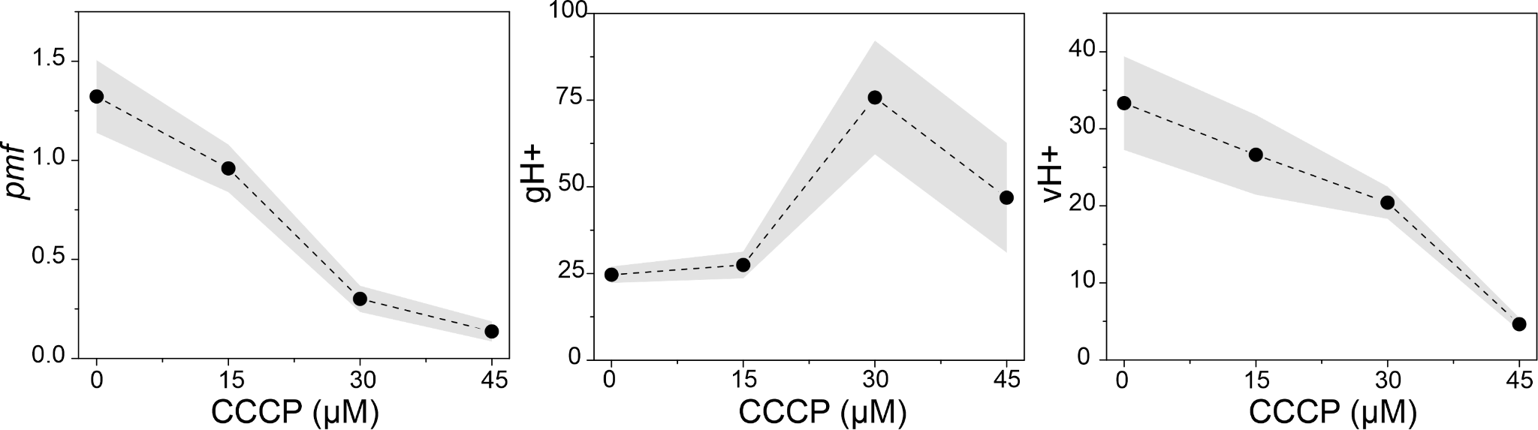
Supplementary Figure 6. Effect of CCCP on the pmf in Synechocystis. The magnitude of the pmf was determined from the dark interval relaxation kinetics (DIRK) of the ECS signal after illuminating WT Synechocystis cells for 27 s at 500 µmol photons m⁻² s⁻¹ in the presence of 0, 15, 30, or 45 µM CCCP. Pmf is the extent of ECS signal decay during a DIRK, thylakoid proton conductivity (gH+) is the inverse of the time constant of a first order fit to DIRK kinetics, and thylakoid proton flux (vH+) is calculated as pmf*gH+. The values shown are averages from 3 (15 µM CCCP) or 4 (0, 30, and 45 µM CCCP) biological replicates +/- SEM.

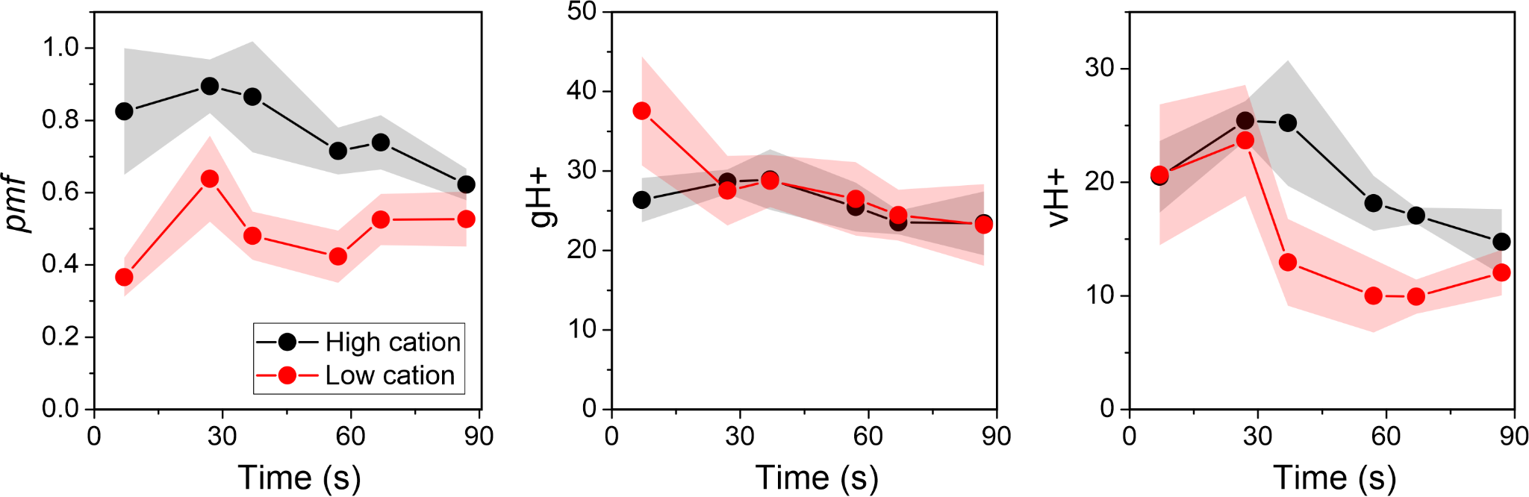
Supplementary Figure 7. Generation of the pmf, thylakoid conductivity (gH+), and proton flux (vH+) during dark-to-light transitions in low vs high cation concentration. Dark-adapted WT Synechocystis cells grown for in BG-11 pH 7.5 in 3% CO₂ under 50 µmol photons m⁻² s⁻¹ were harvested and resuspended in fresh BG-11 medium containing either now added source of Mg²⁺ and Ca²⁺ (low cation) or in BG-11 supplemented with 25 mM MgCl₂ and 30mM CaCl₂ (high cation). Suspensions were illuminated for 90s with 500 µmol photons m⁻² s⁻¹ of green light, with 600 ms dark intervals administered after 7, 27, 37, 57, 67, and 87 s of light. Pmf, gH+, and vH+ were determined using DIRK analysis of the ECS signal. Values are averages from 4 biological replicates +/- SEM (shadowed area).

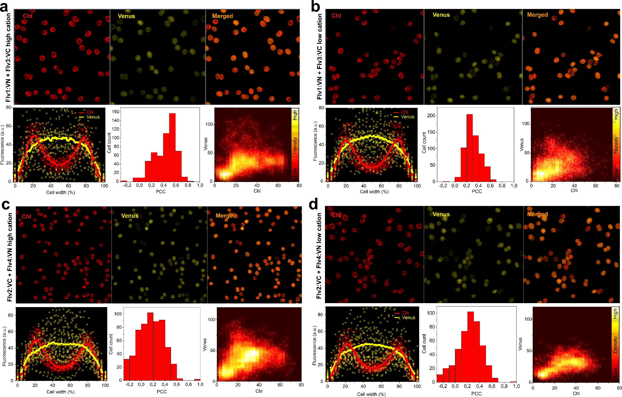
Supplemental Figure 8. Effect of cation concentration on the subcellular localisation of Flv1/3 and Flv2/4 interactions. BiFC tests between Flv1:VN and Flv3:VC and between Flv2:VC and Flv4:VN in BG-11 medium with no added source of Mg²⁺ or Ca²⁺ (A and C, respectively) or in BG-11 supplemented with 25mM MgCl₂ and 30mM CaCl₂ (B and D, respectively) are shown. Upper panels show representative confocal micrographs from the chlorophyll and Venus fluorescence channels as well as a merged image. The lower panels show co-localisation of Chl (red) and Venus (yellow) fluorescence intensities over cross-sections of 30-40 cells (with width normalised to 100%) shown as a scatterplot. Brighter red and yellow lines show moving regression curves produced by locally weighted scatterplot smoothing (LOWESS). The histograms show the distribution of the Pearson Correlation Coefficient (PCC) for Chl and Venus fluorescence co-localisation in all cells from three micrographs from individual replicates. A PCC of 1 indicates perfect co-localisation and a PCC of 0 no co-localisation. The cytofluorograms show co-localised Chl and Venus fluorescence intensities as a scatter plot from all cells in three micrographs from independent replicates.

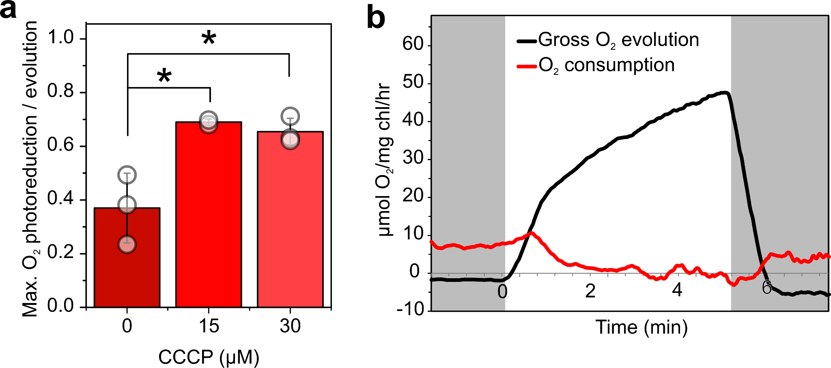
Supplemental Figure 9. Effect of CCCP on O₂ uptake. (a) Maximum light-induced O₂ uptake rate during dark-to-light transitions, normalised to maximum gross O₂ evolution rate in BG-11 pH 7.5 supplemented with 0, 15, or 30 µM CCCP. WT Synechocystis cells were grown under 3% CO₂ for 3 days, harvested and resuspended in fresh BG-11 at Chl concentration of 10 µg/ml. Cells were illuminated with 500 µmol photons m⁻²s⁻¹ for 5 min while ¹⁶O₂ and ¹⁸O₂ fluxes were monitored by MIMS. Light-induced uptake was calculated as total uptake - average uptake rate during 1 min in darkness. The values shown are averages from 3 (0 and 30 µM) or 2 (15µM) biological replicates +/- standard deviation, with individual data points shown as circles and statistically significant differences according to Student’s T-tests (P<0.05) as *. (b) O₂ fluxes in ΔFlv3 cells in the presence of 30mM CCCP. O₂ evolution and uptake were measured with MIMS as in (a).

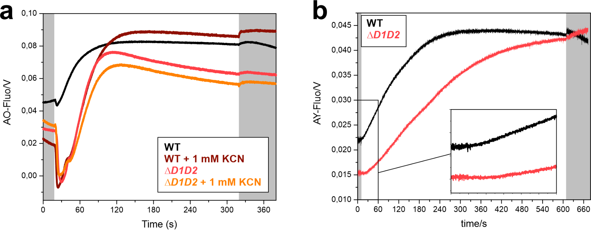
Supplemental Figure 10. Cytosolic alkalisation upon illumination. (a) Acridine orange (AO) and (b) acridine yellow (AY) fluorescence was recorded from dark-adapted WT and ΔD1D2 Synechocystis cultures with and without 1mM KCN under 216 µmol photons m⁻²s⁻¹ of actinic light for 5 min (a) and 10 min (b). Cultures were grown in BG-11 pH 7.5 in air-level CO₂ under 50 µmol photons m⁻²s⁻¹ for 4 days before measurements. Chl concentration was adjusted to 5 µg/ml, and AO and AY were added to a concentration of 5 µM prior to measurements. AY fluorescence derives from cytosolic pH changes only, while AO fluorescence represents an aggregate of cytosolic and lumenal pH changes. Representative traces from 3 (WT +AY), 2 (WT +AO, WT +AO+KCN, ΔD1D2 +AO, ΔD1D2 +AY), or 1 (ΔD1D2 +AO+KCN) biological replicate are shown.

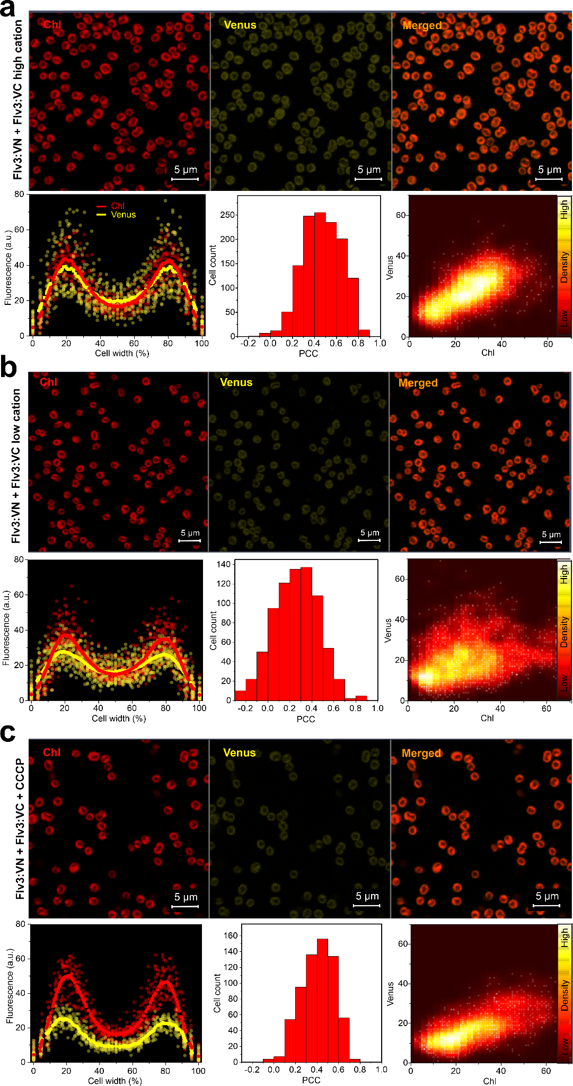
Supplemental Figure 11. Effect of cation concentration and pmf uncoupling on the subcellular localisation of Flv3 self-interactions. See legend for Supplemental Figure 8 for explanations of subpanels. BiFC tests were performed in medium supplemented with 25 mM MgCl₂ and 30mM CaCl₂ (high cation, a), in medium without added source of MgCl₂ and CaCl₂ (low cation, b), and in medium supplemented with 30 µM CCCP (c).
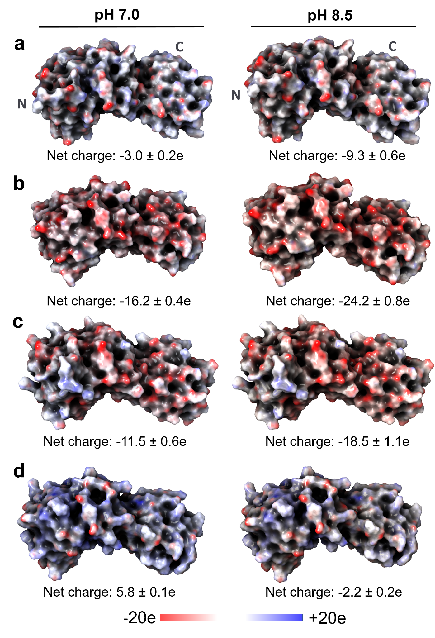
Supplementary Figure 12. In silico analysis of electrostatic surface charges of FDP monomers under pH 7.0 and pH 8.5. (a) Flv1 monomer, (b) Flv2 monomer, (c) Flv3 monomer, and (d) Flv4 monomer. Surface charges are color-coded with red representing negatively charged regions, blue depicting positively charged regions, and white showing neutral regions. Left panels show charge at pH 7.0, while right panels depict charge at pH 8.5. Since relative orientation of C-terminal Flavine reductase domain could not be modelled reliably, only core domains (β-lactamase-like and Flavodoxin-like domains) are shown for visualisation purposes.

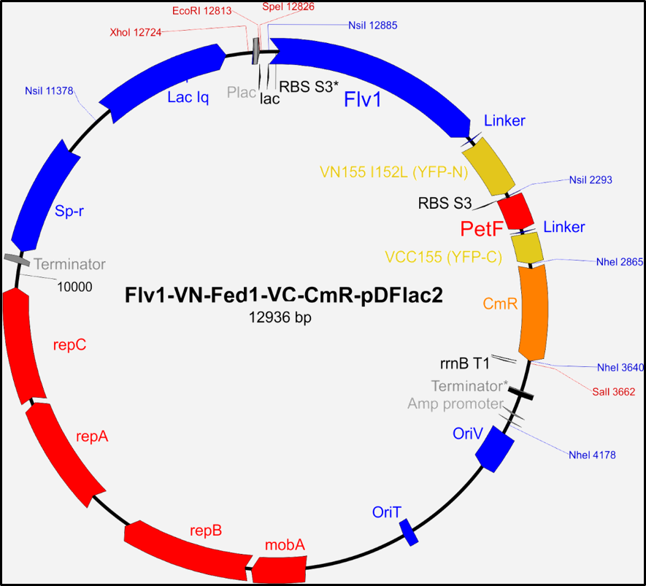
Supplementary Figure 13. Plasmid map of a BiFC construct to express Synechocystis flv1 and petF (Fed1) as fusion proteins with N- and C-terminal Venus fragments, respectively.

Supplementary Table 1. Primers used for generating the ∆Fed10 and ∆Fed11 strains.
Primer Name | Sequence
∆FED10-GIB1 | GACTACTATAGGGCGAATTGGGTACGTAAAACCGATTACATTGTGGTGGGCAA
∆FED10-GIB2 | TTCTGGCTGGATGATGGGGCGATGGAAATGTGCGCGAAAACTGAATAATCG
∆FED10-GIB3 | CGATTATTCAGTTTTCGCGCACATTTCCATCGCCCCATCATCCAGCCAGAA
∆FED10-GIB4 | CCGACTCGTTTCTATAGCGGTTTTGATAATCCACGTTGTGTCTCAAAATCTCTGATGTTAC
∆FED10-GIB5 | GTAACATCAGAGATTTTGAGACACAACGTGGATTATCAAAACCGCTATAGAAACGAGTCGG
∆FED10-GIB6 | ACTAAAGGGAACAAAAGCTGGAGCTCGGCAATATCCTCGTTGCGTTTAATAACTA
∆FED11-GIB1 | GACTACTATAGGGCGAATTGGGTACGTAAAAAGCCCGGCAGAGGGGAT
∆FED11-GIB2 | TTCTGGCTGGATGATGGGGCGATTGCAATTTCCTCCTGTCCTCAGGG
∆FED11-GIB3 | CCCTGAGGACAGGAGGAAATTGCAATCGCCCCATCATCCAGCCAGAA
∆FED11-GIB4 | TTGGCCTCCGGTGATCGCCCCCACGTTGTGTCTCAAAATCTCTGATGTTAC
∆FED11-GIB5 | GTAACATCAGAGATTTTGAGACACAACGTGGGGGCGATCACCGGAGGCCAA
∆FED11-GIB6 | ACTAAAGGGAACAAAAGCTGGAGCTCGGCGGATAACGATGTTGTACTTTATAGT

