Supplementary Information
Nanoscale Doping of Polymeric Semiconductors with Confined Electrochemical Ion Implantation
Lanyi Xiang^{1,2}, Zihan He^{1,2}, Lingxuan Jia^{1,2}, Ziling Jiang², Xiaojuan Dai¹, Yingqiao Ma¹, Liyao Liu¹, Qing Meng¹, Ye Zou¹, Fengjiao Zhang²*, Chong-an Di¹*, and Daoben Zhu¹

¹Beijing National Laboratory for Molecular Sciences, CAS Key Laboratory of Organic Solids, Institute of Chemistry, Chinese Academy of Sciences; Beijing, 100190, China.
²School of Chemical Sciences, University of Chinese Academy of Sciences; Beijing, 100049, China.
These authors contributed equally: Lanyi Xiang, Zihan He
* Email: dicha@iccas.ac.cn (C.-a.D.); fjiaozhang@ucas.ac.cn (F. Z.)
Table of contents:

Note 1 Discussion and definition of electrochemical ion implantation.
Table S1 Summary of the conventional ion implantation doping and electrochemical ion implantation doping.
Fig. S1~ S25
Reference

Supplementary Note 1. Discussion and definition of electrochemical ion implantation.
Conventional ion implantation
Ion implantation is the non-thermodynamic doping process whereby dopant ions are accelerated in an electrical field and directly implanted into target semiconductors to modify their electric properties^{1,2}. As a mature industrial technique that is integral to microelectronics manufacturing, the ion implantation exhibits prominent doping resolution due to its unidirectional ion migration along the electric field lines. By combining the nanostencil technique, this fascinating process can readily achieve nanoscale doping resolution of inorganic semiconductors³, in a way that is infeasible with thermal diffusion or epitaxy methods. Many other reasons accounting for the success of ion implantation are as follows^{1,2,4-6}: a.) High controllability. The total amount of the implanted dopants can be accurately controlled and monitored by measuring the ion current. (b) Beyond thermodynamic limitation. The use of energetic ions affords the possibility that any charged species might be implanted into any host materials with desirable high doping level that not restricted by thermodynamic equilibrium solubility. c.) It is also very clean, being carried out in a vacuum, and could be automated for highly uniform and reproduceable semiconductor doping.
One main challenge in the conventional ion implantation is the damage because of its high kinetic energy typically ranging from 10² to 10⁶ electron volts^{4,7}. Upon ion bombardment, the ion energy is transferred to either the electrons and atomic nuclei of the target material that often breaks molecular bonds, thus destroying the lattice structure of the inorganic semiconductor⁵. Besides, such damage also creates a large number of defects including vacancies and interstitials, of which will trap the conduction electrons and holes that degrade the desirable characteristic of semiconductor devices. Although strategies have been devoted to reduce the ions energy lower than 100 eV, the target charge-up and space charge problem causes low doping efficiency and complexes the ion implanter design especially at high ion current ^{8,9}. To overcome the damage problem, an additional annealing process is usually used to restore the defects as well as to activate the dopants after ion implantation⁵. Therefore, in fact, nondestructive, high-spatial-resolved and highly controllable ion implantation doping can be finally achieved for inorganic semiconductors by combining both of the so-called “nano-stencil” and “post-implantation annealing” techniques.
Ion implantation is also a powerful and versatile tool to modulate electrical properties of the polymers¹⁰. The very initial attempt was to turn the normally insulating polymers into semiconductors or conductors, for example, poly (methyl methacrylate) (PMMA), poly(2,6-dimethylphenylene-oxide) (PPO), or poly(vinyl-chloride) (PVC) with orders of conductivity enhancement after ion implantation. Contrarily to the doping effect on inorganic semiconductors, the implement of ion implantation on these polymers lies in a radiation-induced disruption of chemical bonds with subsequent cross-linking and conjugation, leading to the formation of carbon-rich structures with significant enhancement of the conductance¹¹. Similarly, such radiation effects by energy transferred to the target semiconducting polymers have been also widely observed. In the case of no matter for the insulating or semiconducting polymers, energy loss of incident ions in these polymer films can be as high as hundreds or even thousands of electron-volts per angstrom of track length. Considering the fact that the bond dissociation energies in polymers does not exceed 10 eV, e.g., 4.3 eV for the C-H and 9.3 eV for the C=N bond, the ion energy is large enough to break chemical bonds of the polymer semiconductors within the track volume even with low ion energies down to hundreds or even tens of electron-volts¹². In this circumstance, ion implantation causes non-recoverable structure change of the polymers¹³ (fig. S1), and more importantly does not always produce doping effect to the polymers, in spite of the observed conductivity enchantment.
Electrochemical ion implantation doping for polymeric semiconductors
Because of the unique chemical and electronic structures, the doping mechanism for polymeric semiconductors is completely different to that for their inorganic counterparts¹⁴. Doping effect occurs only when the polymers undergo redox processes in which charges are transferred to the backbones and ionized dopants into the film to compensate the electron charge on the polymer, that is fundamentally challenging by the conventional ion implantation as discussed above. Electrochemical doping provides an efficient way to reduce/oxide the polymer backbones and achieve ion injection into films simultaneously¹⁵. In this process, the working electrode supplies the redox charge to the conducting polymer, while counterions in electrolyte are implanted into the semiconductor film drive by an electric field¹⁶. We assumed that this electromigration of counterions under the electric field is almost the same as that of the conventional ion implantation process, not matter from the aspect of the ion injection mechanism and device structure, as shown in fig. S1. Under this assumption, we therefore propose the electrochemical ion implantation concept with a strict definition: Electrochemical ion implantation is the doping process whereby counterions in electrolyte are accelerated by an electrical field and directly implanted into the target film to keep its electrical neutrality.
The electrochemical ion implantation is also the non-thermodynamic process that driven by the electric force. The yielded doping therefore exhibits many merits that similar to conventional ion implantation. For example, high controllability that the number of the implanted counterions can be monitored by measuring the ion current and determined by electrochemical equilibrium, and its beyond thermodynamic limitation that any salt ions might be implanted into the films with ultra-high doping levels, which are proven challenging by the thermodynamic chemical doping process. More importantly, owing to the low redox potentials of the polymer (i.e., the onset of oxidation for p-type polymers), the electrochemical doping can be implemented with ultralow voltage down to several volts (driving force for ion migration: several electron volts), thus does not disturb the ordered structure of the polymer film¹⁷⁻¹⁹. The doped film often exhibits alternating layers of semiconducting sheets and counterion layers, as the ions intercalated into the side-chain domains of the crystallites^{17,20}, leveling the charge transport pathways intact that enables prominent electronic performance. Although this efficient method has shown fundamentally challenge in achieving nanoscale doping, the anisotropic ion migration along the electric field lines suggests the possibility of optimizing the doping spatial resolution by focusing the field distribution.

Table S1. Summary of the conventional ion implantation doping and electrochemical ion implantation doping.
Method  Merits | Conventional ion implantation |  |  | Electrochemical ion implantation
Dopant ions
Driven force | Electrical field  (Non-thermodynamic equilibrium) |  | Electrical field  (Non- thermodynamic equilibrium)
Ion species | Charged atomic ions  (Almost all elements) | Charged molecular ions  (Infinite selection of synthetically  accessible salt ions)
Ion path | Vacuum | Electrolyte
Ion migration | Unidirectional along the electric field lines | Unidirectional along the electric field lines
Structure change upon doping
Damage | Lattice disorder created by ion bombardment | Nondestructive
Subsequent annealing | Necessary to activate dopants and restore defects | Unnecessary
Doped semiconductors
Controllability | Doping level can be monitored by ion current | Doping level can be monitored by ion current
Resolution | Nanoscale (atomic level) | Nanoscale (this work)

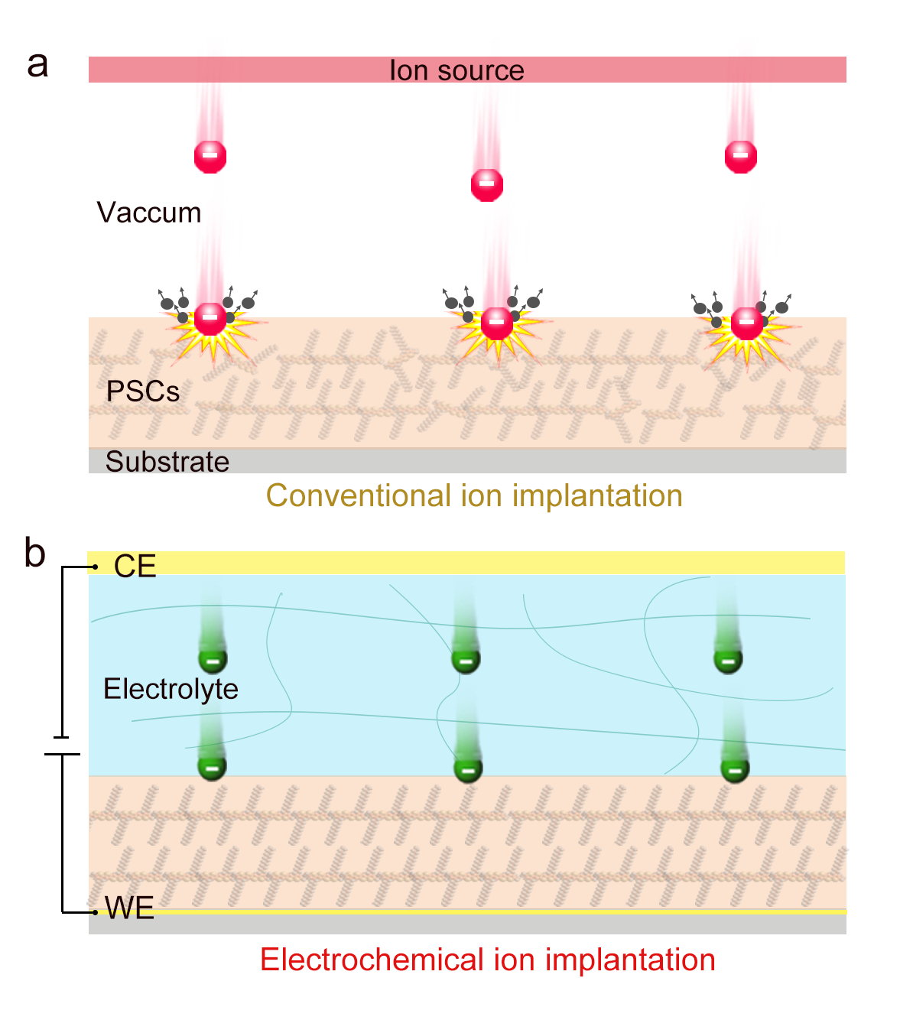
Fig. S1. a-b Schematic diagram showing (a) conventional ion implantation and (b) electrochemical ion implantation process for polymeric semiconductor doping. Conventional ion implantation involves an accelerator incorporated ion source where dopants can be ionized and electrostatically accelerated to a high energy, and a target semiconductor film where the ions are implanted in. The ion bombardment with high kinetic energy cause irreversible chemical and structural damage of the polymer, which is not wanted. As the comparison, electrochemical ion implantation takes the electrolyte as the ion source where does not need to ionize the dopants, and implement the doping by implanting counterions into the polymer film with a much lower energy. CE, counter electrode. WE, working electrode. PSCs, polymeric semiconductors.

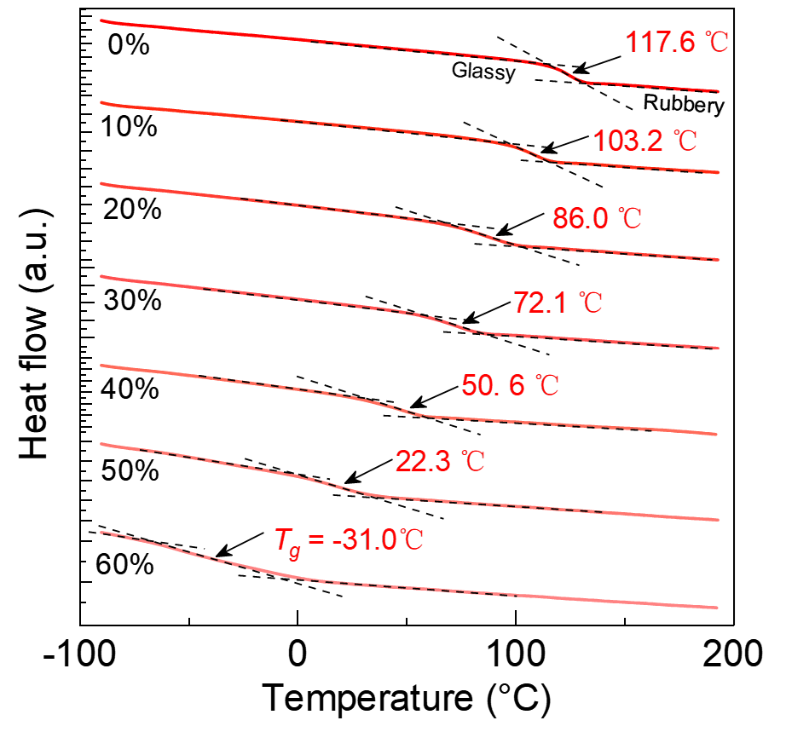
Fig. S2. Differential scanning calorimeter (DSC) thermal analysis curves of PMMA/EMIM-TFSI electrolytes with different weight ratio of EMIM-TFSI ionic liquid. The electrolyte T_{g} was determined by extracting the midpoint between extrapolated heat flow rubber and glass baselines, as shown in the figure. With increasing the weight ratio of EMIM-TFSI from 0 % to 60 %, the glass transition processes broaden and the T_{g} values shift from 117.6 ℃ to −31 ℃, indicating that the relaxation dynamics of electrolytes was steadily enhanced caused by the plasticizing effect of ionic liquid on insulating polymers.

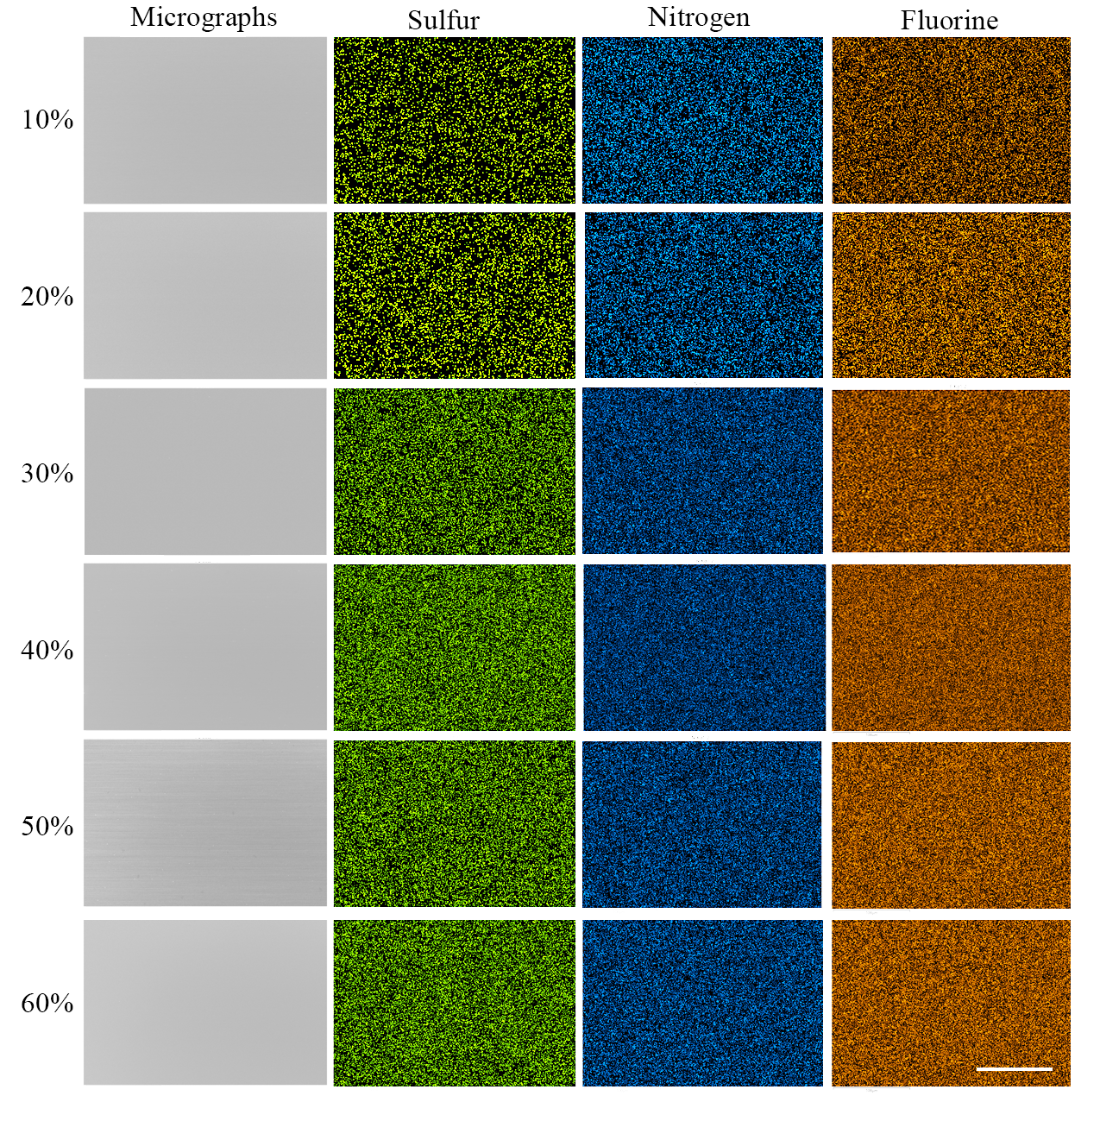
Figure S3. SEM micrographs and the corresponding EDS mapping of sulfur, nitrogen and fluorine distribution of PMMA/EMIM-TFSI electrolytes with different weight ratio. The result clearly shows that all electrolytes with different weight ratios from 10 wt.% to 60 wt.% have smooth surface morphology and uniform ion distribution, which is beneficial to obtain the uniform electrochemical doping of polymeric semiconductors over a large area. The contrast and brightness for both of the micrographs and EDS mapping are modulated to offer a clear view of the images. The scale bar is 100 μm.

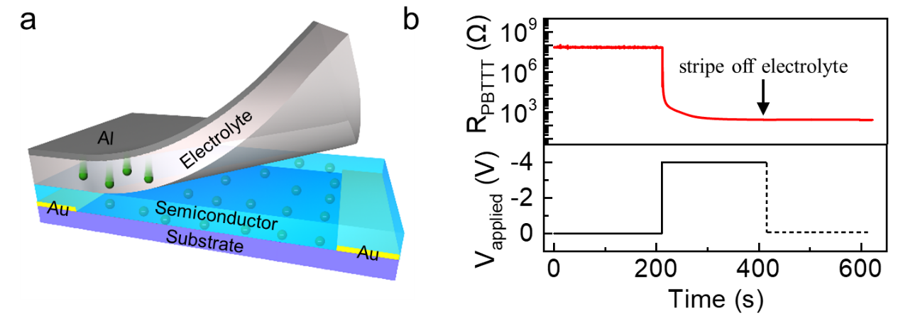
Fig. S4. Nonvolatile electrochemical doping of polymeric semiconductors. a, schematic illustration showing the stripping off process of the electrolyte from doped semiconductor layer, and b, the variation of PBTTT’ resistance versus time when switching on the voltages and stripping off the electrolyte. The resistance of doped PBTTT films could almost maintained its ~100% of the doped state after stripping off the electrolyte, leading to nonvolatile electrochemical doping. Here, the mechanism should be that physically striping off the electrolyte could hinder anion-cation coulomb interaction and thus permanently block anion reflux from the doped semiconductor to the electrolyte. Beyond nonvolatile doping, we supposed that the “stripping off” approach could be useful to distinguish the ambiguous mechanism of the interfacial electric double layer based gating and bulk doping in the electrolyte transistor, as the former is expected to be instable after removing the electrolyte from the semiconductor layer. Such approach could be also extended to other material systems, including different semiconductors and electrolytes.

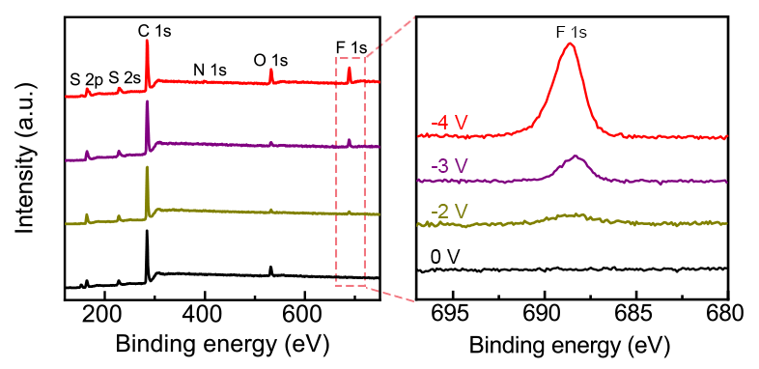
Fig. S5. XPS survey spectra of the electrochemically doped PBTTT films with varied voltages. The right shows the enlargement of characteristic F 1s spectra. The appearance of F 1s in the doped films demonstrates that TFSI⁻ anions are successfully implanted and retained in the PBTTT films by our “stripping off” approach. The increased intensity of the F 1s peak was caused by higher doping density at higher voltages.

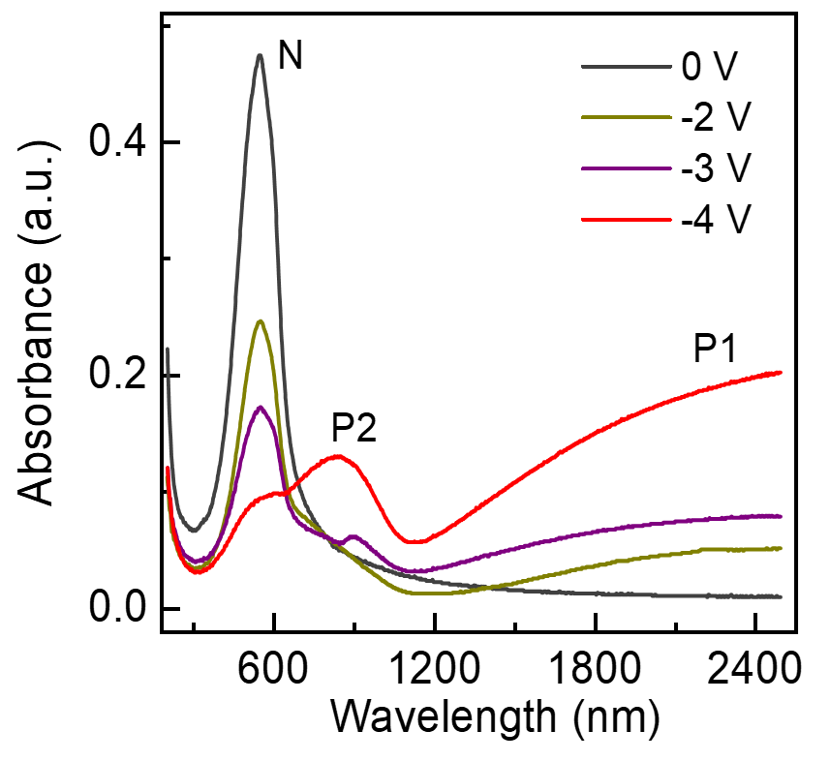
Fig. S6. UV-Vis-NIR spectra for pristine PBTTT and electrochemically doped PBTTT at varied voltages. In comparison with neutral peak absorption at ~550 nm (marked as N, neutral peak) of pristine film that origins from the π - π* transition from valence band to conduction band, the new absorption at polaronic and bipolaronic bands, P2 and P1, were observed when the films were doped at varied voltages, demonstrating the generation of positive carriers in this p-type electrochemical doping. The measurement was carried out after stripping off the electrolyte from the semiconductor layer.

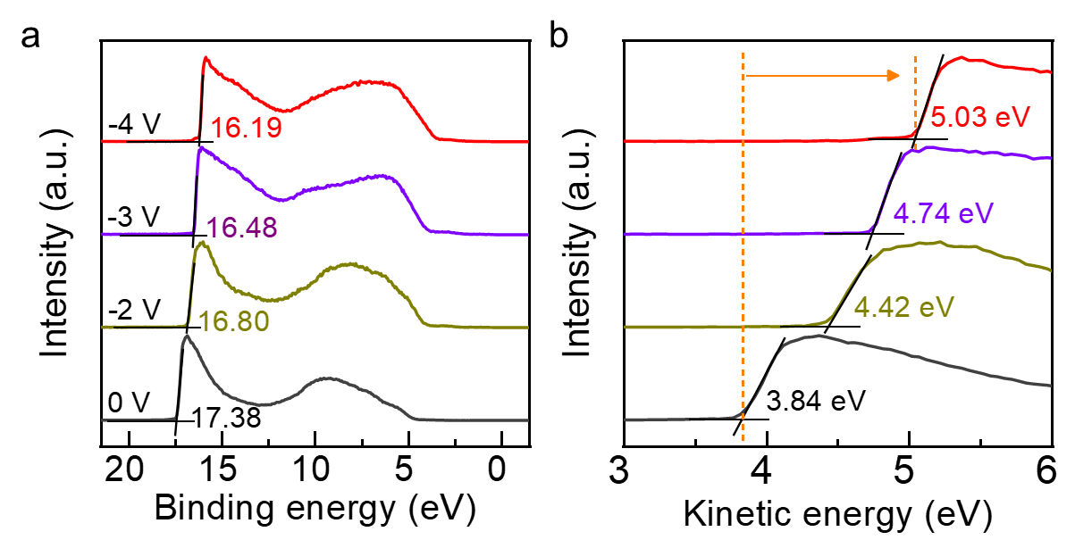
Fig. S7. a, UPS spectra and b, corresponded low kinetic energy region for electrochemically doped PBTTT films with varied voltages. The binding energy cutoff for secondary electrons were shown in panel a. As the doping voltage increased, the binding energy of the valence structures significantly changed, owing to the enhancement in the doping level. The work function (W_{F}), was also calculated by using equation of W_{F} = hv − E_{B} (secondary cutoff), where hv is the photon energy (He I, 21.22 eV) and E_{B} is the binding energy. Panel b displayed a continually shift of work function from 3.84 to 5.03 eV when the doping voltage was increased to −4 V, indicating that the gap between the Fermi level (E_{F}) and highest occupied molecular orbital (HOMO) were effective reduced. In addition, together with the XPS and optical absorption results, the voltage dependent work function demonstrated here proves that the electrochemical doping possess prominent controllability in defining doping levels.

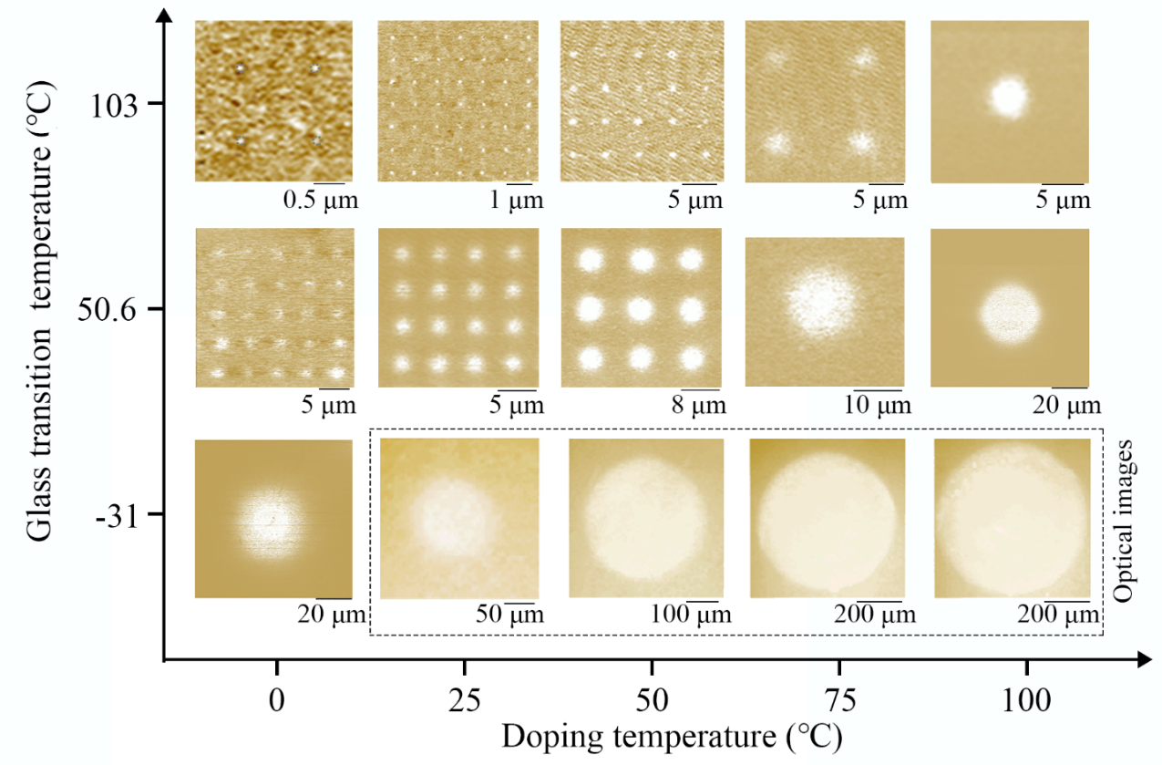
Fig. S8. Current imaging or optical images of the PBTTT films that doped with different electrolyte T_{g} under varied temperatures. The bright round dot and dark brown area denote the doped and undoped regions, receptivity. The contrast and color of all optical images (in the dotted box) are modulated to offer a clear comparison with the current-voltage images. As shown here, either increasing electrolyte T_{g} or reducing doping temperature could lead to the enhancement of electrochemical doping resolution.

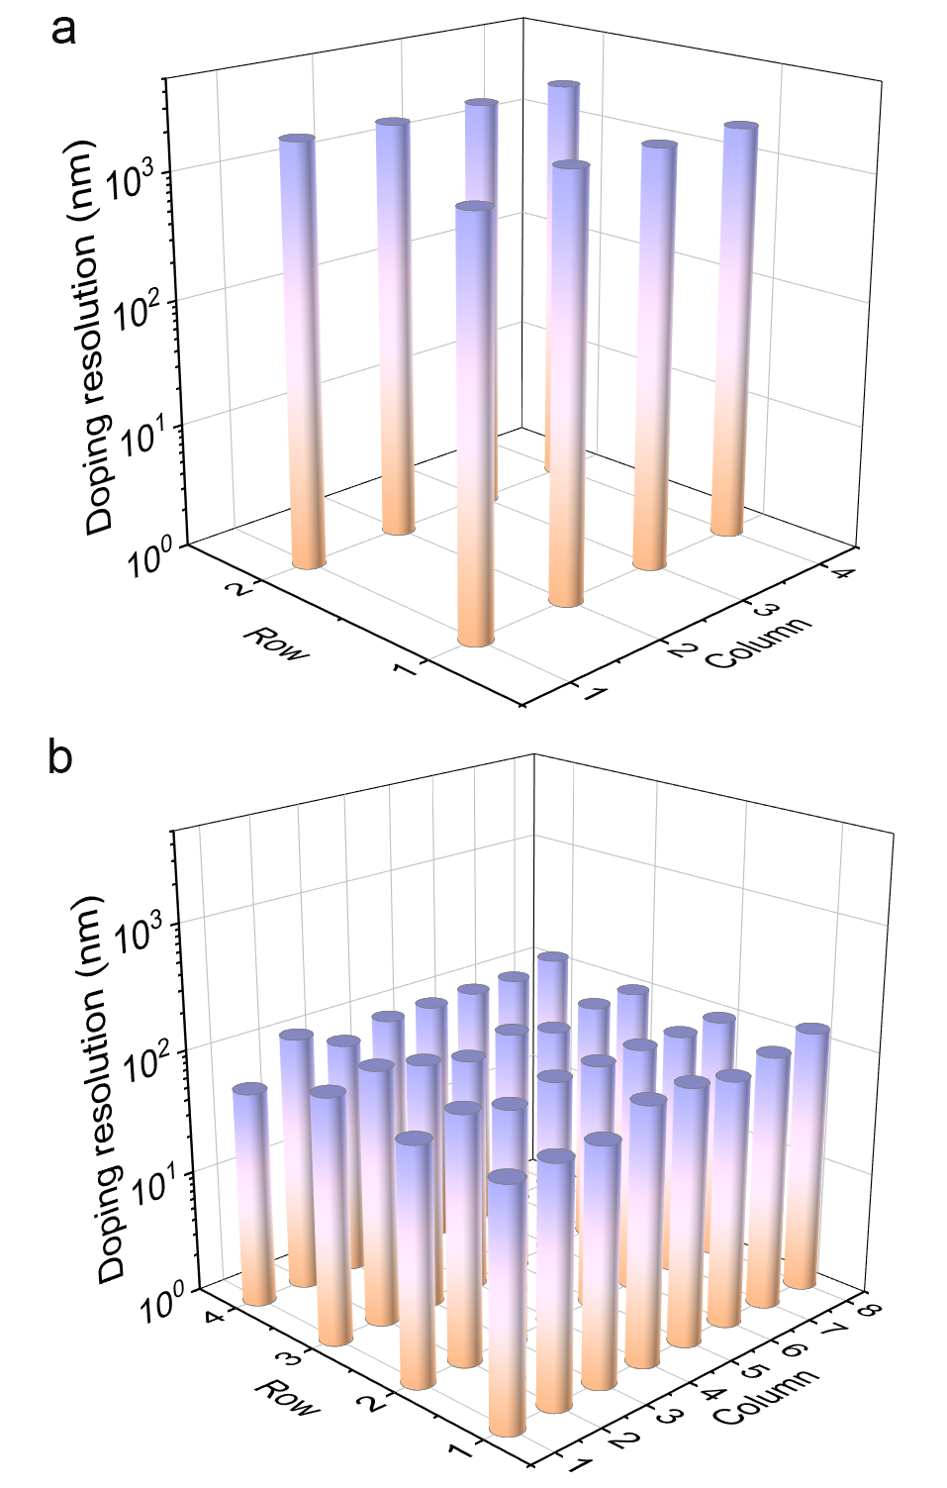
Fig. S9. Doping resolution distribution based on electrolyte T_{g} of a, 50.6 ℃ and b, 103.2 ℃. The measurement was performed at room temperature. Both of these two films showed relatively uninform distribution in the doping resolution.

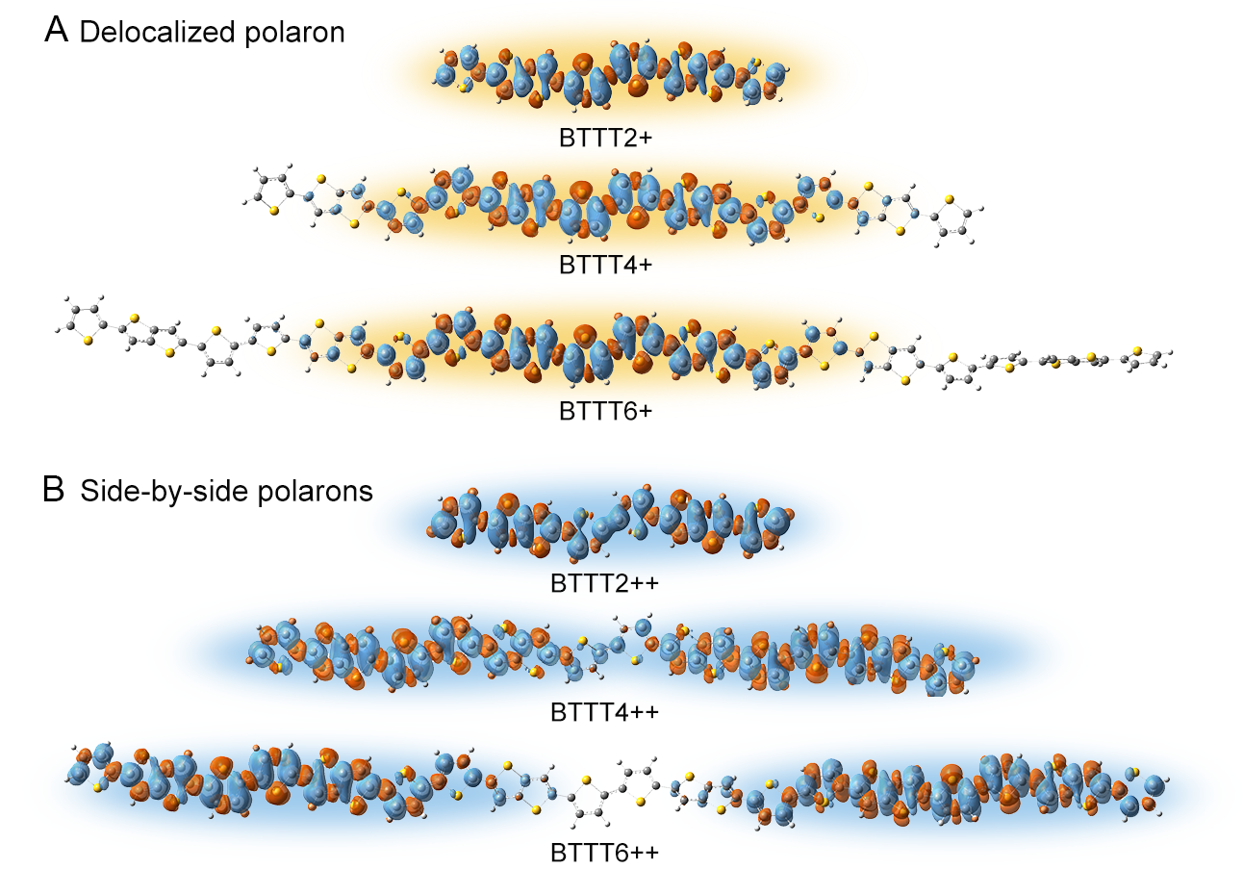
Fig. S10. Spin density map for the A, BTTT2+, BTTT4+, BTTT6+ that with one polaron, and B, BTTT2++, BTTT4++, BTTT6++ that with two side-by-side polarons. The yellow and blue frame mark the region with spin density on a TTT unit of more than 0.01 e. The calculation is based on TRS-ωB97XD/6-31G(d) level of theory.

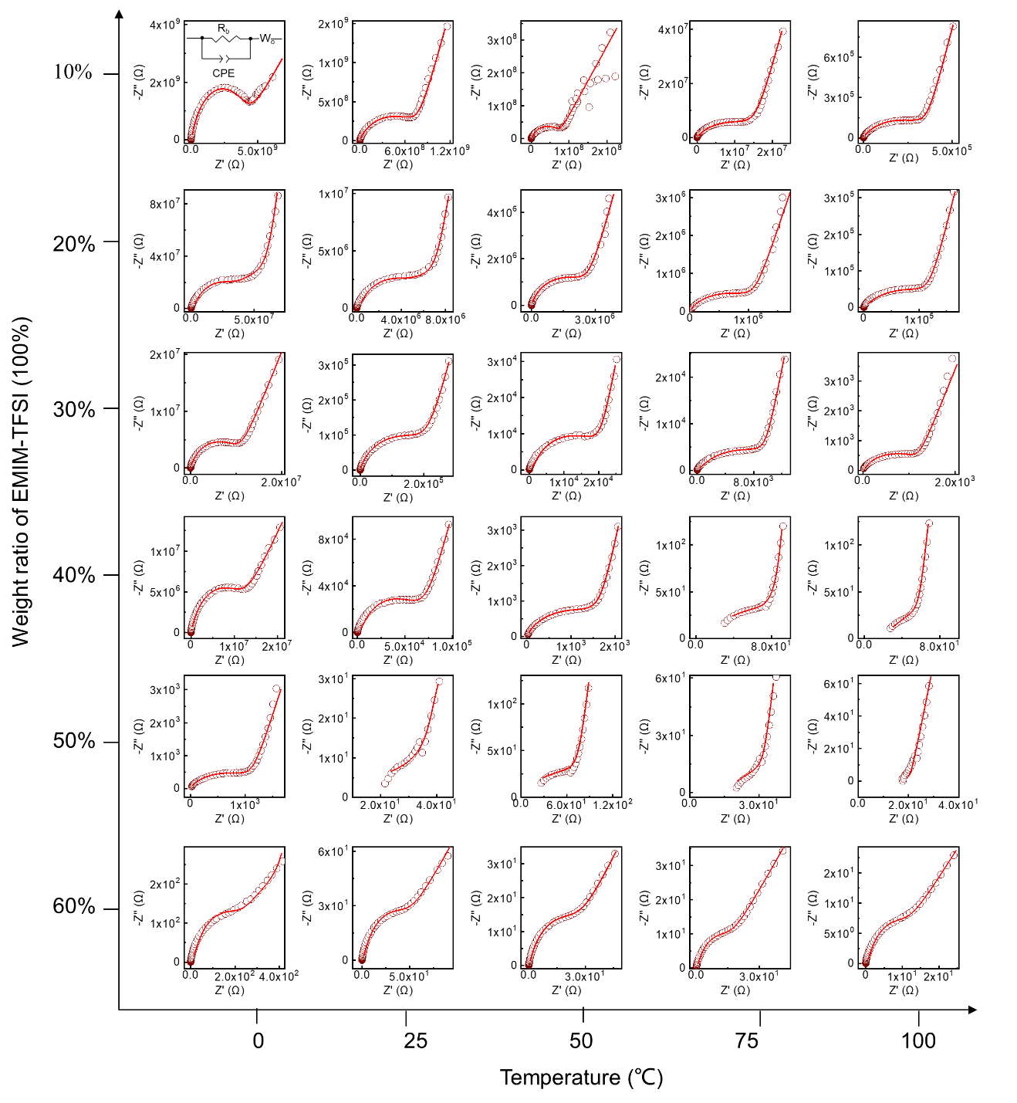
Fig. S11. Nyquist plots of the PMMA/EMIM-TFSI electrolytes with different weight ratios measured at varied temperatures. The red lines represent fits of the equivalent circuit model (inset) to the ac-impedance data, where R_{b}, CPE and W_{O} correspond to bulk resistance, a constant phase element and Warburg element respectively. The devices are characterized at vacuum to avoid water condensation. The ratio in t/A is 2.2*10⁻³ cm⁻¹, where the t and A are the thickness and area of the capacitor. Z’, real part of complex impedance; Z’’, imaginary part of complex impedance.
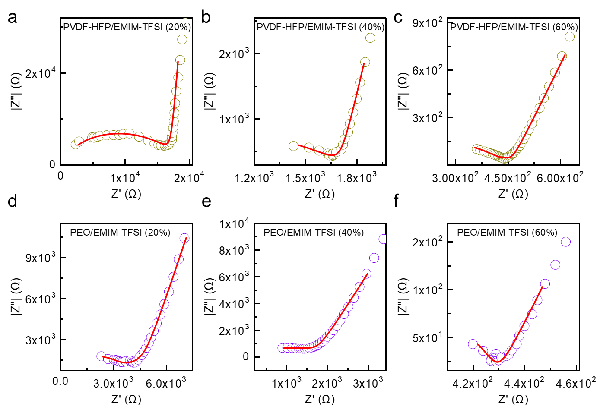
Fig. S12. Nyquist plots of the PVDF-HFP/EMIM-TFSI and PEO/EMIM-TFSI electrolytes with a, d, 20%, b, e, 40% and c,f, 60% weight ratios of ionic liquid. The red lines represent fits of the equivalent circuit model (inset) to the ac-impedance data. The measurements were taken at room temperature. The ratio in t/A is 8*10⁻² cm⁻¹, where the t and A are the thickness and area of the capacitor. Z’, real part of complex impedance; Z’’, imaginary part of complex impedance.

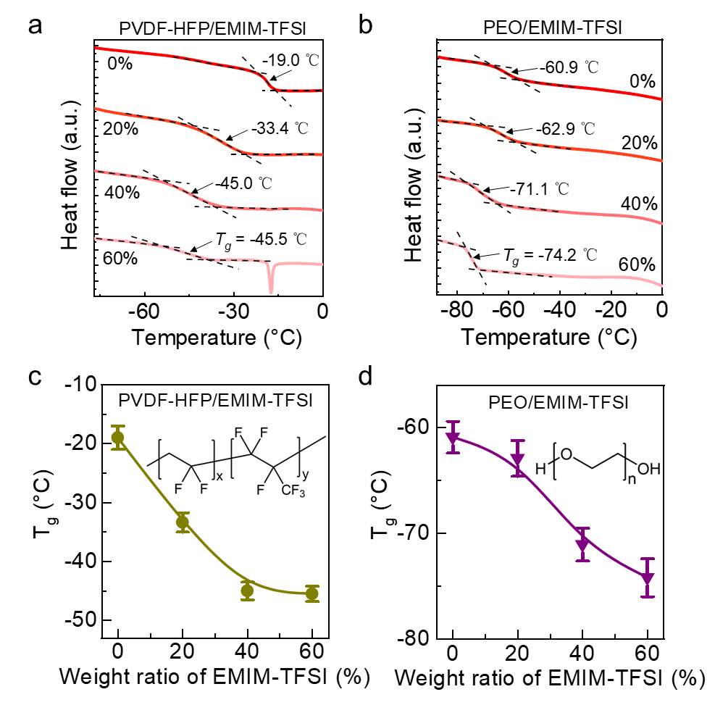
Fig. S13. DSC thermal analysis curves of a, PVDF-HFP/EMIM-TFSI and b, PEO/EMIM-TFSI electrolytes with different weight ratio of EMIM-TFSI ionic liquid. The determination of electrolyte T_{g} was shown in the figure by extracting the midpoint between rubber and glass baselines. Glass transition temperature of c, PVDF-HFP/EMIM-TFSI and d, PEO/EMIM-TFSI electrolyte with varying weight ratio of EMIM-TFSI. The error bars result from uncertainties in fitting of the DSC curve and represent one standard deviation. The chemical structures of PVDF-HFP and PEO are in the inset of fig. c and fig. d, respectively.
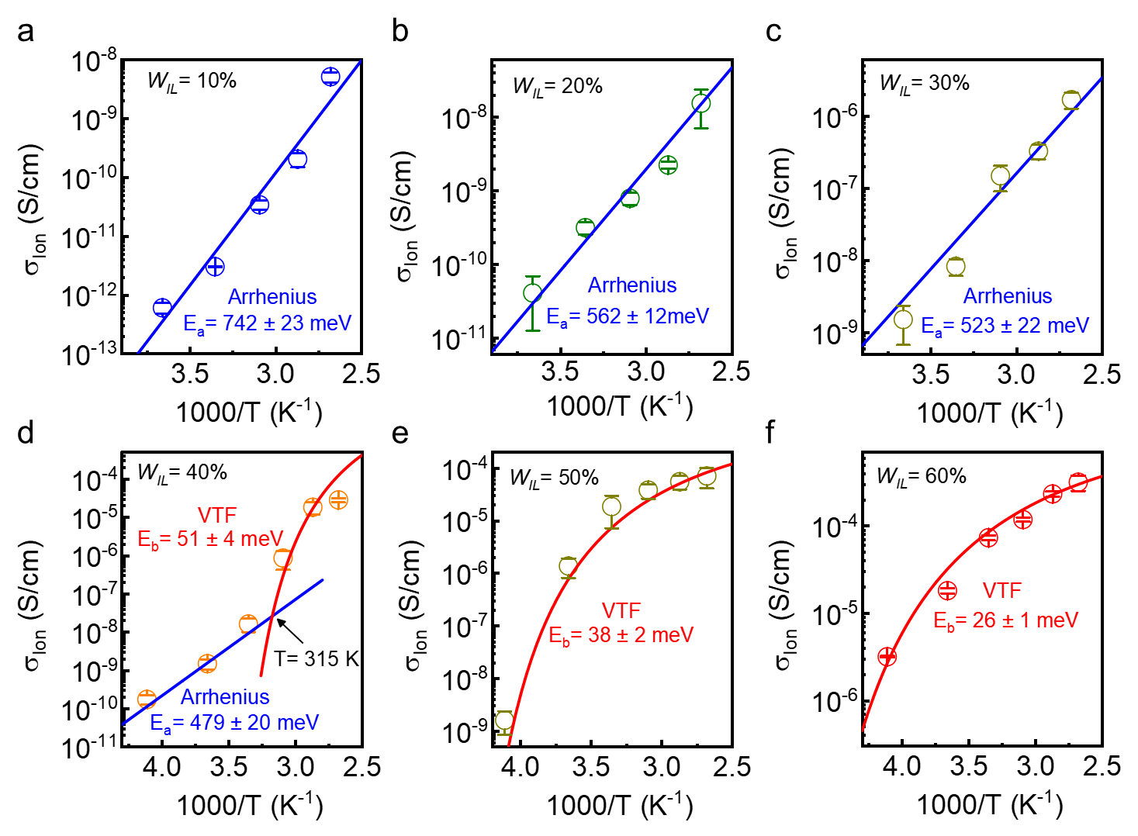
Fig. S14. Temperature dependent ionic conductivity of the PMMA/EMIM-TFSI electrolytes with W_{IL} of a, 10%, b, 20%, c, 30%, d, 40%, e, 50%, and f, 60%. For electrolyte with W_{IL} between 10% to 30%, the data are fitted well by Arrhenius model, indicating the decoupling of ion transport from segmental dynamics. Specially, for electrolyte with W_{IL} of 40%, it showed an obvious crossover from a VFT-like behavior to an Arrhenius-like behavior when the T (41.85 ℃, 315 K) approaches to electrolyte T_{g} (50.6 ℃). As for the electrolyte with W_{IL} of 50% and 60%, the data were fitted by VTF. The well-fitting by VTF model indicates that strong coupling ion transport from segmental dynamics occurs when the electrolyte translated into the rubbery state. The error bars result from uncertainties in fitting of the Nyquist plots and represent one standard deviation.

Estimation of segmental relaxation time of the electrolyte
A common representation of impedance spectra is used as the complex dielectric to analysis segmental chain relaxation and ion transporting in the polymer electrolyte^{21,22}. The dielectric properties ($ε$), can be expressed as a complex dielectric function according to the following equation:
$$\begin{aligned}ε=ε_{r}^{'}-{jε}_{r}^{''}\#\left(1\right)\end{aligned}$$
Where $ε_{r}^{'}$ and $ε_{r}^{‘’}$ is the real and imaginary components of the complex dielectric, and represents dielectric permittivity and dielectric loss, respectively. Here, the dielectric permittivity is primary arising from the polarization of the polymer electrolyte, while the dielectric loss comes from a combination of structural relaxation processes, i.e., the fluctuations of molecular dipoles of polymer chains and ion transporting. The $ε_{r}^{'}$ and $ε_{r}^{‘’}$ , can be further experimentally obtained from the EIS measurement and derived using equation (6) and (7)
$$\begin{aligned}ε_{r}^{'}= \frac{-Z^{''}}{\left(2πf\right)C_{0}{\left|Z\right|}^{2}}\#\left(2\right)\end{aligned}$$

$$\begin{aligned}ε_{r}^{‘’}= \frac{Z^{'}}{\left(2πf\right)C_{0}{\left|Z\right|}^{2}}\#\left(3\right)\end{aligned}$$
Where $f$ is frequency in Hz, $Z^{'}$ and $Z^{''}$ are the real and imaginary components of the impedance modulus, $\left|Z\right|$ is the electrolyte impedance, $C_{0}=ε_{0}\frac{A}{t}$ is the vacuum capacitance ($ε_{0}$ is the permittivity of free space, $A$ is the geometric area of the capacitor, and $t$ is the thickness of the polymer electrolyte).
The relaxation time ($τ$) that represents the response time of the polymer chain movement coupled with ionic motions can be estimated from the derivative of the real part of permittivity ($ε_{r}^{'}$):
$$\begin{aligned}ε_{der}^{''}= -\frac{π}{2}\frac{∂ε^{‘}\left(f\right)}{∂lnf}\#\left(4\right)\end{aligned}$$

And the $τ$ value could be further calculated by the following equation.
$$\begin{aligned} τ= \frac{1}{{2πf}_{c}} \#\left(5\right)\end{aligned}$$
Where $f_{c}$is the frequency at the transition peak in the derivative spectra^{23,24}.

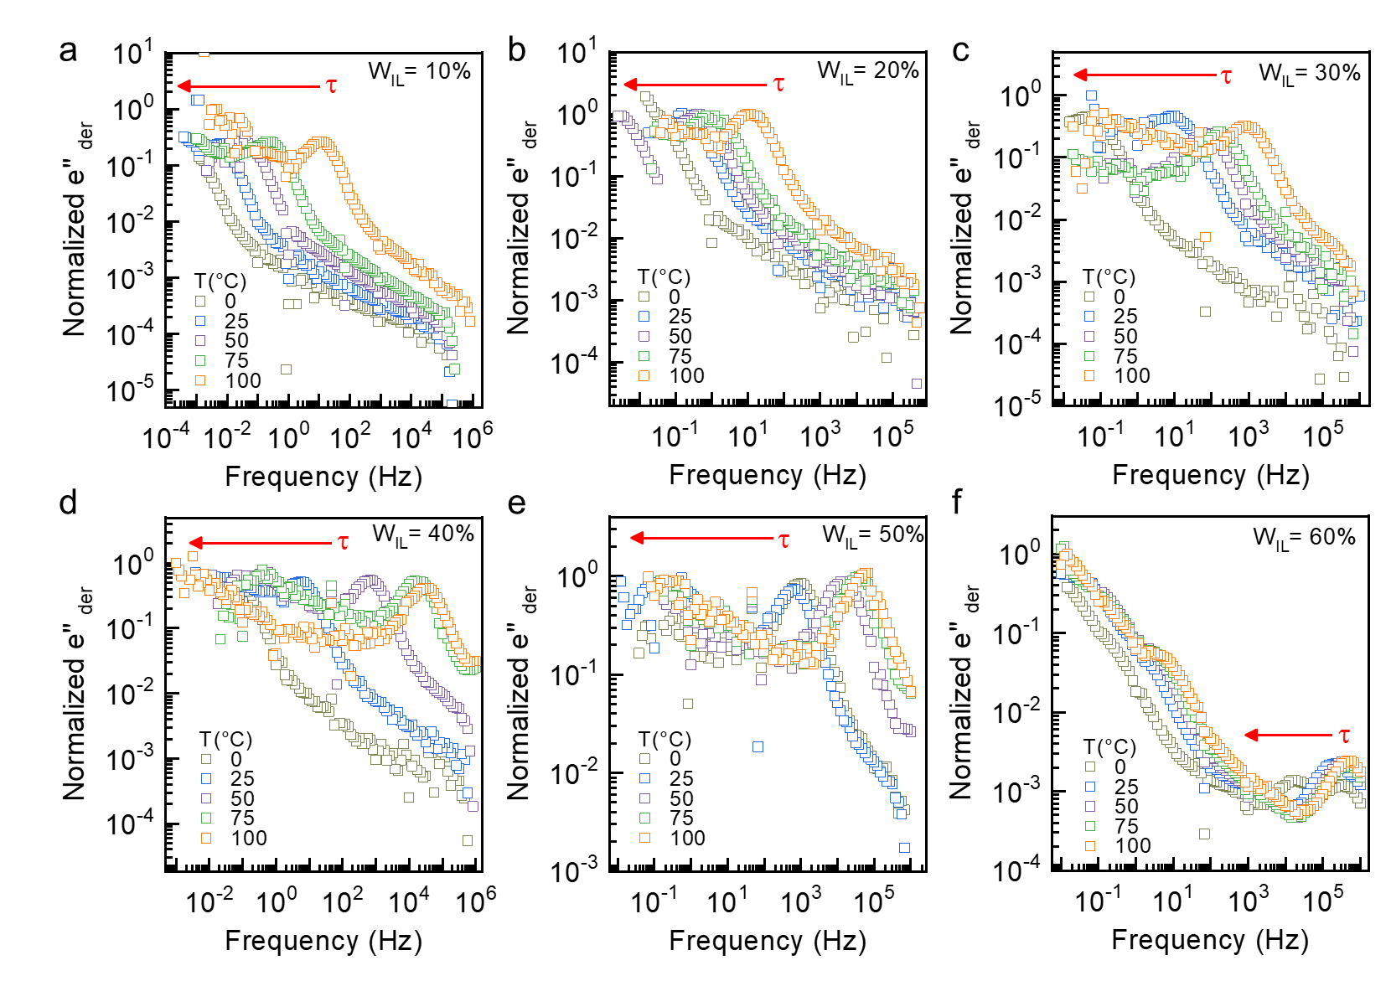
Fig. S15. Normalized dielectric loss derivative spectrum of the PMMA/EMIM-TFSI electrolytes with a, 10%, b, 20%, c, 30%, d, 40%, e, 50%, and f, 60% weight ratio of the ionic liquid. The in-situ measurements were taken at varied temperatures from 0 to 100 ℃ in vacuum. The results were used to extract the relaxation time of the electrolyte as plotted in fig. S16. All derivative spectrums are normalized to show the trend of transition peak more clearly. τ, relaxation time of the polymer electrolyte.

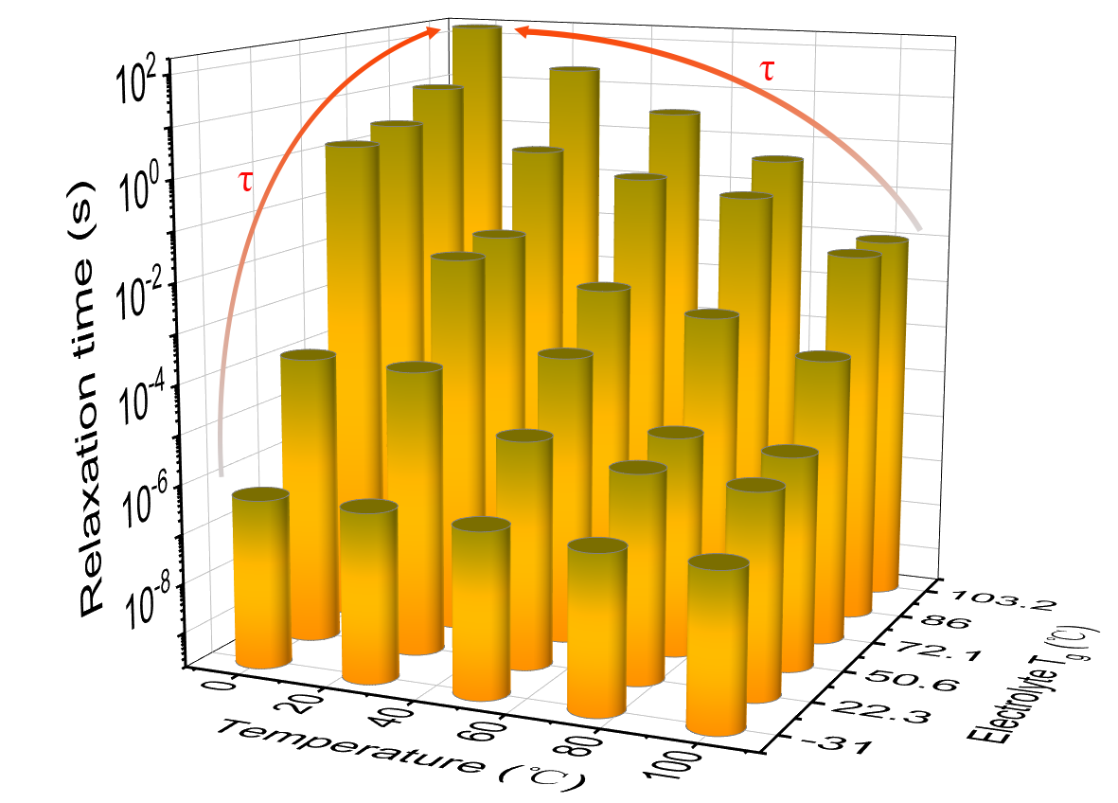
Fig. S16. Segmental relaxation time of the PMMA/EMIM-TFSI electrolyte as a function of glass transition temperature (T_{g}) and operational temperature (T). The result demonstrated that either increasing T_{g} or decreasing T can significantly improve the relaxation time, which is associated with ionic transport. τ, relaxation time of the polymer electrolyte.

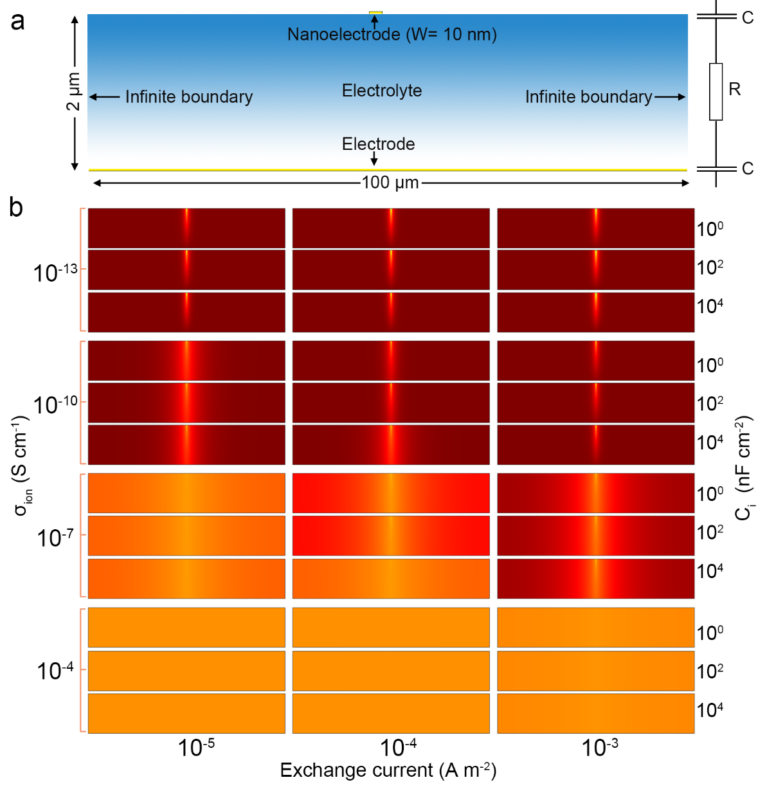
Fig. S17. a, Schematic diagram for 2D modeling of the COMSOL simulation. The semiconductor was assumed as a conducting electrode and use a point charge as the controlling electrode at a distance of 2000 nm to model the electric potential across the electrolyte. The ionic circuit of electrolyte was treated as a resistor, describing the flow of ions in the electrolyte, in series with capacitors, describing the ions accumulation at the electrode-electrolyte interface. b, the effect of ionic conductivity, capacitance and exchange current on the electric potential distribution in the solid electrolyte. The scales in x and y directions of the electric field distribution are 100 μm and 2000 nm, respectively. From this simulation result, it can be clearly observed that ionic conductivity variation is responsible for the highly confined electric field, while the capacitance or exchange current have little impact.
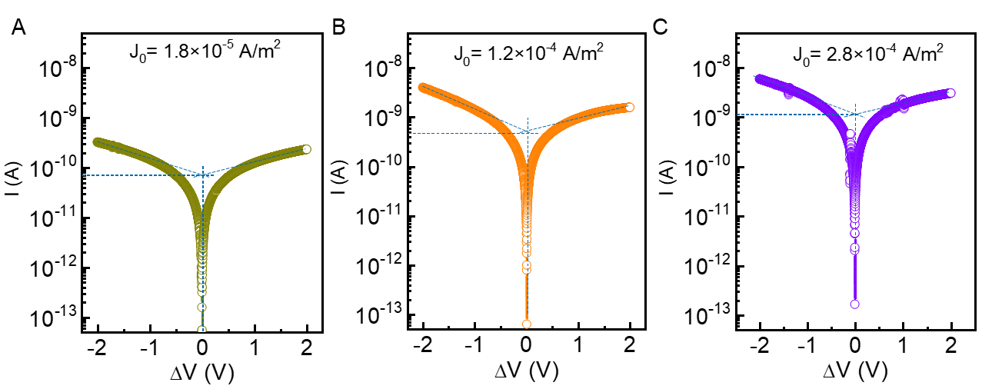
Fig. S18. Potentiodynamic polarization curves obtained for the PMMA/EMIM-TFSI electrolytes with a, 10%, b, 40%, c, 60% weight ratio of the EMIM-TFSI. To determine the transfer current density, a vertical line and two linear branches of the curve are drawn. Their intersection is the transfer current density, while the slopes of the extended lines are Tafel constants.

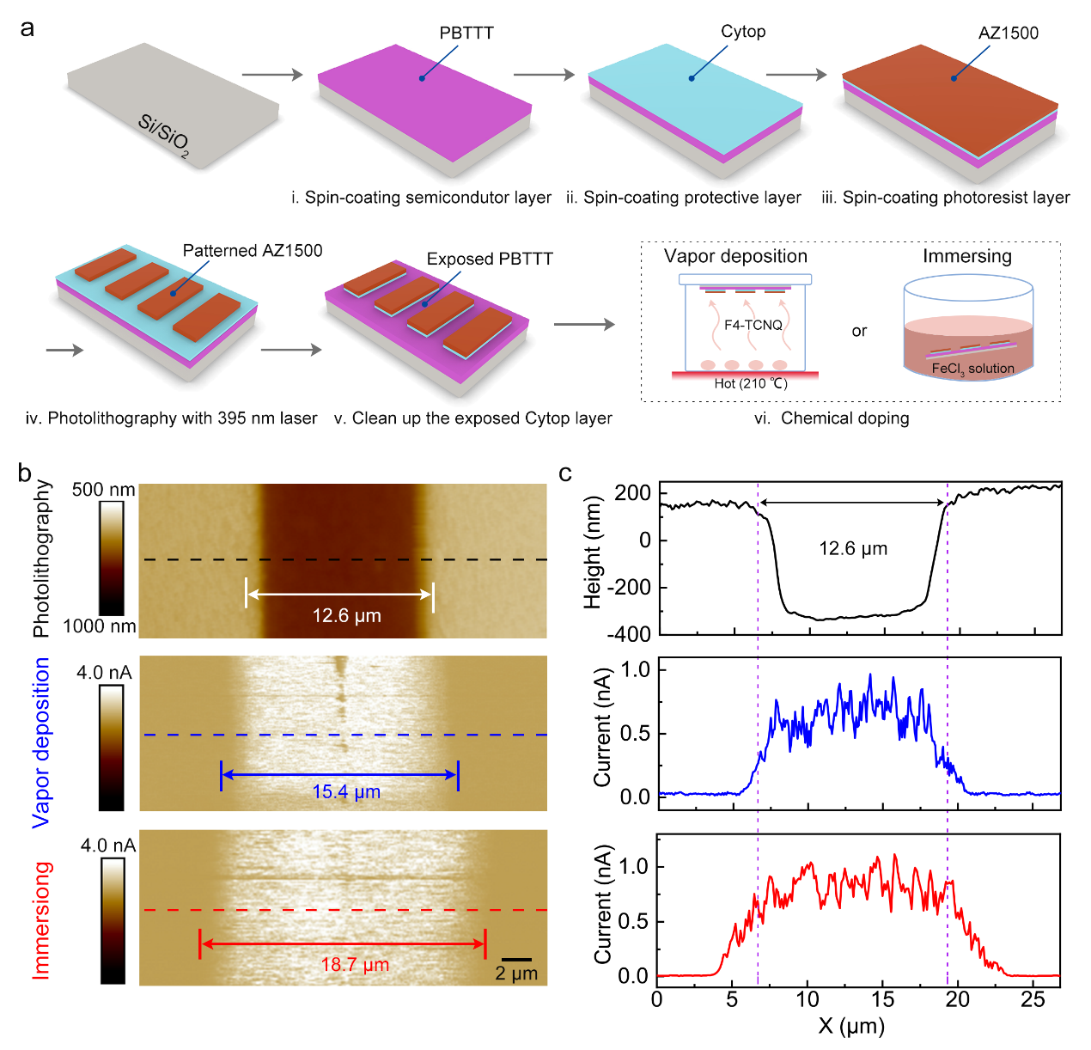
Fig. S19. Lateral diffusion length characterization of the photolithography technology based chemical doping. a, A schematic of chemical doping process flow. We first create the mask by using photolithography with an exposed window of 12.6 μm for doping of the PBTTT films (see panel b). Then, the chemical doping was performed by either F4-TCNQ vapor deposition or immersing the film in the FeCl₃/ acetonitrile solution (reference). b, AFM mapping of the photolithography-based films and chemical doping resolution. c, Corresponding line cut profiles from figure b. The figure (b) and (c) show that the doping resolution for vapor deposition and immersing doping process were 15.4 and 18.7 μm, respectively which were much larger than that of the exposed window (12.6 μm) of the PBTTT films. And the calculated lateral diffusion length for vapor deposition and immersing doping were 2.8 and 6.1 μm, respectively.
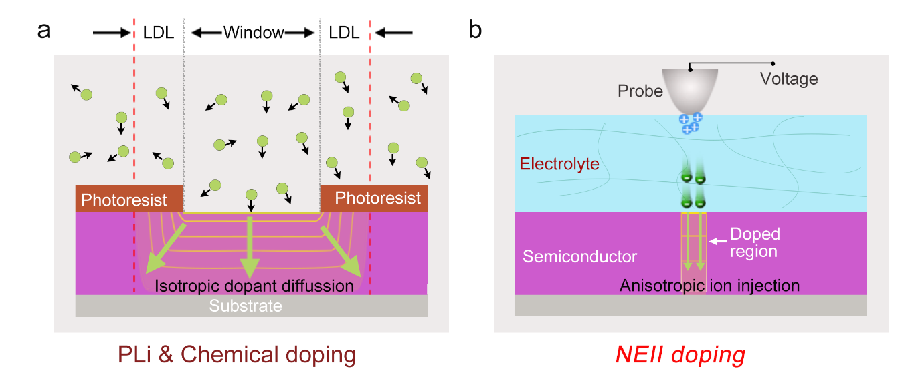
Fig. S20. Schematic diagrams for comparison of the a, the PLi-based chemical doping and b, our NEII doping process. The chemical doping (either vapor deposition and immersing process) is based on thermodynamic equilibrium and the energies for dopant migration are random or isotropic, that accounts for the large LDL observed in fig. S19. By contrast, our NEII doping is a process in which the energetic, charged molecular ions are accelerated and directly injected into the target in an anisotropic manner, leading to a molecular-level LDL.

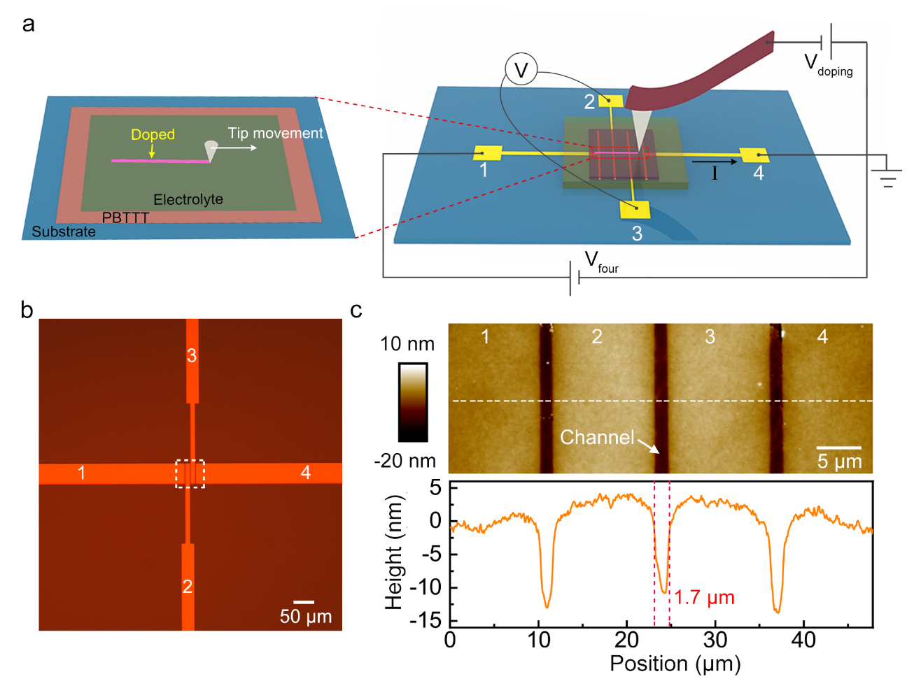Fig. S21. In-situ measurement of the conductivity for the high-resolution electrochemical doping. a, Schematic diagram for the four-probe conductivity measurement of doped films. When the tip moves from the left to right, a nanoscale doping line was simultaneously created. The V_{doping} and V_{four} were applied by AFM (Brucker in ScanAsyst Mode) and Keithley 4200 for the electrochemical doping and the four-probe measurement, respectively. b, Optical images for the four-probe structure. The electrode 1 and 4 were used for applying a constant V_{four} (0.5V), while the 2 and 3 were connected for the measurement of voltage drop in the conductive channel. c, AFM image and corresponding cut line profiles of the four-probe device. Both of the electrodes and semiconductor channel are marked in the AFM image. The extracted channel length was 1.7 μm.

Fig. S22. Comparison of the doping concentration between the typical ion implantation for inorganics^{25-42, 43} and our NEII doping method for polymers. The doping concentration in our work is estimated by $n= \frac{σ}{μ e}$ , where $σ$ is the conductivity, $μ$ is the mobility measured by hall-effect and estimated to be 2.5 cm²/Vs, $e$ is the elementary charge. The doping concentration for electrochemical doping is among 10¹⁹-10²¹ cm⁻³, that is comparable to that of typical one via conventional ion implantation.

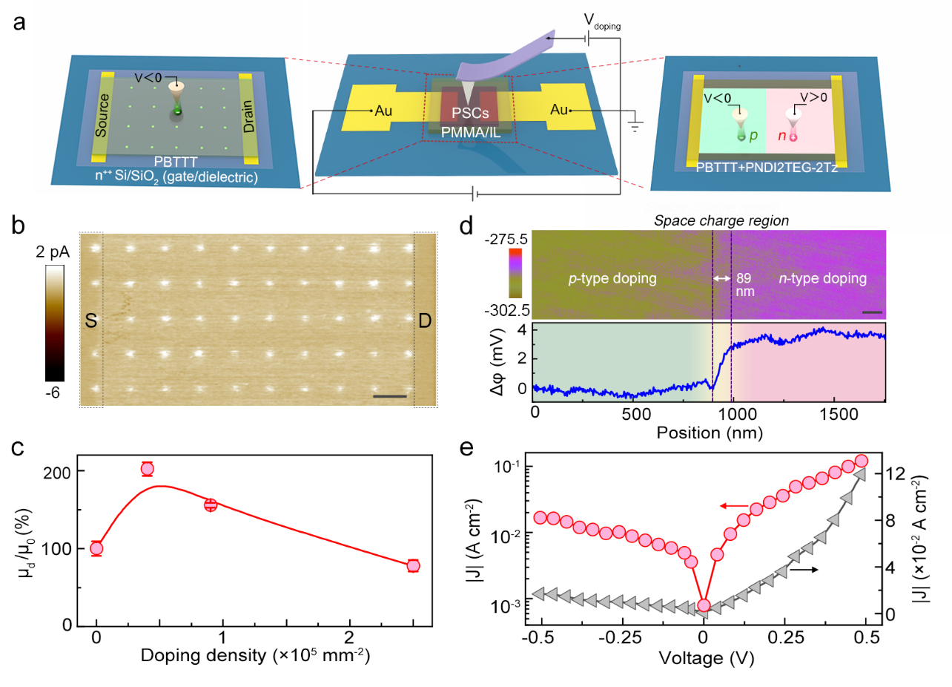
Fig. S23 Summary for NEII-doped devices. a, Schematic diagram shows the device construction of the high-performed transistor and seamless lateral p-n junction. b, Current-voltage mapping image of the PBTTT transistors that are modulated by sub-microscale doping arrays. Scale bar, 2 μm. S, source. D, drain. c, The mobility enhancement (μ_{d}/μ₀) of the transistor as a function of doping density. μ_{d} and μ₀ represent field-effect mobility for doped and pristine PBTTT films. d, KPFM images (top) and corresponding potential profile (bottom) of the lateral p-n diode that was created by nanoscale doping patterns. Scale bar, 200 nm. φ, voltage potential. e, J–V characteristics (log: red, linear: grey) of the PN diode. J, current density.

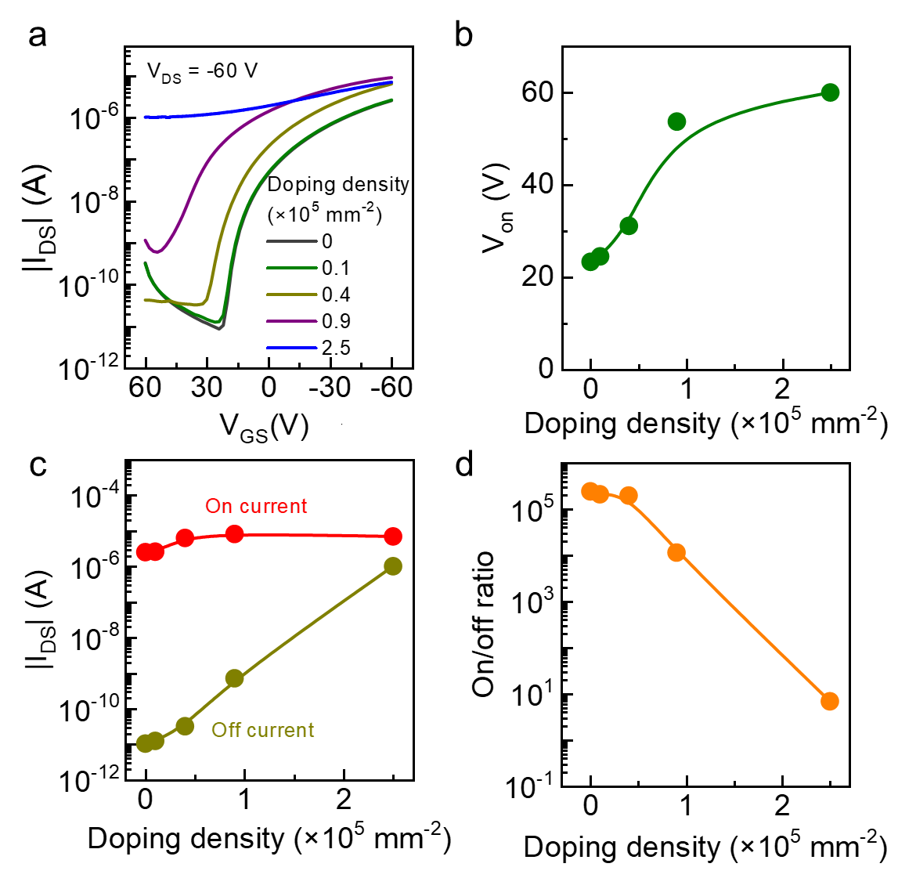
Fig. S24. a-b Representative (a) output and (b) transfer curves for the pristine OFET device. The inset shows the AFM images of the PBTTT films, which demonstrated terrace morphology with large crystallize domains. The high crystallinity leads a prominent field-effect mobility up to 0.6 cm² V⁻¹s⁻¹. Scale bar, 1 μm. c, Evolution of transfer curves for doped OFET devices with different doping density. The current was normalized by the on current of the pristine one. d, on/ off ratio of the transistor as a function of the doping density. When the doping density increased, a rational positive shift of V_{on} was observed, leading to the enhancement in the channel current as well as the mobility depicted in Fig. 5c. Surprisingly, the on/off ratio could be maintained over 10⁵ when the doping density are below 0.4×10⁵ mm⁻², indicating that our NEII doping is an ideal approach for enhancing the transistor’ performance.

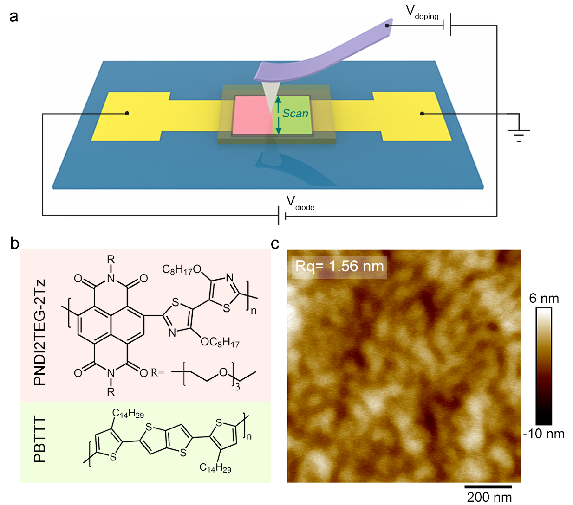
Fig. S25. a, Schematic diagram for the fabrication of p-n junction diode and in-situ measurement of the rectifying characteristics. When scanning, high resolution doping patterns could be simultaneously created. The p and n-type doping were achieved by applying negative and positive voltage on the counter electrolyte (AFM tip), respectively. b, Chemical structures and c, height image of the PBTTT/PNDI2TEG-2Tz blending polymers. The weight ratio of the PBTTT polymer was 2.5%.

References
1 Dearnaley, G. Ion implantation. Science 256, 5, doi:10.1126/science.170.3956.425 (1975).
2 TANJYO, M. & NAITO, M. History of ion implanter and its future perspective. SEI Technical Review 179, 10 (2011).
3 Persaud, A. et al. Quantum computer development with single ion implantation. Quantum Inf. Process 3, 233-245, doi:10.1007/s11128-004-3879-1 (2004).
4 Larson, L. A., Williams, J. M. & Current, M. I. Ion implantation for semiconductor doping and materials modification. Rev. Acceler Sci. Technol. 04, 11-40, doi:10.1142/s1793626811000616 (2012).
5 Li, W. et al. A review of recent applications of ion beam techniques on nanomaterial surface modification: design of nanostructures and energy harvesting. Small 15, e1901820, doi:10.1002/smll.201901820 (2019).
6 Raatz, N., Scheuner, C., Pezzagna, S. & Meijer, J. Investigation of ion channeling and scattering for single‐ion implantation with high spatial resolution. Phys. Status Solidi a 216, 1900528, doi:10.1002/pssa.201900528 (2019).
7 Tsukamoto, K. et al. Evolution of ion implantation technology and its contribution to semiconductor industry. AIP Conference Proceedings 1321, 9-16, doi:10.1063/1.3548476 (2011).
8 Sakai, S., Takahashi, M., Tanjyo, M. & Matsuda, K. Development of an ion source for the low energy ion implantation. Mater. Chem. Phys. 54, 4, doi: 10.1016/S0254-0584(98)00092-3 (1998).
9 Graf, M. A., Vanderberg, B., Benveniste, V., Tieger, D. R. & Ye, J. Low Energy Ion Beam Transport. Proceedings of the 14th international conference on. IEEE, 5 , 359-364, doi: 10.1109/IIT.2002.1258015 (2022).
10 Moliton, A., Lucas, B., Moreau, C., Friend, R. H. & François, B. Ion implantation in conjugated polymers: mechanisms for generation of charge carriers. Philosophical Magazine B. 69, 1155-1171, doi:10.1080/01418639408240186 (2006).
11 WINTERSGILL, M. Ion implantation in polymers. Nucl. Instrum. Methods Phys. Res. 1, 595-598. doi: 10.1016/0168-583X(84)90129-0 (1984)
12 Sviridov, D. V. Chemical aspects of implantation of high-energy ions into polymeric materials. Russ. Chem. Rev. 71, 315-327, doi:10.1070/RC2002v071n04ABEH000710 (2002).
13 Popok, V. Ion implantation of polymers: formation of nanoparticulate materials. Rev. Adv. Mater. Sci. 30, 26 (2012).
14 Scaccabarozzi, A. D. et al. Doping approaches for organic semiconductors. Chem. Rev. 122, 4420-4492, doi:10.1021/acs.chemrev.1c00581 (2022).
15 Jacobs, I. E. et al. High-efficiency ion-exchange doping of conducting polymers. Adv. Mater., 2102988, doi:10.1002/adma.202102988 (2021).
16 Heeger, A. J. Semiconducting and metallic polymers: the fourth generation of polymeric materials. Angew. Chem. Int. Ed. 40, 2591-2611, doi: 10.1021/jp011611w (2001).
17 Quill, T. J. et al. An ordered, self-assembled nanocomposite with efficient electronic and ionic transport. Nat. Mater. 22, 362-368, doi:10.1038/s41563-023-01476-6 (2023).
18 Giridharagopal, R. et al. Electrochemical strain microscopy probes morphology-induced variations in ion uptake and performance in organic electrochemical transistors. Nat. Mater. 16, 737-742, doi:10.1038/nmat4918 (2017).
19 Bischak, C. G. et al. A reversible structural phase transition by electrochemically-driven ion injection into a conjugated polymer. J. Am. Chem. Soc. 142, 7434-7442, doi:10.1021/jacs.9b12769 (2020).
20 Tanaka, H. et al. Thermoelectric properties of a semicrystalline polymer doped beyond the insulator-to-metal transition by electrolyte gating. Sci. Adv. 6, eaay8065, doi: 10.1126/sciadv.aay8065 (2020).
21 Ketabi, S. & Lian, K. The effects of SiO₂ and TiO₂ nanofillers on structural and electrochemical properties of poly(ethylene oxide)–EMIHSO₄ electrolytes. Electrochimi. Acta 154, 404-412, doi:10.1016/j.electacta.2014.12.036 (2015).
22 Li, J. & Lian, K. Investigation of hydroxide ion-conduction in solid polymer electrolytes via electrochemical impedance spectroscopy. Electrochimi. Acta 288, 1-11, doi:10.1016/j.electacta.2018.08.059 (2018).
23 Boucher, V. M. et al. Tg depression and invariant segmental dynamics in polystyrene thin films. Soft Matter 8, doi:10.1039/c2sm25419k (2012).
24 Bandara, T. M. W. J. et al. Characterization of poly (vinylidene fluoride-co-hexafluoropropylene) (PVdF-HFP) nanofiber membrane based quasi solid electrolytes and their application in a dye sensitized solar cell. Electrochimi. Acta 266, 276-283, doi:10.1016/j.electacta.2018.02.025 (2018).
25 Cardellino, J. et al. The effect of spin transport on spin lifetime in nanoscale systems. Nat. Nanotechnol. 9, 343-347, doi:10.1038/nnano.2014.39 (2014).
26 Liu, Y. et al. A photonic integrated circuit–based erbium-doped amplifier. Science 376, 1309, doi:10.1126/science.abo2631 (2022).
27 Wang, M. et al. Self-aligned patterning technique for fabricating high-performance diamond sensor arrays with nanoscale precision. Sci. Adv. 8, eabn9573, doi:10.1126/sciadv.abn9573 (2022).
28 Hoffmann, S. et al. Axial p-n junctions realized in silicon nanowires by ion implantation. Nano Lett. 9, 4, doi:10.1021/nl802977m (2009).
29 Silva, A. F. d. Impurity resistivity of the double-donor system Si:P,Bi. Phys. Rev. B 60, 5, doi:10.1103/PhysRevB.60.15824 (1999).
30 Winkler, M. T. et al. Insulator-to-metal transition in sulfur-doped silicon. Phys. Rev. Lett. 106, 178701, doi:10.1103/PhysRevLett.106.178701 (2011).
31 Romano, L. et al. Effect of strain on the carrier mobility in heavily doped p-type Si. Phys. Rev. Lett. 97, 136605, doi:10.1103/PhysRevLett.97.136605 (2006).
32 Groot-Berning, K. et al. Deterministic single-ion implantation of rare-earth ions for nanometer-resolution color-center generation. Phys. Rev. Lett. 123, 106802, doi:10.1103/PhysRevLett.123.106802 (2019).
33 Ozaki, N. et al. Significant enhancement of ferromagnetism in Zn1-xCrxTe doped with iodine as an n-type dopant. Phys. Rev. Lett. 97, 037201, doi:10.1103/PhysRevLett.97.037201 (2006).
34 Wahl, U. et al. Lattice location of mg in GaN: a fresh look at doping limitations. Phys. Rev. Lett. 118, 095501, doi:10.1103/PhysRevLett.118.095501 (2017).
35 Larsen, A. N. et al. E center in silicon has a donor level in the band gap. Phys. Rev. Lett. 97, 106402, doi:10.1103/PhysRevLett.97.106402 (2006).
36 Sati, P. et al. Magnetic anisotropy of Co2+ as signature of intrinsic ferromagnetism in ZnO:Co. Phys. Rev. Lett. 96, 017203, doi:10.1103/PhysRevLett.96.017203 (2006).
37 Kanungo, P. D. et al. Ex situ n and p doping of vertical epitaxial short silicon nanowires by ion implantation. Nanotechnology 20, 165706, doi:10.1088/0957-4484/20/16/165706 (2009).
38 Colli, A. et al. Ion beam doping of silicon nanowires. Nano lett. 8, 5, doi:10.1021/nl080610d (2008).
39 Sosa, N. E., Liu, J., Chen, C., Marks, T. J. & Hersam, M. C. Nanoscale writing of transparent conducting oxide features with a focused ion beam. Adv.Mater. 21, 721-725, doi:10.1002/adma.200802129 (2009).
40 Pennelli, G., Dimaggio, E. & Masci, A. Silicon nanowires: a breakthrough for thermoelectric applications. Mater. 14, 5305, doi:10.3390/ma14185305 (2021).
41 Stichtenoth, D. et al. P-type doping of GaAs nanowires. Appl. Phys. Lett. 92, 163107, doi:10.1063/1.2912129 (2008).
42 Zeiner, C. et al. Atypical self-activation of Ga dopant for Ge nanowire devices. Nano Lett. 11, 3108-3112, doi:10.1021/nl201105k (2011).
43 Ndoye, C., Liu, T. & Orlowski, M. Comparison of diffusion mechanisms in Si Bulk, nanomembranes, and nanowires. ECS Trans. 33, 15, doi:10.1149/1.3567398 (2011).

