Analyzed Ct miRNA s

Ct
 | miR-208 | miR-208b | miR-1 | miR-133b | miR-21 | miR-155 | miR-126 | miR-16
ECT1 | 34.8543413 | 38.3672095 | 34.2343164 | 30.7062189 | 24.3721958 | 30.6790121 | 23.6426862 | 17.7453825
ECT2 | 34.0485609 | 38.3852363 | 31.2645636 | 29.9098942 | 22.9722826 | 30.5233422 | 22.9911051 | 15.5552597
ECT3 | 34.3419219 | 36.7219055 | 33.6945847 | 30.6132688 | 25.6801436 | 31.1916026 | 26.2192518 | 18.7095167
ECT4 | 34.343668 | 45.1344327 | 34.6743489 | 31.6697971 | 25.3220455 | 31.1605352 | 25.5242856 | 18.4607729
ECT5 | 34.477488 | 35.0159092 | 32.4591253 | 29.959491 | 23.9718275 | 30.4045236 | 23.7762138 | 17.0293453
ECT6 | 34.53941 | 38.7 | 34.0258758 | 31.2038318 | 24.9555325 | 31.1852767 | 25.5691198 | 18.8535162
ECT7 | 33.6769375 | 39.2845755 | 33.1866988 | 30.6536106 | 23.754927 | 30.9853925 | 24.2262862 | 16.8790633
ECT8 | 34.5368274 | 31.5514359 | 29.1775773 | 28.0517162 | 26.8170788 | 31.6336858 | 25.2917727 | 19.2696534
ECT9 | 34.4104357 | 37.051928 | 32.2919707 | 30.2781184 | 23.2799261 | 30.467931 | 23.2633754 | 16.3570201
ECT10 | 35.2317032 | 40.074794 | 35.5727343 | 31.2175208 | 29.5776269 | 31.8403387 | 28.9704903 | 23.4970258
ECT11 | 34.178482 | 33.4492448 | 33.3115393 | 30.8394718 | 25.3774603 | 31.1461139 | 25.5375675 | 18.8609308
ECT12 | 34.5346579 | 41.9859408 | 34.0254455 | 31.16272 | 24.7438138 | 28.8190517 | 24.2178862 | 19.8763218
ECT13 | 34.7158027 | 44.8928496 | 35.6600686 | 31.3802707 | 27.1510378 | 31.323105 | 27.3882077 | 21.1051343
ECT14 | 35.0734771 | 44.2381579 | 34.0510801 | 31.1567357 | 24.5426067 | 30.9717878 | 24.7823316 | 17.3954509
ECT15 | 34.4851467 | 32.1216503 | 30.6447505 | 27.865822 | 25.215408 | 30.8752026 | 23.4309625 | 17.0144003
ECT16 | 34.7020969 | 32.9697687 | 34.7990066 | 30.15567 | 25.1712452 | 31.3398612 | 25.1777003 | 19.0804276
ECT17 | 35.1468848 | 36.9793788 | 35.8890407 | 31.5622227 | 34.3231316 | 31.9412279 | 30.7317616 | 30.7139816
ECT18 | 34.9971154 | 45.4150606 | 35.2240361 | 32.0139691 | 31.1239317 | 31.7201993 | 30.265826 | 25.2511783
ECT19 | 34.5456879 | 45.0943763 | 33.7913124 | 31.1065719 | 24.2808646 | 30.1893351 | 23.6759569 | 17.680676
ECT20 | 43.4753035 | 35.9661591 | 32.144929 | 30.7126963 | 28.041094 | 29.8365656 | 23.9835619 | 18.0670007
ECT21 | 34.8848695 | 36.750927 | 35.0868452 | 31.2851197 | 27.6552563 | 31.5325395 | 29.0794955 | 25.0495386
ECT22 | 36.217278 | 38.7 | 34.8848275 | 33.4529256 | 29.7292453 | 30.8771668 | 26.2530825 | 22.0751851
ECT23 | 34.9734531 | 35.0118511 | 29.0380129 | 29.5045623 | 25.1289516 | 31.4126033 | 26.2039598 | 19.1035406
ECT24 | 34.5013227 | 44.9737244 | 34.4800962 | 31.6799327 | 27.0207391 | 31.2977354 | 26.1912204 | 20.3349957
CTRL1 | 34.5351047 | 45.5241418 | 33.6311792 | 31.6829861 | 28.9211577 | 31.880491 | 28.4507736 | 23.6340972
CTRL2 | 34.6320949 | 38.71 | 34.1669067 | 31.7838873 | 28.6482916 | 32.0960074 | 28.2516709 | 22.7703485
CTRL3 | 35.2811769 | 36.8853871 | 35.0898423 | 31.9730752 | 25.0359309 | 31.6686676 | 25.607375 | 18.519628
CTRL4 | 35.9460238 | 34.5538153 | 33.5619453 | 31.0469833 | 26.0157929 | 30.1431166 | 24.3051415 | 19.3179562
CTRL5 | 35.0799196 | 36.7418373 | 31.8885097 | 31.2913095 | 23.6205418 | 30.4977943 | 22.6511968 | 16.0440484
CTRL6 | 35.4091591 | 35.2825751 | 30.5967108 | 29.9553001 | 25.4327449 | 31.4959378 | 25.0827073 | 18.1008445
CTRL7 | 34.1685388 | 33.1549836 | 32.3322545 | 30.1233171 | 25.3159075 | 31.4585349 | 24.627615 | 18.3766688
CTRL8 | 34.6002335 | 43.8073323 | 34.2158845 | 31.4745356 | 26.2640094 | 31.8026265 | 26.217908 | 20.4389522
CTRL9 | 38.0654388 | 45.0261229 | 34.351335 | 33.2438533 | 26.3977643 | 31.4764088 | 25.465666 | 19.0710763
CTRL10 | 35.2339507 | 35.7429059 | 31.3481826 | 30.6520009 | 25.5028198 | 31.1227401 | 24.3198041 | 19.9958894
CTRL11 | 35.017887 | 35.732287 | 33.0539609 | 30.6873892 | 24.2358071 | 30.0813142 | 23.122633 | 17.2574999
CTRL12 | 34.7642622 | 39.0849879 | 34.6149349 | 32.2858174 | 26.5922288 | 30.6228312 | 25.6053611 | 19.8536125
CTRL13 | 34.4571156 | 42.3549833 | 32.8659285 | 32.131601 | 25.1433928 | 30.3771044 | 23.5912393 | 19.5252607

CTRL14 | 35.0345295 | 40.8086962 | 33.9909153 | 32.2530781 | 25.7013575 | 30.124924 | 24.9207728 | 18.852986
CTRL15 | 34.3112733 | 34.2756595 | 34.3147612 | 30.7494273 | 25.8160249 | 31.1020019 | 25.9742778 | 19.7940582
CTRL16 | 35.3214389 | 38.71 | 33.6060348 | 32.2400058 | 34.5992779 | 32.1143676 | 24.5388919 | 19.0157414
CTRL17 | 34.3394605 | 32.4777468 | 33.6042948 | 30.2795774 | 25.113102 | 31.1570799 | 24.5906726 | 18.756167
CTRL18 | 35.1491207 | 45.8983833 | 33.8957176 | 32.3425436 | 25.7275706 | 31.891544 | 24.7881552 | 18.787464
CTRL19 | 34.4716086 | 45.7224303 | 34.3759499 | 31.9374474 | 25.7812021 | 31.0140102 | 25.8658985 | 19.3494717
CTRL20 | 35.1985466 | 41.1747605 | 32.3349048 | 31.1280862 | 25.4067392 | 42.6840996 | 24.4058487 | 18.2437559
CTRL21 | 34.832832 | 40.1909625 | 33.7113923 | 31.9355684 | 25.2422134 | 31.0582205 | 25.2825182 | 19.8793458
CTRL22 | 34.1005879 | 33.816086 | 30.126588 | 29.7611942 | 24.1399949 | 30.122165 | 23.1132413 | 16.9603068

Network of possible genes in the interaction of miR-133b and IL-2, IL-4 and IL-6.
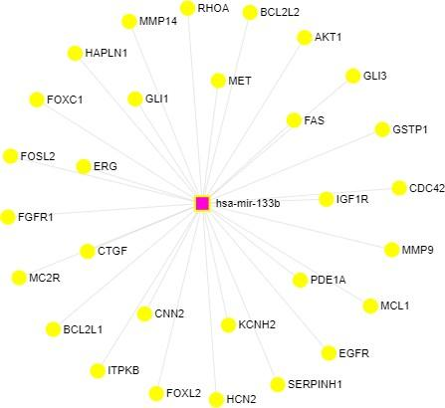

Genes’ network of targets predicted by miRNet. Potential target genes predicted in the interaction of IL-2, IL-4, IL-6 and microRNA 133b.

Network of the main pathways of possible genes.
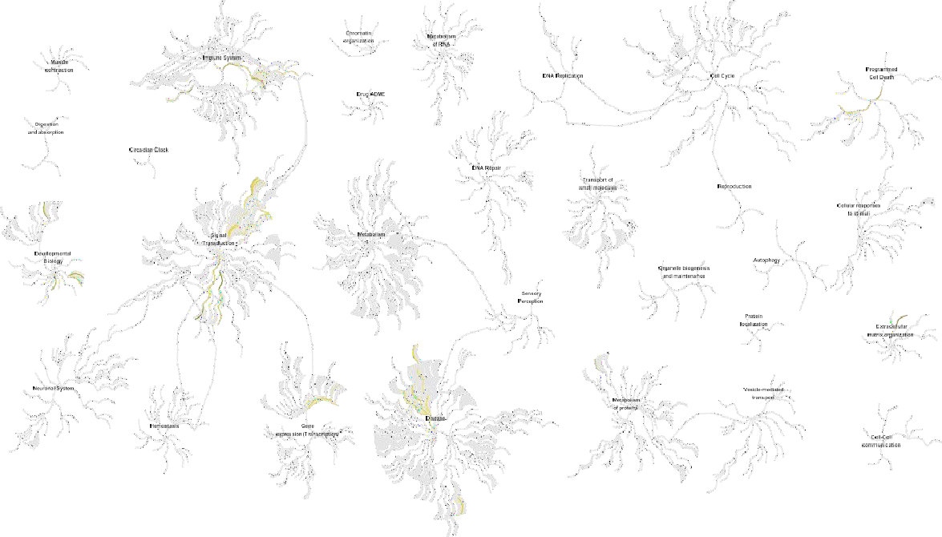

This figure shows a genome-wide overview of the results of pathway analysis. Reactome path- ways are arranged in a hierarchy. The center of each of the circular "bursts" is the root of one top- level pathway. Each step away from the center represents the next level lower in the pathway hierarchy. The color code denotes over-representation of that pathway in your input dataset. Light gray signifies pathways which are not significantly over-represented.

Most significant pathways of possible coronary artery ectasia genes.

Name | Hits | Pval | adj.Pval
Signaling by EGFR | 5 | 0.000168 | 0.00417
PI3K/AKT activation | 4 | 0.00024 | 0.00417
Axon guidance | 6 | 0.000258 | 0.00417
G beta:gamma signalling through PI3Kgamma | 2 | 0.000281 | 0.00417
Sema4D mediated inhibition of cell attachment and  migration | 2 | 0.000281 | 0.00417
RHO GTPases activate KTN1 | 2 | 0.000281 | 0.00417
NGF signalling via TRKA from the plasma membrane | 5 | 0.000292 | 0.00417
Developmental Biology | 7 | 0.000335 | 0.00419
G-protein beta:gamma signalling | 2 | 0.000548 | 0.00609
Signaling by SCF-KIT | 4 | 0.0008 | 0.00627
Downstream signaling of activated FGFR1 | 4 | 0.000945 | 0.00627
Downstream signaling of activated FGFR2 | 4 | 0.000945 | 0.00627
Downstream signaling of activated FGFR3 | 4 | 0.000945 | 0.00627
Downstream signaling of activated FGFR4 | 4 | 0.000945 | 0.00627
Downstream signal transduction | 4 | 0.00129 | 0.00627
Signaling by FGFR | 4 | 0.00129 | 0.00627
Signaling by FGFR1 | 4 | 0.00129 | 0.00627
Signaling by FGFR2 | 4 | 0.00129 | 0.00627
Signaling by FGFR3 | 4 | 0.00129 | 0.00627
Signaling by FGFR4 | 4 | 0.00129 | 0.00627
Signaling by ERBB2 | 4 | 0.00132 | 0.00627
DAP12 signaling | 4 | 0.00138 | 0.00627
Signalling by NGF | 5 | 0.00156 | 0.00678
DAP12 interactions | 4 | 0.00204 | 0.0082
Signal transduction by L1 | 2 | 0.00205 | 0.0082

