Supplementary Material
Presenilin2 D439A mutation induced the dysfunction of mitochondrial fusion/fission dynamics via regulating Miro2 in Alzheimer’s disease
Chenhao Gao ^{1,2#}, Junkui Shang^{1,3#}, Zhengyu Sun ^{1,3}, Mingrong Xia¹, Dandan Gao¹, Ruihua Sun^{1,2}, Wei Li¹, Fengyu Wang^{1,3}, Jiewen Zhang^{1,2,3}*
¹ Department of Neurology, Zhengzhou University People’s Hospital, Henan Provincial People’s Hospital, Zhengzhou, Henan, 450003, China.
² Academy of Medical Sciences, Zhengzhou University, Zhengzhou, Henan, 450003, China.
³ Department of Neurology, Henan University People’s Hospital, Henan Provincial People’s Hospital, Zhengzhou, Henan, 450003, China.
*Corresponding authors: zhangjiewen9900@126.com
# These authors have contributed equally to this work Supplementary Figures and Tables

Supplementary Figures
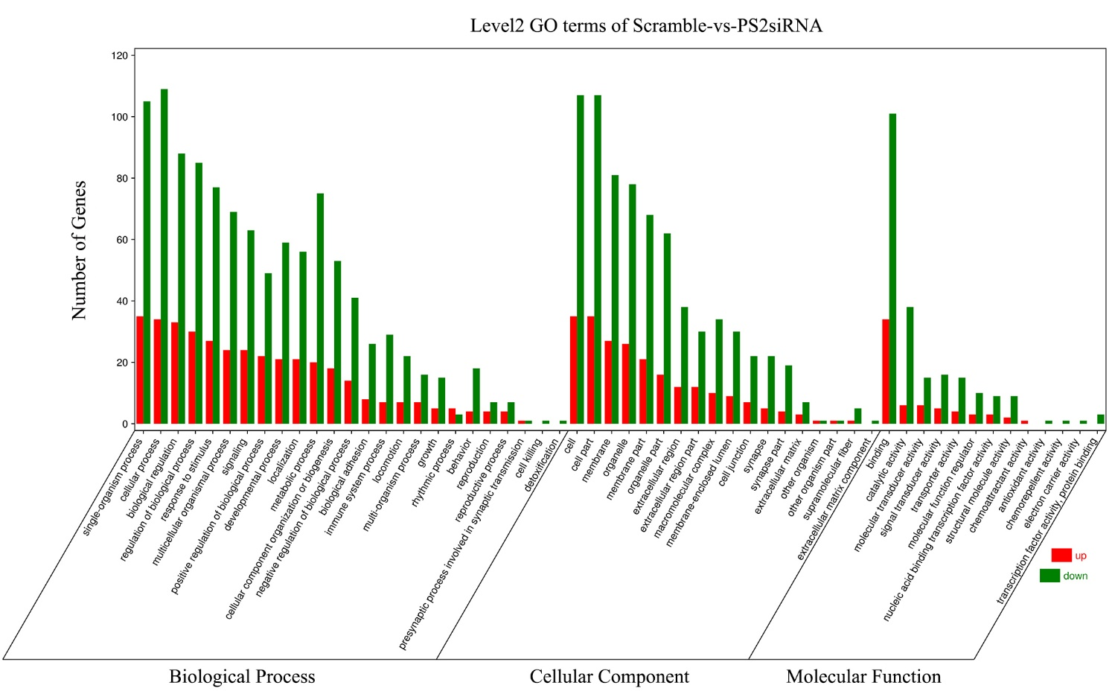Supplementary Fig. 1 The GO enrichment classification histogram of differential genes in scramble and PS2 siRNA groups. The figure shows the GO enrichment results, where the X axis is the GO entry and the Y axis is the number of genes. Red represents gene up regulation and green represents gene down regulation.
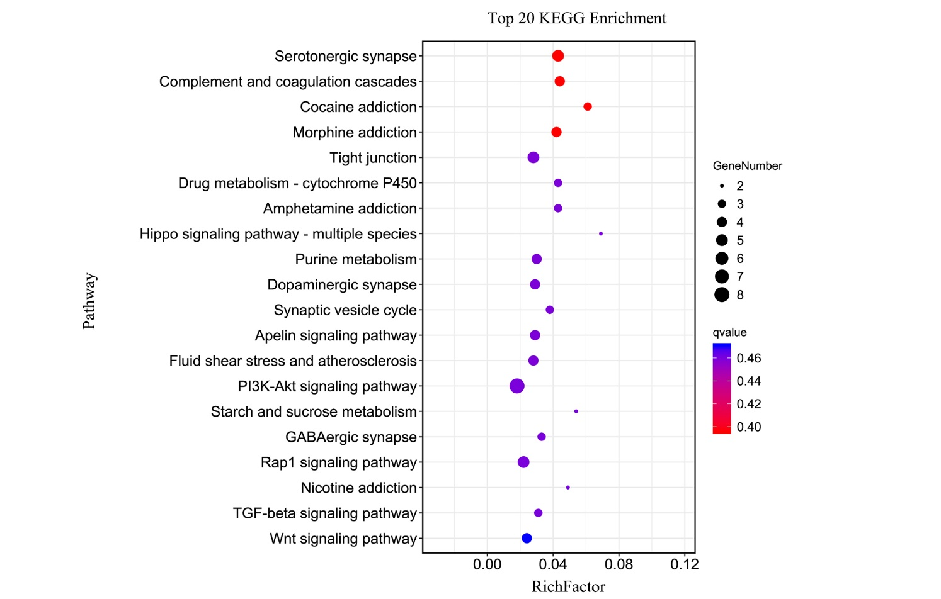
Supplementary Fig. 2 KEGG enrichment Bubble Diagram. The vertical coordinate is the pathway, and the horizontal coordinate is the Rich factor (the difference genes in the path are divided by all the numbers). The bubble size is proportional to the number of genes. The red color means the smaller the Q value.

