Supplementary
For modeling and statistical tests, we removed the first sequence of each trial because that sequence had systematically longer RTs (Figure Supp 1), as was done in Gupta and Rickard. Averaged across all trials, there is a significant difference for each group between the first and second sequence, t(41) = 10.2, p < .0001, d = 1.57; t(40) = 12.4, p < .0001, d = 1.94; t(41) = 9.69, p < .0001, d = 1.49; t(42) = 10.1, p < .0001, d = 1.53 for the S30, S10, M30 and M10 groups respectively. Buch et al., (2020) employed a statistical method of obtaining “instantaneous sequence speed” and for that reason were unable to pick up on this phenomenon. We have separately confirmed that their dataset also suffers from the first sequence slow down. In that dataset there are a variable number of completed sequences per trial, regardless the first sequence is much slower than the rest of the. Further, their method was unable to detect RI. These observations raise doubt about validity of that statistical method.
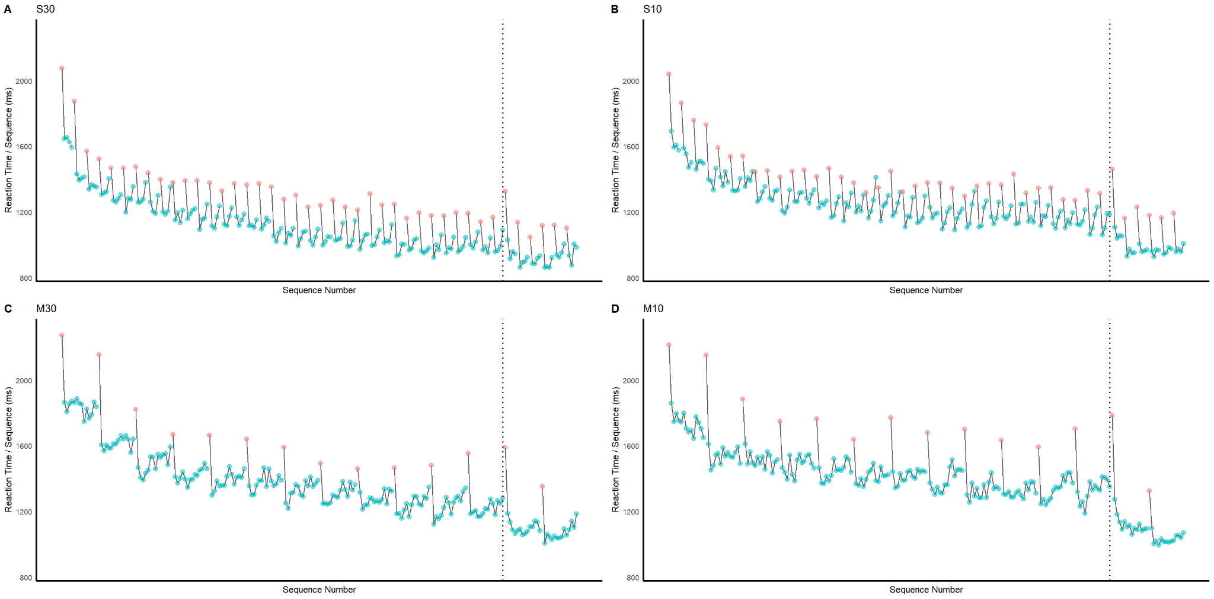

Supp 1. RTs for each sequence across trials, including the first sequence, marked in red. In every trial across groups, aside for the first couple, the first sequence is markedly slower than the rest. This systematicity warranted the removal of it because it is clear there is a third variable problem influencing the RTs of that sequence.

Statistical Analysis of RI and Post-rest Gains
The current method of controlling the number of sequences completed instead of controlling for the total practice time yielded analogous results to our previous study (Gupta & Rickard, 2022), and in line with previous findings from Brawn et al., (2011) and Rickard et al., (2008). To confirm the presence of RI in the 15 sequence groups, we compared the second sequence to the 15th sequence averaged across all training trials. A one-tailed paired-samples t-test, averaged over all practice trials, yielded evidence of RI in the 30 s break group, t(41) = -3.83, p = .0002, d = -.42, but not the 10 s break group, t(42) = .33, p = .43, d = -.019. We believe this may be due to a consistently longer warmup time for this group. To confirm the presence of RI in the five sequence trial groups, we compared the second sequence to the last sequence. A one-tailed paired-samples t-test, averaged over all practice trials, yielded evidence of RI in the 30 s break group, t(41) = -2.94, p-value =.0027, d = -.32, and the 10 s break group t(40) = -6.35, p = <.0001, d = -.7.
With the presence of RI confirmed, we determined whether the current results replicate our previous findings regarding how the number of sequences completed and the break time affected the post-rest improvement (Figure Supp 2). As in Gupta and Rickard (2022), we compared the RT means (sequence 2 onward) over the last two training trials (11 and 12) with the post-rest trials (13 and 14). A 2x2 mixed-factors Analysis of Variance (ANOVA) revealed a significant effect of break time on the post-rest improvement, F(1, 164) = 9.08, p = .003, 𝜂² = .05, as well as a significant effect of the number of sequences during the trial on the post-rest improvement, F(1, 164) = 6.66, p = .012, 𝜂² = .04 (Figure Supp 2). There was no significant interaction between the two factors, F(1, 164) = .321, p = .57, 𝜂² = .002. These results replicated the same pattern observed in Gupta and Rickard.
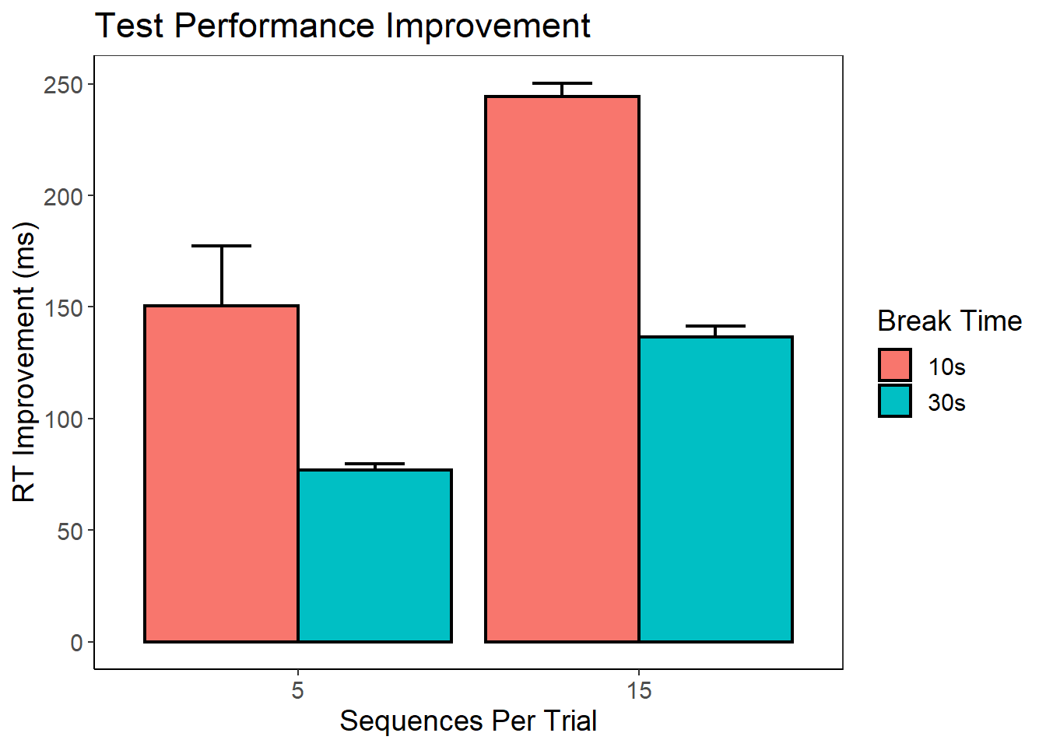
Supp 2. The bar chart shows the total amount of improvement from the last 30 sequences of training compared to the 30 sequences after rest. The y-axis is the average amount of RT improvement. The x-axis indicates the number of sequences performed during a trial, whereas the color indicates the amount of break time. These results replicate our previous findings in Gupta and Rickard (2022) that both break time and the number of sequences performed affect the amount of improvement.

