Manuscript Title: The impact of changing exposure to PM_{2.5} on mortality for US diplomats with multiple international relocations: A modelling study
Leslie Edwards, James Milner, Paul Wilkinson, Ai Milojevic
London School of Hygiene and Tropical Medicine, London, UK

Supplementary Material

Supplementary Table 1: Ten diplomatic assignments with the city and number of years in each city indicated
Supplementary Table 2: Example calculations of the impacted MR for COPD using inception and cessation lags
Supplementary Table 3: Assumptions of the model and the sensitivity analysis
Supplementary Figure 1: Global Burden of Disease 2019 concentration-response (C-R) functions for 6 pollution-sensitive conditions

Supplementary Figure 2: Inception (A) and cessation (B) lags used in the model and sensitivity analysis

Supplementary Figure 3: Mortality rates for six pollution-sensitive conditions, older diplomat, Standard A assignment

Supplementary Table 1: Ten diplomatic assignments with the city and number of years in each city indicated¹.
Assignment | Assignment Description | Assignment locations (number of years in each location)
1 | Standard A | Manila (2 years), Riyadh (2), Munich (2), San Francisco (3), Kathmandu (2), Bangkok (3), Washington, DC (2), Dakar (2), Washington, DC (1)
2 | Standard B | Yaoundé (2), Tirana (2), Amman (3), Dhaka (3), Washington, DC (5), Hanoi (3), Stockholm (2)
3 | Standard A x 2¹ | Manila (2 years), Riyadh (2), Munich (2), San Francisco (3), Kathmandu (2), Bangkok (3), Washington, DC (2), Dakar (2), Washington, DC (1), Manila (2), Riyadh (2), Munich (2), San Francisco (3), Kathmandu (2), Bangkok (3), Washington, DC (2), Dakar (2), Washington, DC (1)
4 | High 1 year & low 3 years cycle | Riyadh (1), Washington, DC (3), Kathmandu (1), Washington, DC (3), Yaoundé (1), Washington, DC (3), Dakar (1), Washington, DC (3), Riyadh (1), Washington, DC (3)
5 | High 2 years & low 2 years cycle | Riyadh (2), Washington, DC (2), Kathmandu (2), Washington, DC (2), Yaoundé (2), Washington, DC (2), Dakar (2), Washington, DC (2), Riyadh (2), Washington, DC (2)
6 | High 3 years & low 1 year cycle | Riyadh (3), Washington, DC (1), Kathmandu (3), Washington, DC (1), Yaoundé (3), Washington, DC (1), Dakar (3), Washington, DC (1), Riyadh (3), Washington, DC (1)
7 | High 4 years x 5 | Riyadh (4), Kathmandu (4), Yaoundé (4), Dakar (4), Riyadh (4)
8 | Very high 2 years & low 2 years cycle | New Delhi (2), Washington, DC (2), New Delhi (2), Washington, DC (2), New Delhi (2), Washington, DC (2), New Delhi (2), Washington, DC (2), New Delhi (2), Washington, DC (2)
9 | Very high 20 years | New Delhi (20)
10 | Standard A with mitigation² | Manila* (2 years), Riyadh* (2), Munich (2), San Francisco (3), Kathmandu* (2), Bangkok* (3), Washington, DC (2), Dakar* (2), Washington, DC (1)

¹ Each of the assignments have a 20 year duration except for profile 3 which had a 40 year duration.
² Air purifiers provided to diplomats for use in their residence while working in cities in Africa and Asia. Cities where air purifiers were provided are indicated with an asterisk (*).

Supplementary Table 2: Example calculations of the impacted MR for COPD using inception and cessation lags
Inception lag
In 2000, a person moved from Washington, DC to Manila, Philippines. In 1999, Washington, DC’s annual PM_{2.5} mean was 13.2 µg/m³ and the GBD CR function (reported as relative risk (RR)) of COPD mortality was 1.09. In 2000, Manila’s annual PM_{2.5} mean was 19.0 µg/m³ and the GBD CR function RR of COPD mortality was 1.15. To calculate the adjusted RR of COPD mortality in 2000, the 1st year in Manila:
- Lag the risk for Manila first by dividing the Manila RR by the Washington, DC RR and identify the excess risk due to Manila by subtracting 1
  - (1.15/1.09) - 1 = 0.05
- Apply a 20-year inception lag to 0.05, the first year of lag is 30% of the lagged risk
  - (0.05 * 0.30) +1 = 1.02
- Multiply the RR for Washington, DC (1.09) by the lagged risk for Manila RR/Washington, DC RR (this is 1.02 as indicated in step 2)
  - Adjusted RR in the first year in Manila = 1.09 * 1.02 = 1.11
5. Continue this calculation for 20 years each year up to 20 years in Manila or until the diplomat moves to an area with a change in PM_{2.5}.

Cessation lag
In 2004, a person has lived in Riyadh, Saudi Arabia for 2 years and is moving to Munich, Germany. In 2003, Riyadh’s annual PM_{2.5} mean was 50 µg/m³ and the GBD CR function of COPD mortality for this PM_{2.5} level was 1.43. In 2004, Munich’s annual PM_{2.5} mean was 18.5 µg/m³ and the GBD CR function of COPD mortality for this PM_{2.5} level was 1.43. To calculate the adjusted RR of COPD mortality for 2004, the 1st year in Munich:
- Because the person had only lived in Riyadh for 2 years and had moved there from a city with much lower ambient PM_{2.5}, the person’s evolved RR of COPD mortality was 1.25 and not the full RR for Riyadh, 1.43
- Lag the continued risk for Riyadh by dividing the evolved Riyadh RR divided by the Munich RR and identify the excess risk due to Riyadh by subtracting 1
    - (1.25/1.14) - 1 = 0.09
- Apply a 20-year cessation lag to 0.09, the first year of the cessation lag is 70% of the lagged risk
  - (0.09 * 0.70) + 1 = 1.07
- Multiply the RR for Munich (1.14) by the lagged risk for evolved Riyadh RR/Munich RR (1.07)
  - 1.14 * 1.07 = 1.22
- Continue this calculation for the remaining 19 years, unless the person moves again

Supplementary Table 3: Assumptions of the model and the sensitivity analysis

- All diplomats move on 1 January each year and spend an entire year in a location.
- All diplomats live in the US before and after their 20 year period of diplomatic assignments and their PM_{2.5} exposure in the US is equal to the overall US annual mean concentration of PM_{2.5} in those years.
- An inception lag is applied to the GBD C-R function when a diplomat move to a location with higher ambient PM_{2.5} concentration compared to the prior location by 5 µg/m³ or more.
- A cessation lag is applied to the GBD C-R function when a diplomat move to a location with lower ambient PM_{2.5} concentration compared to the prior location by 5 µg/m³ or more.
- When a diplomat move to a location with a change in ambient PM_{2.5} concentration +/-5 ug/m³, the current lag is cancelled and a new lag is applied to take into account the difference between the RR in the new location and the evolved RR in the prior year in the prior location.
- Exposure to PM_{2.5} is estimated by city averaged annual PM_{2.5} concentration without considering the time spent outdoors or indoors, or activities including cooking or outdoor exercise that could potentially lead to a higher personal exposure to PM_{2.5}.
- The GBD C-R functions apply to the US diplomatic population.
- Baseline mortality for the US diplomatic corps population is same as that for the US population, reflected in the US mortality statistics in 2019.
- The PM_{2.5} concentration and response relationship does not differ by sources of PM_{2.5}.
- For child assignment profiles, PM_{2.5} exposure begins at birth excluding the pre-natal exposure period and continues until age 20 years in order to maintain the same duration of exposure among the three age groups studied.

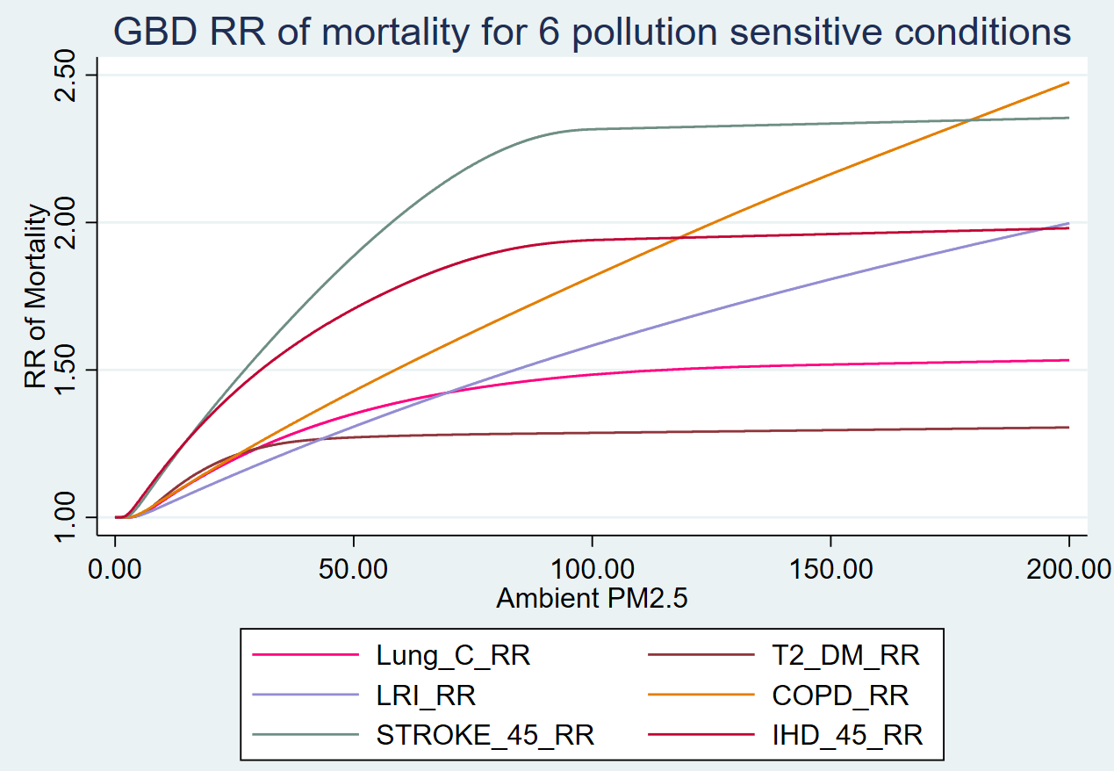
Supplementary Figure 1: Global Burden of Disease 2019 concentration-response (C-R) functions for 6 pollution-sensitive conditions

A – Inception Lags
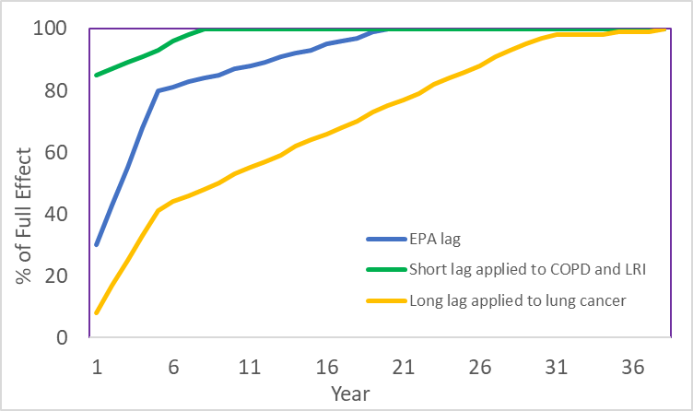
B – Cessation Lags
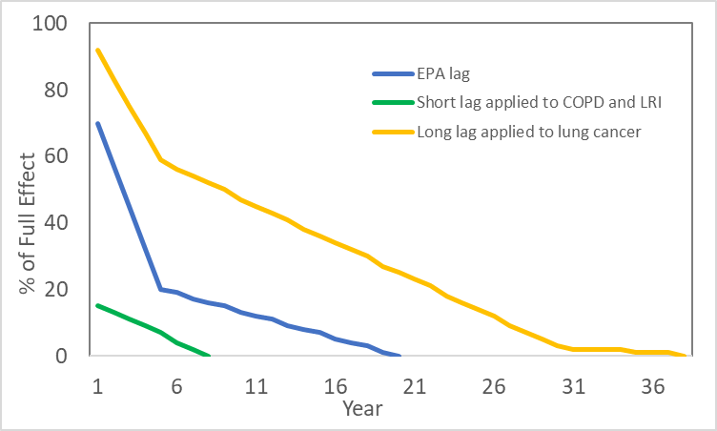

Supplementary Figure 2: Inception (A) and cessation (B) lags used in the model and sensitivity analysis

(A) IHD  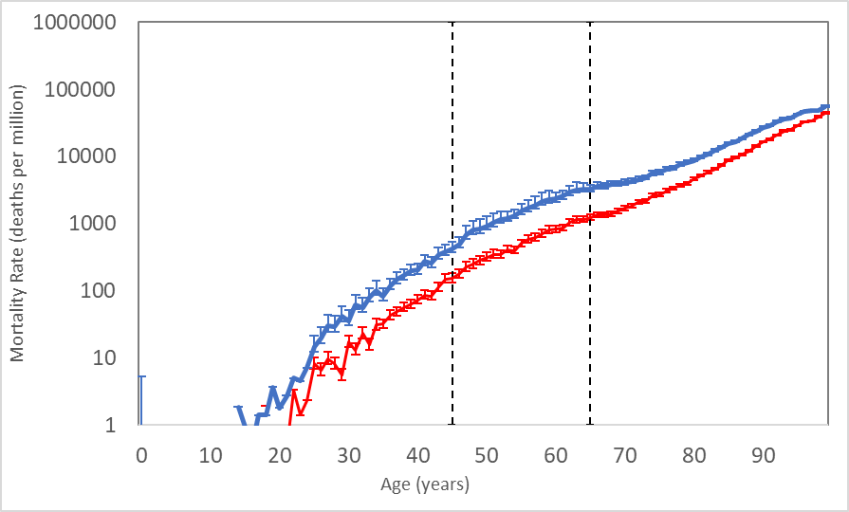 | (B) Stroke  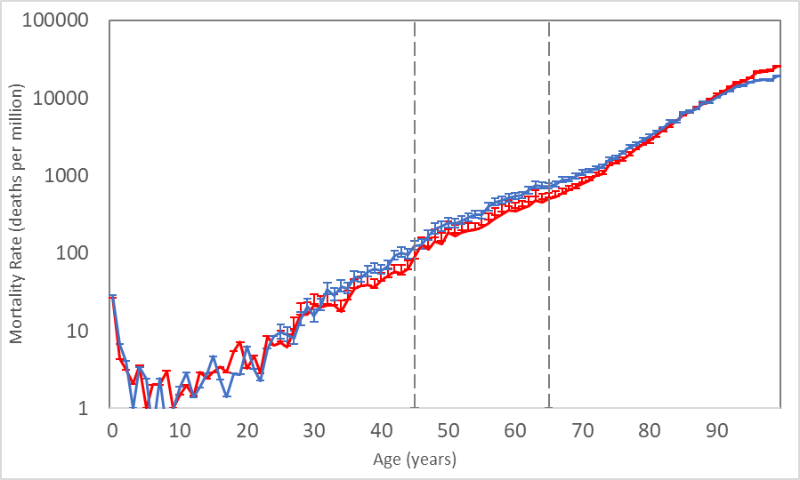
(C) COPD  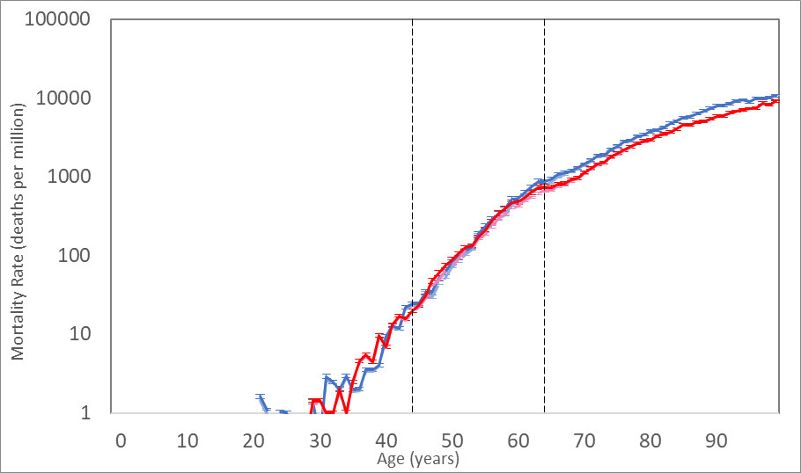 | (D) LRI  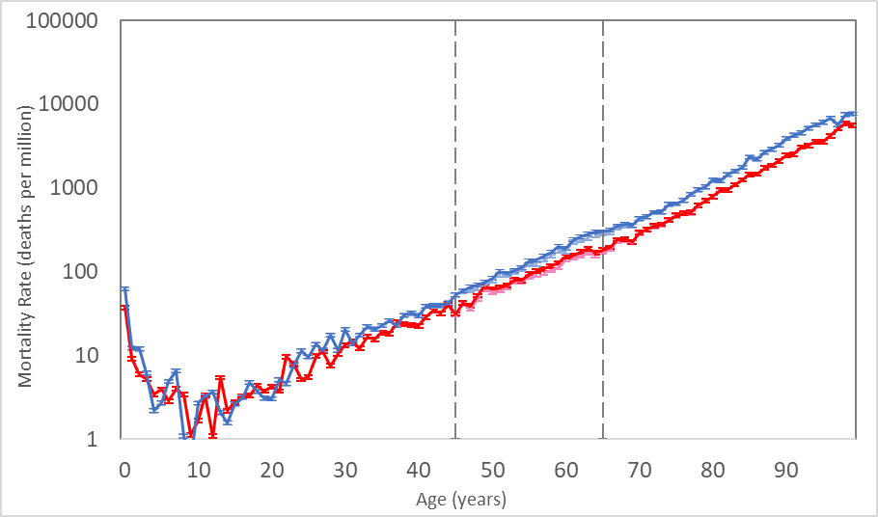
(E) Type 2 Diabetes Mellitus  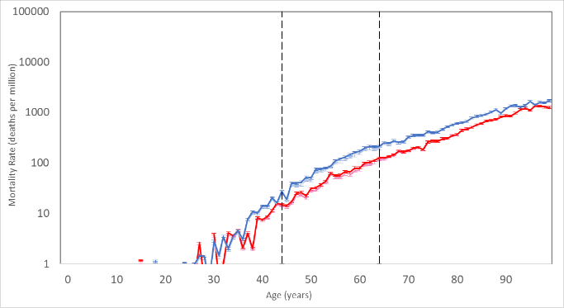 | (F) Lung Cancer  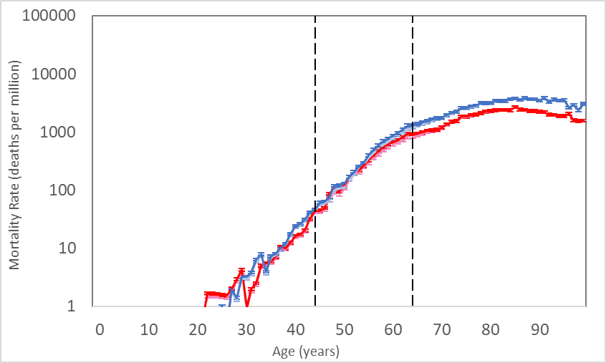

Supplementary Figure 3: Mortality rates for six pollution-sensitive conditions, older diplomat, Standard A assignment

