Supporting Information
Efficient fractionation of microalgae biomass as a whole for biodiesel production enabled by deep eutectic solvent and water
Dayong Yu ^{a, b}, Hangyu Luo ^{a, b}, Jinyu Tan ^{b}, Junfa Yuan ^{b}, Jiasheng Chen ^{b}, Zhen Fang ^{c}, Xiaofang Liu ^{a, *}, Hu Li ^{b, *}
ª Guizhou Provincial Key Laboratory for Rare Animal and Economic Insects of the Mountainous Region, College of Biology and Environmental Engineering, Guiyang University, Guiyang 550005, China
^{b} National Key Laboratory of Green Pesticide, Key Laboratory of Green Pesticide and Agricultural Bioengineering, Ministry of Education, State-Local Joint Laboratory for Comprehensive Utilization of Biomass, Center for R&D of Fine Chemicals, Guizhou University, Guiyang, 550025, China.
^{c} Biomass Group, College of Engineering, Nanjing Agricultural University, 40 Dianjiangtai Road, Nanjing, Jiangsu 210031, China

* Corresponding authors.
E-mails: liuxfzap@163.com (X. Liu); hli13@gzu.edu.cn (H. Li)

Tables and Figures Captions
Fig. S1. (a) Chemical structures of HBDs and HBA for DESs synthesis; (b-d) FT-IR spectra of pure components and DESs.
Fig. S2. FT-IR spectra of raw microalgae and RMP.
Fig. S3. SEM images of (a) raw microalgae; (b) RMP after CC-FA; (c) RMP after CC-AA; (d) RMP after CC-LA.
Fig. S4. XRD diffraction patterns of raw microalgae and different RMPs.

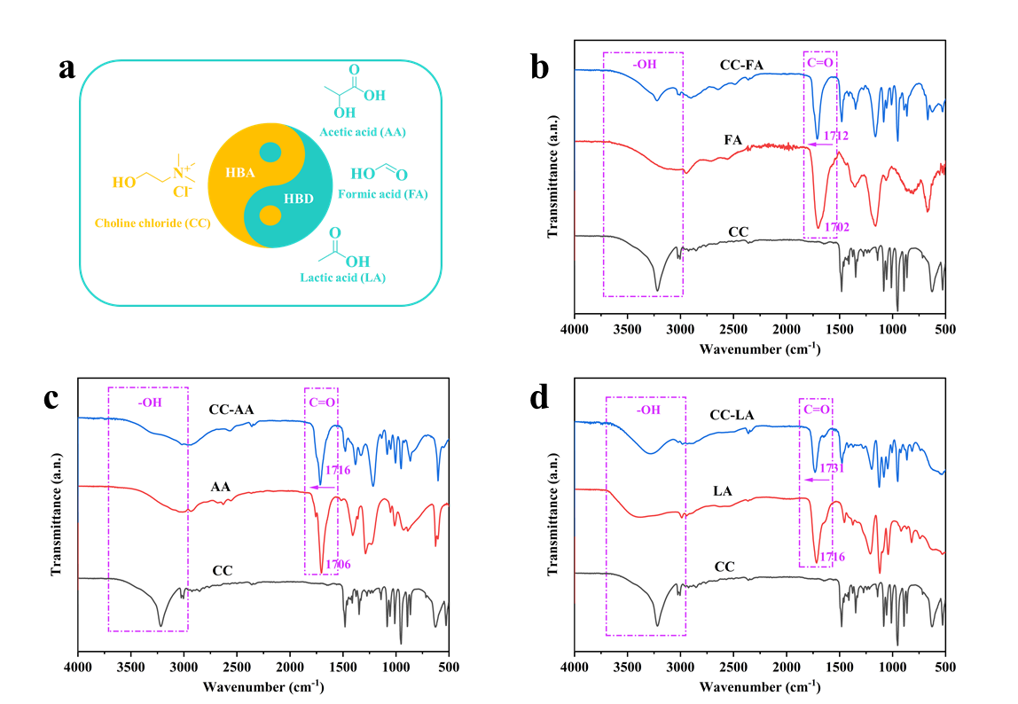
Fig. S1. (a) Chemical structures of HBDs and HBA for DESs synthesis; (b-d) FT-IR spectra of pure components and DESs.

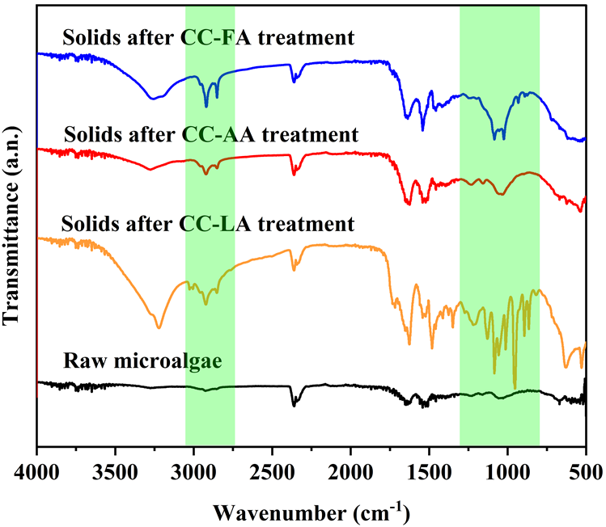
Fig. S2. FT-IR spectra of raw microalgae and RMP.

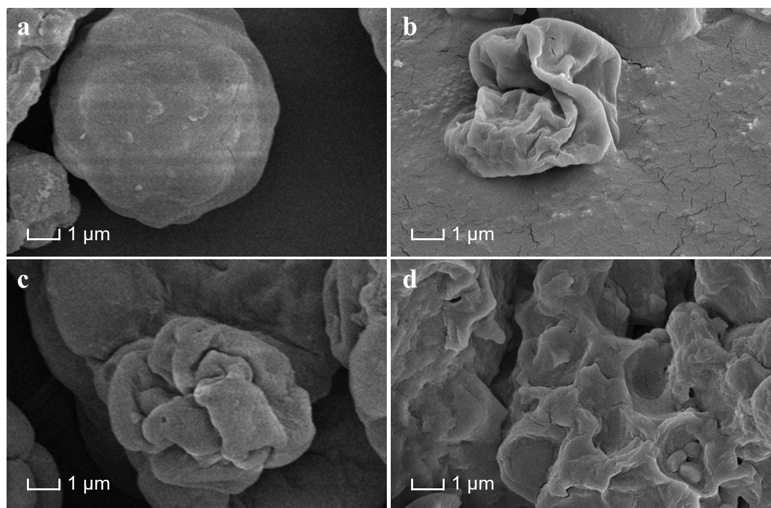
Fig. S3. SEM images of (a) raw microalgae; (b) RMP after CC-FA; (c) RMP after CC-AA; (d) RMP after CC-LA.

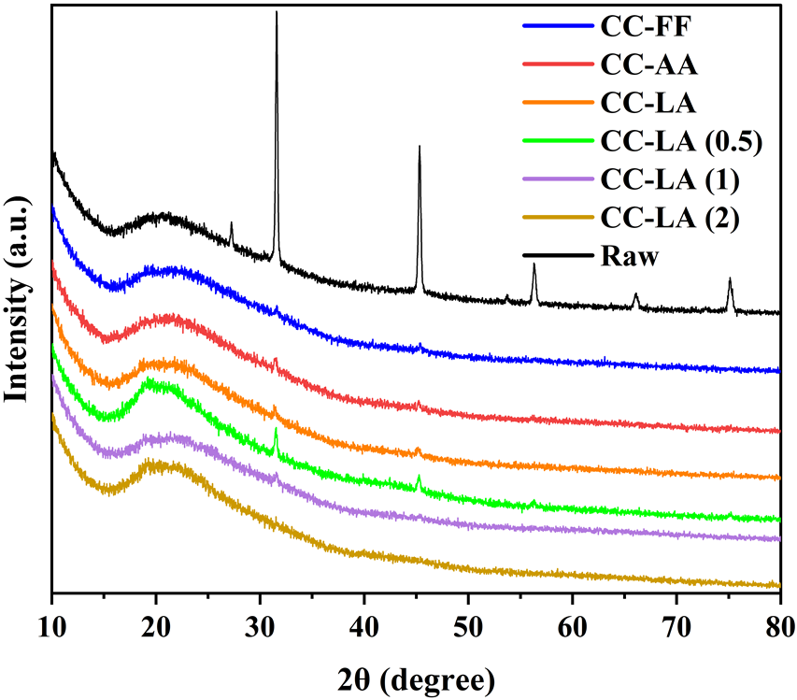
Fig. S4. XRD diffraction patterns of raw microalgae and different RMPs.

