Supplementary material

A. Genetic variance calculation in simulated MPPs considering epistasis
The genetic effect contributed by the main additive effect of the three simQTLs and the epistasis between simQTL1 and simQTL3 per family is expressed as: $Q_{family}=z_{1}a_{1}+z_{2}a_{2}+z_{3}a_{3}+z_{1}z_{3}δ_{1,3}$. In each family of simDiallel and simNAM designs, we assume the three simQTLs from different chromosomes are independent, i.e., $cov\left(z_{2},z_{3}\right)=cov\left(z_{1},z_{3}\right)=cov\left(z_{2},z_{3}\right)=cov\left(z_{2},z_{1}z_{3}\right)=0$, so we can deduce the unified formula of genetic variance in each family as:
$$var\left(Q_{family}\right)=a_{1}^{2}var\left(z_{1}\right)+a_{2}^{2}var\left(z_{2}\right)+a_{3}^{2}var\left(z_{3}\right)+δ_{1,3}^{2}var\left(z_{1}z_{3}\right)+2a_{1}δ_{1,3}cov\left(z_{1},z_{1}z_{3}\right)+2a_{3}δ_{1,3}cov\left(z_{3},z_{1}z_{3}\right).$$
The variance and covariance of those genotype indicators $z_{1}$, $z_{2}$, and $z_{3}$ is determined by their genetic frequencies $f_{z_{x}}$ or $f_{z_{y}}$ ($x or y=1, 2, 3$ for the three simQTLs) in each family as:
$$var\left(z_{x}\right)=E\left(z_{x}^{2}\right)-{\left\{E\left(z_{x}\right)\right\}}^{2}$$
$$=1-{\left(f_{z_{x}=1}-f_{z_{x}=-1}\right)}^{2}$$
and
$$cov\left(z_{x},{z_{x}z}_{y}\right)=E\left(z_{x}^{2}z_{y}\right)-E\left(z_{x}\right)E\left({z_{x}z}_{y}\right)$$
$$=E\left(z_{y}\right)-E\left(z_{x}\right)E\left({z_{x}z}_{y}\right)$$
$$=f_{z_{y}=1}-f_{z_{y}=-1}-\left(f_{z_{x}=1}-f_{z_{x}=-1}\right)\left(f_{{z_{x}z}_{y}=1}-f_{{z_{x}z}_{y}=-1}\right).$$
Without considering residual heterozygotes, expected genotype frequencies are listed in the table:

Therefore, in simDiallel, we obtain the formula for the calculation of expected genetic variance per family as:
$$var\left(Q_{A×B}\right)=a_{1}^{2}+a_{3}^{2}+δ_{1,3}^{2}$$
$$var\left(Q_{A×C}\right)=a_{1}^{2}+a_{2}^{2}+δ_{1,3}^{2}+2a_{1}δ_{1,3}={\left(a_{1}+δ_{1,3}\right)}^{2}+a_{2}^{2}$$
$var\left(Q_{B×C}\right)=a_{2}^{2}+a_{3}^{2}+δ_{1,3}^{2}-2a_{3}δ_{1,3}=a_{2}^{2}+{\left(a_{3}-δ_{1,3}\right)}^{2}$.
In simNAM, we have:
$$var\left(Q_{D×A}\right)=a_{2}^{2}+a_{3}^{2}+δ_{1,3}^{2}+2a_{3}δ_{1,3}=a_{2}^{2}+{\left(a_{3}+δ_{1,3}\right)}^{2}$$
$$var\left(Q_{D×B}\right)=a_{1}^{2}+a_{2}^{2}+δ_{1,3}^{2}-2a_{1}δ_{1,3}={\left(a_{1}-δ_{1,3}\right)}^{2}+a_{2}^{2}$$
$var\left(Q_{D×C}\right)=a_{1}^{2}+a_{3}^{2}+δ_{1,3}^{2}$.
The above formulas of genetic variance per family demonstrate the genetic component associated with each simQTL, and thus we can calculate the expected heritability ($h^{2}$) for each simQTL per family given the simulated residual error $e$.
In the simDiallel design,
for the family $A×B$:
$h_{simQTL1_{A×B}}^{2}=\frac{a_{1}^{2}+δ_{1,3}^{2}}{a_{1}^{2}+a_{3}^{2}+δ_{1,3}^{2}+var(e)}$; $h_{simQTL2_{A×B}}^{2}=0$;$h_{simQTL3_{A×B}}^{2}=\frac{a_{3}^{2}+δ_{1,3}^{2}}{a_{1}^{2}+a_{3}^{2}+δ_{1,3}^{2}+var(e)}$.
for the family $A×C$:
$h_{simQTL1_{A×C}}^{2}=\frac{{\left(a_{1}+δ_{1,3}\right)}^{2}}{{\left(a_{1}+δ_{1,3}\right)}^{2}+a_{2}^{2}+var(e)}$; $h_{simQTL2_{A×C}}^{2}=\frac{a_{2}^{2}}{{\left(a_{1}+δ_{1,3}\right)}^{2}+a_{2}^{2}+var(e)}$;$h_{simQTL3_{A×C}}^{2}=0$.
for the family $B×C$:
$h_{simQTL1_{B×C}}^{2}=0$; $h_{simQTL2_{B×C}}^{2}=\frac{a_{2}^{2}}{a_{2}^{2}+{\left(a_{3}-δ_{1,3}\right)}^{2}+var(e)}$;$h_{simQTL3_{B×C}}^{2}=\frac{{\left(a_{3}-δ_{1,3}\right)}^{2}}{a_{2}^{2}+{\left(a_{3}-δ_{1,3}\right)}^{2}+var(e)}$.
In the simNAM design,
for the family $D×A$:
$h_{simQTL1_{D×A}}^{2}=0$; $h_{simQTL2_{D×A}}^{2}=\frac{a_{2}^{2}}{a_{2}^{2}+{\left(a_{3}+δ_{1,3}\right)}^{2}+var(e)}$;$h_{simQTL3_{D×A}}^{2}=\frac{{\left(a_{3}+δ_{1,3}\right)}^{2}}{a_{2}^{2}+{\left(a_{3}+δ_{1,3}\right)}^{2}+var(e)}$.
for the family $D×B$:
$h_{simQTL1_{D×B}}^{2}=\frac{{\left(a_{1}-δ_{1,3}\right)}^{2}}{{\left(a_{1}-δ_{1,3}\right)}^{2}+a_{2}^{2}+var(e)}$; $h_{simQTL2_{D×B}}^{2}=\frac{a_{2}^{2}}{{\left(a_{1}-δ_{1,3}\right)}^{2}+a_{2}^{2}+var(e)}$;$h_{simQTL3_{D×B}}^{2}=0$.
for the family $D×C$:
$h_{simQTL1_{D×C}}^{2}=\frac{a_{1}^{2}+δ_{1,3}^{2}}{a_{1}^{2}+a_{3}^{2}+δ_{1,3}^{2}+var(e)}$; $h_{simQTL2_{D×C}}^{2}=0$;$h_{simQTL3_{D×C}}^{2}=\frac{a_{3}^{2}+δ_{1,3}^{2}}{a_{1}^{2}+a_{3}^{2}+δ_{1,3}^{2}+var(e)}$

B. QTL profiles of empirical datasets for the cP&F approach and the reference model rP
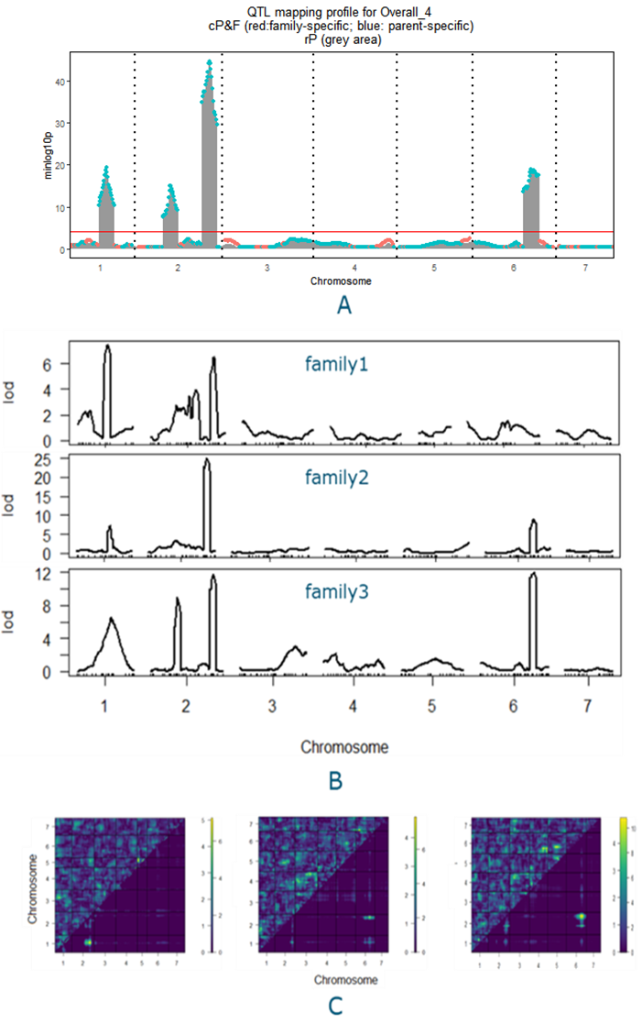
Fig. S1 QTL profiles for the cucumber NAM design using the cP&F approach, compared with the mapping profiles using the reference model rP. B. the QTL profiles of composite interval mapping for each biparental family by r/qtl. C. The heat map of LOD signals from the two-dimensional scan by r/qtl. The LOD signal of testing epistasis is displayed in the upper left triangle; The LOD signal of testing additive effects is displayed in the lower right triangle. In the color scale on the right, numbers to the left and right correspond to LOD signals for interactive and additive effects, respectively.

Fig. S2. QTL profiles for the maize NAM design using the cP&F approach, compared with the mapping profiles using the reference model rP.

Fig. S3. QTL profiles for the tomato NAM design using the cP&F approach, compared with the mapping profiles using the reference model rP.

Fig. S4. QTL profiles for the tomato diallel using the cP&F approach, compared with the mapping profiles using the reference model rP.
Fig. S5. QTL profiles for the maize diallel using the cP&F approach, compared with the mapping profiles using the reference model rP.

(Figure caption on next page)
Fig. S6. QTL profiles for the Arabidopsis connected diallel using the cP&F approach, compared with the mapping profiles using the reference model rP.

