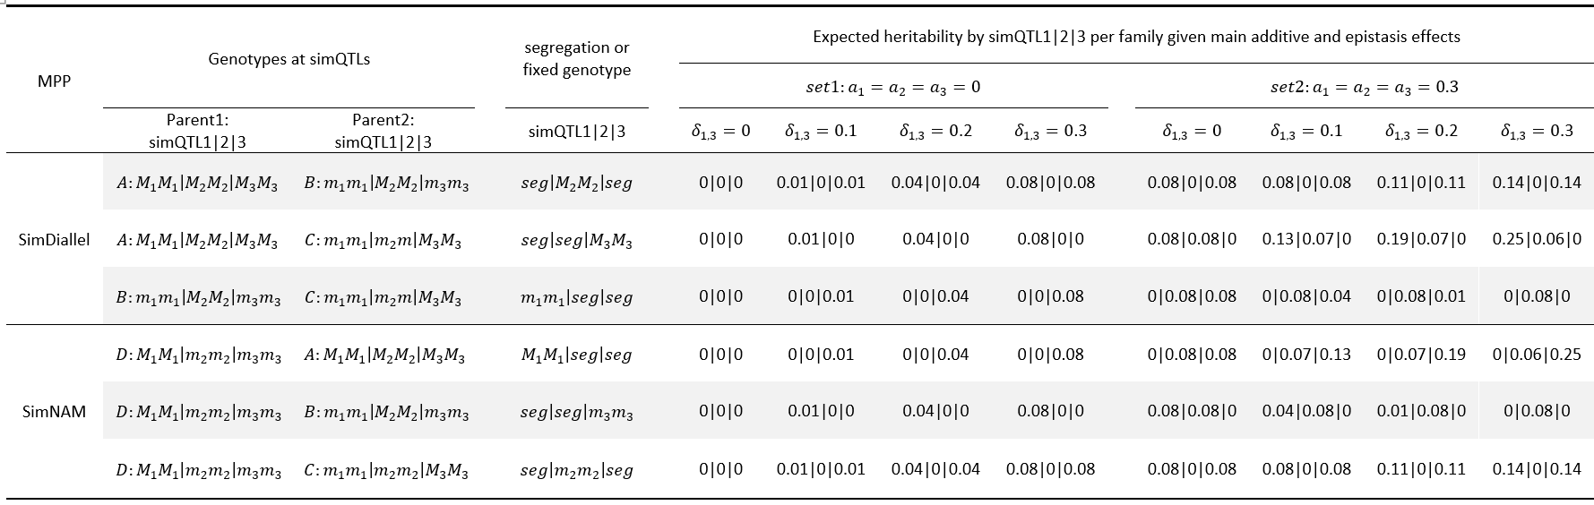
Table 1. Segregation of simulated QTLs and expected heritability for each simQTL per family in simDiallel and simNAM designs. Among the simulated genome of parents A, B, C, and D, three simQTLs were selected to generate varying segregation scenarios. The heritability for each simQTL per family was calculated for a series of interaction effects (0, 0.1, 0.2, and 0.3) in combination with no additive effects (set 1) versus additive effects of 0.3 (set 2).
Table 2. Summary of various real MPP designs and QTL mapping results by the reference parent-specific (rP) and combined parent- and family-specific (cP&F) approaches.
MPP designs | Family type | Number of progenies | Traits | Number of  identified QTLs* |  | Explained variance
 |  |  |  |  |  | rP | cP&F
Cucumber NAM with big families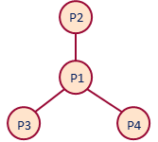 | F2 | 963 | Overall_4 |  |  | 0.38 | 0.38
Maize EU-NAM with small families  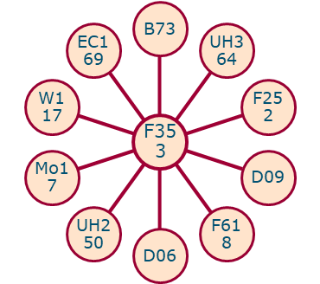 | DH | 841 | Dry matter yield (DMY) | 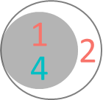 |  | 0.37 | 0.41
 | DH | 841 | Plant height (PH) | 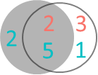 |  | 0.56 | 0.61
 | DH | 841 | Day to silking (DtSILK) | 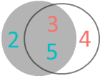 |  | 0.70 | 0.72
Tomato two concatenated NAMs  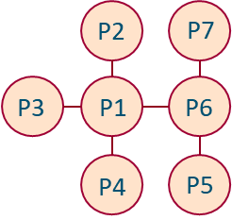 | F2 | 718 | Infection severity (sore) |  |  | 0.11 | 0.11
Tomato full diallel  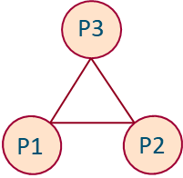 | F2 | 248 | Area |  |  | 0.60 | 0.62
 | F2 | 248 | Proximal angel |  |  | 0.80 | 0.80
Mazi partial diallel  (round robin)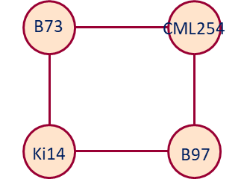 | RIL | 569 | Plant height (PHP) |  |  | 0.51 | 0. 51
 | RIL | 569 | Ear height (EHP) |  |  | 0.43 | 0. 43
 | RIL | 569 | Total leaf in number (TLNP) | 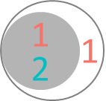 |  | 0.41 | 0. 45
Arabidopsis two concatenated diallels 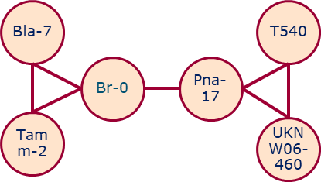 | DH | 507 | Cauline leaf number in cold condition (CL_c) | 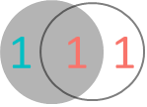 |  | 0.36 | 0.38
 | DH | 507 | Cauline leaf number in warm condition (CL_w) | 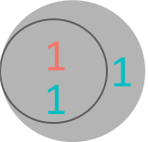 |  | 0.36 | 0.32
 | DH | 507 | Flowering time in cold condition (FT_c) |  |  | 0.22 | 0.51
 | DH | 507 | Flowering time in warm condition (FT_w) | 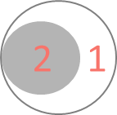 |  | 0.56 | 0.60
*Number of identified QTLs are presented in Venn diagram. Numbers of QTLs detected by the rP model are in the grey circles, those detected by the cP&F model are in white circles where red highlighted numbers are numbers of family-specific QTLs and blue highlighted numbers are numbers of parent-specific QTLs.

