Supplementary file
The resource utilization of debris flow deposits is causing widespread concern in the society, and after investigation, it is known that there are debris flow cleaning projects in progress, as shown in Figure 1 and Figure 2.
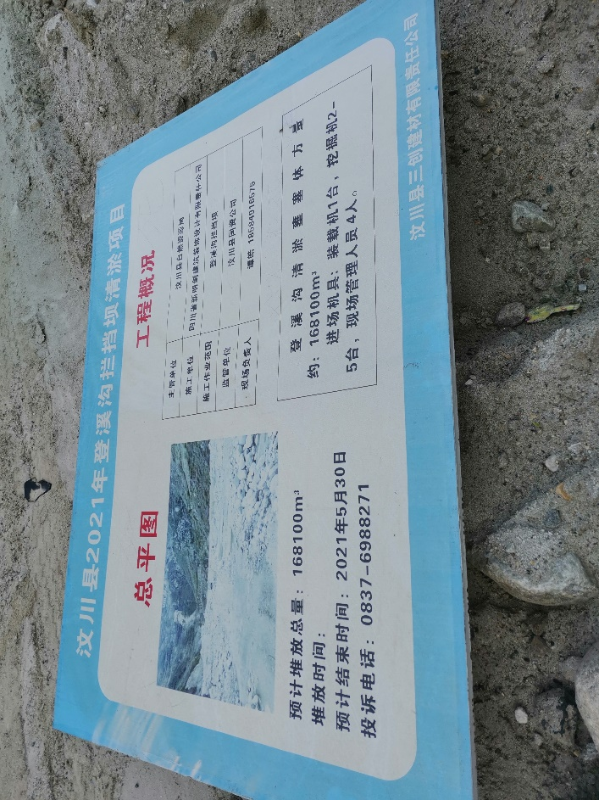
Figure 1. Dengxi gully dam dredging project in Wenchuan County in 2021; The volume of Dengxi gully dredging fortress is about 168100 m³.
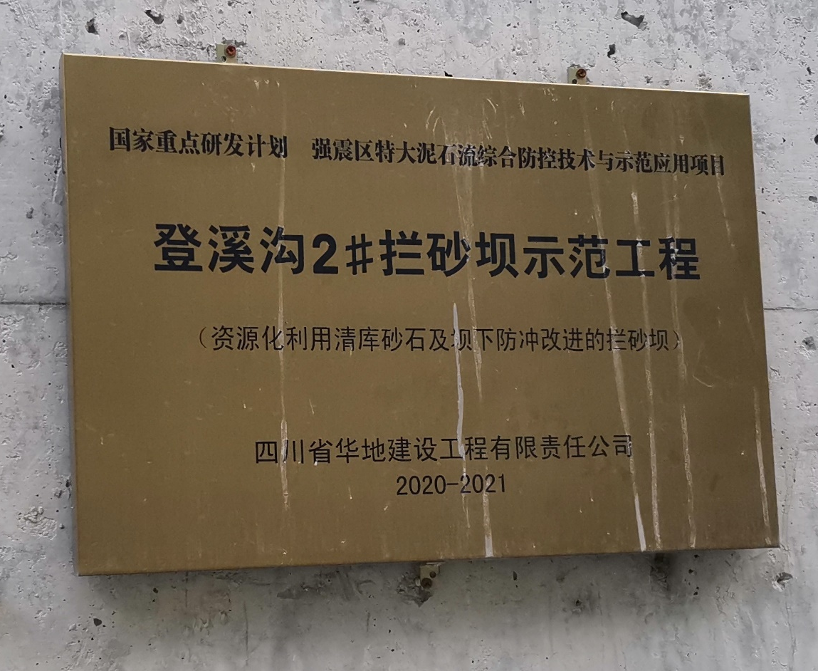
National Key R&D Program — Comprehensive prevention and control technology and demonstration application project of extra-large debris flow in strong earthquake area

Figure 2. Dengxi gully 2# dam – the dam with improved utilization of debris flow deposits and impact prevention under the dam.

